Communicable Diseases Intelligence, Year 2023, Volume 47
https://doi.org/10.33321/cdi.2023.47.44
Publication date: 24/8/2023
http://health.gov.au/cdi

Australian Meningococcal Surveillance Programme Annual Report, 2022
Monica M Lahra, CR Robert George, Sebastiaan J van Hal and Tiffany R Hogan for the National Neisseria Network

Abstract
In Australia, both probable and laboratory-confirmed cases of invasive meningococcal disease (IMD) are reported to the National Notifiable Diseases Surveillance System (NNDSS). Compared to 2021, the number of IMD notifications in 2022 increased by 81% to 127, alongside the easing of COVID-19 containment measures. Laboratory confirmation occurred in 95% of these cases, with 51% (62/121) diagnosed by bacterial culture and 49% (59/121) by nucleic acid amplification testing. The serogroup was determined for 97% of laboratory-confirmed cases (117/121): serogroup B (MenB) accounted for 83% of infections (100/121); MenW for 4% (5/121); MenY for 10% (12/121); no infections were attributed to MenC disease. Fine typing was available on 67% of the cases for which the serogroup was determined (78/117). In MenB isolates, 27 porA types were detected, the most prevalent of which were P1.7-2,4 (18%;11/62), P1.22,14 (15%; 9/62), P1.18-1,34 (10%; 6/62) and P1.7,16-26 (10%; 6/62). All five MenW infections identified as porA type P1.5,2 with different MLST sequence types (ST): 11, 574, 1287, 12351, 13135 all belonging to clonal complex 11, the hypervirulent strain reported in outbreaks in Australia and overseas. In MenY, the predominant porA type was P1.5-1,10-1 (73%; 8/11), ST 1655 and from clonal complex 23.
Children less than 5 years of age and people aged 15–19 years were overrepresented with IMD notifications, accounting for 22% (27/121) and 23% (28/121) of laboratory-confirmed cases respectively. Fifteen percent of laboratory-confirmed notifications (18/121) were in persons aged 45–64 years. MenB infections were detected in all age groups but predominated in persons aged 15–19 years (93% of IMD in this age group; 26/28) and comprised 89% (24/27) of infections in children aged less than 5 years. MenW infections were markedly reduced in 2022, accounting for two IMD detections in children 1–4 years (2/16) and sporadic detections in other older age groups. MenY infections were largely detected in adults aged 45–64 years, accounting for 28% of IMD in this age group (5/18).
All 62 cultured IMD isolates had antimicrobial susceptibility testing performed. Minimum inhibitory concentration (MIC) values were categorised using Clinical Laboratory Standards Institute (CLSI) interpretative criteria: 5% (3/62) were defined as penicillin resistant (MIC value ≥ 0.5 mg/L); 71% (44/62) had intermediate susceptibility to penicillin (MIC values 0.125 and 0.25 mg/L) and 24% (15/62) were susceptible to penicillin. All isolates were susceptible to ceftriaxone, ciprofloxacin and rifampicin.
Keywords: antimicrobial resistance; disease surveillance; invasive meningococcal disease; Neisseria meningitidis

Introduction
Established in 1979, the National Neisseria Network (NNN) is a network of reference laboratories in each Australian state and territory that collaboratively undertake surveillance of the pathogenic Neisseria species: N. meningitidis and N. gonorrhoeae. Since 1994, the NNN has coordinated laboratory data from cases of invasive meningococcal disease (IMD) for the Australian Meningococcal Surveillance Programme (AMSP), supported by the Australian Government Department of Health and Aged Care and the jurisdictions.¹ The NNN laboratories supplement notification data from the National Notifiable Diseases Surveillance System (NNDSS), which includes cases of probable and laboratory confirmed IMD.
Notifications of IMD in Australia peaked in 2002 at 3.5 cases per 100,000 persons per year,² with the majority of disease caused by MenB and MenC. After the introduction of the conjugate serogroup C meningococcal vaccine to the National Immunisation Program (NIP) in 2003, there was a significant and sustained reduction in serogroup C IMD notifications, and a reduction in overall notifications to a nadir of 0.6 cases per 100,000 in 2013.^{3,4} The IMD notification rate increased to 1.5 cases per 100,000 in 2017,² when MenACWY immunisation programmes were implemented across jurisdictions in targeted age groups. Following the substitution of the monovalent MenC vaccine with the quadrivalent MenACWY vaccine in 2018, IMD notifications declined further from 1.1 per 100,000 in 2018 to 0.8 per 100,000 in 2019. In 2020, there were 0.4 cases per 100,000 recorded and a continued reduction was recorded in 2021, to 0.3 cases per 100,000. This reduction in disease rate was beyond the expected vaccine impact and was likely attributable to the impact of public health measures implemented in response to the SARS-CoV-2 pandemic. In 2022, with the gradual easing of infection control containment measures, IMD notifications rose to 0.5 cases per 100,000 persons per year.
IMD is a rare disease in Australia, but one of public health concern; continued monitoring of phenotypic and genotypic features of IMD strains is critical to plan and inform clinical management of cases, case clusters and outbreaks of IMD locally and nationally, and to inform and monitor public health interventions.

Methods

Case confirmation of invasive meningococcal disease
Case confirmation is based on culture of N. meningitidis, or molecular diagnoses from a normally sterile site, defined as laboratory-definitive evidence of IMD according to national case definitions.⁵ Information regarding the site of infection and the age and sex of the patients is collated by the NNN for the AMSP.
Invasive N. meningitidis infections are categorised according to the site of isolation, or the specimen type from which meningococcal DNA was detected (blood, joint fluid, and vitreous fluid). For a given patient, when N. meningitidis is detected from both blood and cerebrospinal fluid (CSF) it is classified as one of meningitis.

Serogroup and genotyping of Neisseria meningitidis
Serogroup determination is by detection of soluble polysaccharide antigens, with molecular testing playing an increasing role.⁶ Genotyping of both isolates and DNA extracts is performed by sequencing products derived from amplification of the porA gene. Multi-locus sequence typing (MLST) and clonal complex assignment is additionally reported by some jurisdictions.

Antimicrobial susceptibility testing
Antimicrobial susceptibility testing (AST) of invasive meningococcal isolates is undertaken to determine minimum inhibitory concentration (MIC) values for antibiotics used for treatment (ceftriaxone, penicillin), and for clearance of carriage (ciprofloxacin and rifampicin). In this report, antibiotic susceptibilities are reported according to the Clinical Laboratory Standards Institute’s (CLSI) M100 guidelines;⁷ this differs from historical reporting. By CLSI guidelines, MIC breakpoints are categorised as follows, for penicillin: susceptible (MIC ≤ 0.06 mg/L); intermediate susceptibility (MIC 0.125–0.25 mg/L); and resistant (MIC ≥ 0.5 mg/L); for ceftriaxone: susceptible (MIC ≤ 0.125 mg/L); for ciprofloxacin: susceptible (MIC ≤ 0.03 mg/L), intermediate susceptibility (MIC 0.06 mg/L) and resistant (MIC ≥ 0.125 mg/L); and for rifampicin: susceptible (MIC ≤ 0.5 mg/L), intermediate susceptibility (MIC 1.0 mg/L) and resistant (MIC ≥ 2 mg/L).

Results
In 2022, there were 127 IMD cases notified to the NNDSS, of which 121 were laboratory confirmed.² Laboratory data were available to the AMSP for all 121 laboratory-confirmed IMD cases, as shown in Figure 1. In 2022, an increase in IMD notifications was seen across all jurisdictions, particularly in New South Wales, Queensland and Western Australia where notification numbers doubled from those reported in 2021.⁸ In 2022, the peak incidence of IMD occurred in winter through early spring (1 July to 30 September), as shown in Table 1.
Figure 1: Number of invasive meningococcal disease cases reported to the National Notifiable Diseases Surveillance System compared with laboratory-confirmed data from the Australian Meningococcal Surveillance Programme, Australia,ª 1991–2022
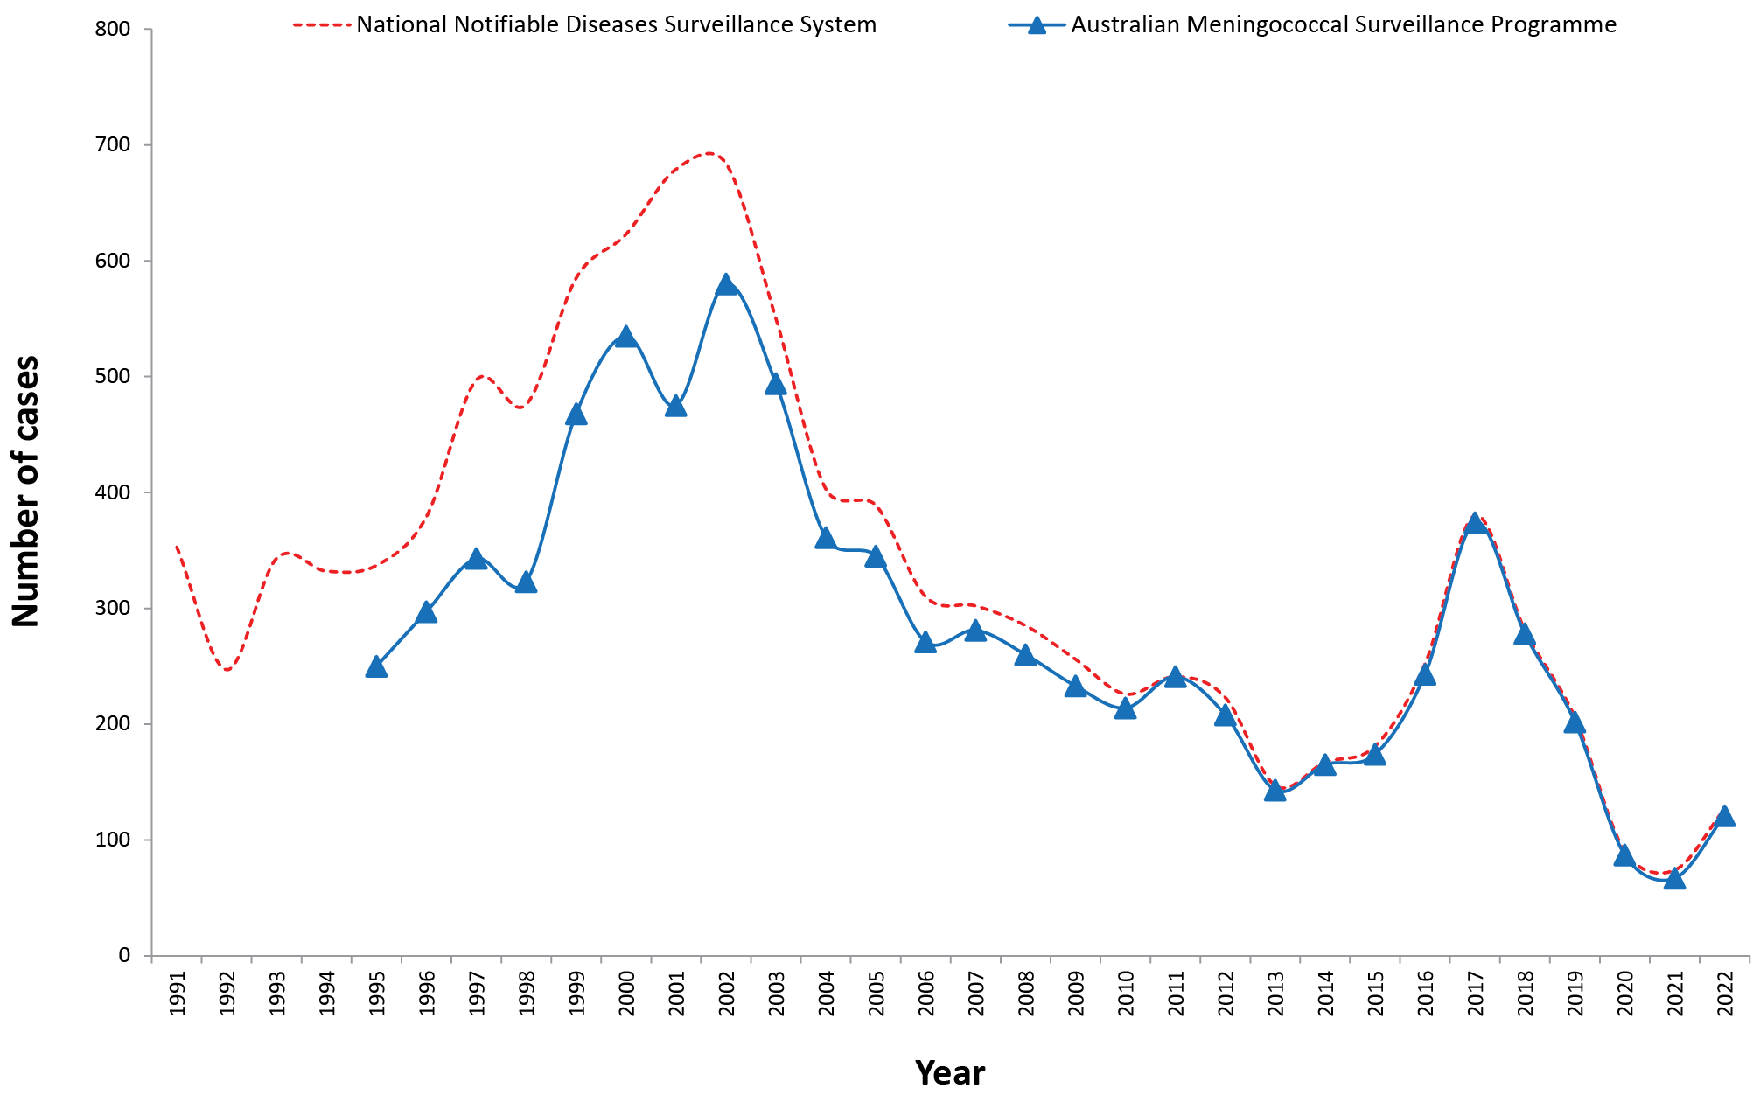
a Source: National Notifiable Diseases Surveillance System. Data extracted 10 May 2023.

Table 1: Laboratory-confirmed cases of invasive meningococcal disease, Australia, 2022
IMD  serogroup | 1 January – 31 March | 1 April – 30 June | 1 July – 30 September | 1 October – 31 December | 2022 total
B | 13 | 22 | 35 | 30 | 100
C | 0 | 0 | 0 | 0 | 0
W | 0 | 4 | 1 | 0 | 5
Y | 1 | 5 | 4 | 2 | 12
NDª | 2 | 0 | 2 | 0 | 4
Total | 16 | 31 | 42 | 32 | 121
a ND: not determined.
Table 2: Number of laboratory-confirmed cases of invasive meningococcal disease, Australia, 2022, by specimen type and method of confirmation
Specimen | Bacterial culture | Nucleic acid amplification test | Total
Blood | 47 | 19 | 66
CSF ± blood | 12 | 40 | 52
Joint aspirate | 3 | 0 | 3
Total | 62 | 59 | 121
Table 3: Number of laboratory-confirmed cases of invasive meningococcal disease, Australia, 2022, by jurisdiction and by serogroup
Jurisdiction | Serogroup
 | B | C | W | Y | NDª | Total
Australian Capital Territory | 1 | 0 | 0 | 1 | 0 | 2
New South Wales | 32 | 0 | 0 | 1 | 1 | 34
Northern Territory | 1 | 0 | 0 | 0 | 0 | 1
Queensland | 23 | 0 | 2 | 7 | 1 | 33
South Australia | 12 | 0 | 0 | 1 | 1 | 14
Tasmania | 3 | 0 | 0 | 0 | 0 | 3
Victoria | 14 | 0 | 0 | 0 | 1 | 15
Western Australia | 14 | 0 | 3 | 2 | 0 | 19
Australia | 100 | 0 | 5 | 12 | 4 | 121
% | 83 | 0 | 4 | 10 | 3
a ND: not determined.

Laboratory diagnosis of IMD
In 2022, laboratory diagnosis of IMD was via culture in 51% of laboratory-confirmed cases (62/121) and by molecular testing (nucleic acid amplification testing) in 49% (59/121), as shown in Table 2. There were 52 diagnoses of meningitis, 66 diagnoses of bacteraemia, and three IMD diagnoses from joint fluid aspirates.

Notifications by jurisdiction
Across the jurisdictions in 2022, New South Wales reported the highest number of IMD notifications nationally (28%; 34/121), followed by Queensland (27%, 33/121). For New South Wales, the number of IMD notifications was higher than that reported in 2021 but the proportion similar (2021: 27% (18/67)), whereas for Queensland, both the number and proportion were higher (2021: 21% (14/67)). In Western Australia, notification numbers increased in 2022 to 19/121 (16%) from 10/67 (15%) in 2021, but the proportion was similar. From Victoria, there were 15 notifications in 2022, an increase in number from 10 in 2021 but a decrease in proportion (2022: 15/121 (12%), 2021: 10/67 (15%)). In South Australia, IMD notifications decreased in both number and proportion in 2022 (12%, 14/121) after increasing sharply in 2021 (18%, 12/67) compared with 2020 (6%, 5/87). Jurisdictional case numbers are shown in Table 3.
In 2022, MenB accounted for 83% of IMD notifications (see Table 3), reaching a proportion not observed since 2008 – 2009 (see Figure 2). Of note, MenB proportionality was highest in New South Wales (94%, 32/34), Victoria (93%, 14/15) and South Australia (86%, 12/14). MenB IMD was reported across all age groups. Historically, from 2006 through 2014, the proportion of IMD attributable to MenB ranged from 74–84% nationwide, falling to 62% in 2015, and then 37% in 2016–2017. Subsequently, there has been an overall increase in the proportion of IMD attributable to MenB, rising to 44% in 2018, 50% in 2019, and 62% in 2020, with a temporally limited decrease to 52% observed in 2021.
Figure 2: Proportion of serogroups of laboratory-confirmed invasive meningococcal disease, Australia, 2000 – 2022 by year
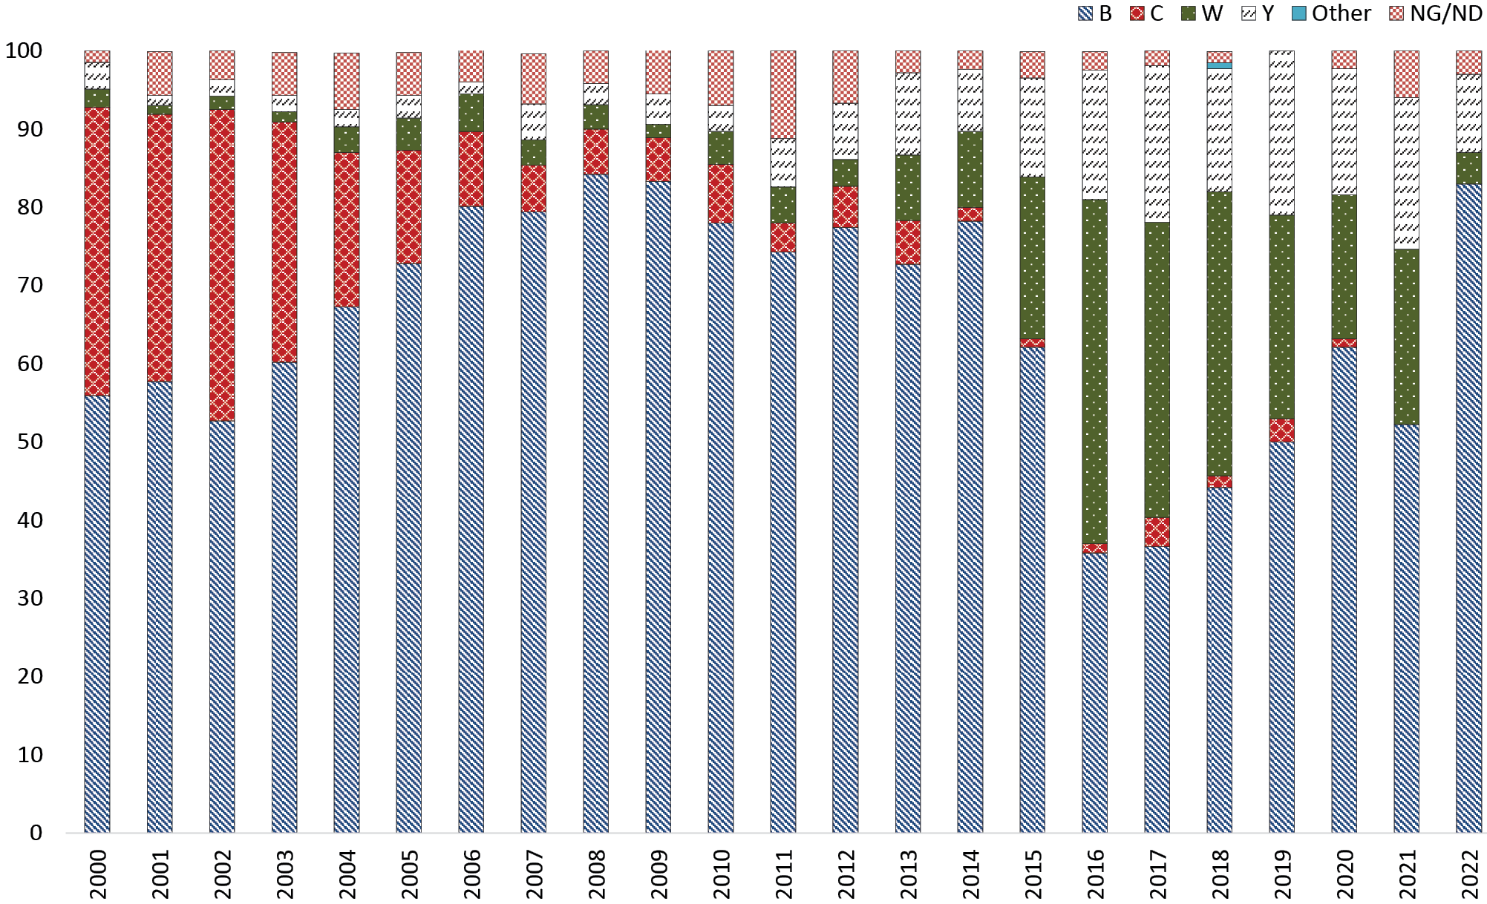
MenW and MenY respectively accounted for 4% and 10% of IMD nationally in 2022 (see Table 3). Since 2014, the rise in IMD notifications has generally coincided with increases in numbers of infections of both MenW and MenY (see Figure 1 and Figure 2). Regarding MenW, this serogroup was responsible for a relatively low proportion of IMD cases prior to 2015, ranging within 1–5% during 2000–2012. Increases to 8–10% were observed in 2013–2014, to 21% in 2015, and a peak proportion of 44% observed in 2016. Subsequently, rates have progressively declined, from 36–38% in 2017–2018, 18-26% in 2019-2021, and then falling sharply to 4% in 2022 (Figure 2). MenW disease was only reported in Western Australia (3) and Queensland (2). Regarding MenY, the proportion of IMD cases attributable to this serogroup ranged within 1–5% in the years 2000–2010 before increasing to 6–11% from 2011–2014, to 13% in 2015, 17% in 2016, and then 20% in 2017. The attributable proportion of MenY IMD ranged from 16% to 21% between 2018 and 2021, declining sharply to 10% in 2022 (see Figure 2). In 2022, MenY disease was largely reported from Queensland (7/33), accounting for 21% of jurisdictional notifications.
In 2022, no MenC IMD was reported from Australia. Additionally, very few cases of any serogroup were reported from the Australian Capital Territory (2 cases); the Northern Territory (1 case); and Tasmania (3 cases).

IMD age and serogroup distribution
In 2022, IMD notifications were reported in all age groups. Disease peaks occurred in children less than 5 years of age (27/121 cases; 22%) and in persons aged 15 to 19 years (28/121 cases; 23%). Fifteen percent of notifications (18/121) were in adults aged 45–64 years, as shown in Table 4. Serogrouping was determined for 117/121 cases of IMD (97%), with MenB accounting for 83%, MenY for 10% and MenW for 4%, as shown in Table 3. There were no notifications of MenC IMD nationwide in 2022. Serogroup distribution is also shown in Table 4 and Figure 3; MenB accounted for 83% of IMD, and was the majority serogroup in all age groups excepting in those aged 65 years and over.

Figure 3: Number of serogroup B, C, Y and W cases of laboratory-confirmed invasive meningococcal disease, Australia, 2022, by age
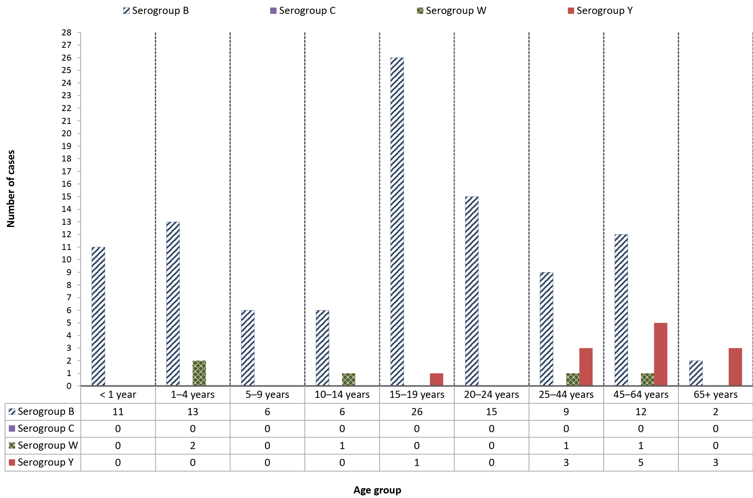
Table 4: Laboratory-confirmed cases of invasive meningococcal disease (IMD), Australia, 2022, by age and serogroup, and the proportion of IMD attributable to MenB
Serogroup | Age group (years) |  |  |  |  |  |  |  |  | Total
 | < 1 | 1–4 | 5–9 | 10–14 | 15–19 | 20–24 | 25–44 | 45–64 | 65+
B | 11 | 13 | 6 | 6 | 26 | 15 | 9 | 12 | 2 | 100
C | 0 | 0 | 0 | 0 | 0 | 0 | 0 | 0 | 0 | 0
W | 0 | 2 | 0 | 1 | 0 | 0 | 1 | 1 | 0 | 5
Y | 0 | 0 | 0 | 0 | 1 | 0 | 3 | 5 | 3 | 12
ND | 0 | 1 | 0 | 1 | 1 | 0 | 1 | 0 | 0 | 4
Total | 11 | 16 | 6 | 8 | 28 | 15 | 14 | 18 | 5 | 121
% B within age group | 100% | 81% | 100% | 75% | 93% | 100% | 64% | 67% | 40% | 83%

IMD and genotyping
Finetyping was performed on 62 of 100 MenB IMD cases and this serogroup showed the greatest variability, with 27 porA types represented and with four porA types predominating: P1.7-2,4 (11/62; 18%), P1.22,14 (9/62; 15%), P1.18-1,34 (6/62, 10%) and P1.7,16-26 (6/62, 10%), as shown in Figure 4 and Table 5.

Figure 4: The number of porA types represented in serogroup B, W and Y invasive meningococcal disease notifications in Australia in 2022
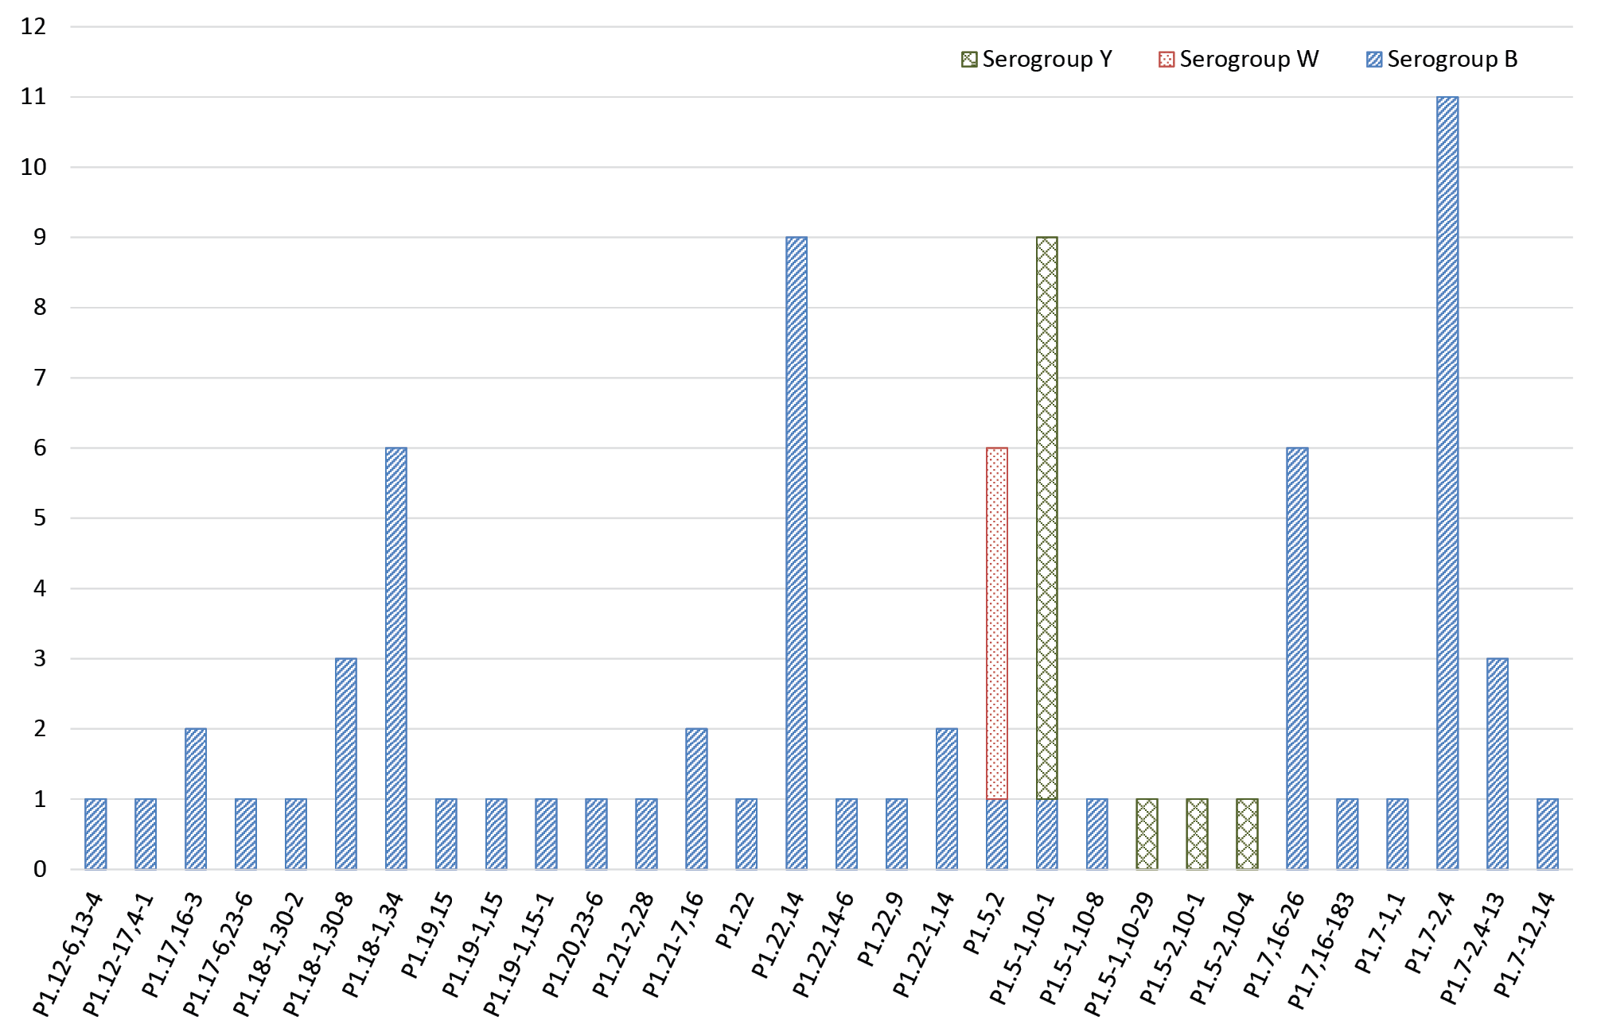

Table 5: Distribution of porA genotypes in typed isolates of invasive meningococcal disease, Australia, 2022, by state or territory (n = 78/121)
2022 AMSP |  | Number per serogroup per state / territoryª
SEROGROUP | GENOTYPE_PorA | ACT |  | NSW |  | NT |  | Qld |  | SA |  | Tas. |  | Vic. |  | WA | TOTAL
B | P1.12-6,13-4 | 0 |  | 0 |  | 0 |  | 1 |  | 0 |  | 0 |  | 0 |  | 0 | 1
B | P1.12-17,4-1 | 0 |  | 1 |  | 0 |  | 0 |  | 0 |  | 0 |  | 0 |  | 0 | 1
B | P1.17,16-3 | 0 |  | 0 |  | 0 |  | 2 |  | 0 |  | 0 |  | 0 |  | 0 | 2
B | P1.17-6,23-6 | 0 |  | 0 |  | 0 |  | 0 |  | 0 |  | 0 |  | 1 |  | 0 | 1
B | P1.18-1,30-2 | 1 |  | 0 |  | 0 |  | 0 |  | 0 |  | 0 |  | 0 |  | 0 | 1
B | P1.18-1,30-8 | 0 |  | 0 |  | 0 |  | 3 |  | 0 |  | 0 |  | 0 |  | 0 | 3
B | P1.18-1,34 | 0 |  | 4 |  | 0 |  | 0 |  | 0 |  | 0 |  | 2 |  | 0 | 6
B | P1.19,15 | 0 |  | 0 |  | 0 |  | 0 |  | 0 |  | 0 |  | 1 |  | 0 | 1
B | P1.19-1,15 | 0 |  | 1 |  | 0 |  | 0 |  | 0 |  | 0 |  | 0 |  | 0 | 1
B | P1.19-1,15-1 | 0 |  | 0 |  | 0 |  | 0 |  | 0 |  | 0 |  | 0 |  | 1 | 1
B | P1.20,23-6 | 0 |  | 1 |  | 0 |  | 0 |  | 0 |  | 0 |  | 0 |  | 0 | 1
B | P1.21-2,28 | 0 |  | 1 |  | 0 |  | 0 |  | 0 |  | 0 |  | 0 |  | 0 | 1
B | P1.21-7,16 | 0 |  | 1 |  | 0 |  | 0 |  | 0 |  | 0 |  | 0 |  | 1 | 2
B | P1.22 | 0 |  | 0 |  | 0 |  | 0 |  | 0 |  | 0 |  | 1 |  | 0 | 1
B | P1.22,14 | 0 |  | 2 |  | 0 |  | 1 |  | 1 |  | 0 |  | 2 |  | 3 | 9
B | P1.22,14-6 | 0 |  | 0 |  | 0 |  | 1 |  | 0 |  | 0 |  | 0 |  | 0 | 1
B | P1.22,9 | 0 |  | 0 |  | 0 |  | 1 |  | 0 |  | 0 |  | 0 |  | 0 | 1
B | P1.22-1,14 | 0 |  | 0 |  | 1 |  | 0 |  | 0 |  | 0 |  | 0 |  | 1 | 2
B | P1.5-1,10-1 | 0 |  | 0 |  | 0 |  | 0 |  | 0 |  | 0 |  | 1 |  | 0 | 1
B | P1.5-1,10-8 | 0 |  | 0 |  | 0 |  | 1 |  | 0 |  | 0 |  | 0 |  | 0 | 1
B | P1.5,2 | 0 |  | 0 |  | 0 |  | 0 |  | 0 |  | 0 |  | 0 |  | 1 | 1
B | P1.7,16-26 | 0 |  | 1 |  | 0 |  | 2 |  | 0 |  | 0 |  | 3 |  | 0 | 6
B | P1.7,16-183 | 0 |  | 1 |  | 0 |  | 0 |  | 0 |  | 0 |  | 0 |  | 0 | 1
B | P1.7-1,1 | 0 |  | 1 |  | 0 |  | 0 |  | 0 |  | 0 |  | 0 |  | 0 | 1
B | P1.7-2,4 | 0 |  | 0 |  | 0 |  | 6 |  | 5 |  | 0 |  | 0 |  | 0 | 11
B | P1.7-2,4-13 | 0 |  | 2 |  | 0 |  | 0 |  | 1 |  | 0 |  | 0 |  | 0 | 3
B | P1.7-12,14 | 0 |  | 1 |  | 0 |  | 0 |  | 0 |  | 0 |  | 0 |  | 0 | 1
W | P1.5,2 | 0 |  | 0 |  | 0 |  | 2 |  | 0 |  | 0 |  | 0 |  | 3 | 5
Y | P1.5-1,10-1 | 0 |  | 0 |  | 0 |  | 6 |  | 1 |  | 0 |  | 0 |  | 1 | 8
Y | P1.5-1,10-29 | 0 |  | 1 |  | 0 |  | 0 |  | 0 |  | 0 |  | 0 |  | 0 | 1
Y | P1.5-2,10-1 | 0 |  | 0 |  | 0 |  | 0 |  | 0 |  | 0 |  | 0 |  | 1 | 1
Y | P1.5-2,10-4 | 0 |  | 0 |  | 0 |  | 1 |  | 0 |  | 0 |  | 0 |  | 0 | 1
Total |  |  |  |  |  |  |  |  |  |  |  |  |  |  |  |  | 78
a ACT: Australian Capital Territory; NSW: New South Wales; NT: Northern Territory; Qld: Queensland; SA: South Australia; Tas.: Tasmania; Vic.: Victoria; WA: Western Australia.

All of the five MenW IMD were determined to be from a single porA type, P1.5,2, as shown in Figure 4 and Table 5. Five different MLST sequence types were represented: 11; 574; 1287; 12351; and 13135, with all belonging to clonal complex 11. The porA type P1.5,2 has been the predominant genotype in recent years, from the clonal complex 11, which is the same strain type as the hypervirulent serogroup W strain reported in the United Kingdom and South America since 2009.^{9,10}
Of the 12 MenY cases, 11 had finetyping performed and were determined to be from four porA types, with P1.5-1,10-1 the most prevalent (8/11, 73%) (as shown in Figure 4 and Table 5), identifying as MLST sequence type 1655 and belonging to clonal complex 23. The porA type P1.5-1,10-1 has been the predominant MenY genotype circulating in Australia since 2014, when the increase in serogroup Y IMD was first noted in Australia.

Antimicrobial susceptibility testing
Neisseria meningitidis isolates are tested against currently recommended treatment (ceftriaxone and penicillin) and clearance antibiotics (rifampicin and ciprofloxacin). In 2022, national AST data are reported according to CLSI interpretative guidelines, changed from historical reporting (1997 to 2020). Fifty-one percent of laboratory-confirmed IMD (62/121 isolates) had N. meningitidis cultures, permitting AST by NNN laboratories. Ceftriaxone AST was performed on all 62 isolates with each testing susceptible. The distribution of penicillin MIC values is shown in Table 6. Regarding penicillin, 24% of IMD isolates (15/62) tested susceptible (MIC ≤ 0.06 mg/L); 71% (44/62) demonstrated intermediate susceptibility (MIC 0.125–0.25 mg/L); and 5% (3/62) were resistant (MIC ≥ 0.5 mg/L) (see Table 6). The proportion of penicillin-resistant isolates in 2022 was lower than reported in 2021 (13%, 6/46). Of the isolates that tested penicillin resistant, two were MenB and one was MenW. In recent years, MenW has demonstrated higher penicillin MIC values and higher proportions of resistance. Regarding the clearance antibiotics for IMD, all isolates tested in 2022 were susceptible to ciprofloxacin and rifampicin.
Table 6: Penicillin MIC distribution of laboratory-confirmed invasive meningococcal disease isolates, Australia, 2022
Penicillin MIC distribution
MIC mg/L | ≤ 0.032 | 0.064 | 0.125 | 0.25 | 0.5 | 1 | 2 | ≥ 4 | Total
Number of isolates | 4 | 11 | 13 | 31 | 3 | 0 | 0 | 0 | 62
% | 6% | 18% | 21% | 50% | 5% | 0% | 0% | 0% | 100%

Discussion
In 2022, there were 127 IMD notifications nationally; an 81% increase from that reported in 2021, following the easing of COVID-19 containment measures. In recent years there has been an ongoing annual decrease in IMD notifications from 1.5 cases per 100,000 in 2017 to 1.1 per 100,000 in 2018; 0.8 cases per 100,000 in 2019; 0.4 cases per 100,000 in 2020; 0.3 cases per 100,000 in 2021. The notification rate in 2021 was the lowest recorded since records were kept and coincided with both widespread public health initiatives designed to reduce COVID-19 transmission and changes in the national immunisation programme (NIP) from a monovalent MenC to a quadrivalent MenACWY vaccine.^{11,12} In 2022, there were 0.5 IMD cases per 100 000 population reported, and 95% (121/127) of IMD notifications in Australia were laboratory confirmed.
In Australia in 2016–2017 the AMSP reported increased notifications of MenW and MenY IMD. In response, time-limited, jurisdictional MenACWY vaccination programs for target age groups were implemented; in July 2018, the MenC vaccine at 12 months of age was replaced with a quadrivalent ACWY vaccine on the NIP.¹² A decrease in both notifications and proportionality of MenW and MenY disease followed, accompanied by a gradual increase in the proportion of MenB disease (from 44% to 62% in 2018–2021 to 83% of IMD in 2022). Prior to the introduction of the MenC vaccine in 2003, the proportion of MenB IMD was 84–88% in the years 2006–2012. Notifications of IMD subsequently increased with the emergence of MenW and MenY disease since 2014 in Australia.^{4,13} In 2022, the number and proportion of IMD cases caused by MenB (100/121; 83%) was substantially greater than the MenB IMD reported in 2021 (35/67; 52%). New South Wales reported the largest number of MenB notifications. Fine typing of MenB notifications revealed the diversity of porA types (27 different porA types from the 62 investigations). The predominant MenB porA genotype in Australia was P1.7-2,4 (18%, 11/62), followed by genotypes P1.22,14 (15%, 9/62), P1.18-1,34 (10%, 6/62) and P1.7,16-26 (10%, 6/62). Across the age groups, MenB was predominant in IMD in all age groups excepting in those over 65 years.
MenW accounted for 4% (5/121) of IMD. The proportion of IMD caused by MenW declined to 22% in 2021 from 38% in 2017. Of MenW notifications in 2022, two (2/5) occurred in children aged 1–4 years; in the previous year, MenW accounted for 50% (5/10) of IMD notifications in infants less than one year old. The predominant circulating strain of MenW continues to be porA genotype P1.5,2 with MLST types belonging to clonal complex 11. This same MenW strain previously emerged in the United Kingdom (UK) and South America in 2009,^{9,10} and spread to account for 25% of IMD in the UK in 2014–2015 and 59% of all cases in Chile in 2012. MenW ST11 is hypervirulent and associated with atypical clinical presentations, more severe disease, and a higher case fatality rate. ¹⁰ The initial increase in MenW overseas and in Australia was seen in older adults, but was subsequently reported in all age groups, particularly in adolescents and infants.¹⁴
In 2022, MenY accounted for 10% of IMD nationally (12/121), predominantly affecting older age groups. MenY accounted for 21% of notifications (3/14) in individuals aged 25–44 years, 28% of notifications (5/18) in individuals aged 45–64 years, and 60% of notifications (3/5) in individuals aged 65 years and greater. Since 2014, the predominant MenY genotype since 2014 continues to be P1.5-1,10-1, whereas previously MenY genotype distribution had been more heterogeneous.¹⁵
Antimicrobial susceptibility testing of IMD isolates in 2022 detected 5% (3/62) penicillin resistance (MIC values ≥ 0.5 mg/L) in clinical isolates. All IMD isolates tested in 2022 were susceptible to ceftriaxone, ciprofloxacin and rifampicin.
The NNN is continuing to lead further investigations with the Australian Government Department of Health and Aged Care and is closely monitoring the phenotypic and genotypic features of N. meningitidis causing IMD in Australia. Additional investigations by the NNN, including whole genome sequencing of IMD isolates, are in progress to enhance IMD surveillance in Australia. The AMSP data are used for informing treatment guidelines and disease prevention strategies; and to monitor the effect of interventions.

Acknowledgements
Meningococcal isolates were received in the reference centres from many laboratories throughout Australia. The considerable time and effort involved in forwarding these isolates is recognised and these efforts are greatly appreciated. These data could not have been provided without this assistance and the help of clinical colleagues and public health personnel. The Australian Government Department of Health and Aged Care provided funding for the National Neisseria Network.
Members of the AMSP in 2022, to whom isolates and samples should be referred, and enquiries directed, are listed below.

Australian Capital Territory
P Collignon, S Bradbury, C. O’Brien Microbiology Department, The Canberra Hospital, Gilmore Crescent, Garran ACT 2605. Telephone: +61 2 5124 2510.
Facsimile: +61 2 5124 4646 Email: peter.collignon@act.gov.au

New South Wales
MM Lahra, EA Limnios, TR Hogan, RL Kundu, S Ray, Microbiology Department, New South Wales Health Pathology, The Prince of Wales Hospital, Barker Street, Randwick NSW 2031. Telephone: +61 2 9382 3689. Facsimile: +61 2 9382 3719. Email: monica.lahra@health.nsw.gov.au
M Maley, R Porritt Department of Microbiology and Infectious Diseases, New South Wales Health Pathology, Liverpool Hospital, , Liverpool NSW 2170. Telephone: +61 8738 5124. Facsimile: +61 2 8738 5129. Email: Robert.Porritt@health.nsw.gov.au

Northern Territory
R Baird, K Freeman Microbiology Department, Territory Pathology, Royal Darwin Hospital, Rocklands Drive. Tiwi NT 0810. Telephone: +61 8 8922 8685. Facsimile: +61 8 8922 7788. Email: rob.baird@nt.gov.au

Queensland
S Schlebusch, H Smith, V Hicks, A. Jennison Public Health Microbiology, Queensland Health Forensic and Scientific Services, 39 Kessels Road, Coopers Plains Qld 4108. Telephone: +61 7 3096 2825. Facsimile: +61 7 3096 2973, +61 7 3274 9175. Email: Amy.Jennison@health.qld.gov.au

South Australia
I Bastian, Lex Leong, Megan Hodgson, Casey Moore SA Pathology, Royal Adelaide Hospital Site, Microbiology and Infectious Diseases, Royal Adelaide Hospital, North Terrace, Adelaide, SA 5000. Telephone: +61 8 8222 3382. Facsimile: +61 8 2223543. Email: Lex.Leong@sa.gov.au

Tasmania
L Cooley, B McEwan Department of Microbiology and Infectious Diseases, Royal Hobart Hospital, 48 Liverpool Street, Hobart Tasmania 7000 Telephone: +61 3 6166 8417 Email: belinda.mcewan@ths.tas.gov.au

Victoria
B Howden, K Stevens, S. Tawil, Paula Roydhouse. Microbiological Diagnostic Unit Public Health Laboratory, Department of Microbiology and Immunology, The Peter Doherty Institute, The University of Melbourne, Parkville Victoria 3052. Telephone: +61 3 8344 5713. Facsimile: +61 3 8344. 7833 Email: kerries@unimelb.edu.au

Western Australia
D Speers, R. Ferdinand Department of Microbiology, QEII Medical Centre, PP Block Level 5, PathWest Laboratory Medicine WA, Hospital Avenue, Nedlands, WA 6009. Telephone: 61 8 6383 4501. Facsimile: +61 8 9382 8046. Email: Rebecca.Ferdinand@health.wa.gov.au

Author details
Monica M Lahra ^{1,2}
CR Robert George ³
Sebastiaan van Hal ^{4,5}
Tiffany R Hogan ¹
- World Health Organisation Collaborating Centre for STI and AMR, Sydney and Neisseria Reference Laboratory, Department of Microbiology, NSW Health Pathology, The Prince of Wales Hospital, Randwick, 2031, NSW Australia
- School of Medical Sciences, Faculty of Medicine, The University of New South Wales, NSW, 2052 Australia
- N S W Health Pathology, John Hunter Hospital, Newcastle, 2300, NSW Australia
- New South Wales Health Pathology, Microbiology, Royal Prince Alfred Hospital Camperdown, NSW, Australia
- School of Medicine, University of Sydney

Corresponding author
Professor Monica M. Lahra
Director, Microbiology Department Neisseria Reference Laboratory and WHO Collaborating Centre for STI and AMR, NSW Health Pathology, Level 4, Campus Centre, The Prince of Wales Hospital, Randwick NSW, 2031

References
- National Neisseria Network. Meningococcal Isolate Surveillance Australia 1994. Commun Dis Intell. 1995;19(12):286–9.
- Australian Government Department of Health and Aged Care. National Notifiable Diseases Surveillance System (NNDSS) data visualisation tool. [Webpage.] Canberra: Australian Government Department of Health and Aged Care; 14 December 2022. [Accessed on 10 May 2023.] Available from: https://www.health.gov.au/resources/apps-and-tools/national-notifiable-diseases-surveillance-system-nndss-data-visualisation-tool.
- National Notifiable Diseases Surveillance System (NNDSS). Number of notifications of Meningococcal disease (invasive), received from State and Territory health authorities in the period of 1991 to 2012 and year-to-date notifications for 2014–2021. Available from: http://www9.health.gov.au/cda/source/rpt_4_sel.cfm.
- Australian Government Department of Health and Aged Care. Invasive meningococcal disease. [Internet.] Canberra: Australian Government Department of Health and Aged Care; 12 July 2022. Available from: https://www.health.gov.au/internet/main/publishing.nsf/Content/ohp-meningococcal-W.htm.
- Australian Government Department of Health and Aged Care, Communicable Diseases Network Australia (CDNA). Invasive Meningococcal Disease: CDNA National Guidelines for Public Health Units. Canberra: Australian Government Department of Health and Aged Care; 4 July 2017. Available from: https://www.health.gov.au/sites/default/files/documents/2020/02/invasive-meningococcal-disease-cdna-national-guidelines-for-public-health-units.pdf.
- George CRR, Smith HV, Lahra MM. Neisseria meningitidis. In de Filippis I, ed. Molecular Typing in Bacterial Infections, Volume I. London: Springer International Publishing, Springer Cham, 2022;85–99.
- Clinical and Laboratory Standards Institute (CLSI). Performance standards for antimicrobial susceptibility testing. 32nd ed. CLSI supplement M100. Wayne, PA: CLSI; 2022.
- Lahra MM, George CRR, Hogan TR for the National Neisseria Network. Australian Meningococcal Surveillance Programme Annual Report, 2021. Commun Dis Intell (2018). 2022;46. doi: https://doi.org/10.33321/cdi.2022.46.46.
- Abad R, López EL, Debbag R, Vázquez JA. Serogroup W meningococcal disease: global spread and current affect on the Southern Cone in Latin America. Epidemiol Infect. 2014;142(12):2461–70. doi: https://doi.org/10.1017/S0950268814001149.
- Ladhani SN, Beebeejaun K, Lucidarme J, Campbell H, Gray S, Kaczmarski E et al. Increase in endemic Neisseria meningitidis capsular group W sequence type 11 complex associated with severe invasive disease in England and Wales. Clin Infect Dis. 2015;60(4):578–85. doi: https://doi.org/10.1093/cid/ciu881.
- George CR, Booy R, Nissen MD, Lahra MM. The decline of invasive meningococcal disease and influenza in the time of COVID-19: the silver linings of the pandemic playbook. Med J Aust. 2022. doi: https://doi.org/10.5694/mja2.51463.
- Chiu C, Dey A, Wang H, Menzies R, Deeks S, Mahajan D et al. Vaccine preventable diseases in Australia, 2005 to 2007. Commun Dis Intell Q Rep. 2010;34(Suppl):S1–167.
- Australian Government Department of Health and Aged Care. Immunise Australia Program. Meningococcal Disease. [Internet.] Canberra: Australian Government Department of Health and Aged Care; 20 April 2015. Available from: https://www.health.gov.au/internet/immunise/publishing.nsf/Content/immunise-meningococcal.
- Araya P, Fernández J, Del Canto F, Seoane M, Ibarz-Pavón AB, Barra G et al. Neisseria meningitidis ST-11 clonal complex, Chile 2012. Emerg Infect Dis. 2015;21(2):339–41. doi: https://doi.org/10.3201/eid2102.140746.
- Bröker M, Jacobsson S, Kuusi M, Pace D, Simões MJ, Skoczynska A et al. Meningococcal serogroup Y emergence in Europe: update 2011. Hum Vaccin Immunother. 2012;8(12):1907–11. doi: https://doi.org/10.4161/hv.21794.
- a Source: National Notifiable Diseases Surveillance System. Data extracted 10 May 2023.

Communicable Diseases Intelligence
ISSN: 2209-6051 Online

Communicable Diseases Intelligence (CDI) is a peer-reviewed scientific journal published by the Office of Health Protection, Department of Health and Aged Care. The journal aims to disseminate information on the epidemiology, surveillance, prevention and control of communicable diseases of relevance to Australia.

Editor: Christina Bareja
Deputy Editor: Simon Petrie
Design and Production: Kasra Yousefi
Editorial Advisory Board: David Durrheim, Mark Ferson, Clare Huppatz, John Kaldor, Martyn Kirk, Meru Sheel and Steph Williams

Website: http://www.health.gov.au/cdi

Contacts
CDI is produced by the Office of Health Protection, Australian Government Department of Health and Aged Care, GPO Box 9848, (MDP 6) CANBERRA ACT 2601

Email: cdi.editor@health.gov.au

Submit an Article
You are invited to submit your next communicable disease related article to the Communicable Diseases Intelligence (CDI) for consideration. More information regarding CDI can be found at: http://health.gov.au/cdi.
Further enquiries should be directed to: cdi.editor@health.gov.au.

This journal is indexed by Index Medicus and Medline.

Creative Commons Licence - Attribution-NonCommercial-NoDerivatives CC BY-NC-ND
© 2023 Commonwealth of Australia as represented by the Department of Health and Aged Care
This publication is licensed under a Creative Commons Attribution-NonCommercial-NoDerivatives 4.0 International Licence from https://creativecommons.org/licenses/by-nc-nd/4.0/legalcode (Licence). You must read and understand the Licence before using any material from this publication.

Restrictions
The Licence does not cover, and there is no permission given for, use of any of the following material found in this publication (if any):
- the Commonwealth Coat of Arms (by way of information, the terms under which the Coat of Arms may be used can be found at www.itsanhonour.gov.au);
- any logos (including the Department of Health and Aged Care’s logo) and trademarks;
- any photographs and images;
- any signatures; and
- any material belonging to third parties.

Disclaimer
Opinions expressed in Communicable Diseases Intelligence are those of the authors and not necessarily those of the Australian Government Department of Health and Aged Care or the Communicable Diseases Network Australia. Data may be subject to revision.

Enquiries
Enquiries regarding any other use of this publication should be addressed to the Communication Branch, Department of Health and Aged Care, GPO Box 9848, Canberra ACT 2601, or via e-mail to: copyright@health.gov.au

Communicable Diseases Network Australia
Communicable Diseases Intelligence contributes to the work of the Communicable Diseases Network Australia.
http://www.health.gov.au/cdna

