Communicable Diseases Intelligence, Year 2023, Volume 47
https://doi.org/10.33321/cdi.2023.47.31
Publication date: 25/05/2023
http://health.gov.au/cdi

Characterisation of Corynebacterium diphtheriae isolates in the Northern Territory of Australia
Matthew Howes, Dimitrios Menouhos, Stefanos Christofis, Jann Hennessy, Rob Baird

Abstract
This article summarises our review of 41 Corynebacterium diphtheriae wound swab isolates from the tropical Northern Territory of Australia. On polymerase chain reaction and whole genome sequencing, no isolates were toxigenic strains.
Keywords: Corynebacterium; diphtheria; tropical; wounds; phage; toxin
We reviewed the toxigenic potential and phylogeny of Corynebacterium diphtheriae from skin isolates in the Northern Territory (NT) of Australia. C. diphtheriae is a human-only pathogen found throughout the NT; it is a common laboratory isolate from skin swabs.¹ Geographically, the Top End of the Northern Territory is a region of almost 250,000 km² with a tropical climate and C. diphtheriae is frequently endemic in tropical regions. C. diphtheriae is often a component of polymicrobial wound cultures.
Strains of C. diphtheriae can be divided into those that produce toxin (toxigenic strains) and those that do not (non-toxigenic strains). Toxigenic strains of C. diphtheriae are the commonest causative agent of respiratory diphtheria, a potentially fatal clinical syndrome.² Toxigenic diphtheria is very rare in the NT, with only one toxigenic isolate recorded since 1992 in a worker returning from East Timor.³ Notifications have significantly reduced since the early twentieth century, largely due to vaccination (introduced in 1932) as demonstrated in Figure 1.

Figure 1: Diphtheria notifications (1917–2015) for Australia ª
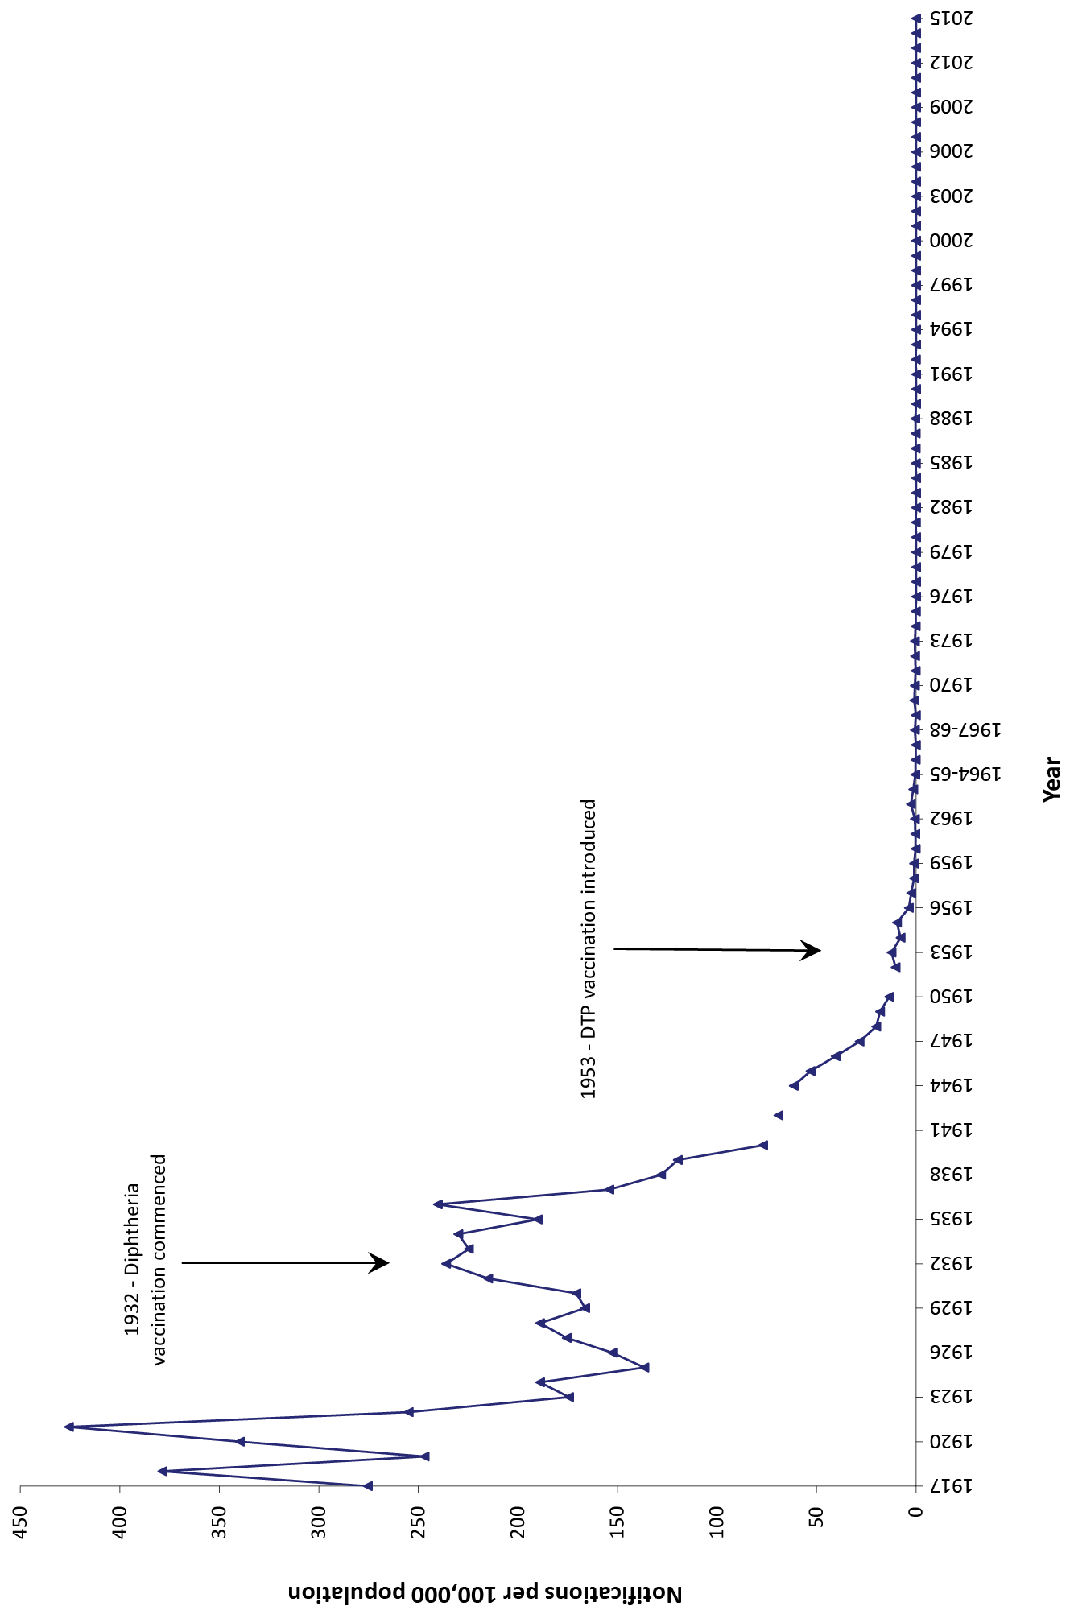
a Figure reproduced from reference 4, under a Creative Commons CC-BY-NC-ND licence.

A prospective and retrospective review of C. diphtheriae isolates within the NT, in 2011, demonstrated no toxin-positive strains from a five-year period.¹ C. diphtheriae from wound isolates are not routinely tested for toxins due to low rates. There has been public health concern with recent cases of diphtheria in unvaccinated children in New South Wales⁵ and Queensland,⁶ and a review from 2022 highlighted that 98% of diphtheria notifications in Australia between 1999 and 2019 occurred after 2011.⁷ We therefore set out to interrogate C. diphtheriae in a tropical centre to ensure that we were not missing asymptomatic carriage of toxin-producing organisms. There is concern that asymptomatic carriage of toxigenic strains in wounds can disseminate to close contacts causing disease as has been previously described, particularly amongst unvaccinated individuals.^{8,9} Twenty-two cases of toxigenic cutaneous diphtheria epidemiologically linked to a North Queensland strain have been identified between 2020 and 2022.⁶
Forty-one C. diphtheriae isolates from clinical specimens were collected prospectively during the period 1 August – 30 November 2022. The C. diphtheriae isolates were collected from wound and skin swabs. There were no isolates from throat swabs during this period. C. diphtheriae specimens then underwent in-house polymerase chain reaction (PCR) for toxin detection,¹⁰ and were subjected also to whole genome sequencing for the presence of toxin-producing genes and the examination of phylogeny. No clinical data were collected and therefore no ethics application was sought.
Of the 41 C. diphtheriae isolates, none were found to be toxin positive on in-house PCR. On whole genome sequencing and utilisation of toxin pipelines TAfinder, a single specimen, S21, recorded presence of a protein associated with toxin/antitoxin (DIP0007/DIP0008). On further analysis, this has not been noted elsewhere in other toxin-producing strains and therefore is likely to be a false positive. A phylogenetic tree with a known toxin-producing strain as reference is shown in Figure 2.

Figure 2: A single nucleotide pair (SNP) distance-based maximum likelihood phylogenetic tree of C. diphtheriae isolatesª
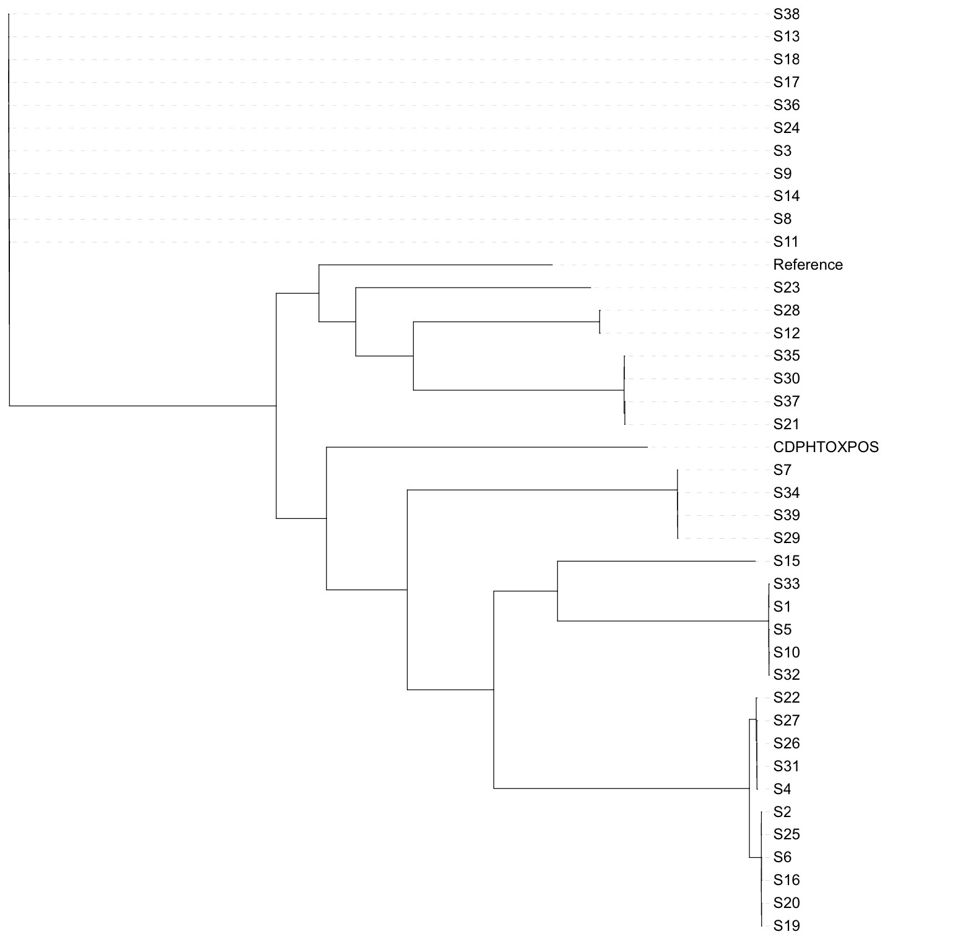
a Tree was constructed using the FASTTREE bioinformatics tool.
A review of all C. diphtheriae isolates from the start of the year revealed 148 isolates from 117 patients with not a single isolate from throat swabs. All wound swabs were polymicrobial.
This analysis highlights the frequency of C. diphtheriae in wound culture in a tropical setting but rarity in throat carriage. These data provide reassurance that despite occasional cases of severe disease in Australia, our relatively high number of skin isolates do not translate into clinical diphtheria. Maintaining high rates of vaccination is essential to reduce the risk of toxigenic carriage translating into severe disease.

Author details
Matthew Howes,¹
Dimitrios Menouhos,¹
Stefanos Christofis,¹
Jann Hennessy,¹
Rob Baird¹
- Territory Pathology, Royal Darwin Hospital, Rocklands Drive TIWI NT 0810 Australia

Corresponding author
Matthew Howes Territory Pathology, Royal Darwin Hospital, Rocklands Drive TIWI NT 0810 Australia.
email: Mathew.Howes@nt.gov.au

References
- Gordon CL, Fagan P, Hennessy J, Baird R. Characterization of Corynebacterium diphtheriae isolates from infected skin lesions in the Northern Territory of Australia. J Clin Microbiol. 2011;49(11):3960–2. doi: https://doi.org/10.1128/JCM.05038-11.
- Schaechter M. Encyclopedia of Microbiology (third edition). Cambridge, Mass.: Elsevier/Academic Press, 2009.
- Northern Territory Centre for Disease Control. Guidelines for the Control of Diphtheria in the Northern Territory. Darwin: Northern Territory Government Department of Health and Community Services; March 2004. [Accessed on 1 November 2022.] Available from: https://digitallibrary.health.nt.gov.au/prodjspui/bitstream/10137/522/1/Diphtheria.pdf.
- Dey A, Wang H, Beard F, Macartney K, McIntyre P. Summary of national surveillance data on vaccine preventable diseases in Australia, 2012–2015. Commun Dis Intell (2018). 2019;43. doi: https://doi.org/10.33321/cdi.2019.43.58.
- Beard F, Macartney K, Winkler N. Diphtheria is back in Australia, here’s why – and how vaccines can prevent its spread. [Webpage.] Sydney: National Centre for Immunisation Research and Surveillance; 8 July 2022. [Accessed on 28 October 2022.] Available from: https://www.ncirs.org.au/diphtheria-back-australia-heres-why-and-how-vaccines-can-prevent-its-spread.
- Hempenstall A, Short J, Marquardt T, Fisher V, Johnson J. Clinician alert: toxigenic diphtheria cases across North Queensland are on the rise. Med J Aust. 2023;218(5):238. doi: https://doi.org/10.5694/mja2.51858.
- Winkler NE, Dey A, Quinn HE, Pourmarzi D, Lambert S, McIntyre P et al. Australian vaccine preventable disease epidemiological review series: diphtheria 1999–2019. Commun Dis Intell (2018). 2022;46. doi: https://doi.org/10.33321/cdi.2022.46.42.
- de Benoist AC, White JM, Efstratiou A, Kelly C, Mann G, Nazareth B et al. Imported cutaneous diphtheria, United Kingdom. Emerg Infect Dis. 2004;10(3):511–3. doi: https://doi.org/10.3201/eid1003.030524.
- Daskalaki I. 130 - Corynebacterium diphtheriae. In Long SS, Prober CG, Fischer M, eds. Principles and Practice of Pediatric Infectious Diseases (fifth edition). Amsterdam: Elsevier, 2018:773–778.e1. doi: https://doi.org/10.1016/B978-0-323-40181-4.00130-4.
- Schuhegger R, Lindermayer M, Kugler R, Heesemann J, Busch U, Sing A. Detection of toxigenic Corynebacterium diphtheriae and Corynebacterium ulcerans strains by a novel real-time PCR. J Clin Microbiol. 2008;46(8):2822–3. doi: https://doi.org/10.1128/JCM.01010-08.

Communicable Diseases Intelligence
ISSN: 2209-6051 Online

Communicable Diseases Intelligence (CDI) is a peer-reviewed scientific journal published by the Office of Health Protection, Department of Health and Aged Care. The journal aims to disseminate information on the epidemiology, surveillance, prevention and control of communicable diseases of relevance to Australia.

Editor: Christina Bareja
Deputy Editor: Simon Petrie
Design and Production: Kasra Yousefi
Editorial Advisory Board: David Durrheim, Mark Ferson, Clare Huppatz, John Kaldor, Martyn Kirk, Meru Sheel and Steph Williams

Website: http://www.health.gov.au/cdi

Contacts
CDI is produced by the Office of Health Protection, Australian Government Department of Health and Aged Care, GPO Box 9848, (MDP 6) CANBERRA ACT 2601

Email: cdi.editor@health.gov.au

Submit an Article
You are invited to submit your next communicable disease related article to the Communicable Diseases Intelligence (CDI) for consideration. More information regarding CDI can be found at: http://health.gov.au/cdi.
Further enquiries should be directed to: cdi.editor@health.gov.au.

This journal is indexed by Index Medicus and Medline.

Creative Commons Licence - Attribution-NonCommercial-NoDerivatives CC BY-NC-ND
© 2023 Commonwealth of Australia as represented by the Department of Health and Aged Care
This publication is licensed under a Creative Commons Attribution-NonCommercial-NoDerivatives 4.0 International Licence from https://creativecommons.org/licenses/by-nc-nd/4.0/legalcode (Licence). You must read and understand the Licence before using any material from this publication.

Restrictions
The Licence does not cover, and there is no permission given for, use of any of the following material found in this publication (if any):
- the Commonwealth Coat of Arms (by way of information, the terms under which the Coat of Arms may be used can be found at www.itsanhonour.gov.au);
- any logos (including the Department of Health and Aged Care’s logo) and trademarks;
- any photographs and images;
- any signatures; and
- any material belonging to third parties.

Disclaimer
Opinions expressed in Communicable Diseases Intelligence are those of the authors and not necessarily those of the Australian Government Department of Health and Aged Care or the Communicable Diseases Network Australia. Data may be subject to revision.

Enquiries
Enquiries regarding any other use of this publication should be addressed to the Communication Branch, Department of Health and Aged Care, GPO Box 9848, Canberra ACT 2601, or via e-mail to: copyright@health.gov.au

Communicable Diseases Network Australia
Communicable Diseases Intelligence contributes to the work of the Communicable Diseases Network Australia.
http://www.health.gov.au/cdna

http://bioinfo-mml.sjtu.edu.cn/TADB2/.

