Communicable Diseases Intelligence

Instructions for authors
To access the latest versions of forms, and the current version of CDI's submission guidelines, please visit: https://health.gov.au/internet/main/publishing.nsf/Content/cda-pubs-cdi-auth_inst.htm
Contents
ABOUT THE JOURNAL 4
SUBMISSION OVERVIEW 4
Manuscripts 4
Authorship 4
WORKFLOW 5
Submission package 6
Revision/resubmission policy 6
Manuscript types 7
Overview of manuscript categories 8
Structure specific to original articles and outbreak reports 10
General requirements 11
Ethics committee approvals and patients’ rights to privacy 11
Copyright 11
Privacy 11
STYLE GUIDELINES 12
TECHNICAL REQUIREMENTS 13
Syntax, formatting and file types 13
Article by-line formatting 13
Author details 13
Citations 13
References 13
Footnotes 15
Tables 15
Syntax for table keyed notes (footnotes related to a particular cell datum) 15
Figures, graphics, images 15
Figures 15
Illustrations 16
Photographs 16
Maps 16
Other images 16
Multi-page tables and figures 16
ACCESSIBILITY REQUIREMENTS 17
Common accessibility issues 18
Spacing and indenting issues 18
Table formatting issues 18
PDF linkage problems 18
Examples of accessible text formatting 18
APPENDIX 1 - Specifications for Excel figures 19
APPENDIX 2 - Sample Excel figures 20
APPENDIX 3 - Sample HTML text descriptors for web accessibility and metadata 22
What is required? 22
Advice 22
Examples 22
Article/report title and summary 23
Tables 23
Figures 24
Sample No.1 24
Sample No.2 25
Sample No.3 26
Sample No.4 27
Maps 28
Flowcharts 29

ABOUT THE JOURNAL
Communicable Diseases Intelligence (CDI) is a peer-reviewed scientific journal published by the Office of Health Protection and Response, Australian Government Department of Health and Aged Care. The journal aims to disseminate information on the epidemiology, surveillance, prevention and control of communicable diseases of relevance to Australia. The objectives of CDI are:
- to report on surveillance of communicable diseases of relevance to Australia;
- to publish high quality original articles relevant to communicable disease epidemiology in Australia; and
- to provide information on activities relevant to the surveillance, prevention and control of communicable disease in Australia.
CDI is listed on MEDLINE and indexed by PubMed, an online searchable index of published articles and authors. CDI is also available full-text on the Global Health (CABI), EMBASE and Scopus (Elsevier) databases.
CDI is open access and does not charge page charges. All articles published are made available free of charge through the Australian Government’s Health portal.

SUBMISSION OVERVIEW

Manuscripts
Manuscripts submitted to CDI must be offered exclusively to the journal. All manuscripts must be accompanied by an Article submission cover sheet that includes:
- confirmation that the manuscript content (in part or in full) has not been submitted or published elsewhere; and
- the manuscript type (see Manuscript types).
Accepted manuscripts are edited for style and clarity and final proofs are returned to the corresponding author for checking prior to publication.

Authorship
Authorship should be based on substantial contribution to the article. Each author should have participated sufficiently to take public responsibility for the article. Others contributing to the work should be recognised in the acknowledgments.
Authors’ details and affiliations should be included in the manuscript before the references. Details should include:
- each author’s title (e.g. Prof, Dr, Ms, Miss, Mrs, Mr), full name including middle initial, position held, and institution at the time the article was written (and if different, institution at which the work was performed); and
- name and institutional postal address of corresponding author, telephone, and email.

WORKFLOW
The flow diagram below outlines CDI’s editorial/publication process, which differs from a ‘general’ academic journal process in its handling of the ‘Report/Policy’ categories and in its consideration of accessibility issues.
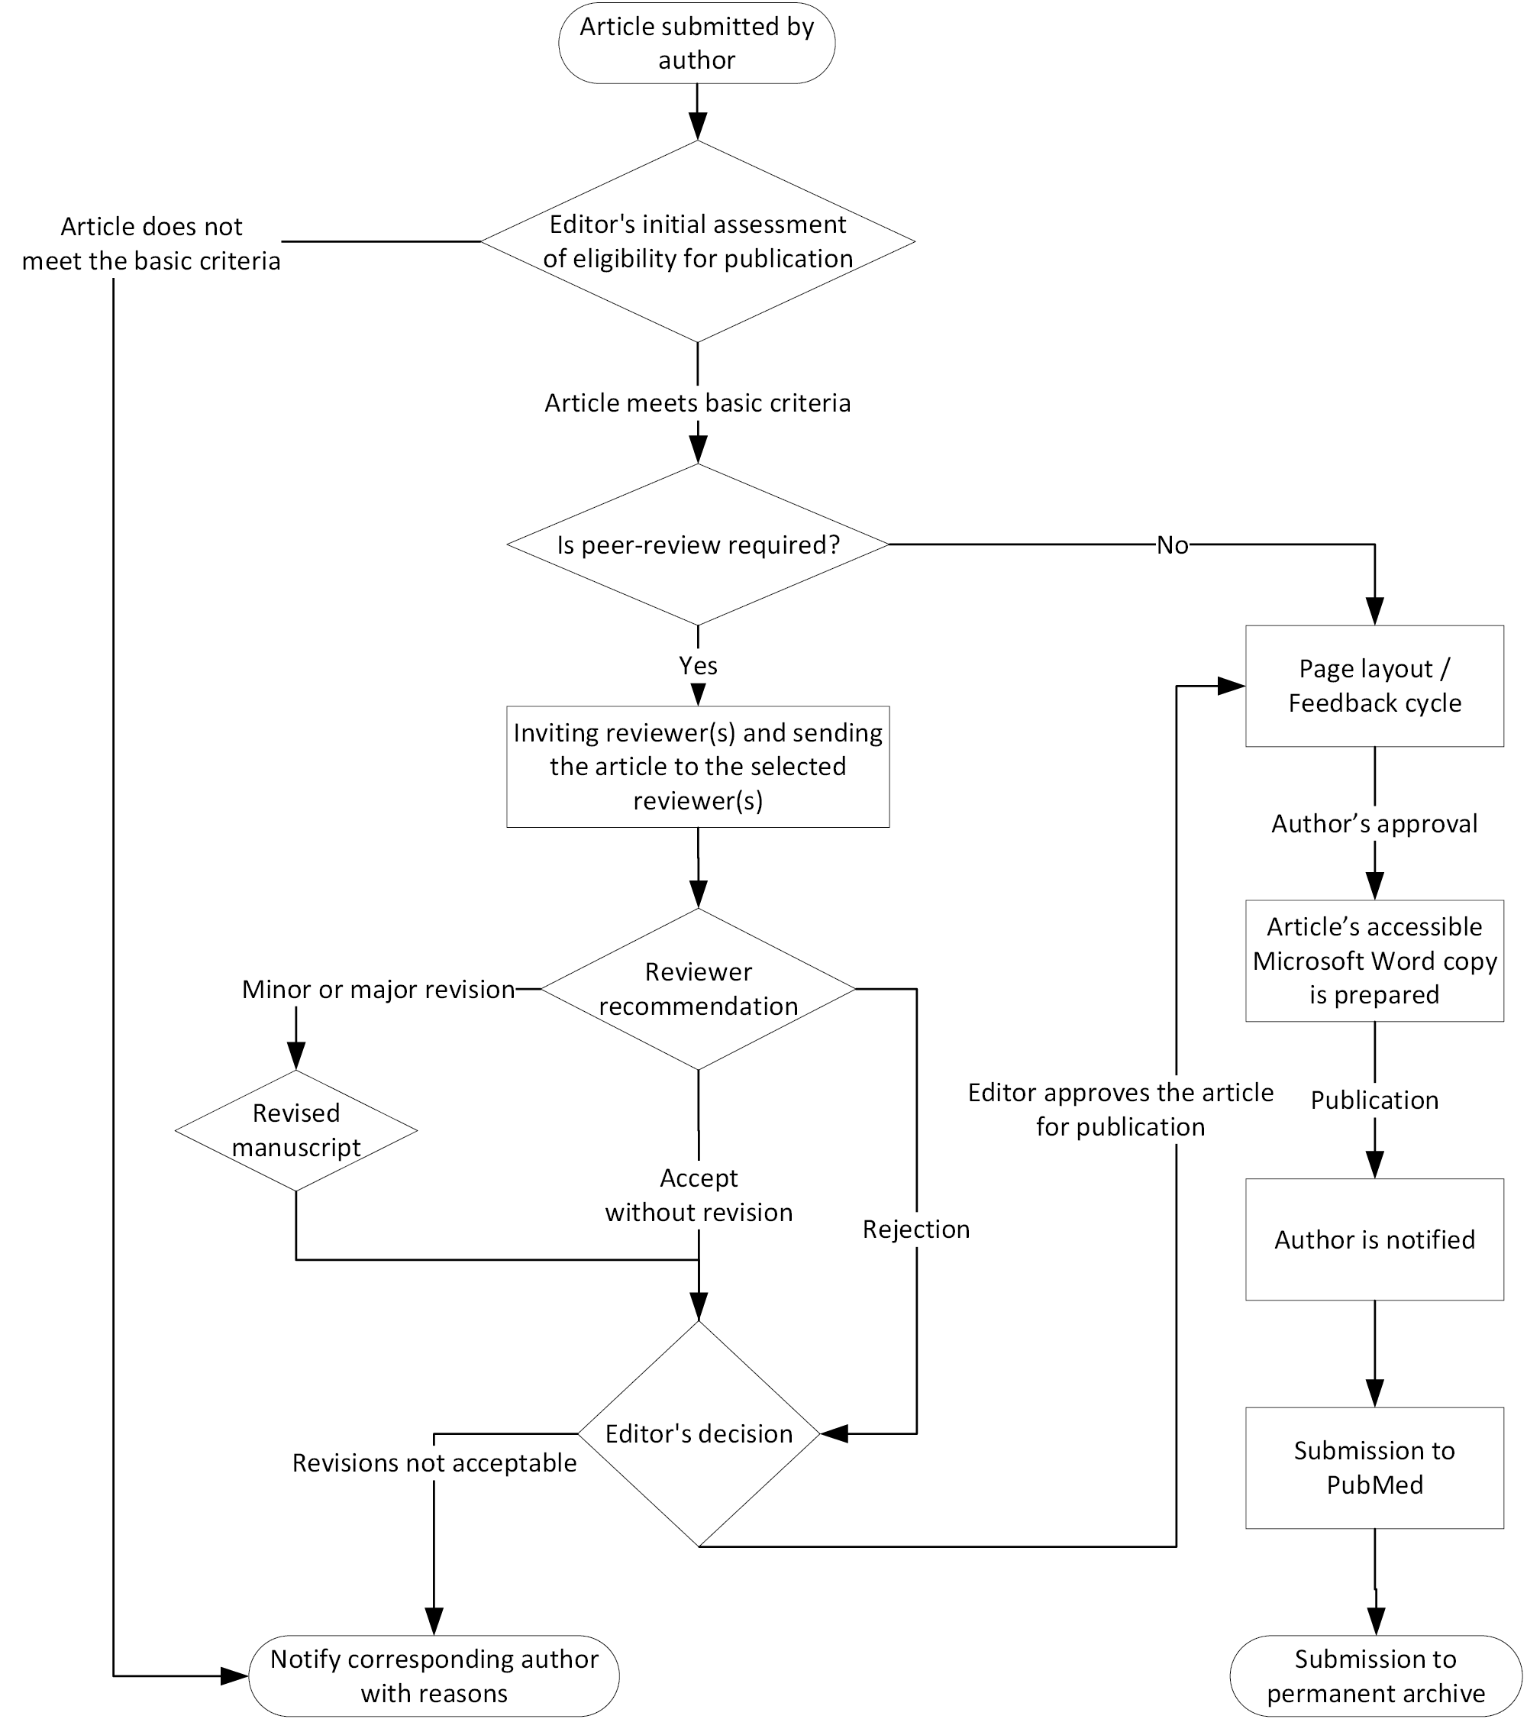

Submission package
To ensure the efficient handling of submitted manuscripts, authors must submit the following documents and files at one time to cdi.editor@health.gov.au.
- Article Submission Coversheet.
- Article in Microsoft Word format.
- Article charts in an acceptable format (See “Figures, graphics, images” on page 11).
- For general contributions: Copyright Transfer Agreement.
- For Australian Government Department of Health and Aged Care contributors: Australian Privacy Principle 5 (APP5) Notification Form.
- Article illustrations in an appropriate format, at 300 dpi resolution or higher.
- Accessibility information:
  - Article summary.
  - Table descriptions.
  - Figure descriptions.
On receipt of a manuscript, authors will be sent a brief acknowledgment.
To access the latest versions of these forms, and the current version of CDI’s submission guidelines, please visit: https://health.gov.au/internet/main/publishing.nsf/ content/cda-pubs-cdi-auth_inst.htm

Revision/resubmission policy
Effective commencing 1 February 2023, CDI will impose a 90-day limit on the resubmission of manuscripts for which revision has been requested following peer review. That is, the allowed window for revision and resubmission is 90 days from the date on which referee reports are returned to the corresponding author. Any resubmitted manuscript received beyond this time will be handled as a new submission.
This policy applies also to manuscripts pending resubmission to CDI prior to 1 February 2023, in the sense that any such manuscripts not resubmitted to CDI by 2 May 2023 will be treated as ‘withdrawn’.
Resubmitted manuscripts should have all revision clearly shown in ‘Track Changes’ and should be accompanied by a detailed rebuttal document addressing all stated referee concerns and recommendations.

Manuscript types
Manuscripts submitted to CDI should clearly conform to one of the following types, for which descriptions are provided on the following pages.
Category | Subtype
Original article | n/a
Systematic review | n/a
Editorial | n/a
Letter to the editor | n/a
Short report
 | Surveillance summary
 | Case report
 | Outbreak report
Surveillance report
 | Annual report
 | Quarterly report
 | Multi-year report
Policy and guidelines | n/a
Other | n/a
Notice to readers | n/a

Overview of manuscript categories
Manuscript Type | Word limit ª | Peer review (double blind) | No. of peer reviewers | Type of author declaration form required |  | Description | Requirements
 |  |  |  | Departmental contributors | Non-departmental contributors
Original Article | 3,000 | Yes | 2 | APP5 Privacy | Copyright Transfer Agreement | Original articles describe original work and will most generally concern analysis and/or investigation of some phenomenon connected with the spread or control of communicable diseases | Refer to Structure for an original article  At a minimum articles must include an abstract (up to 300 words), key words (up to 10)
Systematic Review | 3,500 | Yes | 2 | APP5 Privacy | Copyright Transfer Agreement | Systematic reviews summarise, survey and integrate the currently-available research on some phenomenon connected with the spread or control of communicable diseases | At a minimum articles must include an abstract (up to 300 words), key words (up to 10)  Reviews must conform with the Preferred Reporting Items for Systematic Reviews and Meta-Analyses (PRISMA) guidelines (www.prisma-statement.org)
Editorial | 500 | At the discretion of the Editor | Up to 2 | APP5 Privacy | Copyright Transfer Agreement | Editorials may be commissioned at the discretion of the Editor. | Editorials can include no more than one figure or one chart and up to six references.
Letters to the Editor | 500 | At the discretion of the Editor | Up to 2 | APP5 Privacy | Copyright Transfer Agreement | The CDI editorial team welcomes comments on articles or current communicable disease issues in the form of letters to the editor. Publication will be at the discretion of the Editor. | Letters can include no more than one figure or one chart and up to six references
Short Reports
Surveillance summary | 1,000 | Yes | 1 | APP5 Privacy | Copyright Transfer Agreement | Brief reports on changes in the local epidemiology of a communicable disease, changes in surveillance systems, or new interventions, such as introducing vaccination in an at-risk group. | Surveillance summaries should provide a brief description of the setting and a discussion of the significance of the events, changes or interventions.
Case Report | 1,000 | Yes | 1 | APP5 Privacy | Copyright Transfer Agreement | Brief reports on cases of communicable disease will be considered based on their public health significance. | Some discussion of the significance of the case for communicable disease control should be included.
Outbreak Report | 1,000 | Yes | 1 | APP5 Privacy | Copyright Transfer Agreement | Reports of communicable disease outbreaks will be considered for publication based on their public health significance. Reports should include details of the investigation, including results of interventions and the significance of the outbreak for public health practice.  Most outbreak reports will present only the descriptive epidemiology of the outbreak, with suspected risk factors for infection. More comprehensive reports on outbreaks should be submitted as articles. | Refer to Structure for an outbreak report (The subheadings can be adjusted to suit), or may be unstructured if very brief.
Surveillance Reports
Annual Report | - | At the discretion of the Editor | 1 | APP5 Privacy | Conditional^{b} | Annual surveillance reports should include a comprehensive analysis of one or more communicable diseases of public health importance in Australia, including incidence/prevalence, trend analyses and other data analyses relevant to informing public health measures. | At a minimum, annual reports must include an abstract (250 words), key words (up to 10), introduction, methods, results, discussion, acknowledgements and references.
Quarterly Report | 1,500 | At the discretion of the Editor | 1 | APP5 Privacy | Conditional^{b} | Quarterly surveillance reports should include a brief analysis of one communicable disease of public health importance in Australia, including incidence/prevalence, trend analyses and other data analyses relevant to informing public health measures. | Same as annual reports
Multi-year Report | - | At the discretion of the Editor | 1 | APP5 Privacy | Conditional^{b} | Multi-year surveillance reports should include a comprehensive analysis of one or more communicable diseases of public health importance in Australia over two or more years. Reports should include incidence/prevalence, trend analyses and other data analyses relevant to informing public health measures. | Same as annual reports
Policy & Guidelines | - | No | - | APP5 Privacy | Conditional^{b} | Communicable disease related policy and guidelines will be published in CDI where there is a national agreement on the content to be published.  These articles must be, at a minimum, endorsed by the Communicable Diseases Network of Australia (CDNA) and be of a publishable standard.  Policy recommendations made by individual authors or an organisation will be considered as an Original Article.
Other | 3,000 | At the discretion of the Editor | Up to 2 | APP5 Privacy | Copyright Transfer Agreement | In exceptional circumstances, the publication of a manuscript that doesn’t fit the above categories may be published as ‘Other’. This will be at the discretion of the Editor. | The use of this category must be negotiated with the CDI Editor prior to submission.
Notice to readers | 500 | At the discretion of the Editor | - | N/A | N/A | A notice can be published to communicate information that may be of relevance to the communicable diseases community. This will be at the discretion of the Editor. | The use of this category must be negotiated with the CDI Editor prior to submission.
a Word count determined using Microsoft Word. Excludes abstracts, acknowledgements, author details, references, tables and figure legends.
b Where copyright in a submission in this category is already vested in the Australian Government Department of Health and Aged Care, only an APP5 Privacy form is required. In other circumstances, a Copyright Transfer Agreement should be submitted.

Structure specific to original articles and outbreak reports
Structure for an Original Article
Title
Author(s)
name(s)
Abstract (Structured or unstructured)
Keywords
Introduction
Methods
Results
Discussion
Acknowledgement (optional)
Author details
Authors and affiliations
Corresponding author
References
Appendix (optional)

Structure for an Outbreak Report
Section / description and requirements
Abstract
A very brief unstructured abstract should be
included
Background and methods
Including initial detection of the outbreak, case
finding and interview techniques, study design and any statistical methods.
Description of outbreak
- case definition
- number of cases
- number laboratory confirmed, symptoms, time
- place and person
- epidemic curve - A maximum of 2 tables and/or figures is suggested.
Laboratory, trace back and environmental investigations
Details of the proportion of laboratory confirmation of cases.
Public health response
A very brief description of any actions taken to prevent further cases may be included.
Discussion
Including the significance of the outbreak for public health practice.
References
A maximum of 20 references is suggested.

General requirements

Ethics committee approvals and patients’ rights to privacy
All manuscripts must include details on the ethics approval obtained for the study, including the name of the ethics committee or institutional review board, or a statement that ethics approval was not required; and an acknowledgment of all funding sources and the role of the funder (if any); and when relevant, an acknowledgement of data sources.
All investigations on human subjects must include a statement that the subjects gave their written informed consent, unless (i) data collection was covered by public health legislation or (ii) similar studies have been considered by a relevant ethics committee and a decision made that its approval was not required.
Ethical approval and patient consent may also be required for case reports. Identifying details about patients should be omitted if they are not essential, but data should never be altered or falsified in an attempt to attain anonymity.

Copyright
If the Article is accepted for publication in Communicable Diseases Intelligence, then from the date of that acceptance the author assigns to the Commonwealth all copyright throughout the world in the Article, without limitation. This means that from that date the author will no longer own any copyright in the Article, and the Commonwealth may, among other things, edit and publish the Article anywhere in any form, including electronic form and permit the use, reproduction and/or publication of the Article (or part of) by persons other than the Commonwealth, including under a Creative Commons licence.
If the Article is accepted for publication in Communicable Diseases Intelligence, the Commonwealth in return grants to the author(s) of the Article a permanent, irrevocable, royalty-free, non-exclusive licence to use, reproduce, adapt and exploit the Article anywhere in the world.
Where the Commonwealth already owns the copyright, the author is not required to submit the copyright form.

Privacy
Your personal information is protected by law, including the Privacy Act 1988 and the Australian Privacy Principles (APPs), and is being collected by the Australian Government Department of Health and Aged Care (‘Department’) for the purposes of allowing us to publish your Article in the journal Communicable Diseases Intelligence.
If you do not provide this information, the Department will not be able to publish your Article.
The Department will disclose your name, the name of your Institution and your Article to Crossref, Portico and PubMed in the United States of America to facilitate the cross referencing of your Article.
You can get more information about the way in which the Department will manage your personal information, including our privacy policy, at http://www.health.gov.au/internet/main/publishing.nsf/Content/privacy-policy.

STYLE GUIDELINES
To simplify the authoring, proofreading and widespread use of articles, CDI tries its best to avoid making proprietary styles and guidelines.
Our goal is to comply with universally accepted scientific and Australian government style guidelines as much as possible. Please use the following guidelines for corresponding aspects of the manuscript.
Domain | Reference
Scientific style and format | Scientific Style and Format: the Council of Scientific Editors (CSE) Manual for Authors, Editors and Publishers, the latest edition, henceforth abbreviated as CSE. Latest edition at time of writing this guide is 8th , ISBN-13: 978-0226116495, or visit: https://www.scientificstyleandformat.org/
General style guidelinesª | Australian Government Style Manual: https://www.stylemanual.gov.au/
Spelling | The Macquarie Dictionary https://www.macquariedictionary.com.au/
For systematic reviews | Preferred Reporting Items for Systematic Reviews and Meta-Analyses (PRISMA) guidelines: www.prisma-statement.org
Citations | the Vancouver system  Primary resource: CSE  Secondary resource: Citing Medicine, the latest edition. (https://www.ncbi.nlm.nih.gov/books/NBK7256/)
References cited within the work | Adopt the appropriate NLM title abbreviations for all journal titles.  Please pay attention to CDI’s referencing style.
Accessibility | See document accessibility requirements ^{b}

a In case of style conflicts between the two references, CSE overrules the Australian Government Style Manual
b For details, visit: Web Content Accessibility Guidelines (WCAG) 2.0 https://www.w3.org/TR/WCAG20/

TECHNICAL REQUIREMENTS
CDI has a small set of guidelines for the purpose of consistency and meeting technical requirements of third-party services like indexes libraries and archives.

Syntax, formatting and file types

Article by-line formatting
No title is necessary for author(s) name(s) on the article’s front page. Full titles for each author will be mentioned in the “Author details” section.

Author details
STRUCTURE THE AUTHOR DETAILS SUBSECTION AS IN THE FOLLOWING EXAMPLE:
Dr John J Smith,¹ Dr Jane Doe²

- Anytown Regional Hospital, Anytown. General Medicine, Oldtown Memorial Hospital, Oldtown. Department of Public Health Studies, University of Capitalville
- General Medicine, Capitalville University Hospital, Capitalville. Benefactor’s Medical Research Institute (BMRI), Newplace. Department of Medical Technology, University of Capitalville.

STRUCTURE THE CORRESPONDING AUTHOR’S INFORMATION USING THE FOLLOWING EXAMPLE:

Corresponding author

Dr John J Smith
Address: Anytown Regional Hospital, Random Avenue, Anytown, Thatstate
Phone: 0123456789
Email: email_address@sample_address.com.au

Citations
- Avoid using brackets or parentheses for citations.
- Citations should be superscripted.
- Citation numbers should follow any adjacent punctuation marks.
CORRECT EXAMPLE:

Competition between the two species is said to occur primarily at the juvenile stage,^{27,28} where A. priori shows significantly greater survivorship especially in resource-limited conditions;²⁹ A. posteriori gets more severely affected when the number density of juvenile A. priori increases.³⁰⁻³²

References
- Referencing follows the Vancouver system.
- Reference author lists should be truncated after the sixth listed author.
- Book titles are italicised; journal names are italicised and abbreviated. The primary reference for journal title abbreviations is the NLM Catalogue (e.g., as given in PubMed).
- Articles must be specified by the appropriate publication details: year, then volume, then the article’s page range or article number, if such detail is catalogued. If the article has a digital object identifier (DOI), it should be provided after the other publication details.
  - Where a page range or article number exists as an ‘identifier’ for the article (separate from a DOI), the format is [year;volume(issue number in parentheses, if applicable):article identifier.] For articles not bearing a page range or article number, the format is [year;volume(issue, if applicable).] In either instance, there should be no spaces within this specification. If a DOI exists for the article, this should then be specified as: [‘ doi: ‘ DOI URL.]ª Except between the journal volume(issue) number, page range or article number and the doi URL, there should be no spaces within this specification.
- Please do not specify month or date of publication unless this is essential for unambiguous identification of the source. Refer to the following examples for indications of the correct usage.
- When citing other work published within CDI, please ensure the correct edition of CDI is named, i.e. Commun Dis Intell for work published up to 2000 (vols. 1–24), Commun Dis Intell Q Rep for work published between 2001 and 2017 (vols. 25–41), and Commun Dis Intell (2018) for work published from 2018 (vol. 42) onwards.
CORRECT EXAMPLES:

Mackerras IM. Transmission of dengue fever by Aedes (Stegomyia) scutellaris Walker in New Guinea. Trans R Soc Trop Med Hyg. 1946;40(3);295-312. doi: https://doi.org/10.1016/0035-9203(46)90070-3.

Vo TH, Okasha O, Al-Hello H, Polkowska A, Räsänen S, Bojang M et al. An outbreak of norovirus infections among lunch customers at a restaurant, Tampere, Finland, 2015. Food Environ Virol. 2016;8(3):174–9. doi: https://doi.org/10.1007/s12560-016-9236-6.

Webb C, Doggett S, Russell R. A guide to the mosquitoes of Australia. Melbourne: CSIRO Publishing, 2016.

Nicol K. Efficacy/clinical effectiveness of inactivated influenza virus vaccines in adults. In Nicholson KG, Webster RG, Hay AJ, eds. Textbook of influenza. London: Blackwell Science, 1998;358-72.

Tacharoenmuang R, Komoto S, Guntapong R, Ide T, Sinchai P, Upachai S et al. Full genome characterization of novel DS-1-like G8P[8] rotavirus strains that have emerged in Thailand: reassortment of bovine and human rotavirus gene segments in emerging DS-1-like intergenogroup reassortant strains. PLoS ONE. 2016;11(11):e0165826. doi: https://doi.org/10.1371/journal.pone.0165826.

Skowronski DM, Chambers C, De Serres G, Dickinson JA, Winter AL, Hickman R et al. Early season co-circulation of influenza A(H3N2) and B(Yamagata): interim estimates of 2017/18 vaccine effectiveness, Canada, January 2018. Euro Surveill. 2018;23(9). doi: https://doi.org/10.2807/1560-7917.ES.2018.23.9.18-00086.

World Health Organization (WHO). Meningococcal meningitis. [Internet.] Geneva: WHO; 19 February 2018. [Accessed on 20 May 2020.] Available from: https://www.who.int/news-room/fact-sheets/detail/meningococcal-meningitis.

Seemann T, Goncalves da Silva A, Bulach DM, Schultz MB, Kwong JC, Howden BP. Nullarbor. San Francisco; Github. [Accessed on 3 June 2016.] Available from: https://github.com/tseemann/nullarbor.

Footnotes

USE LOWERCASE ROMAN NUMERALS. EXAMPLE:
i Item one.
ii Item two.

Tables
- Tables and table headings should be located within the body of the manuscript and all tables should be referenced within the results section.
- Information in tables should not be duplicated in the text.
- Headings should be brief.
- Simplify the information as much as possible, keeping the number of columns to a minimum and avoid merged cells as much as possible.
- Separate rows or columns are to be used for each information type (e.g. percentage and number should be in separate columns rather than having one in parentheses in the same column).
- Do not use blank rows or blank columns for spacing.
- If acronyms are used these should be explained in a footnote.

Syntax for table keyed notes (footnotes related to a particular cell datum)
CDI uses lowercase alphabetic characters for keyed notes.
EXAMPLE:
State or territory | Month ª | Agent responsible ^{b}
NSW | October | Norovirus
a First footnote.
b Second footnote.

Figures, graphics, images

Figures
Graphs (figures) for publication in CDI need to be formatted for consistency and to meet production requirements. For additional details, refer to Appendix 1 – Specifications for Excel figures and Appendix 2 – Sample Excel figures. Although these appendices, and the text descriptions below, specify the requirements and settings to be used in figures generated using Excel, they are also largely applicable to figures generated using R, Stata, or other graphing or data-visualisation packages, and should be followed as far as possible when using those programs. If charts are produced using other graphing software such as R or Stata, all charts should be directly exported from this software in an editable or vector-graphics format such as .PDF or .SVG. If it is not possible to supply graphs and charts as MS Excel charts, .PDF or .SVG files, they should be supplied as images of at least 300 dpi resolution.
If using Microsoft Excel:
- Each figure should be created as a separate chart rather than as an object in the datasheet (right-click on the sheet tab on the bottom of the page and choose Insert > New Chart).
- The numerical data used to create each figure must be included on a separate worksheet.
- Worksheet tabs should be appropriately titled to distinguish each graph (e.g. Figure 1, Figure 2; Figure 1 data, Figure 2 data).
- The title for each graph should be included as a figure caption within the main manuscript’s Word document. Do not place a title on the Excel worksheet itself.
- Graphs should be formatted to the following as much as possible.
- Only the relevant worksheets should be included in the file.
- Do not embed Excel sheets / charts within one another.
- Ensure that all data used to generate each figure is embedded within the corresponding Excel worksheet.
- Do not link from Excel to other files or other locations for the required data.
In case of any doubts as to file requirements associated with use of a specific program other than Excel, please query at CDI.Editor@health.gov.au.
It is strongly recommended that all graphs and charts within a submitted manuscript be sized and labelled consistently, to facilitate uniformity of presentation within the published article. Thus, where possible, dimensions (width and height) of each graph should be consistent; font sizes for axis labels should be consistent throughout; font sizes for axis titles should be consistent; similarly legend entries. It is recommended that authors use templates to assist in this aspect of figure generation.

Illustrations
- Illustrations or flow charts can be included if required.
- Images should preferably be at least 300 dpi.
- Electronic copies of computer-generated illustrations should preferably be saved in a vector image program such as Adobe Illustrator or other similar graphic design program but charts created in either Word or PowerPoint are acceptable. Use a sans serif font for figures (e.g. Calibri). Symbols, lettering and numbering should be clear and large enough to be legible when reduced in size.

Photographs
Photographs may be submitted if required. Photos need to be at least 300 dpi. File formats (in preferential order): PSD, TIFF, JPEG, PNG.

Maps
Maps, created by mapping programs such as MapInfo or ArcGIS, should be saved at 300 dpi and in one of the following graphic formats (in preferential order) to allow editing of font size and colours: AI, PDF, EPS.
If this is not possible the following graphic formats should be used (in preferential order): PSD, TIFF, JPEG, PNG

Other images
- Other images may be submitted in one of the following graphic formats (in preferential order): PSD, TIFF, JPEG, PNG.
- Authors should aim for maximum levels of contrast between shaded areas. Use a sans serif font for text. Symbols, lettering and numbering should be clear and large enough to be legible when reduced in size.

Multi-page tables and figures
Use an appendix for tables and figures that span along several pages and interrupt the reading flow.

ACCESSIBILITY REQUIREMENTS
The Australian Government is required to meet level AA of the Web Content Accessibility Guidelines version 2.0 (WCAG 2.0). These guidelines include the need for alternate methods of presenting the information depicted in images—including figures and maps—for readers with vision impairment and other disabilities who use text readers. Complex tables also present challenges for text readers.
Articles and reports should be submitted with a separate Word document that includes:
- a one- or two-sentence summary of the article;
- a short summary of any tables; and
- a long text description of any figures, maps, flowcharts, or other images. For thermal maps showing disease rates by statistical location or complex figures, a data table may be a preferred alternative.
Keep in mind that the description should be sufficient for a sight impaired person to understand what the information image is conveying.

Common accessibility issues

Spacing and indenting issues
Avoid using space and tab characters for laying out page elements. Using more than one space or tab character for distancing and spacing page elements makes reading the article difficult for people who uses screen readers.

Table formatting issues
Create a separate cell for each individual entity or value in a table. Avoid using paragraphs, tabs or spaces for layout. Note the placement of paragraph symbols “¶” in the incorrect example, demonstrating incorrect use of paragraphs to create separation.
INCORRECT:
Item | Value
Alpha¶  Alpha 1 ¶  Alpha 2 | 1 ¶  2 ¶  3
Beta¶  Beta 1 ¶  Beta 2 | 4 ¶  5 ¶  6

CORRECT:
Item | Value
Alpha | 1
Alpha 1 | 2
Alpha 2 | 3
Beta | 4
Beta 1 | 5
Beta 2 | 6

PDF linkage problems
Do not embed links to PDF files. Outgoing links to PDF documents require a supporting format, either an HTML (web page), or accessible MS Word file, otherwise they will be displayed as plain text in the online publication.

Examples of accessible text formatting
Please refer to Appendix 3 for examples that demonstrate how to prepare accessible text for various page elements.

APPENDIX 1 - Specifications for Excel figures
Element | Requirements
Typeface | Use Microsoft Office default font (Calibri) for all text.
Titles | Size: 12 pt
Footnotes and titles | Place all footnotes and headings in the document text, not the Excel chart. Use sentence case.
Worksheet margins | Margins: 0
Page size | A4, Landscape
Axis tick mark labels | next to axis
Axis tick mark type | Major: outside  Minor: none
Axis scale | Varies with X axis span, but ensure the number of categories between tick marks matches the number of categories between tick mark labels.  When using percentages, ensure the maximum axis scale is 100.
Axis numerical values | Don’t use decimal points if all fields are a whole number.
Axis alignment | The X axis text is always horizontal where space permits. Only apply vertical text when horizontal text is not feasible.
Axis text | Don’t use leading zeros. E.g. 1 Jan, not 01 Jan
Axis title | Type size: 12 pt
Legends | Border: None  Fill: None  Type size: 10 pt  Do not use abbreviations unless footnoted (except for names of states and territories.)
Plot area | Border: None  Plot area colour: None
Chart area | Border: None  Chart area colour: None  Gridlines: None
Chart colours | Use the auto colour option if you wish. Do not use the same colour for any two series. Do not use gradients or 3D fills or black.
Chart types | Histograms: Use a gap width of 0  Stack charts: Use gap width of 50 and an overlap of 100  Bar charts: Use a gap width of 50  Line charts: Use a triangular marker on the 1st series (top (first) entry in legend)
Text boxes | Type size: 10 pt

APPENDIX 2 - Sample Excel figures
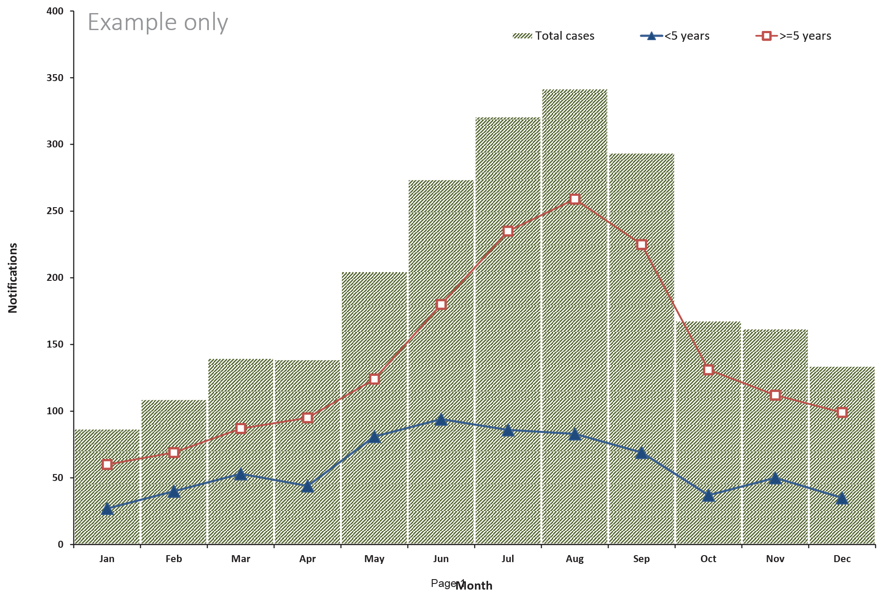
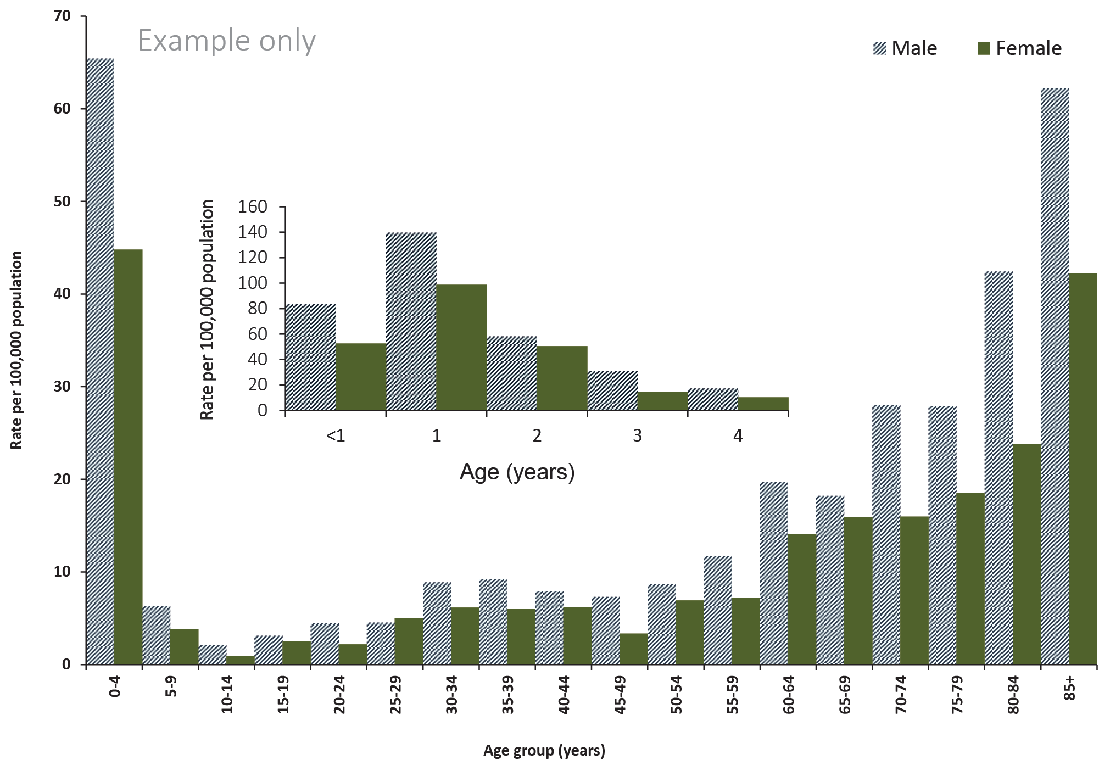

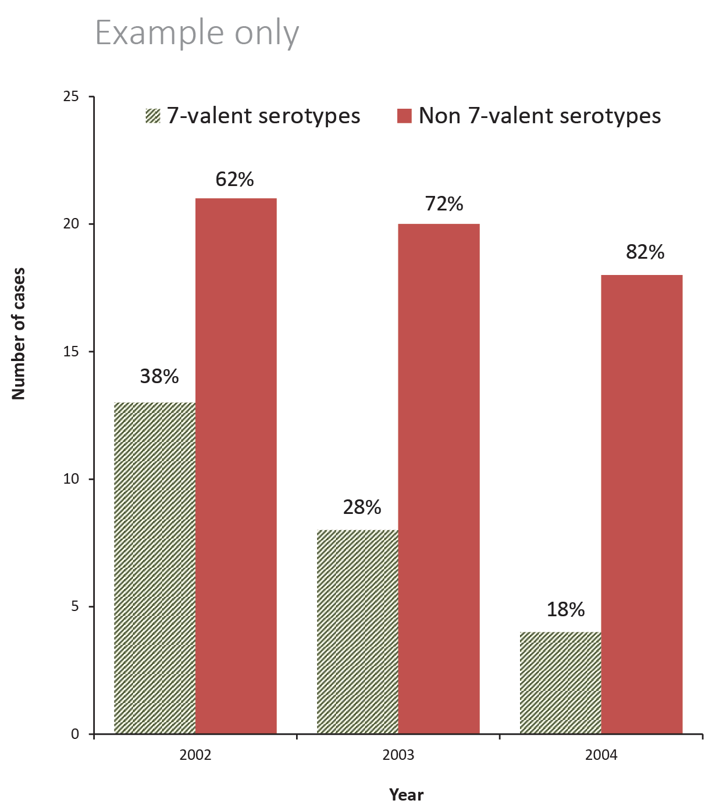
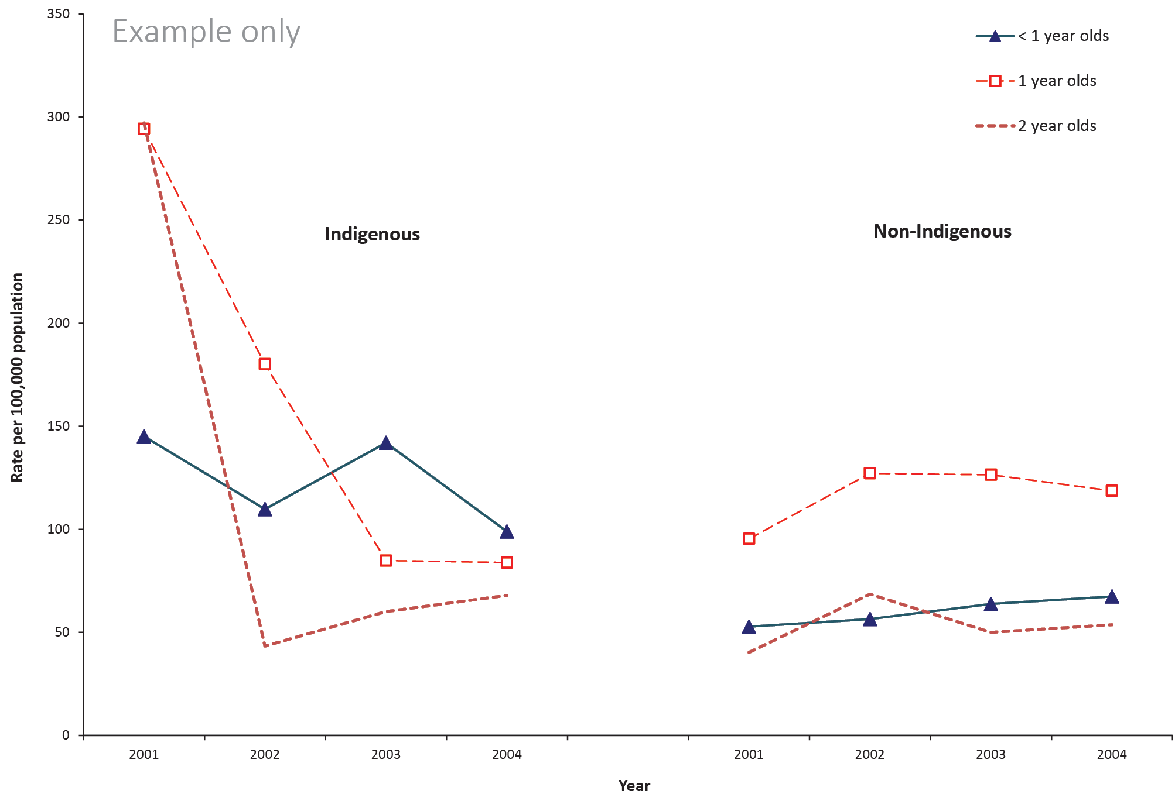

APPENDIX 3 - Sample HTML text descriptors for web accessibility and metadata
The following pages contain examples of descriptors that authors need to provide when submitting articles for publication. This includes document and table summaries and text descriptors for maps, figures and flow charts.
The following are examples of summaries and text descriptors required for Australian Government compliance with the WCAG 2.0 web accessibility requirements when publishing CDI articles on the web site.

What is required?
A separate document with:
- article/report title
- a short one or two sentence summary of the article/report
- a short one sentence summary of any tables
- a long text description of any figures or images including maps or flow charts; the description should be sufficient so that a sight impaired person can interpret the figure/map/chart. In some cases a data table may be published instead, but please let us know if this is your intention. All data tables must be provided as Excel files.

Advice
Do not use dot points in your descriptions. The text descriptions are saved as text only files, which do not handle formatting such as dot points.
Do not repeat the headings as this is repetitive for text readers. The vision Australia advice for long descriptions is that to provide a suitable long description, you should:
- identify the type of graph or chart
- provide a summary of the data, explaining the trends that a sighted person can see in the image.

Examples
Notes:
- Not all examples are taken from the same report.
- Don’t physically include the table or figures in your document of accessibility text descriptors. There are only included here to give a sense of what the descriptions are describing.

Article/report title and summary

ARTICLE/REPORT TITLE
2010 Australian Trachoma Surveillance Report

SUMMARY
The National Trachoma Surveillance and Reporting Unit was established in November 2006 to improve the quality and consistency of data collection and reporting of active trachoma in Australia. This report presents data from the 2009 screening program conducted in At Risk communities from those Northern Territory, South Australia and Western Australia regions with endemic trachoma and compares 2009 data with those from screening conducted from 2006 to 2008 inclusive.

Tables
Table 1: Factors associated with admission to intensive care in patients hospitalised with confirmed influenza
Variable | Odds ratio (95% CI) | p value
Age >65 years | 0.49 (0.29, 0.84) | 0.01
Medical comorbidities | 1.89 (1.02, 3.50) | 0.042
Pregnancy | 0.20 (0.04, 0.89) | 0.034
Indigenous Australian | 2.05 (0.68, 6.19) | 0.206
Influenza type
Influenza A | 1 (referent) | –
Influenza B | 1.08 (0.66, 1.77) | 0.747

TEXT DESCRIPTION

Table 1 shows the odds ratio and p value for factors associated with admission to intensive care, including age group, comorbidities, pregnancy, Indigenous status and influenza type.

Figures

Sample No.1
Figure 2: Notification rate for Ross River virus infection, Australia, 2011 to 2012, by age group and sex
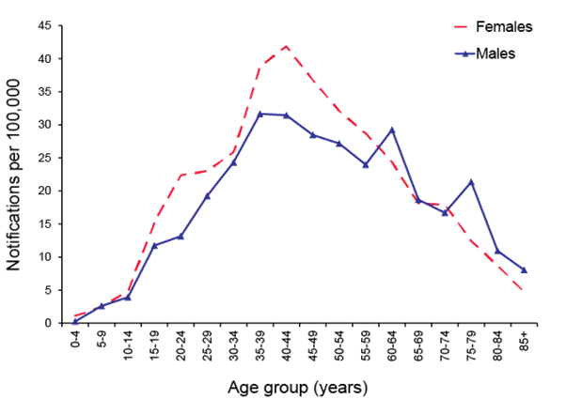
TEXT DESCRIPTION
Line chart showing rates of Ross River virus infection by 5-year age groups. Age-group specific rates were highest in middle aged males and females, peaking at 41.8 per 100,000 in females aged 40 to 44 years.

Sample No.2
Figure 8: Notifications of dengue virus infection, Australia, July 2006 to June 2012, by month, year and place of acquisition
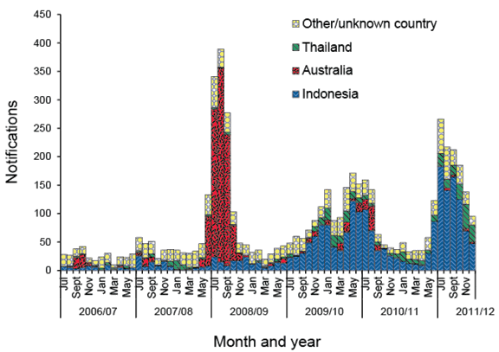
TEXT DESCRIPTION
Bar chart showing dengue notifications place of acquisition from Australia, Indonesia, Thailand or other/unknown country. The large outbreak of locally-acquired dengue in North Queensland in 2008-09 is a feature, as well as the increasing trend of cases acquired in Indonesia, particularly from 2010 onwards. In 2011/12, there were 893 notifications of dengue acquired in Indonesia, and these were 62% of all notifications.

Sample No.3
Figure 2: Swab testing results for influenza-like illness, ASPREN, 1 January to 31 March 2013, by week of report
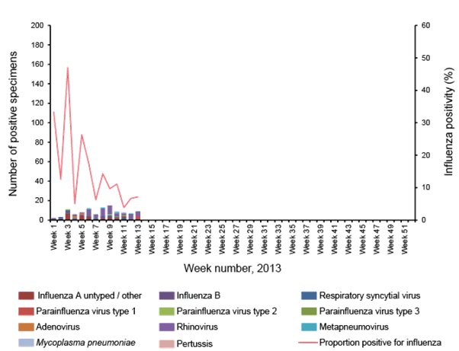
TEXT DESCRIPTION
Dual column and line graph with the primary axis demonstrating the detection of respiratory viruses by week of report from January – March 2013. The secondary axis (line graph) demonstrates overall influenza positivity by week of report. Viruses monitored are as follows: influenza A untyped, influenza A H1N1(2009), influenza B, respiratory syncytial virus, parainfluenza virus type 1, 2 and 3, adenovirus, rhinovirus, metapneumovirus, enterovirus, mycoplasma pneumoniae, and pertussis. These data represent the inter-seasonal period, where fewer samples are submitted for processing. An influenza positivity peak occurred at week 3 at 47% positivity, representing 8 positive samples. Rhinovirus was the most commonly detected respiratory virus, with 19% of all swabs performed during the reporting period being positive for rhinovirus. Influenza A (untyped) was the second most common respiratory virus, representing 11% of all swabs taken.

Sample No.4
Figure 2: Estimated vaccine effectiveness against hospitalisation for all patients, in specified subgroups and against infection with influenza subtypes
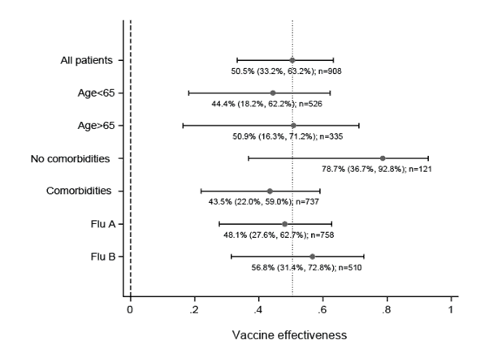
TEXT DESCRIPTION
Forest plot chart showing the estimated vaccine effectiveness for all patients (50%), and in subgroups (age group, comorbidity status and influenza type). Estimated vaccine effectiveness was similar in most subgroups but was higher in patients without comorbidities (79%) but 95% confidence intervals all overlap.

Maps
Map: Number of at-risk communities screened and trachoma prevalence, 2010
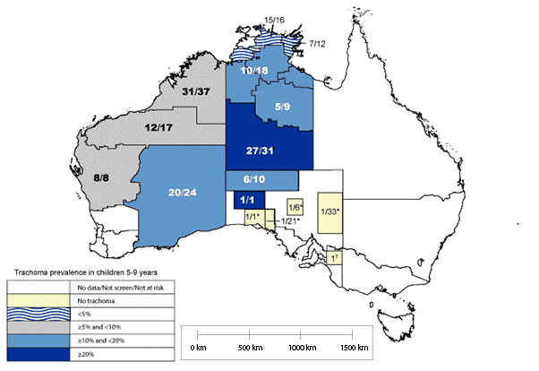
TEXT DESCRIPTION
Text description Map of the statistical sub-divisions of Australia showing that prevalence was highest in the Northern Territory sub-division of NT central with a prevalence of 20% or greater. Prevalence was 10% or greater but less than 20% in rest of the Northern Territory, apart from the far northern tip which includes Darwin, Alligator and East Arnhem and had a prevalence of less than 5%. Prevalence in this range was also found in the south eastern region of Western Australia and the north western region of South Australia. Prevalence in the range 5% to less than 10% was found in the Midlands (mid-west), and the Kimberley and Pilbara regions in the north. The south western regions of Western Australia, Queensland, New South Wales, Victoria, Tasmania and the remaining South Australian regions were not tested as these areas are not at risk of trachoma.

Flowcharts
Figure 1: Communicable diseases notifiable fraction
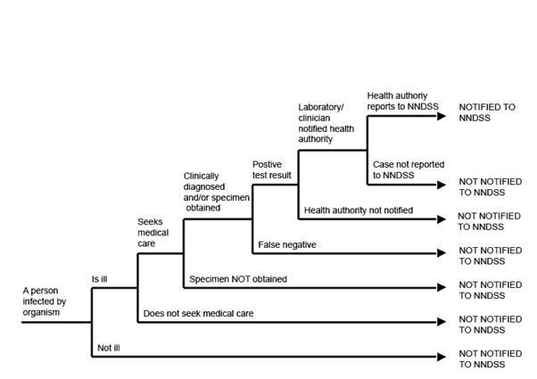
TEXT DESCRIPTION
Flow chart illustrating the fraction of actual cases notified. Instances where a person infected by an organism is not recorded on the NNDSS include; the person shows no signs of illness; is ill but does not seek medical care; seeks medical care but a specimen is not obtained; a specimen is obtained but tests false negative; a positive test is not notified to the health authority; or when a clinician or laboratory notifies the health authority but the health authority does not report the case to NNDSS. Only if the notified health authority reports the case to NNDSS is the case recorded.

Communicable Diseases Intelligence
ISSN: 2209-6051 Online

Communicable Diseases Intelligence (CDI) is a peer-reviewed scientific journal published by the Office of Health Protection, Department of Health and Aged Care. The journal aims to disseminate information on the epidemiology, surveillance, prevention and control of communicable diseases of relevance to Australia.

Editor: Christina Bareja
Deputy Editor: Simon Petrie
Design and Production: Kasra Yousefi
Editorial Advisory Board: David Durrheim, Mark Ferson, Clare Huppatz, John Kaldor, Martyn Kirk, Meru Sheel and Stephanie Williams

Website: http://www.health.gov.au/cdi

Contacts
CDI is produced by the Office of Health Protection, Australian Government Department of Health and Aged Care, GPO Box 9848, (MDP 6) CANBERRA ACT 2601

Email: cdi.editor@health.gov.au

Submit an Article
You are invited to submit your next communicable disease related article to the Communicable Diseases Intelligence (CDI) for consideration. More information regarding CDI can be found at: http://health.gov.au/cdi.
Further enquiries should be directed to: cdi.editor@health.gov.au.

This journal is indexed by Index Medicus and Medline.

Creative Commons Licence - Attribution-NonCommercial-NoDerivatives CC BY-NC-ND
© 2022 Commonwealth of Australia as represented by the Department of Health and Aged Care
This publication is licensed under a Creative Commons Attribution-NonCommercial-NoDerivatives 4.0 International Licence from https://creativecommons.org/licenses/by-nc-nd/4.0/legalcode (Licence). You must read and understand the Licence before using any material from this publication.

Restrictions
The Licence does not cover, and there is no permission given for, use of any of the following material found in this publication (if any):
- the Commonwealth Coat of Arms (by way of information, the terms under which the Coat of Arms may be used can be found at www.itsanhonour.gov.au);
- any logos (including the Department of Health and Aged Care’s logo) and trademarks;
- any photographs and images;
- any signatures; and
- any material belonging to third parties.

Disclaimer
Opinions expressed in Communicable Diseases Intelligence are those of the authors and not necessarily those of the Australian Government Department of Health and Aged Care or the Communicable Diseases Network Australia. Data may be subject to revision.

Enquiries
Enquiries regarding any other use of this publication should be addressed to the Communication Branch, Department of Health and Aged Care, GPO Box 9848, Canberra ACT 2601, or via e-mail to: copyright@health.gov.au

Communicable Diseases Network Australia
Communicable Diseases Intelligence contributes to the work of the Communicable Diseases Network Australia.
http://www.health.gov.au/cdna

