An outbreak of leptospirosis associated with cattle workers during the wet season, in the Northern Territory of Australia, 2021
Damien R Brown, Ruwani Peiris, Claire Waller, Elizabeth M Stedman, Susanne E Fitzpatrick, Vicki L Krause, Anthony DK Draper

Abstract
An outbreak of leptospirosis occurred in the Top End of the Northern Territory, Australia, during the wet season in early 2021. There were 14 outbreak cases; most were male (12/14; 86%) and non-Indigenous (13/14; 93%) with a median age of 22 years (range 19–52 years). We conducted a descriptive case series to investigate the outbreak. We determined that the outbreak was most likely due to higher than usual rainfall in a workplace with exposure to cattle, heightened by wearing clothing and footwear which offered little protection, with limited use of personal protective equipment (PPE). Increased and ongoing education for cattle industry workers, and promotion of the use of appropriate clothing and PPE, may minimise the risk of future outbreaks. Australia’s national surveillance case definition for leptospirosis should be reviewed to incorporate the use of nucleic acid testing in the detection of leptospirosis.
Keywords: outbreak, leptospirosis, Leptospira, cattle, Northern Territory, rainfall.

Background
Leptospirosis is a widespread bacterial zoonotic illness, occurring worldwide but more commonly in the tropics.¹ Leptospira spirochetes, of which there are nearly 300 serovars, are found in numerous domestic and wild animals, including rats, cattle, pigs and dogs.¹ Humans can become infected when animal urine or tissue, or environmental matter contaminated with the same, enters the body through skin abrasions or via mucous membranes.¹ Illness can range from a mild, self-limiting flu-like condition to severe and potentially fatal disease.¹ Appropriate antibiotic therapy is usually highly effective.² Outbreaks are often associated with occupation (e.g. farming and cattle work)^{3,4} and with recreational activities (e.g. freshwater sports),^{5,6} with spread exacerbated by heavy rainfall and flooding.^{7–11}
On average, two or three cases of leptospirosis are notified annually in the Northern Territory (NT), usually in the Top End wet season (Figure 1) with a previous outbreak occurring in 2017.¹²
In 2021, a cluster/outbreak investigation was initiated after six cases were notified to the NT Centre for Disease Control (CDC) by 18 February. We describe the investigation.

Figure 1: Epidemiological curve of leptospirosis cases notified in the Northern Territory, Australia (2000-2021)
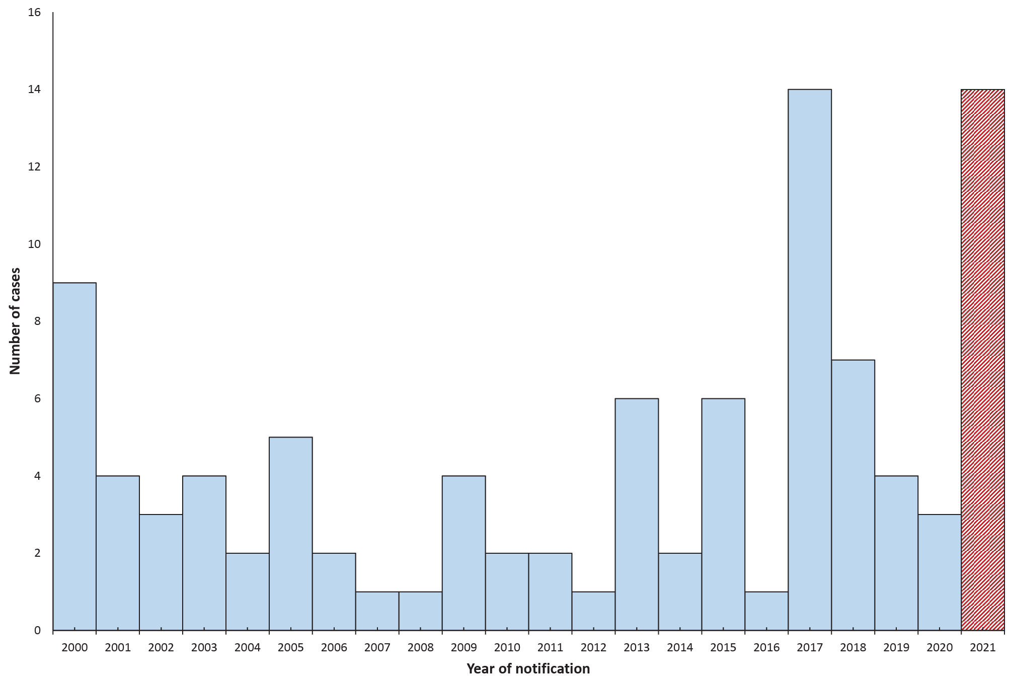

Methods

Epidemiological investigation
A confirmed outbreak case was defined as any person notified with leptospirosis in the NT (i.e. meeting the Australian national notifiable diseases case definition)¹³ with onset after 1 January 2021. A probable outbreak case was defined as any person with a clinically compatible illness AND an epidemiological link to a confirmed outbreak case AND leptospirosis detected by nucleic acid testing from urine or blood samples, with onset after 1 January 2021. The detection of leptospirosis by nucleic acid testing is an accepted surveillance case definition by the United States of America’s Centres for Disease Control and Prevention,¹⁴ but is not regarded, in Australia, as definitive evidence.
Case finding occurred through routine notification activity. Some potential cases self-reported to the CDC following a media release on 1 March 2021 which alerted the NT public to the outbreak.¹⁵
We conducted a descriptive case series investigation. We used a case questionnaire to record symptoms, laboratory results, exposures and risk factors. Descriptive analysis was performed using Microsoft Excel 2010.

Laboratory investigation
Serum, blood or urine was collected and polymerase chain reaction (PCR) testing or serological testing was performed, depending on what was requested by the treating clinician. Serology testing for leptospirosis immunoglobulin M (IgM) was performed on acute phase serum and on convalescent serum (which, if obtained, was collected at least two weeks later) using the microscopic agglutination test (MAT). Serovars of Leptospira spp. included in the MAT panel were: Arborea; Australis; Bataviae; Bulgarica; Canicola; Celledoni; Copenhageni; Cynopteri; Djasimen; Grippotyphosa; Hardjo; Javanica; Kremastos; Mendanensis; Panama; Pomona; Robinsoni; Shermani; Szwajizsk; Tarassovi; Topaz; and Zanoni.

Veterinary and environmental investigation
Leptospirosis is not a notifiable disease of animals; however, we reviewed submissions of diagnostic animal cases to the Berrimah Veterinary Laboratory, Darwin, from 1 January 2021 for possible related animal cases. We examined rainfall patterns in the NT using data from the Australian Bureau of Meteorology (BoM).

Results

Epidemiological investigation
There were 14 cases that met the outbreak case definition: 12 confirmed and two probable cases (Figure 2). The majority of cases were male (12/14; 86%) and non-Indigenous (13/14; 93%), with a median age of 22 years (range 19–52 years).
Figure 2: Epidemiological curve of outbreak cases by onset date, 1 January to 31 March 2021 (n = 14)
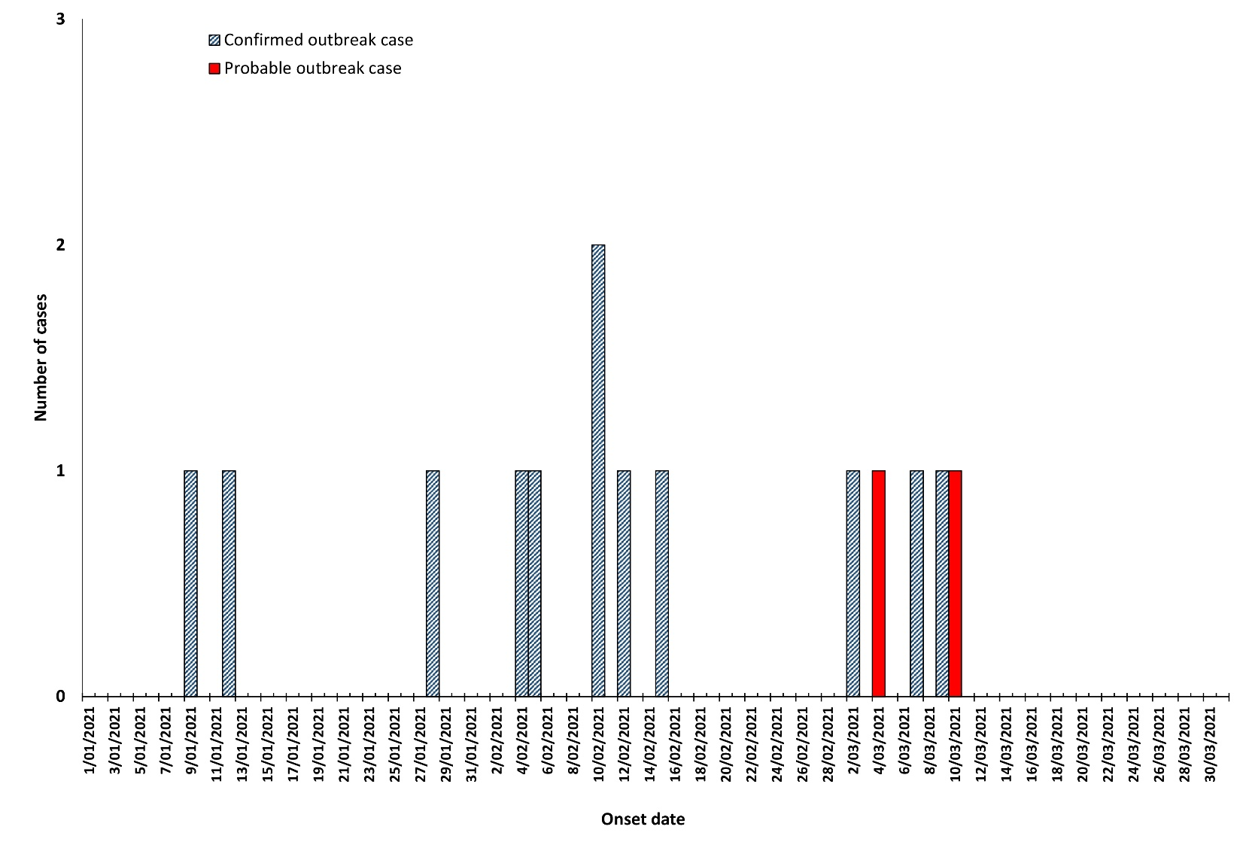
In addition to fever (14/14; 100%), the predominant symptoms were myalgia/arthralgia (10/14; 71%), headache (10/14; 71%), and rigors (8/14; 57%) (Table 1). There were four cases who required hospitalisation with a median duration of three days (range 2–6 days). No cases required admission to an intensive care unit, and none died.
Twelve cases had significant cattle exposure through their work, one through recreation (fishing near cattle); another could not be interviewed. Two had been pig hunting; another reported a number of rats/mice on their property. All reported minimal if any PPE use; many worked in shorts and wore no gloves when handling cattle, citing high ambient heat and humidity as reasons. Regular handwashing was seldom practised.
Table 1: Clinical characteristics of leptospirosis outbreak cases, Northern Territory, Australia, January to March 2021 (n = 14)
Symptom | Number of cases (%)
Fever | 14 (100)
Myalgia/arthralgia | 10 (71)
Headache | 10 (71)
Rigors | 8 (57)
Vomiting | 6 (43)
Diarrhoea | 3 (21)
Conjunctival suffusion | 1 (7)

Two cases worked and/or lived in the Katherine region and 12 cases in the Daly River/Litchfield regions (Figure 3). Five of the cases worked on the same cattle station, accounting for the mid-February peak in cases; two others worked at a cattle transfer station which received cattle from this first cattle station, and indeed from the wider region. Five other stations had one case each.

Figure 3: Location of leptospirosis cases in the Top End of the Northern Territory, Australia, January to March 2021 (n = 14)^{a,b}
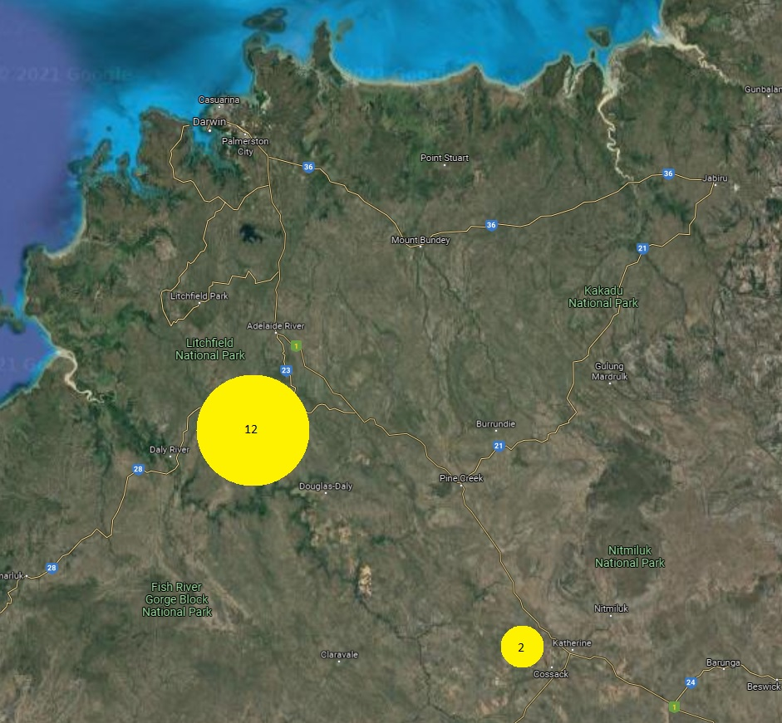
a Map credit: Google.
b Circles with case numbers represent the wider regions where cases likely acquired their infections.

Figure 4: Northern Territory total rainfall compared to mean, February 2021
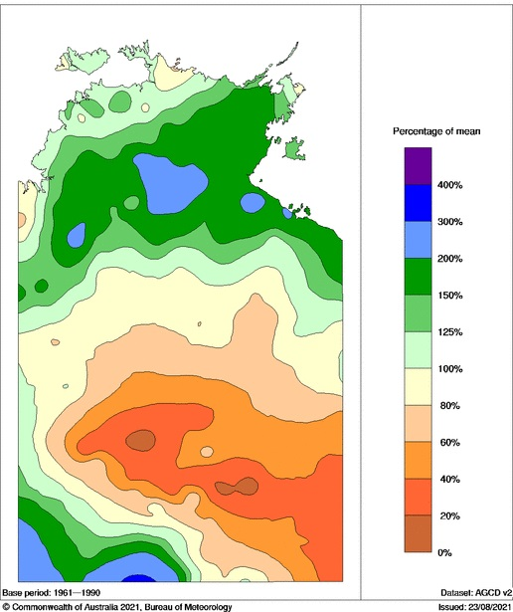

Laboratory investigation
Of the 14 outbreak cases, 12 were identified to the serovar level; 11 were Leptospira interrogans serovar Hardjo and one was L. weilii serovar Topaz. Two cases were positive by PCR only (Table 2).
Of the 11 cases that were identified as L. Hardjo, ten were interviewed; 9/10 (90%) reported their occupation as ‘cattle worker’ and the other was a student who reported fishing near cattle. The case of L. Topaz and the two cases that were PCR positive only (no serovar determined) also worked in the cattle industry.

Veterinary and environmental investigation
There were no cases of suspected or confirmed clinical leptospirosis identified in animals. Relevant cattle properties were contacted by a veterinary officer; none reported clinical signs of leptospirosis or other illness in any animals.
February 2021 began with an active monsoon across the Top End of the NT. Rainfall in the NT was 22% above the long-term average for the month and two sites within the generalised outbreak region received their highest February rainfall on record.¹⁶

Public health response
Following the initial detection of an outbreak in February 2021, a media release was issued and industry was engaged.¹⁵ An advisory group was assembled which included the public health unit, Environmental Health, the NT Chief Veterinary Officer, and government media. Managers of cattle stations with known human cases were contacted directly and were provided with information and education on prevention.¹⁷ Medical officers and clinic managers were advised to be alert for potential leptospirosis cases in the outbreak region, particularly amongst cattle workers.
Table 2: Leptospirosis outbreak cases by diagnostic method(s) and results, Northern Territory, Australia, January to March 2021 (n = 14)
 |  |  | Serology |  |  | PCRª
Case number | Date of initial test | Onset date | Acute titre | Convalescent titre^{b} | Serovar^{b} | Serum^{b} | Urine^{b}
1 | 13/01/2021 | 09/01/2021 | 3200 | — | Hardjo | — | —
2 | 15/01/2021 | 12/01/2021 | 800 | — | Hardjo | — | —
3 | 28/01/2021 | 28/01/2021 | 3200 | — | Hardjo | — | —
4 | 6/02/2021 | 05/02/2021 | 0 | 800 | Hardjo | Detected | Not detected
5 | 9/02/2021 | 09/02/2021 | 0 | 800 | Hardjo | Not detected | Not detected
6 | 11/02/2021 | 10/02/2021 | 0 | 200 | Hardjo | Detected | —
7 | 15/02/2021 | 12/02/2021 | 0 | 3200 | Hardjo | Detected | —
8 | 15/02/2021 | 15/02/2021 | 0 | 400 | Hardjo | Detected | Detected
9 | 15/02/2021 | 10/02/2021 | 800 | 1600 | Hardjo | Not detected | —
10 | 18/02/2021 | 04/02/2021 | 1600 | 3200 | Topaz | Detected | —
11 | 4/03/2021 | 04/03/2021 | 0 | — | — | Detected | —
12 | 10/03/2021 | 09/03/2021 | 0 | — | — | Detected | —
13 | 11/03/2021 | 07/03/2021 | 0 | 1600 | Hardjo | Detected | —
14 | 12/03/2021 | 10/03/2021 | 0 | 1600 | Hardjo | — | Detected
a PCR: polymerase chain reaction.
b ‘—‘: not available/not tested.

Discussion and conclusion
Cattle are well-known sources of human leptospirosis, particularly due to L. Hardjo.³ The majority of cases in our outbreak were young cattle workers and the Hardjo serovar was predominant. While no cases of clinical animal disease were reported during this outbreak investigation, L. Hardjo infection in cattle is often subclinical in presentation and may not be observed.¹⁸
It is likely that high rainfall and wet and muddy conditions contributed to the transmission of disease, with hot and humid temperatures also likely contributing to work practices that increased the risk of exposure to workers such as: working in shorts; wearing open footwear (thongs/sandals); and not using appropriate PPE such as gloves, eye shields or aprons when handling cattle or in environments contaminated with urine. Infrequent handwashing, and smoking while working, also likely increased the risk of infection. There was a lack of awareness of the risks of leptospirosis, with a high turnover of seasonal workers possibly a contributing factor. The provision, upon commencement, of ongoing and regular training and education to cattle workers is arguably the most effective intervention to prevent future outbreaks.
Seasonal prophylactic doxycycline (200 mg weekly) could be a possible preventative measure for cattle workers in the Top End;¹⁹ however, the common side effect of increased photosensitivity and susceptibility to sunburn may detract from its uptake. Furthermore, a systematic review in 2009 did not identify clear benefit from prophylactic doxycycline in preventing leptospirosis.²⁰
Cattle can be effectively vaccinated against L. Hardjo and L. interrogans serovar Pomona; however, the vaccine schedule is onerous, with doses required at 6 and 12 weeks of age, followed by annual boosters.²¹ Leptospirosis vaccination of cattle in the Northern Territory is uncommon, due to the practical challenges and costs associated with the mustering of large numbers of cattle on extensive pastoral properties.
Our investigation identified that Australia’s national notifiable diseases case definition is in need of review. Two of our outbreak cases (probable) were detected by PCR only which currently does not meet the confirmed national surveillance case definition which has not been updated since 2004. A simple change in nomenclature to the required laboratory definitive evidence from “isolation of pathogenic Leptospira species” to “detection of pathogenic Leptospira species” would result in our probable cases meeting confirmed national surveillance case definitions and would see Australia align with other developed countries.

Acknowledgements
We acknowledge the station owners and managers in the NT, and cattle industry representatives, who assisted with our outbreak investigation and response.

Author details
Damien R Brown,¹
Ruwani Peiris,¹
Claire Waller,²
Elizabeth M Stedman,³
Susanne E Fitzpatrick,³
Vicki L Krause,¹
Anthony DK Draper^{1,4}
- Centre for Disease Control, Public Health Unit, Top End Health Service, Northern Territory Government Department of Health, Darwin, Northern Territory, Australia.
- Territory Pathology, Northern Territory Government Department of Health, Darwin, Northern Territory, Australia
- Livestock Biosecurity, Biosecurity and Animal Welfare Branch, Department of Industry, Tourism and Trade, Berrimah, Northern Territory, Australia.
- Menzies School of Health Research, Darwin, Northern Territory, Australia.

Corresponding author
Anthony Draper
Centre for Disease Control, Public Health Unit, Top End Health Service, Northern Territory Government Department of Health, PO Box 45096, Casuarina NT 0811.
Telephone: +61 8 8922 7635.
Facsimile: +61 8 8922 8310.
Email: anthony.draper@nt.gov.au

References
- Lau CL, Craig SB. Leptospirosis. In Heymann DL, ed. Control of Communicable Diseases Manual (20th edition). Washington, DC: American Public Health Association (APHA), 2015. doi: https://doi.org/10.2105/CCDM.2745.090.
- Lau CL, Townell N, Stephenson E, van den Berg D, Craig SB. Leptospirosis: An important zoonosis acquired through work, play and travel. Aust J Gen Pract. 2018;47(3):105–10. doi: https://doi.org/10.31128/AFP-07-17-4286.
- Smythe L, Dohnt M, Symonds M, Barnett L, Moore M, Brookes D et al. Review of leptospirosis notifications in Queensland and Australia: January 1998 – June 1999. Commun Dis Intell. 2000;24(6):153–7.
- Lau CL, Skelly C, Dohnt M, Smythe LD. The emergence of Leptospira borgpetersenii serovar Arborea in Queensland, Australia, 2001 to 2013. BMC Infect Dis. 2015;15:230. doi: https://doi.org/10.1186/s12879-015-0982-0.
- Morgan J, Bornstein SL, Karpati AM, Bruce M, Bolin CA, Austin CC et al. Outbreak of leptospirosis among triathlon participants and community residents in Springfield, Illinois, 1998. Clin Infect Dis . 2002;34(12):1593–9. doi: https://doi.org/10.1086/340615.
- Agampodi SB, Karunarathna D, Jayathilala N, Rathnayaka H, Agampodi TC, Karunanayaka L. Outbreak of leptospirosis after white-water rafting: sign of a shift from rural to recreational leptospirosis in Sri Lanka? Epidemiol Infect. 2014;142(4):843–6. doi: https://doi.org/10.1017/S0950268813001465.
- Naing C, Reid SA, Aye SN, Htet NH, Ambu S. Risk factors for human leptospirosis following flooding: a meta-analysis of observational studies. PLoS One. 2019;14(5):e0217643. doi: https://doi.org/10.1371/journal.pone.0217643.
- Hacker KP, Sacramento GA, Cruz JS, de Oliveira D, Nery N, Lindow JC et al. Influence of rainfall on Leptospira infection and disease in a tropical urban setting, Brazil. Emerg Infect Dis. 2020;26(2):311–4. doi: https://doi.org/10.3201/eid2602.190102.
- Radi MFM, Hashim JH, Jaafar MH, Hod R, Ahmad N, Nawi AW et al. Leptospirosis outbreak after the 2014 major flooding event in Kelantan, Malaysia: a spatial-temporal analysis. Am J Trop Med Hyg. 2018;98(5):1281–95. doi: https://doi.org/10.4269/ajtmh.16-0922.
- Wynwood SJ, Craig SB, Graham GC, Blair BR, Burns MA, Weier SL et al. The emergence of Leptospira borgpetersenii serovar Arborea as the dominant infecting serovar following the summer of natural disasters in Queensland, Australia 2011. Trop Biomed. 2014;31(2):281–5.
- Smith JKG, Young MM, Wilson KL, Craig SB. Leptospirosis following a major flood in Central Queensland, Australia. Epidemiol Infect. 2013;141(3):585–90. doi:https://doi.org/10.1017/S0950268812001021.
- Australian Government Department of Health, National Notifiable Disease Surveillance System (NNDSS). Public datasets. [Internet.] Canberra: Australian Government Department of Health; 2021. [Accessed on 1 March 2021.] Available from: https://www1.health.gov.au/internet/main/publishing.nsf/Content/ohp-pub-datasets.htm.
- Australian Government Department of Health. Australian national notifiable diseases case definitions. Leptospirosis case definition. [Internet.] Canberra: Australian Government Department of Health; 2004. [Accessed on 1 February 2021.] Available from: https://www1.health.gov.au/internet/main/publishing.nsf/Content/cda-surveil-nndss-casedefs-cd_lepto.htm.
- Centers for Disease Control and Prevention (CDC). National Notifiable Diseases Surveillance System Surveillance Case Definitions. Leptospirosis (Leptospira interrogans) 2013 Case Definition. [Internet.] Atlanta: United States Government Department of Health and Human Services, CDC; 2013. [Accessed on 20 Feburary 2021.] Available from: https://ndc.services.cdc.gov/case-definitions/leptospirosis-2013/.
- Northern Territory Government Department of Health (NT Health). News – Leptospirosis warning. [Internet.] Darwin: Northern Territory Government, NT Health; 1 March 2021. [Accessed on 1 March 2021.] Available from: https://health.nt.gov.au/news/leptospirosis-warning.
- Australian Government Bureau of Meteorology (BoM). Northern Territory in February 2021: wet in the north and southwest; cool days, warm nights. [Internet.] Canberra: Australian Government, BoM; 1 March 2021. [Accessed on 30 October 2021.] Available from: http://www.bom.gov.au/climate/current/month/nt/archive/202102.summary.shtml.
- Northern Territory Government. Leptospirosis. [Internet.] Darwin: Northern Territory Government; 12 May 2016. [Accessed on 20 February 2021.] Available from: https://nt.gov.au/wellbeing/health-conditions-treatments/bacterial/leptospirosis.
- Lilenbaum W, Martins G. Leptospirosis in cattle: a challenging scenario for the understanding of the epidemiology. Transbound Emerg Dis. 2014;61(Suppl 1);63–8. doi: https://doi.org/10.1111/tbed.12233.
- Takafuji ET, Kirkpatrick JW, Miller RN, Karwacki JJ, Kelley PW, Gray MR et al. An efficacy trial of doxycycline chemoprophylaxis against leptospirosis. N Engl J Med. 1984;310(8):497–500. doi: https://doi.org/10.1056/NEJM198402233100805.
- Brett-Major DM, Lipnick RJ. Antibiotic prophylaxis for leptospirosis. Cochrane Database Syst Rev. 2009;3:CD007342. doi: https://doi.org/10.1002/14651858.CD007342.pub2.
- Zoetis Australia. Cattle product information sheet – Leptoshield® Vaccine. Rhodes (NSW): Zoetis; September 2019. [Accessed on 1 March 2021.] Available from: https://www.zoetis.com.au/livestock-solutions/pdfs/zoetis_leptoshield-product-information_print_notrim_hr.pdf.

Appendix A
Box A.1: Australian national surveillance case definitionª
Only confirmed cases should be notified.
Confirmed case A confirmed case requires laboratory definitive evidence only.
Laboratory definitive evidence
1. Isolation of pathogenic Leptospira species
OR
2. A fourfold or greater rise in Leptospira agglutination titre between acute and convalescent phase sera obtained at least two weeks apart and preferably conducted at the same laboratory
OR
3. A single Leptospira micro agglutination titre greater than or equal to 400 supported by a positive enzyme-linked immunosorbent assay IgM result.
a Australian Government Department of Health.¹³

Box A.2: CDC (United States of America) surveillance case definitionª
Probable
A clinically compatible case with at least one of the following:
- Involvement in an exposure event (e.g., adventure race, triathlon, flooding) with known associated cases, or
- Presumptive laboratory findings, but without confirmatory laboratory evidence of Leptospira infection.
Confirmed
A case with confirmatory laboratory results, as listed below.
Laboratory Criteria for Diagnosis
Diagnostic testing should be requested for patients in whom there is a high index of suspicion for leptospirosis, based either on signs and symptoms, or on occupational, recreational or vocational exposure to animals or environments contaminated with animal urine.
Supportive:
- Leptospira agglutination titer of ≥ 200 but < 800 by Microscopic Agglutination Test (MAT) in one or more serum specimens, or
- Demonstration of anti-Leptospira antibodies in a clinical specimen by indirect immunofluorescence, or
- Demonstration of Leptospira in a clinical specimen by darkfield microscopy, or
- Detection of IgM antibodies against Leptospira in an in acute phase serum specimen.
Confirmed:
- Isolation of Leptospira from a clinical specimen, or
- Fourfold or greater increase in Leptospira agglutination titer between acute- and convalescent-phase serum specimens studied at the same laboratory, or
- Demonstration of Leptospira in tissue by direct immunofluorescence, or
- Leptospira agglutination titer of ≥ 800 by Microscopic Agglutination Test (MAT) in one or more serum specimens, or
- Detection of pathogenic Leptospira DNA (e.g., by PCR) from a clinical specimen.
a United States Government Department of Health and Human Services, Centers for Disease Control and Prevention.¹⁴

Communicable Diseases Intelligence
ISSN: 2209-6051 Online

Communicable Diseases Intelligence (CDI) is a peer-reviewed scientific journal published by the Office of Health Protection and Response, Department of Health. The journal aims to disseminate information on the epidemiology, surveillance, prevention and control of communicable diseases of relevance to Australia.

Editor: Jennie Hood and Noel Lally
Deputy Editor: Simon Petrie
Design and Production: Kasra Yousefi
Editorial Advisory Board: David Durrheim, Mark Ferson, John Kaldor, Martyn Kirk and Linda Selvey

Website: http://www.health.gov.au/cdi

Contacts
CDI is produced by the Office of Health Protection and Response, Australian Government Department of Health, GPO Box 9848, (MDP 6) CANBERRA ACT 2601

Email: cdi.editor@health.gov.au

Submit an Article
You are invited to submit your next communicable disease related article to the Communicable Diseases Intelligence (CDI) for consideration. More information regarding CDI can be found at: http://health.gov.au/cdi.
Further enquiries should be directed to: cdi.editor@health.gov.au.

This journal is indexed by Index Medicus and Medline.

Creative Commons Licence - Attribution-NonCommercial-NoDerivatives CC BY-NC-ND
© 2022 Commonwealth of Australia as represented by the Department of Health
This publication is licensed under a Creative Commons Attribution-NonCommercial-NoDerivatives 4.0 International Licence from https://creativecommons.org/licenses/by-nc-nd/4.0/legalcode (Licence). You must read and understand the Licence before using any material from this publication.

Restrictions
The Licence does not cover, and there is no permission given for, use of any of the following material found in this publication (if any):
- the Commonwealth Coat of Arms (by way of information, the terms under which the Coat of Arms may be used can be found at www.itsanhonour.gov.au);
- any logos (including the Department of Health’s logo) and trademarks;
- any photographs and images;
- any signatures; and
- any material belonging to third parties.

Disclaimer
Opinions expressed in Communicable Diseases Intelligence are those of the authors and not necessarily those of the Australian Government Department of Health or the Communicable Diseases Network Australia. Data may be subject to revision.

Enquiries
Enquiries regarding any other use of this publication should be addressed to the Communication Branch, Department of Health, GPO Box 9848, Canberra ACT 2601, or via e-mail to: copyright@health.gov.au

Communicable Diseases Network Australia
Communicable Diseases Intelligence contributes to the work of the Communicable Diseases Network Australia.
http://www.health.gov.au/cdna

