Australian vaccine preventable disease epidemiological review series: measles, 2012–2019
Noni E Winkler, Aditi Dey, Helen E Quinn, Davoud Pourmarzi, Stephen Lambert, Peter McIntyre, Frank Beard

Abstract

Background
Data sources, relevant to measles epidemiology from 2012 to 2019, were reviewed in the context of Australia’s certification, by the World Health Organization in 2014, of the elimination of measles.

Methods
Data on measles notifications, hospitalisations, and deaths were obtained from the National Notifiable Diseases Surveillance System, the National Hospital Morbidity Database, and the Australian Coordinating Registry. Data were analysed by age group, state/territory, Aboriginal and Torres Strait Islander status, genotype, place of acquisition, source of infection (importation status), and vaccination status.

Results
Between 2012 and 2019, there were 1,337 measles notifications (average annual notifications 0.7 per 100,000 population per year) and 425 hospitalisations with measles as principal diagnosis (0.3 per 100,000 population per year) were recorded. The highest annual notification rate was in 2014, when the rate in the Northern Territory was 21.4 per 100,000 population per year. Although notification and hospitalisation rates were highest in infants < 12 months (respectively 5.8 and 2.1 per 100,000 population per year), people aged 10 to 39 years (10–19y: 272 notifications; 20–29y: 347; 30–39y: 266) accounted for 66% of notified cases. Of cases with a known vaccination status, only 20/169 (11.8%) of those aged 1–9 years had received at least one dose of measles-containing vaccine, compared with 215/571 (37.7%) of those aged 10–39 years. Persons born before 1966 (at least 47 years of age during the study period) are likely to have immunity from wild-type measles infection and had the lowest notification rates in each year. Of notified cases, 98.1% were imported or import related, and of the 900 measles viruses genotyped, D8 and B3 accounted for 89.1%.

Conclusion
This review’s findings of low measles incidence, in the presence of robust surveillance and high two-dose measles vaccination coverage, provide evidence of continued elimination of endemic measles in Australia, with almost all cases imported or epidemiologically linked to an imported case. Most cases eligible for vaccination are unvaccinated, which should remain the primary focus for prevention. Potential waning immunity in older age groups requires monitoring. Continued high population immunity and high-quality public health response to cases will be needed to maintain Australia’s elimination status, particularly once international borders reopen.
Keywords: Measles, disease surveillance, immunisation, epidemiology, vaccine preventable disease

Introduction
Measles virus is a highly infectious paramyxovirus that causes coryza, cough, fever, and a maculopapular rash.¹ Complications of infection can include pneumonia, encephalitis, otitis media, diarrhoea, and, rarely, subacute sclerosing panencephalitis.¹ It is estimated that more than 140,000 people died worldwide from measles in 2018, the majority of whom were children younger than 5 years of age.²
Globally, the years from 2000 to 2016 saw an 88% decrease in annual measles incidence, with an increase in vaccination coverage with at least one dose over this period from 72% to 85%.³ However, incidence increased more than fivefold between 2016 and 2019 and endemic measles transmission was re-established in a number of countries in the Americas and Europe.³ In 2019, widespread outbreaks of measles occurred in the Western Pacific region, including in Australia’s near neighbours Samoa, New Zealand, Fiji, American Samoa, and Tonga.^{4,5} In 2012, the World Health Assembly (WHA) endorsed a target for measles elimination in five World Health Organization (WHO) regions by 2020, but this target was not met.² A formal commitment to measles eradication has been postponed by the WHA,⁶ replaced by a goal of sustained elimination in all six WHO regions by 2030.⁷
In Australia, there was a peak in measles notifications and hospitalisations in the mid-1990s, followed by a decline to < 1 per 100,000 population per year in the 2000s.⁸ This decrease was due to measures implemented under the 1998 National Measles Control Campaign, including a school-based vaccination program targeting 5–12 year old children, allowing for movement of the second dose of MMR from 11–13 years to 4–5 years of age.⁸ Australia was certified by the WHO in 2014 as having achieved elimination of endemic measles,⁹ although elimination was probably reached in the early 2000s.¹⁰
The last detailed review of measles epidemiology in Australia covered the period 2000–2011.⁸ Since then, as well as WHO certification of measles elimination, there have been substantial changes to immunisation policy impacting on the timing and coverage of measles-containing vaccines. In 2013, the second dose of measles-containing vaccine on the National Immunisation Program (NIP) schedule was moved to 18 months of age, given as the combination measles-mumps-rubella-varicella (MMRV) vaccine. MMRV replaced the second dose of measles-mumps-rubella (MMR) vaccine previously scheduled at 4 years of age, and the monovalent varicella vaccine dose previously scheduled at 18 months. In 2016, the federal government’s No Jab No Pay policy was introduced, removing ‘conscientious objection’ exemptions from immunisation requirements to access a range of federal government family assistance payments.¹¹ At the same time, vaccination status assessment time points for family assistance payments expanded from 1, 2, and 5 years only,¹² to annually up to 19 years of age.¹³ Substantial catch-up vaccination activity was observed in the two years following the introduction of No Jab No Pay compared to baseline.¹³
This study provides an updated review of measles epidemiology in Australia in the context of these issues, events and policy changes.

Methods

Notifications
Notification data were obtained from the National Notifiable Diseases Surveillance System (NNDSS). Data are collected by state and territory health departments under the provisions of the public health legislation in each jurisdiction and are submitted to the Australian Government Department of Health on a daily basis for inclusion in the NNDSS.¹⁴ Data included all notifications for confirmed or probable measles, as per the national case definition,¹⁵ with an onset date (or where onset date was not available, the earliest of the specimen date, notification date, or notification received date) between 1 January 2012 and 31 December 2019.

Hospitalisations
Hospitalisation data were obtained from the Australian Institute of Health and Welfare (AIHW) National Hospital Morbidity Database (NHMD), which contains line-listed, episode-level records for all hospital admissions in Australian public and private hospitals. Data included in this review were all hospitalisations with an admission date between 1 January 2012 and 31 December 2018 (latest full calendar year with data available) for which there was a principal or additional diagnosis code for measles (International Statistical Classification of Diseases and Related Health Problems, Tenth Revision, Australian Modifications [ICD-10-AM] codes B05.0 [measles complicated by encephalitis], B05.1 [measles complicated by meningitis], B05.2 [measles complicated by pneumonia], B05.3 [measles complicated by otitis media], B05.4 [measles with intestinal complications], B05.8 [measles with other complications], or B05.9 [measles without complications]). The Aboriginal and Torres Strait Islander variable in this dataset is coded only as “Aboriginal and Torres Strait Islander” and “other”, with “other” including all other Australians and those not stated or unknown.

Mortality
Mortality data (line-listed cause of death unit record file data) were obtained from the Australian Coordinating Registry (ACR). We included deaths with a date of death between 1 January 2012 and 31 December 2018 (latest year of data available) with measles (ICD-10 code B05) recorded as the underlying or an associated cause of death. Counts fewer than six are expressed as a range to comply with the data release condition that small counts be suppressed in published reports.

Population estimates
Mid-year resident population estimates by age and jurisdiction of residence were obtained from the Australian Bureau of Statistics (ABS). The ABS Aboriginal and Torres Strait Islander population projections for 2012–2019 were used. The ABS mid-year resident population estimates at statistical area 3 (SA3) level were also used.

Data analyses
A descriptive analysis of the data was performed. Notifications were analysed by variables including: age; sex; state/territory of residence; place of acquisition (overseas/Australia); source of infection (importation status [imported or import-related]); whether recorded as hospitalised; geographical area (SA3); Aboriginal and Torres Strait Islander status; and vaccination history. Vaccinations were deemed invalid if they were given within the two weeks prior to onset date; these cases were reported as unvaccinated if no other valid doses were recorded. Vaccinations reported without a vaccination date were included as valid. Hospitalisations were analysed by variables including: age, sex, jurisdiction, Aboriginal and Torres Strait Islander status, principal and additional diagnoses, and length of stay, with the main focus on hospitalisations with measles as the principal diagnosis. Age groups were assigned as follows: < 1; 1–4; 5–9; 10–19; 20–29; 30–39; 40–49; and ≥ 50 years of age. Rates were calculated per 100,000 population per year using mid-year ABS resident population data, age-specific or jurisdiction-specific mid-year resident population data, or Aboriginal and Torres Strait Islander population projections as applicable. Summary statistics including median and range were calculated for age and length of hospital stay. Birth cohorts were selected based on key changes in immunisation schedules and identified levels of natural and vaccine acquired immunity in cohorts (Table 1). The 95% confidence intervals (CI) for birth cohort rates were calculated assuming a Poisson distribution.
Analysis was performed using Microsoft Excel 2010 and Stata 14.2 (Statacorp LLC, College Station, TX, USA). Maps were created using version 15 of the MapInfo mapping software.²¹

Table 1: Immunisation schedule, immunity, and age band of birth cohorts
Birth cohort | Schedule and coverage | Age band during study (years)ª
≤ 1965 | Pre-vaccine era  Natural immunity assumed | ≥ 47
1966–1980 | 1 dose recommended/scheduled  Assumed low to modest coverage^{b} | 32–53
1981–1999 | 2-dose schedule  Variable 2-dose coverage (68–92%)^{16,17} | 13–38
2000–2011 | 2-dose schedule  Higher 2-dose coverage (93–94%)^{18,19} | 1–19
≥ 2012 | Dose 2 moved to 18 months  High 2-dose coverage (95% in 2015)²⁰ | < 1–7
a Age bands overlap due to ageing of individual birth cohorts across the years assessed.
b Coverage estimates not available from the literature for this age cohort.

Ethics
This epidemiological review was approved by the Australian National University Human Research Ethics Committee (ANU/2020/63).

Results

Secular trends
There were 1,337 measles notifications between 2012 and 2019 (average annual rate 0.7 per 100,000 population per year), and 474 hospitalisations between 2012 and 2018 with measles recorded in any diagnosis field, of which 425 (89.7%) had measles as the principal diagnosis (average annual rate 0.3 per 100,000 population per year). There were peaks in measles notifications in 2014 (n = 339) and 2019 (n = 284) (Figure 1). Hospitalisations also peaked in 2014 (n = 120); hospitalisation data for 2019 were not available at the time of analysis.

Figure 1: Number and rate per 100,000 population per year of measles notifications (2012–2019) and hospitalisations (principal diagnosis; 2012–2018; 2019 data not available),ª Australia
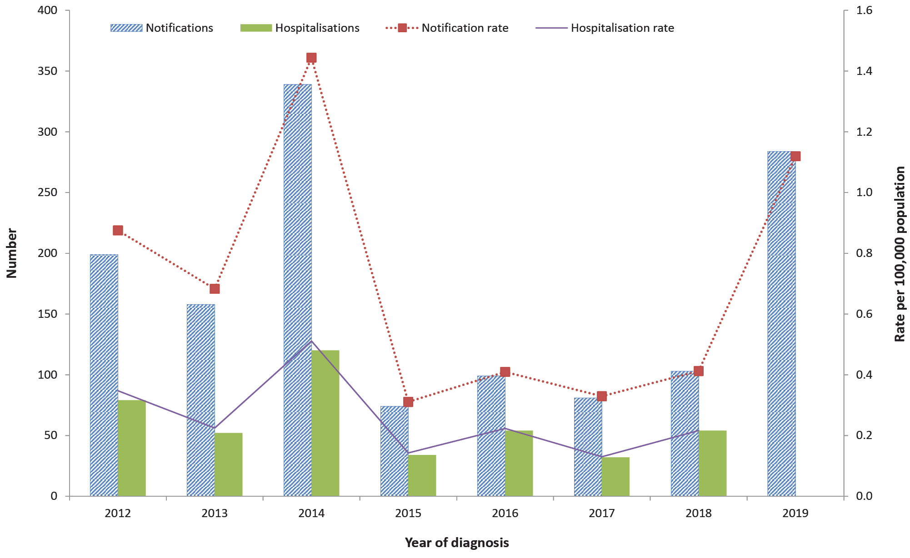
a Data sources: National Notifiable Diseases Surveillance System; Australian Institute of Health and Welfare’s National Hospital Morbidity Database.

Notification rate by jurisdiction
Notification rates varied within a narrow band across all jurisdictions except the Northern Territory during the study period. Apart from the Northern Territory, where the peak incidence was 21.4 per 100,000 population per year in 2014, peak incidence ranged from 1.0 per 100,000 population per year in South Australia to 2.3 per 100,000 population per year in New South Wales and occurred in 2014 in all jurisdictions except New South Wales (2012), Western Australia (2019), and South Australia (2013), although incidence in 2014 was also above baseline in all of these states (Figure 2). The three most populous jurisdictions (New South Wales, Victoria, Queensland) accounted for 72.7% of all notified cases (972/1,337). The notification rate in the Northern Territory was tenfold higher in 2014 (21.4 per 100,000 population per year) and sixfold higher in 2019 (12.6 per 100,000 population per year) than any other jurisdiction, with a total of 87 notifications across the study period (n = 52 in 2014 and n = 31 in 2019), accounting for 6.5% of notifications despite the Northern Territory population accounting for only 1% of the Australian population. Hospitalisation rates nationally were lower than notification rates and followed the same trends as notification rates for the years from 2012 to 2018 (2019 data not available).

Figure 2: Measles notification count and rate per 100,000 population per year by jurisdiction, Australia, 2012–2019^{a,b}
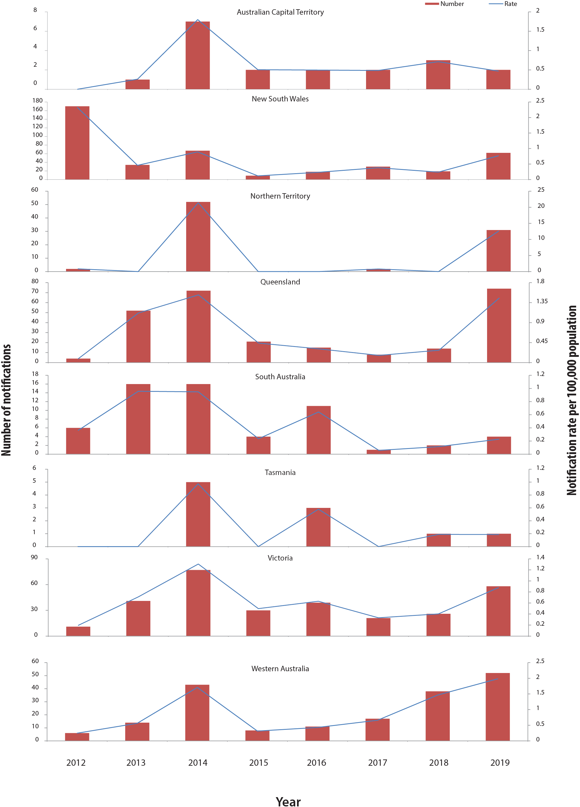
a Data source: National Notifiable Diseases Surveillance System.
b Note: scales used on the y-axes differ by jurisdiction.

Place of acquisition and importation status
Between 2012 and 2019, there were 486/1,337 notifications (36.4%) recorded as overseas acquired (imported) and 837 (62.6%) as acquired in Australia (Table 2), with 14 (1.0%) without a documented country of acquisition or source of infection. Of the 837 cases acquired in Australia, 825 (98.6%) were import-related (epidemiologically linked to an imported case). The proportion of overseas acquired cases ranged from 10.6% in 2012 to 54.4% in 2018. Of the overseas-acquired cases, over 90% were acquired in either the WHO South East Asia (n = 220; 46.4%) or Western Pacific (n = 208; 43.9%) region. The most common countries of acquisition were Indonesia (n = 106), Philippines (n = 84), Thailand (n=52), India (n = 41), and Vietnam (n = 29). Of the 42 infants < 12 months of age (29.6%) who acquired measles infection overseas, the youngest was aged 6 months.
Table 2: Measles notifications by place of acquisition, importation status, and year, Australia, 2012–2019ª
Year | Place of acquisition/importation status |  |  |  |  |  |  |  | Total
 | Overseas |  | Australia |  |  |  | Unknown
 |  |  | Import-related |  | Unknown
 | n | % | n | % | n | % | n | % | n
2012 | 21 | 10.6 | 168 | 84.4 | 0 | 0 | 10 | 5.0 | 199
2013 | 51 | 32.3 | 107 | 67.7 | 0 | 0 | 0 | 0 | 158
2014 | 140 | 41.3 | 194 | 57.2 | 4 | 1.2 | 1 | 0.3 | 339
2015 | 35 | 47.3 | 39 | 52.7 | 0 | 0 | 0 | 0 | 74
2016 | 33 | 33.3 | 64 | 64.6 | 0 | 0 | 2 | 2.0 | 99
2017 | 38 | 46.9 | 41 | 50.6 | 1 | 1.2 | 1 | 1.2 | 81
2018 | 56 | 54.4 | 40 | 38.8 | 7 | 6.8 | 0 | 0 | 103
2019 | 112 | 39.4 | 172 | 60.6 | 0 | 0 | 0 | 0 | 284
Total | 486 | 36.4 | 825 | 61.7 | 12 | 0.9 | 14 | 1.0 | 1,337
a Data source: National Notifiable Diseases Surveillance System.

Small area analysis
Average annual incidence from 2012 to 2019 was < 2 per 100,000 population per year in 326 of 340 (95.9%) spatial SA3 areas (Figure 3). The highest incidence was in Palmerston (Northern Territory, 16.0 per 100,000 population per year), followed by Caboolture Hinterland (Queensland, 12.1 per 100,000 population per year), Campbelltown (New South Wales, 5.9 per 100,000 population per year), and Litchfield (Northern Territory 4.2 per 100,000 population per year). Incidence was 2–4 per 100,000 population per year in 10 additional SA3 areas located in NSW (Bringelly-Green Valley, Camden), Northern Territory (Darwin City, Darwin Suburbs, East Arnhem), Queensland (Nathan, Noosa), Victoria (Brunswick-Coburg), and Western Australia (Albany, Perth City).

Figure 3: Average annual measles notification rate (per 100,000 population) by Statistical Area 3, Australia, 2012–2019
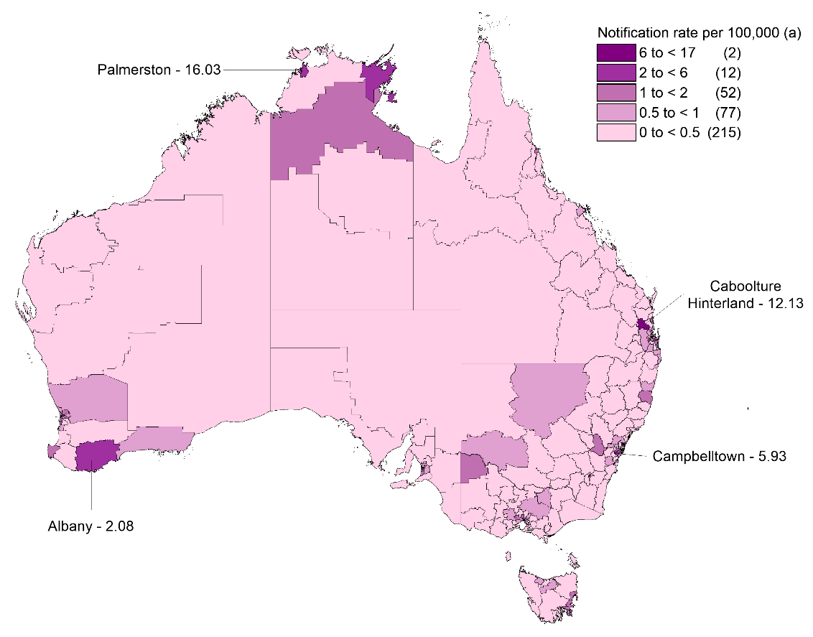
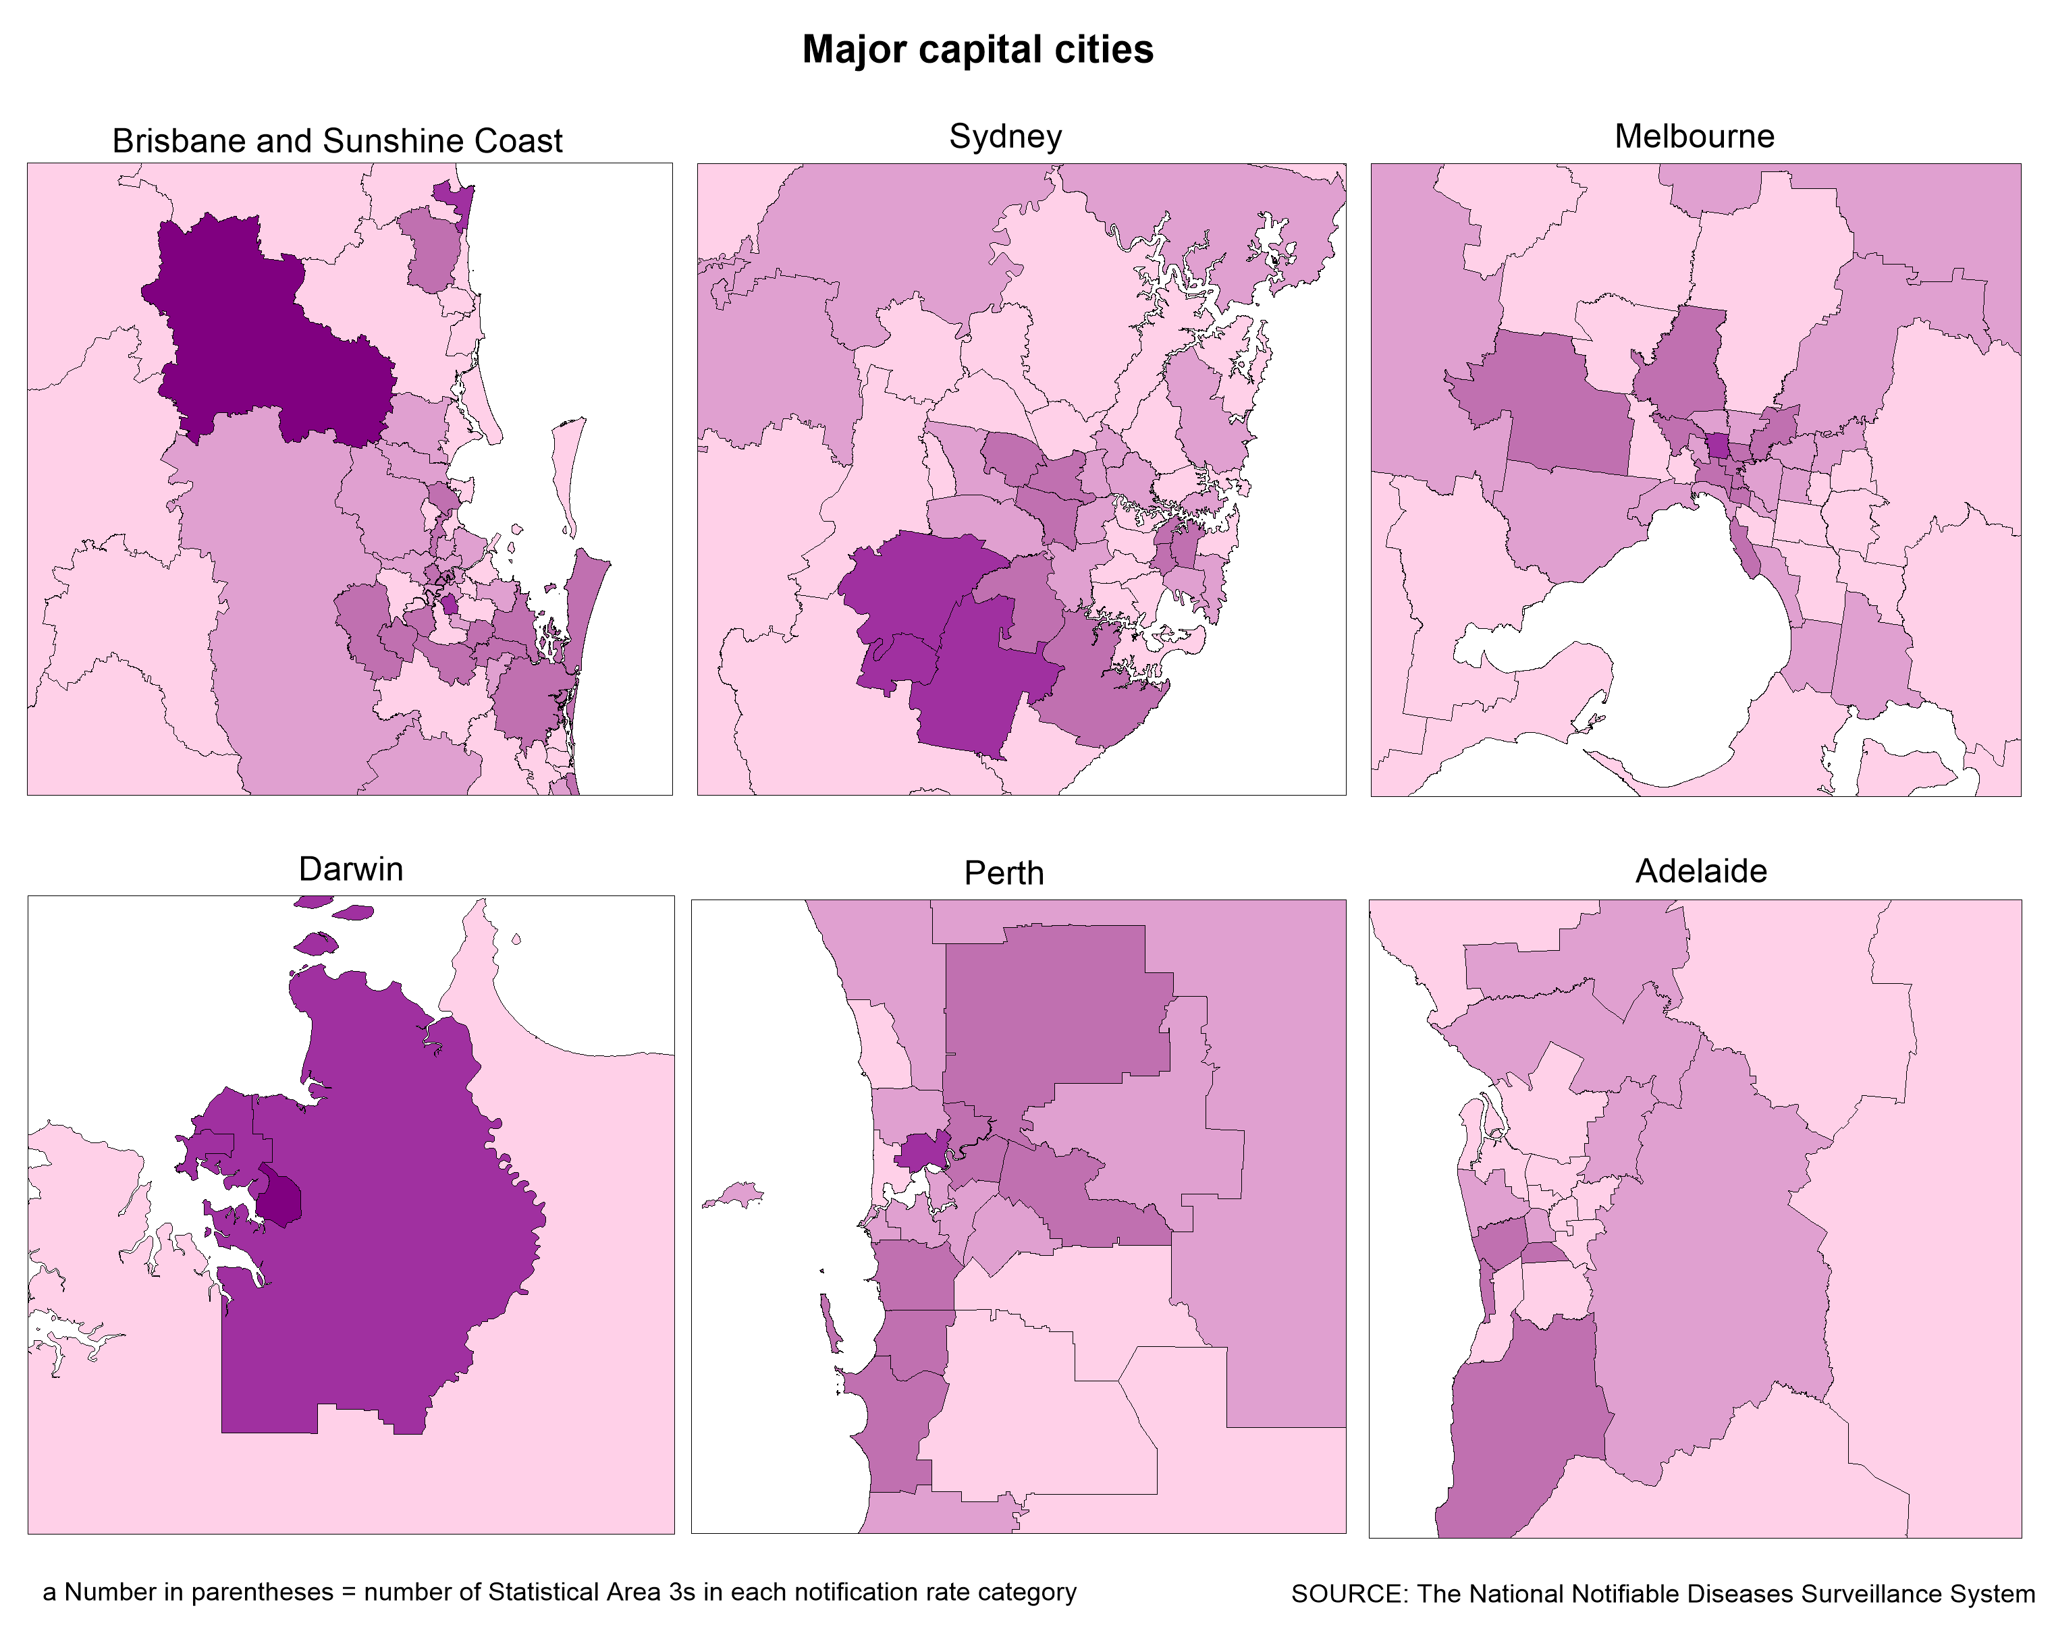

Seasonality
No consistent seasonal trend was evident in either notifications (2012–2019) or hospitalisations (2012–2018) (data not shown).

Genotype
Data on genotype were available for 900/1,337 notifications overall (67.3%), with completeness increasing from 42.7% in 2012 to a high of 82.5% in 2018 before decreasing to 72.3% in 2019 (Figure 4). Notably, 45/78 of notifications with a missing genotype in 2019 (57.7%) were in the final quarter of the year. Genotype D8 was the most common genotype overall from 2012–2019 (n = 526; 58.4% of cases genotyped) and was the most common genotype in all years except 2013 (D9: n = 33; 37.5%) and 2014 (B3: n = 153; 63.8%). Genetic diversity decreased between 2012 and 2019, with the prevalence of D4, D9, G3, and H1 all decreasing over time. B3 and D8 were the only detected genotypes in 2018 and 2019, and together made up 89.1% of all known genotypes (802/900) over the study period.

Figure 4: Proportion of measles genotypes among notifications by year, Australia, 2012–2019ª
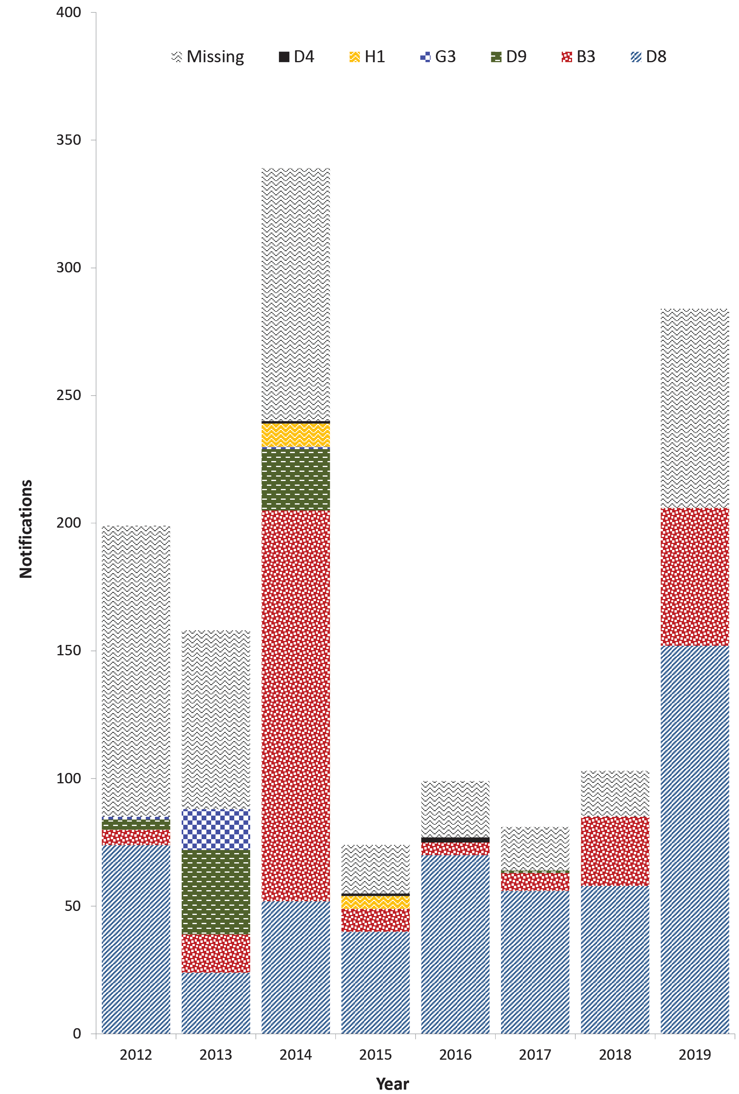
a Data source: National Notifiable Diseases Surveillance System.

Age distribution
The highest age-specific notification rate across all years was in infants aged < 12 months, with an average annual incidence of 5.8 per 100,000 population per year. The notification rate in infants aged < 12 months was highest in 2012 (12.5 per 100,000 population per year), with lesser peaks in 2014, 2018, and 2019 (Figure 5a). The second highest age-specific rate was in the 10–19 year age group early in the study period (2012–2014) but was in the 20–29 year age group towards the end of the study period (2016, 2018–2019). The lowest incidence across all years was in people aged ≥ 50 years (< 0.1 per 100,000 population per year), followed by those aged 40–49 years (0.4 per 100,000 population per year). Other age groups had average annual incidence rates per 100,000 population per year across the whole study period as follows: 1.0 in 1–4 years; 0.6 in 5–9 years; 1.2 in 10–19 years; 1.2 in 20–29 years; 1.0 in 30–39 years.
The highest age-specific average annual rate of hospitalisations (principal diagnosis) was in infants aged < 12 months (2.1 per 100,000 population per year) (Figure 5b). The lowest average annual hospitalisation rate was in the ≥ 50 year age group (< 0.1 per 100,000 population per year), followed by the 5–9 year age group (0.1 per 100,000 population per year). The age-specific notification to hospitalisation (principal diagnosis) ratios were as follows: 2.6 for < 12 months; 1.6 for 1–4 years; 4.4 for 5–9 years; 4.5 for 10–19 years; 2.6 for 20–29 years; 2.2 for 30–39 years; 1.6 for 40–49 years; and 0.6 for ≥ 50 years.

Comparison of notifications recorded as hospitalised with NHMD hospitalisation data
Between 2012 and 2018, there were 187 notified measles cases recorded in NNDSS as hospitalised, compared to the 474 hospitalisations (425 as principal diagnosis) recorded in the NHMD. The numbers of hospitalisations recorded in NNDSS were lower than in NHMD (principal diagnosis) in all jurisdictions except Western Australia, and the degree of discrepancy varied by jurisdiction. The age distribution of cases recorded as hospitalised in the NNDSS was similar to that recorded in the NHMD.

Birth cohort analysis
The measles notification rate in the birth cohort of children born from 2012 onwards was more than twice as high as the rate in any other birth cohort in 2014, but was lower than the rate in the 1981–1999 cohort in 2019 (Figure 6). Notification rates between 2012 and 2019 were similar in the cohorts born between 1966 and 2011, and rates were consistently lowest in those born prior to 1966. The 1981–1999 cohort had the highest average annual rate between 2012 and 2019 (1.2 per 100,000 population per year) once cases aged < 12 months were excluded from the 2012 onwards cohort (Table 3).

Figure 5: (a) Measles notification rate per 100,000 population per year by age group, Australia, 2012–2019;ª and (b) rate of measles hospitalisations (principal diagnosis) per 100,000 population per year by age group and year, Australia, 2012–2018^{b}
(a)
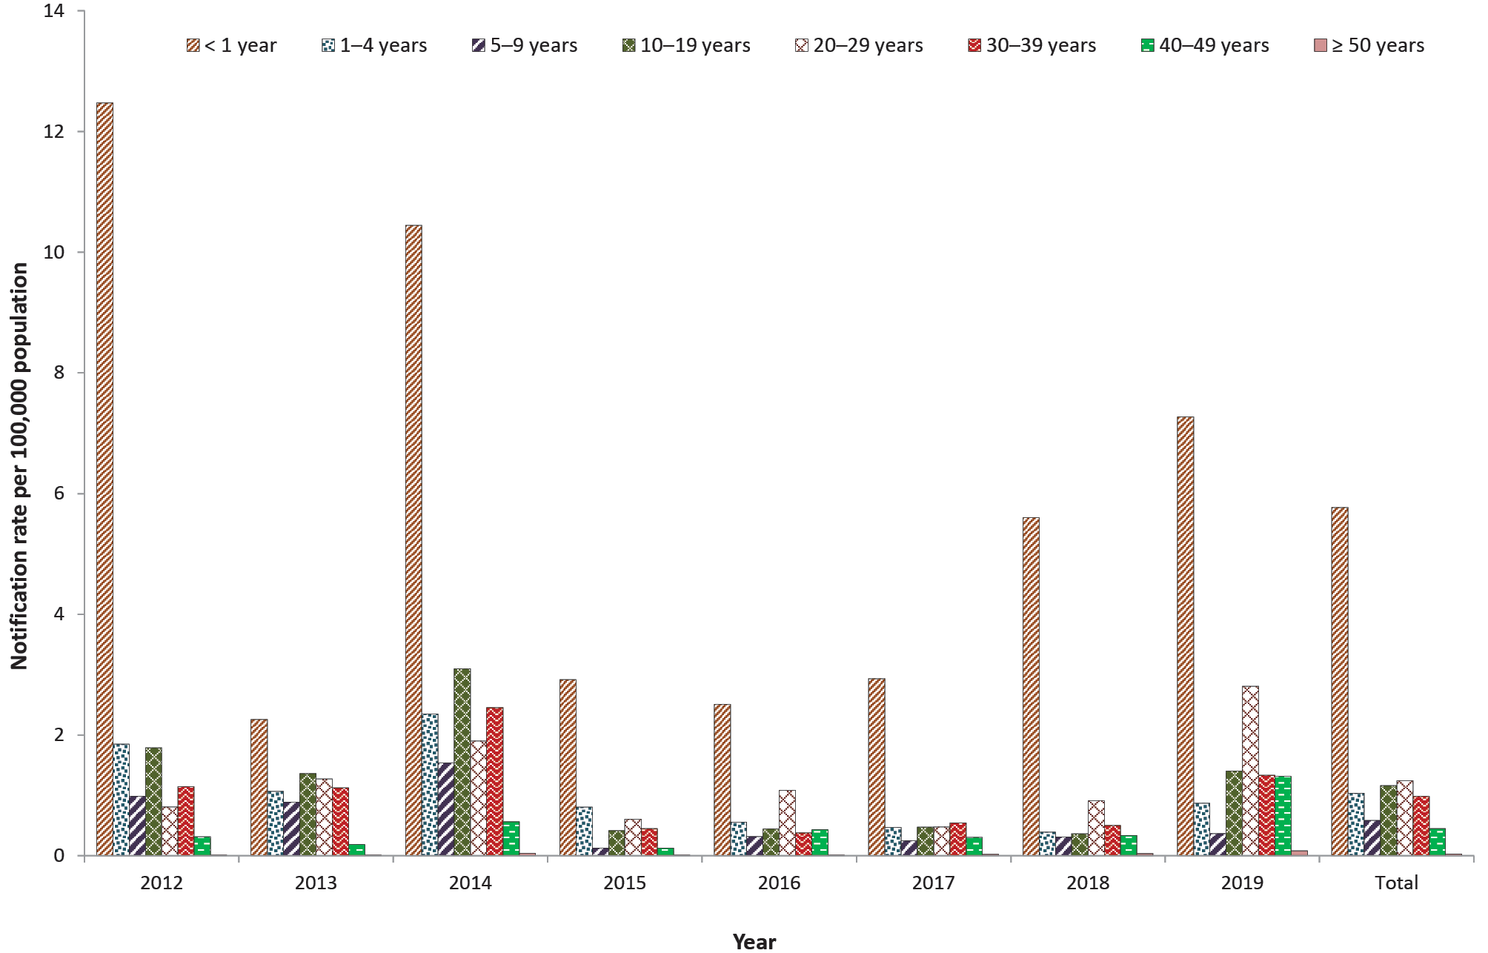
(b)
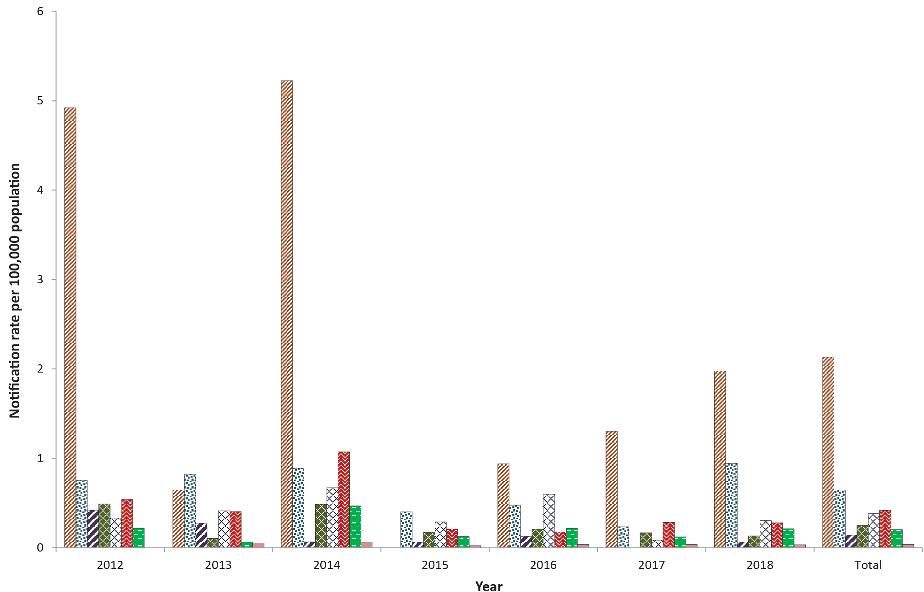
a Data source: National Notifiable Diseases Surveillance System.
b Data source: Australian Institute of Health and Welfare National Hospital Morbidity Database.
Figure 6: Measles notification rate per 100,000 population per year by birth cohort and year of diagnosis, Australia, 2012–2019^{a,b}
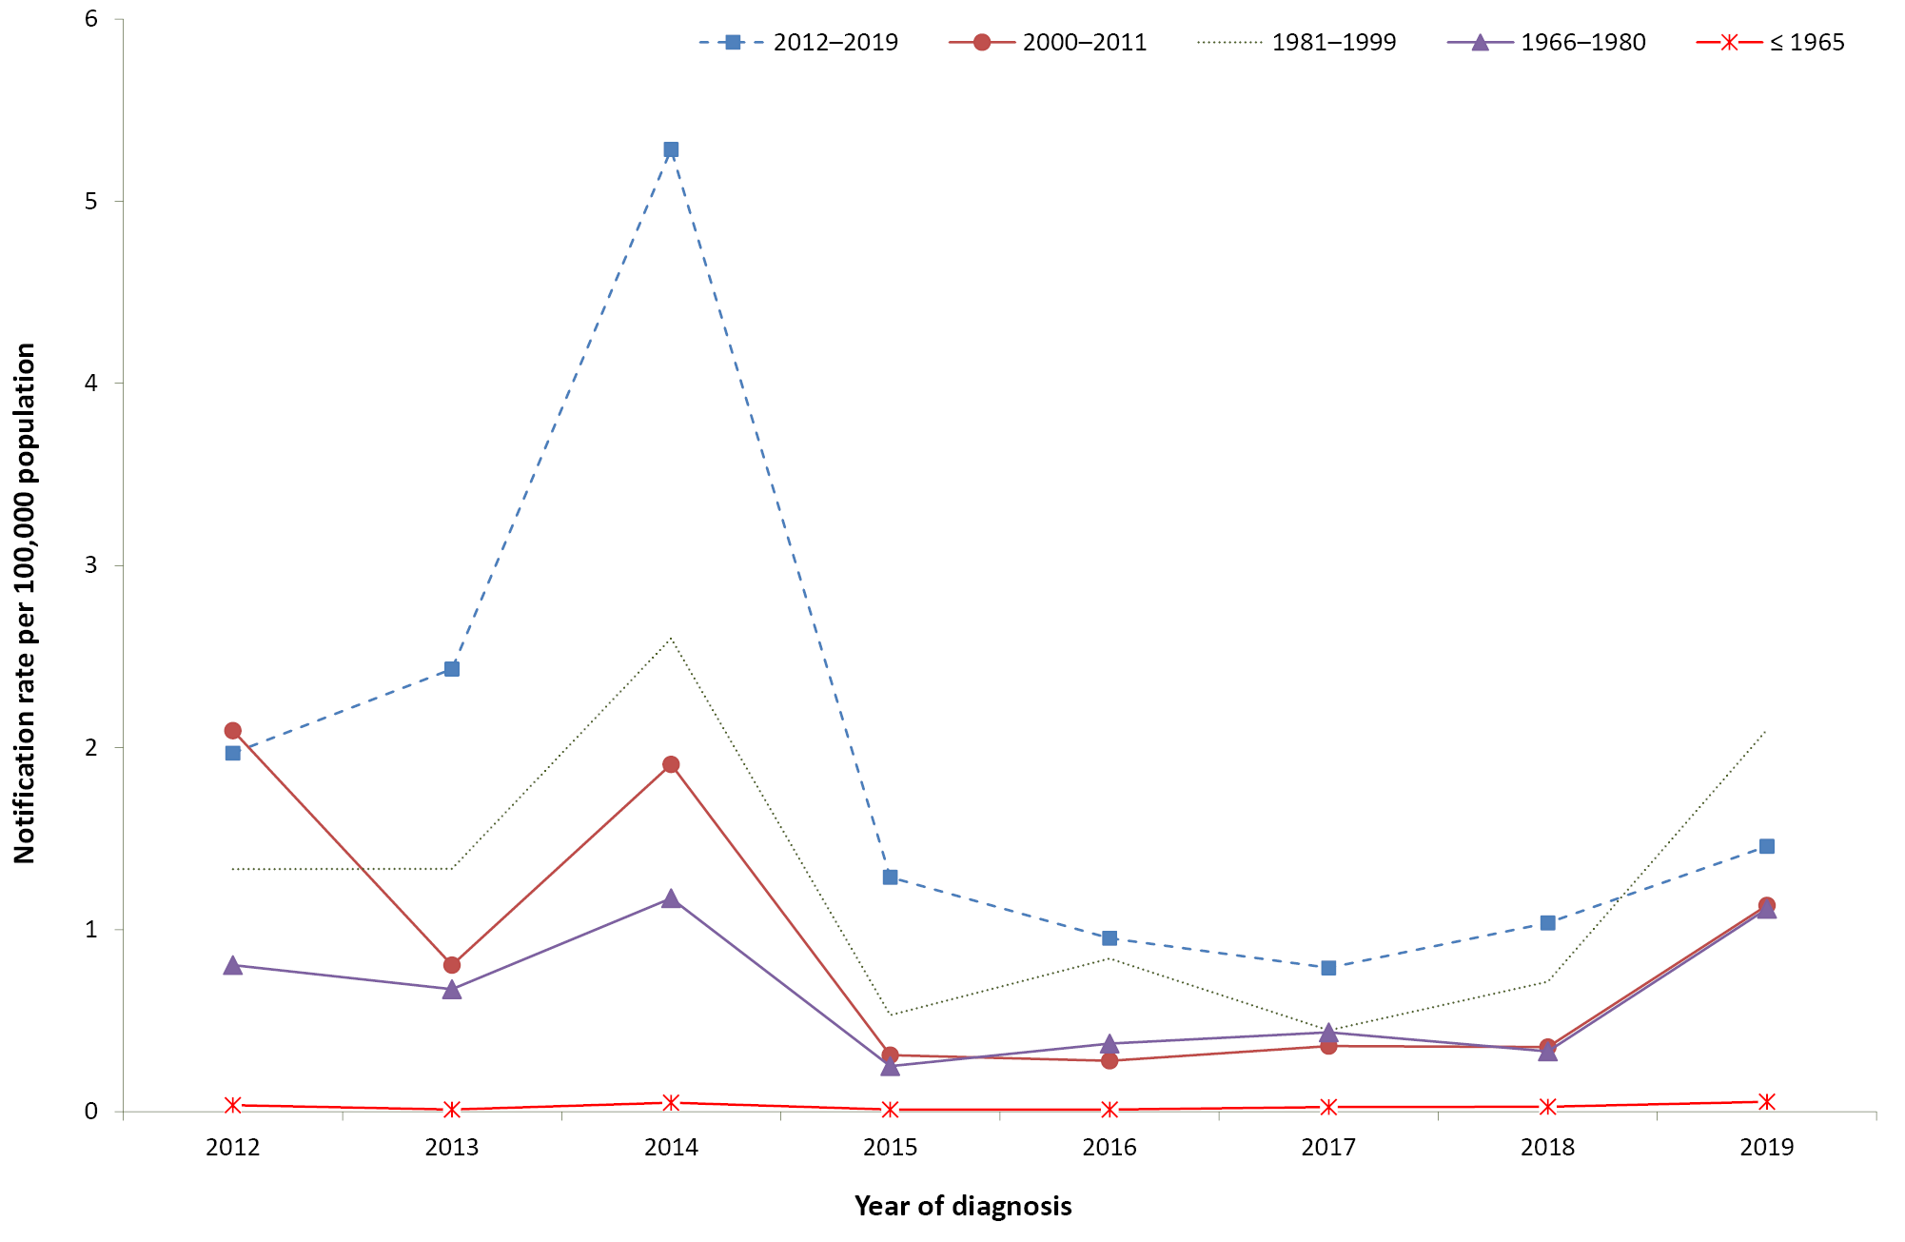
a Data source: National Notifiable Diseases Surveillance System.
b Note that the 2012–2019 birth cohort progressively increases in size each year of the study period (moving right across the x axis) due to addition of new annual birth cohorts.
Table 3: Average rate of measles notification per 100,000 population per year by birth cohort, Australia, 2012–2019ª
Birth cohort (year) | Rate per 100,000 population per year | 95% CI
≤ 1965 | 0.03 | 0.02–0.05
1966–1980 | 0.6 | 0.6–0.7
1981–1999 | 1.2 | 1.1–1.3
2000–2011 (rate including < 12 month old cases) | 0.9 | 0.8–1.0
2000–2011 (rate excluding <1 2 month old cases) | 0.8 | 0.7–0.9
≥ 2012 (rate including < 12 month old cases) | 1.6 | 1.3–1.8
≥ 2012 (rate excluding < 12 month old cases) | 0.7 | 0.6–0.9
a Data source: National Notifiable Diseases Surveillance System.

Vaccination status by age group
Vaccination status was recorded for 927/1337 notified cases (69.3%):
- <1 year of age: 120/142 cases (84.5%)
- 1–4 years of age: 100/103 cases (97.1%)
- 5–9 years of age: 69/72 cases (95.8%)
- 10–19 years of age: 221/272 cases (81.3%)
- 20–29 years of age: 227/347 cases (65.4%)
- 30–39 years of age: 123/266 cases (46.2%)
- 40–49 years of age: 58/116 cases (50.0%)
- ≥ 50 years of age: 9/19 cases (47.4%).
Date of vaccination was missing for 59 of the 253 first doses (23.3%) and for five of the 86 second doses (5.8%) recorded. Among cases aged 1–9 years, vaccination status was recorded in NNDSS for 169/175 (96.6%), of whom only 20 (11.8%) had received at least one dose of measles-containing vaccine (Table 4). Among cases aged 10–39 years with a known vaccination status (571/885; 64.5%), at least one dose had been received by 37.7% of cases, with the proportion ranging from 30.8% in the 10–19 year age group (81.3% known vaccination status) to 43.9% in the 30–39 year age group (46.2% known vaccination status). At the other end of the age spectrum, infants younger than 12 months of age accounted for 142 cases (10.6%), and were all unvaccinated (Figure 7).
Table 4: Doses of measles-containing vaccine recorded for notified measles cases (where vaccination status known), by age group, Australia, 2012–2019ª
Age group | Doses recorded |  |  |  |  |  | Total
 | None |  | 1 |  | 2
 | n | % | n | % | n | %
< 12 months | 120 | 100.0 | 0 | 0 | 0 | 0 | 120
12–17 months | 43 | 89.6 | 5 | 10.4 | 0 | 0 | 48
18 months – 4 years | 43 | 82.7 | 5 | 9.6 | 4 | 7.7 | 52
5–9 years | 63 | 91.3 | 4 | 5.8 | 2 | 2.9 | 69
10–19 years | 153 | 69.2 | 35 | 15.8 | 33 | 14.9 | 221
20–29 years | 134 | 59.0 | 54 | 23.8 | 39 | 17.2 | 227
30–39 years | 69 | 56.1 | 48 | 39.0 | 6 | 4.9 | 123
40–49 years | 41 | 70.7 | 15 | 25.9 | 2 | 3.4 | 58
≥ 50 years | 8 | 88.9 | 1 | 11.1 | 0 | 0 | 9
Total | 674 | 72.7 | 167 | 18.0 | 86 | 9.3 | 927
a Data source: National Notifiable Diseases Surveillance System.

Figure 7: Proportion of total notified measles cases by age group (regardless of vaccination status), and proportion in each age group with ≥ 1 dose of measles-containing vaccine recorded (where vaccination status known) Australia, 2012–2019ª
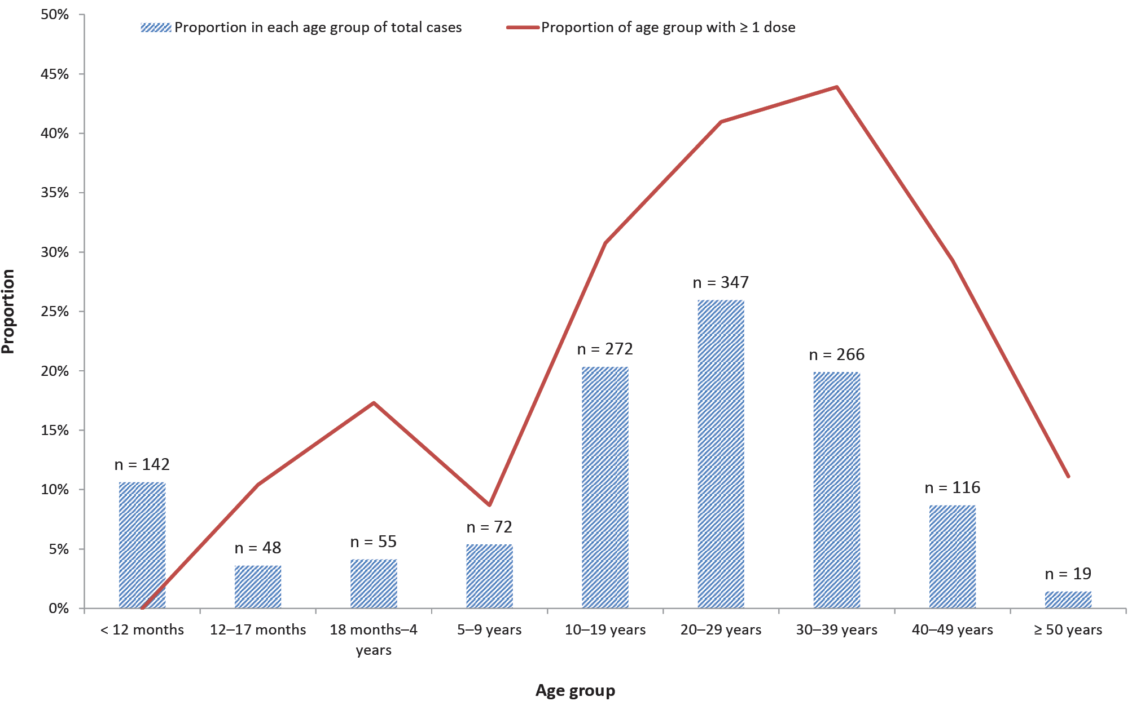
a Data source: National Notifiable Diseases Surveillance System.

Aboriginal and Torres Strait Islander status
Recording of Aboriginal and Torres Strait Islander status was almost complete among measles notifications (97.7%), with 42 cases (3.1%) reported as occurring in Aboriginal and Torres Strait Islander people (average annual rate 0.7 per 100,000 population per year). Aboriginal and Torres Strait Islander people accounted for 3.8% of hospitalisations (average annual rate 0.3 per 100,000 population per year). These average annual rates of notification and hospitalisation are the same as those seen among the total population across the study period. Of notifications in Aboriginal and Torres Strait Islander people, 60.5% (n = 26) were in individuals aged 10–39 years and 16.3% (n = 7) in infants aged < 12 months (median age 18 years; range 5 months – 43 years).

Severe morbidity and mortality
Of the 425 hospitalisations with measles as principal diagnosis between 2012 and 2018, 79 (18.6%) had a recorded complication: 41 (9.6%) pneumonia; 10 (2.4%) encephalitis, meningitis, or intestinal complications; and 28 (6.6%) other complications. The proportion with a recorded complication was higher in older adults (15.2% in those aged 40–49 years, 30% in those aged ≥ 50 years), than in children (10.7% in those aged 1–4 years, 6.7% in those aged 5–9 years).
Hospitalisations with measles as the principal diagnosis accounted for 1,342 bed days, with a median length of stay of 3 days (range 1–20 days; Table 5). Adults and infants aged < 1 year had a longer median length of stay (3–3.5 days) than did children and adolescents (1–2 days).
Between 2012 and 2018, there were a total of 1–5 deaths coded as due to measles (underlying or associated cause of death) recorded in the cause of death data. No deaths were recorded in the hospitalisation or notification data.
Table 5: Number, rate per 100,000 population per year and length of stay, measles hospitalisations (principal diagnosis), by age group, Australia, 2012–2018ª
Age group (years) | Hospital admissions |  | Length of stay (days)
 | n | Rate per 100,000 per year | Median | Range
< 1 | 46 | 2.1 | 3 | 1–8
1–4 | 56 | 0.6 | 1 | 1–7
5–9 | 15 | 0.1 | 1 | 1–4
10–19 | 51 | 0.3 | 2 | 1–11
20–29 | 93 | 0.4 | 3 | 1–19
30–39 | 98 | 0.4 | 3 | 1–20
40–49 | 46 | 0.2 | 3.5 | 1–11
≥ 50 | 20 | < 0.1 | 3 | 1–14
Total | 425 | 0.3 | 3 | 1–20
a Data source: Australian Institute of Health and Welfare National Hospital Morbidity Database.

Discussion
The incidence of measles in Australia remains low, although the average annual notification and hospitalisation rates (0.7 and 0.3 per 100,000 population per year, respectively) in the 2012–2019 period were each higher than those for the 2000–2011 period (notification rate 0.4 per 100,000 population per year; hospitalisation rate 0.2 per 100,000 population per year).⁸ Measles notification and hospitalisation rates in Aboriginal and Torres Strait Islander people, averaged across the 2012–2019 period, were the same as the rates among the overall population.
The highest age-specific notification (5.8 per 100,000 population per year) and hospitalisation rates (2.1 per 100,000 population per year) were in infants < 12 months of age, who are not eligible for vaccination, first scheduled at 12 months. In elimination settings, infants become susceptible to measles earlier than 12 months of age due to waning of maternal antibodies in the absence of natural boosting.²² The next highest notification rates were in the 10–19 and 20–29 year age groups (1.2 per 100,000 population per year); the lowest notification rates were in adults aged ≥ 50 years (< 0.1 per 100,000 population per year), followed by those aged 40–49 years (0.4 per 100,000 population per year).
Measles is highly communicable, with a basic reproductive rate (R₀) between 9 and 18.⁴ Therefore, population immunity (either vaccine acquired or ‘natural’ immunity from wild-type measles virus infection) of 95% or higher across all age groups is required to prevent ongoing transmission.⁴ While coverage of two doses of measles-containing vaccine recorded in the Australian Immunisation Register (AIR) in 2019 reached 93.3% at 2 years and 96.4% at 5 years,²⁰ coverage in older children and younger adults is lower due to lower historical coverage.^{23–25} Although coverage of two doses of measles-containing vaccine in adolescents aged 10–19 years increased from 86.6% to 89.0% at the national level during the two years following introduction of the federal No Jab, No Pay policy in 2016, this is still below the target of 95%.¹³ Lower coverage in particular sub-populations can also increase the risk of outbreaks. The 2012 peak in notifications and hospitalisations in NSW was due to a sustained outbreak, centred on south-western and western Sydney, which disproportionately affected the 10–19 year age group and people of Pacific Islander descent.²⁶ Many Pacific Islander adolescents appeared to have missed routine childhood vaccinations, both before and after their arrival in Australia.²⁶ Data on vaccination coverage in young adults in the 20–29 year age group dates from the early period of operation of the AIR, and so are likely to be incompletely captured, but estimated childhood coverage in this age group is similar or slightly lower than 10–19 year olds.¹⁷
Analysis by birth cohort showed the lowest notification rate to be in the pre-1966 birth cohort (< 0.1 per 100,000 population per year), who were born before measles-containing vaccines were available and are known to have high levels of natural immunity.²⁷ The 1966–1980 birth cohort have lower levels of vaccination coverage than subsequent cohorts, due to the single-dose vaccination schedule in place until the addition of the adolescent dose in 1993; they also have had less exposure to wild-type measles infection than the pre-1966 birth cohort.^{27,28} This age group was the target of an immunisation campaign in 2001 and 2002, although uptake was poor.²⁹ We found the measles notification rate between 2012 and 2019 was lower in the 1966–1980 cohort (0.6 per 100,000 population per year) than in later cohorts (1981–1999 cohort: 1.2 per 100,000 population per year; 2000–2011 cohort: 0.9 per 100,000 population per year), which could potentially be due to lower levels of exposure, such as less frequent travel to endemic countries or lower-risk contact patterns when travelling. The notification rate in 2019 in the post-2012 birth cohort was similar to that in the 2000–2011 cohort and lower than the 1981–1999 cohort, which could reflect the impact of moving the second dose of measles-containing vaccine from 4 years to 18 months of age since 2013. However, age-specific trends may potentially also be influenced by contact patterns affecting exposure during outbreaks.
Small area analysis showed that most areas with higher incidence were areas with documented measles outbreaks over the study period, including inner Melbourne (Brunswick-Coburg),³⁰ Greater Darwin (Palmerston, Litchfield, Darwin City, Darwin Suburbs),^{31,32} South West Sydney (Campbelltown, Bringelly-Green Valley, Camden),²⁶ South East Queensland (Caboolture Hinterland),³³ South West Western Australia (Albany),³⁴ and Perth (Perth City).³⁵ None of these areas had particularly low vaccination coverage in young children aged under 5 years (two-dose MMR coverage was above 90% for all or most of the study period),^{20,36–39} although vaccination coverage is likely to have been lower in adults and coverage of 95% or more across all age groups is required to ensure herd immunity.¹¹ Noosa, on the Sunshine Coast, was the only area with both higher incidence and notably low coverage over the study period (two-dose MMR coverage in young children 84.5% in 2019), as well as high rates of vaccination objection (10.1% in 2012 and 6.6% in 2014).^{20,40,41} Other reasons for higher incidence in some areas may include travel and contact patterns, as well as stochastic factors.
Of cases notified between 2012 and 2019 with a known vaccination history, the proportion of those aged 1–9 years who had received at least one dose of measles-containing vaccine was 11.8%, compared to 37.7% of those aged 10–39 years. Although higher proportions of vaccinated cases are broadly consistent with what is expected in high-coverage settings,^{42,43} the higher proportion of cases in the 10–39 year age groups could point to a combination of under-vaccination and to waning immunity in those who were vaccinated. In sequential national serosurveys, antibody attrition has been observed with time-since-immunisation in age groups 5–34 years, presumed to be related to the absence of natural boosting in the elimination setting, although it is unclear whether this translates to increased susceptibility.⁴⁴ Vaccinated cases are likely to present with attenuated disease and thus pose a challenge in terms of clinical recognition and laboratory diagnosis.⁴⁵ It is possible that there is better ascertainment of these cases with greater availability and use of polymerase chain reaction (PCR) testing in this period than in the past. The vaccination status of adult cases who were born before the AIR was established may also be less reliable, due to recall bias. In cases among children aged 1–4 years, the high proportion who were unvaccinated (86.0 %) indicates that improving timeliness of the first dose of measles-containing vaccine should be a priority. The majority of cases aged ≥30 years had an unknown vaccination status, consistent with historical vaccinations in older age groups not being captured by the AIR.
Of the 1,337 measles notifications recorded between 2012 and 2019, almost all (97.7%) were either imported or epidemiologically linked to an imported case. There were 42 cases of measles acquired overseas in children aged 6–11 months who were all unvaccinated. Infants travelling to measles-endemic countries can receive early vaccination as per Australian Immunisation Handbook guidelines, with the previous lower age limit of 9 months brought down to 6 months in April 2019 in response to an increased number of cases in infants with a history of overseas travel.⁴⁶ Earlier vaccination may also be appropriate in outbreak settings. In response to a 2019 outbreak in the Northern Territory, the first dose of measles-containing vaccine was recommended at 9 months of age for children in the Darwin region until the outbreak had resolved.³² Infants who receive a measles-containing vaccine early still require two further doses commencing from 12 months of age or a month after their initial dose, whichever is the later.⁴⁶
The most common genotype in Australia from 2012–2019 was D8, followed by B3 and D9. These genotypes were also some of the predominant genotypes circulating over this period in the Western Pacific Region,⁴⁷ which accounted for 43.9% of overseas-acquired cases. D8 was also common in Thailand during this period,⁹ while B3 has been endemic in the Philippines since 2013,⁴⁷ with both of these countries accounting for substantial proportions of Australia’s overseas-acquired cases. The genetic diversity of measles globally has decreased due to improvements in control. Detected genotypes worldwide decreased from eight in 2009–2014 to four in 2018–2019, with 20 out of 24 measles genotypes now eliminated.^{3,48} This is reflected in the decreasing diversity of genotypes we found over the course of our study. The higher proportion of notifications without a recorded genotype in 2019, particularly from the fourth quarter, is likely due to coronavirus disease 2019 (COVID-19) pandemic related delays in testing.
The continuing low incidence of cases in Australia over this study period—with nearly all cases imported or epidemiologically linked to imported cases, in the context of relatively high vaccination coverage,²⁰ high-quality surveillance and response mechanisms, and sophisticated laboratory testing capacity¹⁰—is consistent with maintenance of elimination. However, the 2014 and 2019 peaks in cases were a result of increased importations on a background of a global surge in cases in both years, including large outbreaks in Australia’s Asia-Pacific neighbours.^{4,9,49} The causes of the resurgence of measles globally include weak immunisation systems, vaccine hesitancy, unidentified or unaddressed immunity gaps in older children and adults, and international travel facilitating spread of measles.⁵⁰ Australians travelling to endemic countries are therefore a particularly important target for prevention strategies. A 2013–2014 study of pre-travel health seeking behaviours of notified cases of imported infectious disease, including measles, found only 25% of cases overall, and 15% of cases who went on to develop a vaccine-preventable disease had sought pre-travel advice from a healthcare provider, primarily due to lack of awareness.⁵¹ Jurisdictions have implemented media campaigns aimed at travellers in recent years,^{52,53} such as a NSW Health social media campaign in 2019 urging travellers to ‘bring back memories, not measles’, but the impact of these is unknown.⁴⁹
In response to the COVID-19 pandemic, Australia closed its international borders to tourists in March 2020, and required all returning residents to quarantine for 14 days on arrival.⁵⁴ As of May 2021, no cases of measles had been reported nationally since these measures were implemented.^{14,55} While no impact on uptake of routine childhood immunisation, as a result of the COVID-19 pandemic, has been observed in Australia,⁵⁶ disruptions have occurred in many countries globally.⁵⁷ This poses a risk of large measles outbreaks internationally, and increasing importations to Australia once international travel restrictions are lifted. To maintain Australia’s elimination status, sustained high vaccination coverage and robust surveillance and public health follow-up of cases will be needed.
This review has several limitations. Notification data may underestimate incidence, as not all cases seek health care, the diagnosis may be missed or diagnosed cases may not be notified. For measles, this is less likely due to its severity and the high level of public health scrutiny and follow-up of contacts. Hospitalisation data are prone to misclassification due to coding errors, particularly for rare diseases in age groups where they are uncommon,⁵⁸ which may explain the higher rate of measles hospitalisation compared to notification in the ≥ 50 year age group in our study. While NHMD hospitalisation data may overestimate the number of hospitalisations due to measles, notifications recorded as hospitalised likely underestimate the true number. Additionally, vaccination status was missing for a substantial proportion of notifications, largely as a result of childhood vaccination of adults born before 1996 not being captured in the AIR. Recorded vaccinations were missing a date of vaccination for 23.3% of first doses and 5.8% of second doses; some of these may have been given within the 2 weeks prior to disease onset and hence not appropriate for inclusion in our analyses. The case definition for measles notification was amended in mid-2019 with changes to the definitions of laboratory definitive, laboratory suggestive, and epidemiological evidence,¹⁵ making the case definition slightly more sensitive, although these changes were minor and only applicable during the last 6 months of our study period. Hospitalisation data are episode-level records and may include multiple records for individual cases transferred between hospitals or readmitted. Completeness of Aboriginal and Torres Strait Islander status in hospitalisation data was not able to be assessed due to coding of the variable in the dataset.

Conclusion
Measles remains a rare disease in Australia. Our findings of low measles incidence, with almost all cases imported or epidemiologically linked to an imported case, in the presence of robust surveillance and high two-dose measles vaccination coverage, provide evidence of continued elimination of endemic measles in Australia. However, continued vigilant surveillance and public health response measures, along with sustained high vaccination coverage, will be needed to maintain elimination, particularly once international borders reopen. Potential waning immunity in older age groups requires monitoring. Timely routine vaccination of infants, and vaccination of non-immune travellers, including early vaccination of infant travellers in line with Australian Immunisation Handbook recommendations, remain priorities.

Acknowledgments
We wish to acknowledge the Office of Health Protection and state and territory health departments through the Communicable Diseases Network Australia for release of data from the National Notifiable Diseases Surveillance System; the public health officers in states and territories responsible for the primary collection of the data used; and the Hospitals Unit, Australian Institute of Health and Welfare for data from the National Hospital Morbidity Database. We thank the Australian Coordinating Registry, state and territory registries of births, deaths and marriages, state and territory coroners, and the National Coronial Information System, for providing access to cause of death data. NCIRS is supported by the Australian Government Department of Health, NSW Health and The Sydney Children’s Hospitals Network. The opinions expressed in this report are those of the authors, and do not necessarily represent the views of these agencies. Noni Winkler is supported by a Master of Applied Epidemiology Scholarship from the Australian National University.

Author details
Noni E Winkler^{1,2}
Aditi Dey^{1,3}
Helen E Quinn^{1,3}
Davoud Pourmarzi²
Stephen Lambert¹
Peter McIntyre^{1,3}
Frank Beard^{1,3}
- The National Centre for Immunisation Research and Surveillance (NCIRS)
- The Australian National University, College of Health and Medicine, National Centre for Epidemiology and Population Health
- The University of Sydney, Faculty of Medicine and Health

Corresponding author:
Noni Winkler BN, MPHTM
MAE Scholar | National Centre for Immunisation Research and Surveillance (NCIRS)
phone: (02) 9845 0849
email: Noni.Winkler@health.nsw.gov.au

References
- Strebel PM, Orenstein WA. Measles. N Engl J Med. 2019;381(4):349–57.
- World Health Organization (WHO). Fact sheets: Measles. [Internet.] Geneva: WHO; 5 December2019. [Accessed on 8 April 2021.] Available from: https://www.who.int/news-room/fact-sheets/detail/measles.
- Patel MK, Goodson JL, Alexander JP, Kretsinger K, Sodha SV, Steulet C et al. Progress toward regional measles elimination – worldwide, 2000–2019. MMWR Morb Mortal Wkly Rep. 2020;69(45):1700–5.
- Williamson KM, Merritt T, Durrheim DN. Australia: an island in a sea of measles. Med J Aust. 2020;213(3):101–3.
- Craig AT, Heywood AE, Worth H. Measles epidemic in Samoa and other Pacific islands. Lancet Infect Dis. 2020;20(3):273–5.
- Durrheim DN. Measles eradication—retreating is not an option. Lancet Infect Dis. 2020;20(6):e138–41.
- WHO. Measles and rubella strategic framework: 2021-2030. Geneva: WHO; 8 November 2020. [Accessed on 8 April 2021.] Available from: https://www.who.int/publications/i/item/measles-and-rubella-strategic-framework-2021-2030.
- Chiew M, Dey A, Martin N, Wang H, Davis S, McIntyre PB. Australian vaccine preventable disease epidemiological review series: measles 2000–2011. Commun Dis Intell Q Rep. 2015;39(1):E1–9.
- Hagan JE, Kriss JL, Takashima Y, Mariano KML, Pastore R, Grabovac V et al. Progress toward measles elimination – Western Pacific Region, 2013–2017. MMWR Morb Mortal Wkly Rep. 2018;67(17):491–5.
- Heywood AE, Gidding HF, Riddell MA, McIntyre PB, MacIntyre CR, Kelly HA. Elimination of endemic measles transmission in Australia. Bull World Health Organ. 2009;87(1):64–71.
- Beard FH, Leask J, McIntyre PB. No Jab, No Pay and vaccine refusal in Australia: the jury is out. Med J Aust. 2017;206(9):381–3.
- Ward K, Hull BP, Leask J. Financial incentives for childhood immunisation – a unique but changing Australian initiative. Med J Aust. 2013;198(11):590–2.
- Hull BP, Beard FH, Hendry AJ, Dey A, Macartney K. “No jab, no pay”: catch-up vaccination activity during its first two years. Med J Aust. 2020;213(8):364–9.
- Australian Government Department of Health. National Notifiable Diseases Surveillance System: Public datasets. [Internet.] Canberra: Australian Government Department of Health; 2021. [Accessed on 16 April 2021.] Available from: http://www9.health.gov.au/cda/source/rpt_3.cfm.
- Australian Government Department of Health. Measles case definition. [Internet.] Canberra: Australian Government Department of Health; 29 May 2019. [Accessed on 8 April 2021.] Available from: https://www1.health.gov.au/internet/main/publishing.nsf/Content/cda-surveil-nndss-casedefs-cd_measl.htm.
- Australian Bureau of Statistics. Childrens immunisation survey, Australia, November 1983. Canberra: Australia Bureau of Statistics; 1984. 30pp.
- Lister S, McIntyre PB, Burgess MA, O’Brien ED. Immunisation coverage in Australian children: a systematic review 1990-1998. Commun Dis Intell. 1999;23(6):145–70.
- Brotherton J, McIntyre P, Puech M, Wang H, Gidding H, Hull B et al. Vaccine preventable diseases and vaccination coverage in Australia 2001 to 2002. Commun Dis Intell Q Rep. 2004;28(Suppl 2):vii–S116.
- Hull BP, Dey A, Beard FH, Menzies RI, Brotherton JM, McIntyre PB. Immunisation coverage annual report, 2013. Commun Dis Intell Q Rep. 2016;40(1):E146–69.
- Hull B, Hendry A, Dey A, Macartney K, Beard F. Immunisation Coverage Annual Report, 2019. Commun Dis Intell (2018). 2021;45. doi: https://doi.org/10.33321/cdi.2020.45.18.
- MapInfo. MapInfo Pro. version 15.0. Stamford, Connecticut, USA. MapInfo; 2015.
- Guerra FM, Crowcroft NS, Friedman L, Deeks SL, Halperin SA, Severini A et al. Waning of measles maternal antibody in infants in measles elimination settings – a systematic literature review. Vaccine. 2018;36(10):1248–55.
- Turnbull FM, Burgess MA, McIntyre PB, Lambert SB, Gilbert GL, Gidding HF et al. The Australian Measles Control Campaign, 1998. Bull World Health Organ. 2001;79(9):882–8.
- Hull B, Deeks S, Menzies R, McIntyre P. Immunisation coverage annual report, 2007. Commun Dis Intell Q Rep. 2009;33(2):170–87.
- Hull BP, Mahajan D, Dey A, Menzies RI, McIntyre PB. Immunisation coverage annual report, 2008. Commun Dis Intell Q Rep. 2010;34(3):241–58.
- Najjar Z, Hope K, Clark P, Nguyen O, Rosewell A, Conaty S. Sustained outbreak of measles in New South Wales, 2012: risks for measles elimination in Australia. Western Pac Surveill Response J. 2014;5(1):14–20.
- Gidding HF, Gilbert GL. Measles immunity in young Australian adults. Commun Dis Intell Q Rep. 2001;25(3):133–6.
- Lambert SB, Morgan ML, Riddell MA, Andrews RM, Kelly HA, Leydon JA et al. Measles outbreak in young adults in Victoria, 1999. Med J Aust. 2000;173(9):467–71.
- Kelly HA, Gidding HF, Karapanagiotidis T, Leydon JA, Riddell MA. Residual susceptibility to measles among young adults in Victoria, Australia following a national targeted measles-mumps-rubella vaccination campaign. BMC Public Health. 2007;7:99. doi: https://doi.org/10.1186/1471-2458-7-99.
- Department of Health and Human Services (DHHS). Measles outbreak in Brunswick area. [Internet.] Melbourne: Victoria State Government, DHHS; 23 February 2016. [Accessed on 23 June 2021.] Available from: https://www2.health.vic.gov.au/about/publications/policiesandguidelines/cho-alert-measles-outbreak-in-brunswick-area.
- Markey P, Lines S. Measles outbreak summary. N T Dis Control Bull. 2014;21(1):23.
- Boyd R. Darwin measles outbreak 2019… the first …and only? N T Dis Control Bull. 2019;26(2):3–7.
- Chatterji M, Baldwin AM, Prakash R, Vlack SA, Lambert SB. Public health response to a measles outbreak in a large correctional facility, Queensland, 2013. Commun Dis Intell Q Rep. 2014;38(4):E294–7.
- ABC news. Albany measles warning remains in place. [Online news article.] Sydney: Australian Broadcasting Corporation; 25 August 2014. [Accessed on 13 July 2021.] Available from: https://www.abc.net.au/news/2014-08-25/measles-warning-remains-for-recent-visitors-to/5694132.
- Government of Western Australia Department of Health (WA Health). Measles cluster in Perth metropolitan area update #3. [Internet.] Perth: WA Health; 4 October 2019. [Accessed on 23 June 2021.] Available from: https://ww2.health.wa.gov.au/Media-releases/2019/Measles-cluster-in-Perth-metropolitan-area-update-3.
- Hull B, Hendry A, Dey A, Beard F, Brotherton J, McIntyre P. Annual Immunisation Coverage Report 2016. Commun Dis Intell (2018). 2019;43. doi: https://doi.org/10.33321/cdi.2019.43.44.
- Hull B, Hendry A, Dey A, Brotherton J, Macartney K, Beard F. Annual Immunisation Coverage Report 2017. Commun Dis Intell (2018). 2019;43. doi: https://doi.org/10.33321/cdi.2019.43.47.
- Hull B, Hendry A, Dey A, McIntyre P, Macartney K, Beard F. Immunisation Coverage Annual Report 2018. Commun Dis Intell (2018). 2021;45. doi: https://doi.org/10.33321/cdi.2020.45.17.
- Gidding HF, Martin NV, Stambos V, Tran T, Dey A, Dowse GK et al. Verification of measles elimination in Australia: application of World Health Organization regional guidelines. J Epidemiol Glob Health. 2016;6(3):197–209.
- Hull BP, Hendry AJ, Dey A, Beard FH, Brotherton JM, McIntyre PB. Immunisation coverage annual report, 2014. Commun Dis Intell Q Rep. 2017;41(1):E68–90.
- Hull BP, Dey A, Menzies RI, Brotherton JM, McIntyre PB. Immunisation coverage, 2012. Commun Dis Intell Q Rep. 2014;38(3):E208–31.
- Smith J, Banu S, Young M, Francis D, Langfeldt K, Jarvinen K. Public health response to a measles outbreak on a university campus in Australia, 2015. Epidemiol Infect. 2018;146(3):314–8.
- Althaus CL, Salathé M. Measles vaccination coverage and cases among vaccinated persons. Emerg Infect Dis. 2015;21(8):1480–1.
- Gidding HF, Quinn HE, Hueston L, Dwyer DE, McIntyre PB. Declining measles antibodies in the era of elimination: Australia’s experience. Vaccine. 2018;36(4):507–13.
- Gibney KB, Attwood LO, Nicholson S, Tran T, Druce J, Healy J, et al. Emergence of attenuated measles illness among IgG-positive/IgM-negative measles cases: Victoria, Australia, 2008-2017. Clin Infect Dis. 2020;70(6):1060–7.
- Australian Government Department of Health. Australian Immunisation Handbook: Measles. [Internet.] Canberra: Australian Government Department of Health; 2019. [Accessed on 8 April 2021.] Available from: https://immunisationhandbook.health.gov.au/vaccine-preventable-diseases/measles.
- World Health Organization (WHO) Regional Office for the Western Pacific (WPRO). Regional strategy and plan of action for measles and rubella elimination in the Western Pacific. Manila: WHO WPRO; 2018. Available from: https://iris.wpro.who.int/handle/10665.1/14227.
- Brown KE, Rota PA, Goodson JL, Williams D, Abernathy E, Takeda M et al. Genetic characterization of measles and rubella viruses detected through global measles and rubella elimination surveillance, 2016–2018. MMWR Morb Mortal Wkly Rep. 2019;68(26):587–91.
- Alexander KE, Wickens M, Fletcher-Lartey SM. Measles elimination in Australia: Hard won, easily lost. Aust J Gen Pract. 2020;49(3):112–4.
- Patel MK, Dumolard L, Nedelec Y, Sodha SV, Steulet C, Gacic-Dobo M et al. Progress toward regional measles elimination—worldwide, 2000–2018. MMWR Morb Mortal Wkly Rep. 2019;68(48):1105–11.
- Paudel P, Raina C, Zwar N, Seale H, Worth H, Sheikh M et al. Risk activities and pre-travel health seeking practices of notified cases of imported infectious diseases in Australia. J Travel Med. 2017;24(5). doi: https://doi.org/10.1093/jtm/tax044.
- MacIntyre CR, Karki S, Sheikh M, Zwar N, Heywood AE. The role of travel in measles outbreaks in Australia – an enhanced surveillance study. Vaccine. 2016;34(37):4386–91.
- WA Health. Adult measles vaccination program campaign. [Internet.] Perth: WA Health; 2019. [Accessed on 5 May 2021.] Available from: https://ww2.health.wa.gov.au/Articles/A_E/Campaign-adult-measles-vaccination-program.
- McAnulty JM, Ward K. Suppressing the epidemic in New South Wales. N Engl J Med. 2020;382(21):e74. doi: https://doi.org/10.1056/NEJMc2011592.
- Bright A, Glynn-Robinson AJ, Kane S, Wright R, Saul N. The effect of COVID-19 public health measures on nationally notifiable diseases in Australia: preliminary analysis. Commun Dis Intell (2018). 2020;44. doi: https://doi.org/10.33321/cdi.2020.44.85.
- National Centre for Immunisation Research and Surveillance (NCIRS). COVID-19: Impact on routine childhood vaccination uptake in Australia. Sydney: NCIRS; 18 November 2020. [Accessed on 8 April 2021.] Available from: https://www.ncirs.org.au/covid-19-impact-routine-childhood-vaccination-uptake-australia.
- WHO, Strategic Advisory Group of Experts (SAGE) on Immunization. Meeting of the Strategic Advisory Group of Experts on Immunization, October 2020 – conclusions and recommendations. Wkly Epidemiol Rec. 2020;95(48):585–608.
- Chiu C, Dey A, Wang H, Menzies R, Deeks S, Mahajan D et al. Vaccine preventable diseases in Australia, 2005 to 2007. Commun Dis Intell Q Rep. 2010;34(Supp):S1–167.

Communicable Diseases Intelligence
ISSN: 2209-6051 Online

Communicable Diseases Intelligence (CDI) is a peer-reviewed scientific journal published by the Office of Health Protection and Response, Department of Health. The journal aims to disseminate information on the epidemiology, surveillance, prevention and control of communicable diseases of relevance to Australia.

Editor: Noel Lally
Deputy Editor: Simon Petrie
Design and Production: Kasra Yousefi
Editorial Advisory Board: David Durrheim, Mark Ferson, John Kaldor, Martyn Kirk and Linda Selvey

Website: http://www.health.gov.au/cdi

Contacts
CDI is produced by the Office of Health Protection and Response, Australian Government Department of Health, GPO Box 9848, (MDP 6) CANBERRA ACT 2601

Email: cdi.editor@health.gov.au

Submit an Article
You are invited to submit your next communicable disease related article to the Communicable Diseases Intelligence (CDI) for consideration. More information regarding CDI can be found at: http://health.gov.au/cdi.
Further enquiries should be directed to: cdi.editor@health.gov.au.

This journal is indexed by Index Medicus and Medline.

Creative Commons Licence - Attribution-NonCommercial-NoDerivatives CC BY-NC-ND
© 2022 Commonwealth of Australia as represented by the Department of Health
This publication is licensed under a Creative Commons Attribution-NonCommercial-NoDerivatives 4.0 International Licence from https://creativecommons.org/licenses/by-nc-nd/4.0/legalcode (Licence). You must read and understand the Licence before using any material from this publication.

Restrictions
The Licence does not cover, and there is no permission given for, use of any of the following material found in this publication (if any):
- the Commonwealth Coat of Arms (by way of information, the terms under which the Coat of Arms may be used can be found at www.itsanhonour.gov.au);
- any logos (including the Department of Health’s logo) and trademarks;
- any photographs and images;
- any signatures; and
- any material belonging to third parties.

Disclaimer
Opinions expressed in Communicable Diseases Intelligence are those of the authors and not necessarily those of the Australian Government Department of Health or the Communicable Diseases Network Australia. Data may be subject to revision.

Enquiries
Enquiries regarding any other use of this publication should be addressed to the Communication Branch, Department of Health, GPO Box 9848, Canberra ACT 2601, or via e-mail to: copyright@health.gov.au

Communicable Diseases Network Australia
Communicable Diseases Intelligence contributes to the work of the Communicable Diseases Network Australia.
http://www.health.gov.au/cdna

