Creutzfeldt-Jakob disease surveillance in Australia: update to 31 December 2021
Christiane Stehmann, Matteo Senesi, Shannon Sarros, Amelia McGlade, Victoria Lewis, Marion Simpson, Genevieve Klug, Catriona McLean, Colin L Masters, Steven Collins

Abstract
Nationwide surveillance of Creutzfeldt-Jakob disease (CJD) and other human prion diseases is performed by the Australian National Creutzfeldt-Jakob Disease Registry (ANCJDR). National surveillance encompasses the period since 1 January 1970, with prospective surveillance occurring from 1 October 1993. Over this prospective surveillance period, considerable developments have occurred in pre-mortem diagnostics; in the delineation of new disease subtypes; and in a heightened awareness of prion diseases in healthcare settings. Surveillance practices of the ANCJDR have evolved and adapted accordingly. This report summarises the activities of the ANCJDR during 2021.
Since the ANCJDR began offering diagnostic cerebrospinal fluid (CSF) 14-3-3 protein testing in Australia in September 1997, the annual number of referrals has steadily increased. In 2021, a total of 548 domestic CSF specimens were referred for 14-3-3 protein testing; 73 persons with suspected human prion disease were formally added to the national register. As of 31 December 2021, just over half of the 73 suspect case notifications (37/73) remain classified as ‘incomplete’; 17 cases were classified as ‘definite’ and 13 as ‘probable’ prion disease; six cases were excluded through either detailed clinical follow-up (two cases) or neuropathological examination (four cases). For 2021, sixty-four percent of all suspected human-prion-disease-related deaths in Australia underwent neuropathological examination. No cases of variant or iatrogenic CJD were identified.
The SARS-CoV-2 pandemic did not affect prion disease surveillance outcomes in Australia.
Keywords: Creutzfeldt-Jakob disease; prion disease; transmissible spongiform encephalopathy; disease surveillance

Introduction
Of human prion diseases (also known as transmissible spongiform encephalopathies), the most common is Creutzfeldt-Jakob disease (CJD). The Australian National Creutzfeldt-Jakob Disease Registry (ANCJDR) was established in 1993 as part of the response to four people dying from CJD related to fertility treatment utilising cadaveric pituitary hormones. As described previously,¹ human prion disease mostly arises sporadically, but can occur through person-to-person transmission or from a genetic aetiology. In 1993, the Allars inquiry² released its findings into the use of cadaver-derived pituitary hormones under the Australian Human Pituitary Hormone Program and the association with four medically-acquired (iatrogenic) CJD (iCJD) deaths, recommending a broadening of the responsibilities of the then nascent ANCJDR. In addition to monitoring for further cases of iCJD in Australia, related to cadaveric pituitary hormone treatment for infertility or short stature and to contaminated dura mater grafts, the ANCJDR’s activities have evolved to encompass the surveillance of all types of CJD, including sporadic, genetic and variant CJD (vCJD, the zoonosis related to bovine spongiform encephalopathy [BSE]), as well as other prion diseases such as Gerstmann-Sträussler-Scheinker syndrome and fatal sporadic or familial insomnia.
Human prion disease became a notifiable disease in all states and territories of Australia in June 2006. Most initial case awareness at the ANCJDR arises through diagnostic testing requests made to the ANCJDR; this occurs prior to Health Department notification. After a preliminary review of referred cases, those deemed to be genuine suspected human prion disease undergo further detailed evaluation and addition to the national surveillance register, to determine whether a case can be excluded from suspicion or can be classified as a ‘definite’, ‘probable’ or ‘possible’ prion disease case according to diagnostic criteria endorsed by the Creutzfeld-Jakob Disease International Surveillance Network (colloquially EUROCJD) and to determine the aetiology of the illness.³
The incidence of sporadic CJD (sCJD) is commonly reported to be approximately one case per million per year; however, in most countries with longstanding surveillance systems in place, annual incidence rates have been consistently reported above this quoted figure.^{4,5} Multi-national collaborative studies show that intensity of surveillance correlates with reported incidence rates.⁶ Temporally, human prion disease incidence rates have increased in most countries, including Australia, as surveillance mechanisms have been optimised and diagnostic testing capabilities improved, in parallel with a generally greater awareness of this rare disease in the healthcare setting.
In this report, updated national surveillance figures to 31 December 2021 are provided for all retrospective (to 1970) and prospective (from 1993) cases ascertained, including a discussion on case notifications, classifications and overall incidence.

Surveillance methods
Patients with suspected human prion disease have been prospectively notified to the ANCJDR since October 1993. From 1997 onwards, suspected cases have been increasingly notified through referral for CSF 14-3-3 protein western blot testing, which has over time become the predominant source of initial awareness of suspected CJD cases. Other ascertainment mechanisms include, or have included, personal communications from clinicians, families, hospitals and CJD-related groups, as well as health record searches through hospitals and health departments.
Once referred to the ANCJDR, referrals undergo a prima facie assessment and, if the suspicion of prion disease is supported, the case is notified to the appropriate health department and added to the ANCJDR register as a formal ‘suspected case’ for continued surveillance and evaluation with the aim of exclusion or classification according to EUROCJD-endorsed diagnostic criteria. Investigation of registered cases can be prolonged, as the ANCJDR requires next-of-kin consent to access and compile the appropriate clinical information from various health information sources to facilitate a comprehensive review. Response times can vary, as the information can be extensive or sources numerous. Medico-demographic questionnaires are offered and forwarded to families, if they are willing to contribute, providing valuable information for analysis and evaluation.
Classification of registered cases remains as ‘incomplete’ until all known available information is gathered and reviewed, or until a definitive result from neuropathological assessment is obtained. Cases may be excluded from the register based on neuropathological examination or after thorough clinical evaluation. A ‘definite’ classification requires brain neuropathological examination, including immunochemical analysis; ‘probable’ and ‘possible’ cases are reliant on a specific clinical profile and diagnostic test outcomes being met as previously described.³ As of 1 January 2017, the diagnostic criteria were amended to include a positive result in the real-time quaking-induced conversion (RT-QuIC) assay using CSF or other tissues in a person with a progressive neurological syndrome. The updated EUROCJD diagnostic criteria for surveillance of sporadic CJD are listed in Appendix A. In keeping with previous reports, the total number of confirmed prion disease cases for 2021, including for statistical analyses, are those that have been classified as ‘definite’ or ‘probable’ cases during 2021.
In support of its surveillance responsibilities, the ANCJDR provides diagnostic platforms for ante- and post-mortem testing for human prion diseases. The testing of CSF for the presence of a family of low-molecular-weight proteins (14-3-3) has been performed weekly by the ANCJDR since 1997. This test has been readily utilised by clinicians. In 2017, the ANCJDR formally added estimation of CSF total-tau protein concentrations, which is also National Association of Testing Authorities/International Laboratory Accreditation Cooperation (NATA/ILAC) accredited, for the diagnosis of human prion disease. The concentration of total-tau protein in CSF is measured by Roche Elecsys® technology;⁷ the test is performed at the National Dementia Diagnostic Laboratory on a weekly basis. In 2021, the RT-QuIC assay was performed routinely on all CSF specimens referred for 14-3-3 testing with sufficient sample volume and in consultation with managing clinicians. The ANCJDR also undertakes western blot analysis for misfolded, protease-resistant prion protein in brain and tonsil tissue from biopsies or autopsies to supplement immunohistochemical assessment, as required for diagnostic and sub-classification purposes. Prion protein gene (PRNP) testing for sequence variations in the open reading frame, particularly for proven disease-causing mutations, is performed by an external independent provider as appropriate. Upon request, the ANCJDR performs DNA extractions from frozen post-mortem brain tissue, which can be used for PRNP testing. The ANCJDR actively promotes all diagnostic tests to clinicians and families to achieve the most accurate diagnosis and classification of persons suspected to suffer from prion disease.
Annual human prion disease incidence rates are calculated using direct age-standardisation, based on the 1970–2021 Australian Bureau of Statistics estimated resident population data for Australia and for each state and territory.⁸ Health information is collected through a combination of public health and surveillance responsibilities, based on the national notification of communicable diseases in observance of the National Health Security Act 2007 and Privacy Act 1988 (Cth) 16B. ANCJDR surveillance activities for 2021 were approved by The University of Melbourne Human Research Ethics Committee (#20361).

Results
In 2021, the ANCJDR received 548 domestic CSF specimens for 14-3-3 protein testing. This number reflects a continuing positive trend in annual CSF referral numbers and represents an increased awareness and perceived utility of 14-3-3 protein diagnostic testing by clinicians (Figure 1). In 2021, non-domestic CSF referrals made up 7% of the total CSF specimens received by the ANCJDR; the total number of non-domestic CSF test referrals has also steadily increased over time. The majority of domestic CSF referrals come from the most populous states, in which there has been a noticeable steady increase in test referrals, while CSF referrals from the Australian Capital Territory, the Northern Territory and Tasmania have remained relatively unchanged.
During 2021, seventy-six persons with suspected human prion disease were added to the national CJD surveillance register following prima facie review. Of these, three cases were known to the ANCJDR prior to 2021 through CSF referrals. At the time of their initial notification in 2018 (one case) and 2020 (two cases), these cases were not added to the register due to a low level of suspicion for prion disease after initial case review. Further information ascertained in 2021 increased the likelihood of prion disease, resulting in formal notification and addition of the cases to the register. These three cases therefore contribute to the total numbers of suspect case notifications arising in 2018 and 2020.
The 73 suspected cases for 2021 were initially notified via: request for CSF 14-3-3 protein testing (41 cases); and personal communications from neuropathology services (five cases); clinicians or hospitals (21 cases); families and the CJD Support Group Network (six cases). In twelve suspected cases, no CSF specimen was received by the ANCJDR for diagnostic testing; these cases were notified by neuropathologists (five cases); the treating doctor or hospital (five cases) and the CJD Support Group Network (two cases). While there is still a predominance of initial case awareness through referrals for CSF diagnostic testing, there has been in recent years a noticeable increase in case notifications through treating clinicians, neuropathologists, health departments and families seeking expert advice and guidance from the ANCJDR. Some previous proactive ANCJDR surveillance mechanisms (e.g. mortality database searches and reply-paid mailouts to clinicians) have been discontinued over time due to human resource constraints.
Figure 1: Annual number of CSF specimens referred to the ANCJDR for 14-3-3 protein diagnostic testing, from 1997 to 2021
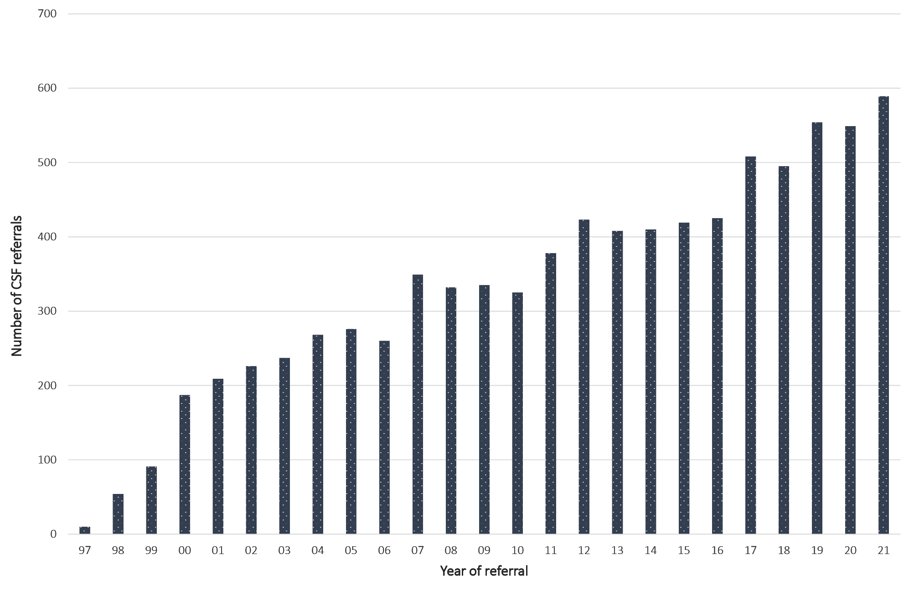
The number of suspected cases added to the ANCJDR register in 2021 follows the trend of increasing rates and was not significantly affected through the SARS-Cov-2 pandemic. The average annual number of suspected prion disease cases notified to the ANCJDR for the period 1997–2021 (i.e. since the introduction of diagnostic testing of CSF) is 73.
States and territories exhibited modest fluctuations in the annual number of suspect case notifications for 2021, compared to both the previous year and the longer-term average.
Of the 73 formal suspect case notifications received in 2021, seventeen cases were confirmed as ‘definite’ by neuropathological examination and thirteen cases were classified as ‘probable’ following detailed review of clinical information. Four cases were confirmed as non-prion disease following neuropathological assessment and two following detailed clinical case review, while 14 cases were still alive and considered ‘incomplete’ at the end of 2021; neuropathology reports were pending for 15 deceased suspected cases. It is routine for several months to elapse between performance of a post-mortem and completion of the neuropathology report. Another eight cases have died without autopsy and remain ‘incomplete’ pending detailed case investigation.
Since 1993, there has been a positive trend in the annual number of suspected cases of human prion disease undergoing post-mortem brain examination, or less commonly brain biopsies, albeit with relative plateauing over the last 15 years; beginning with twelve such cases in 1993 to around 30 to close to 50 brain autopsy referrals per year for the period from 2005 to 2020 (Figure 2). In 2021, of the 74 suspected CJD case deaths, 47 were referred for a brain post-mortem examination, with two additional patients undergoing pre-mortem brain biopsy.
Figure 2: Number of brain-only post-mortem (PM) examinations and brain biopsies (BBx) completed relative to suspect case deaths from 1993 to 2021, by year
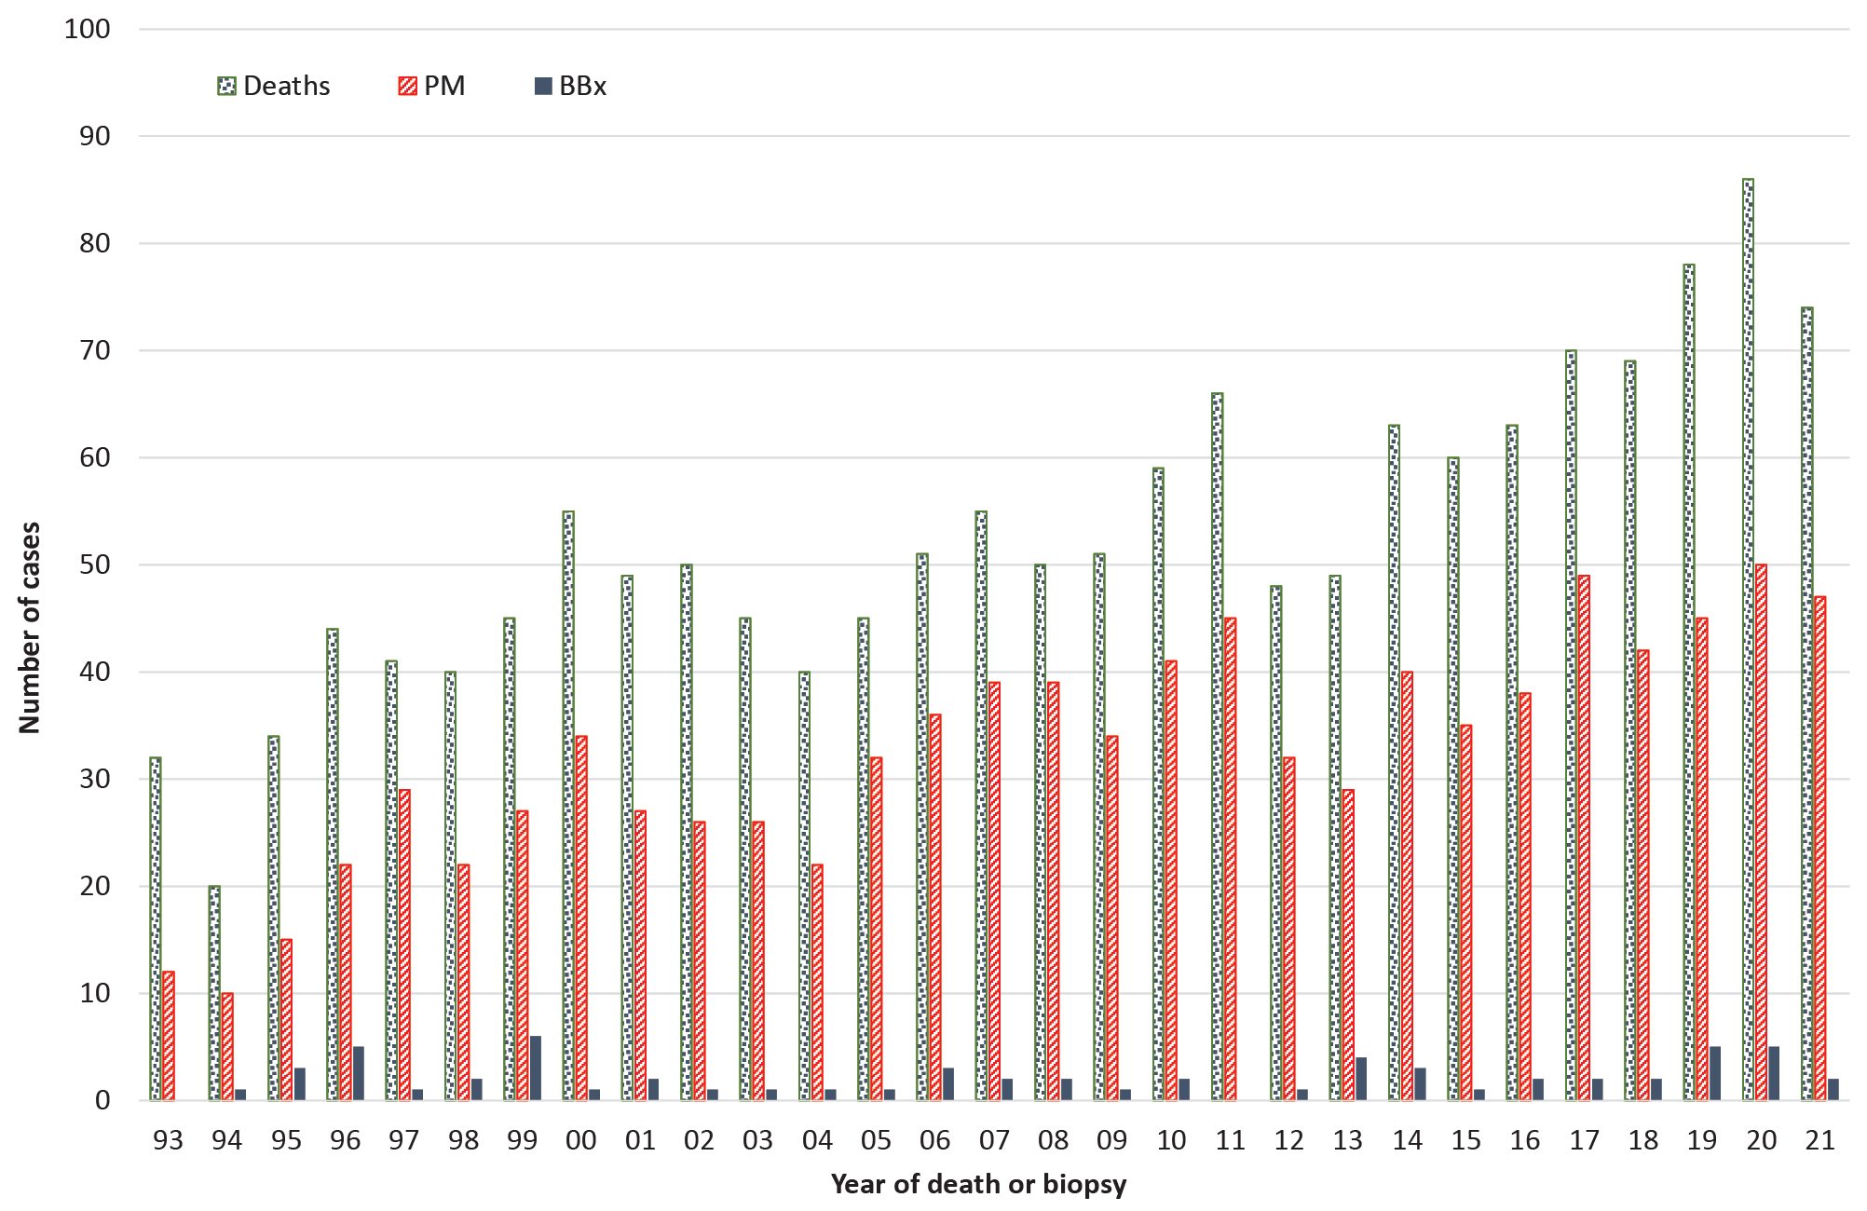
The average annual proportion of suspected prion disease cases on the register between 1993 and 2020 undergoing post-mortem brain examination is 63% (range 38–78%); the provisional proportion for 2021 is 64%. Annual suspected prion disease brain autopsy referrals by states and territories over the period 1993–2021 display considerable fluctuation in each jurisdiction. In the more populous states, there has generally been an overall temporal increase in brain autopsy referrals. In regions with smaller populations this positive trend is also present but less robust due to the relative impact of variation in the annual brain autopsy referrals caused by small population sizes and case numbers.
As of 31 December 2021, there were 1,442 cases on the ANCJDR register with 1,193 of these classified as ‘probable’ or ‘definite’ prion disease cases. An additional ‘definite’ iatrogenic case who was treated in Australia but died in the UK is included in Table 1; this case is not classified as an Australian case due to their location at death and is thereby excluded from the overall statistical analysis of Australian prion disease cases. Since the start of prospective surveillance in 1993, a total of 848 suspected prion disease cases have been excluded from the register after detailed follow-up.

Table 1: Overall summary of Australian human prion disease, 1 January 1970 to 31 December 2021
Classification | Sporadic | Familial | Iatrogenic | Variant CJD | Unclassified | Total
Definite | 693 | 63 | 5ª | 0 | 0 | 760
Probable | 400 | 30 | 4 | 0 | 0 | 434
Possible | 14 | 1 | 1 | 0 | 0 | 16
Incomplete |  | 4 | 0 | 0 | 228 | 232
Total | 1,107 | 98 | 9 | 0 | 228 | 1,442
a Includes one definite iatrogenic case who received pituitary hormone treatment in Australia, but disease onset and death occurred while a resident of the United Kingdom. This case is not included in statistical analysis since morbidity and mortality did not occur within Australia.
In 2021, forty-two cases were re-classified from ‘incomplete’ to ‘definite’ prion disease and 53 cases to ‘probable’ prion disease; no further cases of ‘possible’ prion disease were classified. The total number of ‘possible’ cases remains at 16, of which 14 were sporadic, plus one iCJD and one gCJD case (Table 1). In 2021, the total number of ‘incomplete’ cases under evaluation was slightly lower than in 2020.
The age-standardised mortality rate (ASR) for prion disease for 2021 is 1.18 deaths per million per year. This figure is provisional and almost certainly an underestimate, as 17 neuropathology reports are pending and nine cases who died in 2021 remain under investigation. Annual ASR values for human prion disease in Australia during the period of 1970 to 2020 have generally increased. The mean annual ASR during the period from 1970 to 2021 is 1.09 death per million (range 0.1–2.1). For the prospective surveillance period of 1993 to 2021, the annual mean ASR is 1.42 deaths per million (range 0.7–2.1). By state and territory, most regions in Australia have an annual mean ASR equivalent to or above one case per million per year between 1993 and 2021 (Table 2) with the exception of the Northern Territory. The lower rates of ascertainment in the Northern Territory may be explained by its small population and therefore vulnerability to variations and the impact of a missed case. Proximity to specialised health care and post-mortem services may also play a role in case under-ascertainment, as demonstrated in an autopsy referral rate of 38%, well below the national average of 63%.
A breakdown of annual case numbers and mortality rates is shown in Figure 3 and Table 2. The highest annual number of ‘probable’ and ‘definite’ prion disease cases reported, since surveillance commenced in 1993, was 68 in 2020, resulting in an annual ASR of 2.13 deaths per million. Higher mortality rates, ranging between 1.6 and 2.1, have been recorded since 2016; this coincides with the introduction of new diagnostic tools, such as CSF tau estimation and the RT-QUIC assay and improved MR brain imaging.
The proportions of human prion disease aetiologies on the ANCJDR register for 2021 remained similar to previous years (Figure 4); the vast majority of the 1,193 statistical cases of human prion disease are ‘sporadic’ (92%) while genetic and iatrogenic cases represent 8% and < 1%, respectively, of all ‘definite’ and ‘probable’ cases. No case of vCJD has yet been confirmed, including during 2021, although there have been cases of concern that have required thorough evaluation to exclude this possibility, with a recent example eventually shown to be the rare VV1 molecular subtype of sCJD.⁹
There are currently 1,093 ‘definite’ and ‘probable’ sporadic prion disease cases on the ANCJDR register. The distribution is almost equal between males (48%) and females (52%), with the slight predominance in females reflecting their longer life expectancy. The average age at death is 67 years, with a median of 68 years, ranging in age from 19 to 91 years. The average duration of illness is 6.3 months, with a median of 3.9 months, ranging from 0.9 to 60 months.
Figure 3: Human prion disease in Australia from 1993 to 2021; number of cases and age-standardised mortality rates (ASR), by year
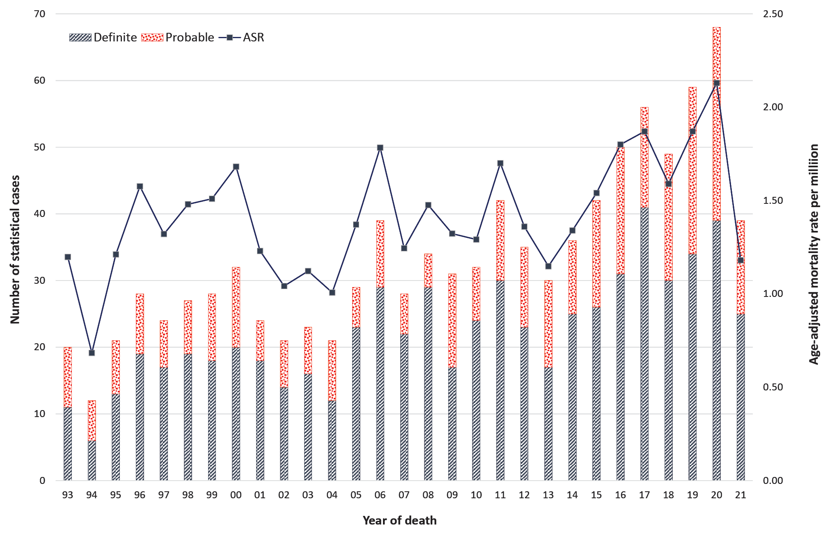
Table 2: ‘Definite’ and ‘probable’ cases of human prion disease from 1993 to 2021, by year and state or territory
Jurisdiction^{b} | 2021ª |  | 1993-2021
 | Cases | ASR^{c}  (dths/mill/yr) | Total cases | Long term average cases | Average ASR (dths/mill/yr)
ACT | 0 | 0 | 15 | 0.5 | 1.28
NSW | 13 | 1.25 | 312 | 10.8 | 1.39
NT | 0 | 0 | 6 | 0.2 | 0.67
Qld | 5 | 0.70 | 153 | 5.3 | 1.10
SA | 5 | 2.13 | 85 | 2.9 | 1.62
Tas. | 2 | 2.46 | 20 | 0.7 | 1.08
Vic. | 11 | 1.38 | 266 | 9.2 | 1.59
WA | 3 | 0.78 | 123 | 4.3 | 1.71
Australia | 39 | 1.18 | 980 | 33.8 | 1.42
a The figures for 2021 are provisional and almost certainly an underestimate, as 17 neuropathology reports are pending and nine cases who died in 2021 remain under investigation.
b ACT: Australian Capital Territory; NSW: New South Wales; NT: Northern Territory; Qld: Queensland; SA: South Australia; Tas.: Tasmania; Vic.: Victoria; WA: Western Australia.
c ASR: age-standardised mortality rate, in deaths per million population per year.

Figure 4: ‘Definite’ and ‘probable’ human prion disease cases 1970 to 2021,ª by year and aetiology
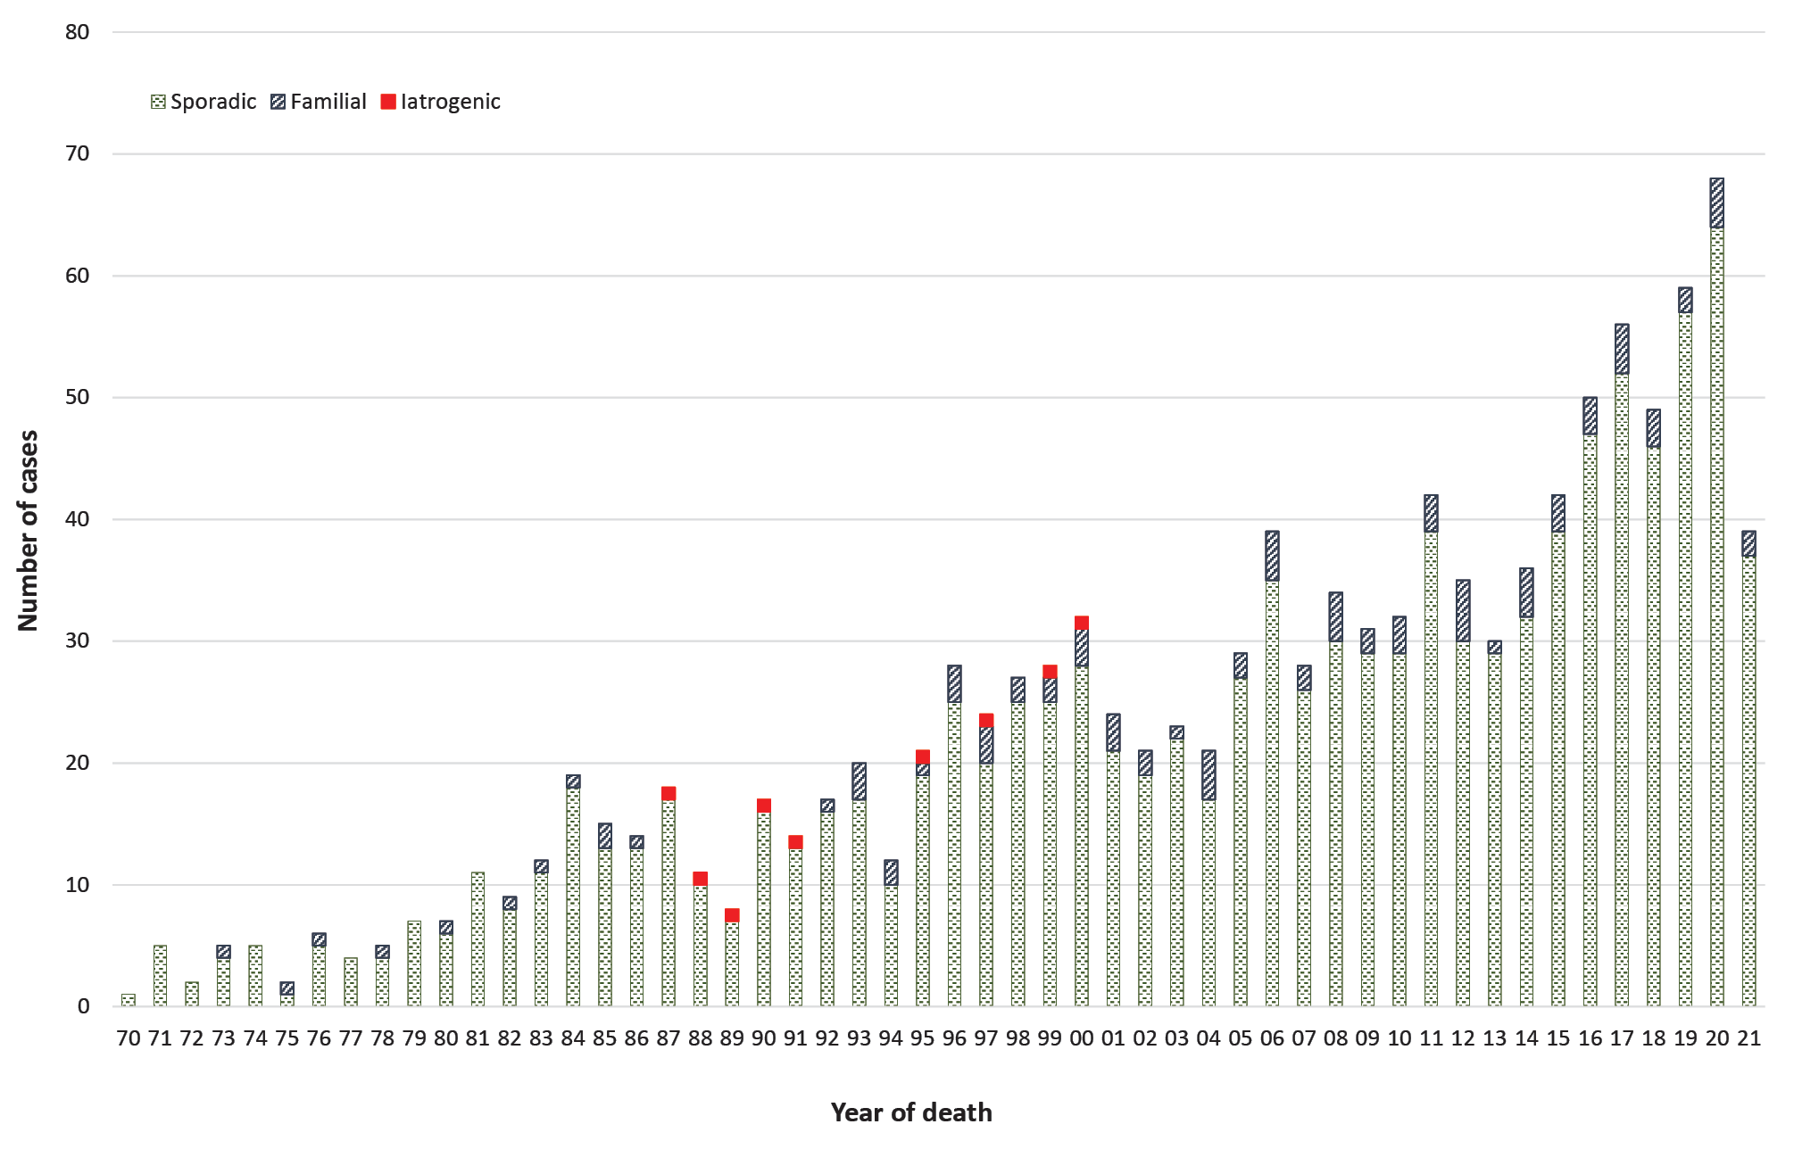
a Includes 1 definite iatrogenic case who received pituitary hormone treatment in Australia but disease onset and death occurred while a resident of the United Kingdom.
All sporadic CJD cases can be sub-classified by prion molecular subtype, determined by the combination of PrP^{Sc} glycotype and PRNP codon 129 genotype when frozen brain tissue is available. Ongoing ANCJDR PrP^{Sc} glycotyping has recently uncovered the first confirmed case of Variable Protease Sensitive Proteinopathy (VPSPr) in Australia, a rare subtype of sporadic prion disease first described in 2008.¹⁰ Our VPSPr case died in 2010 after an unusually long duration of illness of approximately 4.5 years, presenting initially with dizziness, balance problems and unsteady gait, progressing to mood deterioration, anxiety and eventually dementia. Investigations including electroencephalography (EEG), magnetic resonance imaging (MRI) and CSF 14-3-3 were not indicative of CJD, and the patient did not harbour any PRNP mutations, prompting their illness to be attributed to Alzheimer’s disease (on death certificate). Post-mortem examination of the brain found clear evidence of prion disease pathology, although the pattern of changes was unusual and their initial classification was consistent with possible sporadic fatal insomnia (sFI). It was only through specialist and thorough biochemical assessment of PrP^{Sc} that the molecular signature of VPSPr (ie the universal presence of the ladder-like electrophoretic profile) became evident. The re-classification of this case has prompted an ongoing review of previously glycotyped cases. VPSPr has an estimated incidence of approximately 1% of all sporadic prion disease,¹¹ providing an estimated number of VPSPr cases in Australia at approximately eleven.
There are currently 58 families affected by genetic prion disease on the ANCJDR register, comprising 93 individuals (63 ‘definite’ and 30 ‘probable’ cases) with a confirmed genetic aetiology, 57% of whom were female. The average age at death for genetic prion disease is approximately a decade younger than in sporadic prion disease, at 57.7 years, with the median of 60 years, ranging from 18 to 83 years; the average duration of illness is approximately 7 months longer than in sporadic prion disease, at 13.6 months, with a median of 5 months, ranging from 1.3 to 192 months. The average age at death in males is 57 years, with a median of 59 years, ranging in age from 20 to 83 years. The average duration of illness in males is 12.4 months, with a median of 4.1 months, ranging from 1.3 to 108 months. The average age at death in females is 58.6 years, with a median of 62 years, ranging in age from 18 to 82 years; the average duration in females is 14.4 months, with a median of 7 months, ranging from 1.5 to 192 months. Three PRNP gene mutation carriers (all with the E200K mutation) were removed from the register after brain autopsies excluded evidence of prion disease. These three E200K carriers died aged 70 or older; the mean age at death for the E200K mutation is 63 years. Five cases on the register remain under investigation without a neuropathological or case classification outcome; however, there is a documented concern for genetic prion disease. Five families are of unspecified PRNP status, although there is a recorded family history of prion disease. The range of PRNP mutations in Australian genetic prion disease cases is shown in Table 3. In 2021, six cases of genetic prion disease were confirmed. The utility of diagnostic biomarkers for genetic prion disease, especially those found in CSF, continues to be defined.¹²
Table 3: Prion protein gene (PRNP) sequence variations/mutations identified in Australian cases
Mutation/Polymorphism | Definite/probable  cases | Cases  PM proven  Not CJD
E200K | 42 | 3
D178N | 15 | 0
V210I | 8 | 0
P105T | 6 | 0
P102L | 5 | 0
Insert mutations/OPRIª | 4 | 0
Other mutations^{b} | 7 | 0
Not determined | 6 | 0
Total | 93 | 3
a OPRI - abbreviation for octapeptide repeat insertion.
b G131V, T188A, V180I, A133V, V176G, E200D, V189I.

Discussion
In 2021, the number of suspected prion disease referrals and confirmed cases broadly matched the long-term average (1997–2020). Australia continued to be free of vCJD and no further cases of iCJD were detected. By state and territory, the numbers of suspected case referrals showed generally only modest fluctuations during 2021 compared to previous years; the fluctuations seen in 2021 are within previously observed ranges.
Long-term national surveillance units report differing annual prion disease mortality rates, ranging from 0.24 to 4.56 per million population.^{4,5} Higher rates of human prion disease over short time frames have also been recognised and investigated in various global settings with inconclusive outcomes.¹³ The underlying basis for fluctuations and differences in national mortality rates is uncertain, although variation in case ascertainment is one potentially contributing factor.⁶
Spatio-temporal clustering of CJD has previously been recognised in New South Wales and Victoria.^{14, 15} Detailed epidemiological assessment by the ANCJDR did not disclose any likely horizontal transmission event, but instead uncovered a heightened intensity of surveillance.¹⁴ This more intense level of surveillance was reflected by the significantly higher rates of referrals of suspect prion disease cases for evaluation and diagnostic testing to the ANCJDR, as well as higher neuropathological examination rates in suspected patients.^{6,14,15} Monitoring of the geographical distribution of suspected case referrals and confirmed cases remains an important facet of ANCJDR national surveillance.
An overall increase in sporadic CJD cases has also been observed in Australia and is most likely due to a combination of an ageing population, improved case ascertainment and diagnostic methodologies, and greater awareness of prion disease in the healthcare sector.^{5,14} The gradual but notable increase in the incidence of sCJD, but not that of genetic CJD, has also been reported in other countries with longstanding prion disease surveillance and supports the notion that it is a result of the globally ageing population.^{5,16}
Ascertainment mechanisms in 2021 were unchanged compared to recent years, with the majority of initial referrals coming through requests for diagnostic CSF 14-3-3 protein testing. Some proactive ascertainment mechanisms (such as state health department and tertiary hospital mortality data base searches) have ceased, while other case detection methods have increased. The number of CSF referrals to the ANCJDR for diagnostic (14-3-3 protein) testing remained high for 2021. A 20% increase in diagnostic test referrals coincided with the introduction of CSF total-tau protein estimation and the identification of misfolded prion protein in CSF by real time conversion assays (such as RT-QuIC) in 2017.
The proportion of post-mortems being performed in suspect prion disease cases remains high and aligns with the long-term mean brain autopsy percentage of approximately 63% (of suspected case deaths) between 1993 and 2020. This contrasts with the findings of an Australian healthcare setting survey where the national hospital post-mortem rate was 12% in 2002–2003;¹⁷ more recently, a major Australian tertiary centre audit of hospital autopsy data has described an autopsy rate of 6.6% in 2011–2013.¹⁸ The high suspected prion-disease-related post-mortem rate underpins the high and consistent number of confirmed Australian human prion disease cases recorded over the more recent prospective surveillance time period, and provides confident understanding of the cause of death in suspected cases ultimately determined as non-prion disease.
A recent study by the ANCJDR of prion disease in Indigenous Australians has confirmed that sporadic CJD occurs in Indigenous Australians throughout Australia with a phenotype and incidence rate equivalent to non-Indigenous Australians, supporting the adequacy of national human prion disease surveillance.¹⁹
No further iCJD cases were confirmed in Australia during 2021. The most recent human cadaveric pituitary gonadotrophin-related CJD death occurred in 1991, while the most recent Lyodura-related CJD death occurred in 2000. In 2021, Japan reported two iCJD cases, associated with dura mater transplants.²⁰
Since vCJD was first reported in 1996, a total of 232 patients, from 12 countries, have been identified with this disease. The most recent vCJD case died in France in 2021. A recent vCJD case (death occurred in 2016) from the UK was the first to be reported as methionine-valine heterozygous at codon 129 of the PRNP gene;²¹ all cases previously had been methionine homozygous. The patient was 36 years old when he presented with psychiatric symptoms prior to onset of neurological features that included cognitive decline, ataxia and myoclonus, dying after an illness of 20 months. CSF 14-3-3 and RT-QuIC were negative. Brain MRI revealed features more typical of sporadic CJD (bilateral high signal in basal ganglia) without any posterior thalamic high signal (‘pulvinar sign’). The patient did not meet the epidemiologic diagnostic surveillance criteria for ‘probable’ or ‘possible’ vCJD, although fulfilled criteria for ‘probable’ sCJD; neuropathology, including western blot glycotyping, was typical of vCJD. It remains uncertain whether this case marks the start of a second wave of vCJD affecting those heterozygous for methionine-valine at codon 129. This case also underscores the importance of performing suspect CJD brain autopsy examinations and the benefits of maintaining high-level surveillance within Australia. The most recent three vCJD cases, who died in France in 2019 and 2021 and Italy in 2016, are considered to be plausibly related to accidental occupational exposure incidents in laboratory settings.^{22–24}
The horizontal transmission of amyloid beta (Aβ) peptides associated with Alzheimer’s disease through contaminated pituitary hormone treatments and dura mater grafts is essentially proven^{25–27} with the likelihood that contaminated neurosurgical instruments may also be a source of transmission.²⁸ It is also becoming increasingly accepted that such inadvertent inoculation can eventuate many years later in a disease phenotype.²⁹ Prion protein and Aβ protein share similar properties, such as prion-like mechanisms of template-directed protein propagation, as well as inter-cellular spread of the misfolded protein isoforms and formation of larger fibrils. The slow propagation is associated with prolonged long incubation periods before these proteins result in overt clinical and pathological evidence of disease following inoculation. Further studies are required to resolve the important issue of the risk of Aβ peptide transmission during routine surgical procedures. History of neurosurgery, embolisation procedures with the use of dura mater in infancy or childhood, and any other therapeutic procedures involving the use of dura mater or cadaver-derived pituitary hormones should be searched for in patients who develop early-onset cerebral amyloid angiopathy (CAA). In 2021, four recipients of cadaver-derived human pituitary hormones were investigated at the Royal Melbourne Hospital for early-onset CAA. A manuscript reporting the findings of this research is currently under peer review.

Acknowledgements
The ANCJDR wishes to thank families, as well as medical practitioners and associated staff, for their generous support of Australian CJD surveillance. The ANCJDR also thanks Associate Professor Handan Wand, Professor Matthew Law and Professor John Kaldor (The Kirby Centre; formerly the National Centre in HIV Epidemiology and Clinical Research at the University of New South Wales) for their expert ad hoc epidemiological and statistical support, as well as the CJD Support Group Network for their assistance in surveillance activities.

Author details
Dr Christiane Stehmann – Coordinator, Australian National Creutzfeldt-Jakob Disease Registry (ANCJDR)¹
Dr Matteo Senesi – Research Fellow, ANCJDR²
Ms Shannon Sarros – Research Assistant, ANCJDR¹
Ms Amelia McGlade – Research Assistant, ANCJDR¹
Dr Victoria Lewis – Research Fellow, ANCJDR²
Dr Marion Simpson – Neurologist, ANCJDR¹
Ms Genevieve Klug – Research Assistant, ANCJDR¹
Professor Catriona A McLean – Neuropathologist, ANCJDR^{1,3}
Professor Colin L Masters – Director, ANCJDR¹
Professor Steven J Collins – Director, ANCJDR²
- The Florey Institute, The University of Melbourne, Victoria, 3010, Australia
- Department of Medicine, The University of Melbourne, Victoria, 3010, Australia
- The Alfred Hospital, Department of Anatomical Pathology, 55 Commercial Rd, Melbourne Vic 3004 Australia

Corresponding author
Prof Steven Collins
Australian National Creutzfeldt-Jakob Disease Registry, Department of Medicine, The University of Melbourne, Victoria, 3010, Australia.
Telephone: +61 8344 1949.
Facsimile: +61 9349 5105.
Email: s.collins@unimelb.edu.au

References
- Klug GM, Boyd A, Zhao T, Stehmann C, Simpson M, McLean CA et al. Surveillance for Creutzfeldt-Jakob disease in Australia: update to December 2012. Commun Dis Intell Q Rep. 2013;37(2):E115–20.
- Allars M. Report of the inquiry into the use of pituitary derived hormones in Australia and Creutzfeldt-Jakob disease. Canberra: AGPS, 1994.
- Zerr I, Kallenberg K, Summers DM, Romero C, Taratuto A, Heinemann U et al. Updated clinical diagnostic criteria for sporadic Creutzfeldt-Jakob disease. Brain. 2009;132(10):2659–68. doi: https://doi.org/10.1093/brain/awp191.
- Creutzfeldt-Jakob Disease International Surveillance Network: Surveillance Data. [Internet.] Solna: European Centre for Disease Prevention and Control; 2021. Available from: https://www.eurocjd.ed.ac.uk/data_tables.
- Uttley L, Carroll C, Wong R, Hilton DA, Stevenson M. Creutzfeldt-Jakob disease: a systematic review of global incidence, prevalence, infectivity, and incubation. Lancet Infect Dis. 2020;20(1):e2–10. doi: https://doi.org/10.1016/S1473-3099(19)30615-2.
- Klug GM, Wand H, Simpson M, Boyd A, Law M, Masters CL et al. Intensity of human prion disease surveillance predicts observed disease incidence. J Neurol Neurosurg Psychiatry. 2013;84(2):1372–7. doi: https://doi.org/10.1136/jnnp-2012-304820.
- Roche Diagnostics. The power of Elecsys® in Alzheimer’s disease. [Internet.] Basel: Roche Diagnostics; 2022. Available from: https://diagnostics.roche.com/global/en/article-listing/health-topics/neurology/the-power-of-elecsys-in-alzheimers-disease.html.
- Australian Bureau of Statistics. National, state and territory population - reference period June 2021. [Webpage.] Canberra: Australian Bureau of Statistics; 16 December 2021. [Accessed on 2 February 2022.] Available from: https://www.abs.gov.au/statistics/people/population/national-state-and-territory-population/jun-2021#data-download.
- Holper S, Lewis V, Wesselingh R, Gaillard F, Collins SJ, Butzkueven H. Comprehensive clinical, radiological, pathological and biochemical analysis required to differentiate VV1 sporadic Creutzfeldt-Jakob disease from suspected variant CJD. BMJ Neurol Open. 2022;4(1):e000299. doi: https://doi.org/10.1136/bmjno-2022-000299.
- Gambetti P, Dong Z, Yuan J, Xiao X, Zheng M, Alshekhlee A et al. A novel human disease with abnormal prion protein sensitive to protease. Ann Neurol. 2008;63(6):697–708. doi: https://doi.org/10.1002/ana.21420.
- Notari S, Appleby BS, Gambetti P. Variably protease-sensitive prionopathy. Handb Clin Neurol. 2018;153:175–90. doi: https://doi.org/10.1016/B978-0-444-63945-5.00010-6.
- Schmitz M, Villar-Piqué A, Hermann P, Escaramís G, Calero M, Chen C et al. Diagnostic accuracy of cerebrospinal fluid biomarkers in genetic prion diseases. Brain. 2022;145(2):700–12. doi: https://doi.org/10.1093/brain/awab350.
- Glatzel M, Rogivue C, Ghani A, Streffer JR, Amsler L, Aguzzi A. Incidence of Creutzfeldt-Jakob disease in Switzerland. Lancet. 2002;360(9327):139–41. doi: https://doi.org/10.1016/S0140-6736(02)09384-4.
- Klug GM, Wand H, Boyd A, Law M, Whyte S, Kaldor J et al. Enhanced geographically restricted surveillance simulates sporadic Creutzfeldt-Jakob disease cluster. Brain. 2009:132(2);493–501. doi: https://doi.org/10.1093/brain/awn303.
- Collins S, Boyd A, Fletcher A, Kaldor J, Hill A, Farish S et al. Creutzfeldt-Jakob disease cluster in an Australian rural city. Ann Neurol. 2002;52(1):115–8. doi: https://doi.org/10.1002/ana.10224.
- Stevenson M, Uttley L, Oakley JE, Carroll C, Chick SE, Wong R. Interventions to reduce the risk of surgically transmitted Creutzfeldt-Jakob disease: a cost-effective modelling review. Health Technol Assess. 2020;24(11):1–150. doi: https://doi.org/10.3310/hta24110.
- The Royal College of Pathologists of Australasia Autopsy Working Party. The decline of the hospital autopsy: a safety and quality issue for healthcare in Australia. Med J Aust. 2004;180(6):281–5. doi: https://doi.org/10.5694/j.1326-5377.2004.tb05926.x.
- Jackett L, McLean C. Hospital autopsy audit: discordant primary clinical diagnoses are found in 20% of cases in a reducing autopsy case load. Selection bias or significant findings? Pathology. 2015;47(6):499–502. doi: https://doi.org/10.1097/PAT.0000000000000297.
- Panegyres PK, Stehmann C, Klug GM, Masters CL, Collins S. Prion disease in Indigenous Australians. Intern Med J. 2020. doi: https://doi.org/10.1111/imj.14835.
- Japanese CJD Surveillance Unit. Personal communication.
- Mok T, Jaunmuktane Z, Joiner S, Campbell T, Morgan C, Wakerley B et al. Variant Creutzfeldt–Jakob disease in a patient with heterozygosity at PRNP codon 129. N Engl J Med. 2017;376(3):292–4. doi: https://doi.org/10.1056/NEJMc1610003.
- Watson N, Brandel JP, Green A, Hermann P, Ladogana A, Lindsay T et al. The importance of ongoing international surveillance for Creutzfeldt-Jakob disease. Nat Rev Neurol. 2021;17(6):362–79. doi: https://doi.org/10.1038/s41582-021-00488-7.
- Brandel JP, Vlaicu MB, Culeux A, Belondrade M, Bougard D, Grznarova K et al. Variant Creutzfeldt–Jakob disease diagnosed 7.5 years after occupational exposure. N Engl J Med. 2020;383(1):83–5. doi: https://doi.org/10.1056/NEJMc2000687.
- Brandel JP. Personal communication; February 2022.
- Alnakhli SH, Wand H, Law M, Sarros S, Stehmann C, Senesi M et al. Intra-cerebral haemorrhage but not neurodegenerative disease appears over-represented in deaths of Australian cadaveric pituitary hormone recipients. J Clin Neurosci. 2020;81:78–82. doi: https://doi.org/ 10.1016/j.jocn.2020.09.021.
- Cali I, Cohen ML, Haїk S, Parchi P, Giaccone G, Collins SJ et al. Iatrogenic Creutzfeldt-Jakob disease with Amyloid-β pathology: an international study. Acta Neuropathol Commun. 2018;6(1):5. doi: https://doi.org/10.1186/s40478-017-0503-z.
- Purro SA, Farrow MA, Linehan J, Nazari T, Thomas DX, Chen Z et al. Transmission of amyloid-β protein pathology from cadaveric pituitary growth hormone. Nature. 2018;564(7736):415–9. doi: https://doi.org/10.1038/s41586-018-0790-y.
- Jaunmuktane Z, Quaegebeur A, Taipa R, Viana-Baptista M, Barbosa R, Koriath C et al. Evidence of amyloid-β cerebral amyloid angiopathy transmission through neurosurgery. Acta Neuropathol. 2018;135(5):671–9. doi: https://doi.org/10.1007/s00401-018-1822-2.
- Banerjee G, Adams ME, Jaunmuktane Z, Lammie GA, Turner B, Wani M et al. Early onset cerebral amyloid angiopathy following childhood exposure to cadaveric dura. Ann Neurol. 2019;85(2):284–90. doi: https://doi.org/10.1002/ana.25407.

Appendix A
EUROCJD diagnostic criteria for surveillance of sporadic CJD from 1 January 2017
Definite:
Progressive neurological syndrome AND Neuropathologically or immunohistochemically or biochemically confirmed
Probable:
I + two of II and typical EEGª
OR
1.2.2 I + two of II and typical MRI brain scan^{b}
OR
1.2.3 I + two of II and positive CSF 14-3-3
OR
1.2.4 Progressive neurological syndrome and positive RT-QuIC in CSF or other tissues
Possible:
I + two of II + duration < 2 years
I Rapid progressive cognitive impairment
II A Myoclonus
B Visual or cerebellar problems
C Pyramidal or extrapyramidal features
D Akinetic mutism
a Generalised periodic complexes
b High signal in caudate/putamen and MRI brain scan or at least two cortical regions (temporal, parietal, occipital) either on DWI or FLAIR

Communicable Diseases Intelligence
ISSN: 2209-6051 Online

Communicable Diseases Intelligence (CDI) is a peer-reviewed scientific journal published by the Office of Health Protection and Response, Department of Health and Aged Care. The journal aims to disseminate information on the epidemiology, surveillance, prevention and control of communicable diseases of relevance to Australia.

Editor: Noel Lally
Deputy Editor: Simon Petrie
Design and Production: Kasra Yousefi
Editorial Advisory Board: David Durrheim, Mark Ferson, John Kaldor, Martyn Kirk and Linda Selvey

Website: http://www.health.gov.au/cdi

Contacts
CDI is produced by the Office of Health Protection and Response, Australian Government Department of Health and Aged Care, GPO Box 9848, (MDP 6) CANBERRA ACT 2601

Email: cdi.editor@health.gov.au

Submit an Article
You are invited to submit your next communicable disease related article to the Communicable Diseases Intelligence (CDI) for consideration. More information regarding CDI can be found at: http://health.gov.au/cdi.
Further enquiries should be directed to: cdi.editor@health.gov.au.

This journal is indexed by Index Medicus and Medline.

Creative Commons Licence - Attribution-NonCommercial-NoDerivatives CC BY-NC-ND
© 2022 Commonwealth of Australia as represented by the Department of Health and Aged Care
This publication is licensed under a Creative Commons Attribution-NonCommercial-NoDerivatives 4.0 International Licence from https://creativecommons.org/licenses/by-nc-nd/4.0/legalcode (Licence). You must read and understand the Licence before using any material from this publication.

Restrictions
The Licence does not cover, and there is no permission given for, use of any of the following material found in this publication (if any):
- the Commonwealth Coat of Arms (by way of information, the terms under which the Coat of Arms may be used can be found at www.itsanhonour.gov.au);
- any logos (including the Department of Health and Aged Care’s logo) and trademarks;
- any photographs and images;
- any signatures; and
- any material belonging to third parties.

Disclaimer
Opinions expressed in Communicable Diseases Intelligence are those of the authors and not necessarily those of the Australian Government Department of Health and Aged Care or the Communicable Diseases Network Australia. Data may be subject to revision.

Enquiries
Enquiries regarding any other use of this publication should be addressed to the Communication Branch, Department of Health and Aged Care, GPO Box 9848, Canberra ACT 2601, or via e-mail to: copyright@health.gov.au

Communicable Diseases Network Australia
Communicable Diseases Intelligence contributes to the work of the Communicable Diseases Network Australia.
http://www.health.gov.au/cdna

