FluTracking: Weekly online community based surveillance of influenza-like illness in Australia, 2018 Annual Report
Zachary L Howard, Sandra J Carlson, Sarah Moberley, Michelle Butler, Craig B Dalton

Abstract
FluTracking experienced major growth in 2018, with participation numbers increasing 34.1% from 2017. The addition of 16,881 new participants brought the total number of participants for 2018 to 45,532. A majority of participants continued to complete their survey within 24 hours of the email being sent (mean 74.3% responses received in 24 hours).
The rate of influenza-like illness (ILI) in 2018 was the lowest since FluTracking commenced in 2007 and was consistently low across all ages. The peak weekly ILI rate was consistent with previous years, occurring during the week ending 19 August. This preceded the peak in laboratory-confirmed influenza notifications by three weeks.
During the peak week of FluTracking, 2.1% of unvaccinated, and 1.9% of vaccinated participants reported fever and cough. By the final survey of 2018, 65.6% of participants had received the annual influenza vaccine, compared with 60.2% in 2017. Vaccination rates in participants under five years of age doubled from 23.7% in 2017, to 55.6% in 2018.
During the peak four weeks of reported ILI, a lower percentage of participants sought medical care in 2018 compared to 2017 (36.7% and 42.3% respectively), and fewer participants reported a positive laboratory test for influenza (0.8% and 4.8%). Overall the severity of the 2018 season was one of the lowest FluTracking has recorded.
Rates of both influenza laboratory notifications and general practitioner (GP) ILI consultations were lower in 2018 than most prior years. We found a reduction in the percentage of FluTracking participants with ILI who were tested for influenza (3.2% compared with 5.0% in 2017), and who visited a medical practitioner (36.7% compared with 42.3% in 2017). The drop in laboratory-confirmed cases and Australian Sentinel Practices Research Network (ASPREN) reported GP consultations concurs with our survey results that 2018 was a milder influenza season than many previous.
Keyword: FluTracking, influenza, surveillance

Introduction
FluTracking provides weekly community level influenza-like illness (ILI) surveillance that is not biased by health seeking behaviour, clinician testing practices or differences in jurisdictional surveillance methods.^{1–5} FluTracking provides an indication of the differential ILI attack rates by age and geography, and seriousness of disease at a community level.⁶ The FluTracking surveillance system has been incorporated into the weekly Australian Influenza Surveillance Report since 2009.⁷
The main aims of FluTracking are to:
- contribute to community level influenza surveillance in Australia;
- provide consistent surveillance of influenza attack rates across all jurisdictions and over time; and
- provide year-to-year comparison of the timing, attack rates, and seriousness of influenza in the community.
In this report, we:
- describe the epidemiology of ILI in the community;
- describe influenza vaccine coverage and laboratory influenza testing self-reported by participants;
- describe the performance characteristics of the FluTracking system;
- compare FluTracking ILI estimates with notifications of laboratory-confirmed influenza; and
- compare ILI consultation rates from the Australian Sentinel Practices Research Network (ASPREN) with the percentage of FluTracking participants with ILI who visited a general practitioner (GP).

Methods
The FluTracking surveillance system operated for 26 weeks from the week ending Sunday 29 April to the week ending Sunday 21 October 2018. The recruitment drive commenced on 24 April and continued through to the end of May, although participants were able to join at any time during the year. Recruitment methods were similar to those used in 2007–2017.⁸ The weekly survey questions evolved from 2007–2012.^{1,2,4,8}
Descriptive statistics were tabulated and summarised for each state and territory, by age group, sex, education level, Aboriginal and Torres Strait Islander status, and influenza vaccination status. Note that FluTracking asks if a participant ‘identifies’ as Aboriginal or Torres Strait Islander, rather than asking if a participant is of Aboriginal or Torres Strait Islander ‘origin’. The rationale for this decision is discussed elsewhere.⁹
A participant was defined as anyone who had a survey submitted by themself or on their behalf. A respondent was anyone who submitted a survey either for themself or on behalf of a household member. Each household has one only respondent but can have multiple participants.
The participation rate for state and territory, age group, and sex was calculated using the Australian Bureau of Statistics June 2018 Estimated Resident Population.¹⁰ The participation rate for education level was calculated using the 2016 Australian Census data, and Aboriginal and Torres Strait Islander status used the 2016 Australian Census data.^{11,12}
Unless otherwise stated, an ILI case was defined as a participant who reported both fever and cough. For all ILI analyses, any surveys including a response of ‘don’t know’ for the ‘fever’ or ‘cough’ or ‘influenza vaccination status’ or ‘time off work or normal duties’ variables were removed from analysis. ILI percentages include all vaccinated and unvaccinated participants unless otherwise noted or stratified.
For ILI percentage calculations, the numerator was all participants who completed a survey for the current week and reported new ILI symptoms, and the denominator was all participants who completed a survey for that week (excluding participants who responded ‘don’t know’ as noted above). Where there were consecutive weeks of reporting ILI symptoms, only the first week of onset of symptoms was used to determine attack rates. Symptoms reported following at least one week with no symptoms, or following at least two missing surveys, were treated as a new case of ILI.
A participant was considered to be effectively vaccinated two survey periods after they reported being vaccinated. This delay was not applied to any participants who reported being vaccinated in their first FluTracking survey for the year.
We analysed the percentage of vaccinated participants for the following groups: those aged less than 5 years, those greater than 65 years, and those who identified as working face-to-face with patients. Weekly ILI percentages were compared by self-reported vaccination status, adjusted by effective vaccination as described above.
We compared the weekly percentage of participants who reported ILI across 2011 to 2018 alongside two additional severity definitions: 1) two or more days off work or normal duties; and 2) visited a GP, emergency department, or were admitted to hospital due to ILI.
ILI percentages were compared with national laboratory confirmed influenza notifications for 2009 to 2018.
The mean weekly percentage of FluTracking participants with ILI that were tested for influenza was compared across states and territories from 2013 to 2018.
We compared the percentage of participants reporting ILI in the peak four weeks, and cumulative incidence of ILI across the season, stratified by age group.
For 2014 to 2018, we also compared the weekly percentage of FluTracking participants with ILI who visited a GP, to the Australian Sentinel Practices Research Network (ASPREN) rate per 1,000 consultations of fever, cough, fatigue.¹³

Results

Recruitment
An additional 16,881 FluTracking participants were recruited in 2018, slightly more than the previous two years combined (7,785 and 8,609 new participants recruited during 2017 and 2016 respectively).
For 2018, the most successful recruitment strategy continued to be the email asking existing participants to invite two friends (with 5,749 participants signing up in the following six days). There was overlap between the first survey sent on 30 April and an email invite to a website subscription list targeting Australians aged 65 years and over (wyza.com.au) on 1 May (with 4,136 new participants over the following six days, Figure 1). A total of 1,407 participants signed up by following the link in their WYZA email.
Facebook posts were boosted in April and May, which resulted in a combined 1,992 likes, 347 comments, 1,360 shares and a reach of 195,788. The number of “likes” for the FluTracking Facebook page increased from 5,097 to 6,716; the page had 6,645 followers at the end of the FluTracking surveillance period.

Figure 1: Significant FluTracking recruitment events and impact, 2018
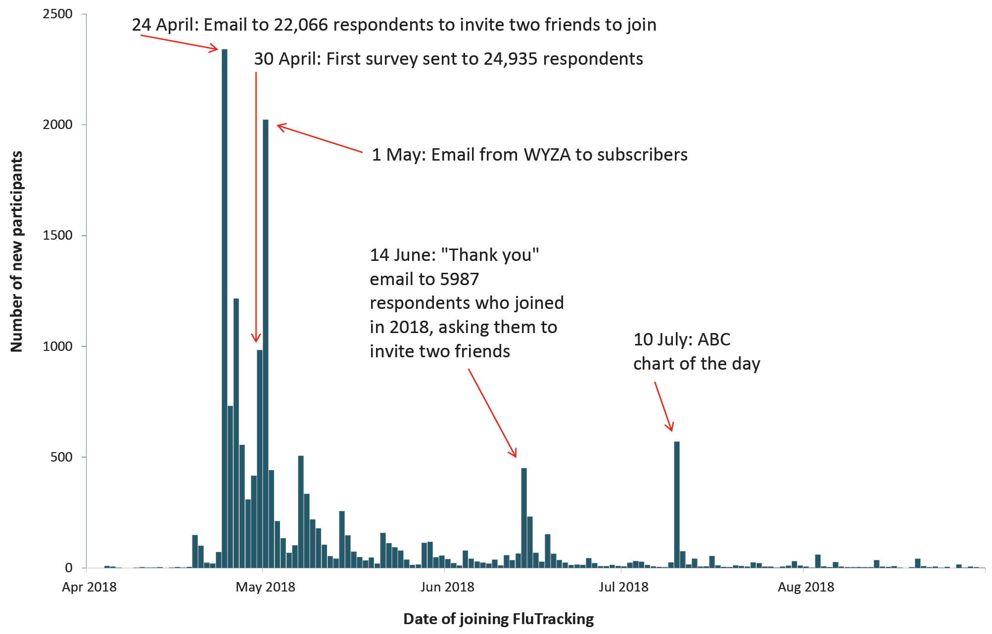

Participation
At least one survey was completed by 25,895 respondents and 19,637 household members for a total of 45,532 participants. This represented a 34.1% increase from 2017 (n = 33,947, Figure 2). Of the 42,400 participants who completed a survey during the first four survey weeks, 67.5% (28,606) completed all available surveys, and 80.3% (34,045) completed more than 90.0% of available surveys. Eighty-five percent of the 2017 participants (n = 28,922) returned in 2018 to complete at least one survey, and this group comprised 64.0% of the 2018 participants.
During 2018, percentage increases in peak week participation were most marked in New South Wales, Victoria and Queensland. Queensland was the only jurisdiction with fewer than 100 participants (89.7) per 100,000 population (Appendix A, Table A.1). Tasmania continued to have the highest rate of FluTracking participation, with 619.7 FluTracking participants per 100,000 population (Figure 3 and Appendix A, Table A.1).

Figure 2: Number of participants who completed at least one survey, Australia, 2006 to 2018, by year
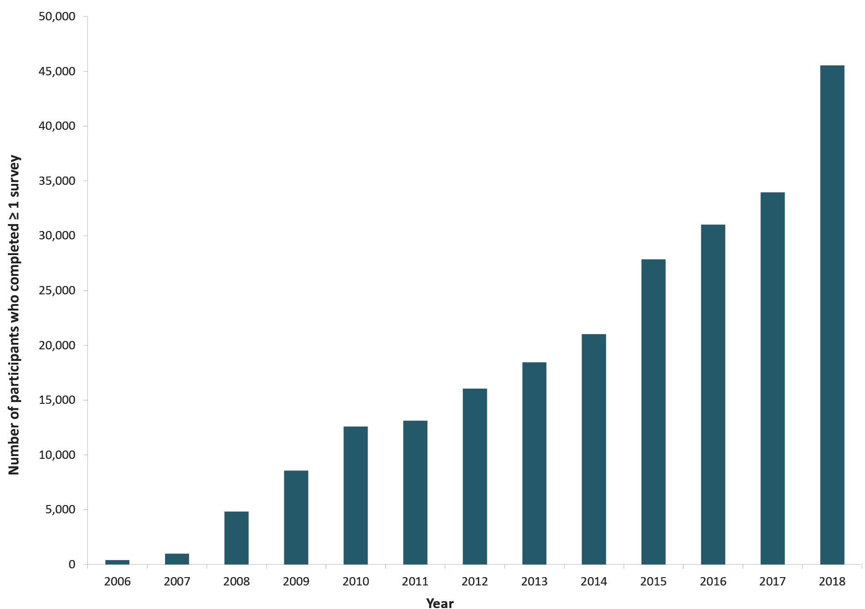
Figure 3. FluTracking participation per 100,000 population, by jurisdiction, 2018
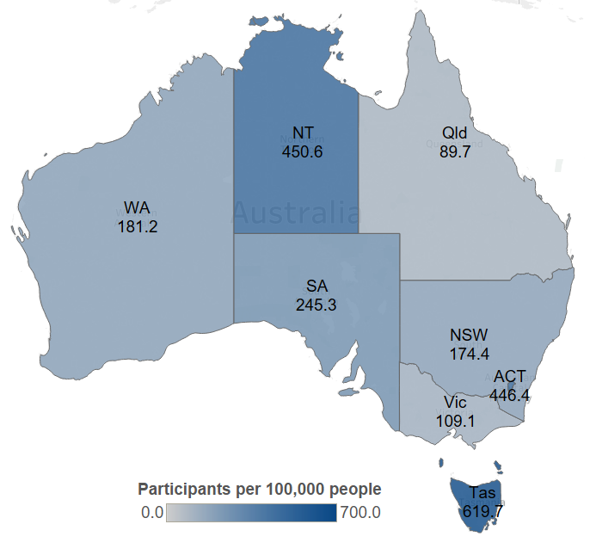

Socio-demographic characteristics
Of the participants who completed at least one survey in 2018, complete demographic details were available for 42,696 (773 participants were missing sex, 1,342 were missing education, and 2,238 were missing Aboriginal and Torres Strait Islander status; these participants signed up prior to these data being collected). The largest age bracket was participants aged 50 to 64 years (31.1%), followed by participants aged 35 to 49 years (22.7%); 16 to 34 years (15.6%); 65 years and over (17.3%); and 0 to 15 years (13.3%, Appendix A, Table A.2). More participants were female (59.8%) than male (40.2%), and the largest education group was ‘completed a bachelors degree’ (23.7%). The percentage of participants who identified as being Aboriginal or Torres Strait Islander remained at 1.6% (compared to 3.3% of the Australian population).

Time to respond to survey each week
Most participants responded within 24 hours of the survey being sent, with a mean 24-hour response of 74.3% over the 26 weeks. The 65 years or over age group had the highest mean 24-hour response of 81.3% over the 26 weeks.

Percentage of participants vaccinated
By the final survey for 2018, the annual influenza vaccine had been received by 65.7% of participants (29,891/45,531), compared with 60.2% of 2017 participants (20,421/33,947) vaccinated by the end of 2017 (Figure 4). Participants aged less than five years had the largest increase in vaccine coverage, with 55.6% coverage compared to 23.7% in 2017. Participants aged 65 years and above had the highest coverage, at 86.6%, which was slightly higher than 84.2% in 2017.
Of the 7,956 participants in 2018 who identified as working face-to-face with patients, 6,586 (82.8%) received the vaccine compared with 80.2% by the end of 2017.

Figure 4: Influenza vaccination uptake at the final survey of each participant, by participant characteristics, Australia, 2007 to 2018, by year
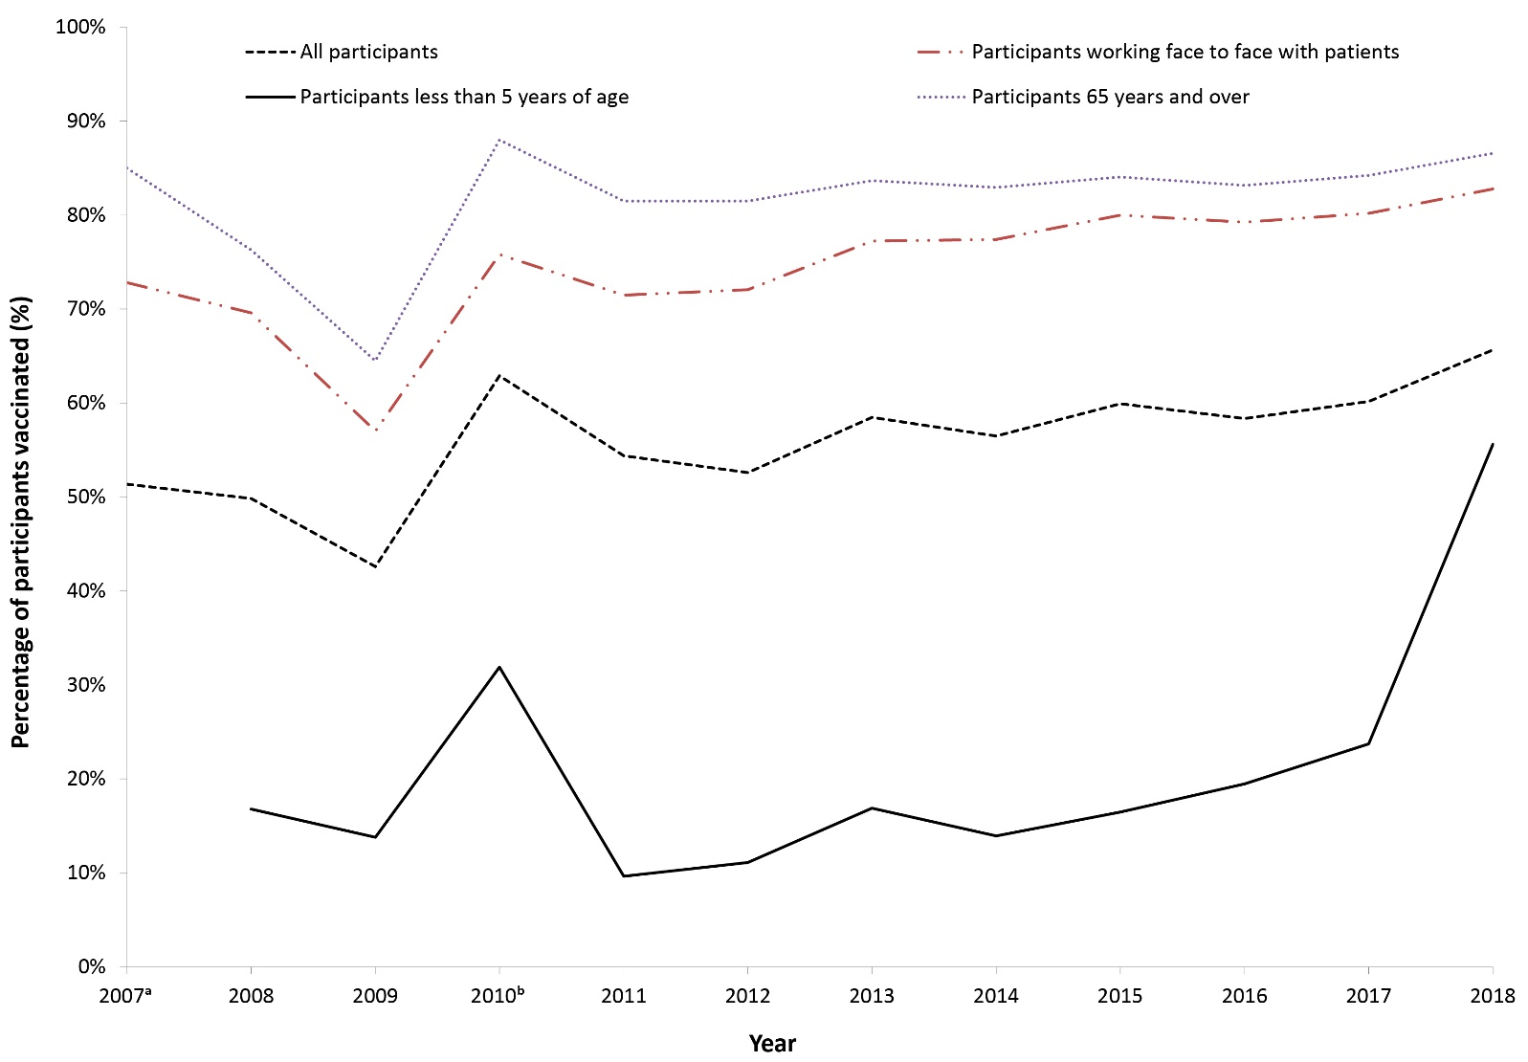
a Household members (including children) were not added to FluTracking until the 2008 season.
b This percentage calculation included participants who received either the monovalent H1N109 influenza vaccine in 2009 or 2010, or received the 2010 seasonal influenza vaccine.

Figure 5: Percent of participants with ILI stratified by influenza vaccination status, Australia, 2009 to 2018, by week
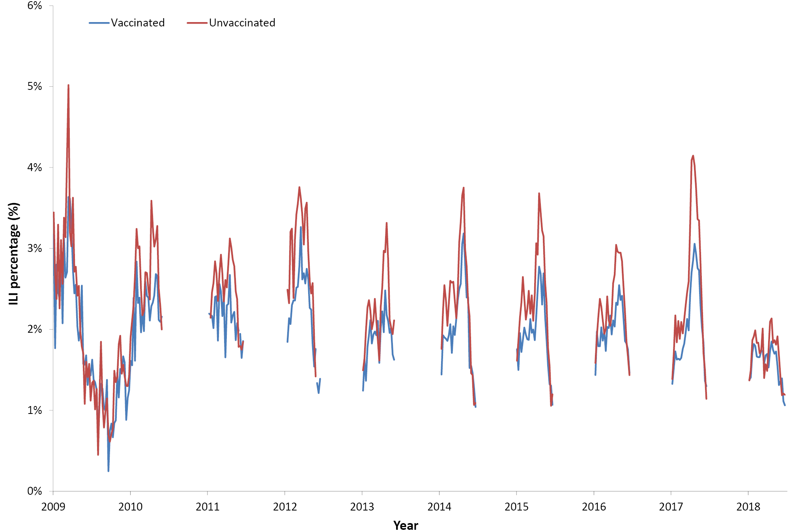

Figure 6: ILI percentage, 1 April to 31 October,ª compared with national influenza laboratory notifications, Australia, 2009 to 2018, by week
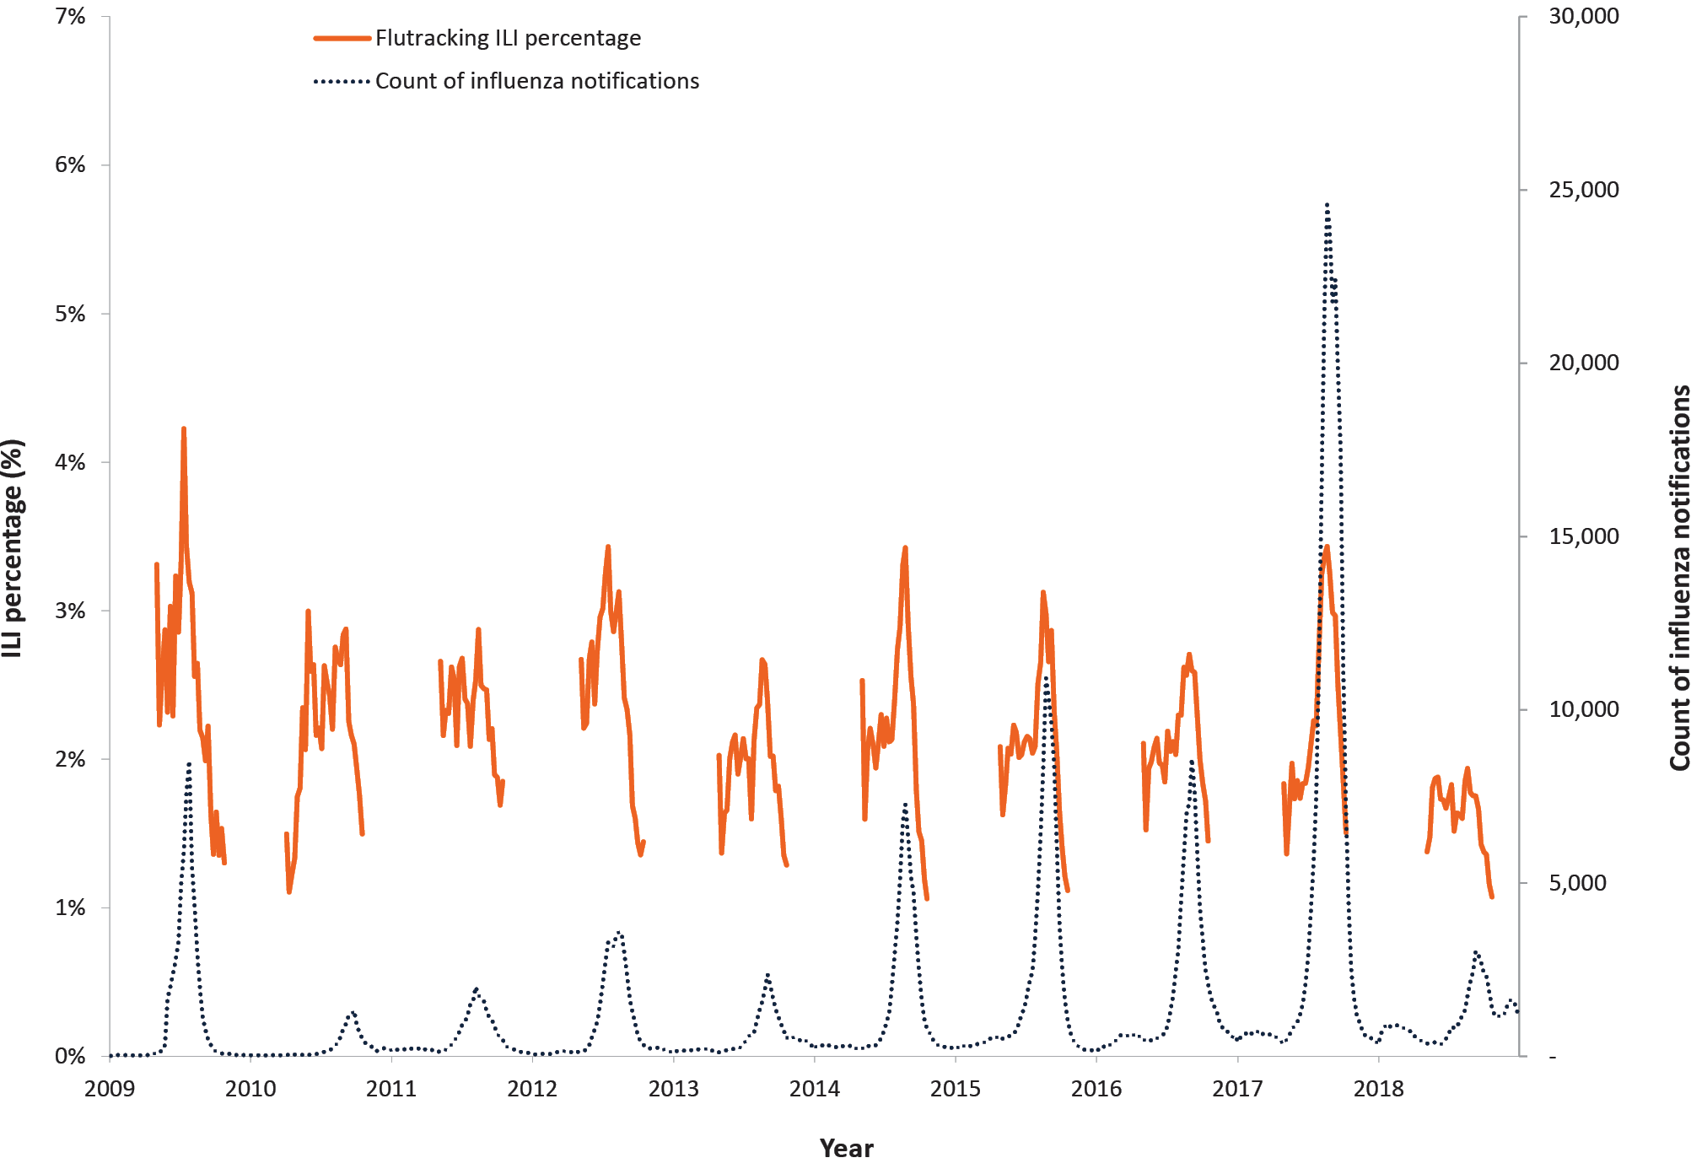
a Laboratory notifications are recorded year-round, while FluTracking typically collects data only between May and October.

Percentage of participants with influenza-like illness symptoms
Of participants who completed a survey in the national peak week of ILI for 2018, ILI was reported by 1.9% (compared with 3.4% in 2017 and 2.7% in 2016). Of participants who completed at least one survey in the national peak four-week period of ILI for 2018, ILI was reported by 6.8%, compared with 12.3% in 2017 and 9.6% in 2016 (Appendix A, Table A.3).

Detection of influenza-like illness
The peak in ILI activity for 2018 occurred during the week ending 19 August; with 2.1% of unvaccinated and 1.8% of vaccinated participants reporting ILI (Figure 5). Divergence between the vaccinated and unvaccinated participants’ ILI percentages was highest during the week ending 16 September (1.5% in the vaccinated group and 1.9% in the unvaccinated group).

Comparison with national laboratory influenza notifications
Nationally there was a large decrease in the number of laboratory confirmed cases of influenza in 2018 compared to 2017 (58,418 and 251,508 laboratory notifications respectively). In 2018, the peak week of laboratory notifications of influenza (3,039 laboratory notifications) occurred the week ending 9 September, compared with the peak week for FluTracking ILI (week ending 19 August).

Percent of self-reported laboratory influenza tests
There was a reduction in the mean percentage of FluTracking participants with ILI in 2018 who were tested for influenza compared to 2017 (3.2% compared to 5.0% in 2017). This decrease in testing was consistent across all jurisdictions except for Western Australia. The percentage of participants with ILI who reported being tested for influenza ranged from 1.5% in the Northern Territory to 4.4% in South Australia, Figure 7).
Figure 7: Mean weekly percentage of FluTracking participants with ILI who reported being tested for influenza, by jurisdiction, 2013-2018
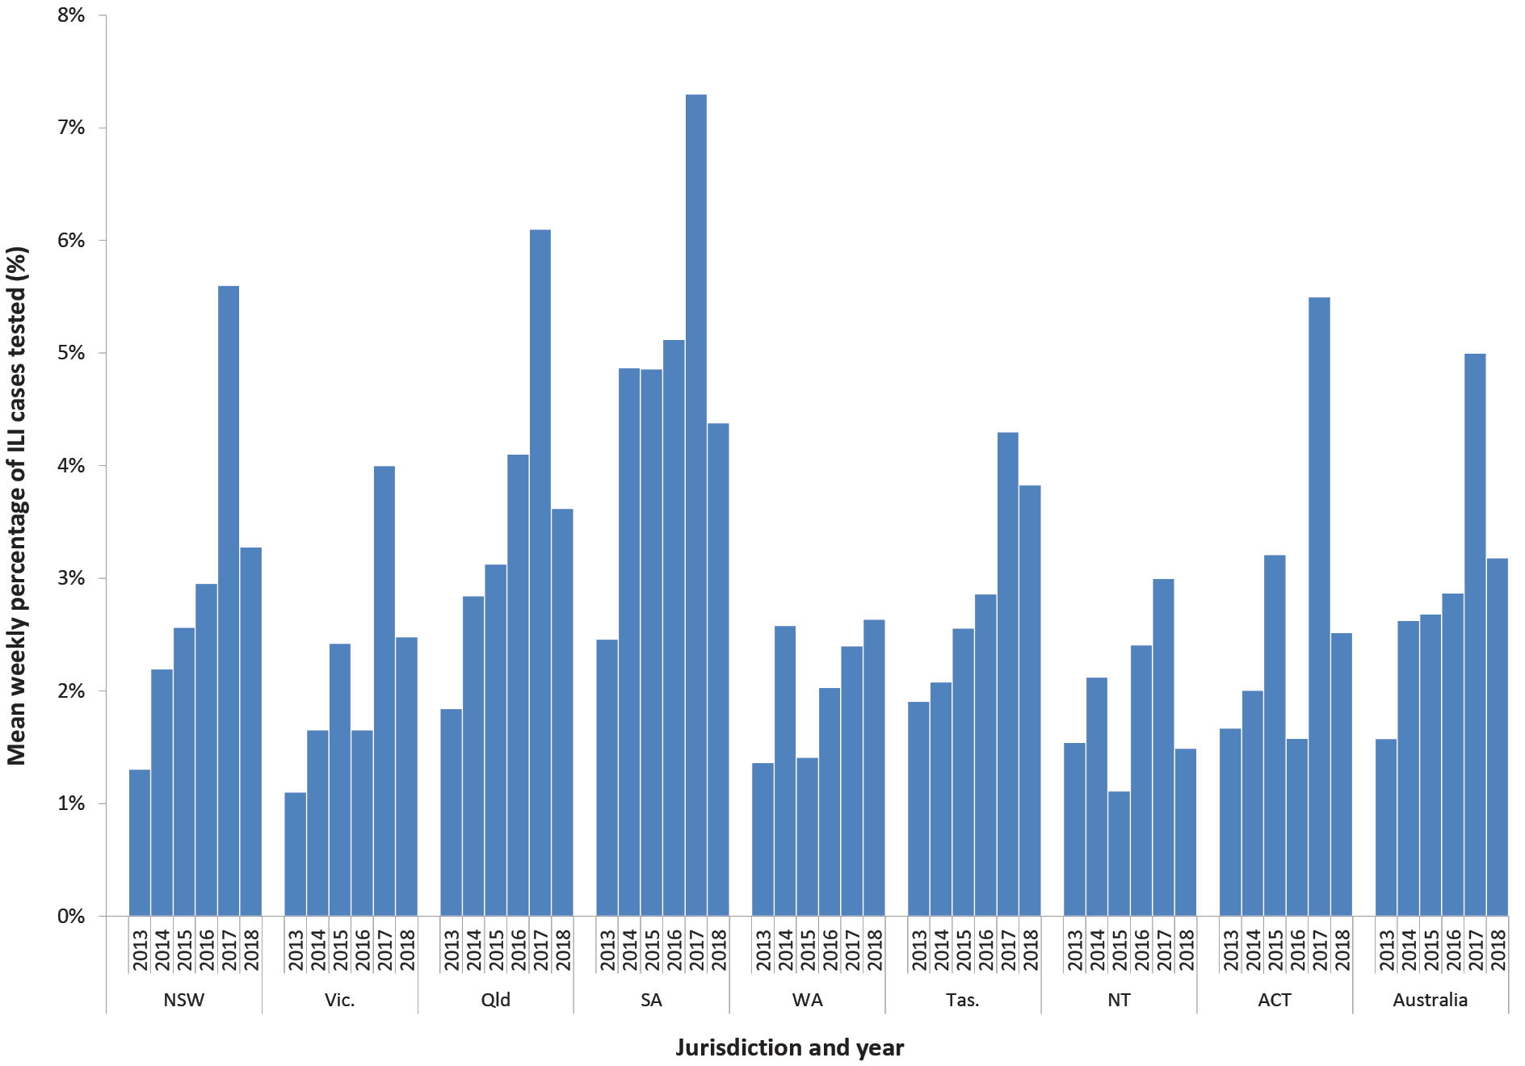

Time off work or normal duties and health-seeking behaviour
The peak weekly percentage of participants with ILI taking time off work or normal duties was 56.8% in 2018 and 70.0% in 2017, while the peak weekly percentage of participants with ILI seeking health care was 36.9% in 2018 and 43.6% in 2017 (Figure 8).

Figure 8: Weekly ILI severity,ª Australia, 2011 to 2018, by week
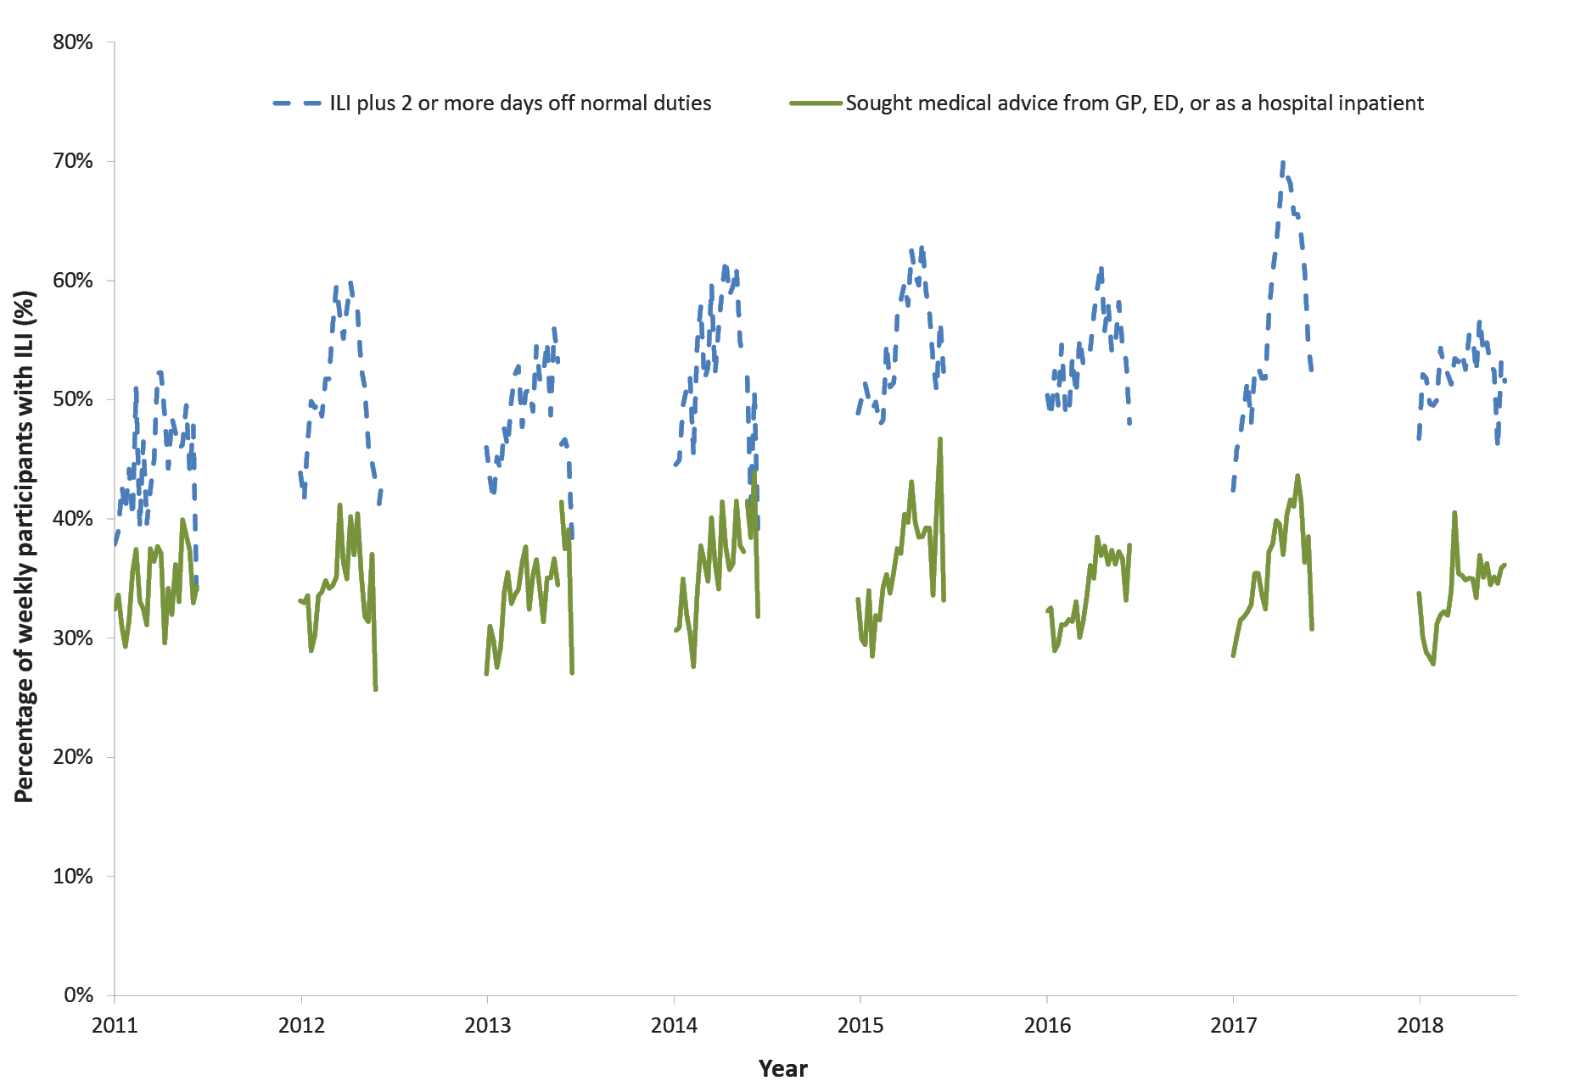
a The denominator is the number of weekly ILI cases.

Figure 9: Burden of Illness pyramid for the peak four weeks of influenza activity in 2017 (weeks ending 6 August to 27 August) and 2018 (weeks ending 12 August to 2 September).
2017
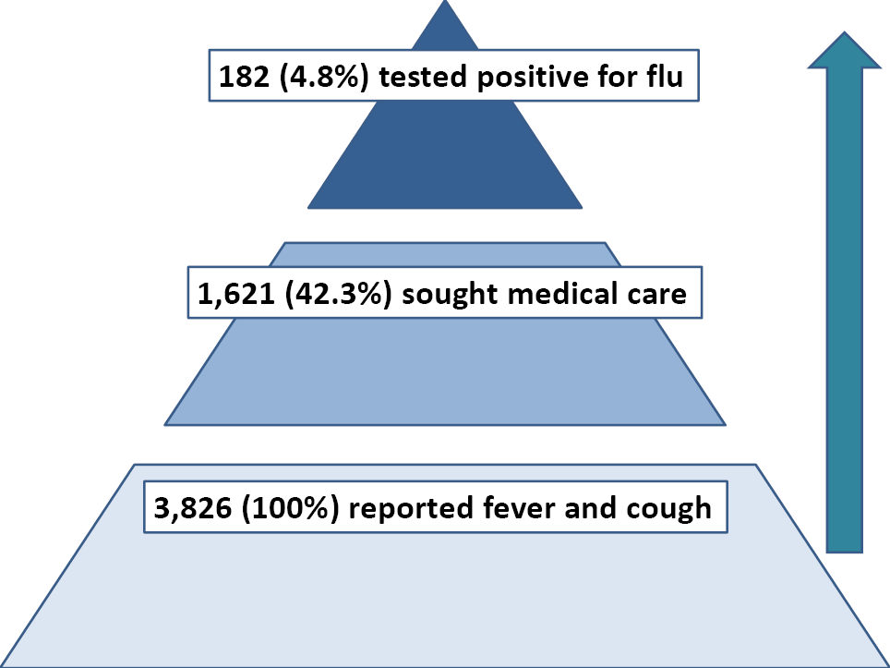
2018
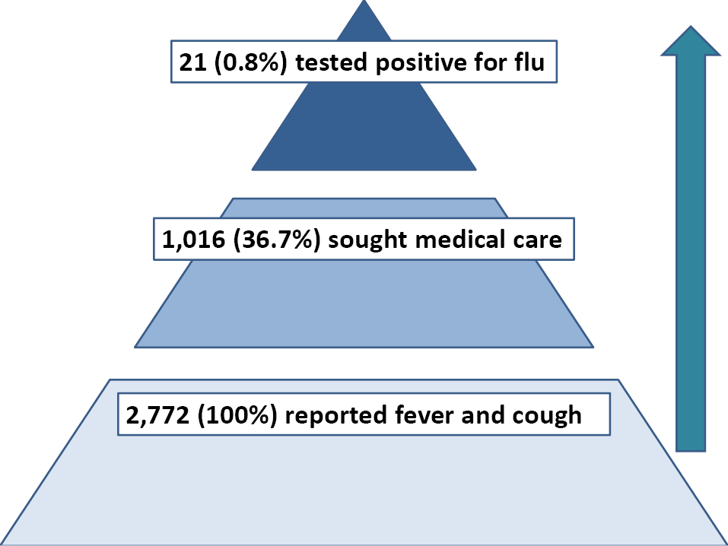

Burden of illness pyramid
The percentage of FluTracking participants seeking care for ILI during the peak four weeks of influenza activity was lower in 2018 than in 2017 (36.7% versus 42.3%, Figure 9). Likewise, the percentage of FluTracking participants with ILI who tested positive for influenza during this period in 2018 was lower, at 0.8% compared to 4.8% in 2017.

Percentage of participants with influenza-like illness by age group
During the four-week peak of 2018, FluTracking participants reported lower rates of ILI across all age groups than was reported for the peak four weeks of 2017 or for the five-year average (2013–2017) of this measure. ILI percentages among FluTracking participants were highest in the youngest age group, and lowest in the oldest age group for these peak four weeks (Figure 10).

Figure 10: Percentage of participants with ILI episodes, by year and age group, Australia, 2013 to 2018ª
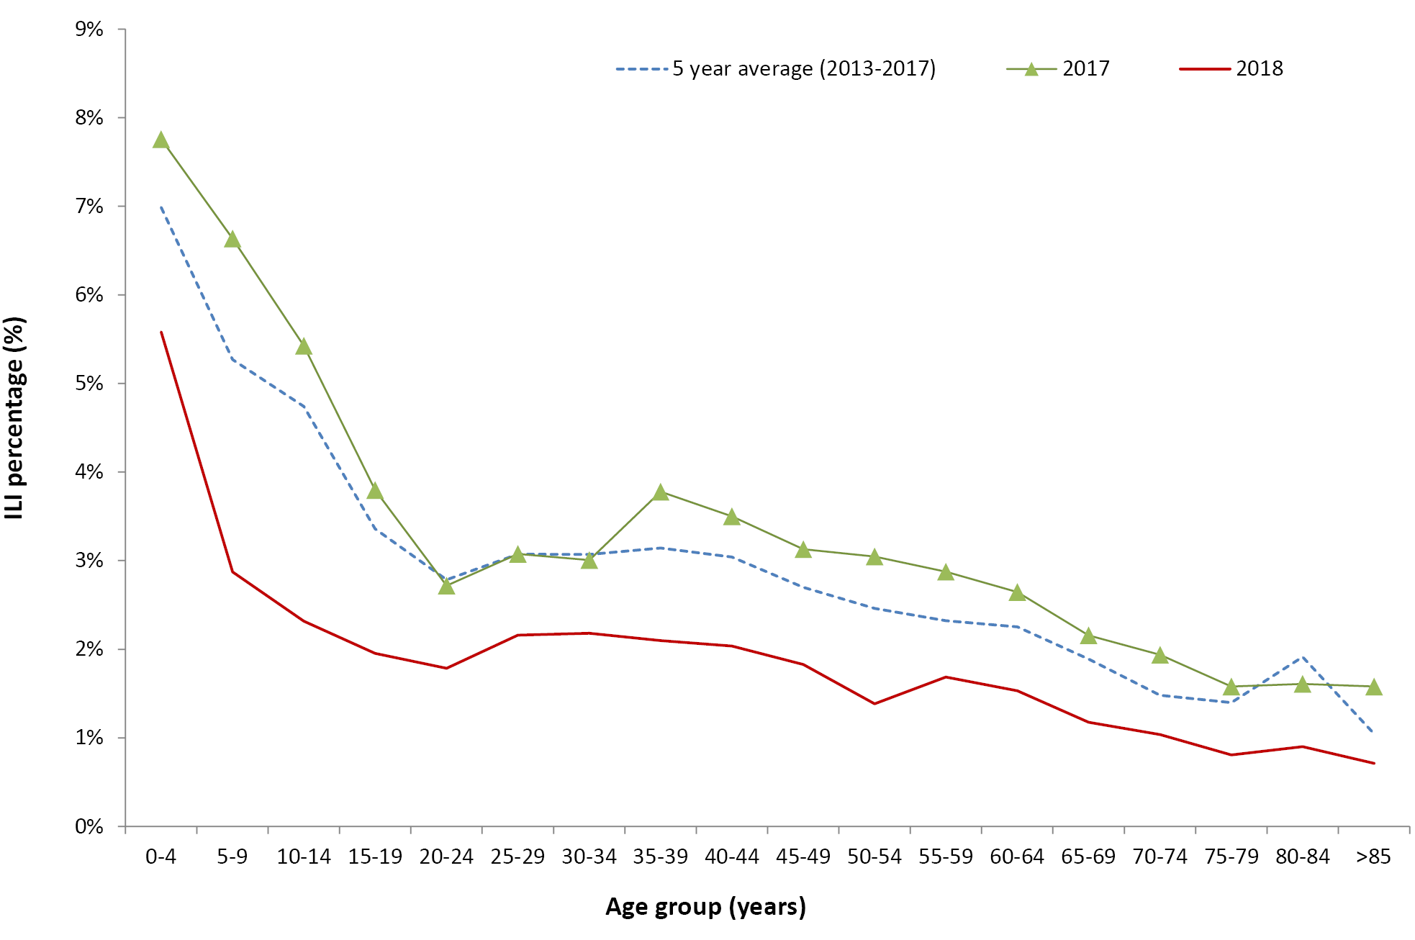
a Only the peak four weeks of ILI in Australia for each year were included.

Cumulative incidence
For participants completing all 26 surveys for 2018, the cumulative incidence of ILI was highest in the youngest age group, reaching 63%, and lowest in those aged 65 years or older (19%). There was a gradual increase in cumulative incidence for all age groups, with a sharper rise in ILI during May/June for the 0 to 4 year age group (Figure 11).

Comparison with the Australian Sentinel Practices Research Network (ASPREN)
Nationally, the rate of ILI diagnosed by GP per 1,000 consultations showed a very similar trend to the percentage of FluTracking participants with ILI who visited a GP for the period 2014 to 2018 (Figure 12). In particular, the timing of the peak for both sources of data was consistent for each year considered.

Figure 11: Cumulative incidence of ILI, by age group, April to October 2018 by weekª
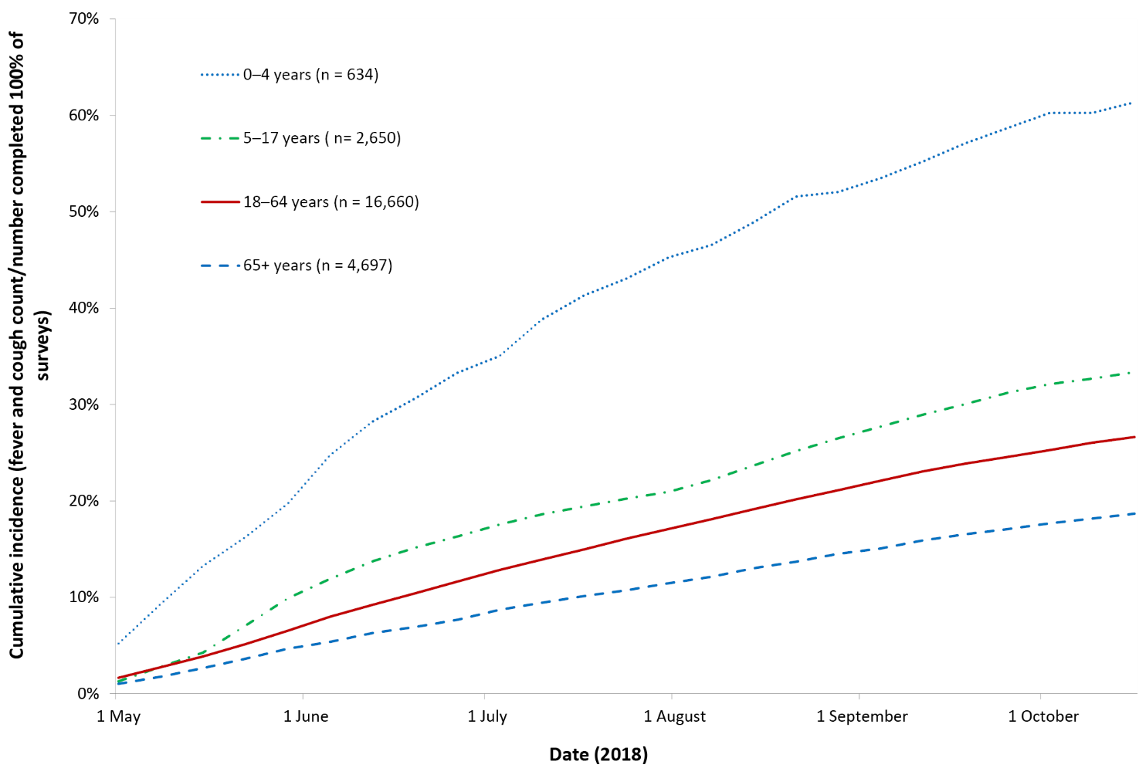
a Only first ILI episode of each participant was included.

Figure 12: Percentage of FluTracking participants with ILI and rate of ILI/1,000 general practitioner consultations, 2014 to 2018
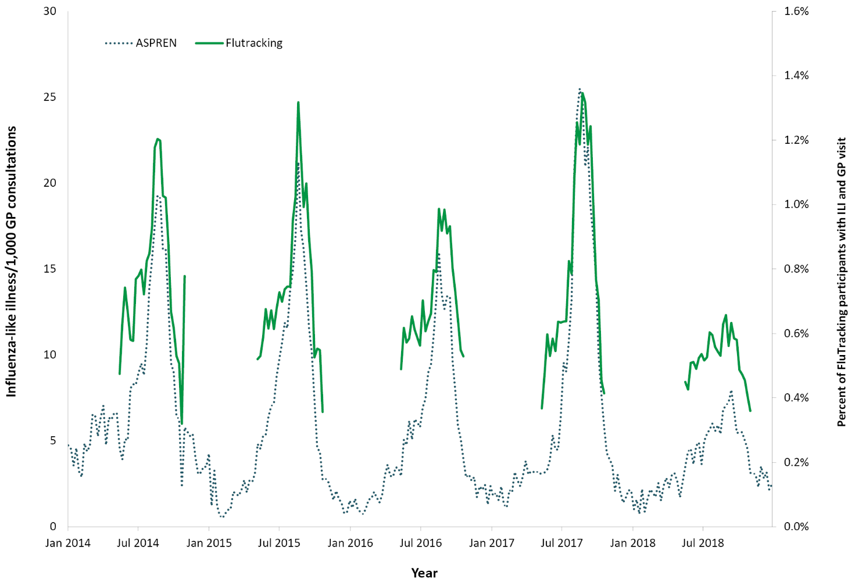

Discussion
The key highlights of FluTracking in 2018 were the large increase in new participants as well as the record low ILI and increased vaccination in young FluTrackers. Rates of ILI during 2018 were the lowest seen since FluTracking commenced in 2007, and we provided context to these rates by showing that ILI also tended to be less severe (with lower percentages of health-seeking or time off work/normal duties per ILI case) than during previous seasons. This low level of ILI was consistent with the ASPREN surveillance system and the number of laboratory confirmed influenza notifications. The value of multiple surveillance systems becomes clear when the usual epidemiological patterns are disrupted such as during the 2009 pandemic.⁴
The commitment of the FluTracking surveillance cohort continued to be demonstrated by the high percentage of participants completing their surveys within 24 hours (mean 74.3% of participants) and the high completion rate, with a majority of participants (80.3%) completing 90% or more of surveys. These completion rates are much higher than other community based surveillance systems internationally (e.g., Flu Near You reports that around 22% of participants complete at least half the possible surveys).¹⁴ The strong FluTracking completion rates may be due to the user experience and brevity of the FluTracking survey, along with the active engagement that FluTracking aims for with our participants and strong participant involvement in the recruitment process itself.¹⁵ This is a strength of the system, as consistent participation reduces the likelihood of bias, such as participants only reporting when they experience symptoms.
The timing of the peak percent of ILI in FluTracking was consistently three weeks prior to the peak in the notification of laboratory confirmed influenza cases. This suggests that community surveillance provides an earlier picture of ILI levels compared with the delay in testing and notification.
FluTracking participants reported higher vaccination coverage for each age group in 2018 than in previous years, with the most notable increase in children aged younger than five years. This increase may be due to the newly-introduced funding of influenza vaccines for all children aged six months to five years, which commenced in 2018; we provide a more detailed analysis of these trends elsewhere.^{16,17} Another source of data for vaccination coverage, the Australian Immunisation Register, also released coverage data showing increased vaccination in children from 2016 to 2018 (Aboriginal and Torres Strait Islander from 11.6% to 28.2%; non-Aboriginal from 2.7% to 24.8% ).^{18,19} It is unclear whether the downturn in ILI throughout 2018 is related to this sharp increase in childhood vaccination rates.
Some limitations of the system should be noted. The profile of FluTracking participants continued to comprise greater proportions of those with higher education levels and female. There were also fewer younger, and fewer Aboriginal and Torres Strait Islander participants, than would be expected in a fully representative group of Australians. We are continually working toward improving representativeness of participants through targeted recruitment strategies and exploring a governance structure to honour and privilege First Nations voices and participation in FluTracking. FluTracking data also shows a consistent pattern of low rates of ILI in participants aged 65 years or older that is at odds with other data sources.
During 2019, we aim to continue expanding FluTracking participation in Australia and our near neighbours. In 2018 FluTracking expanded to New Zealand, with excellent initial uptake showing promise for further expansion.

Acknowledgements
We acknowledge the Custodians of the land and waters in which we live as First Nations Peoples of Australia. We acknowledge the contributions, wisdoms, knowledges and experiences of the First Nations participants involved in FluTracking.
We acknowledge the University of Newcastle for their continued support, and the Australian Government Department of Health and Aged Care and the Hunter Medical Research Institute for their funding and support. We also acknowledge Stephen Clarke for software and database development, and John Fejsa for his contribution to the design of the project, and the many thousands of FluTracking participants who freely give their time each week to contribute to influenza surveillance.

Author details
Zachary L Howard^{1,4}
Sandra J Carlson²
Sarah Moberley³
Michelle Butler²
Craig B Dalton^{2,4}
- University of Western Australia, Western Australia, Australia
- Hunter New England Population Health, New South Wales, Australia
- Calvary Mater Newcastle, Waratah, Australia
- University of Newcastle, Callaghan, Australia

Corresponding author
Sandra J Carlson
Hunter New England Population Health, New South Wales, Australia
Sandra.Carlson@health.nsw.gov.au

References
- Carlson SJ, Dalton CB, Tuyl FA, Durrheim DN, Fejsa J, Muscatello DJ et al. Flutracking surveillance: comparing 2007 New South Wales results with laboratory confirmed influenza notifications. Commun Dis Intell Q Rep. 2009;33(3);323–7.
- Dalton CB, Durrheim DN, Fejsa J, Francis L, Carlson SJ, d’Espaignet ET et al. Flutracking: a weekly Australian community online survey of influenza-like illness in 2006, 2007 and 2008. Commun Dis Intell Q Rep. 2009;33(3);316–22.
- Parrella A, Dalton CB, Pearce R, Litt JCB, Stocks N. ASPREN surveillance system for influenza-like illness: a comparison with FluTracking and the National Notifiable Diseases Surveillance System. Aust Fam Physician. 2009;38(11);932–6.
- Carlson SJ, Dalton CB, Durrheim DN, Fejsa J. Online Flutracking survey of influenza-like illness during pandemic (H1N1) 2009, Australia. Emerg Infect Dis. 2010;16(12):1960–2.
- Dalton CB, Carlson SJ, Durrheim DN, Butler MT, Cheng AC, Kelly HA. Flutracking weekly online community survey of influenza-like illness annual report, 2015. Commun Dis Intell Q Rep. 2016;40(4);E512–20.
- World Health Organization (WHO). Pandemic Influenza Severity Assessment (PISA): a WHO guide to assess the severity of influenza epidemics and pandemic. Geneva: WHO; May 2017. Available from: https://apps.who.int/iris/bitstream/handle/10665/259392/WHO-WHE-IHM-GIP-2017.2-eng.pdf.
- Australian Government Department of Health. Australian influenza report 2009. Canberra: Australian Government Department of Health; 2009.
- Moberley S, Carlson SJ, Durrheim DN, Dalton CB. Flutracking: Weekly online community-based surveillance of influenza-like illness in Australia, 2017 Annual Report. Commun Dis Intell (2018). 2019;43. doi: https://doi.org/10.33321/cdi.2019.43.31.
- Crooks K, Carlson SJ, Dalton CB. Defining, controlling and analysing Indigenous data: commitment to historical consistency or commitment to Australian Aboriginal and Torres Strait Islander peoples? Public Health Res Pract. 2019;29(4);2941926. doi: https://doi.org/10.17061/phrp2941926.
- Australian Bureau of Statistics. 3101.0 Australian Demographic Statistics, Jun 2018. [Webpage.] Canberra: Australian Bureau of Statistics; 20 December 2018. [Accessed on 10 June 2022.] Available from: https://www.abs.gov.au/AUSSTATS/abs@.nsf/DetailsPage/3101.0Jun%202018.
- Australian Bureau of Statistics. 2016 Census QuickStats. [Webpage.] Canberra: Australian Bureau of Statistics. [Accessed on 10 June 2022.] Available from: https://www.abs.gov.au/census/find-census-data/quickstats/2016/0.
- Australian Bureau of Statistics. 2016 Census: Aboriginal and/or Torres Strait Islander Peoples QuickStats. [Webpage.] Canberra: Australian Bureau of Statistics; 2017. [Accessed on 28 February 2018.] Available from: https://quickstats.censusdata.abs.gov.au/census_services/getproduct/census/2016/quickstat/IQS036.
- Clothier HJ, Fielding JE, Kelly HA. An evaluation of the Australian Sentinel Practice Research Network (ASPREN) surveillance for influenza-like illness. Commun Dis Intell Q Rep. 2005;29(3):231–47.
- Smolinski MS, Crawley AW, Baltrusaitis K, Chunara R, Olsen JM, Wójcik O et al. Flu Near You: crowdsourced symptom reporting spanning 2 influenza seasons. Am J Public Health. 2015;105(10);2124–30.
- Dalton CB, Carlson SJ, Butler M, Cassano D, Clarke S, Fejsa J et al. Insights from Flutracking: thirteen tips to growing a web-based participatory surveillance system. JMIR Public Health Surveill. 2017;3(3);e48. doi: https://doi.org/10.2196/publichealth.7333.
- New South Wales Government Department of Health (NSW Health). Free flu shots for children aged 6 months to under 5 years. [Internet.] Sydney: NSW Health; 5 October 2018. [Accessed on 4 March 2019.] Available from: https://www.health.nsw.gov.au/immunisation/Pages/flu.aspx.
- Howard ZL, Dalton CB, Carlson SJ, Baldwin Z, Durheim DN. Impact of funding on influenza vaccine uptake in Australian children. Public Health Res Pract. 2021;31(1);e3112104. doi: https://doi.org/10.17061/phrp3112104.
- Hull B, Hendry A, Dey A, Beard F, Brotherton J, McIntyre P. Annual Immunisation Coverage Report 2016. Commun Dis Intell (2018). 2019;43. doi: https://doi.org/10.33321/cdi.2019.43.44.
- Beard FH, Hendry AJ, Macartney K. Early success with room for improvement: influenza vaccination of young Australian children. Med J Aust. 2019;210(11);484–6.

Appendix A: Supplementary tables
Table A.1: FluTracking growth and participation in 2017 and 2018, by jurisdiction
State or Territory | Percent distribution of Australian population from ABS ERP | 2017 |  | 2018
 |  | Number of participants at peak (% of total) | FluTracking participation per 100,000 population | Number of participants at peak (% of total) | FluTracking participation per 100,000 population | % increase from 2017
NSW | 32.0 | 9,782 (32.8%) | 124.4 | 13,933 (34.2%) | 174.4 | 42.4%
Vic | 25.7 | 4,935 (16.6%) | 78 | 7,044 (17.3%) | 109.1 | 42.7%
Qld | 20.0 | 2,989 (10.0%) | 60.6 | 4,496 (11.0%) | 89.7 | 50.4%
SA | 7.0 | 3,400 (11.4%) | 197.3 | 4,259 (10.5%) | 245.3 | 25.3%
WA | 10.5 | 3,583 (12.0%) | 138.9 | 4,702 (11.6%) | 181.2 | 31.2%
Tas | 2.1 | 2,750 (9.2%) | 527.9 | 3,272 (8.0%) | 619.7 | 19.0%
NT | 1.0 | 986 (3.3%) | 400.7 | 1,113 (2.7%) | 450.6 | 12.9%
ACT | 1.7 | 1,387 (4.7%) | 338 | 1,875 (4.6%) | 446.4 | 35.2%
Total | 100 | 29,814 (100%) | 121.2 | 40,689 (100%) | 162.8 | 36.5%

Table A.2: Socio-demographic characteristics of FluTracking participants who completed at least one survey during 2017 and 2018
 | 2017 |  |  | 2018 |  |  | % Australian population
 | Frequency | % | Rate /100,000 | Frequency | % | Rate /100,000
Age (years)
0–15 | 4,454 | 13.1 | 89.5 | 6,048 | 13.3 | 121.5 | 20.0
16–34 | 5,335 | 15.7 | 79.8 | 7,090 | 15.8 | 106.1 | 26.8
35–49 | 8,075 | 23.8 | 161.9 | 10,330 | 22.7 | 207.1 | 20.0
50–64 | 11,167 | 32.9 | 252.8 | 14,173 | 31.1 | 320.8 | 17.8
65 and over | 4,916 | 14.5 | 125.6 | 7,890 | 17.3 | 201.6 | 15.4
Total participants | 33,947 |  | 135.9 | 45,531 (1 missing) |  | 182.3
Gender
Male | 13,155 | 39.7 | 113.9 | 17,986 | 40.1 | 155.8 | 49.6
Female | 19,935 | 60.2 | 168.2 | 26,749 | 59.8 | 225.6 | 50.4
Other | 5 |  |  | 24 | 0.1
Total reported | 33,095 (852 missing) |  | 134.5 | 44,759 (773 missing)
Highest level of education completed by participantª
Year 11 or below (or equiv) or Certificate I/II/III/IV | 5,612 | 20.4 | 73.1 | 8,201 | 21.1 | 106.8 | 44.1
Year 12 (or equivalent) | 2,241 | 8.1 | 74.8 | 3,165 | 8.5 | 105.7 | 16.6
Advanced Diploma/Diploma | 2,544 | 9.2 | 150.7 | 3,623 | 9.8 | 214.6 | 8.0
Completed Bachelor Degree | 6,600 | 23.9 | 410.5 | 8,796 | 23.7 | 528.9 | 13.5
Grad Diploma/Grad Certificate | 3,688 | 13.4 |  | 4,611 | 12.4 |  | 1.7
Postgraduate Degree | 6,875 | 24.9 |  | 8,708 | 22.5 |  | 3.6
Total who nominated an ABS equivalent education level (15 years and over only) | 27,560 |  | 148.8 | 37,104 (1,342 missing) |  | 207.9
Aboriginal and/or Torres Strait Islander
Yes | 492 | 1.6 | 75.8 | 713 | 1.6 | 109.8 | 2.5
No | 30,897 | 98.4 | 135.8 | 42,377 | 98.3 | 186.3 | 97.5
Prefer not to say | 129 |  |  | 204 | 0.5
Total reported | 31,518 (missing 2,429) |  | 134.7 | 43,294 (missing 2,238) |  | 185.0
a Missing data points result from participants who joined prior to collecting a certain variable and who have not updated their records since.
Table A.3: Incidence of participants with influenza-like illness symptoms who completed a survey either in the national peak influenza-like illness week, or completed at least one survey in the national peak 4 weeks of influenza-like illness, Australia, 2016 to 2018
ILI symptoms | Participants who completed a survey in the peak week of ILI nationally |  |  |  |  |  | Participants who completed at least one survey during the peak 4 weeks of ILI nationally
 | 2016ª |  | 2017^{b} |  | 2018^{c} |  | 2016^{d} |  | 2017e |  | 2018^{f}
 | n | % | n | % | n | % | n | % | n | % | n | %
Fever | 889 | 3.4 | 1,222 | 4.2 | 987 | 2.5 | 3,637 | 13.1 | 4,954 | 16.0 | 3,676 | 9.0
Cough | 1,674 | 6.4 | 2,096 | 7.1 | 2,274 | 5.9 | 8,267 | 29.8 | 10,009 | 32.3 | 8,088 | 19.9
Fever & cough | 705 | 2.7 | 1,008 | 3.4 | 752 | 1.9 | 2,665 | 9.6 | 3,826 | 12.3 | 2,772 | 6.8
Fever, cough & sore throat | 567 | 2.2 | 766 | 2.6 | 559 | 1.4 | 2,128 | 7.7 | 2,965 | 9.6 | 2,116 | 5.2
a Week ending 28 August 2016; N = 26,117.
b Week ending 20 August 2017; N = 29,355.
c Week ending 19 August 2018; N = 38,803.
d Weeks ending 14 August to 4 September 2016; N = 27,765.
e Weeks ending 6 August to 27 August 2017; N = 31,047.
f Weeks ending 12 August to 2 September 2018; N = 40,676.
Communicable Diseases Intelligence
ISSN: 2209-6051 Online

Communicable Diseases Intelligence (CDI) is a peer-reviewed scientific journal published by the Office of Health Protection and Response, Department of Health. The journal aims to disseminate information on the epidemiology, surveillance, prevention and control of communicable diseases of relevance to Australia.

Editor: Noel Lally
Deputy Editor: Simon Petrie
Design and Production: Kasra Yousefi
Editorial Advisory Board: David Durrheim, Mark Ferson, John Kaldor, Martyn Kirk and Linda Selvey

Website: http://www.health.gov.au/cdi

Contacts
CDI is produced by the Office of Health Protection and Response, Australian Government Department of Health and Aged Care, GPO Box 9848, (MDP 6) CANBERRA ACT 2601

Email: cdi.editor@health.gov.au

Submit an Article
You are invited to submit your next communicable disease related article to the Communicable Diseases Intelligence (CDI) for consideration. More information regarding CDI can be found at: http://health.gov.au/cdi.
Further enquiries should be directed to: cdi.editor@health.gov.au.

This journal is indexed by Index Medicus and Medline.

Creative Commons Licence - Attribution-NonCommercial-NoDerivatives CC BY-NC-ND
© 2022 Commonwealth of Australia as represented by the Department of Health
This publication is licensed under a Creative Commons Attribution-NonCommercial-NoDerivatives 4.0 International Licence from https://creativecommons.org/licenses/by-nc-nd/4.0/legalcode (Licence). You must read and understand the Licence before using any material from this publication.

Restrictions
The Licence does not cover, and there is no permission given for, use of any of the following material found in this publication (if any):
- the Commonwealth Coat of Arms (by way of information, the terms under which the Coat of Arms may be used can be found at www.itsanhonour.gov.au);
- any logos (including the Department of Health and Aged Care’s logo) and trademarks;
- any photographs and images;
- any signatures; and
- any material belonging to third parties.

Disclaimer
Opinions expressed in Communicable Diseases Intelligence are those of the authors and not necessarily those of the Australian Government Department of Health and Aged Care and Aged Care or the Communicable Diseases Network Australia. Data may be subject to revision.

Enquiries
Enquiries regarding any other use of this publication should be addressed to the Communication Branch, Department of Health and Aged Care, GPO Box 9848, Canberra ACT 2601, or via e-mail to: copyright@health.gov.au

Communicable Diseases Network Australia
Communicable Diseases Intelligence contributes to the work of the Communicable Diseases Network Australia.
http://www.health.gov.au/cdna

