Legionella pneumophila serogroup 1 infection associated with the use of an apartment building spa pool
Toni Cains, Hakoum Shalak, Verlaine J Timms, Alexander Kiss, Anna Smith, Vitali Sintchenko, Catherine Bateman-Steel, Mark J Ferson

Abstract

Background
Legionnaires’ disease is a notifiable condition in New South Wales (NSW), Australia; clinicians and laboratories are required to report the disease to NSW Health. We describe the investigation of a sporadic case associated with the use of a communal spa pool in the case’s apartment building complex and the use of whole genome sequencing to examine relatedness between clinical and environmental Legionella pneumophila serogroup 1 (Lp1) strains.

Methods
In February 2018, a confirmed case of Lp1 infection was notified in a man in his 60s hospitalised with pneumonia. We asked the clinical team to obtain sputum in the event we found a potential source. The case described the use of the communal spa pool in his apartment building on two occasions during the putative exposure period. Environmental Health Officers from the Public Health Unit inspected the spa pool and found that the free chlorine level was well below the recommended concentration; a water sample was submitted for microbial analysis.

Results
Lp1 was grown from the case’s sputum and microbial analysis of the spa water sample found Lp1 at a concentration of 20 CFU/mL. The human and environmental isolates were subjected to whole genome sequencing and found to be highly genomically related. There was no other plausible environmental source of legionella.

Conclusions
Whole genome sequencing of the clinical and environmental Lp1 isolates implicated a contaminated spa pool as the source of the case’s exposure. This strongly supports the application of whole genome sequencing to the investigation of single cases of legionellosis. Communal spa pools in apartment buildings are not regulated in most Australian jurisdictions but must be considered to pose a potential legionella risk if improperly maintained.
Keywords: Legionella; legionnaires’ disease; regulation; spa pools; whole genome sequencing

Introduction
Legionella species are ubiquitous in the moist natural and built environment. Infection by Legionella pneumophila serogroup 1 (Lp1) may lead to Legionnaires’ disease, a potentially fatal form of atypical pneumonia associated with multi-organ damage. It generally results from inhalation of contaminated aerosols disseminated from cooling towers, baths, fountains, wastewater plant, humidifiers, ice or mist machines and a number of other sources.¹ A recent review of legionellosis associated with exposure to recreational waters identified public spa pools supplied with reticulated water as causes of legionellosis outbreaks, mostly due to Lp1.²
Whilst the focus of the regulation of air conditioning cooling towers and warm water systems in New South Wales (NSW) under the Public Health Act 2010 (NSW) is explicitly to mitigate the risk of legionellosis, the purpose of regulation of public spa pools and other public pools under the Act is to prevent transmission of infections generally. The disinfection and proper maintenance of spa pools is particularly important, as the higher water temperatures used reduces the effectiveness of chlorine and can be conducive to the propagation of legionellae and other pathogens. In addition, when in use, spa pools are likely to generate high volumes of aerosols, which can be easily inhaled by spa pool users or by people in the vicinity. However, spa pools located in residential premises, including apartment buildings, are not regulated in NSW, nor in most other Australian jurisdictions.
Legionnaires’ disease is a notifiable condition in NSW under the Public Health Act 2010; clinicians are required to report to the local Public Health Unit all suspected cases and clinical laboratories are to notify detection of any Legionella species. Notification triggers a public health investigation to determine the source and mechanism of exposure to inform subsequent preventive interventions.
Various methods of genotyping of Lp1 have been employed to characterise isolates recovered from sporadic cases and outbreaks of legionellosis. The demonstration of similarity between bacteria cultured from environmental sources and clinical cases has been the most reliable approach to investigating transmission pathways. Gene sequencing based typing (SBT) methods were previously recommended to type Lp1 isolates in outbreak investigations.³ However, SBT discriminates among strains using only seven alleles within the genome; there are often problems identifying a type, given the high recombination rate of the L pneumophila genome. Therefore, the limited resolution of SBT has led to a wider application of whole genome sequencing (WGS) in the investigation of community outbreaks of legionellosis. WGS offers increased discrimination of outbreak isolates, as the whole genome is used in the analysis compared to the seven alleles in SBT.^{4–6} With WGS, further analysis can be performed such as Single Nucleotide Polymorphisms (SNP) based, core and pan-genome based comparisons of Lp1 isolates which can assist in deciphering and confirming transmission pathways during the investigation of complex outbreaks of legionellosis.⁷
This report describes the investigation of a case of Legionnaires’ disease putatively associated with exposure to a spa pool within a residential apartment building complex and the use of WGS to examine relatedness between clinical and environmental Lp1 strains.

Methods

Epidemiological investigation
In February 2018, the Public Health Unit was notified of a man in his 60s hospitalised with a history of high fever, lethargy, cough and shortness of breath, in whom a diagnosis of Legionnaires’ disease was confirmed by the detection of urinary Lp1 antigen. He had no specific risk factors for legionellosis apart from his age. The clinical team was asked to arrange collection of sputum samples for legionella culture in the event that an environmental isolate could also be obtained. Sputum specimens were processed using standard microbiological techniques, and Lp1 was isolated; the isolate was forwarded to the Centre for Infectious Diseases and Microbiology Laboratory Services, NSW Health Pathology, for confirmatory testing and genotyping.
The case was interviewed by a public health nurse using a standard questionnaire. The case’s movements during the ten-day exposure period prior to illness onset were documented, in order to map these against potential Legionella sources. The questionnaire asks specifically about exposures to pools, spas (including home spas), water parks, water fountains or sprinklers among other water sources. The case reported use of a communal spa pool in his apartment complex on two occasions, eight and five days prior to his illness onset.

Environmental health investigation
Two days after the case was notified, Environmental Health Officers from the Public Health Unit went to the complex where the case owned an apartment. The complex has an air conditioning cooling tower which was inspected, and from which a water sample was collected for microbiological analysis. In keeping with Australian legionellosis investigation guidelines, samples of reticulated water (including hot water from the shower) were not collected.
The communal recreational facilities included a heated spa pool, which had water chemistry routinely conducted for pH and chlorine levels once per week. Water samples had never been taken from the spa pool for microbial analysis (and were not legally required).
The building manager was told of the reason for the visit and granted permission for the officers to inspect and take samples from the spa pool (Figure 1). At the time of inspection the spa pool was open but there were no bathers. During the inspection, chemical testing of the spa pool water was carried out using a recently calibrated Pooltest 9 Photometer (Palintest Australia Pacific, Peakhurst, NSW, Australia) with a DPD1 tablet for free residual chlorine; a DPD1 mixed with a DPD2 tablet to assess the total chlorine; and a phenol red tablet to assess pH.
Once the chemical tests were completed, a water sample was collected for the purpose of microbiological analysis, using aseptic technique, in a 250mL sterile container which had a trace of thiosulphate to neutralise chlorine.
The cooling tower and spa pool microbial water samples were placed into a foam cooler containing an ice freezing brick and delivered to the Forensic and Analytical Science Service Legionella Reference Laboratory.
Figure 1: Implicated heated fibreglass spa pool
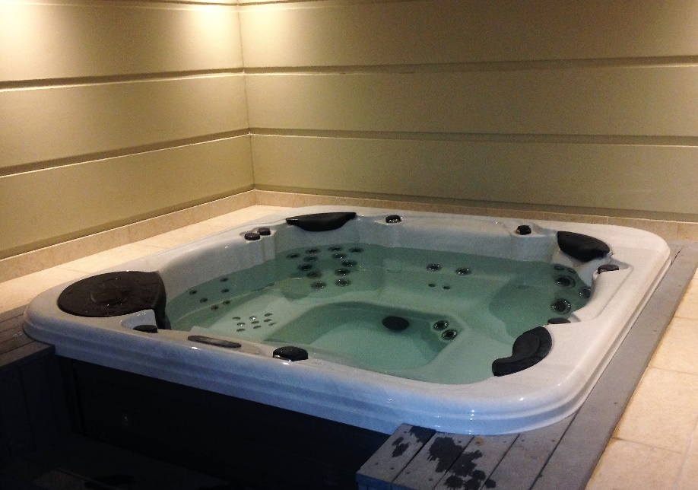

Culture of Legionella from water samples
Both water samples were tested as soon as possible on receipt. Quantitative analysis for Legionella was performed in accordance with Australian Standard AS4276.1:2021 Water Microbiology. The spread plate technique was used, in which 0.1 mL aliquots of sample were inoculated onto both agar plates with non-selective culture (buffered charcoal, yeast extract: BCYE), and agar plates with a selective culture (BCYE containing the antibiotics glycine, vancomycin hydrochloride, polymyxin B sulphate and cycloheximide: GVPC). After incubation at 37 °C for 5 to 7 days, plates were examined at 7–40× total magnification using a stereomicroscope. Colonies expressing characteristic Legionella morphology were tallied. A representative number of presumptive Legionella colonies, of each morphological type, were streaked onto BCYE and tryptone soya plus sheep blood agar (TSSBA) plates. Legionella isolates were defined as those which grew on BCYE but not on TSSBA. Legionella isolates were further identified serologically as Lp1, using the Legionella Latex Test (Oxoid, Thermo Fisher Scientific, North Ryde, NSW). A report was issued as Lp1 colony forming units (CFU) per millilitre based on the highest final confirmed colony count; that is, one colony from a 0.1 ml aliquot equated to 10 CFU/mL. Samples with zero colonies on a 0.1 mL plate were reported as < 10 CFU/mL. Pure colonies of Lp1 were forwarded to the Centre for Infectious Diseases and Microbiology – Public Health for genotyping.

Genotyping and sequencing of clinical and environmental isolates
Lp1 isolates were subjected to WGS in order to verify or refute the hypothesis that they could be related. All isolates were sequenced on the NextSeq 500 platform (Illumina) as described previously.⁷ Single nucleotide polymorphisms (SNPs) were identified using Snippy v3.2 by mapping reads against curated L. pneumophila reference genome strain Philadelphia (GenBank accession NC002942) and a SNP phylogeny constructed using PhyML. Genomes were assembled using SPAdes 3.9.0,⁸ and the L pneumophila sequence type was determined by uploading identified alleles to the database and obtaining SBT if the latter existed in the database of 2,793 SBT types.³ To provide context for the case isolates, genomes of epidemiologically unrelated Lp1 isolates were included in the phylogenetic analysis and are listed in Table 1.
This investigation was conducted under the authority of the Public Health Act 2010 (NSW) and hence institutional ethics approval for its conduct was not required.
Table 1: List of L. pneumophila isolates and their sequence type (SBT)
Strain number | Isolate type | SBT
BE21 | Environmental (present investigation) | Non-typeable
BC11 | Clinical (present investigation) | Non-typeable
BC10 | Clinical | 42
BE1 | Environmental | 211
BC1 | Clinical | 211
RC1 | Clinical | 211
RE6 | Environmental | 211
BC8 | Clinical | 211
BE3 | Environmental | Non-typeable
Reference 1 | Clinical | —
Reference 2015 | Clinical | Non-typeable
BE5 | Environmental | 1
BE20 | Environmental | 284
BE12 | Environmental | 1
Reference 2013 | Clinical | 762
GC2 | Clinical | Non-typeable

Results
Documentation kept by the complex’s building manager revealed that the spa pool temperature was maintained at 37–38 °C. The spa pool was being dosed manually with chlorine, and the single record of water chemistry carried out during the case’s putative exposure period showed a very low free chlorine concentration of 0.46 mg/L (NSW requirement at least 2.0 mg/L). At the time of inspection, the pH was 7.6 (NSW requirement pH 7.0–7.8) while there was a low free chlorine concentration of 1.05 mg/L (requirement at least 2.0 mg/L).
As the free chlorine levels were low and an investigation for Legionnaires’ disease was being undertaken, the building manager voluntarily closed the spa pool after the inspection. The following day the building manager engaged a swimming and spa pool consultant to drain and clean the pool and an automatic dosing system was subsequently installed to ensure that adequate free chlorine concentrations were maintained. The spa pool was closed to users for some time whilst these improvements were undertaken. Inspection of the water cooling tower for the building’s air conditioning system determined that it was well maintained.
Using the standard quantitative cultural microbiological techniques described above, the sample of cooling tower water was found to have < 10 CFU/mL of total Legionella, whilst the spa pool water sample was found to contain 20 CFU/mL of Lp1. This result was relayed to the building manager at the apartment complex.
The isolates from the case and from the spa pool were found to be highly genomically related (Figure 2), with the distance between genomes only two SNPs, and they were distinct from other Lp1 strains previously investigated and reported in association with community outbreaks of Lp1 in Sydney (Table 1). Of note, these isolates were not typeable using the SBT scheme. Given the one case and one environmental sample, it is important to note that background prevalence of this strain in the environment is unknown.

Figure 2: Maximum likelihood single nucleotide polymorphism (SNP) phylogenetic analysis of 16 isolates of L. pneumophila serogroup 1
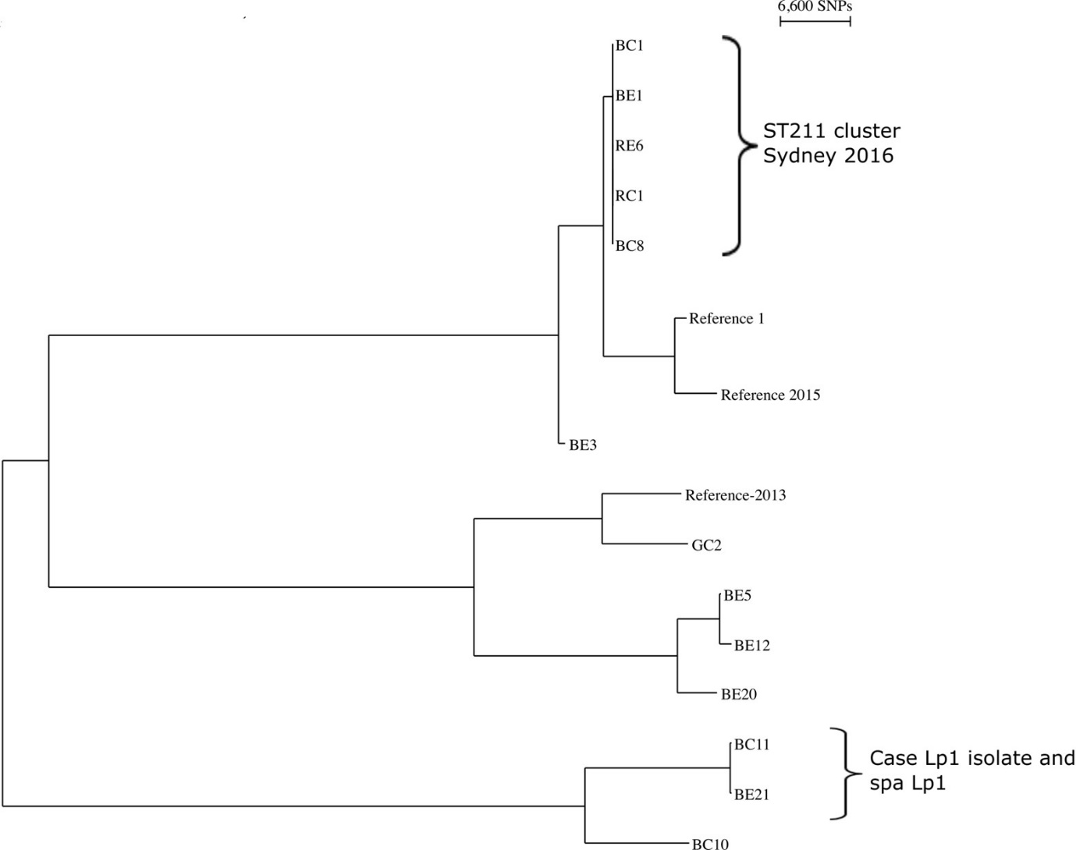

Discussion
This combined environmental health and microbiological investigation using whole genome sequencing showed a very high degree of relatedness between the clinical and environmental isolates, supporting the conclusion that the communal spa pool was the source of the case’s Lp1 exposure. The building’s water cooling tower was negative for Legionella and so was not likely to be the source. Although overseas studies have found legionellae to be widely distributed in reticulated and other water supplies,^{9–11} and present in domestic hot water¹² and showers,¹³ the latter are a rarely identified source due in part to the relatively high temperatures at which hot water is delivered. Only a single Australian report of Legionnaires’ disease acquired from domestic hot water has been published, in that case due to Lp serogroup 6,¹⁴ and hence Australian legionellosis investigation guidelines do not advise collection of samples of reticulated drinking or shower water. For this reason, we did not seek access to the case’s apartment to collect water samples.
Spa pools are a recognised source of Legionella exposure.^{2,15,16} Recent reviews of legionellosis related to spa pools supplied by reticulated water found strongest evidence for causation in relation to public spa pools.^{2,17} Sporadic cases and small outbreaks were also associated with private spa pools; but strong evidence of causation, based on matching of clinical and water isolates using sequence based typing, was often missing.²
High water temperatures in spa pools, combined with low water volumes compared to heavy bather loads, can result in low disinfectant levels which allow bacterial multiplication. Inadequate water treatment and/or inadequate free disinfectant levels were identified in most spa pools associated with cases of legionellosis.¹⁷ The spa pool associated with our case was being manually dosed with chlorine rather than using an automated dosing system, and we measured the free chlorine level as very low compared to the requirement of at least 2.0 mg/L under the NSW Public Health Regulation 2012 and compared to a minimum of 3.0 mg/L in both the United States of America (USA)¹⁸ and European¹⁹ standards.
The legionella count in the spa pool in our investigation was 20 CFU/mL, much lower than the counts generally found in outbreaks associated with contaminated cooling towers. However, exposure to spa pool waters is much more intense and likely more prolonged than putative cooling tower exposures, and a recent quantitative microbial risk assessment found that risk of legionellosis cannot be excluded in the presence of even very low concentrations of L. pneumophila in spa pool water.²⁰
WGS showed that the isolates from the case and from the spa pool were highly genomically related. Whilst we describe a single case, the recent review of outbreaks associated with spa pools identified a number of events where multiple cases occurred over extended periods, suggesting long term failure of disinfection conditions.² We are of the opinion that recognition of this sporadic case and our intervention may have prevented further cases of Legionnaires’ disease among users of this communal spa pool.
The added value of WGS in this investigation is highlighted by the fact that the isolates were not typable using the SBT scheme. While the 7-allelle gene SBT method has been used for outbreak investigations in the past,³ the limited resolution of SBT has encouraged a wider application of WGS. WGS is universally acknowledged to be a powerful tool that can provide high-resolution information on strain type, probable transmission pathways, outbreak origin and antibiotic resistance, for a growing number of community outbreaks of bacterial infections both in Australia⁷ and internationally.^{21,22} For example, the application of WGS in the USA as a public health surveillance tool for foodborne outbreaks caused by Listeria monocytogenes greatly increased the number of detected and solved outbreaks.²³ The WGS approach relies on the availability of culture, but high-resolution and standardised sequencing data can now be used as the basis for more accurate cluster assignment without the reliance on the 7-allelle SBT scheme given the latter method’s limited resolution and utility.

Conclusion
This appears to be the first report of a single case of legionellosis linked through the use of WGS molecular technology to exposure to a contaminated spa pool. The exposure is believed to have occurred despite the comparatively low Lp1 concentration in the spa pool water of 20 CFU/mL. This finding also supports the value of investigating single notifications with a small number of potential sources present (such as a communal spa pool), and it demonstrates the importance of the collection of clinical samples for Lp1 culture in order to have isolates which can then be subjected to WGS.
Spa pools have operating conditions that facilitate the growth of pathogens, including legionellae, such as: the high temperature of the circulating water; the presence of aerosol-generating jets; and a small volume of water with a potential high bather load. However, in NSW, communal spa pools in apartment complexes are not defined as public spa pools and are therefore exempt from the operational requirements set by the Public Health Regulation 2012. Throughout Australia, the regulation of public spa pools is highly variable; specific legislation exists in NSW, South Australia, Tasmania, Victoria, and Western Australia, but of these, communal spa pools in apartment buildings are regulated only in South Australia under the South Australian Public Health (General) Regulations 2013 and in Western Australia under the Health (Aquatic Facilities) Regulations 2007. As communal spa pools installed in multi-dwelling complexes that are poorly disinfected are a potential Legionella source, we believe that building managers should be made aware of the need for their proper maintenance.

Acknowledgements
We wish to thank the following NSW Health Pathology staff for microbial analyses: Peter Howard and Centre for Infectious Diseases and Microbiology – Public Health staff, and the Forensic and Analytical Science Service Legionella Reference Laboratory staff.

Author details
Ms Toni Cains,¹
Ms Hakoum Shalak,¹
Dr Verlaine J Timms,²
Mr Alexander Kiss,¹
Ms Anna Smith,³
Prof Vitali Sintchenko,^{2,4,5}
Dr Catherine Bateman-Steel,¹
Prof Mark J Ferson.^{1,6}
- Public Health Unit, South Eastern Sydney Local Health District, Sydney, New South Wales, Australia
- Centre for Infectious Diseases and Microbiology-Public Health, Westmead Hospital, Sydney, New South Wales, Australia
- Forensic and Analytical Science Service, NSW Health Pathology, Sydney, New South Wales, Australia
- Centre for Infectious Diseases and Microbiology Laboratory Services, Institute of Clinical Pathology and Medical Research, NSW Health Pathology, Sydney, New South Wales, Australia
- Marie Bashir Institute for Infectious Diseases and Biosecurity, Sydney Medical School, University of Sydney, Sydney, New South Wales, Australia
- School of Population Health, University of New South Wales, Sydney, New South Wales, Australia

Corresponding author
Prof Mark J Ferson
Address: Public Health Unit, South Eastern Sydney Local Health District, Locked Bag 88, Randwick NSW 2031
Phone: +61 401141890
Email: m.ferson@unsw.edu.au

References
- van Heijnsbergen E, Schalk JA, Euser SM, Brandsema PS, den Boer JW, de Roda Husman AM. Confirmed and potential sources of Legionella reviewed. Environ Sci Technol. 2015;49(8):4797–815. doi: https://doi.org/10.1021/acs.est.5b00142.
- Leoni E, Catalani F, Marini S, Dallolio L. Legionellosis associated with recreational waters: a systematic review of cases and outbreaks in swimming pools, spa pools and similar environments. Int J Environ Res Public Health. 2018;15(8):1612. doi: https://doi.org/10.3390/ijerph15081612.
- Gaia V, Fry NK, Afshar B, Lück PC, Meugnier H, Etienne J et al. Consensus sequence-based scheme for epidemiological typing of clinical and environmental isolates of Legionella pneumophila. J Clin Microbiol. 2005;43(5):2047–52. doi: https://doi.org/10.1128/JCM.43.5.2047-2052.2005.
- Bartley PB, Ben Zakour NL, Stanton-Cook M, Muguli R, Prado L, Garnys V et al. Hospital-wide eradication of a nosocomial Legionella pneumophila serogroup 1 outbreak. Clin Infect Dis. 2016;62(3):273–9. doi: https://doi.org/10.1093/cid/civ870.
- Reuter S, Harrison TG, Köser CU, Ellington MJ, Smith GP, Parkhill J et al. A pilot study of rapid whole-genome sequencing for the investigation of a Legionella outbreak. BMJ Open. 2013;3(1):e002175. doi: https://doi.org/10.1136/bmjopen-2012-002175.
- Graham RM, Doyle CJ, Jennison AV. Real-time investigation of a Legionella pneumophila outbreak using whole genome sequencing. Epidemiol Infect. 2014;142(11):2347–51. doi: https://doi.org/10.1017/S0950268814000375.
- Timms VJ, Rockett R, Bachmann NL, Martinez E, Wang Q, Chen SCA et al. Genome sequencing links persistent outbreak of legionellosis in Sydney to an emerging clone of Legionella pneumophila ST211. Appl Environ Microbiol. 2018;84(5):e02020-17. doi: https://doi.org/10.1128/AEM.02020-17.
- Bankevich A, Nurk S, Antipov D, Gurevich AA, Dvorkin M, Kulikov AS et al. SPAdes: A new genome assembly algorithm and its applications to single-cell sequencing. J Comput Biol. 2012;19(5):455–77. doi: https://doi.org/10.1089/cmb.2012.0021.
- Benedict KM, Reses H, Vigar M, Roth DM, Roberts VA, Mattioli M et al. Surveillance of waterborne outbreaks associated with drinking water – United States, 2013–2014. MMWR Morb Mortal Wlky Rep. 2017;66(44):1216–21. doi: https://doi.org/10.15585/mmwr.mm6644a3.
- Waak MB, LaPara TM, Hallé C, Hozalski RM. Occurrence of Legionella spp. in water-main biofilms from two drinking water distribution systems. Environ Sci Technol. 2018;52(14):7630−9. doi: https://doi.org/10.1021/acs.est.8b01170.
- Whiley H. Legionella risk management and control in potable water systems: argument for the abolishment of routine testing. Int J Environ Res Public Health. 2017;14(1):12. doi: https://doi.org/10.3390/ijerph14010012.
- Borella P, Montagna MT, Romano-Spica V, Stampi S, Stancanelli G, Triassi M et al. Legionella infection risk from domestic hot water. Emerg Infect Dis. 2004;10(3):457–64. doi: https://doi.org/10.3201/eid1003.020707.
- Collins S, Stevenson D, Bennett A, Walker J. Occurrence of Legionella in UK household showers. Int J Hygiene Environ Health. 2017;220(2 Pt B):401–6. doi: https://doi.org/10.1016/j.ijheh.2016.12.001.
- Young M, Smith H, Gray B, Huang B, Barten J, Towner C et al. The public health implications of a sporadic case of culture proven Legionnaires’ disease, Australia. Aust N Z J Public Health. 2005;29(6):513–7. doi: https://doi.org/10.1111/j.1467-842x.2005.tb00241.x.
- Campese C, Roche D, Clément C, Fierobe F, Jarraud S, de Waelle P et al. Cluster of Legionnaires’ disease associated with a public whirlpool spa, France, April–May 2010. Euro Surveill. 2010;15(26):19602.
- Sánchez-Busó L, Guiral S, Crespi S, Moya V, Camaró ML, Olmos MP et al. Genomic investigation of a legionellosis outbreak in a persistently colonized hotel. Front Microbiol. 2016;6:1556. doi: https://doi.org/10.3389/fmicb.2015.01556.
- Dabrera G, Naik F, Phin N. Legionellosis incidents associated with spa pools, England, 2002-2018. Public Health. 2020;185: 232–4. doi: https://doi.org/10.1016/j.puhe.2020.05.061.
- Centers for Disease Control and Prevention (CDC). Clause 5.7.3. In CDC, Model Aquatic Health Code. (3rd edition.) Atlanta: United States Government Department of Health and Human Services, CDC, 2018;122–3. Available from: https://www.cdc.gov/mahc/editions/current.html.
- ESCMID Study Group for Legionella Infections (ESGLI). Clause 1.63. In ESGLI, European Technical Guidelines for the Prevention, Control and Investigation, of Infections Caused by Legionella species. Basel: European Society of Clinical Microbiology and Infectious Diseases,2017; 42–4. Available from: https://www.ecdc.europa.eu/en/publications-data/european-technical-guidelines-prevention-control-and-investigation-infections.
- Bouwkneg, M, Schijven JF, Schalk JA, de Roda Husman AM. Quantitative risk estimation for a Legionella pneumophila infection due to whirlpool use. Risk Anal. 2013;33(7):1228–36. doi: https://doi.org/10.1111/j.1539-6924.2012.01909.x.
- Gire SK, Goba A, Andersen KG, Sealfon RSG, Park DJ, Kanneh L et al. Genomic surveillance elucidates Ebola virus origin and transmission during the 2014 outbreak. Science. 2014;345(6202):1369–72. doi: https://doi.org/10.1126/science.1259657.
- Grad YH, Godfrey P, Cerquiera GC, Mariani-Kurkdjian P, Gouali M, Bingen E et al. Comparative genomics of recent Shiga toxin-producing Escherichia coli O104:H4: short-term evolution of an emerging pathogen. mBio. 2013;4(1):e00452-12. doi: https://doi.org/10.1128/mBio.00452-12.
- Jackson BR, Tarr C, Strain E, Jackson KA, Conrad A, Carleton H et al. Implementation of nationwide real-time whole-genome sequencing to enhance listeriosis outbreak detection and investigation. Clin Infect Dis. 2016;63(3):380–6. doi: https://doi.org/10.1093/cid/ciw242.
Communicable Diseases Intelligence
ISSN: 2209-6051 Online

Communicable Diseases Intelligence (CDI) is a peer-reviewed scientific journal published by the Office of Health Protection and Response, Department of Health and Aged Care. The journal aims to disseminate information on the epidemiology, surveillance, prevention and control of communicable diseases of relevance to Australia.

Editor: Noel Lally
Deputy Editor: Simon Petrie
Design and Production: Kasra Yousefi
Editorial Advisory Board: David Durrheim, Mark Ferson, John Kaldor, Martyn Kirk and Linda Selvey

Website: http://www.health.gov.au/cdi

Contacts
CDI is produced by the Office of Health Protection and Response, Australian Government Department of Health and Aged Care, GPO Box 9848, (MDP 6) CANBERRA ACT 2601

Email: cdi.editor@health.gov.au

Submit an Article
You are invited to submit your next communicable disease related article to the Communicable Diseases Intelligence (CDI) for consideration. More information regarding CDI can be found at: http://health.gov.au/cdi.
Further enquiries should be directed to: cdi.editor@health.gov.au.

This journal is indexed by Index Medicus and Medline.

Creative Commons Licence - Attribution-NonCommercial-NoDerivatives CC BY-NC-ND
© 2022 Commonwealth of Australia as represented by the Department of Health and Aged Care
This publication is licensed under a Creative Commons Attribution-NonCommercial-NoDerivatives 4.0 International Licence from https://creativecommons.org/licenses/by-nc-nd/4.0/legalcode (Licence). You must read and understand the Licence before using any material from this publication.

Restrictions
The Licence does not cover, and there is no permission given for, use of any of the following material found in this publication (if any):
- the Commonwealth Coat of Arms (by way of information, the terms under which the Coat of Arms may be used can be found at www.itsanhonour.gov.au);
- any logos (including the Department of Health and Aged Care’s logo) and trademarks;
- any photographs and images;
- any signatures; and
- any material belonging to third parties.

Disclaimer
Opinions expressed in Communicable Diseases Intelligence are those of the authors and not necessarily those of the Australian Government Department of Health and Aged Care or the Communicable Diseases Network Australia. Data may be subject to revision.

Enquiries
Enquiries regarding any other use of this publication should be addressed to the Communication Branch, Department of Health and Aged Care, GPO Box 9848, Canberra ACT 2601, or via e-mail to: copyright@health.gov.au

Communicable Diseases Network Australia
Communicable Diseases Intelligence contributes to the work of the Communicable Diseases Network Australia.
http://www.health.gov.au/cdna

https://github.com/tseemann/snippy

