Pens down: An outbreak of the B.1.617.2 SARS-CoV-2 variant in an Australian high school, August 2021
Keeley Allen, Alexandra Marmor, Davoud Pourmarzi

Abstract

Background
Little is known about the transmission dynamics of the B.1.617.2 (Delta) variant of severe acute respiratory syndrome coronavirus 2 (SARS-CoV-2) among children and young adolescents. We investigated an outbreak in an Australian high school, with limited public health mitigation measures in place, to understand the school activities associated with transmission, and the role of young adolescents in spreading SARS-CoV-2.

Methods
All 1,164 school attendees were monitored for SARS-CoV-2 infection through their mandated 14-day quarantine period. A cohort study design was used to investigate the effect of contact with the index case in different classes on the transmission of SARS-CoV-2, and the effect of vaccination among household contacts on becoming infected by SARS-CoV-2.

Results
There were 48 outbreak cases, including 14 students and one teacher who likely acquired their infection at the school. Attack rates among students in the index case’s classes ranged from 0% to 45%. The greatest risk of infection for students in the same grade attending a class with the index case were from the drama class (risk ratio, RR: 111.6; 95% confidence interval (95% CI): 14.88–837.19) and the personal development, health, and physical education class (RR: 7.45: 95% CI: 2.27–24.44). The overall household attack rate was 57%, and household contacts who were not fully vaccinated were 2.9 times more likely (95% CI: 1.07–7.87) to become cases than were effectively-vaccinated household contacts.

Conclusion
Children can play an important role in the transmission of the Delta variant of SARS-CoV-2 within schools and at home. Transmission in this outbreak was largely associated with active, practical lessons that had close contact between students. This study demonstrates that the absence of public health and social measures in a low-incidence context resulted in the rapid spread of coronavirus disease 2019 (COVID-19) within an educational setting. These findings reinforce the role of public health and social measures and vaccinations to reduce airborne transmission and to enable a safe face-to-face learning environment.
Keywords: COVID-19; SARS-CoV-2; schools; risk factors; outbreak; contact tracing; adolescent; child; transmission; classroom

Introduction
After 16 months of no known local transmission in the Australian Capital Territory (ACT), the first locally-acquired coronavirus disease 2019 (COVID-19) case of 2021 was notified to the ACT Health Directorate (ACT Health) on 12 August 2021. This prompted a territory-wide stay-at-home order and the closure of the ACT’s schools. A mask mandate was introduced for all persons aged 12 years and over; non-essential services were closed; schools were closed; and home-based learning was introduced for ACT students.¹ On 15 August 2021, ACT Health was notified of a high school student with a positive reverse transcription polymerase chain reaction (RT-PCR) test result for severe acute respiratory syndrome coronavirus 2 (SARS-CoV-2).
While infectious, the student attended a local public high school serving 1,079 students aged 12–16 years (grades 7–10), with 114 staff. Students were grouped into different classes for each subject and attended multiple classrooms through the school day. The school had been operating face-to-face learning for the 2021 school year and masks were not required for staff or students. Public health and social measures across ACT schools focused on hand hygiene promotion and on increased frequency of cleaning services. At the time of this outbreak, people aged 29 years and younger were not eligible for a COVID-19 vaccination.²
The index case became symptomatic on 12 August 2021 with a sore throat and fever, undertook a RT-PCR test on 14 August 2021 and was notified to ACT Health on 15 August 2021. The student was considered infectious while symptomatic and for three days before symptom onset. From Monday 9 August to Thursday 12 August 2021 during this infectious period they had attended school, which was considered a high-risk setting.³ Genomic sequencing on 17 August 2021 confirmed that the student case was infected with the B.1.617.2 (Delta) variant. This outbreak investigation documents the transmission of the B.1.617.2 variant of SARS-CoV-2 from a single student to others in a classroom setting. In this report, we describe the investigation, the epidemiological characteristics of the outbreak, and the risk factors associated with transmission at the high school.

Methods
A school-associated case was defined as a person with a positive RT-PCR test for SARS-CoV-2 who attended the high school between 9 August 2021 and 12 August 2021. A household-associated case was defined as a person who received a positive RT-PCR test for SARS-CoV-2 and who was a household contact of an outbreak case. All people who attended the school campus any day between 9 August 2021 and 12 August 2021 were considered close contacts of the index case and were required to quarantine for 14 days after their exposure date, and to be tested immediately and on days 5 and 13 of quarantine, or upon the development of symptoms. The household contacts of the close contact attendees were considered secondary contacts and were required to quarantine for 14 days and to get tested if they developed symptoms of COVID-19.⁴ A household close contact was defined as a person residing in the same dwelling as an outbreak case during their infectious period.
All cases in this outbreak were interviewed to ascertain their symptomology, potential exposures, and vaccination status. A breakthrough infection was defined as a confirmed case who had received two doses of COVID-19 vaccine at least 14 days prior to symptom onset.
A cohort study design was used to investigate the effect of contact with the index case in different classes on the transmission of SARS-CoV-2. The cohort included all students in the same grade as the index case who attended the high school between Monday 9 August and Thursday 12 August 2021. Only students in the same grade as the index case were included, as students from other year groups could not be enrolled in the index case’s classes. Exposure was defined as attending a class with the index case for any length of time. The outcome was defined as having a positive RT-PCR test. Data on exposure were collected through interviews using a standard questionnaire, with the case and their legal guardian, to ascertain movements and activities at school, and through reviewing school timetables. All attendees were followed up until 14 days after their last exposure date at the school. Data was collected and managed using REDCap electronic data capture tools hosted at ACT Health.^{5,6}
Attack rates were calculated for attendees and non-attendees for each class attended by the index case. Relative risk (RR) and associated 95% confidence intervals (95% CI) were calculated for students in the same grade as the index case, to examine the association between attending different classes and becoming a confirmed COVID-19 case. Staff members were excluded from these analyses. The effect of being fully vaccinated on becoming infected by SARS-CoV-2 was examined by calculating attack rates and relative risk for household contacts of outbreak cases. For the purposes of the relative risk calculations, fully vaccinated was defined as receiving two doses at least 14 days before the start of the infectious period for the first case in the household. Results of hypothesis testing were considered statistically significant where confidence intervals did not include 1 and p values were less than 0.05. Statistical analysis was conducted in R version 4.1.1.
Whole genomic sequencing was conducted by the Australian National University on behalf of ACT Health, with lineage assigned using Phylogenetic Assignment of Named Global Outbreak Lineages (PANGOLIN) nomenclature.
The investigation formed part of a public health emergency response under the ACT Public Health Act 2010; therefore, ethics approval was not required. This investigation is covered by the Australian National University Human Research Ethics Committee (Protocol 2017/909) standing approval for outbreak investigations involving staff and students.

Results

Outbreak associated cases
Fifteen students who had not attended the school campus between 9 August and 12 August 2021 were excluded. A total of 110 out of 114 (96.5%) staff members and 1,054 out of 1,064 (99.1%) included students were tested for SARS-CoV-2 during the quarantine period.
Overall, there were 48 outbreak cases. Sixteen cases were school-associated and were likely to have acquired their infection from the index case at the school, including one staff member and fifteen students. A further five students who attended the school were assessed as likely to have acquired their infection as a household close contact of an infectious sibling who also attended the high school, based on their time of symptom onset. A further 27 household contacts were notified as confirmed COVID-19 cases. The key characteristics of the cases are summarised in Table 1. The median age of the cases was 15 years (IQR: 13–40 years) and 63% of cases (30/48) were female. There were no hospitalisations or deaths.
Forty-two samples from this outbreak were sequenced, and six were unable to be sequenced. All sequenced samples were the B.1.617.2 (Delta) variant and were within two single nucleotide polymorphisms (SNPs) of the index case’s sequence.
An epidemic curve of the outbreak by symptom onset date is shown in Figure 1. One school-associated case reported the same symptom onset date as the index case. The genomic analysis indicated that this secondary case was closely related, but not identical and suggests the transmission event may have occurred earlier in the index case’s infectious period. Further, this second student did not share their genomic sequence with any other school-associated cases, suggesting only one index case was present in this outbreak.
Among the 14 age-eligible cases, six were unvaccinated, three had received one dose, and five cases had received two doses. Three of the latter were breakthrough infections.
All but one case reported at least one COVID-19 symptom throughout their infection. The remaining case was asymptomatic through their infection. The most commonly-reported symptoms among child and adult cases were cough (83%; 40/48), runny or blocked nose (81%; 39/48), and headache (79%; 38/48) (Figure 2). A greater proportion of adult cases than child cases reported alteration of taste or smell; muscle or joint pain; diarrhoea; shortness of breath; or chest pain.
Table 1: Characteristics of cases associated with the B.1.617.2 high school outbreak (n = 48), Australian Capital Territory, August 2021
Characteristic | School associatedª | Household associated | Total
Total | 16 | 32 | 48
Sex
Male | 4 | 14 | 18
Female | 12 | 18 | 30
Age group (years)
0–9 | — | 3 | 3
10–19 | 15 | 13 | 28
20–29 | 1 | — | 1
30–39 | — | 3 | 3
40–49 | — | 9 | 9
50+ | — | 4 | 4
Indigenous status
Aboriginal and Torres Strait Islander people | 1 | — | 1
Non-Indigenous people | 15 | 31 | 46
Not stated | — | 1 | 1
Country of birth
Australia | 15 | 22 | 38
Overseas | 1 | 9 | 10
Vaccination status
Not age eligible | 16 | 16 | 31
Unvaccinated | — | 6 | 6
1 dose | — | 5 | 5
2 doses | — | 5 | 5
2 doses > 14 days before onset | — | 3 | 3
a Includes the index case, students who likely acquired their infection at school, and the staff member case.

Figure 1: Epidemic curve of COVID-19 cases associated with the B.1.617.2 outbreak (n = 48), by symptom onset date,ª Australian Capital Territory, August 2021
a Specimen collection date was used for cases that remained asymptomatic throughout their infection.
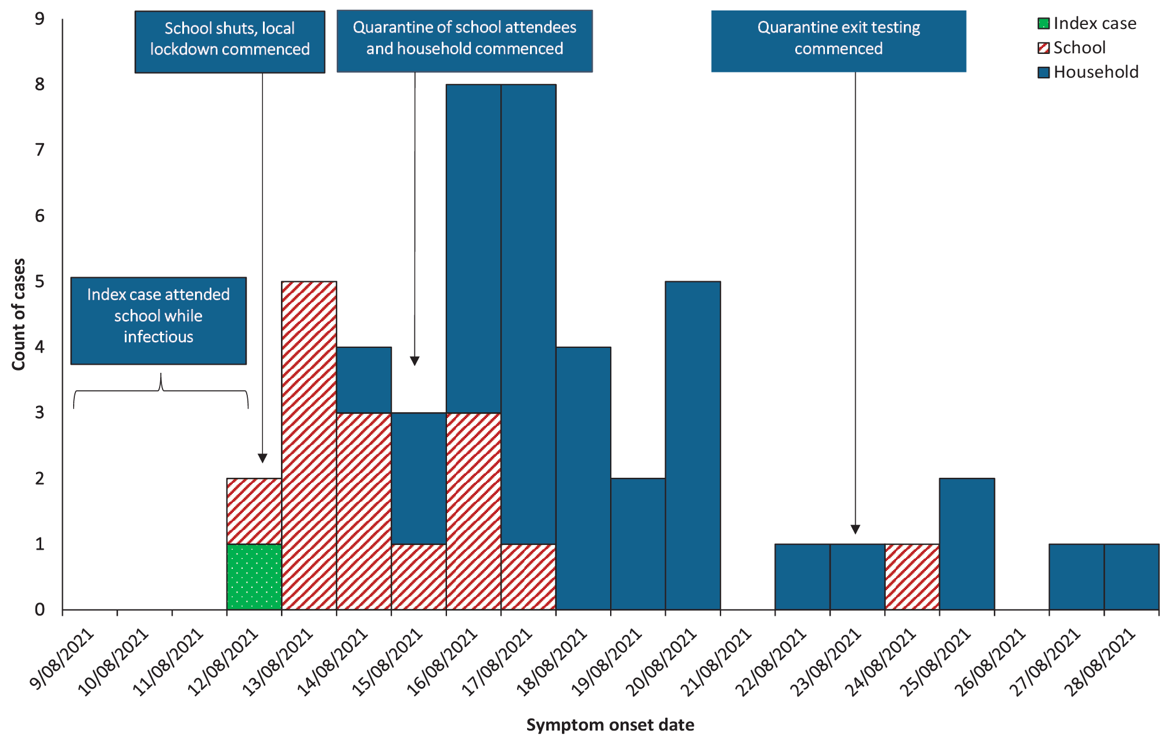
a Specimen collection date was used for cases that remained asymptomatic throughout their infection.

Figure 2: Symptom profile of child and adult COVID-19 cases associated with the B.1.617.2 high school outbreak (n = 48),ª Australian Capital Territory, August 2021
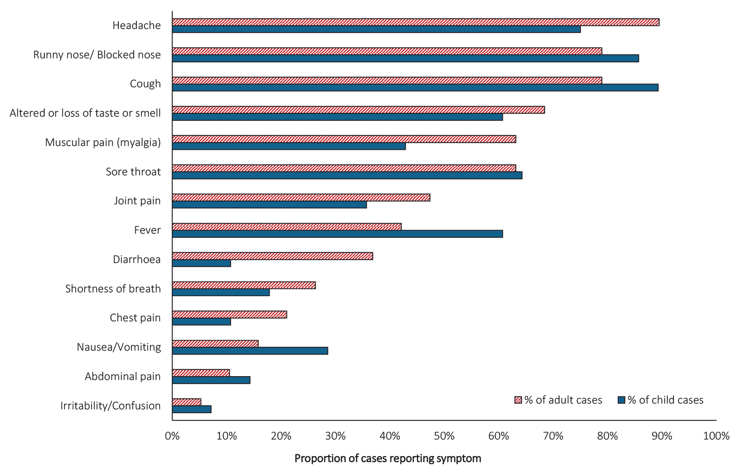
a One case reported remaining asymptomatic through their infection.

Transmission events
Based on the findings of the case interview and genomic analysis, the source of the index case’s infection was identified as a theatre group rehearsal at a community hall the weekend before onset.

School transmission
The in-school transmission events associated with this outbreak are shown in Figure 3. Ten of the 14 school-acquired cases (71%) were in the same grade as the index case and had attended at least one class together. Four of these students attended multiple classes with the index case. The attack rates for the eight classes that the index case attended ranged between 0% and 45% (median: 3.2%) (Table 2). All lessons were indoors.
The highest attack rate was seen in the drama class, where nine of the 20 classmates of the index case were confirmed outbreak cases. This practical class had three timetabled indoor lessons during 9–12 August 2021 and involved small groups in close contact preparing short performances and the class sitting together as an audience. Risk of infection for students attending drama class was over one hundred times the risk for students in the same grade who did not attend this class (95% CI: 14.88–837.19; p < 0.001). Three student cases attended a personal development, health, and physical education (PDHPE) class with the index case for three lessons during 9–12 August 2021. All three practical lessons involved indoor physical activity, social mixing and close contact between students, and using the change rooms before and after class. Students in the PDHPE class were seven times more likely to be cases (RR 7.45; 95% CI: 2.27–24.44; p < 0.001) than were students who did not attend the class. The teacher of this class was also a confirmed outbreak case.
Figure 3: Likely transmission tree of school-associated COVID-19 cases associated with the B.1.617.2 high school outbreak (n = 16), by symptom onset date,ª Australian Capital Territory, August 2021^{b}
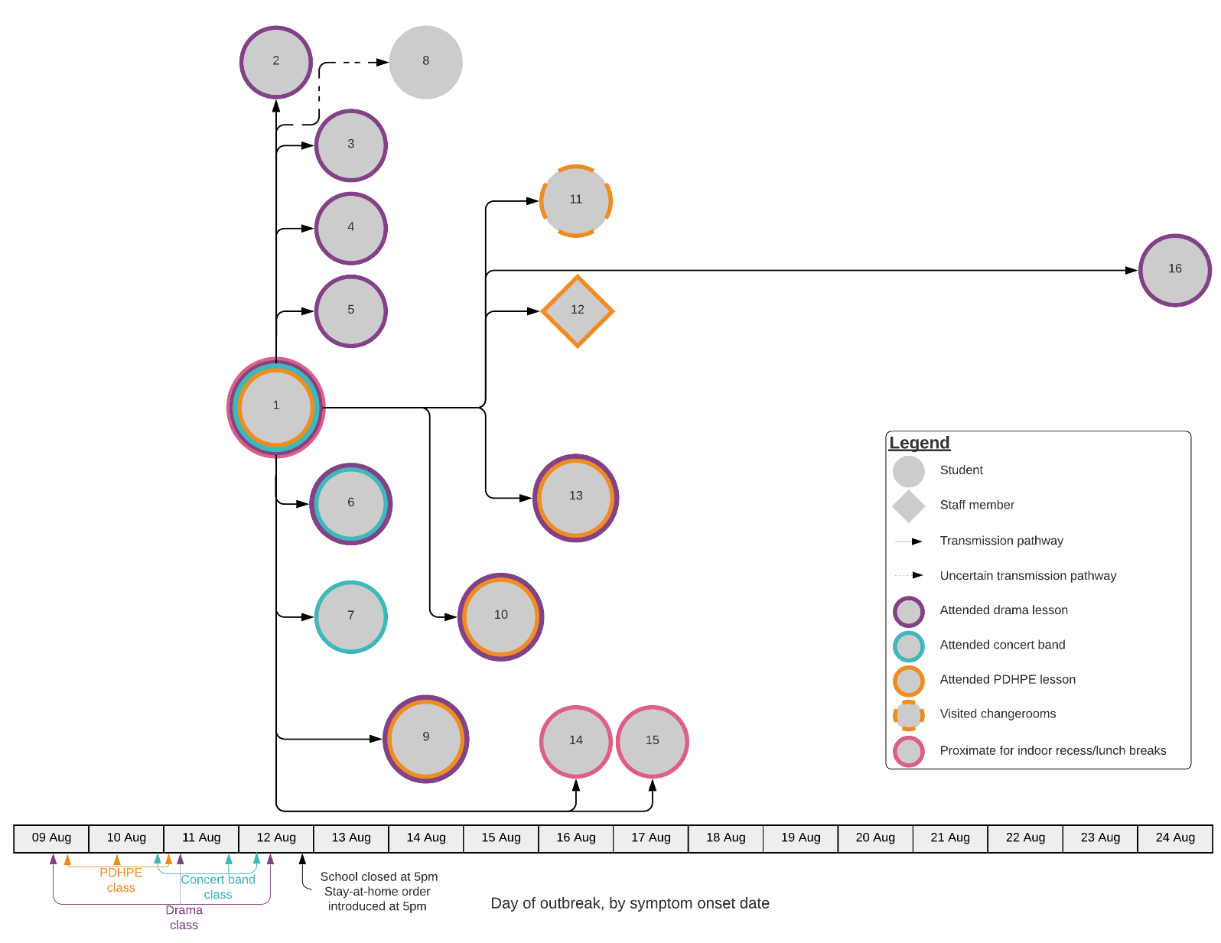
a Specimen collection date used for cases that remained asymptomatic throughout their infection.
b Note: This figure only includes school-associated cases. Household associated cases have been excluded.
c PDHPE: Personal development, health, and physical education.
Two student cases attended a concert band rehearsal with the index case for two lessons during 9–12 August 2021. These lessons involved students playing brass and woodwind instruments and were conducted indoors in a dedicated music performance space. The risk of transmission in this class was not statistically significant (RR: 0.54; 95% CI: 0.12–2.48; p = 0.418). Two student cases also attended home group and a science class with the index case; however, these cases also attended the drama class.
Four school-associated cases were in a different grade to the index case. None of these four cases reported social interactions or timetabled classes with the index case, or with each other, and no likely sources of infection outside the educational setting were identified. Genomic analysis confirmed these four cases shared the same sequence as the index case. One of these four cases reported three timetabled practical PDHPE lessons with a different teacher at the same time as the index case, and both cases reported using the change rooms before and after each lesson. Although the lessons were conducted in different areas of the school, the repeated use of the change rooms may have provided an opportunity for transmission between the index case and this student.
Two additional students reported sitting near the index case for recess and lunch periods during 9–12 August 2021. The seating area was indoors and an informal setting enabled students to move freely. There was potential for the virus to have been transmitted to students during the lunch and recess periods in this shared space. One student case had an unclear source of exposure. This student had practical PDHPE lessons timetabled directly after the index case on three days; however, they reported using different change rooms and a different PDHPE teacher.

Table 2: Attack rates and relative risk of COVID-19 among students in different classes, B.1.617.2 high school outbreak, Australian Capital Territory, August 2021 (n = 258)
Class | Student cases who attended the class | Student non-cases who attended the class | AR | Student cases who did not attend the class | Student non-cases who did attend the class | RR | p value | 95% CI
Home group | 2 | 18 | 10% | 8 | 240 | 3.10 | 0.124 | 0.70–13.63
PDHPEª | 4 | 18 | 18% | 6 | 240 | 7.45 | < 0.001 | 2.27–24.44
History and social sciences | 0 | 24 | 0% | 10 | 234 | — | — | —
Science | 1 | 24 | 4% | 9 | 234 | 1.08 | 0.941 | 0.14–8.18
Drama | 9 | 11 | 45% | 1 | 247 | 111.6 | <0.001 | 14.88–837.19
English | 0 | 21 | 0% | 10 | 237 | — | — | —
Concert band | 2 | 83 | 2.4% | 8 | 175 | 0.54 | 0.417 | 0.12–2.48
Maths | 0 | 25 | 0% | 10 | 233 | — | — | —
a PDHPE: Personal development, health, and physical education.
Table 3: The risk of transmission to household contacts (n = 52) by vaccination status among cases associated with the B.1.617.2 high school outbreak, Australian Capital Territory, August 2021
Vaccination statusª | Case | Negative contact | Total | AR | RR
Fully vaccinated | 3 | 9 | 12 | 25% | 2.9^{b}
Not fully vaccinated | 29 | 11 | 40 | 73%
Total | 32 | 20 | 52
a For this analysis, fully vaccinated was defined as receiving 2 doses > 14 days before the start of the infectious period for of the first case in the household.
b 95% CI: 1.07–7.87; p = 0.003.

Household transmission
Household size ranged from three to six people with a median of four residents. Twelve school-associated cases led to onward transmission within their household. Household attack rates ranged from 33% to 100% of household contacts and the overall attack rate among household contacts was 57% (30/56). Three school-associated cases did not lead to onward transmission at home. The median household size was the same for households with transmission (four residents) and households with no transmission (four residents).
The relative risk of a household contact becoming a COVID-19 case was 2.9 times higher (95% CI: 1.07–7.87; p = 0.003) among household contacts who were not fully vaccinated than among those who had received two doses of COVID-19 vaccine at least 14 days before the infectious period of the outbreak case (Table 3).
The outbreak was declared over on 12 September 2021, fourteen days after the notification of the final household-associated case.

Discussion
This high school outbreak demonstrates the transmission of the Delta variant of COVID-19, in an education setting with limited mitigation measures in place, during a period of low incidence. Masks were not worn during indoor lessons and public health and social measures in place had focused on surface cleaning and hand hygiene. These conditions promoted transmission among young adolescents in class and have been associated with in-school transmission in other COVID-19 outbreaks.^{7–14}
Transmission in this outbreak was largely associated with active, practical lessons that had close contact between students. The drama, PDHPE and concert band classes all involved activities—including students mingling throughout the room, raised voices, physical activity, and playing musical instruments—with greater aerosol-generating potential than did quietly sitting at a desk. Transmission of SARS-CoV-2 has been documented in PDHPE classes in other jurisdictions,^{8,9,15,16} and in classes and extracurricular activities with raised voices from teachers and students.^{7,11,17,18} These activities may explain why transmission occurred in these classes and not during didactic lessons, where students are more often passive listeners as a teacher gives a lecture. Practical lessons are core components to student learning and safe face-to-face learning will require adherence to public health and social measures, such as mask wearing among staff and students, and conducting practical lessons outdoors where feasible.
Although schools and students were previously considered to play limited roles in transmission for ancestral strains of SARS-CoV-2 in Australia and internationally,^{19–22} this investigation suggests that new variants may have greater potential for transmission within educational settings. Investigations of outbreak of the B.1.617.2, B.1.1.57 (Alpha), and B.1.1.159 (Omicron) variants within schools have found higher attack rates compared to ancestral strains, and more frequent student-to-student and student-to-staff transmission.^{7,11,21,23–26} The introduction of mask wearing in high schools and of vaccinations for children have been shown to reduce attack rates of the B.1.617.2 variant compared to ancestral SARS-CoV-2 in schools elsewhere in Australia,²¹ demonstrating the value of public health and social measures to reduce transmission.
It is evident from this outbreak investigation that children experience symptoms and can play an important role in the transmission of the B.1.617.2 variant of COVID-19, particularly when limited public health mitigation measures are in place. Only one child case (2%) in this outbreak reported no symptoms. This is a lower proportion of asymptomatic cases than in previously-reported symptom profiles among children with B.1.617.2 infection.^{27–32} The household attack rate in this outbreak indicates the potential for increased transmissibility of the Delta variant compared with other variants.^{33–38}
The findings of this outbreak investigation are subject to some limitations. Firstly, not every student and staff member was recorded in ACT Health’s quarantine database or had testing records identified. This may have resulted in under-ascertainment of cases. Further, the exact number of household contacts of staff and students is unknown, limiting our understanding of the extent of those impacted by the outbreak. Secondly, while all cases were able to be interviewed, the school-specific interviews took place up to two weeks after last attending the school campus. Recall bias may have affected the quality of data collected; the recall was particularly low for the use of toilets and attending non-timetabled areas of the school such as the library or the office. Thirdly, six cases were unable to have their samples sequenced to confirm their lineage and relatedness to other outbreak associated cases. Despite these limitations, these findings demonstrate transmission between young adolescents in an educational setting.
The transmission events in this outbreak demonstrate that the absence of public health and social measures in a low prevalence setting resulted in rapid spread in an educational setting. Promoting vaccination among eligible populations; mask wearing during class; improving indoor ventilation; encouraging outdoor rest periods and lessons (especially for practical classes); physical distancing of students; and staying home when symptomatic all remain crucial components to limit transmission and to enable a safe face-to-face learning environment for children and school staff.

Acknowledgements
The authors would like to thank the following case investigators for their efforts conducting initial case interviews: Charissa Hayward, Regan Bartholomew, Kari Tveit, Margaret Curran, Brody Bamford, Algreg Gomez, Gabrielle Robens, Leonie Williamson, Yasmin Lisson, Mary Brunton, Aruna Phabmixay, Christopher Harris, Rebekah Bowman, Pallavi Venkatesh. We also thank Dr Nevada Pingault and Timothy Sloan-Gardner for their review of the manuscript and subsequent suggestions. We would also like to thank the school, the ACT Education Directorate, and Dr Sally Singleton for their collaboration and collation of data. The Master of Philosophy (Applied Epidemiology) (MAE Program) is funded by Australian federal and state and territory health departments.

Author details
Keeley Allen1,2 Alexandra Marmor² Dr Davoud Pourmarzi¹
- National Centre for Epidemiology and Population Health, Australian National University, Acton, ACT, Australia.
- Communicable Disease Control, ACT Health, Holder, ACT, Australia.

Corresponding author
Keeley Allen
National Centre for Epidemiology and Population Health, Australian National University, Acton, ACT
Phone: (02) 5124 6215
Email address: keeley.allen@anu.edu.au

References
- Australian Capital Territory Government (ACT Government), ACT Legislation Register. Public Health (Lockdown Restrictions) Emergency Direction 2021 (No 1). ((ACT) NI2021-480). [Legislation.] Canberra: ACT Government; 12 August 2021. Available from: https://www.legislation.act.gov.au/ni/2021-480/.
- ACT Government. COVID-19 vaccine bookings open for 16–29 year old Canberrans. [Internet.] Canberra: ACT Government; 1 September 2021. Available from: https://www.covid19.act.gov.au/news-articles/covid-19-vaccine-bookings-open-for-16-29-year-old-canberrans.
- Australian Government Department of Health. Coronavirus Disease 2019 (COVID-19). CDNA National guidelines for public health units. Version 4.7. [Internet.] Canberra: Australian Government Department of Health; 2021. Available from: https://www1.health.gov.au/internet/main/publishing.nsf/Content/cdna-song-novel-coronavirus.htm.
- ACT Government, ACT Legislation Register. Public Health (Diagnosed People and Close Contacts) Emergency Direction 2021 (No 1). ((ACT) NI2021–421). [Legislation.] Canberra: ACT Government; 9 July 2021. Available from: https://www.legislation.act.gov.au/ni/2021-421/.
- Harris PA, Taylor R, Minor BL, Elliott V, Fernandez M, O’Neal L et al. The REDCap consortium: building an international community of software platform partners. J Biomed Inform. 2019;95:103208. doi: https://doi.org/10.1016/j.jbi.2019.103208.
- Harris PA, Taylor R, Thielke R, Payne J, Gonzalez N, Conde JG. Research electronic data capture (REDCap)—a metadata-driven methodology and workflow process for providing translational research informatics support. J Biomed Inform. 2009;42(2):377–81. doi: https//doi.org/10.1016/j.jbi.2008.08.010.
- Baumgarte S, Hartkopf F, Hölzer M, von Kleist M, Neitz S, Kriegel M et al. Investigation of a limited but explosive COVID-19 outbreak in a German secondary school. Viruses. 2022;14(1):87. doi: https://doi.org/10.3390/v14010087.
- Gettings JR, Gold JAW, Kimball A, Forsberg K, Scott C, Uehara A et al. SARS-CoV-2 transmission in a Georgia school district – United States, December 2020–January 2021. Clin Infect Dis. 2022;74(2):319–26. doi: https://doi.org/10.1093/cid/ciab332.
- Gold JAW, Gettings JR, Kimball A, Franklin R, Rivera G, Morris E et al. Clusters of SARS-CoV-2 infection among elementary school educators and students in one school district – Georgia, December 2020–January 2021. MMWR Morb Mortal Wkly Rep. 2021;70(8):289–92. doi: https://doi.org/10.15585/mmwr.mm7008e4.
- Jehn M, McCullough JM, Dale AP, Gue M, Eller B, Cullen T et al. Association between K–12 school mask policies and school-associated COVID-19 outbreaks – Maricopa and Pima Counties, Arizona, July–August 2021. MMWR Morb Mortal Wkly Rep. 2021;70(39):1372–3. doi: https://doi.org/10.15585/mmwr.mm7039e1.
- Lam-Hine T, McCurdy SA, Santora L, Duncan L, Corbett-Detig R, Kapusinszky B et al. Outbreak associated with SARS-CoV-2 B.1.617.2 (Delta) variant in an elementary school – Marin County, California, May–June 2021. MMWR Morb Mortal Wkly Rep. 2021;70(35):1214–9. doi: https://doi.org/10.15585/mmwr.mm7035e2.
- Schoeps A, Hoffmann D, Tamm C, Vollmer B, Haag S, Kaffenberger T et al. Surveillance of SARS-CoV-2 transmission in educational institutions, August to December 2020, Germany. Epidemiol Infect. 2021;149:e213. doi: https://doi.org/10.1017/S0950268821002077.
- Stein-Zamir C, Abramson N, Shoob H, Libal E, Bitan M, Cardash T et al. A large COVID-19 outbreak in a high school 10 days after schools’ reopening, Israel, May 2020. Euro Surveill. 2020;25(29):2001352. doi: https://doi.org/10.2807/1560-7917.ES.2020.25.29.2001352.
- Torres JP, Piñera C, De La Maza V, Lagomarcino AJ, Simian D, Torres B et al. Severe acute respiratory syndrome coronavirus 2 antibody prevalence in blood in a large school community subject to a coronavirus disease 2019 outbreak: a cross-sectional study. Clin Infect Dis. 2021;73(2):e458–65. doi: https://doi.org/10.1093/cid/ciaa955.
- Atherstone C, Siegel M, Schmitt-Matzen E, Sjoblom S, Jackson J, Blackmore C et al. SARS-CoV-2 transmission associated with high school wrestling tournaments – Florida, December 2020–January 2021. MMWR Morb Mortal Wkly Rep. 2021;70(4):141–3. doi: https://doi.org/10.15585/mmwr.mm7004e4.
- Zimmerman KO, Brookhart MA, Kalu IC, Boutzoukas AE, McGann KA, Smith MJ et al. Community SARS-CoV-2 surge and within-school transmission. Pediatrics. 2021;148(4). doi: https://doi.org/10.1542/peds.2021-052686.
- Pray IW, Gibbons-Burgener SN, Rosenberg AZ, Cole D, Borenstein S, Bateman A et al. COVID-19 outbreak at an overnight summer school retreat – Wisconsin, July-August 2020. MMWR Morb Mortal Wkly Rep. 2020;69(43):1600–4. doi: https://doi.org/10.15585/mmwr.mm6943a4.
- Vishnu Prasad S, Mukherjee G, Bobdey S, Kaushik SK, Yadav AK, Teli P et al. Epidemiological analysis of SARS-COV-2 B.1.617.2 (delta variant) transmission in an educational institute. Med J Armed Forces India. 2022. doi: https://doi.org/10.1016/j.mjafi.2022.02.008.
- Brandal LT, Ofitserova TS, Meijerink H, Rykkvin R, Lund HM, Hungnes O et al. Minimal transmission of SARS-CoV-2 from paediatric COVID-19 cases in primary schools, Norway, August to November 2020. Euro Surveill. 2021;26(1):2002011. doi: https://doi.org/10.2807/1560-7917.ES.2020.26.1.2002011.
- Macartney K, Quinn HE, Pillsbury AJ, Koirala A, Deng L, Winkler N et al. Transmission of SARS-CoV-2 in Australian educational settings: a prospective cohort study. Lancet Child Adolesc Health. 2020;4(11):807–16. doi: https://doi.org/10.1016/S2352-4642(20)30251-0.
- National Centre for Immunisation Research and Surveillance (NCIRS), New South Wales Government Department of Health (NSW Health). COVID-19 in schools – the experience in NSW: 18 October 2021 to 17 December 2021. Sydney: NCIRS, NSW Health; 18 February 2022. Available from: https://www.ncirs.org.au/sites/default/files/2022-02/NCIRS_NSW_Schools_COVID_Summary_Term_4_2021_Report%20-%2024-02-2022_Final.pdf.
- Otte Im Kampe E, Lehfeld AS, Buda S, Buchholz U, Haas W. Surveillance of COVID-19 school outbreaks, Germany, March to August 2020. Euro Surveill. 2020;25(38):2001645. doi: https://doi.org/10.2807/1560-7917.ES.2020.25.38.2001645.
- Hwang H, Lim JS, Song SA, Achangwa C, Sim W, Kim G et al. Transmission dynamics of the Delta variant of SARS-CoV-2 infections in South Korea. J Infect Dis. 2021;225(5):793–9. doi: https://doi.org/10.1093/infdis/jiab586.
- Li YF, Fan W, Wang WH et al. A school cluster outbreak of COVID-19 caused by SARS-CoV-2 Omicron variant. Chin J Public Health. 2022;38(5):614–8. doi: https://doi.org/10.11847/zgggws1138512.
- Lorthe E, Bellon M, Berthelot J, Michielin G, L’Huillier AG, Posfay-Barbe KM et al. A SARS-CoV-2 omicron (B.1.1.529) variant outbreak in a primary school in Geneva, Switzerland. Lancet Infect Dis. 2022;S1473-3099(22)00267-5. doi: https://doi.org/10.1016/S1473-3099(22)00267-5.
- Grant R, Charmet T, Schaeffer L, Galmiche S, Madec Y, Von Platen C et al. Impact of SARS-CoV-2 Delta variant on incubation, transmission settings and vaccine effectiveness: results from a nationwide case-control study in France. Lancet Reg Health Eur. 2022;13:100278. doi: https://doi.org/10.1016/j.lanepe.2021.100278.
- Assaker R, Colas AE, Julien-Marsollier F, Bruneau B, Marsac L, Greff B et al. Presenting symptoms of COVID-19 in children: a meta-analysis of published studies. Br J Anaesth. 2020;125(3):e330–2. doi: https://doi.org/10.1016/j.bja.2020.05.026.
- Forrest CB, Burrows EK, Mejias A, Razzaghi H, Christakis D, Jhaveri R et al. Severity of acute COVID-19 in children <18 years old March 2020 to December 2021. Pediatrics. 2022;149(4):e2021055765. doi: https://doi.org/10.1542/peds.2021-055765.
- Meuris C, Kremer C, Geerinck A, Locquet M, Bruyère O, Defêche J et al. Transmission of SARS-CoV-2 after COVID-19 screening and mitigation measures for primary school children attending school in Liège, Belgium. JAMA Netw Open. 2021;4(10):e2128757. doi: https://doi.org/10.1001/jamanetworkopen.2021.28757.
- Shoji K, Akiyama T, Tsuzuki S, Matsunaga N, Asai Y, Suzuki S et al. Comparison of the clinical characteristics and outcomes of COVID-19 in children before and after the emergence of Delta variant of concern in Japan. J Infect Chemother. 2022;28(4):591–4. doi: https://doi.org/10.1016/j.jiac.2022.01.009.
- Viner RM, Ward JL, Hudson LD, Ashe M, Patel SV, Hargreaves D et al. Systematic review of reviews of symptoms and signs of COVID-19 in children and adolescents. Arch Dis Child. 2020. doi: https://doi.org/10.1136/archdischild-2020-320972.
- Yasuhara J, Kuno T, Takagi H, Sumitomo N. Clinical characteristics of COVID-19 in children: a systematic review. Pediatr Pulmonol. 2020;55(10):2565–75. doi: https://doi.org/10.1002/ppul.24991.
- Chudasama DY, Tessier E, Flannagan J, Leeman D, Webster H, Demirjian A et al. Surge in SARS-CoV-2 transmission in school-aged children and household contacts, England, August to October 2021. Euro Surveill. 2021;26(48):2101019. doi: https://doi.org/10.2807/1560-7917.ES.2021.26.48.2101019.
- Dougherty K, Mannell M, Naqvi O, Matson D, Stone J. SARS-CoV-2 B. 1.617. 2 (Delta) variant COVID-19 outbreak associated with a gymnastics facility—Oklahoma, April–May 2021. MMWR Morb Mortal Wkly Rep. 2021;70(28):1004. doi: https://doi.org/10.15585/mmwr.mm7028e2.
- Goldstein E, Lipsitch M, Cevik M. On the effect of age on the transmission of SARS-CoV-2 in households, schools, and the community. J Infect Dis. 2020;223(3):362–9. doi: https://doi.org/10.1093/infdis/jiaa691.
- Madewell ZJ, Yang Y, Longini IM, Halloran ME, Dean NE. Household transmission of SARS-CoV-2: a systematic review and meta-analysis. JAMA Netw Open. 2020;3(12):e2031756. doi: https://doi.org/10.1001/jamanetworkopen.2020.31756.
- Peng J, Liu J, Mann SA, Mitchell AM, Laurie MT, Sunshine S et al. Estimation of secondary household attack rates for emergent spike L452R SARS-CoV-2 variants detected by genomic surveillance at a community-based testing site in San Francisco. Clin Infect Dis. 2022;74(1):32–9. doi: https://doi.org/10.1093/cid/ciab283.
- Tanaka H, Hirayama A, Nagai H, Shirai C, Takahashi Y, Shinomiya H et al. Increased transmissibility of the SARS-CoV-2 Alpha variant in a Japanese population. Int J Environ Res Public Health. 2021;18(15):7752. doi: https://doi.org/10.3390/ijerph18157752.

Communicable Diseases Intelligence
ISSN: 2209-6051 Online

Communicable Diseases Intelligence (CDI) is a peer-reviewed scientific journal published by the Office of Health Protection and Response, Department of Health and Aged Care. The journal aims to disseminate information on the epidemiology, surveillance, prevention and control of communicable diseases of relevance to Australia.

Editor: Noel Lally
Deputy Editor: Simon Petrie
Design and Production: Kasra Yousefi
Editorial Advisory Board: David Durrheim, Mark Ferson, John Kaldor, Martyn Kirk and Linda Selvey

Website: http://www.health.gov.au/cdi

Contacts
CDI is produced by the Office of Health Protection and Response, Australian Government Department of Health and Aged Care, GPO Box 9848, (MDP 6) CANBERRA ACT 2601

Email: cdi.editor@health.gov.au

Submit an Article
You are invited to submit your next communicable disease related article to the Communicable Diseases Intelligence (CDI) for consideration. More information regarding CDI can be found at: http://health.gov.au/cdi.
Further enquiries should be directed to: cdi.editor@health.gov.au.

This journal is indexed by Index Medicus and Medline.

Creative Commons Licence - Attribution-NonCommercial-NoDerivatives CC BY-NC-ND
© 2022 Commonwealth of Australia as represented by the Department of Health and Aged Care
This publication is licensed under a Creative Commons Attribution-NonCommercial-NoDerivatives 4.0 International Licence from https://creativecommons.org/licenses/by-nc-nd/4.0/legalcode (Licence). You must read and understand the Licence before using any material from this publication.

Restrictions
The Licence does not cover, and there is no permission given for, use of any of the following material found in this publication (if any):
- the Commonwealth Coat of Arms (by way of information, the terms under which the Coat of Arms may be used can be found at www.itsanhonour.gov.au);
- any logos (including the logo of the Department of Health and Aged Care) and trademarks;
- any photographs and images;
- any signatures; and
- any material belonging to third parties.

Disclaimer
Opinions expressed in Communicable Diseases Intelligence are those of the authors and not necessarily those of the Australian Government Department of Health and Aged Care or the Communicable Diseases Network Australia. Data may be subject to revision.

Enquiries
Enquiries regarding any other use of this publication should be addressed to the Communication Branch, Department of Health and Aged Care, GPO Box 9848, Canberra ACT 2601, or via e-mail to: copyright@health.gov.au

Communicable Diseases Network Australia
Communicable Diseases Intelligence contributes to the work of the Communicable Diseases Network Australia.
http://www.health.gov.au/cdna

https://cov-lineages.org/

