Public health response to a norovirus viral gastroenteritis outbreak in early childhood learning centres in Victoria, Australia, 2021
George P Drewett, Anna-Lena Arnold, Leesa Bruggink, Sarah Borg, Kaye Sturge, Bruce Bolam
Keywords: norovirus; alcohol-based hand sanitiser; soap and water handwashing; mass media; public health; GII.P16/GII.2
We report on the public health response to an outbreak of infectious viral gastroenteritis in early childhood learning centres (ECLC) in Victoria, Australia, during the first half of 2021. Viral gastroenteritis is a common cause of childhood diarrhoea,^{1,2} and is frequently spread through high-risk environments such as ECLC.³ Laboratory testing identified an international epidemic strain of norovirus, GII.P16/GII.2 (Figure 1), which had not previously caused epidemic norovirus outbreaks in Victoria, as the predominant infectious agent in this outbreak. Similar outbreaks of norovirus had been observed in other Australian jurisdictions recently prior to this outbreak.⁴
Figure 1: Norovirus genotyping from gastroenteritis outbreaks in early childhood learning centres, Victoria, by month, January–June 2021
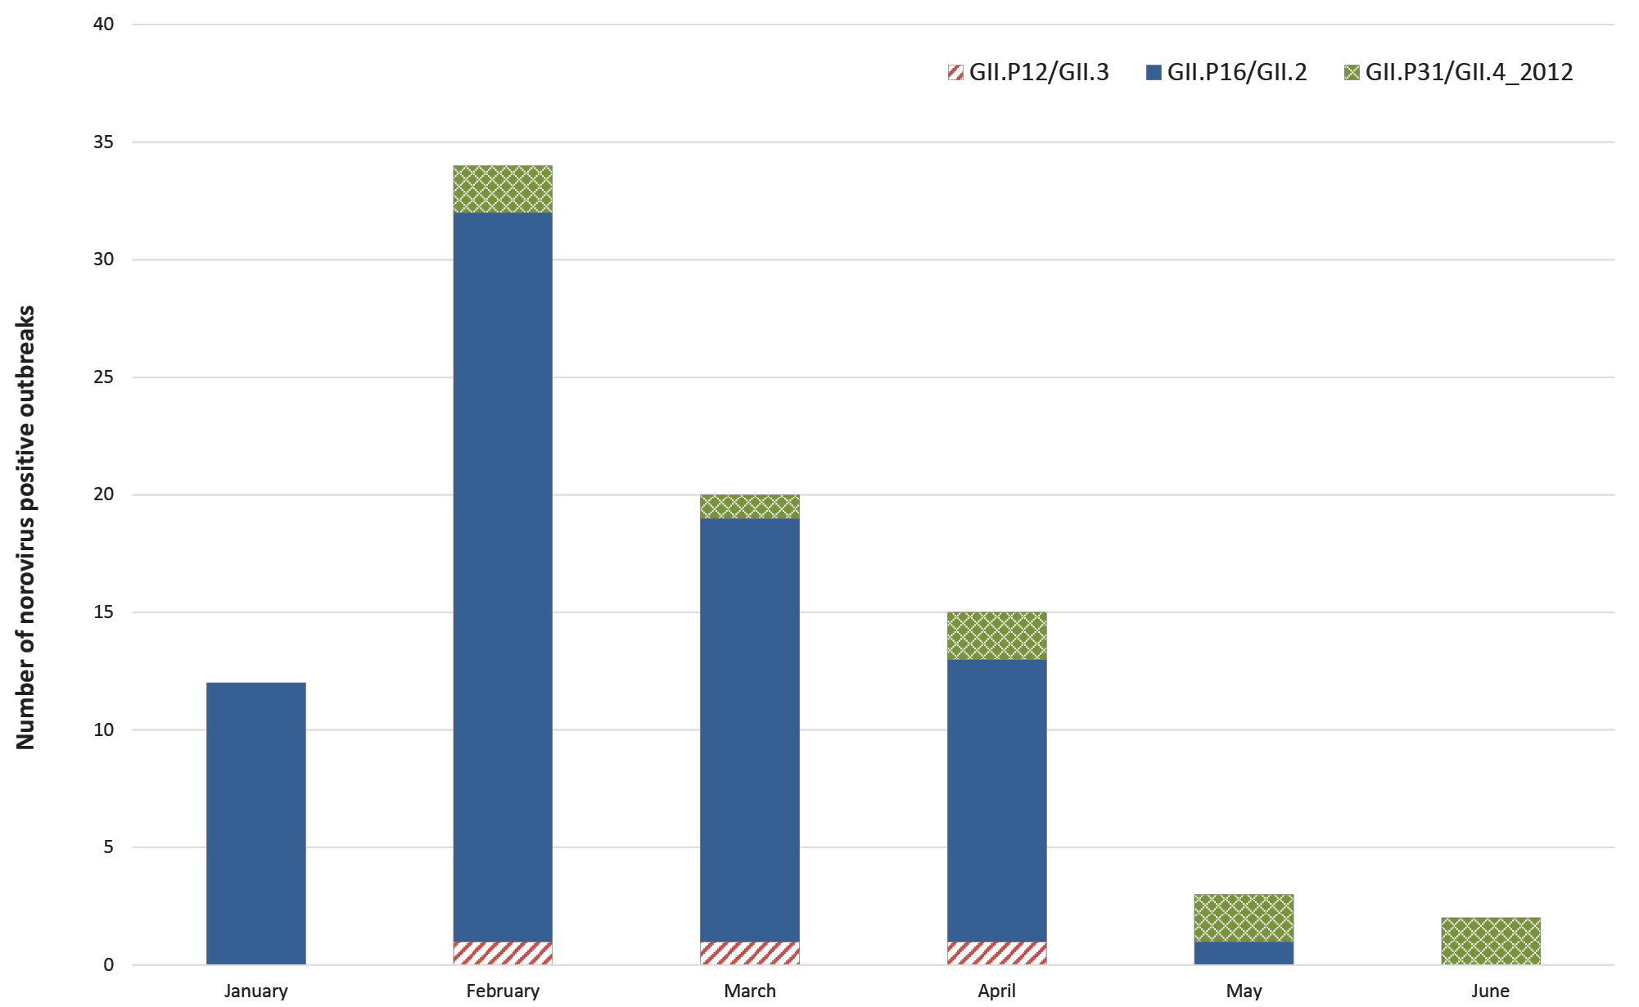

In Victoria, there is no requirement for residential facilities, health care facilities, children’s services centres or camps to notify the department of an outbreak of gastroenteritis.⁵ However, notification is strongly recommended, to allow the department to provide advice and support to facilities to manage the outbreak, in order to help minimise the severity of the illness and outbreak duration, particularly in vulnerable population groups. Suspected gastroenteritis outbreaks (two or more cases of vomiting and/or diarrhoea occurring among children and/or staff within 48 hours of each other), once notified, are recorded on the Department of Health’s disease surveillance system.⁵ Local council provides stool collection kits to affected individuals, which are then processed at the Microbiological Diagnostic Unit (MDU), Public Health Laboratory (PHL) at the University of Melbourne, which tests all samples received for norovirus.⁶
In early March 2021, a five-fold increase above the five-year average was detected in the number of notifications of viral gastroenteritis in ECLC (Figure 2). An incident management team (IMT) was assembled, with fortnightly meetings established. The purpose of these multidisciplinary meetings was to investigate the increase in the number of notifications, to discuss the epidemiology of the outbreaks using surveillance data, to decide on an appropriate intervention, and to coordinate the public health response.
Figure 2: Epicurve demonstrating number of outbreaks notified in early childhood learning centres by calendar week in Victoria in 2021, with public health interventions marked
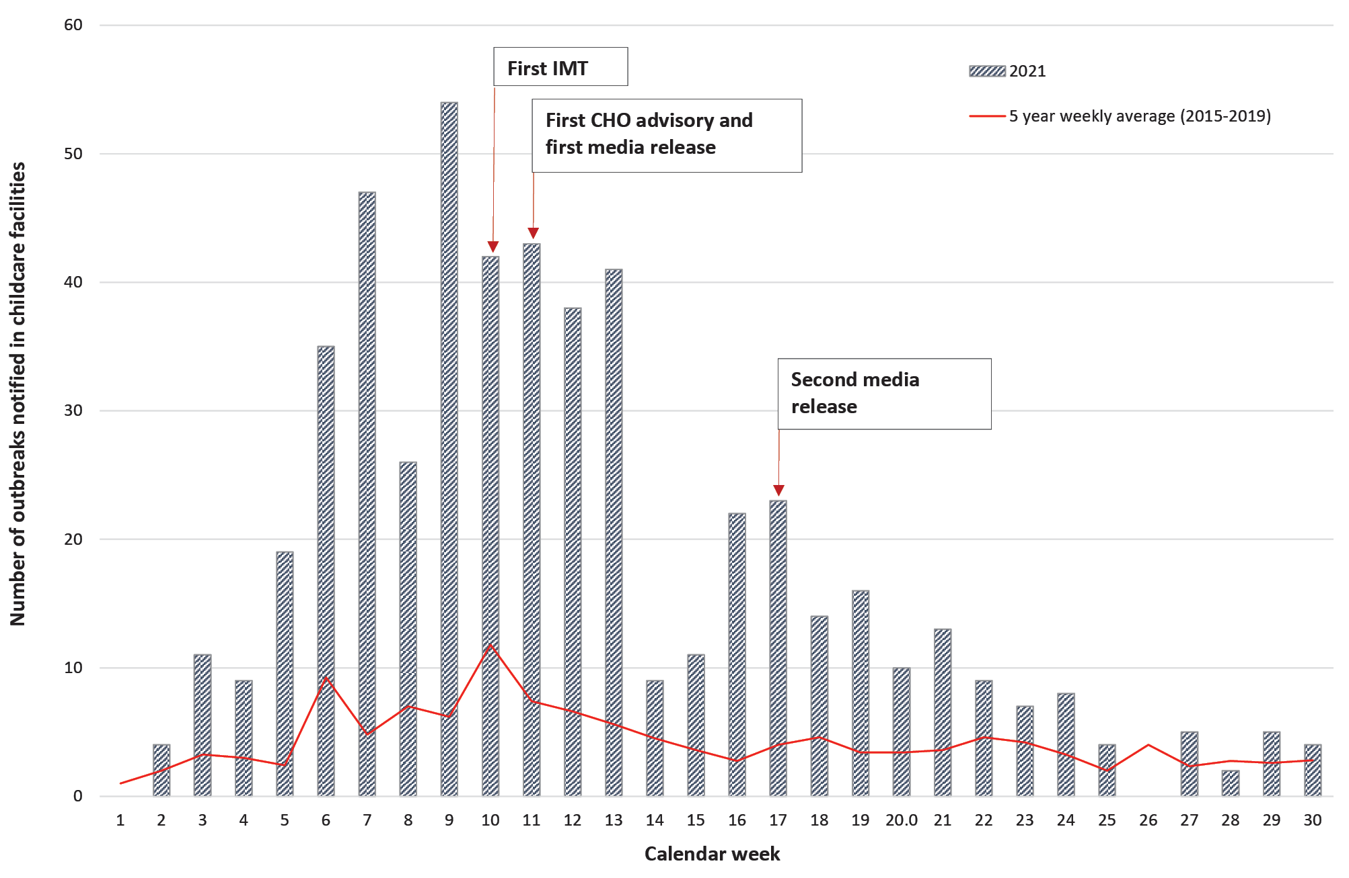
We hypothesised that one possible driver of this outbreak was a change in community hand-hygiene practices observed since the start of the coronavirus disease 2019 (COVID-19) pandemic,⁷ where an increase in the use of alcohol-based hand sanitisers (ABHS) in order to reduce transmission of the SARS-CoV-2 virus led to a relative reduction in the use of soap- and water-based handwashing practice. While ABHS are effective at inactivating SARS-CoV-2,⁷ they are less effective against norovirus,^{8,9} and hence at interrupting person-to-person transmission of norovirus, with Australian guidelines preferencing soap and water over ABHS.¹⁰ Exclusion of symptomatic children until 48 hours post-resolution of symptoms likely also helped to interrupt the chain of transmission. Additional potential drivers included a return to increased numbers of children attending ECLC following a period of minimal attendance during the July-November 2020 COVID-19 lockdown, a relatively norovirus-naïve population due to minimal circulating virus over preceding months, and the spread of gastroenteritis between ECLCs through children’s transmission networks outside of ECLCs.
Accordingly, targeted media was developed, advocating the use of soap and handwashing, rather than relying on ABHS, as well as recommending a 48-hour exclusion period following resolution of symptoms. In week 11 (week ending 15 March 2021), a communication from the Victorian Chief Health Officer was formulated, translated into nine key languages, and distributed to 4,500 ECLCs. A newsletter to parents outlining key messages for gastroenteritis was also distributed to parents of children at these centres and at primary schools across the state.
Proactive media engagement was undertaken, conducting multiple interviews on high-audience public and private radio and television stations, as well as focused social media releases on government health communication channels and platforms, with excellent media uptake and reach, and an estimated advertising sales reach of $1.65 million (Appendix A: Figures A.1 and A.2), despite no purchased advertising. While it is not certain exactly what effect these communications had on hand washing practices, we suggest that, given the scale of the community reach, it is likely that there was some change to handwashing practices as a result.
After an initial slight increase in notifications following the first round of media engagement (Figure 2), the number of notifications decreased. Following a two-week period of school holidays where a reduced number of notifications occurred, a slight increase in notifications prompted a second round of media engagement, with a steady reduction in notifications and return to 5-year averages by week 22 of 2021. As Figure 1 also demonstrates, the epidemic GII.P16/GII.2 strain was no longer detected after May 2021, leaving only low levels of circulating endemic GII.P31/GII.4_2012 (Sydney) strain.

Author details
George P Drewett^{1,2}
Anna-Lena Arnold¹
Leesa Bruggink³
Sarah Borg¹
Kaye Sturge¹
Bruce Bolam¹
- Communicable Diseases Branch, Victorian Department of Health, Melbourne, Australia
- Department of Infectious Diseases, Austin Health, Heidelberg, Australia
- Victorian Infectious Diseases Reference Laboratory, Royal Melbourne Hospital, at the Peter Doherty Institute for Infection and Immunity, Melbourne, Australia

Corresponding author
George Drewett
Infectious Diseases Registrar, Austin Health, Heidelberg 3084, Victoria, Australia
Phone: +61394966676
Email: george.drewett@burnet.edu.au

References
- Lian Y, Wu S, Luo L, Lv B, Liao Q, Li Z et al. Epidemiology of norovirus outbreaks reported to the Public Health Emergency Event Surveillance System, China, 2014–2017. Viruses. 2019;11(4):342. doi: https://doi.org/ 10.3390/v11040342.
- Osborne CM, Montano AC, Robinson CC, Schultz-Cherry S, Dominguez SR. Viral gastroenteritis in children in Colorado 2006–2009. J Med Virol. 2015;87(6):931–9. doi: https://doi.org/10.1002/jmv.24022.
- Hebbelstrup Jensen B, Jokelainen P, Nielsen ACY, Franck KT, Rejkjaer Holm D, Schønning K et al. Children attending day care centers are a year-round reservoir of gastrointestinal viruses. Sci Rep. 2019;9(1):3286. doi: https://doi.org/10.1038/s41598-019-40077-9.
- Smoll NR, Khan A, Walker J, McMahon J, Kirk M, Khandaker G. A norovirus gastroenteritis outbreak in an Australian child-care center: a household-level analysis. PLoS One. 2021;16(11):e0259145. doi: https://doi.org/10.1371/journal.pone.0259145.
- Victoria State Government Department of Health. A guide to the management and control of gastroenteritis outbreaks in children’s centres. [Internet.] Melbourne: Victoria State Government Department of Health; 19 February 2019. Available from: https://www2.health.vic.gov.au/about/publications/researchandreports/A-guide-to-the-management-and-control-of-gastroenteritis-outbreaks-in-childrens-centres.
- Victoria State Government Department of Health. Guidelines for the investigation of gastroenteritis. Melbourne: Victoria State Government Department of Health; 2010. Available from: https://www.health.vic.gov.au/sites/default/files/migrated/files/collections/research-and-reports/g/gastro-guidelines-web---pdf.pdf.
- Singh D, Joshi K, Samuel A, Patra J, Mahindroo N. Alcohol-based hand sanitisers as first line of defence against SARS-CoV-2: a review of biology, chemistry and formulations. Epidemiol Infect. 2020;148:e229. doi: https://doi.org/10.1017/S0950268820002319.
- Sato S, Matsumoto N, Hisaie K, Uematsu S. Alcohol abrogates human norovirus infectivity in a pH-dependent manner. Sci Rep. 2020;10(1):15878. doi: https://doi.org/10.1038/s41598-020-72609-z.
- Tuladhar E, Hazeleger WC, Koopmans M, Zwietering MH, Duizer E, Beumer RR. Reducing viral contamination from finger pads: handwashing is more effective than alcohol-based hand disinfectants. J Hosp Infect. 2015;90(3):226–34. doi: https://doi.org/10.1016/j.jhin.2015.02.019.
- Australian Government Department of Health and Aged Care. Guidelines for the public health management of gastroenteritis outbreaks due to norovirus or suspected viral agents in Australia. Canberra: Australian Government Department of Health and Aged Care; 2 June 2010. Available from: https://www.health.gov.au/resources/publications/norovirus-and-suspected-viral-gastroenteritis-cdna-national-guidelines-for-public-health-units.

Appendix A: Supplementary material
Appendix A: Supplementary material
Figure A.1: Media mentions of viral gastroenteritis-related public health communications over time
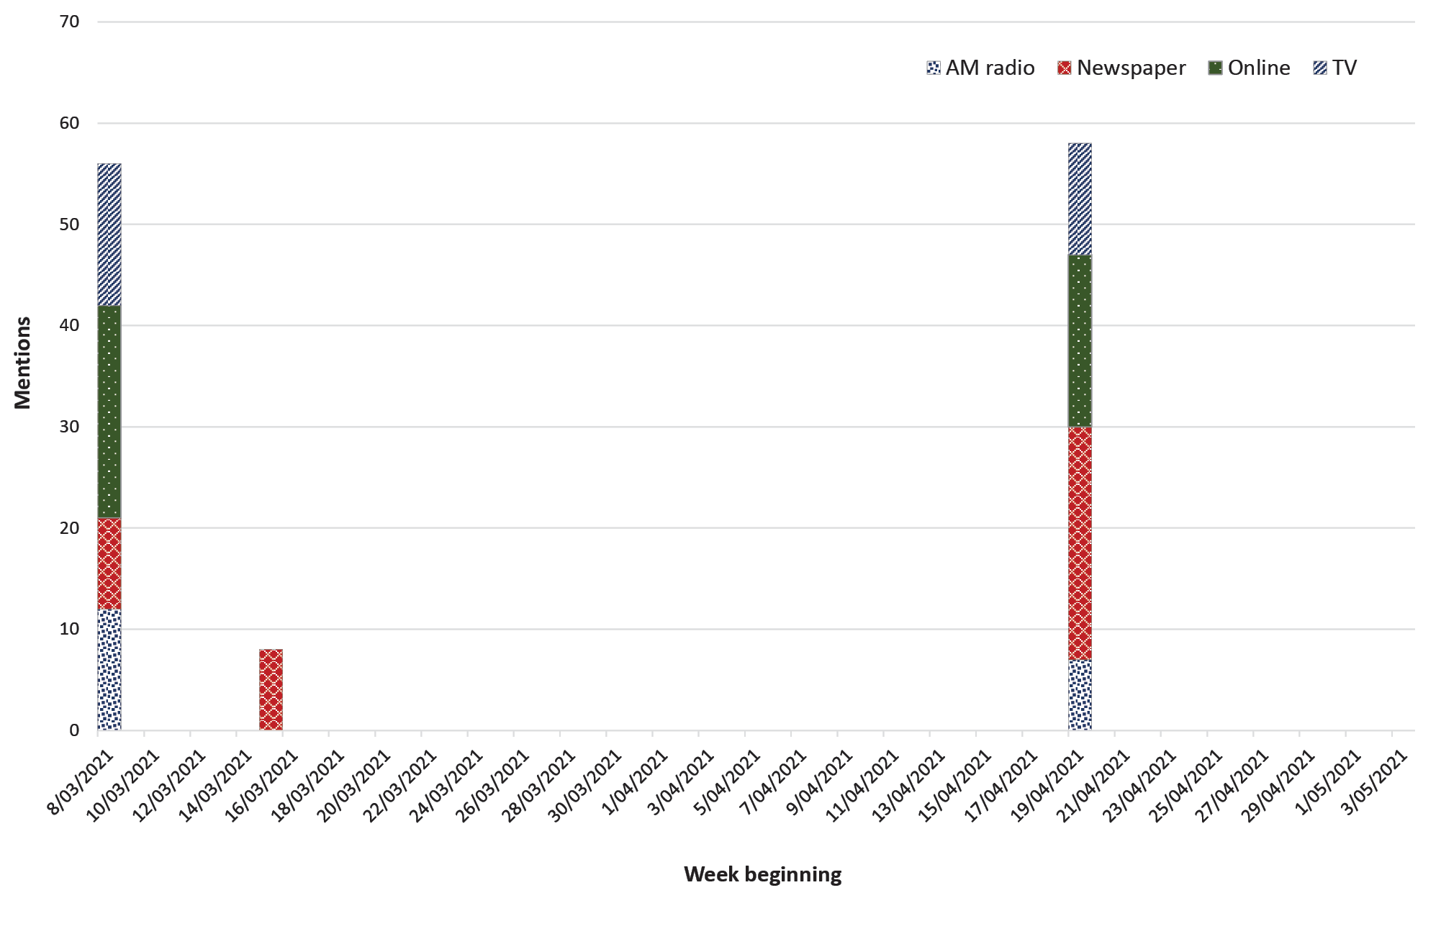

Figure A.2: Advertising sales reach (ASR) from public health communications over time
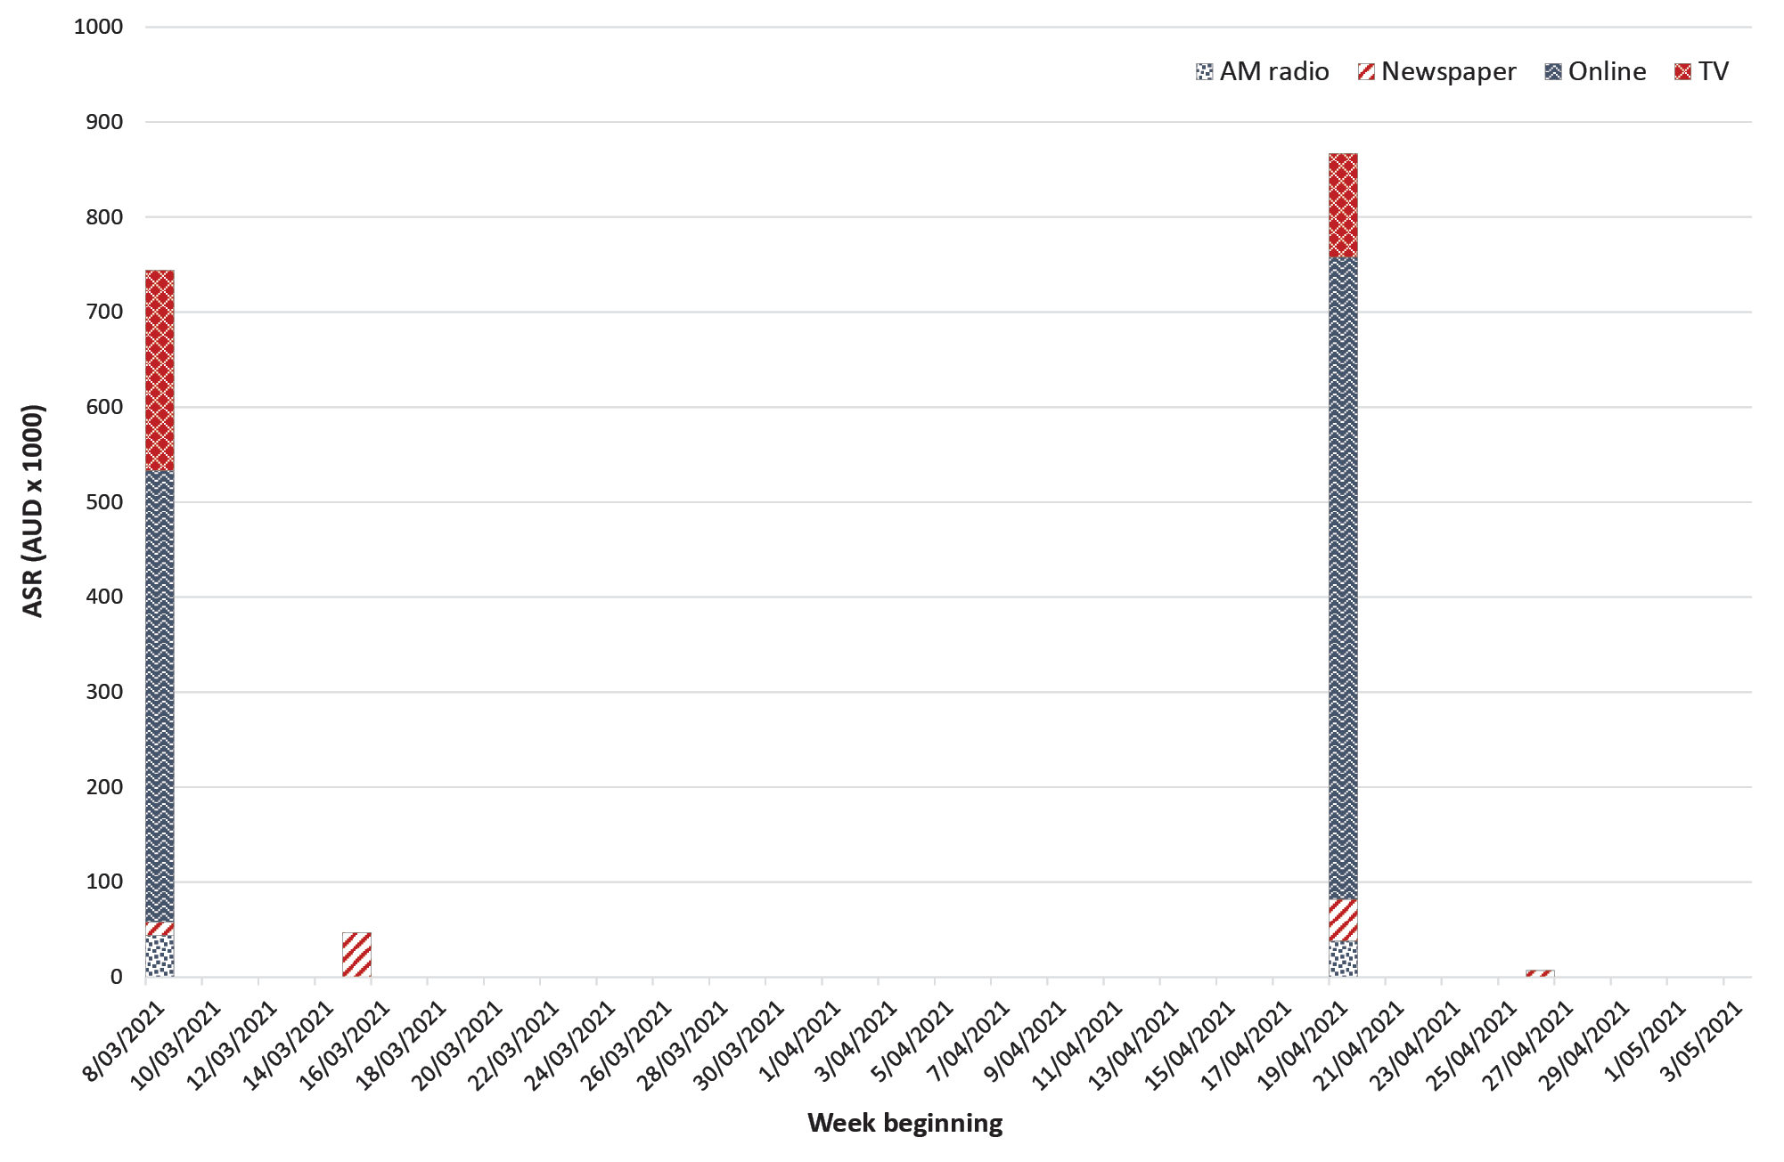

Communicable Diseases Intelligence
ISSN: 2209-6051 Online

Communicable Diseases Intelligence (CDI) is a peer-reviewed scientific journal published by the Office of Health Protection and Response, Department of Health and Aged Care. The journal aims to disseminate information on the epidemiology, surveillance, prevention and control of communicable diseases of relevance to Australia.

Editor: Noel Lally
Deputy Editor: Simon Petrie
Design and Production: Kasra Yousefi
Editorial Advisory Board: David Durrheim, Mark Ferson, John Kaldor, Martyn Kirk and Linda Selvey

Website: http://www.health.gov.au/cdi

Contacts
CDI is produced by the Office of Health Protection and Response, Australian Government Department of Health and Aged Care, GPO Box 9848, (MDP 6) CANBERRA ACT 2601

Email: cdi.editor@health.gov.au

Submit an Article
You are invited to submit your next communicable disease related article to the Communicable Diseases Intelligence (CDI) for consideration. More information regarding CDI can be found at: http://health.gov.au/cdi.
Further enquiries should be directed to: cdi.editor@health.gov.au.

This journal is indexed by Index Medicus and Medline.

Creative Commons Licence - Attribution-NonCommercial-NoDerivatives CC BY-NC-ND
© 2022 Commonwealth of Australia as represented by the Department of Health and Aged Care
This publication is licensed under a Creative Commons Attribution-NonCommercial-NoDerivatives 4.0 International Licence from https://creativecommons.org/licenses/by-nc-nd/4.0/legalcode (Licence). You must read and understand the Licence before using any material from this publication.

Restrictions
The Licence does not cover, and there is no permission given for, use of any of the following material found in this publication (if any):
- the Commonwealth Coat of Arms (by way of information, the terms under which the Coat of Arms may be used can be found at www.itsanhonour.gov.au);
- any logos (including the Department of Health and Aged Care’s logo) and trademarks;
- any photographs and images;
- any signatures; and
- any material belonging to third parties.

Disclaimer
Opinions expressed in Communicable Diseases Intelligence are those of the authors and not necessarily those of the Australian Government Department of Health and Aged Care or the Communicable Diseases Network Australia. Data may be subject to revision.

Enquiries
Enquiries regarding any other use of this publication should be addressed to the Communication Branch, Department of Health and Aged Care, GPO Box 9848, Canberra ACT 2601, or via e-mail to: copyright@health.gov.au

Communicable Diseases Network Australia
Communicable Diseases Intelligence contributes to the work of the Communicable Diseases Network Australia.
http://www.health.gov.au/cdna

