Summary of National Surveillance Data on Vaccine Preventable Diseases in Australia, 2016-2018 Final Report
Cyra Patel, Aditi Dey, Han Wang, Peter McIntyre, Kristine Macartney, Frank Beard

Overview
This summary report on vaccine preventable diseases (VPDs) in Australia brings together the three most important national sources of routinely-collected data on VPDs (notifications, hospitalisations and deaths) for all age groups for the three-year period 1 January 2016 to 31 December 2018. Information about each VPD is provided in 16 chapters using a standard structure.
Changes in the National Immunisation Program (NIP) between 2016 and 2018 are listed below:
- Addition of a booster dose of diphtheria-tetanus-acellular pertussis vaccine (DTPa) at 18 months (March 2016).
- Replacement of trivalent influenza vaccine with quadrivalent influenza vaccines (from 2016), and availability of two enhanced trivalent vaccines (high-dose and adjuvanted vaccines), for people aged 65 years and older (in 2018).
- Addition of a single dose of live attenuated herpes zoster vaccine for people aged 70 years from November 2016, with a five-year catch-up program for 71- to 79-year olds.
- Replacement of the quadrivalent human papillomavirus (HPV) vaccine (4vHPV) for adolescents with a nonavalent HPV vaccine (9vHPV) in January 2018.
- Replacement of the 12-month dose of combination Haemophilus influenzae type b–meningococcal serogroup C vaccine (Hib-MenC) with a single dose of quadrivalent meningococcal conjugate (MenACWY) vaccine, with monovalent Hib vaccine given at 18 months of age (July 2018).
- Change in the timing of routine infant doses of 13-valent pneumococcal conjugate vaccine (PCV13) from 2, 4, and 6 months (3+0 schedule) to 2, 4, and 12 months (2+1 schedule), commencing July 2018. The schedule remained as 2, 4, 6, and 12 months (3+1) for Aboriginal and Torres Strait Islander children in the Northern Territory, South Australia, Queensland and Western Australia, and for children with specified underlying medical conditions.
- Addition of a dose of diphtheria-tetanus-acellular pertussis vaccine (dTpa) for all women in the third trimester of pregnancy, from July 2018 (replacing funding by states and territories).
Notifications, hospitalisations and deaths in this three-year reporting period and the previous four-year reporting period (2016–2018 and 2012–2015) are summarised in Table 1. Influenza, pertussis and rotavirus were the most commonly notified conditions whereas the most common causes of hospitalisation were influenza, zoster, rotavirus and pneumococcal disease. There were no notifications or hospitalisations due to polio and a continuing low incidence of diphtheria, rubella and tetanus.

Table 1: Notifications, hospitalisations and deaths for 16 vaccine preventable diseases, current versus previous reporting periods (2016–18 vs 2012–15)ª
Disease | Notifications |  |  | Hospitalisations (Principal diagnosis) |  |  | Deaths (Underlying cause)
 | Average annual rate^{b}  2012–2015 | Average annual rate^{b}  2016–2018 | Rate ratio  (95% CI)^{c} | Average annual rate^{b}  2012–2015 | Average annual rate^{b}  2016–2018 | Rate ratio  (95% CI)^{c} | Average annual rate^{b}  2012–2015 | Average annual rate^{b}  2016–2018 | Rate ratio  (95% CI)^{c}
Diphtheria | < 0.01 | 0.04 | 4.87 (2.07–13.26) | 0.01 | 0.01 | 0.88 (0.29–2.57) | < 0.01 | < 0.01 | 1.26 (0.02–99.21)
Haemophilus influenzae type b | 0.08 | 0.07 | 0.88 (0.61–1.28) | na^{f} | na^{f} | – | na^{f} | na^{f} | –
Hepatitis A | 0.83 | 1.08 | 1.31 (1.19–1.45) | 0.43 | 0.61 | 1.41 (1.23–1.62) | 0.01 | 0 | 0 (0–1.38)
Hepatitis B | 0.73 | 0.62 | 0.86 (0.76–0.97) | 0.49 | 0.37 | 0.75 (0.65–0.88) | 0.09 | 0.07 | 0.82 (0.57–1.18)
Influenza^{d} | 258.65 | 543.42 | 2.10 (2.09–2.11) | 34.68 | 73.92 | 2.13 (2.11–2.16) | 0.84 | 2.51 | 3.01 (2.77–3.28)
Measles | 0.83 | 0.38 | 0.46 (0.40–0.53) | 0.31 | 0.19 | 0.62 (0.50–0.76) | < 0.01 | 0 | 0 (0–49.29)
Meningococcal disease | 0.77 | 1.24 | 1.60 (1.45–1.77) | 1.00 | 1.37 | 1.38 (1.26–1.51) | 0.04 | 0.06 | 1.61 (1.02–2.57)
Mumps | 1.34 | 3.05 | 2.28 (2.13–2.44) | 0.31 | 0.44 | 1.45 (1.23–1.71) | < 0.01 | < 0.01 | 2.53 (0.13–149.13)
Pertussis | 75.96 | 60.91 | 0.80 (0.79–0.81) | 2.15 | 1.40 | 0.66 (0.61–0.71) | 0.01 | < 0.01 | 0.53 (0.15–1.61)
Pneumococcal disease^{e} | 6.91 | 7.78 | 1.13 (1.09–1.17) | 1.74 | 2.23 | 0.63 (0.59–0.67) | 0.09 | 0.11 | 1.18 (0.86–1.61)
Q fever | 2.08 | 2.10 | 1.01 (0.95–1.08) | 0.66 | 0.74 | 1.12 (1.00–1.26) | 0.01 | < 0.01 | 0.76 (0.12–3.90)
Rotavirus | na^{f} | 11.63^{g} | – | 3.83 | 3.03 | 0.79 (0.75–0.84) | < 0.01 | < 0.01 | 1.26 (0.09–17.44)
Rubella | 0.10 | 0.05 | 0.49 (0.32–0.73) | 0.01 | < 0.01 | 0.63 (0.19–1.82) | < 0.01 | 0.01 | 7.58 (0.92–348.81)
Tetanus | 0.02 | 0.02 | 1.11 (0.50–2.42) | 0.05 | 0.05 | 1.10 (0.70–1.72) | < 0.01 | 0.01 | 2.53 (0.36–27.94)
Varicella | na^{f} | na^{f} | – | 1.82 | 1.82 | 1.00 (0.93–1.07) | 0.02 | 0.02 | 0.77 (0.37–1.56)
Zoster | na^{f} | na^{f} | – | 11.21 | 13.14 | 1.17 (1.14–1.21) | 0.12 | 0.12 | 1.05 (0.78–1.39)
a Data from 2012–2015 are in the previous report.¹²
b Rate per 100,000 population.
c Rate ratio = (average annual rate in 2016–2018) / (average annual rate in 2012–2015). Please note the following when interpreting rate ratios:
Rate ratio > 1: the average annual rate ratio was higher in the current reporting period (2016–2018) than in the previous reporting period (2012–2015)
Rate ratio < 1: the average annual rate ratio was lower in the current reporting period than in the previous reporting period
Rate ratio =1: the average annual rate ratio was the same in the current reporting period as in the previous reporting period
A rate ratio with a 95% confidence interval (95% CI) that overlaps with 1 is considered not statistically significant.
d Minimum estimates as notifications, hospitalisations and deaths grossly underestimate influenza-related cases.
e Pneumococcal hospitalisations and deaths septicaemia and meningitis only.
f na: not applicable, because data are unavailable for one or both periods.
g Rotavirus notifications for the period 2016–2018 are reported for notifications where the month of diagnosis was between 1 July 2018 and 31 December 2018 only.

Important changes in VPDs in the 2016–2018 reporting period
Influenza was the most commonly reported VPD, with the incidence of notifications and hospitalisations during this period approximately twice that in the previous period. The increase in influenza notifications and hospitalisations was driven by a high-activity influenza season in 2017 that was the largest season since the 2009 pandemic year, although increased laboratory testing, especially greater use of influenza polymerase chain reaction (PCR) tests, also contributed. The highest numbers and rates of influenza-related deaths were reported in those aged ≥ 65 years.
Pertussis was the second most commonly notified VPD, although declines in both notification and hospitalisation annual rates were observed compared with the previous four-year period (2012–2015). Notification rates were highest in the 5–14 year age group, while hospitalisation rates were highest among infants aged < 1 year.
Diphtheria notifications increased from seven in the previous four-year period to 27 in the three years 2016–2018, with the highest number (14) and incidence among persons older than 50 years. The reasons for this increase in notifications should be explored further. The only notified diphtheria death occurred in an unvaccinated male 25–49 years of age; and, of 20 cases with known vaccination status, only two were fully vaccinated.
Meningococcal disease notifications and hospitalisations increased substantially in this reporting period, due to the emergence of serogroups W and Y. The accelerating increase in meningococcal disease notifications between 2015 and 2017 prompted several jurisdictionally-funded meningococcal (MenACWY) vaccination programs, replaced by a nationally-funded vaccination program in 2018.
Acute hepatitis B notifications progressively declined over this reporting period; a trend evident since 2007,¹ but which has accelerated. While hepatitis A infections among Aboriginal and Torres Strait Islander people continued to decline, an increase in overall notifications of hepatitis A was observed due to a number of outbreaks, most notably among men who have sex with men.
Notifications and hospitalisations due to pneumococcal disease increased in this reporting period. The highest numbers of pneumococcal notifications, hospitalisations and deaths occurred in older adults aged ≥ 65 years. Rates of pneumococcal notifications and deaths were also highest in adults aged ≥ 65 years; however, the highest rates of pneumococcal hospitalisations occurred among infants aged < 1 year. Aboriginal and Torres Strait Islanders continue to experience substantially higher rates of pneumococcal disease relative to the rest of the population.
Small overall reductions in Haemophilus influenzae type b disease notifications were seen in this reporting period, following on from larger earlier reductions.
Reductions in the overall average annual rate of hospitalisations due to rotavirus were observed during this reporting period, even though a spike was observed in 2017 due to disease outbreaks.
The rate of hospitalisations coded as varicella (chickenpox) in this reporting period was similar to that in the previous four years. Following the introduction of the national zoster vaccination program in November 2016, the increasing trend in zoster hospitalisation rates stabilised for the first time since 1993.
Measles notifications and hospitalisations continued to remain low, but outbreaks linked to imported cases in travellers from high endemicity regions occurred sporadically, with 73% of cases reported to be unvaccinated. The available evidence supports continued elimination of endemic measles, first documented in 2005,² with verification by the World Health Organization (WHO) in 2014.^{3,4}
Mumps occurred in localised outbreaks, commencing in central Australia in 2015 and seen through most of the reporting period before a decline in notifications in 2018. Cases were predominantly two-dose vaccinated adolescents and young adults in Aboriginal communities, as previously documented in a 2007–2008 outbreak in the Kimberley,⁵ and also seen in close contact settings in other developed countries.^{6,7} This was in contrast to previous mumps outbreaks in adolescents and young adults in Australia, which had primarily been in persons who had received only one vaccine dose or were unvaccinated.^{5–9}
Rubella notifications and hospitalisations continued to decline in this reporting period and have remained consistently low since 2004, following marked declines in the late 1990s and early 2000s. In 2018, the WHO officially declared that Australia had eliminated rubella.^{10,11}
Q fever notifications and hospitalisations remained stable in 2016–2018 compared with 2012–2015, with rates remaining highest in males aged 50–64 years.

Limitations
The data sources used in this report have a number of limitations, discussed in detail in the body of the report. The datasets for notifications, hospitalisations and deaths differ in their purpose for data collection, reporting mechanisms and accuracy, so comparisons between them should be made with caution. We found that, for some diseases, the number of deaths recorded in the National Notifiable Diseases Surveillance System (NNDSS) differ substantially from cause of death data from the Australian Coordinating Registry and the AIHW National Hospital Morbidity Database. Notification data on vaccination status (vaccine type and vaccination date) in the NNDSS had low levels of completeness for age groups not targeted for vaccination programs. Interpretation of hospitalisation data derived from codes in any diagnosis field and of death data derived from all coded associated causes of death should take into account the lack of specificity compared with principal diagnosis and underlying cause of death. Interpretation of trends in notification rates over time needs to take account of changing patterns of diagnostic testing, particularly for influenza and pertussis, and changes in case definitions.

1. Introduction
The National Centre for Immunisation Research and Surveillance (NCIRS) has published six comprehensive reports on vaccine preventable diseases (VPDs) and vaccination coverage in Australia since 2000. These reports (the ‘VPD reports’) have been published as supplements in Communicable Diseases Intelligence. They serve as a national resource to support surveillance and control of VPDs in Australia, particularly VPDs targerted by the NIP.
In addition to these summary VPD reports, which use a standard structure across all VPDs, a rolling series of epidemiologic reviews provides more detailed data for individual VPDs. Epidemiologic reviews including data relevant to this report include Haemophilus influenzae type b (Hib)¹³ and pertussis.¹⁴

2. Methods
In keeping with previous practice, three main sources of routinely collected data on VPDs in Australia were used for this report. Disease notification data were obtained from the Office of Health Protection’s National Notifiable Diseases Surveillance System (NNDSS), supplied by states and territories; data on coded hospitalisations were sourced from the Australian Institute of Health and Welfare (AIHW) National Hospital Morbidity Database; and causes of death unit record file data were obtained from the Australian Coordinating Registry (ACR).
A comprehensive listing of significant events in vaccination practice in Australia is available from the National Centre for Immunisation Research and Surveillance.

Notifications
The NNDSS was established in its current form in 1991 and includes de-identified information on cases of notifiable disease reported by state and territory authorities in Australia. Each of the eight state and territory health departments collects data on notifiable diseases under its respective public health legislation. Data quality of the NNDSS is continually monitored by the Office of Health Protection within the Australian Government Department of Health, and by the National Surveillance Committee, a committee which includes jurisdictional surveillance and data managers. Historically, state and territory notification criteria were based on the 1994 National Health and Medical Research Council surveillance case definitions.¹⁵ In September 2003, a new set of national case definitions for notifiable diseases reported to the NNDSS was endorsed by the Communicable Diseases Network Australia,¹⁶ with all jurisdictions implementing in 2004.¹⁷
Information on case definitions currently in use for vaccine preventable diseases is available on the Australian Government Department of Health website. For this report, data for a ten-year period from 1 January 2009 to 31 December 2018 were extracted from the NNDSS in November 2019, with the exception of Q fever for which data were extracted in December 2020 for the period from 1 January 2010 to 31 December 2019. Data were checked and cleaned. Disease notification data for cases with a date of diagnosis between 1 January 2016 and 31 December 2018 are included in this report, with the exception of rotavirus (cases reported for 1 July to 31 December 2018) which became nationally notifiable in July 2018. It should be noted that historical notification data (i.e. data for the period 2009 to 2015 for all diseases except Q fever, which was updated for the period 2010 to 2015) included in this report have been updated from previous reports and the updated data used for trend analysis. For data prior to 2009 (2010 for Q fever), existing published data were used for trend analysis.The variables extracted for each VPD in this report were: date of diagnosis, age at onset, sex, Aboriginal and Torres Strait Islander status and state or territory of residence. Date of diagnosis is derived from the date of onset, or, where not supplied, the earliest date recorded among the three fields of date of specimen, date of notification, or date notification received (the only mandatory date field).
Aboriginal and Torres Strait Islander status in the notification data provided by the Department of Health to NCIRS includes three categories: ‘Aboriginal and/or Torres Strait Islander origin’, ‘not Aboriginal or Torres Strait Islander origin’ and ‘not stated’. For the purposes of calculating rates, we used two categories: ‘Aboriginal and Torres Strait Islander’ (individuals identified as Aboriginal and/or Torres Strait Islander) and ‘other’ (individuals recorded as not Aboriginal or Torres Strait Islander and where not stated).
Completeness of Aboriginal and Torres Strait Islander status was assessed for each disease by calculating the proportions of notifications where Aboriginal and Torres Strait Islander status was ‘not stated’ and/or where the data field was left blank. Incomplete identification may result in the rates reported underestimating the true incidence of disease in Aboriginal and Torres Strait Islander people. Notification data are not reported for influenza due to poor overall completeness of Aboriginal and Torres Strait Islander status, and for pertussis only reported for the < 5 years age group due to poor completeness in other age groups, as per previous practice.¹⁸
Vaccination status was assessed using the new vaccine type and vaccination date data fields, which included information on the vaccine type (or brand), date of vaccination and age at time of vaccination for the five most recent vaccine doses received. In jurisdictions where new vaccination data fields were not used for the specified years, we used the old vaccination data fields, which included data on vaccination status (i.e. fully vaccinated, partially vaccinated, unvaccinated or unknown/missing data), whether previous doses were validated using official records or patient/parent recall only, how many previous vaccine doses were received, and the date of last vaccination. Data provided via the new vaccination data fields allows for collection of data for up to five previous vaccinations relevant to the disease; data on additional vaccine doses received (where six or more previous doses of a vaccine were received) was not available for analysis. We also used a cut-off of 14 days between vaccination date and disease onset date for estimating validity of vaccine doses. Vaccine doses given < 14 days prior to disease onset date or given after the disease onset date were considered invalid. We provide details of only valid vaccine doses in this report. Data provided via the old vaccination data fields only reported the date of the most recent vaccination; therefore assessment of the validity of additional previous doses of vaccine (where two or more previous doses were received) was not possible. Where information on the date of vaccination was missing for a case who had received a vaccine dose, the dose was assumed to be valid (i.e. received 14 days or more prior to disease onset date).

Hospitalisations
Hospitalisation data from the AIHW National Hospital Morbidity Database were analysed by calendar year of hospital admission for the three years 2016–2018. Historical data on hospitalisations since July 2001 were updated for trend analysis. For data prior to July 2001, the report uses selected historical data from previous reports.¹² Hospitalisations where the date of admission fell within the reporting period were included, with analysis by variables such as age and sex grouped by the calendar year of hospital admission. Data for each VPD were extracted based on the International Statistical Classification of Diseases and Related Health Problems, 10th Revision, Australian Modification (ICD-10-AM). Records of hospitalisations included in analysis were those with the code(s) of interest listed as the principal diagnosis (the diagnosis recorded as chiefly responsible for the hospitalisation) or as any other diagnosis for that episode of hospitalisation. The proportion of hospitalisations where the disease of interest was coded as the principal diagnosis is reported for each disease. For hepatitis B, only hospitalisations with acute hepatitis B coded as the principal diagnosis are included, consistent with the approach taken in previous reports.
The variables extracted for analysis included: month of admission, age on admission, sex, Aboriginal and Torres Strait Islander status, state or territory of residence, length of stay, and diagnosis (principal and other diagnoses) coded using the relevant edition of ICD-10-AM for the collection period.
Aboriginal and Torres Strait Islander status in the hospitalisation data provided by AIHW to NCIRS includes the two categories ‘Aboriginal and Torres Strait Islander Australians’ and ‘Other Australians’. ‘Other Australians’ includes those with a status of ‘not stated’. Completeness and accuracy of Aboriginal and Torres Strait Islander status in hospitalisation data is high, with an estimated 88% of Aboriginal and Torres Strait Islander patients correctly identified in public hospital admission records in 2011–2012.¹⁹ Incomplete identification may result in the rates reported underestimating the true incidence of disease in Aboriginal and Torres Strait Islander people.

Deaths
Death data were obtained from the Cause of Death Unit Record File (COD URF) data from the Australian Coordinating Registry (ACR). The Queensland Registry of Births, Deaths and Marriages is the ACR for COD URF data. The ACR coordinates the approval and release of COD URF files on behalf of the data custodians – Australian Registrars of Births, Deaths and Marriages, State/Chief Coroners and the National Coronial Information System (NCIS).
Since 1997, ICD-10 has been used to identify the cause of death. Deaths analysed in this report included those recorded as occurring in the calendar years 2016–2018. The variables included were cause of death, age, year of death, sex, and state or territory in which the death was recorded. Both underlying and associated causes of death were analysed for this reporting period. Deaths recorded in the NNDSS are also reported in relevant disease chapters.

Calculations
All rates were calculated using the mid-year estimated resident populations released by the Australian Bureau of Statistics (ABS) as the population denominator and hospital admissions (data from AIHW)/ notifications (data from NNDSS) /deaths (from ACR) as the numerator. Rates are presented as annual rates or average annual rates per 100,000 total population, or population in age, sex or geographical subgroups, as appropriate. The reported rate estimates for the populations were not stratified by age groups (i.e. all ages together) and are crude rates that have not been age-standardised.
For notification, hospitalisation and death data, the mid-year population estimates for the corresponding calendar year were used as the denominator population. Averages were calculated for rates of notifications and hospitalisations and for bed-days of hospitalisation episodes per year. Rate ratios were calculated for average annual rates in this reporting period (2016–2018) compared with the previous period (2012–2015). The median (rather than average) and range were used to describe the distribution of notifications and hospitalisations per month, and the length of stay per hospitalisation episode, as these data are not normally distributed.
Current case definitions²⁰ and significant events in vaccination practice²¹ in Australia were taken into consideration for this report. Documentation of changes in case definitions is no longer readily available and hence could not be considered in this report.

Notes on interpreting data
Comparison between the notification, hospitalisation and death data should be made with caution since these datasets differ in their purpose for data collection, reporting mechanisms and accuracy. The rates presented in this report are crude rates, not adjusted for differences in population structure between jurisdictions.
Rate ratios with wide confidence intervals should be interpreted with caution, as they indicate very small numbers of cases with underlying rates typically less than 0.1 per 100,000 population. These rate ratios are subject to wide fluctuations with very small changes in the numbers of cases.

Notification data
A major limitation of notification data is that they represent only a proportion of all the cases occurring in the community, due to under-reporting and/or testing practices. This proportion may vary between diseases, over time, and across jurisdictions. An infectious disease diagnosed by a laboratory test should be notified by the testing laboratory or treating clinician, as required by jurisdictional legislation, whereas diagnoses without laboratory confirmation rely on notification by clinicians, known to be substantially less complete. Changes in screening programs—including the preferential testing of high-risk populations; the availability and use of less invasive and more sensitive diagnostic tests; and periodic awareness campaigns—may influence the number of notifications over time. Data accuracy may also vary among jurisdictions due to the use of different case definitions for surveillance prior to adoption of the national case definitions in 2004 (a consideration that is particularly relevant to trend graphs which present pre-2004 data) and varying reporting requirements and clinician practice with respect to laboratory testing.
Aboriginal and Torres Strait Islander status completeness in notification data was assessed for the period 2016–2018 and reported in each chapter.
Interpretation of data on vaccination status is limited due to missing data on a substantial proportion of notifications, although the quality of data is improving compared with previous reports. The Vaccine Preventable Diseases Surveillance Program Project Agreement, finalised in late 2017, supports states and territories to improve reporting of vaccination information for children aged less than 10 years, specifically to report these data for at least 95% of notified cases in this age group.²² In many cases, vaccination history was self-reported and not validated, and should be interpreted with caution. As we assumed vaccine doses received were valid for notifications who had received a vaccine but for whom the date of vaccination was missing, some doses included may have been invalid (i.e. received < 14 days prior to the disease onset date), resulting in an overestimation of the proportion of notifications previously vaccinated.

Hospitalisation data
The AIHW publishes regular overviews of Australian hospitalisation statistics, including details of the number of hospitals reporting and any documented data problems. The AIHW performs logical validations on the ICD-10-AM coded data; for example, for sex- and age-specific diagnoses. Coding audits and coding quality improvement activities are variously performed at hospital level and/or at state or territory level. Some variation in hospital access, admission practices, and record coding may occur between regions and over time and this may impact upon the use of hospitalisation data for monitoring disease trends over time and between jurisdictions.
There are also limitations associated with the use of ICD-10-AM codes to identify cases. Errors that cause the ICD-10-AM code to differ from the true disease may be either random or systematic measurement errors. For rare diseases, such as acute poliomyelitis, tetanus and diphtheria, hospitalisation episodes or deaths so coded are much more likely to be miscoding of other conditions. The ICD-10-AM codes for diagnosis chosen for analysis of a disease should accurately reflect the specific condition which is vaccine preventable. For some diseases, such as Haemophilus influenzae type b (Hib) infection, both the previously used ICD-9-CM and current ICD-10-AM codes lack specificity for serotype b, and may not be limited to sterile site isolates, in contrast to more stringent case definitions used for notification data. For each disease in this report, the ICD-10-AM code(s) selected to best represent hospitalisation for the disease of interest are listed on the first page of each disease chapter.
In the AIHW hospitalisation database, there is one record for each hospital admission episode.^{23,24} This means that there will be separate records for each re-admission or inter-hospital transfer. This is unlikely to have a major impact on the numbers reported for most of the diseases reviewed in this report, as they are mostly acute diseases, but severe cases in regional and remote areas may be transferred for specialist care.^{23,24} However, there may be greater impact on numbers reported for diseases where re-admission due to long-term complications is more likely e.g. meningococcal disease and tetanus. It is also more difficult to gauge the relevance where the coded disease was not the principal diagnosis but was recorded as an additional or secondary diagnosis for that hospitalisation episode.
AIHW has restrictions on release of data that may potentially identify cases. Reporting of fewer than five hospitalisations in the period of interest is expressed as a range, 1–4, rather than as the actual number. The exact date of admission was not provided by AIHW to NCIRS (month of admission was provided instead). Length of stay was provided as ’30 days’ for hospitalised cases where the length of stay was 30 days or longer.
Aboriginal and Torres Strait Islander status in the hospitalisation data provided by AIHW to NCIRS includes the categories ‘Aboriginal and Torres Strait Islander Australians’ and ‘Other Australians’. As the ‘Other Australians’ category includes both non-Aboriginal and Torres Strait Islander people and those with unknown Aboriginal and Torres Strait Islander status, it is not possible to report the exact proportion with ‘unknown’ Aboriginal and Torres Strait Islander status. However, Aboriginal and Torres Strait Islander status completeness for hospitalisation data has been greater than 80% in all jurisdictions since 2010–2011.¹⁹

Death data
Mortality data are analysed by year of death and cause of death. The ACR has restrictions, which apply to this report, on release of data that may potentially identify cases. Where there are fewer than six (but not zero) deaths in the period of interest, this is reported as a range from 1–5 rather than the actual number. In addition, death data are not provided for some age groups, where back-calculations could compromise confidentiality. Many of the issues for accuracy of ICD coding in hospital separations, such as propensity for laboratory testing, are also relevant for mortality data.
Aboriginal and Torres Strait Islander status in the death data provided by the ACR has a high degree of completeness (> 99%) for all deaths, but there are concerns regarding the accuracy of the data, with the number of deaths among Aboriginal and Torres Strait Islanders possibly underestimated.²⁵ Efforts have been made to improve ascertainment of Aboriginal and Torres Strait Islander status. Year-to-year comparisons should be interpreted with caution.

3. Vaccine preventable diseases

3.1 Diphtheria

Highlights
In the three years 2016–2018, there were 27 notifications of toxigenic diphtheria (0.04 per 100,000 population per year), compared with 7 in the four years 2012–2015 (0.01 per 100,000 population per year).

Diphtheria is caused by toxigenic strains of the bacteria Corynebacterium diphtheriae and Corynebacterium ulcerans.²⁶ Corynebacterium diphtheriae is transmitted from person to person by intimate respiratory and direct contact.²⁷ Corynebacterium ulcerans, a bacterium found in cattle and more recently in cats, can also express diphtheria toxin and can cause zoonotic infection in humans.^{27–32} Infection can present as respiratory or cutaneous diphtheria, with cutaneous diphtheria being more common in warmer climates and in settings with poor hygiene and overcrowding.³³ Infection typically remains localised to the throat or skin, but disease manifestations arise from both local inflammation and/or systemic toxaemia. Pharyngeal diphtheria presents with a membranous inflammation of the upper respiratory tract, which can be extensive and cause laryngeal obstruction. Damage to other organs including the myocardium, nervous system and kidneys, caused by the organism’s exotoxin, may complicate pharyngeal or cutaneous diphtheria.^{34,35} Non-toxigenic C. diphtheriae usually causes mild throat or skin infection, which is occasionally complicated by invasive disease including endocarditis or arthritis.

Case definition

Notifications³⁶
Diphtheria case definition:
http://www.health.gov.au/internet/main/publishing.nsf/Content/cda-surveil-nndss-casedefs-cd_dipth.htm
Note that this case definition was updated in January 2017.
Hospitalisations and deaths
The ICD-10-AM/ICD-10 code A36 (Diphtheria) was used to identify hospitalisations and deaths.

Secular trends
There were 27 notified cases of toxigenic diphtheria during 2016–2018 (Table 3.1.1): 8 in 2016 (3 cutaneous, 1 pharyngeal, 4 unknown); 8 in 2017 (7 cutaneous, 1 pharyngeal); and 11 in 2018 (9 cutaneous, 2 pharyngeal), a median of 1 case (range 0 – 3) notified per month. This represents an average annual notification rate of 0.04 per 100,000 population, compared with 0.01 per 100,000 population per year during 2012–2015 (7 notified cases). The majority of the 2016–2018 cases were cutaneous (n = 19; 70%), with 4/27 cases (15%) pharyngeal. Twenty-three cases (85%) were due to infection with C. diphtheriae, with four (15%) due to C. ulcerans. The majority of cases (17/27; 63%) were acquired overseas, all from South East Asian or Pacific Island countries, with 9/27 (33%) reported as acquired in Australia. Prior to 2011, there had been no notified cases since 2002. However, even this recent increase corresponds to very low notification rates compared with historical data (Appendix A, Figure A.1).
In contrast to notifications, the number of hospitalisations (any diagnosis) in the current three-year reporting period 2016–2018 was lower than the previous four-year period 2012–2015 (38 versus 61 admissions; average annual rate 0.05 vs 0.07 per 100,000 population) with 13, 15 and 10 hospitalisations recorded in 2016, 2017 and 2018, a median of 1 (range 0–4) per month.

Severe morbidity and mortality
Of the 38 hospital admissions coded as due to diphtheria from 1 January 2016 to 31 December 2018, 23 (59%) were cutaneous and 4 were pharyngeal diphtheria (10%). Diphtheria was the principal diagnosis in 7 (18%) of the hospitalisations, 4 cutaneous and 1 pharyngeal. A total of 264 bed-days were recorded between 2016 and 2018, with a median length of stay of five days, highest in patients aged 65 years and above (12.5 days) and lowest in those aged 15–24 years (1.5 days).
In the causes of death data, there were 1–5 deaths in this reporting period with diphtheria recorded as the underlying or associated cause. One death attributable to diphtheria was recorded in the NNDSS, in a young (aged 25–49 years) unvaccinated male.

Age and sex distribution
There were more notifications and hospitalisations for diphtheria in males than in females, with an average male:female rate ratio of 1.7:1 for notifications and 1.3:1 for hospitalisations. Between 2016 and 2018, there were no notifications of diphtheria in cases aged younger than 15 years, although six hospital admissions in patients aged < 15 years were recorded (16%). Slightly more than half of the notified cases were aged 50 years or older (n = 14/27; 52%). Half of the hospitalisations, also, were recorded among persons 50 years or older (19/38; 50%), with approximately one-quarter among adults aged 25 to 49 years (n = 9/38; 24%).

Table 3.1.1: Diphtheria notifications, hospitalisations and deaths, Australia, 2016 to 2018,ª by age group
Age group (years) | Diphtheria  notifications |  | Diphtheria  hospitalisations |  |  |  | LOS^{b} per admission |  | Diphtheria deaths^{c}
 | n | Rate^{d} | Any diagnosis |  | Principal diagnosis |  | Any diagnosis | Principal diagnosis^{e} | n | Rate^{d}
 |  |  | n | Rate^{d} | n^{e} | Rate^{d,e} | Median days
< 1 | 0 | 0.00 | 1–4 | 0.22 | 0 | 0.00 | 3.5 | 0.0 | 0 | 0.00
1–4 | 0 | 0.00 | 1–4 | 0.03 | 1–4 | 0.03 | 5.0 | 5.0 | 0 | 0.00
5–14 | 0 | 0.00 | 1–4 | 0.03 | 1–4 | 0.01 | 3.0 | 3.0 | 0 | 0.00
15–24 | 5 | 0.05 | 1–4 | 0.04 | 1–4 | 0.01 | 1.5 | 2.0 | 0 | 0.00
25–49 | 8 | 0.03 | 9 | 0.03 | 1–4 | 0.00 | 5.0 | 5.0 | 1–5 | 0.00
50–64 | 7 | 0.05 | 7 | 0.05 | 1–4 | 0.02 | 3.0 | 4.5 | 0 | 0.00
≥ 65 | 7 | 0.06 | 12 | 0.11 | 1–4 | 0.01 | 12.5 | 22.0 | 1–5 | 0.01
All ages | 27 | 0.04 | 38 | 0.05 | 7 | 0.01 | 5.0 | 5.0 | 1–5 | 0.00
a Notifications where the month of diagnosis was between January 2016 and December 2018; hospitalisations where the month of admission was between January 2016 and December 2018.
b LOS: length of stay in hospital.
c Deaths include underlying and associated causes of deaths.
d Average annual age-specific rate per 100,000 population.
e Principal diagnosis (hospitalisations).

Geographical distribution
Two-thirds (n = 18/27) of diphtheria notifications between 1 January 2016 and 31 December 2018 occurred in Queensland, where 16 hospitalisations also occurred (42%). Five hospitalisations (71%) where diphtheria was the principal diagnosis occurred in Queensland, with the remaining two (29%) in Victoria. No notifications but three hospitalisations (8%) were recorded in the Northern Territory (NT), in contrast to the four years between 1 January 2012 and 31 December 2015 when 28% of all hospitalisations occurred in the NT and the NT rate of hospitalisations was more than four times as high (1.7 per 100,000 population per year versus 0.41 per 100,000 population per year in the current reporting period). Despite this decrease, the highest rate of diphtheria hospitalisations in this reporting period was still in the Northern Territory.

Aboriginal and Torres Strait Islander status
Aboriginal and Torres Strait Islander status was reported for 25 of the 27 notifications (93%) of diphtheria during 2016–2018, with two not stated (7%). Aboriginal and Torres Strait Islander people accounted for 11% (3/27) of notifications and 13% (5/38) of hospitalisations for diphtheria, representing higher rates than those seen in other Australians, with notification rates of 0.12 vs 0.03 per 100,000 population per year, respectively, and a rate ratio of 3.7 over the 3-year period. Of the three notifications among Aboriginal and Torres Strait Islanders, one was cutaneous, one was pharyngeal, and one was unknown.

Vaccination status
Of the 27 notifications, vaccination data were available for 74% (20/27) of cases. Of the seven cases where vaccination data were not available, two were recorded as having been followed up but with no information available, and five as not followed up. Of the 20 cases that had vaccination data available, 15 were previously vaccinated; five were unvaccinated. Of the 15 vaccinated cases, ten cases had received only 1 dose and three had received 2 doses, with one case receiving 4 and one receiving 5 doses of diphtheria-containing vaccine. Among vaccinated cases, 50% (7/14) had received their most recent dose within five years of disease onset, 43% (6/14) within 5–10 years prior to disease onset and 7% (1/14) more than 20 years prior to onset. The notified case who died was recorded as unvaccinated.

Comment
Although diphtheria remains a rare disease in Australia, the fourfold increase in notifications of confirmed toxigenic disease in the 2016–2018 period, compared to the 2012–2015 period (27 vs 7), after no cases were notified between 2002 and 2011, was notable. While diphtheria hospital admissions were lower in 2016–2018 than in 2012–2015, hospitalisation data lack specificity and are unreliable for understanding the burden of diphtheria in Australia. Population-based serosurveys in Australia have found low levels of immunity in middle-aged and older adults.³⁷ The continued occurrence of cases, particularly with respect to travel-associated exposure in adults, and fatalities caused by this preventable disease, with one known to occur in an unvaccinated individual, is cause for vigilance in ensuring high vaccination rates in all age groups. Travellers may benefit from booster doses of vaccine prior to travel, particularly given recent outbreaks in the Asia-Pacific region.^{26,38–41}

3.2 Haemophilus influenzae type b disease

Highlights
Notifications for invasive Haemophilus influenzae type b (Hib) disease remained low for the period 1 January 2016 to 31 December 2018. Infants aged < 1 year accounted for 27% and children aged 1–5 years for 20% of invasive Hib notifications for the reporting period.
Haemophilus influenzae is a gram-negative bacterium, which occurs in both encapsulated and unencapsulated forms. It is predominantly a commensal organism in the nasopharynx, especially in young children. The H. influenzae bacterium can be further characterised, by its capsular polysaccharide, into six serotypes designated by the letters a to f. The serotype which has most often been associated with invasive disease is H. influenzae type b, or Hib. Before Hib vaccines became available, Hib was recognised as the most serious bacterial infection in young children in Australia.⁴² Hib caused at least 95% of invasive disease due to H. influenzae in children, and up to 70% of bacterial meningitis in children in Australia was estimated to be attributable to Hib.^{43,44} Worldwide, 90% of invasive Hib disease occurs in children < 5 years of age.⁴⁵ Before Hib vaccine was introduced in Australia, infants < 18 months of age had the highest incidence,^{43,46} and Aboriginal and Torres Strait Islander children had rates among the highest recorded in the world and a significantly younger age of onset.⁴⁴ While population-level vaccination programs in Australia have successfully reduced the incidence of Hib disease, the decline has been greater among non-Aboriginal and Torres Strait Islander children than among Aboriginal and Torres Strait Islander children and a gap in the rates of disease remains.^{47,48} The most common manifestations of invasive Hib disease are meningitis and epiglottitis, with meningitis more common in infants than in older children.^{46,49,50} Epiglottitis has been most often seen in children > 18 months of age and is rare in Aboriginal and Torres Strait Islander children.^{43,51} Survivors of Hib meningitis commonly have neurological sequelae such as deafness and intellectual impairment. Other manifestations of Hib disease include cellulitis, septic arthritis, pneumonia, pericarditis, osteomyelitis and septicaemia.⁴⁶
This report only presents notification data for Hib disease. No hospitalisation or mortality data are presented for invasive Hib disease because the available ICD-10-AM/ICD-10 codes are not type-specific.

Case definition

Notifications⁵²
Haemophilus influenzae type b (Hib) infection (invasive) case definition: http://www.health.gov.au/internet/main/publishing.nsf/Content/cda-surveil-nndss-casedefs-cd_hib.htm

Secular trends
Notifications for invasive Hib disease declined steeply in Australia between 1993 and 1995 following the introduction of Hib vaccine in 1993. There were 51 notifications between 1 January 2016 and 31 December 2018 (Figure 3.2.1), an average annual notification rate of 0.07 per 100,000 population (Table 3.2.1), which is similar to the rate seen in the previous review period (1 January 2012 to 31 December 2015). A median of 1 case per month (range 0–3) was notified (Figure 3.2.1).
Figure 3.2.1: Haemophilus influenzae type b notifications for all ages, Australia, January 1993 to December 2018,ª by month of diagnosis
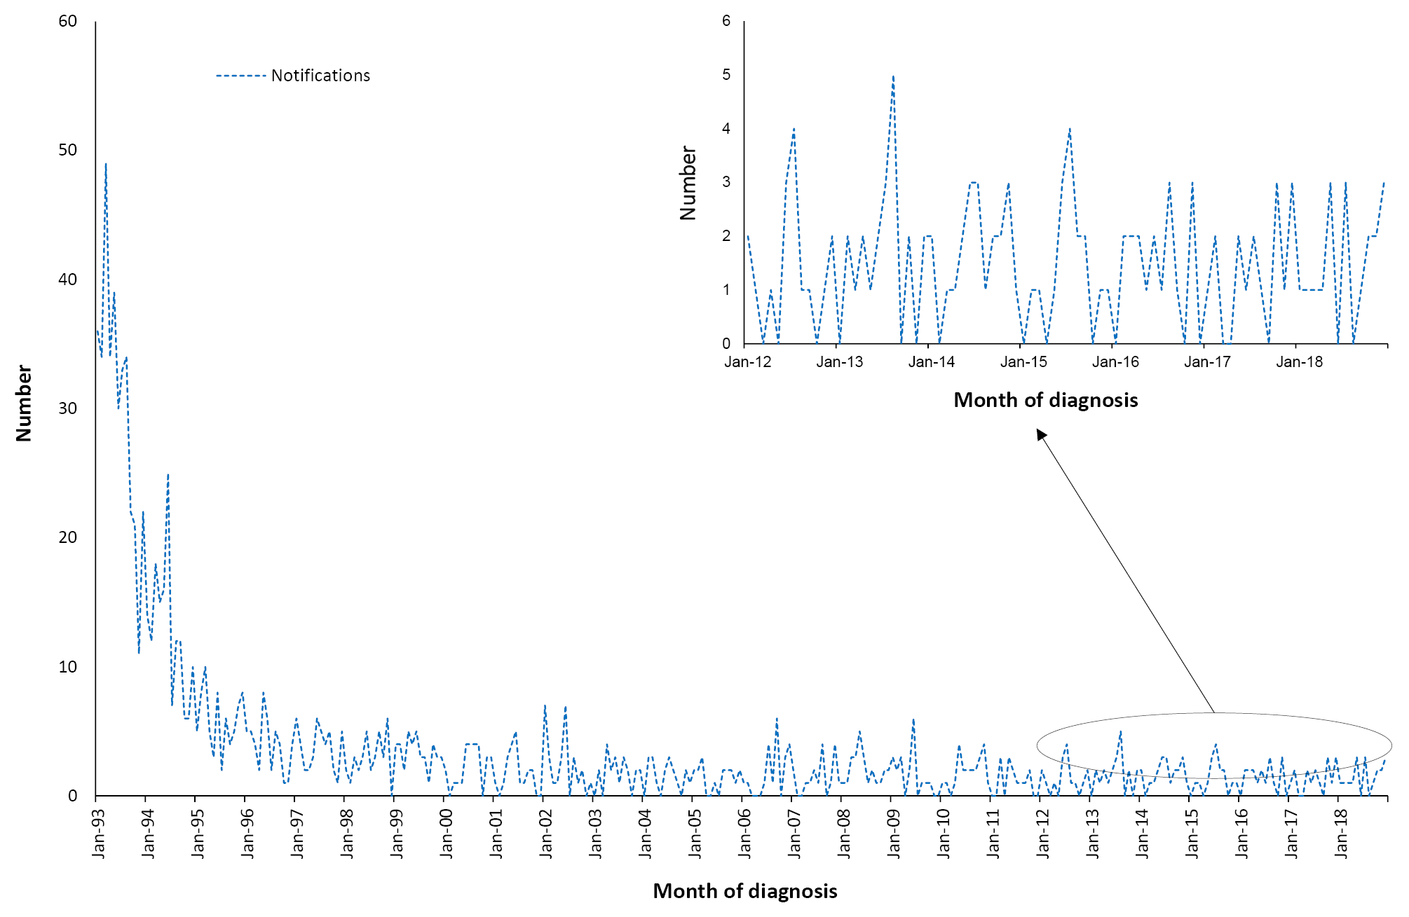
a Notifications where the month of diagnosis was between 1 January 1993 and 31 December 2018.
Table 3.2.1: Haemophilus influenzae type b notifications, Australia, 2016 to 2018,ª by age group
 | H. influenzae type b notifications
Age group (years) | n | Rate^{b}
< 1 | 14 | 1.51
1–4 | 10 | 0.26
5–14 | 6 | 0.07
15–24 | 1 | 0.01
25–49 | 7 | 0.03
50–64 | 8 | 0.06
≥ 65 | 5 | 0.04
All ages | 51 | 0.07
a Notifications where the month of diagnosis was between January 2016 and December 2018.
b Average annual age-specific rate per 100,000 population.

Severe morbidity and mortality
There were four notified deaths among the 51 Hib notifications to the NNDSS in the three years from 1 January 2016 to 31 December 2018 (3 in 2017 and 1 in 2018). Of these four deaths, two occurred in infants aged < 1 year, one in a child aged 10 years, and one in an adult aged 61 years. Details of some of these deaths have been published elsewhere.^{13,53}

Age and sex distribution
There were more notifications for invasive Hib disease for females than males, with a male: female ratio of 1:1.3 (0.06 vs 0.08 per 100,000 population per year, respectively) over the three years from 1 January 2016 to 31 December 2018.
Notifications of invasive Hib disease were highest among children aged < 5 years, with infants < 1 year of age (Table 3.2.1) accounting for 14/51 (27%) and children aged 1–4 years accounting for 10/51 (20%) of invasive Hib notifications, incidences of 1.51 and 0.26 per 100,000 population per year, respectively. The annual average notification rate in this reporting period for children 0–4 years of age was 0.5 per 100,000 population, identical to the previous four-year reporting period (1 January 2012 to 31 December 2015). Notifications were rare among children and young adults aged 5–24 years, with one each among those aged 5–14 years and 15–24 years (Table 3.2.1).

Geographical distribution
Eighty percent of notifications occurred across New South Wales (39%), Queensland (29%), and Victoria (12%). Relative to its small population, the Northern Territory accounted for 8% of notifications for invasive Hib disease, with the highest rate of notification (0.50 per 100,000 population per year) rate, sevenfold higher than the national average of 0.07 per 100,000 population per year (Appendix B). All four notified cases in the Northern Territory occurred among Aboriginal and Torres Strait Islander people. No cases of Hib were notified in the Australian Capital Territory or Tasmania.

Aboriginal and Torres Strait Islander status
Aboriginal and Torres Strait Islander status was reported for all 51 notifications of invasive Hib disease over the 2016–2018 period. Notification of Hib recorded among Aboriginal and Torres Strait Islander people accounted for 29% of all notifications (15/51) with a rate over 12 times as high as that seen in other Australians (0.61 versus 0.05 per 100,000 population per year respectively). The age distribution was younger for notifications among Aboriginal and Torres Strait Islanders, with 67% of notifications aged 0–4 years compared with 39% among other Australians.

Vaccination status
Vaccination status in the NNDSS was evaluated for all notified cases born after 31 December 1987, i.e. the cohort eligible to receive the Hib vaccine. Of the total 51 notifications, there were 31 vaccine-eligible cases. Of the 20 cases not eligible for nationally-funded vaccine, 7 (35%) were unvaccinated and no information was available for the remaining 13 cases. Of the 31 cases in vaccine-eligible birth cohorts, vaccination data were available for 29 cases (94%), of which 3 (10%) had received no vaccine doses, with one too young to be vaccinated. Among vaccinated cases (n = 26), four had received 1 dose, four had received 2 doses, nine had received 3 doses and nine had received 4 doses.

Comment
Notification rates for invasive Hib disease remained low for all ages and in children < 5 years of age between 2016 and 2018, and were similar to the previous reporting period (2012–2015). Our report is consistent with a recent review of the epidemiology of Hib disease in Australia,¹³ which provides further evidence of the persistent gap in rates of disease between Aboriginal and Torres Strait Islanders and other Australians.

3.3 Hepatitis A

Highlights
The average annual notification rate for hepatitis A in the three-year period from 1 January 2016 to 31 December 2018 was 1.1 per 100,000 population, higher than in the previous four years from 1 January 2012 to 31 December 2015 (0.8 per 100,000 population per year), largely due to outbreaks among men who have sex with men (MSM). The notification rate in Aboriginal and Torres Strait Islander people (0.6 per 100,000 population per year) was lower than in other Australians (1.1 per 100,000 population per year). The average annual rate of hepatitis A hospitalisations was higher in the current reporting period than in the previous period (1.5 vs 1.1 per 100,000 population).
Hepatitis A is caused by the hepatitis A virus (HAV), a RNA virus classified within the genus hepatovirus of the picornavirus family. There is only one human HAV serotype.^{54–57} Hepatitis A is an acute inflammatory disease of the liver and can produce either asymptomatic or symptomatic infection.⁵⁸ Clinical manifestations of symptomatic infection vary from mild anicteric illness to fulminant hepatic failure. Infection with HAV typically has a sudden onset of symptoms that can include fever, anorexia, malaise, nausea, abdominal discomfort, jaundice and dark urine.^{54–57} The likelihood of having symptoms with HAV infection is related to age. In young children, hepatitis A is usually asymptomatic or associated with mild illness without jaundice. In adults, symptomatic infection is characteristic and 70–95% of infected adults show clinical symptoms.⁶ Complications are uncommon, but in rare cases infection can develop into fulminant hepatitis for which mortality can be as high as 60%.^{56,59} Transmission typically occurs via the faecal-oral route or through close physical contact with an infected person.^{54,56} Hepatitis A infection was prevalent among Aboriginal and Torres Strait Islander children in the late 1990s, but a national targeted program in affected jurisdictions since 2005 has been highly effective in decreasing disease incidence in both children and adults.^{51,60,61} Increasingly, a large proportion of cases in Australia are related to overseas travel to countries where hepatitis A is endemic.^{62,63}

Case definition
Notifications⁶⁴
Hepatitis A case definition:
http://www.health.gov.au/internet/main/publishing.nsf/Content/cda-surveil-nndss-casedefs-cd_hepa.htm
Hospitalisations and deaths
The ICD-10-AM/ICD-10 codes B15.0 (hepatitis A with hepatic coma) and B15.9 (hepatitis A without hepatic coma) were used to identify hospitalisations and deaths.

Secular trends
There were 796 notifications of hepatitis A over the three-year period from 1 January 2016 to 31 December 2018, with a median of 20 (ranging from 5 to 59) per month (Figure 3.3.1). The average annual notification rate was 1.08 per 100,000 population (Table 3.3.1), with the annual rate increasing over the three-year period from 0.60 per 100,000 population in 2016 (n = 145) to 0.88 per 100,0000 population in 2017 (n = 217) and1.74 per 100,000 population in 2018 (n = 434) (Appendix B). Of the 796 notifications, 263 were noted as acquired in Australia (33%), 351 from overseas (44%) and 182 (23%) unknown. The total number of coded hospitalisations (n = 1,129) exceeded notifications, but only 451 (40%) were coded as principal diagnosis (average annual rate of 0.61 per 100,000 population). The rate of hepatitis A notifications and hospitalisations was higher in this reporting period (2016–2018) than in the previous four-year reporting period from 2012–2015 (1.53 vs 1.11 per 100,000 population per year for notifications; and 0.61 vs 0.43 per 100,000 population per year for hospitalisations coded as the principal diagnosis, respectively), with a median of 29 hospitalisations a month (range from 18 to 55).
Figure 3.3.1: Hepatitis A notifications and hospitalisations, Australia, 1993 to 2018,ª by month of diagnosis or admission
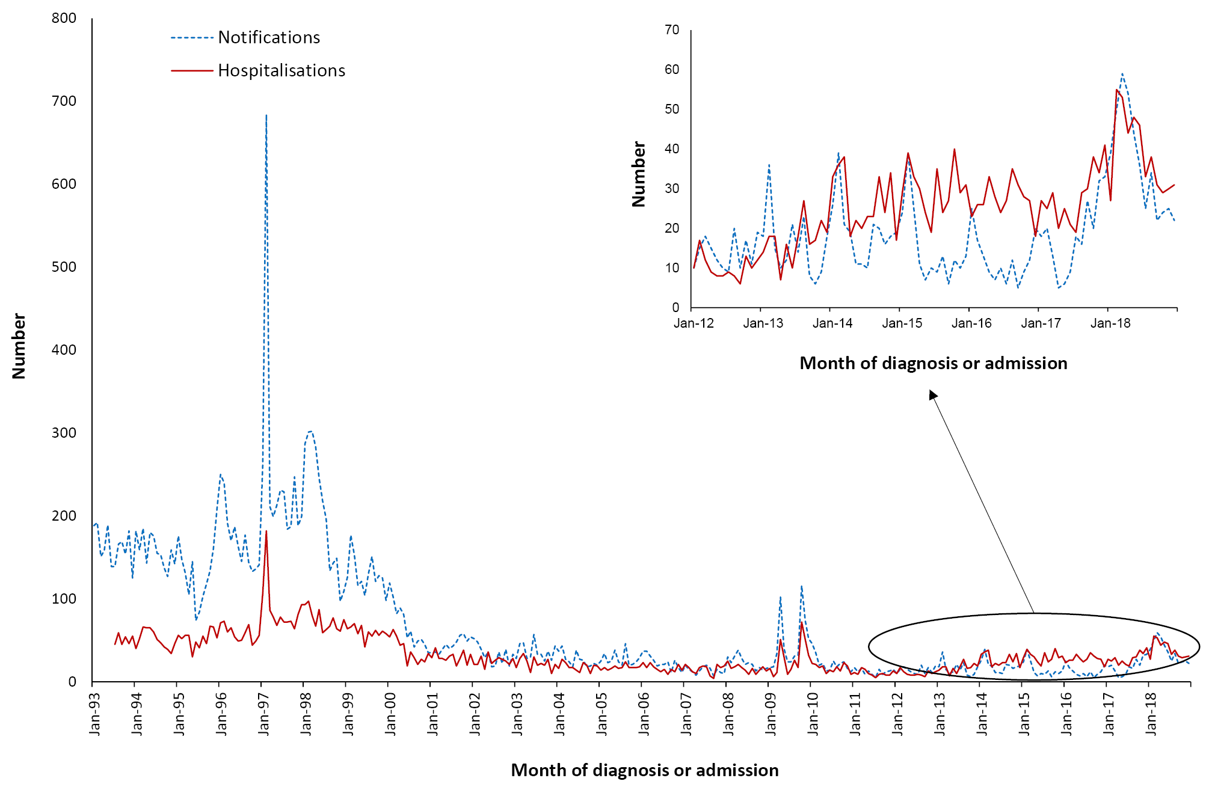
a Notifications where the month of diagnosis was between 1 January 1993 and 31 December 2018; hospitalisations where the month of admission was between 1 July 1993 and 31 December 2018.

Severe morbidity and mortality
In the three years from 1 January 2016 to 31 December 2018, hospitalisations where hepatitis A was the principal diagnosis accounted for 1,459 bed-days, with a median length of stay of two days, increasing with age (Table 3.3.1). A total of nine deaths were recorded in the causes of death data, although hepatitis A was recorded as an associated rather than underlying cause of death in all of these. All deaths occurred among adults aged 25 years or older. Two deaths were reported in the NNDSS (aged between 55 and 70 years) and two in-hospital deaths where hepatitis A was the principal diagnosis (both aged 60 years or older) were recorded in AIHW hospitalisation data.

Table 3.3.1: Hepatitis A notifications, hospitalisations and deaths, Australia, 2016 to 2018,ª by age group
Age group (years) | Notifications |  | Hospitalisations |  |  |  | LOS^{b} per admission |  | Deaths^{c}
 |  |  | Any diagnosis |  | Principal diagnosis |  | Any diagnosis | Principal diagnosis
 | n | Rate^{d} | n | Rate^{d} | n^{e} | Rate^{d,e} | Median days |  | n | Rate^{d}
< 1 | 1 | 0.11 | 1–4 | 0.22 | 1–4 | 0.22 | 1 | 1 | 0 | 0.00
1–4 | 56 | 1.48 | np^{f} | 0.29 | np^{f} | 0.26 | 1 | 1 | 0 | 0.00
5–14 | 100 | 1.09 | 44 | 0.48 | 40 | 0.44 | 2 | 2 | 0 | 0.00
15–24 | 136 | 1.42 | 103 | 1.07 | 73 | 0.76 | 2 | 2 | 0 | 0.00
25–49 | 383 | 1.49 | 423 | 1.64 | 224 | 0.87 | 3 | 3 | 1–5 | 0.00
50–64 | 88 | 0.67 | 251 | 1.91 | 61 | 0.46 | 2 | 3 | 5 | 0.04
≥ 65 | 32 | 0.28 | 295 | 2.59 | 41 | 0.36 | 3 | 3 | 1–5 | 0.03
All ages | 796 | 1.08 | 1,129 | 1.53 | 451 | 0.61 | 2 | 2 | 9 | 0.01
a Notifications where the month of diagnosis was between 1 January 2016 and 31 December 2018; hospitalisations where the month of admission was between 1 January 2016 and 31 December 2018.
b LOS: length of stay in hospital.
c Deaths include underlying and associated causes of deaths.
d Average annual age-specific rate per 100,000 population.
e Principal diagnosis (hospitalisations).
f np: not provided.

Age and sex distribution
The largest number of notifications of hepatitis A (48%) was in the 25-49 year age group (383/796, 1.49 per 100,000 population per year) but notification rates were similar for those aged 1–49 at 1.4 to 1.5 per 100,000 population per year (Table 3.3.1). When restricted to principal diagnosis, hospitalisation rates were highest in those 25-49 years (Table 3.3.1), although this varied by year. Notifications were almost twice as high in males as in females (523 vs 273, ratio 1.95:1).

Geographical distribution
The highest numbers of notified cases during this reporting period were from Victoria (n = 394; a notification rate of 2.08 per 100,000 population per year) and New South Wales (n = 200; a notification rate of 0.85 per 100,000 population per year), where outbreaks of hepatitis A were observed. Hospitalisation rates were similarly high in these states (2.30 per 100,000 population per year in Victoria [n = 436] and 1.46 per 100,000 population per year in New South Wales [n = 344]). Tasmania, the Northern Territory and Queensland had the lowest average annual rates of notifications (0.19, 0.27 and 0.67 per 100,000 population, respectively) and the lowest hospitalisation rates where hepatitis A was the principal diagnosis (0.26, 0.41 and 0.31 per 100,000 population, respectively) (Appendix C).

Aboriginal and Torres Strait Islander status
Aboriginal and Torres Strait Islander status was reported for 741 of the 796 notifications (93%) of Hepatitis A during 2016–2018, with 55 not stated (7%). Of the 796 hepatitis A notifications, 15 were in Aboriginal and Torres Strait Islander people (2% of all notifications) and 781 in other people (notification rate 0.6 versus 1.1 per 100,000 population per year, respectively).

Vaccination status
Of the 796 notifications, vaccination data was available for 57% (454/796) with 434 of those (96%) reported to have received no vaccine doses. Of the 20 vaccinated cases, only seven had received 2 or more doses.

Comment
Hepatitis A vaccine has been available on the National Immunisation Program (NIP) for Aboriginal and Torres Strait Islander children in the Northern Territory, Queensland, South Australia and Western Australia since 2005, with a resultant marked decline in disease rates despite relatively modest vaccination coverage.⁶¹ Hepatitis A notification rates among Aboriginal and Torres Strait Islander people remained lower than in other Australians in this reporting period. However an overall increase in notifications of hepatitis A was observed, largely due to outbreaks, primarily among men who have sex with men (MSM).^{65,66} Other key risk groups include people who inject drugs, homeless persons and adult prisoners. State-funded 2-dose hepatitis A vaccination programs targeting MSM and injection drug users were introduced in Victoria and Tasmania from mid-2018 until June 2019 to control the outbreak,^{65,67} with the program successfully increasing immunity against hepatitis A and likely preventing disease transmission and further outbreaks.⁶⁸ Additional food-borne outbreaks resulting in substantial numbers of cases have also been reported,⁶⁹ particularly in Victoria and New South Wales.^{70,71} However, a large proportion of cases continue to be acquired overseas (351/796), accounting for 44% of notifications in this reporting period, with data missing for 23% of cases.
The Australian Immunisation Handbook recommends hepatitis A vaccination for people with an increased risk of acquiring hepatitis A, due to occupational or other factors,⁵⁴ but coverage of the vaccine in such groups is unknown.

3.4 Hepatitis B

Highlights
The declining trend in the number of notifications of newly-acquired hepatitis B observed since 2007 continued over the three-year reporting period. There were 461 notifications of newly-acquired hepatitis B from 1 January 2016 to 31 December 2018, and the majority (58%) were among adults aged 25 to 49 years.
The acute hepatitis B hospitalisation rate was low at 0.37 per 100,000 population per year from 1 January 2016 to 31 December 2018.
The focus of this chapter is acute infection with hepatitis B virus (HBV), a hepadnavirus. Humans are the only known reservoir for human HBV genotypes, but closely related HBV genotypes exist in higher primates.⁷² The outcomes of HBV infection depend on host factors including age, sex, genetic background, co-infections, other co-existing diseases and concomitant medications, and on viral factors including the HBV genotype and viral DNA levels.⁷² It produces a range of conditions from subclinical infection to acute and, rarely (in < 1% of cases), fulminant hepatitis.⁷³ The majority of HBV infections are not clinically recognised, with < 10% of children and 30–50% of adults experiencing jaundice.^{74,75} When illness occurs, it is usually insidious, with anorexia, vague abdominal discomfort, nausea and vomiting, sometimes arthralgia and rash, often progressing to jaundice. The main burden of disease is related to chronic HBV infection, which is the primary cause of cirrhosis deaths in the Asia-Pacific region.^{76,77} The risk of an acute infection becoming chronic varies inversely with age. Chronic HBV infection occurs in about 90% of infants infected at birth, in 20–50% of children infected at 1–5 years of age, and with much lower but highly variable risk (1–10%) in people infected as older children and adults.⁷⁴ Of those chronically infected with HBV, 15–40% develop cirrhosis of the liver and/or hepatocellular carcinoma.^{78,79}
HBV transmission occurs by percutaneous or permucosal exposure to infective body fluids such as blood, semen, vaginal secretions and any other body fluid containing blood.⁷⁴ Major modes of transmission include sexual or close household contact with an infected person; perinatal transmission from mother to infant; injecting drug use; and nosocomial exposure.⁷⁴ Screening of blood and organ donors has nearly eliminated the risk of transmission through blood transfusion and organ transplants.⁸⁰
The summary below is restricted to newly-acquired hepatitis B notifications and acute hepatitis B hospitalisations.

Case definition
Notifications⁸¹
Hepatitis B (newly acquired) case definition:
http://www.health.gov.au/internet/main/publishing.nsf/Content/cda-surveil-nndss-casedefs-cd_hepbnew.htm
Hospitalisations and deaths
The ICD-10-AM/ICD-10 code B16 (acute hepatitis B) was used to identify hospital admissions and deaths. As in previous reports, only those hospitalisations with B16 as the principal diagnosis were included.

Secular trends
In the three years from 1 January 2016 to 31 December 2018, there were 461 notifications of newly acquired hepatitis B (an average annual rate of 0.6 per 100,000 population) (Table 3.4.1), decreasing from a median of 14.0 per month in 2016 to 11.5 in 2018 (Figure 3.4.1). There were 274 hospitalisations with a principal diagnosis of acute hepatitis B over the three years, an average annual rate of 0.37 per 100,000 population (Table 3.4.1). The number and rate of hospitalisations were lower in this reporting period than in the previous four-year period (2012–2015), but rates have remained fairly stable since 2015 (0.35 per 100,000 population in 2016; 0.36 per 100,000 population in 2017; and 0.41 per 100,000 population in 2018).
Figure 3.4.1: Hepatitis B notifications and hospitalisations with a principal diagnosis of acute hepatitis B, Australia, 1997 to 2018,ª by month of diagnosis or admission
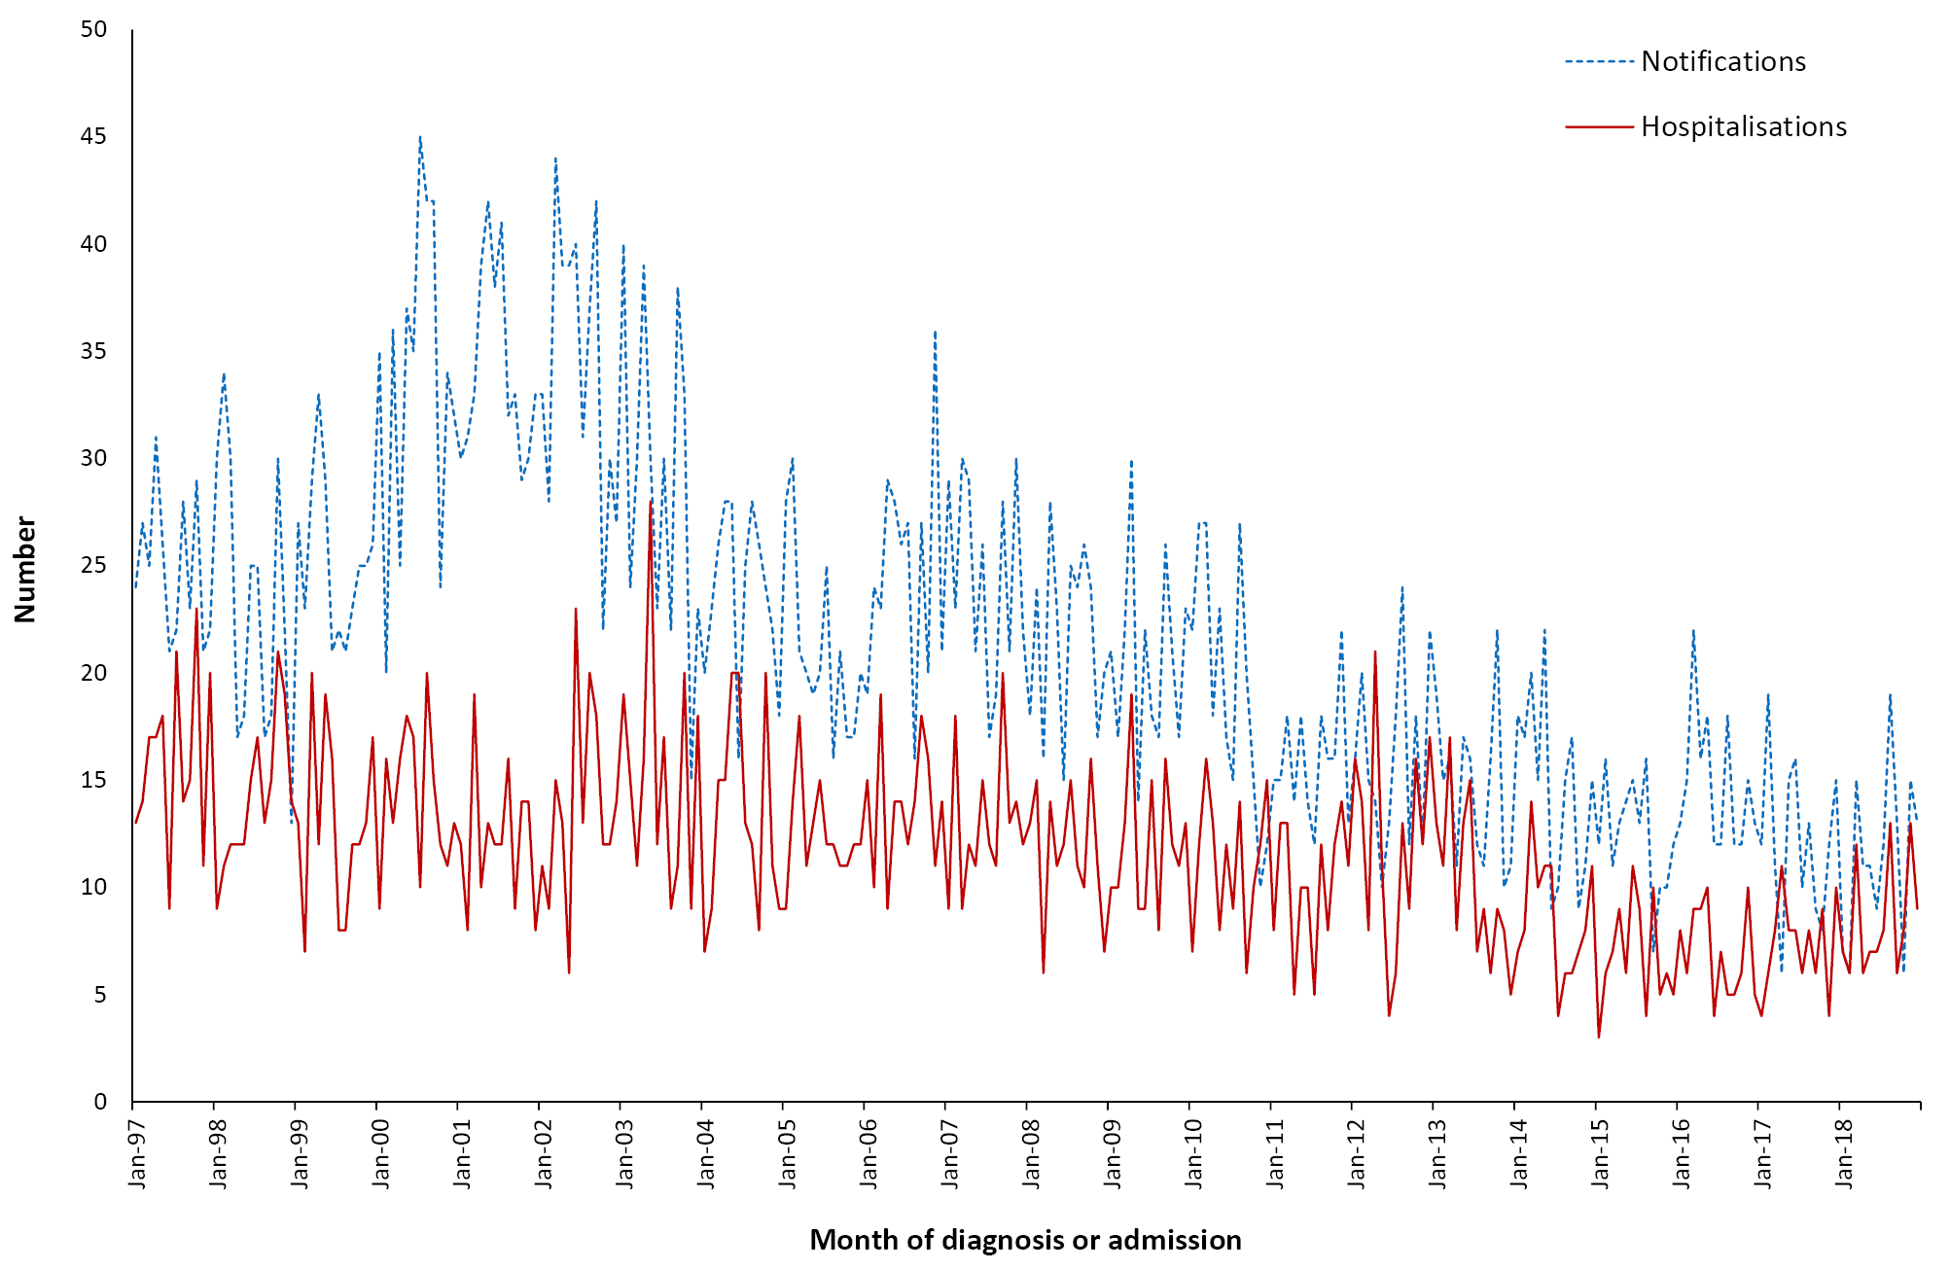
a Notifications with month of diagnosis between 1 January 1997 and 31 December 2018; hospitalisations where the month of admission was between 1 January 1997 and 31 December 2018. This figure includes data from 1997 onwards since it was not until 1996 that acute hepatitis B became notifiable in all states and territories; prior to 1994, hospitalisations for acute hepatitis B were not distinguished from chronic hepatitis B.

Severe morbidity and mortality
In the three-year reporting period, the 274 hospitalisations for acute hepatitis B infection accounted for 1,453 bed days. The median length of stay in hospital was four days for people aged 15–64 years, and slightly higher (median: five days) for people aged ≥ 65 years (Table 3.4.1). Seven hospitalisations occurred among children 5–14 years, all in 2018, of which six were Aboriginal and Torres Strait Islander children. Between 2016 and 2018, there were no hospitalisations among children aged less than 5 years.
There were 533 deaths recorded in the causes of death data over the three-year period where acute hepatitis B infection (ICD-10 code B16) was an underlying or associated cause, with only 52 (9.8%) coded as the underlying cause of death (eight deaths in those aged 25–49 years, 19 in 50–64 years and 25 in ≥ 65 years) (Table 3.4.1). The number of deaths where hepatitis B was the underlying cause of death decreased from 24 in 2016 to 21 in 2017 and 7 in 2018. No deaths were recorded among notifications to NNDSS during this reporting period, and 1–4 in-hospital deaths were recorded in the AIHW dataset among cases with a principal diagnosis of acute hepatitis B, all aged between 45 and 55 years.

Age and sex distribution
From 1 January 2016 to 31 December 2018, the highest rates for notification of newly-acquired hepatitis B infection and hospitalisations for acute hepatitis B were among adults aged 25–49 years, followed by adults aged 50–64 years (Table 3.4.1). In children aged 0–4 years, there were six notifications of newly-acquired hepatitis B and no hospitalisations (Table 3.4.1).
Overall, the number of notifications and hospitalisations was higher for males (male:female rate ratio for notifications 2.6:1 and for hospitalisations 2.1:1), especially in adults aged 50–64 years (male:female rate ratio for notifications 6.4:1 and for hospitalisations 3.3:1).
Table 3.4.1: Hepatitis B notifications, hospitalisations and deaths, Australia, 2016 to 2018,ª by age group
Age group (years) | Notifications |  | Hospitalisations^{b} |  | LOS^{c} per admission^{b} | Deaths^{d}
 | n | Rate^{e} | Principal diagnosis |  | Principal diagnosis | n | Rate^{e}
 |  |  | n | Rate^{e} | Median days
< 1 | 2 | 0.22 | 0 | 0.00 | 0 | 0 | 0.00
1–4 | 4 | 0.11 | 0 | 0.00 | 0 | 0 | 0.00
5–14 | 3 | 0.03 | 7 | 0.08 | 1 | 0 | 0.00
15–24 | 35 | 0.36 | 24 | 0.25 | 4 | 1–5 | 0.01
25–49 | 269 | 1.04 | 158 | 0.61 | 4 | np^{f} | 0.37
50–64 | 115 | 0.88 | 62 | 0.47 | 4 | 220 | 1.68
≥ 65 | 33 | 0.29 | 23 | 0.20 | 5 | 217 | 1.91
All ages | 461 | 0.62 | 274 | 0.37 | 4 | 533 | 0.72
a Notifications where the month of diagnosis was between 1 January 2016 and 31 December 2018; hospitalisations where the month of admission was between 1 January 2016 and 31 December 2018.
b Principal diagnosis (hospitalisations).
c LOS: length of stay in hospital.
d Deaths include underlying and associated causes of deaths.
e Average annual age-specific rate per 100,000 population.
f np: not provided.

Geographical distribution
Similar numbers of notifications were reported in Queensland (146/461, 32%) and Victoria (144/461, 31%), with notable numbers reported in Western Australia (73/461, 16%) and New South Wales (48/461, 10%) over the 3 years from 1 January 2016 to 31 December 2018 (Appendix B). The largest numbers of hospitalisations occurred in Victoria (31%), New South Wales (25%) and Queensland (20%). However, the highest rates of notifications and hospitalisations occurred in the Northern Territory (average annual rate of 1.89 per 100,000 population for both notifications and hospitalisations) (Appendices B and C).

Aboriginal and Torres Strait Islander status
Aboriginal and Torres Strait Islander status was reported for 430 of the 461 notifications (93%) of hepatitis B during 2016–2018, with 31 not stated (7%). Of the 461 notifications, 37 (8%) were in Aboriginal and Torres Strait Islander people. Of the 274 hospitalisations with hepatitis B recorded as the principal diagnosis, 23 (8%) were in Aboriginal or Torres Strait Islander people. Notification rates in Aboriginal and Torres Strait Islander people were 2.5 times as high (1.51 per 100,000 population per year) as in other Australians (0.59 per 100,000 population per year), and hospitalisation rates were 2.7 times as high (0.94 per 100,000 population per year versus 0.35 per 100,000 population per year). Aboriginal and Torres Strait Islanders accounted for 55 of the 533 deaths (10.3%) where hepatitis B was recorded as underlying or associated cause, and for five of the 52 deaths (9.6%) where hepatitis B was recorded as the underlying cause, with rates more than three times as high as those seen in other Australians.

Vaccination status
Of the 12 notifications between January 2016 and December 2018 in people born in 2000 or later who were eligible to receive hepatitis B vaccine as part of the universal infant vaccination program, vaccination status was not available for five cases (42%). Of the seven cases (58%) with vaccination data available, two were reported to have received no vaccine doses (unvaccinated), of whom one was too young to receive the vaccinations scheduled at 2 months of age. Of the five cases who had received a hepatitis B-containing vaccine, one had received 2 doses and four had received 4 doses.

Comment
Universal infant hepatitis B immunisation was introduced in May 2000, although targeted programs had been in place since the 1980s in all jurisdictions. A progressive downward trend in total notifications of acute hepatitis B has been evident since 2007, with notifications continuing to decline between 2016 and 2018. However, the longstanding disparity in rates of hepatitis B infections among Aboriginal and Torres Strait Islander people persists.^{1,18,82} Modelling has suggested that a nationally-funded hepatitis B immunisation program for Aboriginal and Torres Strait Islander adults could have a considerable impact on the prevention of acute and subsequent chronic hepatitis B infections.¹

3.5 Influenza

Highlights
There was a marked increase in influenza notifications, hospitalisations and deaths in 2017, which was the largest season observed since the 2009 pandemic, with both A/H3N2 and type B influenza strains circulating. Increased use of PCR rapid tests and changing testing and reporting practices partially contributed to the increase in notifications observed over the reporting period 2016 to 2018.
Influenza viruses, predominantly influenza type A (H1N1 and H3N2) and type B (Yamagata and Victoria lineages), cause annual epidemics of respiratory disease, which is mainly spread by droplet transmission.⁸³ The disease is often indistinguishable clinically from that caused by other respiratory viruses. Typical symptoms include abrupt onset of fever, cough, malaise, myalgia, sore throat and headache. Complications of influenza infection include pneumonia, cardiovascular events, stroke, otitis media and exacerbation of chronic medical conditions.⁸⁴ Significant antigenic changes can lead to pandemics with higher rates of illness and death.⁸³ Seasonal epidemics occur in Australia mainly between June and September, with year-to-year variability in terms of activity, severity and age groups affected, based on the viruses predominantly circulating. Influenza can cause severe illness or death, particularly in high-risk groups including children younger than 5 years; people 65 years and older; Aboriginal and Torres Strait Islander people; pregnant women; and people with chronic medical conditions.^{54,85–88}

Case definition
Notifications⁸⁹
Influenza laboratory-confirmed case definition:
http://www.health.gov.au/internet/main/publishing.nsf/Content/cda-surveil-nndss-casedefs-cd_flu.htm
Hospitalisations and deaths
The ICD-10-AM/ICD-10 codes J09 (influenza due to certain identified influenza virus, including avian influenza and the influenza A/H1N1 pandemic strain), J10 (influenza due to identified virus) and J11 (influenza, virus not identified) were used to identify influenza hospitalisations and deaths. As no avian influenza cases have been reported in Australia, J09 in this report refers to the influenza A/H1N1 pandemic strain.

Secular trends
In the three years from 1 January 2016 to 31 December 2018, there were 400,907 notifications of influenza with an average annual rate of 543.4 per 100,000 population (Table 3.5.1). Notifications varied substantially by year, with the highest levels of activity since the 2009 pandemic season seen in 2017 (251,163 notifications, 1020.9 per 100,000 population, comprising 63% of the influenza notifications across 2018–2018). Notifications in 2016 were lower at 90,879 (375.7 per 100,000 population), and lower still in the mild 2018 influenza season (58,865 notifications, 235.6 per 100,000 population) (Appendix B). Similar to previous reporting periods, seasonal peaks in influenza notifications were observed between July and September, although the 2017 season appeared to continue into October (Figure 3.5.1). Although notifications were substantially lower in 2018 compared with previous years, a higher number of inter-seasonal notifications were observed following the regular 2018 season, with three times as many notifications observed in December 2018 as in December 2017 (6,269 vs 2,207, respectively).
Table 3.5.1: Influenza notifications, hospitalisations and deaths, Australia, 2016 to 2018,ª by age group
Age group (years) | Notifications |  | Hospitalisations |  |  |  | LOS^{b} per admission |  | Deaths^{c}
 | n | Rate^{d} | Any diagnosis |  | Principal diagnosis |  | Any diagnosis | Principal diagnosis | n | Rate^{d}
 |  |  | n | Rate^{d} | n^{e} | Rate^{d,e} | Median days
< 1 | 5,998 | 645.6 | 2,634 | 283.5 | 2,001 | 215.4 | 2 | 2 | 1–5 | 0.3
1–4 | 35,081 | 924.2 | 4,711 | 124.1 | 3,656 | 96.3 | 2 | 2 | 7 | 0.2
5–14 | 65,425 | 712.7 | 3,653 | 39.8 | 2,709 | 29.5 | 1 | 1 | np^{f} | 0.1
15–24 | 38,499 | 401.0 | 3,528 | 36.7 | 2,443 | 25.4 | 1 | 1 | 10 | 0.1
25–49 | 107,473 | 417.0 | 12,488 | 48.5 | 8,101 | 31.4 | 2 | 1 | 55 | 0.2
50–64 | 63,508 | 484.0 | 13,018 | 99.2 | 7,950 | 60.6 | 3 | 3 | 143 | 1.1
≥ 65 | 84,869 | 746.0 | 47,043 | 413.5 | 27,675 | 243.3 | 5 | 4 | 2,145 | 18.9
All ages | 400,907^{g} | 543.4 | 87,075 | 118.0 | 54,535 | 73.9 | 3 | 3 | 2,368 | 3.21
a Notifications where the month of diagnosis was between 1 January 2016 and 31 December 2018; hospitalisations (ICD-10-AM codes J09, J10 and J11) where the month of admission was between 1 January 2016 and 31 December 2018.
b LOS: length of stay in hospital.
c Deaths include underlying and associated causes of deaths.
d Average annual age-specific rate per 100,000 population.
e Principal diagnosis (hospitalisations).
f np: not provided.
g Total notifications for all ages: includes 54 notifications without data on age group.
From 1 January 2016 to 31 December 2018, there were 87,075 hospitalisations with ICD-10-AM influenza codes J09, J10 or J11. A trend similar to that for notifications was observed, with the highest number of hospitalisations observed in 2017 (50,688 hospitalisations, 206.0 per 100,000 population) (Appendix C). Influenza was the principal diagnosis in 63% of hospitalisations, with 89% of these coded as J10. Influenza coded as J11 and J09 made up only a small proportion of cases (9% and 3%, respectively).

Severe morbidity and mortality
In the three-year reporting period, there were 469,172 bed days for hospitalisations due to any influenza (J09, J10 or J11). The median length of hospital stay was three days, increasing to five days for patients aged ≥ 65 years (Table 3.5.2). In the cause of death data, influenza (ICD-10 codes J09, J10, J11) was recorded in 2,368 cases between 1 January 2016 and 31 December 2018, an average annual rate of 3.2 deaths per 100,000 population (Table 3.5.1). This varied substantially from year to year, being highest in 2017 (1,629 deaths; 6.62 per 100,000 population) followed by 2016 (585 deaths; 2.42 per 100,000) and lowest in 2018 (154 deaths; 0.62 per 100,000 population).

Age and sex distribution
The highest rate of notifications for influenza was among children aged 1–4 years for the overall three-year reporting period (924.2 per 100,000 population per year) (Table 3.5.1), and for each individual year included in the reporting period (575.1, 1722.5 and 469.0 per 100,000 population in 2016, 2017 and 2018 respectively). The second highest rate of influenza notifications was among adults aged 65 years and older (746.0 per 100,000 population per year) (Table 3.5.1), but there was some variation by year, dependent on the season characteristics. For example, in 2018 there were higher notification rates observed among infants aged < 1 years (298.0 per 100,000 population) and children aged 5–14 years (307.9 per 100,000 population) than among adults aged 65 years and older (249.2 per 100,000 population). Hospitalisation rates for influenza coded as J09, J10 or J11 were highest for adults aged 65 years or older, followed by infants aged < 1 year (Table 3.5.1). Adults aged 65 years and older accounted for 91% of recorded influenza deaths.
There were slightly fewer influenza notifications and hospitalisations for males than for females (male:female rate ratio 0.8:1 for notifications and 0.9:1 for hospitalisations).
Figure 3.5.1: Influenza notifications and hospitalisations from 2001 to 2018,ª Australia, by month of diagnosis or admission
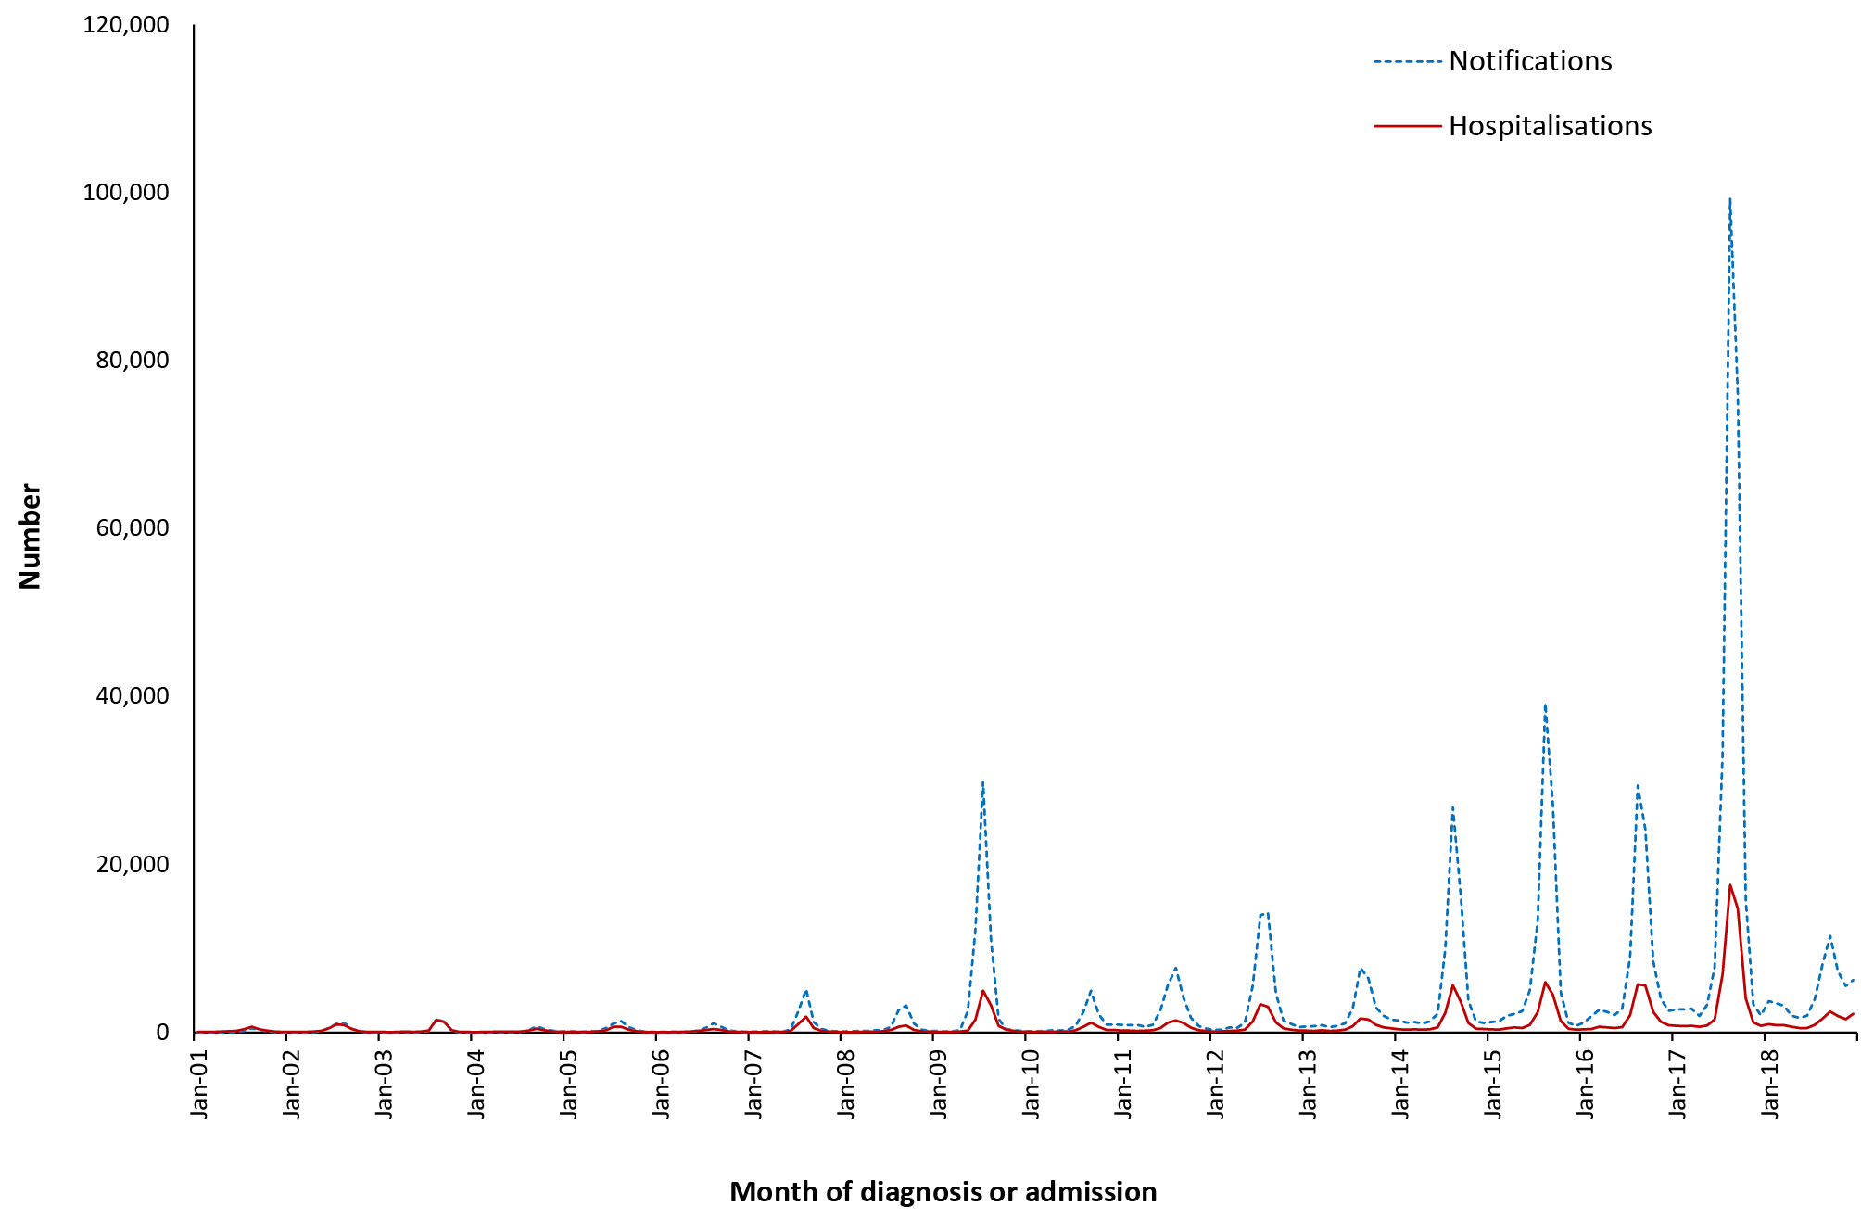
a Notifications with ICD-10-AM code for influenza (J09, J10, J11) where the month of diagnosis was between 1 January 2001 and 31 December 2018; hospitalisations with ICD-10-AM code for influenza (J09, J10, J11) where the month of admission was between 1 January 2001 and 31 December 2018.

Geographical distribution
Notification rates were highest in South Australia, followed by New South Wales and Queensland (Appendix B). Notification rates in 2017 were more than twofold higher across every state and territory, relative to 2016, with the exception of Western Australia where rates remained relatively constant across the three-year period. Hospitalisation rates were highest in the Northern Territory and Queensland (196.0 and 151.3 per 100,000 population per year, respectively) (Appendix C). As with notifications, hospitalisation rates were markedly higher in 2017 across all jurisdictions except Western Australia.

Aboriginal and Torres Strait Islander status
Of the 400,907 notifications of influenza over the 2016–2018 period, Aboriginal and Torres Strait Islander status was reported for only 133,604 (33%). Reporting of Aboriginal and Torres Strait Islander status varied across jurisdictions, ranging from the Northern Territory (98% complete) and Western Australia (94% complete) to Tasmania (6% complete), New South Wales (8% complete) and Victoria (17% complete). The Australian Capital Territory (87%), South Australia (70%) and Queensland (56%) also had relatively high completeness. Due to low completeness of reporting of Aboriginal and Torres Strait Islander status in several jurisdictions, notification rates of influenza for Aboriginal and Torres Strait Islander people are not presented in this report.
Of the 87,075 hospitalisations for influenza, approximately 4.7% (4,053) were recorded as occurring in Aboriginal and Torres Strait Islander people, a hospitalisation rate of 165.9 per 100,000 population per year compared with 116.4 per 100,000 population per year in other Australians (rate ratio 1.43). Of the 2,368 deaths recorded in the causes of death data, 40 (2%) occurred among Aboriginal and Torres Strait Islander people.

Vaccination status
Vaccination status data were not provided to NCIRS due to data quality issues. As influenza notifications are reported to the NNDSS by laboratories, generally without further public health follow up, vaccination status is not routinely reported for influenza notifications.

Influenza type and subtype
Influenza A comprised the majority of notifications in each year, decreasing from 2016 (89%) to 2018 (80%) and 2017 (62%), with influenza B comprising the remainder. Of those influenza A viruses that were subtyped, A/H3N2 predominated in 2016 (64.5% vs 35.5% A/H1N1) and 2017 (76% vs 24% A/H1N1), while A/H1N1 was more common in 2018 (66.5% vs 33.5% A/H3N2).
Over the three reporting years, influenza A was responsible for the highest proportion of notifications in infants aged < 1 year (80%) and older adults aged 65 years and over (77%), while influenza B occurred most frequently among children aged 5–14 years (41%) and adolescents and young adults aged 15–24 years (32%).

Comment
Influenza remains the most commonly notified VPD in Australia. Consistent with a detailed review of the epidemiology of influenza in Australia for the period 2006 to 2015,⁸⁵ high rates of disease were observed among young infants and children and older adults aged 65 years and older. Notification rates in Aboriginal and Torres Strait Islander people were not calculated as they would substantially underestimate the burden of influenza due to low completeness of reporting of Aboriginal and Torres Strait Islander status in many states, as has been reported previously.¹⁸
This reporting period was marked by a longer influenza season of heightened activity in 2017, with excess mortality due to influenza and pneumonia observed above what would normally be expected,⁹⁰ and in which influenza subtype A/H3N2 predominated.^{91,92} Influenza A/H3N2-predominant seasons tend to be associated with higher morbidity and mortality, particularly among adults aged 65 years and over.^{93–95} Influenza A/H3N2 also tends to be associated with lower vaccine effectiveness.^{96–98} Influenza vaccine effectiveness in 2017 was lower than in previous seasons, particularly for the A/H3N2 strain.^{99–101} The severity of the 2017 season led to the introduction, in 2018, of two new enhanced influenza vaccines (a high-dose and an adjuvanted influenza vaccine) onto the National Immunisation Program for Australians aged 65 years and older.⁹³
In contrast, influenza activity in 2018 was low and comparatively mild, with A/H1N1 the dominant circulating strain.¹⁰² Vaccine effectiveness was also higher in 2018.^{103,104}
Comparisons made with rates of influenza in earlier years, particularly the 2009 A/H1N1 pandemic year, can be misleading, due to improved reporting of cases of influenza and the impact of increased influenza testing in recent years, an effect that is difficult to quantify. Increased uptake of polymerase chain reaction (PCR) testing in primary care, and of rapid PCR testing in hospitals, have contributed to increases in laboratory-confirmed influenza notifications in the last decade.^{85,91,105} Although geographic variations are expected, differences in notifications, hospitalisations and deaths across jurisdictions are likely due in part to testing and reporting practices. Despite improvements in reporting, notifications of influenza to NNDSS still likely substantially underestimate the true rate of influenza disease. Similarly, coded influenza death data are known to significantly underestimate the true influenza-associated hospitalisation and death rates.

3.6 Measles

Highlights
Measles notifications remained low in Australia over the three-year reporting period, consistent with continuing elimination of endemic measles. Almost half of notified cases (45%) were acquired overseas. Notification rates were highest in infants < 1 year of age, as were coded hospitalisations. At least 48% of cases were unvaccinated.
Measles is an acute and highly communicable disease caused by a member of the genus Morbillivirus. Before the introduction of a vaccine, measles caused more than two million deaths annually worldwide.¹⁰⁶ The virus is transmitted directly from person to person, by respiratory droplets, and is contagious from approximately two weeks before symptoms develop for up to four days after the rash appears.^{106,107} The clinical picture includes a prodromal fever, cough, coryza, conjunctivitis, and Koplik spots on the buccal mucosa, before the onset of rash.^{106,108} Complications include otitis media, pneumonia and encephalitis.¹⁰⁹ Subacute sclerosing panencephalitis (SSPE) occurs very rarely as a late sequel of wild infection but not of vaccination.¹¹⁰ Complications and deaths occur more commonly in developing countries in children aged < 5 years and adults, and in persons with malnutrition or immune deficiencies.¹⁰⁸ Improved rates of childhood vaccination have resulted in the burden of disease shifting from young children to older age groups.¹¹¹ Achieving herd immunity requires 2-dose vaccine coverage rates in excess of 95%.^{112–114} In 2014, the World Health Organization declared that Australia had achieved elimination of measles.^{3,115}

Case definition

Notifications¹¹⁶
Measles case definition:
http://www.health.gov.au/internet/main/publishing.nsf/Content/cda-surveil-nndss-casedefs-cd_measl.htm
Hospitalisations and deaths
The ICD-10-AM/ICD-10 code B05 (measles) was used to identify hospitalisations and deaths. SSPE, a very rare late sequel of measles infection, was not included in this analysis.

Secular trends
In the three years from 1 January 2016 to 31 December 2018, there were 283 notifications of measles recorded nationally, an average annual notification rate of 0.4 per 100,000 population (Table 3.6.1), a 50% reduction on the notification rate recorded in the four-year period 2012 to 2015 (0.8 per 100,000 population per year). Notification rates were similar in 2016 (n = 99, 0.4 per 100,000 population), 2017 (n = 81, 0.3 per 100,000 population), and 2018 (n = 103, 0.4 per 100,000 population) (Figure 3.6.1 insert and Appendix B). About half of notified cases (151/283, 53%) were acquired within Australia, and 126 (45%) acquired overseas, with only six cases (2%) of unknown origin.

Table 3.6.1: Measles notifications, hospitalisations and deaths, Australia, 2016 to 2018,ª by age group
Age group (years) | Notifications |  | Hospitalisations |  |  |  | LOS^{b} per admission |  | Deaths^{c}
 | n | Rate^{d} | Any diagnosis |  | Principal diagnosis |  | Any diagnosis | Principal diagnosis | n | Rate^{d}
 |  |  | n | Rate^{d} | n^{e} | Rate^{d,e} | Median days
< 1 | 33 | 3.55 | 15 | 1.61 | 13 | 1.40 | 3 | 2 | 0 | 0.00
1–4 | 19 | 0.50 | 24 | 0.63 | 21 | 0.55 | 1 | 1 | 0 | 0.00
5–14 | 25 | 0.27 | np^{f} | 0.07 | 1–4 | 0.04 | 2 | 2 | 0 | 0.00
15–24 | 74 | 0.77 | 36 | 0.37 | 33 | 0.34 | 3 | 3 | 0 | 0.00
25–49 | 126 | 0.49 | 69 | 0.27 | 60 | 0.23 | 3 | 3 | 0 | 0.00
50–64 | 6 | 0.05 | 9 | 0.07 | 7 | 0.05 | 3 | 3 | 0 | 0.00
≥ 65 | 0 | 0.00 | 1-4 | 0.04 | 1–4 | 0.02 | 7 | 2 | 1–5 | 0.01
All ages | 283 | 0.38 | 163 | 0.22 | 140 | 0.19 | 3 | 3 | 1–5 | 0.00
a Notifications where the month of onset was between 1 January 2016 and 31 December 2018; hospitalisations where the month of admission was between 1 January 2016 and 31 December 2018.
b LOS: length of stay in hospital.
c Deaths sourced from the Causes of Death database from the Australian Coordinating Registry. Deaths include underlying and associated causes of deaths.
d Average annual age-specific rate per 100,000 population.
e Principal diagnosis (hospitalisations).
f np: not provided.
Hospitalisations followed the same general trend as notifications (Figure 3.6.1). From 1 January 2016 to 31 December 2018, there were 163 hospitalisations with the ICD-10-AM code B05 (measles) at an average annual rate of 0.22 per 100,000 population (Table 3.6.1), lowest in 2017 (n = 41, 0.17 per 100,000 population) and similar in 2016 (n = 60) and 2018 (n = 62) (rate=0.25 per 100,000 population in both years) (Appendix C).

Figure 3.6.1: Measles notifications and hospitalisations, Australia, 1993 to 2018,ª by month of diagnosis or admission
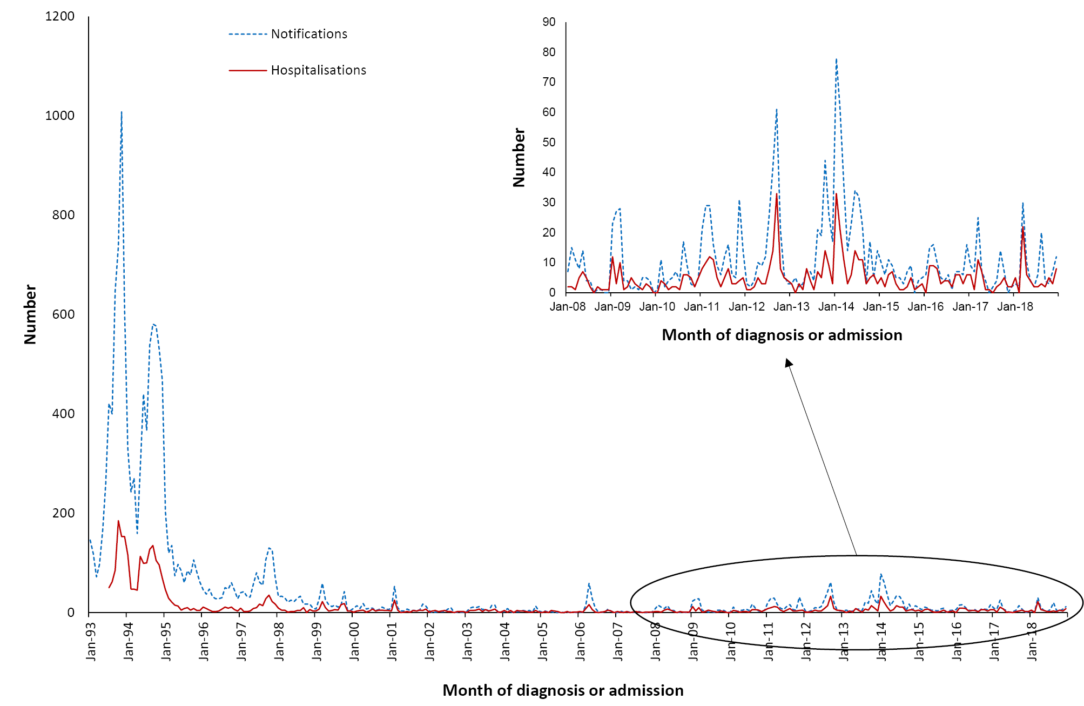
a Notifications where the month of diagnosis was between 1 January 1993 and 31 December 2018; hospitalisations where the month of admission was between 1 January 1993 and 31 December 2018.

Severe morbidity and mortality
In the three-year reporting period, hospital admissions coded as measles accounted for 546 hospital bed days. The median length of stay was three days; of the 163 hospitalisations, 140 (86%) had measles recorded as the principal diagnosis (Table 3.6.1). In the causes of death data, 1–5 deaths were recorded with measles as the underlying or associated cause of death for 2016–2018, all in people aged 65 years and older. There were no deaths recorded in the NNDSS for this reporting period.

Age and sex distribution
From 1 January 2016 to 31 December 2018, the highest age-specific notification rate (3.6 per 100,000 population per year) was in infants (< 1 year) (Table 3.6.1). Notification rates among adolescents and adults in the 2016–2018 period were lower than in the 2012–2015 period (15–24 year olds: 0.49 vs 1.63 per 100,000 population per year; 25–49 year olds: 0.55 vs 0.83 per 100,000 population per year). A greater proportion of cases among infants and young children aged 1–4 years were acquired overseas (52% and 68%) than was evident among older children and adults (5–14 years: 40%; 15–24 years: 34%; 25–49 years: 46%; 50–64 years: 50%).
Age-specific hospitalisation rates reflected notification rates; the highest rate was in infants < 1 year of age (1.61 per 100,000 population per year), with hispitalisation rates below 1 per 100,000 population per year for all other age groups (Table 3.6.1). There were slightly more notifications and hospitalisations for females than males (male:female rate ratio 0.9:1 for both).

Geographical distribution
Measles notifications rates over the three-year reporting period were highest in Western Australia (0.85 per 100,000 population per year) (Appendix B). Consistent with population size, cases in Victoria and New South Wales accounted for the majority of notifications (30% and 24%, respectively).

Aboriginal and Torres Strait Islander status
Of 283 notifications of measles 2016–2018, Aboriginal and Torres Strait Islander status was reported for 277 (98% complete), with only seven cases (2.5%) reported in Aboriginal and Torres Strait Islander people, all in New South Wales. The measles notification rate in Aboriginal and Torres Strait Islander people was lower than in other Australians (0.29 vs 0.39 per 100,000 population per year).

Vaccination status
Of the 283 notifications, vaccination data was available for 187 cases (66%), of which 139 (74%) were reported to have received no vaccine doses; 25/139 (18%) were aged < 1 year and hence not eligible for vaccination. Of the 48 cases who had received at least one dose of measles-containing vaccine more than 14 days before disease onset, 26 had received 1 dose and 21 had received 2 doses (data on the number of doses received for one case was missing).

Comment
Measles notifications and hospitalisations continue to remain low in Australia, with the majority of cases in Australia travel-related.^{112,117} Outbreaks linked to imported cases related to travel to or from high endemicity regions continue to sporadically occur,^{112,117} most notably during this reporting period in Western Australia.¹¹⁸ Evidence continues to support the maintenance of elimination of endemic measles from Australia, which was verified by the World Health Organization in 2014.^{3,4,115,119}
A substantial proportion of cases were unvaccinated, highlighting the need to achieve high vaccine coverage across all age groups and to ensure vaccination among travellers to endemic countries. Although vaccinated cases typically have a milder clinical presentation,¹²⁰ evidence of declining measles-specific immunoglobulin G (IgG) antibody levels among individuals more than 10 years since vaccination¹²¹ emphasizes the importance of continued vigilance in monitoring rates of disease, particularly in light of the shift of the second dose of measles-containing vaccine from age 4 years to 18 months in 2013.¹²²

3.7 Invasive meningococcal disease

Highlights
The reporting period 2016–2018 saw the reversal of a declining trend (evident since the commencement of the national meningococcal C vaccination program in 2003) in notifications and hospitalisations for invasive meningococcal disease. Increases in notifications and hospitalisations commenced in 2015, peaking in 2017 at 380 notifications (1.54 per 100,000 population per year). This increase was largely due to the increase in disease associated with serogroups W and Y (38% and 17% of all notified cases, respectively), with serogroup B cases making up 38%.
Invasive meningococcal disease is defined as the isolation of Neisseria meningitidis from cerebrospinal fluid (CSF), blood or other normally-sterile sites including skin lesions.^{123,124} There are 13 N. meningitidis serogroups, of which the most common globally are A, B, C, W and Y.^{123,124} Clinical manifestations include meningitis; septicaemia with or without meningitis, and septic arthritis. In culture-negative cases with a compatible clinical picture (such as fever, haemorrhagic rash and shock), a diagnosis of meningococcal disease can be supported by a range of laboratory evidence. This includes the identification of gram-negative intracellular diplococci or meningococcal antigen in blood or CSF, the identification of nucleic acid from N. meningitidis in body fluids, or demonstration of a serological response to N. meningitidis.^{125,126} Between 10% and 30% of survivors of invasive meningococcal disease develop permanent physical, psychological and/or cognitive sequelae.^{127–130}
The summary below includes data on invasive meningococcal disease by serogroup. Serogroup data are only available for notifications reported to the NNDSS, as hospitalisation and death data do not include information on serogroup. Given the high ascertainment of invasive meningococcal disease cases by the NNDSS and high completeness of recording of deaths,¹³¹ we report data on deaths recorded in the NNDSS complemented by data recorded in the causes of death data.

Case definitions

Notifications¹³²
Meningococcal disease (invasive) surveillance case definition:
http://www.health.gov.au/internet/main/publishing.nsf/Content/cda-surveil-nndss-casedefs-cd_mening.htm
Hospitalisations and deaths
The ICD-10-AM/ICD-10 code A39 (meningococcal infection) was used to identify hospitalisations and deaths.

Secular trends
There were 913 notifications of invasive meningococcal disease during the three years from 1 January 2016 to 31 December 2018. This equated to an average annual notification rate of 1.2 per 100,000 population, 55% higher than in the four-year period from 2012 to 2015 (0.8 to per 100,000 population per year, 720 notifications; Table 3.7.1). The number of notifications increased from 252 in 2016, to 380 in 2017 (Appendix B), before declining to 281 in 2018. The monthly median number of notifications over the 2016–2018 period was 23 (range: 9–67 notifications per month).
Figure 3.7.1: Meningococcal disease notifications and hospitalisations, Australia, 1993 to 2018,ª by month of diagnosis or admission
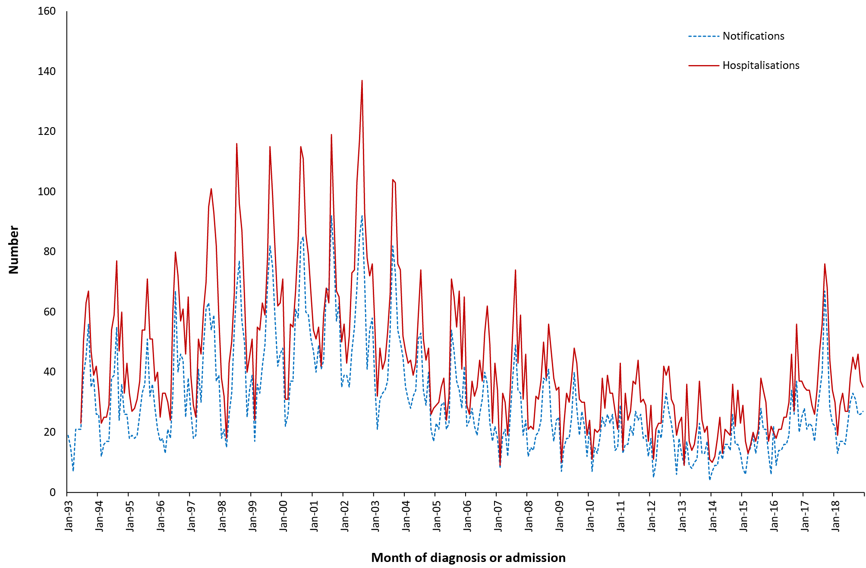
a Notifications where the month of diagnosis was between 1 January 1993 and 31 December 2018; hospitalisations where the month of admission was between 1 July 1993 and 31 December 2018.
There were marked increases, compared with the previous 2012–2015 reporting period, in notification rates caused by serogroups W (0.47 per 100,000 population per year [347 cases; 38% of all cases] in 2016–2018, vs 0.07 per 100,000 population per year [69 cases; 10% of all cases] in 2012–2015) and Y (0.22 per 100,000 population per year [159 cases; 17% of all cases] in 2016–2018, vs 0.07 per 100,000 population per year [65 cases; 9% of all cases] in 2012–2015) reported over the three years. Serogroup B accounted for 38% of all notifications (348 cases; 0.47 per 100,000 population per year) in this reporting period, compared with 71% (512 cases; 0.55 per 100,000 population per year) in the previous reporting period. For all three serogroups, notifications increased between 2016 (B: 92; W: 108; Y: 40) and 2017 (B: 137; W: 139; Y: 74), and then declined in 2018 (B: 119; W: 100; Y: 45). Serogroup C accounted for only 2% of cases (21/913; 0.03 per 100,000 population per year) during the reporting period, with these mainly due to an outbreak of serogroup C in 2017 in Victoria (14 cases). In 2018, there were two cases of serogroup E disease, a rare serogroup that has never previously been reported in Australia. There were no notifications for serogroup A and X during this reporting period.

Severe morbidity and mortality
In the three-year reporting period, hospitalisations with an ICD-10 code of meningococcal infection were associated with a total of 8,659 hospital bed days. The median length of stay was six days, varying from three days in 5–14 year olds to eight days in those aged 65 years and older (Table 3.7.1). There were 51 deaths due to meningococcal infection (of which 46, or 90%, were recorded as the underlying cause) recorded in the causes of death data over the three-year reporting period, an average annual rate of 0.07 deaths per 100,000 population (Table 3.7.1), almost double that reported for the 2012–2015 period (0.04 per 100,000 population per year), but lower than the number of deaths recorded in NNDSS (60, 0.08 per 100,000 population per year). The overall case fatality rate from NNDSS data was 6.6% (60/913), higher for serogroup W (10.1%, 35/347) than serogroup B (4.3%, 15/348) and Y (4.4%, 7/159).
Table 3.7.1: Meningococcal disease notifications, hospitalisations and deaths, Australia, 2016 to 2018,ª by age group
Age group (years) | Notifications |  | Hospitalisations |  |  |  | LOS^{b} per admission |  | Deaths^{c}
 | n | Rate^{d} | Any diagnosis |  | Principal diagnosis |  | Any diagnosis | Principal diagnosis | n | Rate^{d}
 |  |  | n | Rate^{d} | n^{e} | Rate^{d,e} | Median days
< 1 | 102 | 10.98 | 150 | 16.15 | 130 | 13.99 | 5 | 6 | 1–5 | 0.32
1–4 | 112 | 2.95 | 188 | 4.95 | 160 | 4.22 | 4 | 4 | 5 | 0.13
5–14 | 49 | 0.53 | 97 | 1.06 | 83 | 0.90 | 3 | 4 | 1–5 | 0.01
15–24 | 211 | 2.20 | 257 | 2.68 | 225 | 2.34 | 6 | 6 | 11 | 0.11
25–49 | 144 | 0.56 | 194 | 0.75 | 148 | 0.57 | 5 | 5 | 11 | 0.04
50–64 | 135 | 1.03 | 188 | 1.43 | 135 | 1.03 | 6 | 6 | 11 | 0.08
≥ 65 | 160 | 1.41 | 213 | 1.87 | 133 | 1.17 | 8 | 8 | 9 | 0.08
All ages | 913 | 1.24 | 1,287 | 1.74 | 1,014 | 1.37 | 6 | 6 | 51 | 0.07
a Notifications where the month of diagnosis was between 1 January 2016 and 31 December 2018; hospitalisations where the month of admission was between 1 January 2016 and 31 December 2018.
b LOS: length of stay in hospital.
c Deaths include underlying and associated causes of deaths.
d Average annual age-specific rate per 100,000 population.
e Principal diagnosis (hospitalisations).

Age and sex distribution
Infants aged < 1 year had the highest notification rate for invasive meningococcal disease (11.0 per 100,000 population per year), decreasing to 3.0 per 100,000 population per year in children aged 1–4 years (Table 3.7.1) and with a smaller peak in adolescents and young adults (aged 15–24 years) of 2.2 per 100,000 population per year. Rates of serogroup B meningococcal diseases were higher than those of serogroup W among infants < 1 year old (5.81 vs 3.55 per 100,000 population per year), children aged 1–4 years (1.40 vs 1.21 per 100,000 population per year), and adolescents and young adults aged 15–24 years (1.15 vs 0.56 per 100,000 population per year). In contrast, among adults aged 65 years and older, the rate of serogroup B cases was lower than those of serogroups W and Y (0.23, 0.69 and 0.45 per 100,000 population per year for serogroups B, W and Y, respectively). Of the small number of serogroup C cases, 13/21 (62%, 0.05 per 100,000 population per year) were aged 25–49 years. Overall, numbers of notifications for 2016–2018 were similar in males (n = 455) and females (n = 457).
The case fatality rate, calculated from NNDSS data, was highest for adults aged 65 years and older (22%, 12/60), lowest for infants aged < 1 year (8%, 5/102) and children 1–4 years (8%, 5/112) and intermediate for adolescents and young adults aged 15–24 years (13%, 14/211).

Geographical distribution
Notification rates of invasive meningococcal disease increased in every state and territory from 2016 to 2017 and then declined in 2018, with the exception of the Australian Capital Territory (where notification rates remained stable throughout this period) (Appendix B). Rates were highest in the Northern Territory (Appendices B and C), largely due to an outbreak of serogroup W disease in 2017 among Aboriginal communities in central Australia.¹³³ Serogroup W accounted for 82% of cases in the Northern Territory (33/45), an average annual rate of 4.46 per 100,000 compared with the national rate of 0.47 per 100,000. Serogroup B accounted for 73% of all notifications in South Australia (71/97), an average annual rate of 1.37 per 100,000 compared with the national rate of 0.47 per 100,000.

Aboriginal and Torres Strait Islander status
Aboriginal and Torres Strait Islander status was reported for 901 of the 913 notifications (99%) of invasive meningococcal disease during 2016–2018, with 12 not stated (1%). Of the 913 notifications, 133 (15%) were in Aboriginal and Torres Strait Islander people, with 82/133 (62%) in children aged < 5 years and 27/133 (20%) among children aged 5–14 years, whereas children aged < 5 years comprised only 17% (133/780) of notifications among other Australians. A greater proportion of cases among other Australians were aged 15–24 years (26%, 205/780) than among Aboriginal and Torres Strait Islander people (4.5%, 6/133), but all-age Aboriginal and Torres Strait Islander notification rates were fivefold higher than rates in other Australians (5.4 vs 1.1 per 100,000 population per year). Aboriginal and Torres Strait Islander people accounted for 14% of all meningococcal deaths recorded in the causes of death data, 4.6 times that of other Australians (0.29 vs 0.06 per 100,000 population per year).

Vaccination status
The completeness of vaccination data improved to 71% (650/913 cases) in the 2016–2018 reporting period, compared to 42% in 2012–2015. Of the 650 cases with vaccination data available, 445 (68%) had received no meningococcal vaccine doses and 205 (32%) had 1 or more doses. Of the 205 previously vaccinated, 189 had received 1 dose, 12 had received 2 doses, and four had received 3 or more.

Comments
Notifications for invasive meningococcal disease increased in 2016 and 2017, driven by serogroup W and Y disease,^{134–138} before declining in 2018. In recent years, cases of meningococcal serogroup W disease caused by strains that are close variants of the virulent ST-11 clone have risen in several regions of the world (namely Australia, Europe, South America and parts of sub-Saharan Africa), and have been associated with atypical clinical presentations (particularly pneumonia and gastrointestinal symptoms), greater disease severity and higher case fatality rates.^{138–142} An outbreak of invasive meningococcal disease caused by serogroup W in the latter half of 2017, primarily among young Aboriginal children (< 10 years of age) in remote communities,^{133,143–145} highlighted the previously-documented disparity in rates of meningococcal disease among Aboriginal and Torres Strait Islander people.^{12,18,146}
A small decline in disease rates in 2018 followed the introduction of several jurisdictionally-funded quadrivalent conjugate meningococcal (MenACWY) vaccination programs, which varied in their target age group, duration and mode of delivery.¹⁴⁷ A nationally-funded MenACWY vaccination program commenced for young children aged 12 months in July 2018,^{147,148} and subsequently for adolescents in 2019.^{147,149,150} The continued predominance of serogroup B disease in South Australia prompted the introduction of a jurisdictionally-funded meningococcal B vaccination program for young children in October 2018 and for adolescents in February 2019.^{151,152}

3.8 Mumps
Mumps is an acute viral disease caused by a paramyxovirus. In the pre-vaccine era it was a well-known and common childhood viral disease.¹⁵³ Mumps infection is systemic with variable pathology and symptomatology. The classical disease is characterised by fever and painful swelling and inflammation of one or more salivary glands, most commonly the parotid glands.^{153,154} Between 20% and 40% of cases, however, are subclinical.¹⁵⁴ Aseptic meningitis can develop in up to 10% of cases, though long term sequelae are rare.^{9,153} Between 15% and 30% of post-pubertal males experienced epididymoorchitis in the pre-vaccination era, though this is less common (< 10%) in the post-vaccine era.^{9,153,155–158} Vaccination programs have resulted in substantial decreases in mumps incidence among young children, but a rise in incidence has been seen among older adolescents and young adults.^{54,159,160} Increasingly, outbreaks of mumps have been observed among adolescent and young adult populations with high coverage of 2 doses of mumps-containing vaccine and living in close contact.^{5,155,161–169}

Highlights
During the review period from 1 January 2016 to 31 December 2018, there was a major outbreak of mumps, predominantly affecting Aboriginal communities in Western Australia, the Northern Territory and Queensland. More than 64% of notifications (1,451/2,250) were in Aboriginal and Torres Strait Islander people, with at least 57% known to have received one or more doses of mumps-containing vaccine.

Case definition

Notifications¹⁷⁰
Mumps case definition:
http://www.health.gov.au/internet/main/publishing.nsf/Content/cda-surveil-nndss-casedefs-cd_mumps.htm
Hospitalisations and deaths
The ICD-10-AM/ICD-10 code B26 (mumps) was used to identify hospitalisations and deaths.

Secular trends
This reporting period saw the growth of a major outbreak of mumps that started in 2015 (Figure 3.8.1). In the three years from 1 January 2016 to 31 December 2018, there were 2,250 notification of mumps, an average annual notification rate of 3.1 per 100,000 population (Table 3.8.1), more than double that observed between 2012 and 2015 (1.3 per 100,000 population per year). The rate was 3.3 per 100,000 population per year in 2016 and 2017 and then declined slightly to 2.5 per 100,000 population in 2018 (Appendix B and Figure 3.8.1). From 1 January 2016 to 31 December 2018, there were 411 hospitalisations for ICD-10-AM/ICD-10 code B26 (mumps), an average annual rate of 0.6 per 100,000 population (Table 3.8.1), stable over the 3 years (0.53, 0.56 and 0.57 per 100,000 population in 2016, 2017 and 2018, respectively) (Appendix C).
Figure 3.8.1. Mumps notifications and hospitalisations, Australia,ª 1993 to 2018,^{b} by month of diagnosis or admissions
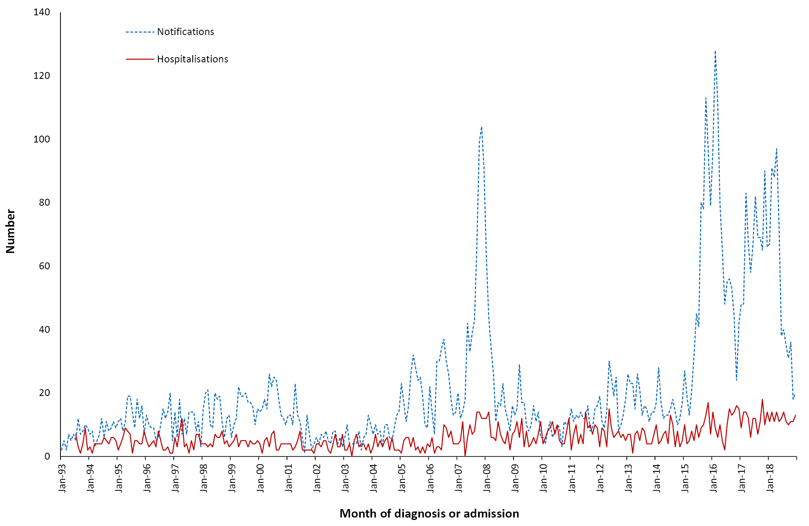
a Note that the number of jurisdictions notifying mumps increased over the review period until July 1996 when mumps became notifiable in all states and territories. From July 1999 until June 2001, mumps was not notifiable in Queensland. Only the Australian Capital Territory, New South Wales and Victoria notified for the entire review period.
b Notifications where the month of diagnosis was between 1 January 1993 and 31 December 2018; hospitalisations where the month of admission was between 1 July 1993 and 31 December 2018.

Severe morbidity and mortality
Between January 2016 and December 2018, mumps hospitalisations accounted for 1,243 hospital bed days. The median length of stay was 1 day, but was higher among people aged over 65 years (5 days) and infants < 1 years (2.5 days) (Table 3.8.1). There were 1–5 deaths recorded in the causes of death data with mumps as any (underlying or associated) cause, all occurring among people aged ≥ 65 years (Table 3.8.1).

Table 3.8.1: Mumps notifications, hospitalisations and deaths, Australia, 2016 to 2018,ª by age group
Age group (years) | Notifications |  | Hospitalisations |  |  |  | LOS^{b} per admission |  | Deaths^{c}
 | n | Rate^{d} | Any diagnosis |  | Principal diagnosis |  | Any diagnosis | Principal diagnosis
 |  |  | n | Rate^{d} | n^{e} | Rate^{d,e} | Median days |  | n | Rate^{d}
< 1 | 8 | 0.86 | 6 | 0.65 | 1-4 | 0.43 | 3 | 3 | 0 | 0.00
1–4 | 77 | 2.03 | 26 | 0.68 | np^{f} | 0.55 | 1 | 1 | 0 | 0.00
5–14 | 516 | 5.62 | 69 | 0.75 | 58 | 0.63 | 1 | 1 | 0 | 0.00
15–24 | 619 | 6.45 | 74 | 0.77 | 66 | 0.69 | 1 | 1 | 0 | 0.00
25–49 | 849 | 3.29 | 148 | 0.57 | 123 | 0.48 | 1 | 1 | 0 | 0.00
50–64 | 112 | 0.85 | 30 | 0.23 | 16 | 0.12 | 3 | 2 | 0 | 0.00
≥ 65 | 69 | 0.61 | 58 | 0.51 | 38 | 0.33 | 5 | 3 | 1–5 | 0.04
All ages | 2,250 | 3.05 | 411 | 0.56 | 326 | 0.44 | 1 | 1 | 1–5 | 0.01
a Notifications where the month of diagnosis was between 1 January 2016 and 31 December 2018; hospitalisations where the month of admission was between 1 January 2016 and 31 December 2018.
b LOS: length of stay in hospital.
c Deaths include underlying and associated causes of deaths.
d Average annual age-specific rate per 100,000 population.
e Principal diagnosis (hospitalisations).
f np: not provided.

Age and sex distribution
Over the three-year reporting period, 88% of mumps notifications were in persons aged 5 to 49 years (23% among 5–14 year olds; 28% among 15–24 year olds; and 38% among 25–49 year olds). Notification rates were highest among 15–24 year olds (6.4 per 100,000 population per year) (Table 3.8.1). A similar trend was observed for hospitalisations, though a greater proportion of hospitalised cases were aged 65 years or older (who accounted for 14% of hospitalisations vs 3% of notifications) (Table 3.8.1). Since 2002, the notification rate of mumps for children aged < 5 years has remained low, mostly below 1 per 100,000 population per year. Over the three-year reporting period, notifications were evenly distributed among males and females (49% vs 51%); hospitalisations were slightly more common among females (53% vs 47% in males, male:female rate ratio of 0.9:1).

Geographical distribution
Notification and hospitalisation rates were highest in the Northern Territory, at more than 14 times and 7 times the national rates, respectively (Appendices B and C). Notification rates were also higher than the national average in Queensland and Western Australia, with all three jurisdictions affected by an outbreak predominantly affecting Aboriginal communities.

Aboriginal and Torres Strait Islander status
Aboriginal and Torres Strait Islander status was reported for 2,150 of the 2,250 notifications (96%) of mumps during 2016–2018, with 100 not stated (4%). Almost two-thirds of notifications (64.5%, 1,451/2,250) were in Aboriginal and Torres Strait Islander people, with nearly all of these from Queensland (47%), Western Australia (29%) and the Northern Territory (21%). The notification rate among Aboriginal and Torres Strait Islander people was 53 times higher than that among other Australians (59.4 vs 1.1 per 100,000 population per year). Notified cases among Aboriginal and Torres Strait Islander people tended to be younger than cases among other Australians (29% of cases among Aboriginal and Torres Strait Islander people, vs 12% of cases among other Australians, were aged 5–14 years; 32% vs 20% were aged 15–24 years, 34% vs 44% were aged 25–49 years).

Vaccination status
Of the 2,250 notifications, vaccination data was available for 65% (1,462/2,250) of cases, with completeness higher for cases born from 1983 onwards (and hence eligible for vaccination at 12 months of age under the NIP – 1,281/1,621; 79%) than for those born up to 1982 (181/629, 29%). Of 1,462 notifications with vaccination data available, 170 (12%) had received no vaccine doses, including seven aged < 1 year and so not yet eligible for vaccination. Among the 1,292 cases (88%) recorded as vaccinated, 276 had received 1 dose, 933 had received 2 doses and 72 had received 3 or more doses (data on the number of doses received was missing for 11 vaccinated cases).

Comment
Previous mumps outbreaks in young adults in Australia have largely been concentrated in those who had received only one vaccine dose or were unvaccinated.^{5–9} This reporting period was marked by a series of large outbreaks of mumps, predominantly affecting young adults in Aboriginal communities in northern Australia of whom most (89% of cases aged 1–19 years) had at least two documented doses of mumps vaccine.^{155,171} A similar mumps outbreak was previously documented in 2007–2008 in the Kimberley.^{5,6} Other outbreaks among communities in close contact, where the force of infection is high, have been reported internationally, particularly among people who completed the vaccination series against mumps more than 10 years previously.^{161–165,172,173} The Advisory Committee on Immunization Practices in the USA has recommended a third dose of mumps vaccine for populations at increased risk in the context of an outbreak.¹⁷⁴ Outbreak control strategies in Australia should take into consideration that vaccine effectiveness against the mumps component of measles-mumps-rubella (MMR)-containing vaccines is lower relative to the other antigens,^{154,169} seroprevalence is below the threshold for herd immunity,¹⁷⁵ and waning may occur earlier following the shift of the second dose of mumps-containing vaccine from 4 years to 18 months of age.¹²²

3.9 Pertussis

Highlights
Pertussis notification rates were lower over the three-year period from 1 January 2016 to 31 December 2018 than in the January 2012 to December 2015 period. Notification rates were highest in the 5–14 year age group (183.3 per 100,000 population per year) and hospitalisation rates were highest in infants aged < 1 year (31% of all pertussis hospital admissions; average annual rate 55.4 per 100,000 population).
Pertussis (whooping cough) is an acute respiratory illness, caused by the Bordetella pertussis bacterium. The illness begins with an irritating cough that gradually becomes paroxysmal and lasts for 1–2 months or longer. Paroxysms are characterised by repeated violent coughs and are followed by a characteristic crowing or high-pitched inspiratory whoop. The characteristic paroxysmal cough is more common in young children than in infants < 6 months of age, adolescents and adults, and is less common in people who are partially protected due to either vaccine-derived or national immunity.^{176,177} The most common complication and cause of pertussis-related deaths is secondary bacterial pneumonia.¹⁷⁷ Complications can occur in up to 6% of young children, and up to 24% of infants aged < 6 months.¹⁷⁸ The greatest morbidity and mortality occur at the extremes of age, with the case fatality rate in unvaccinated infants aged < 6 months reported at 0.8%.^{176,179}

Case definition

Notifications¹⁸⁰
Pertussis case definition:
http://www.health.gov.au/internet/main/publishing.nsf/Content/cda-surveil-nndss-casedefs-cd_pertus.htm
Hospitalisations and deaths
The ICD-10-AM/ICD-10 code A37 (whooping cough) was used to identify hospitalisations and deaths.

Secular trends
In the three years from 1 January 2016 to 31 December 2018, there were 44,918 cases of pertussis notified to the NNDSS. The average annual notification rate over the three-year period was 60.9 per 100,000 population, 19% lower than that in the four-year period 2012–2015 (76.0 per 100,000 population per year).¹² The notification rate was 83.1 per 100,000 population in 2016, which marked a decline from 2015 when a peak in notifications was observed (Figure 3.9.1). The rate declined by 40% to 49.7 per 100,000 population in 2017 and was similar in 2018 (50.4 per 100,000 population; Appendix B). Seasonal peaks were seen from approximately July to December. (Figure 3.9.1).

Figure 3.9.1: Pertussis notifications and hospitalisations, Australia, 1995 to 2018,ª by month of diagnosis or admission
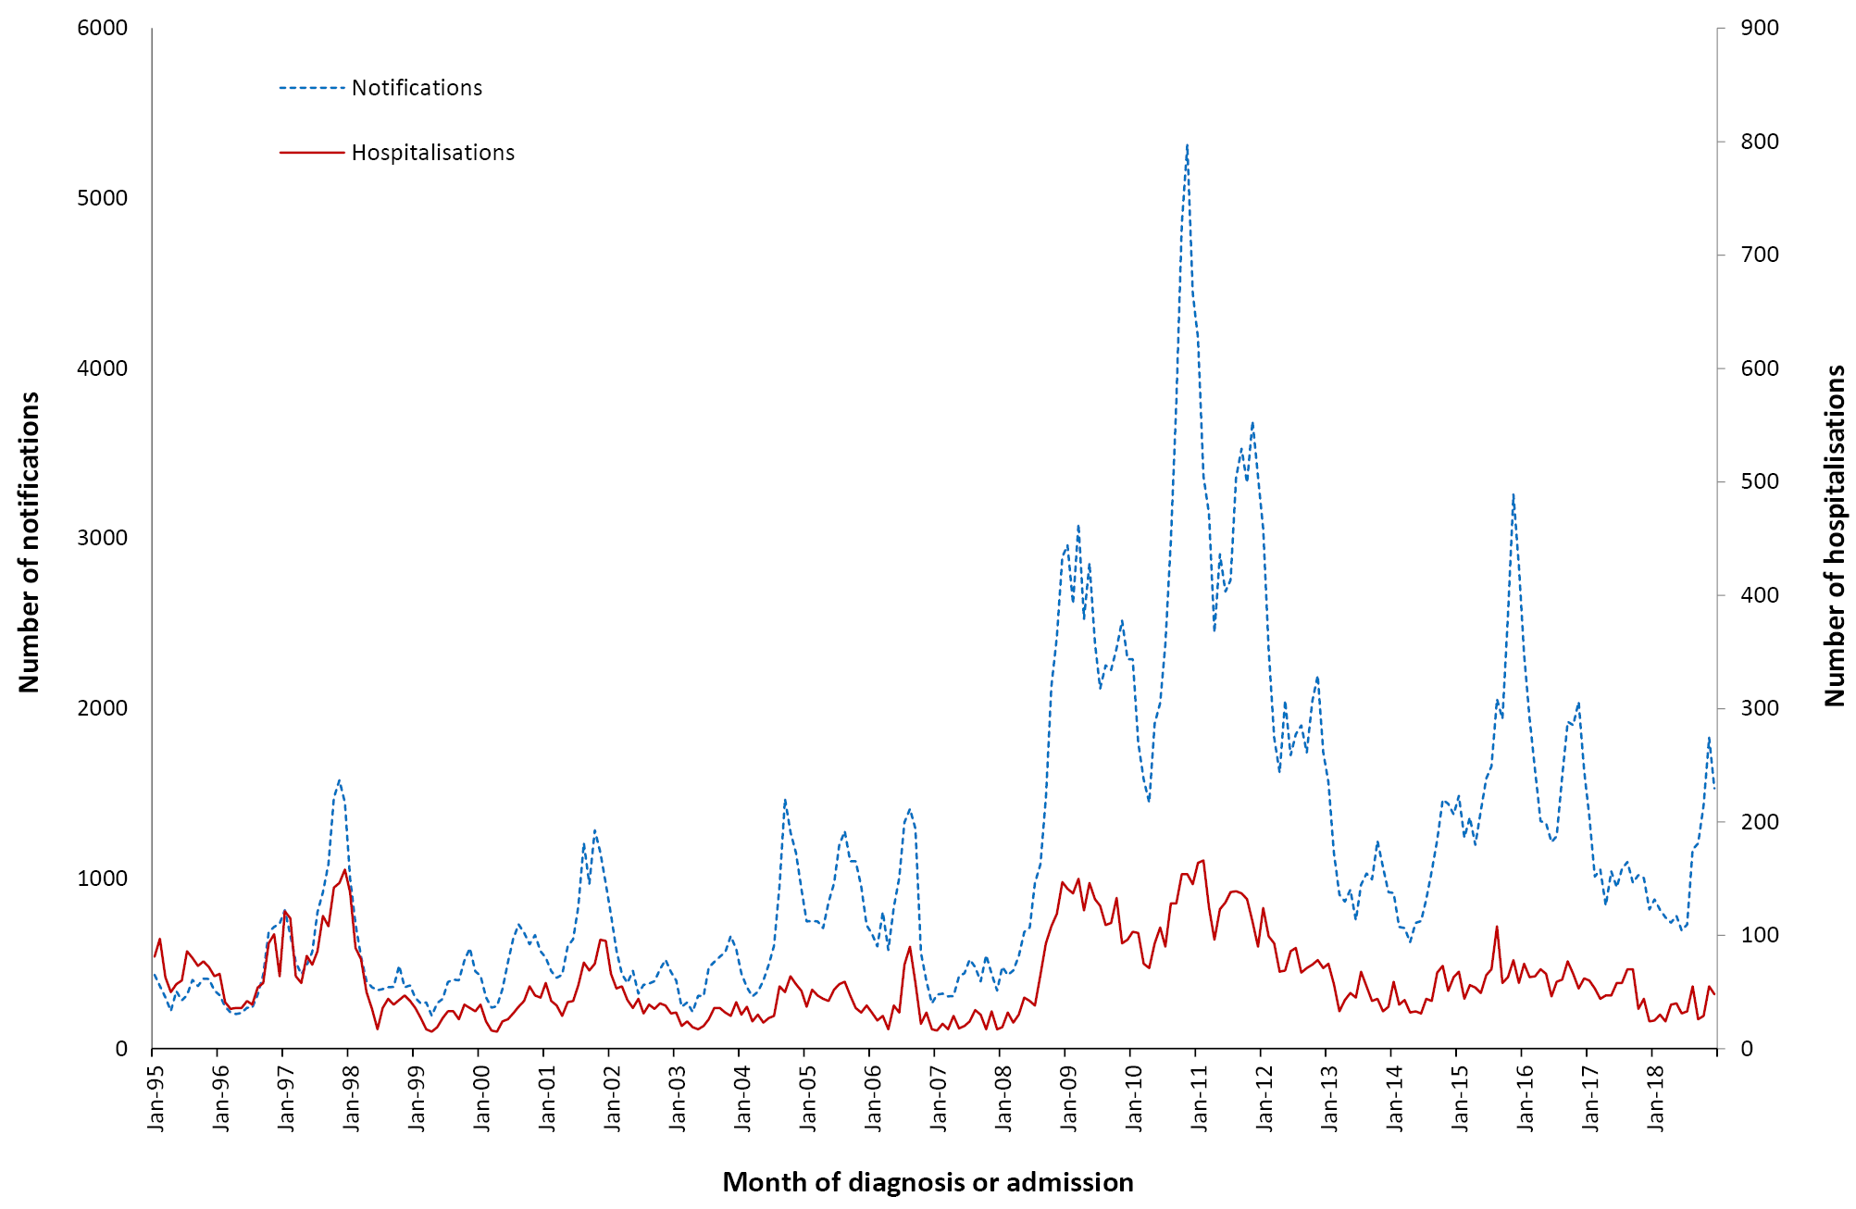
a Notifications where the month of diagnosis was between 1 January 1995 and 31 December 2018; hospitalisations where the month of admission was between 1 January 1995 and 31 December 2018.
There were 1,807 hospital admissions coded as pertussis between 2016 and 2018. Hospitalisation rates in this three-year reporting period were lower than the previous four-year reporting period between 2012 and 2015 (average annual rate 2.4 vs 3.2 per 100,000 population, respectively). The annual hospitalisation rate declined from 3.1 per 100,000 population in 2016 to 1.7 per 100,000 population in 2018 (Figure 3.9.1 and Appendix C).

Severe morbidity and mortality
Between 1 January 2016 and 31 December 2018, hospital admissions coded as pertussis accounted for a total of 7,775 hospital bed days with a median length of stay of two days, higher in people aged 65 years and older (Table 3.9.1). In the three-year reporting period, eight deaths were recorded in the causes of death data (of which five were recorded with pertussis as the underlying cause), all of which were in either infants aged < 1 year or adults aged 65 years or older (Table 3.9.1).

Age and sex distribution
Just over half of all notifications (51%) in the three-year reporting period occurred among children < 15 years of age, with the highest rate among 5–14 year olds (183.3 per 100,000 population per year) followed by infants aged < 1 year (142.2 per 100,000 population per year). Among adult age groups, notifications declined with increasing age, and were lowest among people aged 65 years and older (32.3 per 100,000 population per year) (Table 3.9.1). Hospitalisation rates were highest among infants aged < 1 year (55.4 per 100,000 population per year), with infants accounting for 31% of all hospitalisations. Adults aged 65 years and older comprised 26% of hospitalisations, but the hospitalisation rate (4.2 per 100,000 population per year) was tenfold lower than in infants. A greater proportion of notifications were female (55%) than male (45%) (male:female rate ratio of 0.85:1), while hospitalisations were more evenly distributed (male:female rate ratio 0.9:1).
Table 3.9.1: Pertussis notifications, hospitalisations and deaths, Australia, 2016 to 2018,ª by age group
Age group (years) | Notifications |  | Hospitalisations |  |  |  | LOS^{b} per admission |  | Deaths^{c}
 | n | Rate^{d} | Any diagnosis |  | Principal diagnosis |  | Any diagnosis | Principal diagnosis
 |  |  | n | Rate^{d} | n^{e} | Rate^{d,e} | Median days |  | n | Rate^{d}
< 1 | 1,321 | 142.2 | 515 | 55.4 | 387 | 41.7 | 2 | 2 | 1–5 | 0.22
1–4 | 4,946 | 130.3 | 202 | 5.3 | 128 | 3.4 | 1 | 1 | 0 | –
5–14 | 16,828 | 183.3 | 139 | 1.5 | 84 | 0.9 | 1 | 1 | 0 | –
15–24 | 3,901 | 40.6 | 38 | 0.4 | 21 | 0.2 | 1 | 1 | 0 | –
25–49 | 9,613 | 37.3 | 231 | 0.9 | 122 | 0.5 | 3 | 2 | 0 | –
50–64 | 4,634 | 35.3 | 187 | 1.4 | 80 | 0.6 | 3 | 2 | 0 | –
≥ 65 | 3,673 | 32.3 | 495 | 4.4 | 214 | 1.9 | 6 | 4 | np^{f} | 0.05
All ages | 44,938^{g} | 60.9 | 1,807 | 2.4 | 1,036 | 1.4 | 2 | 2 | 8 | 0.01
a Notifications where the month of diagnosis was between 1 January 2016 and 31 December 2018; hospitalisations where the month of admission was between 1 January 2016 and 31 December 2018.
b LOS: length of stay in hospital.
c Deaths include underlying and associated causes of deaths.
d Average annual age-specific rate per 100,000 population.
e Principal diagnosis (hospitalisations).
f np: not provided.
g Total for notifications includes 22 cases without data on age of onset.

Geographical distribution
Pertussis notifications declined across all states and territories from 2016 to 2018, but notifications in some states and territories rose slightly between 2017 and 2018 (Appendix B). Over the three-year period, notification rates were highest in New South Wales (95.2 per 100,000 population per year), followed by South Australia (85.2 per 100,000 population per year) and the Australian Capital Territory (83.7 per 100,000 population per year) (Appendix B). The highest hospitalisation rate for pertussis occurred in the Northern Territory (4.5 per 100,000 population per year) followed by South Australia (4.0 per 100,000 population per year) (Appendix C).

Aboriginal and Torres Strait Islander status
Aboriginal and Torres Strait Islander status was reported for 25,853 of the 44,938 notifications (58%) of pertussis during 2016–2018, with 19,085 not stated (42%). There was a high level of completeness in Western Australia (96%), the Northern Territory (96%), the Australian Capital Territory (95%) and South Australia (93%), with completeness lowest in New South Wales (40%) and Victoria (51%) and intermediate in other jurisdictions (Queensland 66%, Tasmania 74%). However, overall completeness of Aboriginal and Torres Strait Islander status was high for young children (96% for those aged < 1 year and 92% for those aged 1–4 years). Notification rates in Aboriginal and Torres Strait Islander children were higher in infants (310.4 vs 131.2 per 100,000 population per year [rate ratio 2.4:1]) and children aged 1–4 years (152.0 vs 128.9 per 100,000 population per year [rate ratio 1.2:1]).
Of the 1,807 hospitalisations, 9.5% (172 cases) were in Aboriginal and Torres Strait Islander people. The hospitalisation rate in Aboriginal and Torres Strait Islander peope was higher than in other Australians (7.0 vs 2.3 per 100,000 population per year, a ratio of 3.1:1).

Vaccination status
Of the 44,938 notifications, vaccination data was available for only 40% (17,754/44,938), with 2,643 of these (15%) having no recorded vaccine doses. In comparison, the completeness of vaccination data was far improved for children aged < 5 years, with vaccination data available for 95% (5,979) of the 6,267 cases. Among all notifications, 15,111 had received a pertussis-containing vaccine, of whom 8,758 had received 1 dose; 267 had received 2 doses; 1,585 had received 3 doses; 3,711 cases had received 4 doses; 487 had received 5 doses; and 59 had received 6 or more doses of pertussis-containing vaccine. Data on the number of doses received was unavailable for 244 vaccinated cases. Among the 5,979 cases aged < 5 years, 786 (13%) had not received any doses of pertussis-containing vaccine; 3,312 had received 1 dose; 154 had received 2 doses; 1,246 had received 3 doses; 431 had received 4 doses; and 3 each received 5 and 6 doses (data on the number of doses received was unavailable for 44 vaccinated cases).

Comments
Rates of pertussis notifications and hospitalisations declined between 2016 and 2018 following a spike in cases in 2015. Reintroduction of the 18-month booster dose of pertussis-containing vaccine in 2016,^{181,182} and rising coverage of pertussis-containing vaccine in pregnancy (funded by jurisdictions from 2015 and then under the NIP in 2018),^{183–185} may have contributed to this decline. Although severe disease predominantly occurs in unvaccinated young infants, high healthcare utilisation has also been reported among older adults with pertussis, with burden of disease in older adults believed to be underestimated.^{186,187}

3.10 Pneumococcal disease

Highlights
Pneumococcal disease is caused by the bacterium Streptococcus pneumoniae (pneumococcus). There are over 90 different serotypes of pneumococcus. Pneumococci can be isolated from the upper respiratory tract in adults and, more often, in children, and can spread directly from the nasopharynx to the respiratory tract, which may cause otitis media, sinusitis or pneumonia. Pneumococci are also able to enter the bloodstream to cause invasive disease, which may manifest as meningitis, pneumonia, septicaemia without focal infection or, less commonly, infection of other sites such as pleural, peritoneal or joint fluid. Invasive pneumococcal disease (IPD) is diagnosed by detecting S. pneumoniae from blood, CSF or other sterile site. In the absence of a sterile site isolate, a presumptive diagnosis of pneumococcal pneumonia may be based on a sputum isolate of S. pneumoniae and/or clinical features such as chest X-ray appearance or prompt response to antibiotic therapy.¹⁸⁸ Children with comorbid conditions have higher rates of pneumococcal disease and higher case fatality rates than do otherwise healthy children.^{189,190} While pneumococcal conjugate vaccines have substantially reduced the incidence of pneumococcal disease caused by vaccine serotypes, there is evidence of an increase in disease incidence due to non-vaccine serotypes in some settings.^{191–193}
Notification rates for invasive pneumococcal disease were slightly higher in the three-year period 2016–2018 than in the previous four years (2012–2015), as were hospitalisations for pneumococcal disease. Adults aged ≥ 65 years accounted for a large proportion of notifications and hospitalisations and the majority of deaths.

Case definition

Notifications¹⁹⁴
Pneumococcal disease (invasive) case definition:
http://www.health.gov.au/internet/main/publishing.nsf/Content/cda-surveil-nndss-casedefs-cd_pnuemo.htm
Hospitalisations and deaths
The ICD-10-AM/ICD-10 codes G00.1 (pneumococcal meningitis) and A40.3 (pneumococcal septicaemia) are each considered to be a proxy for IPD; these codes, and J13 (pneumococcal pneumonia), which is less strongly associated with IPD, were used to identify pneumococcal disease hospitalisations and deaths.

Secular trends
In the three years from 1 January 2016 to 31 December 2018, notification patterns of IPD remained relatively steady, with marked seasonality noted for notifications and hospitalisations (Figure 3.10.1). Overall, there were 5,742 notifications of IPD over the three-year reporting period at an average annual rate of 7.8 per 100,000 population (Table 3.10.1), an increase of 13% on the average notification rate for the previous four-year reporting period (6.9 per 100,000 population). The annual number of notifications increased from 1,498 in 2015 to 1,664 in 2016, to 2,050 in 2017, and decreased slightly to 2,028 in 2018 (Appendix B).
There has been an increasing trend in hospital admissions with ICD codes of interest since 2006 (Figure 3.10.1). Between 1 January 2016 and 31 December 2018, there were 13,297 hospitalisations coded as pneumococcal meningitis, septicaemia or pneumonia, an average annual rate of 18.0 per 100,000 population (Table 3.10.1), which was 21% higher than the average annual hospitalisation rate in the 2012–2015 period (14.9 per 100,000 population). Of the 13,297 hospitalisations, 3,081 (23.2%) were for presumed IPD (pneumococcal meningitis and/or septicaemia) and 10,216 (76.8%) for pneumococcal pneumonia (Table 3.10.1). The seasonal peak in admissions for pneumococcal disease was highest in 2017, reaching 671 hospitalisations in September 2017 (Figure 3.10.1).

Severe morbidity and mortality
Between 1 January 2016 and 31 December 2018, admissions with pneumococcal disease codes accounted for 97,021 hospital bed days (an average of 32,340 bed days per year), higher than the 29,774 average bed days per year between 2012 and 2015. The median length of stay for hospitalisations coded as pneumococcal meningitis or septicaemia (7 days) was higher than for hospitalisations coded as pneumonia (5 days) (Table 3.10.1).
For the three years from 1 January 2016 to 31 December 2018, there were 159 deaths (average annual rate 0.2 per 100,000 population) recorded in the causes of death data with pneumococcal disease-related ICD-10 codes (A40.3, G00.1 and J13) as the underlying or associated cause of death (Table 3.10.1), of which 82 (52%) were recorded as deaths with pneumococcal disease being the underlying cause. The 159 deaths recorded in the causes of death data was less than half the number of deaths recorded in the NNDSS database (452; average annual rate 0.6 per 100,000 population). The recorded in-hospital death rate among hospitalisations recorded in the AIHW data was almost three times as high for pneumococcal meningitis and septicaemia (8.6%) than for pneumococcal pneumonia (3.0%).

Figure 3.10.1: Pneumococcal disease notifications and hospitalisations, Australia, 1998 to 2018,ª by month of diagnosis or admission
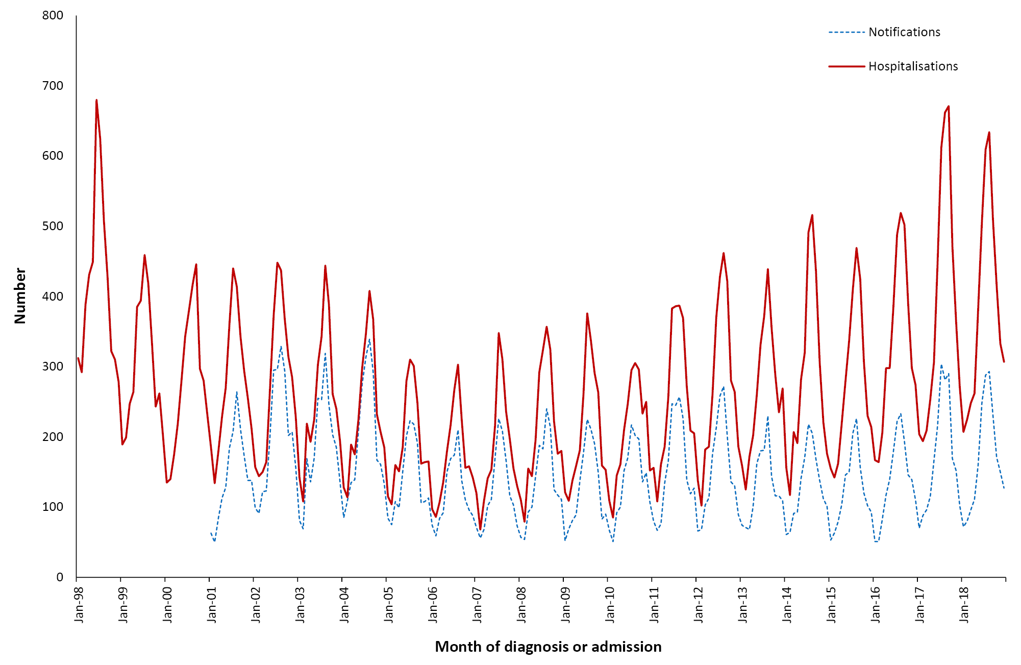

a Notifications where the month of diagnosis was between 1 January 2001 and 31 December 2018; hospitalisations where the month of admission was between 1 January 1998 and 31 December 2018. Hospitalisations include pneumonia, meningitis and septicaemia.

Age and sex distribution
For the three-year period from 1 January 2016 to 31 December 2018, the IPD notification rate was highest in infants aged < 1 year, followed by adults aged ≥ 65 years and children aged 1–4 years (Table 3.10.1). differing from the previous four-year period when the highest incidence was in older adults followed by infants.
Rates of IPD notifications among children aged < 5 years increased between 2016 and 2017, and then stayed steady in 2018. Notification rates in infants aged < 1 year increased from 18.8 per 100,000 population (n = 60) in 2016 to 26.4 per 100,000 population (n = 81) in 2017, and in children aged 1–4 years from 13.9 (n = 174) to 17.1 (n = 217) per 100,000 population per year. The rate in adults aged ≥ 65 years increased from 16.6 per 100,000 population (n = 611) in 2016 to 20.9 per 100,000 population (n = 793) in 2017, with smaller increases for other age groups.
The rate of hospitalisation for pneumococcal disease was highest in adults aged ≥ 65 years (55.0 per 100,000 population per year), comprising almost half (47.1%) of all hospital admissions for pneumococcal disease. For pneumococcal meningitis or septicaemia, the highest rate of hospitalisation was in infants aged < 1 year (12.3 per 100,000 population per year), whereas for pneumococcal pneumonia the highest rate was in adults aged ≥ 65 years (43.4 per 100,000 population per year). Hospitalisations for pneumococcal disease were slightly more common among males than females (18.9 vs 17.2 per 100,000 population per year respectively, rate ratio 1.1:1).
Death rates based on the causes of death data were highest among adults aged ≥ 65 years, followed by adults aged 50–64 years (Table 3.10.1). The recorded in-hospital death rate among hospital admissions for pneumococcal disease was highest among adults aged ≥ 65 years (6.0%).
Table 3.10.1: Pneumococcal disease notifications, hospitalisations and deaths, Australia, 2016 to 2018,ª by age group
Age group (years) | Notifications |  | Hospitalisations |  |  |  | LOS^{b} per admission |  | Deaths^{c}
 |  |  | Pneumococcal meningitis or septicaemia |  | Pneumococcal  pneumonia (without meningitis or septicaemia) |  | Pneumococcal meningitis or septicaemia | Pneumococcal pneumonia  (without meningitis or septicaemia)
 | n | Rate^{d} | n^{e} | Rate^{d,e} | n^{f} | Rate^{d,f} | Median days |  | n | Rate^{d}
< 1 | 222 | 23.89 | 84 | 9.04 | 32 | 3.44 | 6 | 6 | 1–5 | 0.22
1–4 | 618 | 16.28 | 92 | 2.42 | 301 | 7.93 | 6 | 6 | 1–5 | 0.08
5–14 | 241 | 2.63 | 67 | 0.73 | 147 | 1.60 | 5 | 7 | 1–5 | 0.01
15–24 | 149 | 1.55 | 33 | 0.34 | 174 | 1.81 | 5 | 3 | 1–5 | 0.02
25–49 | 1,025 | 3.98 | 292 | 1.13 | 1,433 | 5.56 | 6 | 4 | 22 | 0.09
50–64 | 1,299 | 9.90 | 417 | 3.18 | 17,44 | 13.29 | 8 | 5 | 40 | 0.30
≥ 65 | 2,188 | 19.23 | 663 | 5.83 | 3,485 | 30.63 | 8 | 6 | 89 | 0.78
All ages | 5,742 | 7.78 | 1,648 | 2.23 | 7,316 | 9.92 | 7 | 5 | 159 | 0.22
a Notifications where the month of diagnosis was between 1 January 2016 and 31 December 2018; hospitalisations where the month of admission was between 1 January 2016 and 31 December 2018.
b LOS: length of stay in hospital.
c Deaths sourced from the Causes of Death database from the Australian Coordinating Registry. Deaths include underlying and associated causes of deaths.
d Average annual age-specific rate per 100,000 population.
e Pneumococcal meningitis or septicaemia (proxy for invasive pneumococcal disease).
f Pneumococcal pneumonia.

Geographical distribution
The Northern Territory had the highest rates of notifications of IPD (average annual rate 22.4 per 100,000 population), and hospitalisations coded as pneumococcal disease (average annual rate 66.1 per 100,000 population), across the three-year period 2016–2018. Notification and hospitalisation rates in the other states and territories did not differ appreciably from the national average (Appendices B and C).

Aboriginal and Torres Strait Islander status
Aboriginal and Torres Strait Islander status was reported for 5,260 of the 5,742 notifications of IPD (92%) during 2016–2018, with 482 not stated (8%). Of the total notified cases (5,742), there were 644 cases (11%) in Aboriginal and Torres Strait Islander people, with 36% of these aged between 25–49 years. Notification rates were almost four times higher in Aboriginal and Torres Strait Islander people than in other Australians (26.4 versus 7.1 per 100,000 population per year); among those aged 15–24 and 25–49 years this disparity was more than ninefold.
Aboriginal and Torres Strait Islander people accounted for 1,548/13,297 (11.6%) of total hospitalisations for this reporting period, with 40.2% of these (622) in adults aged 25–49 years; 31.5% (487) in adults aged 50–64 years; and 15.1% (233) in adults aged ≥ 65 years. Aboriginal and Torres Strait Islander hospitalisation rates were almost four times higher than those for other Australians (63.4 vs 16.5 per 100,000 population per year; rate ratio 3.8).
Mortality attributed to pneumococcal disease (as either the underlying or associated cause of death) in the causes of death data was 1.6 times greater among Aboriginal and Torres Strait Islander people than in others (0.3 vs 0.2 per 100,000 population per year). The death rate among Aboriginal and Torres Strait Islander people was higher when calculated based on NNDSS data (1.4 vs 0.6 per 100,000 population per year) and AIHW hospitalisation data (1.8 vs 0.7 per 100,000 population per year).

Vaccination status
Of the total 5,742 notifications, vaccination data was available for 75% of cases (4,294). Of 840 notifications in children aged < 5 years, 818 (97%) had vaccination data available, of whom 79 (10%) had received no vaccine doses and 739 (90%) had received at least one dose of pneumococcal vaccine. Among the 739 vaccinated cases, 103 had received 1 dose; 47 had received 2 doses; 554 had received 3 doses; 32 had received 4 doses; and three had received 5 doses of pneumococcal vaccine.
Of the 2,188 notifications in adults aged ≥ 65 years, vaccination data was not available for 19% (426). Of the 1,762 cases aged ≥ 65 years for whom vaccination data was available, 951 cases (54%) were unvaccinated and 811 (46%) had received at least one dose of pneumococcal vaccine. Of the vaccinated cases, 554 had received 1 dose; 222 had received 2 doses; 33 had received 3 doses; and two had received 4 doses of pneumococcal vaccine.
Of the 243 cases in Aboriginal and Torres Strait Islander adults aged ≥ 50 years, 92% (224) had vaccination data available, of whom 83 cases (37%) had no recorded vaccine doses and 141 (63%) had received at least one dose of pneumococcal vaccine. Of the 141 vaccinated cases, 45 had received 1 dose; 46 had received 2 doses; 37 had received 3 doses; and 13 had received 4 or more doses of pneumococcal vaccine.

Serotype of notifications
Among the 5,742 IPD notifications, 32% (1,852) were due to a serotype contained in the 13-valent pneumococcal conjugate vaccine (PCV13) and 62% (3,552) were due to a serotype contained in the 23-conjugate pneumococcal polysaccharide vaccine (PPV23); 1,712 (30% of total cases) were due to a serotype contained in PPV23 but not in PCV13. Another 30% of all cases (1,716) were due to serotypes not included in PPV23 and 8% (462) were of unknown serotype. Among cases aged < 5 years who had received at least one prior dose of pneumococcal vaccine, approximately 34% had a PCV13 serotype, compared with 41% of unvaccinated cases.

Comment
From 1 January 2005, all children born from January 2003 were eligible for a full course of pneumococcal conjugate vaccine (then 7-valent) funded on the NIP. Since 2005, there have been large reductions in notifications of vaccine type IPD in Australia. For the three-year reporting period 2016–2018, rates of IPD increased slightly, with marked seasonality observed in notified and hospitalised cases. In-depth examination of the epidemiology of pneumococcal disease in Australia has found that reductions in vaccine-type IPD post-PCV13 introduction were inferior in Australia than the reductions seen in countries providing a booster dose at 12 months of age,¹⁹² with more breakthrough cases among fully-vaccinated children.¹⁹⁵ Subsequently, the NIP schedule for PCV13 for infants was updated from a 3+0 schedule to a 2+1 schedule, i.e. 2 doses in infancy and a booster dose at 12 months of age,¹⁹⁶ with the expectation that this will induce longer-lasting protection against pneumococcal disease.¹⁹⁷ Despite the presence of a nationally-funded pneumococcal vaccination program, uptake of pneumococcal vaccine slowly declined between 2011 and 2016 among adults aged ≥ 65 years,¹⁹⁸ and a substantial proportion (54%) of cases in this age group in this reporting period were unvaccinated. The disparity in pneumococcal disease between Aboriginal and Torres Strait Islanders and others continues to persist,¹⁹⁹ and warrants consideration of differential vaccination policies to reduce this gap.

3.11 Poliomyelitis
Poliomyelitis (polio) is caused by an enterovirus, poliovirus. Infection involves the gastrointestinal tract, and may progress to the nervous system, resulting in paralysis. Acute flaccid paralysis (AFP) occurs in fewer than 1% of infections.²⁰⁰ More than 90% of infections are asymptomatic, with a minor illness characterised by fever, headache, malaise and nausea/vomiting occurring in about 10%. The maximum extent of paralysis is usually reached within 3–4 days of disease onset. Any paralysis still present after 60 days is likely to be permanent.²⁰¹ In the pre-vaccine era, poliovirus was the leading cause of permanent disability in children.²⁰⁰ Efforts to eradicate polio have resulted in the eradication of two of three wild poliovirus (WPV) serotypes, with type 2 certified as eradicated in 2015 and type 3 in October 2019.²⁰² Transmission of WPV type 1 remains uninterrupted only in Afghanistan and Pakistan, with 175 cases reported in 2019.²⁰²

Highlights
There were no notifications or deaths due to poliomyelitis between January 2016 and December 2018.
Vaccine-associated paralytic poliomyelitis (VAPP) is acute flaccid paralysis due to a Sabin-like poliovirus (i.e. a virus similar to that used in the Sabin live attenuated oral poliovirus vaccine [OPV]). A vaccine-derived poliovirus (VDPV) is defined as having 1–15% nucleic acid sequence variation from the prototype Sabin strain. The variation is due to long-term (more than 1 year) virus replication after the administration of OPV. Virus replication may occur in an individual with an immunodeficiency (iVDPV) or through sustained person-to-person transmission in areas with low OPV coverage (circulating or cVDPV). Any VDPVs not clearly assigned to either of these categories are known as ambiguous VDPVs (aVDPV).²⁰³ Low vaccination coverage is a major risk factor for cVDPV outbreaks and has been observed in under-vaccinated communities in developed countries.²⁰⁰

Case definition
Notifications²⁰⁴
Poliovirus infection:
http://www.health.gov.au/internet/main/publishing.nsf/Content/cda-surveil-nndss-casedefs-cd_polio.htm
Hospitalisations and deaths
The ICD-10-AM/ICD-10 code A80 (acute poliomyelitis) was used to identify hospitalisations and deaths. Note: This code includes VAPP and specific codes for Aboriginal and Torres Strait Islander and imported wild-type poliovirus infection. Sequelae of poliomyelitis (ICD-10 code B91) were not included in these analyses.
There were no acute poliomyelitis notifications or deaths reported during the 3-year period 1 January 2016 to 31 December 2018. There were 1–4 hospitalisations with a principal diagnosis of A80.9 (acute poliomyelitis, unspecified); however, hospitalisations for rare diseases such as poliomyelitis should be interpreted with caution due to possible misclassification, coding and data related issues.
Australia was declared polio-free in 2000, with the only case of polio since 1987 reported in 2007 in an overseas-born student who acquired the disease during a visit to a country with ongoing polio transmission.²⁰⁵ Regular case review is undertaken by the Polio Expert Panel (PEP) and existing polio surveillance strategies are considered appropriate for Australia.²⁰⁶ In the annual PEP reports for the three years 2016 to 2018, no cases of poliomyelitis were identified from clinical surveillance, with between 1.24 and 1.38 non-polio AFP cases per 100,000 children less than 15 years of age, exceeding the WHO AFP surveillance performance criterion of 1 case of non-polio AFP per 100,000 children.^{207–209} While Australia has regularly met national AFP surveillance performance indicators, a recent study identified local areas with AFP surveillance detection rates lower than expected.²¹⁰ Serosurveillance in 2012 and 2013 found that over 80% of the Australian population were seropositive for poliovirus type 1 and type 2; lower levels of seropositivity against poliovirus type 3 (67%) are not a major concern given that wildtype poliovirus type 3 has not been detected worldwide since November 2012.

3.12 Q fever

Highlights
The rate of Q fever notifications and hospitalisations observed between 2016 and 2018 was largely unchanged from the previous reporting period between 2012 and 2015. Notification and hospitalisation rates continue to be more than threefold higher among males compared to females, and remain highest for adults aged 50–64 years.
Q fever is a zoonotic disease caused by Coxiella burnetii. It has been identified in a wide range of wild and domestic animal hosts including arthropods, birds, rodents, marsupials and livestock, but the most important reservoirs as a source for human infections are cattle, sheep and goats. Humans become infected primarily by inhaling aerosols contaminated by C. burnetii. Occupations with higher exposure risks include abattoir and farm workers and veterinarians. Windborne spread and indirect exposures in a contaminated environment account for non-occupational infections.^{211–214}
High proportions, up to 60%, of persons infected with C. burnetti are asymptomatic during primary infection or only experience a self-limiting febrile illness.^{211,212,214} Q fever may present with acute or chronic clinical manifestations. There is increasing acceptance of an association with long-term sequelae, in particular the post Q fever fatigue syndrome which develops in up to 20% of people with acute Q fever.^{215,216} The most common complication in adults is subacute endocarditis.²¹⁷ Infection in pregnancy can result in fetal death, intrauterine growth restriction and premature delivery.^{218,219} Although men and women are similarly exposed to the pathogen, epidemiological studies have shown that Q fever symptoms are more than twice as frequent in men than in women.²¹⁴
Australia has a highly effective licensed Q fever vaccine (Q-VAX; CSL Limited) that requires pre-vaccination screening tests.²¹⁵ A time-limited nationally funded vaccination program for at-risk populations between 2001 and 2006 resulted in a decline in Q fever notifications by more than 50% to the lowest levels on record in 2005 and 2006.²²⁰ This vaccine is currently not recommended for children aged less than 15 years due to lack of data on safety and efficacy;^{215,221} however, a clinical trial of Q fever vaccination in children aged 10–15 years is underway.²²²

Case definition
Notifications²²³
Q fever case definition:
http://www.health.gov.au/internet/main/publishing.nsf/Content/cda-surveil-nndss-casedefs-cd_qfev.htm
Hospitalisations and deaths
The ICD-10-AM/ICD-10 code A78 (Q fever) was used to identify hospitalisations and deaths.

Secular trends
From 1 January 2016 to 31 December 2018, there were 1,552 notifications of Q fever (average annual rate 2.1 per 100,000 population) (Table 3.12.1), and 766 hospital admissions (average annual rate 1.0 per 100,000 population) (Table 3.12.1). The average annual rate of notifications and hospitalisations was largely unchanged in this reporting period compared with the previous 4-year reporting period between 2012 and 2015 (2.1 per 100,000 notifications and 0.9 per 100,000 hospitalisations).
Table 3.12.1: Q fever notifications, hospitalisations and deaths, Australia, 2016 to 2018,ª by age group
Age group (years) |  |  | Hospitalisations |  |  |  | LOS^{b} per admission |  | Deaths^{c}
 | Notifications |  | Any diagnosis |  | Principal diagnosis |  | Any diagnosis | Principal diagnosis | n | Rate^{d}
 | n | Rate^{d} | n | Rate^{d} | n^{e} | Rate^{d,e} | Median days
< 1 | 0 | 0.00 | 0 | 0.00 | 0 | 0.00 | – | – | 0 | 0.00
1–4 | 8 | 0.21 | 10 | 0.26 | 1-4 | 0.05 | 1 | 3 | 0 | 0.00
5–14 | 35 | 0.38 | 19 | 0.21 | np^{f} | 0.07 | 2 | 4 | 0 | 0.00
15–24 | 131 | 1.36 | 50 | 0.52 | 43 | 0.45 | 2 | 2 | 0 | 0.00
25–49 | 585 | 2.27 | 249 | 0.97 | 189 | 0.73 | 3 | 3 | 1–5 | 0.00
50–64 | 551 | 4.20 | 251 | 1.91 | 196 | 1.49 | 5 | 4 | 0 | 0.00
≥ 65 | 242 | 2.13 | 187 | 1.64 | 112 | 0.98 | 6 | 6 | 1–5 | 0.03
All ages | 1,552 | 2.10 | 766 | 1.04 | 548 | 0.74 | 4 | 4 | 1–5 | 0.01
a Notifications where the month of diagnosis was between 1 January 2016 and 31 December 2018; hospitalisations where the month of admission was between 1 January 2016 and 31 December 2018.
b LOS: length of stay in hospital.
c Deaths include underlying and associated causes of deaths.
d Average annual age-specific rate per 100,000 population.
e Principal diagnosis (hospitalisations).
f np: not provided.

Severe morbidity and mortality
There were 4,502 bed days associated with hospital admissions coded as due to Q fever over the period 1 January 2016 to 31 December 2018. The median length of stay was 4 days, but increased with increasing age (Table 3.12.1). Q fever was the principal diagnosis in 71.5% of these admissions (Table 3.12.1). Over the 3-year reporting period, 1–5 deaths were recorded as due to Q fever.

Age and sex distribution
The highest age-specific notification and hospitalisation rates for Q fever were in adults aged 50–64 years (4.2 per 100,000 population per year for notifications and 1.9 per 100,000 population per year for hospitalisations) (Table 3.12.1). Notification rates were also relatively high among adults aged 25–49 year (2.3 per 100,000 population per year) and those aged ≥ 65 years (2.1 per 100,000 population per year). There were more notifications and hospitalisations in males than females (male:female rate ratio 3.3:1 for notifications and 3.1:1 for hospitalisations). The highest gender-specific rates of notifications and hospitalisations were in males aged 50–64 years (6.5 and 3.0 per 100,000 population per year, respectively).
There were no notifications among infants aged < 1 year. Among children and young adults, notification rates were low in the 1–4 years (0.2 per 100,000 population per year) and 5–14 years (0.4 per 100,000 population per year) age groups, but were higher among 15–24 year olds (1.4 per 100,000 population per year).

Geographical distribution
The largest numbers of notifications for Q fever occurred in Queensland (43%; 4.5 per 100,000 population per year) and New South Wales (43%; 2.8 per 100,000 population per year) (Appendix B). Trends for hospitalisations were similar to notifications, with the majority of hospitalisations occurring in Queensland (50%) and New South Wales (33%).

Figure 3.12.1: Q fever notifications and hospitalisations, Australia, 1993 to 2018,ª by month of diagnosis or admission
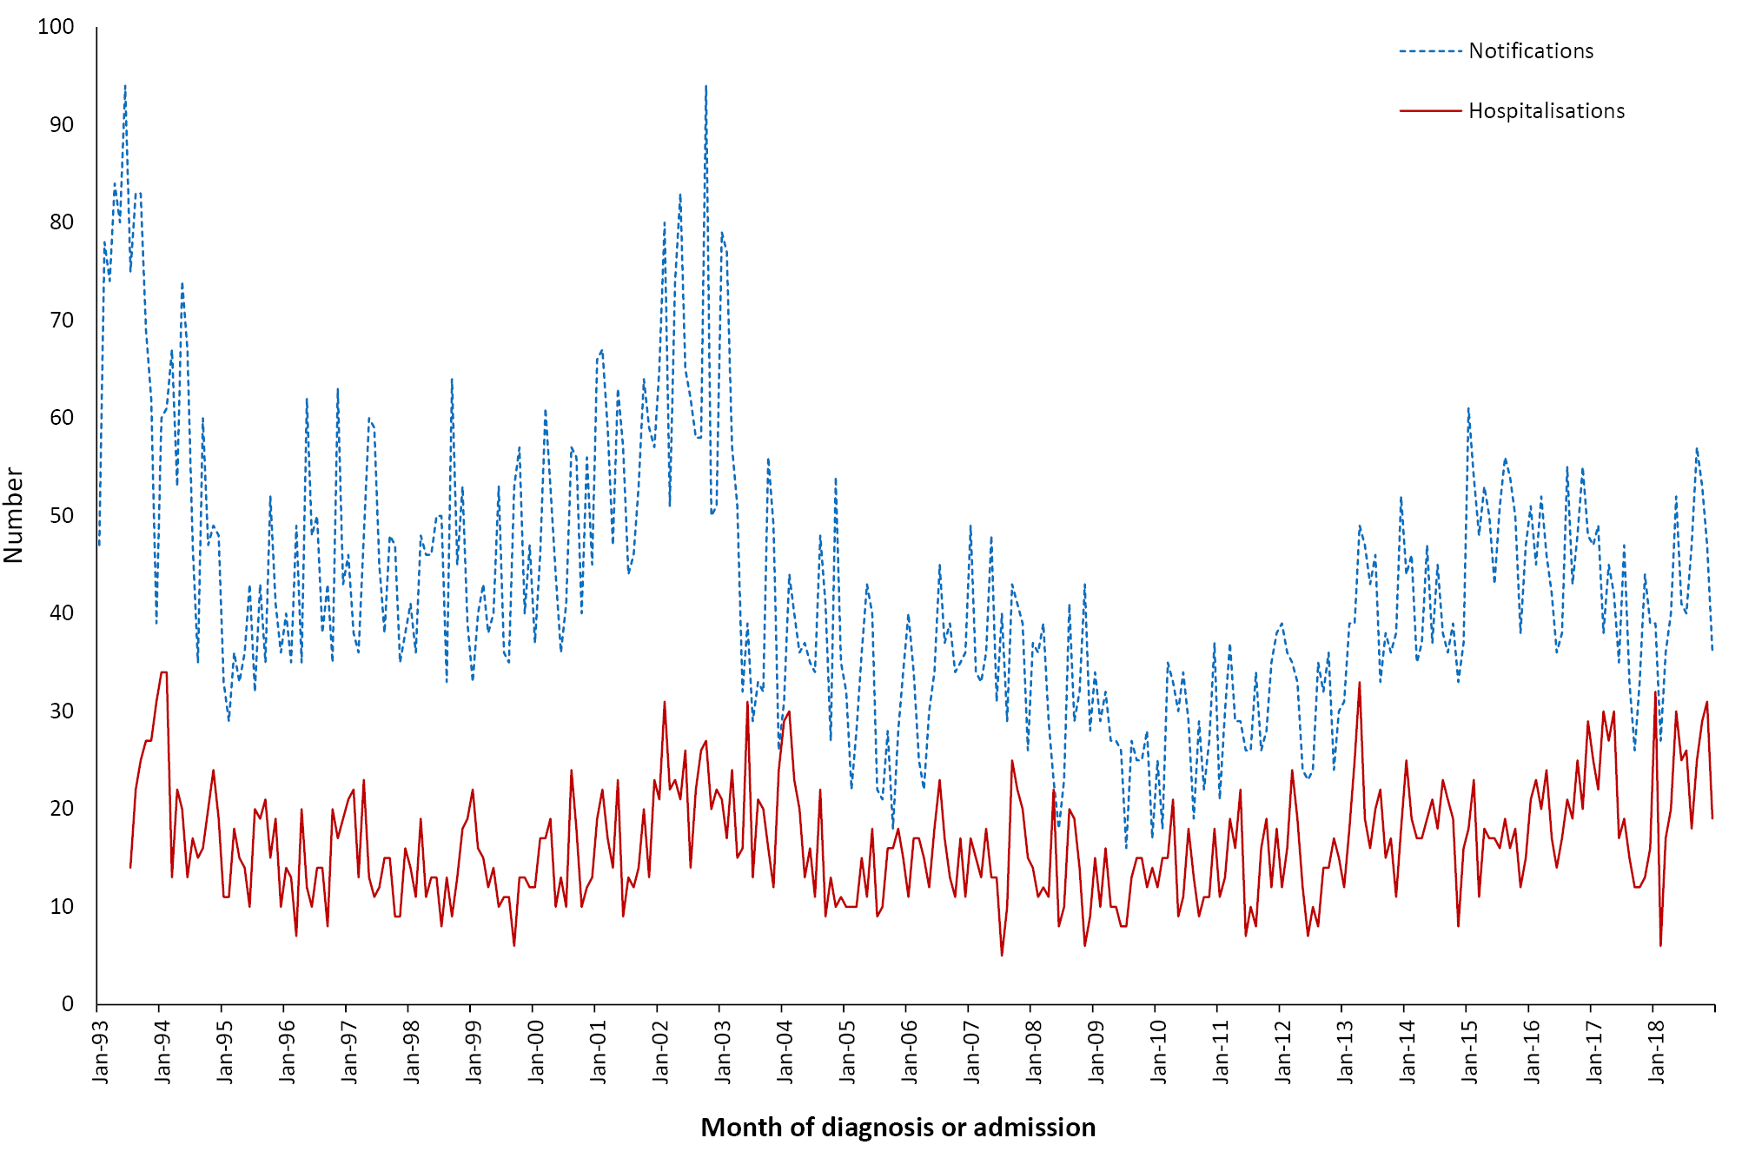
a Notifications where the month of diagnosis was between 1 January 1993 and 31 December 2018; hospitalisations where the month of admission was between 1 July 1993 and 31 December 2018.

Aboriginal and Torres Strait Islander status
Aboriginal and Torres Strait Islander status was reported for 1,484 of the 1,552 notifications of Q fever (96%) during 2016–2018, with 68 not stated (4%). Of the 1,552 notifications, 4.3% (n = 66) were in Aboriginal and Torres Strait Islander people, with notification rates slightly higher than other people (2.7 vs 2.1 per 100,000 population per year; rate ratio 1.3:1). The age distribution of Q fever notifications among Aboriginal and Torres Strait Islander people was younger, with a greater proportion aged 15–24 years relative to other Australians (15–24 years: 24.2% vs 7.7%; 25–49 years: 47.0% vs 37.3%; 50–64 years: 24.2% vs 36.0%; ≥ 65 years: 1.5% vs 16.2%).

Vaccination status
Vaccination status data were not available.

Comment
Despite some variation over the three years between 1 January 2016 and 31 December 2018, notifications and hospitalisations of Q fever were largely similar to rates during the previous four-year period (2012–2015). The highest notification rates were among adults aged 50–64 years, followed by those aged 25–49 years, consistent with occupational exposure and similar to the previous reporting period, although notification rates for 2016–2018 were also relatively high among adults aged ≥ 65 years. Seroprevalence studies in New South Wales and Queensland have estimated seroprevalence to be between 3% and 5%.^{224–226} There is evidence of variance between metropolitan and non-metropolitan areas, likely linked to occupational exposure.²²⁴ While studies have noted the higher risk of Q fever among occupations involving contact with livestock,^{227,228} the lack of risk factor data limits the ability of routinely-collected notification data in informing policies regarding Q fever prevention and vaccination.

3.13 Rotavirus
Rotavirus is a non-enveloped virus that is the major cause of acute gastroenteritis in young children and infants, and globally the leading cause of severe dehydrating diarrhoea in children aged < 5 years.²²⁹ Infection can be asymptomatic; can cause mild to moderate gastroenteritis; or can cause severe gastroenteritis with dehydration requiring hospitalisation.²³⁰ Virtually all children worldwide are infected with rotavirus by 5 years of age, but severe disease occurs most commonly in those aged 6 months to 2 years.²³¹ However, disease does occur in all age groups. Rotaviruses are primarily spread by faecal–oral transmission. Infection with rotavirus confers some protection against subsequent serious disease.²³² Rotaviruses are typed based on two surface proteins, VP7 (G protein) and VP4 (P protein). G1P[8] was the dominant genotype in Australia in the pre-vaccine era, with other common strains being G2, G3, G4 and G9.²³³ In recent years, following the introduction of the national rotavirus vaccination program, G12P[8] has become the dominant genotype nationally, but other genotypes (specifically G2P[4] and equine-like G3P[8]) have been more common since 2016, although genotype distribution has varied based on the vaccine implemented.^{233–236}

Highlights
Since the funding of rotavirus vaccine on the National Immunisation Program in 2007, there has been a substantial decrease in hospitalisations due to rotavirus. The average annual hospitalisation rate in the three-year period 2016–2018 was 5.0 per 100,000 population, lower than the 2012–2015 average annual rate of 5.4 per 100,000 population. In 2017, an outbreak of rotavirus resulted in a higher rotavirus hospitalisation rate of 8.6 per 100,000 population.
A national case definition for rotavirus was defined by the Communicable Diseases Network Australia (CDNA) in 2017.²³⁷ Rotavirus became a nationally notifiable disease from 1 July 2018. This report includes rotavirus notifications from January 2017, but focuses on notifications from July 2018 to December 2018.

Case definition
Notifications
Rotavirus case definition:
https://www1.health.gov.au/internet/main/publishing.nsf/Content/cdna-casedef-rotavirus.htm
Hospitalisations and deaths
The ICD-10-AM/ICD-10 code A08.0 (rotavirus enteritis) was used to identify hospitalisations and deaths.

Secular trends
Rotavirus notifications have only been recorded as per the national definition since 1 January 2017; rotavirus became a nationally notifiable disease in July 2018. There was an increase in rotavirus notifications in mid-2017, with notifications peaking in September 2017, declining again by the end of 2017. Notifications remained low in 2018. A total of 7,267 and 2,881 notifications were recorded in 2017 and 2018, respectively, with 1,453 notifications reported between July and December 2018.
In the three years from 1 January 2016 to 31 December 2018, the number of monthly hospitalisations with an ICD-10-AM code for rotavirus enteritis was largely similar to the monthly average number in the previous reporting period (2012–2015) (Figure 3.13.1). However, a larger peak and higher median monthly cases were observed in 2017 due to an outbreak in the latter half of the year (median monthly cases: 65 in 2016, 160 in 2017 and 55 in 2018). As in previous years, seasonal peaks were seen during the winter months.
Figure 3.13.1: Rotavirus hospitalisations for all ages, Australia, 1994 to 2018,^{a,b} by month of admission
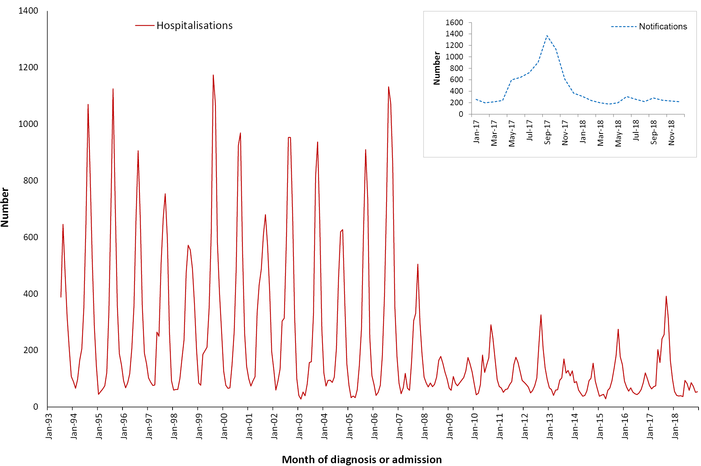
a Hospitalisations where the month of admission was between 1 January 1994 and 31 December 2018.
b Inset graph shows notifications where the month of notifications was between 1 January 2017 and 31 December 2018.
There were 3,673 hospital admissions over the three years with an ICD-10-AM code of rotavirus enteritis. The average annual hospitalisation rate was 5.0 per 100,000 population, slightly lower than in the 2012–2015 period (5.4 per 100,000 population per year) (Table 3.13.1). The majority of hospitalisations (2,112/3,673; 57.5%) occurred in 2017, peaking in September 2017 (n = 392).

Table 3.13.1. Rotavirus hospitalisations and deaths, Australia, 2016 to 2018,* by age group
Age group (years) | Notifications  (July–December 2018) |  | Hospitalisations |  |  |  | LOS^{b} per admission (days) |  | Deaths^{c}
 | n | Rate^{d} | Any diagnosis |  | Principal diagnosis |  | Any diagnosis | Principal diagnosis
 |  |  | n | Rate^{d} | n^{e} | Rate^{d,e} | Median days |  | n | Rate^{d}
< 1 | 431 | 284.1 | 919 | 98.92 | 544 | 58.55 | 2 | 2 | 0 | –
1–4 | 295 | 46.5 | 891 | 23.47 | 673 | 17.73 | 2 | 2 | 0 | –
5–14 | 112 | 7.2 | 375 | 4.09 | 293 | 3.19 | 2 | 2 | 0 | –
15–24 | 68 | 4.2 | 114 | 1.19 | 64 | 0.67 | 3 | 2 | 0 | –
25–49 | 248 | 5.7 | 309 | 1.20 | 156 | 0.61 | 3 | 2 | 0 | –
50–64 | 113 | 5.1 | 297 | 2.26 | 147 | 1.12 | 5 | 3 | 1–5 | 0.01
≥ 65 | 186 | 9.5 | 768 | 6.75 | 359 | 3.16 | 6 | 5 | 1–5 | 0.03
All ages | 1,453 | 11.6 | 3,673 | 4.98 | 2,236 | 3.03 | 3 | 2 | 1–5 | 0.01
a Notifications where the month of diagnosis was between 1 July 2018 and 31 December 2018; hospitalisations where the month of admission was between 1 January 2016 and 31 December 2018.
b LOS: length of stay in hospital.
c Deaths include underlying and associated causes of deaths.
d Average annual age-specific rate per 100,000 population.
e Principal diagnosis (hospitalisations).

Severe morbidity and mortality
During the three-year reporting period, rotavirus was recorded as the principal diagnosis in 60.9% of hospitalisations with rotavirus enteritis (2,236/ 3,673), accounting for 6,625 bed days (average 2,208 bed days per year) with a median length of stay of two days (Table 3.13.1). The length of stay for hospitalisations with rotavirus as any diagnosis was slightly higher at three days (Table 3.13.1).
There were 1–5 deaths recorded in the causes of death data for the three years from 1 January 2016 to 31 December 2018 with rotavirus enteritis (ICD-10 code, A08) as the underlying or associated cause of death; all were in adults aged ≥ 50 years and all occurred in 2017.

Age and sex distribution
Between July and December 2018, young children aged < 5 years comprised half of all rotavirus notifications (726/1,453), though rates were by far the highest among infants aged < 1 year (303.6 per 100,000 population per year) (Table 3.13.1). Notifications were relatively evenly distributed between males and females (male:female rate ratio of 0.95:1), although there were slightly more notifications observed among males in children aged < 5 years (male:female rate ratio of 1.1:1).
During the three-year reporting period, rates of hospitalisations with an ICD-10-AM code for rotavirus enteritis as a principal diagnosis were highest among infants aged < 1 year (58.6 per 100,000 population per year), followed by children aged 1–4 years (17.7 per 100,000 population per year) (Table 3.13.1), with these age groups accounting for 54% of hospitalisations with a principal diagnosis of rotavirus enteritis. There were slightly fewer hospitalisations in males than females (male to female ratio 0.9:1). Trends were similar for hospitalisations with rotavirus as any diagnosis (Table 3.13.1).

Geographical distribution
Between July and December 2018, the rotavirus notification rate was highest in the Northern Territory (36.7 per 100,000 population per year), followed by South Australia (32.8 per 100,000 population per year), with Victoria recording the lowest notification rate (0.5 per 100,000 population per year) (Appendix B).
Over the three-year period 1 January 2016 to 31 December 2018, the Northern Territory recorded the highest rate of hospitalisations with rotavirus enteritis (29.7 per 100,000 population per year), representing nearly six times the Australian average (Appendix C), while South Australia recorded the second-highest rate (10.5 per 100,000 population per year). The Australian Capital Territory (1.3 per 100,000 population per year) and Victoria (1.5 per 100,000 population per year) recorded the lowest rates of hospitalisations.

Aboriginal and Torres Strait Islander status
Aboriginal and Torres Strait Islander status was reported for 1,050 of the 1,453 rotavirus notifications (72%) between July and December 2018, with 403 not stated (28%). Of the 1,453 cases, 10.7% (156) were among Aboriginal and Torres Strait Islander people. The rate of rotavirus notifications was 3.5 times higher among Aboriginal and Torres Strait Islander people than among others. The majority of notifications among Aboriginal and Torres Strait Islander people (123/156, 79%) were in children aged < 5 years (57 [36.5%] in infants aged < 1 year and 66 [42%] in children aged 1-4 years). In comparison, 46.5% of notifications among other Australians were aged < 5 years (374/1,297 [29%] aged < 1 year and 229/1,297 [18%] aged 1-4 years).
For the reporting period between 2016 and 2018, 13.1% (481) of the total 3,673 hospitalisations were recorded as being in Aboriginal and Torres Strait Islander people. The proportion of rotavirus hospitalisations that were reported to be in Aboriginal and Torres Strait Islander people increased over the reporting period, from 9.0% in 2016 to 13.4% in 2017 and 17.0% in 2018. Of these 481 hospitalisations, 85% (409) were in children aged < 5 years. The Aboriginal and Torres Strait Islander hospitalisation rate was more than four-fold higher than other Australians (19.7 per 100,000 population versus 4.8 per 100,000 population, respectively).

Vaccination status
Of the total 1,453 rotavirus notifications between July and December 2018, vaccination data was available for 830 cases (57%). Of these, 284/830 (34%) had received no vaccine doses and 546 (66%) had received at least one dose of rotavirus vaccine. Among the 546 vaccinated cases, 254 had received 1 dose; 148 had received 2 doses; 121 had received 3 doses; and one had received 4 doses of rotavirus vaccine. Data on the number of vaccine doses received was unavailable for 22 vaccinated cases.

Comment
Prior to the national rotavirus vaccination program which commenced in July 2007, thousands of hospitalisations due to rotavirus were reported annually.²³⁸ Since then, there has been a decline in hospitalisations, particularly in children aged < 5 years,²³⁹ with a continued small decline during this reporting period. Seasonality continued to be evident but was substantially dampened compared to the pre-vaccine era. An increase in hospitalisations in 2017 was observed due to an outbreak of rotavirus, caused by novel strains G2P[4], equine-like G3P[8] and G8P[8].^{234,240} Examination of cases in New South Wales found high vaccine effectiveness over an 8-year period against vaccine-type strains, even in 2017 in the context of the outbreak.²⁴⁰ However, lower vaccine effectiveness among Aboriginal and Torres Strait Islander people, more akin to that seen in developing countries, has been reported,²³⁹ consistent with the higher rates of disease observed in this high-risk population in the current reporting period.

3.14 Rubella
Rubella is caused by the rubella virus (family Togaviridae), which only infects humans and is transmitted by aerosol droplets. Rubella is usually a mild febrile viral disease characterised by a discrete maculopapular rash; conjunctivitis; sore throat; headache; nausea; and postauricular, suboccipital and cervical lymphadenopathy.²⁴¹ However, subclinical infection occurs in up to 50% of cases. Arthralgia and arthritis may occur in up to 70% of infected adult females, but is uncommon in younger females and males. More severe complications, such as encephalitis, are rare. Rubella is important because up to 90% of infants born to women with a primary infection during the first trimester of pregnancy develop abnormalities characteristic of congenital rubella syndrome (CRS).^{242–244} The latter syndrome involves multiple serious defects, including cataract, retinopathy, deafness, heart defects and neurological deficits.^{241,242} Rubella infection during the first 20 weeks of pregnancy also increases the risk of spontaneous abortion, fetal death and infant mortality.^{242,245,246} Rubella vaccination has successfully decreased the burden of rubella worldwide, with 81 countries verified as having eliminated rubella as of 2018, inclusive of Australia.²⁴⁷ The risk of rubella is highest in countries that have not yet introduced rubella-containing vaccines in their national program, with women of reproductive age remaining at risk.²⁴⁸

Highlights
Notification and hospitalisation rates for rubella remained low over the reporting period 1 January 2016 to 31 December 2018. No new cases of congenital rubella syndrome were notified during this period. The highest notification rates were among adults aged 25–49 years.

Case definition

Secular trends
Notifications^{249,250}
Rubella case definition:
http://www.health.gov.au/internet/main/publishing.nsf/Content/cda-surveil-nndss-casedefs-cd_rubela.htm
Rubella (congenital) case definition:
http://www.health.gov.au/internet/main/publishing.nsf/Content/cda-surveil-nndss-casedefs-cd_conrub.htm
Hospitalisations and deaths
The ICD-10-AM/ICD-10 code B06 (rubella [German measles]) was used to identify hospitalisations and deaths for rubella and P35.0 (congenital rubella syndrome) for hospitalisations and deaths from CRS.
In the three years from 1 January 2016 to 31 December 2018, there were 36 notified cases of rubella, an average annual notification rate of 0.05 per 100,000 population (Table 3.14.1). Rubella notifications have remained consistently low since 2004, following a marked decline in the late 1990s and early 2000s (Figure 3.14.1). There were no notifications of congenital rubella syndrome (CRS) between 2016 and 2018. This is consistent with surveillance reports by the Australian Paediatric Surveillance Unit which also reported no cases of CRS over this period.^{251–253}
Table 3.14.1: Rubella notifications, hospitalisations and deaths, Australia, 2016 to 2018, by age groupª
Age group (years) | Notifications |  | Hospitalisations |  |  |  | LOS^{b} per admission |  | Deaths^{c}
 | n | Rate^{d} | Any diagnosis |  | Principal diagnosis |  | Any diagnosis | Principal diagnosis | n | Rate^{d}
 |  |  | n | Rate^{d} | n^{e} | Rate^{d,e} | Median days
< 1 | 0 | 0.00 | 0 | 0.00 | 0 | 0.00 | – | – | 0 | 0.00
1–4 | 3 | 0.08 | 1–4 | 0.05 | 1–4 | 0.03 | 1 | 1 | 0 | 0.00
5–14 | 3 | 0.03 | 1–4 | 0.01 | 0 | 0.00 | 2 | – | 0 | 0.00
15–24 | 7 | 0.07 | 1–4 | 0.04 | 1–4 | 0.02 | 2 | 1 | 0 | 0.00
25–49 | 20 | 0.08 | 7 | 0.03 | 1–4 | 0.01 | 1 | 3 | 1–5 | 0.02
50–64 | 1 | 0.01 | 1–4 | 0.01 | 1–4 | 0.01 | 6 | 6 | np^{f} | 0.07
≥ 65 | 2 | 0.02 | 1–4 | 0.01 | 0 | 0.00 | 17 | – | 13 | 0.11
All ages | 36 | 0.05 | 16 | 0.02 | 6 | 0.01 | 2 | 2 | 26 | 0.04
a Notifications where the month of diagnosis was between 1 January 2016 and 31 December 2018; hospitalisations where the month of admission was between 1 January 2016 and 31 December 2018.
b LOS: length of stay in hospital.
c Deaths include underlying and associated causes of deaths.
d Average annual age-specific rate per 100,000 population.
e Principal diagnosis (hospitalisations).
f np: not provided.
The average annual hospitalisation rate for rubella remained low in this reporting period at 0.02 per 100,000 population, with 16 hospitalisations (Table 3.14.1 and Appendix C). There were 32 hospitalisations coded as due to congenital rubella syndrome (CRS) between 2016 and 2018 (0.04 per 100,000 population per year).

Severe morbidity and mortality
From 1 January 2016 to 31 December 2018, hospitalisations with an ICD-10-AM code for rubella accounted for 45 bed days with a median length of stay of 1.5 days (Table 3.14.1). The median length of stay was longer for hospitalisations recorded as due to CRS (4 days), which accounted for 191 bed days. There were 26 deaths (0.4 per 100,000 population per year) recorded over the three years from 1 January 2016 to 31 December 2018 in the causes of death data with rubella (ICD-10 code B06) as the underlying or associated cause of death, with rubella recorded as the underlying cause of death in six of these deaths.

Age and sex distribution
Adults aged 25–49 years accounted for 56% (20/36) of rubella notifications for the three-year reporting period and had the highest rate of notifications (0.08 per 100,000 population per year) (Table 3.14.1).
Rates of rubella notifications for children < 5 years of age have remained very low since 2003 and remained low over the three years from 1 January 2016 to 31 December 2018, with three cases reported among children aged 1–4 years (0.08 per 100,000 population per year). All 32 CRS hospitalisations were aged 25 years or older (13 were people aged 25–49 years; 11 were aged 50–64 years; and eight were aged ≥ 65 years).
While hospitalisation rates for rubella for the three-year period were highest for children aged 1–4 years, they were very low in all age groups at 0.05 per 100,000 population per year or lower (Table 3.14.1). Almost all deaths recorded in the causes of death data were in adults aged 50 years and older (85%), with none occurring among people aged < 25 years (Table 3.14.1).
The overall male:female rate ratio for the three-year reporting period was 0.8:1 for notifications and 0.2:1 for hospitalisations.
Figure 3.14.1. Rubella notifications and hospitalisations,ª Australia, 1993 to 2018,^{b} by month of diagnosis or admission
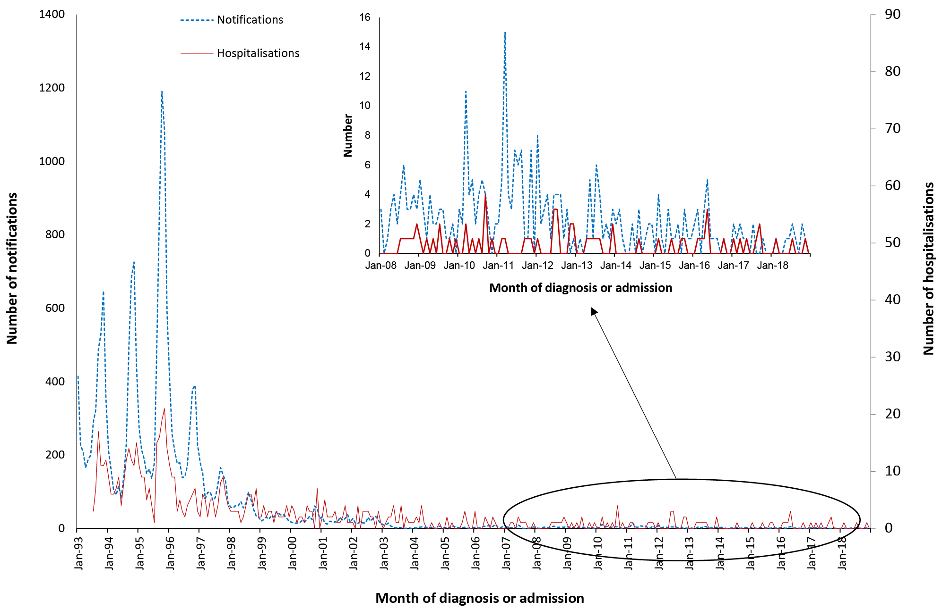
a Note: varying scales between notifications and hospitalisations.
b Notifications where the month of diagnosis was between 1 January 1993 and 31 December 2018; hospitalisations where the month of admission was between1 July 1993 and 31 December 2018.

Geographical distribution
Notification rates for rubella remained low for all states and territories for each year from 2016 to 2018 (all < 0.1 per 100,000 population per year) (Appendix B). Similarly, hospitalisation rates for rubella in each state and territory were also very low between 2016 and 2018 (range 0–0.06 per 100,000 population per year) (Appendix C).

Aboriginal and Torres Strait Islander status
Aboriginal and Torres Strait Islander status was reported for 32 of the 36 notifications (89%) of rubella during 2016–2018, with 4 not stated (11%). There were no rubella or CRS notifications or hospitalisations recorded as being in Aboriginal or Torres Strait Islander people.

Vaccination status
Of the 36 notifications, vaccination data were available for 14/36 cases (39%). Among these, six (43%) had not received any vaccine doses and eight had received 1 dose of rubella-containing vaccine.
Vaccination status should be complete in the NNDSS for all notifications of rubella in women of child-bearing age (15–45 years). There were fewer than half as many notifications (14; 0.09 per 100,000 population per year) of rubella among women aged 15–45 years between 1 January 2016 and 31 December 2018 compared to the 2012–2015 period (37; 0.18 per 100,000 population per year).²⁵⁴ Of these 14 cases in women aged 15–45 years, vaccination data were available for seven (50%), of whom two had received no vaccine doses and five had received 1 dose of rubella-containing vaccine.

Comment
The low and declining numbers of rubella notifications indicate that vaccination has been highly effective in Australia. A serosurvey of a nationally representative sample of the Australian population in 2012–2013 showed high levels of rubella-specific IgG seropositivity, with the effective reproductive number (R) estimated at 0.33 (95%CI: 0.28–0.39),²⁵⁵ consistent with previous serosurveys reporting R less than 0.5.²⁵⁶ In October 2018, the WHO certified that Australia had eliminated rubella.^{10,11} Deaths with rubella coded as an underlying or associated cause of death should be interpreted with caution, given the generally mild illness associated with the disease. The low incidence of rubella in Australia means that the majority of IgM-positive tests are likely false positive, and may occur due to the presence of rheumatoid factors (including rheumatologic disease), cross-reacting IgM, or infection with other viruses.^{257,258}

3.15 Tetanus
Tetanus is a disease caused by an exotoxin of the Clostridium tetani bacterium, which grows anaerobically at the site of an injury and is not transmissible from human to human.²⁵⁹ The disease is characterised by painful muscle contractions, primarily of the masseter and neck muscles, secondarily of the trunk muscles. The case-fatality rate ranges from 10% to 24% in settings with intensive care facilities, but approaches 100% in their absence, with the highest case-fatality rates in infants and the elderly.^{260,261}

Highlights
The number of notifications (14) and hospitalisations (52) for tetanus remained low between 2016 and 2018.

Case definition

Secular trends
Notifications²⁶²
Tetanus case definition:
http://www.health.gov.au/internet/main/publishing.nsf/Content/cda-surveil-nndss-casedefs-cd_tetanus.htm
Hospitalisations and deaths
The ICD-10-AM/ICD-10 codes A33 (tetanus neonatorum), A34 (obstetrical tetanus) and A35 (other tetanus) were used to identify hospitalisations and deaths.
In the three years from 1 January 2016 to 31 December 2018, there were 14 notifications of tetanus (average annual notification rate 0.02 per 100,000 population) (Table 3.15.1). The annual number of notifications for tetanus has remained stable since 2005, though a slight increase was seen during this reporting period in 2016 (Figure 3.15.1). There were 52 hospital admissions for tetanus from 1 January 2016 to 31 December 2018 (average annual hospitalisation rate 0.07 per 100,000 population) (Table 3.15.1). Hospitalisations have remained relatively stable since 1998, including during this three-year reporting period (Figure 3.15.1).

Severe morbidity and mortality
Hospitalisations with an ICD-10-AM code for tetanus accounted for 351 bed days. No hospitalisations were coded as tetanus neonatorum (A33) or obstetrical tetanus (A34). The median length of stay in hospital was three days. Adults aged 50–64 years and those aged ≥ 65 years had a longer median stay of 6.5 and 6 days, respectively. A substantially longer median stay was reported for children aged 1–4 years (25 days) (Table 3.15.1).
Causes of death data recorded 1–5 deaths with tetanus as the underlying or associated cause of death for the three years from 1 January 2016 to 31 December 2018, all in people aged ≥ 65 years (Table 3.15.1).

Figure 3.15.1: Tetanus notifications and hospitalisations, Australia, 1998 to 2018,ª by year of diagnosis or admission
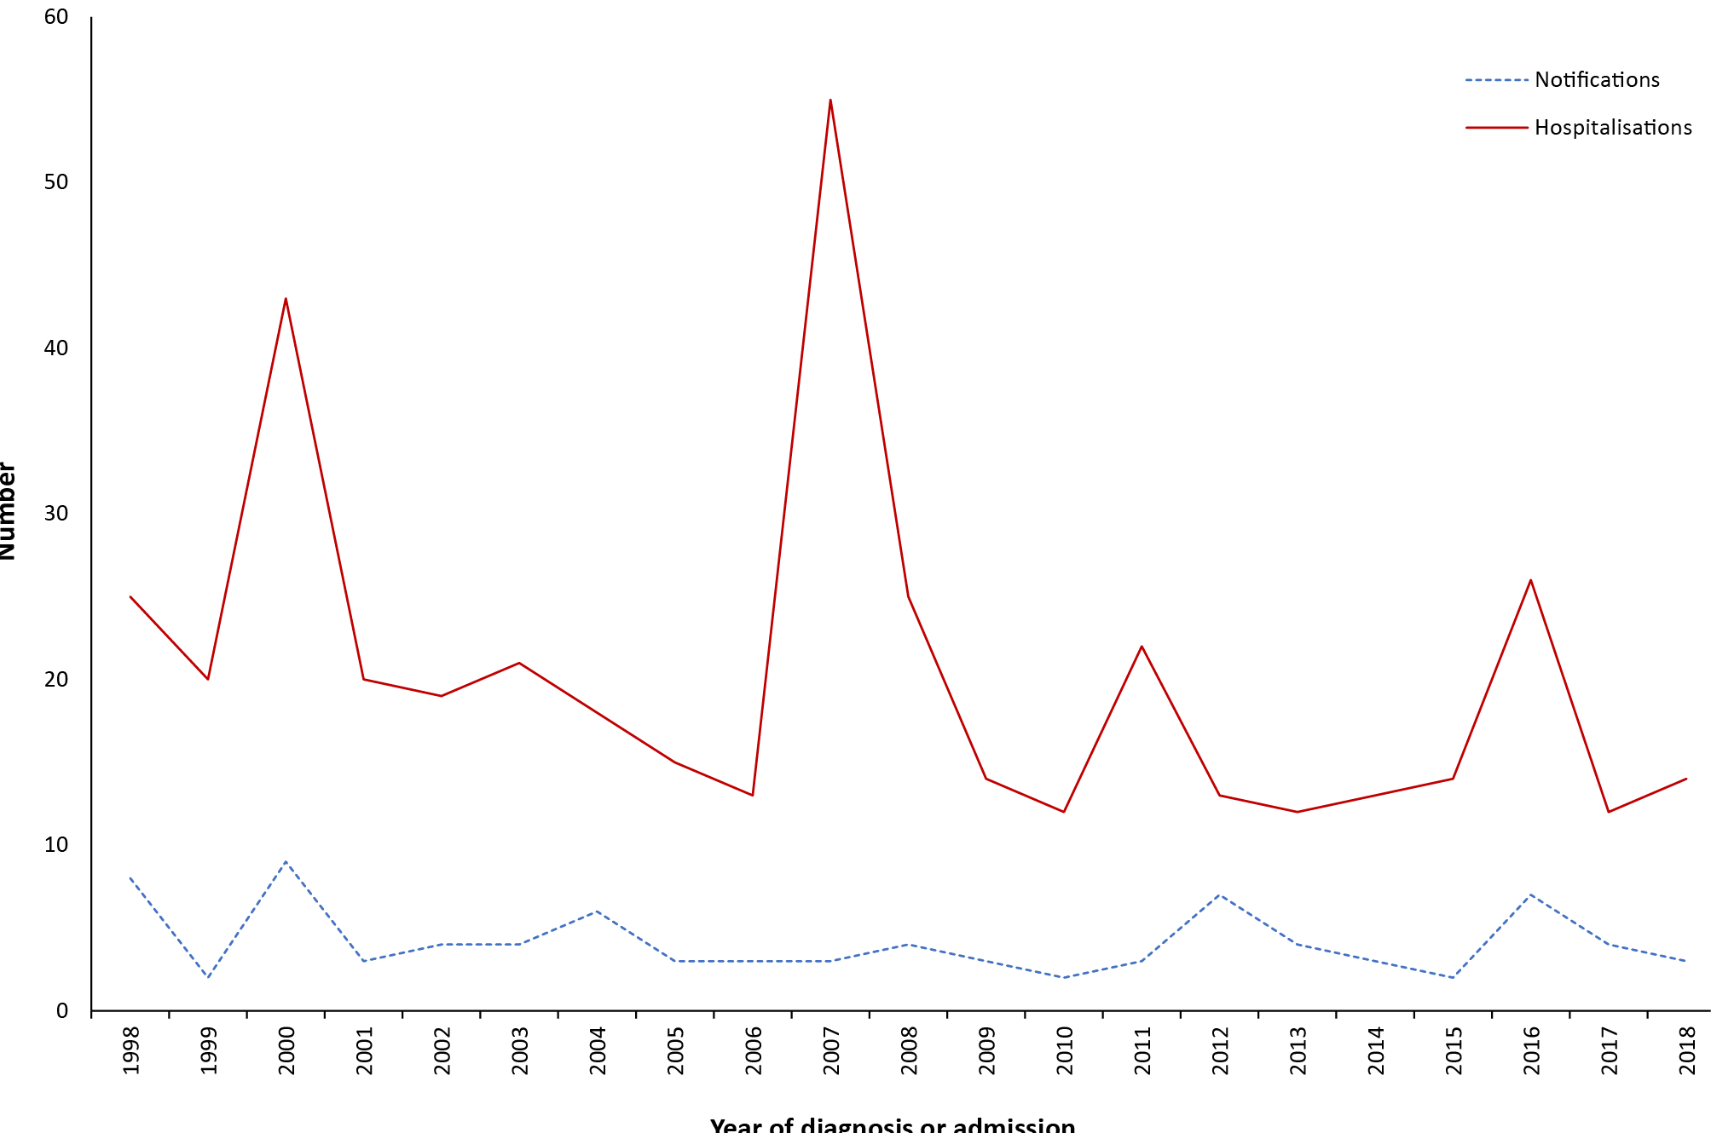
a Notifications where the year of diagnosis was between 1 January 1998 and 31 December 2018; hospitalisations where the year of admission was between 1 January1998 and 31 December 2018.

Age and sex distribution
During the three-year reporting period, five notifications (36%) were in adults aged ≥ 65 years (Table 3.15.1). Hospitalisations were most common among adults aged 25–49 years (21/52; 40%), but the highest hospitalisation rate was among adolescents and young adults aged 15–24 years (13/52; 0.14 per 100,000 population per year) (Table 3.15.1). There were more notifications and hospitalisations among males (male:female rate ratio 1.4:1 for notifications and 1.3:1 for hospitalisations).

Geographical distribution
The greatest number of tetanus notifications was in Queensland (n = 6) over the three years 2016–2018. The greatest number of tetanus hospitalisations was in New South Wales (n = 16) followed by Queensland (n = 14) and Victoria (n = 10) (Appendices B and C).

Aboriginal and Torres Strait Islander status
Aboriginal and Torres Strait Islander status was reported for all 14 notifications of tetanus over the 2016–2018 period, with none recorded as being in Aboriginal and Torres Strait Islander people. There were 1–4 hospitalisations recorded as being in Aboriginal and Torres Strait Islander people during this reporting period.
Table 3.15.1: Tetanus notifications, hospitalisations and deaths, Australia, 2016 to 2018,ª by age group
Age group (years) | Notifications |  | Hospitalisations |  |  |  | LOS^{b} per admission |  | Deaths^{c}
 | n | Rate^{d} | Any diagnosis |  | Principal diagnosis |  | Any diagnosis | Principal diagnosis | n | Rate^{d}
 |  |  | n | Rate^{d} | n^{e} | Rate^{d,e} | Median days
< 1 | 0 | 0.00 | 0 | 0.00 | 0 | 0.00 | 0 | 0 | 0 | 0.00
1–4 | 1 | 0.03 | 1–4 | 0.03 | 1–4 | 0.03 | 25 | 25 | 0 | 0.00
5–14 | 2 | 0.02 | 6 | 0.07 | 6 | 0.07 | 2 | 2 | 0 | 0.00
15–24 | 3 | 0.03 | 13 | 0.14 | 11 | 0.11 | 2 | 1 | 0 | 0.00
25–49 | 3 | 0.01 | 21 | 0.08 | 14 | 0.05 | 3 | 3 | 0 | 0.00
50–64 | 0 | 0.00 | 1–4 | 0.03 | 1–4 | 0.02 | 7 | 17 | 0 | 0.00
≥ 65 | 5 | 0.04 | 7 | 0.06 | 6 | 0.05 | 6 | 6 | 1–5 | 0.04
All ages | 14 | 0.02 | 52 | 0.07 | 40 | 0.05 | 3 | 3 | 1–5 | 0.01
a Notifications where the month of diagnosis was between 1 January 2016 and 31 December 2018; hospitalisations where the month of admission was between 1 January 2016 and 31 December 2018.
b LOS: length of stay in hospital.
c Deaths include underlying and associated causes of deaths.
d Average annual age-specific rate per 100,000 population.
e Principal diagnosis (hospitalisations).

Vaccination status
Of the 14 notifications, vaccination data was available for eight (57%); four of these had received no vaccine doses, two had received 1 dose, one had received 4 doses and one had received 5 doses of tetanus-containing vaccine.

Comment
Tetanus immunisation (complete) induces protective levels of antitoxin throughout childhood and into adulthood.⁵⁴ However, by middle age, approximately 50% of vaccinated persons have low or undetectable levels of antitoxin.^{54,263} In Australia, tetanus remains largely a disease of older adults,²⁶⁴ but also occurred in adolescents and young adults in this reporting period. Adolescents aged 11–13 years are scheduled to receive a dTpa booster dose under the NIP, and adults aged 50 years or older are recommended to receive a booster dose of tetanus-containing vaccine if their last dose of dTpa was more than 10 years previously. Notification and hospitalisation rates in this reporting period were largely similar to those in the 2012–2015 period, with hospitalisation rates considerably higher than notification rates, as in previous reports.^{12,254,265} Under-notification by hospital staff, multiple hospital admissions or inter-hospital transfers for true cases, and coding errors are all possible contributing factors.²⁶⁶

3.16 Varicella-zoster virus infection

Highlights
The number of varicella (chickenpox) hospitalisations remained low during the three-year period 1 January 2016 to 31 December 2018. The increasing trend in the numbers of herpes zoster hospitalisations, observed since 1993, has stabilised following the introduction of the national zoster vaccination program in 2016, with hospitalisation rates similar to the previous reporting period.
The varicella-zoster virus (VZV) is a DNA virus in the herpesvirus family that causes two distinct illnesses: varicella (chickenpox) following primary infection and herpes zoster (shingles) following reactivation of latent virus. Varicella is a highly contagious infection with an incubation period of 10–21 days, after which a characteristic rash appears.²⁶⁷ While typically a mild childhood disease, complications occur in about 1% of cases.²⁶⁸ Acute varicella may be complicated by secondary bacterial skin infections, haemorrhagic complications, encephalitis and pneumonia.^{267,269} Encephalitis occurs in 1 in 100,000 cases.²⁶⁷ Varicella is more severe in adults, particularly pregnant women and people of any age who are immunocompromised who can develop disseminated disease and are more likely to die from varicella complications.²⁶⁷ Varicella infection during pregnancy can result in congenital varicella syndrome in the infant, causing skin scarring, limb defects, ocular abnormalities and neurological malformations in the infant.^{267,270}
Herpes zoster (HZ) or shingles is a sporadic disease, caused by reactivation of latent VZV in sensory nerve ganglia.²⁷¹ VZV reactivation occurs, in part, due to a decline in cellular immunity to the virus, most commonly due to ageing or with immunocompromising medical conditions or immunosuppressive treatment, and affects half of people who live to 80 years.⁵⁴ Herpes zoster infections are characterised by severe pain with dermatomal distribution, sometimes followed by post-herpetic neuralgia, which can be chronic and debilitating, particularly in the elderly, and can last for months to years.^{272–274} Other neurological complications may occur, including ophthalmicus (which can lead to monocular blindness); Ramsay-Hunt syndrome; asepctic meningitis; transverse myelitis; and neurosensory hearing impairment.²⁷⁴ Approximately 13–30% of patients with herpes zoster develop complications, occurring more often in patients who are older and/or immunocompromised.^{54,275–277} Treatment with antivirals aims to shorten the duration of disease, alleviate the severity of acute pain and limit viral shedding.²⁷⁴ Atypical manifestations of HZ, such as glioma, zoster sine herpete and bilateral HZ, are rare, with limited guidelines on how to manage these patients.²⁷⁴ Given Australia’s ageing population, the burden of HZ is substantial and, in the absence of vaccination, would have been expected to increase over time.^{278,279}

Case definition
Notifications^{280–282}
Varicella-zoster (chickenpox) case definition: https://www1.health.gov.au/internet/main/publishing.nsf/Content/cdna-casedef-chickenpox.htm
Varicella-zoster (shingles) case definition: https://www1.health.gov.au/internet/main/publishing.nsf/Content/cdna-casedef-shingles.htm
Varicella-zoster (unspecified) case definition: https://www1.health.gov.au/internet/main/publishing.nsf/Content/cdna-casedef-varicella-unspec.htm
Hospitalisations and deaths
The ICD-10-AM/ICD-10 code B01 (varicella [chickenpox]) was used to identify varicella hospitalisations and deaths and B02 (zoster [shingles]) was used to identify herpes zoster hospitalisations and deaths.

Notifications of varicella and herpes zoster
Detailed notification data are not reported due to the large proportion that are unspecified as to whether varicella or zoster. Varicella-zoster virus infection is also not notifiable in New South Wales. For the current reporting period (2016–2018), of the total 85,870 notifications in NNDSS, 12.6% (10,800) were recorded as varicella, 36.0% (30,882) as zoster and 51.5% (44,188) unspecified.

Secular trends, varicella and herpes zoster hospitalisations
In the three years from 1 January 2016 to 31 December 2018, there were 2,459 hospital admissions with an ICD-10-AM code for varicella, an average annual rate of 3.3 per 100,000 population (Table 3.16.1), similar to the 2012–2015 period (3.4 per 100,000 population per year, Figure 3.16.1).

Figure 3.16.1: Varicella and herpes zoster hospitalisations, Australia, 1993 to 2018,^{a,b} by month of admission
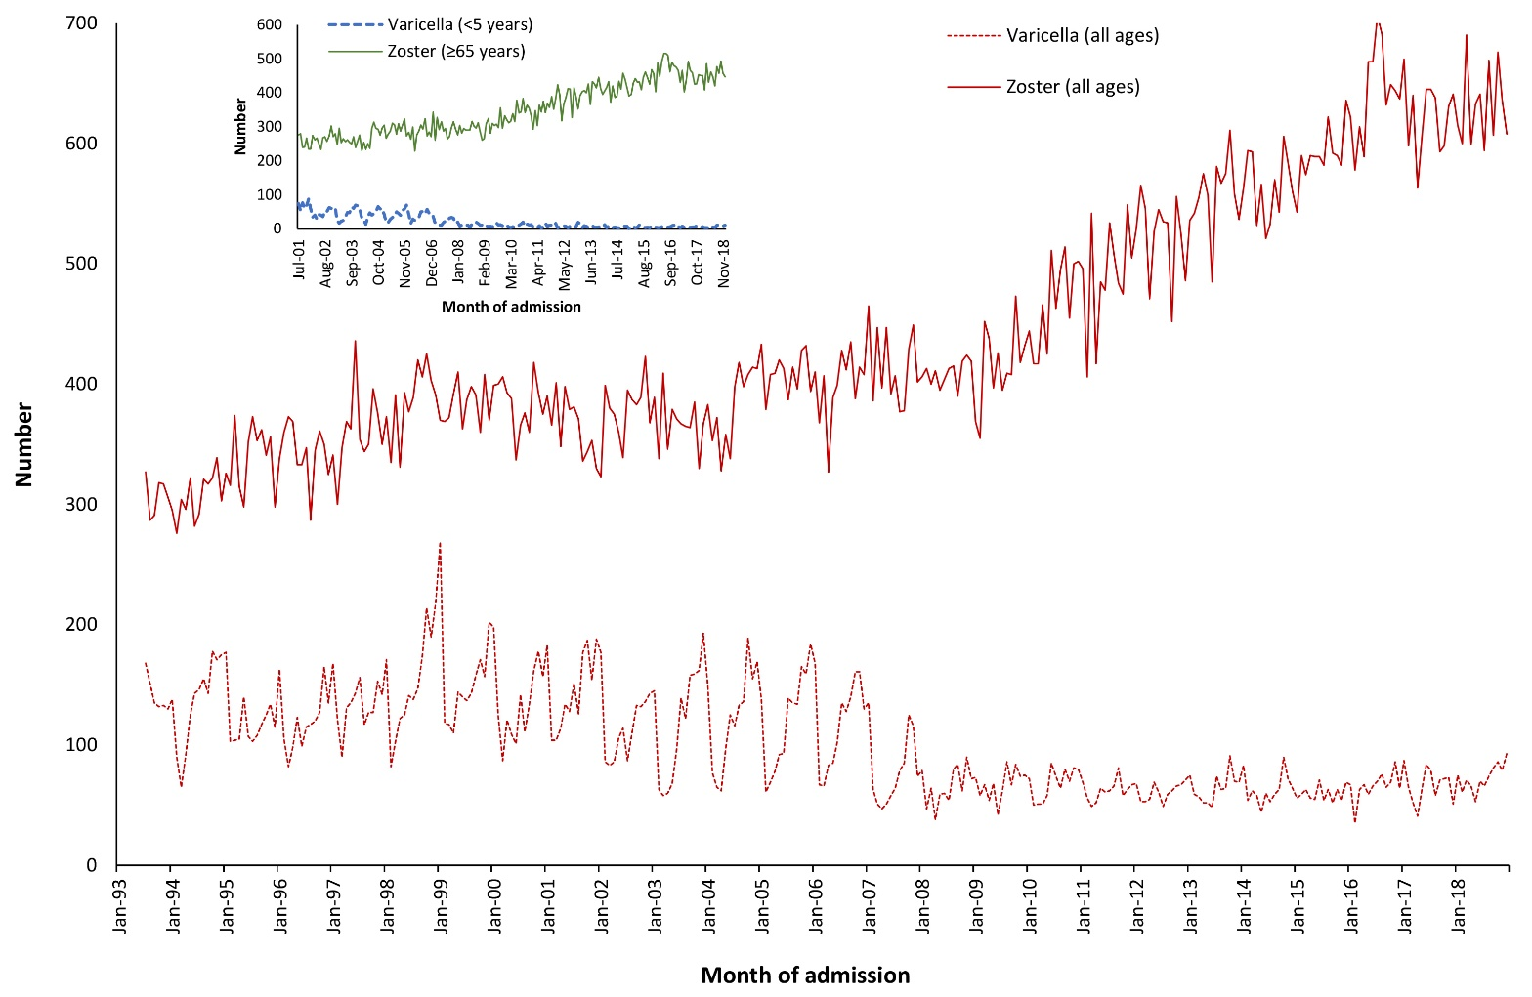
a Hospitalisations where the month of admission was between 1 July 1993 and 31 December 2018.
b Inset graph shows hospitalisations, where the month of admission was between 1 July 2001 and 31 December 2018, for vaccine-eligible age groups.
Monthly hospitalisations with an ICD-10-AM code for herpes zoster were also stable, with an average annual rate between 2016 and 2018 of 30.8 per 100,000 population compared to 30.6 per 100,000 population per year between 2012 and 2015. This represents a stabilisation in the previously steadily-rising trend in the number of zoster hospitalisations (Figure 3.16.1).

Severe morbidity and mortality (varicella)
From 1 January 2016 to 31 December 2018, hospitalisations with an ICD-10-AM code for varicella accounted for 15,543 bed days, with a median length of stay of four days (Table 3.16.1). The median length of stay was higher in adults aged ≥ 50 years (five days for 50–64 years, seven days for ≥ 65 years) compared with younger people (two or three days, see Table 3.16.1). For the three-year period, the causes of death data recorded 41 deaths with varicella as underlying or associated cause of death (of which 14 [34%] were recorded as the underlying cause), 88% (36/41) of which occurred in adults aged ≥ 65 years (Table 3.16.1).

Table 3.16.1: Varicella hospitalisations and deaths, Australia, 2016 to 2018,ª by age group
Age group (years) | Hospitalisations |  |  |  | LOS^{b} per admission |  | Deaths^{c}
 | Any diagnosis |  | Principal diagnosis |  | Any diagnosis | Principal diagnosis
 | n | Rate^{d} | n | Rate^{d,e} | Median days |  | n | Rate^{d,e}
< 1 | 103 | 11.09 | 79 | 8.50 | 2 | 2 | 0 | 0.00
1–4 | 128 | 3.37 | 85 | 2.24 | 2 | 1 | 0 | 0.00
5–14 | 140 | 1.53 | 93 | 1.01 | 3 | 3 | 0 | 0.00
15–24 | 144 | 1.50 | 105 | 1.09 | 2 | 3 | 1–5 | 0.01
25–49 | 649 | 2.52 | 433 | 1.68 | 3 | 3 | 1–5 | 0.01
50–64 | 377 | 2.87 | 173 | 1.32 | 5 | 4 | 1–5 | 0.02
≥ 65 | 918 | 8.07 | 375 | 3.30 | 7 | 6 | 36 | 0.32
All ages | 2,459 | 3.33 | 1,343 | 1.82 | 4 | 3 | 41 | 0.06
a Hospitalisations where the month of admission was between 1 January 2016 and 31 December 2018.
b LOS: length of stay in hospital.
c Deaths include underlying and associated causes of deaths.
d Average annual age-specific rate per 100,000 population.
e Principal diagnosis (hospitalisations and deaths).

Age and sex distribution (varicella)
During the three-year reporting period, the highest hospitalisation rate for varicella was among infants aged < 1 year (11.1 per 100,000 population per year), followed by adults aged ≥ 65 years (8.1 per 100,000 population per year) (Table 3.16.1). In comparison to the previous four-year reporting period, the rate of varicella hospitalisations among children aged 1–4 years declined from 4.5 to 3.4 per 100,000 population per year, and among 5–14 year olds declined from 2.2 to 1.5 per 100,000 population per year. Hospitalisation rates among other age groups remained similar between the two reporting periods.
There were slightly more hospitalisations for males than females over the three years (465 vs 453, male:female rate ratio 1.1:1).

Geographical distribution (varicella)
The Northern Territory had the highest hospitalisation rate for chickenpox (4.6 per 100,000 population per year), but accounted for only 1.4% of hospitalisations for chickenpox (Appendix C). New South Wales (29%), Queensland (24%) and Victoria (24%) accounted for just over three-quarters of hospitalisations with an ICD-10-AM code for chickenpox.

Severe morbidity and mortality (herpes zoster)
Hospitalisations with an ICD-10-AM code for herpes zoster accounted for 151,495 bed days in the three years from 1 January 2016 to 31 December 2018. This is an average of 50,498 bed days per year, a decrease from the average annual number reported in the 2012–2015 period (61,212). The median length of stay was four days for hospitalisations with any herpes zoster diagnosis and three days for those with a principal diagnosis of herpes zoster (Table 3.16.2).
For the three-year reporting period, the causes of death data recorded 322 deaths with zoster (herpes zoster, shingles) as the underlying or associated cause of death (of which 91 [28%] were recorded as the underlying cause); nearly all (309/322, 96%) were aged ≥ 65 years (Table 3.16.2).
Table 3.16.2: Zoster hospitalisations and deaths, Australia, 2016 to 2018,ª by age group
Age group (years) | Hospitalisations |  |  |  | LOS^{b} per admission |  | Deaths^{c}
 | Any diagnosis |  | Principal diagnosis |  | Any diagnosis | Principal diagnosis
 | n | Rate^{d} | n | Rate^{d,e} | Median days |  | n | Rate^{d,e}
< 1 | 16 | 1.72 | 1-4 | 0.43 | 3 | 4 | 0 | 0.00
1–4 | 33 | 0.87 | np^{f} | 0.40 | 1 | 1 | 0 | 0.00
5–14 | 92 | 1.00 | 61 | 0.66 | 2 | 2 | 0 | 0.00
15–24 | 354 | 3.69 | 179 | 1.86 | 2 | 2 | 1–5 | 0.01
25–49 | 2,091 | 8.11 | 1,031 | 4.00 | 3 | 2 | 1–5 | 0.00
50–64 | 3,588 | 27.35 | 1,767 | 13.47 | 3 | 2 | 11 | 0.08
≥ 65 | 16,561 | 145.58 | 6,637 | 58.34 | 5 | 4 | 309 | 2.72
All ages | 22,735 | 30.82 | 9,694 | 13.14 | 4 | 3 | 322 | 0.44
a Hospitalisations where the month of admission was between 1 January 2016 and 31 December 2018.
b LOS: length of stay in hospital.
c Deaths include underlying and associated causes of deaths.
d Average annual age-specific rate per 100,000 population.
e Principal diagnosis (hospitalisations and deaths).
f np: not provided

Age and sex distribution (herpes zoster)
During the three-year reporting period the highest hospitalisation rate for herpes zoster was among adults aged ≥ 65 years (145.6 per 100,000 population per year), followed by 50–64 year olds (27.3 per 100,000 population per year) (Table 3.16.2). The rate of hospitalisation among adults ≥ 65 years was slightly lower in this reporting period than in the 2012–2015 period (145.6 vs 155.3 per 100,000 population per year). The median length of stay for zoster hospitalisations was greatest among those aged ≥ 65 years (five days). There were more zoster hospitalisations for females than males (9,615 vs 13,120, male:female rate ratio 1:1.3).

Geographical distribution (herpes zoster)
The highest zoster hospitalisation rate was in Queensland (34.5 per 100,000 population per year). New South Wales (32%), Victoria (25%) and Queensland (22%) accounted for over three-quarters of hospitalisations (Appendix C).

Aboriginal and Torres Strait Islander status
Aboriginal and Torres Strait Islander people accounted for 3.8% of varicella hospitalisations (94/2,459), with the highest rate observed in infants aged < 1 year (21.1 per 100,000 population per year). Aboriginal and Torres Strait Islander varicella hospitalisation rates were slightly higher than those of other Australians (3.9 vs 3.3 per 100,000 population per year; rate ratio 1.2:1). Aboriginal and Torres Strait Islander people accounted for 2% of zoster hospitalisations (425/22,735), with the highest rate in those aged ≥ 65 years (106.1 per 100,000 population per year). The overall Aboriginal and Torres Strait Islander zoster hospitalisation rate was lower than in other Australians (17.4 per 100,000 population per year and 31.3 per 100,000 population per year, respectively). While rates of hospitalisation among adults aged ≥ 65 years were lower among Aboriginal and Torres Strait Island people than among non-Aboriginal and Torres Strait Islander adults (106.1 vs 146.0 per 100,000 population per year, respectively), rates were higher for Aboriginal and Torres Strait Islander people in younger age groups (adults aged 50–64 years: 52.8 vs 26.8 per 100,000 population per year; adults aged 25–49 years: 14.6 vs 7.9 per 100,000 population per year; 15–24 years: 6.8 vs 3.5 per 100,000 population per year).

Comment
A nationally-funded zoster vaccination program commenced in Australia in November 2016, with people aged 70 years eligible for a single dose of live attenuated zoster vaccine, and a five-year catch-up program for people aged 71 to 79 years.^{283,284} Coverage in the first 17 months of the program (1 November 2016 to 31 March 2018) was less than optimal (33.9% for adults aged 70 years and 25.8% for the catch-up program for adults aged 71–79 years), although there has likely been underreporting of administered vaccines to the Australian Immunisation Register;^{284,285} another study using an electronic primary care dataset has reported higher coverage estimates (46.9% up to 31 December 2018).²⁸⁶ However, despite this less than optimal coverage, hospitalisation rates for herpes zoster stabilised in this reporting period, breaking the steadily increasing trend observed since 1993, and the rate of zoster hospitalisations was slightly lower among adults aged ≥ 65 years than during the 2012–2015 period. An evaluation of antiviral prescriptions for herpes zoster found that, despite increases in the rate of antiviral prescriptions in the decade prior to the vaccination program,²⁷⁸ prescriptions decreased markedly in the following two years, providing further evidence of impact on disease incidence.²⁸⁷ Rates of zoster hospitalisations among Aboriginal and Torres Strait Islander adults aged < 70 years have been previously reported to be higher than those among non-Indigenous Australians,²⁸⁸ a trend that continued in this reporting period.
Although the vaccine effectiveness of a single dose against varicella hospitalisation has been moderate, reported at 64.7%,²⁸⁹ varicella vaccination has substantially reduced the burden of varicella disease in Australia.²⁹⁰ Varicella hospitalisation rates remained stable in this reporting period compared with the previous 2012–2015 period, indicating the sustained impact of varicella vaccination since its introduction onto the NIP in 2005.^{290,291} Varicella hospitalisation rates continued to decline among the age groups eligible to receive varicella vaccination under the NIP (1–14 years). The vaccination program has also been successful in reducing the disparity in varicella hospitalisation rates between Aboriginal and Torres Strait Islander children and non-Aboriginal and Torres Strait Islander children.²⁹¹

Acknowledgements
Hospitalisation data were provided by the Australian Institute of Health and Welfare.
Notification data from the National Notifiable Diseases Surveillance System were provided by the Office of Health Protection, Australian Government Department of Health, on behalf of Communicable Diseases Network Australia.
We thank the Australian Coordinating Registry, state and territory registries of births, deaths and marriages, state and territory coroners, and the National Coronial Information System, for providing access to cause of death data.
The National Centre for Immunisation Research and Surveillance is supported by the Australian Government Department of Health, the New South Wales Ministry of Health and The Sydney Children’s Hospitals Network. The opinions expressed in this report are those of the authors, and do not necessarily represent the views of these agencies.

Author details
Cyra Patel¹
Aditi Dey^{1,2}
Han Wang¹
Peter McIntyre¹
Kristine Macartney^{1,2}
Frank Beard^{1,2}
- National Centre for Immunisation Research and Surveillance, The Children’s Hospital at Westmead, Locked Bag 4001, Westmead, NSW 2145
- The University of Sydney, Camperdown, NSW 2006

Corresponding author
Aditi Dey
National Centre for Immunisation Research and Surveillance, The Children’s Hospital at Westmead, Locked Bag 4001 Westmead NSW 2145 Telephone: +61 2 9845 1433
Email: aditi.dey@health.nsw.gov.au

References
- Wattiaux AL, Yin JK, Beard F, Wesselingh S, Cowie B, Ward J et al. Hepatitis B immunization for Indigenous adults, Australia. Bull World Health Organ. 2016;94(11):826–34A.
- Chiew M, Dey A, Martin N, Wang H, Davis S, McIntyre PB. Australian vaccine preventable disease epidemiological review series: measles 2000–2011. Commun Dis Intell Q Rep. 2015;39(1):E1–9.
- Measles & Rubella Initiative. Four Western Pacific Countries and areas are the first in their Region to be measles-free. [Internet.] Washington DC: American Red Cross, Measles & Rubella Initiative; 20 March 2014. [Accessed on 23 May 2021.] Available from: https://measlesrubellainitiative.org/measles-news/four-western-pacific-countries-areas-first-region-measles-free/.
- Gidding HF, Martin NV, Stambos V, Tran T, Dey A, Dowse GK. Verification of measles elimination in Australia: application of World Health Organization regional guidelines. J Epidemiol Glob Health. 2016;6(3):197–209.
- Bangor-Jones RD, Dowse GK, Giele CM, van Buynder PG, Hodge MM, Whitty MM. A prolonged mumps outbreak among highly vaccinated Aboriginal people in the Kimberley region of Western Australia. Med J Aust. 2009;191(7):398–401.
- Bag SK, Dey A, Wang H, Beard FH. Australian vaccine preventable disease epidemiological review series: Mumps 2008–2012. Commun Dis Intell Q Rep. 2015;39(1):E10–8.
- Westphal D, Davies J, Huppatz C, Eastwood A, Gilles M, Lyttle H et al. The epidemiology of a large mumps outbreak in Western Australia. Canberra: Public Health Association of Australia; 12 July 2017. [Accessed on 23 May 2021.] Available from: https://www.phaa.net.au/documents/item/2228.
- Aratchige PE, McIntyre PB, Quinn HE, Gilbert GL. Recent increases in mumps incidence in Australia: the “forgotten” age group in the 1998 Australian Measles Control Campaign. Med J Aust. 2008;189(8):434–7.
- Senanayake SN. Mumps: a resurgent disease with protean manifestations. Med J Aust. 2008;189(8):456–9.
- World Health Organization (WHO). Singapore wipes out measles; Australia, Brunei Darussalam and Macao SAR (China) eliminate rubella. [Internet.] Geneva: WHO; 31 October 2018. [Accessed on 23 May 2021.] Available from: https://www.who.int/westernpacific/news/detail/31-10-2018-singapore-wipes-out-measles-australia-brunei-darussalam-and-macao-sar-(china)-eliminate-rubella.
- Gidding H, Dey A, Macartney K. Australia has eliminated rubella – but that doesn’t mean it can’t come back. [Internet.] Melbourne: The Conversation Media Group Ltd; 2 November 2018. [Accessed on 23 May 2021.] Available from: https://theconversation.com/australia-has-eliminated-rubella-but-that-doesnt-mean-it-cant-come-back-106056.
- Dey A, Wang H, Beard F, Macartney K, McIntyre P. Summary of national surveillance data on vaccine preventable diseases in Australia, 2012-2015. Commun Dis Intell (2018). 2019;43. doi: https://doi.org/10.33321/cdi.2019.43.58.
- Maguire JE, Beard F, Méder K, Dey A, Macartney K, McIntyre P. Australian vaccine preventable disease epidemiological review series: invasive Haemophilus influenzae type b disease, 2000-2017. Commun Dis Intell (2018). 2020;44. doi: https://doi.org/10.33321/cdi.2020.44.11.
- Marshall KS, Quinn H, Pillsbury AJ, Maguire JE, Lucas RM, Dey A et al. Australian vaccine preventable disease epidemiological review series: Pertussis, 2013–2018. Commun Dis Intell (2018). 2022;46. doi: https://doi.org/10.33321/cdi.2022.46.3.
- Public Health Committee, National Health and Medical Research Council (NHMRC). Surveillance case definitions: endorsed at the 115th Session of NHMRC, Adelaide, June 1993. Canberra: NHMRC; 1994.
- Australian Government Department of Health. Australian national notifiable diseases and case definitions. [Internet.] Canberra: Australian Government Department of Health, Communicable Diseases Network Australia (CDNA); 2021. [Accessed on 23 May 2021.] Available from: https://www1.health.gov.au/internet/main/publishing.nsf/Content/cdna-casedefinitions.htm.
- CDNA Surveillance Case Definitions Working Group. Editorial: Notifiable diseases, Australia, 2004. Commun Dis Intell Q Rep. 2004;28(1):1–5.
- Ioannides S, Beard F, Larter N, Clark K, Wang H, Hendry A et al. Vaccine preventable diseases and vaccination coverage in Aboriginal and Torres Strait Islander people, Australia, 2011–2015. Commun Dis Intell (2018). 2019;43. doi: https://doi.org/10.33321/cdi.2019.43.36.
- Australian Institute of Health and Welfare (AIHW). Indigenous identification in hospital separations data: quality report. (Cat. no. IHW 90.) Canberra: Australian Government, AIHW; 1 May 2013. [Accessed on 23 May 2021.] Available from: https://www.aihw.gov.au/reports/indigenous-australians/indigenous-identification-in-hospital-separations/contents/table-of-contents.
- Australian Government Department of Health. Australian national notifiable diseases and case definitions. [Internet.] Canberra: Australian Government Department of Health; 2021. [Accessed on 23 May 2021.] Available from: http://www.health.gov.au/casedefinitions.
- National Centre for Immunisation Research and Surveillance (NCIRS). History of immunisation in Australia. [Internet.] Sydney: NCIRS; 2021. [Accessed on 23 May 2021.] Available from: https://www.ncirs.org.au/health-professionals/history-immunisation-australia.
- Commonwealth of Australia. Project agreement for vaccine preventable diseases surveillance program. Canberra: Australian Government; 2017. Available from: https://www.federalfinancialrelations.gov.au/content/npa/health/project-agreement/Vaccines_Preventable_Diseases_Surveillance_Program.pdf.
- AIHW. Admitted patient care: 2015-16. Australian Hospital Statistics. (Health Services Series, Number 75.) Canberra: Australian Government; AIHW; 2017. [Accessed on 23 May 2021.] Available from: https://www.aihw.gov.au/getmedia/3e1d7d7e-26d9-44fb-8549-aa30ccff100a/20742.pdf.
- AIHW. Web update: Potentially preventable hospitalisations in 2015–16. Technical note. Canberra: Australian Government, AIHW; 2017. [Accessed on 23 May 2021.] Available from: https://www.aihw.gov.au/getmedia/14ba43a3-9ae9-4b19-beb9-e9c714e2fb3f/aihw-mhc-hpf-37-technical-note.pdf.
- Australian Bureau of Statistics (ABS). Causes of Death, Australia methodology. Reference period 2018. [Internet.] Canberra: ABS; 25 September 2019. [Accessed on 14 February 2021.] Available from: https://www.abs.gov.au/methodologies/causes-death-australia-methodology/2018.
- Sheel M, Macartney K. Have you had your diphtheria vaccines? Here’s why it matters. [Internet.] Melbourne: The Conversation Media Group Ltd; 8 August 2018. Available from: https://theconversation.com/have-you-had-your-diphtheria-vaccines-heres-why-it-matters-98174.
- WHO. Surveillance standards for vaccine-preventable diseases: diphtheria. Geneva: World Health Organization; 5 September 2018. [Accessed on 14 February 2021.] Available from: https://www.who.int/immunization/monitoring_surveillance/burden/vpd/WHO_SurveillanceVaccinePreventable_04_Diphtheria_R2.pdf.
- Hatanaka A, Tsunoda A, Okamoto M, Ooe K, Nakamura A, Miyakoshi M et al. Corynebacterium ulcerans diphtheria in Japan. Emerg Infect Dis. 2003;9(6):752–3.
- DeWinter LM, Bernard KA, Romney MG. Human clinical isolates of Corynebacterium diphtheriae and Corynebacterium ulcerans collected in Canada from 1999 to 2003 but not fitting reporting criteria for cases of diphtheria. J Clin Microbiol. 2005;43(7):3447–9.
- Tiwari TS, Golaz A, Yu DT, Ehresmann KR, Jones TF, Hill HE et al. Investigations of 2 cases of diphtheria-like illness due to toxigenic Corynebacterium ulcerans. Clin Infect Dis. 2008;46(3):395–401.
- Elden S, Coole L, Efstratiou A, Doshi N. Laboratory-confirmed case of toxigenic Corynebacterium ulcerans. Euro Surveill. 2007;12(3). doi: https://doi.org/10.2807/esw.12.13.03166-en.
- Moore LSP, Leslie A, Meltzer M, Sandison A, Efstratiou A, Sriskandan S. Corynebacterium ulcerans cutaneous diphtheria. Lancet Infect Dis. 2015;15(9):1100–7.
- WHO. Diphtheria vaccine: WHO position paper, August 2017 – Recommendations. Vaccine. 2018;36(2):199–201.
- Diphtheria. In Heymann DL, ed. Control of Communicable Diseases Manual (19th edition). Washington, DC: American Public Health Association (APHA), 2008;195-200.
- Tiwari TSP, Wharton M. 19 – Diphtheria toxoid. In Plotkin SA, Orenstein WA, Offit PA, Edwards KM, eds. Plotkin’s Vaccines (7th edition). Amsterdam: Elsevier, 2018;261–75.e7. Available from: http://www.sciencedirect.com/science/article/pii/B9780323357616000195.
- Australian Government Department of Health. Diphtheria case definition. [Internet.] Canberra: Australian Government Department of Health, CDNA; 2017. [Accessed on 30 June 2020.] Available from: https://www1.health.gov.au/internet/main/publishing.nsf/Content/cda-surveil-nndss-casedefs-cd_dipth.htm.
- Lu X, Quinn HE, Menzies RI, Hueston L, Gilbert L, McIntyre PB. Diphtheria immunity in Australia: should we be concerned? Infect Disord Drug Targets. 2020;20(3):323–9.
- Paveenkittiporn W, Sripakdee S, Koobkratok O, Sangkitporn S, Kerdsin A. Molecular epidemiology and antimicrobial susceptibility of outbreak-associated Corynebacterium diphtheriae in Thailand, 2012. Infect Genet Evol. 2019;75. doi: https://doi.org/10.1016/j.meegid.2019.104007.
- Rahman MR, Islam K. Massive diphtheria outbreak among Rohingya refugees: lessons learnt. J Travel Med. 2019;26(1). doi: https://doi.org/10.1093/jtm/tay122.
- Sangal L, Joshi S, Anandan S, Balaji V, Johnson J, Satapathy A. Resurgence of diphtheria in North Kerala, India, 2016: laboratory supported case-based surveillance outcomes. Front Public Health. 2017;5:218.
- Harapan H, Anwar S, Dimiati H, Hayati Z, Mudatsir M. Diphtheria outbreak in Indonesia, 2017: An outbreak of an ancient and vaccine-preventable disease in the third millennium. Clin Epidemiol Glob Health. 2019;7(2):261–2.
- McIntyre P. Vaccines against invasive Haemophilus influenzae type b disease. J Paediatr Child Health. 1994;30(1):14–8.
- Wang H, Deeks S, Glasswell A, McIntyre P. Trends in invasive Haemophilus influenzae type b disease in Australia, 1995–2005. Commun Dis Intell Q Rep. 2008;32(3):316–25.
- Hanna JN, Wild BE. Bacterial meningitis in children under five years of age in Western Australia. Med J Aust. 1991;155(3):160–4.
- McIntyre PB, O’Brien KL, Greenwood B, van de Beek D. Effect of vaccines on bacterial meningitis worldwide. Lancet. 2012;380(9854):1703–11.
- McIntyre PB, Leeder SR, Irwig LM. Invasive Haemophilus influenzae type b disease in Sydney children 1985–1987: a population-based study. Med J Aust. 1991;154(12):832–7.
- Cleland G, Leung C, Wan Sai Cheong J, Francis J, Heney C, Nourse C. Paediatric invasive Haemophilus influenzae in Queensland, Australia, 2002-2011: young Indigenous children remain at highest risk. J Paediatr Child Health. 2018;54(1):36–41.
- Menzies RI, Bremner KM, Wang H, Beard FH, McIntyre PB. Long-term trends in invasive Haemophilus influenzae type B disease among indigenous Australian children following use of PRP-OMP and PRP-T vaccines. Pediatr Infect Dis J. 2015;34(6):621–6.
- Heath PT, Booy R, Azzopardi HJ, Slack MP, Fogarty J, Moloney AC et al. Non-type b Haemophilus influenzae disease: clinical and epidemiologic characteristics in the Haemophilus influenzae type b vaccine era. Pediatr Infect Dis J. 2001;20(3):300–5.
- Ladhani S, Heath PT, Slack MPE, McIntyre PB, Diez-Domingo J, Campos J et al. Haemophilus influenzae serotype b conjugate vaccine failure in twelve countries with established national childhood immunization programmes. Clin Microbiol Infect. 2010;16(7):948–54.
- Hanna JN, Hills SL, Humphreys JL. Impact of hepatitis A vaccination of Indigenous children on notifications of hepatitis A in north Queensland. Med J Aust. 2004;181(9):482–5.
- Australian Government Department of Health. Haemophilus influenzae type B (Hib) infection (invasive) case definition. [Internet.] Canberra: Australian Government Department of Health, CDNA; 2014. [Accessed on 30 June 2020.] Available from: http://www.health.gov.au/internet/main/publishing.nsf/Content/cda-surveil-nndss-casedefs-cd_hib.htm.
- NSW Health. Communicable Diseases Weekly Report: Week 21, 21 May to 27 May 2017. Sydney: Government of New South Wales Department of Health; 2017. Available from: https://www.health.nsw.gov.au/Infectious/Reports/Publications/cdwr/2017/CDWR-Week21-2017.pdf.
- Australian Government Department of Health. The Australian Immunisation Handbook. [Website.] Canberra: Australian Government Department of Health; 2021. [Accessed on 6 February 2021.] Available from: https://immunisationhandbook.health.gov.au.
- [No authors listed.] WHO position paper on hepatitis A vaccines – June 2012. Wkly Epidemiol Rec. 2012;87(28/29):261–76.
- Averhoff FM, Khudyakov Y, Nelson NP. 24 – Hepatitis A vaccines. In Plotkin SA, Orenstein WA, Offit PA, Edwards KM, eds. Plotkin’s Vaccines (7th edition). Amsterdam: Elsevier, 2018;319–41.e15. Available from: http://www.sciencedirect.com/science/article/pii/B9780323357616000249.
- Koff RS. Hepatitis A. Lancet. 1998;351(9116):1643–9.
- Abutaleb A, Kottilil S. Hepatitis A: epidemiology, natural history, unusual clinical manifestations, and prevention. Gastroenterol Clin North Am. 2020;49(2):191–9.
- Hanna JN, Warnock TH, Shepherd RW, Selvey LA. Fulminant hepatitis A in indigenous children in north Queensland. Med J Aust. 2000;172(1):19–21.
- MacIntyre CR, Burgess M, Isaacs D, McIntyre PB, Menzies R, Hull B. Epidemiology of severe hepatitis A in Indigenous Australian children. J Paediatr Child Health. 2007;43(5):383–7.
- Thompson C, Dey A, Fearnley E, Polkinghorne B, Beard F. Impact of the national targeted Hepatitis A immunisation program in Australia: 2000–2014. Vaccine. 2017;35(1):170–6.
- Jayasundara D, Hui BB, Regan DG, Heywood AE, MacIntyre CR, Wood JG. Quantifying the population effects of vaccination and migration on hepatitis A seroepidemiology in Australia. Vaccine. 2017;35(39):5228–34.
- Heywood AE, Zwar N, Forssman BL, Seale H, Stephens N, Musto J et al. The contribution of travellers visiting friends and relatives to notified infectious diseases in Australia: state-based enhanced surveillance. Epidemiol Infect. 2016;144(16):3554–63.
- Australian Government Department of Health. Hepatitis A case definition. [Internet.] Canberra: Australian Government Department of Health, CDNA; 2013. [Accessed on 30 June 2020.] Available from: http://www.health.gov.au/internet/main/publishing.nsf/Content/cda-surveil-nndss-casedefs-cd_hepa.htm.
- Victoria State Government Department of Health and Human Services (DHHS). Hepatitis A outbreak - Update December 2018. [Internet.] Melbourne: Victoria State Government, DHHS; 20 December 2018. [Accessed on 26 June 2020.] Available from: https://www2.health.vic.gov.au/about/news-and-events/healthalerts/hepatitis-a-outbreak-december-2018.
- NSW Health. Hepatitis A control guideline. [Internet.] Sydney: Government of New South Wales, NSW Health; 1 August 2019. [Accessed on 26 June 2020.] Available from: https://www.health.nsw.gov.au/Infectious/controlguideline/Pages/hepa.aspx.
- NCIRS. Significant events in hepatitis A vaccination practice in Australia. Sydney: NCIRS; 2018. [Accessed on 26 June 2020.] Available from: http://www.ncirs.org.au/sites/default/files/2018-12/Hepatitis-A-history-Dec-2018.pdf.
- Burrell S, Vodstrcil LA, Fairley CK, Kilner A, Bradshaw CS, Chen MY et al. Hepatitis A vaccine uptake among men who have sex with men from a time-limited vaccination programme in Melbourne in 2018. Sex Transm Infect. 2020;96(2):110–4.
- Franklin N, Camphor H, Wright R, Stafford R, Glasgow K, Sheppeard V. Outbreak of hepatitis A genotype IB in Australia associated with imported frozen pomegranate arils. Epidemiol Infect. 2019;147. doi: https://doi.org/10.1017/S0950268818003515.
- NSW Health. Hepatitis A linked to imported frozen pomegranate. [Internet.] Sydney: Government of New South Wales, NSW Health; 8 June 2018. [Accessed on 26 June 2020.] Available from: https://www.health.nsw.gov.au/Infectious/alerts/Pages/hep-A-pomegranate.aspx.
- DHHS. Hepatitis A outbreak. [Internet.] Melbourne: Victoria State Government, DHHS; 20 September 2017. [Accessed on 26 June 2020.] Available from: https://www2.health.vic.gov.au/about/news-and-events/healthalerts/hepatitis-a-outbreak-september-2017.
- WHO. Hepatitis B vaccines: WHO position paper – July 2017. Wkly Epidemiol Rec. 2017;92(27):369–92.
- Van Damme P, Ward JW, Shouval D, Zanetti A. 25 – Hepatitis B vaccines. In Plotkin SA, Orenstein WA, Offit PA, Edwards KM, eds. Plotkin’s Vaccines (7th edition). Amsterdam: Elsevier, 2018;342–74.e17. Available from: http://www.sciencedirect.com/science/article/pii/B9780323357616000250.
- Hepatitis, viral. II. Viral hepatitis B. In Heymann DL, ed. Control of Communicable Diseases Manual (19th edition). Washington, DC: APHA, 2008;284–93.
- Kaldor JM, Plant AJ, Thompson SC, Longbottom H, Rowbottom J. The incidence of hepatitis B infection in Australia: an epidemiological review. Med J Aust. 1996;165(6):322–6.
- Sarin SK, Kumar M, Eslam M, George J, Al Mahtab M, Akbar SMF et al. Liver diseases in the Asia-Pacific region: a Lancet Gastroenterology & Hepatology Commission. Lancet Gastroenterol Hepatol. 2020;5(2):167–228.
- Wong MCS, Huang JLW, George J, Huang J, Leung C, Eslam M et al. The changing epidemiology of liver diseases in the Asia-Pacific region. Nat Rev Gastroenterol Hepatol. 2019;16(1):57–73.
- O’Sullivan BG, Gidding HF, Law M, Kaldor JM, Gilbert GL, Dore GJ. Estimates of chronic hepatitis B virus infection in Australia, 2000. Aust N Z J Public Health. 2004;28(3):212–6.
- Ryder SD, Beckingham IJ. ABC of diseases of liver, pancreas, and biliary system: chronic viral hepatitis. BMJ. 2001;322(7280):219–21.
- Seed CR, Kiely P. A method for estimating the residual risk of transfusion-transmitted HBV infection associated with occult hepatitis B virus infection in a donor population without universal anti-HBc screening. Vox Sang. 2013;105(4):290–8.
- Australian Government Department of Health. Hepatitis B (newly acquired) case definition. Canberra: Australian Government Department of Health, CDNA; 1 July 2015. [Accessed on 30 June 2020.] Available from: http://www.health.gov.au/internet/main/publishing.nsf/Content/cda-surveil-nndss-casedefs-cd_hepbnew.htm.
- McGregor S, King J, McManus H, Gray R, Guy R. 3.1 Hepatitis B notifications. In HIV, viral hepatitis and sexually transmissible infections in Australia: annual surveillance report 2018. Sydney: University of New South Wales, Kirby Institute; 2018. [Accessed on 23 May 2021.] Available from: https://kirby.unsw.edu.au/sites/default/files/kirby/report/KI_Annual-Surveillance-Report-2018.pdf#page=112.
- Bresee JS, Fry AM, Sambhara S, Cox NJ. 31 – Inactivated influenza vaccines. In Plotkin SA, Orenstein WA, Offit PA, Edwards KM, eds. Plotkin’s Vaccines (7th edition). Amsterdam: Elsevier, 2018;456–88.e21. Available from: http://www.sciencedirect.com/science/article/pii/B9780323357616000316.
- Nicholson KG, Wood JM, Zambon M. Influenza. Lancet. 2003;362(9397):1733–45.
- Li-Kim-Moy J, Yin JK, Patel C, Beard FH, Chiu C, Macartney KK et al. Australian vaccine preventable disease epidemiological review series: influenza 2006 to 2015. Commun Dis Intell Q Rep. 2016;40(4):E482–95.
- Mertz D, Geraci J, Winkup J, Gessner BD, Ortiz JR, Loeb M. Pregnancy as a risk factor for severe outcomes from influenza virus infection: a systematic review and meta-analysis of observational studies. Vaccine. 2017;35(4):521–8.
- Mertz D, Lo CK, Lytvyn L, Ortiz JR, Loeb M. Pregnancy as a risk factor for severe influenza infection: an individual participant data meta-analysis. BMC Infect Dis. 2019;19(1). doi: https://doi.org/10.1186/s12879-019-4318-3.
- Nair H, Brooks WA, Katz M, Roca A, Berkley JA, Mahdi SA et al. Global burden of respiratory infections due to seasonal influenza in young children: a systematic review and meta-analysis. Lancet. 2011;378(9807):1917–30.
- Australian Government Department of Health. Influenza laboratory-confirmed. [Internet.] Canberra: Australian Government Department of Health, CDNA; 29 October 2008. [Accessed on 30 June 2020.] Available from: http://www.health.gov.au/internet/main/publishing.nsf/Content/cda-surveil-nndss-casedefs-cd_flu.htm.
- ABS. Measuring excess mortality in Australia during the COVID-19 pandemic: Influenza and pneumonia (J09-J18). [Internet.] Canberra: ABS; 25 November 2020. [Accessed on 23 May 2021.] Available from: https://www.abs.gov.au/articles/measuring-excess-mortality-australia-during-covid-19-pandemic#influenza-and-pneumonia-j09-j18-.
- Australian Government Department of Health. 2017 Influenza Season in Australia: A summary from the National Influenza Surveillance Committee. Canberra: Australian Government Department of Health; 22 November 2017. [Accessed on 26 June 2020.] Available from: https://www1.health.gov.au/internet/main/publishing.nsf/Content/097F15A91C05FBE7CA2581E20017F09E/$File/2017-season-summary-22112017.pdf.
- Grant KA, Carville KS, Sullivan SG, Strachan J, Druce J, Fielding JE. A severe 2017 influenza season dominated by influenza A(H3N2), Victoria, Australia. Western Pac Surveill Response J. 2018;9(5 Suppl 1):18–26.
- Sheridan SL, Patel C, Macartney K, Cheng AC. New enhanced influenza vaccines for older Australians: what promise do they hold? Med J Aust. 2018;209(3):110–2.
- Metersky ML, Masterton RG, Lode H, File TM Jr, Babinchak T. Epidemiology, microbiology, and treatment considerations for bacterial pneumonia complicating influenza. Int J Infect Dis. 2012;16(5):e321–31.
- Kwong JC, Schwartz KL, Campitelli MA, Chung H, Crowcroft NS, Karnauchow T et al. Acute myocardial infarction after laboratory-confirmed influenza infection. N Engl J Med. 2018;378(4):345–53.
- Kwok KO, Riley S, Perera RAPM, Wei VWI, Wu P, Wei L et al. Relative incidence and individual-level severity of seasonal influenza A H3N2 compared with 2009 pandemic H1N1. BMC Infect Dis. 2017;17(1). doi: https://doi.org/10.1186/s12879-017-2432-7.
- Centers for Disease Control and Prevention (CDC). Estimates of deaths associated with seasonal influenza --- United States, 1976-2007. MMWR Morb Mortal Wkly Rep. 2010;59(33):1057–62.
- Jester BJ, Uyeki TM, Jernigan DB. Fifty years of influenza A(H3N2) following the pandemic of 1968. Am J Public Health. 2020;110(5):669–76.
- Blyth CC, Macartney KK, McRae J, Clark JE, Marshall HS, Buttery J et al. Influenza epidemiology, vaccine coverage and vaccine effectiveness in children admitted to sentinel Australian hospitals in 2017: results from the PAEDS-FluCAN collaboration. Clin Infect Dis. 2019;68(6):940–8.
- Cheng AC, Holmes M, Dwyer DE, Senanayake S, Cooley L, Irving LB et al. Influenza epidemiology in patients admitted to sentinel Australian hospitals in 2017: the Influenza Complications Alert Network (FluCAN). Commun Dis Intell (2018). 2019;43. doi: https://doi.org/10.33321/cdi.2019.43.39.
- Sullivan SG, Chilver MB, Carville KS, Deng YM, Grant KA, Higgins G et al. Low interim influenza vaccine effectiveness, Australia, 1 May to 24 September 2017. Euro Surveill. 2017;22(43). doi: https://doi.org10.2807/1560-7917.ES.2017.22.43.17-00707.
- Australian Government Department of Health. 2018 Influenza Season in Australia: A summary from the National Influenza Surveillance Committee. Canberra: Australian Government Department of Health; 16 November 2018. [Accessed on 26 June 2020.] Available from: https://www1.health.gov.au/internet/main/publishing.nsf/Content/CA086525758664B4CA25836200807AF9/$File/2018-Season-Summary.pdf.
- Cheng AC, Holmes M, Dwyer DE, Senanayake S, Cooley L, Irving LB et al. Influenza epidemiology in patients admitted to sentinel Australian hospitals in 2018: the Influenza Complications Alert Network (FluCAN). Commun Dis Intell (2018). 2019;43. doi: https://10.33321/cdi.2019.43.48.
- Blyth CC, Cheng AC, Crawford NW, Clark JE, Buttery JP, Marshall HS et al. The impact of new universal child influenza programs in Australia: Vaccine coverage, effectiveness and disease epidemiology in hospitalised children in 2018. Vaccine. 2020;38(13):2779–87.
- Kaczmarek MC, Ware RS, Lambert SB. The contribution of PCR testing to influenza and pertussis notifications in Australia. Epidemiol Infect. 2016;144(2):306–14.
- Moss WJ. Measles. Lancet. 2017;390(10111):2490–502.
- CDC. Measles. In Hamborsky J, Kroger A, Wolfe S, eds. Epidemiology and prevention of vaccine-preventable diseases. (13th edition.) Washington DC: Public Health Foundation; 2015.
- Perry RT, Halsey NA. The clinical significance of measles: a review. J Infect Dis. 2004;189(Suppl 1):S4–16.
- Strebel PM, Papania MJ, Gastañaduy PA, Goodson JL. 37 – Measles vaccines. In Plotkin SA, Orenstein WA, Offit PA, Edwards KM, eds. Plotkin’s Vaccines (7th edition). Amsterdam: Elsevier, 2018;579–618.e21. Available from: http://www.sciencedirect.com/science/article/pii/B9780323357616000377.
- Campbell H, Andrews N, Brown KE, Miller E. Review of the effect of measles vaccination on the epidemiology of SSPE. Int J Epidemiol. 2007;36(6):1134–48.
- Coughlin MM, Beck AS, Bankamp B, Rota PA. Perspective on global measles epidemiology and control and the role of novel vaccination strategies. Viruses. 2017;9(1). doi: https://doi.org/10.3390/v9010011.
- MacIntyre CR, Kpozehouen E, Kunasekaran M, Harriman K, Conaty S, Rosewell A et al. Measles control in Australia - threats, opportunities and future needs. Vaccine. 2018;36(30):4393–8.
- Funk S, Knapp JK, Lebo E, Reef SE, Dabbagh AJ, Kretsinger K et al. Combining serological and contact data to derive target immunity levels for achieving and maintaining measles elimination. BMC Med. 2019;17(1). doi: https://doi.org/10.1186/s12916-019-1413-7.
- Patel MK, Dumolard L, Nedelec Y, Sodha SV, Steulet C, Gacic-Dobo M et al. Progress toward regional measles elimination - worldwide, 2000–2018. MMWR Morb Mortal Wkly Rep. 2019;68(48):1105–11.
- Australian Government Department of Health. Measles – Elimination Achieved in Australia. [Internet.] Canberra: Australian Government Department of Health; 20 March 2014. [Accessed on 30 June 2020.] Available from: http://www.health.gov.au/internet/main/publishing.nsf/Content/ohp-measles-elim-announce-2014.htm.
- Australian Government Department of Health. Measles case definition. Australian Government Department of Health, CDNA; 2004. [Accessed on 30 June 2020.] Available from: http://www.health.gov.au/internet/main/publishing.nsf/Content/cda-surveil-nndss-casedefs-cd_measl.htm.
- MacIntyre CR, Karki S, Sheikh M, Zwar N, Heywood AE. The role of travel in measles outbreaks in Australia – an enhanced surveillance study. Vaccine. 2016;34(37):4386–91.
- Government of Western Australia Department of Health. Measles alert for Perth residents and overseas travellers. [Internet.] Perth: Government of Western Australia Department of Heath; 17 August 2018. [Accessed on 29 June 2020.] Available from: https://ww2.health.wa.gov.au/Media-releases/2018/Measles-alert-for-Perth-residents-and-overseas-travellers.
- Heywood AE, Gidding HF, Riddell MA, McIntyre PB, MacIntyre CR, Kelly HA. Elimination of endemic measles transmission in Australia. Bull World Health Organ. 2009;87(1):64–71.
- Gibney KB, Attwood LO, Nicholson S, Tran T, Druce J, Healy J et al. Emergence of attenuated measles illness among IgG-positive/IgM-negative measles cases: Victoria, Australia, 2008–2017. Clin Infect Dis. 2020;70(6):1060–7.
- Gidding HF, Quinn HE, Hueston L, Dwyer DE, McIntyre PB. Declining measles antibodies in the era of elimination: Australia’s experience. Vaccine. 2018;36(4):507–13.
- NCIRS. Significant events in measles, mumps and rubella vaccination practice in Australia. Sydney: NCIRS; 2019. [Accessed on 29 June 2020.] Available from: http://ncirs.org.au/sites/default/files/2019-12/Measles-mumps-rubella-history-Dec%202019.pdf.
- Granoff DM, Pollard AJ, Harrison LH. 39 – Meningococcal capsular group B vaccines. In Plotkin SA, Orenstein WA, Offit PA, Edwards KM, eds. Plotkin’s Vaccines (7th edition). Amsterdam: Elsevier, 2018;644–62.e6. Available from: http://www.sciencedirect.com/science/article/pii/B9780323357616000535.
- Harrison LH, Granoff DM, Pollard AJ. 38 – Meningococcal capsular group A, C, W, and Y conjugate vaccines. In Plotkin SA, Orenstein WA, Offit PA, Edwards KM, eds. Plotkin’s Vaccines (7th edition). Amsterdam: Elsevier, 2018;619–43.e11. Available from: http://www.sciencedirect.com/science/article/pii/B9780323357616000389.
- Apicella MA. Neisseria meningitidis. In Mandell GL, Bennett JE, Dolin R, eds. Mandell, Douglas, and Bennett’s Principles and Practice of Infectious Diseases (7th edition). Philadelphia: Churchill Livingstone Elsevier, 2010;2737–52.
- Granoff DM, Pelton S, Harrison LH. Meningococcal vaccines. In Plotkin SA, Orenstein WA, Offit PA, eds. Plotkin’s Vaccines (6th edition). Philadelphia: Elsevier Saunders, 2013;388–418.
- Borg J, Christie D, Coen PG, Booy R, Viner RM. Outcomes of meningococcal disease in adolescence: prospective, matched-cohort study. Pediatrics. 2009;123(3):e502–9.
- Strifler L, Morris SK, Dang V, Tu HAT, Mindas RS, Jamieson FB et al. The health burden of invasive meningococcal disease: a systematic review. J Pediatric Infect Dis Soc. 2016;5(4):417–30.
- Viner RM, Booy R, Johnson H, Edmunds WJ, Hudson L, Bedford H et al. Outcomes of invasive meningococcal serogroup B disease in children and adolescents (MOSAIC): a case-control study. Lancet Neurol. 2012;11(9):774–83.
- Wang B, Clarke M, Thomas N, Howell S, Afzali HHA, Marshall H. The clinical burden and predictors of sequelae following invasive meningococcal disease in Australian children. Pediatr Infect Dis J. 2014;33(3):316–8.
- Gibson A, Jorm L, McIntyre P. Using linked birth, notification, hospital and mortality data to examine false-positive meningococcal disease reporting and adjust disease incidence estimates for children in New South Wales, Australia. Epidemiol Infect. 2015;143(12):2570–9.
- Australian Government Department of Health. Meningococcal disease (invasive) surveillance case definition. [Internet.] Canberra: Australian Government Department of Health, CDNA; 19 January 2010. [Accessed on 30 June 2020.] Available from: http://www.health.gov.au/internet/main/publishing.nsf/Content/cda-surveil-nndss-casedefs-cd_mening.htm.
- Sudbury EL, O’Sullivan S, Lister D, Varghese D, Satharasinghe K. Case manifestations and public health response for outbreak of meningococcal W disease, Central Australia, 2017. Emerg Infect Dis. 2020;26(7):1355–63.
- Lahra MM, Enriquez R. Australian Meningococcal Surveillance Programme annual report, 2016. Commun Dis Intell Q Rep. 2017;41(4):E369–82.
- Lahra MM, Enriquez RP. Australian Meningococcal Surveillance Programme annual report, 2015. Commun Dis Intell Q Rep. 2016;40(4):E503–11.
- Lahra MM, Enriquez RP, George CRR. Australian Meningococcal Surveillance Programme annual report, 2017. Commun Dis Intell (2018). 2019;43. doi: https://doi.org/10.33321/cdi.2019.43.66.
- Lahra MM, Enriquez RP, Hogan TP. Australian Meningococcal Surveillance Programme annual report, 2018. Commun Dis Intell (2018). 2020;44. doi: https://doi.org/10.33321/cdi.2020.44.10.
- Martin NV, Ong KS, Howden BP, Lahra MM, Lambert SB, Beard FH et al. Rise in invasive serogroup W meningococcal disease in Australia 2013-2015. Commun Dis Intell Q Rep. 2016;40:E454–9.
- Booy R, Gentile A, Nissen M, Whelan J, Abitbol V. Recent changes in the epidemiology of Neisseria meningitidis serogroup W across the world, current vaccination policy choices and possible future strategies. Hum Vaccin Immunother. 2019;15(2):470–80.
- Borrow R, Alarcón P, Carlos J, Caugant DA, Christensen H, Debbag R et al. The Global Meningococcal Initiative: global epidemiology, the impact of vaccines on meningococcal disease and the importance of herd protection. Expert Rev Vaccines. 2017;16(4):313–28.
- Campbell H, Ladhani S. The importance of surveillance: group W meningococcal disease outbreak response and control in England. Int Health. 2016;8(6):369–71.
- Loenenbach AD, van der Ende A, de Melker HE, Sanders EAM, Knol MJ. The clinical picture and severity of invasive meningococcal disease serogroup W compared with other serogroups in the Netherlands, 2015–2018. Clin Infect Dis. 2020;70(10):2036–44.
- Northern Territory Government Department of Health. Health Alert: Meningococcal outbreak in Central Australia. [Internet.] Darwin: Northern Territory Government Department of Health; 26 September 2017. [Accessed on 29 June 2020.] Available from: http://mediareleases.nt.gov.au/mediaRelease/23733.
- Northern Territory Government Department of Health. Update - Meningococcal outbreak in Central Australia. [Internet.] Darwin: Northern Territory Government Department of Health; 10 October 2017. [Accessed on 29 June 2020.] Available from: http://mediareleases.nt.gov.au/mediaRelease/23779.
- Government of Western Australia Department of Health. Remote WA free meningococcal vaccine. [Internet.] Perth: Government of Western Australia Department of Health. Available from: https://ww2.health.wa.gov.au/Articles/N_R/Remote-WA-free-meningococcal-vaccine.
- Archer BN, Chiu CK, Jayasinghe SH, Richmond PC, McVernon J, Lahra MM et al. Epidemiology of invasive meningococcal B disease in Australia, 1999–2015: priority populations for vaccination. Med J Aust. 2017;207(9):382–7.
- Patel C, Chiu CK, Beard FH, Crawford NW, Macartney K. One disease, two vaccines: challenges in prevention of meningococcal disease. Med J Aust. 2020;212(10). doi: https://doi.org/10.5694/mja2.50567.
- Australian Government Department of Health. Quad-strain meningococcal vaccine to be added to National Immunisation Program. [Internet.] Canberra: Australian Government Department of Health, The Hon Greg Hunt MP; 2 February 2018. [Accessed on 29 June 2020.] Available from: https://www.health.gov.au/ministers/the-hon-greg-hunt-mp/media/quad-strain-meningococcal-vaccine-to-be-added-to-national-immunisation-program.
- Australian Government Department of Health. $52 million to deliver free meningococcal vaccine to teenagers. [Internet.] Canberra: Australian Government Department of Health, The Hon Greg Hunt MP; 25 September 2018. [Accessed on 29 June 2020.] Available from: https://www.health.gov.au/ministers/the-hon-greg-hunt-mp/media/52-million-to-deliver-free-meningococcal-vaccine-to-teenagers.
- Sharma K, Chiu C, Wood N. Meningococcal vaccines in Australia: a 2019 update. Aust Prescr. 2019;42(4):131–5.
- Marshall HS, Lally N, Flood L, Phillips P. First statewide meningococcal B vaccine program in infants, children and adolescents: evidence for implementation in South Australia. Med J Aust. 2020;212(2):89–93.
- NCIRS. Significant events in meningococcal vaccination practice in Australia. Sydney: NCIRS; 2020. [Accessed on 29 June 2020.] Available from: http://ncirs.org.au/sites/default/files/2020-03/Meningococcal-history-Mar%202020.pdf.
- Hviid A, Rubin S, Mühlemann K. Mumps. Lancet. 2008;371(9616):932–44.
- Rubin SA. 40 – Mumps vaccines. In Plotkin SA, Orenstein WA, Offit PA, Edwards KM, eds. Plotkin’s Vaccines (7th edition). Amsterdam: Elsevier, 2018;663–88.e11. Available from: http://www.sciencedirect.com/science/article/pii/B9780323357616000390.
- Westphal DW, Eastwood A, Levy A, Davies J, Huppatz C, Gilles M et al. A protracted mumps outbreak in Western Australia despite high vaccine coverage: a population-based surveillance study. Lancet Infect Dis. 2019;19(2):177–84.
- Donahue M, Schneider A, Ukegbu U, Shah M, Riley J, Weigel A et al. Notes from the field: complications of mumps during a university outbreak among students who had received 2 doses of measles-mumps-rubella vaccine — Iowa, July 2015-May 2016. MMWR Morb Mortal Wkly Rep. 2017;66(14):390–1.
- Kutty PK, Lawler J, Rausch-Phung E, Ortega-Sanchez IR, Goodell S, Schulte C et al. Epidemiology and the economic assessment of a mumps outbreak in a highly vaccinated population, Orange County, New York, 2009–2010. Hum Vaccin Immunother. 2014;10(5):1373–81.
- Yung CF, Andrews N, Bukasa A, Brown KE, Ramsay M. Mumps complications and effects of mumps vaccination, England and Wales, 2002–2006. Emerg Infect Dis. 2011;17. doi: https://doi.org/10.3201/eid1704.101461.
- Marshall HS, Plotkin S. The changing epidemiology of mumps in a high vaccination era. Lancet Infect Dis. 2019;19(2):118–9.
- Beleni AI, Borgmann S. Mumps in the vaccination age: global epidemiology and the situation in Germany. Int J Environ Res Public Health. 2018;15. doi: https://doi.org/10.3390/ijerph15081618.
- Centers for Disease Control and Prevention (CDC). Mumps cases and outbreaks. [Internet.] Atlanta: United States Government Department of Health and Human Services, CDC; 2017. [Accessed on 30 June 2020.] Available from: https://www.cdc.gov/mumps/outbreaks.html.
- Fields VS, Safi H, Waters C, Dillaha J, Capelle L, Riklon S et al. Mumps in a highly vaccinated Marshallese community in Arkansas, USA: an outbreak report. Lancet Infect Dis. 2019;19(2):185–92.
- Shah M, Quinlisk P, Weigel A, et al. Mumps outbreak in a highly vaccinated university-affiliated setting before and after a measles-mumps-rubella vaccination campaign—Iowa, July 2015–May 2016. Clin Infect Dis. 2018;66(1):81–8.
- Vygen S, Fischer A, Meurice L, Njoya IM, Gregoris M, Ndiaye B et al. Waning immunity against mumps in vaccinated young adults, France 2013. Euro Surveill. 2016;21(10). doi: https://doi.org/10.2807/1560-7917.ES.2016.21.10.30156.
- Albertson JP, Clegg WJ, Reid HD, Arbise BS, Pryde J, Vaid A et al. Mumps outbreak at a university and recommendation for a third dose of measles-mumps-rubella vaccine — Illinois, 2015–2016. MMWR Morb Mortal Wkly Rep. 2016;65(29):731–4.
- Deeks SL, Lim GH, Simpson MA, Gagné L, Gubbay J, Kristjanson E et al. An assessment of mumps vaccine effectiveness by dose during an outbreak in Canada. CMAJ. 2011;183(9):1014–20.
- Indenbaum V, Hübschen JM, Stein-Zamir C, Mendelson E, Sofer D, Hindiyeh M et al. Ongoing mumps outbreak in Israel, January to August 2017. Euro Surveill. 2017;22(35). doi: https://doi.org/10.2807/1560-7917.ES.2017.22.35.30605.
- Willocks LJ, Guerendiain D, Austin HI, Morrison KE, Cameron RL, Templeton KE et al. An outbreak of mumps with genetic strain variation in a highly vaccinated student population in Scotland. Epidemiol Infect. 2017;145(15):3219–25.
- Di Pietrantonj C, Rivetti A, Marchione P, Debalini MG, Demicheli V. Vaccines for measles, mumps, rubella, and varicella in children. Cochrane Database Syst Rev. 2020;4(4):CD004407. doi: https://doi.org/10.1002/14651858.CD004407.pub4.
- Australian Government Department of Health. Mumps case definition. [Internet.] Canberra: Australian Government Department of Health, CDNA; 12 March 2004. [Accessed on 30 June 2020.] Available from: http://www.health.gov.au/internet/main/publishing.nsf/Content/cda-surveil-nndss-casedefs-cd_mumps.htm.
- Westphal D, Quinn HE, Effler P. Vaccine effectiveness during a large mumps outbreak in Western Australia. 15th National Immunisation Conference, 7–9 June 2016. Brisbane: Public Health Association of Australia; 2016.
- Eriksen J, Davidkin I, Kafatos G, Andrews N, Barbara C, Cohen D et al. Seroepidemiology of mumps in Europe (1996–2008): why do outbreaks occur in highly vaccinated populations? Epidemiol Infect. 2013;141(3):651–66.
- Cardemil CV, Dahl RM, James L, Wannemuehler K, Gary HE, Shah M et al. Effectiveness of a third dose of MMR vaccine for mumps outbreak control. N Engl J Med. 2017;377(10):947–56.
- Marin M, Marlow M, Moore KL, Patel M. Recommendation of the Advisory Committee on Immunization Practices for use of a third dose of mumps virus-containing vaccine in persons at increased risk for mumps during an outbreak. MMWR Morb Mortal Wkly Rep. 2018;67:33–8.
- Patel C, Beard F, Hendry A, Quinn H, Dey A, Macartney K et al. Australian mumps serosurvey 2012-2013: any cause for concern? Commun Dis Intell (2018). 2020;44. doi: https://doi.org/10.33321/cdi.2020.44.67.
- Pertussis and parapertussis. In Heymann DL, ed. Control of Communicable Diseases Manual (19th edition). Washington, DC: APHA, 2008;455–61.
- CDC. Pertussis. In Hamborsky J, Kroger A, Wolfe S, eds. Epidemiology and prevention of vaccine-preventable diseases. (13th edition.) Washington DC: Public Health Foundation; 2015.
- Edwards KM, Decker MD. 44 – Pertussis vaccines. In Plotkin SA, Orenstein WA, Offit PA, Edwards KM, eds. Plotkin’s Vaccines (7th edition). Amsterdam: Elsevier, 2018;711–61.e16. Available from: http://www.sciencedirect.com/science/article/pii/B9780323357616000432.
- CDC. Pertussis--United States, 2001-2003. MMWR Morb Mortal Wkly Rep. 2005;54(50):1283–6.
- Australian Government Department of Health. Pertussis case definition. [Internet.] Canberra: Australian Government Department of Health, CDNA; 16 January 2014. [Accessed on 30 June 2020.] Available from: http://www.health.gov.au/internet/main/publishing.nsf/Content/cda-surveil-nndss-casedefs-cd_pertus.htm.
- Allen TJ, Georgousakis M, Macartney K. Childhood immunisation in Australia: 2015 update. MedicineToday. 2015;16(7):16–23.
- NCIRS. Significant events in diphtheria, tetanus and pertussis vaccination practice in Australia. Sydney: NCIRS; 2018. [Accessed on 30 June 2020.] Available from: http://www.ncirs.org.au/sites/default/files/2018-11/Diphtheria-tetanus-pertussis-history-July-2018.pdf.
- Mak DB, Regan AK, Vo DT, Effler PV. Antenatal influenza and pertussis vaccination in Western Australia: a cross-sectional survey of vaccine uptake and influencing factors. BMC Pregnancy Childbirth. 2018;18(1):416. doi: https://doi.org/10.1186/s12884-018-2051-3.
- Mohammed H, Clarke M, Koehler A, Watson M, Marshall H. Factors associated with uptake of influenza and pertussis vaccines among pregnant women in South Australia. PLoS One. 2018;13(6):e0197867. https://doi.org/10.1371/journal.pone.0197867.
- Rowe SL, Perrett KP, Morey R, Stephens N, Cowie BC, Nolan TM et al. Influenza and pertussis vaccination of women during pregnancy in Victoria, 2015–2017. Med J Aust. 2019;210(10):454–62.
- Leong RNF, Wood JG, Liu B, McIntyre PB, Newall AT. High healthcare resource utilisation due to pertussis in Australian adults aged 65 years and over. Vaccine. 2020;38(19):3553–9.
- Kandeil W, Atanasov P, Avramioti D, Fu J, Demarteau N, Li X. The burden of pertussis in older adults: what is the role of vaccination? A systematic literature review. Expert Rev Vaccines. 2019;18(5):439–55.
- Musher DM. Streptococcus pneumoniae. In Mandell GL, Bennett JE, Dolin R, eds. Mandell, Douglas, and Bennett’s Principles and Practice of Infectious Diseases (7th edition). Philadelphia: Churchill Livingstone Elsevier, 2010;2623–42.
- Yildirim I, Shea KM, Pelton SI. Pneumococcal disease in the era of pneumococcal conjugate vaccine. Infect Dis Clin North Am. 2015;29(4):679–97.
- van Aalst M, Lötsch F, Spijker R, van der Meer JTM, Langendam MW, Goorhuis A et al. Incidence of invasive pneumococcal disease in immunocompromised patients: a systematic review and meta-analysis. Travel Med Infect Dis. 2018;24:89–100.
- Ladhani SN, Collins S, Djennad A, Sheppard CL, Borrow R, Fry NK et al. Rapid increase in non-vaccine serotypes causing invasive pneumococcal disease in England and Wales, 2000-17: a prospective national observational cohort study. Lancet Infect Dis. 2018;18(4):441–51.
- Jayasinghe S, Menzies R, Chiu C, Toms C, Blyth CC, Krause V et al. Long-term impact of a “3 + 0” Schedule for 7- and 13-valent pneumococcal conjugate vaccines on invasive pneumococcal disease in Australia, 2002–2014. Clin Infect Dis. 2017;64(2):175–83.
- Pennington K, Enhanced Invasive Pneumococcal Disease Surveillance Working Group for the Communicable Diseases Network Australia. Invasive Pneumococcal Disease Surveillance, 1 July to 30 September 2019. Canberra: Australian Government Department of Health; 2019. [Accessed on 30 June 2020.] Available from: https://www1.health.gov.au/internet/main/publishing.nsf/Content/15C3D92378263DBDCA257C9700814898/$File/IPD-jul-sept-2019-Qrt.pdf.
- Australian Government Department of Health. Pneumococcal disease (invasive) case definition. [Internet.] Canberra: Australian Government Department of Health, CDNA; 12 March 2004. [Accessed on 30 June 2020.] Available from: http://www.health.gov.au/internet/main/publishing.nsf/Content/cda-surveil-nndss-casedefs-cd_pnuemo.htm.
- Jayasinghe S, Chiu C, Quinn H, Menzies R, Gilmour R, McIntyre P. Effectiveness of 7- and 13-valent pneumococcal conjugate vaccines in a schedule without a booster dose: a 10-year observational study. Clin Infect Dis. 2018;67(3):367–74.
- Blyth CC, Jayasinghe S, Andrews RM. A rationale for change: an increase in invasive pneumococcal disease in fully vaccinated children. Clin Infect Dis. 2020;70(4):680–3.
- Jayasinghe S. Pneumococcal disease and vaccination recommendations: the state of play. Respiratory Medicine Today. 2019;4(2):16–22.
- Frank O, De Oliveira Bernardo C, González-Chica DA, Macartney K, Menzies R, Stocks N. Pneumococcal vaccination uptake among patients aged 65 years or over in Australian general practice. Hum Vaccin Immunother. 2020;16(4):965–71.
- Meder KN, Jayasinghe S, Beard F, Dey A, Kirk M, Cook H et al. Long-term impact of pneumococcal conjugate vaccines on invasive disease and pneumonia hospitalizations in Indigenous and non-Indigenous Australians. Clin Infect Dis. 2020;70(12):2607–15.
- World Health Organization. Polio vaccines: WHO position paper, March 2016—recommendations. Vaccine. 2017;35(9):1197–9.
- Poliomyelitis, acute. In Heymann DL, ed. Control of Communicable Diseases Manual (19th edition). Washington, DC: APHA, 2008;484–91.
- Chard AN, Datta SD, Tallis G, Burns CC, Wassilak SGF, Vertefeuille JF et al. Progress toward polio eradication - worldwide, January 2018–March 2020. MMWR Morb Mortal Wkly Rep. 2020;69(25):784–9.
- Centers for Disease Control and Prevention (CDC). Update on vaccine-derived polioviruses. MMWR Morb Mortal Wkly Rep. 2006;55(40):1093–7.
- Australian Government Department of Health. Poliovirus infection case definition. [Internet.] Canberra: Australian Government Department of Health, CDNA; 1 January 2015. [Accessed on 30 June 2020.] Available from: http://www.health.gov.au/internet/main/publishing.nsf/Content/cda-surveil-nndss-casedefs-cd_polio.htm.
- AIHW. Polio in Australia. Canberra: Australian Government, AIHW; 2018. [Accessed on 13 February 2021.] Available from: https://www.aihw.gov.au/getmedia/ea7684ff-753c-44db-9091-24654db8b6b1/aihw-phe-236_Polio.pdf.
- Paterson BJ, Durrheim DN. Review of Australia’s polio surveillance. Commun Dis Intell Q Rep. 2013;37(2):E149–55.
- Roberts JA, Hobday LK, Ibrahim A, Thorley BR. Australian National Enterovirus Reference Laboratory annual report, 2016. Commun Dis Intell (2018). 2020;44. doi: https://doi.org/10.33321/cdi.2020.44.25.
- Roberts JA, Hobday LK, Ibrahim A, Thorley BR. Australian National Enterovirus Reference Laboratory annual report, 2018. Commun Dis Intell (2018). 2020;44. doi: https://doi.org/10.33321/cdi.2020.44.26.
- Roberts JA, Hobday LK, Ibrahim A, Thorley BR. Australian National Enterovirus Reference Laboratory annual report, 2017. Commun Dis Intell (2018). 2020;44. doi: https://doi.org/10.33321/cdi.2020.44.32.
- Butler M, Paterson BJ, Martin N, Hobday L, Thorley B, Durrheim DN. ‘Silent’ and ‘noisy’ areas: acute flaccid paralysis surveillance at subnational level, Australia, 2001–2015. Int Health. 2017;9(3):190–4.
- Maurin M, Raoult D. Q fever. Clin Microbiol Rev. 1999;12(4):518–53.
- Parker NR, Barralet JH, Bell AM. Q fever. Lancet. 2006;367(9511):679–88.
- Wade AJ, Cheng AC, Athan E, Molloy JL, Harris OC, Stenos J et al. Q fever outbreak at a cosmetics supply factory. Clin Infect Dis. 2006;42(7):e50–2.
- Eldin C, Mélenotte C, Mediannikov O, Ghigo E, Million M, Edouard S et al. From Q fever to Coxiella burnetii infection: a paradigm change. Clin Microbiol Rev. 2017;30(1):115–90.
- Australian Technical Advisory Group on Immunisation (ATAGI). The Australian immunisation handbook. (10th edition.) Canberra: Australian Government Department of Health, ATAGI; 2013.
- Hatchette TF, Hayes M, Merry H, Schlech WF, Marrie TJ. The effect of C. burnetii infection on the quality of life of patients following an outbreak of Q fever. Epidemiol Infect. 2003;130(3):491–5.
- Kersh GJ, Anderson AD. Q Fever. In Heymann DL, ed. Control of Communicable Diseases Manual (20th edition). Washington DC: APHA; 19 January 2016. Available from: https://ccdm.aphapublications.org/doi/abs/10.2105/CCDM.2745.119.
- Coste Mazeau P, Hantz S, Eyraud JL, Donadel L, Lacorre A, Rogez S et al. Q fever and pregnancy: experience from the Limoges Regional University Hospital. Arch Gynecol Obstet. 2016;294(2):233–8.
- Ghanem-Zoubi N, Paul M. Q fever during pregnancy: a narrative review. Clin Microbiol Infect. 2020;26(7):864–70.
- Gidding HF, Wallace C, Lawrence GL, McIntyre PB. Australia’s national Q fever vaccination program. Vaccine. 2009;27(14):2037–41.
- Armstrong M, Francis J, Robson J, Graves S, Mills D, Ferguson J et al. Q fever vaccination of children in Australia: limited experience to date. J Paediatr Child Health. 2019;55(9):1099–102.
- Australian New Zealand Clinical Trials Registry (ANZCTR). Trial registered on ANZCTR: Safety and immunogenicity of Q fever vaccine in children aged 10 to 15 years (ACTRN12617000375358). ANZCTR; 13 March 2017. [Accessed on 21 February 2021.] Available from: https://www.anzctr.org.au/Trial/Registration/TrialReview.aspx?id=372443.
- Australian Government Department of Health. Q fever case definition. [Internet.] Canberra: Australian Government Department of Health, CDNA; 12 March2004. [Accessed on 30 June 2020.] Available from: http://www.health.gov.au/internet/main/publishing.nsf/Content/cda-surveil-nndss-casedefs-cd_qfev.htm.
- Gidding HF, Faddy HM, Durrheim DN, Graves SR, Nguyen C, Hutchinson P et al. Seroprevalence of Q fever among metropolitan and non-metropolitan blood donors in New South Wales and Queensland, 2014–2015. Med J Aust. 2019;210(7):309–15.
- Gidding HF, Peng CQ, Graves S, Massey P D, Nguyen C, Stenos J et al. Q fever seroprevalence in Australia suggests one in twenty people have been exposed. Epidemiol Infect. 2020;148. doi: https://doi.org/10.1017/S0950268820000084.
- Francis JR, Robson JM. Q fever: more common than we think, and what this means for prevention. Med J Aust. 2019;210(7):305–6.
- Sloan-Gardner TS, Massey PD, Hutchinson P, Knope K, Fearnley E. Trends and risk factors for human Q fever in Australia, 1991–2014. Epidemiol Infect. 2017;145(4):787–95.
- Rahaman MR, Milazzo A, Marshall H, Bi P. Spatial, temporal, and occupational risks of Q fever infection in South Australia, 2007–2017. J Infect Public Health. 2020;13(4):544–51.
- World Health Organization. Rotavirus vaccines. WHO position paper – January 2013. Wkly Epidemiol Rec. 2013;88(5):49–64.
- Clark HF, Offit PA, Parashar UD. Rotavirus vaccines. In Plotkin SA, Orenstein WA, Offit PA, eds. Plotkin’s Vaccines (6th edition). Philadelphia: Elsevier Saunders, 2013; 715–34.
- Parashar UD, Gibson CJ, Bresee JS, Glass RI. Rotavirus and severe childhood diarrhea. Emerg Infect Dis. 2006;12(2):304–6.
- Velázquez FR, Matson DO, Calva JJ, Guerrero L, Morrow A L, Carter-Campbell S et al. Rotavirus infection in infants as protection against subsequent infections. N Engl J Med. 1996;335(14):1022–8.
- Roczo-Farkas S, Kirkwood CD, Cowley D, Barnes GL, Bishop RF, Bogdanovic-Sakran N et al. The impact of rotavirus vaccines on genotype diversity: a comprehensive analysis of 2 decades of Australian surveillance data. J Infect Dis. 2018;218(4):546–54.
- Roczo-Farkas S, Cowley D, Bines JE. Australian Rotavirus Surveillance Program: annual report, 2017. Commun Dis Intell (2018). 2019;43. doi: https://doi.org/10.33321/cdi.2019.43.28.
- Roczo-Farkas S, Kirkwood CD, Bines JE. Australian Rotavirus Surveillance Program: annual report, 2016. Commun Dis Intell Q Rep. 2017;41(4):E455–71.
- Roczo-Farkas S, Kirkwood CD, Bines JE. Australian Rotavirus Surveillance Program annual report, 2015. Commun Dis Intell Q Rep. 2016;40(4):E527–38.
- Australian Government Department of Health. Rotavirus case definition. [Internet.] Canberra: Australian Government Department of Health, CDNA; 26 June 2018. [Accessed on 30 June 2020.] Available from: https://www1.health.gov.au/internet/main/publishing.nsf/Content/cdna-casedef-rotavirus.htm.
- Newall AT, MacIntyre R, Wang H, Hull B, Macartney K. Burden of severe rotavirus disease in Australia. J Paediatr Child Health. 2006;42(9):521–7.
- Dey A, Wang H, Menzies R, Macartney K. Changes in hospitalisations for acute gastroenteritis in Australia after the national rotavirus vaccination program. Med J Aust. 2012;197(8):453–7.
- Maguire JE, Glasgow K, Glass K, Roczo-Farkas S, Bines JE, Sheppeard V et al. Rotavirus epidemiology and monovalent rotavirus vaccine effectiveness in Australia: 2010–2017. Pediatrics. 2019;144(4). doi: https://doi.org/10.1542/peds.2019-1024.
- Best JM. Rubella. Semin Fetal Neonatal Med. 2007;12(3):182–92.
- Lambert N, Strebel P, Orenstein W, Icenogle J, Poland GA. Rubella. Lancet. 2015;385(9984):2297–307.
- Miller E, Cradock-Watson JE, Pollock TM. Consequences of confirmed maternal rubella at successive stages of pregnancy. Lancet. 1982;320(8302):781–4.
- Reef SE, Plotkin SA. 53 – Rubella vaccines. In Plotkin SA, Orenstein WA, Offit PA, Edwards KM, eds. Plotkin’s Vaccines (7th edition). Amsterdam: Elsevier, 2018;970–1000.e18. Available from: http://www.sciencedirect.com/science/article/pii/B9780323357616000523.
- Miller E. Rubella in the United Kingdom. Epidemiol Infect. 1991;107(1):31–42.
- Thompson KM, Simons EA, Badizadegan K, Reef SE, Cooper LZ. Characterization of the risks of adverse outcomes following rubella infection in pregnancy. Risk Anal. 2016;36(7):1315–31.
- Grant GB, Desai S, Dumolard L, Kretsinger K, Reef SE. Progress toward rubella and congenital rubella syndrome control and elimination — worldwide, 2000–2018. MMWR Morb Mortal Wkly Rep. 2019;68(39):855–9.
- Patel MK, Antoni S, Danovaro-Holliday MC, Desai S, Gacic-Dobo M, Nedelec Y et al. The epidemiology of rubella, 2007–18: an ecological analysis of surveillance data. Lancet Glob Health. 2020;8(11):e1399–407.
- Australian Government Department of Health. Rubella case definition. [Internet.] Australian Government Department of Health, CDNA; 29 May 2019. [Accessed on 30 June 2020.] Available from: http://www.health.gov.au/internet/main/publishing.nsf/Content/cda-surveil-nndss-casedefs-cd_rubela.htm.
- Australian Government Department of Health. Rubella (congenital) case definition. [Internet.] Australian Government Department of Health, CDNA; 1 January 2016. [Accessed on 30 June 2020.] Available from: http://www.health.gov.au/internet/main/publishing.nsf/Content/cda-surveil-nndss-casedefs-cd_conrub.htm.
- Deverell M, Phu A, Zurynski Y, Elliott E. Australian Paediatric Surveillance Unit annual report, 2016. Commun Dis Intell Q Rep. 2017;41(3):E288–93.
- Nunez CA, Morris A, Teutsch SM, McGregor S, Brotherton J, Novakovic D et al. Australian Paediatric Surveillance Unit annual report 2018. Commun Dis Intell (2018). 2019;43. doi: https://doi.org/10.33321/cdi.2019.43.53.
- Teutsch S, Zurynski Y, Elliott E. Australian Paediatric Surveillance Unit annual report, 2017. Commun Dis Intell (2018). 2018;42. pii: S2209-6051(18)00006-4.
- Dey A, Knox S, Wang H, Beard FH, McIntyre PB. Summary of national surveillance data on vaccine preventable diseases in Australia, 2008-2011. Commun Dis Intell Q Rep. 2016;40(Suppl):S1–70.
- Edirisuriya C, Beard FH, Hendry AJ, Dey A, Gidding HF, Hueston L et al. Australian rubella serosurvey 2012–2013: on track for elimination? Vaccine. 2018;36(20):2794–8.
- Song N, Gao Z, Wood JG, Hueston L, Gilbert GL, MacIntyre CR et al. Current epidemiology of rubella and congenital rubella syndrome in Australia: progress towards elimination. Vaccine. 2012;30(27):4073–8.
- Queensland Health. Rubella: Queensland Health Guidelines for Public Health Units. [Internet.] Queensland Government, Queensland Health; June 2019. [Accessed on 30 June 2020.] Available from: https://www.health.qld.gov.au/cdcg/index/rubella.
- WHO. Chapter 4: Antibody detection methods for laboratory diagnosis and molecular epidemiology of measles, rubella, and congenital rubella syndrome. In Manual for the Laboratory-based Surveillance of Measles, Rubella, and Congenital Rubella Syndrome. (3rd edition.) Geneva: WHO; 2018. Available from: https://cdn.who.int/media/docs/default-source/immunization/vpd_surveillance/lab_networks/measles_rubella/manual/chapter-4.pdf.
- Roper MH, Wassilak SGF, Scobie HM, Ridpath AD, Orenstein WA. 58 – Tetanus toxoid. In Plotkin SA, Orenstein WA, Offit PA, Edwards KM, eds. Plotkin’s Vaccines (7th edition). Amsterdam: Elsevier, 2018;1052–79.e18. Available from: http://www.sciencedirect.com/science/article/pii/B9780323357616000584.
- World Health Organization. Tetanus vaccines: WHO position paper – February 2017. Wkly Epidemiol Rec. 2017;92(6):53–76.
- Yen LM, Thwaites CL. Tetanus. Lancet. 2019;393(10181):1657–68.
- Australian Government Department of Health. Tetanus case definition. [Internet.] Australian Government Department of Health, CDNA; 1 February 2012. [Accessed on 30 June 2020.] Available from: http://www.health.gov.au/internet/main/publishing.nsf/Content/cda-surveil-nndss-casedefs-cd_tetanus.htm.
- Gidding HF, Backhouse JL, Burgess MA, Gilbert GL. Immunity to diphtheria and tetanus in Australia: a national serosurvey. Med J Aust. 2005;183(6):301–4.
- Lu X, Quinn HE, Menzies RI, Hueston L, McIntyre PB. Tetanus immunity and epidemiology in Australia, 1993–2010. Infect Disord Drug Targets. 2020;20(3):330–40.
- Chiu C, Dey A, Wang H, Menzies R, Deeks S, Mahajan D et al. Vaccine preventable diseases in Australia, 2005 to 2007. Commun Dis Intell Q Rep. 2010;34(Suppl):S1–167.
- Quinn HE, McIntyre PB. Tetanus in the elderly – an important preventable disease in Australia. Vaccine. 2007;25(7):1304–9.
- Gershon AA, Marin M, Seward JF. 62 – Varicella vaccines. In Plotkin SA, Orenstein WA, Offit PA, Edwards KM, eds. Plotkin’s Vaccines (7th edition). Amsterdam: Elsevier, 2018;1145–80.e17. Available from: http://www.sciencedirect.com/science/article/pii/B9780323357616000626.
- Choo PW, Donahue JG, Manson JE, Platt R. The epidemiology of varicella and its complications. J Infect Dis. 1995;172(3):706–12.
- Chickenpox/herpes zoster. In Heymann DL, ed. Control of Communicable Diseases Manual (19th edition). Washington, DC: APHA, 2008;109–16.
- Enders G, Miller E, Cradock-Watson J, Bolley I, Ridehalgh M. Consequences of varicella and herpes zoster in pregnancy: prospective study of 1739 cases. Lancet. 1994;343(8912):1548–51.
- Levin MJ. 65 – Zoster vaccines. In Plotkin SA, Orenstein WA, Offit PA, Edwards KM, eds. Plotkin’s Vaccines (7th edition). Amsterdam: Elsevier, 2018;1268–81.e6. Available from: http://www.sciencedirect.com/science/article/pii/B9780323357616000651.
- Bowsher D. The lifetime occurrence of Herpes zoster and prevalence of post-herpetic neuralgia: a retrospective survey in an elderly population. Eur J Pain. 1999;3(4):335–42.
- Schmader K. Herpes zoster in older adults. Clin Infect Dis. 2001;32(10):1481–6.
- Dayan RR, Peleg R. Herpes zoster - typical and atypical presentations. Postgrad Med. 2017;129(6):567–71.
- Edmunds WJ, Brisson M, Rose JD. The epidemiology of herpes zoster and potential cost-effectiveness of vaccination in England and Wales. Vaccine. 2001;19(23–24):3076–90.
- Kawai K, Gebremeskel BG, Acosta CJ. Systematic review of incidence and complications of herpes zoster: towards a global perspective. BMJ Open. 2014;4(6). doi: https://doi.org/10.1136/bmjopen-2014-004833.
- Scott FT, Johnson RW, Leedham-Green M, Davies E, Edmunds WJ, Breuer J. The burden of herpes zoster: a prospective population based study. Vaccine. 2006;24(9):1308–14.
- MacIntyre R, Stein A, Harrison C, Britt H, Mahimbo A, Cunningham A. Increasing trends of herpes zoster in Australia. PLoS One. 2015;10(4). doi: https://doi.org/10.1371/journal.pone.0125025.
- Costantino V, Gidding HF, Wood JG. Projections of zoster incidence in Australia based on demographic and transmission models of varicella-zoster virus infection. Vaccine. 2017;35(48 part B):6737–42.
- Australian Government Department of Health. Varicella-zoster infection (chickenpox) definition. [Internet.] Canberra: Australian Government Department of Health, CDNA; 6 March 2018. [Accessed on 30 June 2020.] Available from: https://www1.health.gov.au/internet/main/publishing.nsf/Content/cdna-casedef-chickenpox.htm.
- Australian Government Department of Health. Varicella-zoster infection (shingles) definition. [Internet.] Canberra: Australian Government Department of Health, CDNA; 8 March 2018. [Accessed on 30 June 2020.] Available from: https://www1.health.gov.au/internet/main/publishing.nsf/Content/cdna-casedef-shingles.htm.
- Australian Government Department of Health. Varicella-zoster infection (not elsewhere classified) definition. Canberra: Australian Government Department of Health, CDNA; 6 March 2018. [Accessed on 30 June 2020.] Available from: https://www1.health.gov.au/internet/main/publishing.nsf/Content/cdna-casedef-varicella-unspec.htm.
- Australian Government Department of Health. Clinical update: Zostavax® free for 70 to 79 year olds from November 2016. [Internet.] Canberra: Australian Government Department of Health; 21 December 2017. [Accessed on 3 July 2020.] Available from: https://www.health.gov.au/news/clinical-update-zostavaxr-free-for-70-to-79-year-olds-from-november-2016.
- Jayasinghe S, Sheridan S, Macartney K. Herpes zoster vaccination in Australia: what’s available and who benefits? Aust Prescr. 2020;43(1):2–6.
- NCIRS. Evaluation of the National Shingles Vaccination Program Process and early impact evaluation. Final report: 1 March 2019. Sydney: NCIRS; 2019. [Accessed on 3 July 2020.] Available from: http://ncirs.org.au/sites/default/files/2019-04/Shingles%20Program%20Evaluation%20Report_1%20March%202019_Final%20for%20web.pdf.
- Lin J, Wood JG, Bernardo C, Stocks NP, Liu B. Herpes zoster vaccine coverage in Australia before and after introduction of a national vaccination program. Vaccine. 2020;38(20):3646–52.
- Litt J, Booy R, Bourke D, Dwyer DE, Leeb A, McCloud P et al. Early impact of the Australian national shingles vaccination program with the herpes zoster live attenuated vaccine. Hum Vaccin Immunother. 2020;16(12):3081–9.
- Sheel M, Beard FH, Dey A, Macartney K, McIntyre PB. Rates of hospitalisation for herpes zoster may warrant vaccinating Indigenous Australians under 70. Med J Aust. 2017;207(9):395–6.
- Quinn HE, Gidding HF, Marshall HS, Booy R, Elliott EJ, Richmond P et al. Varicella vaccine effectiveness over 10 years in Australia; moderate protection from 1-dose program. J Infect. 2019;78(3):220–5.
- Sheel M, Beard F, Quinn H, Dey A, Kirk M, Koehler A et al. Australian vaccine preventable disease epidemiological review series: varicella-zoster virus infections, 1998–2015. Commun Dis Intell Q Rep. 2018;42. pii: S2209-6051(18)00002-7.
- Heywood AE, Wang H, Macartney KK, McIntyre P. Varicella and herpes zoster hospitalizations before and after implementation of one-dose varicella vaccination in Australia: an ecological study. Bull World Health Organ. 2014;92(8):593–604.

Appendix A. Charts of historical national notification data
Selected vaccine preventable diseases
Figure A.1: Notifications of diphtheria, 1917 to 2018,ª Australia
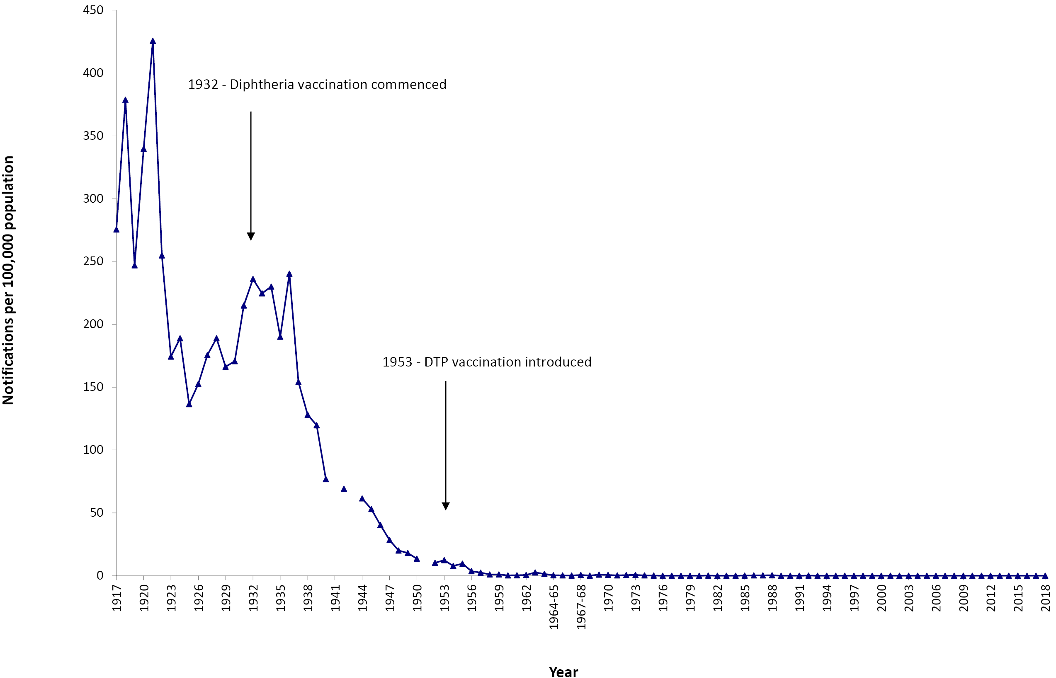
a Data are reported by calendar year from 1917–1963 and 1970–2018 and by financial year 1963/1964–1969/1970.
Source: National Notifiable Diseases Surveillance System; and Hall R. Notifiable disease surveillance, 1917 to 1991. Commun Dis Intell. 1993;17(11):226–36.

Figure A.2: Notifications of Haemophilus influenzae type b, 1991 to 2018,ª Australia
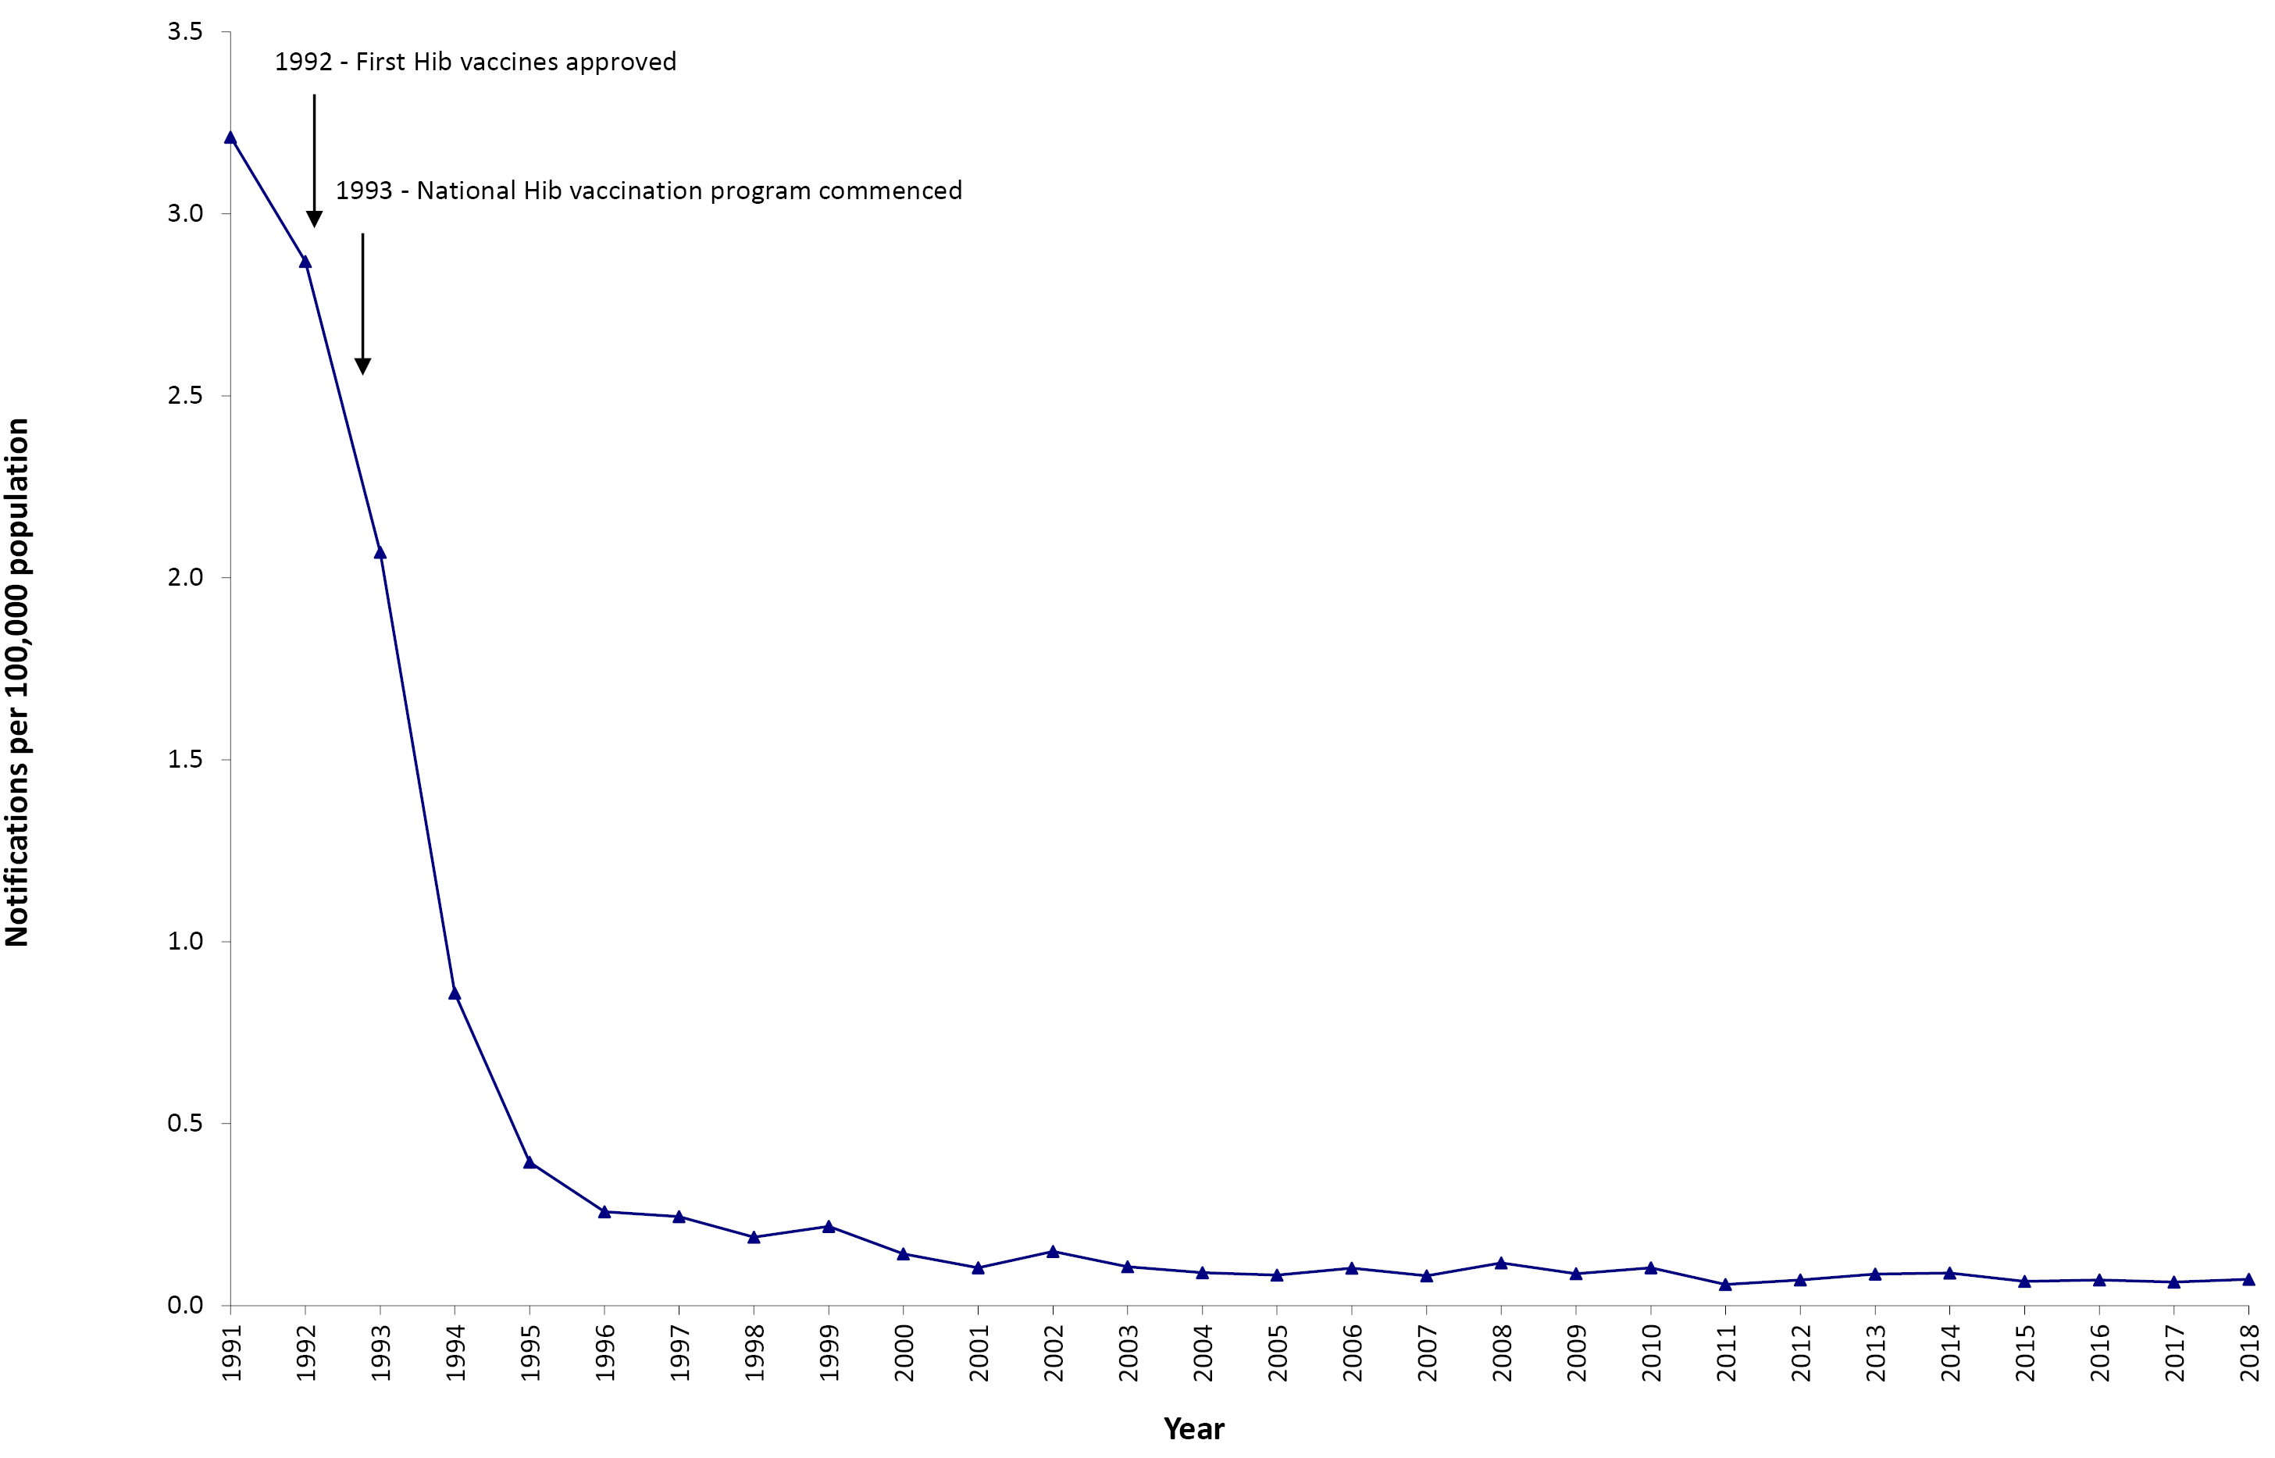
a Source: National Notifiable Diseases Surveillance System; and Hall R. Notifiable disease surveillance, 1917 to 1991. Commun Dis Intell. 1993;17(11):226–36.
Figure A.3: Notifications of hepatitis A, 1952 to 2018,ª Australia
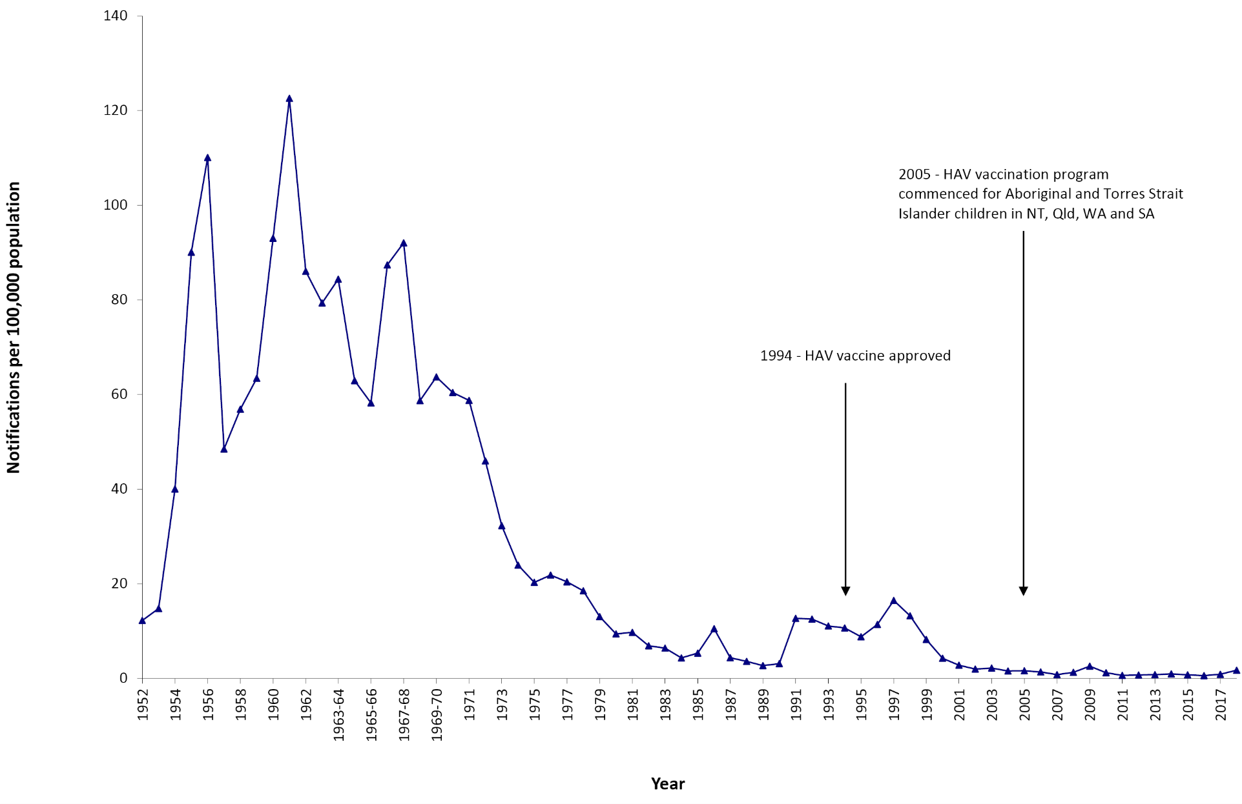
a Data are reported by calendar year from 1952–1963 and 1970–2018 and by financial year 1963/1964–1969/1970.
Source: National Notifiable Diseases Surveillance System; and Hall R. Notifiable disease surveillance, 1917 to 1991. Commun Dis Intell. 1993;17(11):226–36.
Figure A.4: Notifications of measles, 1917 to 2018,ª Australia
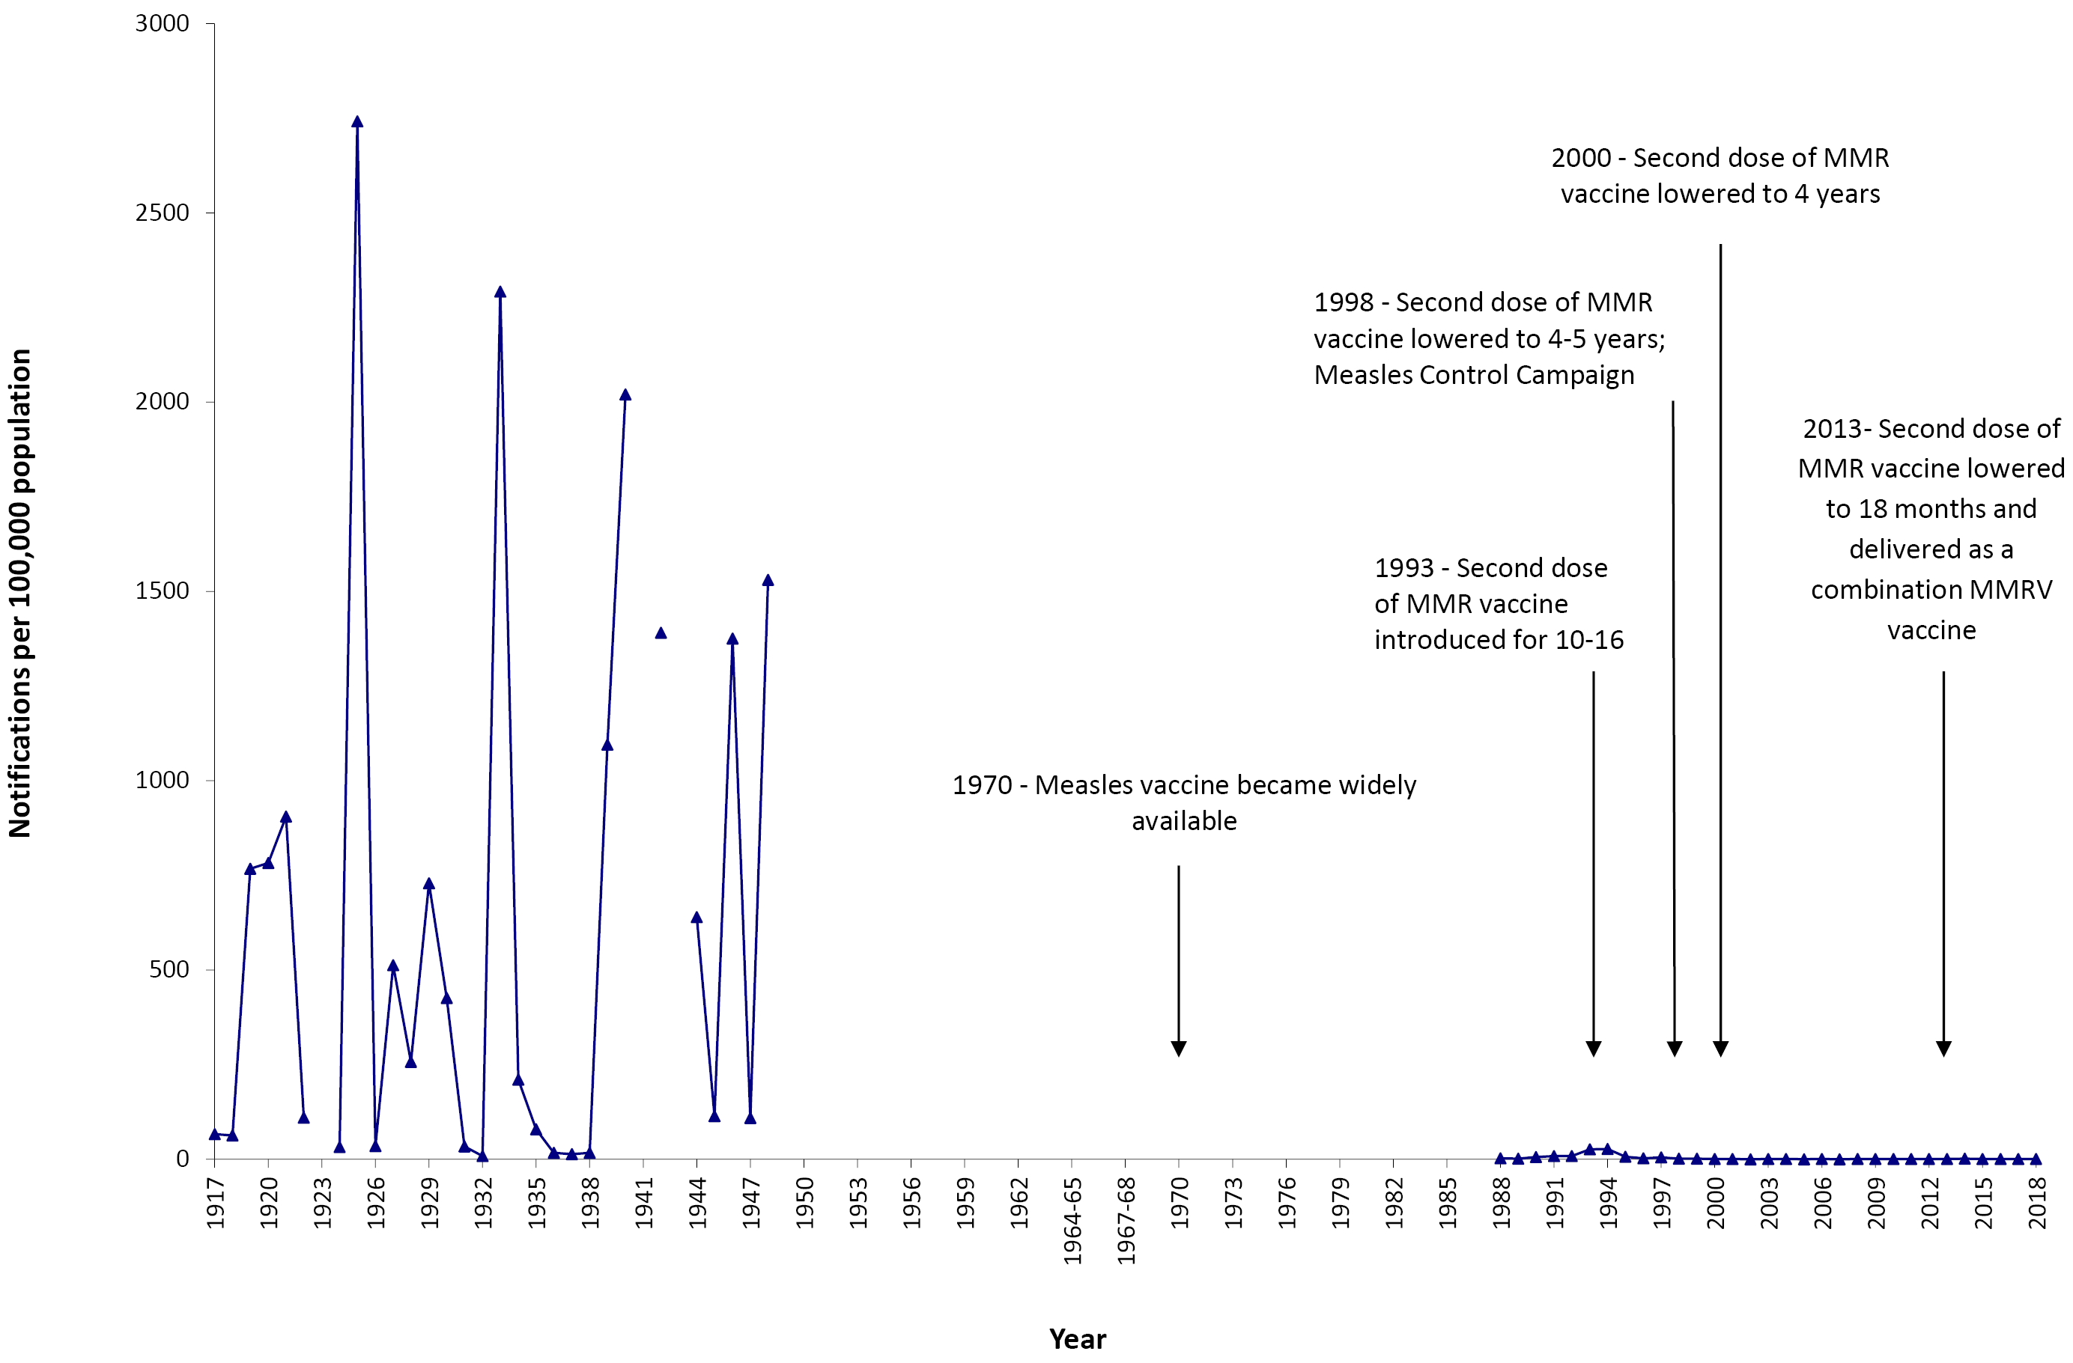
a Data are reported by calendar year from 1917–1963 and 1970–2018 and by financial year 1963/1964–1969/1970.
Source: National Notifiable Diseases Surveillance System; and Hall R. Notifiable disease surveillance, 1917 to 1991. Commun Dis Intell. 1993;17(11):226–36.
Figure A.5: Notifications of meningococcal disease (invasive), 1949 to 2018,ª Australia
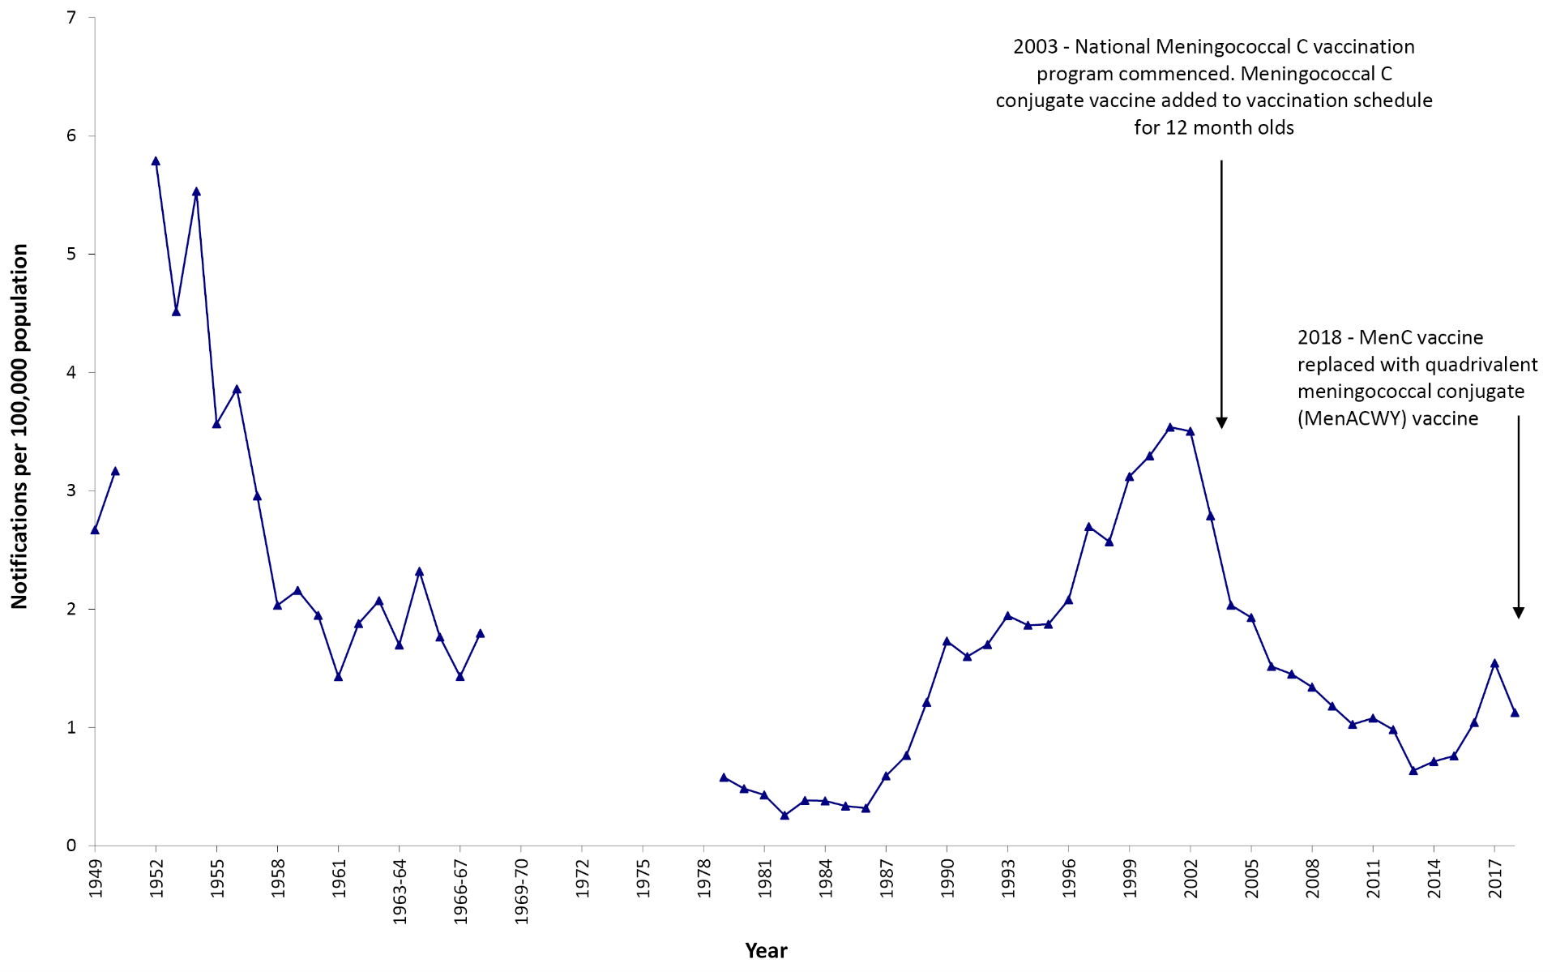
a Data are reported by calendar year from 1949–1963 and 1970–2018 and by financial year 1963/1964–1969/1970.
Source: National Notifiable Diseases Surveillance System; and Hall R. Notifiable disease surveillance, 1917 to 1991. Commun Dis Intell. 1993;17(11):226–36.

Figure A.6: Notifications of mumps, 1932 to 2018,a Australia
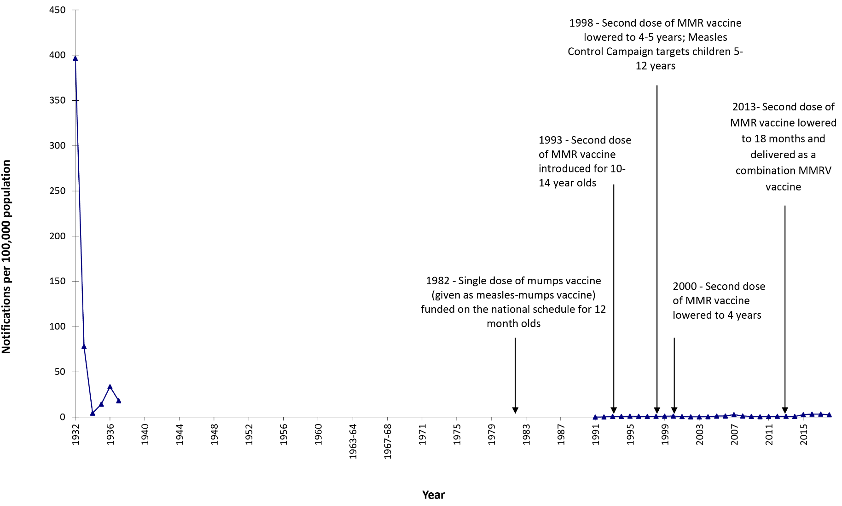
a Data are reported by calendar year from 1932–1963 and 1970–2018 and by financial year 1963/1964–1969/1970.
Source: National Notifiable Diseases Surveillance System; and Hall R. Notifiable disease surveillance, 1917 to 1991. Commun Dis Intell. 1993;17(11):226–36.

Figure A.7: Notifications of pertussis, 1917 to 2018,ª Australia
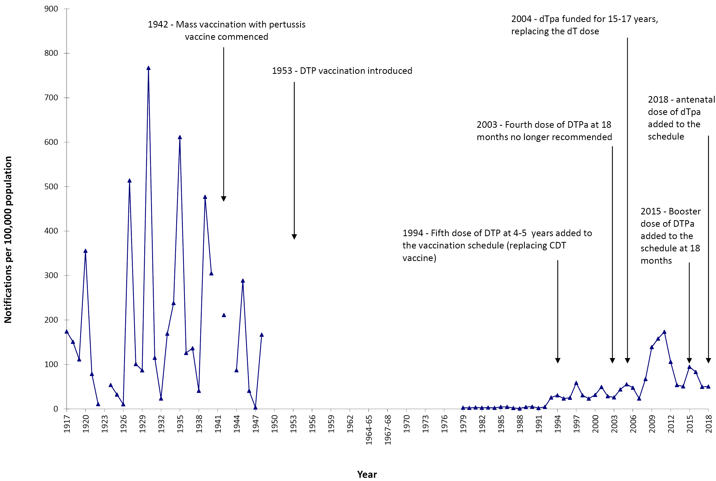
a Data are reported by calendar year from 1917–1963 and 1970–2015 and by financial year 1963/1964–1969/1970.
Source: National Notifiable Diseases Surveillance System; and Hall R. Notifiable disease surveillance, 1917 to 1991. Commun Dis Intell. 1993;17(11):226–36.

Figure A.8: Notifications of poliomyelitis, 1917 to 2018,ª Australia
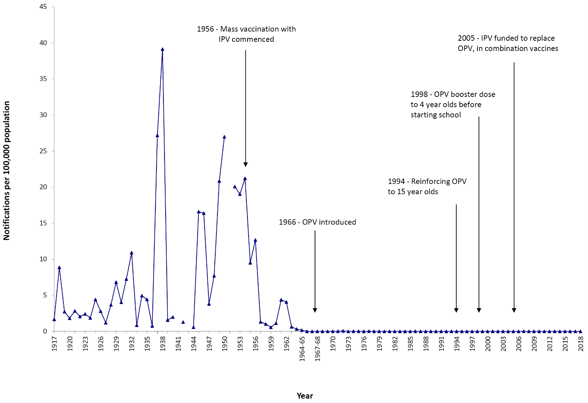
a Data are reported by calendar year from 1942–1963 and 1970–2018 and by financial year 1963/1964–1969/1970.
Source: National Notifiable Diseases Surveillance System; and Hall R. Notifiable disease surveillance, 1917 to 1991. Commun Dis Intell. 1993;17(11):226–36.

Figure A.9: Notifications of rubella, 1942 to 2018,ª Australia
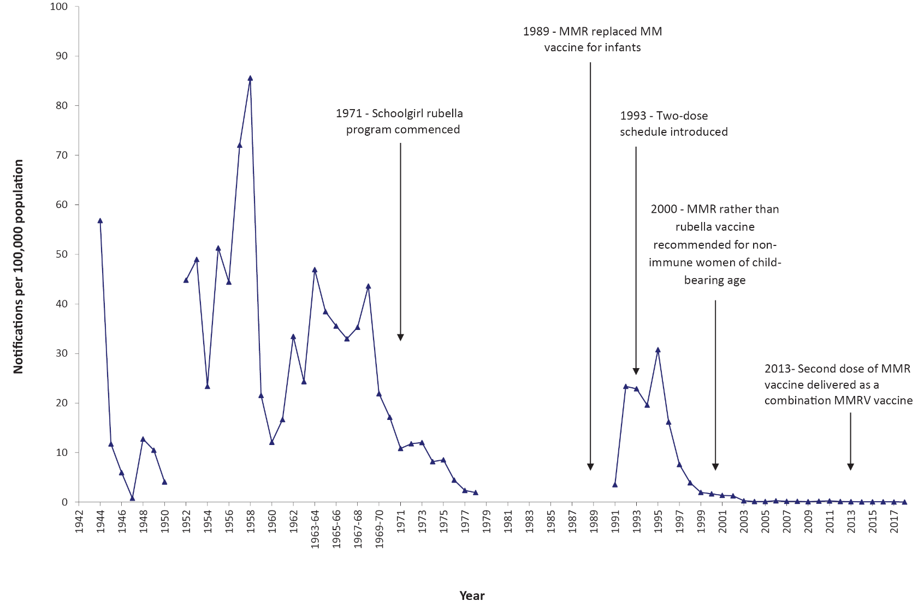
a Data are reported by calendar year from 1921–1963 and 1970–2018 and by financial year 1963/1964–1969/1970.
Source: National Notifiable Diseases Surveillance System; and Hall R. Notifiable disease surveillance, 1917 to 1991. Commun Dis Intell. 1993;17(11):226–36.

Figure A.10: Notifications of tetanus, 1921 to 2018,ª Australia
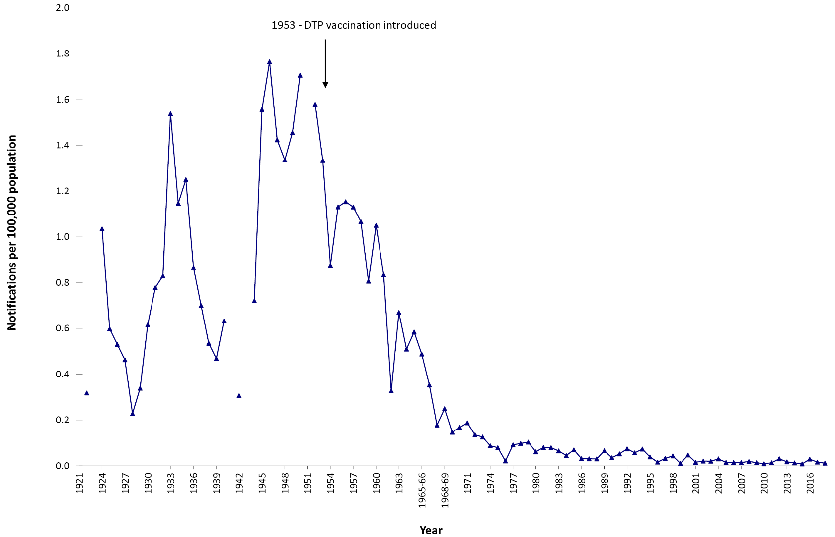

a Data are reported by calendar year from 1921–1963 and 1970–2018 and by financial year 1963/1964–1969/1970.
Source: National Notifiable Diseases Surveillance System; and Hall R. Notifiable disease surveillance, 1917 to 1991. Commun Dis Intell. 1993;17(11):226–36.

Appendix B. Notifications by state or territory
Table A.1: Notifications and notification rates for vaccine preventable diseases, Australia, 1 January 2016 to 31 December 2018,ª by state or territory and year
Disease | Year | Number of notifications |  |  |  |  |  |  |  |  | Notification rate per 100,000 population
 |  | ACT | NSW | NT | Qld | SA | Tas. | Vic. | WA | Total | ACT | NSW | NT | Qld | SA | Tas. | Vic. | WA | Total
Diphtheria | 2016 | 0 | 0 | 0 | 8 | 0 | 0 | 0 | 0 | 8 | 0.00 | 0.00 | 0.00 | 0.17 | 0.00 | 0.00 | 0.00 | 0.00 | 0.03
 | 2017 | 0 | 0 | 0 | 4 | 0 | 0 | 3 | 1 | 8 | 0.00 | 0.00 | 0.00 | 0.08 | 0.00 | 0.00 | 0.05 | 0.04 | 0.03
 | 2018 | 0 | 4 | 0 | 6 | 1 | 0 | 0 | 0 | 11 | 0.00 | 0.05 | 0.00 | 0.12 | 0.06 | 0.00 | 0.00 | 0.00 | 0.04
 | Total^{b} | 0 | 4 | 0 | 18 | 1 | 0 | 3 | 1 | 27 | 0.00 | 0.02 | 0.00 | 0.12 | 0.02 | 0.00 | 0.02 | 0.01 | 0.04
Haemophilus influenzae type b | 2016 | 0 | 5 | 1 | 5 | 1 | 0 | 4 | 1 | 17 | 0.00 | 0.06 | 0.41 | 0.10 | 0.06 | 0.00 | 0.06 | 0.04 | 0.07
 | 2017 | 0 | 9 | 2 | 3 | 0 | 0 | 2 | 0 | 16 | 0.00 | 0.11 | 0.81 | 0.06 | 0.00 | 0.00 | 0.03 | 0.00 | 0.07
 | 2018 | 0 | 6 | 1 | 7 | 3 | 0 | 0 | 1 | 18 | 0.00 | 0.08 | 0.40 | 0.14 | 0.17 | 0.00 | 0.00 | 0.04 | 0.07
 | Total^{b} | 0 | 20 | 4 | 15 | 4 | 0 | 6 | 2 | 51 | 0.00 | 0.08 | 0.54 | 0.10 | 0.08 | 0.00 | 0.03 | 0.03 | 0.07
Hepatitis A | 2016 | 2 | 43 | 0 | 30 | 7 | 0 | 46 | 17 | 145 | 0.50 | 0.56 | 0.00 | 0.62 | 0.41 | 0.00 | 0.75 | 0.67 | 0.60
 | 2017 | 2 | 70 | 0 | 26 | 23 | 0 | 84 | 12 | 217 | 0.49 | 0.89 | 0.00 | 0.53 | 1.33 | 0.00 | 1.33 | 0.47 | 0.88
 | 2018 | 2 | 87 | 2 | 43 | 21 | 3 | 264 | 12 | 434 | 0.48 | 1.09 | 0.81 | 0.86 | 1.21 | 0.57 | 4.09 | 0.46 | 1.74
 | Total^{b} | 6 | 200 | 2 | 99 | 51 | 3 | 394 | 41 | 796 | 0.49 | 0.85 | 0.27 | 0.67 | 0.99 | 0.19 | 2.08 | 0.53 | 1.08
Hepatitis B (acute) | 2016 | 3 | 15 | 2 | 66 | 6 | 2 | 59 | 25 | 178 | 0.74 | 0.19 | 0.81 | 1.36 | 0.35 | 0.39 | 0.96 | 0.98 | 0.74
 | 2017 | 1 | 11 | 7 | 48 | 12 | 5 | 41 | 21 | 146 | 0.24 | 0.14 | 2.83 | 0.97 | 0.70 | 0.96 | 0.65 | 0.82 | 0.59
 | 2018 | 0 | 22 | 5 | 32 | 4 | 3 | 44 | 27 | 137 | 0.00 | 0.28 | 2.02 | 0.64 | 0.23 | 0.57 | 0.68 | 1.04 | 0.55
 | Total^{b} | 4 | 48 | 14 | 146 | 22 | 10 | 144 | 73 | 461 | 0.32 | 0.20 | 1.89 | 0.99 | 0.43 | 0.64 | 0.76 | 0.95 | 0.62
Influenza | 2016 | 1,604 | 35,602 | 701 | 23,282 | 7,874 | 1,055 | 12,924 | 7,837 | 90,879 | 397.91 | 460.40 | 285.33 | 480.52 | 459.70 | 203.86 | 209.36 | 306.61 | 375.67
 | 2017 | 3,098 | 103,874 | 1,474 | 56,592 | 28,490 | 3,506 | 48,120 | 6,009 | 251,163 | 751.90 | 1,320.22 | 595.51 | 1,148.46 | 1,652.63 | 671.12 | 761.20 | 233.43 | 1,020.91
 | 2018 | 476 | 17,520 | 1,195 | 15,697 | 5,897 | 452 | 11,758 | 5,870 | 58,865 | 113.23 | 219.54 | 483.69 | 313.35 | 339.59 | 85.56 | 181.96 | 226.28 | 235.62
 | Total^{b} | 5,178 | 156,996 | 3,370 | 95,571 | 42,261 | 5,013 | 72,802 | 19,716 | 400,907 | 419.10 | 665.77 | 455.25 | 646.53 | 816.91 | 319.66 | 384.04 | 255.24 | 543.42
Measles | 2016 | 2 | 18 | 0 | 15 | 11 | 3 | 39 | 11 | 99 | 0.50 | 0.23 | 0.00 | 0.31 | 0.64 | 0.58 | 0.63 | 0.43 | 0.41
 | 2017 | 2 | 30 | 2 | 8 | 1 | 0 | 21 | 17 | 81 | 0.49 | 0.38 | 0.81 | 0.16 | 0.06 | 0.00 | 0.33 | 0.66 | 0.33
 | 2018 | 3 | 19 | 0 | 14 | 2 | 1 | 26 | 38 | 103 | 0.71 | 0.24 | 0.00 | 0.28 | 0.12 | 0.19 | 0.40 | 1.46 | 0.41
 | Total^{b} | 7 | 67 | 2 | 37 | 14 | 4 | 86 | 66 | 283 | 0.57 | 0.28 | 0.27 | 0.25 | 0.27 | 0.26 | 0.45 | 0.85 | 0.38
Meningococcal disease (invasive) | 2016 | 2 | 71 | 2 | 45 | 27 | 5 | 79 | 21 | 252 | 0.50 | 0.92 | 0.81 | 0.93 | 1.58 | 0.97 | 1.28 | 0.82 | 1.04
 | 2017 | 2 | 91 | 32 | 69 | 36 | 16 | 89 | 45 | 380 | 0.49 | 1.16 | 12.93 | 1.40 | 2.09 | 3.06 | 1.41 | 1.75 | 1.54
 | 2018 | 2 | 72 | 11 | 58 | 34 | 11 | 53 | 40 | 281 | 0.48 | 0.90 | 4.45 | 1.16 | 1.96 | 2.08 | 0.82 | 1.54 | 1.12
 | Total^{b} | 6 | 234 | 45 | 172 | 97 | 32 | 221 | 106 | 913 | 0.49 | 0.99 | 6.08 | 1.16 | 1.88 | 2.04 | 1.17 | 1.37 | 1.24
Mumps | 2016 | 1 | 67 | 137 | 62 | 20 | 4 | 32 | 481 | 804 | 0.25 | 0.87 | 55.76 | 1.28 | 1.17 | 0.77 | 0.52 | 18.82 | 3.32
 | 2017 | 4 | 128 | 147 | 401 | 62 | 3 | 44 | 23 | 812 | 0.97 | 1.63 | 59.39 | 8.14 | 3.60 | 0.57 | 0.70 | 0.89 | 3.30
 | 2018 | 1 | 71 | 39 | 475 | 11 | 1 | 18 | 18 | 634 | 0.24 | 0.89 | 15.79 | 9.48 | 0.63 | 0.19 | 0.28 | 0.69 | 2.54
 | Total^{b} | 6 | 266 | 323 | 938 | 93 | 8 | 94 | 522 | 2250 | 0.49 | 1.13 | 43.63 | 6.35 | 1.80 | 0.51 | 0.50 | 6.76 | 3.05
Pertussis | 2016 | 506 | 10831 | 224 | 2157 | 1960 | 30 | 2892 | 1520 | 20120 | 125.53 | 140.06 | 91.18 | 44.52 | 114.43 | 5.80 | 46.85 | 59.47 | 83.17
 | 2017 | 254 | 5270 | 110 | 1343 | 1741 | 40 | 1970 | 1507 | 12235 | 61.65 | 66.98 | 44.44 | 27.25 | 100.99 | 7.66 | 31.16 | 58.54 | 49.73
 | 2018 | 274 | 6352 | 68 | 1763 | 705 | 415 | 1693 | 1313 | 12583 | 65.18 | 79.60 | 27.52 | 35.19 | 40.60 | 78.55 | 26.20 | 50.61 | 50.37
 | Total^{b} | 1034 | 22453 | 402 | 5263 | 4406 | 485 | 6555 | 4340 | 44938 | 83.69 | 95.22 | 54.31 | 35.60 | 85.17 | 30.93 | 34.58 | 56.19 | 60.91
Pneumococcal disease (invasive) | 2016 | 28 | 542 | 46 | 265 | 137 | 50 | 396 | 200 | 1664 | 6.95 | 7.01 | 18.72 | 5.47 | 8.00 | 9.66 | 6.41 | 7.82 | 6.88
 | 2017 | 23 | 697 | 65 | 311 | 212 | 48 | 497 | 197 | 2050 | 5.58 | 8.86 | 26.26 | 6.31 | 12.30 | 9.19 | 7.86 | 7.65 | 8.33
 | 2018 | 21 | 667 | 55 | 369 | 149 | 44 | 516 | 207 | 2028 | 5.00 | 8.36 | 22.26 | 7.37 | 8.58 | 8.33 | 7.99 | 7.98 | 8.12
 | Total^{b} | 72 | 1906 | 166 | 945 | 498 | 142 | 1409 | 604 | 5742 | 5.83 | 8.08 | 22.42 | 6.39 | 9.63 | 9.05 | 7.43 | 7.82 | 7.78
Q fever | 2016 | 2 | 233 | 2 | 238 | 28 | 0 | 44 | 12 | 559 | 0.50 | 3.01 | 0.81 | 4.91 | 1.63 | 0.00 | 0.71 | 0.47 | 2.31
 | 2017 | 0 | 210 | 0 | 214 | 21 | 3 | 21 | 9 | 478 | 0.00 | 2.67 | 0.00 | 4.34 | 1.22 | 0.57 | 0.33 | 0.35 | 1.94
 | 2018 | 2 | 223 | 0 | 215 | 30 | 0 | 32 | 13 | 515 | 0.48 | 2.79 | 0.00 | 4.29 | 1.73 | 0.00 | 0.50 | 0.50 | 2.06
 | Total^{b} | 4 | 666 | 2 | 667 | 79 | 3 | 97 | 34 | 1552 | 0.32 | 2.82 | 0.27 | 4.51 | 1.53 | 0.19 | 0.51 | 0.44 | 2.10
Rotavirus | 2016 | N/A | N/A | N/A | N/A | N/A | N/A | N/A | N/A | N/A | N/A | N/A | N/A | N/A | N/A | N/A | N/A | N/A | N/A
 | 2017 | N/A | N/A | N/A | N/A | N/A | N/A | N/A | N/A | N/A | N/A | N/A | N/A | N/A | N/A | N/A | N/A | N/A | N/A
 | 2018^{c} | 15 | 368 | 49 | 505 | 285 | 19 | 15 | 197 | 1453 | 7.14 | 9.22 | 39.67 | 20.16 | 32.82 | 7.19 | 0.46 | 15.19 | 11.63
 | Total^{c} | 15 | 368 | 49 | 505 | 285 | 19 | 15 | 197 | 1453 | 7.14 | 9.22 | 39.67 | 20.16 | 32.82 | 7.19 | 0.46 | 15.19 | 11.63
Rubella | 2016 | 0 | 7 | 0 | 3 | 0 | 1 | 5 | 1 | 17 | 0.00 | 0.09 | 0.00 | 0.06 | 0.00 | 0.19 | 0.08 | 0.04 | 0.07
 | 2017 | 0 | 5 | 0 | 3 | 0 | 0 | 0 | 2 | 10 | 0.00 | 0.06 | 0.00 | 0.06 | 0.00 | 0.00 | 0.00 | 0.08 | 0.04
 | 2018 | 0 | 0 | 0 | 5 | 0 | 0 | 3 | 1 | 9 | 0.00 | 0.00 | 0.00 | 0.10 | 0.00 | 0.00 | 0.05 | 0.04 | 0.04
 | Total^{b} | 0 | 12 | 0 | 11 | 0 | 1 | 8 | 4 | 36 | 0.00 | 0.05 | 0.00 | 0.07 | 0.00 | 0.06 | 0.04 | 0.05 | 0.05
Tetanus | 2016 | 0 | 0 | 0 | 4 | 0 | 0 | 2 | 1 | 7 | 0.00 | 0.00 | 0.00 | 0.08 | 0.00 | 0.00 | 0.03 | 0.04 | 0.03
 | 2017 | 0 | 1 | 0 | 1 | 2 | 0 | 0 | 0 | 4 | 0.00 | 0.01 | 0.00 | 0.02 | 0.12 | 0.00 | 0.00 | 0.00 | 0.02
 | 2018 | 0 | 0 | 0 | 1 | 0 | 0 | 1 | 1 | 3 | 0.00 | 0.00 | 0.00 | 0.02 | 0.00 | 0.00 | 0.02 | 0.04 | 0.01
 | Total^{b} | 0 | 1 | 0 | 6 | 2 | 0 | 3 | 2 | 14 | 0.00 | 0.00 | 0.00 | 0.04 | 0.04 | 0.00 | 0.02 | 0.03 | 0.02
a Notifications source: National Notifiable Diseases Surveillance System, Office of Health Protection, Department of Health. Data extracted in April 2017 version and subject to retrospective revision.
b Total cases for 3-year period and average annual rate per 100,000 population.
c Total cases for 6-month period July to December 2018 only (i.e. since rotavirus became a nationally notifiable disease); rates have been annualised.

Appendix C. Hospitalisations by state or territory
Table A.2: Hospitalisation rates for vaccine preventable diseases, Australia, 1 January 2016 to 31 December 2018, by state or territory and year
Disease | Year | Hospitalisation rate per 100,000 population
 |  | ACT | NSW | NT | Qld | SA | Tas. | Vic. | WA | Total
Diphtheriaª | 2016 | 0.00 | 0.04 | 0.41 | 0.06 | 0.12 | 0.00 | 0.05 | 0.00 | 0.05
 | 2017 | 0.00 | 0.05 | 0.40 | 0.14 | 0.00 | 0.00 | 0.05 | 0.00 | 0.06
 | 2018 | 0.00 | 0.03 | 0.40 | 0.12 | 0.00 | 0.00 | 0.02 | 0.00 | 0.04
 | Total^{b} | 0.00 | 0.04 | 0.41 | 0.11 | 0.04 | 0.00 | 0.04 | 0.00 | 0.05
Haemophilus influenzae meningitis^{c} | 2016 | – | – | – | – | – | – | – | – | –
 | 2017 | – | – | – | – | – | – | – | – | –
 | 2018 | – | – | – | – | – | – | – | – | –
 | Total | – | – | – | – | – | – | – | – | –
Hepatitis A | 2016 | 6.70 | 1.29 | 1.22 | 0.74 | 1.58 | 0.19 | 1.62 | 0.82 | 1.35
 | 2017 | 1.46 | 1.56 | 2.83 | 0.55 | 2.32 | 0.19 | 1.72 | 0.78 | 1.37
 | 2018 | 2.14 | 1.52 | 1.62 | 0.86 | 1.04 | 1.70 | 3.51 | 0.93 | 1.86
 | Total^{b} | 3.40 | 1.46 | 1.89 | 0.72 | 1.64 | 0.70 | 2.30 | 0.84 | 1.53
Hepatitis B (acute) (principal diagnosis only) | 2016 | 0.00 | 0.23 | 0.81 | 0.33 | 0.18 | 0.19 | 0.55 | 0.31 | 0.35
 | 2017 | 0.73 | 0.23 | 1.62 | 0.47 | 0.23 | 0.19 | 0.38 | 0.35 | 0.36
 | 2018 | 0.24 | 0.41 | 3.24 | 0.34 | 0.06 | 0.00 | 0.43 | 0.39 | 0.41
 | Total^{b} | 0.32 | 0.29 | 1.89 | 0.38 | 0.15 | 0.13 | 0.45 | 0.35 | 0.37
Influenza | 2016 | 93.5 | 94.5 | 109.5 | 116.8 | 103.9 | 67.2 | 61.1 | 55.7 | 87.4
 | 2017 | 167.2 | 247.6 | 269.5 | 257.5 | 254.4 | 207.3 | 157.5 | 51.4 | 206.0
 | 2018 | 30.9 | 52.9 | 208.5 | 80.0 | 66.6 | 31.2 | 54.4 | 50.7 | 61.0
 | Total^{b} | 96.8 | 131.5 | 196.0 | 151.3 | 141.5 | 101.8 | 90.9 | 52.5 | 118.0
Measles | 2016 | 0.00 | 0.14 | 0.00 | 0.12 | 0.47 | 0.00 | 0.44 | 0.04 | 0.25
 | 2017 | 0.97 | 0.17 | 0.81 | 0.14 | 0.00 | 0.19 | 0.11 | 0.27 | 0.17
 | 2018 | 0.24 | 0.18 | 0.40 | 0.18 | 0.06 | 0.38 | 0.31 | 0.35 | 0.25
 | Total^{b} | 0.40 | 0.16 | 0.41 | 0.15 | 0.17 | 0.19 | 0.28 | 0.22 | 0.22
Meningococcal disease | 2016 | 0.50 | 1.32 | 0.81 | 1.82 | 2.34 | 0.97 | 1.47 | 1.06 | 1.50
 | 2017 | 0.24 | 1.72 | 15.35 | 1.83 | 3.48 | 4.59 | 1.63 | 2.41 | 2.10
 | 2018 | 0.71 | 1.13 | 4.05 | 1.98 | 2.53 | 2.65 | 1.32 | 2.24 | 1.63
 | Total^{b} | 0.49 | 1.39 | 6.75 | 1.87 | 2.78 | 2.74 | 1.47 | 1.90 | 1.74
Mumps | 2016 | 0.00 | 0.28 | 6.51 | 0.60 | 0.29 | 0.19 | 0.42 | 1.13 | 0.53
 | 2017 | 0.49 | 0.48 | 3.64 | 0.95 | 0.35 | 0.38 | 0.38 | 0.23 | 0.56
 | 2018 | 0.24 | 0.48 | 2.02 | 1.16 | 0.23 | 0.76 | 0.42 | 0.15 | 0.57
 | Total^{b} | 0.24 | 0.42 | 4.05 | 0.91 | 0.29 | 0.45 | 0.41 | 0.50 | 0.56
Pertussis | 2016 | 1.74 | 3.78 | 2.85 | 3.84 | 5.08 | 0.97 | 2.32 | 1.17 | 3.15
 | 2017 | 1.46 | 2.48 | 4.85 | 2.66 | 5.86 | 0.19 | 1.47 | 2.64 | 2.48
 | 2018 | 0.24 | 2.13 | 5.67 | 1.76 | 1.21 | 1.33 | 1.49 | 1.19 | 1.74
 | Total^{b} | 1.13 | 2.79 | 4.46 | 2.74 | 4.04 | 0.83 | 1.75 | 1.67 | 2.45
Pneumococcal diseased | 2016 | 17.12 | 19.36 | 56.17 | 13.99 | 13.95 | 18.55 | 14.22 | 13.38 | 16.49
 | 2017 | 13.59 | 23.55 | 71.51 | 15.26 | 17.81 | 21.63 | 15.77 | 13.75 | 18.98
 | 2018 | 9.04 | 22.09 | 70.43 | 17.87 | 12.78 | 27.45 | 15.24 | 14.07 | 18.57
 | Total^{b} | 13.19 | 21.68 | 66.06 | 15.73 | 14.85 | 22.57 | 15.09 | 13.74 | 18.02
Q fever | 2016 | 0.00 | 0.84 | 0.81 | 2.95 | 0.76 | 0.19 | 0.19 | 0.47 | 1.03
 | 2017 | 0.00 | 1.05 | 2.83 | 2.17 | 0.87 | 0.57 | 0.17 | 0.43 | 0.97
 | 2018 | 0.24 | 1.27 | 0.00 | 2.67 | 0.81 | 0.00 | 0.29 | 0.19 | 1.11
 | Total^{b} | 0.08 | 1.06 | 1.22 | 2.60 | 0.81 | 0.26 | 0.22 | 0.36 | 1.04
Rotavirus | 2016 | 0.25 | 2.77 | 11.80 | 8.67 | 5.49 | 4.06 | 0.60 | 0.82 | 3.51
 | 2017 | 3.40 | 7.26 | 53.73 | 15.16 | 20.71 | 7.47 | 2.34 | 3.34 | 8.58
 | 2018 | 0.24 | 1.57 | 23.48 | 4.91 | 5.41 | 3.98 | 1.55 | 2.16 | 2.85
 | Total^{b} | 1.30 | 3.86 | 29.72 | 9.56 | 10.53 | 5.17 | 1.50 | 2.11 | 4.98
Rubellaª | 2016 | 0.00 | 0.04 | 0.00 | 0.04 | 0.00 | 0.00 | 0.02 | 0.04 | 0.03
 | 2017 | 0.00 | 0.05 | 0.00 | 0.00 | 0.12 | 0.00 | 0.00 | 0.00 | 0.02
 | 2018 | 0.00 | 0.01 | 0.00 | 0.00 | 0.06 | 0.00 | 0.02 | 0.00 | 0.01
 | Total^{b} | 0.00 | 0.03 | 0.00 | 0.01 | 0.06 | 0.00 | 0.01 | 0.01 | 0.02
Congenital Rubella Syndrome | 2016 | 0.00 | 0.05 | 0.00 | 0.08 | 0.00 | 0.00 | 0.06 | 0.04 | 0.05
 | 2017 | 0.00 | 0.00 | 0.00 | 0.00 | 0.00 | 0.00 | 0.02 | 0.00 | 0.00
 | 2018 | 0.00 | 0.01 | 0.00 | 0.24 | 0.00 | 0.00 | 0.06 | 0.04 | 0.07
 | Total^{b} | 0.00 | 0.02 | 0.00 | 0.11 | 0.00 | 0.00 | 0.05 | 0.03 | 0.04
Tetanusª | 2016 | 0.00 | 0.12 | 0.00 | 0.19 | 0.00 | 0.00 | 0.06 | 0.08 | 0.11
 | 2017 | 0.00 | 0.06 | 0.00 | 0.04 | 0.12 | 0.19 | 0.03 | 0.00 | 0.05
 | 2018 | 0.00 | 0.03 | 0.00 | 0.06 | 0.06 | 0.00 | 0.06 | 0.15 | 0.06
 | Total^{b} | 0.00 | 0.07 | 0.00 | 0.09 | 0.06 | 0.06 | 0.05 | 0.08 | 0.07
Varicella | 2016 | 3.22 | 2.99 | 4.48 | 3.84 | 4.26 | 2.32 | 3.09 | 2.46 | 3.25
 | 2017 | 1.94 | 2.73 | 4.44 | 4.02 | 3.77 | 4.40 | 2.97 | 2.72 | 3.24
 | 2018 | 1.90 | 3.41 | 4.86 | 4.19 | 3.92 | 3.03 | 3.20 | 2.70 | 3.50
 | Total^{b} | 2.35 | 3.04 | 4.59 | 4.02 | 3.98 | 3.25 | 3.09 | 2.63 | 3.33
Zoster | 2016 | 26.54 | 32.02 | 30.53 | 34.32 | 36.31 | 33.04 | 30.81 | 25.12 | 31.82
 | 2017 | 28.64 | 30.29 | 27.47 | 33.65 | 29.06 | 28.90 | 29.82 | 26.26 | 30.36
 | 2018 | 20.70 | 29.07 | 28.33 | 35.43 | 28.39 | 28.01 | 30.84 | 25.02 | 30.29
 | Total^{b} | 25.25 | 30.44 | 28.77 | 34.47 | 31.24 | 29.97 | 30.49 | 25.46 | 30.82
a Hospitalisations for rare diseases such as diphtheria, rubella and tetanus should be interpreted with caution due to possible misclassification, coding and data related issues. Diphtheria hospitalisations coded here include non-respiratory and non-toxigenic diphtheria infections.
b Average annual rate per 100,000 population. The rates are based on hospitalisations (in public and private hospitals) by date of admission and state of residence.
c Retained for consistency with previous reports in this series. Data for Haemophilus influenzae (Hib) hospitalisations are not presented because the available ICD-10 codes are not type specific.
d Pneumococcal meningitis, septicaemia or pneumonia.

Appendix D. Abbreviations
Abbreviations | Definitions
4vHPV | Quadrivalent human papillomavirus vaccine
9vHPV | Nonavalent human papillomavirus vaccine
ABS | Australian Bureau of Statistics
ACR | Australian Coordinating Registry
AFP | Acute flaccid paralysis
AIHW | Australian Institute of Health and Welfare
AIR | Australian Immunisation Register
COD URF | Cause of Death Unit Record File
CRS | Congenital rubella syndrome
DTPa | diphtheria-tetanus-pertussis vaccine
dTpa | diphtheria-tetanus-pertussis vaccine (reduced antigen formulation)
Hib | Haemophilus influenzae type b
Hib-MenC | Haemophilus influenzae type b- meningococcal serogroup C vaccine
HZ | Herpes zoster
ICD | International Classification of Diseases
ICD-9-CM | International Classification of Diseases, Ninth Revision, Clinical Modification
ICD-10-AM | International Statistical Classification of Diseases and Related Health Problems, 10th Revision, Australian Modification
IMD | Invasive meningococcal disease
IPD | Invasive pneumococcal disease
LOS | Length of stay (hospitalisations)
MenACWY | Quadrivalent meningococcal conjugate vaccine
NCIRS | National Centre for Immunisation Research and Surveillance
NCIS | National Coronial Information System
NIP | National Immunisation Program
NNDSS | National Notifiable Diseases Surveillance System
PCR | Polymerase chain reaction
PCV7 | 7-valent pneumococcal conjugate vaccine
PCV13 | 13-valent pneumococcal conjugate vaccine
PEP | Polio Expert Panel
PPV23 | 23-valent pneumococcal polysaccharide vaccine
VAPP | Vaccine-associated paralytic poliomyelitis
VDPV | Vaccine-derived poliovirus
VPD | Vaccine preventable disease
VZV | Varicella-zoster virus
WHO | World Health Organization

Communicable Diseases Intelligence
ISSN: 2209-6051 Online

Communicable Diseases Intelligence (CDI) is a peer-reviewed scientific journal published by the Office of Health Protection and Response, Department of Health. The journal aims to disseminate information on the epidemiology, surveillance, prevention and control of communicable diseases of relevance to Australia.

Editor: Noel Lally
Deputy Editor: Simon Petrie
Design and Production: Kasra Yousefi
Editorial Advisory Board: David Durrheim, Mark Ferson, John Kaldor, Martyn Kirk and Linda Selvey

Website: http://www.health.gov.au/cdi

Contacts
CDI is produced by the Office of Health Protection and Response, Australian Government Department of Health, GPO Box 9848, (MDP 6) CANBERRA ACT 2601

Email: cdi.editor@health.gov.au

Submit an Article
You are invited to submit your next communicable disease related article to the Communicable Diseases Intelligence (CDI) for consideration. More information regarding CDI can be found at: http://health.gov.au/cdi.
Further enquiries should be directed to: cdi.editor@health.gov.au.

This journal is indexed by Index Medicus and Medline.

Creative Commons Licence - Attribution-NonCommercial-NoDerivatives CC BY-NC-ND
© 2022 Commonwealth of Australia as represented by the Department of Health
This publication is licensed under a Creative Commons Attribution-NonCommercial-NoDerivatives 4.0 International Licence from https://creativecommons.org/licenses/by-nc-nd/4.0/legalcode (Licence). You must read and understand the Licence before using any material from this publication.

Restrictions
The Licence does not cover, and there is no permission given for, use of any of the following material found in this publication (if any):
- the Commonwealth Coat of Arms (by way of information, the terms under which the Coat of Arms may be used can be found at www.itsanhonour.gov.au);
- any logos (including the Department of Health’s logo) and trademarks;
- any photographs and images;
- any signatures; and
- any material belonging to third parties.

Disclaimer
Opinions expressed in Communicable Diseases Intelligence are those of the authors and not necessarily those of the Australian Government Department of Health or the Communicable Diseases Network Australia. Data may be subject to revision.

Enquiries
Enquiries regarding any other use of this publication should be addressed to the Communication Branch, Department of Health, GPO Box 9848, Canberra ACT 2601, or via e-mail to: copyright@health.gov.au

Communicable Diseases Network Australia
Communicable Diseases Intelligence contributes to the work of the Communicable Diseases Network Australia.
http://www.health.gov.au/cdna

http://www.ncirs.org.au/health-professionals/history-immunisation-australia.
https://www.health.gov.au/casedefinitions.

