Surveillance for severe influenza and COVID-19 in patients admitted to sentinel Australian hospitals in 2020: the Influenza Complications Alert Network (FluCAN)
Husna Begum, Dominic E Dwyer, Mark Holmes, Louis B Irving, Graham Simpson, Sanjaya Senanayake, Tony Korman, N Deborah Friedman, Louise Cooley, Peter Wark, Simon Bowler, Jen Kok, John W Upham, Daniel M Fatovich, Grant W Waterer, Kristine Macartney, Christopher C Blyth, Nigel Crawford, Jim Buttery, Helen S Marshall, Julia E Clark, Joshua R Francis, Tom Kotsimbos, Paul M Kelly, Allen C Cheng

Abstract

Introduction
Influenza is a common cause of acute respiratory infection, and is a major cause of morbidity and mortality. Coronavirus disease 2019 (COVID-19) is an acute respiratory infection that emerged as a pandemic worldwide before the start of the 2020 Australian influenza season. This report summarises the epidemiology of hospitalisations with laboratory-confirmed influenza and COVID-19 during the 2020 influenza season in a sentinel surveillance system.

Methods
The Influenza Complications Alert Network (FluCAN) is a sentinel hospital-based surveillance program that operates at sites in all jurisdictions in Australia. Influenza and COVID-19 cases were defined as patients hospitalised at sentinel hospitals and confirmed by nucleic acid detection.

Results
There were 448 patients with COVID-19 admitted between 16 March and 31 December 2020, and only 20 patients with influenza admitted between 1 April and 30 November 2020, to one of 22 FluCAN hospitals. Of the COVID-19 cases, 173 (39%) were > 65 years of age, 36 (8%) were children (< 16 years), 6 (1%) were Aboriginal and Torres Strait Islander peoples, 4 (1%) were pregnant and 289 (65%) had chronic comorbidities. COVID-19 hospital admissions peaked between weeks 13 and 15 (first wave) nationally, and again between weeks 31 and 35 (Victoria), with most admissions represented by those above 40 years of age.

Discussion
There was an unusually low number of hospital admissions with laboratory-confirmed influenza in this season, compared to recent seasons. This is likely to be due to effective public health interventions and international border closures as a result of a rise in COVID-19 respiratory infections and associated hospitalisations.
Keywords: Influenza, public health surveillance, influenza vaccines, vaccination coverage, coronavirus

Introduction
In 2020, most countries saw an unprecedented rise in viral respiratory tract infections worldwide caused by a unique respiratory coronavirus, SARS-CoV-2. Coronavirus disease 2019 (COVID-19) resulted in substantial morbidity and mortality, and was declared a pandemic by the World Health Organization (WHO) on 11 March 2020. While the countries in the Southern Hemisphere were preparing for the upcoming winter respiratory pathogen infections, it was anticipated that there would be a co-circulation of both COVID-19 and the influenza virus, amongst other respiratory viruses.
Influenza is an acute respiratory viral infection caused by influenza viruses. Global studies suggest that, along with respiratory syncytial virus (RSV), influenza A and B are the most common viruses identified in surveillance systems.¹ It has been estimated that influenza caused 9.5 million hospitalisations and 145,000 deaths in 2017.² In Australia, an analysis of administrative hospital data found that influenza is diagnosed in up to 10,000 admissions annually, with the highest incidence in children and the elderly.³ In 2020, the COVID-19 pandemic caused an unprecedented rise in hospitalisations due to acute respiratory illness caused by SARS-CoV-2, while simultaneously resulting in an all-time low record of influenza infections in Australia.⁴ In this report, we characterise the epidemiology of hospitalisations in Australia due to influenza and COVID-19.

Methods
The Influenza Complications Alert Network (FluCAN) is a national hospital-based sentinel surveillance system,^{5–7} with the capacity to activate data collection for new infections such as the current pandemic. Since 2011, the participating sites have been:
- Canberra Hospital (Australian Capital Territory, ACT)
- Calvary Hospital (ACT)
- Westmead Hospital (New South Wales, NSW)
- John Hunter Hospital (NSW)
- Children’s Hospital at Westmead (NSW)
- Alice Springs Hospital (Northern Territory, NT)
- Mater Hospital (Queensland, Qld)
- Princess Alexandra Hospital (Qld)
- Cairns Base Hospital (Qld),
- Royal Adelaide Hospital (South Australia, SA)
- Royal Hobart Hospital (Tasmania, Tas.)
- The Alfred Hospital (Victoria, Vic.)
- Royal Melbourne Hospital (Vic.)
- Monash Medical Centre (Vic.)
- University Hospital Geelong (Vic.)
- Royal Perth Hospital (Western Australia, WA)
- Perth Children’s Hospital (previously Princess Margaret Hospital; WA)
Since 2018, additional specialist paediatric hospitals—Queensland Children’s Hospital (previously Lady Cilento Children’s Hospital, QLD); Women’s and Children’s Hospital (SA); the paediatric ward of the Royal Darwin Hospital (NT); and Royal Children’s Hospital (VIC)—also have contributed data. Influenza vaccine effectiveness has been estimated in previous years but was not examined in 2020 due to low numbers. Data were also collected for hospitalised COVID-19 patients in this network of sentinel hospitals. Research ethics has been obtained at all participating sites and at Monash University. Hospital bed capacity statistics were obtained from each participating hospital, and national bed capacity was obtained from the last published Australian Institute of Health and Welfare (AIHW) report.⁸
An influenza or COVID-19 case was defined as a patient admitted to hospital with influenza or COVID-19 as confirmed by nucleic acid testing (NAT). Surveillance was conducted from mid-March to the end of December 2020 for COVID-19 cases, and from April to November 2020 for influenza cases. Patients who were admitted with an acute respiratory infection but tested negative for influenza (including those with COVID-19) were regarded as influenza controls. Admission or transfer to an intensive care unit (ICU) included patients managed in a high dependency unit (HDU). The onset date was defined as the date of admission except for patients where the date of the test was more than seven days after admission, where the onset date was the date of the test. The presence of risk factors and comorbidities was ascertained from the patient’s medical record.
We examined factors associated with ICU admission using multivariable regression. Factors independently associated with ICU admission were determined using a logistic regression model with no variable selection process, as all included factors were plausibly related to ICU admission. We modelled factors associated with length of hospital stay using a negative binomial regression, where the exponential of the regression coefficient represents the relative increase in hospital length of stay.
The presentation delay was defined as the time from the date of symptom onset to the date of admission to hospital. For influenza patients, the treatment delay was defined as the time from onset of illness to prescription of oseltamivir (in patients that received treatment). Patients were categorised into those that either (a) did not receive oseltamivir; (b) received oseltamivir within two days of symptom onset; or (c) received oseltamivir more than two days after symptom onset.

Results

Influenza
During the influenza season (1 April – 30 November 2020), a total of 20 patients were admitted with laboratory-confirmed influenza to the 17 FluCAN sentinel hospitals. The majority of cases were due to influenza A (A/H1N1= 25%; A/unknown = 40%) and B (30%) (Table 1).
Of the 20 patients admitted with confirmed influenza, five (25%) were ≥ 65 years of age, eight (40%) were children (< 16 years), five (25%) were Aboriginal and Torres Strait Islander peoples, and eleven (55%) had chronic comorbidities (Table 1; Table 2). There were no pregnant women hospitalised at FluCAN sentinel hospitals with influenza in 2020. Peak hospital admission was reported on week 13 (n = 5, equivalent to 25% of influenza positive cases) as seen in Figure 1. Of all cases, only one influenza patient (5%) was admitted to ICU (Table 2).
Overall, the peak incidence of admissions with confirmed influenza was 1.2 per 100 hospital beds in the Children’s Hospital at Westmead (Appendix Figures 1 and 2; in epidemiological week 13).

Figure 1: Date of admissionª in patients hospitalised with confirmed influenza
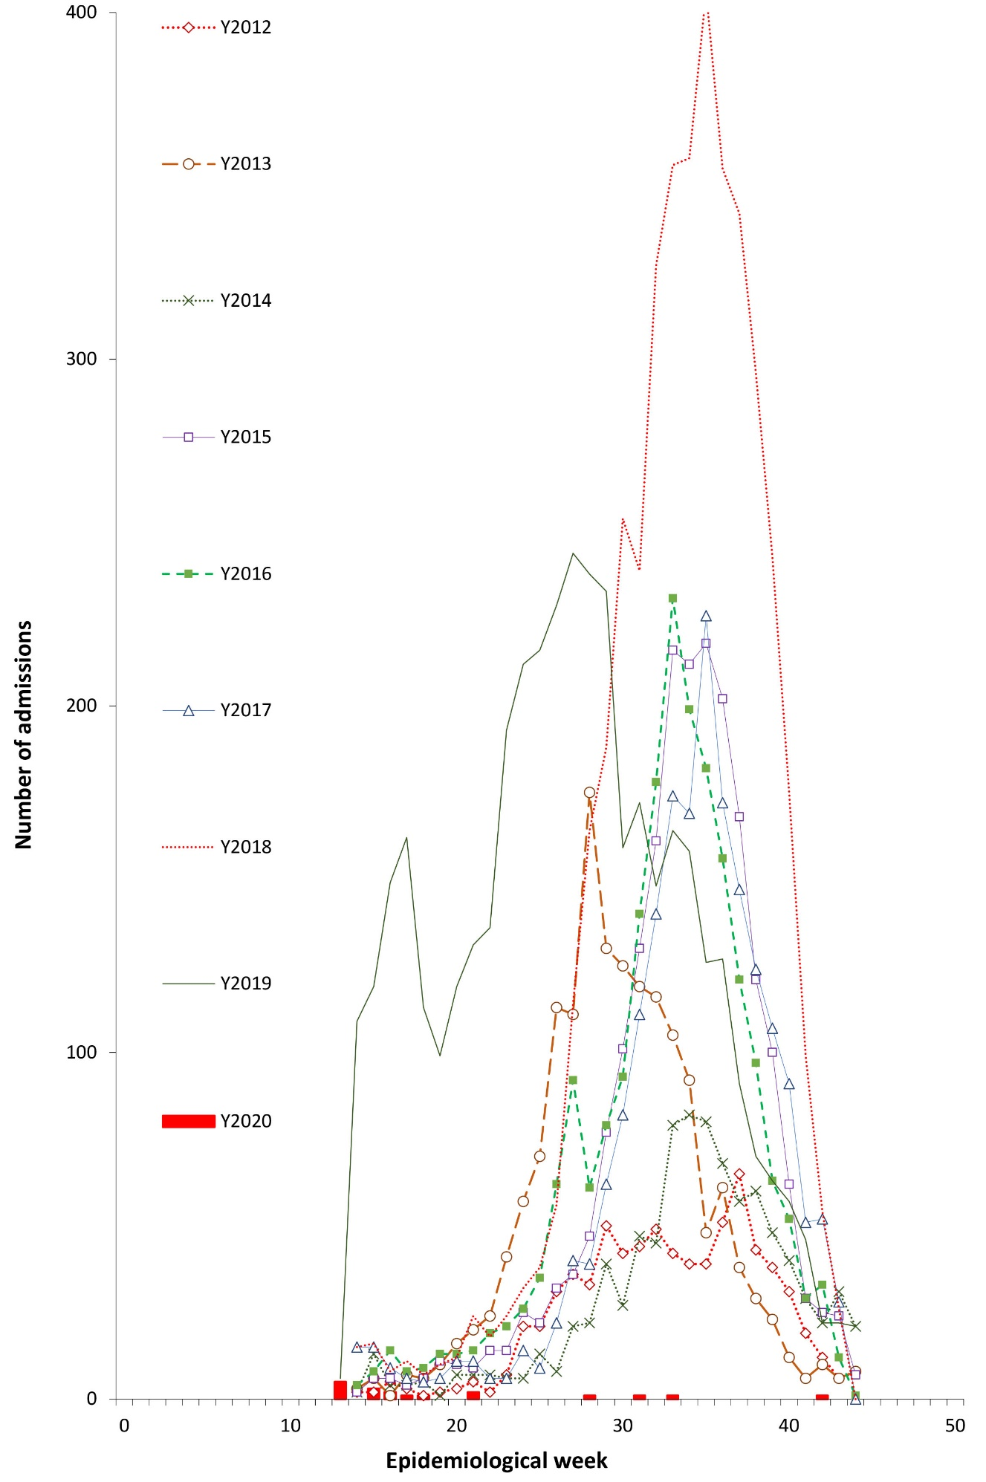
a By week beginning on listed date; representing date of admission (or date of influenza diagnosis if acquired > 7 days in hospital).

Use of antivirals and vaccine effectiveness
Of the 17 influenza cases where the date of onset was reported, 47% did not receive oseltamivir, 6% received oseltamivir within two days of symptom onset and 17% received oseltamivir more than two days after the onset of illness. Oseltamivir use was lower in children (13% within two days; a further 13% more than two days) than in non-elderly adults (0%; 80%) and the elderly (0%; 75%) (Appendix, Table A.1). The small number of cases precluded meaningful estimation of vaccine effectiveness. However, influenza vaccination coverage was estimated based on the vaccination status of patients without influenza (including those with COVID-19) (Table 3). Estimated influenza vaccine was 74% (88/119) in the elderly (≥ 65 years), and 50% (52/104) in non-elderly adults with medical comorbidities. In children below 16 years of age, the estimated influenza vaccine coverage was 19% (11/58).

Table 1: Demographic characteristics of hospitalised patients with confirmed influenza
 | Influenza type/subtype |  |  |  |  |  |  |  | Total  ( n = 20 )
 | A/H1N1  ( n = 5; 25%) |  | A/H3N2  ( n = 1; 5%) |  | A/unknown  ( n = 8; 40%) |  | B  ( n = 6; 30%)
 | A/H1N1 | %ª | A/H3N2 | %ª | A/unknown | %ª | B | %ª | n | %ª
Age group
< 16 years | 5 | 100 | 0 | 0 | 1 | 13 | 2 | 33 | 8 | 40
16–49 years | 0 | 0 | 0 | 0 | 1 | 13 | 3 | 50 | 4 | 20
50–64 years | 0 | 0 | 0 | 0 | 2 | 25 | 1 | 17 | 3 | 15
65–79 years | 0 | 0 | 1 | 100 | 2 | 25 | 0 | 0 | 3 | 15
80+ years | 0 | 0 | 0 | 0 | 2 | 25 | 0 | 0 | 2 | 10
Male | 3 | 60 | 1 | 100 | 7 | 88 | 3 | 50 | 14 | 70
Pregnant | 0 | 0 | 0 | 0 | 0 | 0 | 0 | 0 | 0 | 0
Aboriginal and Torres Strait Islander | 0 | 0 | 0 | 0 | 2 | 25 | 3 | 50 | 5 | 25
Jurisdiction
ACT | 0 | 0 | 0 | 0 | 0 | 0 | 0 | 0 | 0 | 0
NSW | 5 | 100 | 1 | 100 | 2 | 25 | 0 | 0 | 8 | 40
NT | 0 | 0 | 0 | 0 | 0 | 0 | 4 | 67 | 4 | 20
Qld | 0 | 0 | 0 | 0 | 2 | 25 | 0 | 0 | 2 | 10
SA | 0 | 0 | 0 | 0 | 0 | 0 | 1 | 17 | 1 | 5
Tas. | 0 | 0 | 0 | 0 | 0 | 0 | 0 | 0 | 0 | 0
Vic. | 0 | 0 | 0 | 0 | 3 | 38 | 1 | 17 | 4 | 20
WA | 0 | 0 | 0 | 0 | 1 | 13 | 0 | 0 | 1 | 5
a Percentage within the indicated demographic category or jurisdiction among all cases of this influenza subtype (i.e., denominator = n).

Table 2: Risk factors, severity and outcomes in hospitalised patients with confirmed influenza
 | Not admitted to ICU  ( n = 19; 95%) |  | Admitted to ICU  ( n = 1; 5%) |  | Total  ( n = 20 )
 | n | %ª | n | %ª | n | %ª
Pregnant | 0 | 0 | 0 | 0 | 0 | 0
Chronic comorbidities | 11 | 58 | 0 | 0 | 11 | 55
Chronic respiratory illness | 3 | 16 | 0 | 0 | 3 | 15
Diabetes | 2 | 11 | 0 | 0 | 2 | 10
Chronic liver disease | 1 | 5 | 0 | 0 | 1 | 5
Immunosuppressed | 1 | 5 | 0 | 0 | 1 | 5
Malignancy | 0 | 0 | 0 | 0 | 0 | 0
Chronic cardiac disease | 4 | 21 | 0 | 0 | 4 | 20
Obesity | 1 | 5 | 0 | 0 | 1 | 5
Chronic neurological illness | 2 | 11 | 0 | 0 | 2 | 10
Chronic renal disease | 2 | 11 | 0 | 0 | 2 | 10
Nursing home resident | 0 | 0 | 0 | 0 | 0 | 0
Received influenza vaccine | 2 | 15 | 0 | 0 | 2 | 14
Influenza subtype
A/H1N1 | 4 | 21 | 1 | 100 | 5 | 25
A/H3N2 | 1 | 5 | 0 | 0 | 1 | 5
A/unknown | 8 | 42 | 0 | 0 | 8 | 40
B | 6 | 32 | 0 | 0 | 6 | 30
In-hospital mortality, HFRª | 3/19 | 16 | 0/1 | 0 | 3/20 | 15
a Percentage having the indicated comorbidity or influenza subtype among all cases having this ICU status (i.e., denominator = n).
b HFR: Hospitalisation fatality ratio.
Table 3: Estimated influenza vaccine coverage among patients without influenza
 |  | Not vaccinated | Vaccinated | Total | Vaccination %
Age < 16 | No risk factors | 30 | 6 | 36 | 16.7
 | Risk factors | 17 | 5 | 22 | 22.7
 | Total | 47 | 11 | 58 | 19.0
Age 16–64 | No risk factors | 56 | 33 | 89 | 37.1
 | Risk factors | 52 | 52 | 104 | 50.0
 | Total | 108 | 85 | 193 | 44.0
Age ≥ 65 | No risk factors | 9 | 12 | 21 | 57.1
 | Risk factors | 31 | 88 | 119 | 73.9
 | Total | 40 | 100 | 140 | 71.4
No comorbidities |  | 95 | 51 | 146 | 34.9
Medical comorbidities |  | 100 | 145 | 245 | 59.1
Total |  | 195 | 196 | 391 | 50.1

COVID-19
During the period 16 March – 31 December 2020, 448 patients were admitted with laboratory-confirmed COVID-19 at all participating hospitals, of which 400 patients were from 17 FluCAN sentinel hospitals and 48 patients at other paediatric hospitals. Data are presented for admissions at all participating hospitals (Table 4).
Of these 448 admitted with confirmed COVID-19, 173 (39%) were ≥ 65 years of age, 36 (8%) were children (< 16 years), six (1%) were Aboriginal and Torres Strait Islander peoples, and 289 (65%) had chronic comorbidities (Table 4).
There were four pregnant women (2%) hospitalised with COVID-19 during this timeframe. COVID-19 hospital admissions peaked between week 13 and 15 (first wave) nationally, and again between weeks 31 and 35 (second wave) predominantly in Victoria, with most admissions represented by those above 40 years of age (Figure 2).⁹

Incidence of hospital admissions with COVID-19
In Victoria’s second COVID-19 wave, the peak incidence of admissions with confirmed COVID-19 was 5.4 per 100 hospital beds at the Royal Melbourne Hospital (Figure 3; in epidemiological week 28). During this time, peak bed occupancy at across six Victorian hospitals varied from 0.88 at the Royal Children’s Hospital to 5.39 at the Royal Melbourne Hospital.
Figure 2: Distribution of age group and week of admission across all patients hospitalised with confirmed COVID-19
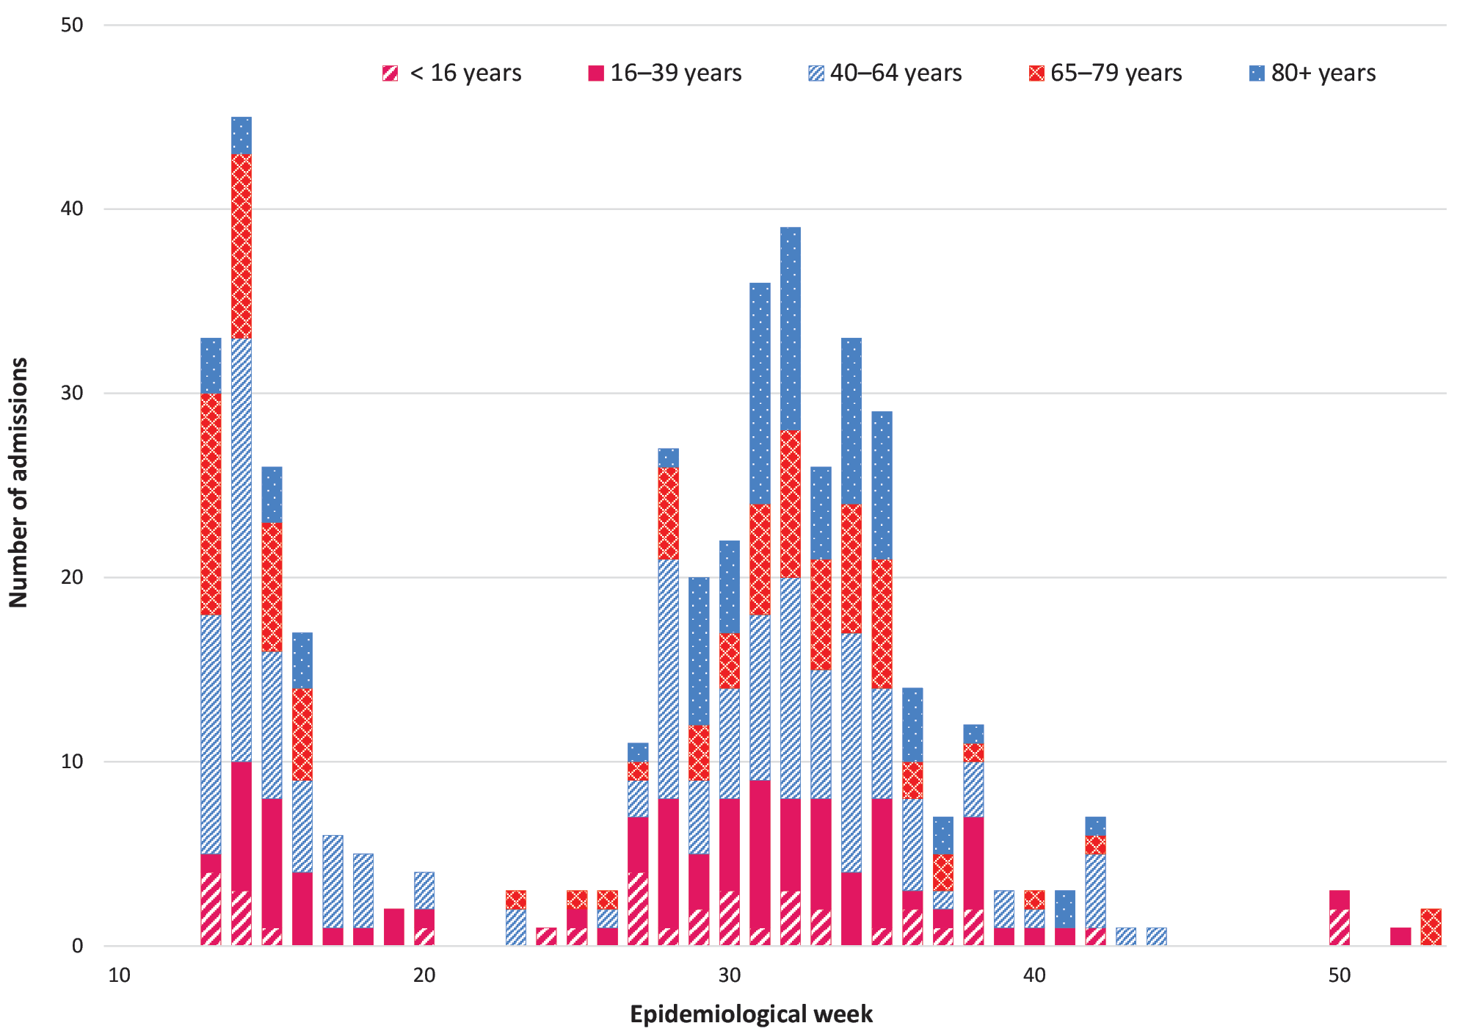

Figure 3: Peak incidence of confirmed COVID-19 (per 100 hospital beds per week) by hospitalª
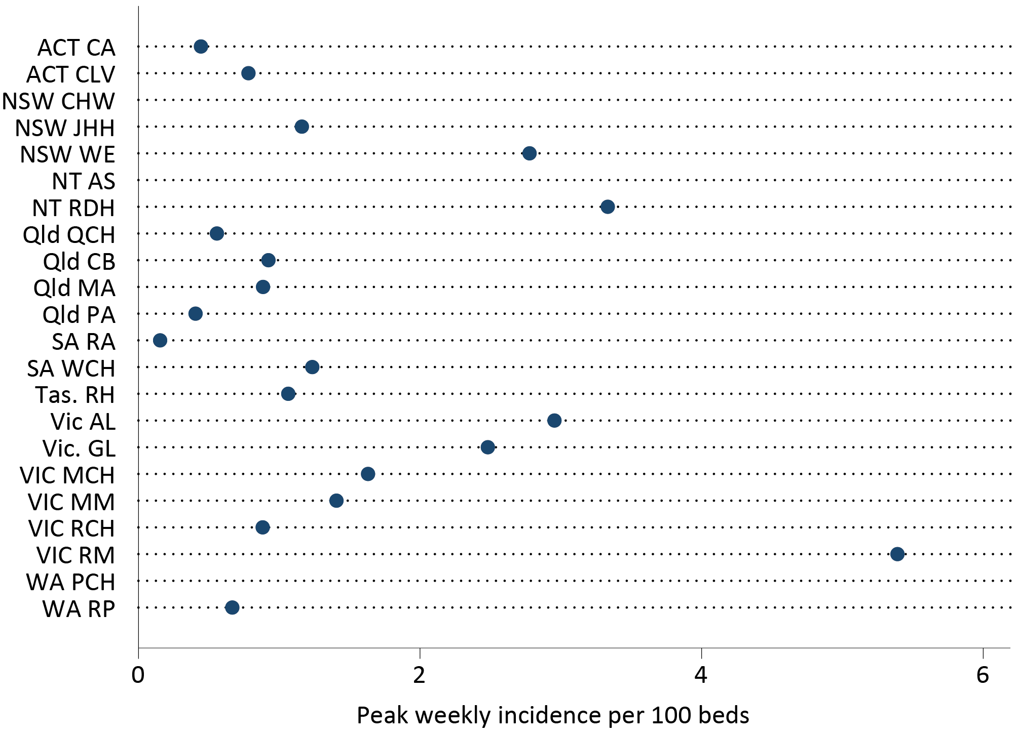
a CA: Canberra Hospital; CLV: Calvary Hospital; CHW: Children’s Hospital at Westmead; JHH: John Hunter Hospital; WE: Westmead Hospital; AS: Alice Springs Hospital; RDH: Royal Darwin Hospital; QCH: Queen’s Children Hospital; CB: Cairns Base Hospital; MA: Mater Hospital; PA: Princess Alexandra Hospital; RA: Royal Adelaide; WCH: Women’s and Children’s Hospital; RH: Royal Hobart Hospital; AL: The Alfred Hospital; GL: University Hospital Geelong; MCH: Monash Children’s Hospital; MM: Monash Medical Centre; RCH: Royal Children’s Hospital; RM: Royal Melbourne; PCH: Perth Children’s Hospital; RP: Royal Perth Hospital.

Table 4: Demographic characteristics of hospitalised patients with confirmed COVID-19
 | Not admitted to ICU  (n = 378; 84.4%) |  | Admitted to ICU  (n = 70; 15.6%) |  | Total  ( n = 448)
 | n | %ª | n | %ª | n | %ª
Age group
< 16 years | 32 | 8 | 4 | 6 | 36 | 8
16–40 years | 74 | 20 | 12 | 17 | 86 | 19
40–64 years | 121 | 32 | 32 | 46 | 153 | 34
65–79 years | 72 | 19 | 20 | 29 | 92 | 21
80+ years | 79 | 21 | 2 | 3 | 81 | 18
Male | 197 | 52 | 45 | 64 | 242 | 54
Pregnant | 3 | 1 | 1 | 1 | 4 | 1
Aboriginal and Torres Strait Islander peoples | 6 | 2 | 0 | 0 | 6 | 1
Chronic comorbidities | 236 | 62 | 53 | 76 | 289 | 65
Jurisdiction
ACT | 5 | 1 | 4 | 6 | 9 | 2
NSW | 48 | 13 | 21 | 30 | 69 | 15
NT | 1 | < 1 | 0 | 0 | 1 | < 1
Qld | 33 | 9 | 0 | 0 | 33 | 7
SA | 6 | 2 | 1 | 1 | 7 | 2
Tas. | 10 | 3 | 0 | 0 | 10 | 2
Vic. | 270 | 72 | 44 | 63 | 314 | 70
WA | 5 | 1 | 0 | 0 | 5 | 1
In-hospital mortality
Diedª | 37 | 11c | 6 | 12d | 43 | 11
a Percentage within the indicated category or jurisdiction among all cases having this ICU status (i.e., denominator = n).
b Mortality status reported based on 400 patients with known mortality outcome.
c Denominator = 351.
d Denominator = 49.

Presentation and management
Of all COVID-19 cases, 25 patients (6%) did not have a date of symptom onset documented. Where the duration of symptoms was known, the median duration of symptoms prior to admission was six days (interquartile range (IQR): 3, 9 days).
Radiological evidence of pneumonia was present in 158 patients (35%). There were no children (< 16 years) with pneumonia detected. The proportion of patients with pneumonia was slightly higher in non-elderly adults (21%) than in elderly adults (15%). A higher proportion of patients with pneumonia were admitted to ICU (29%) than those without pneumonia (8%).
Of all cases, 70 COVID-19 patients (16%) were admitted into ICU (Table 4). Among COVID-19 patients, those who were male; those 40–64 years of age; or those who possessed chronic comorbidities were more likely to be admitted to ICU (Table 5). Hospital length of stay was correlated with older age and longer in those with medical comorbidities and those who were admitted into intensive care (Table 6).
Table 5: Factors associated with admission to intensive care in patients hospitalised with confirmed COVID-19
Variableª | Crude OR^{b} (IQR) | p value | Adjusted OR^{b,c} (IQR) | p value
Age
16–39 years | 0.46 (0.22, 0.98) | 0.04 | 0.63 (0.29, 1.39) | 0.26
40–64 years | 1.03 (0.58, 1.82) | 0.93 | 1.19 (0.66, 2.15) | 0.56
65–79 years | 1 (referent) |  | 1 (referent)
> 80 years | 0.17 (0.06, 0.47) | < 0.01 | 0.18 (0.07, 0.51) | < 0.01
Medical comorbidities | 1.64 (0.99, 2.71) | 0.06 | 1.82 (1.02, 3.09) | 0.03
Pregnancy | 1.20 (0.12, 11.63) | 0.88 | 1.48 (0.14, 15.58) | 0.74
Male | 2.02 (1.23, 3.32) | < 0.01 | 1.72 (1.02, 2.89) | 0.04
a Observations for those < 16 years age or Aboriginal and Torres Strait Islander patients in ICU were omitted from the analysis.
b OR: odds ratio.
c All variables included in multivariate model.
Table 6: Factors associated with length of stay in patients with confirmed COVID-19
Variable | Crude rate ratioª (IQR) | p value | Adjusted rate ratio (IQR) | p value
Age group
< 16 years | 0.55 (0.33, 0.91) | 0.02 | 0.65 (0.41, 1.04)^{b} | 0.07
16–39 years | 0.56 (0.48, 0.64) | < 0.01 | 0.65 (0.56, 0.77) | < 0.01
40–64 years | 0.75 (0.59, 0.94) | 0.01 | 0.78 (0.63, 0.97) | 0.03
65–79 years | 1 (referent) |  | 1 (referent)
> 80 years | 0.97 (0.83, 1.13) | 0.69 | 1.06 (0.95, 1.18) | 0.30
Comorbidities | 1.74 (1.38, 2.21) | < 0.01 | 1.37 (1.14, 1.65) | < 0.01
Male | 1.16 (1.04, 1.30) | < 0.01 | 1.05 (0.89, 1.23) | 0.59
Aboriginal or Torres Strait Islander peoples | 0.71 (0.31, 1.62) | 0.41 | 0.93 (0.50, 1.72) | 0.82
Pregnancy | 0.68 (0.61, 0.76) | < 0.01 | 0.62 (0.53, 0.72) | < 0.01
ICU admission | 1.59 (1.24, 2.04) | < 0.01 | 1.66 (1.30, 2.11) | < 0.01
a Represents relative difference in length of stay; rate ratio > 1 indicates longer stay associated with factor.
b Omitted ICU status but includes age.

Outcome
Of the 356 patients with known length of stay, the mean length of hospital stay was 9.8 days. Admission to ICU was associated with a mean hospital length of stay of 10.8 days compared to those not admitted to ICU (9.1 days). Of the 400 patients where hospital mortality status was documented, 43 patients died (11%); of these, 6 deaths (14%) occurred in patients admitted to ICU, and 37 deaths (86%) in those not admitted to ICU.

Discussion
The 2020 pandemic year was characterised by an unusually low number of influenza cases in contrast to the several thousand influenza admissions in 2018 and 2019.⁴ The near-absent influenza season is likely to reflect closed international borders (with strict quarantine for arrivals) as well as public health interventions that were put in place for COVID-19, such as mandatory mask wearing in some states, staged lockdowns with restricted movement of the public, and maintenance of physical distancing both indoors and outdoors. Although school-aged children are thought to be a driver for influenza transmission (in contrast to COVID-19), influenza activity remained low despite schools being open in most states.
Surveillance for COVID-19 was able to be established quickly using the pre-existing influenza surveillance system; however, this was limited only to surveillance at sentinel sites. In our study, the COVID-19 surveillance provided additional detail on comorbidities and on length of stay, especially in patients not admitted to ICU, to complement data collected by other surveillance systems.^{9,10}
While meaningful comparisons cannot be made with the limited number of influenza admissions in 2020, it is of interest to compare the clinical profile of patients hospitalised with COVID-19 with those hospitalised with influenza in 2019. Several indicators reflect the more severe disease course of COVID-19 compared to influenza. The proportion of patients admitted to ICU was 15.6% for COVID-19 patients in 2020 compared to 7.8% for influenza patients in 2019. Notably, 14% of younger adults (16–40 years) and 21% of adults 40–64 years hospitalised with COVID-19 were admitted to ICU, compared to 7.4% and 12.8% in patients in the same age groups with influenza in 2019. Mortality in hospitalised patients was 11% for COVID-19 compared to 2.8% for influenza. The mean length of hospital stay was 9.8 days for patients with COVID-19 compared to 4.9 days for influenza. Factors associated with a longer stay in hospital included increased age and the presence of comorbidities.
When compared to international studies, the proportion of patients hospitalised with COVID-19 who were admitted to ICU is similar to that reported overseas.^{11,12} The FluCAN data show a lower hospitalisation-fatality ratio both within and outside ICU than obtained from international reports,^{11–14} and this could be attributed to a well-equipped and better resourced healthcare system that was not heavily overburdened, similar to what was reported in Singapore.¹⁵ Similarly, the lower proportion admitted to ICU compared to other studies may reflect the lower ICU burden, different admission policies, hospitalisation for non-medical reasons (e.g. infection control) and the older age profile with advanced care directives particularly in the Victorian second wave.^{16,17}
Male gender and medical comorbidities were associated with an increased severity of COVID-19 (as assessed by ICU admission), in line with other international reports.^{11,12,14,16,18,19} While non-elderly adults in the present study were observed to be very susceptible to hospitalisation,^{14,16,17} the British and Spanish COVID-19 patient cohorts who were hospitalised were significantly older.^{12,19} The present study also observed a high prevalence of chronic comorbidities ^{14,19} in hospitalised COVID-19 patients when compared to other studies,^{12,15,16,18,20} indicating the susceptibility of this cohort with underlying conditions to being admitted to hospital. These risk factors reported in the FluCAN cohort are similar to other studies, as reported by a recent systematic review on hospitalised COVID-19 patients.²¹
The duration of symptoms prior to hospital admission reported in the present study was shorter than patients reported in Singapore,¹⁵ but similar to the British cohort, Italian cohort,¹⁴ Wuhan cohorts,^{12,16} and Zhejiang cohort in China.²⁰ The length of hospital stay was identical between the FluCAN cohort and the Spanish cohort.¹⁹ This could be attributed to the differences in national guidelines in clinical management of COVID-19 cases across different countries.
Some strengths of FluCAN surveillance include potential for further analysis, including the ability to estimate influenza vaccine coverage from COVID-19 patients. The FluCAN COVID-19 cohort showed similar influenza vaccination rates as the Spanish cohort for those above 65 years of age,¹⁹ and this could be due to the higher prevalence of COVID-19 cases in the elderly patients across both these countries. Further comparisons could also be made between the two cohorts when compared to previous influenza seasons. This season saw a higher hospitalisation fatality ratio and an under-representation of pregnant women and Aboriginal and Torres Strait Islander people for both influenza and COVID-19 compared to the 2019 influenza season. More non-elderly adults were infected with COVID-19 compared to previous influenza seasons, while children were under-represented in both cohorts. This suggests that the older population were more susceptible to SARS-CoV-2 infection with higher mortality rates when compared to influenza infection.
The peak COVID-19 hospitalisation rate relative to hospital bed capacity provides a measure of impact. The peak rate of admissions overall was 5.4 per 100 beds per week in week 28. During the Victorian second wave, the peak range of admissions across six Victorian hospitals varied from 0.88 per 100 beds at the Royal Children’s Hospital to 5.39 per 100 beds at the Royal Melbourne Hospital, indicating a substantial burden across the Victorian healthcare system due to COVID-19 .⁹ Based on a mean length of hospital stay of 9.8 days, this suggests that 7.7% of hospital beds were occupied with patients with confirmed COVID-19 during this week 28.
There are several limitations to the FluCAN surveillance system. While ascertainment of COVID-19 cases is likely to be complete due to high clinical awareness, the impact of the pandemic on the rates of influenza diagnostic tests is uncertain. However, the near-absence of the influenza season was seen in other surveillance systems.⁴ Influenza cases may also be missed due to the lack of testing, poor quality sample collection or delayed presentations. Influenza activity in other surveillance systems showed a significant increase in interseasonal activity until February–March 2020,⁴ prior to FluCAN surveillance commencing in mid-March and the rise of COVID-19 infections.
Vaccine effectiveness was not analysed due to low influenza case numbers this season but based on crude analyses appeared to be high. We have traditionally used influenza test-negative patients as controls and to estimate vaccine coverage in key groups. In the 2020 cohort, estimated vaccine coverage was not that different to previous years, indicating a similar rate of vaccination across all age groups. However, where controls may be dominated by patients with COVID-19 , there is a potential for selection biases or confounders. For example, a type of healthy user bias may occur if influenza vaccination is linked to other behaviours that reduce the risk of COVID, such as mask wearing or compliance with physical distancing. This may also have implications for vaccine effectiveness studies of COVID-19 vaccines.
In summary, we were able to rapidly establish hospital-based COVID-19 surveillance in an influenza surveillance system. FluCAN surveillance detected an unusually low number of hospital admissions with laboratory-confirmed influenza in this national observational study in 2020, compared to previous seasons. This could be due to effective public health interventions as a result of a rise in COVID-19 respiratory infections and associated hospitalisations. Several indicators reflect the more severe clinical course of COVID-19 compared to influenza.

Acknowledgements
We thank Janette Taylor, Li (Lucy) Ying, Renuka Liyanage (Westmead Hospital); Cazz Finucane, Camille Gibson (Perth Children’s Hospital; Telethon Institute); Janine Roney, Jill Garlick, Virginia Cable, (The Alfred Hospital); Stevie Lingman, Melissa Finney, Megan Martin (Mater Hospital); Michelle Thompson, Fiona Sultana, Casey McLeod, Adam Kadmon, Stewart Duncum, Gerri Shandler, Sarah Mclean (Royal Melbourne Hospital); Jocelynne McRae, Laura Rost, Nicole Dinsmore, Gemma Saravanos, Kathy Meredith, Emma Carey (Children’s Hospital at Westmead); Wendy Beckingham, Sandra Root, Michelle Gordon, Teena Russell, Kris Farrelly, Stephanie Hatte (Canberra and Calvary Hospitals); Stella Green, Sue Richmond, Michelle Gosley (Cairns Base Hospital); Jane Nelson, Anngie Everitt, Kealie Kennedy (Alice Springs Hospital; Menzies School of Health Research); Tina Collins, Dieu Le, Krystal Rudland (Princess Alexandra Hospital); Susan Wagg (Royal Hobart Hospital); Tiffany Perkins, Anne Welsh, Krystle Wilson (University Hospital Geelong, Barwon Health); Doug Dorahy, Isabella Mackay, Lorissa McGufficke (John Hunter Hospital); Jenny McGrath, Louise Milazzo, Sarah Richards, Cathy Short, Cate Green, Mary McAlister, Eve Boxhall, Ashleigh Richardson, Catriona Doran, Nicole Gurrey, Sophie Whitehead, Jiayas Lin, Rebecca Glover, Segun Kandel, Monima Pamang, Kate Shelton (Royal Adelaide Hospital); Jonathon Burcham, Sophie Damianopoulos, Helen Hammersley, Fiona Seroney (Royal Perth Hospital); and Jess O’Bryan (Monash Medical Centre). We also thank Rebecca Doyle, Sara Cook, Sonia Dougherty, Natasha Doran (Queensland Children’s Hospital); Chris Heath, Mary Walker (Women & Childrens Hospital Adelaide); Laura Francis (Royal Darwin Hospital); Gowri Selvaraj, Karen Bellamy (Monash Children’s Hospital); and Alissa McMinn, Donna Lee, Isabella Overmars, Lois Tham (Royal Children’s Hospital). We acknowledge the support of the Australian Government Department of Health (the Department) for funding this system. The opinions expressed in this paper are those of the authors, and do not necessarily represent the views of the Department.

Author details
Dr Husna Begum ¹
Professor Dominic E Dwyer ²
Professor Mark Holmes ³
A/Professor Louis Irving ⁴
Dr Graham Simpson ⁵
A/Professor Sanjaya Senenayake ⁶
A/Professor Tony Korman ⁷
A/Professor N Deborah Friedman ⁸
Dr Louise Cooley ⁹
Professor Peter Wark ¹⁰
A/Professor Simon Bowler ¹¹
Dr Jen Kok ¹²
Professor John Upham ¹³
Professor Daniel M. Fatovich ¹⁴
Professor Grant Waterer ¹⁵
Professor Kristine Macartney ¹⁶
A/Professor Christopher C Blyth ¹⁷
Dr Nigel Crawford ¹⁸
Professor Jim Buttery ¹⁹
Professor Helen S. Marshall ²⁰
A/Professor Julia E Clark ²¹
Dr Joshua R Francis ²²
A/Professor Tom Kotsimbos ²³
Adjunct Professor Paul Kelly ²⁴
Professor Allen Cheng ²⁵
- Project Manager, Alfred Health and Monash University
- Clinical Professor, University of Sydney and Westmead Hospital
- Professor, University of Adelaide; Respiratory and Sleep Medicine Specialist, Royal Adelaide Hospital
- Associate Professor and Respiratory Physician, Royal Melbourne Hospital and University of Melbourne
- Respiratory Physician, Cairns Base Hospital
- Associate Professor, Australian National University; Infectious Disease Physician, The Canberra Hospital
- Clinical Professor, Monash Medical Centre and Monash University
- Associate Professor and Infectious Disease Physician, University Hospital Geelong
- Director of Microbiology, Royal Hobart Hospital
- Professor, University of Newcastle; Respiratory; Sleep Medicine Specialist, John Hunter Hospital
- Respiratory and Sleep Physician, Mater Health
- Infectious Disease Physician, NSW Health Pathology-Institute of Clinical Pathology and Medical Research, Westmead Hospital
- Professor of Respiratory Medicine, University of Queensland; Respiratory Physician, Princess Alexandra Hospital
- Professor of Emergency Medicine, University of Western Australia; Director of Research, Royal Perth Hospital
- Professor of Medicine, University of Western Australia; Director of Clinical Services, Royal Perth Hospital
- Director of the National Centre for Immunisation Research and Surveillance (NCIRS) within Kids Research, Children’s Hospital at Westmead
- Associate Professor of Paediatrics, University of Western Australia, Perth Children’s Hospital and Telethon Kids Institute
- Director of SAEFVIC, Murdoch Children’s Research Institute; Head of Immunisation Service, Royal Children’s Hospital, Melbourne
- Professor and Infectious Disease Physician, Monash University and Monash Children’s Hospital
- Professor in Vaccinology, University of Adelaide; Medical Director of VIRTU, Women’s and Children’s Hospital
- Director of Infection Management and Prevention, Queensland Children’s Hospital
- Paediatric Infectious Disease Physician, Royal Darwin Hospital, Menzies School of Health Research, Charles Darwin University
- Head of Respiratory Medicine Laboratory, Monash University; Specialist Respiratory and Transplant Physician, Alfred Hospital
- Deputy Chief Medical Officer, Australian Department of Health; Professor, Australian National University Medical School
- Director, Infection Prevention and Healthcare Epidemiology Unit, Alfred Health; Professor of Infectious Diseases Epidemiology, School of Public Health and Preventive Medicine, Monash University; Infectious Diseases Physician, Department of Infectious Diseases, The Alfred and Central Clinical School, Monash University

Corresponding author
Professor Allen Cheng
Address: Department of Epidemiology and Preventive Medicine, Monash University, Commercial Road, Melbourne VIC3004
Phone: +61 3 9903 0555
Email: allen.cheng@monash.edu

References
- Lam TT, Tang JW, Lai FY, Zaraket H, Dbaibo G, Bialasiewicz S et al. Comparative global epidemiology of influenza, respiratory syncytial and parainfluenza viruses, 2010-2015. J Infect. 2019;79(4):373–82.
- GBD 2017 Influenza Collaborators. Mortality, morbidity, and hospitalisations due to influenza lower respiratory tract infections, 2017: an analysis for the Global Burden of Disease Study 2017. Lancet Respir Med. 2019;7(1):69–89.
- Li-Kim-Moy J, Yin JK, Patel C, Beard FH, Chiu C, Macartney KK et al. Australian vaccine preventable disease epidemiological review series: influenza 2006 to 2015. Commun Dis Intell Q Rep. 2016;40(4):E482–95.
- Sullivan SG, Carlson S, Cheng AC, Chilver MB, Dwyer DE, Irwin M et al. Where has all the influenza gone? The impact of COVID-19 on the circulation of influenza and other respiratory viruses, Australia, March to September 2020. Euro Surveill. 2020;25(47). doi: https://doi.org/10.2807/1560-7917.ES.2020.25.47.2001847.
- Kelly PM, Kotsimbos T, Reynolds A, Wood-Baker R, Hancox B, Brown SGA et al. FluCAN 2009: initial results from sentinel surveillance for adult influenza and pneumonia in eight Australian hospitals. Med J Aust. 2011;194(4):169–74.
- Cheng AC, Holmes M, Dwyer DE, Senanayake S, Cooley L, Irving LB et al. Influenza epidemiology in patients admitted to sentinel Australian hospitals in 2018: the Influenza Complications Alert Network (FluCAN). Commun Dis Intell (2018). 2019;43. doi: https://doi.org/10.33321/cdi.2019.43.48.
- Cheng AC, Holmes M, Dwyer DE, Senanayake S, Cooley L, Irving LB et al. Influenza epidemiology in patients admitted to sentinel Australian hospitals in 2017: the Influenza Complications Alert Network (FluCAN). Commun Dis Intell (2018). 2019;43. doi: https://doi.org/10.33321/cdi.2019.43.39.
- Australian Institute of Health and Welfare (AIHW). Hospital resources 2017–18: Australian hospital statistics. [Webpage.] Canberra: Australian Government, AIHW; 26 June 2019. Available from: https://www.aihw.gov.au/reports/hospitals/hospital-resources-2017-18-ahs/contents/at-a-glance.
- Burrell AJ, Neto AS, Broadley T, Trapani T, Begum H, Campbell LT et al. Comparison of baseline characteristics, treatment and clinical outcomes of critically Ill COVID-19 patients admitted in the first and second wave in Australia. Crit Care Resusc. 2021;in press.
- Burrell AJ, Pellegrini B, Salimi F, Begum H, Broadley T, Campbell LT et al. Outcomes for patients with COVID-19 admitted to Australian intensive care units during the first four months of the pandemic. Med J Aust. 2021;214(1):23–30.
- Serafim RB, Póvoa P, Souza-Dantas V, Kalil AC, Salluh JIF. Clinical course and outcomes of critically ill patients with COVID-19 infection: a systematic review. Clin Microbiol Infect. 2021;27(1):47–54.
- Docherty AB, Harrison EM, Green CA, Hardwick HE, Pius R, Norman L et al. Features of 20 133 UK patients in hospital with covid-19 using the ISARIC WHO Clinical Characterisation Protocol: prospective observational cohort study. BMJ. 2020;369. doi: https://doi.org/10.1136/bmj.m1985.
- Abate SM, Ahmed Ali S, Mantfardo B, Basu B. Rate of intensive care unit admission and outcomes among patients with coronavirus: a systematic review and meta-analysis. PLoS One. 2020;15(7). doi: https://doi.org/10.1371/journal.pone.0235653.
- Grasselli G, Greco M, Zanella A, Albano G, Antonelli M, Bellani G et al. Risk factors associated with mortality among patients with COVID-19 in intensive care units in Lombardy, Italy. JAMA Intern Med. 2020;180(10):1345–55.
- Young BE, Ong SWX, Kalimuddin S, Low JG, Tan SY, Loh J et al. Epidemiologic features and clinical course of patients infected with SARS-CoV-2 in Singapore. JAMA. 2020;323(15):1488–94.
- Huang C, Wang Y, Li X, Ren L, Zhao J, Hu Y et al. Clinical features of patients infected with 2019 novel coronavirus in Wuhan, China. Lancet. 2020;395(10223):497–506.
- Wang D, Hu B, Hu C, Zhu F, Liu X, Zhang J et al. Clinical characteristics of 138 hospitalized patients with 2019 novel coronavirus–infected pneumonia in Wuhan, China. JAMA . 2020;323(11):1061–9.
- Puah SH, Young BE, Chia PY, Ho VK, Loh J, Gokhale RS et al. Clinical features and predictors of severity in COVID-19 patients with critical illness in Singapore. Sci Rep . 2021;11(1). doi: https://doi.org/10.1038/s41598-021-81377-3.
- Jiménez E, Fontán-Vela M, Valencia J, Fernandez-Jimenez I, Álvaro-Alonso EA, Izquierdo-García E et al. Characteristics, complications and outcomes among 1549 patients hospitalised with COVID-19 in a secondary hospital in Madrid, Spain: a retrospective case series study. BMJ Open . 2020;10(11). doi: https://doi.org/10.1136/bmjopen-2020-042398.
- Xu XW, Wu XX, Jiang XG, Xu KJ, Ying LJ, Ma CL et al. Clinical findings in a group of patients infected with the 2019 novel coronavirus (SARS-Cov-2) outside of Wuhan, China: retrospective case series. BMJ . 2020;368. doi: https://doi.org/10.1136/bmj.m606.
- Li Y, Ashcroft T, Chung A, Dighero I, Dozier M, Horne M et al. Risk factors for poor outcomes in hospitalised COVID-19 patients: a systematic review and meta-analysis. J Glob Health . 2021;11. doi: https://doi.org/10.7189/jogh.11.10001.

Appendix A
Table A.1: Oseltamivir treatment, by age group in patients with confirmed influenza
Factor | Age < 16 years | Age 16–64 years | Age 65+ years | p value
Number of patients | 8 | 5 | 4
Oseltamivir not received | 6 (75%) | 1 (20%) | 1 (25%) | 0.11
Oseltamivir received | 2 (25%) | 4 (80%) | 3 (75%) | 0.09
- received within 2 days of symptom onset | 1 (13%) | 0 (0%) | 0 (0%)
- received more than 2 days after symptom onset | 1 (13%) | 4 (80%) | 3 (75%)
Delay between onset and admission, median (IQR) | 1.5 (0.5, 4.5) | 6 (5, 7) | 3.5 (3, 5.5) | 0.08
Delay between onset and treatment,ª median (IQR) | 4 (1, 7) | 5 (4.5, 7) | 5 (4, 5) | 0.81
Length of stay, median (IQR) | 2.5 (1, 3) | 3 (2, 3) | 4.5 (1.5, 8.5) | 0.66
a Of patients who received oseltamivir.
Figure A.1: Incidence of confirmed influenza (per 100 influenza tests and per 1000 admissions) by epidemiological week
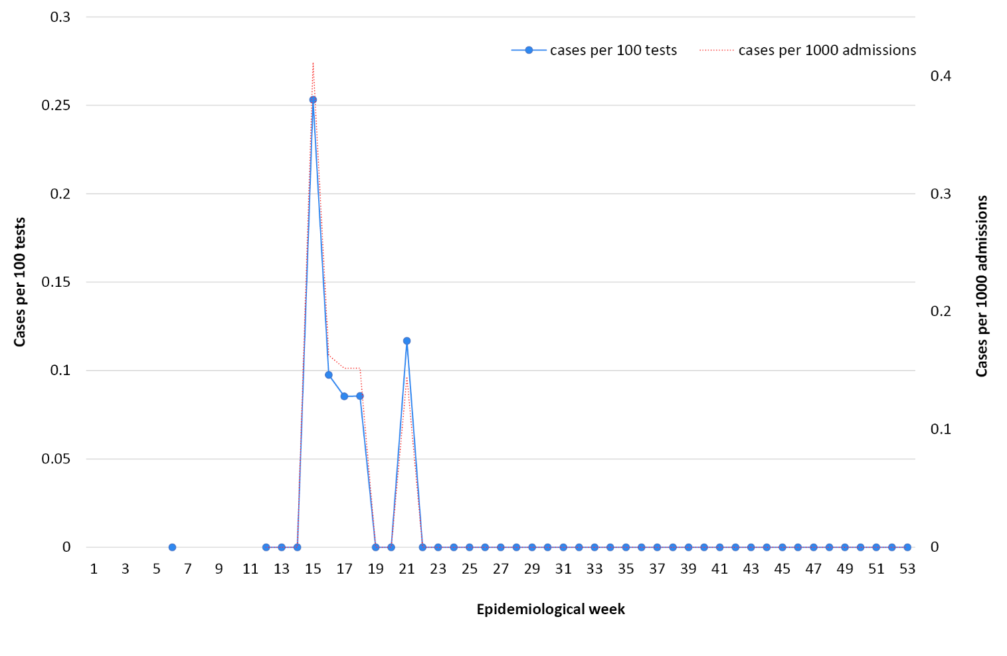

Figure A.2: Peak incidence of confirmed influenza (per 100 hospital beds per week) by hospitalª
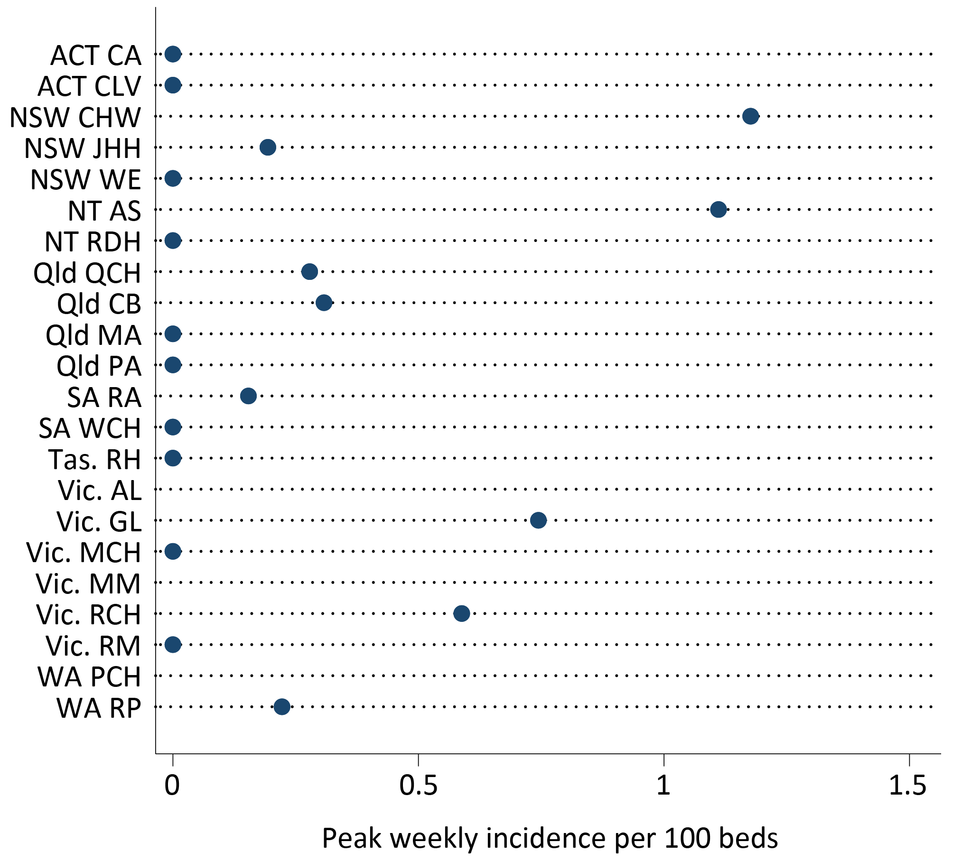
CA: Canberra Hospital; CLV: Calvary Hospital; CHW: Children’s Hospital at Westmead; JHH: John Hunter Hospital; WE: Westmead Hospital; AS: Alice Springs Hospital; RDH: Royal Darwin Hospital; QCH: Queen’s Children Hospital; CB: Cairns Base Hospital; MA: Mater Hospital; PA: Princess Alexandra Hospital; RA: Royal Adelaide; WCH: Women’s and Children’s Hospital; RH: Royal Hobart Hospital; AL: The Alfred Hospital; GL: University Hospital Geelong; MCH: Monash Children’s Hospital; MM: Monash Medical Centre; RCH: Royal Children’s Hospital; RM: Royal Melbourne; PCH: Perth Children’s Hospital; RP: Royal Perth Hospital.

Communicable Diseases Intelligence
ISSN: 2209-6051 Online

Communicable Diseases Intelligence (CDI) is a peer-reviewed scientific journal published by the Office of Health Protection and Response, Department of Health. The journal aims to disseminate information on the epidemiology, surveillance, prevention and control of communicable diseases of relevance to Australia.

Editor: Jennie Hood
Deputy Editor: Simon Petrie
Design and Production: Kasra Yousefi
Editorial Advisory Board: David Durrheim, Mark Ferson, John Kaldor, Martyn Kirk and Linda Selvey

Website: http://www.health.gov.au/cdi

Contacts
CDI is produced by the Office of Health Protection and Response, Australian Government Department of Health, GPO Box 9848, (MDP 6) CANBERRA ACT 2601

Email: cdi.editor@health.gov.au

Submit an Article
You are invited to submit your next communicable disease related article to the Communicable Diseases Intelligence (CDI) for consideration. More information regarding CDI can be found at: http://health.gov.au/cdi.
Further enquiries should be directed to: cdi.editor@health.gov.au.

This journal is indexed by Index Medicus and Medline.

Creative Commons Licence - Attribution-NonCommercial-NoDerivatives CC BY-NC-ND
© 2022 Commonwealth of Australia as represented by the Department of Health
This publication is licensed under a Creative Commons Attribution-NonCommercial-NoDerivatives 4.0 International Licence from https://creativecommons.org/licenses/by-nc-nd/4.0/legalcode (Licence). You must read and understand the Licence before using any material from this publication.

Restrictions
The Licence does not cover, and there is no permission given for, use of any of the following material found in this publication (if any):
- the Commonwealth Coat of Arms (by way of information, the terms under which the Coat of Arms may be used can be found at www.itsanhonour.gov.au);
- any logos (including the Department of Health’s logo) and trademarks;
- any photographs and images;
- any signatures; and
- any material belonging to third parties.

Disclaimer
Opinions expressed in Communicable Diseases Intelligence are those of the authors and not necessarily those of the Australian Government Department of Health or the Communicable Diseases Network Australia. Data may be subject to revision.

Enquiries
Enquiries regarding any other use of this publication should be addressed to the Communication Branch, Department of Health, GPO Box 9848, Canberra ACT 2601, or via e-mail to: copyright@health.gov.au

Communicable Diseases Network Australia
Communicable Diseases Intelligence contributes to the work of the Communicable Diseases Network Australia.
http://www.health.gov.au/cdna

