Two Treponema pallidum strains account for the majority of syphilis infections, including among females, in Queensland, Australia
Emma L Sweeney, Kym Lowry, Mandy Seel, Frashta Rahimi, Julian Langton-Lockton, Cheryl Bletchly, Graeme R Nimmo and David M Whiley

Abstract
An ongoing outbreak of syphilis in Australia, first reported in the state of Queensland in 2011, has led to increasing cases of congenital syphilis, including several deaths. Here, we applied multi-locus sequence typing (MLST) on available Treponema pallidum PCR-positive samples from the state of Queensland from the beginning of the outbreak to July 2020. In total, 393 samples from 337 males and 56 females were genotyped. Of 36 different Treponema pallidum sequence types (ST) observed, the two most common STs, ST 1 (also reported to be a dominant strain in various other countries) and ST 100 (the latter differing from ST 1 by only one single nucleotide polymorphism (SNP) based on the MLST scheme), together comprised 69% (271/393) of all samples, including the majority of samples in females (79%; 44/56). ST 1 was prevalent throughout the entire study period. Both strains remained the most common STs during the year 2020 where social distancing and other measures were implemented due to the COVID-19 pandemic. Both STs had high male-to-female ratios and included male rectal infections, therefore suggestive of occurrence primarily among men-who-have-sex-with-men (MSM). Hence, bridging from MSM to heterosexual networks may potentially contribute to infections among females, but further studies are needed to confirm this. Overall, there was considerable diversity of Treponema pallidum genotypes observed throughout the study period, but the fact that two key strains accounted for the majority of infections, including among females, stresses the need for further investigations into the transmission of these strains, and potentially a need for targeted public health interventions to better control the spread of syphilis in Queensland.
Keywords: syphilis, Treponema pallidum, sexually-transmitted infection, molecular diversity, multi-locus sequence typing, Queensland, Australia

Introduction
Treponema pallidum subspecies pallidum is the bacterial agent responsible for syphilis. In Australia, there has been a syphilis outbreak affecting Aboriginal and Torres Strait Islander people, which originated in rural Queensland in 2011 and subsequently spread to other jurisdictions,¹ including the Northern Territory, Western Australia and South Australia, with notification rates of syphilis increasing 135% between 2013 and 2017.² Also of concern are the increasing cases of congenital syphilis, which disproportionately affect Indigenous Australians in Queensland where there have been 33 cases of confirmed congenital syphilis locally, with 12 deaths reported as a consequence of this sexually-transmitted infection.^{1,3} Due to the widespread nature and severity of this disease in Australia, a number of public health measures and awareness campaigns have been established; however, the outbreak continues to evolve. Overall, notification rates have continued to rise, partly fuelled by a change in the epidemiology of syphilis infection, as denoted by a rise in syphilis infections in urban, non-Indigenous people. Initially this was observed in men-who-have-sex-with-men (MSM); however, in the last two years there has been a sustained increase in the number of women with infectious syphilis and an associated re-emergence of congenital syphilis in urban, non-Indigenous Australian-born women.¹ The relationship, if any, between syphilis infections in these populations is currently unknown.
Molecular typing is a valuable tool that has been used for a variety of bacterial pathogens, and can be used to explore transmission dynamics. A multi-locus sequence typing (MLST) scheme and associated public database was recently established for syphilis,⁴ and has since been used to understand the diversity of syphilis strains in various locations across Europe, North America, Asia and South America, and more recently in France, Switzerland, the Czech Republic and Cuba.^{4–7} These studies have highlighted that the genetic diversity was surprisingly high, suggesting these molecular typing tools may be useful in analysis of community transmission and sexual networks in syphilis infections; as yet, this MLST scheme has not been utilised in Australia.
Here we sought to better understand the transmission of syphilis strains in Queensland, Australia, in the context of the ongoing syphilis outbreak in Queensland, as well as assessing any potential impacts of strong public health measures that were put in place due to COVID-19. We performed MLST studies on available syphilis samples, obtained from Pathology Queensland, dating from the beginning of the Queensland outbreak until July 2020, and mapped individual syphilis cases geographically and temporally.

Methods

Sample bank
A total of 570 syphilis polymerase chain reaction (PCR) positive samples from the last decade were included in this study: 2011 (n = 82); 2012 (n = 4); 2016 (n = 1); 2017 (n = 65); and from 2018 to July 2020 (n = 418). All samples tested positive for syphilis by routine diagnostic real-time PCR assays targeting the Treponema pallidum species specific TP47 gene.⁸ The study was approved by the Children’s Health Queensland Human Research Ethics Committee (HREC/12/QRCH/69) and all methods were performed in accordance with the relevant guidelines/approvals. Informed consent from patients was not required (as per the ethics approval) as these samples were already being submitted for routine diagnostic testing and there was no known or likely reason for thinking that patients would not consent to the samples’ involvement in research, particularly since it carries no more than low risk to participants. Available patient information as per HREC approval included gender, age group (note that as per our HREC approval, precise age was available for persons < 18 years of age and all such ages were rounded to ‘< 18 years’), specimen site, date of sample collection and region of Queensland. Owing to Queensland’s large land mass and decentralised population, we divided the state into distinct regions for the purposes of assessing transmission dynamics; South-East Queensland (SEQ, which includes the cities of Brisbane [the capital of Queensland] and the Gold Coast) and Northern Queensland (NQ, including the cities of Townsville and Cairns, as well as surrounding rural and remote communities).

MLST typing
PCR and Sanger sequencing of the TP0136, TP0548 and TP0705 loci was performed as per the MLST scheme proposed by Grillova et al.⁵ Cleaned and trimmed sequences of each of the target genes were compared to those available within the PubMLST database for T. pallidum subspecies pallidum. Novel sequence types were formally submitted to the database and new sequence type numbers assigned.

Antimicrobial resistance screening
T. pallidum macrolide resistance was determined using previously-published PCR primers,⁹ followed by Sanger sequencing to identify the single nucleotide polymorphisms (SNPs) in the 23S rRNA gene which are known to confer high-level resistance to macrolides. We also screened representative samples from each unique sequence type for the presence of putative markers of tetracycline resistance in the 16S rRNA gene using previously-published PCR primers,¹⁰ noting that these markers have been identified in other species but as yet there is limited data associating these mutations with resistance in T. pallidum.

Phylogenetic analysis
Sequences were imported, concatenated and aligned using Geneious Prime software (version 2020.0.3). Maximum likelihood (PhyML) trees were generated using the PhyML plugin within Geneious, with default settings, using the Tamura Nei model. Trees were visualised and annotated using the interactive Tree of Life (iTOL).
Prevalence and transmission of syphilis genotypes over time were graphed using RStudio (Version 4.0.2).

Results
A total of 570 samples were genotyped as part of this study. Of these, 139 had incomplete genotyping results, predominantly as a result of low-load syphilis infections, and were removed from further analyses. An additional seven samples were removed from the dataset as they were suspected to be to other T. pallidum subspecies, based on a combination of PubMLST database information and subsequent BLAST searches of the genotyping targets. Of the remaining samples, 31 samples were found to be additional subsequent specimens from patients already included in the dataset and were removed, leaving only a single sample from each patient. Based on this, a final dataset of 393 samples were analysed.

Patient population
The majority of the 393 genotyped samples were from young people between the ages of 21–40 years (Appendix A, Table A.1) and were predominantly males (n = 337; 85.5%), with only 56 females in the dataset (Appendix A, Table A.2). The study included a variety of sample types, most commonly genital/labial samples from females and oropharyngeal/penile samples from males (Table A.2). Of the samples, 182 (46.3%) samples were isolated from patients residing in SEQ, while 74 (18.8%) were from NQ and a further 137 (34.9%) samples were from unspecified regions within Queensland.

MLST typing
Of the 393 patient samples in our dataset with complete MLST typing results, we identified a total of 36 different sequence types (Figure 1; Table 1; Appendix A, Figure A.1). Of the 36 STs observed in this study, 23 were novel and one sample harboured a mixture of ST 1 and novel ST 100. The majority of STs (n = 28; 78%) belonged to the SS-14-like clonal complex; the remaining eight STs (22%) belonged to the Nichols-like clonal complex (Table 1). Of the 36 STs, 15 were present in two or more patients, whereas 21 were singletons (only observed in one patient). The top eight STs (ST 1; 100; 3; 26; 11; 2; 6; 103) comprised 89% of all samples. These mainly included males, with the proportions of females for each of these top eight STs ranging from 0% (0/10) to 19.8% (35/177). Two STs comprised 79% (44/56) of all samples from females; ST 1 (n = 35 females) and the closely-related ST 100 (n = 9 females). These trends held for both remote and urban areas (for samples where region was known), with these two strains comprising 86% (25/29) and 50% (6/12) of samples from females in NQ and SEQ areas, respectively. By using rectal samples from males as a proxy for MSM status (n = 31 in the dataset), we identified that several of the most common syphilis STs (ST 1; 100; 3, 26; 11; 6; 27) were present among both MSM and females, suggesting bridging of sexual networks (Figure 2; green dots). A comparison of the STs identified here with those already on the PubMLST database are presented in Figure A.1; in brief, 11 previously-identified STs were identified within our Queensland dataset.

Table 1. Sequence types among the 393 fully typed T. pallidum subsp. pallidum samples
Sequence type | Allelic types |  |  | Clonal complex | Samples N = 393 | Macrolide resistance mutations (%)
 | TP0136 | TP0548 | TP0705 |  | (Male/Female) | No mutation | A2058G | A2059G
1 | 1 | 3 | 1 | SS14-like | 177 (142/35) | 1 (0.6%) | 176 (99.4%) | 0 (0%)
100 | 1 | 70 | 1 | SS14-like | 94 (85/9) | 0 (0%) | 94 (100%) | 0 (0%)
3 | 1 | 1 | 8 | SS14-like | 18 (16/2) | 1 (6%) | 17 (94%) | 0 (0%)
26 | 9 | 7 | 3 | Nichols-like | 18 (17/1) | 0 (0%) | 18 (100%) | 0 (0%)
11 | 1 | 1 | 3 | SS14-like | 14 (13/1) | 8 (57%) | 0 (0%) | 6 (43%)
2 | 1 | 1 | 1 | SS14-like | 11 (9/2) | 3 (27%) | 8 (73%) | 0 (0%)
6 | 3 | 2 | 3 | Nichols-like | 10 (10/0) | 0 (0%) | 10 (100%) | 0 (0%)
103 | 1 | 32 | 9 | SS14-like | 9 (9/0) | 0 (0%) | 9 (100%) | 0 (0%)
27 | 1 | 1 | 9 | SS14-like | 5 (5/0) | 0 (0%) | 5 (100%) | 0 (0%)
101 | 1 | 79 | 1 | SS14-like | 3 (3/0) | 0 (0%) | 3 (100%) | 0 (0%)
108 | 19 | 70 | 1 | Nichols-like | 3 (3/0) | 0 (0%) | 3 (100%) | 0 (0%)
92 | 35 | 70 | 1 | SS14-like | 3 (1/2) | 0 (0%) | 3 (100%) | 0 (0%)
94 | 6 | 70 | 1 | SS14-like | 3 (3/0) | 0 (0%) | 3 (100%) | 0 (0%)
50 | 1 | 32 | 1 | SS14-like | 2 (1/1) | 0 (0%) | 2 (100%) | 0 (0%)
109 | 9 | 16 | 3 | Nichols-like | 2 (2/0) | 0 (0%) | 2 (100%) | 0 (0%)
8 | 1 | 5 | 1 | SS14-like | 1 (0/1) | 0 (0%) | 1 (100%) | 0 (0%)
13 | 6 | 3 | 1 | SS14-like | 1 (1/0) | 0 (0%) | 1 (100%) | 0 (0%)
67 | 1 | 48 | 10 | SS14-like | 1 (1/0) | 1 (100%) | 0 (0%) | 0 (0%)
75 | 1 | 55 | 1 | SS14-like | 1 (1/0) | 0 (0%) | 1 (100%) | 0 (0%)
1 & 70 mix | 1 | 3 + 70 mix | 1 | SS14-like | 1 (1/0) | 0 (0%) | 1 (100%) | 0 (0%)
93 | 1 | 78 | 1 | SS14-like | 1 (1/0) | 0 (0%) | 1 (100%) | 0 (0%)
95 | 1 | 1 | 19 | SS14-like | 1 (0/1) | 0 (0%) | 1 (100%) | 0 (0%)
96 | 1 | 1 | 18 | SS14-like | 1 (1/0) | 0 (0%) | 1 (100%) | 0 (0%)
97 | 1 | 71 | 1 | SS14-like | 1 (1/0) | 0 (0%) | 1 (100%) | 0 (0%)
98 | 1 | 74 | 8 | SS14-like | 1 (1/0) | 0 (0%) | 1 (100%) | 0 (0%)
99 | 1 | 76 | 1 | SS14-like | 1 (1/0) | 0 (0%) | 1 (100%) | 0 (0%)
102 | 1 | 32 | 8 | SS14-like | 1 (1/0) | 0 (0%) | 1 (100%) | 0 (0%)
114 | 1 | 73 | 9 | SS14-like | 1 (1/0) | 1 (100%) | 0 (0%) | 0 (0%)
104 | 34 | 1 | 3 | SS14-like | 1 (1/0) | 0 (0%) | 0 (0%) | 1 (100%)
105 | 32 | 3 | 1 | SS14-like | 1 (0/1) | 0 (0%) | 1 (100%) | 0 (0%)
106 | 39 | 70 | 1 | SS14-like | 1 (1/0) | 0 (0%) | 1 (100%) | 0 (0%)
107 | 40 | 70 | 1 | SS14-like | 1 (1/0) | 0 (0%) | 1 (100%) | 0 (0%)
110 | 9 | 3 | 1 | Nichols-like | 1 (1/0) | 1 (100%) | 0 (0%) | 0 (0%)
111 | 9 | 3 | 3 | Nichols-like | 1 (1/0) | 0 (0%) | 1 (100%) | 0 (0%)
112 | 23 | 7 | 3 | Nichols-like | 1 (1/0) | 0 (0%) | 1 (100%) | 0 (0%)
113 | 31 | 7 | 3 | Nichols-like | 1 (1/0) | 0 (0%) | 1 (100%) | 0 (0%)

Figure 1: Prevalence of syphilis sequence types (STs) over time within the study for all 393 samples included in the final dataset
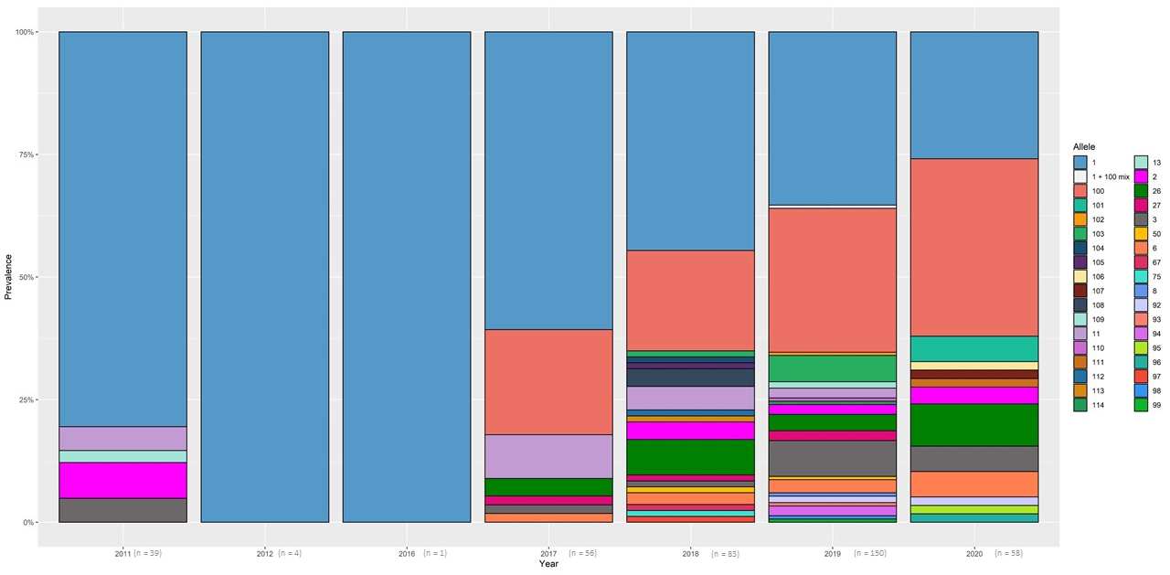

Temporal analysis of syphilis STs in Queensland
Figure 1 shows all 393 samples and associated STs by year. ST 1 was the single most common sequence type (n = 177/393; 45%). Notably, ST 1 accounted for 80% (33/41) of syphilis STs at the beginning of the Queensland syphilis outbreak in 2011, and remained common among circulating strains in subsequent years (2012–2020; mean prevalence 41%; 144/352) (Figure 2). Of further interest, the novel ST 100, which was highly similar to ST1 (one SNP difference in TP0548 allele), first appeared in samples in 2017 (n = 12/56; 21% of all STs) and appeared to displace ST 1 as the dominant ST in Queensland from 2018 to 2020 (mean prevalence 28%; 82/291). While the most stringent social distancing measures associated with the pandemic occurred in March 2020 when the Queensland border was closed to all international and interstate visitors, we still observed sustained transmission of major syphilis STs, as well as several singleton syphilis STs (Figure 2; Appendix A, Figures A.2 and A.3).

Antimicrobial resistance in syphilis
Macrolide resistance was prevalent among syphilis strains across the state, with 377/393 samples (96%) harbouring mutations associated with resistance. Of the top eight STs, 338/351 samples (94%) belonging to these STs had macrolide resistance mutations (Table 1), including STs 1 and 100. The most common macrolide resistance mutation was the A2058G mutation, which was harboured by the majority of syphilis samples within our study (370/393; 94%). The A2059G macrolide resistance mutation was observed in only seven samples in our dataset, and seemed to be linked to ST 11 and novel ST 104, which is 1 SNP different to ST 1.1.3. Only 16 samples within the dataset had no identifiable mutations associated with macrolide resistance (macrolide susceptibility denoted on Figure 2 by the letter “S” and in Figure A.2). The 16S rRNA gene did not indicate tetracycline resistance in any strain; all sequenced samples harboured the A965T mutation but no additional mutations (G966T, A967C or G1058C) that are otherwise associated with elevated minimum inhibitory concentrations (MICs) to tetracyclines.
Figure 2. Syphilis sequence types (STs) plotted by date of collection for 393 samples in our datasetª
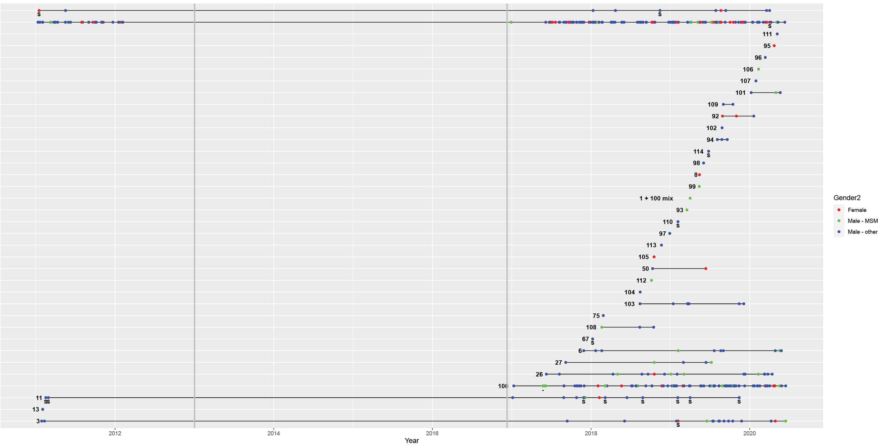
a Each dot represents an individual patient sample and is plotted according to the date of sample collection. Dots have been coloured according to gender, using male rectal samples as a proxy for MSM status, where samples were found to be susceptible to macrolide antibiotics, these samples are denoted by an ‘S’.

Discussion
Here, we used the PubMLST typing scheme to better understand the spread of syphilis within the Australian state of Queensland and its geographically distinct populations. We found that two T. pallidum subspecies pallidum sequence types, ST 1 and ST 100—closely related (on the basis of only a single SNP difference in the TP0548 allele)—together accounted for the majority of syphilis cases (69%; 271/393) in Queensland, one of which (ST 1) was present at the start of the syphilis outbreak in 2011. Previous studies have reported ST 1 to be, for example, the predominant sequence type in samples originating from Europe, North America, Asia and South America.⁴ Subsequent studies have further confirmed that ST 1 is the most common syphilis sequence type in France, Switzerland,⁵ the Czech Republic,¹¹ and Cuba.⁶ This could indicate that the outbreak within Queensland was perhaps driven via importation and expansion of an internationally successful macrolide-resistant ST 1 strain, followed by its displacement and the expansion of ST 100, which is only a single SNP different to ST 1, based on the PubMLST typing scheme.
For females, we observed that ST 1 and ST 100 again comprised the majority of samples in both remote and urban settings. However, based on male to female ratios, and also male rectal samples, our data suggest these STs are primarily among MSM populations, and may further suggest that bridging of syphilis strains between MSM and heterosexuals may potentially contribute to infections among females. The concept of bridging of sexually-transmitted infections has been previously described for syphilis in MSM in the USA,¹² while in China, syphilis rates among MSM who also engage in bisexual behaviour are reportedly high.¹³ Within Australia, bridging of gonorrhoea strains/lineages has been reported between MSM and heterosexual communities in the state of Victoria,¹⁴ but further studies are needed to substantiate this.
Macrolide resistance rates were high in samples within our study, and are higher than those previously reported by Read et al. who found that 83% of syphilis samples in Sydney, Australia, harboured the A2058G mutation associated with macrolide resistance, and who suggested that the presence of macrolide susceptible strains were importations from overseas.¹⁵ Of note was that our study also comprised samples when social distancing protocols were put in place to reduce the spread of COVID-19; however, we observed that these interventions clearly had limited impact upon syphilis notification rates. Given this, specific and targeted public health interventions are clearly warranted to reduce the spread of syphilis in Queensland and elsewhere in Australia.
Of further interest, we identified a small number of samples which were suspected to be misclassified T. pallidum subspecies pallidum samples. While the number of misclassified samples was extremely low within our study (approximately 1% of all samples screened), the allelic profiles for these samples were easily distinguishable as they were remarkably different to the sequences available in the PubMLST scheme, and further BLAST searches pointed to the fact that these samples belonged to either non-venereal T. pallidum subspecies endemicum or pertenue. While the TP0574 (TP47) and TP0105 (polA) targets remain the most widely used for molecular diagnosis of syphilis,^{16–18} our results act as a timely reminder that, due to highly-conserved sequences among T. pallidum subspecies, these tests can also detect non-venereal Treponema species and thus caution may be required in the interpretation and clinical context of the patient symptoms in order to make the correct diagnosis.
There are some limitations of this study. Firstly, we were reliant on nucleic acid samples for testing. The majority of samples collected for diagnosis of syphilis include rapid plasma reagin (RPR)/serology testing, and additional samples such as these were not available. The samples used for this study relied heavily on convenience banks, which also meant that they were not sufficiently representative, potentially including the relative numbers of males and females in the study, and particularly between 2012 and 2017 in terms of sequences types; for this period we only obtained a single sample for analysis, and there may be other syphilis sequence types that were not able to be captured or reported within this study. Secondly, the sample dataset appeared to contain higher numbers of samples from South East Queensland, and we had a high number of samples that were reported to be from unspecified regions in Queensland. Similarly, whole genome sequencing analyses are required to better assess the utility of the PubMLST scheme in our dataset, as it is likely that targeting only a small number of gene loci may lead to some errors in strain groupings; therefore, additional studies are required to provide further local context and resolution for transmission/sexual network analyses.
Overall, this study provides novel insight into the geographical and temporal spread of syphilis sequence types in Queensland, Australia. The fact that two key strains accounted for the majority of infections, including among females, stresses the need for further studies to inform targeted public health interventions against chains of transmission, in order to better control the spread of syphilis in Queensland.

Acknowledgements
The authors wish to acknowledge Pathology Queensland staff for their assistance in the provision of nucleic acid extracts and patient samples for this study.

Author contributions
ELS and DMW planned the study; ELS, KL and FR conducted the study and performed the analyses; ELS and DMW wrote the manuscript; KL, MS, JLL, CB, GRN critically appraised the manuscript and provided feedback; ELS submitted the study.

Funding
This study was supported by the Queensland Sexual Health Research Fund, as well as an Advancing Queensland Clinical Research Fellowship from the Queensland Government, held by DMW.

Author details
Emma L Sweeney¹
Kym Lowry¹
Mandy Seel²
Frashta Rahimi¹
Julian Langton-Lockton³
Cheryl Bletchly⁴
Graeme R Nimmo^{4,5}
David M Whiley^{1,4}
- The University of Queensland Centre for Clinical Research (UQ-CCR), Faculty of Medicine, The University of Queensland, Brisbane, Queensland, Australia
- Metro North Public Health Unit, Brisbane, Queensland, Australia
- Biala Community Health Centre, Brisbane, Queensland, Australia
- Pathology Queensland Central Laboratory, Brisbane, Queensland, Australia
- Griffith University, School of Medicine, Queensland, Australia

Corresponding author
Dr Emma L. Sweeney
The University of Queensland Centre for Clinical Research, Faculty of Medicine, The University of Queensland, Brisbane, Queensland, Australia
Email: e.l.sweeney@uq.edu.au

References
- Queensland Health. Notifications of Syphilis in Queensland. 2019 Report. Brisbane: Queensland Government, Queensland Health; April 2020. Available from: https://www.health.qld.gov.au/__data/assets/pdf_file/0040/959809/syphilis-in-queensland-2019.pdf.
- Kirby Institute. HIV, viral hepatitis and sexually transmissible infections in Australia: annual surveillance report 2018. Sydney: University of New South Wales, Kirby Institute; 2018. Available from: https://kirby.unsw.edu.au/sites/default/files/kirby/report/KI_Annual-Surveillance-Report-2018.pdf.
- Multi-jurisdictional Syphilis Outbreak Working Group. Multijurisdictional syphilis outbreak surveillance report: October 2020. Canberra: Australian Government Department of Health; October 2020. Available from: https://www1.health.gov.au/internet/main/publishing.nsf/Content/ohp-infectious-syphilis-outbreak.htm#historical.
- Grillova L, Jolley K, Šmajs D, Picardeau M. A public database for the new MLST scheme for Treponema pallidum subsp. pallidum: surveillance and epidemiology of the causative agent of syphilis. PeerJ. 2019;6:e6182. doi: https://doi.org/10.7717/peerj.6182.
- Grillová L, Bawa T, Mikalová L, Gayet-Ageron A, Nieselt K, Strouhal M et al. Molecular characterization of Treponema pallidum subsp. pallidum in Switzerland and France with a new multilocus sequence typing scheme. PloS One. 2018;13(7):e0200773. doi: https://doi.org/10.1371/journal.pone.0200773.
- Grillová L, Noda AA, Lienhard R, Blanco O, Rodríguez I, Šmajs D. Multilocus sequence typing of Treponema pallidum subsp. pallidum in Cuba From 2012 to 2017. J Infect Dis. 2019;219(7):1138–45.
- Pospíšilová P, Grange PA, Grillová L, Mikalová L, Martinet P, Janier M et al. Multi-locus sequence typing of Treponema pallidum subsp. pallidum present in clinical samples from France: infecting treponemes are genetically diverse and belong to 18 allelic profiles. PloS One. 2018;13(7):e0201068. doi: https://doi.org/10.1371/journal.pone.0201068.
- Palmer HM, Higgins SP, Herring AJ, Kingston MA. Use of PCR in the diagnosis of early syphilis in the United Kingdom. Sex Transm Infect. 2003;79(6):479–83.
- Li Z, Hou J, Zheng R, Li Z, Wen J, Liu D et al. Two mutations associated with macrolide resistance in Treponema pallidum in Shandong, China. J Clin Microbiol. 2013;51(12):4270–1.
- Wu BR, Liu WC, Wu PY, Su YC, Yang SP, Hung CC et al. Surveillance study of Treponema pallidum harbouring tetracycline resistance mutations in patients with syphilis. Int J Antimicrob Agents. 2014;44(4):370–2.
- Vrbová E, Grillová L, Mikalová L, Pospíšilová P, Strnadel R, Dastychová E et al. MLST typing of Treponema pallidum subsp. pallidum in the Czech Republic during 2004–2017: clinical isolates belonged to 25 allelic profiles and harbored 8 novel allelic variants. PloS One. 2019;14(5):e0217611. doi: https://doi.org/10.1371/journal.pone.0217611.
- Cunningham SD, Olthoff G, Burnett P, Rompalo AM, Ellen JM. Evidence of heterosexual bridging among syphilis-positive men who have sex with men. Sex Transm Infect. 2006;82(6):444–5.
- Yun K, Xu JJ, Reilly KH, Zhang J, Jiang YJ, Wang N et al. Prevalence of bisexual behaviour among bridge population of men who have sex with men in China: a meta-analysis of observational studies. Sex Transm Infect. 2011;87(7):563–70.
- Williamson DA, Chow EPF, Gorrie CL, Seemann T, Ingle DJ, Higgins N et al. Bridging of Neisseria gonorrhoeae lineages across sexual networks in the HIV pre-exposure prophylaxis era. Nat Commun. 2019;10(1):3988. doi: https://doi.org/10.1038/s41467-019-12053-4.
- Read P, Tagg KA, Jeoffreys N, Guy RJ, Gilbert GL, Donovan B. Treponema pallidum strain types and association with macrolide resistance in Sydney, Australia: new TP0548 gene types identified. J Clin Microbiol. 2016;54(8):2172–4.
- Gayet-Ageron A, Combescure C, Lautenschlager S, Ninet B, Perneger TV. Comparison of diagnostic accuracy of PCR targeting the 47-kilodalton protein membrane gene of Treponema pallidum and PCR targeting the DNA polymerase I gene: systematic review and meta-analysis. J Clin Microbiol. 2015;53(11):3522–9.
- Liu H, Rodes B, Chen CY, Steiner B. New tests for syphilis: rational design of a PCR method for detection of Treponema pallidum in clinical specimens using unique regions of the DNA polymerase I gene. J Clin Microbiol. 2001;39(5):1941–6.
- Noda AA, Rodríguez I, Grillová L, Bosshard PP, Lienhard R. Accuracy of PCR and serological testing for the diagnosis of primary syphilis: both tests are necessary. Int J STD AIDS. 2019;30(11):1087–94.

Appendix A
Figure A.1: Phylogenetic tree showing all alleles available in the PubMLST database, including all previously identified and novel sequence types isolated within our study of syphilis samples in Queensland, Australia
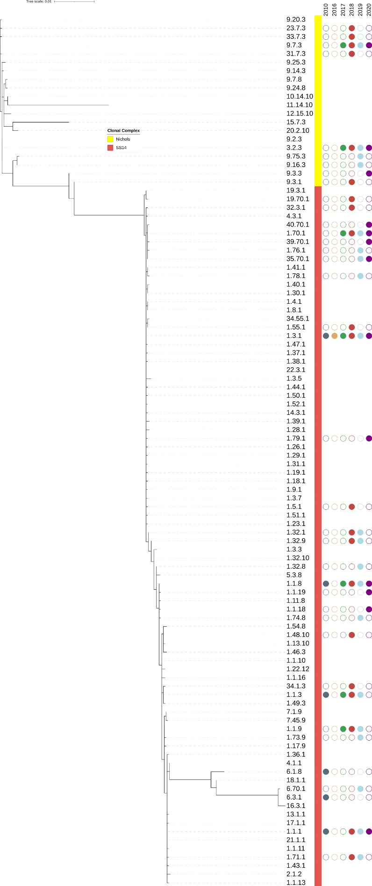
Figure A.2: Syphilis sequence types (STs) plotted by date of collection for 393 samples,ª and coloured according to region^{b}
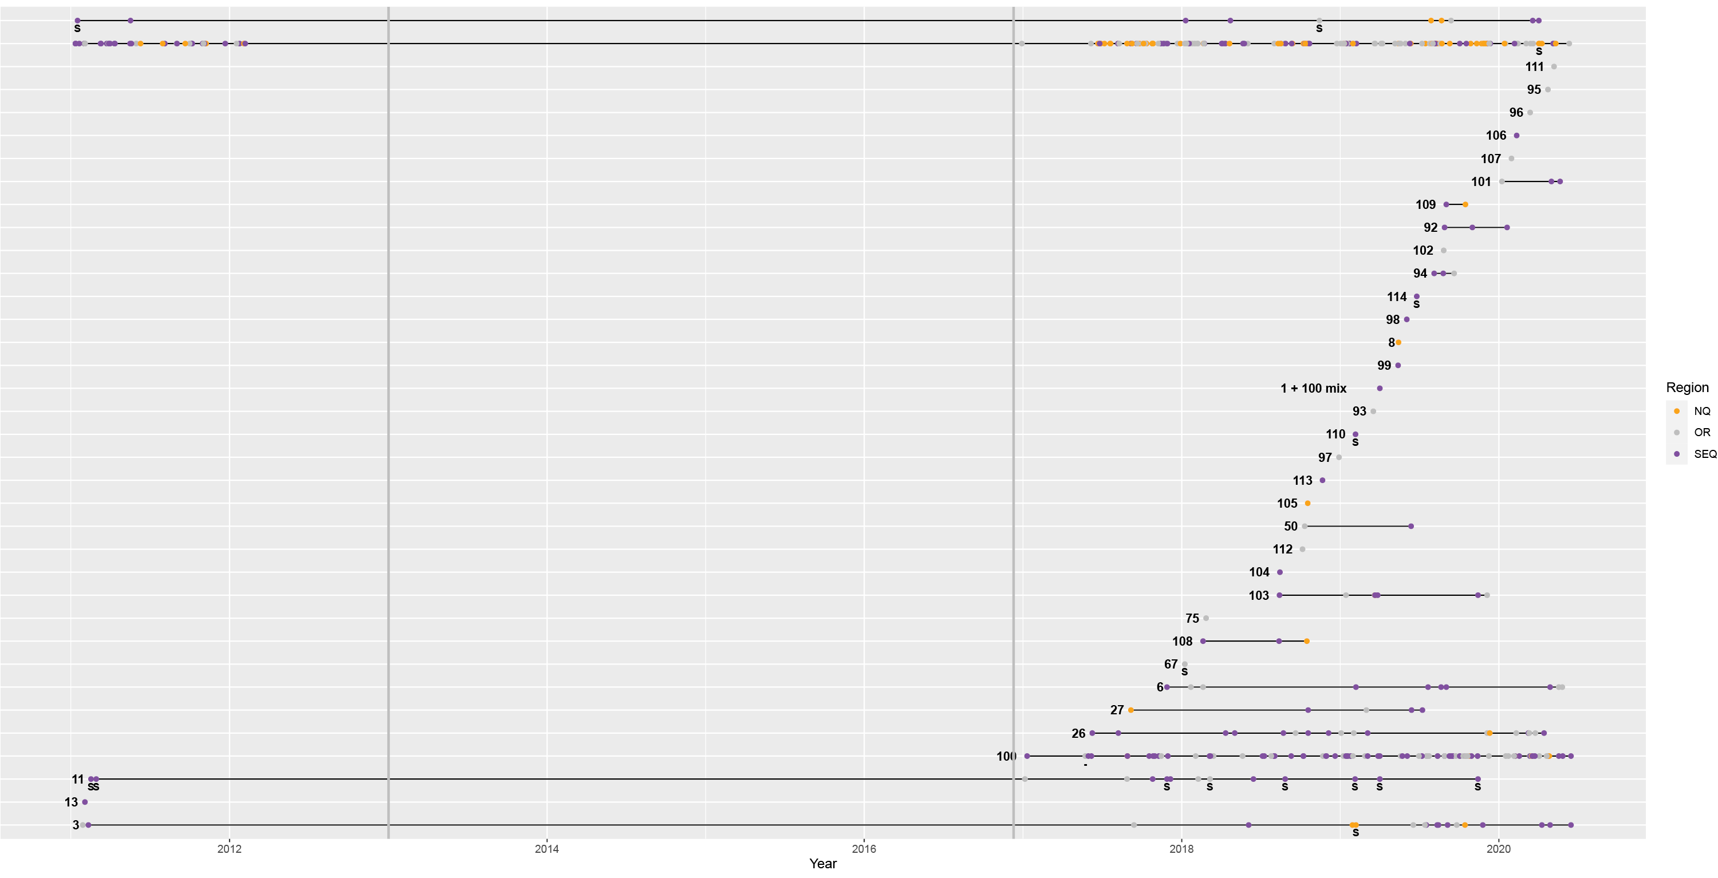
a Each dot represents an individual patient sample.
b NQ: Northern Queensland; OR: Other region in Queensland not specified; SEQ: South East Queensland; S = macrolide susceptibility.

Figure A.3: Syphilis sequence types (STs) present in the months leading up to the implementation of COVID-19 social distancing rules (from November 2019), through to July 2020^{a,b}
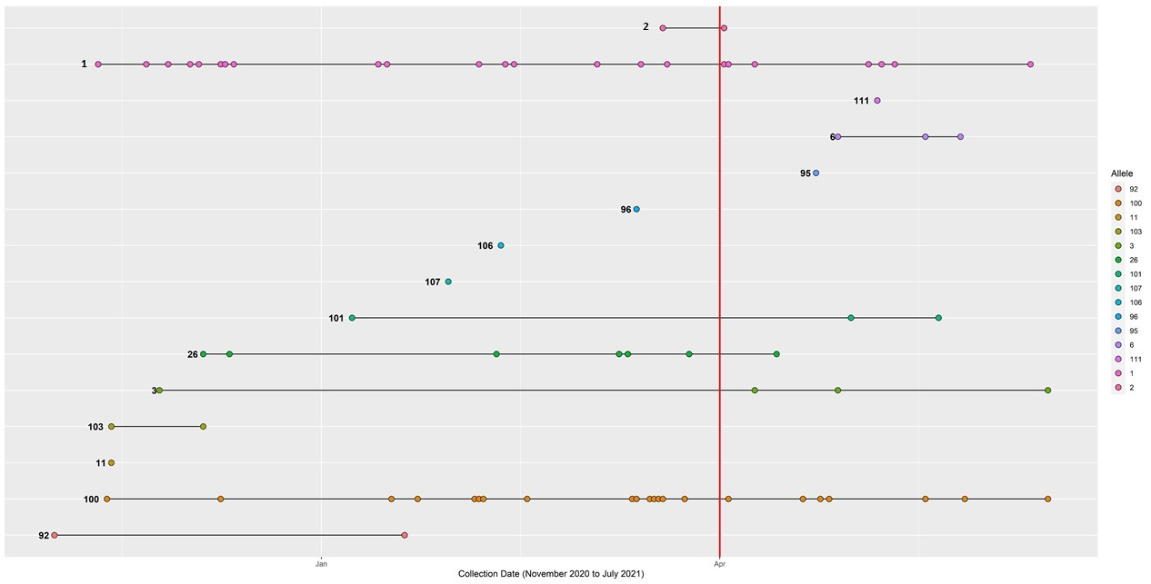
a Each dot represents an individual patient sample and is plotted according to the date of sample collection.
b The red line coincides with the approximate timing of the Queensland COVID-19 ‘lockdown’, highlighting the timing of enhanced social distancing measures, which included border lockdown to other states of Australia.

Table A.1: Age range of patient samples included in the study
Age range (years) | Number of patients (%), n = 392ª
< 18 | 16 (4.1%)
19–20 | 17 (4.3%)
21–25 | 71 (18.1%)
26–30 | 58 (14.8%)
31–35 | 70 (17.9%)
36–40 | 52 (13.3%)
41–45 | 27 (6.9%)
45–50 | 27 (6.9%)
51–55 | 23 (5.9%)
56–60 | 15 (3.8%)
61–65 | 8 (2.0%)
> 65 | 8 (2.0%)
a Age range for one patient sample in the dataset was not available; n = 392 patients with available age ranges are shown.
Table A.2: Gender and specimen type for all samples
Gender | Specimen type (number of samples)
Female (n = 56) | Specimen not specified (11)  Anal/rectal (1)  Back lesion (1)  Buttocks (1)  Cervix (1)  Foot (1)  Genital (15)  Labia (12)  Lesion not specified (3)  Vulva (3)  Lip/oral/throat (2)  Perianal (1)  Pharynx (2)  Skin biopsy (1)  Tongue (1)
Male (n = 337) | Specimen not specified (51)  Anal/rectal (31)  Foot (1)  Genital (7)  Glans (11)  Lesion not specified (5)  Lip/oral/throat (45)  Liver (1)  Penile/scrotum (180)  Perineum (4)  Thigh lesion (1)

Communicable Diseases Intelligence
ISSN: 2209-6051 Online

Communicable Diseases Intelligence (CDI) is a peer-reviewed scientific journal published by the Office of Health Protection and Response, Department of Health. The journal aims to disseminate information on the epidemiology, surveillance, prevention and control of communicable diseases of relevance to Australia.

Editor: Noel Lally
Deputy Editor: Simon Petrie
Design and Production: Kasra Yousefi
Editorial Advisory Board: David Durrheim, Mark Ferson, John Kaldor, Martyn Kirk and Linda Selvey

Website: http://www.health.gov.au/cdi

Contacts
CDI is produced by the Office of Health Protection and Response, Australian Government Department of Health, GPO Box 9848, (MDP 6) CANBERRA ACT 2601

Email: cdi.editor@health.gov.au

Submit an Article
You are invited to submit your next communicable disease related article to the Communicable Diseases Intelligence (CDI) for consideration. More information regarding CDI can be found at: http://health.gov.au/cdi.
Further enquiries should be directed to: cdi.editor@health.gov.au.

This journal is indexed by Index Medicus and Medline.

Creative Commons Licence - Attribution-NonCommercial-NoDerivatives CC BY-NC-ND
© 2022 Commonwealth of Australia as represented by the Department of Health
This publication is licensed under a Creative Commons Attribution-NonCommercial-NoDerivatives 4.0 International Licence from https://creativecommons.org/licenses/by-nc-nd/4.0/legalcode (Licence). You must read and understand the Licence before using any material from this publication.

Restrictions
The Licence does not cover, and there is no permission given for, use of any of the following material found in this publication (if any):
- the Commonwealth Coat of Arms (by way of information, the terms under which the Coat of Arms may be used can be found at www.itsanhonour.gov.au);
- any logos (including the Department of Health’s logo) and trademarks;
- any photographs and images;
- any signatures; and
- any material belonging to third parties.

Disclaimer
Opinions expressed in Communicable Diseases Intelligence are those of the authors and not necessarily those of the Australian Government Department of Health or the Communicable Diseases Network Australia. Data may be subject to revision.

Enquiries
Enquiries regarding any other use of this publication should be addressed to the Communication Branch, Department of Health, GPO Box 9848, Canberra ACT 2601, or via e-mail to: copyright@health.gov.au

Communicable Diseases Network Australia
Communicable Diseases Intelligence contributes to the work of the Communicable Diseases Network Australia.
http://www.health.gov.au/cdna

