COVID-19 Australia: Epidemiology Report 40
Reporting period ending 25 April 2021
COVID-19 National Incident Room Surveillance Team

Summary

Two-week reporting period:
Trends – The number of coronavirus disease 2019 (COVID-19) cases reported in Australia remains relatively low, although new case numbers did increase more than twofold in this two-week reporting period compared to the previous two weeks. The daily average number of cases for this reporting period was seventeen, compared to an average of eight cases per day in the previous fortnight. There were 243 cases of COVID-19 and one new death this fortnight, bringing the cumulative case count to 29,550 with 910 deaths.
Local cases – There were seven locally-acquired cases reported in Australia this fortnight, three each from New South Wales and Western Australia and one from Victoria. Two further cases remained under investigation at the end of this reporting period.
Overseas cases – There were 234 overseas-acquired cases this reporting period. Of these, 33% (78/234) were reported from New South Wales and 22% (52/234) from the Northern Territory.
Vaccinations – As at 27 April 2021, there have been 2,018,554 doses of COVID-19 vaccine administered in Australia.

Four-week reporting period:
Virology – Nationally, SARS-CoV-2 strains from 59% of COVID-19 cases have been sequenced during the pandemic. During 2021, there has been an increase in the number of cases infected with SARS-CoV-2 variants of concern (VOC) in Australia. AusTrakka is actively monitoring and reporting on these variants and has so far identified 340 samples of B.1.1.7 (also known as VOC-202012/01 or 20I/501Y.V1); 63 samples of B.1.351 (aka VOC-202012/02 or 20H/501Y.V2); and five samples of P.1 (aka VOC-202101/02 or 20J/501Y.V3) in Australia.
Testing – Testing rates were slightly lower than in the previous fortnight (15.0 versus 19.6 per 100,000 population). The cumulative positivity rate remains low at 0.02%.
Severity – Of all cases since the beginning of the pandemic, an estimated 12% have been admitted to hospital. According to sentinel surveillance data, 19% of hospitalised patients were admitted to an intensive care unit. Australia’s case fatality rate has remained stable at 3.1%. One COVID-19 related death occurred in the past four weeks.
Public health measures – Extra restrictions were put in place in Queensland and Perth during this reporting period, to minimise the risk associated with locally-acquired cases in each location.
International situation – Cumulative global COVID-19 cases and deaths now exceed 146 million and 3.1 million respectively. India reported over six million cases in this four-week reporting period. In Australia’s near region, Lao PDR and Thailand both experienced the largest increase in infection rates in this reporting period compared to the previous reporting period.
This reporting period covers the last two weeks (12–25 April 2021), with data for this period compared to that from the previous two-week reporting period (29 March – 11 April 2021).¹ As Australia continues to experience low numbers of coronavirus disease 2019 (COVID-19) cases, this report has transitioned to a brief update on case numbers each fortnight and a more detailed analysis every four weeks. The focus of this report is now on the epidemiological situation in Australia since the beginning of this year, 2021. Readers are encouraged to consult prior reports for information on the epidemiology of cases in Australia in 2020. Included in this report with a reporting period of four weeks are sections on genomic surveillance and virology, acute respiratory illness, severity, testing, public health response measures, and the international situation. The reporting period for these topics covers 29 March – 25 April 2021. For comparability, the previous reporting period is the preceding four weeks (1–28 March 2021).
Keywords: SARS-CoV-2; novel coronavirus; 2019-nCoV; coronavirus disease 2019; COVID-19; acute respiratory disease; epidemiology; Australia

In focus: Comparing March 2020 to March 2021 in Australia
It is now over one year since the WHO declared a global pandemic caused by the novel coronavirus SARS-CoV-2 on 11 March 2020.² The outbreak and spread of COVID-19 infections has had a dramatic impact worldwide, but has affected some countries much more than others. In Australia, there were two main peaks of infection in March and July 2020, the first driven by international travellers returning to Australia and the second by an outbreak of community cases in the state of Victoria. Since this second outbreak, case numbers have remained low nationally.
This ‘In focus’ section compares the epidemiology of cases in Australia in March 2020 to that in March 2021, considering the differences in epidemiological curves, source of acquisition of cases, demographic profile of cases and public health actions taken in both periods.

Epidemiological curves
In March 2020, more than twenty times as many new cases were diagnosed in Australia as in March 2021 (Figure 1). The total number of cases diagnosed during March 2021 was 284, compared to 5,984 in March 2020.

Source of acquisition of cases
In March 2021 in Australia, 91% (258/284) of cases were overseas acquired, whereas in March 2020, 68% (4,066/5,984) of cases were acquired overseas.

Demographic profile of cases
The median age of cases in March 2021 was 33 years old (range: 0 to 81). In comparison, the median age of cases in March 2020 was 47 years old (range: 0 to 97). In March 2021, there were more male than female cases (62% male versus 37% female, with 1% of cases with missing data for sex). In March 2020, however, cases were relatively evenly distributed between men and women (51% male versus 48% female, with 1% of cases with missing data for sex).

Figure 1: Comparison of COVID-19 notified cases in Australia by source of acquisition in March 2020 (left) and March 2021 (right)ª
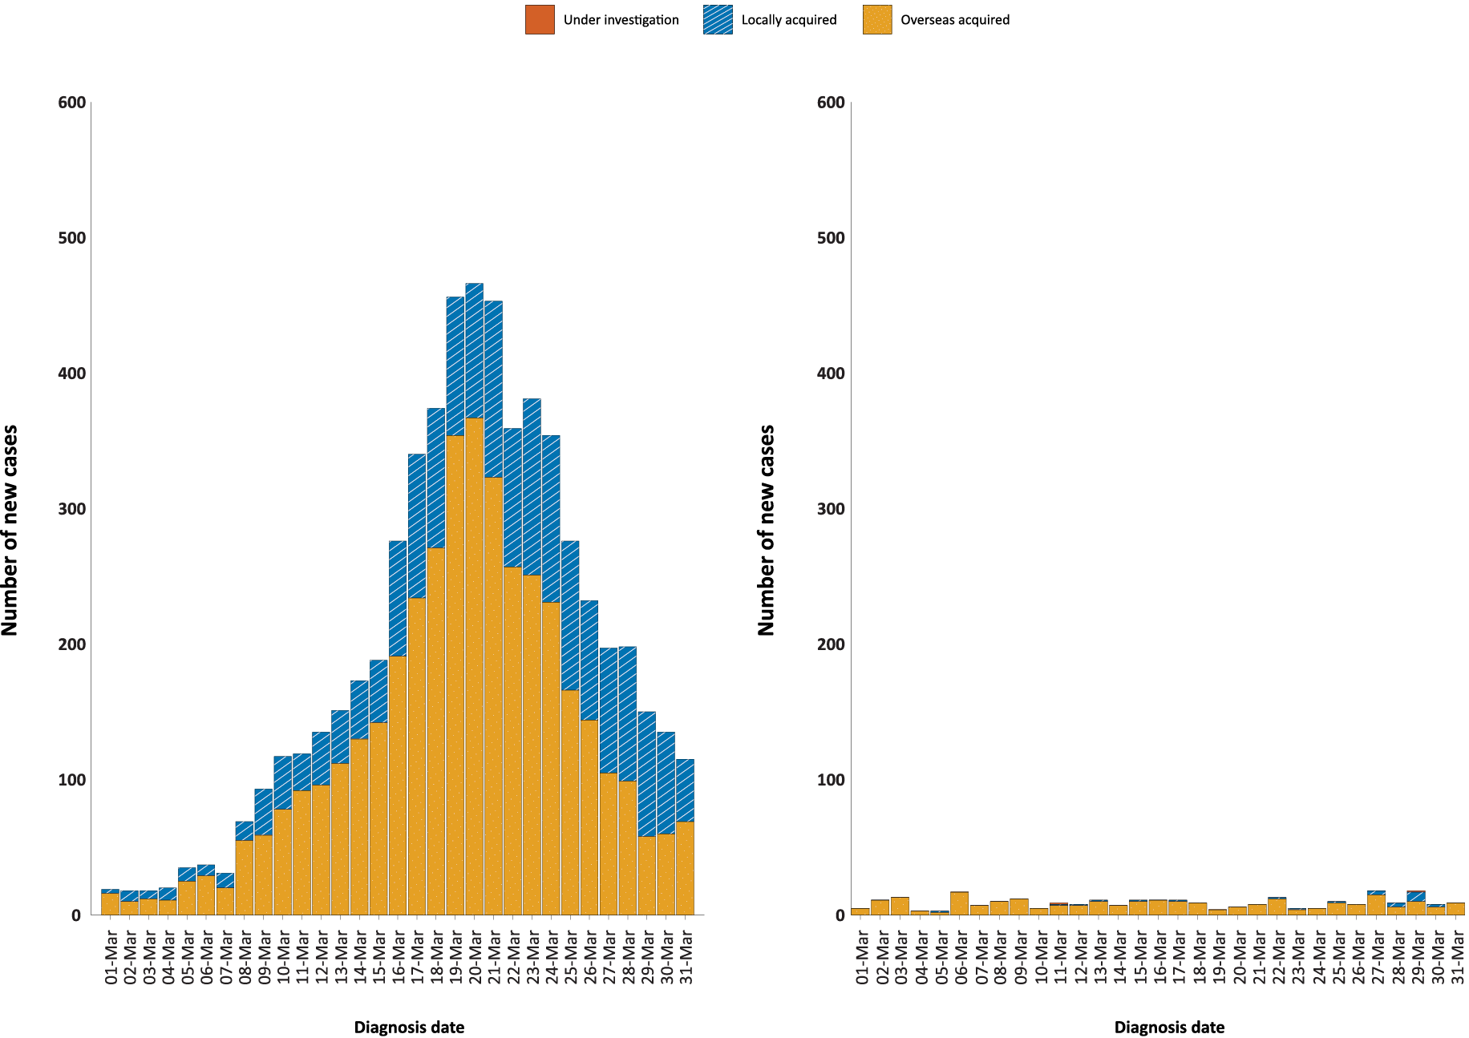
a Source: NNDSS, extract from 29 April 2021, based on diagnosis date.

Major public health measures
Since the emergence of COVID-19, public health measures have been implemented in Australia to reduce the health impacts of the disease. Measures have been adjusted to align with emerging evidence and in response to Australia’s epidemiological situation. One year on, many public health measures introduced remain as the ‘new COVID-19 normal’, including physical distancing, COVIDsafe hand and respiratory hygiene, and registration systems to enable identification of contacts of cases.
Jurisdictions have decision-making authority in relation to public health measures and have implemented or eased restrictions at their own pace, depending on the local public health and epidemiological situation, in line with the ‘Framework for National Reopening’.³
Table 1 shows the major public health measures in March 2020 compared with March 2021. Easing of several measures has occurred with the attainment of low to no community transmission. Periods of higher-level restrictions have been implemented at times to control community transmission events, or in response to the changing international situation.
Table 1: Implementation of major public health measures, March 2020 compared with March 2021
Public health measures | March 2020 | March 2021
International borders closed to all non-citizens and non-residents; passenger caps for incoming flights^{4,5} | Yes | Yes  Exception: New Zealand safe travel zone arrangement
Restrictions on international travel from Australia⁶ | Yes | Yes
Domestic borders closed^{4,a} | Yes | No
Travel into remote Indigenous communities restricted⁴ | Yes | Yes
14 day supervised quarantine requirements for travel from high risk areas^{7,a} | Yes | Yes
Requirement to stay at home, except for:^{8,a}  - Buying essential supplies  - To work, if unable to work from home  - To exercise  - To attend personal medical appointments, or for compassionate reasons | Yes | No
Closure of non-essential businesses^{8,a} | Yes | No
Changes to delivery of education⁷ | Yes  Encouraged to shift to online learning. Recommended only children of essential workers attend physically. | No
Restricted visitation to high risk settings^{4,a} | Yes  Subject to jurisdiction requirements | No
Indoor gathering restrictions^{8,a} | Yes  Restricted to 2 people | No  Subject to jurisdiction discretion
Outdoor gathering restrictions^{8,a} | Yes  Restricted to 2 people | No
Limits on attendance at weddings^{8,a} | Yes  Restricted to 5 people | No
Limits on attendance at funerals^{8,a} | Yes  Restricted to 10 people | No
Suspension of elective surgery⁹ | Yes | No
Person density restrictions^{10,a} | Yes  Maximum 1 person per 4 square metres | Yes  Maximum 1 person per 2 square metres
Physical distancing (1.5m)¹⁰ | Yes | Yes
COVIDsafe hand and respiratory hygiene¹¹ | Yes | Yes
Contact identification (QR codes etc.)¹² | No | Yes
Public use of face masks^{13,a} | No | Yes  Recommended where there is community transmission
a Measures may be adapted or re-implemented at the discretion of jurisdictions during a period of higher-level restrictions following a community transmission event.

Two-week reporting period (12–25 April 2021):

Background and data sources
See the Technical Supplement for general information on COVID-19 including modes of transmission, common symptoms and severity.¹⁴

Activity

COVID-19 trends

(NNDSS and jurisdictional reporting to NIR)
There were 243 cases with a diagnosis date within this two-week reporting period, from 12 to 25 April 2021. This averages to seventeen cases diagnosed per day over this reporting period, which is more than twice the average daily cases for the previous reporting period, when an average of eight cases were diagnosed per day. Of all states and territories, the most cases diagnosed this fortnight were from New South Wales (33% of all cases; 81/243), followed by the Northern Territory (21%; 52/243) (Table 2).
Table 2: COVID-19 notifications by jurisdiction and source of acquisition, 12–25 April 2021ª
Source | ACT | NSW | NT | Qld | SA | Tas. | Vic. | WA | Australia
Overseas | 0 | 78 | 52 | 14 | 32 | 0 | 27 | 31 | 234
Local | 0 | 3 | 0 | 0 | 0 | 0 | 1 | 3 | 7
source known | 0 | 3 | 0 | 0 | 0 | 0 | 1 | 3 | 7
source unknown | 0 | 0 | 0 | 0 | 0 | 0 | 0 | 0 | 0
interstate, source known | 0 | 0 | 0 | 0 | 0 | 0 | 0 | 0 | 0
interstate, source unknown | 0 | 0 | 0 | 0 | 0 | 0 | 0 | 0 | 0
investigation ongoing | 0 | 0 | 0 | 0 | 0 | 0 | 0 | 0 | 0
Under initial investigation | 0 | 3 | 0 | 0 | 1 | 0 | 0 | 1 | 2
Missing source of acquisition | 0 | 0 | 0 | 0 | 0 | 0 | 0 | 0 | 0
Total | 0 | 81 | 52 | 14 | 33 | 0 | 28 | 35 | 243
a Source: NNDSS, extract from 29 April 2021, based on diagnosis date.
In the year to date, from 1 January 2021 to the end of this reporting period 25 April 2021, there have been 1,082 COVID-19 cases reported nationally; cases diagnosed weekly have generally remained low, although cases have exceeded 100 per week in the past two weeks (Figure 2). These low case numbers are in contrast to the two distinct peaks experienced in March and July of 2020, when weekly notifications reached approximately 2,700 and 3,000 respectively (Figure 3). Cumulatively, since the beginning of the epidemic in Australia, there have been 29,550 COVID-19 cases reported in Australia.

Figure 2: COVID-19 notified cases by source of acquisition and diagnosis date, 4 January – 25 April 2021ª
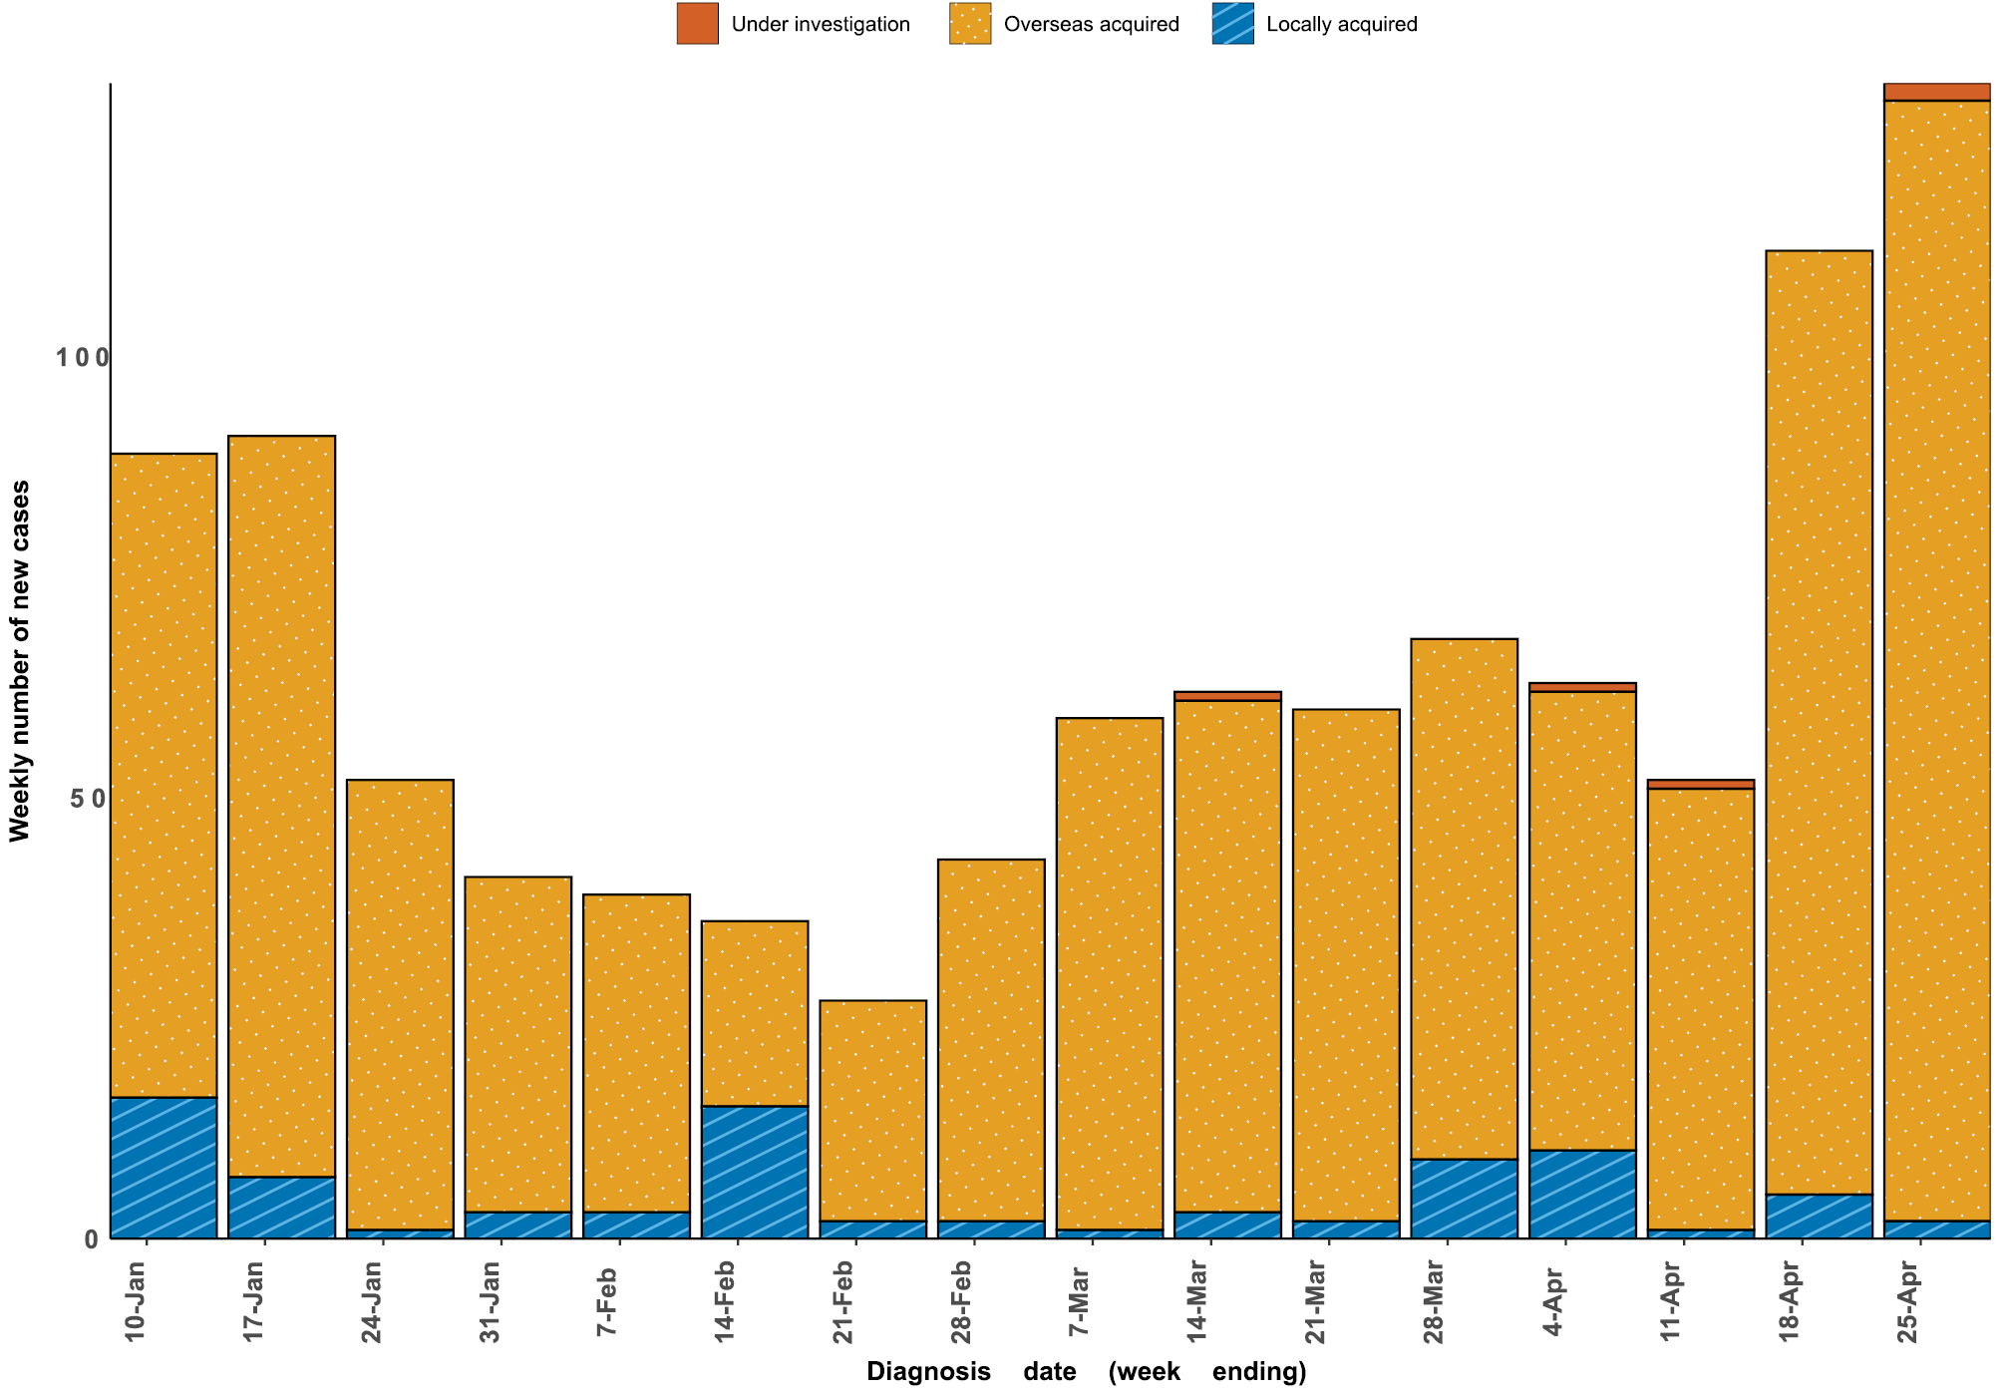
a Source: NNDSS, extract from 29 April 2021, based on diagnosis date.

Figure 3: Cumulative COVID-19 notified cases by source of acquisition and diagnosis date,
2 March 2020 – 25 April 2021ª
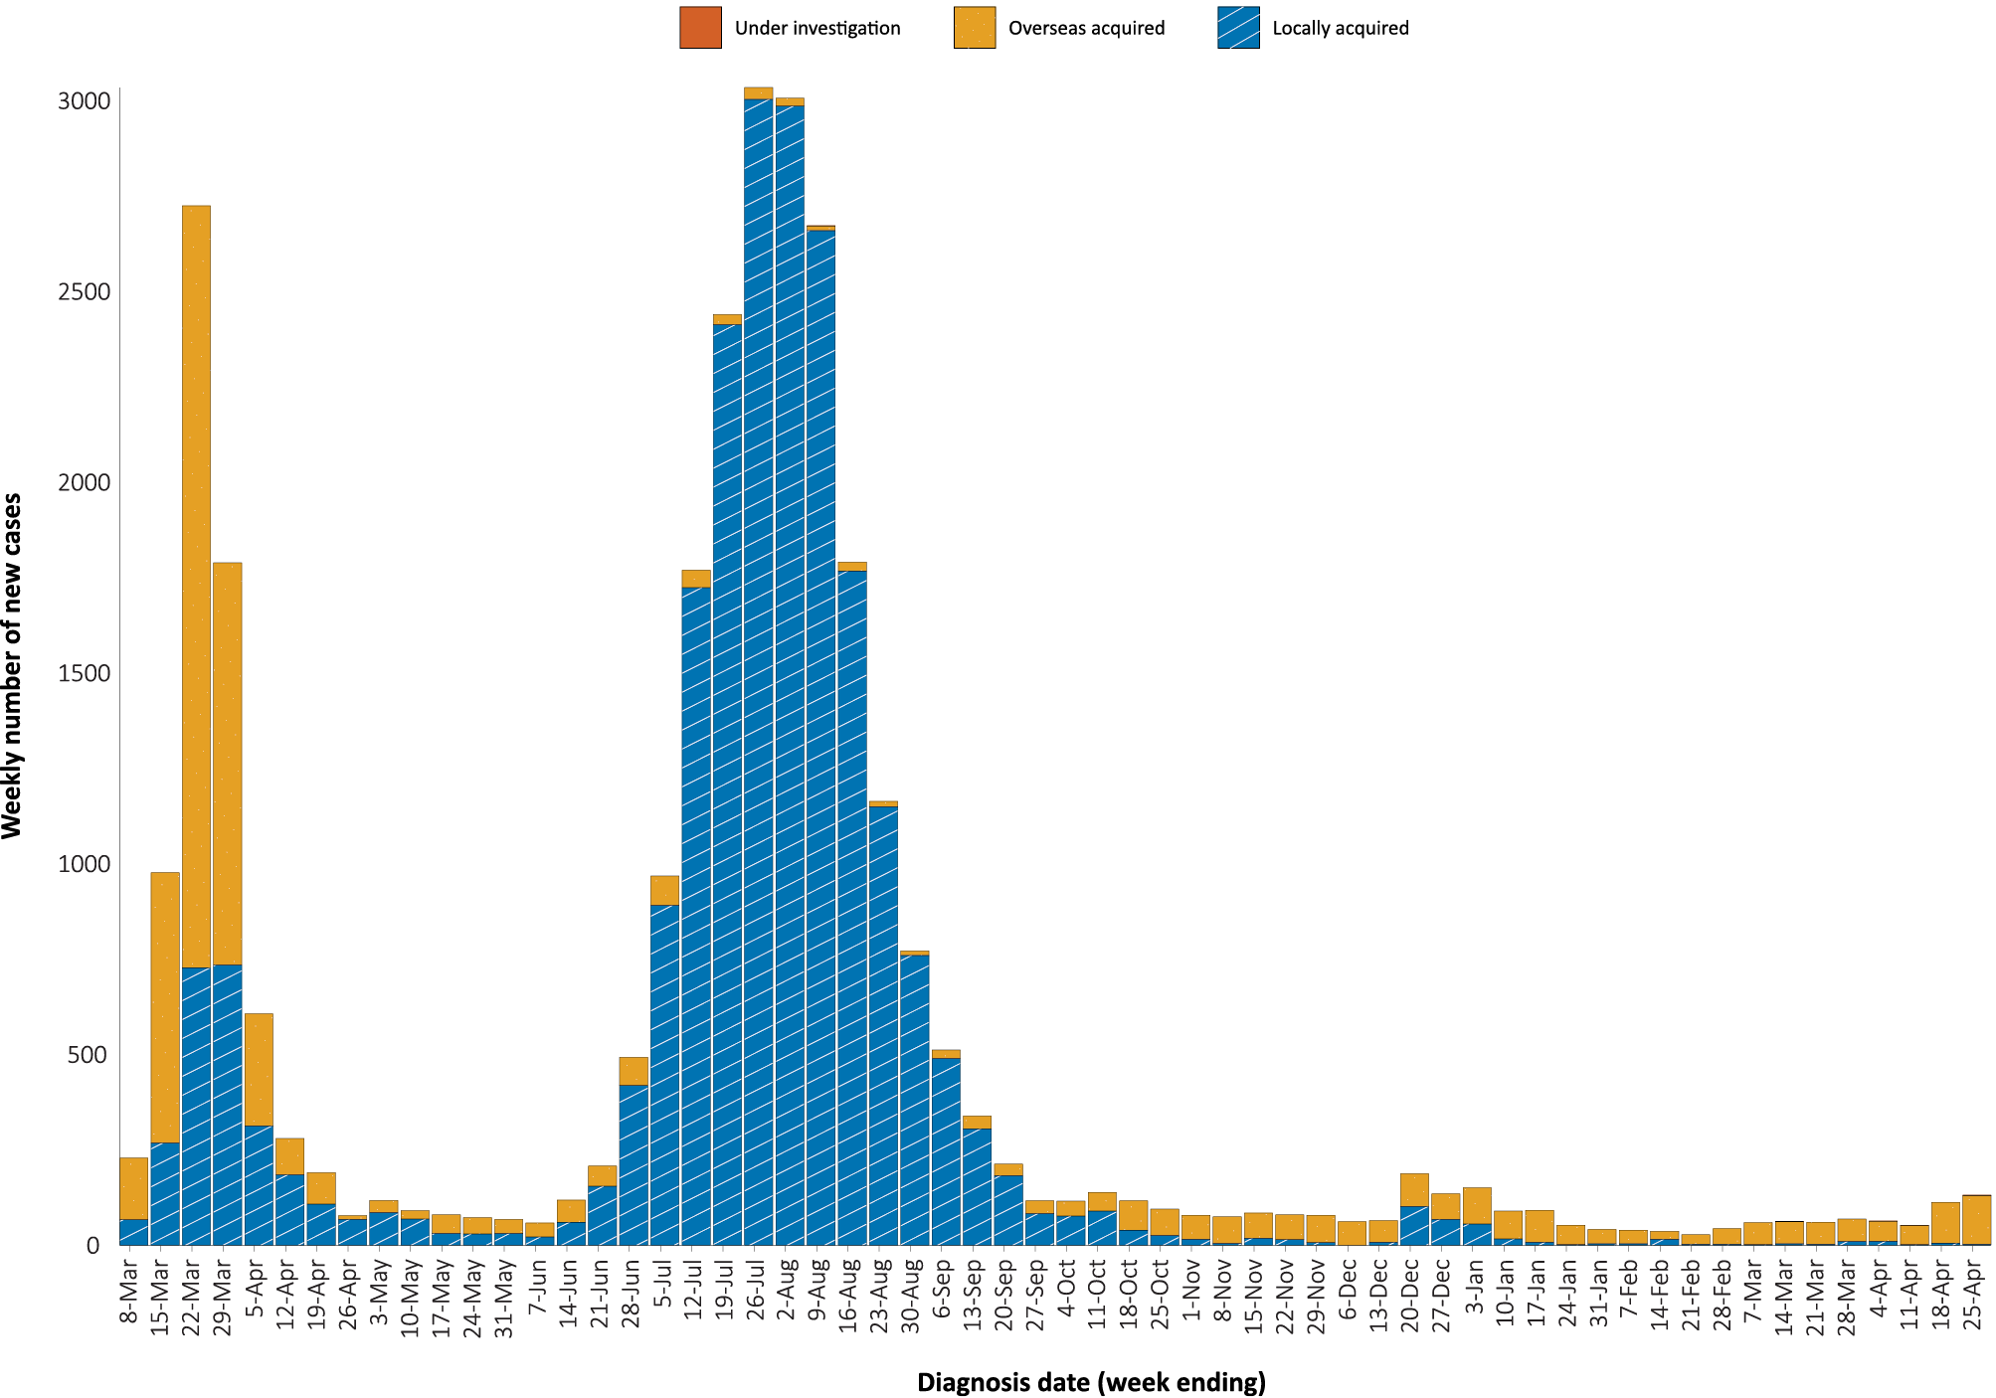
a Source: NNDSS, extract from 29 April 2021, based on diagnosis date.

Source of acquisition

(NNDSS)
In this reporting period, 96% (234/243) of cases were acquired overseas. There were seven locally-acquired cases: three in New South Wales, three in Western Australia and one in Victoria (Table 3). At the end of this reporting period, the source of acquisition of two cases remained under investigation (Table 2).

Table 3: Locally-acquired COVID-19 case numbers and rates per 100,000 population by jurisdiction and reporting period, Australia, 12 to 25 April 2021ª
Jurisdiction | Reporting period  12–25 April 2021 | Reporting period  29 March – 11 April 2021 | Cases this year  1 January – 25 April 2021^{b}
 | Number of cases^{c} | Number of cases^{c} | Number of cases^{c} | Rate per 100,000 population^{d}
ACT | 0 | 0 | 0 | —
NSW | 3 | 2 | 34 | 0.42
NT | 0 | 0 | 0 | —
Qld | 0 | 9 | 26 | 0.50
SA | 0 | 0 | 0 | —
Tas. | 0 | 0 | 0 | —
Vic. | 1 | 0 | 35 | 0.52
WA | 3 | 0 | 4 | 0.15
Australia | 7 | 11 | 99 | 0.39
a Source: NNDSS, extract from 29 April 2021, based on diagnosis date.
b Note the change to a focus on cases in this year only, which substantially lowers rates per 100,000 population.
c This total does not include cases that are under investigation.
d Population data based on Australian Bureau of Statistics (ABS) Estimated Resident Population (ERP) as at June 2020.
The largest number of overseas-acquired cases was reported in New South Wales in this reporting period (33%; 78/234), followed by the Northern Territory (22%; 52/234). In this fortnight, three percent of overseas-acquired cases (8/234) reported an unknown country of acquisition. Of those overseas-acquired cases that did report a country of acquisition, the majority came from India (62%; 141/226), followed by Pakistan (10%; 23/226) and Papua New Guinea (4%; 10/226). The number of cases by country is influenced by travel patterns of returning Australians as well as by the prevalence of COVID-19 in the country the person arrived from.
In 2021, Victoria has the highest infection rate for locally-acquired cases with 0.52 infections per 100,000 population, closely followed by Queensland with a rate of 0.50 infections per 100,000 population (Table 3). At the end of this reporting period, there had been two days since the last locally-acquired case of known source (Table 4).
Table 4: Days since last locally-acquired COVID-19 case (source unknown and source known), by jurisdiction, 25 April 2021ª
Jurisdiction | Locally acquired — source unknown |  | Locally acquired — source known
 | Date of last case | Days since last case | Date of last case | Days since last case
ACT | 21 March 2020 | 400 | 7 July 2020 | 292
NSW | 15 January 2021 | 100 | 15 April 2021 | 10
NT^{b} | NA | NA | 3 April 2020 | 387
Qld | 23 August 2020 | 245 | 3 April 2021 | 22
SA | 24 March 2020 | 397 | 27 November 2020 | 149
Tas. | 9 August 2020 | 259 | 24 April 2020 | 366
Vic. | 30 December 2020 | 116 | 22 April 2021 | 3
WA | 3 Apr 2020 | 387 | 23 April 2021 | 2
a Source: NNDSS, extract from 29 April 2021, based on diagnosis date.
b The Northern Territory has not reported any locally acquired cases with an unknown source of infection.

Demographic features

(NNDSS)
In this reporting period, the largest number of cases occurred in those aged 30 to 39 years (31%; 69/221 cases). For all notifications to date, the highest rate of infection is in those aged 90 and over with a rate of 369.6 per 100,000 population (Figure 4; Appendix A, Table A.1). Children under 10 years old have the lowest rate of infection (50.1 cases per 100,000 population), despite comparable testing rates in this age group.
Figure 4: Cumulative rate of COVID-19 cases per 100,000 population, by age group and sex, 23 January 2020 – 25 April 2021ª
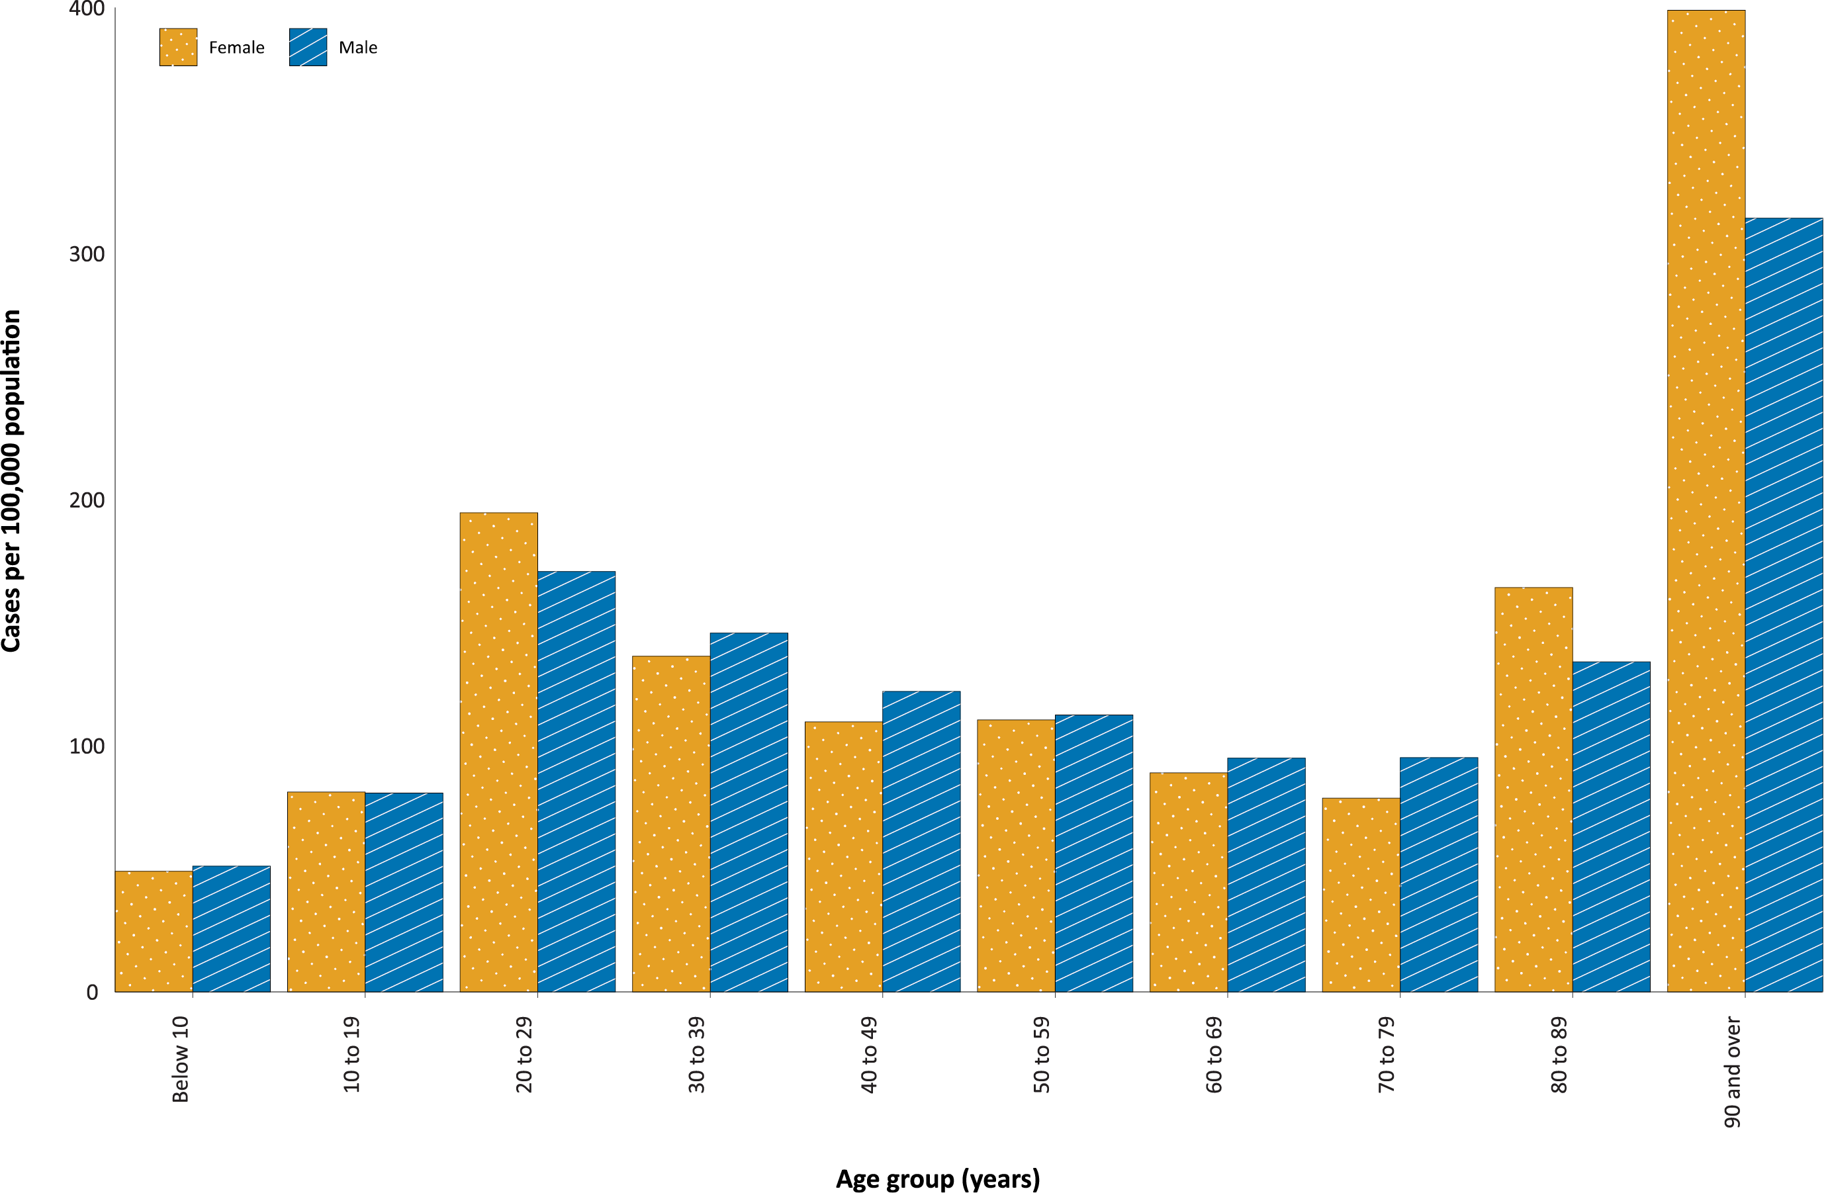
a Source: NNDSS, extract from 29 April 2021, based on diagnosis date.
Cumulatively, the male-to-female rate ratio of cases is approximately 1:1 in most age groups. Notification rates are higher among females than among males in the 20–29 years age group and those aged ≥ 80 years old, and higher among males than among females in most other age groups (Figure 4). The largest difference in cumulative rates is in the 90 years and over age group, where the cumulative rate among males is 314.4 cases per 100,000 population and among females is 398.9 cases per 100,000 population (Appendix A, Table A.1).
The median age of cases in this reporting period is 33 years (range: 0 to 73). Similarly, the median age of cases this year is also 33 years (range: 0 to 86). The median age of all cases since the beginning of the epidemic in Australia is somewhat higher at 37 years (range: 0–106), reflecting a shift in the demographic features of cases over time. Whereas there were higher numbers of locally-acquired cases in 2020, including many cases in residential aged care facilities, most cases in 2021 have been acquired overseas and in a younger cohort of international travellers.

Aboriginal and Torres Strait Islander persons

(NNDSS)
There have been 153 confirmed cases of COVID-19 notified in Aboriginal and Torres Strait Islander people since the beginning of the epidemic. Two new overseas-acquired Aboriginal and Torres Strait Islander cases were notified in the reporting period. Overall, Aboriginal and Torres Strait Islander people represent approximately 0.5% (153/29,550) of all confirmed cases with Indigenous status known. The Indigenous status is unknown for 6.9% (2,043/29,550) of all cases. The majority of locally-acquired cases in Aboriginal and Torres Strait Islander people have been reported in major cities of Australia (79%; 93/117), with only a very small number of cases (n < 10) reported in outer regional Australia or remote or very remote Australia.
The median age of COVID-19 cases in Aboriginal and Torres Strait Islander people is 31.5 years old (range: 1-95), which is younger than for non-Indigenous cases where the median age is 36 years old (range: 0-106). The notification rate across all age groups is higher in non-Indigenous people than in Aboriginal and Torres Strait Islander people. The age-standardised Aboriginal and Torres Strait Islander: non-Indigenous notification rate ratio is 0.2. This indicates that the Aboriginal and Torres Strait Islander population has a significantly lower COVID-19 case rate than the non-Indigenous population, after accounting for differences in age structure.

Vaccinations

(Department of Health)
In this reporting period, the total administration of vaccine in Australia exceeded two million doses. As of 27 April 2021, a total of 2,029,544 doses of COVID-19 vaccine have been administered (Table 5), including 210,770 doses provided to aged care and disability residents.
Table 5: Total number of vaccinations administered, by jurisdiction, Australia, 27 April 2021ª
Jurisdiction | Total number of doses administered
ACT | 26,584
NSW | 198,492
NT | 15,426
Qld | 139,489
SA | 55,478
Tas. | 35,316
Vic. | 198,228
WA | 91,957
Aged care and disability facilities^{b} | 210,770
Primary care^{c} | 1,057,804
Total | 2,029,554
a Source: Australian Government Department of Health website.¹⁵
b Commonwealth vaccine doses administered in aged care and disability facilities.
c Commonwealth vaccine doses administered in primary care settings.
Recent rare occurrences of thrombosis (blood clotting) and thrombocytopenia (low blood platelet count) in patients who had received the AstraZeneca COVID-19 vaccine led to temporary suspensions of the vaccine program in Australia, to allow for investigation by regulatory bodies. It is now recommended that the Pfizer vaccine is the preferred COVID-19 vaccine for adults aged under 50 years.¹⁶

Four-week reporting period (29 March – 25 April 2021):

Genomic surveillance and virology

(Communicable Disease Genomics Network, AusTrakka and jurisdictional sequencing laboratories)
Nationally, 59% of COVID-19 cases have been sequenced over the duration of the pandemic, based on jurisdictional reporting (Table 6, Figure 5).
Table 6: Australian SARS-CoV-2 genome sequences and proportion of positive cases sequenced, 29 March–25 April 2021 and cumulative to date
Measure | Reporting period  29 March – 25 April 2021 | Cumulative 23 January 2020  – 25 April 2021
SARS-CoV-2 cases sequencedª | 230 | 17,381
Percentage of positive cases sequenced^{b} | 59% | 59%
a Based on individual jurisdictional reports of sequences and case numbers. Calculations of the percentage of cases sequenced based on the number of sequences available in AusTrakka may not always be up-to-date, since this may include duplicate samples from cases and may not represent all available sequence data.
b In most jurisdictions sequencing has been attempted on all suitable samples (one sample per case). Sequencing of samples from cases identified in the reporting period may be in process at the time of reporting. Remaining unsequenced samples may be due to jurisdictional sequencing strategy, or where samples have been deemed unsuitable for sequencing (typically, because viral loads were too low for sequencing to be successful).

Figure 5: Samples in AusTrakka since 4 January 2021, by lineage and date of collectionª
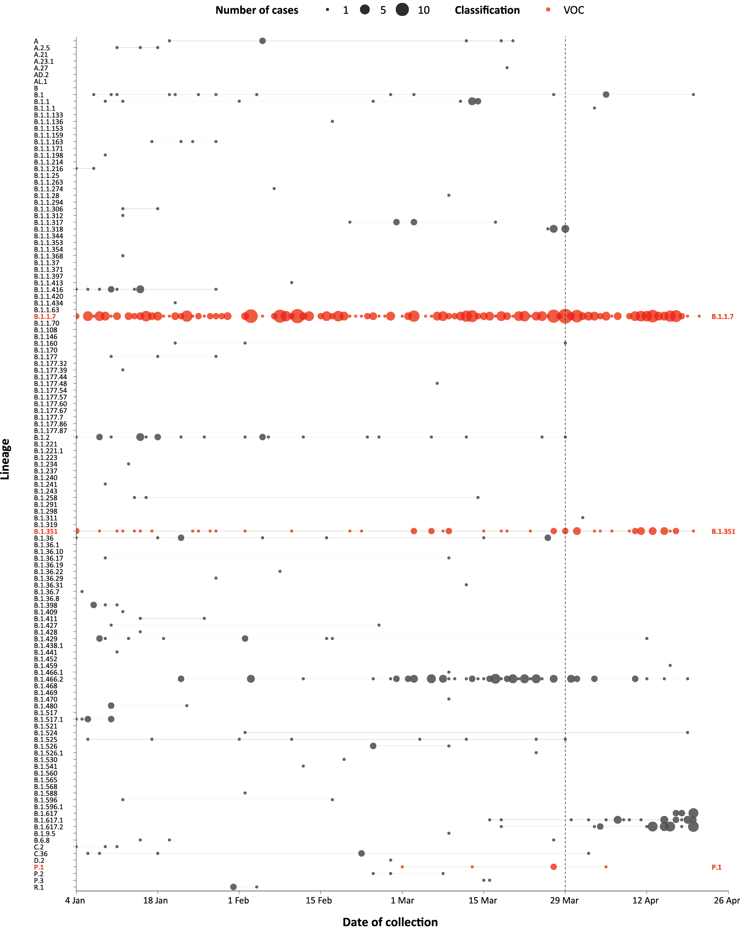
a The start of the current reporting period (29 March – 25 April 2021) is marked by the dotted line, and variant of concern samples are coloured red. The size of the circle is proportional to the number of samples in the lineage at each time point.

Variants of concern
AusTrakka is actively monitoring and reporting on the three lineages designated Variants of Concern (VOC) by international organisations, including the World Health Organisation: B.1.1.7; B.1.351; and P.1 (Table 7). All three variants display characteristic sets of mutation, including a number of variations in the genomic region encoding the spike protein thought to have the potential to increase transmissibility and/or immune evasion.¹⁸ Further information on variants is available in the Technical Supplement.¹⁴
Table 7: Australian SARS-CoV-2 genome sequences in AusTrakka, identified as variants of concern (VOC) to 25 April 2021
VOC lineage | B.1.1.7 | B.1.351 | P.1
Number of samples | 340 | 63 | 5

Testing

(State and territory reporting)
As at 23 April 2021, a cumulative total of 4,208,558 individuals have undergone diagnostic testing for SARS-CoV-2 in Australia this year since 1 January 2021. The cumulative nationwide proportion of positive tests for 2021 remains low at 0.02% (Table 8).
Table 8: Individuals undergoing diagnostic tests for SARS-CoV-2,ª by jurisdiction and reporting period, 1 January – 23 April 2021
Jurisdiction | Individuals tested  10–23 April 2021 |  |  | Individuals tested  27 March – 9 April 2021 |  |  | Cumulative individuals tested  in 2021 to 23 April
 | n | Positivity (%) | Per 1,000 population^{b} | n | Positivity (%) | Per 1,000 population^{b} | n | Positivity (%) | Per 1,000 population^{b}
ACT | 5,170 | 0.00 | 12.1 | 9,634 | 0.00 | 22.6 | 63,814 | < 0.01 | 149.75
NSW | 129,817 | 0.06 | 16.1 | 155,907 | 0.02 | 19.3 | 1,433,333 | 0.03 | 177.3
NT | 7,440 | 0.66 | 30.2 | 8,510 | 0.04 | 34.6 | 62,958 | 0.13 | 255.8
Qld | 27,531 | 0.05 | 5.4 | 60,958 | 0.08 | 12.0 | 254,991 | 0.10 | 50.1
SA | 28,570 | 0.09 | 16.3 | 34,908 | 0.02 | 19.9 | 338,752 | 0.03 | 193.3
Tas. | 7,419 | 0.00 | 13.9 | 9,895 | 0.00 | 18.5 | 59,811 | 0.00 | 111.9
Vic. | 160,047 | 0.01 | 24.3 | 200,528 | < 0.01 | 30.4 | 1,705,235 | < 0.01 | 258.6
WA | 20,516 | 0.13 | 7.8 | 22,201 | 0.09 | 8.5 | 289,664 | 0.04 | 110.5
Australia | 386,510 | 0.05 | 15.0 | 502,541 | 0.02 | 19.6 | 4,208,558 | 0.02 | 163.8
a In order to more accurately reflect positivity rates, numbers of individuals tested is presented rather than total number of tests.
b Population data based on Australian Bureau of Statistics (ABS) Estimated Resident Population (ERP) as at June 2020.
During this reporting period, 386,510 individuals were tested nationally, with a positivity rate of 0.05%. Jurisdictional testing rates are driven by both current case numbers and numbers of people experiencing symptoms. The low national positivity rate, along with high rates of testing, indicates a low incidence of COVID-19 nationally.
For the two-week period ending 23 April 2021, testing rates increased among all age groups (Figure 6), except for those over 60 years of age. Testing rates among children and young adults aged 0–19 years tended to be lower than those of other age groups, while rates among the 20–39 year age groups have remained high throughout the entirety of the pandemic.
Figure 6: SARS-CoV-2 polymerase chain reaction (PCR) testing rates per 1,000 population per week by age group, Australia, 1 May 2020 – 23 April 2021^{a,b}

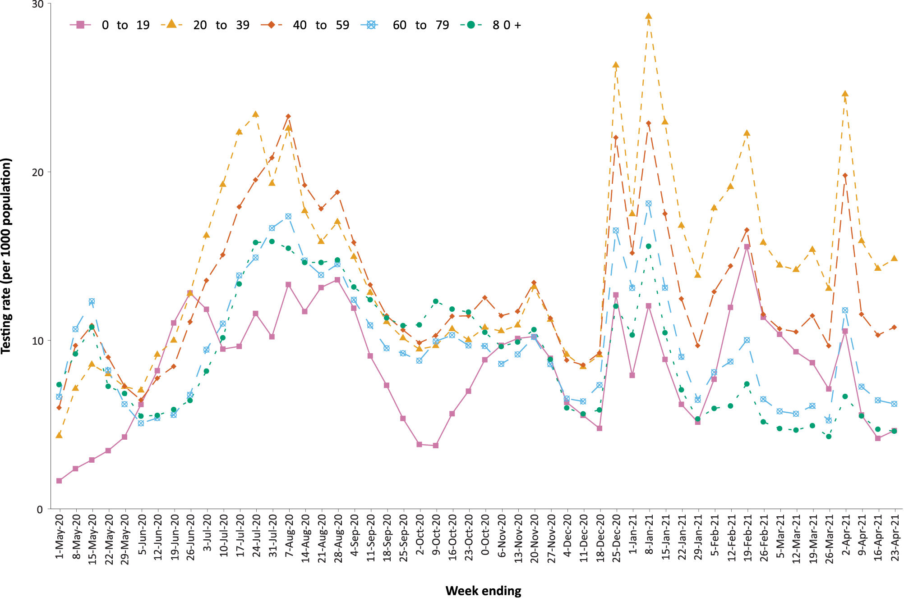
a Source: Data provided by jurisdictions to the NIR weekly, current up to 26 March 2021.
b The jurisdictions reporting each week (i.e. the denominator population) may vary.

Acute respiratory illness

(FluTracking and Commonwealth Respiratory Clinics)
Based on self-reported FluTracking data,¹⁹ prevalence of fever and cough in the community continues to be low nationally, remaining under 0.8% (Figure 7). Runny nose and sore throat symptoms in the community increased somewhat during this reporting period compared to the previous four weeks, however the prevalence in the community remains low at less than 1%.
In this reporting period, acute respiratory illness was highest in those aged under 10 years old and between the ages of 20 and 39, based on both self-reported FluTracking data and presentations to Commonwealth Respiratory Clinics. Females reported respiratory illness more frequently than males. Rates of fever and cough by jurisdiction ranged from 2.7/1,000 FluTracking participants in South Australia to 7.5/1,000 participants in the Australian Capital Territory.
FluTracking data indicated that 44.9% of those in the community with ‘fever and cough’ and 18.3% of those with ‘runny nose and sore throat’ were tested for SARS-CoV-2. This represented a slight decrease in testing for ‘fever and cough’ and a slight increase for ‘sore throat and runny nose’ since the previous reporting period. Testing rates varied by jurisdiction and symptom. For fever and cough, rates were lowest in Western Australia for the four-week reporting period and highest in Queensland for the first two weeks of the reporting period and in Tasmania for the second two weeks. For runny nose and sore throat, there was no testing in the Northern Territory and rates were otherwise lowest in Western Australia. Testing rates were highest for runny nose and sore throat in Queensland for the first two weeks of the reporting period and then in Victoria for the second two weeks. It is important to acknowledge that there may be legitimate reasons why people did not get tested, including barriers to accessing testing. Symptoms reported to Flutracking were not specific to COVID-19 and may also be due to chronic diseases.
Figure 7: Weekly trends in respiratory illness amongst FluTracking survey participants (age-standardised) compared to the average of the previous five years, Australia, 1 March 2020 – 25 April 2021ª
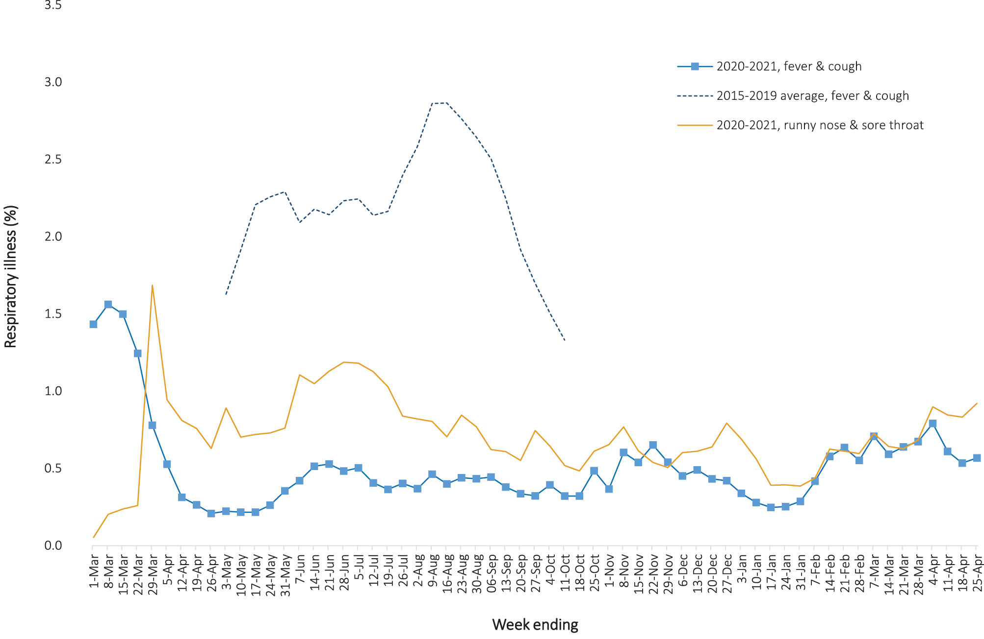
a In years prior to 2020, FluTracking was activated during the main Influenza season from May to October. A historical average beyond the week ending 11 October is therefore not available. In 2020, FluTracking commenced 10 weeks early to capture data for COVID-19. Data on runny nose and sore throat were only collected systematically after 29 March 2020, therefore a historical average for this symptom profile is unavailable.

During this reporting period, there were 60,625 assessments at Commonwealth Respiratory Clinics with 87–89% tested for SARS-CoV-2. There were no cases reported at these clinics in this reporting period.
In patients experiencing influenza-like illness in this reporting period who were tested through the Australian Sentinel Practice Research Network (ASPREN) and Victorian Sentinel Practice Influenza Network (VicSPIN) general practitioner (GP) sentinel surveillance systems, the most frequent respiratory viruses detected were rhinoviruses.
Based on FluTracking data, the rate of self-reported fever and cough among Aboriginal and Torres Strait Islander peoples was similar to that observed in all other participants in the first two weeks of this reporting period, but lower in the last two weeks. The rate for health care worker participants reporting these symptoms during this period was higher than that observed for all other participants for the entire four-week reporting period based on FluTracking data.

Severity

(NNDSS, FluCAN, SPRINT-SARI)

Hospitalisation
We estimate hospitalisation rates based on data from four states/territories (the Australian Capital Territory, Tasmania, Victoria and Western Australia); these jurisdictions do not hold policies that all cases be routinely hospitalised for isolation purposes and have hospitalisation data that is more than 90% complete. In these states/territories, an estimated 3.7% (9/246) of cases (with hospital data) have been hospitalised in the year to date (to 25 April, 2021); this compares to 12.5% (2,680/21,482) hospitalised in these states/territories in 2020. Comparison of proportions between time frames requires consideration of the differences in epidemic circumstances. While a high percentage of cases diagnosed in 2021 acquired their infection overseas (90%), only 22% of cases recorded overseas-acquired infections in 2020. The 2021 case cohort, largely managed in hotel quarantine, may have been less likely to be admitted to hospital due to being generally younger and more healthy than the 2020 case cohort and because they had been closely monitored with access to medical care in hotel quarantine.

Intensive care admission
The proportion of those hospitalised who were admitted to an intensive care unit (ICU) has been estimated from Influenza Complications Alert Network (FluCAN)²⁰ sentinel surveillance system data at 19% (data for those hospitalised between 29 February 2020 and 28 February 2021).
In the year to date (to 25 April 2021), there have been 13 COVID-19 cases admitted to ICUs participating in the sentinel surveillance system, Short Period Incidence Study of Severe Acute Respiratory Infection (SPRINT-SARI),²¹ with four of these admitted during this reporting period (29 March – 25 April 2021).

Risk factors for severe disease
Comorbidity data (Table 9) have been extracted from SPRINT-SARI and reflect the sickest patients with COVID-19 managed in ICU;²¹ data are therefore not generalisable to all cases. In patients admitted to ICU with COVID-19 since 27 February 2020, the most prevalent comorbidity was diabetes, particularly amongst those who died while in hospital (44%). Over a quarter of ICU-admitted COVID-19 patients were classified as obese (a body mass index of > 30, or over 120 kg). Mortality rates, amongst those admitted to ICU, increased with rising numbers of comorbidities; however, there were ten deaths (6% of all deaths in ICU) that occurred in patients with none of the listed co-morbidities recorded (these were aged between 42 and 81 years).

Table 9: Comorbidities for adult COVID-19 cases (> 18 years) amongst those admitted to ICU and those who died in ICU from COVID-19, and case fatality rate by comorbidity, Australia, as at 25 April 2021
Comorbidity | ICU casesª  (n = 509)  (%) | In-ICU deathsª  (n = 66)  (%) | Case fatality amongst ICU admissions with hospital outcomeª  (n = 506)  (%)
Cardiac disease | 75 (16) | 22 (36) | 29.7
Chronic respiratory condition^{b} | 105 (22) | 17 (27) | 16.5
Diabetes | 144 (30) | 27 (44) | 18.9
Obesity | 135 (28) | 18 (29) | 13.5
Chronic renal disease | 33 (7) | 12 (19) | 37.5
Chronic neurological condition | 8 (2) | 3 (5) | 37.5
Malignancy | 32 (7) | 12 (20) | 40.0
Chronic liver disease | 17 (4) | 5 (8) | 29.4
Immunosuppression | 44 (9) | 13 (21) | 31.7
Number of specified comorbidities^{c}
One or more | 322 (66) | 52 (84) | 16.4
Two or more | 167 (34) | 38 (61) | 23.3
Three or more | 65 (13) | 22 (35) | 34.9
No comorbidities | 164 (34) | 10 (16) | 6.1

a Source: SPRINT-SARI.21 Excludes those with missing data (18–25 cases; 3.5–4.9%) on comorbidities or where comorbidity is unknown (6–16 cases; 1.2–3.1%).
b Includes asthma.
c Includes chronic respiratory conditions, cardiac disease (excluding hypertension), immunosuppressive condition/therapy, diabetes, obesity, liver disease, renal disease and neurological disorder.

COVID-19 deaths
In the past four weeks there has been one death due to COVID-19 across Australia (Table 10). Overall, the crude case fatality rate (CFR) remains stable at 3.1%. The ratio of deaths to cases in the year to date has decreased in comparison to this time last year, noting substantially lower case numbers.
Table 10: Deaths due to COVID-19 as count and case fatality rates by reporting period, Australia, 1 January 2020 to 25 April 2021ª
 | Reporting period  29 March–25 April 2021 | Year to date (2021)  1 January – 25 April 2021  Deaths/case numbers | Year to date (2020)  1 January – 25 April 2020  Deaths/case numbers | Epidemic to date  1 January 2020 – 25 April 2021  Deaths/case numbers
Number of deaths | 1/243 | 1/1,082 | 101/6,980 | 910/29,550
Crude case fatality rate | 0.4% | 0.1% | 1.4% | 3.1%
a Source: NNDSS extracted based on diagnosis date.

Public health response measures
Since COVID-19 first emerged internationally, Australia has implemented public health measures informed by the disease’s epidemiology (Figure 8). States and Territories have decision making authority in relation to public health measures and have implemented or eased restrictions at their own pace, depending on the local public health and epidemiological situation, and in line with the ‘Framework for National Reopening’.³ Nationwide requirements involving air travel remain including pre-flight testing for travellers entering Australia and requirements to wear face masks when flying domestically or internationally remain in place. The national vaccination rollout of Phase 1a and Phase 1b have continued across jurisdictions this month. During the current reporting period, short-term higher level restriction periods commenced in Queensland and in Western Australia in response to community transmission of cases found to be infected with SARS-CoV-2 variants of concern (Table 11).

Table 11: State and territory changes to COVID-19 restrictions, Australia, 29 March to 25 April 2021
Jurisdiction | Summary of changes to COVID-19 restrictions
Australian Capital Territory | From 28 March, Australian Capital Territory declared anyone who had been in Greater Brisbane since 11 March must isolate until receiving a negative test result and complete an online declaration form.²²  From 29 March, Australian Capital Territory declared that anyone who had been in Greater Brisbane since 15 March, must immediately enter quarantine until Greater Brisbane lifts their period of higher-level restrictions.²³  From 14 April, Australian Capital Territory eased the following restrictions:²⁴  - Cinemas and movie theatres can sell seated tickets at 100% capacity if operating with an approved COVID Safety Plan; and  - Large indoor performance venues can have events at 100% capacity if ticketed, seated and operating with an approved COVID Safety Plan.  From 24 April, Australian Capital Territory declared that anyone who had been in Perth or Peel regions must immediately isolate until receiving a negative test result and complete a declaration form.²⁵
New South Wales | From 29 March, New South Wales eased the following restrictions:²⁶  - No caps on weddings and funerals;  - No restrictions on singing, including in places of worship;  - No restrictions on dancing, including at weddings, pubs and nightclubs;  - No caps on visitors in homes;  - Up to 200 people allowed for personal outdoor public gatherings;  - All venues to follow 1 person per 2 sqm rule, density restrictions apply once 25 people or more are within a venue;  - 100% seated capacity at entertainment venues including stadiums and theatres; and  - Mask use no longer mandatory on public transport, although still strongly recommended.  From 29 March, Individuals within New South Wales who have been in Greater Brisbane since 20 March must comply with Greater Brisbane’s stay at home restrictions while in effect.²⁷  From 23 April, Individuals within New South Wales who have been in the Perth and Peel regions of Western Australia since 17 April must comply with Peth and Peel regions stay at home restrictions while in effect.²⁸
Northern Territory | From 27 March, Northern Territory declared individuals who were in Greater Brisbane from 12 March must self-quarantine until a negative COVID-19 test is returned.²⁹  From 29 March, Northern Territory declared individuals entering from Greater Brisbane must undertake 14 days of mandatory supervised quarantine.³⁰  From 30 March, Northern Territory declared individuals who arrived between 26 March and 30 March from the Byron Shire Council must get tested and self-quarantine for 14 days, irrespective of returning a negative result.³¹  From 1 April, Northern Territory revoked restrictions in place for travellers from Greater Brisbane and Byron Shire Council.^{32,33}  From 24 April, Northern Territory declared anyone arriving from Perth or Peel regions must undertake 14 days of mandatory supervised quarantine. Individuals who arrived from 17 April to 23 April must self-quarantine until a negative COVID-19 test is returned.³⁴
Queensland | From 29 March, Queensland entered a period of higher level restrictions for Greater Brisbane:³⁵  - Individuals must only leave their residence for essential purposes:  - Obtaining essential goods or services, including healthcare,  - Exercise with others from the same household group and/or one other person from anther household,  - Attending essential work or childcare, and  - Assisting vulnerable persons;  - Individuals must not have more than two visitors to their residence per day;  - Visitor restrictions put in place for aged care facilities, disability accommodation services, hospital and correctional facilities;  - Non-essential businesses are not permitted to operate;  - Retail, food services, entertainment venues and high risk businesses must only open for seated eating and drinking, takeaway and delivery;  - A face mask must be carried at all times, mandatory to wear within indoor spaces:  - Shopping centres and supermarkets,  - Hospitals and aged care facilities,  - Indoor workplaces,  - Public transport, taxis and rideshare, and in queues for this transport, and  - Airports and travelling on planes; and  - Guest capacities reduced to 20 people for funerals and 10 people for weddings, including staff.  From 1 April, Queensland lifted the following higher level restrictions:³⁶  - Individuals can now leave their residence for any purpose;  - Up to 30 people can gather within a residence;  - Up to 500 people can gather outside in a public space;  - Businesses can now open following the 1 person per 2 sqm density restrictions;  - Wedding ceremonies and funerals can have 200 people in attendance or 1 person per 2 sqm whichever is greatest;  - 100% capacity at venues which are ticketed and seated; and  - Dancing is only permitted outdoors.  From 15 April, the following restrictions were lifted:³⁷  - Face masks are only mandatory in certain settings;  - Gatherings at private residences cap increased to 100 people;  - No restriction on gatherings outside in a public space;  - Outdoor events do not need an Approved COVID Safe Plan or Checklist, unless the event is a music festival and/or involves dancing;  - All businesses must continue the 1 person per 2 sqm rule for dance areas; and  - Wedding ceremonies and funerals held outdoors do not have to collect contact details and are not subject to a limit on number of attendees.  From 23 April, anyone who has entered Queensland and been to the Perth or Peel regions since 17 April must remain home until receiving a negative COVID-19 test result.³⁷  From 24 April, those entering Queensland who have been to the Perth or Peel regions since 17 April must enter hotel quarantine for 14 days, non-residents require an exemption to enter the state.³⁷
South Australia | From 27 March, South Australia stated individuals who had visited Greater Brisbane since 20 March must isolate until returning a negative test result and get further tests on day 5 and day 13.³⁸  From 24 April, South Australia stated individuals who had visited the Perth or Peel regions since 17 April must isolate until returning a negative test result and get further tests on day 5 and day 13. Non-essential travel from Perth or Peel regions not permitted without an exemption.³⁹
Tasmania | From 23 April, Tasmania declared the Perth and Peel regions high risk. Tas-e-Travel pass must be applied for prior to entering the state, those granted entry must quarantine for 14 days.⁴⁰
Victoria | From 29 March, Victoria declared Greater Brisbane a red zone and the Gladstone Region and Byron Shire as orange zones under Victoria’s travel permit system.⁴¹  From 1 April, Victoria declared Greater Brisbane an orange zone under Victoria’s travel permit system, while the Gladstone Region and Byron Shire remain as orange zones.⁴¹  From 12 April, Victoria declared Greater Brisbane, Gladstone Region and Byron Shire as green zones under Victoria’s travel permit system.⁴¹  From 24 April, Victoria declared Metropolitan Perth and Peel regions a red zone under Victoria’s travel permit system.⁴¹
Western Australia | From 30 March, Western Australia declared Queensland ‘medium risk’. Travel from Queensland into Western Australia is not permitted without an exemption.⁴²  From 7 April, Western Australia declared Queensland ‘low risk’. All arrivals from Queensland must self-quarantine for 14 days and present for a COVID-19 test on day 11.⁴³  From 10 April, Western Australia eased the following restrictions:⁴⁴  - Certain indoor and outdoor seated entertainment spaces can operate at 100% capacity; and  - Places of worship can have 100% capacity.  From 19 April, Western Australia declared Queensland ‘very-low risk’. Individuals are able to enter Western Australia from Queensland without quarantining, subject to meeting certain conditions.⁴⁵  From 24 April, Western Australia entered into a period of higher-level restrictions for the Perth and Peel regions including:⁴⁶  - Individuals must only leave their residence for essential purposes:  - Essential work,  - To shop for essential supplies,  - Accessing medical or health care,  - Providing care or support to another individual, and  - Exercise for up to 1 hour per day;  - Face masks are mandatory when leaving place of residence;  - Restaurants, cafes, pubs and bars to provide take-away services only;  - Entertainment and nightclub venues to close;  - Community sports, events and functions are not permitted; and  - No visitors allowed to homes, hospitals or residential aged care or disability facilities.

Figure 8: COVID-19 notifications in Australia by week of diagnosis and jurisdiction, 1 January – 25 April 2021,a with timing of key public health measures
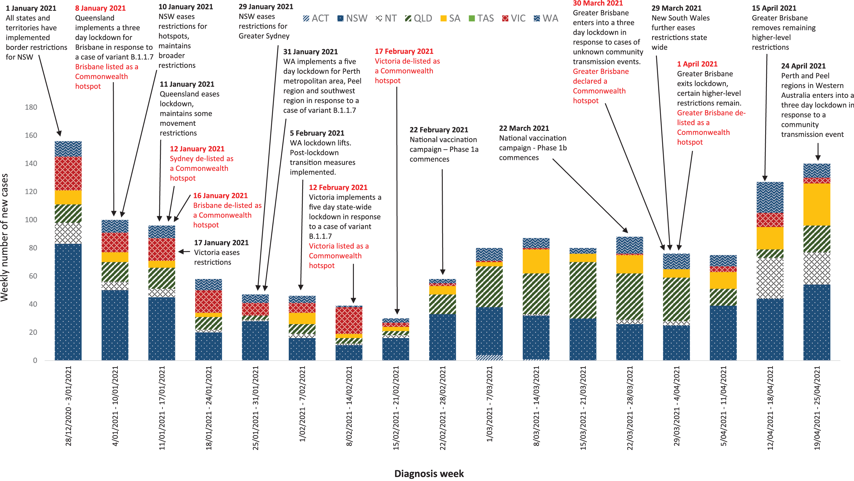
a Notifications throughout this period are predominantly overseas-acquired, with such cases representing a majority in each week of the indicated period (see also Figure 2).

Countries and territories in Australia’s near region
According to the World Health Organization (WHO), 46 countries and territories in the South East Asian (SEARO) and Western Pacific (WPRO) regions reported 5,823,305 newly-confirmed cases and 42,082 deaths in the four-week period from 29 March to 25 April 2021, bringing the cumulative cases in the two regions to over 23 million and 297,605 cumulative deaths.⁴⁷ In the Western Pacific, case numbers (477,543 new cases) and new deaths (4,861 new deaths) both doubled in comparison to the previous four-week period. In South East Asia, there was an almost five-fold surge in reported new cases (5,345,762 new cases) while new deaths increased almost fourfold (37,221 new deaths) compared to the preceding four-week period. Countries and territories that experienced the greatest rate of increase in new cases were:
- Lao PDR (5,410% or a 54-fold increase);
- Thailand (914%);
- India (623%);
- Timor-Leste (496%); and
- Bangladesh (438%).⁴⁸
Trends in new cases and deaths reported has increased significantly in the South East Asia and the Western Pacific regions due to the outbreaks occurring in India and the Philippines. The new cases and deaths reported for each country have skewed the total figures for the respective regions.
Fifteen Pacific Island countries reported no new cases in the past month.
Table 12 outlines the current transmission classification set by WHO for Australia’s near region. Under WHO’s classification, Australia has a transmission classification of ‘clusters of cases’.

Table 12: Transmission patterns for countries in Australia’s near region according to WHO, 25 April 2021^{a,b}
Category | Country
No cases  Countries/territories/areas with no cases | American Samoa, Cook Islands, Democratic People’s Republic of Korea, Kiribati, Marshall Islands, Federated States of Micronesia, Nauru, Niue, Palau, Pitcairn Islands, Samoa, Solomon Islands, Tokelau, Tonga, Tuvalu and Vanuatu
Sporadic cases  Countries/territories/areas with one or more cases, imported or locally detected | Bhutan, Brunei Darussalam, Cambodia, Fiji, French Polynesia, Lao PDR, New Caledonia, Singapore, Wallis and Futuna
Clusters of cases  Countries/territories/areas experiencing cases, clustered in time, geographic location and/or by common exposures | Australia, China, Guam, India, Japan, Maldives, Mongolia, Myanmar, Nepal, New Zealand, Republic of Korea, Sri Lanka, Thailand, Timor-Leste and Vietnam
Community transmission  Countries /territories/areas experiencing larger outbreaks of local transmission defined through an assessment of factors including, but not limited to:  - large numbers of cases not linkable to transmission chains  - large numbers of cases from sentinel lab surveillance or increasing positive tests through sentinel samples (routine systematic testing of respiratory samples from established laboratories)  - multiple unrelated clusters in several areas of the country/territory/area. | Bangladesh, Indonesia, Malaysia, Papua New Guinea and Philippines
a Source: World Health Organization Coronavirus (COVID-19) Dashboard, accessed 28 April 2021.
b Classifications according to WHO.
Globally, reported new cases and deaths increased by 69.7% and 46.6% respectively in the four weeks since 28 March 2021 (21,919,785 reported new cases; 357,129 new deaths) with a global case fatality rate (CFR) of 1.8%. The global case increase was driven by significant increases in South East Asia (482.9%) and the Western Pacific (121.6%). To date, over 146 million COVID-19 cases and 3.1 million deaths have been reported globally. The three regions reporting the largest burden of disease over the past four weeks were Europe (31.9% of all new cases reported), South East Asia (29.3%) and the Region of the Americas (28.2%). The highest number of newly-reported cases in the four-week period 29 March to 25 April 2021 were in:
- India – experiencing clusters of cases (reported 6,025,643 new cases, an over 500% increase);
- Brazil – experiencing community transmission (1,965,009 new cases, representing a 0.8% increase);
- United States of America – experiencing community transmission (1,923,669 which represents a 14.2% increase in cases);
- Turkey – experiencing community transmission (1,531,467 new cases reported, representing an increase of 165.7%);
- France – experiencing community transmission (763,849 new cases, representing a 40.2% increase).
The Region of the Americas accounted for 45.4% of new deaths reported, followed by Europe at 32.2%. The highest number of deaths from COVID-19 in the last four weeks were reported in:
- Brazil (84,824 deaths, representing a 56.3% increase in deaths);
- India (39,635 deaths, representing an over 700% increase);
- United States of America (24,324 deaths, representing 32.9% fewer deaths);
- Poland (14,649 deaths, representing an 80.5% increase);
- Mexico (14,251 deaths, representing 13% fewer deaths).
For many countries, vaccine rollout began in December 2020 but global distribution remains significantly uneven and well below 50% coverage in countries of high transmission.⁴⁹ Public health prevention measures and periods of restriction of community mobility remain the primary means to reduce transmission, particularly as new strains emerge and circulate simultaneously.⁵⁰ An international summary by WHO Region can be found in the WHO Epidemiological Update dated 31 March 2021.^{18,48}

Acknowledgements
We thank public health staff from incident emergency operations centres and public health units in state and territory health departments, and the Australian Government Department of Health, along with state and territory public health laboratories. We thank those who have provided data from surveillance systems, such as Commonwealth respiratory clinics, ASPREN, Flutracking, FluCAN, Communicable Disease Genomics Network, AusTrakka and jurisdictional sequencing laboratories.

Author details

Corresponding author
COVID-19 National Incident Room Surveillance Team
Australian Government Department of Health, GPO Box 9484, MDP 14, Canberra, ACT 2601.
Email: epi.coronavirus@health.gov.au

References
- COVID-19 National Incident Room Surveillance Team. COVID-19 Australia: Epidemiology Report 39: Reporting period ending 11 April 2021. Commun Dis Intell (2018). 2021;45. doi: https://doi.org/10.33321/cdi.2021.45.20.
- World Health Organization (WHO). Coronavirus disease (COVID-19). Timeline: WHO’s COVID-19 response. [Webpage.] Geneva: WHO; 2021. [Accessed on 30 April 2021.] Available from: https://www.who.int/emergencies/diseases/novel-coronavirus-2019/interactive-timeline#!.
- Australian Government Department of Health. Framework for national reopening – October 2020. [Internet.] Canberra: Australian Government Department of Health; 23 October 2020. [Accessed on 10 November 2020.] Available from: https://www.health.gov.au/resources/publications/framework-for-national-reopening-october-2020.
- Australian Government Department of the Prime Minister and Cabinet. Update on coronavirus measures. Media statement. [Internet.] Canberra: Australian Government Department of Prime Minister and Cabinet; 20 March 2020. [Accessed on 29 April 2021.] Available from: https://www.pm.gov.au/media/update-coronavirus-measures-0.
- Australian Government Department of the Prime Minister and Cabinet. Safe travel zone with New Zealand. Media release. [Internet.] Canberra: Australian Government Department of Prime Minister and Cabinet; 2 October 2020. [Accessed on 29 April 2021.] Available from: https://www.pm.gov.au/media/safe-travel-zone-new-zealand.
- Australian Government Department of the Prime Minister and Cabinet. Update on coronavirus measures. Media statement. [Internet.] Canberra: Australian Government Department of Prime Minister and Cabinet; 24 March 2020. [Accessed on 29 April 2021.] Available from: https://www.pm.gov.au/media/update-coronavirus-measures-24-March-2020.
- Australian Government Department of the Prime Minister and Cabinet. Update on coronavirus measures. Media statement. [Internet.] Canberra: Australian Government Department of Prime Minister and Cabinet; 27 March 2020. [Accessed on 29 April 2021.] Available from: https://www.pm.gov.au/media/update-coronavirus-measures-270320.
- Australian Government Department of the Prime Minister and Cabinet. National Cabinet statement. Media statement. [Internet.] Canberra: Australian Government Department of Prime Minister and Cabinet; 29 March 2020. [Accessed on 29 April 2021.] Available from: https://www.pm.gov.au/media/national-cabinet-statement.
- Australian Government Department of the Prime Minister and Cabinet. Elective surgery. Media release. [Internet.] Canberra: Australian Government Department of Prime Minister and Cabinet; 25 March 2020. [Accessed on 29 April 2021.] Available from: https://www.pm.gov.au/media/elective-surgery.
- Australian Government Department of the Prime Minister and Cabinet. Update on coronavirus measures. Media statement. [Internet.] Canberra: Australian Government Department of Prime Minister and Cabinet; 22 March 2020. [Accessed on 29 April 2021.] Available from: https://www.pm.gov.au/media/update-coronavirus-measures-220320.
- Australian Government Department of the Prime Minister and Cabinet. Update on coronavirus measures. Media statement. [Internet.] Canberra: Australian Government Department of Prime Minister and Cabinet; 18 March 2020. [Accessed on 29 April 2021.] Available from: https://www.pm.gov.au/media/update-coronavirus-measures.
- Australian Government Department of Health. COVIDSafe app. [Internet.] Canberra: Australian Government Department of Health; 15 December 2020. [Accessed on 29 April 2021.] Available from: https://www.health.gov.au/resources/apps-and-tools/covidsafe-app.
- Australian Government Department of Health. Masks: wearing a mask can help protect you and those around you. [Internet.] Canberra: Australian Government Department of Health; 18 March 2021. [Accessed on 29 April 2021.] Available from: https://www.health.gov.au/news/health-alerts/novel-coronavirus-2019-ncov-health-alert/how-to-protect-yourself-and-others-from-coronavirus-covid-19/masks.
- COVID-19 National Incident Room Surveillance Team. Technical supplement. COVID-19 Australia: Epidemiology reporting. Commun Dis Intell (2018). 2021;45. doi: https://doi.org/10.33321/cdi.2021.45.2.
- Australian Government Department of Health. Getting vaccinated for COVID-19: Australia’s vaccine rollout. [Internet.] Canberra: Australian Government Department of Health; 30 March 2021. [Accessed on 29 April 2021.] Available from: https://www.health.gov.au/initiatives-and-programs/covid-19-vaccines/getting-vaccinated-for-covid-19#australias-vaccine-rollout.
- Australian Government Department of Health. ATAGI statement on AstraZeneca vaccine in response to new vaccine safety concerns. [Internet.] Canberra: Australian Government Department of Health, Australian Technical Advisory Group on Immunisation; 8 April 2021. [Accessed 29 April 2021.] Available from: https://www.health.gov.au/news/atagi-statement-on-astrazeneca-vaccine-in-response-to-new-vaccine-safety-concerns.
- Communicable Diseases Genomics Network (CDGN). AusTrakka. [Website.] Melbourne: CDGN; 2020. Available from: https://www.cdgn.org.au/austrakka.
- WHO. Coronavirus disease (COVID-19) weekly epidemiological update and weekly operational update. [Internet.] Geneva: WHO; 30 March 2021. [Accessed on 30 March 2021.] Available from: https://www.who.int/emergencies/diseases/novel-coronavirus-2019/situation-reports/.
- Dalton C, Durrheim D, Fejsa J, Francis L, Carlson S, d’Espaignet ET et al. Flutracking: a weekly Australian community online survey of influenza-like illness in 2006, 2007 and 2008. Commun Dis Intell Q Rep. 2009;33(3):316–22.
- Monash Health. FluCAN (Influenza surveillance): FluCAN (The Influenza Complications Alert Network). [Internet.] Melbourne: Monash Health; 2020. Available from: https://monashhealth.org/services/monash-infectious-diseases/research/influenza-research/flucan-influenza-surveillance-2/.
- Australian and New Zealand Intensive Care Society (ANZICS). SPRINT-SARI: Short period incidence study of severe acute respiratory infection. [Internet.] Camberwell: ANZICS; 2020. Available from: https://www.anzics.com.au/current-active-endorsed-research/sprint-sari/.
- Australian Capital Territory Government. COVID-19: Update for travel advice for Greater Brisbane. [Internet.] Canberra: Australian Capital Territory Government; 28 March 2021. [Accessed on 28 April 2021.] Available from: https://www.covid19.act.gov.au/news-articles/update-for-travel-advice-for-greater-brisbane.
- Australian Capital Territory Government. COVID-19: New travel restrictions for people travelling from Greater Brisbane. [Internet.] Canberra: Australian Capital Territory Government; 29 March 2021. [Accessed on 28 April 2021.] Available from: https://www.covid19.act.gov.au/news-articles/new-travel-restrictions-for-people-travelling-from-greater-brisbane.
- Australian Capital Territory Government. COVID-19: ‘COVID-normal’ restrictions in effect today. [Internet.] Canberra: Australian Capital Territory Government; 14 April 2021. [Accessed on 28 April 2021.] Available from: https://www.covid19.act.gov.au/news-articles/covid-normal-restrictions-in-effect-today.
- Australian Capital Territory Government. COVID-19: New travel requirements to ACT due to Perth and Peel lockdown. [Internet.] Canberra: Australian Capital Territory Government; 24 April 2021. [Accessed on 28 April 2021.] Available from: https://www.covid19.act.gov.au/news-articles/new-travel-requirements-to-act-due-to-perth-and-peel-lockdown.
- Government of New South Wales. COVID-19 restrictions to ease but compliance must increase. [Internet.] Sydney: Government of New South Wales; 24 March 2021. [Accessed on 9 April 2021.] Available from: https://www.nsw.gov.au/media-releases/covid-19-restrictions-to-ease-but-compliance-must-increase.
- Government of New South Wales Department of Health. Public health alert - Stay at home restrictions. [Internet.] Sydney: Government of New South Wales Department of Health; 29 March 2021. [Accessed on 27 April 2021.] Available from: https://www.health.nsw.gov.au/news/pages/20210329_02.aspx.
- Government of New South Wales Department of Health. Public health alert - Western Australia. [Internet.] Sydney: Government of New South Wales Department of Health; 23 April 2021. [Accessed on 27 April 2021.] Available from: https://www.health.nsw.gov.au/news/pages/20210423_01.aspx.
- Northern Territory Government. Coronavirus (COVID-19): COVID-19 Update: Additional Testing Requirements for Brisbane. [Internet.] Darwin: Northern Territory Government; 27 March 2021. [Accessed on 28 April 2021.] Available from: https://coronavirus.nt.gov.au/updates/items/2021-03-27-covid-19-update-additional-testing-requirements-for-brisbane.
- Northern Territory Government. Coronavirus (COVID-19): Hotspots declared across Queensland. [Internet.] Darwin: Northern Territory Government; 29 March 2021. [Accessed on 28 April 2021.] Available from: https://coronavirus.nt.gov.au/updates/items/2021-03-29-hotspots-declared-across-queensland.
- Northern Territory Government. Coronavirus (COVID-19): Byron Bay Hotspot and Watch and Wait over Gold Coast. [Internet.] Darwin: Northern Territory Government; 30 March 2021. [Accessed on 28 April 2021.] Available from: https://coronavirus.nt.gov.au/updates/items/2021-03-31-byron-bay-hotspot-and-watch-and-wait-over-gold-coast.
- Northern Territory Government. Coronavirus (COVID-19): Queensland Hotspots Revoked. [Internet.] Darwin: Northern Territory Government; 1 April 2021. [Accessed on 28 April 2021.] Available from: https://coronavirus.nt.gov.au/updates/items/2021-04-01-queensland-hotspots-revoked.
- Northern Territory Government. Coronavirus (COVID-19): Byron Shire Council Hotspot Revoked, Northern NSW Testing Mandated. [Internet.] Darwin: Northern Territory Government; 1 April 2021. [Accessed on 28 April 2021.] Available from: https://coronavirus.nt.gov.au/updates/items/2021-04-1-byron-shire-council-hotspot-revoked,-northern-nsw-testing-mandated.
- Northern Territory Government. Coronavirus (COVID-19): COVID-19 Update: Metropolitan Perth and Peel Region Hotspots Declared. [Internet.] Darwin: Northern Territory Government; 23 April 2021. [Accessed on 28 April 2021.] Available from: https://coronavirus.nt.gov.au/updates/items/2021-04-23-covid-19-update-metropolitan-perth-and-peel-region-hotspots-declared.
- Queensland Government. The Queensland Cabinet and Ministerial Directory: media statements. Greater Brisbane lockdown and Queensland restrictions. [Internet.] Brisbane: Queensland Government; 29 March 2021. [Accessed on 27 April 2021.] Available from: https://statements.qld.gov.au/statements/91825.
- Queensland Government. Queensland’s COVID safe future. Update: easing of restrictions for greater Brisbane. Brisbane: Queensland Government; 2021. [Accessed on 27 April 2021.] Available from: https://www.covid19.qld.gov.au/__data/assets/pdf_file/0016/127150/DPC7309-COVID-19-Restrictions-roadmap.pdf.
- Queensland Health. COVID-19 update: Queensland COVID-19 statistics. [Internet.] Brisbane: Queensland Government, Queensland Health; 2021. [Accessed on 27 April 2021.] Available from: https://www.qld.gov.au/health/conditions/health-alerts/coronavirus-covid-19/current-status/urgent-covid-19-update.
- Government of South Australia. Latest news: COVID-19 Update 27 March. [Internet.] Adelaide: Government of South Australia; 27 March 2021. [Accessed on 28 April 2021.] Available from: https://www.covid-19.sa.gov.au/latest-news/covid-19-update-27-march.
- Government of South Australia. Latest news: COVID-19 Update 24 April 2021. [Internet.] Adelaide: Government of South Australia; 24 April 2021. [Accessed on 28 April 2021.] Available from: https://www.covid-19.sa.gov.au/latest-news/covid-19-update-24-april-2021.
- Tasmanian Government. Coronavirus disease (COVID-19). Important community updates: Western Australia update. [Internet.] Hobart: Tasmanian Government; 23 April 2021. [Accessed on 28 April 2021.] Available from: https://coronavirus.tas.gov.au/facts/important-community-updates.
- Victoria State Government Department of Health and Human Services (DHHS). Updates: updates about the outbreak of the coronavirus disease (COVID-19). [Internet.] Melbourne: Victoria State Government, DHHS; April 2021. [Accessed on 27 April 2021.] Available from: https://www.dhhs.vic.gov.au/coronavirus/updates.
- Government of Western Australia. WA introduces hard border with Queensland. [Internet.] Perth: Government of Western Australia; 29 March 2021. [Accessed on 27 April 2021.] Available from: https://www.wa.gov.au/government/announcements/wa-introduces-hard-border-queensland.
- Government of Western Australia. Queensland to transition to ‘low risk’ state. [Internet.] Perth: Government of Western Australia; 6 April 2021. [Accessed on 27 April 2021.] Available from: https://www.wa.gov.au/government/announcements/queensland-transition-low-risk-state.
- Government of Western Australia. WA’s strong position allows for more positive changes. [Internet.] Perth: Government of Western Australia; 9 April 2021. [Accessed on 27 April 2021.] Available from: https://www.wa.gov.au/government/announcements/was-strong-position-allows-more-positive-changes.
- Government of Western Australia. Controlled interstate border changes - Queensland. [Internet.] Perth: Government of Western Australia; 9 April 2021. [Accessed on 27 April 2021.] Available from: https://www.wa.gov.au/government/announcements/controlled-interstate-border-changes-queensland.
- Government of Western Australia. Perth metro and Peel to enter a 3-day lockdown. [Internet.] Perth: Government of Western Australia; 23 April 2021. [Accessed on 27 April 2021.] Available from: https://www.wa.gov.au/government/announcements/perth-metro-and-peel-enter-3-day-lockdown.
- WHO. Weekly epidemiological update on COVID-19 – 27 April 2021. [Internet.] Geneva: WHO; 27 April 2021. [Accessed on 29 April 2021.] Available from: https://www.who.int/publications/m/item/weekly-epidemiological-update-on-covid-19---27-april-2021.
- Our World in Data. Statistics and research: Coronavirus Pandemic (COVID-19). [Internet.] Oxford: University of Oxford, Our World in Data; 2021. [Accessed on 29 April 2021.] Available from: https://ourworldindata.org/coronavirus.
- Our World in Data. Statistics and research: coronavirus (COVID-19) vaccinations. [Internet.] Oxford: University of Oxford, Our World in Data; 2021. [Accessed on 29 April 2021.] Available from: https://ourworldindata.org/covid-vaccinations.
- Public Health England. Impact of COVID-19 vaccines on mortality in England: December 2020 to February 2021. London: Public Health England; 2021. [Accessed on 30 March 2021.] Available from: https://assets.publishing.service.gov.uk/government/uploads/system/uploads/attachment_data/file/972592/COVID-19_vaccine_impact_on_mortality_240321.pdf.

Appendix A: Supplementary figures and tables
Table A.1: COVID-19 case notifications and rates per 100,000 population, by age group and sex, Australia, 25 April 2021
Age group | This reporting period  12–25 April 2021 |  |  |  |  |  | Cumulative  23 January 2020 – 25 April 2021
 | Cases |  |  | Rate per 100,000 populationª |  |  | Cases |  |  | Rate per 100,000 populationª
 | Male | Female | People | Male | Female | People | Male | Female | People | Male | Female | People
0 to 9 | 18 | 19 | 37 | 1.1 | 1.2 | 1.2 | 837 | 759 | 1,596 | 51.1 | 49.0 | 50.1
10 to 19 | 6 | 3 | 9 | 0.4 | 0.2 | 0.3 | 1,282 | 1,219 | 2,501 | 80.8 | 81.2 | 81.0
20 to 29 | 19 | 25 | 44 | 1.0 | 1.4 | 1.2 | 3,144 | 3,461 | 6,605 | 170.8 | 194.7 | 182.5
30 to 39 | 42 | 32 | 74 | 2.3 | 1.7 | 2.0 | 2,708 | 2,595 | 5,303 | 145.8 | 136.4 | 141.1
40 to 49 | 31 | 14 | 45 | 1.9 | 0.8 | 1.4 | 1,992 | 1,827 | 3,819 | 122.1 | 109.7 | 115.8
50 to 59 | 16 | 5 | 21 | 1.1 | 0.3 | 0.7 | 1,713 | 1,762 | 3,475 | 112.5 | 110.5 | 111.5
60 to 69 | 7 | 3 | 10 | 0.5 | 0.2 | 0.4 | 1,238 | 1,231 | 2,469 | 95.0 | 89.0 | 91.9
70 to 79 | 2 | 1 | 3 | 0.2 | 0.1 | 0.2 | 866 | 760 | 1,626 | 95.2 | 78.7 | 86.7
80 to 89 | 0 | 0 | 0 | 0.0 | 0.0 | 0.0 | 497 | 778 | 1,275 | 134.1 | 164.3 | 151.1
90 and over | 0 | 0 | 0 | 0.0 | 0.0 | 0.0 | 230 | 551 | 781 | 314.4 | 398.9 | 369.6
a Population data based on Australian Bureau of Statistics (ABS) Estimated Resident Population (ERP) as at June 2020. Discrepancies between rates in this and previous reports may arise due to the use of an updated population source.

Communicable Diseases Intelligence
ISSN: 2209-6051 Online

Communicable Diseases Intelligence (CDI) is a peer-reviewed scientific journal published by the Office of Health Protection and Response, Department of Health. The journal aims to disseminate information on the epidemiology, surveillance, prevention and control of communicable diseases of relevance to Australia.

Editor: Jennie Hood
Deputy Editor: Simon Petrie
Design and Production: Kasra Yousefi
Editorial Advisory Board: David Durrheim, Mark Ferson, John Kaldor, Martyn Kirk and Linda Selvey

Website: http://www.health.gov.au/cdi

Contacts
CDI is produced by Environmental Health and Health Protection Policy Branch, Office of Health Protection and Response, Australian Government Department of Health, GPO Box 9848, (MDP 6) CANBERRA ACT 2601

Email: cdi.editor@health.gov.au

Submit an Article
You are invited to submit your next communicable disease related article to the Communicable Diseases Intelligence (CDI) for consideration. More information regarding CDI can be found at: http://health.gov.au/cdi.
Further enquiries should be directed to: cdi.editor@health.gov.au.

This journal is indexed by Index Medicus and Medline.

Creative Commons Licence - Attribution-NonCommercial-NoDerivatives CC BY-NC-ND
© 2021 Commonwealth of Australia as represented by the Department of Health
This publication is licensed under a Creative Commons Attribution-NonCommercial-NoDerivatives 4.0 International Licence from https://creativecommons.org/licenses/by-nc-nd/4.0/legalcode (Licence). You must read and understand the Licence before using any material from this publication.

Restrictions
The Licence does not cover, and there is no permission given for, use of any of the following material found in this publication (if any):
- the Commonwealth Coat of Arms (by way of information, the terms under which the Coat of Arms may be used can be found at www.itsanhonour.gov.au);
- any logos (including the Department of Health’s logo) and trademarks;
- any photographs and images;
- any signatures; and
- any material belonging to third parties.

Disclaimer
Opinions expressed in Communicable Diseases Intelligence are those of the authors and not necessarily those of the Australian Government Department of Health or the Communicable Diseases Network Australia. Data may be subject to revision.

Enquiries
Enquiries regarding any other use of this publication should be addressed to the Communication Branch, Department of Health, GPO Box 9848, Canberra ACT 2601, or via e-mail to: copyright@health.gov.au

Communicable Diseases Network Australia
Communicable Diseases Intelligence contributes to the work of the Communicable Diseases Network Australia.
http://www.health.gov.au/cdna

