Communicable Diseases Intelligence, Year 2023, Volume 47
https://doi.org/10.33321/cdi.2023.47.39
Publication date: 27/7/2023
http://health.gov.au/cdi

Socio-environmental and clinical features of invasive group A streptococcal disease in the Northern Territory of Australia
Johanna M Birrell, Rowena Boyd, Bart J Currie, Asanga Abeyaratne, Sandawana William Majoni, Vicki L Krause

Abstract

Objective
To describe the socio-environmental profile and clinical features of invasive group A streptococcal (iGAS) infections in the Northern Territory (NT) of Australia over 10 years.

Methods
Cases of iGAS disease diagnosed between 1 May 2011 and 30 April 2021 were retrospectively identified from the NT Notifiable Diseases System and electronic health records accessed. Remoteness of residence, socio-economic index, seasonality and clinical characteristics were recorded.

Results
There were 692 cases of iGAS disease identified in the NT during the period 1 May 2011 – 30 April 2021. The age-standardised incidence of iGAS disease was significantly higher in people living in very remote (57.1 cases per 100,000 population, 95% confidence interval [95% CI]: 48.6–65.5) and remote areas (40.9 cases per 100,000 population, 95% CI: 34.7–47.2) than in outer regional areas of the NT (15.7 cases per 100,000 population, 95% CI: 13.4–17.9). People with socio-economic disadvantage were also disproportionately affected, with an incidence of 52.6 cases per 100,000 population (95% CI: 46.2–58.9) in decile 1–3 populations, compared to 8.9 cases per 100,000 population (95% CI: 6.9–10.9) for decile 7–10.
For cases with recorded severity data, 135 of 378 (36%) met locally-defined criteria for severe iGAS disease. Recurrent iGAS disease was commonly observed in the dialysis cohort, affecting 17 of the 106 patients during the study period (16% recurrence rate) and causing two deaths. Five molecularly-confirmed clusters of iGAS disease were identified from the study period.

Conclusions
iGAS disease is unevenly affecting people in the NT. Those living in areas of socio-economic disadvantage, those in remote and very remote communities, and those receiving dialysis were most affected. It is important that primordial, primary and secondary prevention measures be directed towards supporting these disadvantaged population groups.
Keywords: streptococcus; epidemiology; public health; rural health; dialysis

Introduction
Group A streptococcal (GAS) infections are a major cause of morbidity and mortality in the Northern Territory (NT) of Australia, through both direct infection and post-streptococcal immunologic complications (acute rheumatic fever, rheumatic heart disease, glomerulonephritis). Invasive group A streptococcal (iGAS) disease can be associated with severe clinical syndromes including sepsis, necrotising fasciitis and toxic shock syndrome. GAS is the third most common organism causing bacteraemia in the Top End of the NT.¹
iGAS disease has been notifiable in the NT since 2011² and nationally in Australia since July 2021.³ The incidence of iGAS disease in Australia in 2017-18 was estimated at 8.3 cases per 100,000 population.⁴ It has long been recognised that iGAS disease occurs at higher rates in the NT than elsewhere in Australia.^{5–7} From 1 May 2011 to 30 April 2021, the incidence of iGAS disease in the NT was 34.3 cases per 100,000 (95% confidence interval [95% CI]: 31.4–37.1) in the overall population, and 106 cases per 100,000 (95% CI: 95.0–117) in the Indigenous Australian population.⁸ There is known to be a very high burden of iGAS disease in NT patients receiving haemodialysis, with an incidence of 1,643 cases per 100,000 population in this category (95% CI: 1,374–1,950) between 2011 and 2021.⁸
The aims of this study were: (1) to review the socio-environmental profile of iGAS disease in the NT; (2) to examine the clinical features and impact of iGAS disease in people receiving haemodialysis over the past ten years; and (3) to report iGAS disease clusters, to inform public health action and policy.

Methods

Setting
This research was conducted in the NT, which had an estimated population of 249,200 people in 2021 and a geographical area of 1,348,094 km².⁹ Approximately 30% of the population are Indigenous Australians.⁹ The NT has the highest dialysis rate of any state or territory in Australia, at 3,143 patients per million population in 2020, compared to 567 patients per million nationally.¹⁰
Central Australia was defined as the Statistical Area Level 3 (SA3) Census regions of Barkly and Alice Springs. The Top End included Greater Darwin (SA3 regions of Darwin City, Darwin Suburbs, Litchfield and Daly-Tiwi-West Arnhem), Katherine (Big Rivers) and East Arnhem (Figure 1).¹¹ The Australian Statistical Geography Standard (ASGS) Remoteness Structure classifies urban Darwin as ‘outer regional’, greater Darwin and Alice Springs regions as ‘remote’, and all other areas of the Territory as ‘very remote’.¹² The climate in Central Australia is predominantly arid, while the Top End is tropical. For this analysis, the wet season in the Top End was defined as November–April and the dry season as May–October.

Figure 1: Map of the Statistical Area 3 regions11 (left) and 2016 Remoteness Areas12 (right) for the Northern Territory
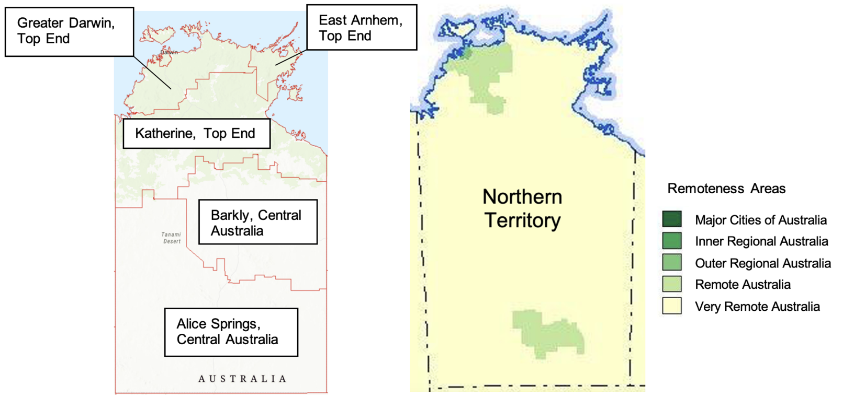

Selection of cases
Cases of iGAS disease diagnosed between 1 May 2011 and 30 April 2021 were identified from the NT Notifiable Diseases System (NTNDS). The confirmed case definition required isolation of GAS from a normally sterile site by culture or nucleic acid testing (NAT). The probable case definition (added October 2016) required isolation of GAS by culture or NAT from the site of necrotising fasciitis.¹³ All GAS isolates for an individual within a 30-day period were treated as a single case. The analysis allowed multiple infections in an individual if episodes were separated by more than 30 days.

Patient characteristics and outcome measures
Age, sex, Indigenous status, region-of-residence, remoteness-of-residence (using the Australian Statistical Geography Standard (ASGS) remoteness structure),¹² Socio-economic Indexes for Areas (SEIFA) index of relative social disadvantage (IRSD),¹⁴ severity, laboratory specimen type and date, hospital admission and discharge dates, and all-cause mortality data (at 7 and 30 days after diagnosis) were extracted from the NTNDS and electronic health records (EHR). Statistical Area 2 (SA2) data (defined by usual place of residence) were used for remoteness and IRSD calculations. Population data were retrieved from the Population and Digital Health Unit¹⁵ and Australian Bureau of Statistics.^{12,14} Age-standardisation was performed using 2001 Australian Census data as the reference population. Cases with a residential address outside the NT were excluded from analyses associated with geographical factors.
Dialysis status at the time of diagnosis was assessed using EHR. For dialysis recipients, data on site of infection, dialysis type (peritoneal or haemodialysis) and vascular access, co-morbidities (diabetes mellitus, heart disease, chronic liver disease, cigarette smoking, active malignancy; as recorded as free text in patient notes), length of hospital stay, number and type of surgeries (from operating theatre notes), intensive care unit (ICU) admission and iGAS disease severity were also collected from EHR.
Severe iGAS disease is defined in the NT guidelines as iGAS cases presenting with pneumonia, meningitis, post-partum sepsis, necrotising fasciitis, toxic shock syndrome or any other manifestation requiring ICU admission or causing death.¹⁶ A cluster was defined as two or more epidemiologically-linked cases of iGAS disease which were identical on molecular typing. Molecular typing was undertaken for cases with suspected epidemiological link during public health response to a case notification. All-cause mortality data were stratified by Indigenous status, dialysis status, socio-economic status, and remoteness-of-residence.

Data analysis
Statistical analyses were performed using Microsoft Excel and Stata (Version 14.2). The 95% confidence intervals (95% CI) for proportions were derived via the Wilson score method, using an analytical tool from the Association of Public Health Observatories.¹⁷ Categorical data were compared using the chi-squared test with a significance level of 5%. The chi-squared test was used to compare 30-day mortality by Indigenous status and dialysis status (binary variables), and by remoteness-of-residence (three-category variable), as determined a priori. Incidence rate ratios (IRRs) were derived using the Stata incidence-rate ratio calculator to compare incidence of iGAS disease by remoteness and socio-economic category. For remoteness, ‘outer regional’ incidence was individually compared to ‘remote’ and ‘very remote’ incidence. For socio-economic status, incidence of iGAS disease in the ‘least disadvantaged’ category (decile 7–10) was individually compared to the ‘moderately disadvantaged’ (decile 4–6) and ‘most disadvantaged’ (decile 1–3) categories. Seasonality was independently analysed for Central Australia and for the Top End using proportions and the Walter-Elwood test, incorporating monthly case numbers and population data.^{18,19}

Ethics approval
The study was approved by the NT Health and Menzies School of Health Research Human Research Ethics Committee (2021-4125).

Results
There were 692 cases of iGAS disease identified in the NT from May 2011 to April 2021 (Table 1), in 614 patients. This included 686 confirmed and 6 probable cases. GAS was isolated from blood culture in 652 cases (94%). Other normally sterile specimen types included synovial fluid (n = 24), peritoneal fluid (n = 3), pleural fluid (n = 2), cerebrospinal fluid (n = 1), and placental tissue (n = 1). Of the probable cases, GAS was isolated from subcutaneous tissue (n = 4) and wound swab (n = 2).

Table 1: Characteristics of invasive group A streptococcal disease cases in the Northern Territory, May 2011 to April 2021
Characteristic | Value | n (%)
Cases |  | 692 (100)
Sex | Female | 380 (55)
 | Male | 312 (45)
Age group (years) | 0–4 | 72 (10)
 | 5–9 | 10 (1)
 | 10–19 | 22 (3)
 | 20–29 | 34 (5)
 | 30–39 | 64 (9)
 | 40–49 | 134 (19)
 | 50–59 | 127 (18)
 | 60–69 | 126 (18)
 | 70–79 | 66 (10)
 | 80–89 | 32 (5)
 | ≥ 90 | 5 (1)
Indigenous status | Indigenous Australians | 511 (74)
 | non-Indigenous Australians | 181 (26)
Region of occurrence | Top End (tropical) | 386 (56)
 | Central Australia (non-tropical) | 306 (44)
Remoteness of residence ª | Major cities / inner regional | 0 (0)
 | Outer regional | 211 (30)
 | Remote | 196 (28)
 | Very remote | 251 (36)
 | Interstate / unknown | 34 (5)
Socio-economic status ^{b} | Most disadvantaged | 212 (31)
 | More disadvantaged | 179 (26)
 | Moderately disadvantaged | 179 (26)
 | Less disadvantaged | 32 (5)
 | Least disadvantaged | 56 (8)
 | Interstate / unknown | 34 (5)
a Australian Statistical Geography Standard (ASGS) remoteness structure.¹²
b Socio-economic Indexes for Areas (SEIFA) Index of Relative Social Disadvantage (IRSD) quintiles.¹⁴

Socio-environmental risk factors
Over half of patients (n = 380; 55%) were female and 511 cases (74%) occurred in Indigenous Australian people. Median age at diagnosis was 50 years (interquartile range (IQR): 37–63 years), and 41 cases (6%) were in children under one year of age. 386 cases (56%) were diagnosed in the Top End and 306 (44%) in Central Australia.
A total of 658 cases (95%) had an NT residential address and 407 of these patients (62%) were living in remote or very remote areas. As illustrated in Figure 2, the age-standardised incidence of iGAS disease was significantly higher among people living in very remote and remote areas than in those living in outer regional areas of the NT (IRR 3.7 for very remote vs outer regional location [95% CI: 2.0–6.6; p < 0.001]; IRR 2.6 for remote vs outer regional location [95% CI: 1.4–4.9; p < 0.001]).
Figure 2: Age-standardised incidence of invasive group A streptococcal disease by remoteness of residential location in the Northern Territory, May 2011 to April 2021
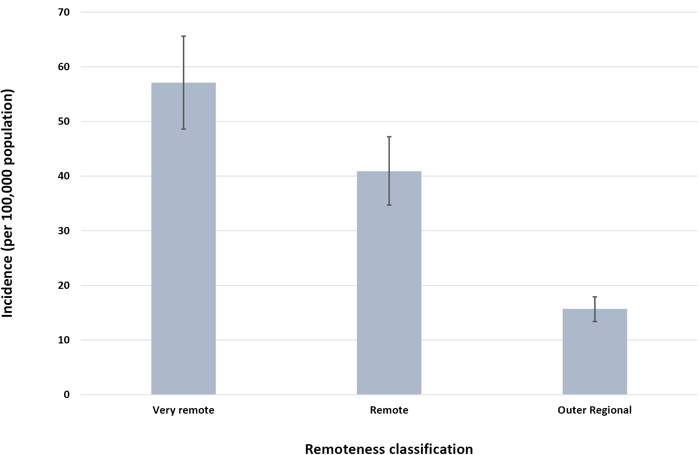
a Australian Statistical Geography Standard (ASGS) remoteness structure.
Of the 658 resident cases, 570 (87%) were living in areas of at least moderate social disadvantage (decile 1–6). As shown in Figure 3, the incidence of iGAS disease was significantly higher in the groups with greater socio-economic disadvantage (IRR 5.9 for ‘most disadvantaged’ vs ‘least disadvantaged’ [95% CI: 2.9–13.6; p < 0.001]; IRR 4.2 for ‘moderately disadvantaged’ vs ‘least disadvantaged’ [95% CI: 2.0–9.9; p < 0.001]). The proportion of cases in the lowest IRSD quintile was 33% in Central Australia (100 of 306 cases) and 29% in the Top End (112 of 386).
Seasonality of iGAS disease was not evident in Central Australia: 155 of 306 cases (51%; 95% CI: 0.45–0.56) were diagnosed in summer months (November–April), and 151 of 306 (49%; 95% CI: 0.44–0.55) in winter (May–October). In the Top End region there was a statistically significant dry season predominance: 225 of 386 cases (58%; 95% CI: 0.53–0.63) were diagnosed in the dry season (May–October), and 161 of 386 (42%; 95% CI: 0.37–0.47) in the wet season (November–April) (p < 0.001).

Figure 3: Age-standardised incidence of invasive group A streptococcal disease by socio-economic status (of residential location) in the Northern Territory, May 2011 to April 2021
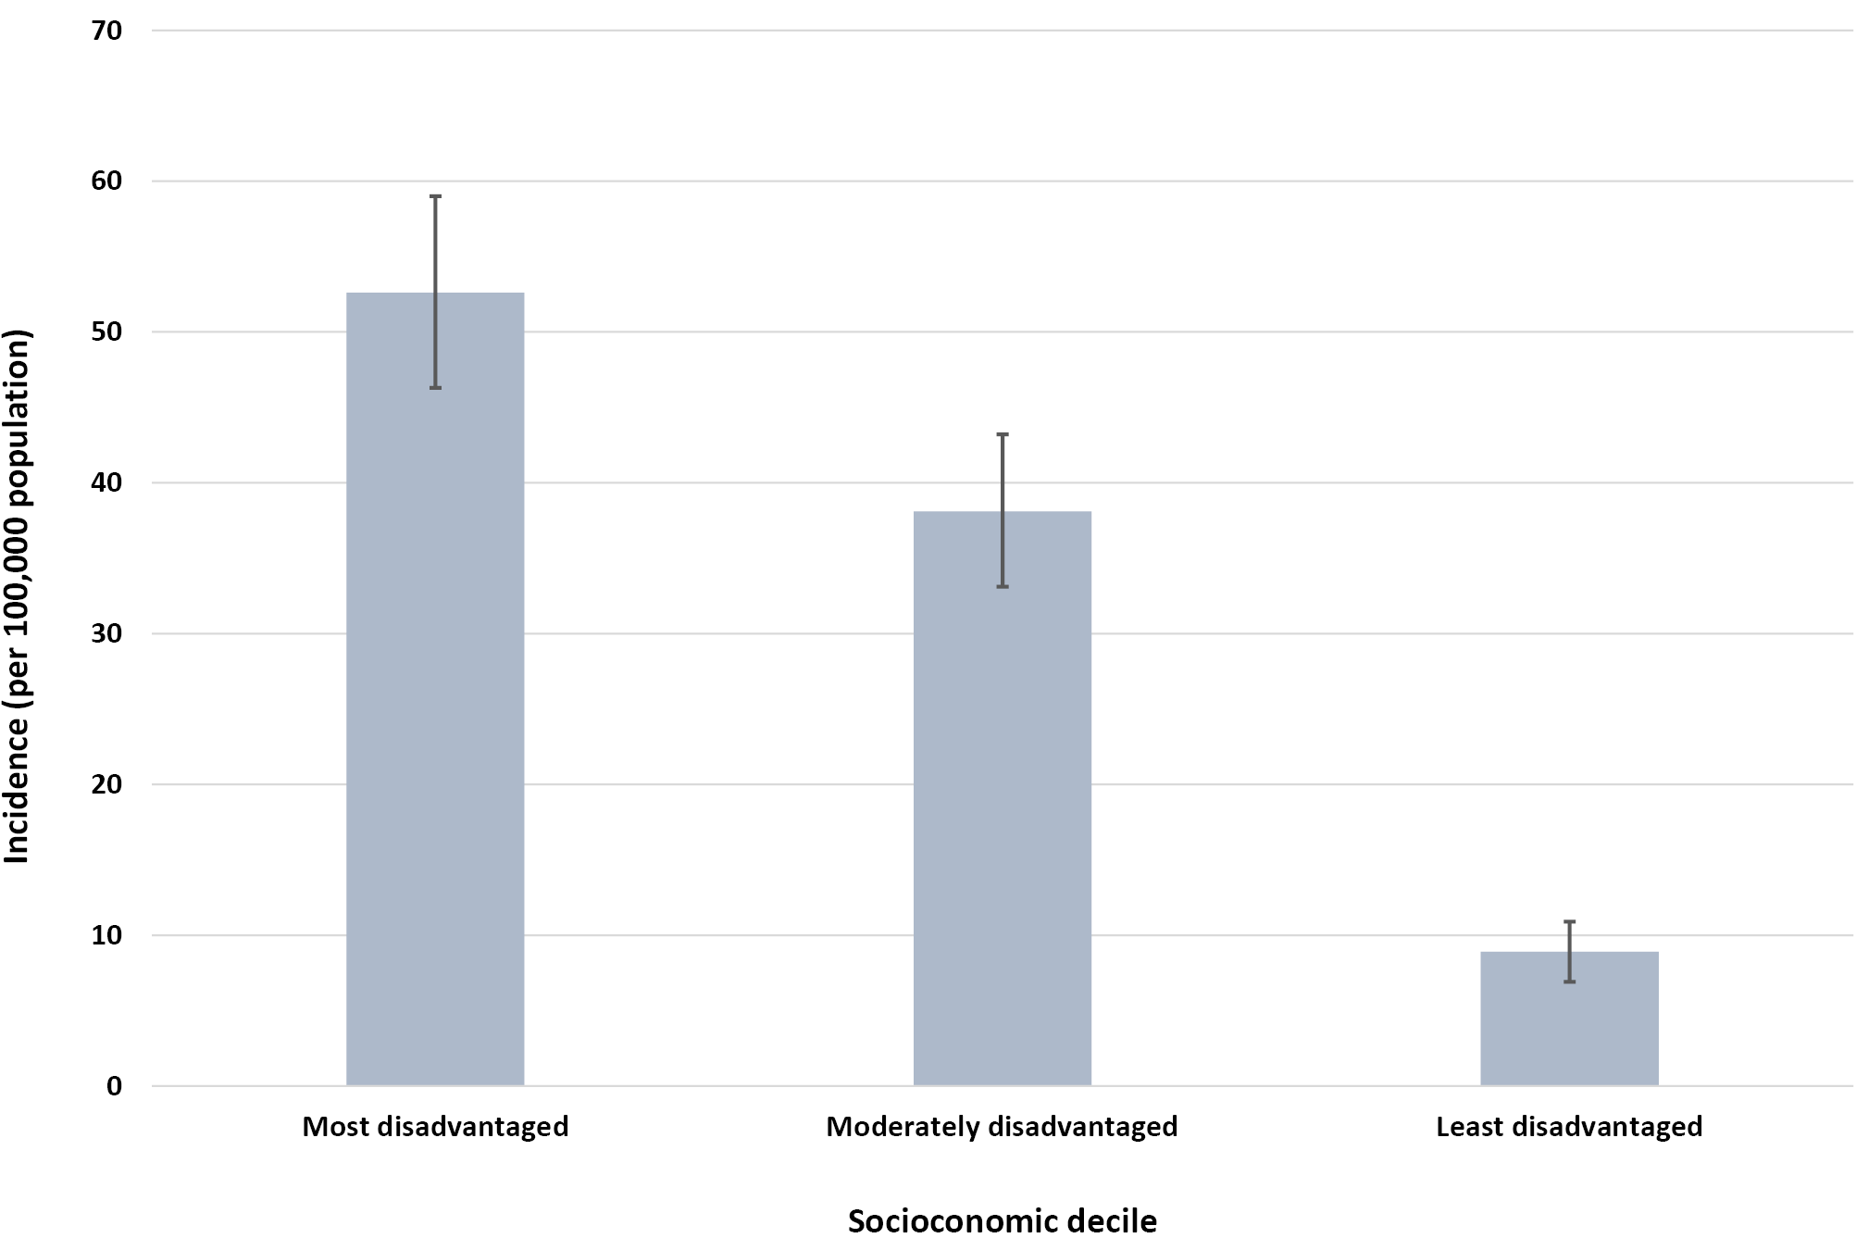
a Socio-economic Indexes for Areas (SEIFA) Index of Relative Social Disadvantage (IRSD): most disadvantaged = deciles 1–3, moderately disadvantaged = 4–6, least disadvantaged = 7–10.

Disease clusters
Five molecularly-confirmed clusters of iGAS disease were identified from the May 2011 – April 2021 study period: (1) two cases within a household between twin infants (emm type 207.1); (2) two in elderly patients in a residential hostel, one of whom died (multi-locus sequence type 392); (3) two in peri-partum women admitted to the same maternity ward (emm type 28.5); (4) three in children attending a childcare facility (emm type 4.0); and (5) two in patients attending the same haemodialysis unit (emm type 114.6).

Severity and all-cause mortality
Severity was recorded for 378 cases, of which 135 (36%) met the NT criteria for severe iGAS disease. For the total study cohort, the all-cause mortality rate at 7 days after diagnosis was 4% (n = 30) and at 30 days was 6% (n = 40). The 30-day mortality rate was equivalent in Indigenous Australians (6%, n = 30) and non-Indigenous Australians (6%, n = 10; p = 0.86), and was similar between dialysis (8%, n = 10) and non-dialysis patients (5%, n = 30; p = 0.34). When stratified by remoteness-of-residence, the 30-day mortality rate was similar across all areas: 8% (n = 16) in patients from outer-regional areas, 6% (n = 12) for remote areas, and 5% (n = 12) for very remote areas (p = 0.45).

Invasive group A streptococcal disease in people receiving dialysis
The number of dialysis recipients in the NT increased from 468 in 2011 to 795 in 2021.¹⁰ There were 133 cases of iGAS disease recorded in people receiving dialysis between May 2011 and April 2021. Median age at diagnosis in the dialysis cohort was 53 years (IQR: 45–60 years) and more than three-quarters of cases were female (n = 101/133, 76%). Table 2 outlines other patient characteristics and outcomes. The 133 cases comprised 106 patients, of whom 19/106 had multiple iGAS disease episodes separated by 30 or more days (an 18% recurrence rate) notified during the study period. Two of these 19 experienced chronic GAS osteomyelitis that accounted for multiple notifications, while true recurrence at different sites occurred in 17 patients (16%). Two of the 19 cases with multiple iGAS disease episodes died. No GAS typing was available for these recurrent cases.
Severity was recorded for 121 dialysis cases, with 60 (50%) experiencing severe iGAS disease. Admission to hospital was required for 127 of the 133 dialysis cases (95%), with median length of hospital stay of 10 days (IQR: 6–16 days). Admission to ICU occurred for 33 cases (25%), with median length of ICU stay of 5 days (IQR: 3–7 days).

Table 2: Characteristics of invasive group A streptococcal disease cases in the dialysis population, Northern Territory, 2011 to 2021
Characteristic | Value or attribute | Number of cases | Proportion of cases (%)
Number of cases in dialysis patients |  | 133 | 100
Number of dialysis patients |  | 106 | —
Sex | Female | 101 | 76
 | Male | 32 | 24
Indigenous status | Indigenous Australians | 130 | 98
 | non-Indigenous Australians | 3 | 2
Type of dialysis | Haemodialysis | 131 | 98
 | Peritoneal dialysis | 2 | 2
Region of occurrence | Top End (tropical) | 52 | 39
 | Central Australia (non-tropical) | 81 | 61
Comorbidities  (as recorded in electronic medical records) | Diabetes mellitus (type 1 or 2) | 99 | 74
 | Heart disease | 85 | 64
 | Chronic liver disease | 36 | 27
 | Current cigarette smoking | 16 | 12
 | Active malignancy | 7 | 5
Dialysis access | Arteriovenous fistula | 92 | 69
 | Central venous catheter or vascular graft | 30 | 23
 | Peritoneal dialysis catheter | 2 | 2
 | Unknown | 9 | 7
Site of infection | Skin ª | 74 | 56
 | Pneumonia | 22 | 17
 | Bacteraemia with no known focus | 22 | 17
 | Osteomyelitis or septic arthritis | 21 | 16
 | Other sites ^{b} | 13 | 10
Specimen type | Blood culture | 131 | 98
 | Synovial fluid culture | 1 | 1
 | Peritoneal fluid culture | 1 | 1
Severity status | Severe ^{c} | 60 | 45
 | Non-severe | 61 | 46
 | Unknown | 12 | 9
Management | Admitted to hospital | 127 | 95
 | Admitted to intensive care unit | 33 | 25
 | Required surgery | 38 | 26
Mortality | Within 7 days of diagnosis | 6 | 5
 | Within 30 days of diagnosis | 10 | 8
a Including impetigo, ulcer, wound, abscess, burn, scabies, vascular access site, cellulitis, necrotising fasciitis.
b Infected vascular graft or fistula, endocarditis, urosepsis, dental abscess, tubo-ovarian abscess.
c Cases presenting with pneumonia, meningitis, necrotising fasciitis, streptococcal toxic shock syndrome or any other manifestation requiring admission to an intensive care unit or causing death.

Discussion
This NT review presents socio-environmental and clinical findings from the longest period of notifiable disease surveillance for iGAS disease in Australia, to inform public health efforts. While the NT has locally-developed guidelines for iGAS disease,¹⁶ Australia-wide public health management guidelines (in the Series of National Guidelines) are currently under development. Our findings are important for considering whether more intensive public health responses are required for remote and socially-disadvantaged populations, particularly in areas with a high incidence of GAS-related disease.
In the NT, we found that iGAS disease disproportionately affects people who are living in remote and very remote areas and those at greatest socio-economic disadvantage. This inequity is consistent with previous studies demonstrating an association of GAS-related disease with social disadvantage and high-density living.²⁰ We recommend a public health response based on remote community engagement and long-term collaboration across multiple government sectors (including housing, education and health) to address the social determinants of skin health. It is also important that healthcare staff working in remote and disadvantaged communities receive education about the importance of early detection and treatment of skin infections and are on alert for clinical features of iGAS disease. Comprehensive prevention and treatment guidelines are available from the NT Healthy Skin Program.²¹
People receiving dialysis in the NT continue to be at significantly increased risk of iGAS disease.⁸ A combination of multiple host risk factors, relative immunocompromise, frequent vascular access and often-limited access to hygiene infrastructure may explain the high incidence in this group. As most patients (69%) were dialysing through an arteriovenous fistula at the time of diagnosis, intravenous line sepsis is unlikely to be a key mechanism of iGAS infection.
We found high rates of concurrent diabetes (74%) and heart disease (64%) in people receiving dialysis who developed iGAS disease. In comparison, approximately 56% of all people receiving haemodialysis in Australia in 2020 were diabetic and 38% had known coronary artery disease.¹⁰ A recent data-linkage study of iGAS disease in Victoria, Australia found a much lower rate of diabetes (15%) and heart disease (30%) in their general iGAS cohort, which was not limited to dialysis recipients.²¹ However, despite the lower comorbidity burden, the rate of ICU admission (33%) was higher in the Victorian than NT dialysis cohort, and the case fatality rate (6%) was similar.²² These results may partly reflect differences in data collection methodology, with non-severe cases and comorbidities less likely to be identified through data-linkage than through mandatory notification and direct review of EHR. Future research using multivariable regression would be valuable in exploring the risk factor profile of iGAS infection, and further characterising which patients are at greatest risk of severe disease.
Skin infections (such as cellulitis and infected wounds) were the most common documented antecedent to iGAS disease, and scabies remains endemic in much of the NT.^{23–25} Our study highlights the considerable morbidity, mortality and healthcare burden arising from iGAS disease in people receiving dialysis, which may be preventable through primordial, primary and secondary prevention measures. This includes action on the social determinants of skin health (such as improved housing and hygiene infrastructure for dialysis recipients), education of patients and health professionals, prompt identification and treatment of superficial skin infections, and targeted use of antibiotic prophylaxis for secondary prevention.¹⁶
No seasonal difference was noted in iGAS disease case numbers in Central Australia. However, in the Top End region, a significantly higher number of cases were diagnosed in the dry season (May–October) than in the wet season. Possible contributing factors include dry season population movements between communities and urban locations such as Darwin, with increased social interaction and GAS transmission, and the routine administration of wet season co-trimoxazole prophylaxis against melioidosis for Top End haemodialysis recipients since November 2014.⁸
There was evidence of GAS transmission in households, residential hostel, childcare and health care settings. These settings are particularly important for consideration of an appropriate public health response, as outlined in the NT public health guidelines.¹⁶ Further studies are required to identify the efficacy of chemoprophylaxis for close contacts in high-risk settings. This research is necessary to direct the public health response for prevention of further transmission of GAS-related disease and to support decision-making for efficient use of public health resources.

Limitations
This study will have missed some cases of iGAS disease in the NT, where appropriate cultures were not performed to obtain a sterile site isolate or because of laboratory limitations. In addition, the probable case definition was only added in 2016, relied upon clinician awareness and reporting, and only included necrotising fasciitis cases. The NT probable case definition has recently been revised to increase sensitivity, now incorporating other compatible clinical syndromes of iGAS disease¹³. Comorbidity data were collected through review of dialysis patient electronic medical records during healthcare encounters for iGAS disease, and co-morbidity frequencies may be underestimated if incompletely documented. As GAS isolates from sterile sites do not routinely undergo molecular typing, we may have missed clusters of disease where an epidemiologic link was not recognised.
This study involved descriptive analysis, without correction for multiple comparisons. There is likely to be a high correlation between analysed variables, such as remoteness and socio-economic status. Future studies using multivariable regression modelling could provide further insights into the contributions of and relationships between different social determinants of iGAS disease.

Conclusions
iGAS disease is unevenly affecting people in the NT, with most affected being those living in areas of socio-economic disadvantage, in remote and very remote communities, and those receiving dialysis. iGAS disease causes substantial morbidity, mortality and healthcare cost within the NT community. It is important that primordial, primary and secondary prevention measures be directed towards supporting these disadvantaged population groups.

Acknowledgements
We thank the laboratory staff at Territory Pathology who perform the culture and identification for GAS infections, and all NT Health clinical staff involved in the patients’ care. We acknowledge Kimberley McMahon (NT Centre for Disease Control) and Nancy Merridew (NT Health) for their valued contributions to the iGAS disease public health response in the NT, which prompted this investigation. For assistance with data extraction we thank Emidio Coccetti (NT Health), and for assistance with data analysis Chris Lowbridge (Menzies School of Health Research) and Ramakrishna Chondur, Libby Morris, and Karen Dempsey (NT Public Health and Digital Team).

Author details
Dr Johanna M Birrell¹
Ms Rowena Boyd¹
Prof Bart J Currie^{2,3}
A/Prof Asanga Abeyaratne^{2,3}
Prof Sandawana William Majoni^{2,3}
A/Prof Vicki L Krause¹
- Northern Territory Centre for Disease Control, NT Health, Darwin, NT
- Menzies School of Health Research, Charles Darwin University, Darwin, NT
- Northern Territory Medical Program, Royal Darwin Hospital, Darwin, NT

Corresponding author
Dr Johanna M Birrell
Address: Northern Territory Centre for Disease Control, PO Box 40596, Casuarina, NT 0811
Phone: (08) 8922 8044
Email: johanna.birrell@cdhb.health.nz

References
- Douglas NM, Hennessy JN, Currie BJ, Baird RW. Trends in bacteremia over 2 decades in the Top End of the Northern Territory of Australia. Open Forum Infect Dis. 2020;7(11): ofaa472. doi: https://doi.org/10.1093/ofid/ofaa472.
- Northern Territory Government Minister for Health. Notifiable Diseases Act. Notifiable diseases: amendment of information to be given by laboratories. [Notice of amendment to legislation.] Darwin: Northern Territory Government; 11 May 2011. [Accessed on 15 March 2023.] Available from: https://nt.gov.au/__data/assets/pdf_file/0007/197278/g19.pdf.
- Australian Government Department of Health and Aged Care, Communicable Diseases Network Australia (CDNA). Invasive group A streptococcal (iGAS) disease: surveillance case definition. Canberra: Australian Government Department of Health and Aged Care; 1 July 2015. [Accessed on 15 March 2023.] Available from: https://www.health.gov.au/resources/publications/invasive-group-a-streptococcal-disease-igas-surveillance-case-definition.
- Wright CM, Langworthy K, Manning L. The Australian burden of invasive group A streptococcal disease: a narrative review. Intern Med J. 2021;51(6):835–844. doi: https://doi.org/10.1111/imj.14885.
- Carapetis JR, Walker AM, Hibble M, Sriprakash KS, Currie BJ. Clinical and epidemiological features of group A streptococcal bacteraemia in a region with hyperendemic superficial streptococcal infection. Epidemiol Infect. 1999;122(1):59–65. doi: https://doi.org/10.1017/s0950268898001952.
- Boyd R, Patel M, Currie BJ, Holt DC, Harris T, Krause V. High burden of invasive group A streptococcal disease in the Northern Territory of Australia. Epidemiol Infect. 2016;144(5):1018–27. doi: https://doi.org/10.1017/s0950268815002010.
- Gear RJ, Carter JC, Carapetis JR, Baird R, Davis JS. Changes in the clinical and epidemiological features of group A streptococcal bacteraemia in Australia’s Northern Territory. Trop Med Int Health. 2015;20(1):40–7. doi: https://doi.org/10.1111/tmi.12405.
- Birrell JM, Boyd R, Currie BJ, Anstey NM, Abeyaratne A, Majoni SW et al. Invasive group A streptococcal disease in the Northern Territory and the impact of melioidosis antibiotic prophylaxis. Med J Aust. 2022;217(10):544–5. doi: https://doi.org/ 10.5694/mja2.51739.
- Australian Bureau of Statistics. Region summary: Northern Territory. [Webpage.] Canberra: Australian Bureau of Statistics; 2022. [Accessed on 15 March 2023.] Available from: https://dbr.abs.gov.au/region.html?lyr=ste&rgn=7.
- ANZDATA Registry. ANZDATA 44th Annual Report 2021: Chapter 2: Prevalence of Kidney Failure with Replacement Therapy. Adelaide: Australia and New Zealand Dialysis and Transplant Registry; 2021. [Accessed on 15 May 2023.] Available from: https://www.anzdata.org.au/report/anzdata-44th-annual-report-2021-data-to-2020/.
- Australian Bureau of Statistics. ABS Maps. [Webpage.] Canberra: Australian Bureau of Statistics. [Accessed on 15 March 2023.] Available from: https://maps.abs.gov.au.
- Australian Bureau of Statistics. The Australian Statistical Geography Standard (ASGS) remoteness structure. [Webpage.] Canberra: Australian Bureau of Statistics; 2016. [Accessed on 15 March 2023.] Available from: http://www.abs.gov.au/websitedbs/d3310114.nsf/home/remoteness+structure.
- Northern Territory Centre for Disease Control. Notifiable diseases public health management guide. Darwin: Northern Territory Government; 2019.
- Australian Bureau of Statistics. Socioeconomic indices for areas. [Webpage.] Canberra: Australian Bureau of Statistics; 6 May 2022. [Accessed on 15 March 2023.] Available from: https://www.abs.gov.au/websitedbs/censushome.nsf/home/seifa.
- Population and Digital Health (NT Health). Northern Territory Health District resident population estimates 1971–2021. [Internal document.] Darwin: NT Health; July 2022.
- Merridew N, Birrell J. Public health management of invasive group A streptococcal disease in the Northern Territory guideline. Version 2.0. Darwin: Northern Territory Government, NT Health; 18 May 2022. [Accessed on 15 March 2023.] Available from: https://hdl.handle.net/10137/12182.
- Office for Health Improvement and Disparities (OHID). Tool for calculating common public health statistics and their confidence intervals. [Online database.] London: OHID; February 2018. [Accessed on 14 May 2023.] Available from: https://fingertips.phe.org.uk/profile/guidance/supporting-information/PH-methods.
- Walter SD, Elwood JM. A test for seasonality of events with a variable population at risk. Br J Prev Soc Med. 1975;29(1):18–21. doi: https://doi.org/10.1136/jech.29.1.18.
- Pearce MS, Feltbower R. Tests for seasonal data via the Edwards and Walter & Elwood tests. Stata Technical Bulletin. 2000;STB-56:47–9. Available from: https://www.stata-press.com/journals/stbcontents/stb56.pdf.
- Coffey PM, Ralph AP, Krause VL. The role of social determinants of health in the risk and prevention of group A streptococcal infection, acute rheumatic fever and rheumatic heart disease: a systematic review. PLoS Negl Trop Dis. 2018;12(6):e0006577. doi: https://doi.org/10.1371/journal.pntd.0006577.
- Northern Territory Centre for Disease Control. Healthy Skin Program. Guidelines for the Community Control of Scabies, Skin Sores, Tinea and Crusted Scabies in the Northern Territory (third edition). Darwin: Department of Health, Northern Territory; August 2015. [Accessed on 15 May 2023.] Available from: https://hdl.handle.net/10137/698.
- Thomson TN, Campbell PT, Gibney KB. The epidemiology of invasive group A streptococcal disease in Victoria, 2007–2017: an analysis of linked datasets. Aust N Z J Public Health. 2022;46(6):878–83. doi: https://doi.org/10.1111/1753-6405.13290.
- Romani L, Steer AC, Whitfield MJ, Kaldor JM. Prevalence of scabies and impetigo worldwide: a systematic review. Lancet Infect Dis. 2015;15(8):960–7. doi: https://doi.org/10.1016/s1473-3099(15)00132-2.
- Lydeamore MJ, Campbell PT, Cuningham W, Andrews RM, Kearns T, Clucas D et al. Calculation of the age of the first infection for skin sores and scabies in five remote communities in northern Australia. Epidemiol Infect. 2018;146(9):1194–201. doi: https://doi.org/10.1017/s0950268818001061.
- Campbell M, van der Linden N, Gardener K, Dickinson H, Agostino J, Dowden M et al. Health care cost of crusted scabies in Aboriginal communities in the Northern Territory, Australia. PLoS Negl Trop Dis. 2022;16(3):e0010288. doi: https://doi.org/10.1371/journal.pntd.0010288.

Communicable Diseases Intelligence
ISSN: 2209-6051 Online

Communicable Diseases Intelligence (CDI) is a peer-reviewed scientific journal published by the Office of Health Protection, Department of Health and Aged Care. The journal aims to disseminate information on the epidemiology, surveillance, prevention and control of communicable diseases of relevance to Australia.

Editor: Christina Bareja
Deputy Editor: Simon Petrie
Design and Production: Kasra Yousefi
Editorial Advisory Board: David Durrheim, Mark Ferson, Clare Huppatz, John Kaldor, Martyn Kirk, Meru Sheel and Steph Williams

Website: http://www.health.gov.au/cdi

Contacts
CDI is produced by the Office of Health Protection, Australian Government Department of Health and Aged Care, GPO Box 9848, (MDP 6) CANBERRA ACT 2601

Email: cdi.editor@health.gov.au

Submit an Article
You are invited to submit your next communicable disease related article to the Communicable Diseases Intelligence (CDI) for consideration. More information regarding CDI can be found at: http://health.gov.au/cdi.
Further enquiries should be directed to: cdi.editor@health.gov.au.

This journal is indexed by Index Medicus and Medline.

Creative Commons Licence - Attribution-NonCommercial-NoDerivatives CC BY-NC-ND
© 2023 Commonwealth of Australia as represented by the Department of Health and Aged Care
This publication is licensed under a Creative Commons Attribution-NonCommercial-NoDerivatives 4.0 International Licence from https://creativecommons.org/licenses/by-nc-nd/4.0/legalcode (Licence). You must read and understand the Licence before using any material from this publication.

Restrictions
The Licence does not cover, and there is no permission given for, use of any of the following material found in this publication (if any):
- the Commonwealth Coat of Arms (by way of information, the terms under which the Coat of Arms may be used can be found at www.itsanhonour.gov.au);
- any logos (including the Department of Health and Aged Care’s logo) and trademarks;
- any photographs and images;
- any signatures; and
- any material belonging to third parties.

Disclaimer
Opinions expressed in Communicable Diseases Intelligence are those of the authors and not necessarily those of the Australian Government Department of Health and Aged Care or the Communicable Diseases Network Australia. Data may be subject to revision.

Enquiries
Enquiries regarding any other use of this publication should be addressed to the Communication Branch, Department of Health and Aged Care, GPO Box 9848, Canberra ACT 2601, or via e-mail to: copyright@health.gov.au

Communicable Diseases Network Australia
Communicable Diseases Intelligence contributes to the work of the Communicable Diseases Network Australia.
http://www.health.gov.au/cdna

