Anatomy of a seasonal influenza epidemic forecast
Robert Moss, Alexander E Zarebski, Peter Dawson, Lucinda J Franklin, Frances A Birrell and James M McCaw

Abstract
Bayesian methods have been used to predict the timing of infectious disease epidemics in various settings and for many infectious diseases, including seasonal influenza. But integrating these techniques into public health practice remains an ongoing challenge, and requires close collaboration between modellers, epidemiologists, and public health staff.
During the 2016 and 2017 Australian influenza seasons, weekly seasonal influenza forecasts were produced for cities in the three states with the largest populations: Victoria, New South Wales and Queensland. Forecast results were presented to Health Department disease surveillance units in these jurisdictions, who provided feedback about the plausibility and public health utility of these predictions.
In earlier studies we found that delays in reporting and processing of surveillance data substantially limited forecast performance, and that incorporating climatic effects on transmission improved forecast performance. In this study of the 2016 and 2017 seasons, we sought to refine the forecasting method to account for delays in receiving the data, and used meteorological data from past years to modulate the force of infection. We demonstrate how these refinements improved the forecast’s predictive capacity, and use the 2017 influenza season to highlight challenges in accounting for population and clinician behaviour changes in response to a severe season.
Keywords: influenza; surveillance; forecasting; mathematical modelling; preparedness; response; research translation

Introduction
Methods for predicting the dynamics of infectious disease epidemics have received much attention since 2012¹, with particular focus on seasonal influenza epidemics in temperate climates.^{2–7} The United States Centers for Disease Control and Prevention (CDC) holds an annual influenza forecasting competition⁸ that attracts teams from around the world. The epidemic forecasting methods tested in these settings have the potential to support public health preparedness and response activities, although a number of practical challenges must be addressed if they are to be adopted and integrated into public health practice.^{3,9}
We have previously tailored epidemic forecasting methods to Australian data^{5,6} and have reported on our pilot of a real-world application of these forecasts during the 2015 influenza season in Melbourne, Australia.⁹ In that study, we used influenza case notification counts to characterise influenza activity in one city whereby for each week of the season we generated forecasts of the weekly case notification counts for future weeks. A fundamental challenge encountered in that study was the delay in reporting and processing of case notifications, which arose due to an unprecedented number of notifications (relative to seasonal intensity¹⁰). Timeliness can also be affected by laboratory capacity when disease activity is high, and clinician testing behaviours also change over the course of the influenza season in response to disease activity in the community.
In this paper, we report on our forecasts for the 2016 and 2017 influenza seasons, in which we also collaborated with NSW and Queensland Departments of Health, to produce influenza forecasts for metropolitan Melbourne, Sydney, Brisbane, Gold Coast and Toowoomba. A key goal of this study was to account for delays in reporting and processing of case notifications, since relying on incomplete data introduces systematic biases into the forecasts and can both reduce the forecast accuracy and also increase the forecast uncertainty. We trialled a method for reducing these biases in the 2016 and 2017 forecasts.
We introduced 2 further refinements in our 2017 forecasts. The first was to use smoothed absolute humidity data from previous years to characterise climatic effects on influenza transmission; we have previously shown that this can improve the forecast predictive skill.⁷ The second was to base our initial expectations for the timing and size of the epidemic peak on the observed characteristics of previous seasonal influenza epidemics. These characteristics are influenced by many variables, including the circulating virus (sub)types, vaccine coverage, vaccine effectiveness and the number of specimens collected for testing.

Methods

Influenza notification data
The notifiable diseases dataset, from which we produce our forecasts, includes only those cases which meet the Communicable Diseases Network Australia (CDNA) case definition for laboratory-confirmed influenza.¹¹These cases represent a small proportion of the actual cases in the community.¹² Some notifications did not include a symptom onset date, so we used the specimen collection date as a proxy. Using specimen collection date is considered not to distort the data substantially since we used weekly case counts, while symptomatic influenza infection (used here as a proxy for transmission potential) typically lasts several days¹³ and the majority of notifications arise from tests that identify the presence of virus (e.g. PCR) rather than the presence of antibodies (i.e. serology). We also mitigated the potential impact of events such as public holidays by generating forecasts on Thursdays for the week ending on the previous Sunday (i.e. 4 days later).
Separate influenza forecasts were produced for metropolitan Melbourne, Sydney, Brisbane, Gold Coast and Toowoomba. The state capitals (Melbourne, Sydney and Brisbane) are also the primary urban centres in these states, and are located at different latitudes on the east coast of Australia. Two other locations in proximity to Brisbane were also chosen so that comparisons could be made against the Brisbane forecasts: the Gold Coast (also located on the east coast, about 60 km south of Brisbane) and Toowoomba (inland, about 125 km west of Brisbane). Both are large regional population centres that historically experience significant seasonal influenza activity.

Forecasting methods
Forecasts were generated every Thursday from April to November 2016, and from April to November 2017, using weekly case notification counts up to the most recent week (ending on Sunday). We reported the median, 50% credible interval and 90% credible interval for the future predicted weekly notification counts and timing of the epidemic peak. Every week the lead modeller (R. Moss) emailed a summary and analysis of these outputs to participating public health staff in each jurisdiction, who were asked to provide feedback about their interpretation of the forecast predictions, the plausibility of these predictions, and what aspects of these forecasts were of particular utility for their public health activities.
As described in detail elsewhere^{5,6}, our forecast method combines an SEIR (susceptible-exposed-infectious-recovered) population model of infection with the weekly influenza case notification counts, through the use of a particle filter. The weekly influenza case notification counts were modelled using a negative binomial distribution with a fixed dispersion parameter k, and assuming some constant “background” notification rate. The expected number of cases (above the background rate) was proportional to the weekly incidence of infection in the model, and this proportion was characterised by the observation probability p_{id}.
The observation probability represented the probability of an infected individual resulting in a notified case (i.e. the probability of seeking health care and having a specimen collected). Values for p_{id} and k were selected from retrospective forecasts using notifications data from previous seasons. The background notification rate was estimated using notification counts from March to May, inclusive, to reflect the disease activity observed in autumn (i.e. just prior to the season onset). This also avoids possible over-estimation by ignoring earlier months, where there may be continued importation of influenza cases during the northern-hemisphere influenza season. These parameters were selected separately for each of the forecast locations (Melbourne, Sydney, Brisbane, Gold Coast, Toowoomba), and are reported in Table S1.
Each week, before generating a forecast for each of the locations, we measured how many additional cases (Δi) had been reported for the previous week during the current week (i.e. since the previous forecast was generated). We then assumed that the number of cases reported for the current week (ci+1) could increase by the same amount, and conditioned the model simulations on the likelihood of observing between ci+1 and ci+1+Δi cases in the current week. To illustrate, consider the scenario where 200 cases are reported for week n when the forecast for week n is generated, and that one week later (a) this total has increased to 250 cases; and (b) there are 300 cases reported for week n+1. When we generate the forecast at the end of week n+1, we therefore assume that the total for week n+1 could be as high as 300 + (250-200)=350 cases. We refer to these estimated case totals as “estimated upper bounds” in the remainder of this manuscript.
Prior to 2017, the SEIR model parameters were independently sampled from broad, uniform distributions (see Table S2). This meant that the forecast predictions initially considered a much wider range of epidemics (in terms of timing, duration and magnitude) than have been observed. In 2017, we modified this sampling process to better reflect the characteristics of previous influenza seasons. This means that before an epidemic signal is present in the notifications data, the forecasts predict outbreaks of similar timing, duration and magnitude, as observed in past epidemics. This was achieved by (a) constructing a multivariate normal distribution for the peak timing and size in previous years; (b) sampling parameter values from the uniform distributions; (c) simulating the epidemic that these parameter values describe; and (d) accepting each sample in proportion to the simulated epidemic’s probability density. Identification of the circulating influenza (sub)types very early in the influenza season could be used to further refine this prior, by constructing it from past epidemics in which similar (sub)types were circulating.
In 2017, we also introduced the concept of “seasonal forcing” into the model, to account for the influence that climate has on the force of infection. This seasonality was characterised by smoothed absolute humidity data for each city in previous years, using time-series data from a single weather station in each city, and we have previously shown that this can improve the forecasts’ predictive skill⁷ (see the supplementary material for details¹⁴). Note that there are many other factors that influence the overall shape of the case notifications data, and forecast performance is highest when humidity exerts only a modest effect on transmission in the simulation model. Humidity is not responsible for initiating epidemic activity in the model. Indeed, it is unknown to what extent climatic factors such as humidity directly contribute to transmission in temperate climates, versus human behavioural changes in colder conditions.

Results
Figure 1 shows the Sydney influenza forecast for the week ending 31 July 2016, which was generated on 4 August 2016. The number of case notifications for each of the proceeding weeks at the time of forecasting are shown as black points, while hollow points show the totals for every week as reported by the end of the season. Note that the weekly totals for the weeks ending 24 July and 31 July increased after this forecast was generated. At the time of forecasting 838 cases were reported for the week ending 31 July; we estimated an upper bound of 1,238 cases (as indicated by the red line) and the final total was 1,191 cases (indicated by the hollow point). The forecast prediction comprises a median prediction (blue line) and credible intervals (shaded blue regions) that indicate the forecast uncertainty. In a perfect forecast, the future case counts would be distributed evenly above and below the median prediction, about half of these counts would fall within the 50% credible interval, and about 90% of these counts would fall within the 90% credible interval. In this example, the epidemic peak is predicted to occur about 2 weeks earlier than the true peak, and the median prediction under-estimates most of the future case counts. Note that the peak timing predictions are also presented as separate plots, and will be shown in subsequent figures in this manuscript.
Figure 1: Example of an influenza forecast: Sydney, 31 July 2016. The weekly number of notified laboratory-confirmed influenza cases at the time of the forecast are shown as black points; hollow points show the case numbers as reported at the end of the season. There were 838 cases for the week ending 31 July when this forecast was generated, and our estimated upper bound was 1,238 cases. This forecast was therefore conditioned on the likelihood of observing between 838 and 1,238 cases, as indicated by the vertical red line. The forecast comprises a median prediction (blue line) and credible intervals (shaded blue regions) indicate the forecast uncertainty.
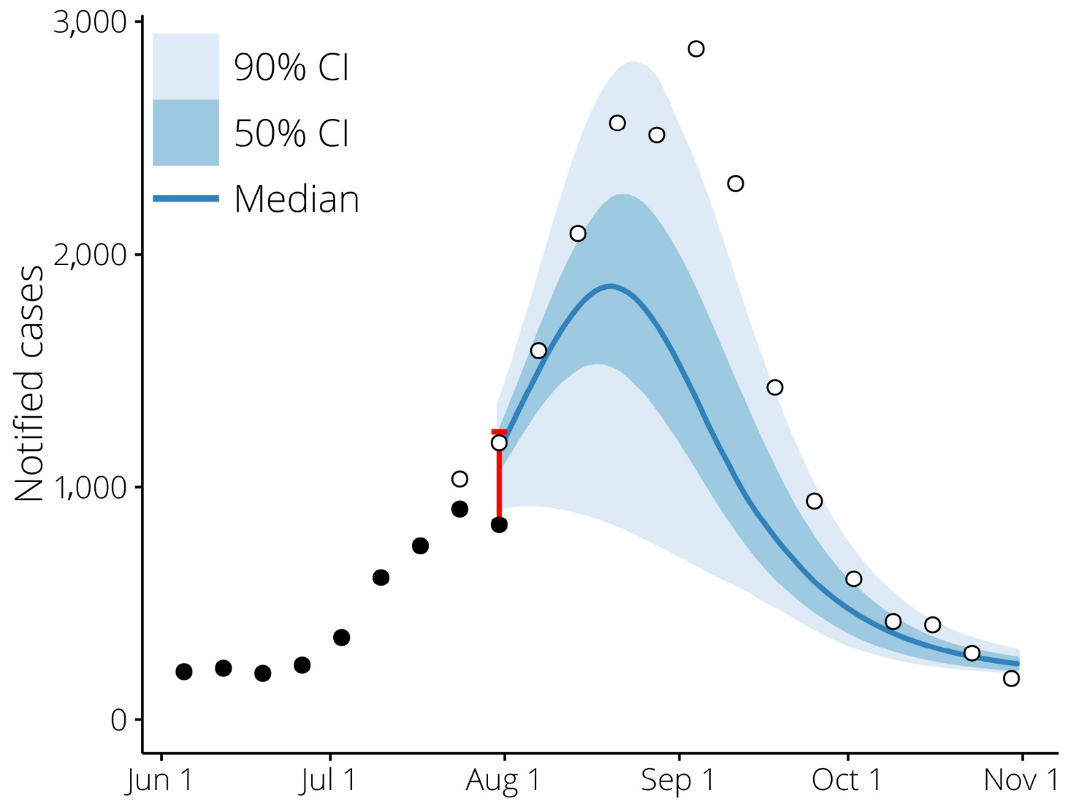
Figure 2 shows how the number of cases reported for each week continued to increase in subsequent weeks: each grey bar depicts the interval between the initial count (i.e. at the time of forecasting) and the count reported at the end of the season. The estimated upper bounds are shown as black stars; perfect estimates would coincide with the top of each grey bar.
Figure 2: The change in weekly case counts, from the initially-reported values (grey horizontal lines) to the final values as reported at the end of the season (grey hollow points), and the estimated upper bounds (black stars) given the initially-reported counts. Results are shown for each of the forecast locations in the 2016 and 2017 influenza seasons.
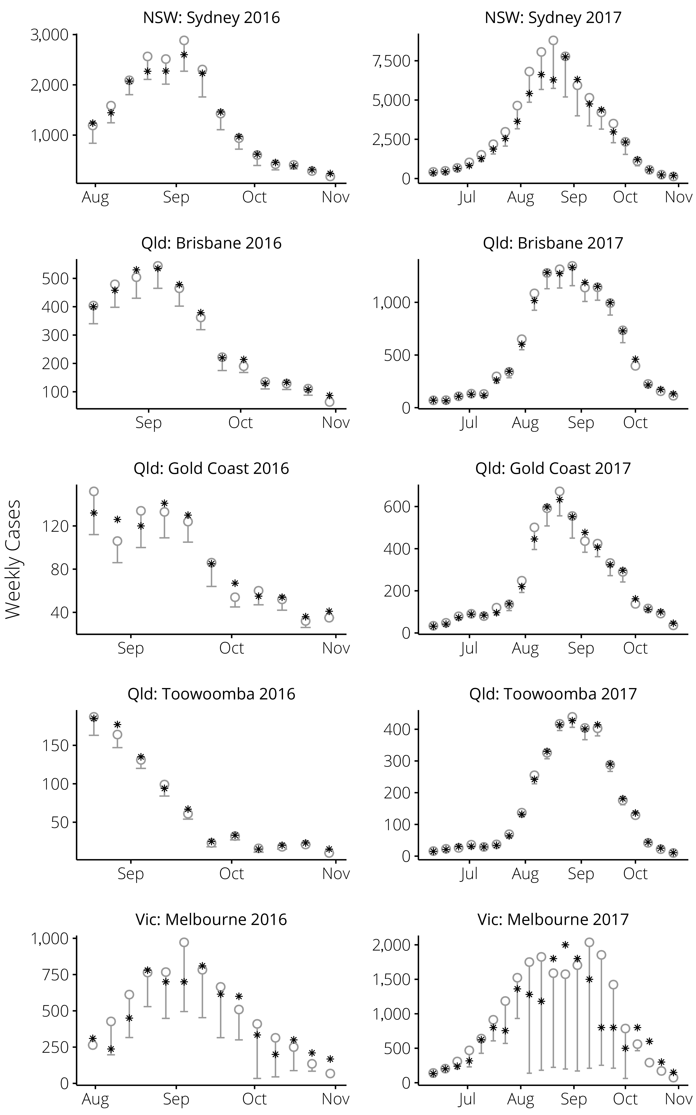
With the exception of Melbourne, where there were longer delays in case notifications⁹, the upper bound estimates performed well and generally provided much more accurate estimates of the final case counts. The performance of these estimates are summarised in Table 1.
Table 1: A summary of the upper bound estimates, expressed as percentages of the final counts for each week: mean absolute error (MAE), standard deviation (SD), and the results of the 2-sample, 2-sided Kolmogorov-Smirnov test (KS test). This test was used to compare the residuals (a) prior to the epidemic peak, and (b) after the epidemic peak; significant differences (P<0.05, shown in bold) were identified for: Sydney, Gold Coast and Toowoomba in 2017.
Setting | MAE | SD | KS test
NSW: Sydney 2016 | 7.9 | 11.5 | 0.165
NSW: Sydney 2017 | 13.0 | 14.8 | 0.002
Qld: Brisbane 2016 | 6.6 | 11.1 | 0.709
Qld: Brisbane 2017 | 5.3 | 7.5 | 0.065
Qld: Gold Coast 2016 | 10.9 | 12.4 | -
Qld: Gold Coast 2017 | 8.0 | 10.8 | 0.03
Qld: Toowoomba 2016 | 10.5 | 15.1 | -
Qld: Toowoomba 2017 | 5.7 | 7.5 | 0.013
Vic: Melbourne 2016 | 31.0 | 48.3 | 0.316
Vic: Melbourne 2017 | 34.4 | 46.1 | 0.054

The upper bound is estimated by adjusting the initially-reported value, based on the observed increase in case counts for prior weeks. However, disease incidence increases faster than linearly in the early stages of an epidemic, and decreases faster than linearly in the later stages of an epidemic. It is therefore reasonable to expect that the upper bound estimates will (a) systematically underestimate the final counts for the weeks prior to the epidemic peak; and (b) systematically overestimate the final counts for the weeks after the epidemic peak. In order to detect this type of bias, we used the two-sample, two-sided Kolmogorov-Smirnov test to identify significant differences between the residuals prior to, and after, the observed peaks. Significant differences (P<0.05) were only identified for Gold Coast, Sydney, and Toowoomba in 2017. Note that there were insufficient data points to evaluate this test for the Gold Coast and Toowoomba epidemics in 2016, as delays in weekly case counts only became evident at the time of the epidemic peak.
The peak timing predictions for 2016 are shown in Figure 3, over the 15 weeks prior to the epidemic peaks. We used non-informative model priors in 2016, and so the early peak timing predictions in all cities were highly uncertain (i.e. very broad) and inaccurate. From 5–8 weeks prior to the epidemic peak, once the notifications data contained evidence of epidemic activity, the peak timing predictions became much more certain (i.e. narrow) and, with the exception of Melbourne where the weekly counts were subject to larger delayed increases (see Figure 2), much more accurate. In the 5 weeks prior to the epidemic peak, the peak timing predictions were accurate to within one week in the Queensland locations included in this study, and to within 2 weeks in Sydney.
Figure 3: Week by week forecasts of the 2016 epidemic peak timing, plotted against the number of weeks prior to the actual peak at which the forecast was made. The timing is reported as ISO 8601 week numbers and the timing of the actual peaks are indicated by the horizontal dashed lines. The predictions are imprecise and inaccurate until the case notifications data contain evidence of a seasonal epidemic.
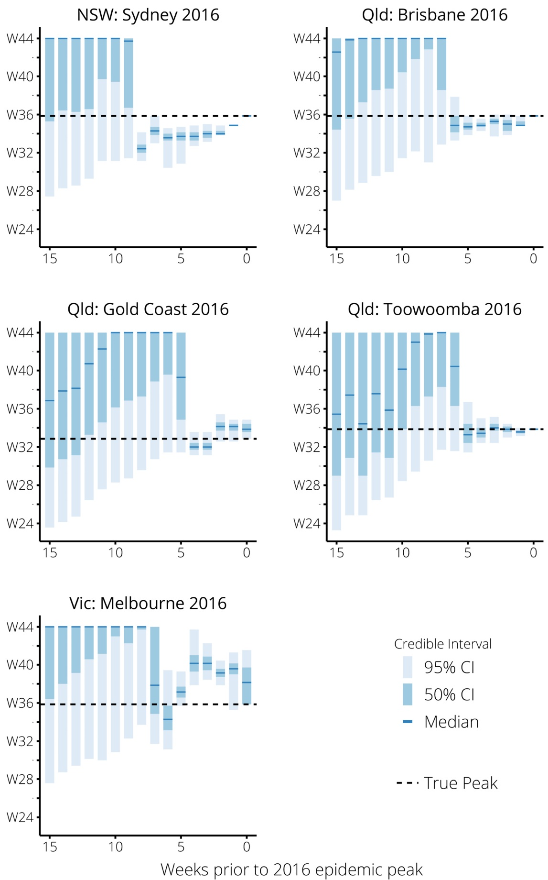
The peak timing predictions for 2017 are shown in Figure 4, and reflect 2 key results. Firstly, the 2017 seasonal epidemics were so large (in terms of notified cases) that they lay outside of our model priors. That is, the observed epidemics were so large that they lay outside of the admitted possibilities in our original forecasts. This became evident in July and August, as epidemic activity continued to increase beyond all expectations (from both expert opinion and from historical data). We re-calibrated our forecasts to correct for this.
Accordingly, we used a higher observation probability P*_{id=4×}P_{id}, based upon expert opinion during our weekly forecast discussions and also informed by our experiences in our 2015 pilot study.⁹Note that this was a coarse adjustment; there was no strong evidence to rule out a three-fold, five-fold, or other increase. It is important to note that this adjustment was not a simple re-scaling of the forecast predictions. The observation probability characterises the relationship between model infections and case notifications. Model infections occur by removing individuals from the susceptible population, and so a change in the observation probability affects how rapidly the susceptible population is depleted in the model. It is this depletion of the susceptible population that determines when the epidemic peaks and then begins to decrease. Therefore, a change in the observation probability affects the timing and duration of the predicted epidemic, as well as its size. The re-calibrated peak timing predictions for 2017 are shown in Figure 5, and are greatly improved when compared to the predictions obtained prior to this re-calibration (as shown in Figure 4). The Melbourne forecast performance was again affected by large increases in weekly case counts, relative to the initially-reported values (see Figure 2).

Figure 4: Week by week forecasts of the 2017 epidemic peak timing, plotted against the number of weeks prior to the actual peak at which the forecast was made. The timing is reported as ISO 8601 week numbers, and the timing of the actual peaks are indicated by the horizontal dashed lines. The predictions are reasonably precise and accurate prior to the seasonal epidemics, due to our use of informative priors. The predictions then become inaccurate due to the unprecedented scale of the 2017 influenza season.
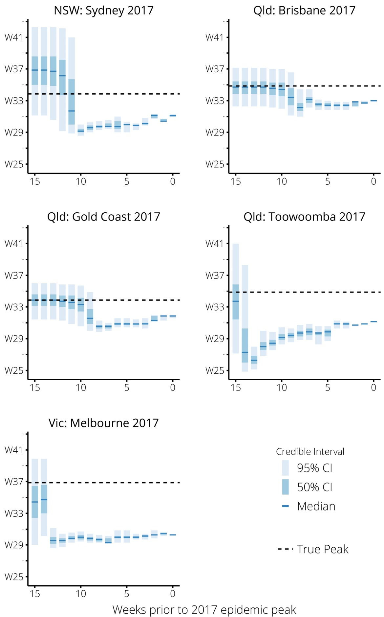
As indicated by the dashed vertical lines in Figure 5, this re-calibration was performed 2 weeks prior to the peaks in Sydney and the Gold Coast, 3 weeks prior to the peaks in Brisbane and Toowoomba and 5 weeks prior to the peak in Melbourne. In ideal circumstances, evidence of inappropriate model calibration would be identified and acted upon earlier than 2–3 weeks prior to the epidemic peak, so that the updated predictions would be of greater utility.
The second key result from our 2017 forecasts is the effect of the informative model priors, as shown in Figures 4 and 5. Prior to the evidence of epidemic activity, the peak timing predictions were much more certain (i.e, narrow) than at the corresponding period in 2016, and they were also accurate, because the 2017 seasonal epidemics peaked at a similar time to previous seasonal influenza epidemics. Had the forecasts been appropriately calibrated at the start of the season (e.g. by having prior knowledge that a larger than normal epidemic might be expected) these priors would have substantially improved forecast performance.

Figure 5: Week by week forecasts of the 2017 epidemic peak timing, once the forecasts were re-calibrated. The timing of the actual peaks are indicated by the horizontal dashed lines, and the vertical dotted lines show when the re-calibrations were performed. The predictions are substantially improved as a result of the re-calibration (i.e. compared to Figure 4).
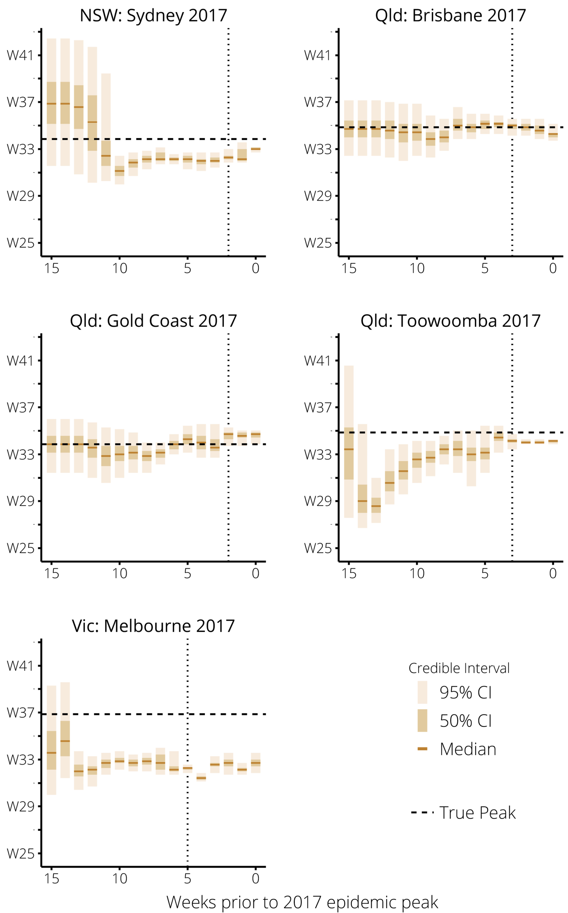
In 2016, we obtained accurate peak size predictions for Brisbane and Gold Coast 2 weeks prior to the peak, and underestimated the peak size in Sydney, Toowoomba and Melbourne. In 2017, all forecasts underestimated the peak size. The size of the epidemic peak is intrinsically harder to predict than its timing, because the peak size is far more sensitive to the parameters; even a small change in R0 or the observation probability can lead to a substantial change in the peak size. Based on previous forecasting studies, we would only expect to have good predictions of the peak size 2–3 weeks prior to the peak.^{5,6}

Discussion
The forecasting refinements that we introduced in 2016 and 2017 improved the forecast performance, and so we will continue to use them in future influenza seasons. We know that the number of cases reported for the most recent week is always an underestimate of the true value, and that unless this is accounted for, it introduces a negative bias into the forecasts. The method that we presented here to account for delays in case notifications data yielded reasonably accurate predictions of the weekly case totals, especially for delays of 1–2 weeks; its performance was reduced when longer delays were evident. With confidence in this method, in future influenza seasons we anticipate conditioning the forecasts on the likelihood of observing the estimated upper bounds themselves, rather than on the likelihood of observing any value between the currently-reported total and the estimated upper bounds (as was done in this study). This will avoid the negative bias associated with using the reported number of cases for the most recent week. These improved estimates of the weekly case totals are also extremely useful when re-calibrating the forecasts, because they allow greater confidence to be placed in the inferences drawn from the data. This is of particular relevance in seasons like 2017, where the epidemics that occurred in each city differed greatly from previous years’ epidemics, and were beyond the scope of epidemics considered in our model priors. The additional refinements that were introduced in 2017 — seasonal modulation of transmission and the informative model priors — also improved forecast performance, although this cannot be quantified precisely due to the unprecedented scale of the 2017 influenza season in eastern Australia.
Indeed, the absence of denominator data for the case notifications is a fundamental challenge of using these data.¹⁵ It means that forecast accuracy can be very low when there is a substantial change in epidemic scale from one year to the next, because the relative contributions of increased disease activity, clinical severity of disease, and increased testing (and any change in vaccine effectiveness, for that matter) cannot be reliably distinguished, and these factors can combine to greatly increase the scale of the case notifications data (as appears to have occurred in 2017¹⁶). It is true that case notification denominators are available in some jurisdictions, but this was not the case for all of the locations considered in this study. For simplicity, we elected to use the same type of surveillance data in each setting. Incorporating percentage-positive data into this forecasting framework also bears careful consideration because, similar to the case notification counts used here, they are influenced by healthcare-seeking behaviours and testing practices.
This can be surmounted to some degree by admitting a wider range of epidemic sizes in the model prior, at the cost of increasing forecast uncertainty. It could also be mitigated by identifying the circulating strains (and adjusting the model to incorporate knowledge about the virulence of the predominant circulating strain, or accounting for the degree of evolutionary change¹⁷) in the early stages of the epidemic and adjusting the expected epidemic size in the model priors. We are currently exploring various avenues for identifying early signals of substantially larger (or smaller) seasons, including synthesising surveillance data across multiple levels of the surveillance pyramid¹², and using genetic data obtained from specimens collected early in the season. The ability to define appropriate expectations, and to adjust them as new evidence become available, is an important methodological challenge for the global infectious disease forecasting community. Addressing this challenge requires both a better understanding of the biological drivers of transmission and new approaches to make best use of novel data streams.¹⁸
A simpler alternative, which capitalises on the use of an informative model prior, would be to assume that the timing of the seasonal peak will be consistent with the distribution of peak timing observed in previous seasonal influenza epidemics. As evidence of epidemic activity becomes apparent in the case notifications data, if the predicted peak timing in the forecasts begin to differ from this peak timing distribution, the forecasts could be re-calibrated so as to yield peak timing predictions that are consistent with this distribution. In 2017, this would have naturally increased the scale of the forecast epidemics, because the peak timing predictions differed greatly from the model priors (Figure 4). Such an approach for continual re-calibration of the case notifications data could be used to estimate the case notifications denominator, and could be validated in those jurisdictions where denominators are available.
Observations of the preceding northern-hemisphere influenza season could conceivably assist in calibrating the forecasts, under the assumption that the following southern-hemisphere influenza season would have similar characteristics. However, the relationship between the northern and southern hemispheres is highly variable and biologically complex.¹⁹ The experience of influenza across Australia is also highly variable. In particular, the northern regions are tropical/subtropical and experience endemic influenza activity with sporadic outbreaks, in contrast to the seasonal activity typical of temperate climates. Epidemic forecasting methods can be used in such settings to predict disease activity over shorter timescales (e.g. 1–3 weeks ahead²⁰). This would require modifications to the infection model used in this study, such as changing how the background rate is estimated and how climatic factors influence transmission (about which there is much uncertainty²¹).
Reliable epidemic forecasts could support public health preparedness and response in several ways. For example, there is evidence that vaccine-acquired immunity can wane quickly enough that provision of seasonal influenza vaccine too early in the year might result in vaccines having little, if any, protection when it is most needed.²² If the timing of the seasonal peak were known sufficiently far in advance, it could influence vaccination policies and help ensure that vaccine-acquired immunity is maintained while the risk of infection is high. There is also the issue of influenza virus co-circulation; recent years have seen co-circulation of influenza types A and B in Australia, with type A dominating early and type B dominating later in the season. Accurately modelling the co-circulation of multiple influenza viruses requires precise knowledge about, e.g. population susceptibility and cross-protective immunity.²³ However, since the co-circulation of influenza types A and B typically exhibits 2 distinct epidemic curves, an alternative is to model each subtype/lineage as circulating independently. Combining these forecasts with knowledge of relevant clinical factors (e.g. expected age distribution of severe cases) could then be used to predict measures of clinical burden such as influenza-related hospitalisations.

Conclusions
Ultimately, to improve our understanding of seasonal influenza burden we need to synthesise data from many levels of the disease surveillance pyramid^{24,25}, and this challenge is exacerbated when trying to develop this understanding for near-real-time and/or predictive purposes. These kinds of data are available in Australia, from healthcare-seeking behaviours reported in Flutracking weekly surveys¹² to sentinel general practice influenza-like illness (ILI) data¹⁰ and sentinel hospital influenza admissions data²⁶, but synthesising these disparate data sources in a meaningful way is highly non-trivial.^{6,27,28} Challenges include differences in case specificity (e.g. syndromic diagnoses vs laboratory-confirmed influenza), reporting delays, and the sample populations (e.g. Flutracking participants, sentinel sites). Engagement with public health staff is also critical to improving forecast performance (e.g. by incorporating expert knowledge) and for ensuring the value of these forecasts as a tool for public health.^{29,30}

Acknowledgements
The authors gratefully acknowledge the assistance provided by public health staff in each jurisdiction:
- Communicable Disease Branch, Health Protection, New South Wales.
- Robin Gilmour
- Nathan Saul
- Epidemiology and Research Unit, Communicable Diseases Branch, Prevention Division, Department of Health, Queensland.
- Angela Wakefield
- Mayet Jayloni
- Communicable Diseases Section, Health Protection Branch, Regulation Health Protection and Emergency Management Division, Victorian Government Department of Health and Human Services, Victoria.
- Nicola Stephens
- Janet Strachan
- Trevor Lauer
- Jess Encena
- Kim White

Author affiliations
Robert Moss¹, Alexander E Zarebski², Peter Dawson³, Lucinda J Franklin⁴, Frances A Birrell⁵ and James M McCaw^{1, 2, 6}
- Modelling and Simulation Unit, Melbourne School of Population and Global Health, The University of Melbourne, Victoria.
- School of Mathematics and Statistics, The University of Melbourne, Victoria.
- Defence Science and Technology Group, Victoria.
- Communicable Diseases Section, Health Protection Branch, Regulation Health Protection and Emergency Management Division, Victorian Government Department of Health and Human Services, Victoria.
- Epidemiology and Research Unit, Communicable Diseases Branch, Prevention Division, Department of Health, Queensland.
- Murdoch Childrens Research Institute, Victoria.

References
- Shaman J, Karspeck A. Forecasting seasonal outbreaks of influenza. Proceedings of the National Academy of Sciences. 2012 Dec;109(50):20425–30.
- Nsoesie EO, Brownstein JS, Ramakrishnan N, Marathe MV. A systematic review of studies on forecasting the dynamics of influenza outbreaks. Influenza and Other Respiratory Viruses. 2014 May;8(3):309–16.
- Chretien J-P, George D, Shaman J, Chitale RA, McKenzie FE. Influenza forecasting in human populations: A scoping review. PLOS ONE. 2014;9(4):e94130.
- Yang W, Karspeck A, Shaman J. Comparison of filtering methods for the modeling and retrospective forecasting of influenza epidemics. PLOS Computational Biology. 2014 Apr;10(4):e1003583.
- Moss R, Zarebski A, Dawson P, McCaw JM. Forecasting influenza outbreak dynamics in Melbourne from Internet search query surveillance data. Influenza and Other Respiratory Viruses. 2016 Jul;10(4):314–23.
- Moss R, Zarebski A, Dawson P, McCaw JM. Retrospective forecasting of the 2010–14 Melbourne influenza seasons using multiple surveillance systems. Epidemiology and Infection. 2017 Jan;145(1):156–69.
- Zarebski AE, Dawson P, McCaw JM, Moss R. Model selection for seasonal influenza forecasting. Infectious Disease Modelling. 2017 Apr;2(1):56–70.
- Biggerstaff M, Alper D, Dredze M, Fox S, Fung IC-H, Hickmann KS, et al. Results from the centers for disease control and prevention’s predict the 2013–2014 Influenza Season Challenge. BMC Infectious Diseases. 2016;16(1):357.
- Moss R, Fielding JE, Franklin LJ, Stephens N, McVernon J, Dawson P, et al. Epidemic forecasts as a tool for public health: Interpretation and (re)calibration. Australian and New Zealand Journal of Public Health. 2018 Feb;42(1):69–76.
- Fielding JE, Regan AK, Dalton CB, Chilver MB-N, Sullivan SG. How severe was the 2015 influenza season in Australia? The Medical Journal of Australia. 2016 Feb;204(2):60–1.
- Rowe SL. Infectious diseases notification trends and practices in Victoria, 2011. Victorian Infectious Diseases Bulletin. 2012 Sep;15(3):92–7.
- Dalton CB, Carlson SJ, Butler MT, Elvidge E, Durrheim DN. Building influenza surveillance pyramids in near real time, Australia. Emerging Infectious Diseases. 2013 Nov;19(11):1863–5.
- Cori A, Valleron A, Carrat F, Tomba GS, Thomas G, Boëlle P. Estimating influenza latency and infectious period durations using viral excretion data. Epidemics. 2012;4(3):132–8.
- Moss R, Zarebski AE, Dawson P, Franklin LJ, Birrell FA, McCaw JM. Anatomy of a seasonal influenza epidemic forecast: Technical appendix [Internet]. University of Melbourne; 2018. Available from: https://doi.org/10.26188/5bb30ab91825f
- Lambert SB, Faux CE, Grant KA, Williams SH, Bletchly C, Catton MG, et al. Influenza surveillance in Australia: We need to do more than count. The Medical Journal of Australia. 2010;193(1):43–5.
- Mackay IM, Arden K. This may not be the “biggest flu season on record”, but it is a big one — here are some possible reasons. The Conversation. 2017;August 18.
- Du X, King AA, Woods RJ, Pascual M. Evolution-informed forecasting of seasonal influenza A (H3N2). Science translational medicine. 2017 Oct;9(413).
- Reich NG, Brooks L, Fox S, Kandula S, McGowan C, Moore E, et al. Forecasting seasonal influenza in the US: A collaborative multi-year, multi-model assessment of forecast performance. bioRxiv. 2018;397190.
- Bedford T, Riley S, Barr IG, Broor S, Chadha M, Cox NJ, et al. Global circulation patterns of seasonal influenza viruses vary with antigenic drift. Nature. 2015 Jul;523(7559):217–20.
- Yang W, Cowling BJ, Lau EHY, Shaman J. Forecasting influenza epidemics in Hong Kong. Koelle K, editor. PLOS Computational Biology. 2015 Jul;11(7):e1004383.
- Roussel M, Pontier D, Cohen J-M, Lina B, Fouchet D. Quantifying the role of weather on seasonal influenza. BMC Public Health. 2016 May;16(1):1–14.
- Kissling E, Nunes B, Robertson C, Valenciano M, Reuss A, Larrauri A, et al. I-MOVE multicentre case-control study 2010/11 to 2014/15: Is there within-season waning of influenza type/subtype vaccine effectiveness with increasing time since vaccination? Eurosurveillance. 2016 Apr;21(16).
- Lavenu A, Valleron A-J, Carrat F. Exploring cross-protection between influenza strains by an epidemiological model. Virus Research. 2004 Jul;103(1-2):101–5.
- O’Brien SJ, Rait G, Hunter PR, Gray JJ, Bolton FJ, Tompkins DS, et al. Methods for determining disease burden and calibrating national surveillance data in the United Kingdom: The second study of infectious intestinal disease in the community (IID2 study). BMC Medical Research Methodology. 2010;10(1):39.
- Moss R, Zarebski AE, Carlson SJ, McCaw JM. Accounting for Healthcare-Seeking Behaviours and Testing Practices in Real-Time Influenza Forecasts. Trop Med Infect Dis. 2019;4(1):12.
- Cheng AC, Holmes M, Dwyer DE, Irving LB, Korman TM, Senenayake S, et al. Influenza epidemiology in patients admitted to sentinel Australian hospitals in 2015: The Influenza Complications Alert Network. Communicable Diseases Intelligence. 2016 Dec;40(4):E521–6.
- Presanis AM, Pebody RG, Paterson BJ, Tom BDM, Birrell PJ, Charlett A, et al. Changes in severity of 2009 pandemic A/H1N1 influenza in England: A Bayesian evidence synthesis. BMJ. 2011 Sep;343:d5408.
- Birrell PJ, De Angelis D, Presanis AM. Evidence synthesis for stochastic epidemic models. Statistical Science. 2018;33(1):34–43.
- Muscatello DJ, Chughtai AA, Heywood A, Gardner LM, Heslop DJ, MacIntyre CR. Translation of real-time infectious disease modeling into routine public health practice. Emerging Infectious Diseases. 2017 May;23(5).
- Doms C, Kramer SC, Shaman J. Assessing the use of influenza forecasts and epidemiological modeling in public health decision making in the United States. Scientific reports. 2018 Aug;8(1):12406.

Communicable Diseases Intelligence
ISSN: 2209-6051 Online

Communicable Diseases Intelligence (CDI) is a peer-reviewed scientific journal published by the Office of Health Protection, Department of Health. The journal aims to disseminate information on the epidemiology, surveillance, prevention and control of communicable diseases of relevance to Australia.

Editor: Cindy Toms
Deputy Editor: Phil Wright
Editorial and Production Staff: Leroy Trapani and Kasra Yousefi
Editorial Advisory Board: David Durrheim, Mark Ferson, John Kaldor, Martyn Kirk and Linda Selvey

Website: http://www.health.gov.au/cdi

Contacts
Communicable Diseases Intelligence is produced by:
Health Protection Policy Branch, Office of Health Protection, Australian Government Department of Health
GPO Box 9848, (MDP 6) CANBERRA ACT 2601

Email: cdi.editor@health.gov.au

Submit an Article
You are invited to submit your next communicable disease related article to the Communicable Diseases Intelligence (CDI) for consideration. More information regarding CDI can be found at: http://health.gov.au/cdi.
Further enquiries should be directed to: cdi.editor@health.gov.au.

This journal is indexed by Index Medicus and Medline.

Creative Commons Licence - Attribution-NonCommercial-NoDerivatives CC BY-NC-ND
© 2019 Commonwealth of Australia as represented by the Department of Health
This publication is licensed under a Creative Commons Attribution-NonCommercial-NoDerivatives 4.0 International Licence from https://creativecommons.org/licenses/by-nc-nd/4.0/legalcode (Licence). You must read and understand the Licence before using any material from this publication.

Restrictions
The Licence does not cover, and there is no permission given for, use of any of the following material found in this publication (if any):
- the Commonwealth Coat of Arms (by way of information, the terms under which the Coat of Arms may be used can be found at www.itsanhonour.gov.au);
- any logos (including the Department of Health’s logo) and trademarks;
- any photographs and images;
- any signatures; and
- any material belonging to third parties.

Disclaimer
Opinions expressed in Communicable Diseases Intelligence are those of the authors and not necessarily those of the Australian Government Department of Health or the Communicable Diseases Network Australia. Data may be subject to revision.

Enquiries
Enquiries regarding any other use of this publication should be addressed to the Communication Branch, Department of Health, GPO Box 9848, Canberra ACT 2601, or via e-mail to: copyright@health.gov.au

Communicable Diseases Network Australia
Communicable Diseases Intelligence contributes to the work of the Communicable Diseases Network Australia.
http://www.health.gov.au/cdna

