Annual Immunisation Coverage Report 2017
Brynley Hull, Alexandra Hendry, Aditi Dey, Julia Brotherton, Kristine Macartney, Frank Beard

Contents
Abstract 1
Introduction 1
Methods 6
Coverage in young children 6
Coverage in adolescents 7
Indigenous status 8
Results 8
Highlights 8
Young children 8
Coverage by vaccine/antigen 10
Coverage estimates by Indigenous status 16
Timeliness of immunisation 32
Adolescents 55
Discussion 63
Vaccination coverage in young children 63
Vaccination coverage in adolescents 64
Conclusion 65
Acknowledgements 65
Author details 65
Corresponding author 66
References 67
Appendix A: List of vaccine abbreviations 70

Annual Immunisation Coverage Report 2017
Brynley Hull, Alexandra Hendry, Aditi Dey, Julia Brotherton, Kristine Macartney, Frank Beard

Abstract
This eleventh national annual immunisation coverage report focuses on data for the calendar year 2017 derived from the Australian Immunisation Register (AIR) and the National Human Papillomavirus (HPV) Vaccination Program Register. This is the first report to include data on HPV vaccine course completion in Aboriginal and Torres Strait Islander (Indigenous) adolescents. ‘Fully immunised’ vaccination coverage in 2017 increased at the 12-month assessment age reaching 93.8% in December 2017, and at the 60-month assessment age reaching 94.5%. ‘Fully immunised’ coverage at the 24-month assessment age decreased slightly to 89.8% in December 2017, following amendment in December 2016 to require the fourth DTPa vaccine dose at 18 months. ‘Fully immunised’ coverage at 12 and 60 months of age in Indigenous children reached the highest ever recorded levels of 93.2% and 96.9% in December 2017. Catch-up vaccination activity for the second dose of measles-mumps-rubella-containing vaccine was considerably higher in 2017 for Indigenous compared to non-Indigenous adolescents aged 10–19 years (20.3% vs. 6.4%, respectively, of those who had not previously received that dose). In 2017, 80.2% of females and 75.9% of males aged 15 years had received a full course of three doses of human papillomavirus (HPV) vaccine. Of those who received dose one, 79% and 77% respectively of Indigenous girls and boys aged 15 years in 2017 completed three doses, compared to 91% and 90% of non-Indigenous girls and boys, respectively. A separate future report is planned to present adult AIR data and to assess completeness of reporting.
Keywords: immunisation coverage, immunisation delay, Indigenous immunisation coverage, influenza vaccination, adolescent immunisation coverage, human papillomavirus vaccine coverage

Introduction
This is the 11th national Annual Immunisation Coverage Report, with reports now covering the years 2007–2017.^{1–10} This report complements other reports providing data on immunisation coverage in Australia^{11–13} and highlights important trends, as well as policy and program changes relevant to these trends. It covers data for the calendar year 2017 as well as trend data from 2006 onwards, and also includes for the first time data from the National Human Papillomavirus (HPV) Vaccination Program Register on completion rates for the HPV vaccine course in Aboriginal and Torres Strait Islander adolescents. This report uses the longstanding international practice of reporting at key milestone ages for children to measure coverage against national targets, and to track trends over time. Readers are referred to the first report in the series for a more detailed explanation of the methods.¹ Table 1 shows the Australian National Immunisation Program Schedule for 2017.
Table 1: Australian National Immunisation Program Schedule for children, adolescents and adults in 2017ª
Age | Vaccine
Childhood vaccines
Birth | Hep B
2 months | Hep B | DTPa | Hib | Polio |  |  |  | 13vPCV | Rotavirus
4 months | Hep B | DTPa | Hib | Polio |  |  |  | 13vPCV | Rotavirus^{b}
6 months | Hep B | DTPa | Hib | Polio |  |  |  | 13vPCV |  | Flu^{c}
12 months |  |  | Hib-Men C |  | MMR |  | Hep A^{d} | 13vPCVe |  | Flu^{c}
18 months |  | DTPa |  |  |  | MMRV | Hep A^{d} | 13vPCVe |  | Flu^{c}
24 months |  |  |  |  |  |  |  |  |  | Flu^{c}
48 months |  | DTPa |  | Polio |  |  |  | 23vPPV^{f} |  | Flu^{c}
Adolescent vaccines
12–15 years |  | dTpa |  |  |  |  |  |  |  |  | HPV
15–49 years |  |  |  |  |  |  |  |  |  | Flu^{c} | 23vPPV^{g}
Adult vaccines
≥50 years |  |  |  |  |  |  |  |  |  | Flu^{c} | 23vPPV^{g}
65 years |  |  |  |  |  |  |  |  |  | Flu^{c} | 23vPPV^{g}
Pregnant women  (any age) |  | dTpa^{h} |  |  |  |  |  |  |  | Flu^{i}
70 years |  |  |  |  |  | HZ^{j}
a See Appendix A for vaccine abbreviations.
b Queensland, South Australia, Victoria and Western Australia changed from a 3-dose rotavirus vaccine schedule to a 2-dose schedule on 1 July 2017.
c Annual vaccination—all Aboriginal and Torres Strait Islander children aged 6 months to < 5 years, all children aged ≥ 6 months with medical risk factors, Aboriginal and Torres Strait Islander people aged ≥15 years, non-Indigenous adults aged ≥65 years
d Aboriginal and Torres Strait Islander children – doses at 12 months and 18 months of age in the Northern Territory, Western Australia, Queensland and South Australia.
e Booster dose for all medically at risk children at 12 months of age, and Aboriginal and Torres Strait Islander children aged 12 months (South Australia and Western Australia) and 18 months (Northern Territory and Queensland).
f Medically at-risk children
g One dose every 5 years—Aboriginal and Torres Strait Islander people aged ≥15 years with medical risk factors; Aboriginal and Torres Strait Islander adults aged ≥50 years and all adults aged ≥65 years
h During the third trimester of pregnancy
i At any stage of pregnancy
j A single dose of herpes zoster (HZ) vaccine is funded for adults aged 70 years (with a 5-year catch-up for 71- to 79-year-olds) who have not previously received a dose of HZ vaccine.

The Australian Childhood Immunisation Register (ACIR) was established on 1 January 1996 by incorporating demographic data from Medicare on all enrolled children under the age of 7 years.¹⁴ On 30 September 2016, the ACIR expanded to become the AIR to collect data on vaccinations given from birth to death.¹⁵ All people registered with Medicare are automatically added to the AIR. Participation in the AIR is ‘opt-out’ and so constitutes a nearly complete population register for Australian resident persons.¹⁴ Persons not enrolled in Medicare can also be added to the AIR via a supplementary number. Since 2001, vaccinations given overseas may be recorded if a provider endorses their validity. Data are transferred to the AIR when a recognised immunisation provider supplies details of an eligible vaccination. This could occur either via medical practice management software or through direct data entry on the AIR website or by submitting paper encounter or history forms. High levels of reporting to the AIR for child vaccinations are maintained by a system of incentive payments for immunisation providers and carers. These have been discussed in detail elsewhere.^{1,6} All vaccination records for a person remain on the register indefinitely.
Important recent changes to immunisation policy, the incentive payment system, and the ‘fully immunised’ coverage algorithms for children are highlighted in Box 1.¹⁶ New immunisation requirements for federal government family assistance payments (the ‘No Jab No Pay’ policy) came into effect on 1 January 2016.¹⁷ Under this policy, only parents of children (aged less than 20 years, up from 9 years previously) who are ‘fully immunised’ or on a recognised catch-up schedule are eligible for the Child Care Benefit, Child Care Rebate, and/or the Family Tax Benefit Part A end-of-year supplement. Children with medical contraindications or natural immunity to certain diseases (as reported by their general practitioner, and based on guidance in the Australian Immunisation Handbook,¹⁸ a vaccination provider factsheet,¹⁹ and the AIR Medical Exemption Form)¹⁷ continue to be exempt from the requirements, but ‘conscientious’ objection to vaccination on non-medical grounds is no longer a valid exemption from immunisation requirements from 1 January 2016 and therefore is no longer recorded on the AIR.¹⁹ In March 2016, a booster dose of DTPa was funded at 18 months of age, almost 13 years after it was removed from the NIP in 2003. A funded national herpes zoster vaccine program commenced in November 2016, with a single dose at 70 years of age (with a 5-year catch-up for 71- to 79-year-olds) for persons who have not previously received a dose of zoster vaccine.²⁰ Between February and September 2017, state-funded meningococcal ACWY conjugate vaccination programs were implemented in most jurisdictions for students in Years 10–12, as well as persons aged 15–19 years who no longer attend school. In July 2017, Queensland, South Australia, Victoria and Western Australia changed from the three-dose RotaTeq® rotavirus vaccine schedule to the two-dose Rotarix® schedule, in line with the other jurisdictions.²¹
While 2017 represents the first full year of data of the expanded whole-of-life register, adult vaccination data from the AIR are not included in this report. A separate standalone report is planned to present adult AIR data and to assess the completeness of reporting.

Box 1: Significant changes in immunisation policy, immunisation incentives and coverage calculation algorithms, Australia, 2013 to 2017
Date | Event
July 2017: | Queensland, South Australia, Victoria and Western Australia changed from the 3-dose RotaTeq rotavirus vaccine schedule to the 2-dose Rotarix schedule.  Coverage for the 2nd dose of MMR-containing vaccine was no longer assessed at 60 months of age.
February – September 2017: | State-funded Meningococcal ACWY conjugate vaccine programs implemented in most jurisdictions for students in Years 10–12, as well as for persons aged 15–19 years who no longer attend school.
November 2016: | Funded national herpes zoster (HZ) vaccine program commenced, with a single dose of HZ vaccine at 70 years of age for persons who have not previously received a dose of zoster vaccine and a catch-up program for persons aged 71–79 years.
March 2016: | A booster dose of DTPa funded at 18 months of age.
January 2016: | New immunisation requirements for federal government family assistance payments (the ‘No Jab No Pay’ policy), came into effect. Only parents of children (aged less than 20 years, up from 9 years previously) who are ‘fully immunised’ or on a recognised catch-up schedule are eligible to receive the Child Care Benefit, Child Care Rebate, and/or the Family Tax Benefit Part A end-of-year supplement. Children with medical contraindications or natural immunity for certain diseases continue to be exempt from the requirements, however objection on non-medical grounds is no longer a valid exemption.
July 2014 – June 2015: | State/territory funded dTpa programs for women during the third trimester of pregnancy commenced in all jurisdictions.
March 2015: | Advice provided that the 1st dose of 13vPCV could be given as early as 6 weeks of age.  Seasonal influenza vaccine funded for Aboriginal and Torres Strait Islander children aged 6 months to less than 5 years. The recommended upper age for children requiring 2 doses in the first year they receive influenza vaccine changed from <10 years to <9 years.
December 2014: | Immunisation coverage assessment algorithm for ‘fully immunised’ at the 24-month milestone amended to require a dose of meningococcal C-containing vaccine and a dose of varicella vaccine, along with the 2nd dose of MMR-containing vaccine, instead of the 1st dose as previously. The 2nd dose of MMR remained in the coverage assessment algorithm for the 60-month milestone age.
December 2013: | Immunisation coverage assessment algorithm for ‘fully immunised’ at the 12-month milestone amended to include a 3rd dose of pneumococcal conjugate vaccine (PCV).
July 2013: | Combined Haemophilus influenzae type b (Hib) and meningococcal serogroup C (Men C) conjugate vaccine, Menitorix, funded in the National Immunisation Program (NIP) Schedule at 12 months of age, replacing the single dose of monovalent Men C vaccine and booster dose of monovalent Hib vaccine previously scheduled at 12 months of age.  Combination measles-mumps-rubella-varicella (MMRV) vaccine funded in the NIP at 18 months of age, replacing the MMR dose previously scheduled at 4 years of age and the varicella vaccine dose previously scheduled at 18 months of age. MMR vaccination at 4 years of age continued in parallel until the first cohort eligible for MMRV vaccine reached 4 years of age.  Hepatitis A vaccination schedule for Indigenous children changed so that dose 1 administered at 12 months of age and dose 2 at 18 months of age in all four relevant jurisdictions (the Northern Territory, Western Australia, Queensland and South Australia).
February 2013: | Human papillomavirus (HPV) vaccine funded under the NIP for males aged 12–13 years, delivered in school-based programs. Catch-up to age 15 to end of 2014.
Source: NCIRS History of Vaccination¹⁶

Methods

Coverage in young children
This report details national immunisation coverage using AIR data downloaded at 31 March 2018. The cohort method has been used for calculating coverage at the population level (national and state/territory) since the ACIR’s inception.²² Cohort immunisation status was assessed at 12 months of age (for vaccines due at 6 months), 24 months of age (for vaccines due at 12 and 18 months), and 60 months of age (for vaccines due at 48 months). A minimum 3-month lag period was allowed for late notification of vaccinations to the AIR, but only vaccines given on or before a child’s 1st, 2nd or 5th birthdays, respectively, were included in coverage calculations.²² If a child’s records indicate receipt of the last dose of a vaccine that requires more than 1 dose to complete the series, it was assumed that earlier vaccines in the sequence have been given. This assumption has been shown to be valid in the past.^{23,24}
Three-month-wide birth cohorts were used for most of the time trend analyses, with children aged 12 to less than 15 months for the 12-month assessment age, children aged 24 to less than 27 months for the 24-month assessment age, and children aged 60 to less than 63 months for the 60-month assessment age. Both 3-month-wide and 12-month-wide cohorts were used for all other analyses in this report. The 12-month-wide cohorts used in this report were children born between 1 January 2016 and 31 December 2016 for the 12-month milestone; between 1 January 2015 and 31 December 2015 for the 24-month milestone; between 1 January 2012 and 31 December 2012 for the 5-year (60-month) milestone.
The proportion of children designated as ‘fully immunised’ was calculated using the number of children completely immunised with the vaccines of interest by the designated age as the numerator, and the total number of Medicare-registered children in the age cohort as the denominator. ‘Fully immunised’ at 12 months of age was defined as a child having a record on the AIR of a 3rd dose of a diphtheria (D), tetanus (T) and acellular pertussis-containing (P) vaccine, a 3rd dose of polio-containing vaccine, a 2nd or 3rd dose of PRP-OMP-containing Haemophilus influenzae type b (Hib) vaccine or a 3rd dose of any other Hib-containing vaccine, a 3rd dose of hepatitis B-containing vaccine, and a 3rd dose of 13-valent pneumococcal conjugate vaccine. ‘Fully immunised’ at 24 months of age was defined as a child having a record on the AIR of a 4th dose of a diphtheria, tetanus, and acellular pertussis-containing vaccine, 3rd doses of hepatitis B-containing and polio-containing vaccines, a 3rd or 4th dose of PRP-OMP Hib-containing vaccine, Infanrix Hexa or Hiberix vaccine (a 3rd dose only of Infanrix Hexa or Hiberix if given after 11.5 months of age), or a 4th dose of any other Hib-containing vaccine, a dose of meningococcal C-containing vaccine, a dose of varicella vaccine, and a 2nd dose of measles-containing vaccine (given as either MMR or MMRV). ‘Fully immunised’ at 60 months of age was defined as a child having a record on the AIR of a 5th dose of a DTP-containing vaccine, a 4th dose of polio-containing vaccine, and a 2nd dose of an MMR-containing vaccine.
Immunisation coverage estimates were also calculated for individual National Immunisation Program (NIP) vaccines, including the three NIP vaccines given in early childhood but not routinely reported on and not part of ‘fully immunised’ calculations at 12, 24 and 60 months of age. These are: a 2nd or 3rd dose of rotavirus vaccine by 12 months of age; a 2nd dose of hepatitis A vaccine in Aboriginal and Torres Strait Islander (hereafter respectfully referred to as Indigenous) children by 30 months of age; and a 4th (booster) dose of pneumococcal conjugate vaccine in Indigenous children by 30 months of age.

Timeliness of vaccination
On-time vaccination was assessed for children aged <2 years, defined as receipt of a scheduled vaccine dose within 30 days of the recommended age. For example, a child who received the 1st dose of DTPa-containing vaccine (due at 60 days of age), when he or she was more than 90 days of age, was classified as late for that dose. For descriptive purposes, we categorised the delay outcome measure for each dose as either ‘delay of 1 – < 3 months’, ‘delay of 3 – < 7 months’ or ‘delay ≥ 7 months’. On-time vaccination was measured in 12-month-wide birth cohorts. Therefore, these cohorts are not the same as those assessed for coverage milestones. Trends in on-time vaccination were also assessed for the 1st, 2nd and 3rd doses of DTPa-containing vaccine and the 1st and 2nd doses of MMR-containing vaccine. The interval between doses was not evaluated.

Remoteness status
The area of residence of children aged <2 years was defined as ‘Major cities’, ‘Inner regional’, ‘Outer regional’, ‘Remote’, and ‘Very remote’ using the Accessibility/Remoteness Index of Australia (ARIA++).²⁵ ARIA++ is a continuous varying index with values ranging from 0 (high accessibility) to 15 (high remoteness), and is based on road distance measurements from over 12,000 populated localities to the nearest service centres in five categories based on population size. For analysis in this report, we combined the two ‘Regional’ categories (‘Inner regional’ and ‘Outer regional’) into one category and the two ‘Remote’ categories (‘Remote’ and ‘Very remote’) into one category. ARIA Accessibility/Remoteness categories were assigned for each child using their current recorded postcode of residence on the AIR.

Small area analysis
Analysis of coverage in children aged ≤2 years was undertaken at small area level using the ABS-defined Statistical Area 3 (SA3),²⁶ chosen because each is small enough to show differences within jurisdictions but not too small to render maps unreadable. For both privacy and precision reasons, SA3s with denominators of less than 26 children were not included in any small area analysis. Maps were created using version 15 of the MapInfo mapping software²⁷ and the ABS Census Boundary Information. As postcode is the only geographical indicator available from the AIR, the ABS Postal Area to SA3 Concordance 2011 was used to match AIR postcodes to SA3s.²⁸

Medical contraindication exemptions
We examined trends in medical contraindication exemptions to assess any potential effect of recent policy changes such as ‘No Jab No Pay’ and the associated removal of the conscientious objector exemption.¹⁷ The trends in the number of children aged 6 months to 10 years with at least one new vaccination exemption due to a medical contraindication entered into the AIR during each year were calculated by state/territory for the years 2011–2017. AIR data are also available on natural immunity exemptions for certain diseases, however we did not report on these data as the numbers involved are very small.

Coverage in adolescents

AIR data
Vaccination coverage estimates calculated using data recorded on the AIR for catch-up doses of the 2nd dose of MMR and the 3rd dose of dTpa/dT vaccine for adolescents (10–19 years of age) not recorded as having received these doses of vaccines prior to 1 January 2017, were assessed by jurisdiction and Indigenous status. The cohort of children assessed were those born 1 July 1997 to 30 June 2007, aged 10–19 years of age as at 30 June 2017.

HPV Register data
Data on HPV vaccination were provided by the National HPV Vaccination Program Register, which is operated by VCS Foundation. Coverage for a full course of HPV vaccine (defined as 3 doses of quadrivalent HPV vaccine at acceptable minimum dose intervals) was assessed for females and males aged 15 years (as recommended by the World Health Organization for the purposes of international comparison) in 2017. As HPV vaccination is delivered routinely in early high school, usually at the age of 12–13 years, all children in each cohort have had the opportunity to complete the vaccination course by 15 years of age. Numerator data comprise valid doses allocated to the child’s state/territory of residence and denominator data comprise Australian Bureau of Statistics (ABS) Estimated Resident Population (ERP) data, based on the 2016 census, in contrast to the Medicare enrolment data used as the denominator for AIR reporting in the rest of this report. A previous study has found that ABS ERP denominator data produce coverage estimates comparable to Medicare enrolment data when applied to the early adolescent age group.²⁹ HPV coverage estimates were also provided separately for doses 1, 2 and 3 and by four age groups: 14–15 years; 16–17 years; 18–19 years; and 20–26 years of age.
The proportion of individuals completing the HPV vaccine course (3 doses received), and the proportion receiving only one or two doses, were calculated by Indigenous status for year-of-birth cohorts turning 15 years of age for each year 2007–2017. None of the 15-year-olds assessed in this report were on the new 2-dose schedule. To assess whether timeliness is also an issue for HPV vaccination course completion amongst Indigenous adolescents, the median time between receipt of dose 1 and dose 3 was also estimated by year of birth cohort and Indigenous status for those who completed the course, as well as the proportion who took more than 12 months to complete.

Indigenous status
Indigenous status on the AIR is recorded as ‘Indigenous’, ‘non-Indigenous’ or ‘unknown’, as reported by the person (or parent/carer) to Medicare or by the immunisation provider to the AIR. For this report we considered two categories: ‘Indigenous’ and ‘non-Indigenous’. Individuals whose Indigenous status was not specified were deemed to be non-Indigenous for the purposes of our analysis. NB, while Indigenous status is available in the AIR, other parameters such as country of birth, ethnicity and medical condition (including pregnancy) are not.

Results

Highlights
‘Fully immunised’ coverage at the 12-month and 60-month age assessment milestones reached their highest ever recorded levels in 2017, 94.3% and 94.5%, respectively. Coverage for the 3rd dose of PCV by 12 months of age reached 94.7% at the end of June 2017, its highest ever recorded level.

Young children

‘Fully immunised’ coverage
Figure 1 shows time trends in quarterly ‘fully immunised’ vaccination coverage estimates in Australia, assessed at 12 months, 24 months and 60 months of age, for 3-month wide cohorts born from 1 January 2000 to 31 December 2016. ‘Fully immunised’ coverage at the 12-month assessment age milestone was largely stable at around 90–92% through until 2014, but then increased reaching 93.8% for the age assessment quarterly data point in December 2017.
‘Fully immunised’ coverage at the 24-month assessment age milestone was also largely stable at around 92–93% through until 2014; declined by 5.5 percentage points in the latter half of 2014; increased to 90.8% in December 2015; decreased marginally to 89.6% for the age assessment quarterly data point in December 2016; then increased to 91.2% in the first half of 2017 but decreased in the second half of the year to 89.8%. The decreases in 2014 and 2016 are likely due to amendments to the assessment algorithm: in July 2014 to include a dose of meningococcal C-containing vaccine, a dose of varicella vaccine and a 2nd dose of MMR-containing vaccine, and in December 2016 to require a 4th dose of DTPa vaccine, following inclusion of a dose at 18 months of age in the NIP.
In contrast, ‘fully immunised’ coverage at the 60-month assessment age milestone increased steadily from 2009, reaching 94.5% for the age assessment quarterly data point in December 2017.

Figure 1: Trends in ‘fully immunised’ vaccination coverage estimates by quarter, Australia, 2006 to 2017^{a,b}
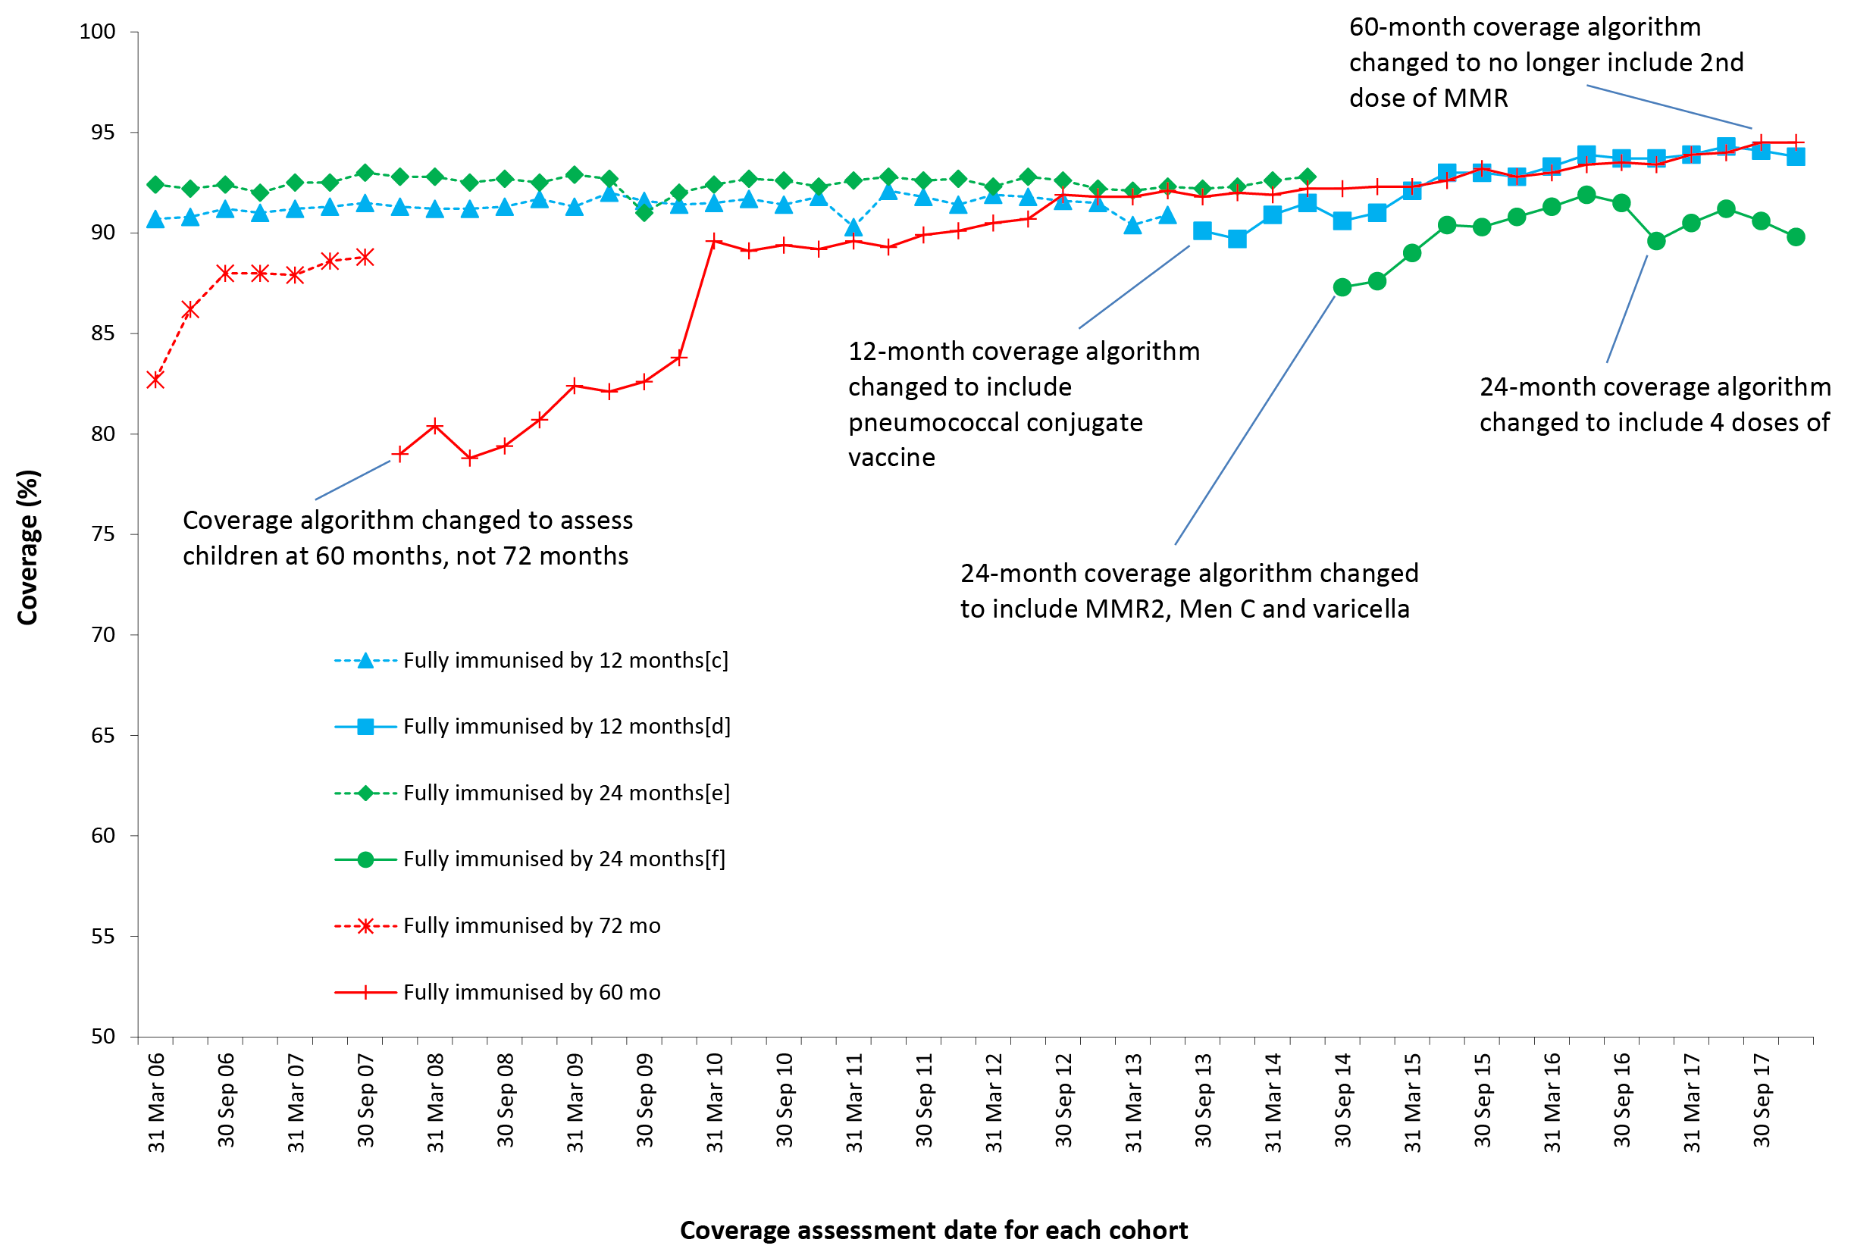
a By 3-month-wide birth cohorts born between 1 January 2000 and 31 December 2016. Coverage assessment date was 12 months after the last birth date of each cohort. Vaccination coverage estimates are calculated by quarter and may differ slightly from estimates published elsewhere using rolling annualised data. Source: Australian Immunisation Register, data as at 31 March 2018.
b See Appendix A for vaccine abbreviations.
c Coverage algorithm prior to 1 July 2013.
d Coverage algorithm from 1 July 2013.
e Coverage algorithm prior to 1 July 2014.
f Coverage algorithm from 1 July 2014.

Coverage by vaccine/antigen

12 months of age
Coverage at the 12-month age assessment milestone for antigens in the relevant combination vaccine (DTPa-hepB-polio-Hib) remained relatively stable throughout 2017 following the increase of around three percentage points between late 2014 and the end of 2016 (91.6% to 94.5%) (Figure 2). Coverage for the 3rd dose of PCV by 12 months of age reached 94.7% at the end of June 2017, its highest ever level, and similar to the level of coverage for all other vaccines/antigens assessed at this age except for rotavirus vaccine. Whilst rotavirus coverage was lower, due to strict upper age limits for administration, it increased from late 2014 onwards and was at 86.3% in December 2017 (Figure 2).

Figure 2: Trends in vaccination coverage estimates at 12 months of age, by vaccine/antigenª and quarter, Australia, 2006 to 2017^{b,c}
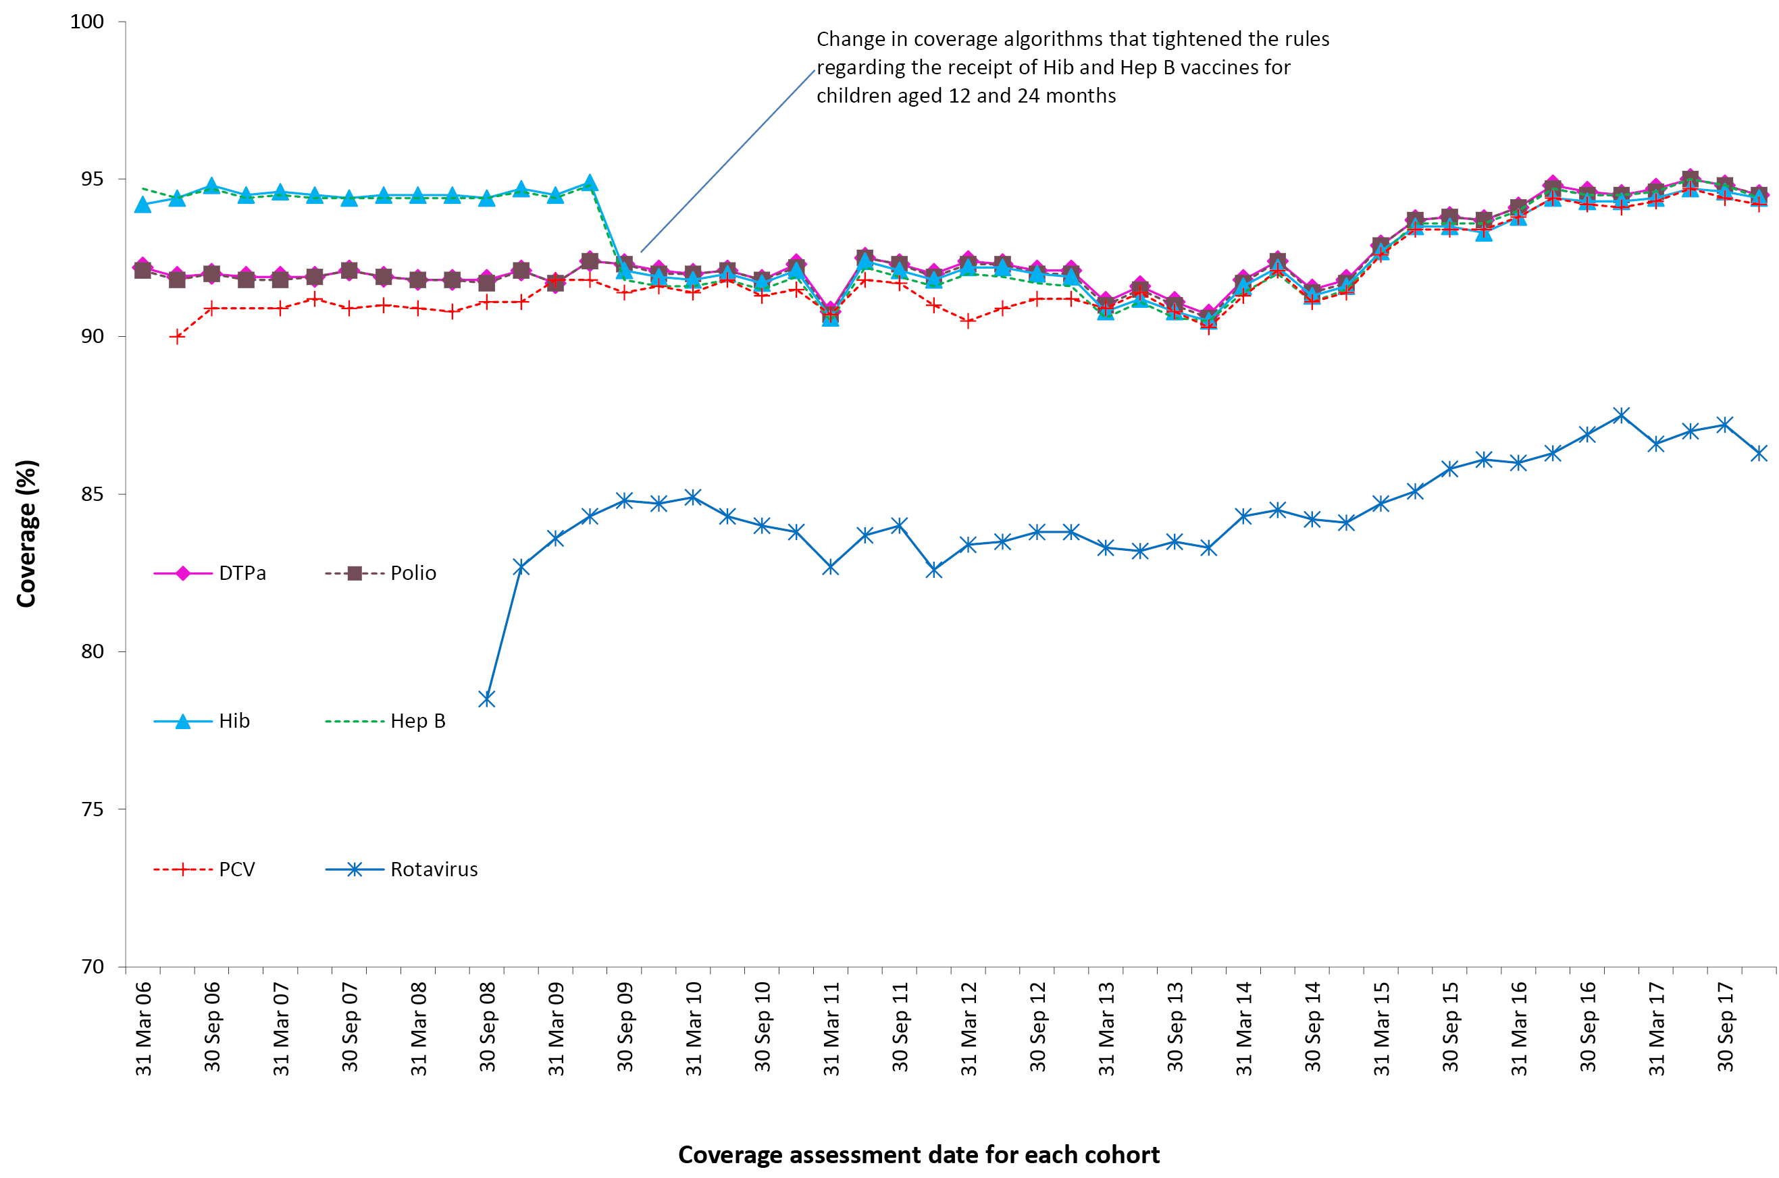
a 3rd dose of DTPa, polio and PCV, 2nd or 3rd dose of Hib and rotavirus, and 3rd dose of hepatitis B.
b By 3-month-wide birth cohorts born between 1 January 2005 and 31 December 2016. Coverage assessment date was 12 months after the last birth date of each cohort. Vaccination coverage estimates are calculated by quarter and may differ slightly from estimates published elsewhere using rolling annualised data. Source: Australian Immunisation Register data as at 31 March 2018.
c See Appendix A for vaccine abbreviations.

24 months of age
In 2017, coverage at the 24-month age assessment milestone increased for all vaccines/antigens (Figure 3). Coverage estimates for the age assessment quarterly data points in December 2017 were 95% or greater for all vaccines/antigens, except DTPa (93.0%), and MMRV (92.0%) (Figure 3). Following the decline in MMR coverage in the latter half of 2014, due to the 2nd dose of MMR-containing vaccine being assessed at 24 months of age for the first time instead of the 1st dose as previously, coverage steadily increased over 2015 and 2016, but decreased at the beginning of 2017.

Figure 3: Trends in vaccination coverage estimates at 24 months of age by vaccine/antigenª and quarter, Australia, 2006 to 2017^{b,c}
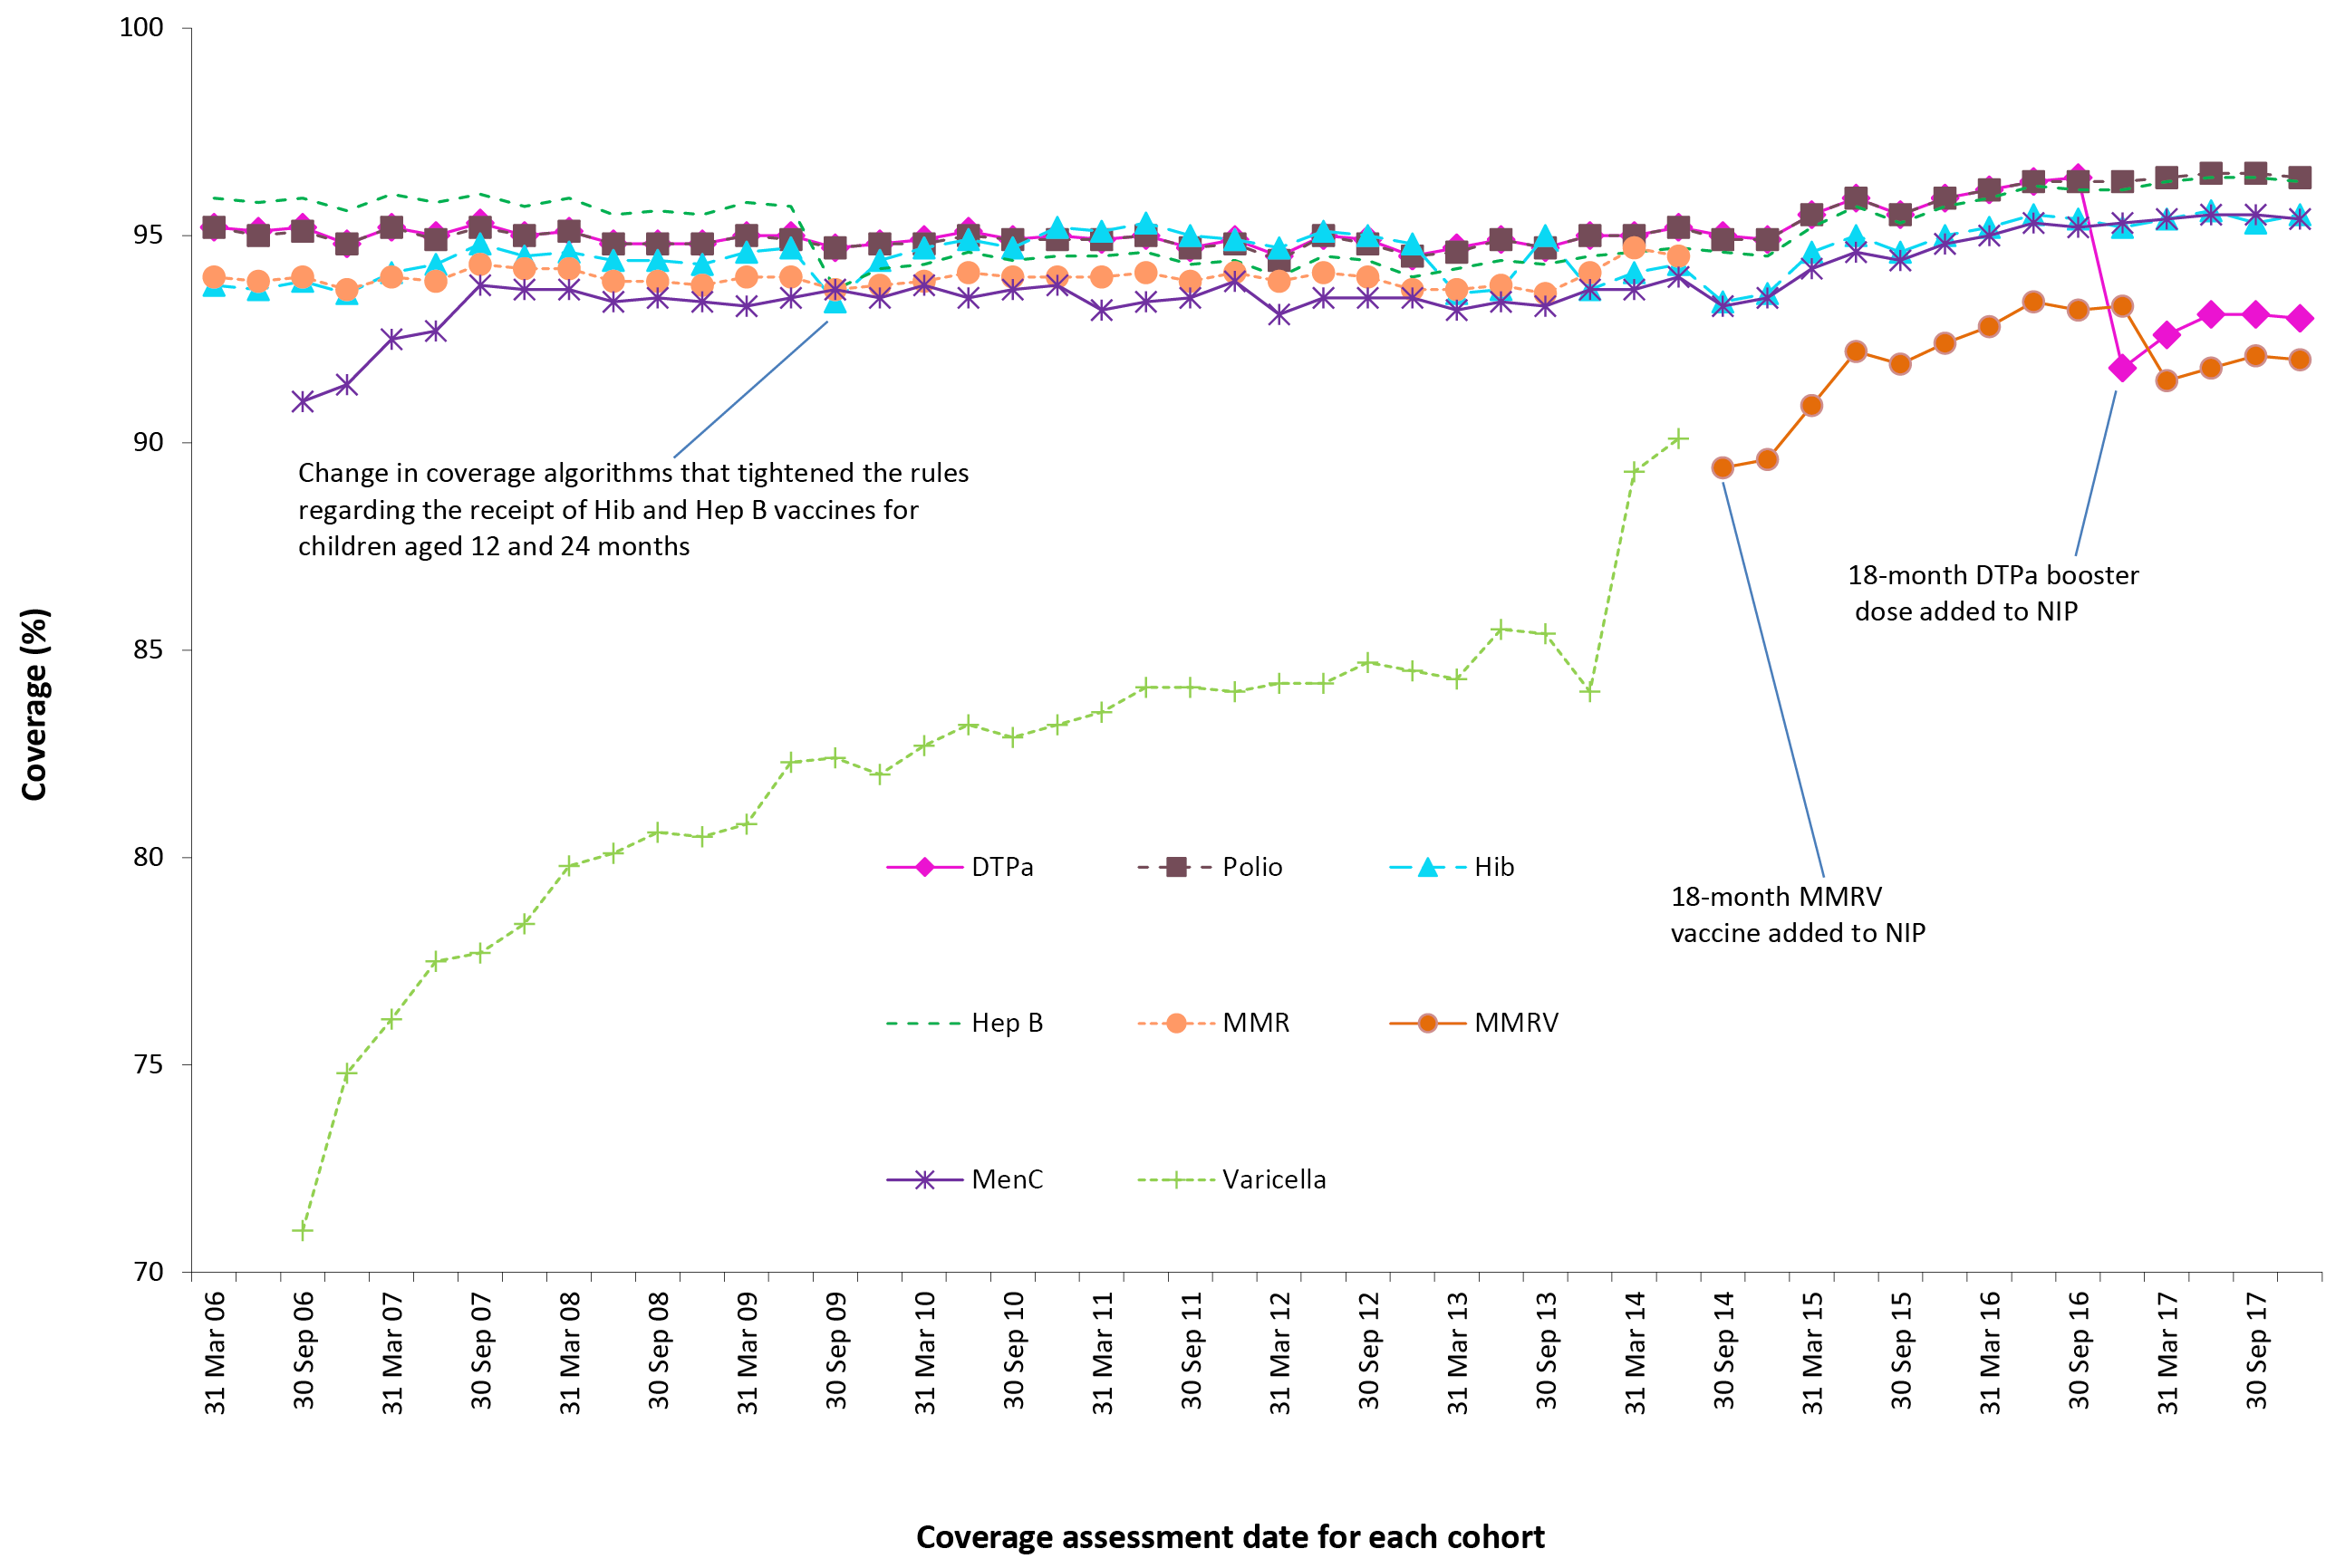
a 4th dose of DTPa (from October 2016), 3rd dose of polio, 3rd or 4th dose of Hib, 3rd dose of hepatitis B, 2nd dose of MMRV (from September 2014), 1st dose of meningococcal C.
b By 3-month-wide birth cohorts born between 1 January 2004 and 31 December 2015. Coverage assessment date was 12 months after the last birth date of each cohort. Vaccination coverage estimates are calculated by quarter and may differ slightly from estimates published elsewhere using rolling annualised data. Source: Australian Immunisation Register, data as at 31 March 2018.
c See Appendix A for vaccine abbreviations.

60 months of age
For vaccines/antigens due at 48 months of age, trends in coverage were similar to that seen for ‘fully immunised’ coverage (Figure 4). Coverage for DTPa and polio increased in 2017 reaching 94.5% at the age assessment quarterly data points in December 2017 (Figure 4). During the first half of 2017, coverage for the 2nd dose of MMR increased by almost 2 percentage points to 96.3%. From July 2017, the 2nd dose of MMR was no longer assessed at 60 months of age.

Figure 4: Trends in vaccination coverage estimates at 60 months of age (72 months prior to December 2007) by vaccine/antigenª and quarter, Australia, 2006 to 2017^{b,c}
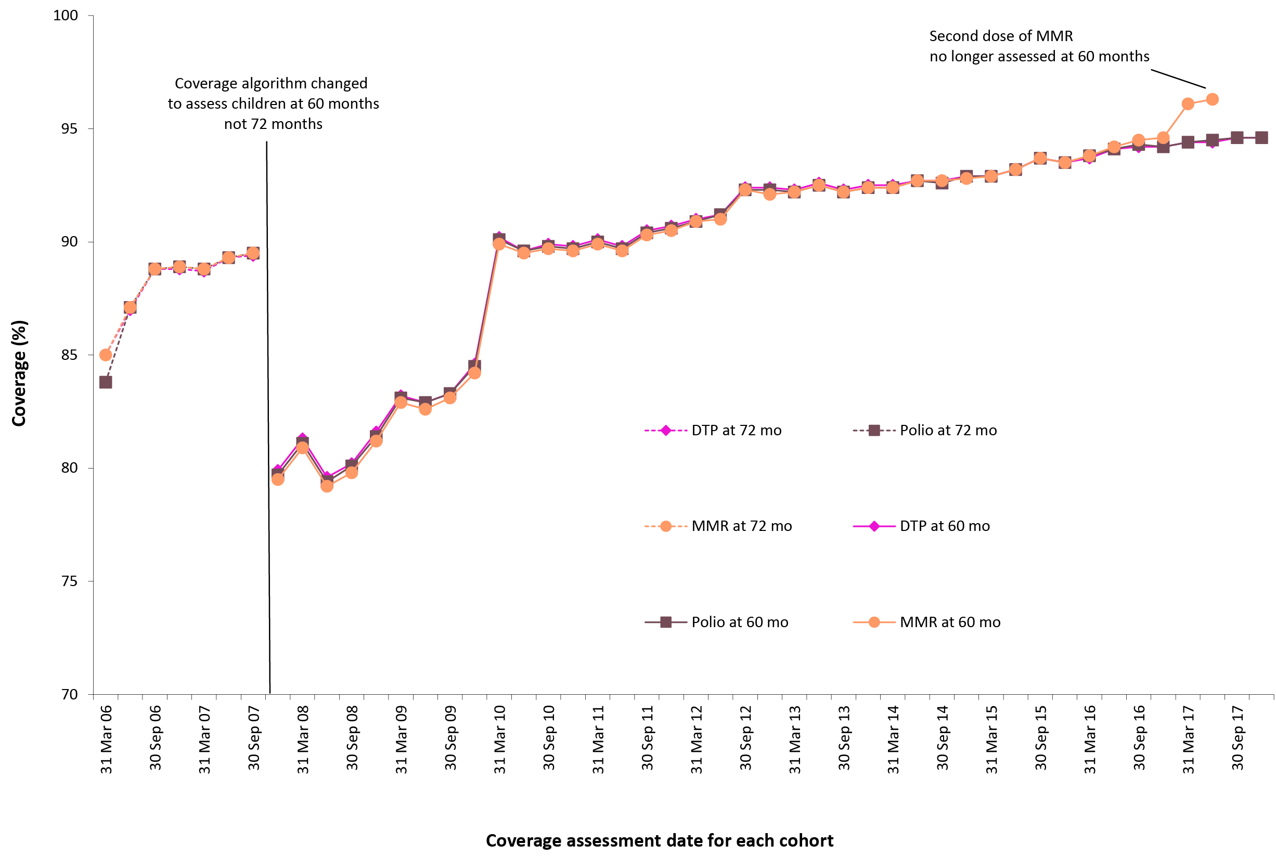
a 4th dose of DTPa and polio, 2nd dose of MMR.
b By 3-month-wide birth cohorts born between 1 January 2000 and 31 December 2012. Coverage assessment date was 72 months after the last birth date of each cohort up to December 2007 and then 60 months after the last birth date of each cohort. Vaccination coverage estimates are calculated by quarter and may differ slightly from estimates published elsewhere using rolling annualised data. Source: Australian Immunisation Register, data as at 31 March 2018.
c See Appendix A for vaccine abbreviations.

Coverage estimates by Indigenous status

Highlights
In 2017, ‘fully immunised’ coverage at 12 and 60 months of age in Indigenous children reached its highest ever recorded levels of 93.2% and 96.9%, respectively.
The gap in ‘fully immunised’ coverage between Indigenous and non-Indigenous children at 12 months of age has closed considerably from 6.7 percentage points in 2013 to 0.7 percentage points in 2017.
Recorded coverage in the influenza immunisation program for Indigenous children aged 6 months to <5 years remained low in 2017, with overall national coverage of 14.9%, and only the Northern Territory (60.6%) achieving coverage above 20%.

‘Fully immunised’
‘Fully immunised’ coverage at 12 and 60 months in Indigenous children has steadily increased reaching 93.2% and 96.9%, respectively, by the end of 2017. Figure 5 shows ‘fully immunised’ coverage at 12 months of age for Indigenous children compared to non-Indigenous children. From 2006, coverage for Indigenous children tracked well below coverage for non-Indigenous children. However, from mid-2013 the gap in coverage (Indigenous versus non-Indigenous) has progressively decreased, from 6.7 percentage points in March 2013 to only 0.7 of a percentage point in December 2017.

Figure 5: Trends in ‘fully immunised’ vaccination coverage at 12 months of age by Indigenous status and quarter, Australia, 2006 to 2017ª
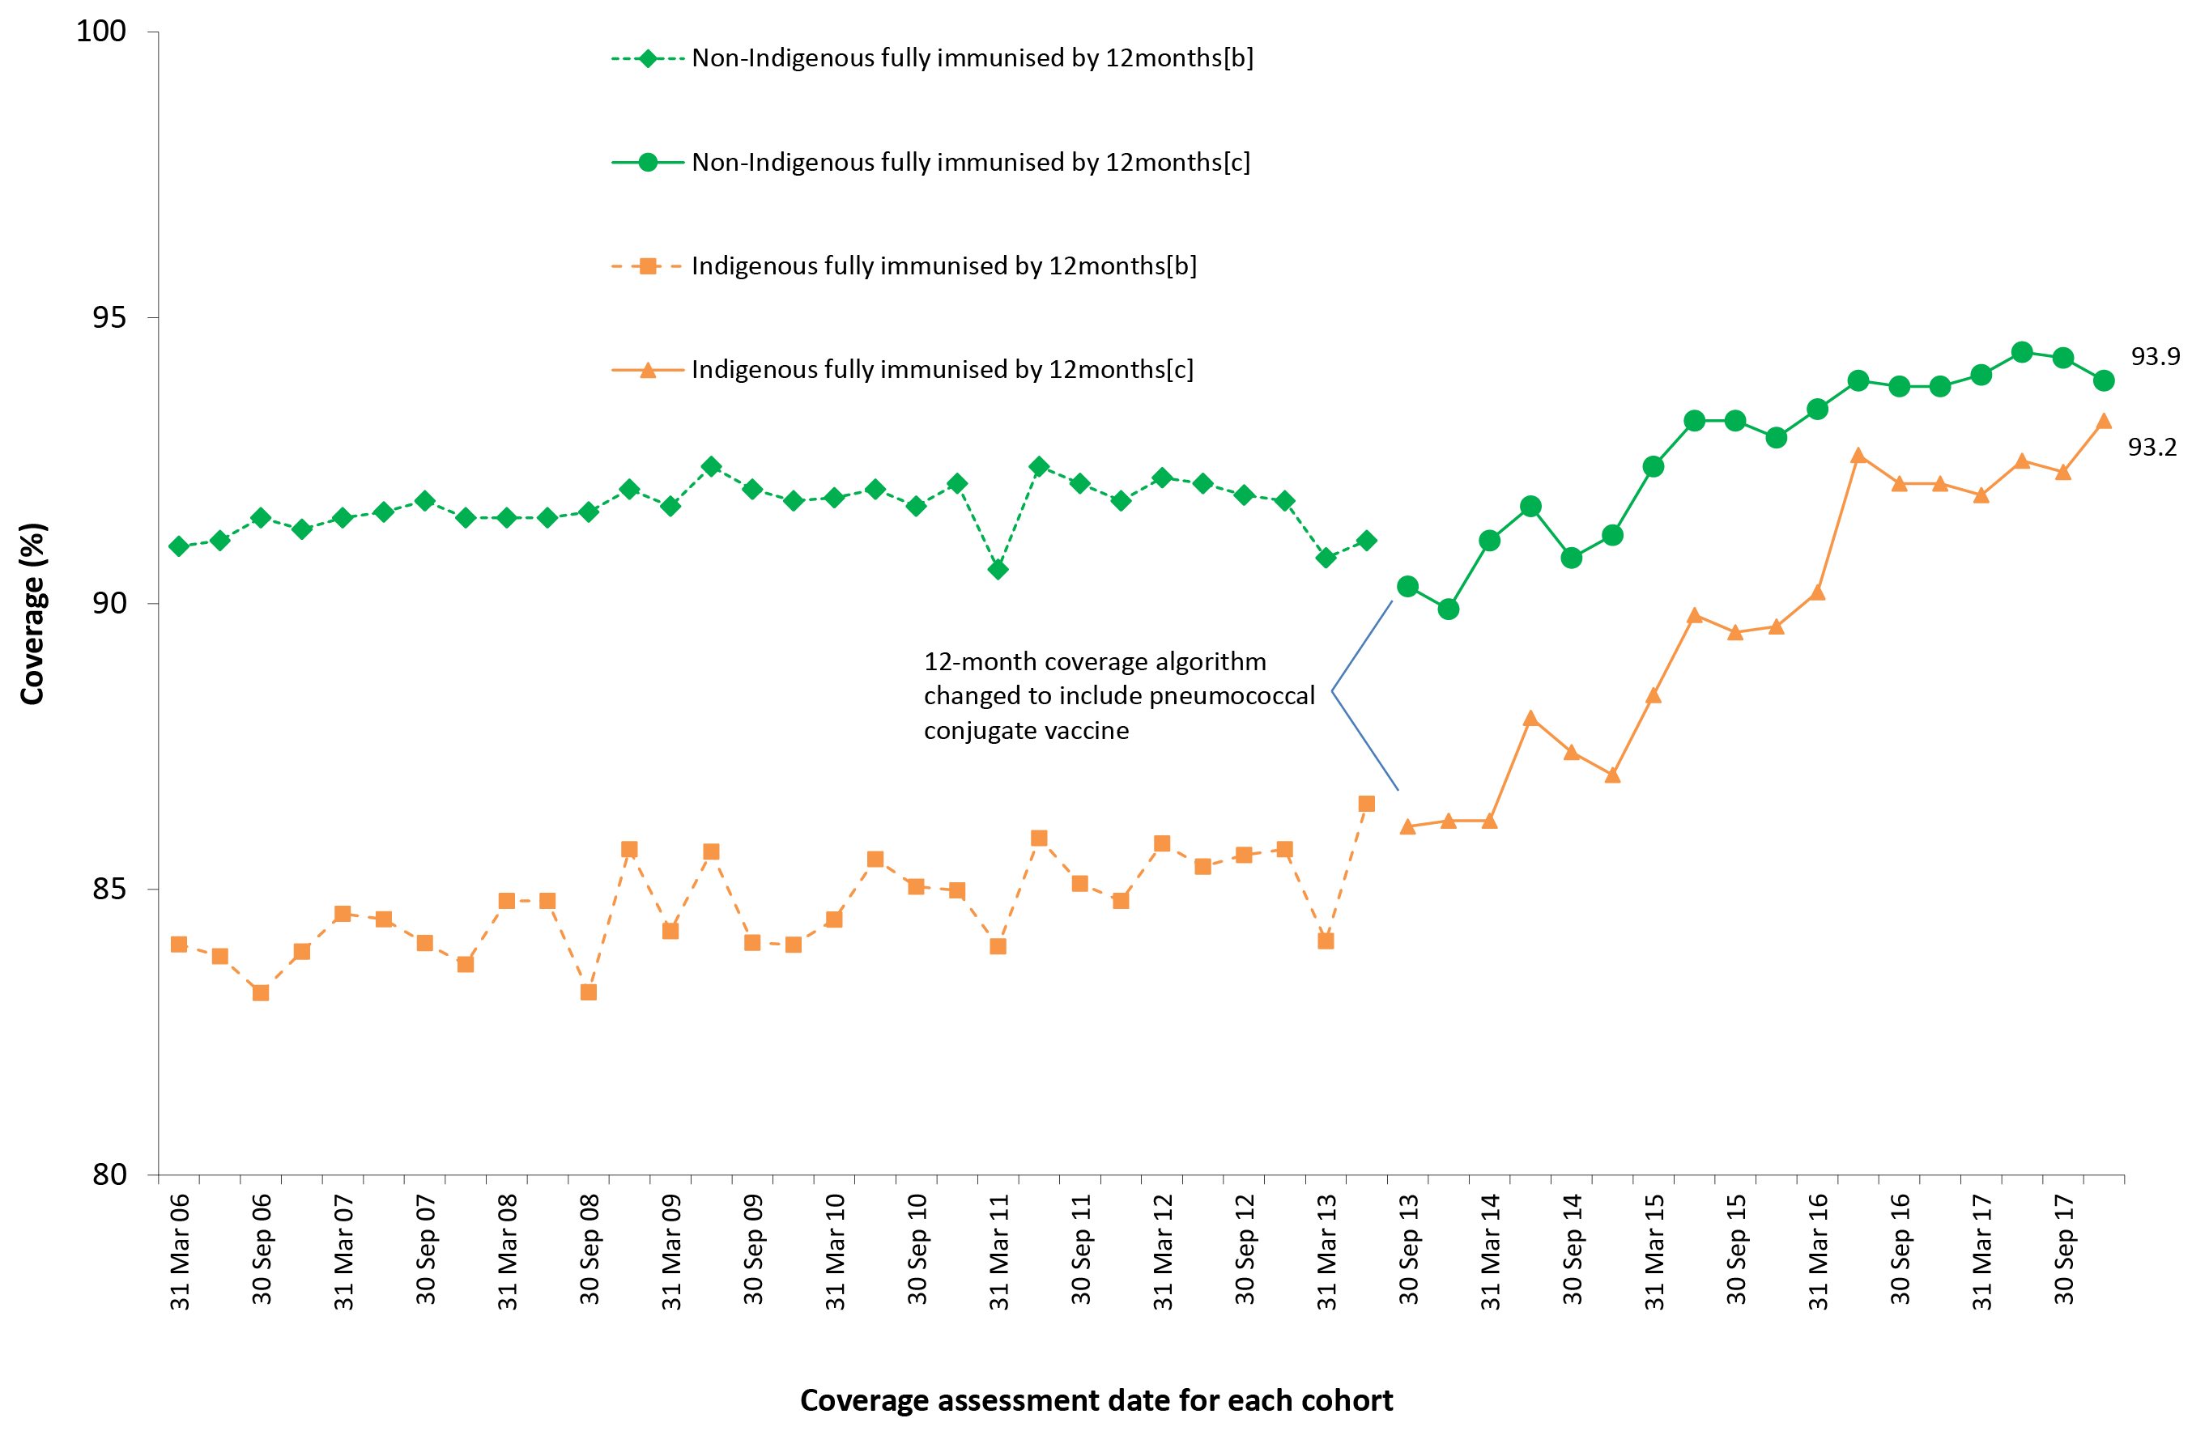
a Vaccination coverage estimates are calculated by quarter and may differ slightly from estimates published elsewhere using rolling annualised data.
b Coverage algorithm prior to 1 July 2013.
c Coverage algorithm from 1 July 2013.

The proportion of Indigenous children ‘fully immunised’ by 24 months of age was consistently higher than at either the 12 or 60 month milestones until 2012, when coverage at 60 months rose to comparable levels (Figures 5, 6 and 7). Figure 6 shows ‘fully immunised’ coverage at 24 months of age for Indigenous children compared to non-Indigenous children. From 2006 to early 2011, coverage for Indigenous children tracked 1–4 percentage points below coverage for non-Indigenous children. From 2011 to mid-2014 coverage was similar for both groups. Following the amendment of the 24-month coverage algorithm in 2014 to include a 2nd dose of MMR-containing vaccine, a dose of meningococcal C-containing vaccine, and one dose of varicella vaccine, coverage has been considerably lower for Indigenous children. ’Fully immunised’ coverage at 24 months in Indigenous children increased to 90.4% in mid-2016 but fell to 87.2% at the end of 2016, when the coverage assessment algorithm was amended in the last quarter of 2016 to include a 4th dose of DTPa instead of a 3rd dose (Figure 6). However, coverage increased marginally to 87.9% in December 2017.

Figure 6: Trends in ‘fully immunised’ vaccination coverage at 24 months of age by Indigenous status and quarter, Australia, 2006 to 2017^{a,b}
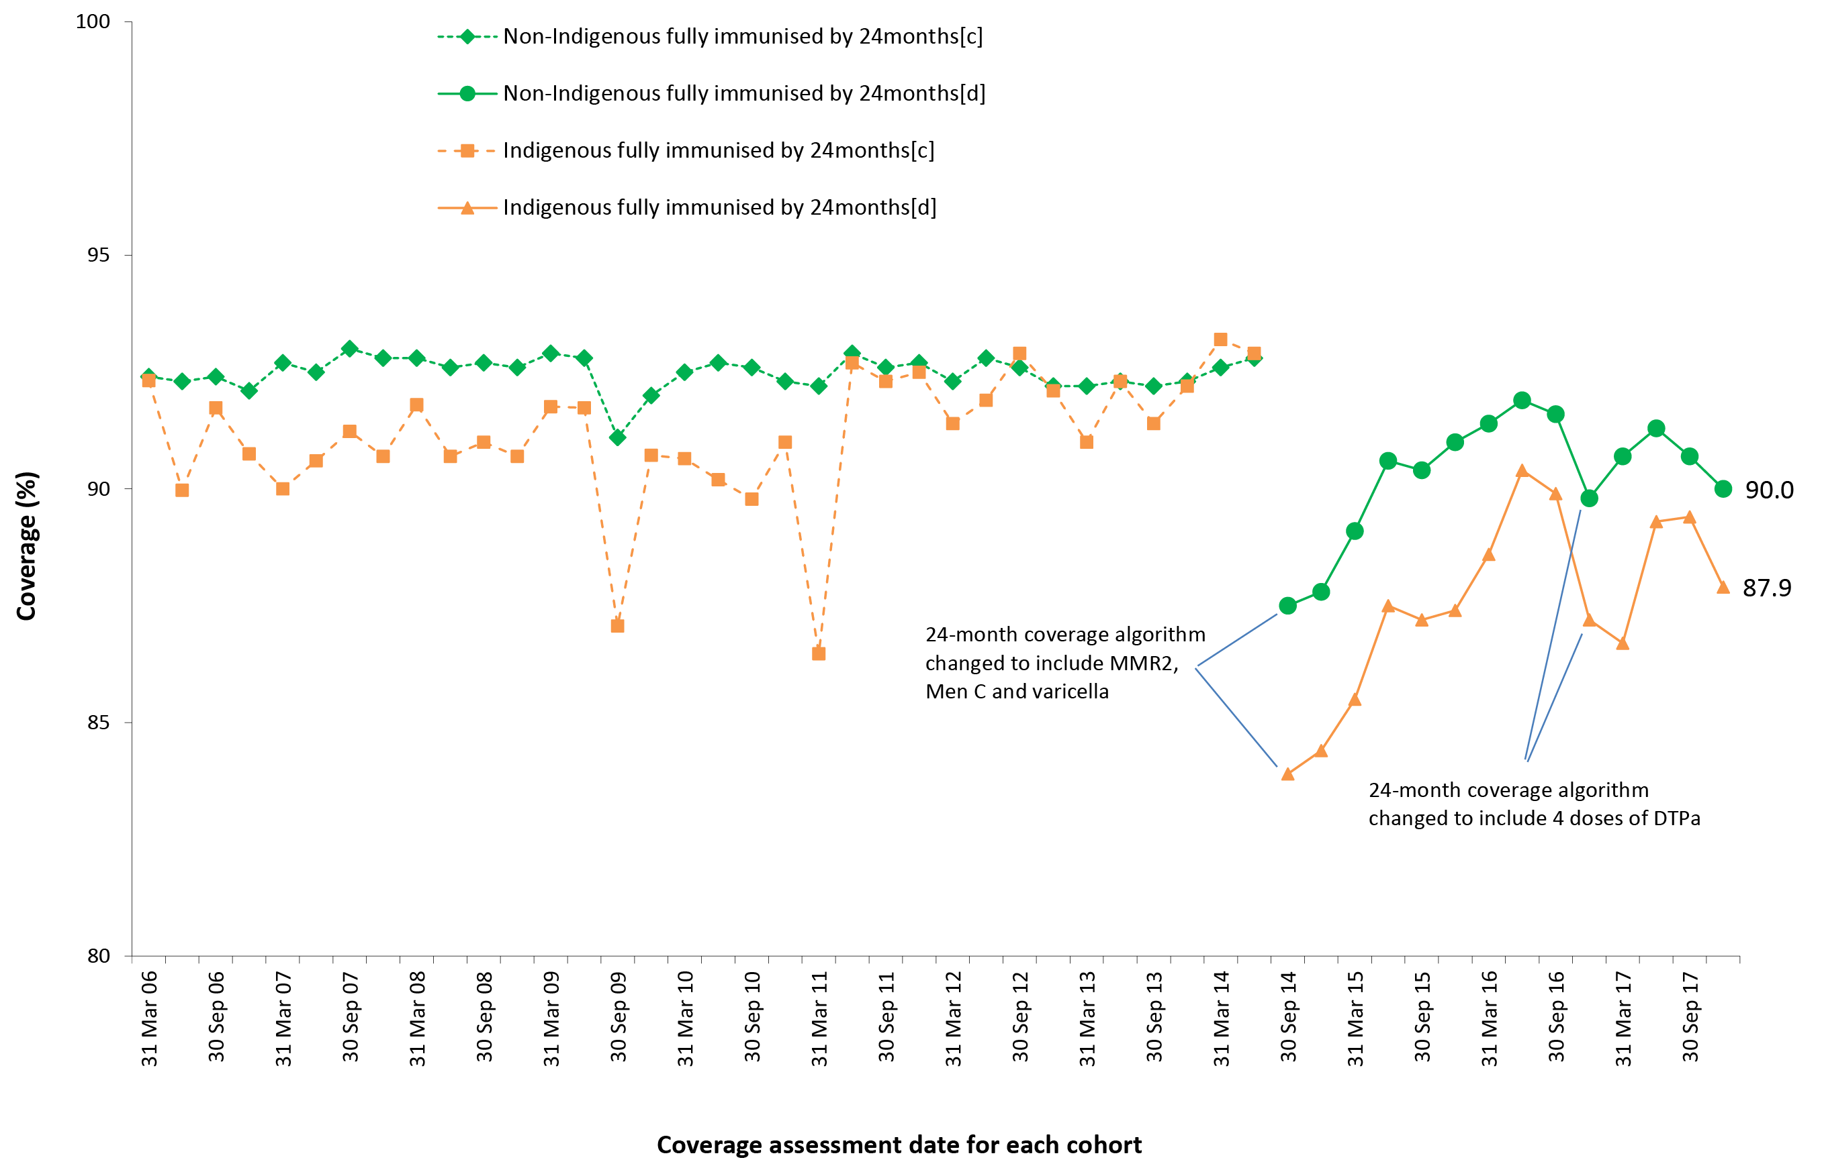
a Vaccination coverage estimates are calculated by quarter and may differ slightly from estimates published elsewhere using rolling annualised data.
b See Appendix A for vaccine abbreviations.
c Coverage algorithm prior to 1 July 2014.
d Coverage algorithm from 1 July 2014.

Figure 7 shows ‘fully immunised’ vaccination coverage at 60 months of age for Indigenous children compared to non-Indigenous children. From 2007 to 2011 coverage for Indigenous children tracked 1–5 percentage points below coverage for non-Indigenous children. However, from late 2012 onwards, coverage for Indigenous children has been higher than for non-Indigenous children, reaching 2.5 percentage points higher in December 2017.

Figure 7: Trends in ‘fully immunised’ vaccination coverage at 60 months of age by Indigenous status and quarter, Australia, 2006 to 2017^{a,b}
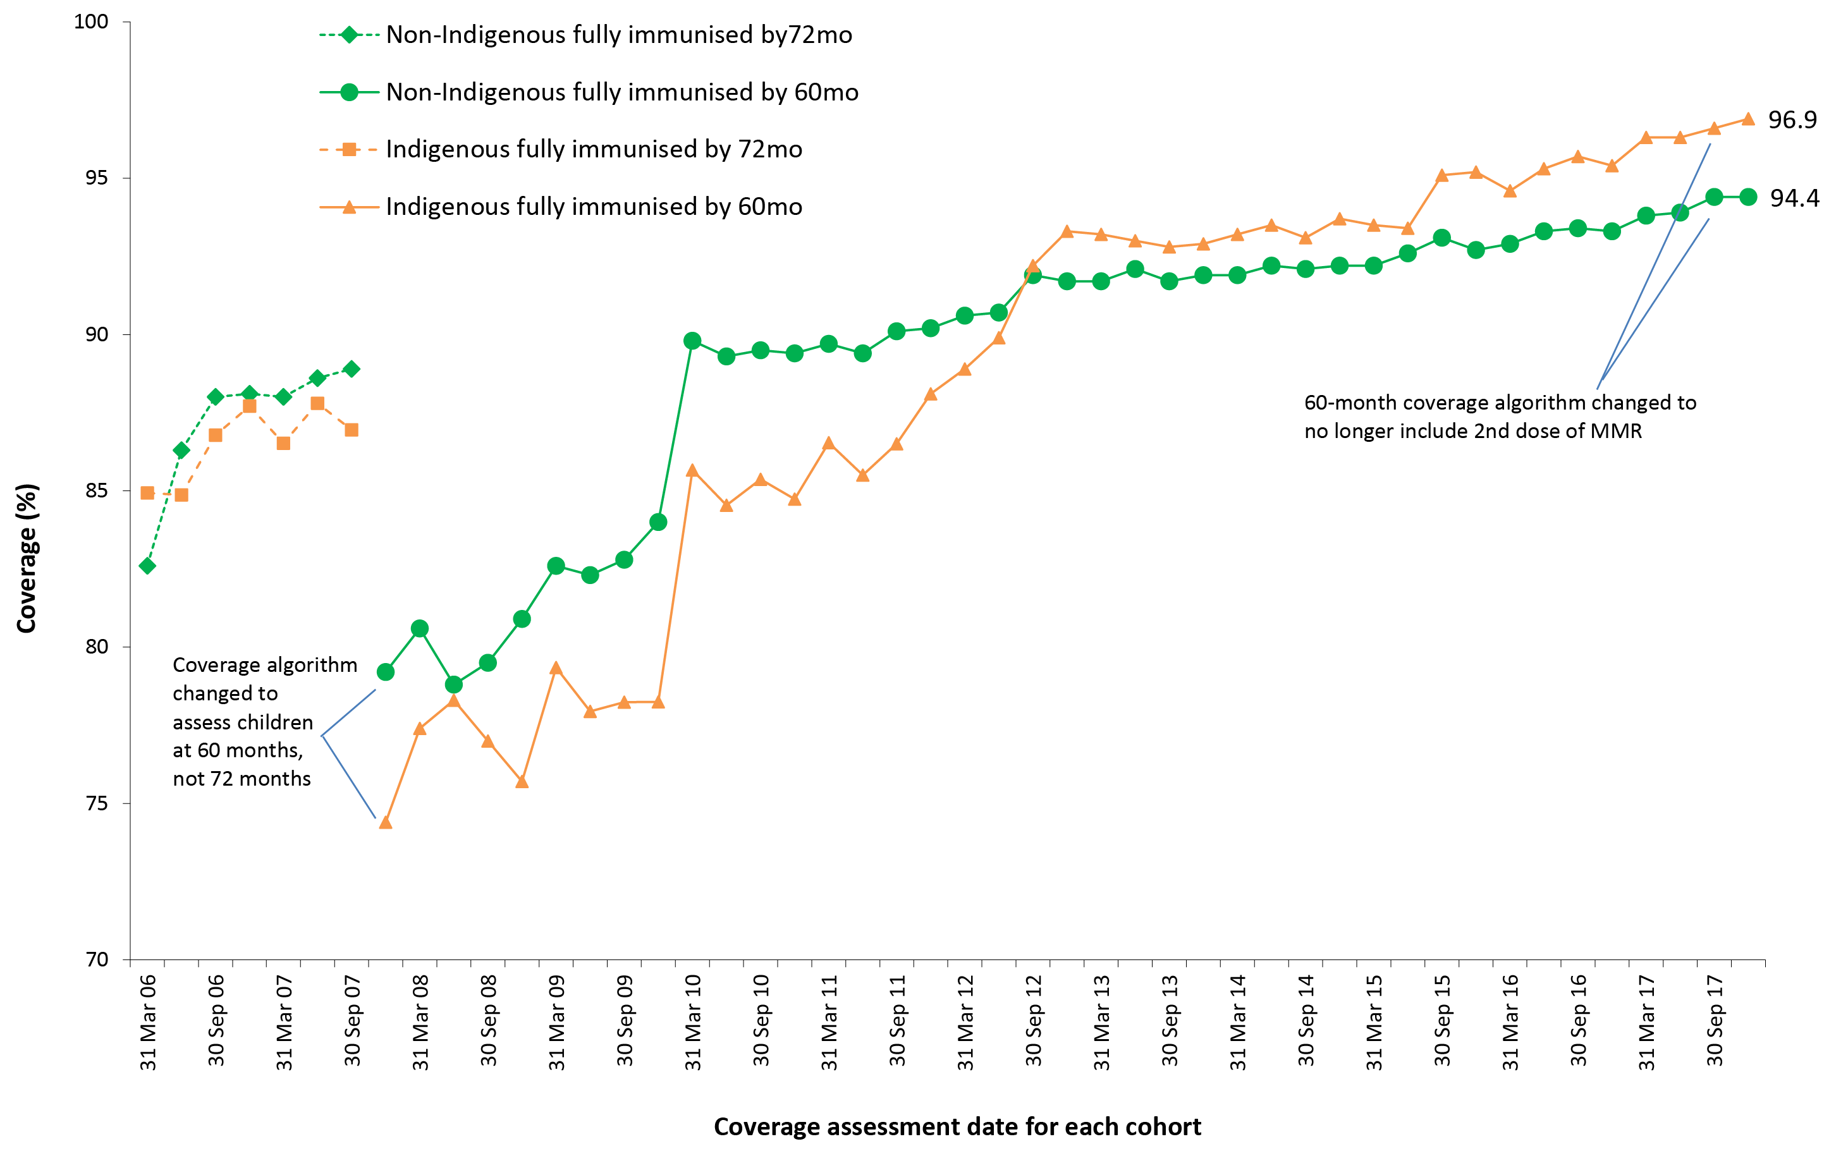
a Vaccination coverage estimates are calculated by quarter and may differ slightly from estimates published elsewhere using rolling annualised data.
b See Appendix A for vaccine abbreviations.

Coverage by vaccine/antigen
Immunisation coverage estimates in 2017 for the three age milestones by vaccine/antigen and Indigenous status are provided in Table 2. Coverage was lower for Indigenous children, compared to non-Indigenous children, for all vaccines/antigens at 12 months of age, but higher at 24 months of age for polio, Hib, hepatitis B and meningococcal C-containing vaccines, and higher at 60 months of age for DTPa-containing, polio and MMR-containing vaccines.

Table 2: Vaccination coverage estimates (%) by age assessment milestone, vaccine/antigen and Indigenous status, Australia, 12-month-wide cohorts assessed during 2017ª
Vaccine/antigen | Milestone age | Indigenous (%) | Non-Indigenous (%)
Diphtheria, tetanus, acellular pertussis | 12 months^{b} | 92.5 | 94.9
 | 24 months^{c} | 90.3 | 92.5
 | 60 months^{d} | 96.5 | 93.5
Polio | 12 months^{b} | 92.5 | 94.8
 | 24 months^{c} | 97.1 | 96.3
 | 60 months^{d} | 96.4 | 93.6
Haemophilus influenzae type b | 12 months^{b} | 92.5 | 94.7
 | 24 months^{c} | 95.7 | 94.7
 | 60 months | N/I | N/I
Hepatitis B | 12 months^{b} | 92.5 | 94.5
 | 24 months^{c} | 97.1 | 95.6
 | 60 months | N/I | N/I
Measles, mumps, rubella | 12 months | N/I | N/I
 | 24 months^{c} | 91.9 | 93.0
 | 60 months^{d} | 98.4 | 95.6
Varicella | 12 months | N/I | N/I
 | 24 months^{c} | 91.1 | 92.7
 | 60 months | N/I | N/I
Meningococcal C conjugate | 12 months | N/I | N/I
 | 24 months^{c} | 96.4 | 94.9
 | 60 months | N/I | N/I
Pneumococcal conjugate | 12 months^{b} | 92.5 | 94.3
 | 24 months | N/I | N/I
 | 60 months | N/I | N/I
Rotavirus | 12 months^{b} | 83.5 | 89.5
 | 24 months | N/I | N/I
 | 60 months | N/I | N/I
a Vaccination coverage estimates in this table are calculated using 12-month wide cohorts and may differ slightly from estimates published elsewhere using rolling annualised cohorts. Source: Australian Immunisation Register, data as at 31 March 2018.
b Cohort born 1 January 2016 – 31 December 2016.
c Cohort born 1 January 2015 – 31 December 2015.
d Cohort born 1 January 2012 – 31 December 2012.
N/I Not included in coverage estimates for that group.

Hepatitis A vaccine for Indigenous children
For the four jurisdictions in which hepatitis A vaccine is funded for Indigenous children (the Northern Territory, Queensland, South Australia and Western Australia), combined coverage of the 2nd dose of hepatitis A vaccine by 30 months of age was stable at close to 60% from 2010 to 2014 but then increased, reaching 74.7% by the end of 2017 (Figure 8). Coverage has consistently been highest in the Northern Territory (86% at the end of 2017). By late 2017, coverage was greater than 65% in all jurisdictions (Figure 8).

Figure 8: Trends in coverage estimates for hepatitis Aa vaccine for Indigenous children by jurisdiction, Australi^{a,b} 2008 to 2017^{c}
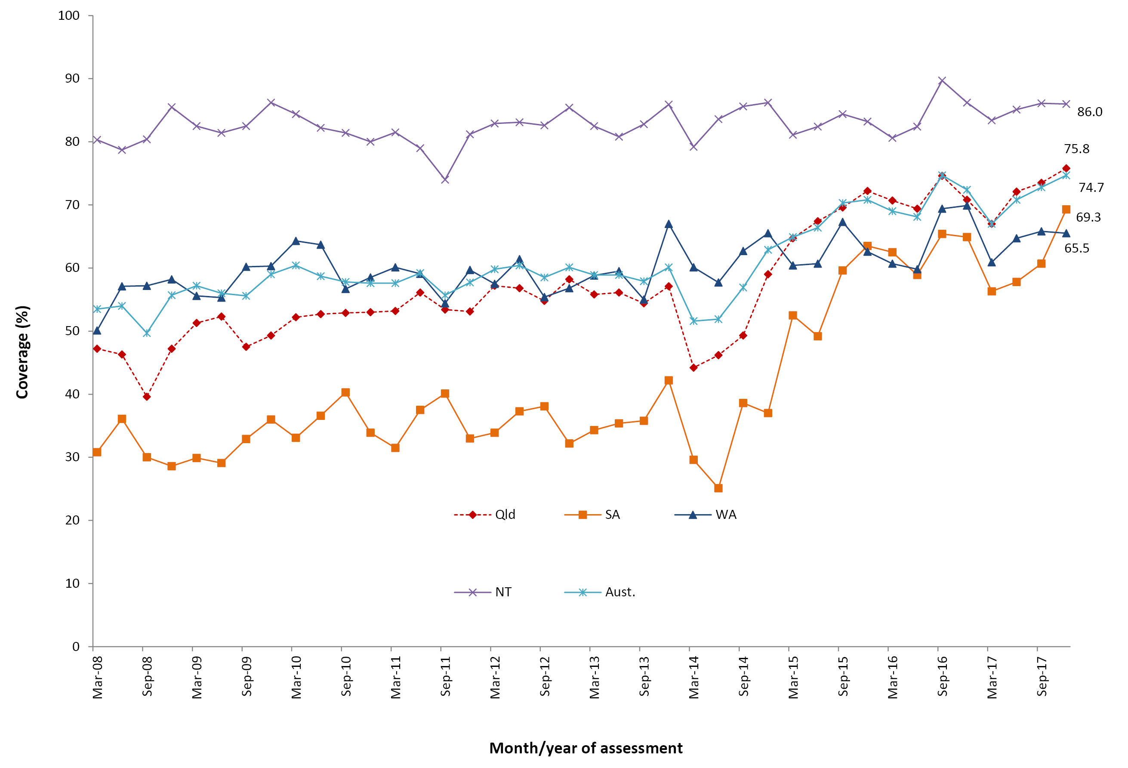
a 18-month dose assessed at 30 months of age in all four jurisdictions.
b Northern Territory (NT), Queensland (Qld), South Australia (SA) and Western Australia (WA) only. Aust = NT + Qld + SA + WA
c Source: Australian Immunisation Register, data as at 31 March 2018.

Pneumococcal vaccine for Indigenous children
For the four jurisdictions in which an 18-month booster dose of pneumococcal conjugate vaccine is funded for Indigenous children (the Northern Territory, Queensland, South Australia and Western Australia), combined coverage increased following the 13vPCV catch-up campaign in 2012, fell in 2013, but then increased reaching 74.7% by the end of 2017 (Figure 9). Coverage has consistently been highest in the Northern Territory (87.8% at the end of 2017). By late 2017, coverage was greater than 63% in all jurisdictions (Figure 9).

Figure 9: Trends in coverage estimates for pneumococcalª vaccine for Indigenous children by jurisdiction,^{b} Australia, 2008 to 2017^{c}
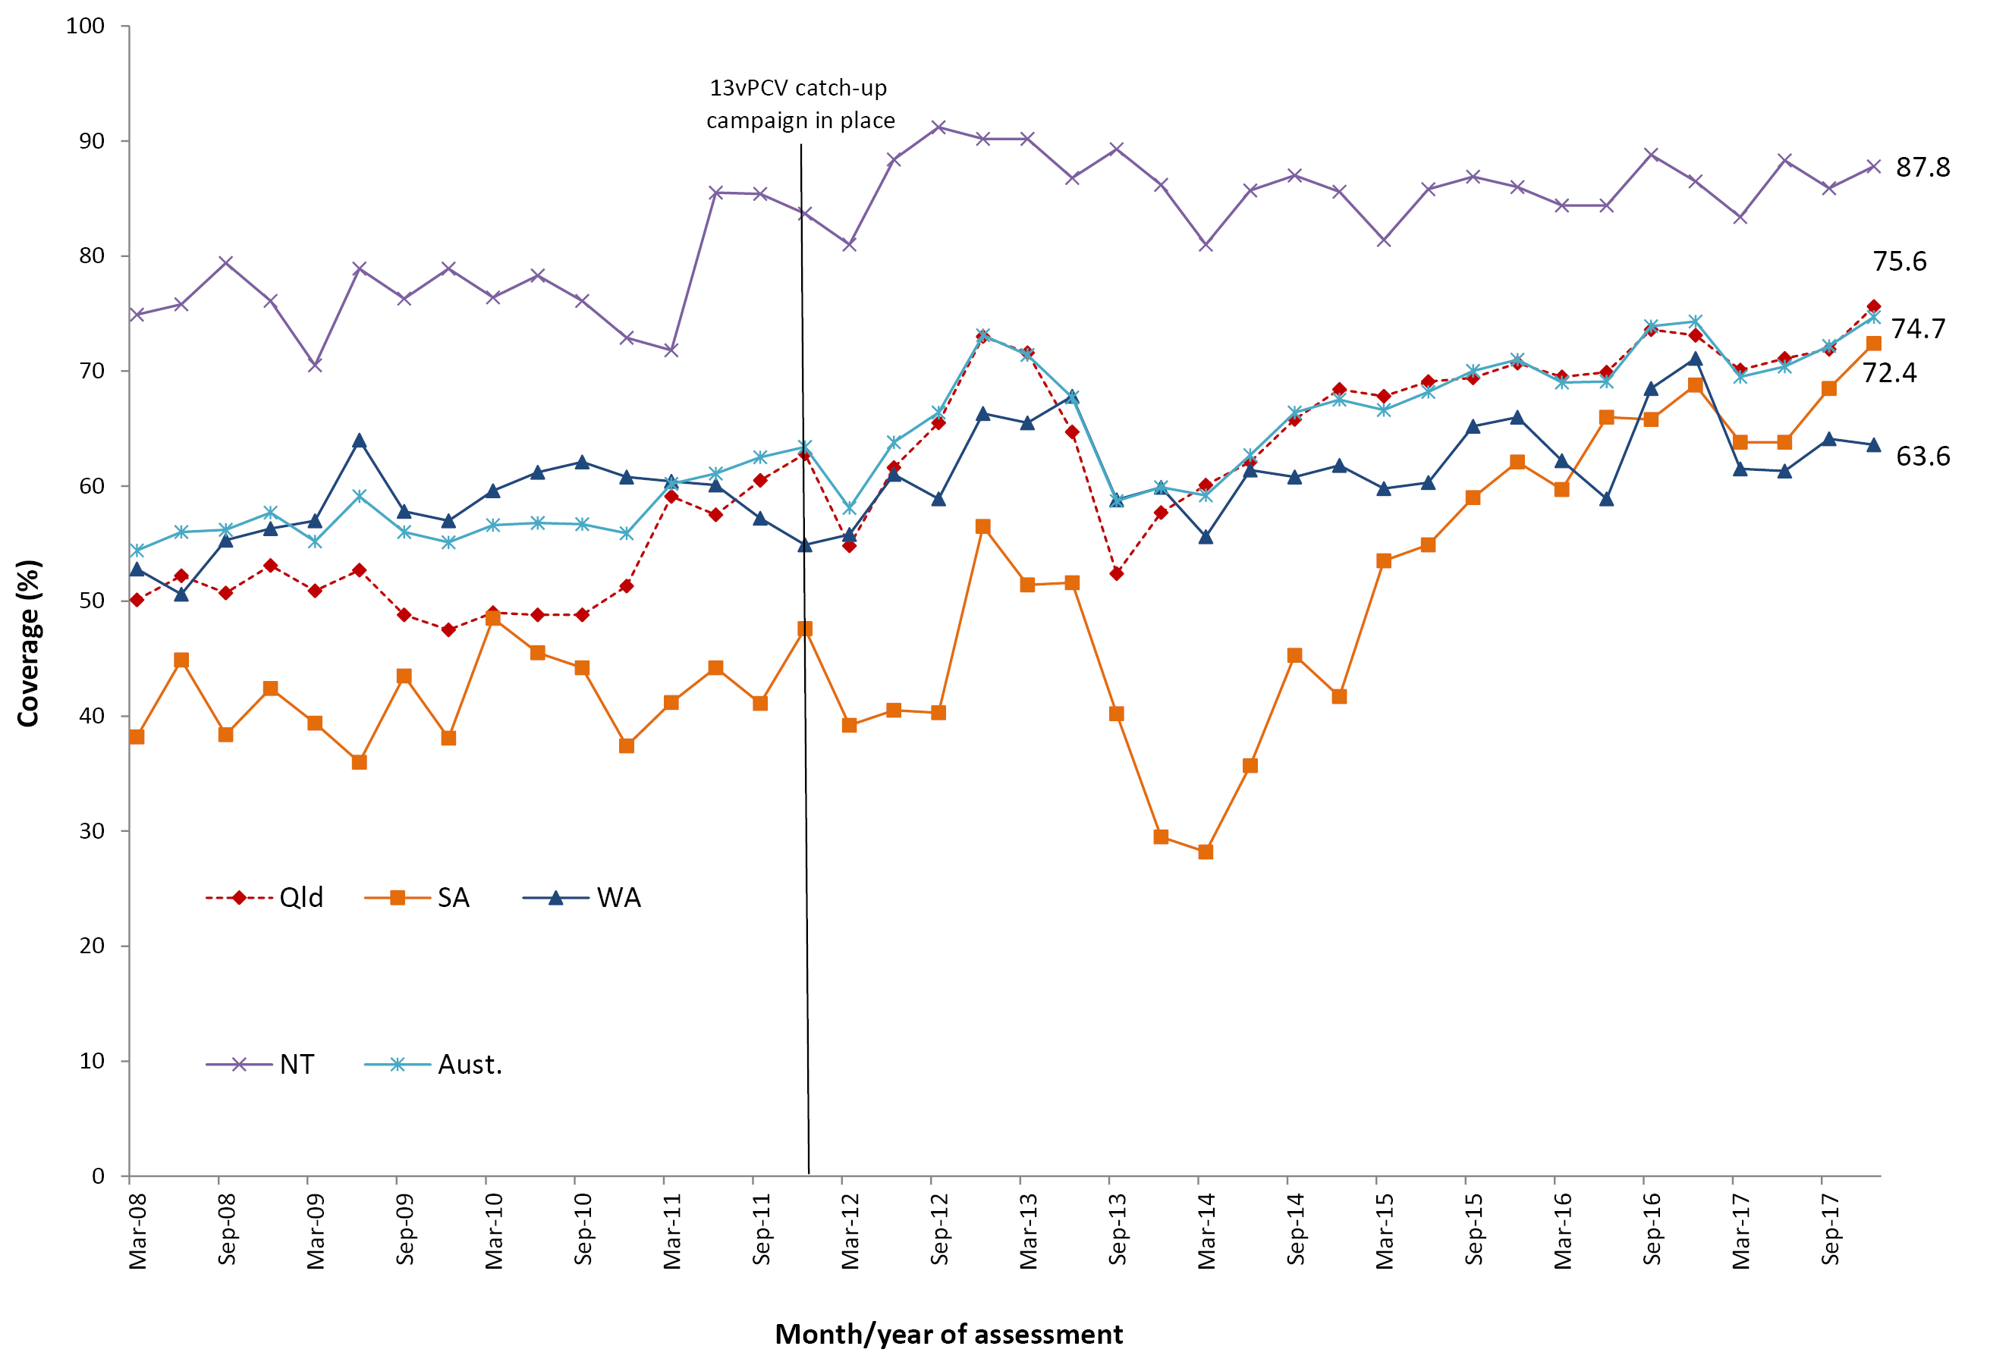
a 18-month booster dose assessed at 30 months of age in all four jurisdictions.
b Northern Territory (NT), Queensland (Qld), South Australia (SA) and Western Australia (WA) only. Aust = NT + Qld + SA + WA
c Source: Australian Immunisation Register, data as at 31 March 2018. See Appendix A for vaccine abbreviations.

Influenza vaccine coverage for Indigenous children aged 6 months to <5 years
Recorded influenza vaccine coverage in Indigenous children aged 6 months to <5 years was generally low across Australia in 2017, with overall national coverage of 14.9%. There was substantial variation in recorded coverage by jurisdiction (Figure 10). Apart from the Northern Territory (60.1%), coverage was only above 10% in the Australian Capital Territory, Queensland and Western Australia (10.7%, 14.9% and 15.3%, respectively). For non-Indigenous children aged 6 months to <5 years, coverage of seasonal influenza vaccine in 2017 was recorded as 5.0% in Australia, and coverage was below 10% in all jurisdictions except Western Australia where it was 11.8% (Figure 10).

Figure 10: Recorded coverage of any dose of seasonal influenza vaccineª administered during 2017 to children aged 6 months to less than 5 years, by Indigenous status and jurisdiction, Australia^{b}
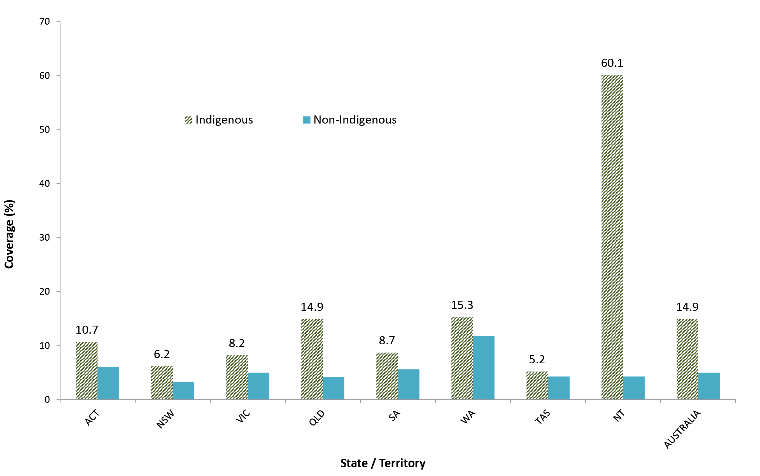
a Any influenza vaccine dose.
b ACT = Australian Capital Territory; NSW = New South Wales; NT = Northern Territory; Qld = Queensland; SA = South Australia; Tas = Tasmania; Vic = Victoria; WA = Western Australia. Source: Australian Immunisation Register, data as at 31 March 2018.

Figure 11 shows the time trends of seasonal influenza vaccine coverage recorded on the AIR between 2007 and 2017 for Indigenous children aged 6 months to <5 years, by jurisdiction. Coverage in WA peaked at 28% in 2009 following the introduction in 2008 of a state-funded universal immunisation program for all children aged 6 months to <5 years. However, coverage was substantially lower in subsequent years following the temporary suspension of the program in 2010 due to an increase in febrile reactions, later shown to be related to a single brand of influenza vaccine. Following the commencement of the nationally funded program for Indigenous children aged 6 months to <5 years in 2015, seasonal influenza vaccine coverage in Indigenous children rose 4-fold to 12.1% nationally in 2015, and reached 14.9% in 2017 (Figure 11). Upward trends in coverage over time were seen for all jurisdictions, with coverage markedly highest in the Northern Territory from 2015 onwards, followed by Western Australia and Queensland. Compared with 2014, flu vaccine coverage in 2017 increased 13-fold in the Northern Territory and almost 7-fold in Queensland.

Figure 11: Trends in recorded coverage of any dose of seasonal influenza vaccineª amongst Indigenous children aged 6 months to less than 5 years, by jurisdiction, Australia, 2007–2017b
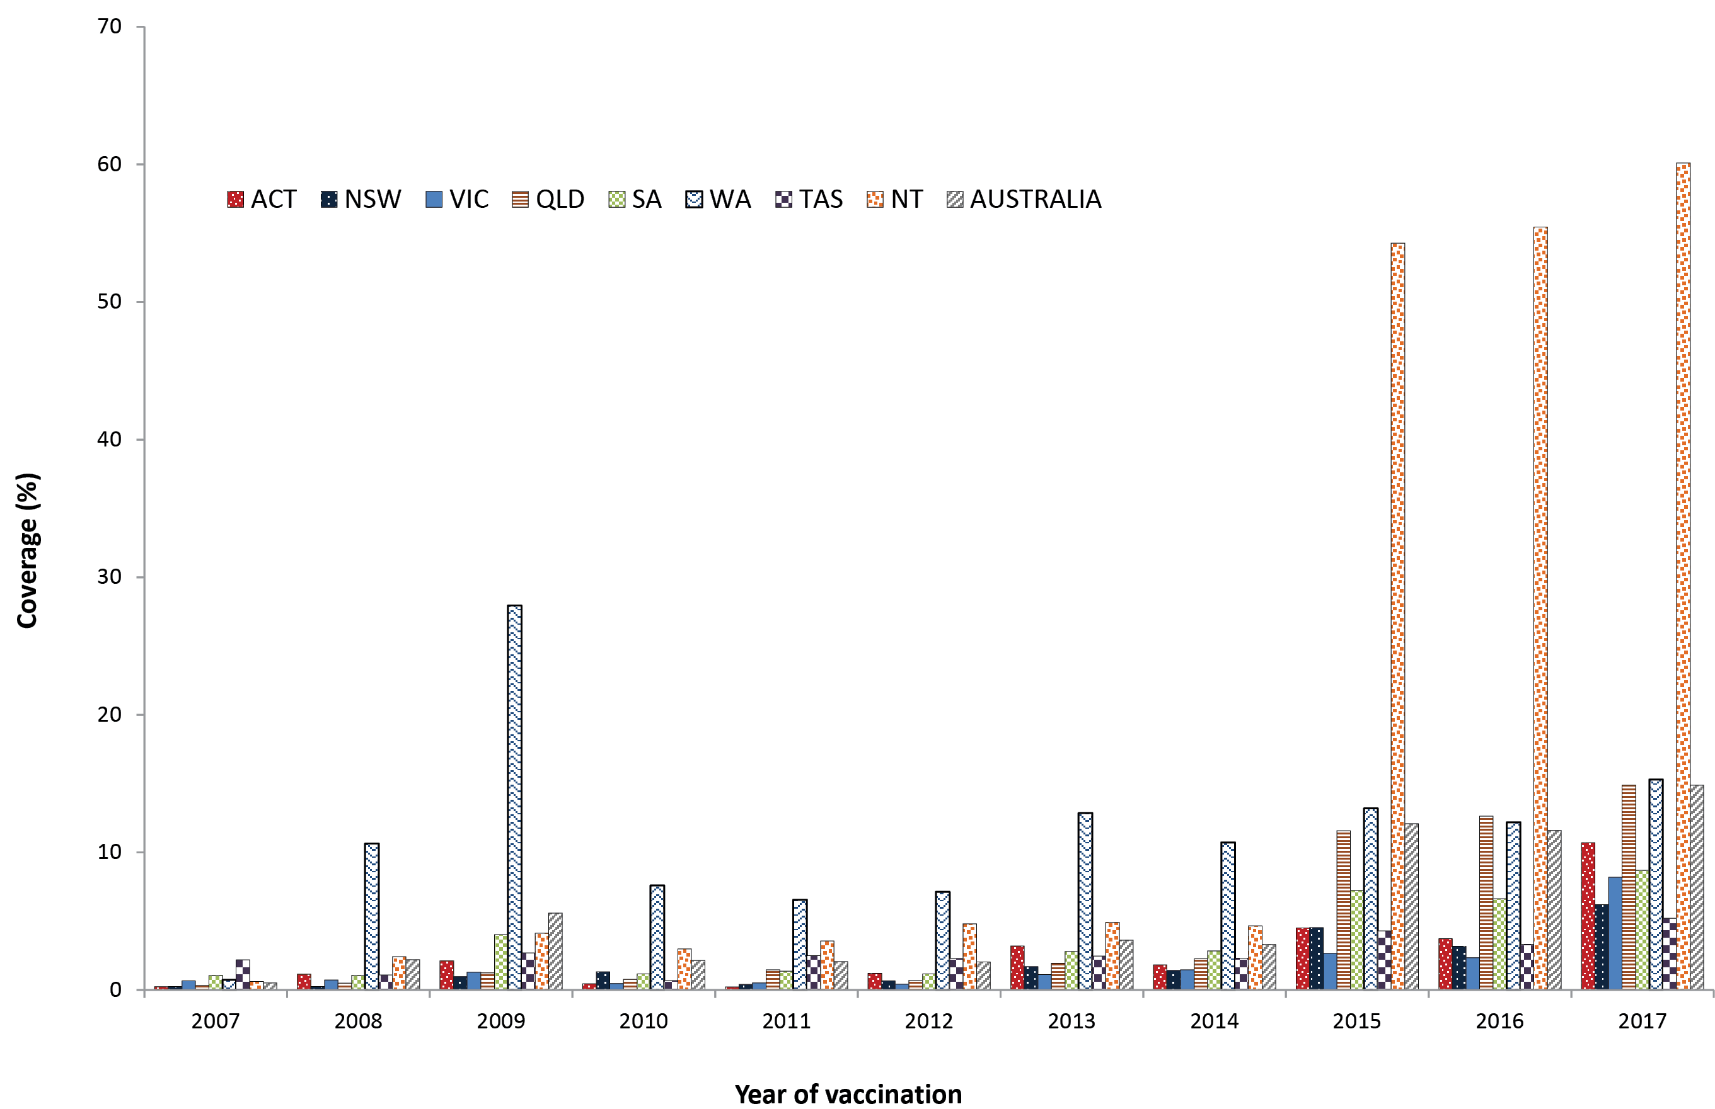
a Any influenza vaccine dose.
b ACT = Australian Capital Territory; NSW = New South Wales; NT = Northern Territory; Qld = Queensland; SA = South Australia; Tas = Tasmania; Vic = Victoria; WA = Western Australia. Source: Australian Immunisation Register, data as at 31 March 2018.

Timeliness of immunisation

Highlights
The disparity in on-time vaccination of the 1st, 2nd, and 3rd doses of DTPa-containing vaccine between Indigenous and non-Indigenous children in Australia decreased by 2.4–5.8 percentage points from 2008 to 2017. Moving the 2nd dose of MMR-containing vaccine in mid-2014 to being due at 18 months of age resulted in an immediate improvement in on-time vaccination for this vaccine, for both Indigenous and non-Indigenous children, although the disparity for this vaccine dose between Indigenous and non-Indigenous children increased from 2.9 percentage points to 14.2 percentage points. For both Indigenous and non-Indigenous children, the majority of delayed vaccination occurred 1 – < 3 months after the schedule point for all four vaccine doses assessed, and across all remoteness categories.
In this section, both on-time vaccination and delay in vaccination are presented. On-time vaccination provides a measure of the percentage of children receiving vaccinations within 30 days of the recommended age, whilst vaccination delay provides more detailed information on the length of vaccination delay occurring. Trends in on-time vaccination for the 1st dose of DTPa-containing vaccine from 2008 to 2017 by Indigenous status are shown in Figure 12. Between 2008 and 2017, the disparity in on-time vaccination for the 1st dose of DTPa-containing vaccine between Indigenous and non-Indigenous children in Australia has decreased from almost 10 percentage points in 2008 to 4.2 percentage points in 2017 (Figure 12).
Figure 12. Trends in on-time vaccination for the first dose of DTPa, by Indigenous status, Australia, 2008–2017ª
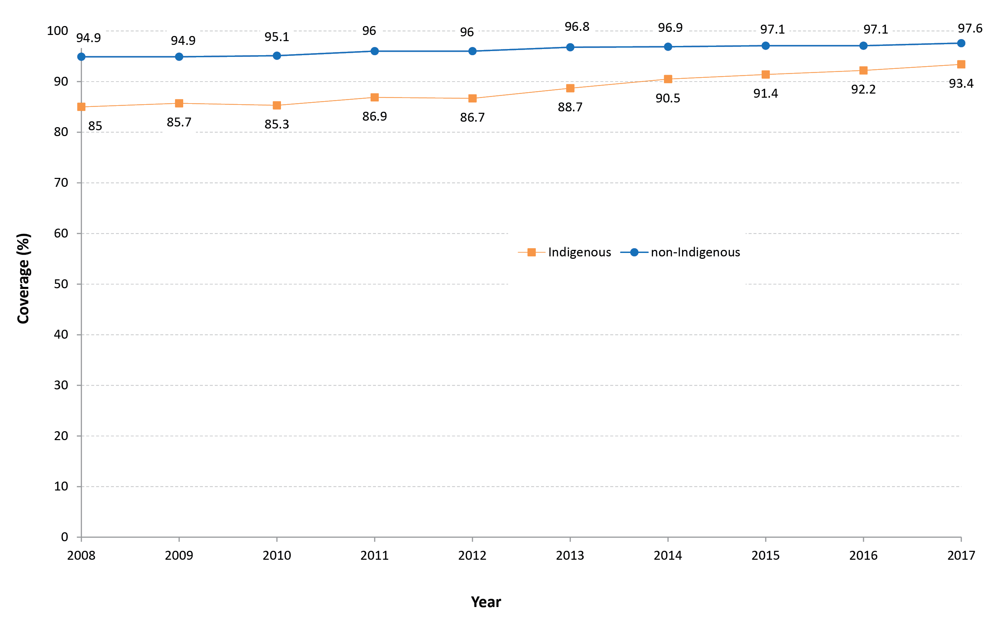
a All data points are calculated for a 12-month-wide birth cohort using AIR data.

Trends in on-time vaccination for the 2nd dose of DTPa-containing vaccine from 2008 to 2017 by Indigenous status are shown in Figure 13. Between 2008 and 2017, the disparity in on-time vaccination for the 2nd dose of DTPa-containing vaccine between Indigenous and non-Indigenous children in Australia decreased from 15.4 to 11.1 percentage points.

Figure 13. Trends in on-time vaccination for the second dose of DTPa, by Indigenous status, Australia, 2008–2017ª
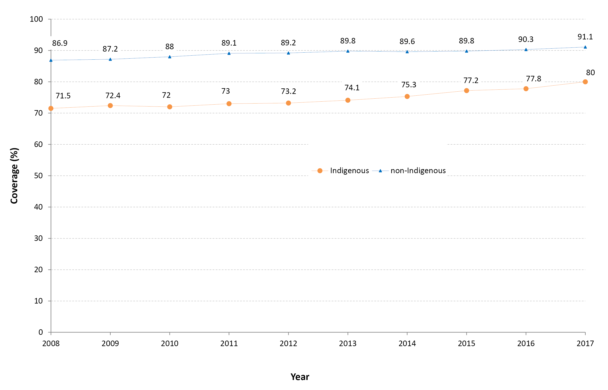
a All data points are calculated for a 12-month-wide birth cohort using AIR data.
Trends in on-time vaccination for the 3rd dose of DTPa-containing vaccine from 2008 to 2017 by Indigenous status are shown in Figure 14. Between 2008 and 2017, the disparity in on-time vaccination for the 3rd dose of DTPa-containing vaccine between Indigenous and non-Indigenous children in Australia decreased from 18.0 to 15.6 percentage points.
Figure 14. Trends in on-time vaccination for the third dose of DTPa, by Indigenous status, Australia, 2008–2017ª
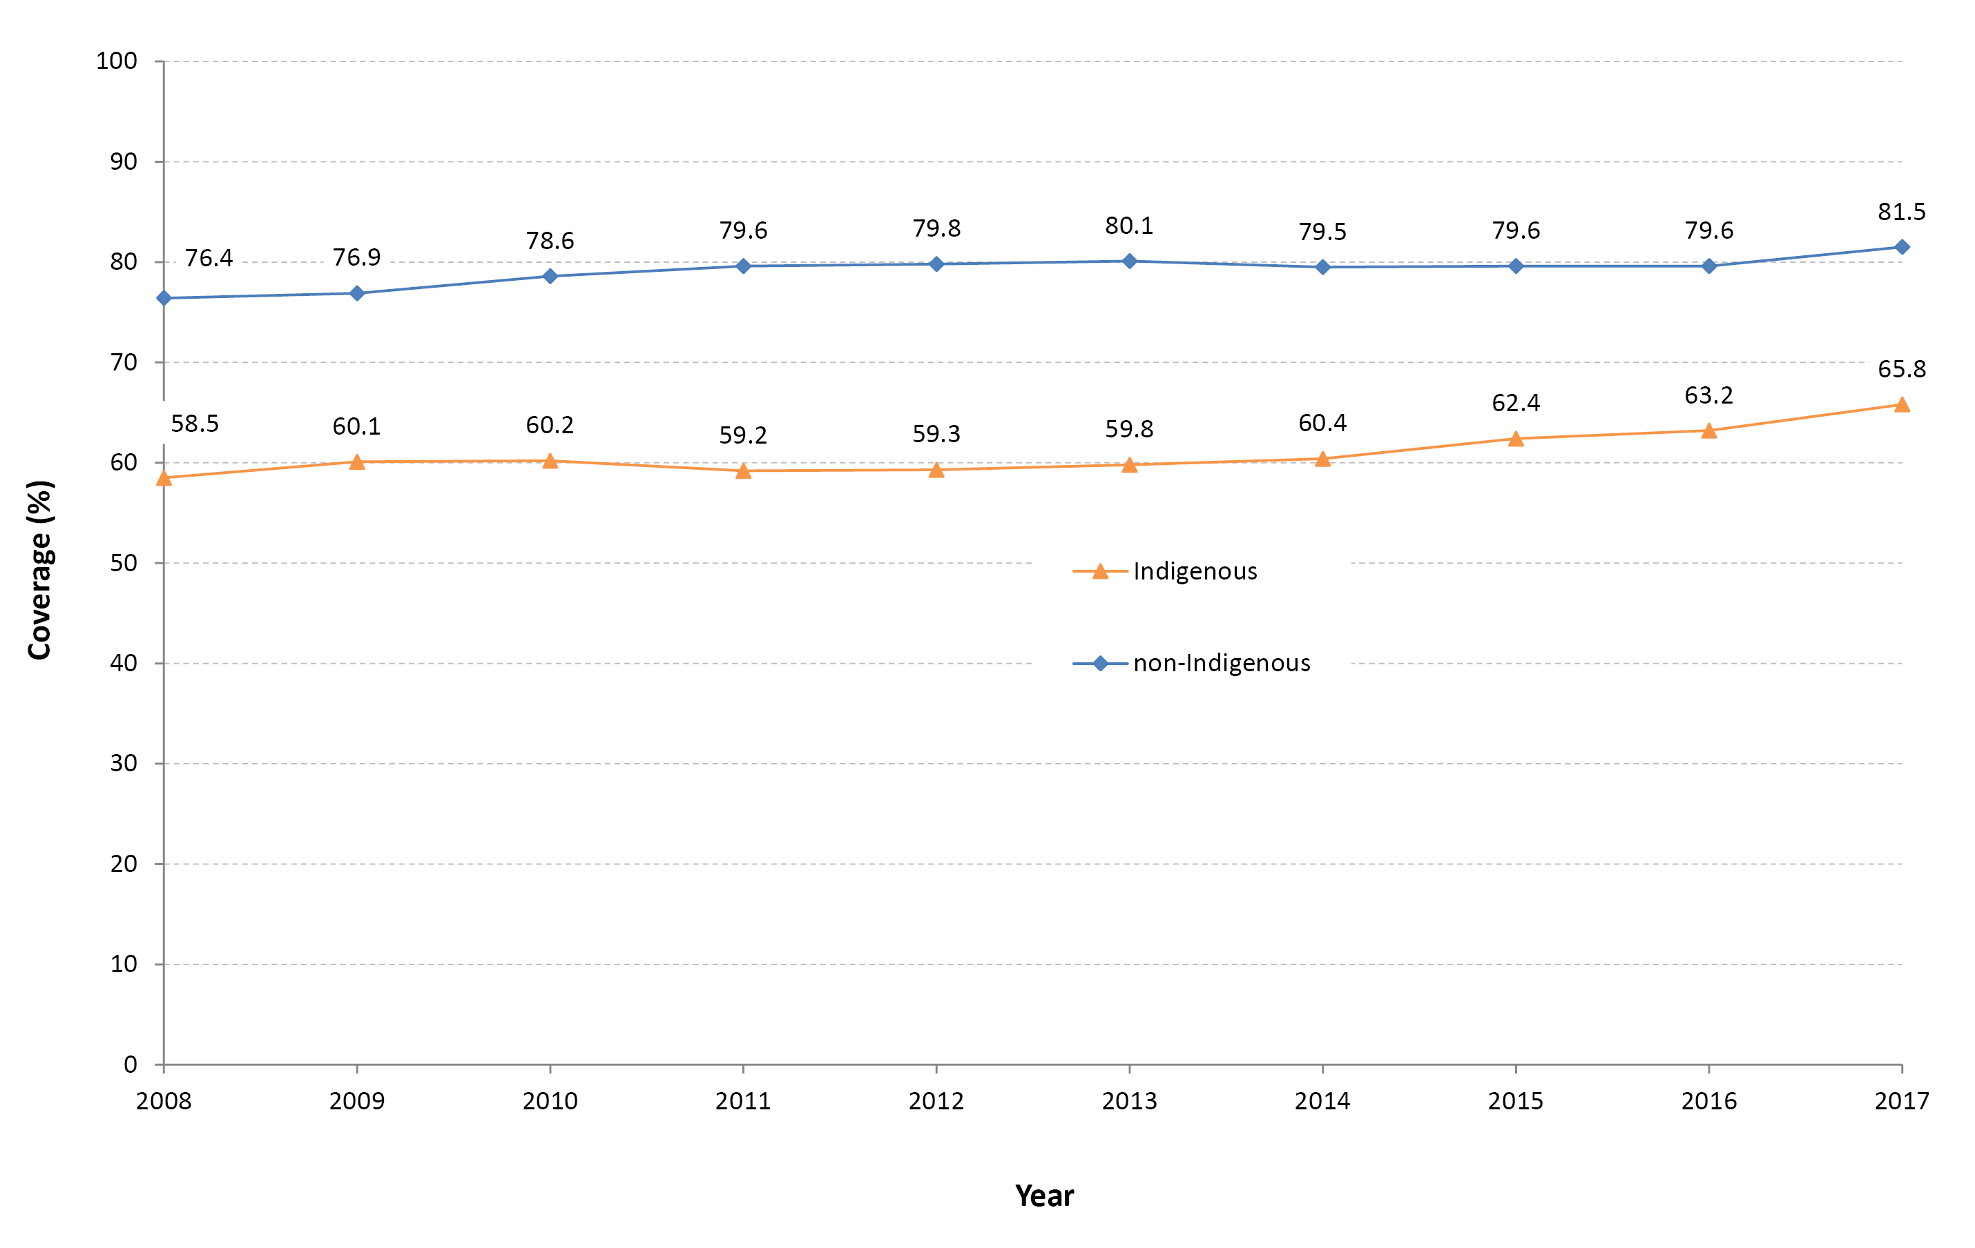
a All data points are calculated for a 12-month-wide birth cohort using AIR data.

Trends in on-time vaccination for the 1st dose of MMR vaccine from 2008 to 2017 by Indigenous status are shown in Figure 15. Between 2008 and 2017, the disparity in on-time vaccination of the 1st dose of MMR vaccine between Indigenous and non-Indigenous children in Australia remained stable at around 10 percentage points.

Figure 15. Trends in on-time vaccination for the first dose of MMR, by Indigenous status, Australia, 2008–2017ª
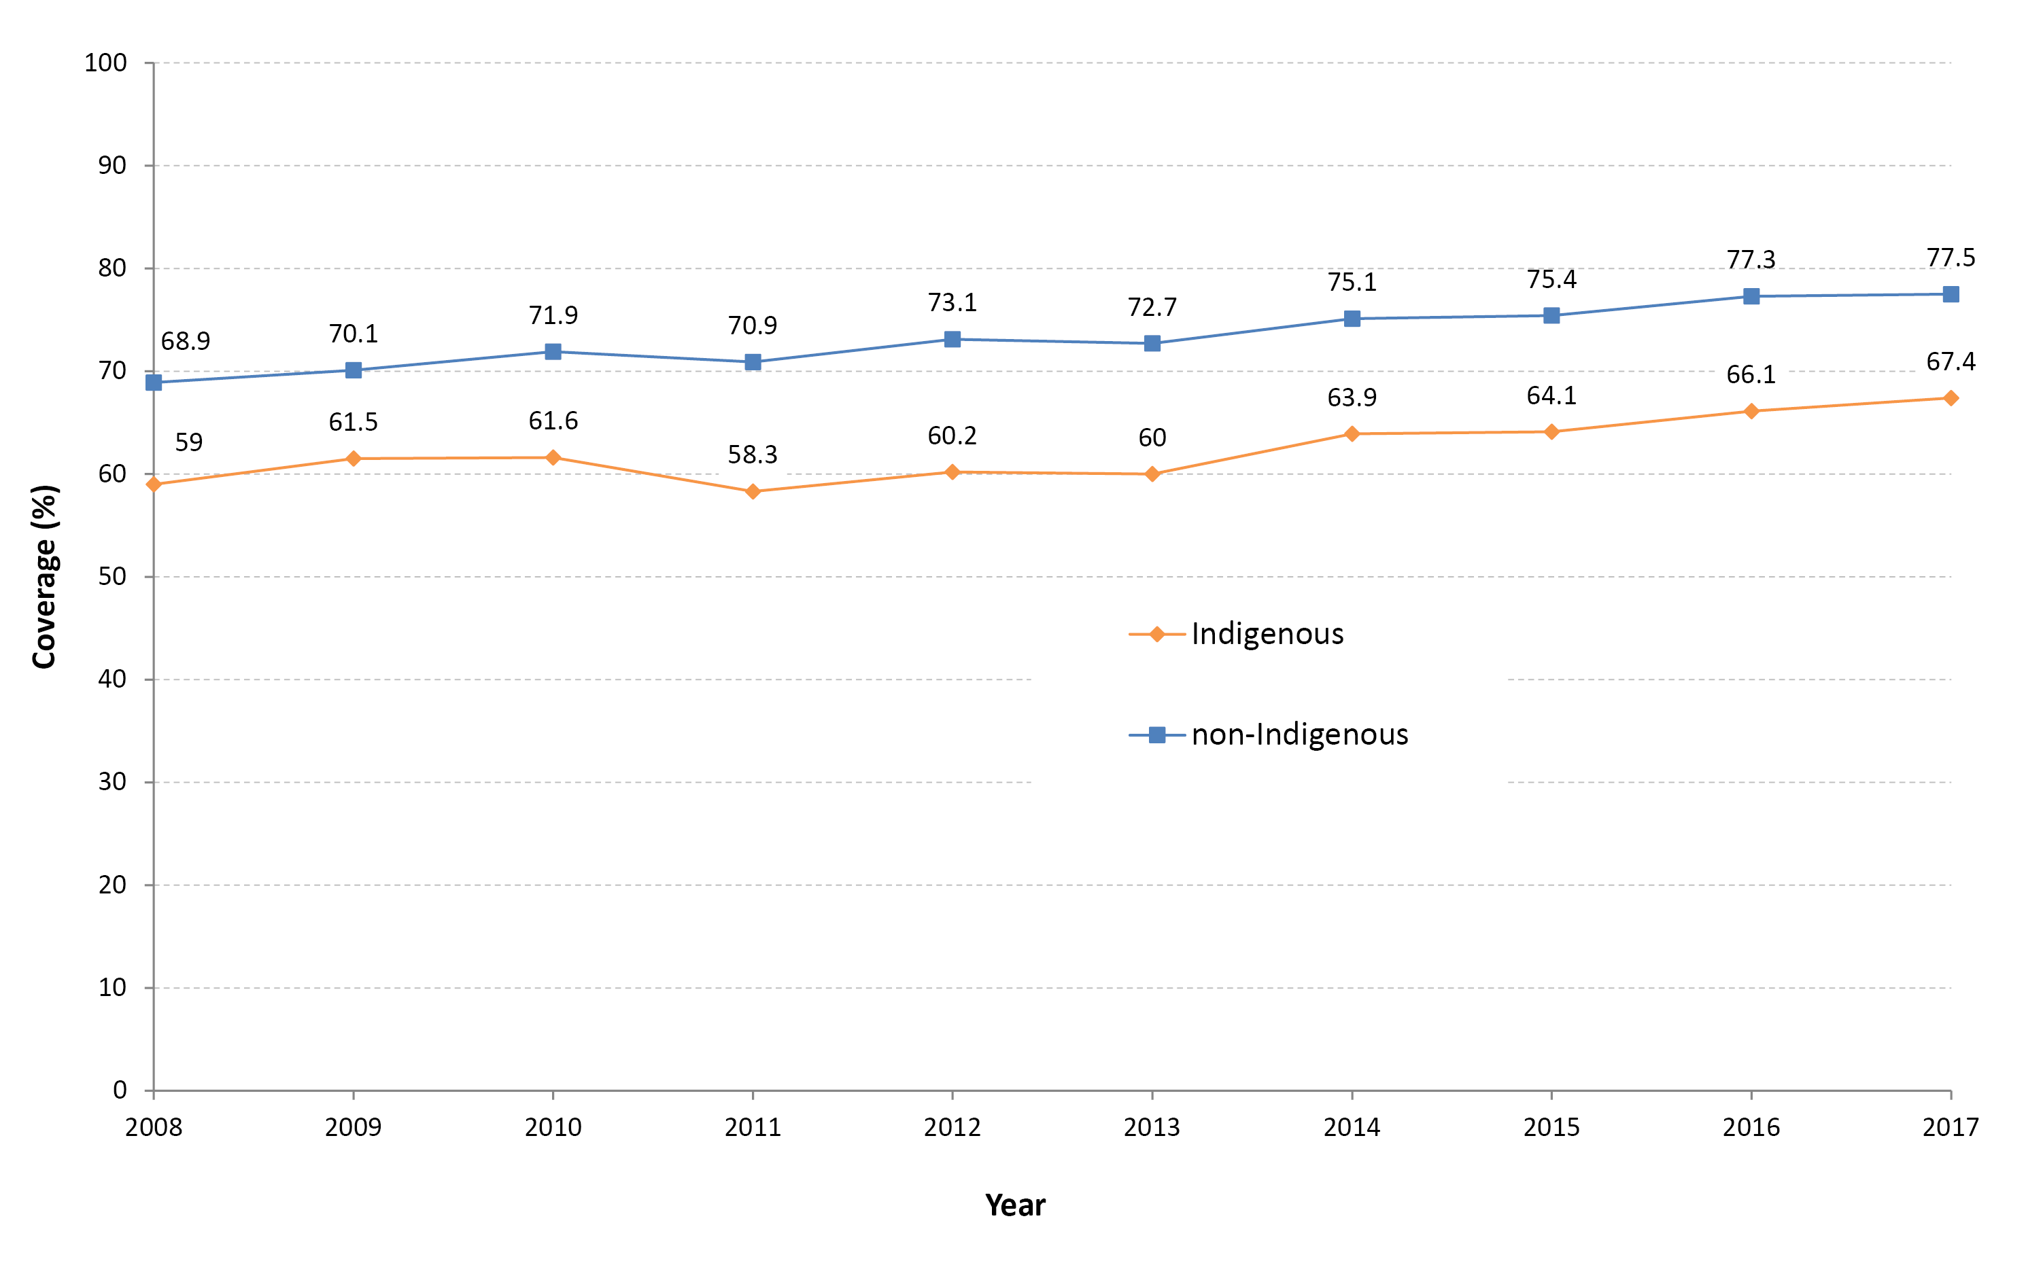
a All data points are calculated for a 12-month-wide birth cohort using AIR data.

Trends in on-time vaccination for the 2nd dose of MMR-containing vaccine from 2008 to 2017 by Indigenous status are shown in Figure 16. Between 2008 and 2014, the percentage of children in Australia who received their second dose of MMR-containing vaccine on time (i.e. between 47–<49 months of age) rose from 27.7% to 47.1% for non-Indigenous children and from 29.3 to 44.2% for Indigenous children. Moving the 2nd dose of MMR-containing vaccine in mid-2014 to being due at 18 months of age resulted in an immediate improvement in on-time vaccination for the 2nd dose of MMR-containing vaccine for both Indigenous and non-Indigenous children. However the disparity in on-time vaccination between Indigenous and non-Indigenous children for this vaccine dose increased from 2.9 percentage points (disparity of 2nd dose of MMR-containing vaccine when given on time between 47–<49 months of age) to 14.2 percentage points (disparity of 2nd dose of MMR-containing vaccine when given on time between 17–<19 months of age). Between 2014 and 2017, the percentage of children who received their 2nd dose of MMR-containing vaccine on time (i.e. between 17–<19 months of age) decreased from 73.9% to 70.1% for non-Indigenous children and from 59.1% to 55.9% for Indigenous children.
Figure 16. Trends in on-time vaccination for the second dose of MMR, by Indigenous status, Australia, 2008–2017ª
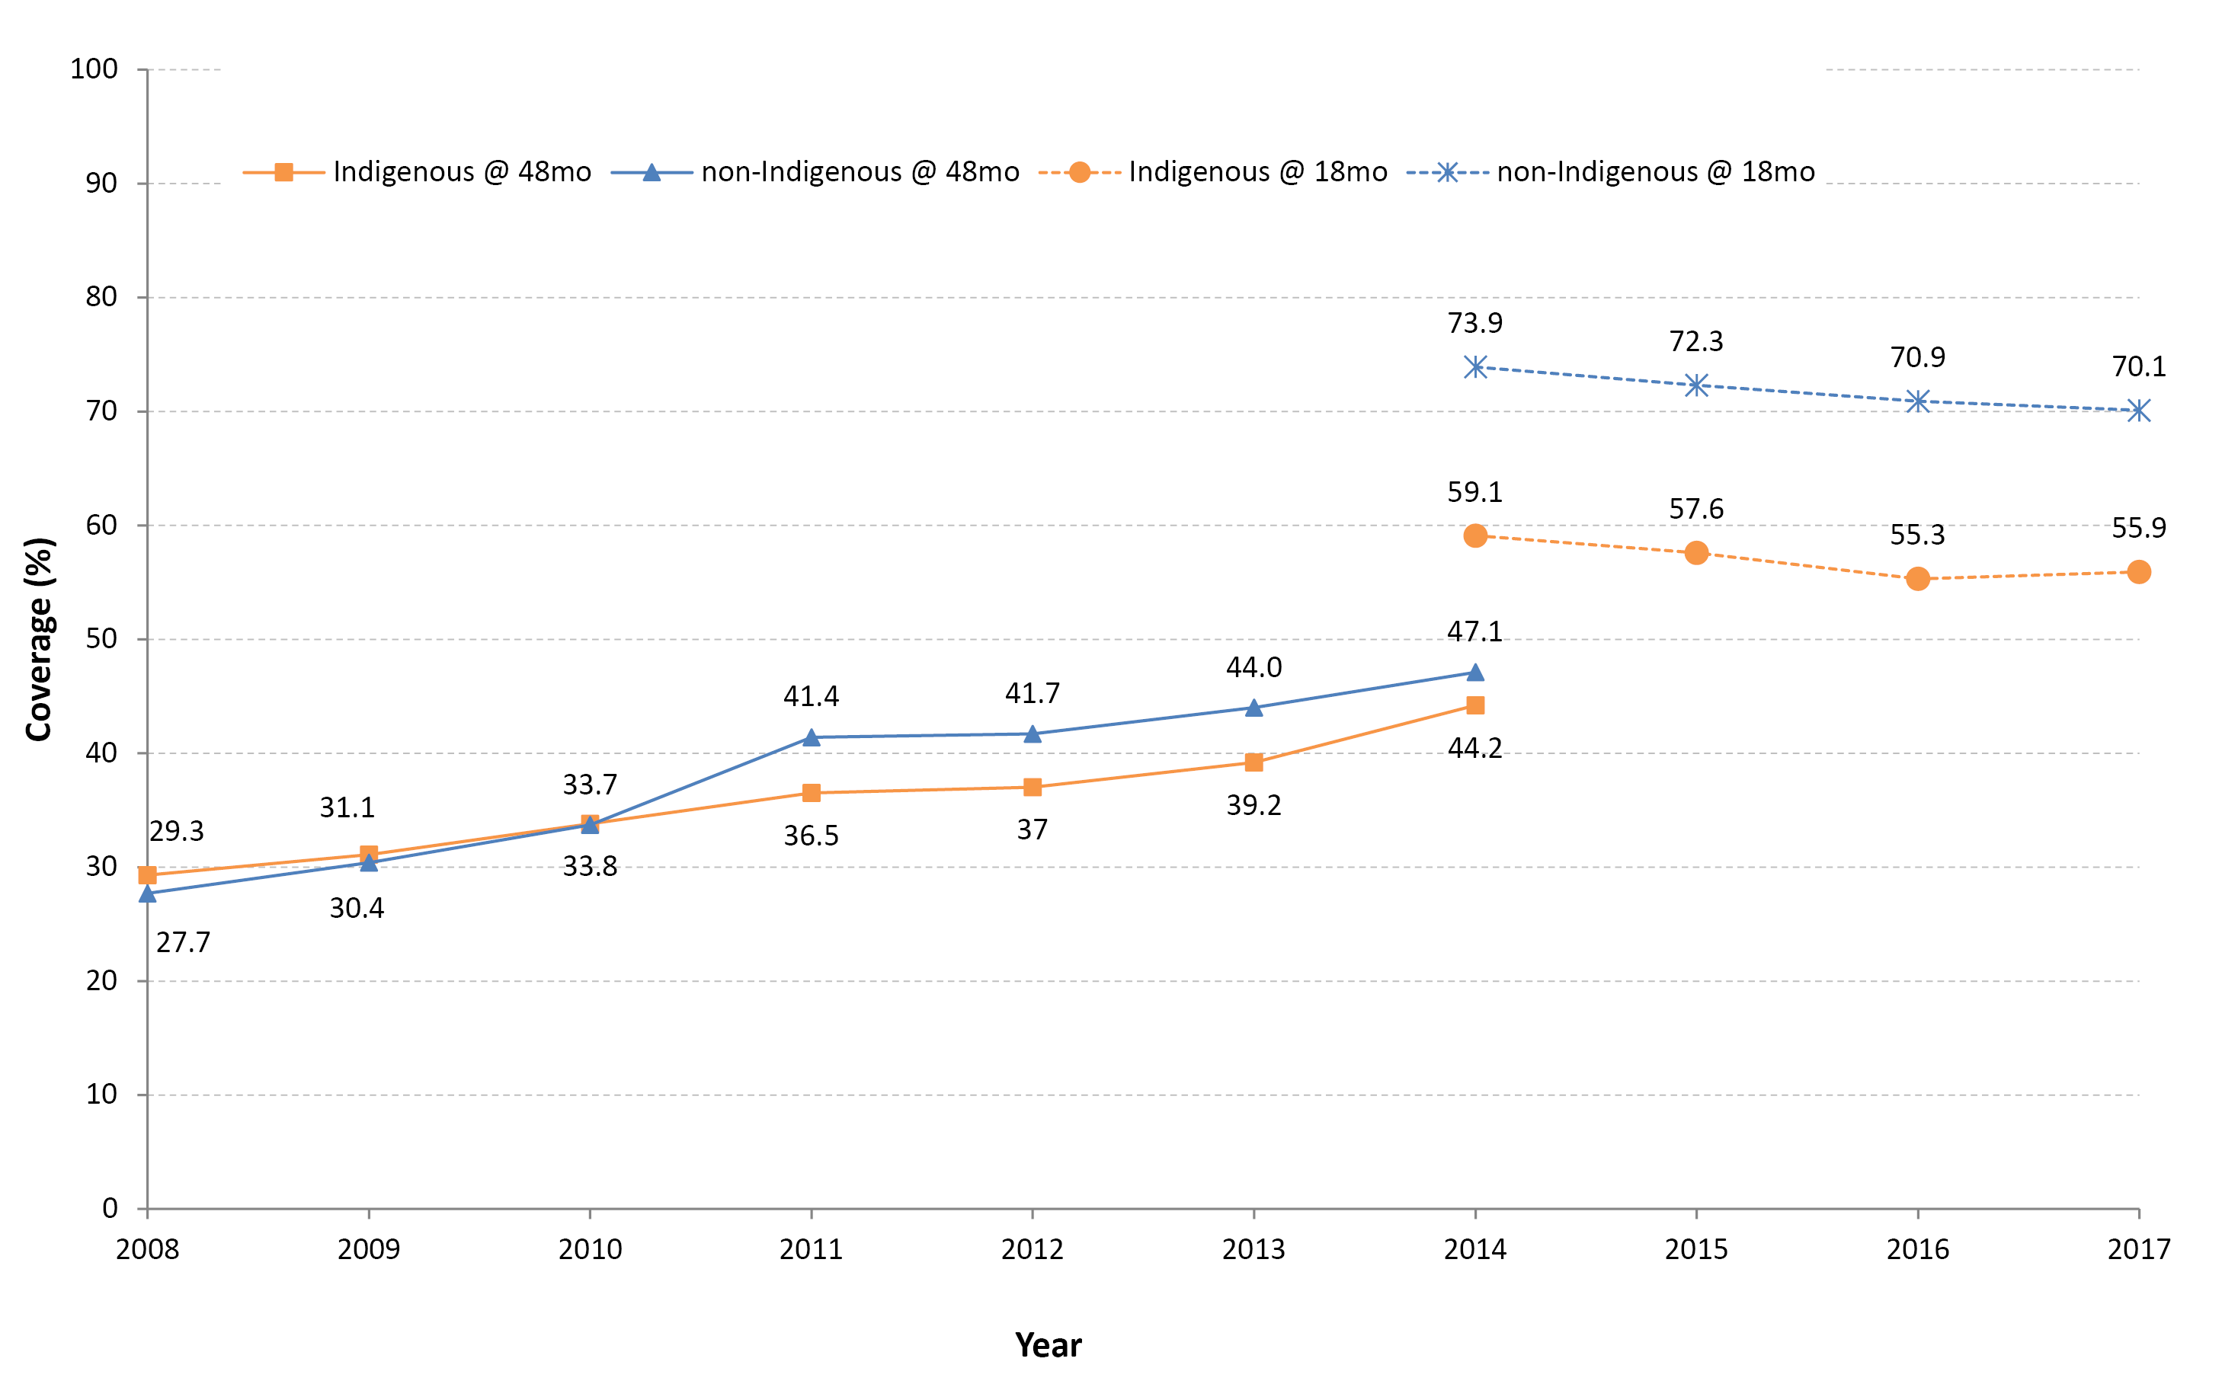
a All data points are calculated for a 12-month-wide birth cohort using AIR data.

Vaccination delay in 2017 for the 1st and 2nd doses of DTPa-containing vaccines, and the 1st and 2nd doses of MMR-containing vaccines, by length of delay, Indigenous status and remoteness category is shown in Table 3. For both Indigenous and non-Indigenous children, the majority of delayed vaccination occurred 1 – < 3 months after the schedule point for all four vaccine doses assessed, and across all remoteness categories. The proportion of Indigenous children living in major cities with a delay of 1 – < 3 months for the 1st and 2nd doses of DTPa-containing vaccines, and the 1st and 2nd doses of MMR-containing vaccines was lower compared to Indigenous children living in remote and very remote areas (3.4% vs. 7.5%, 11.6% vs. 17.9%, 22.9% vs. 24.6%, and 28% vs. 30.7%, respectively), but the proportion with very late vaccination (≥7 months after the schedule point) was higher for Indigenous children residing in major cities for the 2nd dose of DTPa-containing vaccine and the 1st dose of MMR-containing vaccine (2.4% vs. 1.3% and 2.5 vs. 2.3%, respectively).

Table 3: Vaccination delay, by length of delay, Indigenous status and remoteness category, Australia, 2017a
Vaccine dose | Indigenous status | Remoteness category | 1 – < 3 months after schedule point (%) | 3 – < 7 months after schedule point (%) | ≥7 months after schedule point (%)
DTPa1^{b,c} | Indigenous | Major Cities | 3.4 | 1.5 | 1.0
 |  | Inner and Outer Regional | 4.1 | 1.5 | 1.1
 |  | Remote and Very Remote | 7.5 | 1.3 | No data
 | Non-Indigenous | Major Cities | 1.6 | 0.4 | 0.6
 |  | Inner and Outer Regional | 1.4 | 0.4 | 0.6
 |  | Remote and Very Remote | 1.1 | No data | No data
DTPa2^{b,c} | Indigenous | Major Cities | 11.6 | 4.3 | 2.4
 |  | Inner and Outer Regional | 13.4 | 4.9 | 2.3
 |  | Remote and Very Remote | 17.9 | 4.9 | 1.3
 | Non-Indigenous | Major Cities | 6.0 | 1.1 | 0.8
 |  | Inner and Outer Regional | 6.3 | 1.3 | 0.9
 |  | Remote and Very Remote | 5.5 | 1.0 | No data
MMR1^{b,d} | Indigenous | Major Cities | 22.9 | 6.9 | 2.5
 |  | Inner and Outer Regional | 23.6 | 7.4 | 2.5
 |  | Remote and Very Remote | 24.6 | 8.2 | 2.3
 | Non-Indigenous | Major Cities | 17.7 | 3.9 | 1.3
 |  | Inner and Outer Regional | 18.0 | 3.5 | 1.2
 |  | Remote and Very Remote | 18.6 | 3.7 | 0.8
MMR2^{d,e} | Indigenous | Major Cities | 28 | 10.3 | 5.3
 |  | Inner and Outer Regional | 28.8 | 12.1 | 4.7
 |  | Remote and Very Remote | 30.7 | 13.3 | 5.5
 | Non-Indigenous | Major Cities | 20.4 | 5.2 | 3.4
 |  | Inner and Outer Regional | 22 | 5.7 | 2.4
 |  | Remote and Very Remote | 22.4 | 5.4 | 2.3
a Source: Australian Immunisation Register, data as at 31 March 2018.
b The cohort of children born in 2015 and assessed in 2017.
c DTPa1, DTPa2: first or second dose of diphtheria, tetanus, acellular pertussis-containing vaccine.
d MMR1, MMR2: first or second dose of measles, mumps, rubella-containing vaccine.
e The cohort of children born in 2014 and assessed in 2017.

Small area coverage analysis
Vaccination coverage in Australia in 2017 varied substantially within jurisdictions and major capital cities, with some areas substantially below the national averages (Figures 17–19). For the 3rd dose of PCV, 249 (over 75%) Statistical Area 3 (SA3) level areas in Australia had coverage higher than 93% (Figure 17). For the 2nd dose of MMR-containing vaccine, 170 (52%) SA3 areas had coverage higher than 93% (Figure 18). Fifty-one (16%) SA3 areas had coverage below 90% for the 4th dose of DTPa-containing vaccine by 24 months of age (Figure 19).

Figure 17: Pneumococcal conjugate vaccine coverage at 12 months of age (three doses) by SA3, Australia and major capital cities, 2017
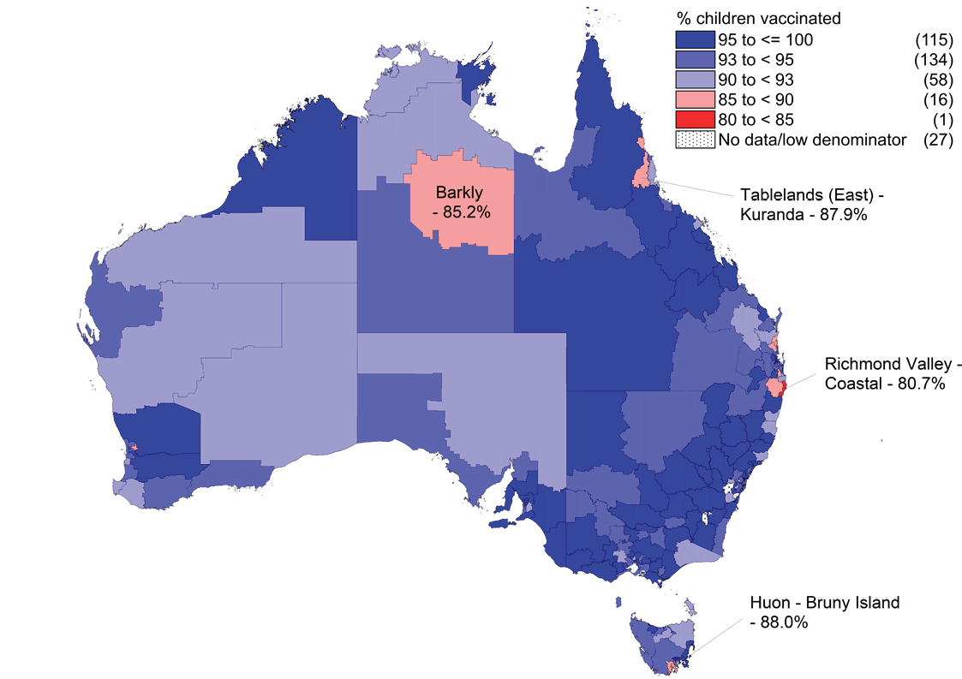
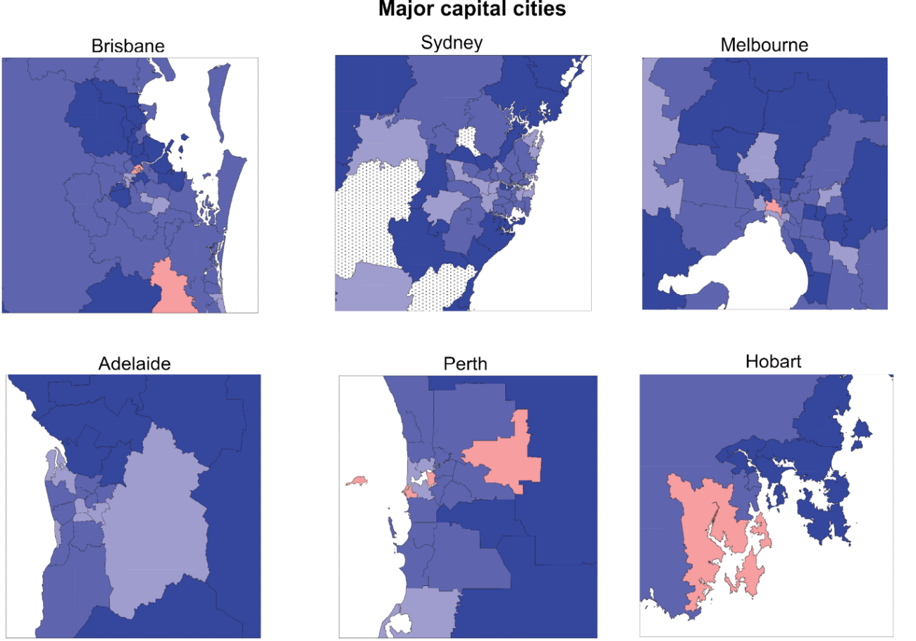

Figure 18: Measles, mumps, rubella (MMR) coverage at 24 months of age (two doses) by SA3, Australia and major capital cities, 2017
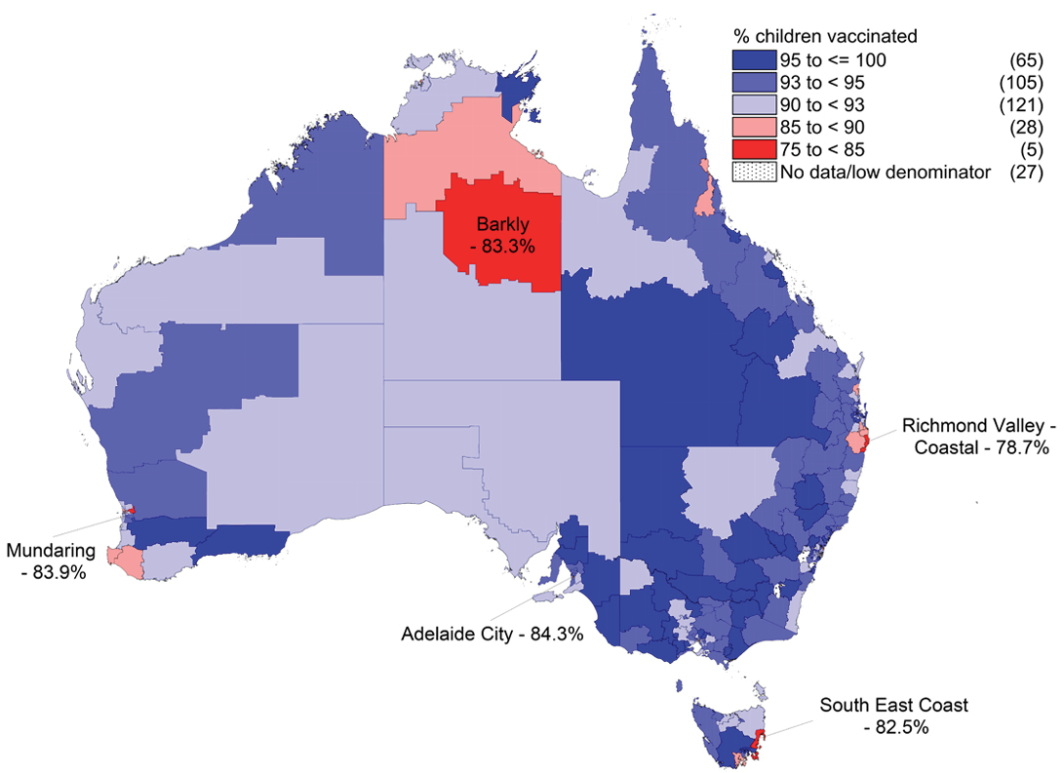
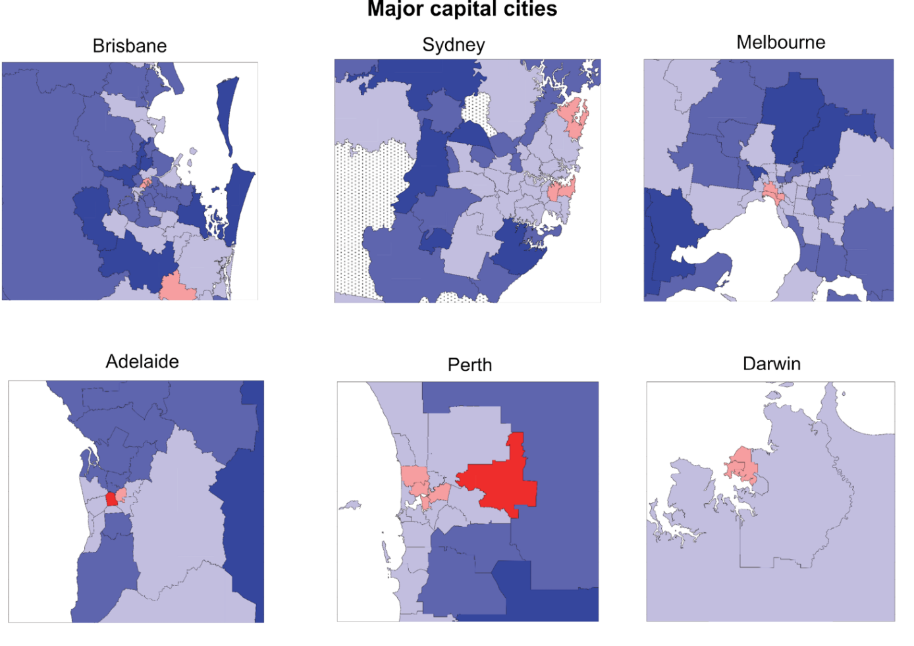
Figure 19: Diphtheria, tetanus, acellular pertussis (DTPa) coverage at 24 months of age (four doses) by SA3, Australia and major capital cities, 2017
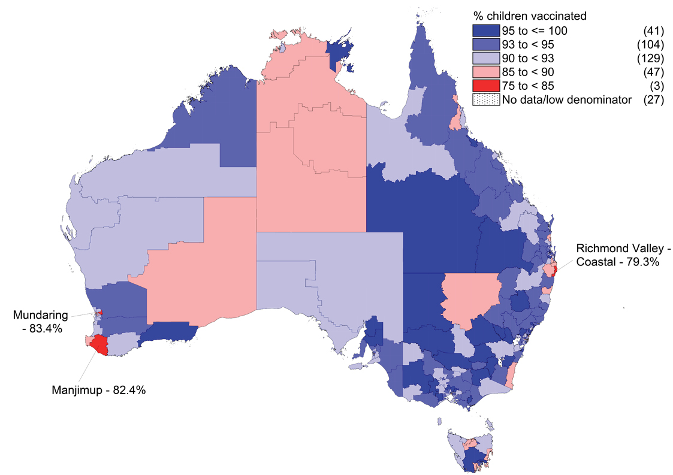
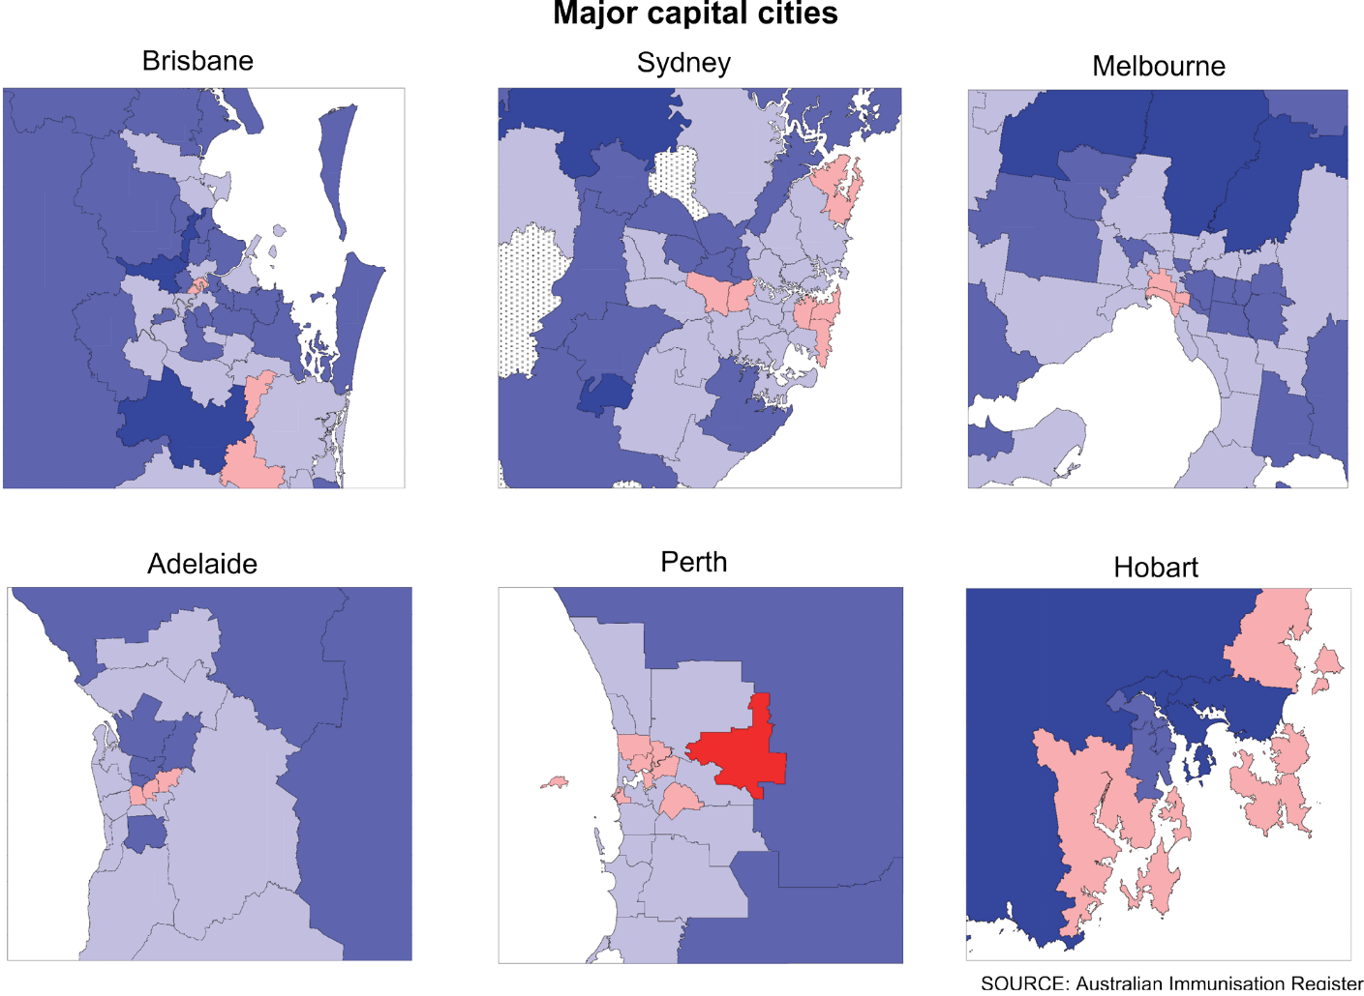

Medical contraindication exemptions
Figure 20 shows the trends in the number of children aged 6 months to 10 years with at least one new vaccination exemption due to a medical contraindication entered into the AIR during each year from 2011 to 2017, by state/territory. From 2011 to 2015 there was a clear trend of increasing numbers of new exemptions. New exemptions more than doubled in 2015 compared with 2014 (635 to 1401), but then decreased markedly in both 2016 and 2017.

Figure 20: Trends in the number of children aged 6 months to 10 years with at least one new vaccination exemption due to a medical contraindication entered into the Australian Immunisation Register, by state/territory, Australia, 2011–2017^{a,b}
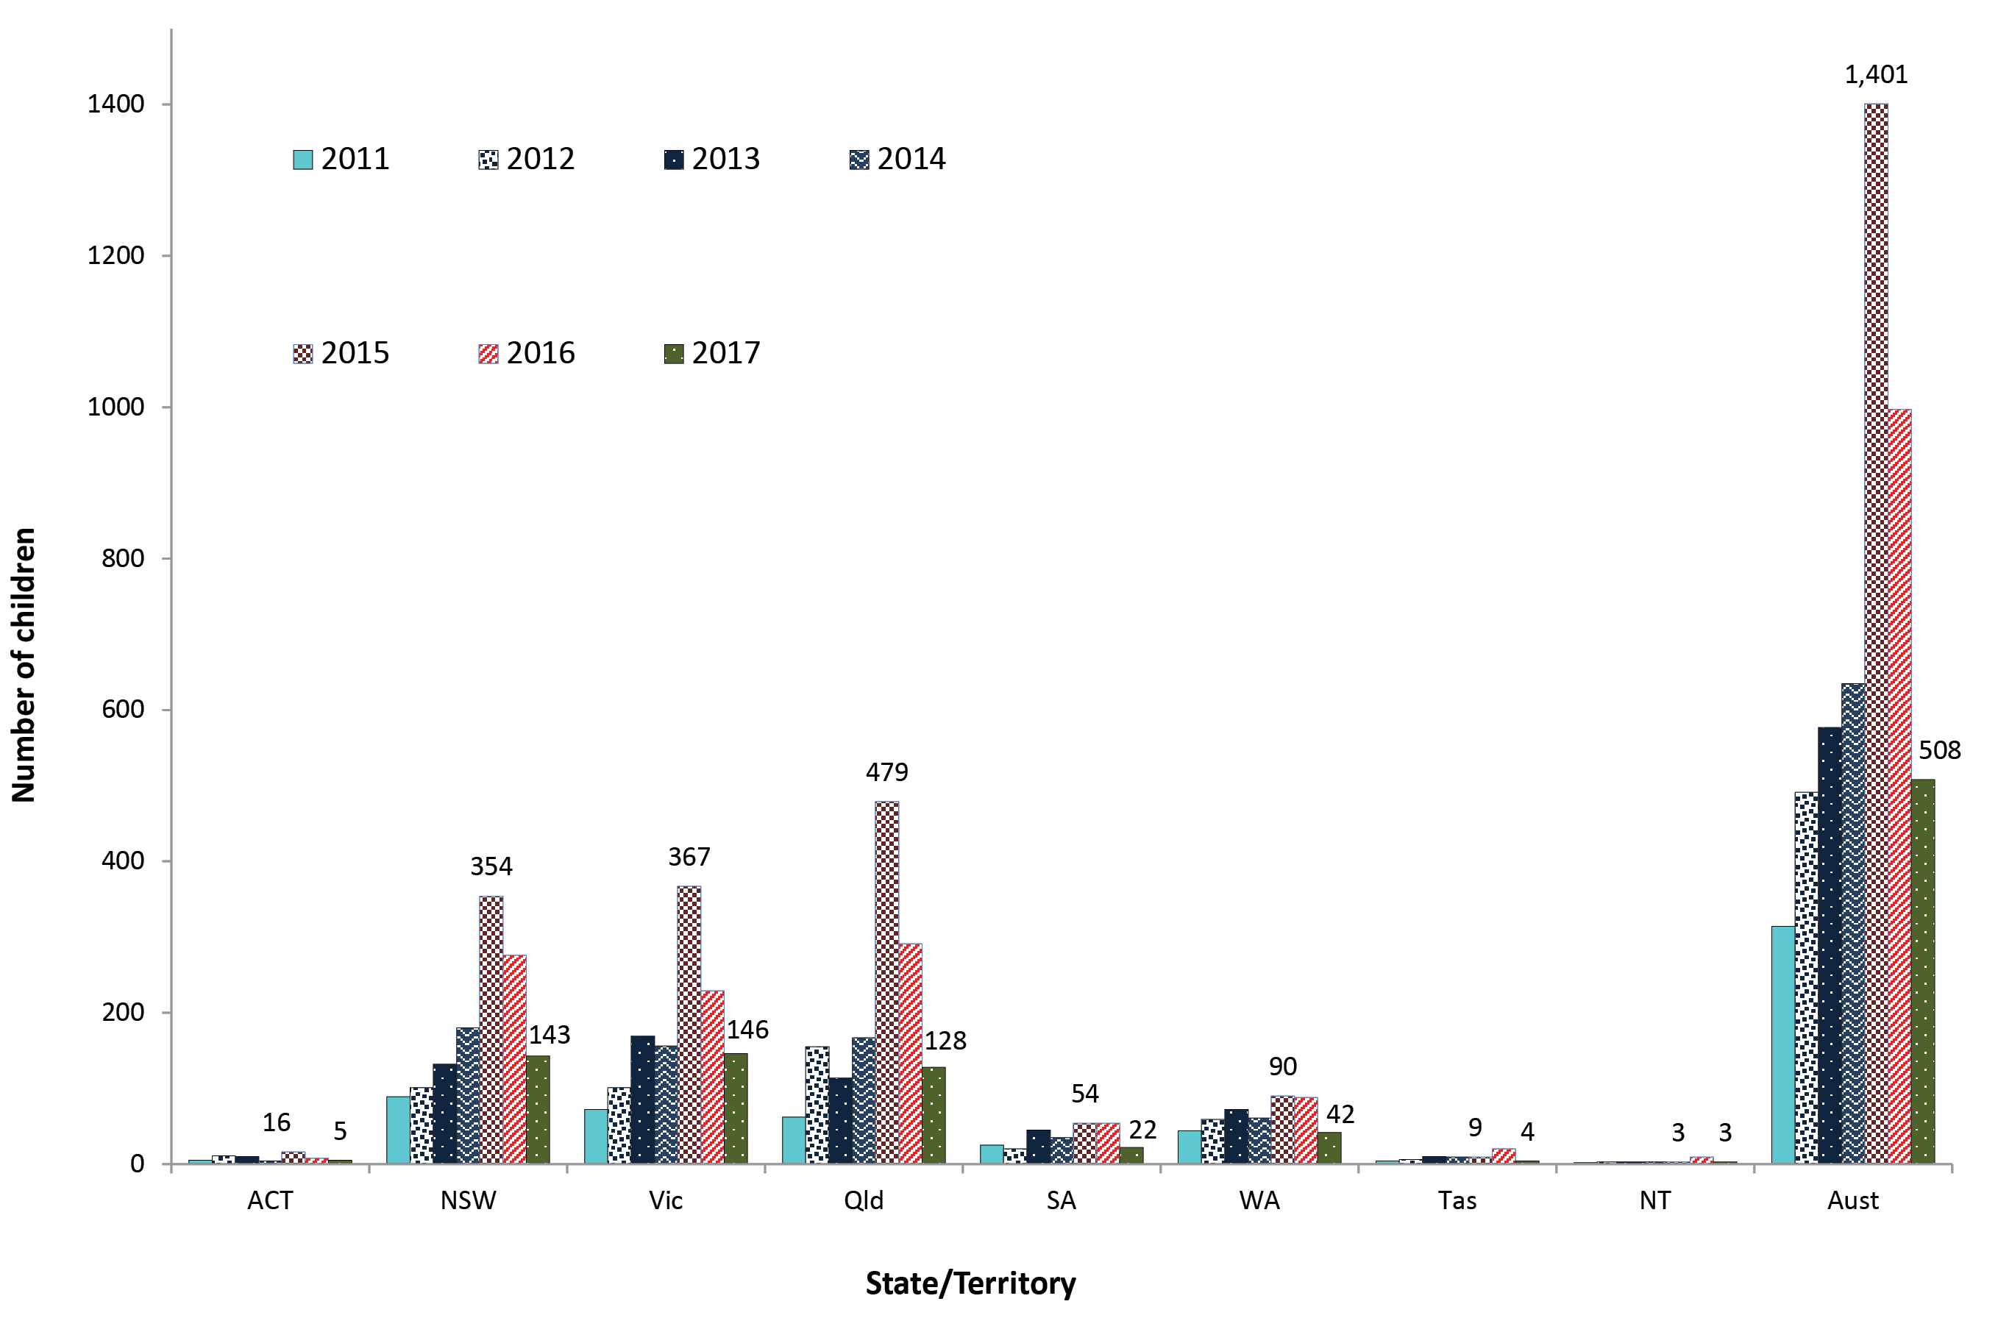
a ACT = Australian Capital Territory; NSW = New South Wales; NT = Northern Territory; Qld = Queensland; SA = South Australia; Tas = Tasmania; Vic = Victoria; WA = Western Australia.
b Source: Australian Immunisation Register, data as at 31 March 2018.

Provider type/setting where vaccination occurred
In 2017, the large majority of vaccinations given to children aged less than 7 years in Australia were administered in general practice settings (80.6%, up from 78.8% in 2016) (Figure 21). Local councils delivered 7.9%, and Community and Indigenous Health Services delivered 7.1%. In the Northern Territory 46.8% of vaccinations were administered by a community health service, whilst 23% of vaccinations in Victoria were administered in local government/council clinics.

Figure 21: Proportion of vaccinations given to children aged <7 years by provider type and state or territory, Australia, 2017^{a,b}
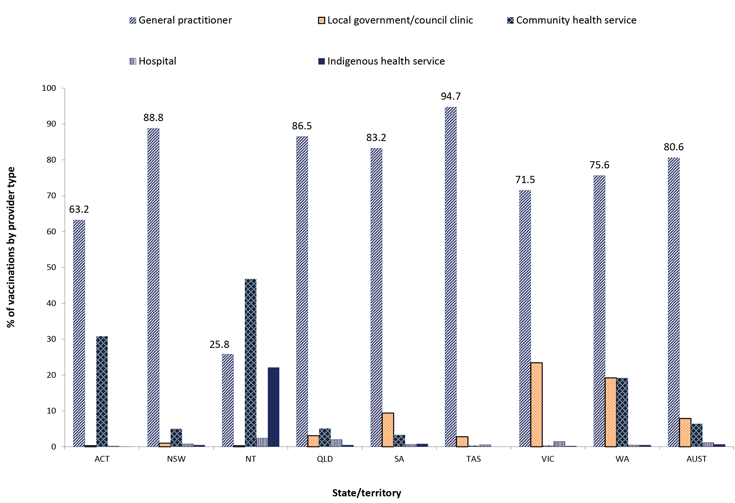
a ACT = Australian Capital Territory; NSW = New South Wales; NT = Northern Territory; Qld = Queensland; SA = South Australia; Tas = Tasmania; Vic = Victoria; WA = Western Australia.
b Source: Australian Immunisation Register, data as at 31 March 2018.

Mechanism of reporting to the AIR
In 2017, 75.5% of vaccination encounter notifications for children aged less than 7 years in Australia were reported to the AIR electronically via practice management software, 16.4% via direct entry on the AIR website, 6.2% by internet data interchange, and only 1.9% by paper forms (Figure 22).

Figure 22: Proportion of vaccinations given to children aged <7 years by type of reporting mechanism and state or territory, Australia, 2017^{a,b}
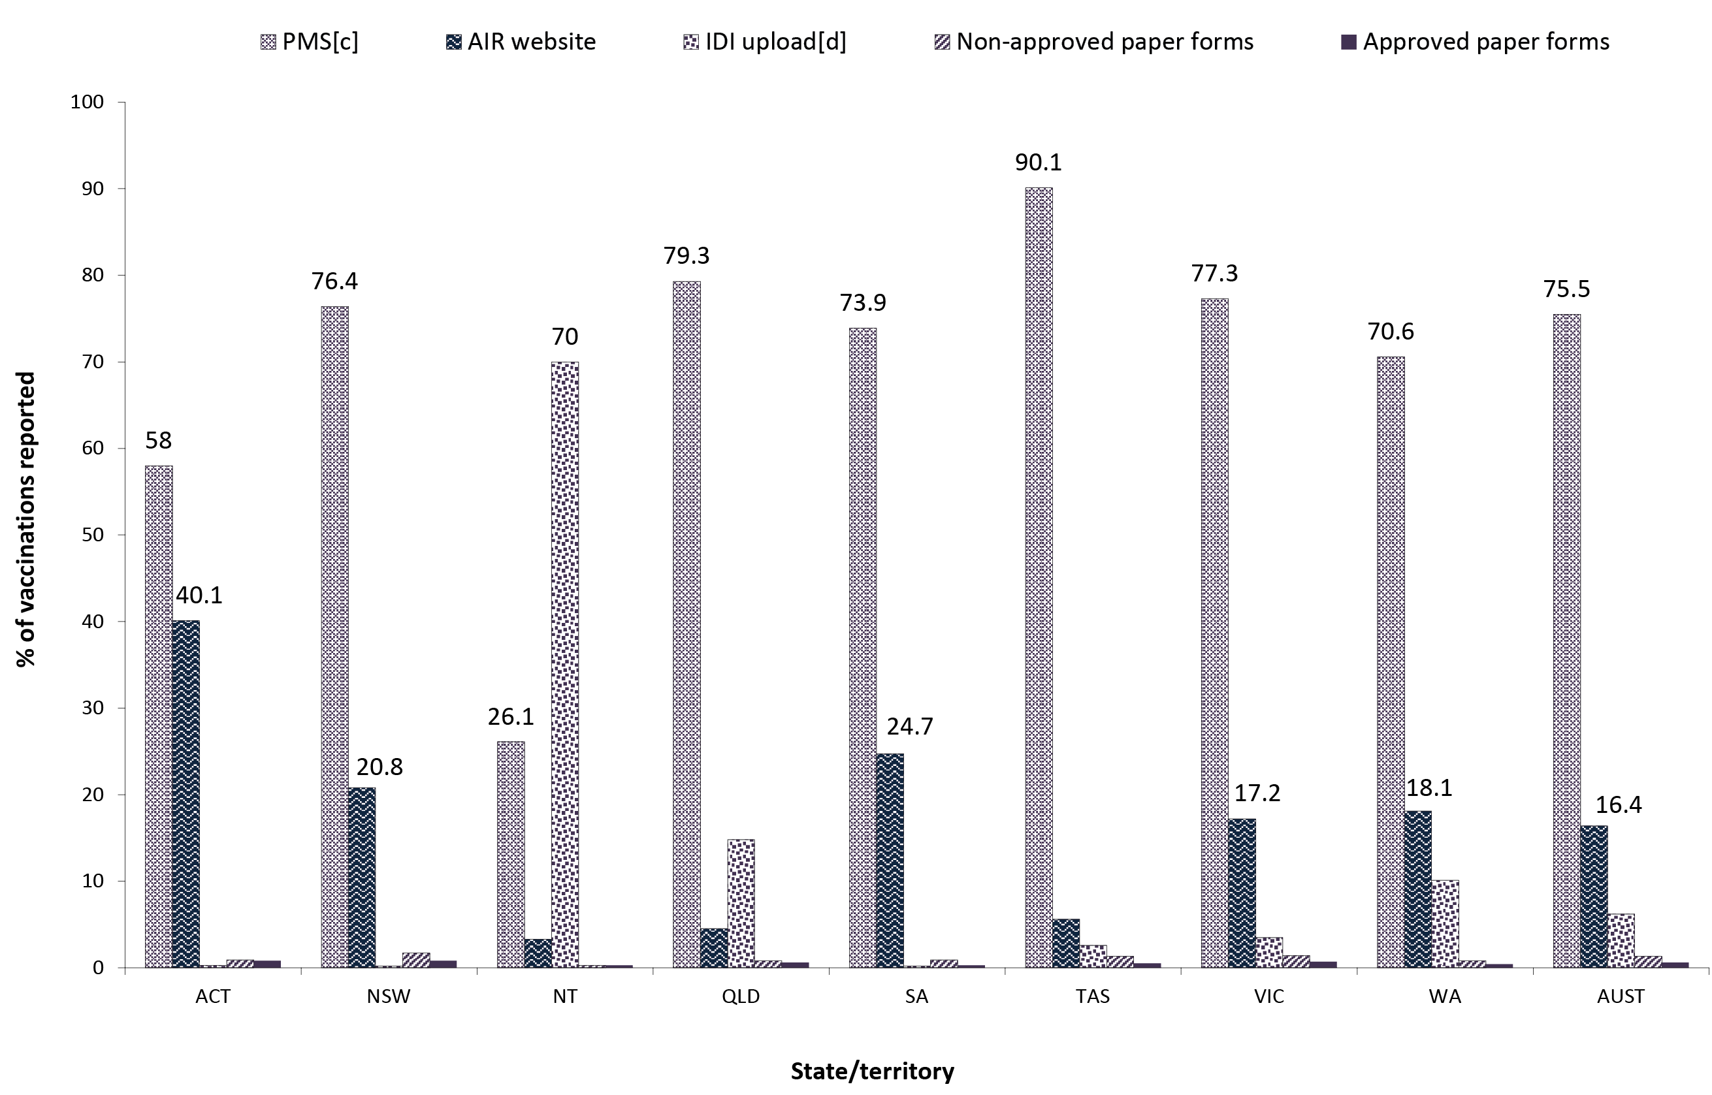
a ACT = Australian Capital Territory; NSW = New South Wales; NT = Northern Territory; Qld = Queensland; SA = South Australia; Tas = Tasmania; Vic = Victoria; WA = Western Australia.
b Source: Australian Immunisation Register, data as at 31 March 2018.
c Practice management software.
d IDI = internet data interchange (approved immunisation providers/organisations can send vaccination encounter details in bulk to the AIR using the IDI upload facility).

Adolescents

Catch-up vaccination activity

Highlights
The proportion of adolescents recorded as not previously having received the relevant dose who received catch-up vaccination in 2017 was 6.8% for the 2nd dose of MMR-containing vaccine and 3.6% for the 3rd dose of dTpa/dT vaccine. Adolescent catch-up vaccination activity for the 2nd dose of MMR-containing vaccine during 2017 was considerably higher for Indigenous adolescents (20.3% of those recorded as not having received the dose) than non-Indigenous adolescents (6.4%).

Table 4: Catch-up vaccination activity for adolescents aged 10–19 years of ageª not recorded as having received relevant doses prior to 1 January 2017 who received catch-up vaccines during 2017, by state or territory,^{b} Australia
 | State or territory
 | ACT | NSW | NT | Qld | SA | Tas | Vic | WA | Australia
Number with no MMR2 record | 5,571 | 102,428 | 4,060 | 76,230 | 21,219 | 4,599 | 71,582 | 51,452 | 337,141
Number of MMR2 doses given | 374 | 6,279 | 272 | 4,883 | 2,190 | 518 | 5,161 | 3,066 | 22,743
MMR2 catch-up activity (%) | 6.7 | 6.1 | 6.7 | 6.4 | 10.3 | 11.3 | 7.2 | 6.0 | 6.8
Number with no DTPa/dTpa/dT3 record | 4,183 | 77,541 | 3,017 | 59,972 | 15,232 | 3,008 | 56,697 | 42,466 | 262,116
Number of dTpa/dT3 doses given | 122 | 2,819 | 92 | 1,591 | 973 | 220 | 2,648 | 968 | 9,433
dTpa/dT3 catch-up activity (%) | 2.9 | 3.6 | 3.1 | 2.7 | 6.4 | 7.3 | 4.7 | 2.3 | 3.6
a Cohort born 1 July 1997 – 30 June 2007, vaccinations given 1 January – 31 December 2017. Source: Australian Immunisation Register, data as at 31 March 2018.
b ACT = Australian Capital Territory; NSW = New South Wales; NT = Northern Territory; Qld = Queensland; SA = South Australia; Tas = Tasmania; Vic = Victoria; WA = Western Australia.

Table 4 shows catch-up vaccination activity for adolescents aged 10–19 years of age recorded as not having received relevant doses of vaccines prior to 1 January 2017, who received a catch-up dose during 2017, by jurisdiction. In Australia, 22,743 (6.8%) of the 337,141 adolescents aged 10–19 years recorded as not having received a 2nd dose of MMR-containing (MMR2) vaccine prior to 1 January 2017 received a catch-up dose of MMR2 vaccine during 2017. The proportion varied from 6.0% in Western Australia to 11.3% in Tasmania. Adolescent catch-up vaccination activity for the 3rd dose of dTpa/dT vaccine during 2017 was relatively low at 3.6% nationally but also varied by jurisdiction, from 2.3% in the Western Australia to 7.3% in Tasmania.
Table 5 shows catch-up activity by Indigenous status for adolescents aged 10–19 years of age recorded as not having received relevant doses of vaccines prior to the 1st January 2017, who received their catch-up doses during 2017. Adolescent catch-up vaccination activity for the 2nd dose of MMR-containing vaccine during 2017 was considerably higher for Indigenous adolescents than non-Indigenous adolescents (20.3% vs. 6.4%). Adolescent catch-up vaccination activity for dTpa/dT3 vaccine during 2017 was also higher for Indigenous adolescents than non-Indigenous adolescents (8.0% v 3.5%).
Table 5: Catch-up vaccination activity for adolescents aged 10–19 years of ageª not recorded as having received relevant doses prior to 1 January 2017 who received catch-up vaccines during 2017, by Indigenous status, Australia^{b}
 | Indigenous status
 | Indigenous | non-Indigenous | Total
Number with no MMR2 record | 7,986 | 329,155 | 337,141
Number of MMR2 doses given | 1,620 | 21,123 | 22,473
MMR2 catch-up activity (%) | 20.3 | 6.4 | 6.8
Number with no DTPa/dTpa/dT3 record | 3,497 | 258,619 | 262,116
Number of dTpa/dT3 doses given | 280 | 9,153 | 9,433
dTpa/dT3 catch-up activity (%) | 8.0 | 3.5 | 3.6
a Cohort born 1 July 1997 – 30 June 2007, vaccinations given 1 January – 31 December 2017.
b Source: Australian Immunisation Register, data as at 31 March 2018.

Human papillomavirus vaccine coverage

Highlights
In 2017, 80.2% of Australian girls aged 15 years completed a full 3-dose course of HPV vaccine, up from 79.7% in 2016. In 2017, 75.9% of Australian boys aged 15 years completed a full 3-dose course of HPV vaccine, up from 73.8% in 2016. In 2017, 79% of Indigenous girls (and 77% of Indigenous boys) aged 15 years who received dose one of HPV vaccine completed the 3-dose course, compared to 91% and 90% amongst non-Indigenous girls and boys, respectively.
Vaccination coverage, as notified to the National HPV Vaccination Program Register, for 3 doses of HPV vaccine, for girls and boys aged 15 years in 2017, is shown in Table 6. At the national level, 80.2% of girls completed a full course of the vaccine, up from 79.7% in 2016. Coverage in girls varied by jurisdiction from 74.6% in Tasmania to 92.5% in the Northern Territory. All jurisdictions except Western Australia recorded an increase in HPV coverage between 2016 and 2017. At the national level, 75.9% of boys completed a full course of the vaccine in 2017, up from 73.8% in 2016 (Table 6). Coverage for males ranged from 64.0% in Tasmania to 84.8% in the Northern Territory. HPV vaccine coverage in males increased between 2016 and 2017 in all jurisdictions except Western Australia, with the largest increase in the Australian Capital Territory (7.2 percentage points).

Table 6: Coverage (%) for three doses of human papillomavirus (HPV) vaccine for girls aged 15 years in 2012–2017, and boys aged 15 years in 2014–2017, by state/territory, Australia^{a,b}
 | State/territory^{c}
 | ACT | NSW | NT | Qld | SA | Tas | Vic | WA | Australia
Girls
2012 | 73.0 | 71.6 | 86.6 | 69.9 | 71.4 | 66.0 | 74.5 | 70.6 | 71.9
2013 | 71.4 | 69.3 | 86.4 | 72.1 | 73.4 | 65.9 | 75.2 | 72.7 | 72.1
2014 | 70.1 | 71.2 | 85.6 | 75.2 | 74.9 | 70.8 | 77.7 | 78.7 | 74.8
2015 | 78.3 | 81.4 | 91.2 | 76.6 | 75.1 | 71.0 | 79.2 | 76.5 | 78.7
2016 | 79.9 | 82.4 | 92.2 | 77.6 | 75.8 | 71.6 | 79.1 | 80.0 | 79.7
2017 | 80.1 | 82.9 | 92.5 | 79.1 | 78.7 | 74.6 | 79.7 | 76.9 | 80.2
Boys
2014 | 64.6 | 57.6 | 64.8 | 62.4 | 64.3 | 58.2 | 67.8 | 63.1 | 62.4
2015 | 69.3 | 64.8 | 72.5 | 68.7 | 69.6 | 61.9 | 71.9 | 64.8 | 67.8
2016 | 71.4 | 74.5 | 82.2 | 70.8 | 72.6 | 63.8 | 74.5 | 78.1 | 73.8
2017 | 78.6 | 78.1 | 84.8 | 73.7 | 74.4 | 64.0 | 76.3 | 75.3 | 75.9
a Population is Estimated Resident Population (ERP) provided by the Australian Bureau of Statistics (ABS)30
b Source: National HPV Vaccination Program Register, data as of 4 July 2018.
c ACT = Australian Capital Territory; NSW = New South Wales; NT = Northern Territory; Qld = Queensland; SA = South Australia; Tas = Tasmania; Vic = Victoria; WA = Western Australia
HPV vaccine coverage in 2017 was highest for the 1st dose and lower for the 2nd and 3rd doses in both males and females and across all age groups. In females, coverage of the 1st dose was highest (89.0%) in the 14- to 15-year-old age group (Figure 23). Coverage decreased by age, with only 58.0% of females aged 20–26 years fully vaccinated compared to 80.0% of females aged 14–15 years. In males, coverage for the 1st dose in the 14- to 15-year-old age group was 86.0%, up three percentage points from 2016, and in the 16- to 17-year-old age group it was 79.0%, up 5 percentage points from 2016 (Figure 24).

Figure 23: HPV vaccination coverage by dose number for females by age group as of mid-2017, Australia, 2017^{a,b}
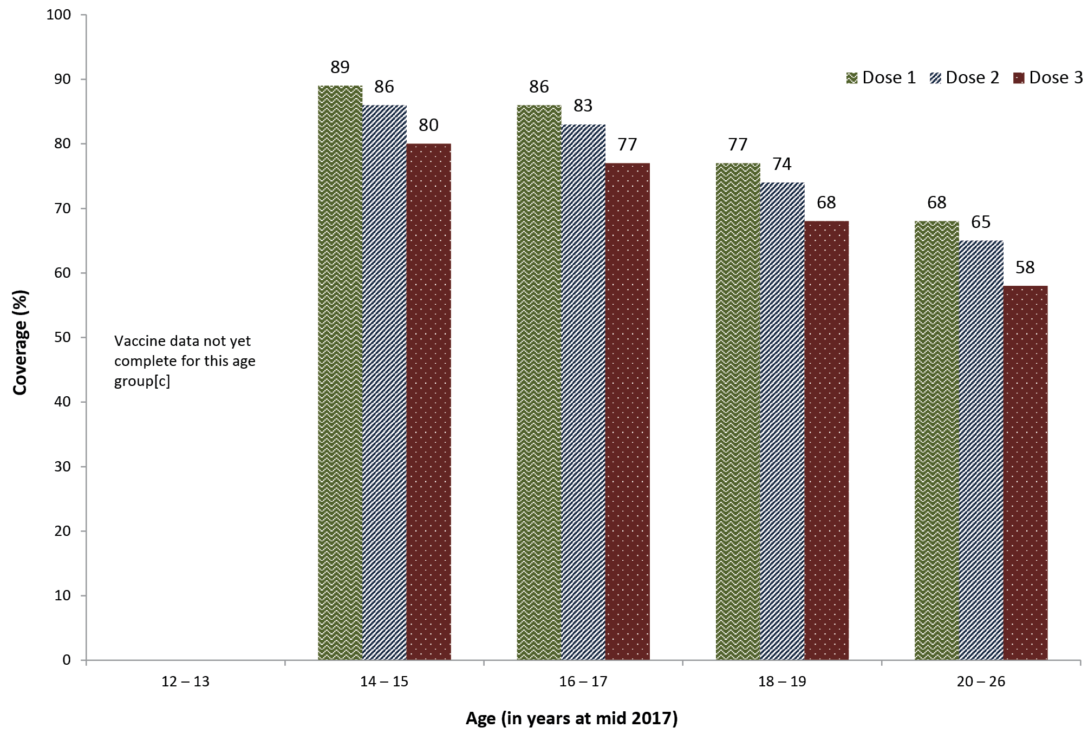
a Population is Estimated Resident Population (ERP) 2017, as at 30 June 2017.³⁰
b Source: National HPV Vaccination Program Register, data as at 4 July 2018.
c In some states those aged 12–13 years in 2017 are not eligible for vaccination until 2018.

Figure 24: HPV vaccination coverage by dose number for males by age group as of mid-2017, Australia, 2017^{a,b}
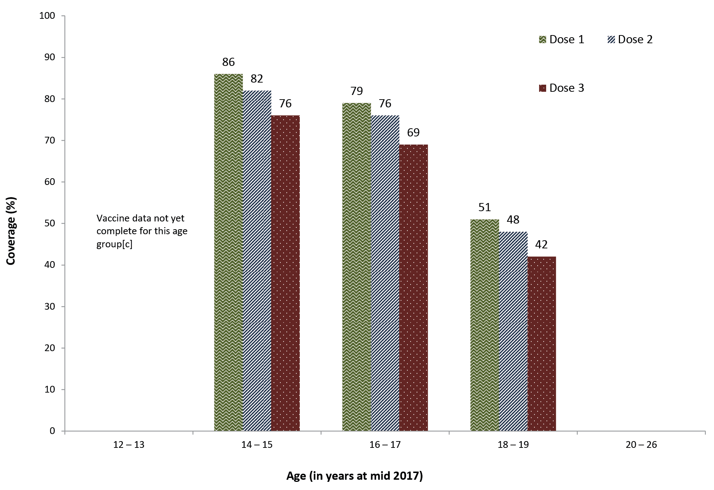
a Population is Estimated Resident Population (ERP) 2016, as at 30 June 2017.³⁰
b Source: National HPV Vaccination Program Register, data as of 4 July 2018.
c In some states those aged 12–13 years in 2017 are not eligible for vaccination until 2018.

Analysis of trends in HPV vaccine course completion show lower rates for Indigenous compared to non-Indigenous individuals, for both females and males and across all birth cohorts (Table 7). In 2017, 79% of 15-year-old Indigenous girls who received the 1st dose of HPV vaccine had completed the course, compared to 91% amongst non-Indigenous girls. The disparity was 1% higher among males in 2017 (77% completion for Indigenous boys compared to 90% for non-Indigenous boys) (Table 7).

Table 7: HPV vaccination completion status (%) amongst those who commenced the course by birth year, Indigenous status, sex and number of doses received, Australia, 2007–2017ª
Birth Year | Equates to 15yo in |  | % of those that commenced course who received 1 dose only |  |  | % of those that commenced course who received 2 doses only |  |  | % of those that commenced course who received all 3 doses
Females |  | Indigenous |  | non-Indigenous | Indigenous |  | non-Indigenous | Indigenous |  | non-Indigenous
1992 | 2007 | 13 |  | 6 | 17 |  | 9 | 71 |  | 85
1993 | 2008 | 12 |  | 5 | 14 |  | 9 | 74 |  | 85
1994 | 2009 | 10 |  | 5 | 15 |  | 8 | 75 |  | 87
1995 | 2010 | 9 |  | 4 | 14 |  | 8 | 77 |  | 88
1996 | 2011 | 10 |  | 4 | 16 |  | 9 | 74 |  | 86
1997 | 2012 | 11 |  | 5 | 14 |  | 9 | 75 |  | 87
1998 | 2013 | 10 |  | 5 | 15 |  | 8 | 74 |  | 88
1999 | 2014 | 9 |  | 4 | 14 |  | 7 | 78 |  | 90
2000 | 2015 | 8 |  | 3 | 12 |  | 6 | 80 |  | 91
2001 | 2016 | 9 |  | 3 | 12 |  | 6 | 80 |  | 91
2002 | 2017 | 8 |  | 3 | 12 |  | 6 | 79 |  | 91
Males |  | Indigenous |  | non-Indigenous | Indigenous |  | non-Indigenous | Indigenous |  | non-Indigenous
1997 | 2012 | 20 |  | 9 | 22 |  | 14 | 58 |  | 77
1998 | 2013 | 12 |  | 5 | 20 |  | 11 | 68 |  | 85
1999 | 2014 | 12 |  | 4 | 18 |  | 11 | 70 |  | 85
2000 | 2015 | 10 |  | 3 | 14 |  | 7 | 76 |  | 89
2001 | 2016 | 10 |  | 3 | 12 |  | 7 | 77 |  | 90
2002 | 2017 | 10 |  | 3 | 13 |  | 7 | 77 |  | 90
a Source: National HPV Vaccination Program Register, data as of 4 July 2018.

Amongst those who did complete the HPV vaccine course, the time taken to complete was consistently longer for Indigenous compared to non-Indigenous individuals across all birth cohorts (data not shown). For those aged 15 years in 2017 there was an average of 8.8 months between dose 1 and dose 3 for both Indigenous girls and boys, compared to 7.5 months for non-Indigenous girls and boys. Twelve point six per cent of Indigenous girls and 14.2% of Indigenous boys took over 12 months to complete, compared to 3.8% of non-Indigenous girls and 4.2% of non-Indigenous boys (data not shown).

Discussion

Vaccination coverage in young children
‘Fully immunised’ coverage at the 12-month age assessment milestone has progressively increased since 2014, after a decade of being largely stable at around 90%, and reached its highest ever recorded level of 94.3% in June 2017. ‘Fully immunised’ coverage at the 24-month age assessment milestone was also largely stable at around 92–93% through until 2014, but then decreased to below 90% due to addition of several new vaccine doses to the assessment algorithm in July 2014. Coverage at this milestone reached 91.2% in the first half of 2017 but then decreased to 89.8% in the second half of the year, following the inclusion of the new 18-month DTPa booster dose in the assessment algorithm. ‘Fully immunised’ coverage at the 60-month age assessment milestone, which has increased steadily since 2009, reached its highest ever recorded level of 94.5% in December 2017. The increases in coverage documented at 12 and 60 months of age are likely to have been contributed to by a range of measures including the federal government ‘No Jab No Pay’ policy (implemented from 1 January 2016) and ‘No Jab No Play’ policies implemented in some states. Although rotavirus vaccine coverage is still lower than for other vaccines due to the strict upper age limits for vaccine administration, the coverage achieved has resulted in substantial herd immunity and decreases in rotavirus hospitalisations in Australia.^{31,32}
‘Fully immunised’ coverage at 12 and 60 months of age in Indigenous children has steadily increased since 2012, and reached the highest ever recorded levels of 93.2% and 96.9%, respectively, in December 2017. The gap in ‘fully immunised’ coverage between Indigenous and non-Indigenous children at 12 months of age has closed considerably from 6.7 percentage points in 2013 to 0.7 percentage points in December 2017. Coverage for Indigenous children at 60 months of age has been higher than for non-Indigenous children since 2012. However ‘fully immunised’ coverage at 24 months of age was 2.1% lower in Indigenous children than in non-Indigenous children at the end of 2017, after having been similar from 2011 to 2013. This highlights a differential impact on coverage in Indigenous children following the incorporation of additional vaccine doses into the assessment algorithm in 2014 and 2016, most likely related to timeliness issues.
The ‘fully immunised’ coverage figures presented in this report likely underestimate true coverage by an amount that is difficult to precisely quantify. This is because of under-reporting due to a range of factors including incorrect data entry and failure of transfer of information from practice management software to the AIR, as documented in a recent report.³³
Recorded coverage in the influenza immunisation program for Indigenous children aged 6 months to <5 years (which commenced in 2015) was low in 2017 with overall national coverage of 15%, with only the Northern Territory (60.6%) achieving coverage above 20%. However, upward trends in coverage over time were seen for all jurisdictions. Compared with 2014, influenza vaccine coverage in 2017 has increased 13-fold in the Northern Territory and almost 7-fold in Queensland. Influenza vaccine coverage data should be regarded as a minimum estimate due to the potential for under-reporting. The extent of under-reporting to the AIR for influenza vaccine is unclear, but may be more than for ‘universal’ vaccines, given the lack of incentive payments for notification to the AIR. Other factors contributing to the low coverage of influenza vaccine likely include parental and provider attitudes and concerns, along with other issues such as the seasonal nature of the program, the two doses required in the first year a child under 9 years of age receives influenza vaccine, and the ‘gap’ in NIP funding for 5- to 14-year-old Indigenous children.³⁴
Coverage for established programs of vaccines targeted specifically at Indigenous children (i.e. hepatitis A and a booster dose of pneumococcal polysaccharide vaccine) has increased in recent years but still remains suboptimal. Both these vaccines are included on the NIP for Indigenous children in the Northern Territory, Queensland, South Australia, and Western Australia. Coverage for the 2nd dose of hepatitis A vaccine in these jurisdictions combined has increased from around 30% in 2007 to 74.7% at the end of 2017, the highest figure on record, with coverage greater than 65% in each jurisdiction. The targeted national hepatitis A immunisation program has been shown to have had a significant impact with relatively modest vaccine coverage, and with evidence suggestive of substantial herd protection effects.³⁵ Coverage of the pneumococcal booster dose in Indigenous children has also increased reaching 74.7% for the four jurisdictions combined in 2017, with coverage greater than 63% in each. The extent of under-reporting to the AIR for hepatitis A vaccine and the pneumococcal booster is unclear, but may be more than for ‘universal’ vaccines, given the lack of incentive payments for notification to the AIR. However, lower coverage for vaccines targeted specifically at Indigenous people has been a relatively consistent finding for both children³⁶ and adults.³⁷ Lack of provider and parent knowledge about the recommendations, and suboptimal identification of Indigenous children by immunisation providers, are likely to be important contributing factors.
Although most children eventually complete the scheduled vaccination series, many still do not do so in a timely manner. On-time vaccination (within 30 days of the recommended age) for the 1st, 2nd, and 3rd doses of DTPa-containing vaccines, and the 1st dose of MMR vaccine, increased in 2017 for both Indigenous and non-Indigenous children, compared to 2016, and also increased for the 2nd dose of MMR-containing vaccine for Indigenous children. The disparity in on-time vaccination of the 1st, 2nd, and 3rd doses of DTPa-containing vaccine between Indigenous and non-Indigenous children in Australia has decreased by 2.4–5.8 percentage points from 2008 to 2017. However, timeliness remains an ongoing problem for Indigenous children in Australia, particularly given the higher rates of many diseases at a younger age.³⁸ As younger children are often more vulnerable to severe disease, immunisation at the earliest appropriate age should be a public health goal for countries such as Australia where high levels of vaccine coverage at milestone ages have been achieved.
In 2017, parental vaccination objection could not be estimated as objection on non-medical grounds is no longer a valid exemption. The number of children aged 6 months to 10 years of age with new medical exemptions recorded on AIR, which had increased sharply in 2015 and then decreased in 2016, following introduction of stricter eligibility criteria,³⁹ decreased further in all jurisdictions in 2017.

Vaccination coverage in adolescents
Of 337,141 adolescents in Australia aged 10–19 years recorded as not having received their second dose of MMR vaccine (MMR2) prior to 1 January 2017, 22,743 (6.8%) received a catch-up dose of MMR2 during 2017. Some of these doses are likely to have been administered as a result of the Australian Government’s ‘No Jab No Pay’ policy, introduced on 1 January 2016, which introduced annual immunisation requirements for eligibility for federal government family assistance payments through to 19 years of age, and removed non-medical exemptions.
Coverage for HPV vaccine, as derived from the National HPV Vaccination Program Register, continues to increase reflecting a successful school-based program and the success of the gender-neutral approach to HPV vaccination.^{10,40,41} Three-dose national coverage by age 15 years in 2017 reached over 80% for girls and 76% for boys, representing incremental improvements in coverage for both genders and closing of the gap between them over time. Ongoing declines in vaccine-type HPV infection rates and incidence of high grade cervical lesions in young women have been documented, building on the rapid and substantial decreases seen initially.^{42–44} Australia is well placed to respond to the recent WHO call for countries to work towards the elimination of cervical cancer as a public health problem,⁴⁵ especially given that modelling studies of the population impact of HPV vaccination programs suggest that sustained vaccination coverage of over 80% will be sufficient for elimination of targeted HPV types.⁴⁶ With the transition from 2018 to a two-dose HPV vaccine schedule for those aged 14 years or younger at first dose, it will be important to monitor coverage, particularly in Indigenous adolescents given the lower completion rate and longer time to completion documented for the first time at national level in this report. Indigenous women have twice the incidence of cervical cancer and four times the mortality rate from cervical cancer, compared to other Australian women,⁴⁴ and vaccination represents a significant opportunity to close this gap.

Conclusion
Data presented in this report reflect continuing successful delivery of the NIP in Australia, while identifying some areas for further improvement, particularly timeliness of vaccination for Indigenous children, and coverage of vaccines specifically targeted to Indigenous children. A separate standalone report is planned to present adult AIR coverage and doses administered data and assess completeness of reporting.

Acknowledgements
The National Centre for Immunisation Research and Surveillance of Vaccine Preventable Diseases is supported by the Australian Government Department of Health, the NSW Ministry of Health and The Children’s Hospital at Westmead. The opinions expressed in this report are those of the authors, and do not necessarily represent the views of these agencies.
The authors acknowledge Karen Winch from the National HPV Vaccination Program Register, for her extraction and preparation of all the HPV data in this report, and Peter McIntyre for his comments on a late draft of the report.

Author details
Brynley Hull¹
Alexandra Hendry¹
Aditi Dey¹
Julia Brotherton²
Kristine Macartney¹
Frank Beard¹
- National Centre for Immunisation Research and Surveillance of Vaccine Preventable Diseases, The Children’s Hospital at Westmead and University of Sydney, Locked Bag 4001, Westmead, NSW 2145.
- National HPV Vaccination Program Register, VCS Foundation, PO Box 310, East Melbourne, Vic 8002.

Corresponding author
Mr Brynley Hull
National Centre for Immunisation Research and Surveillance of Vaccine Preventable Diseases,
The Children’s Hospital at Westmead and University of Sydney Locked Bag 4001,
WESTMEAD NSW 2145
Telephone: +61 2 9845 1435
Facsimile: +61 2 9845 1418
Email: brynley.hull@health.nsw.gov.au

References
- Hull B, Deeks S, Menzies R, McIntyre P. Immunisation coverage annual report, 2007. Commun Dis Intell Q Rep. 2009;33(2):170–87.
- Hull B, Dey A, Mahajan D, Menzies R, McIntyre PB. Immunisation coverage annual report, 2009. Commun Dis Intell Q Rep. 2011;35(2):132–48.
- Hull B, Dey A, Menzies R, McIntyre P. Annual immunisation coverage report, 2010. Commun Dis Intell Q Rep. 2013;37(1):E21–39.
- Hull BP, Dey A, Beard FH, Menzies RI, Brotherton JM, McIntyre PB. Immunisation coverage annual report, 2013. Commun Dis Intell Q Rep. 2016;40(1):E146–69.
- Hull BP, Dey A, Menzies RI, Brotherton JM, McIntyre PB. Immunisation coverage annual report, 2011. Commun Dis Intell Q Rep. 2013;37(4):E291–312.
- Hull BP, Dey A, Menzies RI, Brotherton JM, McIntyre PB. Immunisation coverage, 2012. Commun Dis Intell Q Rep. 2014;38(3):E208–31.
- Hull BP, Hendry AJ, Dey A, Beard FH, Brotherton JM, McIntyre PB. Immunisation coverage annual report, 2014. Commun Dis Intell Q Rep. 2017;41(1):E68–90.
- Hull BP, Mahajan D, Dey A, Menzies RI, McIntyre PB. Immunisation coverage annual report, 2008. Commun Dis Intell Q Rep. 2010;34(3):241–58.
- Hull B, Hendry A, Dey A, Beard F, Brotherton J, McIntyre P.I Immunisation coverage annual report, 2015. Commun Dis Intell (2018). 2019;43. https://doi.org/10.33321/cdi.2019.43.11.
- Hull B, Hendry A, Dey A, Beard F, Brotherton J, McIntyre P.I Annual immunisation coverage report, 2016. Commun Dis Intell (2018). 2019;43:in press. Available from: http://www.ncirs.edu.au/surveillance/immunisation-coverage/ (Accessed 19/07/2018).
- Australian Institute of Health and Welfare. Immunisation rates for children in 2012–13. Australian Government, Australian Institute of Health and Welfare; 2014. Available from: https://www.aihw.gov.au/reports/immunisation/immunisation-rates-for-children-in-2012-13/contents/summary.
- Australian Institute of Health and Welfare. Immunisation rates for children in 2014–15. Australian Government, Australian Institute of Health and Welfare; 2016. Available from: https://www.aihw.gov.au/reports/immunisation/immunisation-rates-for-children-in-2014-15/contents/summary
- Australian Institute of Health and Welfare. Immunisation rates for children in 2015–16. Australian Government, Australian Institute of Health and Welfare; 2017. Available from: https://www.aihw.gov.au/reports/immunisation/immunisation-rates-for-children-in-2015-16/contents/summary
- Hull BP, McIntyre PB, Heath TC, Sayer GP. Measuring immunisation coverage in Australia: a review of the Australian Childhood Immunisation Register. Aust Fam Physician. 1999;28(1):55–60.
- Department of Health. Immunise Australia Program: Expansion of Registers. Australian Government, Department of Health, Canberra; 2016. [Accessed 21 October 2016.] Available from: http://www.immunise.health.gov.au/internet/immunise/publishing.nsf/Content/expansion-registers
- National Centre For Immunisation Research and Surveillance. History of vaccination in Australia. National Centre for Immunisation Research and Surveillance, Sydney; 2019. Available from: http://www.ncirs.org.au/health-professionals/history-immunisation-australia
- Department of Human Services. Australian Immunisation Register (AIR) – Immunisation medical exemption form (IM011). Australian Government, Department of Human Services, Canberra; 2016. [Accessed 24 October 2016.] Available from: https://www.humanservices.gov.au/organisations/health-professionals/forms/im011
- Australian Technical Advisory Group on Immunisation (ATAGI). Australian Immunisation Handbook. Australian Government, Department of Health, Canberra; 2018. Available from: https://immunisationhandbook.health.gov.au
- Department of Health. No Jab, No Pay – New Immunisation Requirements for Family Assistance Payments: Fact sheet for vaccination providers. Australian Government, Department of Health, Canberra; 2016. [Accessed 23 November 2017.] Available from: http://www.immunise.health.gov.au/internet/immunise/publishing.nsf/Content/67D8681A67167949CA257E2E000EE07D/$File/No-Jab-No-Pay-FSheet.pdf
- Department of Health. National Immunisation Program Schedule. Australian Government, Department of Heath, Canberra; 2016. [Accessed 20 February 2018.] Available from: https://beta.health.gov.au/topics/immunisation/immunisation-throughout-life/national-immunisation-program-schedule
- Department of Health. Clinical update: ATAGI advice on Rotarix® to replace RotaTeq®. Australian Government, Department of Health, Canberra; 2017. [Accessed 27 August 2018.] Available from: https://beta.health.gov.au/news-and-events/news/clinical-update-atagi-advice-on-rotarixr-to-replace-rotateqr
- O’Brien ED, Sam GA, Mead C. Methodology for measuring Australia’s childhood immunisation coverage. Commun Dis Intell. 1998;22(3):36–7.
- Hull BP, McIntyre PB. Immunisation coverage reporting through the Australian Childhood Immunisation Register – an evaluation of the third-dose assumption. Aust N Z J Public Health. 2000;24(1):17–21.
- Hull BP, Lawrence GL, MacIntyre CR, McIntyre PB. Estimating immunisation coverage: is the ‘third dose assumption’ still valid? Commun Dis Intell Q Rep. 2003;27(3):357–61.
- Hugo Centre for Migration and Population Research. Acessibility/Remoteness Index of Australia – ARIA++(2011). University of Adelaide, Hugo Centre for Migration and Population Research, Adelaide; 2011. [Accessed 17 November 2017.] Available from: https://www.adelaide.edu.au/hugo-centre/services/aria
- Australian Bureau of Statistics. Australian Statistical Geography Standard (ASGS). Australian Government, Australian Bureau of Statistics, Canberra; 2011. [Accessed 17 November 2014.] Available from: http://www.abs.gov.au/websitedbs/d3310114.nsf/home/australian+statistical+geography+standard+%28asgs%29
- MapInfo. MapInfo Pro version 15.0. Pitney Bowes Software, Stamford, Connecticut, USA; 2015.
- Australian Bureau of Statistics. Australian Statistical Geography Standard (ASGS): Correspondences, July 2011 (Cat. no. 1270.0.55.006). Australian Government, Australian Bureau of Statistics, Canberra; 2012. [Accessed 17 November 2014.] Available from: http://www.abs.gov.au/AUSSTATS/abs@.nsf/Lookup/1270.0.55.006Main+Features1July%202011?OpenDocument
- Barbaro B, Brotherton JM. Measuring HPV vaccination coverage in Australia: comparing two alternative population-based denominators. Aust N Z J Public Health. 2015;39(4):326–30.
- Australian Bureau of Statistics. 3101.0 – Australian Demographic Statistics, Jun 2017. Australian Government, Australian Bureau of Statistics, Canberra; 2017. [Accessed 12 September 2018.] Available from: http://www.abs.gov.au/AUSSTATS/abs@.nsf/DetailsPage/3101.0Jun%202017?OpenDocument (Accessed 12/09/2018).
- Buttery JP, Lambert SB, Grimwood K, Nissen MD, Field EJ, Macartney KK, et al. Reduction in rotavirus-associated acute gastroenteritis following introduction of rotavirus vaccine into Australia’s National Childhood vaccine schedule. Pediatr Infect Dis J. 2011;30(1 Suppl):S25–9.
- Dey A, Wang H, Menzies R, Macartney K. Changes in hospitalisations for acute gastroenteritis in Australia after the national rotavirus vaccination program. Med J Aust. 2012;197(8):453–7.
- Dalton L, Meder K, Beard F, Dey A, Hull B, McIntyre P, et al. Australian Immunisation Register Data Transfer Study - Stage 2 Final Report. 2018. Available from: http://www.ncirs.org.au/sites/default/files/2018-12/2018%20AIR%20data%20tranfer%20report_FINAL_0.pdf
- National Centre For Immunisation Research and Surveillance. Evaluation of the influenza immunisation program for Aboriginal and Torres Strait Islander children aged 6 months to <5 years. National Centre for Immunisation Research and Surveillance, Sydney; 2018. [Accessed 29 August 2018.] Available from: http://www.ncirs.edu.au/assets/surveillance/evaluation/Evaluation-of-Indigenous-Flu-final.pdf
- Thompson C, Dey A, Fearnley E, Polkinghorne B, Beard F. Impact of the national targeted Hepatitis A immunisation program in Australia: 2000–2014. Vaccine. 2017;35(1):170–6.
- Hull BP, McIntyre PB. What do we know about 7vPCV coverage in Aboriginal and Torres Strait Islander children? Commun Dis Intell Q Rep. 2004;28(2):238–43.
- Menzies R, Turnour C, Chiu C, McIntyre P. Vaccine preventable diseases and vaccination coverage in Aboriginal and Torres Strait Islander people, Australia 2003 to 2006. Commun Dis Intell Q Rep. 2008;32 (Suppl):S2–67.
- Naidu L, Chiu C, Habig A, Lowbridge C, Jayasinghe S, Wang H, et al. Vaccine preventable diseases and vaccination coverage in Aboriginal and Torres Strait Islander people, Australia 2006–2010. Commun Dis Intell Q Rep. 2013;37(Suppl):S1–95.
- Beard FH, Wood N. To sign or not to sign. Dealing with requests for vaccination exemption. Medicine Today. 2017;18(4):63–65. [Accessed 13 December 2017.] Available from: https://medicinetoday.com.au/2017/april/regular-series/sign-or-not-sign-dealing-requests-vaccination-exemption.
- Brotherton J, Gertig D, Chappell G, Rowlands L, Saville M. Catching up with the catch-up: HPV vaccination coverage data for Australian women aged 18–26 years from the National HPV Vaccination Program Register. Commun Dis Intell Q Rep. 2011;35(2):197–201.
- Brotherton JM, Murray SL, Hall MA, Andrewartha LK, Banks CA, Meijer D, et al. Human papillomavirus vaccine coverage among female Australian adolescents: success of the school-based approach. Med J Aust. 2013;199(9):614–7.
- Machalek DA, Garland SM, Brotherton JML, Bateson D, McNamee K, Stewart M, et al. Very low prevalence of vaccine human papillomavirus types among 18- to 35-year old Australian women 9 years following implementation of vaccination. J Infect Dis. 2018;217(10):1590–600.
- Garland SM, Cornall AM, Brotherton JML, Wark JD, Malloy MJ, Tabrizi SN, et al. Final analysis of a study assessing genital human papillomavirus genoprevalence in young Australian women, following eight years of a national vaccination program. Vaccine 2018;36(23):3221–30.
- Australian Institute of Health and Welfare. Cervical screening in Australia 2018. Australian Government, Australian Institute of Health and Welfare, Canberra; 2018. [Accessed 31 August 2018.] Available from: https://www.aihw.gov.au/reports/cancer-screening/cervical-screening-in-australia-2018/contents/table-of-contents
- World Health Organization. WHO Director-General calls for all countries to take action to help end the suffering caused by cervical cancer. WHO, Geneva, Switzerland; 2018. [Accessed 31 August 2018.] Available from: http://www.who.int/reproductivehealth/call-to-action-elimination-cervical-cancer/en/
- Brisson M, Bénard É, Drolet M, Bogaards JA, Baussano I, Vänskä S, et al. Population-level impact, herd immunity, and elimination after human papillomavirus vaccination: a systematic review and meta-analysis of predictions from transmission-dynamic models. Lancet Public Health. 2016;1(1):e8–17.

Appendix A: List of vaccine abbreviations
Abbreviation | Description
13vPCV | 13-valent pneumococcal conjugate vaccine
23vPPV | 23-valent pneumococcal polysaccharide vaccine
dT | diphtheria-tetanus (adults, adolescents and children aged ≥10 years formulation)
dTpa | diphtheria-tetanus-acellular pertussis (adults, adolescents and children aged ≥10 years formulation)
DTPa | diphtheria-tetanus-acellular pertussis (children aged <10 years formulation)
Flu | influenza
Hep A | hepatitis A
Hep B | hepatitis B
Hib | Haemophilus influenzae type b
Hib-Men C | combined Haemophilus influenzae type b and meningococcal C vaccine
HPV | human papillomavirus
HZ | herpes zoster
Men ACWY | quadrivalent (A, C, W, Y) meningococcal conjugate
Men C | meningococcal C
MMR | measles-mumps-rubella
MMRV | measles-mumps-rubella-varicella
PCV | pneumococcal conjugate vaccine
PPV | pneumococcal polysaccharide vaccine
PRP-OMP | Haemophilus influenzae type b conjugate vaccine (meningococcal outer membrane conjugate)
VZV | varicella-zoster virus

Communicable Diseases Intelligence
ISSN: 2209-6051 Online

Communicable Diseases Intelligence (CDI) is a peer-reviewed scientific journal published by the Office of Health Protection, Department of Health. The journal aims to disseminate information on the epidemiology, surveillance, prevention and control of communicable diseases of relevance to Australia.

Editor: Cindy Toms
Deputy Editor: Simon Petrie
Design and Production: Kasra Yousefi
Editorial Advisory Board: David Durrheim, Mark Ferson, John Kaldor, Martyn Kirk and Linda Selvey

Website: http://www.health.gov.au/cdi

Contacts
Communicable Diseases Intelligence is produced by:
Health Protection Policy Branch, Office of Health Protection, Australian Government Department of Health
GPO Box 9848, (MDP 6) CANBERRA ACT 2601

Email: cdi.editor@health.gov.au

Submit an Article
You are invited to submit your next communicable disease related article to the Communicable Diseases Intelligence (CDI) for consideration. More information regarding CDI can be found at: http://health.gov.au/cdi.
Further enquiries should be directed to: cdi.editor@health.gov.au.

This journal is indexed by Index Medicus and Medline.

Creative Commons Licence - Attribution-NonCommercial-NoDerivatives CC BY-NC-ND
© 2019 Commonwealth of Australia as represented by the Department of Health
This publication is licensed under a Creative Commons Attribution-NonCommercial-NoDerivatives 4.0 International Licence from https://creativecommons.org/licenses/by-nc-nd/4.0/legalcode (Licence). You must read and understand the Licence before using any material from this publication.

Restrictions
The Licence does not cover, and there is no permission given for, use of any of the following material found in this publication (if any):
- the Commonwealth Coat of Arms (by way of information, the terms under which the Coat of Arms may be used can be found at www.itsanhonour.gov.au);
- any logos (including the Department of Health’s logo) and trademarks;
- any photographs and images;
- any signatures; and
- any material belonging to third parties.

Disclaimer
Opinions expressed in Communicable Diseases Intelligence are those of the authors and not necessarily those of the Australian Government Department of Health or the Communicable Diseases Network Australia. Data may be subject to revision.

Enquiries
Enquiries regarding any other use of this publication should be addressed to the Communication Branch, Department of Health, GPO Box 9848, Canberra ACT 2601, or via e-mail to: copyright@health.gov.au

Communicable Diseases Network Australia
Communicable Diseases Intelligence contributes to the work of the Communicable Diseases Network Australia.
http://www.health.gov.au/cdna

