Australian Paediatric Surveillance Unit Annual Report 2018
Carlos Nunez, Anne Morris, Suzy Teutsch, Skye McGregor, Julia Brotherton, Daniel Novakovic, William Rawlinson, Cheryl Jones, Bruce Thorley and Elizabeth Elliott

Context
The Australian Paediatric Surveillance Unit (APSU) has been conducting active, prospective, national surveillance for rare diseases of children over the last 25 years with monthly reporting by paediatricians. Communicable diseases currently under surveillance include: acute flaccid paralysis (to identify potential cases of poliovirus infection); congenital cytomegalovirus infection; neonatal herpes simplex virus infection; perinatal exposure to human immunodeficiency virus (HIV) and paediatric HIV infection; juvenile onset recurrent respiratory papillomatosis; severe complications of influenza (undertaken during the influenza season June to September 2018); congenital rubella infection; and severe complications of varicella virus infection including neonatal and congenital varicella infection. Of related interest is the study of microcephaly in infants less than 12 months of age, for which monitoring commenced in relation to the emergence of Zika virus and finished at the end of July 2018.

Introduction
The Australian Paediatric Surveillance Unit (APSU) was established in 1993 with the purpose of enabling active, prospective, national case ascertainment of rare conditions in childhood.¹ It covers a wide range of rare conditions, including infectious and vaccine-preventable diseases, genetic disorders, injuries and mental health conditions, in addition to complications of common diseases and adverse effects of treatment.
Essential features of the APSU surveillance system include: provision in advance of clear case definitions for each condition under surveillance and practical reporting instructions; uniform national data collection, which overcomes difficulties in obtaining data from individual state and territory health systems;¹ and its active nature which prompts paediatricians to report and hence results in more complete case-finding.² Additionally, the APSU surveillance system has demonstrated preparedness and capacity for rapid response to public health threats.^{3,4} Information gathered by the APSU is fundamental to inform relevant public health policy, with the ultimate aim of contributing to the health of Australia’s children.
This report provides a summary of eight conditions under surveillance during January to December 2018.

Surveillance Method
The established APSU method for conducting surveillance has previously been published.^{5,6} Briefly, each month, APSU contributors nationally (including ~1,450 paediatricians, paediatric subspecialists and other clinicians who work primarily with children) are sent either an e-mail (94.0%) or a reply-paid report card (6.0%), listing the current conditions under surveillance. Figure 1 shows an example of a report card from 2018.

Figure 1. Example of an APSU report card
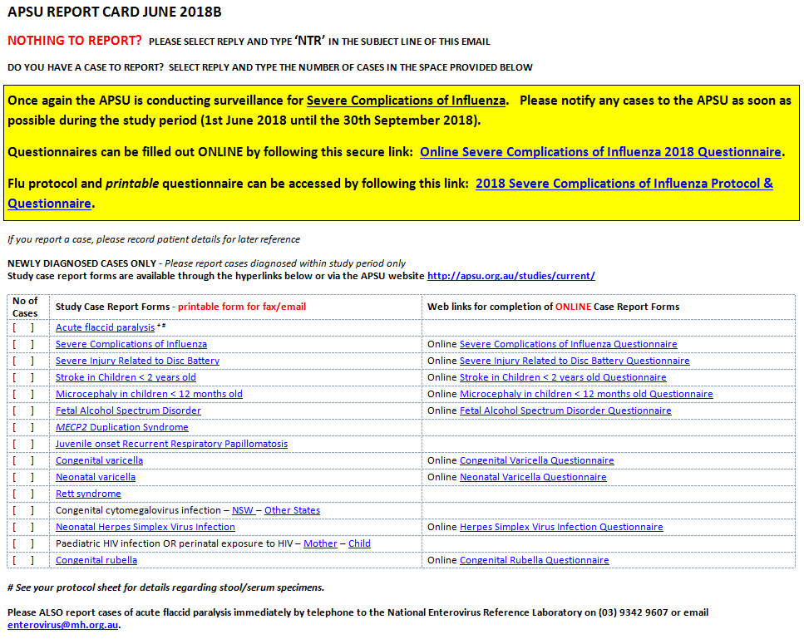

Contributors are asked to return the email or report card, indicating whether they have seen a case newly diagnosed with any of the conditions listed on the report card or have ‘nothing to report’. Clinicians who notify a case are then requested to complete a study questionnaire, providing de-identified data, and a case code is created to facilitate detection of duplicate reports. A link to the study questionnaire is sent electronically to reporting clinicians. Links to study protocols and case definitions are also provided on the card and are downloadable. Figure 2 is a schematic diagram showing the methodology of the APSU. Return of the report card by APSU contributors who are not reporting a case is crucial to the estimation of case ascertainment. The list of conditions on the card is limited to reduce the burden on reporters.
Figure 2. Schematic methodology of APSU surveillance
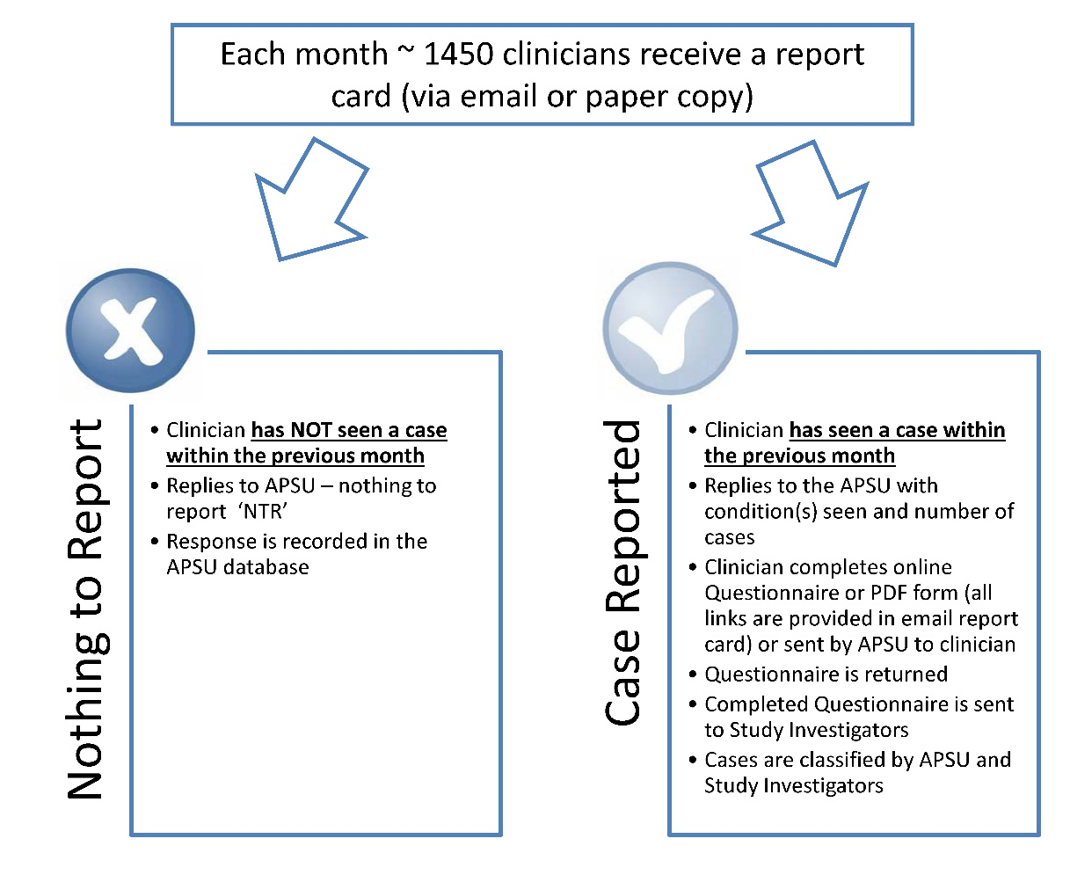
In the case of acute flaccid paralysis (AFP), surveillance is conducted on behalf of the Department of Health. In response to the monthly report card, paediatricians are prompted to report cases to either the APSU (data are then provided to the National Enterovirus Reference Laboratory, NERL) or direct to NERL. In both cases the APSU questionnaire is completed by clinicians. In addition, inpatient cases are identified in seven tertiary paediatric teaching hospitals by nurses working for the Paediatric Active Enhanced Disease Surveillance system (PAEDS) and then reported to NERL. The NERL ensures completeness and accuracy of data provided on questionnaires and compiles and stores data on all AFP cases. Clinical details of all reported cases are regularly reviewed by the Polio Expert Panel (PEP) for confirmation of diagnosis and classification and reporting to the World Health Organization (WHO).
The APSU process utilises Research Electronic Data Capture (REDCap) for data management. REDCap is a secure web application which allows reporting clinicians to complete online questionnaires, providing information that is stored securely on a server at the University of Sydney.
In 2018, there were eight communicable diseases or related conditions under surveillance. Appendix A provides the case definition for each condition. Human Research Ethics Committee Approval was obtained for every condition under surveillance.

Results
The annual overall response rate to the monthly APSU report card for 2018 was 92.0% which is consistent with the response rate of 91.2% in 2017. The APSU received a total of 123 notifications for the different conditions under surveillance (excluding AFP) which included 96 cases after exclusion of duplicates and cases that did not meet diagnostic criteria. Figure 3 shows the geographical distribution of APSU-reporting contributors in 2018.
Figure 3. Geographical coverage of APSU contributors in 2018 (Maptive software)
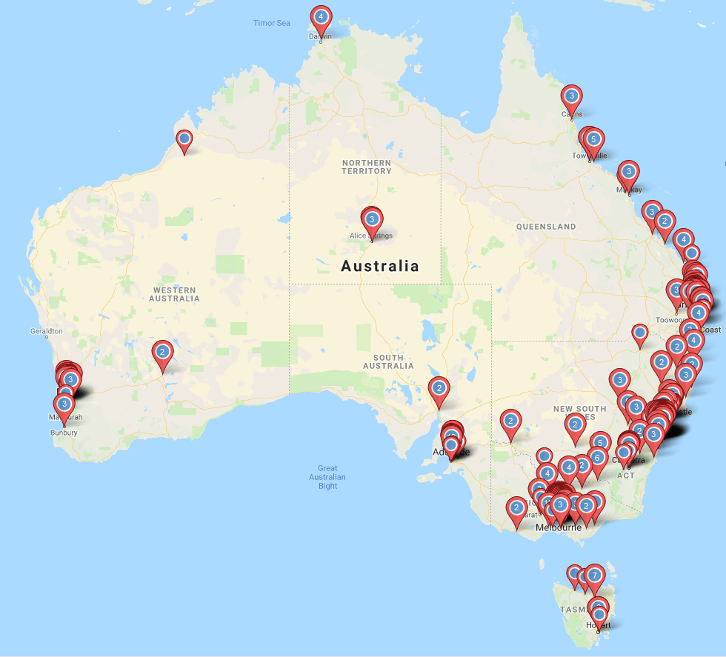
APSU contributors comprise a similar proportion of males (51.3%) and females (48.7%) based across major Australian cities, inner regional, outer regional and remote areas. The geographical coverage by state was: 38.1% in New South Wales, 23.7% in Victoria, 16.6% in Queensland and less than 10% in other states or territories, consistent with the population distribution. Below is a detailed report for each condition.

Acute flaccid paralysis (AFP)
The APSU commenced AFP surveillance at the request of the Department of Health in March 1995 in response to the WHO’s efforts to monitor poliomyelitis in the Western Pacific Region. The objectives of this surveillance are: (i) to conduct surveillance for cases of AFP and contribute to the documentation of the reported rate of AFP over time in those under 15 years in Australia, with the aim of detecting and enabling response to polio-compatible cases in the Western Pacific region; (ii) to collect necessary case and clinical information to enable classification of reported AFP cases by the PEP; (iii) to enable and encourage clinicians to report case information in a timely way to facilitate further clinical investigations and to prompt adequate stool sample collection (two stool specimens of sufficient quantity for laboratory analysis, collected at least 24 hours apart, within 14 days after the onset of paralysis); (iv) to ensure appropriate subnational geographical coverage of surveillance activities; and (v) to describe and monitor trends in the aetiology, clinical features and short-term outcome of non-polio AFP in Australia.
In 2018, there were 88 notifications of AFP received. Questionnaire data were available from all sources for 80 out of 88 (90.9%). Of the 88 notifications, 22 were duplicate reports and 9 were errors (outside of age range, outside of 2018 period). Of the remaining 57 cases, 54 were classified by the PEP as AFP non-polio and three as polio-compatible due to insufficient evidence to exclude poliomyelitis (stool samples were inadequate). Cases were reported from most states and territories; 24 from Victoria (42.1%), 10 from New South Wales (17.5%), 10 from Queensland (17.5%), 8 from Western Australia (14.0%), 3 from the Northern Territory (5.3%); and 2 from South Australia (3.5%). Nine cases reported to APSU came from clinicians working in hospitals that are not included in PAEDS. The diagnoses of cases are shown in Table 1, the most common being Guillain-Barré syndrome and transverse myelitis as previously described.⁷

Table 1. Most common conditions of non-polio AFP
PEP classification | N (%)
Guillain-Barré syndrome | 21 (38.9%)
Transverse myelitis | 11 (20.4%)
Acute disseminated encephalomyelitis | 4 (7.4%)
Anterior horn cell disease: other neurotropic virus | 2 (3.7%)
Enterovirus encephalomyelitis | 2 (3.7%)
Neuropathies of infectious diseases | 2 (3.7%)
Acute cerebellar ataxia | 1(1.9%)
Amebic encephalitis | 1(1.9%)
Botulism | 1(1.9%)
Clinically isolated syndrome | 1(1.9%)
Demyelinating polyradiculopathy | 1(1.9%)
Drug induced paralysis due to corticosteroids and blocking agents | 1(1.9%)
HSV encephalitis | 1(1.9%)
Spinal cord ischaemia | 1(1.9%)
Otherª | 4 (7.0%)
a Other includes: cerebellar ataxia, encephalitis, ischaemia and brainstem encephalitis.

Congenital cytomegalovirus infection (CMV)
Human cytomegalovirus (CMV) is the leading non-genetic cause of congenital malformation in developed countries including Australia.^{8,9} Infection may result in fetal and neonatal death or the development of serious clinical sequelae including sensorineural hearing loss and neurodevelopmental disability. We have recently shown that awareness in the medical and general community about congenital CMV is very low and in need of improvement.¹⁰ The objectives of this surveillance are: (i) to determine the incidence of congenital and suspected congenital CMV infection, prior to trials of vaccines and antiretrovirals; (ii) to determine the presenting features and clinical spectrum of disease due to congenital CMV; and (iii) to identify the therapy used for congenital CMV infection.
During 2018, there were 35 notifications of CMV infection. The response rate to the clinical questionnaire was 71.4%, indicating that there were 24 confirmed cases, one duplicate report and 10 probable cases (requests have been sent for additional data but had not been received at the time of publication).
The ongoing APSU study is a crucial mechanism for increasing awareness and improving diagnosis. During 2017–2018, data from the APSU study informed our work on translation of knowledge into information for clinicians and the community, sampling of different populations to improve understanding of congenital CMV,^{10,11} discussions with NGOs conducting research and providing clinical services in the disability sector (particularly the Cerebral Palsy Alliance and the Congenital CMV Association of Australia), and national and state paediatric and obstetric services. As the longest such study (19 years) in the world, international interest in these Australian data is high.
Data from the APSU CMV study have contributed to:
- A NSW Ministry of Health agreement to enhance congenital CMV awareness through provision of information via public health units on congenital CMV.
- Development of information sheets for the general public, partly or wholly based on documents drafted by investigators from the APSU study group.
- A short online video funded and prepared by the Cerebral Palsy Alliance (led by Dr Hayley Smithers-Sheedy of CPA and Ms Kate Daly of the Congenital CMV Association of Australia) to raise awareness of congenital CMV infection and its role in the aetiology of cerebral palsy.
- Negotiations, led by Dr Lisa Hui and Dr Antonia Shand, with the Royal Australian and New Zealand College of Obstetricians and Gynaecologists (RANZCOG), on including specific information for Obstetricians on congenital CMV prevention in RANZCOG-endorsed guidelines.
- Education of primary care, infectious diseases and pathology physicians about congenital CMV through webinars.
- Development of International Consensus Guidelines now used in public health and government negotiations for congenital CMV screening.¹²
- Multiple presentations in 2018 by the investigators including invited talks at the Annual Meetings of the Australian Institute of Medical Scientists/AACB, Australasian and European Societies of Infectious Diseases short course on Infectious Diseases in Pregnant women, fetuses and newborns, Australian and New Zealand Placental Research Association and invited talks at the University of Erlangen Germany and nationally.
The APSU data continue to be crucial to these communications as findings show ongoing congenital CMV infection and its persistent lack of recognition.

Neonatal herpes simplex virus infection (HSV)
Neonatal herpes simplex virus infection (HSV) is a rare but important condition which presents with disease localised to the skin, eye and/or mouth, encephalitis or a highly lethal disseminated infection associated with shock, disseminated intravascular coagulation and bleeding. It is now treatable with antiviral agents. The objectives of APSU surveillance are: (i) to estimate the incidence and to describe the demographics, presentation, diagnosis and management of acute HSV infection in infants less than 3 months of age in Australia; (ii) to determine the acute and prophylactic management of these infections; (iii) to describe the outcome at discharge from hospital and at 12 months after diagnosis; and (iv) to describe the relationship between infant and maternal risk factors for neonatal HSV infection and adverse outcomes for the infant after infection.
In 2018, there were seven notifications of neonatal HSV infection. The response rate to the clinical questionnaire was 100%, identifying six confirmed cases and one duplicate case. One confirmed case was born in late 2017 and notified in early 2018 from Queensland. This infant had asymptomatic HSV-1 infection and was treated with the antiviral drug Acyclovir. Of the five confirmed cases notified and born in 2018, two were from Victoria, one from Western Australia, and three from Queensland. All of the infants born in 2018 had symptomatic neonatal HSV infection: one had skin, eye or mouth (SEM) disease as the main clinical feature at presentation, two had neurological (CNS) disease, and two had disseminated multi-organ infection. Four infants survived: three of these infants had HSV-1 infection and one of the four was not HSV typed. All four infants were treated with Acyclovir. The infant with disseminated disease died from the infection; this infant had HSV-2 infection and did not receive any antiviral treatment. Neonatal HSV infection remains a rare but potentially lethal disease.
Data from the APSU HSV study have contributed to:
- The 2018 Australasian Society for Infectious Diseases/European Society of Clinical Microbiology and Infectious Diseases (ASID/ESCMID) short course on Infectious Diseases in Pregnant women, fetuses and newborns – Herpes simplex virus in pregnancy and neonates.
- A presentation at the 2018 Australian Academy of Health and Medical Sciences AGM and Scientific meeting.

Perinatal exposure to HIV and paediatric HIV infection
HIV infection among children in Australia is a rare occurrence, with mother-to-child transmission being the most frequent source of HIV among children in Australia. The objectives of APSU surveillance are: (i) to monitor the pattern of newly-diagnosed HIV infection among children aged less than 16 years at HIV diagnosis; (ii) to monitor the pattern of perinatal exposure to HIV among children born to women with HIV infection; (iii) to monitor the uptake of interventions for minimising mother-to-child transmission among women whose HIV infection was diagnosed antenatally; and (iv) to monitor the pattern of mother-to-child transmission in Australia.
In 2018, 35 notifications of perinatal exposure to HIV were reported to the APSU. The response rate to the clinical questionnaire was 91.4%. Of these, 29 were confirmed cases, three were duplicate reports, and three are yet to be classified due to outstanding data (requests have been sent for additional data but were not received at the time of publication). Of the 29 confirmed cases, 27 were Australian-born cases of perinatal exposure to HIV, with one case of perinatal HIV transmission. This compares to 44 Australian born cases of perinatal exposure reported in 2017 and 36 in 2016, with one case of perinatal HIV transmission reported in each of those years. Data on perinatal HIV exposures and perinatal HIV transmissions in Australian born infants are routinely reported in the Australian Annual Surveillance Report on HIV, viral hepatitis and sexually transmissible infections,¹³ and the annual national report tracking the progress against relevant indicators in the National HIV Strategy. Data are also routinely reported to the Joint United Nations Programme on HIV/AIDS (UNAIDS) as part of international reporting on mother-to-child transmission of HIV.
APSU data suggest that Australia continues to achieve high coverage of programs to prevent mother-to-child transmission of HIV; however, vigilance is required to ensure that HIV diagnosis is identified in or prior to pregnancy and appropriate treatment is offered to ensure mother-to-child transmission is eliminated.

Juvenile onset recurrent respiratory papillomatosis (JoRRP)
Juvenile onset recurrent respiratory papillomatosis (JoRRP) is a condition in which benign papillomata develop and recur in the larynx. It usually develops in infancy or early childhood and is the most common benign neoplasm of the larynx in children. JoRRP is caused by human papillomavirus (HPV) infection; of which HPV 6 and HPV 11 are considered the most common causative genotypes.
The incidence of JoRRP has decreased since the introduction of the HPV vaccine into the National Immunisation Program in 2007.¹⁴ Clinician reporting on new JoRRP cases has continued throughout 2018 via the APSU surveillance mechanism and its objectives are: (i) to estimate the Australian incidence of recurrent respiratory papillomatosis (RRP) in children aged less than 15 years; (ii) to describe symptoms, clinical presentation and treatment of RRP in Australia; (iii) to describe characteristics of maternal and delivery history; (iv) to describe child and maternal HPV vaccination history; (v) to describe viral types isolated in biopsy samples; (vi) to describe the distribution of RRP and HPV genotypes according to antenatal maternal HPV vaccination status, and child vaccination status; and (vii) to describe current methods of treatment of JoRRP in Australia.
In 2018, there were no notifications and no suspected or confirmed cases for this condition, whereas three notifications were received in 2017, one of which was a duplicate report. Both cases were classified as probable, with a case of non-laryngeal papillomatosis.
A publication in the Journal of Infectious Diseases, entitled A prospective study of the incidence of Juvenile-Onset Recurrent Respiratory Papillomatosis after implementation of a national HPV vaccination program,¹⁴ included our research findings since the project began in 2011 and was classified by the journal as a ‘major impact’ publication, based on downloads and reading.

Severe complications of influenza
Severe complications of influenza surveillance is added to the routine monthly APSU report card during the influenza season each year from June to September. The objective of this surveillance is to document clinical features, medical and vaccination history, and outcomes in children admitted to national hospitals with severe complications of influenza that are not reported to existing surveillance systems.
There were 22 notifications of severe complications of influenza during June to September 2018. The response rate to the clinical questionnaire was 100%. Of the notifications, 20 were confirmed as cases, one of which was fatal, one duplicate report and one error (outside the reporting period). The number of cases reported in 2018 was much lower than during the previous influenza season (June to September 2017) when there were 107 confirmed cases. The 2017 total was the second-highest number of confirmed cases since seasonal APSU surveillance of severe influenza complications began in 2008.⁵ The high number of notifications observed in 2017 was also documented by another surveillance system.¹⁵
The APSU is preparing a manuscript for publication, compiling data from 613 children reported from the last ten years of surveillance of severe complications of influenza.

Congenital rubella infection
Congenital rubella is a potentially vaccine-preventable condition resulting from maternal infection during pregnancy. It poses significant health consequences in children. The objectives of APSU surveillance are: (i) to more accurately define the present incidence of congenital rubella in Australia; (ii) to evaluate the reasons why mothers of children with congenital rubella have not been effectively vaccinated; and (iii) to monitor the outcome of the rubella vaccination programme.
There were no notifications of congenital rubella syndrome reported to the APSU during 2018. Likewise, no notifications were ascertained by the National Notifiable Disease Surveillance System in 2018.¹⁶ Nevertheless, it is important to continue surveillance as imported or locally-acquired infection can still occur, especially among unvaccinated populations.¹⁷

Neonatal and Congenital varicella
Neonatal and congenital varicella infections are vaccine-preventable conditions resulting from varicella infection during pregnancy and which can lead to serious infant diseases. The objectives of APSU surveillance are: (i) to estimate the incidence of neonatal or congenital varicella infection seen by Australian paediatricians and its associated morbidity and mortality; (ii) to document the source of maternal and neonatal infection or the management and short-term outcome of congenital varicella; (iii) to compare results with those from a previous APSU study of neonatal or congenital varicella that concluded in 1997, prior to the availability of varicella vaccination; (iv) to document current management practices and short term outcome of neonatal varicella; and (v) to estimate the need for screening to identify non-immune women antenatally.
There were no notifications of congenital varicella syndrome reported during 2018. In contrast, in 2017, there was one confirmed case of congenital varicella syndrome. The child presented with multiple clinical abnormalities including herpes zoster (shingles), neurological abnormality, eye lesions and gastrointestinal abnormalities. Regarding neonatal varicella infection, there was one notification reported to the APSU in 2018.
Continued surveillance is required because the National Immunisation Program of varicella vaccination, which commenced in 2005, has primarily targeted young populations, leaving adults who remain unvaccinated as an ongoing potential source of infection.⁵

Microcephaly
APSU surveillance of microcephaly commenced in June 2016, in response to the emergence of Zika virus infection internationally, and formally ended in mid-2018. The objectives of this surveillance were: (i) to describe the epidemiology of microcephaly in children aged less than 12 months presenting to paediatricians; (ii) to describe all causes of microcephaly in Australia; (iii) to document the infective causes of microcephaly such as congenital CMV infection, congenital rubella, toxoplasmosis and maternal Zika virus infection, and to describe how infection was acquired; and (iv) to educate Australian paediatricians about the possible causes of microcephaly including maternal Zika virus infection in women with appropriate travel history of exposure and to disseminate best practice guidelines as these become available or are updated.
During the surveillance period June 2016 – July 2018, there were a total of 106 notifications of microcephaly. In 2018, there were 23 notifications. The response rate to the clinical questionnaire was 91.3%, of which 16 were confirmed cases, four were outside the case definition, one was a duplicate and two have outstanding data or minimal information, precluding classification.
No cases of Zika-associated microcephaly were reported. Two mothers travelled outside Australia during pregnancy or in the three months before pregnancy. One visited a country with evidence of virus circulation before 2015 (Category 2) and the other visited a country with low Zika-transmission likelihood, according to the WHO Zika virus country classification scheme in place during the APSU study. There was one case attributed to CMV infection. Other cases were associated with chromosomal anomalies, intracranial vascular events, or developmental anomalies of the central nervous system (CNS). For the majority of cases (56.2%) no cause for microcephaly could be determined, which is consistent with other published data.¹⁸
APSU has also conducted a 10-year retrospective medical record audit for cases of microcephaly (classified using ICD-AM codes Q00-Q07, Q89.83, Q87.1, Q86, A50, P35.0-P35.2, P35.8 and P37.1), which aims to estimate the prevalence and causes of microcephaly in children receiving care at the Sydney Children’s Hospital Network (Westmead) between 2008 and 2018 (unpublished).
The investigators have been invited to contribute data on severe microcephaly (<1st percentile or more than three standard deviations below the mean) from the APSU microcephaly study to an International Network of Paediatric Surveillance Units report. This will include comparable data from the Canadian Paediatric Surveillance Program, British Paediatric Surveillance Unit and New Zealand Paediatric Surveillance Unit and will allow for international comparison of frequency, causation and clinical presentation.

Conclusions
The APSU provides the only national information available for many of the rare communicable diseases under surveillance. Moreover, the APSU is unique in that it receives monthly reports on inpatients and outpatients in urban and rural regions and from all states and territories, thus providing cases additional to those identified in hospital surveillance systems and overcoming difficulties in obtaining state and territory-based data. Over 1400 paediatricians contribute to APSU and over 90% of them report to APSU each month, providing demographic and clinical data. Clinicians attest to the value of the APSU for improving clinician knowledge, highlighting areas for future research and informing their clinical practice.^{19,20}
This information enables us to monitor disease burden and identify trends over time, describe current management and short term outcomes, recognise populations at heightened risk and guide clinical care and public health actions that provide the foundation for better outcomes for Australian children.
In the case of AFP, APSU data have contributed for 23 years to the reports provided to WHO by the Australian Government to provide evidence that the Western-Pacific Region remains polio-free. In the case of microcephaly, APSU was able to respond rapidly to a request from the Australian Department of Health to initiate national surveillance for microcephaly in the context of the emergence of an epidemic of microcephaly caused by Zika virus infection internationally. Similarly, seasonal surveillance of severe complications of influenza in children was initiated in response to a request from government following several deaths in children and has provided information for 10 years. This study has identified the importance of vaccination for all young children, the need for early diagnosis and antiviral treatment for children hospitalised with influenza, and the high burden of severe influenza in children. The study on congenital CMV infection is the longest-running study of its kind internationally and has assessed recognition and sequelae in Australian children for the last 19 years, improving diagnostic techniques. The HSV study has reported the burden of disease in Australian infants with HSV describing clinical manifestations and features of this infection. The HPV study has documented a decline in JoRRP incidence in children following a quadrivalent HPV vaccination program, a world first, and the study of HIV has allowed the assessment of use of interventions to minimise the risk of HIV transmission from mother to child in Australia.
The need for the APSU to continue conducting surveillance is fundamental in providing evidence-based information relevant not only for clinicians but also for policy makers and the community in general.

Acknowledgements
Chief Investigators of APSU surveillance studies:
Perinatal exposure to HIV and HIV Infection: A/Professor Rebecca Guy, The Kirby Institute, UNSW Australia, Sydney, New South Wales; Congenital Varicella Syndrome and Neonatal Varicella Infection: Professor Robert Booy, National Centre for Immunisation Research and Surveillance, The Children’s Hospital at Westmead, New South Wales; Seasonal Influenza: Professor Robert Booy, National Centre for Immunisation Research and Surveillance, The Children’s Hospital at Westmead, New South Wales.
We thank the APSU scientific Review Panel (Carol Bower, David Burgner, Fiona Mackie, Mavis Duncanson and David Lester-Smith) for providing expertise that has greatly assisted in study development.
APSU also acknowledges the contribution of study coordinators: Linda Hobday and Arnau Garcia Clapes (NERL), Dr Gulam Khandaker (Congenital Rubella Infection; Congenital Varicella Syndrome and Neonatal Varicella Infection) and Jocelynne McRae (PAEDS Coordinator – Research Nurse).
We would also like to acknowledge the continued contribution of all Australian Paediatricians and other child health professionals who participate in surveillance studies conducted by the APSU. Special thanks go to the APSU staff Amy Phu and Dannielle Handel for the management of the APSU database.
APSU activities are supported by the Australian Government Department of Health; Discipline of Child and Adolescent Health, Sydney Medical School, The University of Sydney; The Children’s Hospital at Westmead and The Royal Australasian College of Physicians.

Author details
Dr Carlos A Nunez, Research Associate, Australian Paediatric Surveillance Unit. The Children’s Hospital at Westmead, NSW 2145, Australia.
Dr Anne Morris, Senior Research Fellow, Australian Paediatric Surveillance Unit; and Paediatrician and Senior Lecturer, Clinical School, Children’s Hospital at Westmead, The University of Sydney.
Dr Suzy M. Teutsch, Research Fellow, Australian Paediatric Surveillance Unit
Dr Skye McGregor, Epidemiologist, The Kirby Institute, UNSW Sydney.
A/Professor Julia ML. Brotherton, Medical Director, VCS Population Health, VCS Foundation.
A/Professor Daniel Novakovic, VMO The Canterbury Hospital, Director, Dr Liang Voice Program, Faculty of Medicine and Health, Central Clinical School, The University of Sydney
Professor William Rawlinson, Senior Medical Virologist, Director of Virology, Serology and OTDS Laboratories, NSW Health Pathology
Professor Cheryl A. Jones, Deputy Executive Dean – Academic, The University of Sydney, Faculty of Medicine and Health.
Dr Bruce R. Thorley, Senior Medical Scientist, VIDRL, The Peter Doherty Institute for Infection and Immunity.
Professor Elizabeth J Elliott, Paediatrics and Child Health University of Sydney; Consultant Paediatrician Sydney Children’s Hospitals Network Westmead; and Director Australian Paediatric Surveillance Unit.

Corresponding author
Dr Carlos A Nunez
Research Associate, Australian Paediatric Surveillance Unit. The Children’s Hospital at Westmead, level 2, Research Building, Locked Bag 4001. Westmead, NSW 2145. Australia.
Phone: +61 2 9845 1848.
Email: carlos.nunezmiranda@health.nsw.gov.au

References
- Elliott EJ, Chant KG. Rare disease surveillance. J Paediatr Child Health. 1994;30(6):463–5.
- Webb P, Bain C, Page A. Essential epidemiology: an introduction for students and health professionals. United Kingdom, Cambridge University Press, 2016.
- Zurynski YA, Lester-Smith D, Festa MS, Kesson AM, Booy R, Elliott EJ. Enhanced surveillance for serious complications of influenza in children: role of the Australian Paediatric Surveillance Unit. Commun Dis Intell Q Rep. 2008;32(1):71–6.
- Zurynski Y, Elliott EJ. Australian Paediatric Surveillance Unit annual report, 2010. Commun Dis Intell Q Rep. 2011;35(3):244–9.
- Teutsch S, Zurynski Y, Elliott E. Australian Paediatric Surveillance Unit Annual Report, 2017. Commun Dis Intell (2018). 2018;42. pii: S2209-6051(18)00006-4.
- Deverell M, Phu A, Zurynski Y, Elliott E. Australian Paediatric Surveillance Unit Annual Report, 2016. Commun Dis Intell Q Rep. 2017;41(3):E288–93.
- Roberts J, Hobday L, Ibrahim A, Aitken T, Thorley B. Annual report of the Australian National Enterovirus Reference Laboratory 2012. Commun Dis Intell Q Rep. 2013;37(2):E97–104.
- Rawlinson WD, Palasanthiran P, Hall B, Al Yazidi L, Cannon MJ, Cottier C et al. Neonates with congenital cytomegalovirus and hearing loss identified via the universal newborn hearing screening program. J Clin Virol. 2018;102:110–5.
- Zheng QY, Huynh KT, van Zuylen WJ, Craig ME, Rawlinson WD. Cytomegalovirus infection in day care centres: A systematic review and meta‐analysis of prevalence of infection in children. Rev Med Virol. 2019;29(1):e2011.
- Shand A, Luk W, Nassar N, Hui L, Dyer K, Rawlinson W. Cytomegalovirus (CMV) infection and pregnancy-potential for improvements in Australasian maternity health providers’ knowledge. J Matern Fetal Neonatal Med. 2018;31(19):2515–20.
- Lazzaro A, Vo M, Zeltzer J, Rawlinson W, Nassar N, Daly K et al. Knowledge of congenital cytomegalovirus (CMV) in pregnant women in New South Wales (NSW) is low and improved with education. Aust N Z J Obstet Gynaecol. 2019. https://doi.org/10.1111/ajo.12978.
- Rawlinson WD, Boppana SB, Fowler KB, Kimberlin DW, Lazzarotto T, Alain S et al. Congenital cytomegalovirus infection in pregnancy and the neonate: consensus recommendations for prevention, diagnosis, and therapy. Lancet Infect Dis. 2017;17(6):e177–88.
- Kirby Institute. HIV, viral hepatitis and sexually transmissible infections in Australia: annual surveillance report 2018. Sydney: Kirby Institute, UNSW Sydney. 2018.
- Novakovic D, Cheng ATL, Zurynski Y, Elliott E, Booy R, Walker PJ et al. A prospective study of the incidence of juvenile-onset recurrent respiratory papillomatosis after implementation of a national HPV vaccination program. J Infect Dis. 2018;217(2):208–12.
- Blyth CC, Macartney KK, McRae J, Clark JE, Marshall HS, Buttery J et al. Influenza epidemiology, vaccine coverage and vaccine effectiveness in children admitted to sentinel Australian hospitals in 2017: results from the PAEDS-FluCAN collaboration. Clin Infect Dis. 2019;68(6):940–8.
- National Notifiable Diseases Surveillance System (NNDSS). Number of notifications of Rubella congenital, Australia, in the period of 1991 to 2018 and year-to-date notifications for 2019. [Internet.] Australian Government, Department of Health, 2019. Available from: http://www9.health.gov.au/cda/source/rpt_3.cfm.
- Sathanandan D, Gupta L, Liu B, Rutherford A, Lane J. Factors associated with low immunity to rubella infection on antenatal screening. Aust N Z J Obstet Gynaecol. 2005;45(5):435–8.
- Cragan JD, Isenburg JL, Parker SE, Alverson CJ, Meyer RE, Stallings EB et al. Population-based microcephaly surveillance in the United States, 2009 to 2013: An analysis of potential sources of variation. Birth Defects Res Part A Clin Mol Teratol. 2016;106(11):972–82.
- Zurynski Y, Gonzalez A, Deverell M, Phu A, Leonard H, Christodoulou J et al. Rare disease: a national survey of paediatricians’ experiences and needs. BMJ Paediatr Open. 2017;1(1):e000172.
- Elliott E, Zurynski Y. Rare diseases are a ‘common’ problem for clinicians. Aust Fam Physician. 2015;44(9):630–3.

Appendix A. APSU conditions under surveillance
Surveillance study – Case definition
Acute flaccid paralysis (AFP)
Any child less than 15 years of age with acute flaccid paralysis in one or more limbs or acute onset of bulbar paralysis.
All cases reported through APSU, NERL and PAEDS are reviewed by the PEP and classified as: confirmed poliomyelitis; non-polio AFP, polio-compatible or non-AFP. The NERL determines whether there is an infectious cause of AFP including enteroviruses. The PEP secretariat reports all Australian cases to the World Health Organization (WHO).
Congenital cytomegalovirus (CMV) infection
Congenital CMV: Any child from whom CMV is isolated in the first three (3) weeks of life, from urine, blood, saliva, or any tissue taken at biopsy.
Suspected congenital CMV: any child up to 12 months of age, in whom CMV is isolated from urine, blood, saliva or any tissue taken at biopsy and/or a positive serum IgM is found and in whom clinical features exist that may be due to intrauterine CMV infection.
Clinical features associated with congenital CMV infection include: prematurity, low birth weight, sensorineural deafness, other neurological abnormalities (encephalitis, microcephaly, developmental delay), seizures, microphthalmia, chorioretinitis, cataracts), hepatitis, hepatosplenomegaly, thrombocytopaenia, pneumonitis or myocarditis.
Neonatal and young infant herpes himplex virus (HSV) infection
Any neonate or infant aged less than 3 months of age (regardless of gestation) seen in the last month with laboratory confirmation of HSV infection and with either clinical evidence of HSV infection or laboratory confirmation of maternal perinatal HSV infection in an asymptomatic infant.
Laboratory confirmation is by detection of HSV by PCR in a surface swab, respiratory specimen and/or sterile site (CSF or blood) (or by virus isolation), or by immunofluorescence.
Clinical evidence of neonatal HSV infection is one or more of: typical herpetic lesions of the skin, eye or mouth; evidence of disseminated infection (bleeding, bruising or coagulopathy, jaundice or elevated serum bilirubin, hepatosplenomegaly or elevated liver transaminases), pneumonitis (respiratory distress or chest radiograph) or encephalitis (lethargy, seizures, apnoea or abnormalities on neuroimaging or EEG).
Laboratory evidence of maternal perinatal HSV infection is provided by detection of HSV in maternal genital swab and /or mother seroconverted to HSV or IgM positive in pregnancy or early postnatal period.
Paediatric human immunodeficiency virus (HIV) infection and perinatal exposure to HIV in Australia
Any child aged less than 16 years at diagnosis of HIV infection in Australia or any child born to a woman with diagnosed HIV infection. Children born to women with HIV infection and who are known to have been exposed to HIV perinatally, by in utero exposure or through breastfeeding, should be notified, even if they are subsequently confirmed as HIV antibody negative.
Juvenile onset recurrent respiratory papillomatosis (JoRRP)
Any infant or child under the age of 15 years diagnosed with juvenile onset recurrent respiratory papillomatosis (JoRRP) confirmed by endoscopy of the larynx and by histology.
Severe complications of influenza in children < 15 years (June – September 2018)
Any child aged less than 15 years with laboratory confirmed influenza admitted to hospital with at least one of the following complications:
- Pneumonia (confirmed on X-ray or microbiology)  - Oxygen requirement  - Mechanical ventilation requirement  - Laboratory proven secondary bacterial co-infection; bacteraemia; septicaemia;  - Encephalitis / encephalopathy  - Seizures (including simple febrile seizure, prolonged or focal seizure or status epilepticus)  - Transverse myelitis  - Polyneuritis / mononeuritis | - Reye syndrome  - Myocarditis; pericarditis; cardiomyopathy  - Rhabdomyolysis  - Purpura fulminans  - Disseminated coagulopathy  - Shock (requiring >40 ml/kg fluid resuscitation)  - Acute renal failure  - Death, including death at presentation to hospital  - Guillain-Barré syndrome
Congenital rubella
Any child or adolescent up to 16 years of age who in the opinion of the notifying paediatrician has definite or suspected congenital rubella, with or without defects, based on history, clinical and laboratory findings.
Microcephaly in children aged less than 12 months
Any child less than 12 months of age with microcephaly when the occipito-frontal circumference (OFC) is more than two standard deviations (<3rd percentile) below the mean for age and gender according to standard growth charts and adjusted for gestation in the preterm baby
The WHO recommends the Intergrowth Chartsa which allow for adjustment for gestational age and are based on a wide range of ethnicities.b
Severe complications of varicella virus infection including neonatal and congenital varicella infection Neonatal varicella
Any infant who has neonatal varicella based on history, clinical and/or laboratory findings in the first month of life without features of congenital varicella syndrome.
Features of neonatal varicella infection include pox-like rash which may be papulovesicular, vesiculopustular or haemorrhagic, and fever. Other systemic symptoms may be present. Complications of neonatal varicella include bacterial superinfection, neurological and haematological problems and general visceral involvement.
The diagnosis of neonatal varicella can be made when an infant in the first month of life presents with clinical features of varicella infection. There may be a history of maternal varicella infection in the last 1–4 weeks of pregnancy or contact with a varicella infected person after birth.
The diagnosis can be confirmed by laboratory tests to detect:
- Viral antigen/viral isolate from scrapings of the skin lesions or viral DNA from lesion fluid.
- Varicella specific IgM in a serum sample from the infant (or from the contact).
Congenital varicella
Any stillbirth, newborn infant, or child up to the age of 2 years who, has definite or suspected congenital varicella infection, with or without defects and meets at least one of the following criteria:
- Cicatricial skin lesions in a dermatomal distribution and/or pox-like skin scars and/ or limb hypoplasia.
- Development of herpes zoster in the first year of life.
- Spontaneous abortion, termination, stillbirth or early death following varicella infection during pregnancy.
Confirm varicella infection by one or more of the following:
- Detection of varicella-specific IgM antibodies in cord blood or in serum specimen taken in the first 3 months of life (only 25% of cases are positive).
- Persistence of varicella specific IgG antibody in a child aged beyond 6 months of age.
- Identification of varicella virus in skin lesions or autopsy tissue.
- History of maternal varicella during pregnancy or maternal contact with varicella in pregnancy in the mother of an infant with congenital abnormalities.
The following clinical signs may also be present in cases of congenital varicella syndrome:
- Microcephaly, hydrocephalus, cerebellar hypoplasia, motor or sensory deficits, sphincter dysfunction and peripheral nervous system defects.
- Microphthalmia, cataracts, Horner’s syndrome, chorioretinitis, nystagmus, retinal scars, optic atrophy.
- Gastrointestinal abnormalities including colonic atresia, hepatitis, liver failure.
- Genito-urinary abnormalities.
- Cardiovascular abnormalities.
- Intrauterine growth retardation.
a https://intergrowth21.tghn.org/
b The Intergrowth calculator can be found at http://intergrowth21.ndog.ox.ac.uk/en/ManualEntry

Communicable Diseases Intelligence
ISSN: 2209-6051 Online

Communicable Diseases Intelligence (CDI) is a peer-reviewed scientific journal published by the Office of Health Protection, Department of Health. The journal aims to disseminate information on the epidemiology, surveillance, prevention and control of communicable diseases of relevance to Australia.

Editor: Cindy Toms
Deputy Editor: Simon Petrie
Design and Production: Kasra Yousefi
Editorial Advisory Board: David Durrheim, Mark Ferson, John Kaldor, Martyn Kirk and Linda Selvey

Website: http://www.health.gov.au/cdi

Contacts
Communicable Diseases Intelligence is produced by:
Health Protection Policy Branch, Office of Health Protection, Australian Government Department of Health
GPO Box 9848, (MDP 6) CANBERRA ACT 2601

Email: cdi.editor@health.gov.au

Submit an Article
You are invited to submit your next communicable disease related article to the Communicable Diseases Intelligence (CDI) for consideration. More information regarding CDI can be found at: http://health.gov.au/cdi.
Further enquiries should be directed to: cdi.editor@health.gov.au.

This journal is indexed by Index Medicus and Medline.

Creative Commons Licence - Attribution-NonCommercial-NoDerivatives CC BY-NC-ND
© 2019 Commonwealth of Australia as represented by the Department of Health
This publication is licensed under a Creative Commons Attribution-NonCommercial-NoDerivatives 4.0 International Licence from https://creativecommons.org/licenses/by-nc-nd/4.0/legalcode (Licence). You must read and understand the Licence before using any material from this publication.

Restrictions
The Licence does not cover, and there is no permission given for, use of any of the following material found in this publication (if any):
- the Commonwealth Coat of Arms (by way of information, the terms under which the Coat of Arms may be used can be found at www.itsanhonour.gov.au);
- any logos (including the Department of Health’s logo) and trademarks;
- any photographs and images;
- any signatures; and
- any material belonging to third parties.

Disclaimer
Opinions expressed in Communicable Diseases Intelligence are those of the authors and not necessarily those of the Australian Government Department of Health or the Communicable Diseases Network Australia. Data may be subject to revision.

Enquiries
Enquiries regarding any other use of this publication should be addressed to the Communication Branch, Department of Health, GPO Box 9848, Canberra ACT 2601, or via e-mail to: copyright@health.gov.au

Communicable Diseases Network Australia
Communicable Diseases Intelligence contributes to the work of the Communicable Diseases Network Australia.
http://www.health.gov.au/cdna

http://www.apsu.org.au/
https://www.cmv.org.au/dl-flyer/
https://www.cerebralpalsy.org.au/cmv/
https://www.racgp.org.au/education/professional-development/online-learning/webinars/communicable-disease/congenital-cmv-common-commonly-missed
https://www.asid.net.au/events/event/asidescmid-course-on-infectious-diseases-in-pregnant-women-fetuses-and-newborns

