An Outbreak of Paralytic Shellfish Poisoning in Tasmania
Laura J Edwards, Katrina Wilson, Mark GK Veitch

Abstract
Paralytic shellfish poisoning (PSP) is a rare illness caused by eating shellfish containing paralytic shellfish toxins (PST). Toxins are produced during harmful algal blooms, which occur most years on the east coast of Tasmania. Contaminated seafood looks and tastes normal and toxins are not destroyed by cooking or freezing. Commercial shellfish farms are monitored for harmful algae and shellfish toxins, but wild shellfish are not and pose a potential public health risk.
A case of PSP was documented in Tasmania in 2011, and we are aware of anecdotal reports of cases in the 1980s and 1990s. We are not aware of cases elsewhere in Australia but harmful algal blooms have been detected in Victoria, South Australia and New South Wales.
Routine monitoring of commercial shellfish in 2015 detected a large bloom of Alexandrium tamarense on the east coast of Tasmania, which can cause PSP. Between 2 and 12 October 2015, four cases of PSP were identified. All were adults who ate wild mussels from the east coast of Tasmania and had onset of numbness or tingling of the face and muscle weakness from 30 minutes to 12 hours later. Two cases were briefly hospitalised, both recovered.
Since the outbreak, permanent signage at locations where shellfish are frequently recreationally foraged has been erected. Additional alerts are released during high risk periods based on surveillance of commercial sites by the Tasmanian Shellfish Quality Assurance Program. Several states in Australia are at risk of cases of PSP. We recommend active surveillance and multi-jurisdictional collaboration to manage this risk.

Summary
This article describes an outbreak of four cases of paralytic shellfish poisoning in Tasmania during a harmful algal bloom of Alexandrium tamarense.
Keywords: Paralytic shellfish poisoning, paralytic shellfish toxin, saxitoxin, harmful algal blooms, Alexandrium tamarense

Introduction
Paralytic shellfish poisoning (PSP) is a rare illness caused by consumption of shellfish contaminated with paralytic shellfish toxins (PST). PST are produced by certain types of algae during harmful algal blooms and bioaccumulate in bivalve filter-feeding shellfish such as oysters, mussels and scallops.¹ Contaminated seafood looks, smells and tastes normal and the toxins are not destroyed by cooling or cooking.
PSP primarily occurs in temperate climates but cases also occur in tropical regions.²⁻⁵ The global incidence has been reported to be up to 2000 cases each year but surveillance is limited therefore this may be an understimate. Case-fatality rates vary considerably; from low, up to 6 to 15 percent in some series. Dose, host factors and access to care affect the risk of death.⁶⁻⁸ In Tasmania, one case of PSP was reported in 2011⁹ and we are aware of anecdotal case reports in the 1980s and 1990s.¹⁰ We are not aware of any cases in other states or territories of Australia.
The symptoms of PSP result from toxin-mediated blockage of voltage-gated sodium channels and develop from within a few minutes to several hours after ingestion of contaminated shellfish. Initial symptoms include facial or peripheral paraesthesia progressing to numbness, weakness, loss of coordination, difficulty speaking and double vision. Recovery is expected within hours up to several days but, in severe cases, respiratory failure and death can occur. Treatment is supportive and patients may require mechanical ventilation.¹¹ Laboratory identification of PST in urine or implicated shellfish can be used to confirm the diagnosis.
Three genera of dinoflagellate algae contain species that are capable of producing PST: Gymnodinium spp, Alexandrium spp and Pyrodinium spp.¹² Two species of PST-producing algae are currently found in Tasmania, Gymnodinium catenatum, which has caused recurrent blooms in the south east Huon and Derwent river region since 1973⁹, and Alexandrium tamarense, which has been detected in low concentration on the east coast of Tasmania since 1987.¹³ Harmful algal blooms have also been detected in Victoria, South Australia and New South Wales.⁹
In Tasmania, bivalve shellfish marine farming and commercial wild harvest bivalve shellfish fishing, excluding the commercial scallop industry, are monitored by the Tasmanian Shellfish Quality Assurance Program (TSQAP) under the Tasmanian Biotoxin Management Plan.^{14,15} The Plan outlines the frequency and distribution of biotoxin testing in marine farms. The frequency of testing is based on a risk assessment approach with flesh from most harvest areas tested weekly.
Toxin concentrations above the regulatory limit of 0.8mg/kg result in closure of the marine farm until concentrations drop below the limit on two consecutive tests. TSQAP advises a joint government and industry group, the Harmful Algal Bloom Emergency Management Group, of the results of biotoxin and algae testing and a list of marine farm and harvest closures. TSQAP monitoring information assists in the management of biotoxin risk in susceptible wild fisheries (i.e. scallop, abalone and rock lobster) and enables these industries to enact their own risk management strategies for biotoxins. Other wild shellfish are not routinely monitored for biotoxins.
A permanent Public Health Alert in Tasmania recommends people do not eat recreationally harvested wild shellfish due to the risk of poor water quality in unmonitored areas. During periods of high risk for shellfish poisoning associated with high levels of algae or toxins in marine farms, additional Public Health alerts are issued to warn of the increased risk and distributed using social and traditional media.
This report describes an outbreak of four cases of PSP associated with consumption of wild-harvested mussels from a single location on the east coast of Tasmania during a harmful algal bloom of Alexandrium tamarense in October 2015.

Methods
In July 2015, routine monitoring of marine farms on the east coast of Tasmania detected a bloom of Alexandrium tamarense and elevated levels of PST confirmed in accordance with the TSQAP Biotoxin Management Plan, which resulted in closure of commercial marine farms. From July to September 2015, the algal bloom expanded resulting in a Public Health Alert on 2 October 2015 warning against consumption of wild shellfish.
At approximately 11pm on 2 October, an ambulance officer reported two cases of suspected PSP to Public Health Services. Following this, an outbreak team was established led by Public Health Services including the OzFoodNet epidemiologist, Public Health Officers, Surveillance Coordinator, Environmental Health Officers, Media Liaison Officer, TSQAP and the Acting Director of Public Health.
Public Health Officers conducted telephone interviews with all cases using a standard questionnaire for shellfish poisoning. Information was collected on patient demographics, the consumed shellfish, the location from which wild shellfish were gathered and clinical features.
Case definitions for probable and confirmed cases were adapted from previous case definitions developed by Public Health Services. A probable case was defined as a person who had consumed shellfish and developed clinical features of PSP within 12 hours. Clinical features included numbness or paraesthesia around the mouth, face or extremities and at least one of the following: generalised weakness, dizziness or vertigo, slurred or unclear speech, difficulty swallowing, difficulty breathing, paralysis, clumsiness, unsteady walking, or double vision. A confirmed case was defined as the features of a probable case; and one or more of detection of PST in a urine specimen of the case, detection of PST in a sample of consumed shellfish or consumption of shellfish from an area known to be affected by high levels of paralytic shellfish toxin.
Active case finding involved telephone contact with all the state hospital Emergency Departments; alerts to General Practitioners, Emergency Departments, and ambulance officers; and public media releases.

Results

Descriptive epidemiology
Five suspected cases were notified to Public Health Services, two by an ambulance officer, one by an Emergency Department Physician, one by a General Practitioner and one by a member of the public. One reported illness did not meet a case definition and was excluded. All four cases occurred between 2 and 12 October 2015 and were confirmed as having eaten wild mussels that had been gathered from Little Swanport, an area known to be affected by high levels of PST on the east coast of Tasmania. The median number of mussels consumed was 14 (range 6 to 35). The cases were all aged between 51 and 61; three were male. The time from exposure to onset of symptoms was 30, 60 and 90 minutes, and 12 hours.
All the cases reported numbness or tingling and muscle weakness (Table 1). Most also had dizziness, a floating sensation and nausea. One case reported difficulty swallowing or slurred speech.
Table 1: Summary of symptoms of cases
Symptom | Number affected
Paraesthesia or numbness | 4
Mouth or Face | 4
Fingers | 3
Arms | 0
Legs | 1
Dizziness | 3
Floating sensation | 3
Nausea | 3
Vomiting | 1
Muscle weakness | 4
Arms | 3
Legs | 4
Difficulty with swallowing or slurred speech | 1
Respiratory difficulties | 0

Two cases were hospitalised overnight and both recovered uneventfully. No urine samples were collected for PST testing. One case supplied a sample of leftover mussels pickled in vinegar, but these were unsuitable for toxin testing.

Environmental investigations
Environmental sampling at the time of the outbreak revealed harmful algal blooms and elevated levels of PST at multiple locations on the east and south-east coasts of Tasmania. The commercial harvest areas in Little Swanport and Mercury Passage recorded the highest levels of PST (Figure 1). Little Swanport harvest area, adjacent to the location of wild mussels gathered by the cases, was closed due to elevated PST levels from 23 September until 20 November 2015, and Mercury Passage harvest area, approximately 26 kilometres south, was closed from 29 July to 20 November 2015 (Figure 2). A single wild mussel sample collected from the same location as the four cases at Little Swanport on 14 October 2015 had a PST level of 35 mg/kg, more than 40 times the regulatory limit of 0.8mg/kg (Figure 2).
Figure 1: Location of PSP outbreak and two sampling sites with the highest levels of PST recorded, 2015
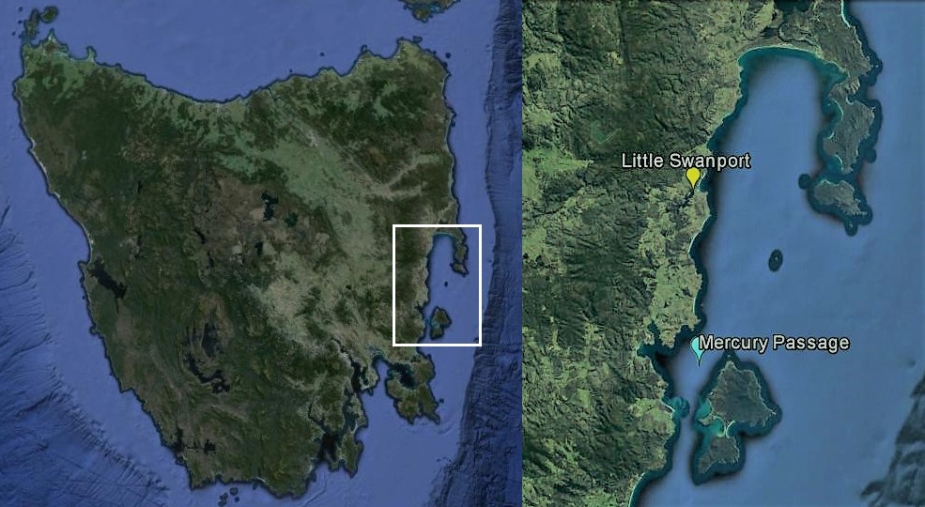
(Source: GoogleEarth and TSQAP)

Figure 2: Total Paralytic Shellfish Toxin levels for Little Swanport and Mercury Passage, July to November 2015

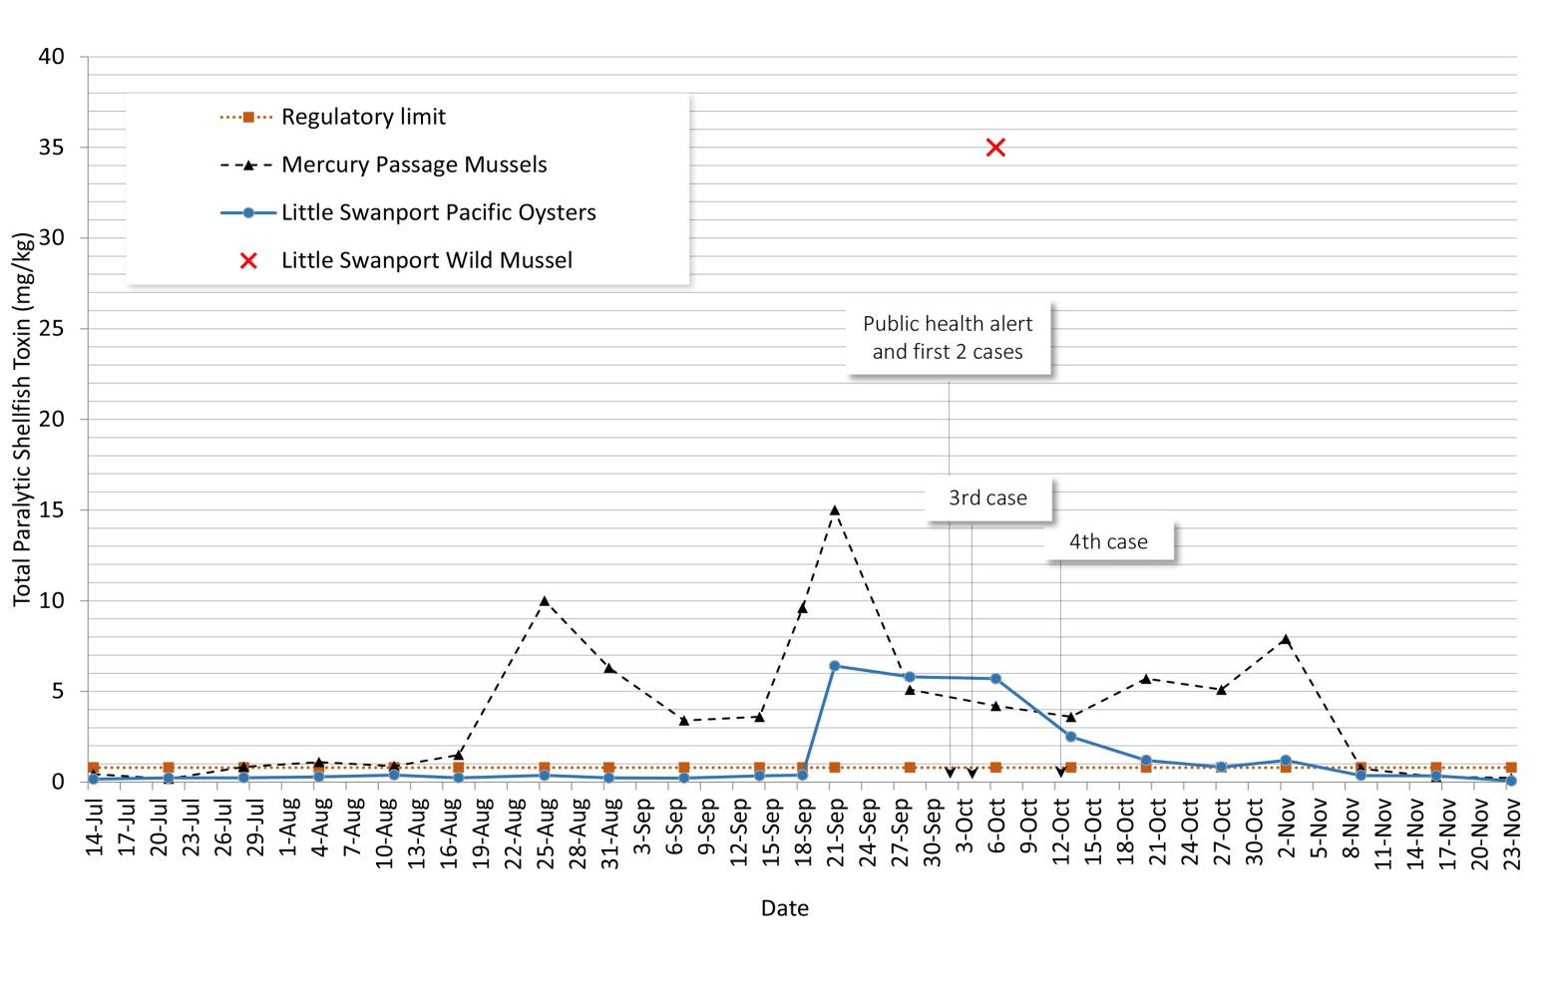

Outbreak response
Temporary warning signs were erected on 5 and 6 October 2015 at 21 east coast locations including boat launching ramps and popular fishing and swimming spots. Public Health Alerts were promoted on Twitter, through Media Releases and on the Department of Health and Human Services website. Multiple television and radio interviews were held in the first two weeks of October.

Discussion
PSP is a notifiable disease in Tasmania – suspected case of food or water-borne illness – under the Public Health Act 1997.¹⁵ Prior to this outbreak, there were anecdotal accounts of PSP cases occurring in the 1980s and 1990s and one documented case in 2011.⁹ Because the disease is rare clinicians and the public have limited awareness of PSP. Mild cases may have not sought medical attention nor been reported. Media campaigns and public signage about various risks from wild foraged shellfish since the 1980s in south-eastern Tasmania have aimed to raise awareness. We are not aware of any cases of PSP elsewhere in Australia but it is possible that cases of PSP may not have been recognised, reported or documented.
Currently, monitoring for PST is confined to commercial marine farms and fisheries. Difficulties in establishing a monitoring system for foraging in recreational waters include the intensity, extent and costs of monitoring that would be required. Techniques for the rapid testing of shellfish flesh for biotoxins have been developed and integrative monitoring systems are being used internationally to share information on current shellfish toxin levels.¹⁶ Some commercial enterprises in Tasmania are using rapid tests to assist with farm risk management practices, but the kits are not yet internationally validated.
Following the outbreak, Public Health Services developed a fact sheet on PSP and permanent signage which was erected at numerous coastal locations. The signs have been designed to enable additional warnings to be revealed during periods of high risk for shellfish poisoning. Guidelines for public health responses to high levels of PST or cases of PSP, and surveillance protocols, have been developed to ensure a consistent response when the risk of shellfish poisoning is present. There are no Australian laboratories accredited for human testing of urinary PST.
The prevalence of algae that can cause PSP has changed in recent decades. Since the 1970s, Gymnodinium catenatum has caused periodic algal blooms in Tasmania. Three genotypes of A. tamarense have been identified in Tasmania. Two of these A. australiense and A. pacificum are known to occur on the east coast. In 2012, a large recall of commercial mussels that had been air freighted to Japan occurred at estimated cost to the shellfish industry of $23 million.¹⁷ Recent evidence suggests that this event may have been caused by a toxigenic genotype of A tamerense, known as A. fundyense, which had not previously been detected.^{13, 18}
Water temperatures on the east coast of Tasmania in 2015 were approximately four degrees warmer than average due to the El Niño Southern Oscillation, which caused warm currents travelling south to move closer to the land mass. The contribution of this to the harmful algal blooms is unclear.
Algal blooms are influenced by factors including nutrient levels, turbulence, water temperature, sunlight, water pH and ocean currents. Anthropogenic global warming figures as a key determinant of factors increasing the distribution and frequency of algal blooms in recent decades.^{19, 20} Additional factors such as increased awareness and testing may also have contributed.^{19, 21-24}

Conclusion
Several Australian states and territories are at risk of cases of PSP. Routine monitoring is in place for commercial shellfish in Tasmania but not for most recreationally foraged wild shellfish, so the public need to be aware of the risks associated with their consumption. Awareness may be improved by permanent signage along the east and south-east coasts of Tasmania, and by public health alerts during high-risk periods. Clinicians also need to be made aware of the need to report suspected cases of PSP to Public Health Units and be encouraged to collect urine specimens or leftover uneaten shellfish for PST testing. We recommend active surveillance across Australia in collaboration with Departments of Primary Industries, researchers and other marine regulatory bodies to manage the social, economic, and environmental and health risks associated with harmful algal blooms and shellfish poisoning.

Acknowledgements
The authors would like to thank David Coleman, Michelle Green, Stewart Quinn, and Scott Burton who assisted in the management of the outbreak and provided additional information on surveillance and management of shellfish poisoning.

Author details
Dr Laura J Edwards, Public Health Registrar, Department of Health and Human Services, Tasmania and Master of Applied Epidemiology (MAE) Scholar, National Centre for Epidemiology and Population Health, Australian National University, Canberra
Katrina Wilson, Program Manager, Tasmanian Shellfish Quality Assurance Program, Biosecurity Tasmania, Department of Primary Industries, Parks, Water and Environment
Dr Mark GK Veitch, Director of Public Health, Department of Health and Human Services, Tasmania
Corresponding author: Laura Edwards, Public Health Services, level 3, 25 Argyle Street, Hobart, Tas 7000, laura.edwards@dhhs.tas.gov.au. Ph 03 6166 0672

References
- Deeds JR, Landsberg JH, Etheridge SM, Pitcher GC, Longan SW. Non-traditional vectors for paralytic shellfish poisoning. Marine drugs. 2008;6(2):308-48.
- Hartigan-Go K, Bateman DN. Redtide in the Philippines. Human & experimental toxicology. 1994;13(12):824-30.
- Suleiman M, Jelip J, Rundi C, Chua TH. Case Report: Paralytic Shellfish Poisoning in Sabah, Malaysia. The American journal of tropical medicine and hygiene. 2017.
- Finnis S, Krstic N, McIntyre L, Nelson TA, Henderson SB. Spatiotemporal patterns of paralytic shellfish toxins and their relationships with environmental variables in British Columbia, Canada from 2002 to 2012. Environmental research. 2017;156:190-200.
- Grattan LM, Holobaugh S, Morris JG, Jr. Harmful Algal Blooms and Public Health. Harmful Algae. 2016;57(B):2-8.
- Isbister GK, Kiernan MC. Neurotoxic marine poisoning. The Lancet Neurology. 2005;4(4):219-28.
- Hallegraeff GM. A review of harmful algal blooms and their apparent global increase*. Phycologia. 1993;32(2):79-99.
- Mines D, Stahmer S, Shepherd SM. Poisonings: food, fish, shellfish. Emergency medicine clinics of North America. 1997;15(1):157-77.
- Turnbull A, Harrison R, McKeown S. Paralytic shellfish poisoning in south eastern Tasmania. Communicable diseases intelligence quarterly report. 2013;37(1):E52-4.
- Turnbull A, personal communication [March 2016]
- Isbister GK, Kiernan MC. Neurotoxic marine poisoning. Lancet Neurol. 2005;4(4):219-28.
- Etheridge SM. Paralytic shellfish poisoning: seafood safety and human health perspectives. Toxicon. 2010;56(2):108-22.
- Hallegraeff G, Bolch C, Condie S, Dorantes-Aranda JJ, Murray S, Quinlan R, et al. Unprecedented Alexandrium blooms in a previously low biotoxin risk area of Tasmania, Australia. 17th International Conference on Harmful Algae Proceedings2017.
- Government T. Tasmanian Shellfish Quality Assurance Program Biotoxin Management Plan. Department of Primay Industries, Parks, Water and Environment, 2015.
- Guidelines for Notifying Diseases and Food Contaminants. Tasmania: Department of Health and Human Services, 2016.
- Trainer VL, Hardy FJ. Integrative monitoring of marine and freshwater harmful algae in Washington State for public health protection. Toxins. 2015;7(4):1206-34.
- Campbell A., Hudson D., McLeod C., Nicholls C., Pointon A. FRDC Project 2012/060 Appendix to the Final Report. SafeFish; Adelaide Australia: 2013. Tactical Research Fund: Review of the 2012 paralytic shellfish toxin event in Tasmania associated with the dinoflagellate algae, Alexandrium tamarense.
- Ajani P, Harwood DT, Murray SA. Recent Trends in Marine Phycotoxins from Australian Coastal Waters. Marine drugs. 2017;15(2):33.
- Ferrante M, Conti GO, Fiore M, Rapisarda V, Ledda C. Harmful algal blooms in the Mediterranean Sea: Effects on human health. EuroMediterranean Biomedical Journal. 2013;8:25-34.
- Pang M, Xu J, Qu P, Mao X, Wu Z, Xin M, et al. Effect of CO2 on growth and toxicity of Alexandrium tamarense from the East China Sea, a major producer of paralytic shellfish toxins. Harmful Algae. 2017;68:240-7.
- Anderson DM, Cembella AD, Hallegraeff GM. Progress in understanding harmful algal blooms: paradigm shifts and new technologies for research, monitoring, and management. Annual review of marine science. 2012;4:143-76.
- Hallegraeff GM. Ocean Climate Change, Phytoplankton Community Responses, and Harmful Algal Blooms: A Formidable Predictive Challenge. Journal of Phycology. 2010;46(2):220-35.
- Van Dolah FM. Marine algal toxins: Origins, health effects, and their increased occurrence. Environmental health perspectives. 2000;108(suppl. 1):133-41.
- Anderson DM, Cembella AD, Hallegraeff GM. Progress in understanding harmful algal blooms: Paradigm shifts and new technologies for research, monitoring, and management. Annu Rev Mar Sci. 2012;4:143-76.

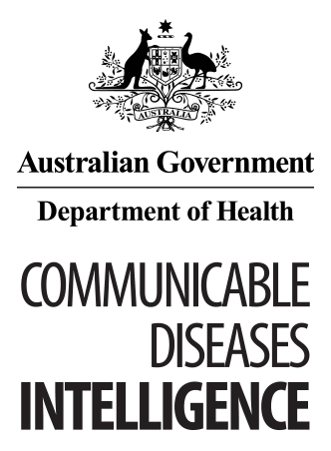
© Commonwealth of Australia 2018 - ISSN: 2209-6051 (Online)
This work is copyright. You may download, display, print and reproduce the whole or part of this work in unaltered form for your own personal use or, if you are part of an organisation, for internal use within your organisation, but only if you or your organisation do not use the reproduction for any commercial purpose and retain this copyright notice and all disclaimer notices as part of that reproduction. Apart from rights to use as permitted by the Copyright Act 1968 or allowed by this copyright notice, all other rights are reserved and you are not allowed to reproduce the whole or any part of this work in any way (electronic or otherwise) without first being given the specific written permission from the Commonwealth to do so. Requests and inquiries concerning reproduction and rights are to be sent to the Online, Services and External Relations Branch, Department of Health, GPO Box 9848, Canberra ACT 2601, or by email to copyright@health.gov.au
Communicable Diseases Intelligence aims to disseminate information on the epidemiology and control of communicable diseases in Australia. Communicable Diseases Intelligence invites contributions dealing with any aspect of communicable disease epidemiology, surveillance or prevention and control in Australia. Submissions can be in the form of original articles, short reports, surveillance summaries, reviews or correspondence. Instructions for authors can be found in Commun Dis Intell 2016;40(1):E189–E193.
Communicable Diseases Intelligence contributes to the work of the Communicable Diseases Network Australia.
http://www.health.gov.au/cdna

This journal is indexed by Index Medicus and Medline.
Disclaimer: Opinions expressed in Communicable Diseases Intelligence are those of the authors and not necessarily those of the Australian Government Department of Health or the Communicable Diseases Network Australia. Data may be subject to revision.

Editor: Cindy Toms
Deputy Editor: Phil Wright
Editorial and Production Staff: Leroy Trapani, Kasra Yousefi
Editorial Advisory Board: Peter McIntyre (Chair), David Durrheim, Mark Ferson, John Kaldor, Martyn Kirk
Website: http://www.health.gov.au/cdi
Communicable Diseases Intelligence is produced by Health Protection Policy Branch, Office of Health Protection, Australian Government, Department of Health, GPO Box 9848, (MDP 6) CANBERRA ACT 2601;
Email: cdi.editor@health.gov.au

