Australian Paediatric Surveillance Unit Annual Report, 2017
Suzy Teutsch, Yvonne Zurynski, Elizabeth Elliott, and all chief investigators of APSU surveillance studies

Context
This annual report provides an update on the surveillance conducted by the Australian Paediatric Surveillance Unit (APSU) during the period January to December 2017.

Introduction
Nine communicable diseases and complications were under surveillance by APSU in 2017. This report highlights key findings from studies on: acute flaccid paralysis (AFP); congenital cytomegalovirus (cCMV) infection, neonatal herpes simplex virus (HSV) infection, perinatal exposure to human immunodeficiency virus (HIV) and paediatric HIV infection, juvenile onset recurrent respiratory papillomatosis (JoRRP), severe complications of influenza (undertaken during the influenza season June to September 2017), microcephaly, which is monitored in relation to the emergence of Zika virus infection, congenital rubella infection and congenital varicella syndrome and neonatal varicella infection.

Methods

Australian Paediatric Surveillance Unit
Each month, 1570 paediatricians and other child health clinicians (including adolescent gynaecologists, paediatric surgeons, paediatric dermatologists) nationally are sent the APSU report card which lists the communicable diseases and complications mentioned in the introduction, as well as other non-communicable diseases under surveillance. Figure 1 shows an example of the APSU report card from December 2017, where there were 16 conditions listed: eight were communicable diseases and eight were non-communicable. The majority of clinicians (94%) report via email, clinicians are asked to indicate whether or not they have seen cases of any child newly diagnosed with one or more of the conditions listed on the report card (Figure 2).¹ Paediatricians who notify a case are then asked to complete a questionnaire providing de-identified clinical and demographic data, including presentation, management and short term outcome. APSU study protocols and case definitions for each condition are developed with a national team of study investigators and distributed before the study commences. The investigators provide clinical expertise for classification of cases and reporting of data. Further information about the study protocols and case definitions are available at www.apsu.org.au.

Figure 1: Example APSU Email Report Card
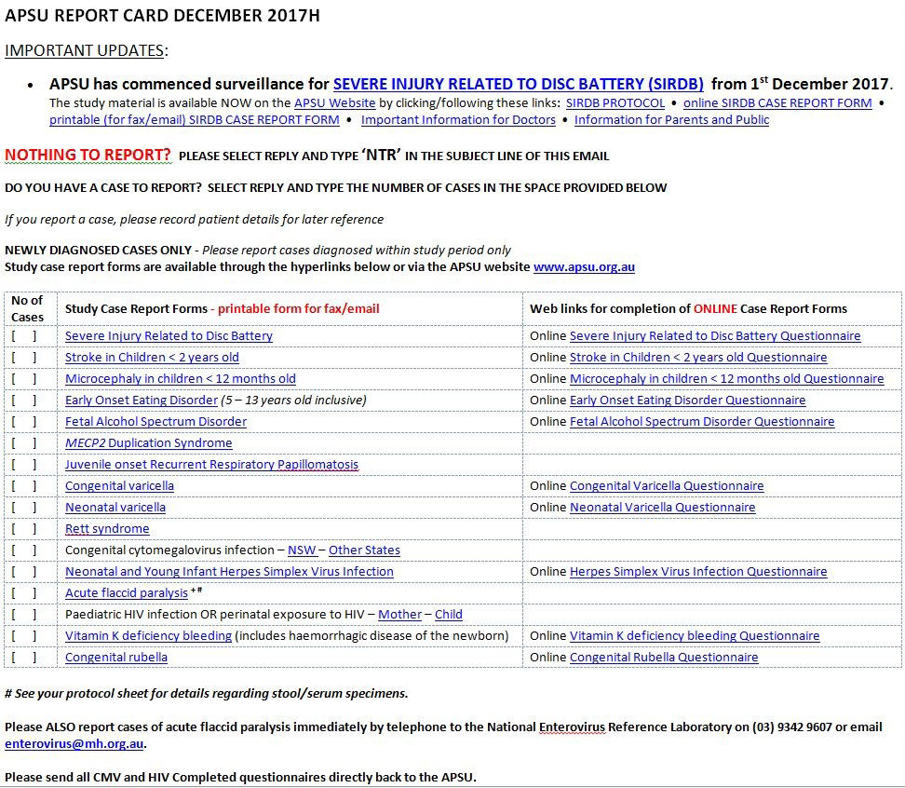

Figure 2: Schematic APSU Methodology

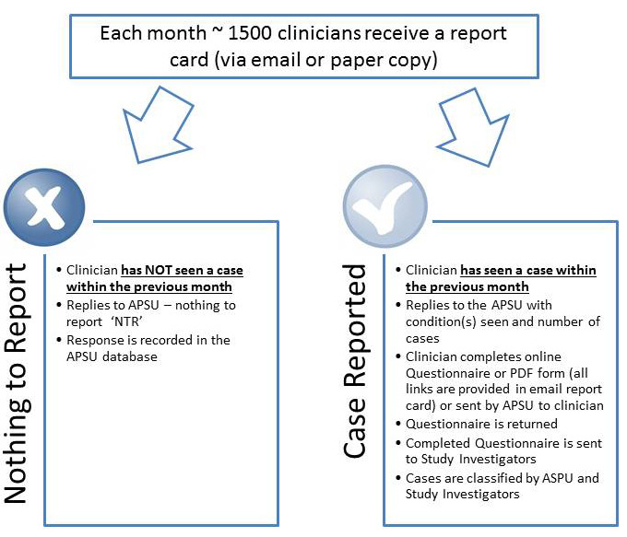

Results
The response rate to the monthly report card for the 12 months of 2017 was 91.4%. Where cases were notified, the questionnaire return rate was 93%. The number of confirmed cases of communicable diseases identified in 2017 in Australian children under the age of 16 years is shown in Table 1. Reported incidence rate estimates per 100,000 children per annum are also shown for the relevant population. The duration of studies and the total number of cases in the entire study period are also shown. All reported rates are based on child population estimates published by the Australian Bureau of Statistics.²
Table 1: Confirmed cases identified Australian children aged < 16 years in 2017 and for the total study period, and estimated incidence per 100,000 children of the relevant population per year, by condition
Condition | Date study commenced | Number of confirmed cases 2017 | Reported rate for 2017  (per 100,000) | Number of confirmed cases for total study period | Reported rate for total study period (per 100,000 per annum)
Acute flaccid paralysis | Mar 1995 | 59* | 1.27.44† | 1012 | 1.06†
congenital cytomegalovirus infection | Jan 1999 | 17 | 5.62§ | 323 | 6.02§
neonatal - Herpes simplex virus infection | Jan 1997 | 4 | 1.32§ | 194 | 3.31§
Herpes simplex virus infection in infants < 2 - 12 months | Jan 2012- 2016 | - | - | 16 | 1.04
Perinatal exposure to HIV | May 1993 | 56 | 18.34§ | 760 | 11.58§
HIV Infection | May 1993 | Nil | Nil | 87 | 0.09^{II}
Severe complications of influenza†† | Influenza season each year since 2008 | 107 | 2.29† | 623 | 1.42†
Juvenile onset recurrent respiratory papillomatosis (JoRRP)** | Oct 2011 | 2 | 0.04† | 17 | 0.06†
Microcephaly | June 2016 | 19 | 4.96 §§ | 39 | 6.32
Congenital rubella infection | May 1993 | Nil | Nil | 54 | 0.06^{II}
Congenital varicella | May 2006 | 1 | 0.33§ | 3 | 0.08§
Neonatal varicella | May 2006 | Nil | Nil | 27 | 0.07§
* Includes all cases of acute flaccid paralysis (AFP) reported via the APSU/National Enterovirus Reference Laboratory (NERL) and PAEDS. All cases have been classified by the Polio Expert Panel (PEP) as ‘non-polio AFP’ according to World Health Organization criteria.
† Based on population of children aged < 15 years.
§ Based on number of live births.
** Includes both confirmed (visualisation via endoscopy and histology report) and probable cases (visualisation via endoscopy but no histology report).
§§ Based on population of children aged < 12 months.
|| Based on population of children aged < 16 years.
†† Influenza surveillance was conducted each year since 2008 during the influenza season, July to September except in pandemic year (2009) when surveillance occurred from June to October.

Acute flaccid paralysis
To fulfil Australia’s commitment to eradication of poliomyelitis globally, acute flaccid paralysis (AFP) surveillance is conducted by the Department of Health with reporting to the World Health Organization (WHO) in the Western Pacific Region. Paediatricians are asked to report all cases of AFP immediately to two or more of three surveillance systems: ASPU, Paediatric Active Enhanced Disease Surveillance (PAEDS) and National Enterovirus Reference Laboratory (NERL), in order to maximise case ascertainment and collection of stool specimens. The clinical details of cases reported to the APSU are collected and collated by NERL. Clinical data on cases identified via PAEDS are also forwarded to NERL. PAEDS is a hospital-based surveillance system operating in five (and from 2018, in seven) tertiary paediatric hospitals around Australia, and cases are identified though active ascertainment by specialist surveillance nurses in hospitals.³ Data from all cases with AFP, including from the APSU, are submitted regularly to the Polio Expert Panel (PEP) and reviewed. Review outcomes for cases reported to both NERL and PAEDS are reported in the Australian National Enterovirus Reference Laboratory and PAEDS annual reports via the Communicable Diseases Intelligence website and to the WHO⁴, respectively, although it should be noted that there is overlap in the reporting of cases between these two surveillance systems and the APSU.
In 2017, there were a total of 58 confirmed cases of AFP in children aged under 15 years notified to either APSU, NERL or to PAEDS. Twenty cases were reported from New South Wales, 18 cases from Queensland, nine cases from Victoria, eight cases from Western Australia, five cases from South Australia, two cases from Tasmania, one case from the Northern Territory and one case from Australian Capital Territory. All cases were reviewed by the PEP and classified as non-polio AFP. The most common diagnoses associated with AFP were: Guillain-Barré syndrome (GBS) in 24 cases (41%), transverse myelitis in 15 cases (25%), acute disseminated encephalomyelitis (ADEM) in five cases (8%) and botulism in two cases (3%). Thirteen of the 58 cases were reported to APSU and also to both NERL and PAEDS, while seven cases were reported exclusively to APSU and NERL. The APSU contributes to the national AFP surveillance efforts to reach the WHO surveillance target of 1/100,000 children aged <15 years per annum⁵ and in 2017 this reached 1.27 per 100,000.

Congenital cytomegalovirus infection
In 2017, 17 confirmed cases of congenital Cytomegalovirus infection cCMV were reported to the APSU. Nine were reported from Queensland, four cases from New South Wales, two cases from Victoria, one case from Tasmania and one case from the ACT. Questionnaire data was only available for 14 of the 17 cases. One out of the 14 cases was identified as being Indigenous. Cases presented with multiple clinical features, including five cases with clinical deafness, four being small for gestational age, three with hepatitis, three with microcephaly, three with thrombocytopaenia, two with hepatomegaly, two with intracranial calcification, two with purpura/petechiae, one anaemia and one with developmental delay. Four cases presented with asymptomatic infection. The investigators of this study have recently shown that hearing loss can develop in asymptomatic cases of cCMV infection, while it is unclear as to whether neurodevelopmental delay also occurs.⁶ A total of 323 cCMV cases has been reported to the APSU since surveillance commenced in 1999, with 195 identified between 1999 and 2009.⁷ There has been no change in the number of cases reported to the APSU in the second decade since surveillance began (2009 – 2017), and similar proportions of clinical features have also been recorded. A recent update on the surveillance has been submitted for publication (Bartlett et al.).

Neonatal herpes simplex virus
The APSU protocol for this study was amended in late 2016 to discontinue Herpes Simplex virus (HSV) surveillance in infants up to 12 months of age and to continue surveillance for neonatal HSV only in infants under three months. The aim was to better describe HSV disease in this younger age group. Also, the protocol was amended to include asymptomatic cases of neonatal HSV infection in order to collect data on vertical transmission and postnatal management in this subgroup.
In 2017, there were seven notifications of neonatal HSV infection, three cases having confirmed HSV symptomatic infection and one case having confirmed asymptomatic HSV infection. Two confirmed cases were reported from Victoria, one case from New South Wales and one case from Western Australia. None of the symptomatic cases were reported as being Indigenous. All three cases had skin or eye or mouth (SEM) disease as the main clinical feature, without neurological involvement.
Twenty one years of APSU surveillance data (1997 - 2017) were analysed to describe the demographic and clinical features of confirmed cases of neonatal HSV infection in babies aged up to 60 days, who presented with neurological disease. Of 193 confirmed cases, 43% had neurological disease, either localised to the central nervous system or highly disseminated lethal disease with multi-organ involvement.⁸

Perinatal exposure to HIV and HIV infection
In 2017, there were 56 confirmed cases of perinatal exposure to HIV reported to the APSU, born to 55 mothers, which was an increase on 2016 numbers (40).⁹ In 2017, 25 cases were reported from Western Australia, 20 from Victoria and 11 from New South Wales. One case was identified as Indigenous. Preliminary investigations into the increase in case numbers in Western Australia indicate that this was either due to underreporting of new cases from the previous year(s), or due to a general increase in cases in that state resulting from increased immigration.
Data about perinatally exposed infants and their mothers were completed by APSU reporting clinicians on separate questionnaires data were available for 43 infants of the 56 infants and for 36 of the 55 mothers of these children. Data for the 36 mothers showed that all had received antiretroviral therapy during pregnancy. These women most frequently gave birth by vaginal delivery (n=16), followed by elective caesarean section (n=10) and emergency caesarean (n=7), with mode of delivery unknown or not reported for three cases.
There were no cases of HIV infection reported in children, although surveillance is continuing for this condition, The last cases of paediatric HIV infection (three cases) were reported to the APSU in 2014 and these were immigrant children.¹⁰

Severe complications of influenza
The number of cases of severe complications of influenza increased in 2017, with the estimated incidence rate reaching 2.29/100,000 children aged <15 years, compared with 2016 when the incidence was 0.62/100,100. The incidence in 2017, was the second highest recorded since APSU surveillance began in 2008 and was anticipated, given the high levels of influenza activity in 2017.¹¹ There were 107 confirmed cases reported in 2017; 56 cases from New South Wales, 38 cases from Queensland, 11 cases from Victoria, one case from South Australia and one case from Tasmania. 50 cases (46.7%) were identified as indigenous. The most frequently reported complications included: pneumonia (53.4%), requirement for mechanical ventilation (24.1%), seizure (16.1%), encephalitis/encephalopathy (14.4%), laboratory proven co-infection (13.0%), shock (requiring >40 ml/kg fluid resuscitation) (7.4%), rhabdomyolysis (4.5%), myocarditis/cardiomyopathy (4.2%), acute renal failure (3.9%), and Guillain-Barré syndrome (0.3%).
Out of the 107 cases reported, 53 (49.5%) were admitted to a paediatric intensive care unit and two children died. Both of these children had an underlying chronic condition predisposing to influenza; one child had a chronic lung disease and a genetic metabolic disorder, the other child had a history of supraventricular tachycardia. One child was vaccinated against influenza while the vaccination status for the other child was unknown. Both children who died in 2017 were over 12 years of age. Since 2008, 29 deaths due to severe influenza disease have been reported and 10 of the children who died were reported as previously healthy. We note the recent introduction of free influenza vaccination for all children under the age of five years in six Australian states and territories (Queensland, New South Wales, Victoria, South Australia, Tasmania and Australian Capital Territory), whereas this had previously only been available in Western Australia.

Juvenile onset recurrent respiratory papillomatosis (JoRRP)
The estimated incidence of JoRRP has been decreasing steadily since October 2011 (when surveillance first commenced), from 0.16/100,000 children <15 years when cases were first reported in 2012 to 0.02/100,000 in 2016. ¹² The decrease in reported cases followed introduction of the National Human papillomavirus (HPV) Vaccination Program in Australia in 2007¹³, The APSU received three notifications of JoRRP in 2017: one was a confirmed case of JoRRP, one was a probable case (i.e. the lesions were visualised on endoscopy but were not confirmed via histopathology and one was a duplicate notification. The confirmed case was reported from New South Wales and the probable case from Queensland. Both children were non-Indigenous. The main clinical features, respectively, were a mass on the palate and a hoarse voice. Seven confirmed JoRRP cases were reported in 2012 after the commencement of APSU surveillance, three cases in 2013, two cases each in 2014 and 2015, and one case in 2016, so the 2017 numbers fit with an overall decrease in JoRRP cases over the duration of the study.

Microcephaly
We conducted a 12-year retrospective medical record audit of microcephaly cases that presented to The Children’s Hospital at Westmead, Sydney, New South Wales in the years 2004 - 2015. The audit was done to estimate the background prevalence of microcephaly in the population catchment area.
Of 102 medical records coded as microcephaly ICD Q02 (Primary ICD-10AM code), 78 cases had documented microcephaly (Occipito-Frontal head Circumference 3rd centile) and 24 cases (23%) were miscoded. The highest number of cases was identified in 2013 (16 cases), followed by 2014 (11 cases). In other years of the study period there were < 10 cases recorded. Three cases (3.8%) were identified as Indigenous. Forty cases (51.3%) were male. Pregnancy and family history showed 54 mothers of cases (69.2%) had complications in pregnancy; 11 cases were < 37 weeks gestation and four cases were < 31 weeks gestation. Twenty cases (25.6%) had a history of congenital abnormality/or genetic disorder in the family and 10 cases (12.8%) were from a consanguineous union. Three children had siblings with microcephaly. In 56 cases (71.8%), there were signs and symptoms of clinically significant neurological or central nervous system (CNS) abnormality, including 35 children with seizure disorder. Causes of microcephaly included 10 cases with congenital infection (nine with CMV and one case with both HSV and CMV), 20 cases with chromosomal/genetic syndrome, 12 with intrauterine growth restriction (IUGR), seven cases with poorly controlled maternal diabetes, four cases with evidence of CNS trauma, ischaemia or haemorrhagic stroke, four cases with severe psychosocial, physical or nutritional deprivation, two cases with exposure to a known teratogen, one case with a neural tube defect and 28 cases in whom the cause was not clear. Fifteen cases (19.2%) had died.
APSU surveillance of microcephaly commenced in mid-2016. In 2017, there were 44 notifications of microcephaly, with 19 confirmed cases at the time of writing. Of the confirmed cases, 13 were reported from New South Wales, four from Victoria and two from Queensland. Three cases had indigenous status. Microcephaly was reportedly caused by CNS abnormalities or damage in four cases, a chromosomal syndrome in two cases, a single gene defect (Rett syndrome) in one case and severe deprivation including malnutrition or placental insufficiency in one case. Ten cases had an unknown cause. No children were identified by reporting paediatricians as having Zika-virus associated microcephaly.

Congenital rubella syndrome
There were no notifications of congenital rubella syndrome reported to the APSU during 2017. Since 1993, there have been 60 cases of congenital rubella infection (54 confirmed and six probable) reported to the APSU, with the most recent case notified in 2015. There were only five cases with confirmed congenital rubella syndrome notified to APSU between the years 2004 - 2013, compared with 29 cases in the preceding 10 years (1993 – 2003).^{14, 15} This is due to rubella being provided on the National Immunisation program, however it is important to continue surveillance, as imported and locally acquired cases still occur, especially among unvaccinated immigrant women.¹⁶

Congenital varicella syndrome and neonatal varicella infection
There was one confirmed case of congenital varicella syndrome reported during 2017 from Victoria, in a non-Indigenous child. The mother was reported as having a varicella-like illness during pregnancy, however a known varicella contact during pregnancy was not identified. The child presented with multiple clinical abnormalities including: herpes zoster (shingles), neurological abnormality, eye lesions and gastrointestinal abnormalities. To date, only three cases of this condition have been reported to the APSU since surveillance commenced in 2006.
No cases of neonatal varicella infection were reported to the APSU in 2017, however there have been 27 cases reported to the APSU since 2006.¹⁷ The varicella vaccine has only been available under the National Immunisation Program since late 2005 and has primarily targeted young children and older children aged 12-13 years in a catch-up program¹⁸, so many adults remain unvaccinated and are the likely source of infection. Continued surveillance is required at present, although the rate of congenital and neonatal disease is expected to continue to fall, as they are occurring in spite of universal childhood vaccination against varicella virus infection and likely reflects unvaccinated adults.

Conclusions and future directions
In 2017, analysis of APSU surveillance data of JoRRP showed that there was a significant association between decreased incidence of JoRRP in children and the introduction of the National HPV Vaccination Program.¹² Moreover, APSU surveillance in 2017 detected the highest incidence of children with severe complications of influenza virus infection since 2009, and elevated numbers of cases of perinatal exposure to HIV in Western Australia. APSU continued to detect cases of increasingly rare but vaccine-preventable conditions in children such as congenital varicella syndrome.
APSU findings were required to be distributed over the last 12 months to paediatricians via the Rare Kids newsletter, the APSU website and scientific conferences, including the May 2018 Royal Australasian College of Physicians Congress and publications.
In 2007, the APSU surveyed 1,260 Australian paediatricians, who report regularly to the APSU, for their opinions about the APSU, ¹⁹ with 95% of the responding paediatricians believing that APSU was of value and 70% believing that APSU data informed clinical practice.
The collection and analysis of novel, prospective data on rare communicable diseases in Australian children continues to be a priority for the APSU to inform appropriate prevention and management of these diseases.

Acknowledgements
Chief Investigators of APSU surveillance studies:
Acute Flaccid Paralysis: Dr Bruce Thorley, Victorian Infectious Diseases Reference Laboratory; Congenital Cytomegalovirus infection: Professor William Rawlinson, Virology Division, Department of Microbiology, Prince of Wales Hospital, Sydney, New South Wales; Congenital Rubella Syndrome: Professor Cheryl Jones, The Royal Children’s Hospital and The University of Melbourne, Melbourne, Victoria; Perinatal exposure to HIV and HIV Infection: A/Professor Rebecca Guy and Dr Skye McGregor, The Kirby Institute, UNSW Australia, Sydney, New South Wales; Herpes Simplex Virus Infection: Professor Cheryl Jones, The Royal Children’s Hospital and The University of Melbourne, Melbourne, Victoria; Congenital Varicella Syndrome and Neonatal Varicella Infection: Professor Robert Booy, National Centre for Immunisation Research and Surveillance, The Children’s Hospital at Westmead, New South Wales; Seasonal Influenza: Professor Elizabeth Elliott, The Children’s Hospital at Westmead and Discipline of Child and Adolescent Health, The University of Sydney, New South Wales and Professor Robert Booy, National Centre for Immunisation Research and Surveillance, The Children’s Hospital at Westmead, New South Wales. Juvenile onset Recurrent respiratory Papillomatosis: Dr Daniel Novakovic, The University of Sydney, New South Wales and Associate Professor Julia Brotherton, National HPV Vaccination Program Register, VCS Inc., East Melbourne, Victoria. Microcephaly: Professor Elizabeth Elliott, The Children’s Hospital at Westmead and Discipline of Child and Adolescent Health, The University of Sydney, New South Wales and Professor Cheryl Jones, The Royal Children’s Hospital and The University of Melbourne, Melbourne, Victoria.
APSU also acknowledges the contribution of study coordinators: Beverley Hall (Study Co-ordinator cCMV), Linda Hobday (National AFP Surveillance Co-ordinator), Dr Gulam Khandaker (Congenital Rubella Infection; Congenital Varicella Syndrome and Neonatal Varicella Infection) and Jocelynne McRae (PAEDS Coordinator - Research Nurse).
We would also like to acknowledge the continued contribution of all Australian Paediatricians and other child health professionals who participate in surveillance studies conducted by the APSU. Special thanks go to the APSU staff Amy Phu and Dannielle Handel for the management of the APSU database.
APSU activities are supported by the Australian Government Department of Health; Discipline of Child and Adolescent Health, Sydney Medical School, The University of Sydney; The Children’s Hospital at Westmead and The Royal Australasian College of Physicians.

Author details
Dr Suzy M. Teutsch^{1, 2}, Research Fellow, Australian Paediatric Surveillance Unit
A/Professor Yvonne A. Zurynski^{1, 2}, Director of Research, Australian Paediatric Surveillance Unit
Professor Elizabeth E. Elliott^{1, 2, 3} Director, Australian Paediatric Surveillance Unit
Australian Paediatric Surveillance Unit, Kids Research SCHN, Westmead, New South Wales
Sydney Medical School, Discipline of Child and Adolescent Health, The University of Sydney, Sydney, New South Wales
Sydney Children’s Hospitals Network (Westmead), Westmead, New South Wales
Corresponding author: Dr Suzy M. Teutsch, Research Fellow, Australian Paediatric Surveillance Unit, Kids Research SCHN, The Children’s Hospital at Westmead, Locked Bag 4001, WESTMEAD NSW 2145. Telephone: +61 2 9845 3025 (direct) or +61 2 9845 3005 (office). Email: suzy.teutsch@health.nsw.gov.au

References
- He S, Zurynski YA, Elliott EJ. Evaluation of a national resource to identify and study rare diseases: the Australian Paediatric Surveillance Unit. J Paediatr Child Health. 2009;45(9):498-504.
- Australian Bureau of Statistics. 3101.0 - Australian Demographic Statistics, Sep 2016. Canberra: Australian Bureau of Statistics: 2016.
- Zurynski Y, McIntyre P, Booy R, Elliott EJ, Paeds Investigators Group. Paediatric active enhanced disease surveillance: a new surveillance system for Australia. J Paediatr Child Health. 2013; 49(7): 588-594.
- Department of Health. Communicable Diseases Intelligence [Internet]. [Accessed 3rd April 2017]. Available from: http://www.health.gov.au/internet/main/publishing.nsf/Content/cda-pubs-cdi-cdiintro.htm
- Desai S, Smith T, Thorley BR, Grenier D, Dickson N, Altpeter E, et al. Performance of acute flaccid paralysis surveillance compared with World Health Organization standards. J Paediatr Child Health. 2015; 51(2):209-214.
- Bartlett AW, McMullan B, Rawlinson WD, Palasanthiran P, Hearing and neurodevelopmental outcomes for children with asymptomatic congenital cytomegalovirus infection: A systematic review. Rev Med Virol. 2017;27:e1938.
- McMullan, BJ., Palasanthiran, P, Jones CA, Hall BM, Robertson PW Howard J, Rawlinson WD. (2011). Congenital cytomegalovirus--time to diagnosis, management and clinical sequelae in Australia: opportunities for earlier identification. MJA.194(12), 625-629.
- Teutsch S, Raynes-Greenow C, Khandaker G, Zurynski Y, Jones CA. Population- based surveillance indicates a varied pattern of HSV CNS infection in young infants. Abstract, 10th World Congress of the World Society for Paediatric Infectious Diseases, 2016.
- Kirby Institute. HIV, viral hepatitis and sexually transmissible infections in Australia: annual surveillance report 2017. Sydney: Kirby Institute, UNSW Sydney; 2017.
- Deverell M, Zurynski Y, Elliott E and all chief investigators of APSU surveillance studies. Australian Paediatric Surveillance Unit Annual Report, 2014. Comm Dis Intell Q Rep. 2015; 40(2):E216-E220.
- Australian Government Department of Health 2017 Influenza season in Australia: A summary from the National Influenza Surveillance Committee. Available from www.health.gov.au/flureport.
- Novakovic D, Cheng ATL, Zurynski Y, Booy R, Walker PJ, Berkowitz R, et al. A prospective study of the incidence of Juvenile-Onset Recurrent Respiratory Papillomatosis after implementation of a National HPV Vaccination Program. J Infect Dis. 2018;217:208-212.
- National HPV Vaccination Program Register. 2017. Available from http://www.hpvregister.org.au/
- Khandaker G, Zurynski Y, Jones C. Surveillance for congenital rubella in Australia since 1993: cases reported between 2004 and 2013. Vaccine. 2014; 32(50):6746-6751
- Martin N, Durrheim D, Khandaker, Butler M, Jones C. Using the two-source capture-recapture method to estimate the incidence and case ascertainment of congenital rubella syndrome in Australia, 1993-2013. West Pacific Surveill and Resp J. 2016; 7:34-37.
- Sathanandan D, Gupta L, Liu B, Rutherford A, Lane J. Factors associated with low immunity to rubella infection on antenatal screening. Aust NZ J Obstetrics. 2005; 45:435-438.
- Khandaker G, Marshall H, Peadon E, et al. Congenital and neonatal varicella: impact of the national varicella vaccination programme in Australia. Arch Dis Child. 2011: 96(5), 453-456.
- Heywood A, Wang H, Macartney K, McIntyre P. Varicella and herpes zoster hospitalizations before and after implementation of one-dose varicella vaccination in Australia: an ecological study. Bull World Health Organ. 2014; 92(8): 593–604.
- He S, Zurynski YA, Elliott EJ. What do paediatricians think of the Australian Paediatric Surveillance Unit? J Paediatr Child Health. 2010; 46(7-8):412-418.
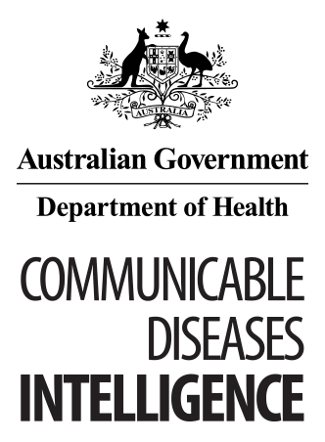
© Commonwealth of Australia 2018 - ISSN: 2209-6051 (Online)
This work is copyright. You may download, display, print and reproduce the whole or part of this work in unaltered form for your own personal use or, if you are part of an organisation, for internal use within your organisation, but only if you or your organisation do not use the reproduction for any commercial purpose and retain this copyright notice and all disclaimer notices as part of that reproduction. Apart from rights to use as permitted by the Copyright Act 1968 or allowed by this copyright notice, all other rights are reserved and you are not allowed to reproduce the whole or any part of this work in any way (electronic or otherwise) without first being given the specific written permission from the Commonwealth to do so. Requests and inquiries concerning reproduction and rights are to be sent to the Online, Services and External Relations Branch, Department of Health, GPO Box 9848, Canberra ACT 2601, or by email to copyright@health.gov.au
Communicable Diseases Intelligence aims to disseminate information on the epidemiology and control of communicable diseases in Australia. Communicable Diseases Intelligence invites contributions dealing with any aspect of communicable disease epidemiology, surveillance or prevention and control in Australia. Submissions can be in the form of original articles, short reports, surveillance summaries, reviews or correspondence. Instructions for authors can be found in Commun Dis Intell 2016;40(1):E189–E193.
Communicable Diseases Intelligence contributes to the work of the Communicable Diseases Network Australia.
http://www.health.gov.au/cdna

This journal is indexed by Index Medicus and Medline.
Disclaimer: Opinions expressed in Communicable Diseases Intelligence are those of the authors and not necessarily those of the Australian Government Department of Health or the Communicable Diseases Network Australia. Data may be subject to revision.

Editor: Cindy Toms
Deputy Editor: Phil Wright
Editorial and Production Staff: Leroy Trapani, Kasra Yousefi
Editorial Advisory Board: Peter McIntyre (Chair), David Durrheim, Mark Ferson, John Kaldor, Martyn Kirk
Website: http://www.health.gov.au/cdi
Communicable Diseases Intelligence is produced by Health Protection Policy Branch, Office of Health Protection, Australian Government, Department of Health, GPO Box 9848, (MDP 6) CANBERRA ACT 2601;
Email: cdi.editor@health.gov.au

