• Volume • • Electronic publication date:

Australian Rotavirus Surveillance Program Annual Report, 2023

Sarah Thomas, Nada Bogdanovic-Sakran, Celeste M Donato, Archana T Sriraman, Daniel Pavlic, Julie E Bines and the Australian Rotavirus Surveillance Group

# Abstract

This report from the Australian Rotavirus Surveillance Program describes the circulating rotavirus genotypes identified in children and adults during the period 1 January to 31 December 2023. During this period, 1,942 faecal samples were referred for rotavirus G- and P- genotype analysis; of these samples, 1,781 were confirmed as rotavirus positive. This is the highest number of rotavirus-positive confirmed samples by the Australian Rotavirus Surveillance Program in the past > 20 years of operation of the program. Of these confirmed rotavirus positive samples, 1,554 of 1,781 (87.3%) were identified as wildtype rotavirus, and 226 of 1,781 (12.7%) were identified as the Rotarix vaccine-like strain. G3P[8] was the dominant genotype nationally (n = 1,117/1,554; 71.9%), comprised of both human G3P[8] (n = 662/1,554; 42.6%) and the equine-like G3P[8] variant (455/1,554; 29.3%). Other frequently identified genotypes included G2P[4] (n = 146/1,554; 9.4%), G12P[8] (n = 100/1,554; 6.4%), G1P[8] (n = 40/1,554; 2.6%), G9P[4] (n = 32/1,554; 2.1%) and G8P[8] (n = 21/1,554; 1.4%).

Genotype distribution was consistent amongst most jurisdictions, with human G3P[8] and equine-like G3P[8] the two dominant genotypes in all jurisdictions, with the exception of the Northern Territory and Western Australia where G2P[4] (7/103; 6.8%) and G12P[8] (54/241; 22.4%) were the second most dominant genotypes respectively.

Consistent with observations in 2022, a small number of unusual genotypes were identified (n = 42/1,554; 2.7%), including G2P[8] (n = 18/1,554; 1.2%), and G3P[4] (n = 6/1,554; 0.4%). The high number of rotavirus positive samples received by the program reflected the notifications for rotavirus disease reported to the National Notifiable Disease Surveillance Service. The ability to monitor the genotypes of rotavirus strains causing disease across ages and across jurisdictions provides important data on assessing the performance of the national rotavirus vaccine program and to inform public health interventions during outbreaks. This Australian Rotavirus Surveillance Program also provides important data to monitor annual variations in genotypic patterns and to provide diagnostic laboratories with quality assurance by reporting incidences of wildtype, vaccine-like, or false positive rotavirus results.

Keywords: rotavirus; gastroenteritis; genotype; surveillance; Australia; vaccine; G3P[8]; equine-like G3P[8]

# Introduction

Group A rotaviruses were identified as the cause of 128,500 deaths and 258 million episodes of diarrhoea among children < 5 years of age in 2016.1 To address this burden, there are now four World Health Organization (WHO) pre-qualified rotavirus vaccines introduced nationally or regionally into the routine immunisation programs of over 126 countries: Rotarix (GlaxoSmith Kline, Belgium); RotaTeq (Merck, USA); Rotavac (Bharat Biotech, India); and RotaSIL (Serum Institute of India, India).2 Post-licensure studies have shown that rotavirus vaccines are safe, effective and associated with significant reduction in the rotavirus burden of disease.3–5

In Australia, rotavirus vaccines were introduced into the routine infant immunisation schedule in the Northern Territory in 2006 and nationally on 1 July 2007. The vaccine choice, Rotarix [GSK] or RotaTeq [Merck] was initially based on a state or territory decision. RotaTeq was administered in Queensland, South Australia and Victoria, whereas Rotarix was administered in the Australian Capital Territory, New South Wales, the Northern Territory and Tasmania. Western Australia initially administered Rotarix but changed to RotaTeq in May 2009. On 1 July 2017, all states and territories in Australia changed to Rotarix.6,7 Following the introduction of rotavirus vaccines, there was a significant reduction in rotavirus-coded and non-rotavirus-coded acute gastroenteritis hospitalisations of children ≤ 5 years of age.3–5 Within the first six years of vaccine introduction, an estimated 77,000 hospitalisations were prevented, 90% of which were in children ≤ 5 years, with indications of herd protection occurring in older age groups.5

In Australia, rotavirus gastroenteritis has been a notifiable disease since 2010, with all jurisdictions reporting through the National Notifiable Disease Surveillance Service (NNDSS) with national representation since 2018.8 This service monitors the reports of rotavirus disease across each jurisdiction monthly and is stratified by age.

Since 1999, the Australian Rotavirus Surveillance Program (ARSP) has characterised rotavirus genotypes causing severe disease in Australian children ≤ 5 years of age.6 From 2010 onwards, surveillance was extended to children ≥ 5 years of age and adults. The ARSP receives rotavirus-positive samples from collaborating laboratories across all states and territories. Samples are confirmed as rotavirus positive and genotyped. Rotavirus strains are defined by a binary classification system based on the two outer capsid proteins, VP7 (G, glycoprotein) and VP4 (P, protease-sensitive), to describe genotypes.9 Globally, there are five common genotype combinations identified in humans: G1P[8], G2P[4], G3P[8], G4P[8], and G9P[8], although G8P[8] and G12P[8] have also been described as globally important genotypes over the last decade.10–12 Additionally, whole genome classification assigns genotypes to each of the 11 genes: Gx-P[x]-Ix-Rx-Cx-Mx-Ax-Nx-Tx-Ex-Hx, denoting the VP7-VP4-VP6-VP1-VP2-VP3-NSP1-NSP2-NSP3-NSP4-NSP5/6 genes.13 The majority of human rotavirus genomes fall under two genotype constellations: Wa-like (genogroup 1: G1/3/4/9/12-P[8]-I1-R1-C1-M1-A1-N1-T1-E1-H1) and DS-1-like (genogroup 2: G2-P[4]-I2-R2-C2-M2-A2-N2-T2-E2-H2).13 A third genogroup, AU-1-like, is also detected in humans, however less frequently (genogroup 3: G3-P[9]-I3-R3-C3-M3-A3-N3-T3-E3-H3).13 Numerous mechanisms contribute to rotavirus diversity including genetic drift, reassortment and zoonotic transmission. The segmented genome allows for reassortment both within and between human and animal strains, leading to the emergence of novel strains and unusual genotype combinations.14

The genotype data provided by the Australian Rotavirus Surveillance Program has revealed changes in rotavirus genetic diversity, as well as temporal and geographic fluctuations.6,15 Furthermore, differences in genotype diversity and dominance were observed when comparing vaccines by jurisdictions, suggesting that RotaTeq and Rotarix exert different immunological pressures.6,15 The continued surveillance and characterisation of rotavirus genotypes circulating in Australia will provide important insights into whether changes in vaccine immunisation programs can impact virus epidemiology and alter genotype diversity, which could have ongoing consequences for the success of current and future vaccination programs. This report describes the G- and P- genotype distribution of rotavirus strains causing severe gastroenteritis in Australia for the period 1 January to 31 December 2023.

# Methods

Faecal samples were tested for the presence of rotavirus by quantitative reverse transcription polymerase chain reaction (RT-qPCR), enzyme immunoassay (EIA), or latex agglutination by collaborating laboratories Australia-wide. Positive samples were frozen and sent to the National Rotavirus Reference Centre (NRRC), Melbourne, together with available metadata including date of collection (DOC), date of birth (DOB), sex, postcode, and the RT-qPCR cycle threshold (Ct) values generated by the collaborating laboratory (where possible). Samples were received from the following 13 collaborating centres located in the Australian Capital Territory (ACT), New South Wales (NSW), Northern Territory (NT), Queensland (Qld), South Australia (SA), Tasmania (Tas.), Victoria (Vic.), and Western Australia (WA) (n = number of samples received):

* Microbiology Department, Canberra Hospital, ACT (n = 14);
* Microbiology Department, SEALS-Randwick, Prince of Wales Hospital NSW (n = 155);
* Department of Microbiology & Infectious Diseases, Liverpool Hospital, Liverpool, NSW (n = 226);
* Virology Department, The Children’s Hospital, Westmead, NSW (n = 94);
* Douglass Hanly Moir Pathology, NSW (n = 28);
* The Microbiology Department, Alice Springs Hospital, Alice Springs, NT (n = 142);
* Pathology Queensland, Royal Brisbane & Women’s Hospital, Herston, Qld (n = 378);
* Microbiology and Infectious diseases laboratory, SA Pathology, Adelaide, SA, South Australia (n = 403);
* Molecular Medicine, Pathology Services, Royal Hobart Hospital, Hobart, Tas. (n = 15);
* Department of Microbiology, Monash Medical Centre, Clayton, Vic. (n = 115);
* Laboratory Services, Royal Children’s Hospital, Parkville, Vic. (n = 73);
* Enteric Virus Reference Laboratory, Victorian Infectious Diseases Reference Laboratory, Melbourne, Vic. (n = 7);
* QEII Microbiology Department, PathWest Laboratory Medicine, Nedlands, WA (n = 292).

Samples were allocated a unique laboratory code and entered in the ARSP database (Excel and REDCap) and stored at -30 ⁰C until analysed.

Viral RNA was extracted from 10–20% faecal extracts using the QIAamp Viral RNA mini extraction kit (QIAGEN), according to the manufacturer’s instructions, except for eluting in 50 µl of nuclease-free water. Rotavirus G- and P- genotypes were determined using an in-house hemi-nested multiplex RT-PCR assay. The first-round RT-PCR reactions were performed using the One Step RT-PCR kit (QIAGEN), in conjunction with VP7 (VP7F/VP7R) or VP4 (VP4F/VP4R) conserved primers.16,17 The second-round genotyping PCR reactions were conducted using specific oligonucleotide primers for G types G1, G2, G3, G4, G8, and G9, or P types P[4], P[6], P[8], P[9], P[10], and P[11].17–19 The G- and P- genotype was determined using agarose gel electrophoresis of second-round PCR products. Samples failing to generate a second-round PCR amplicon or with inconclusive results were further tested by VP6-specific RT-PCR using the Superscript III One-Step RT-PCR System with Platinum Taq DNA Polymerase (Invitrogen) and primers Rot3 and Rot5 as described previously.20,21

Sanger sequencing was used to determine the VP7 and/or VP4 nucleotide sequence for PCR non-typeable samples. The current set of primers in the second-round G-typing protocol is not able to assign genotypes to equine-like G3, G12, and unusual rotavirus strains. Due to the G9 genotyping primer binding non-specifically to equine-like G3 samples, all G9 samples were further tested using equine-like G3 primers as described previously.22,23 The VP7 gene of each G1P[8] sample was sequenced to determine if wildtype or Rotarix vaccine-like strain was detected. The VP7 gene of any sample which was negative by equine-like G3 PCR (potentially G9) was sequenced. Samples which had no first-round PCR amplicon were re-amplified using the Superscript III One-Step RT-PCR System with Platinum Taq DNA Polymerase (Invitrogen), in conjunction with VP7 (Beg9/End9) or VP4 (Con2/Con3) primers, as described previously.16,17,20 First-round VP7 and VP4 amplicons were purified using the Wizard SV Gel for PCR Clean-Up System (Promega) or the QIAquick Gel Extraction Kit (QIAGEN), according to the manufacturer’s protocol with the exception of eluting in 30µl of nuclease-free water. Purified DNA and oligonucleotide primers (VP7F/VP7R, VP4F/VP4R, Beg9/End9, or Con2/Con3) were sent to the Australian Genome Research Facility (AGRF), Melbourne, and sequenced using an ABI PRISM BigDye Terminator Cycle Sequencing Reaction Kit (Applied Biosystems) in an Applied Biosystems 3730xl DNA Analyzer (Applied Biosystems). Electropherograms were visually analysed and edited using Sequencher v.5.4.6. Genotype assignment was determined using BLAST.[1]

# Results

Number of samples

A total of 1,942 samples determined to be rotavirus positive by collaborating laboratories were referred to the NRRC during the period 1 January to 31 December 2023 (Figure 1). A subset of samples were not analysed further due to the sample being duplicate (n = 17), insufficient (n = 4), missing (not received; n = 33), or not confirmed as rotavirus positive by VP6 PCR analysis at the Murdoch Children’s Research Institute (MCRI) (n = 107).

Figure 1: Consort diagram of rotavirus positive stool samples included in the 2023 ARSP, 1 January to 31 December 2023

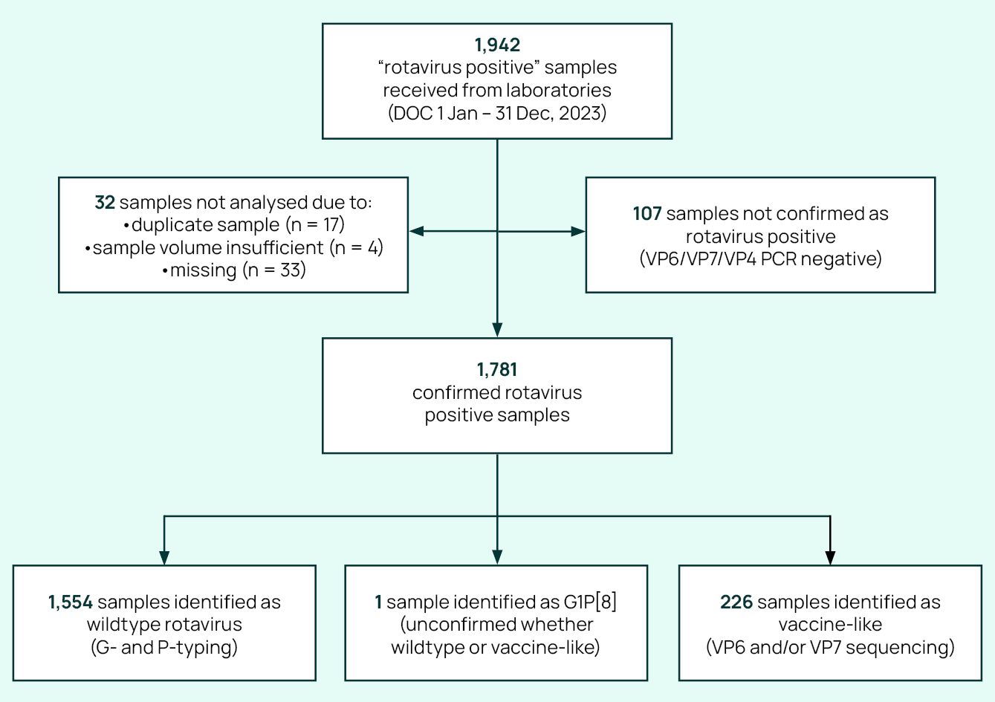

A total of 1,781 samples were genotyped. Samples were then classified as wildtype (no vaccine component identified) or vaccine-like (Rotarix vaccine component identified), based on genotype and the analysis of the top BLAST hits of any G1 VP7 sequence.

Of the 1,554 samples confirmed as wildtype, 691 (44.5%) were collected from children < 5 years of age, and 863 (55.5%) were obtained from children ≥ 5 years of age and from adults (Table 1). In children < 5 years of age, the largest proportion of samples were from children aged 1–2 years (n = 215/691; 31.1%; Table 1). An additional 226 samples were identified as vaccine-like by VP7 sequencing, with the majority (n = 220/226; 97.3%) obtained from infants ≤ 6 months of age (Table 2). One sample genotyped as G1P[8] could not be determined as wildtype or vaccine-like due to repeated failed attempts to generate adequate sequencing results.

Table 1: Age distribution of wildtype rotavirus gastroenteritis cases, Australia, 1 January to 31 December 2023

| Age (months) | Age (years) | n | % of total | % < 5 years of age |
| --- | --- | --- | --- | --- |
| 0–6 | — | 116 | 7.5 | 16.8 |
| 7–12 | ≤ 1 | 100 | 6.4 | 14.5 |
| 13–24 | 1 –≤ 2 | 215 | 13.8 | 31.1 |
| 25–36 | 2 –≤ 3 | 128 | 8.2 | 18.5 |
| 37–48 | 3 –≤ 4 | 82 | 5.3 | 11.9 |
| 49–60 | 4 –≤ 5 | 50 | 3.2 | 7.2 |
| Subtotal | — | 691 | 44.5 | 100.0 |
| 61–120 | 5 –≤ 10 | 180 | 11.6 | — |
| 121–240 | 10 –≤ 20 | 95 | 6.1 | — |
| 241–960 | 20 –≤ 80 | 531 | 34.2 | — |
| 961+ | > 80 | 57 | 3.7 | — |
| Subtotal | — | 863 | 55.5 | — |
| Total | — | 1,554 | 100.0 | — |

Table 2: Age distribution of rotavirus vaccine-like gastroenteritis cases, Australia, 1 January to 31 December 2023

| Age (months) | Age (years) | n | % of total | % < 5 years of age |
| --- | --- | --- | --- | --- |
| 0–6 | — | 220 | 97.3 | 99.5 |
| 7–12 | ≤ 1 | 0 | 0.0 | 0.0 |
| 13–24 | 1 –≤ 2 | 0 | 0.0 | 0.0 |
| 25–36 | 2 –≤ 3 | 0 | 0.0 | 0.0 |
| 37–48 | 3 –≤ 4 | 1 | 0.4 | 0.5 |
| 49–60 | 4 –≤ 5 | 0 | 0.0 | 0.0 |
| Subtotal | — | 221 | 97.8 | 100.0 |
| 61–120 | 5 –≤ 10 | 1 | 0.4 | — |
| 121–240 | 10 –≤ 20 | 0 | 0.0 | — |
| 241–960 | 20 –≤ 80 | 3 | 1.3 | — |
| 961+ | > 80 | 1 | 0.4 | — |
| Subtotal | — | 5 | 2.2 | — |
| Total | — | 226 | 100.0 | — |

## Rotavirus positive samples identified by month

Wildtype and vaccine-like rotavirus positive samples were analysed by date of collection (DOC: month) and then compared to monthly notifications received by the NNDSS (Figure 2).8 The peak of notifications reported by the NNDSS correlated with the number of samples received by the NRRC and both reflected a seasonal pattern. There was no seasonal association for samples with a vaccine-like strain (Figure 2).

Figure 2: Number of analysed wildtype and vaccine-like samples with respect to NNDSS number of rotavirus notifications

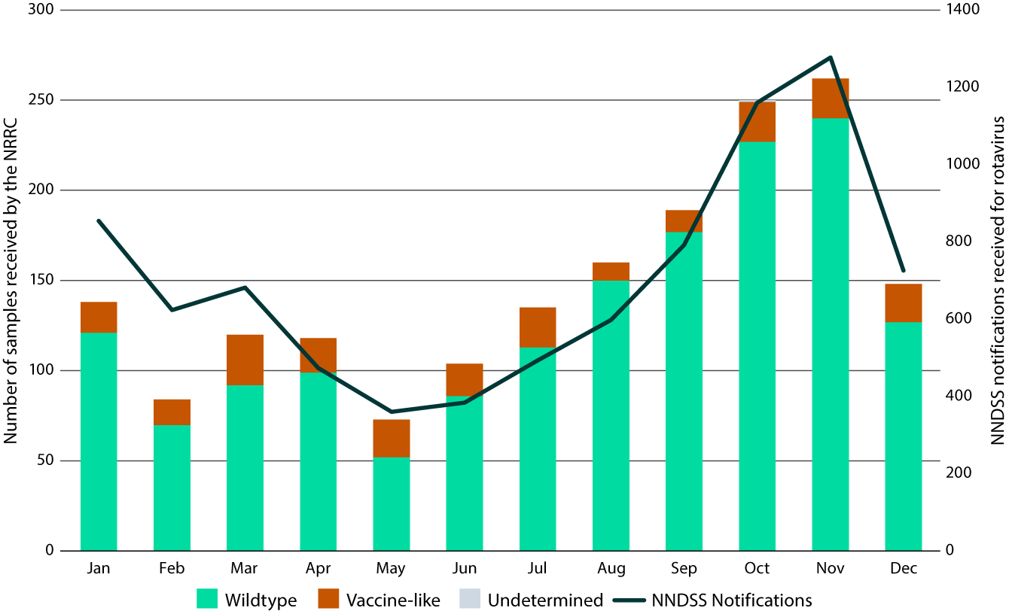

## Rotavirus positive samples for month for each jurisdiction

Rotavirus positive samples were received from all states and territories for the 2023 surveillance period. The highest numbers of wildtype samples for this surveillance period were from New South Wales (n = 358/1,554; 23.0%), followed by South Australia (n = 353/1,554; 22.7%), and Queensland (n = 311/1,554; 20.0%) (Table 3). This surveillance period reveals a comprehensive national representation of samples, which has been sustained since 2022, following reduced numbers and capacity in 2020 and 2021 at collaborating laboratories during and post-SARS-CoV-2 lockdowns which resulted in a lack of representation from all states and territories.

Table 3: Rotavirus G and P genotype distribution observed during the period 1 January to 31 December 2023

| Jurisdictiona,b | Age (years) | Total n | G1P[8] | | G2P[4] | | G3P[8] | | Eq G3P[8]c | | G8P[8] | | G9P[4] | | G9P[8] | | G12P[8] | | Mixed | | Otherd | | Non-typee | |
| --- | --- | --- | --- | --- | --- | --- | --- | --- | --- | --- | --- | --- | --- | --- | --- | --- | --- | --- | --- | --- | --- | --- | --- | --- |
| n | % | n | % | n | % | n | % | n | % | n | % | n | % | n | % | n | % | n | % | n | % |
| **ACT** | < 5 | 9 | 0 | 0 | 1 | 11 | 4 | 44 | 4 | 44 | 0 | 0 | 0 | 0 | 0 | 0 | 0 | 0 | 0 | 0 | 0 | 0 | 0 | 0 |
| ≥ 5 | 4 | 0 | 0 | 1 | 25 | 2 | 50 | 1 | 25 | 0 | 0 | 0 | 0 | 0 | 0 | 0 | 0 | 0 | 0 | 0 | 0 | 0 | 0 |
| **NSW** | < 5 | 170 | 3 | 2 | 15 | 9 | 41 | 24 | 73 | 43 | 2 | 1 | 10 | 0 | 1 | 1 | 10 | 6 | 3 | 2 | 7 | 4 | 5 | 3 |
| ≥ 5 | 188 | 8 | 4 | 24 | 13 | 49 | 26 | 71 | 38 | 0 | 0 | 2 | 0 | 0 | 0 | 7 | 4 | 5 | 3 | 13 | 7 | 9 | 5 |
| **NT** | < 5 | 76 | 0 | 0 | 4 | 5 | 65 | 86 | 0 | 0 | 0 | 0 | 0 | 0 | 0 | 0 | 0 | 0 | 1 | 1 | 1 | 1 | 5 | 7 |
| ≥ 5 | 27 | 0 | 0 | 3 | 11 | 21 | 78 | 0 | 0 | 0 | 0 | 0 | 0 | 0 | 0 | 0 | 0 | 0 | 0 | 0 | 0 | 3 | 11 |
| **Qld** | < 5 | 116 | 0 | 0 | 4 | 3 | 87 | 75 | 20 | 17 | 0 | 0 | 0 | 0 | 0 | 0 | 4 | 3 | 0 | 0 | 0 | 0 | 1 | 1 |
| ≥ 5 | 195 | 8 | 4 | 17 | 9 | 120 | 62 | 20 | 10 | 2 | 1 | 1 | 0 | 1 | 1 | 13 | 7 | 5 | 3 | 7 | 4 | 1 | 1 |
| **SA** | < 5 | 136 | 2 | 1 | 16 | 12 | 33 | 24 | 84 | 62 | 0 | 0 | 0 | 0 | 0 | 0 | 0 | 0 | 0 | 0 | 1 | 1 | 0 | 0 |
| ≥ 5 | 217 | 5 | 2 | 42 | 19 | 43 | 20 | 113 | 52 | 0 | 0 | 4 | 0 | 1 | 0 | 3 | 1 | 2 | 1 | 3 | 1 | 1 | 0 |
| **Tas.** | < 5 | 2 | 0 | 0 | 0 | 0 | 1 | 50 | 1 | 50 | 0 | 0 | 0 | 0 | 0 | 0 | 0 | 0 | 0 | 0 | 0 | 0 | 0 | 0 |
| ≥ 5 | 7 | 0 | 0 | 0 | 0 | 5 | 71 | 2 | 29 | 0 | 0 | 0 | 0 | 0 | 0 | 0 | 0 | 0 | 0 | 0 | 0 | 0 | 0 |
| **Vic.** | < 5 | 60 | 3 | 5 | 6 | 10 | 19 | 32 | 23 | 38 | 0 | 0 | 5 | 0 | 0 | 0 | 1 | 2 | 0 | 0 | 1 | 2 | 2 | 3 |
| ≥ 5 | 106 | 4 | 4 | 13 | 12 | 33 | 31 | 29 | 27 | 0 | 0 | 8 | 0 | 0 | 0 | 8 | 8 | 2 | 2 | 4 | 4 | 5 | 5 |
| **WA** | < 5 | 122 | 2 | 2 | 0 | 0 | 75 | 61 | 9 | 7 | 8 | 7 | 1 | 0 | 0 | 0 | 24 | 20 | 0 | 0 | 3 | 2 | 0 | 0 |
| ≥ 5 | 119 | 5 | 4 | 0 | 0 | 64 | 54 | 5 | 4 | 9 | 8 | 1 | 0 | 0 | 0 | 30 | 25 | 3 | 3 | 2 | 2 | 0 | 0 |
| **Subtotal** | < 5 | 691 | 10 | 1.4 | 46 | 6.7 | 325 | 47.0 | 214 | 31.0 | 10 | 1.4 | 16 | 2.3 | 1 | 0.1 | 39 | 5.6 | 4 | 0.6 | 13 | 1.9 | 13 | 1.9 |
| ≥ 5 | 863 | 30 | 3.5 | 100 | 11.6 | 337 | 39.0 | 241 | 27.9 | 11 | 1.3 | 16 | 1.9 | 2 | 0.2 | 61 | 7.1 | 17 | 2.0 | 29 | 3.4 | 19 | 2.2 |
| Total | — | 1,554 | 40 | 2.6 | 146 | 9.4 | 662 | 42.6 | 455 | 29.3 | 21 | 1.4 | 32 | 2.1 | 3 | 0.2 | 100 | 6.4 | 21 | 1.4 | 42 | 2.7 | 32 | 2.1 |

a ACT: Australian Capital Territory; NSW: New South Wales; NT: Northern Territory; Qld: Queensland; SA: South Australia; Tas.: Tasmania; Vic.: Victoria; WA: Western Australia.

b Samples sorted by sample location, not collection location.

c Equine-like G3P[8].

d Other: unusual and rarely detected genotypes as detailed in Table 4.

e Specimens for which G or P genotype was not determined.

Jurisdiction-based notification reports per 100,000 population suggested that the Australian Capital Territory, Queensland, Tasmania and Victoria had relatively steady notification rates across the year (Figure 3). South Australia had consistently high notifications across the year, with an increase observed from September which remained steadily high until December, peaking between October and November. South Australia had the highest NNDSS notification rate annually per 100,000 population in 2023 (82.0/100,000) followed by the Northern Territory (78.2/100,000). The Northern Territory had a lower number of cases at the beginning of the year, prior to an increase from June with the peak observed between August and September, which coincided with a Health Alert put out by the Northern Territory Centre for Disease Control in early August 2023.24 New South Wales had a low level of rotavirus notifications per 100,000 population across the year, with two small peaks in January and between October and November. However, New South Wales had the highest number of total samples reported to the NNDSS (n = 3,120/8,424; 37.0%) and received by the ASRP (n = 358/1,554; 23.0%) for 2023 (Figure 3). This coincides with New South Wales public health alerts that were published in January. Western Australia had a low level of notifications for most of the year, with a small increase from January to March.

Figure 3: Monthly rotavirus NNDSS notifications per 100,000 population by jurisdiction, 1 January 2023 to 31 December 2023

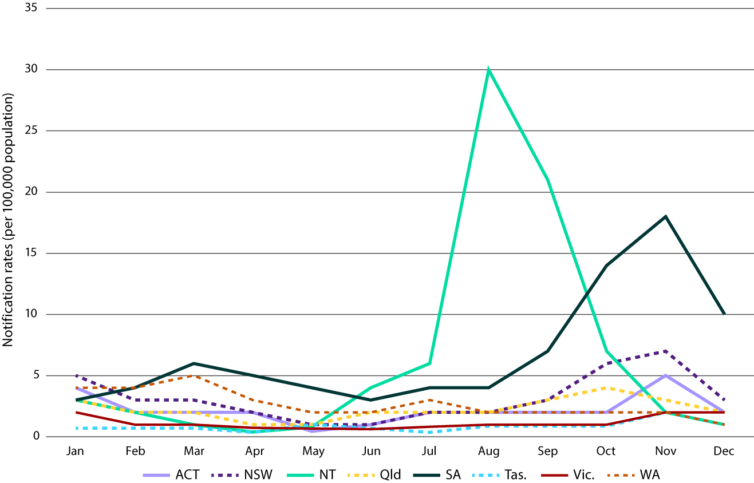

## Genotype distribution of rotavirus positive samples

Genotype analysis was performed on all 1,554 confirmed wildtype rotavirus positive samples (Table 3).

The dominant genotype nationally in 2023 was G3P[8], comprising of both human and equine-like variants (1,117/1,554; 71.9% human and equine-like strains). An equine-like specific PCR and Sanger sequencing were used to differentiate between human and equine-like G3 strains, where 662 samples were identified as human G3P[8] (662/1,554; 42.6%) and 455 samples identified as equine-like G3P[8] (455/1,554; 29.3%). Human G3P[8] and equine-like G3P[8] were the two most dominant genotypes in six of eight jurisdictions. In the Northern Territory and Western Australia, G2P[4] (7/103; 6.8%) and G12P[8] (54/241; 22.4%) were respectively the second most dominant genotypes.

Human G3P[8] was the most common genotype identified nationally (n = 662/1,554) and was identified in all jurisdictions. The proportion was higher in the < 5 years of age group, representing 47.0% (n = 325/691), than in the ≥ 5 years age group, within which it represented 39.0% of the national total (n = 337/863). The highest proportion of human G3P[8] was reported in Queensland (31.3%; n = 207/662), followed by Western Australia (21.0%; n = 139/662) and New South Wales (13.6%; n = 90/662).

Equine-like G3P[8] was the next most common genotype identified nationally, representing 29.3% of all wildtype samples analysed (n = 455/1,554) and identified in seven out of eight jurisdictions; it was not detected in the Northern Territory. The proportion of equine-like G3P[8] was similar between the < 5 and ≥ 5 years of age groups, representing 31.0% (n = 214/691) and 27.9% (n = 241/863) of samples respectively. The highest proportion of equine-like G3P[8] samples was identified in South Australia (43.3%; n = 197/455), followed by New South Wales (31.6%; n = 144/455); it was the dominant genotype in these jurisdictions.

G2P[4] accounted for 9.4% of all wildtype samples analysed (n = 146/1,554) and was identified in 6/8 jurisdictions; it was not detected in Tasmania and Western Australia. G2P[4] was observed in a higher proportion of the ≥ 5 years age group (11.6%; n = 100/863) than the < 5 years age group (6.7%; n = 46/691). The highest representation of G2P[4] was in South Australia, accounting for 39.7% of G2P[4] strains (n = 58/146), followed by New South Wales (26.7%; n = 39/146). G2P[4] was identified in only 6.8% of samples (n = 7/103) in the Northern Territory.

G12P[8] accounted for 6.4% of samples in 2023 (n = 100/1,554) and was detected in five out of eight jurisdictions. The highest representation of G12P[8] was in Western Australia, accounting for 54.0% of all G12P[8] strains (n = 54/100); it was the second most commonly identified genotype overall in Western Australia.

G9P[4] only accounted for 2.1% of all 2023 samples (n = 32/1,554), with the largest proportion of samples from Victoria (40.6%; n = 13/32).

Other unusual genotype combinations were identified this year (n = 42; Tables 3, 4), including G2P[8] (n = 18); G3P[4] (n = 6); G3P[6] (n = 3); G4P[6] (n = 3); G3P[3] (n = 2); G3P[9] (n = 2); G3P[8] feline-like (n = 2); G6P[14] (n = 2); G6P[9] (n = 1); G9P[6] (n = 1); G10P[11] (n = 1); and G10P[14] (n = 1). Some of these genotypes were potentially derived from zoonotic transmission or were strains derived from reassortment events between strains circulating in the human population and in some animal species.

Table 4: Unusual genotypes and genotype combinations observed during the period 1 January 2023 to 31 December 2023

| Genotype | Total |
| --- | --- |
| G2P[8] | 18 |
| G3P[3] | 2 |
| G3P[4] | 6 |
| G3P[6] | 3 |
| Feline-like G3P[8] | 2 |
| G3P[9] | 2 |
| G4P[6] | 3 |
| G6P[9] | 1 |
| G6P[14] | 2 |
| G9P[6] | 1 |
| G10P[11] | 1 |
| G10P[14] | 1 |
| Total | 42 |

# Discussion

The Australian Rotavirus Surveillance Program Report for 2023 describes the distribution of rotavirus genotypes identified in Australia for the period 1 January to 31 December 2023. This marks 16 years since the national introduction of rotavirus vaccines (Rotarix [GSK] or RotaTeq [Merck]) in the National Immunisation Program for all Australian infants, and the sixth year since the exclusive use of Rotarix across all jurisdictions.6,7 Of the 1,942 samples submitted as rotavirus positive by collaborating laboratories across all states and territories, 1,781 samples (91.7%) were confirmed to be rotavirus positive by the Australian Rotavirus Surveillance Program (ARSP). This provides acknowledgement and confidence that collaborating laboratories are accurately identifying rotavirus in diagnostic samples.

The number of samples received by the ARSP in 2023 represents the largest number of confirmed rotavirus-positive samples received to date in the history of the program.6 The collaborating laboratories are to be acknowledged for their engagement and commitment to this program, and for their voluntary contribution to national disease surveillance. The high number of samples received by the ARSP reflects the trends in national rotavirus notification rates reported by the NNDSS in 2023, which were also high.8 The ARSP captured rotavirus-positive stool samples for 21.1% of all NNDSS notifications in 2023. High number of samples were received by the ARSP between August and November from the Northern Territory, New South Wales and South Australia, which correlated with the increase in NNDSS notification rates during this same period.

In 2023, human G3P[8] re-emerged as the dominant genotype (42.6%) and was detected across all jurisdictions. Human G3P[8] had been dominant for three years across 2018–2020 (52%, 46.7% and 27.6% respectively), but decreased in 2021 (3.6%) and 2022 (15.7%) before re-emerging in 2023.6,23,25–31 In 2023, it was the dominant genotype in the Australian Capital Territory, the Northern Territory, Queensland, Tasmania and Western Australia; and was observed in a slightly higher proportion of samples in the < 5 years age group than in those ≥ 5 years of age (47.0% vs 39.0%).

Equine-like G3P[8] was the next most commonly identified genotype, representing 29.3% of all wildtype samples analysed and identified in seven out of eight jurisdictions (it was not detected in the Northern Territory). Equine-like G3P[8] first emerged in Australia in 2013;22 it has subsequently fluctuated in dominance. Equine-like G3P[8] was the second most dominant genotype in 2016 (19%; n = 44/230) and 2017 (25%; n = 255/1,014) but decreased in 2018 (4.6%; n = 21/457) and 2019 (5.7%; n = 41/724). In 2020 the proportion of equine-like G3P[8] temporarily increased again (19.4%; n = 19/98) before reducing in 2021 (n = 4/336; 1.2%; albeit in association with small sample numbers due to the COVID-19 pandemic) and 2022 (1.3%; n = 14/1,119).25–31 Equine-like G3P[8] was the dominant genotype in both New South Wales (40.2%; n = 144/358) and South Australia (55.8%; n = 197/353); it had relatively similar detection between the < 5 and ≥ 5 years of age groups (31.0%; n = 214/691 vs 27.9%; n = 241/863). In Victoria, human G3P[8] and equine-like G3P[8] were detected at the same frequency (31.3%; n = 52/166).

G2P[4] accounted for 9.4% of all wildtype samples analysed (n = 146/1,554) and was identified in six of eight jurisdictions (not detected in Tasmania or Western Australia). Compared with the proportion observed in 2022 (20.3%; n = 227/1,119), this represents a substantial reduction in circulating G2P[4] strains. Samples from South Australia accounted for 39.7% of all G2P[4] strains identified (n = 58/146), followed by New South Wales (26.7%; n = 39/146). Of the G2P[4] strains identified, a higher proportion were from the ≥ 5 years age group (11.6%; n = 100/863) than the < 5 years age group (6.7%; n = 46/691).

Wildtype G1P[8] has been rarely detected in Australia over the last few years (2016: n = 4/230 [1.74%]; 2017: n = 1/1,103 [0.09%]; 2018: n = 1/607 [0.16%]; 2019: n = 2/894 [0.22%]; 2020: n = 1/189 [0.53%]; 2021: n = 2/474 [0.42%]; 2022: n = 13/1,276 [1.02%]).25–31 In 2023, there were 40 samples (2.6%) of wildtype G1P[8] identified, which represents a modest increase (New South Wales: n = 11; Queensland: n = 8; South Australia: n = 7; Victoria: n = 7; and Western Australia: n = 7). These were identified in samples from both children < 5 years of age (n = 10) and the ≥ 5 years age group (n = 30).

In the 2022 surveillance period, G12P[8] was identified as the dominant genotype, accounting for 28.2% of all wildtype samples genotyped (n = 315/1,119). Interestingly, in 2023, G12P[8] detection decreased to 6.4% (n = 100/1,554). Most G12P[8] samples were detected in Western Australia, where it was the second most dominant genotype detected (22.4%; n = 54/100), compared to 2022 when the majority of samples were from Queensland (89.2%; n = 281/315).31

G9P[4] was also identified as a dominant genotype in 2022, accounting for 22.3% of all wildtype samples genotyped (n = 249/1,119).31 In 2023, however, G9P[4] detection decreased to 2.1% of samples genotyped (n = 32/1,554), with the majority of samples detected in Victoria (40.6%; n = 13/32) and New South Wales (37.5%, n = 12/32). This trend was also observed in the region of the WHO Pan American Health Organization (PAHO), where they detected 32.5% G9P[4] in 2019 (n = 39/120), followed by a decrease to 18.75% G9P[4] in 2020 (n = 3/16); in 2021 and 2022, G9P[4] was not detected.32

In 2022, outbreaks were reported in New South Wales, Queensland and the Northern Territory, which were not attributed to a single genotype. In New South Wales, G2P[4] and human G3P[8] co-circulated at similar frequencies during periods of increased rotavirus disease. Likewise, in Queensland, G12P[8] and G9P[4] co-circulated at similar frequencies during periods of increased rotavirus. A localised outbreak in the Northern Territory was attributed to G2P[4].31

Two thirds of samples collected from infants 0 to 6 months of age had rotavirus vaccine-like G1P[8] detected (65.5%; n = 220/336). This most likely reflects the increasing use of multiplex PCR panels in diagnostic laboratories; this highly sensitive test does not distinguish between wildtype and vaccine-like rotavirus strains.33,34 Therefore, a rotavirus-positive result in an infant less than eight months of age needs to be interpreted with caution, as this may reflect shedding of the rotavirus vaccine virus that is expected within the days following administration of a live oral rotavirus vaccine.33,34 The detection of vaccine-like virus in an unvaccinated individual, or in the absence of a relevant history of vaccination or contact, should be further investigated.

Similar to the situation observed in 2022,31 a small number of unusual genotypes were identified (n = 42/1,554; 2.7% of all wildtype genotyped samples), including G2P[8] (1.2%; n = 18/1,554), G3P[4] (0.4%; n = 6/1,554), G4P[6] (0.2%; n = 3/1,554), G3P[6] (0.2%; n = 3/1,554), G3P[3] (0.1%; n = 2/1,554), G3P[9] (0.1%; n = 2/1,554), feline-like G3P[8] (0.1%; n = 2/1,554), G6P[14] (0.1%; n = 2/1,554), G6P[9] (0.1%; 1/1,554), G9P[6] (0.1%; n = 1/1,554), G10P[11] (0.1%; n = 1/1,554), and G10P[14] (0.1%; n = 1/1,554). Interestingly, G2P[8], which had the highest prevalence among unusual genotypes, was only observed in New South Wales (n = 15/18) and Victoria (3/18) and has increased since 2022 when only five G2P[8] strains were detected (0.5%; n = 5/1,119).31 It is possible that these unusual genotype combinations could be inter-genogroup reassortants, such as Wa-like strain undergoing reassortment with DS-1-like or AU-1-like strains resulting in genotypes such as G2P[8] and G3P[4]; or zoonotic in nature, including canine/feline G3P[3] and G3P[9], feline-like G3P[8], porcine-like G4P[6] and bovine-like G10P[11] and G10P[14]. Further full genome sequencing is required to further explore this observation.

In conclusion, the 2023 Annual Australian Rotavirus Surveillance Program Report describes the rotavirus genotypes circulating in Australia during the period of 1 January – 31 December 2023. Of the rotavirus positive samples, the majority (87.3%) were identified as wildtype rotavirus and 12.7% identified as the Rotarix vaccine-like strain, with the latter predominantly identified in infants less than 6 months of age. During this period, human G3P[8] re-emerged as the dominant genotype, along with a high proportion of equine-like G3P[8] strains. Consistent with observations in 2022, a small number of unusual genotypes were identified. In 2023, the Australian Rotavirus Surveillance Program was strongly supported by a network of collaborating laboratories with the aim to provide accurate surveillance data to support the public health response and vaccination programs.

# Acknowledgments

The Australian Rotavirus Surveillance Program is supported by a Service Contract from the Australian Government Department of Health and Aged Care (Reference ID: HEALTH/20-21/D21-210024) and a research grant from GlaxoSmithKline Biologicals SA [Study#209328]. The Murdoch Children’s Research Institute (MCRI) is supported by the Victorian Government’s Operational Infrastructure Support program. The Communicable Disease Epidemiology and Surveillance Section of the Australian Government Department of Health and Aged Care and GSK were provided with the opportunity to review a preliminary version of this manuscript for factual accuracy, but the authors are solely responsible for the final content and interpretation.

The authors received no financial support or other form of compensation related to the development of the manuscript.

We thank H Tran for providing technical assistance and S Roczo-Farkas for her technical advice.

Rotavirus positive samples were collected from numerous centres throughout Australia. We acknowledge and appreciate the significant time and effort involved in the collection, storage, packaging, compiling data and forwarding of samples.

# Author details

Mrs Sarah Thomas, Research Assistant1

Mrs Nada Bogdanovic-Sakran, Research Assistant1

Dr Celeste M Donato, Senior Research Officer1,2,3

Mrs Archana T Sriraman1

Mr Daniel Pavlic, Research Assistant1

Prof. Julie E Bines, Group Leader1,2,4

and the Australian Rotavirus Surveillance Group

1. Enteric Diseases, Murdoch Children’s Research Institute, Parkville, Victoria
2. Department of Paediatrics, University of Melbourne, Parkville, Victoria
3. Department of Microbiology, Biomedicine Discovery Institute, Monash University, Clayton, Victoria
4. Department of Gastroenterology and Clinical Nutrition, Royal Children’s Hospital, Parkville, Victoria

Corresponding author

Prof. Julie E Bines

Murdoch Children’s Research Institute

The Royal Children’s Hospital,

50 Flemington Road,

Parkville, Victoria 3052 Australia

Email: [julie.bines@mcri.edu.au](mailto:julie.bines@mcri.edu.au)

### The National Rotavirus Surveillance Group includes:

#### Australian Rotavirus Surveillance Program Central Laboratory

Mrs Sarah Thomas; Coordinator Australian Rotavirus Surveillance Program, Research Assistant, Enteric Diseases, MCRI

Mrs Nada Bogdanovic-Sakran, Research Assistant, Enteric Diseases, MCRI

Dr Celeste M Donato, Senior Research Officer, Enteric Diseases, MCRI; Department of Paediatrics, University of Melbourne; Department of Microbiology, Biomedicine Discovery Institute, Monash University

Mrs Archana T Sriraman, Research Assistant, Enteric Diseases, MCRI

Mr Daniel Pavlic, Research Assistant, Enteric Diseases, MCRI

Prof. Julie E Bines, Director, Australian Rotavirus Surveillance Program; Leader, Enteric Diseases, MCRI; Department of Paediatrics, University of Melbourne; Department of Gastroenterology and Clinical Nutrition, Royal Children’s Hospital

#### Australian Capital Territory

Assoc. Prof. K Kennedy, S Bradbury and members of the Microbiology Department, Canberra Hospital

#### New South Wales

P Huntington, Prof. M Lahra and members of the Microbiology Department, SEALS, Prince of Wales Hospital

Prof. A Kesson, I Tam, and members of the Virology Department, The Children’s Hospital, Westmead

Dr M Wehrhahn, and members of Douglass Hanly Moir Pathology, New South Wales

F Jozwiak, J Merif and members of the Department of Microbiology and Infectious Diseases, Liverpool Hospital, Liverpool

#### Northern Territory

Dr R Baird, K Freeman, D Menouhos, T Eapen, and members of Territory Pathology, Royal Darwin Hospital, Tiwi, NT

#### Queensland

Dr C Bletchly, Dr R Gupta and department members, Pathology Queensland Central

#### South Australia

M Turra, Dr J Arthur, and members of the Microbiology and Infectious diseases laboratory SA Pathology, Adelaide

#### Tasmania

Assoc. Prof. Louise Cooley, Dr J Williamson, and members of Molecular Medicine, Pathology Services, Royal Hobart Hospital, Hobart, Tasmania

#### Victoria

Dr T Korman, D Kotsanas, K Cisera, and members of the Department of Microbiology, Monash Medical Centre, Clayton

K Rautenbacher, P Adamopoulos, and members of Laboratory Services, Royal Children’s Hospital, Parkville

Dr L Bruggink, and members of the Enteric Virus Reference Laboratory, Victorian Infectious Diseases Reference Laboratory (VIDRL), Peter Doherty Institute for Infection and Immunity, Melbourne.

#### Western Australia

Dr D Speers, D Bradford, D Tennant, and members of QEII Microbiology Department, PathWest Laboratory Medicine WA, Perth

# References

1. Troeger C, Khalil IA, Rao PC, Cao S, Blacker BF, Ahmed T et al. Rotavirus vaccination and the global burden of rotavirus diarrhea among children younger than 5 years. *JAMA Pediatr*. 2018;172(10):958–65. doi: <https://doi.org/10.1001/jamapediatrics.2018.1960>.
2. International Vaccine Access Center (IVAC). VIEW-hub by IVAC. [Website.] Baltimore: Johns Hopkins Bloomberg School of Public Health, IVAC; 2023. [Accessed on 29 APril 2024.] Available from: <https://view-hub.org>.
3. Buttery JP, Lambert SB, Grimwood K, Nissen MD, Field EJ, Macartney KK et al. Reduction in rotavirus-associated acute gastroenteritis following introduction of rotavirus vaccine into Australia’s National Childhood vaccine schedule. *Pediatr Infect Dis J*. 2011;30(1 Suppl):S25–9. doi: <https://doi.org/10.1097/INF.0b013e3181fefdee>.
4. Macartney KK, Porwal M, Dalton D, Cripps T, Maldigri T, Isaacs D et al. Decline in rotavirus hospitalisations following introduction of Australia’s national rotavirus immunisation programme. *J Paediatr Child Health*. 2011;47(5):266–70. doi: <https://doi.org/10.1111/j.1440-1754.2010.01953.x>.
5. Reyes JF, Wood JG, Beutels P, Macartney K, McIntyre P, Menzies R et al. Beyond expectations: post-implementation data shows rotavirus vaccination is likely cost-saving in Australia. *Vaccine*. 2017;35(2):345–52. doi: <https://doi.org/10.1016/j.vaccine.2016.11.056>.
6. Roczo-Farkas S, Kirkwood CD, Cowley D, Barnes GL, Bishop RF, Bogdanovic-Sakran N et al. The impact of rotavirus vaccines on genotype diversity: a comprehensive analysis of 2 decades of Australian surveillance data. *J Infect Dis*. 2018;218(4):546–54. doi: <https://doi.org/10.1093/infdis/jiy197>.
7. Australian Government Department of Health and Aged Care. Clinical update: ATAGI advice on Rotarix® to replace RotaTeq®. [Internet.] Canberra: Australian Government Department of Health and Aged Care; 20 December 2017. Available from: <https://beta.health.gov.au/news-and-events/news/clinical-update-atagi-advice-on-rotarixr-to-replace-rotateqr>.
8. Australian Government Department of Health and Aged Care. National Communicable Disease Surveillance Dashboard. [Website.] Canberra: Australian Government Department of Health and Aged Care; 2024. [Accessed on 29 April 2024.] Available from: <https://nindss.health.gov.au/pbi-dashboard/>.
9. Desselberger U. Rotaviruses. *Virus Res*. 2014;190:75–96. doi: <https://doi.org/10.1016/j.virusres.2014.06.016>.
10. Bányai K, László B, Duque J, Steele AD, Nelson EA, Gentsch JR et al. Systematic review of regional and temporal trends in global rotavirus strain diversity in the pre rotavirus vaccine era: insights for understanding the impact of rotavirus vaccination programs. *Vaccine*. 2012;30(Suppl 1):A122–30. doi: <https://doi.org/10.1016/j.vaccine.2011.09.111>.
11. Dóró R, László B, Martella V, Leshem E, Gentsch J, Parashar U et al. Review of global rotavirus strain prevalence data from six years post vaccine licensure surveillance: is there evidence of strain selection from vaccine pressure? *Infect Genet Evol*. 2014;28:446–61. doi: <https://doi.org/10.1016/j.meegid.2014.08.017>.
12. Kondo K, Tsugawa T, Ono M, Ohara T, Fujibayashi S, Tahara Y et al. Clinical and molecular characteristics of human rotavirus G8P[8] outbreak strain, Japan, 2014. *Emerg Infect Dis.* 2017;23(6):968–72. doi: <https://doi.org/10.3201/eid2306.160038>.
13. Matthijnssens J, Ciarlet M, McDonald SM, Attoui H, Bányai K, Brister JR et al. Uniformity of rotavirus strain nomenclature proposed by the Rotavirus Classification Working Group (RCWG). *Arch Virol*. 2011;156(8):1397–413. doi: <https://doi.org/10.1007/s00705-011-1006-z>.
14. Iturriza-Gómara M, Isherwood B, Desselberger U, Gray J. Reassortment in vivo: driving force for diversity of human rotavirus strains isolated in the United Kingdom between 1995 and 1999. *J Virol*. 2001;75(8):3696–705. doi: <https://doi.org/10.1128/JVI.75.8.3696-3705.2001>.
15. Donato CM, Roczo-Farkas S, Kirkwood CD, Barnes GL, Bines JE. Rotavirus disease and genotype diversity in older children and adults in Australia. *J Infect Dis*. 2022;225(12):2116–26. doi: <https://doi.org/10.1093/infdis/jiaa430>.
16. Gómara MI, Cubitt D, Desselberger U, Gray J. Amino acid substitution within the VP7 protein of G2 rotavirus strains associated with failure to serotype. *J Clin Microbiol*. 2001;39(10):3796–8. doi: <https://doi.org/10.1128/JCM.39.10.3796-3798.2001>.
17. Simmonds MK, Armah G, Asmah R, Banerjee I, Damanka S, Esona M et al. New oligonucleotide primers for P-typing of rotavirus strains: strategies for typing previously untypeable strains. *J Clin Virol*. 2008;42(4):368–73. doi: <https://doi.org/10.1016/j.jcv.2008.02.011>.
18. Gentsch JR, Glass RI, Woods P, Gouvea V, Gorziglia M, Flores J et al. Identification of group A rotavirus gene 4 types by polymerase chain reaction. *J Clin Microbiol*. 1992;30(6):1365–73. doi: <https://doi.org/10.1128/jcm.30.6.1365-1373.1992>.
19. Gouvea V, Glass RI, Woods P, Taniguchi K, Clark HF, Forrester B et al. Polymerase chain reaction amplification and typing of rotavirus nucleic acid from stool specimens. *J Clin Microbiol*. 1990;28(2):276–82. doi: <https://doi.org/10.1128/jcm.28.2.276-282.1990>.
20. Donato CM, Ch’ng LS, Boniface KF, Crawford NW, Buttery JP, Lyon M et al. Identification of strains of RotaTeq rotavirus vaccine in infants with gastroenteritis following routine vaccination. *J Infect Dis*. 2012;206(3):377–83. doi: <https://doi.org/10.1093/infdis/jis361>.
21. Elschner M, Prudlo J, Hotzel H, Otto P, Sachse K. Nested reverse transcriptase-polymerase chain reaction for the detection of group A rotaviruses. *J Vet Med B Infect Dis Vet Public Health*. 2002;49(2):77–81. doi: <https://doi.org/10.1046/j.1439-0450.2002.00510.x>.
22. Cowley D, Donato CM, Roczo-Farkas S, Kirkwood CD. Emergence of a novel equine-like G3P[8] inter-genogroup reassortant rotavirus strain associated with gastroenteritis in Australian children. *J Gen Virol*. 2016;97(2):403–10. doi: <https://doi.org/10.1099/jgv.0.000352>.
23. Roczo-Farkas S, Kirkwood CD, Bines JE, Australian Rotavirus Surveillance Group. Australian Rotavirus Surveillance Program annual report, 2015. *Commun Dis Intell Q Rep*. 2016;40(4):E527–38.
24. Northern Territory Government Department of Health (NT Health). *Health Alert: Rotavirus*. Darwin: NT Health, Centre for Disease Control. Available from: <https://health.nt.gov.au/__data/assets/pdf_file/0013/1216102/health-alert-rotavirus.pdf>.
25. Roczo-Farkas S, Kirkwood CD, Bines JE, Enteric Virus Group. Australian Rotavirus Surveillance Program: Annual Report, 2016. *Commun Dis Intell Q Rep*. 2017;41(4):E455–71.
26. Roczo-Farkas S, Cowley D, Bines JE, the Australian Rotavirus Surveillance Group. Australian Rotavirus Surveillance Program: Annual Report, 2017. *Commun Dis Intell (2018)*. 2019;43. doi: <https://doi.org/10.33321/cdi.2019.43.28>.
27. Roczo-Farkas S, Bines JE, Australian Rotavirus Surveillance G. Australian Rotavirus Surveillance Program: Annual Report, 2018. *Commun Dis Intell (2018)*. 2021;45. doi: <https://doi.org/10.33321/cdi.2021.45.6>.
28. Thomas S, Donato CM, Roczo-Farkas S, Hua J, Bines JE. Australian Rotavirus Surveillance Program: Annual Report, 2019. *Commun Dis Intell (2018)*. 2021;45. doi: <https://doi.org/10.33321/cdi.2021.45.4>.
29. Roczo-Farkas S, Thomas S, Donato CM, Bogdanovic-Sakran N, Bines JE. Australian Rotavirus Surveillance Program: Annual Report, 2020. *Commun Dis Intell (2018)*. 2021;45. doi: <https://doi.org/10.33321/cdi.2021.45.64>.
30. Roczo-Farkas S, Thomas S, Bogdanovic-Sakran N, Donato CM, Lyons EA, Bines J et al. Australian Rotavirus Surveillance Program: Annual Report, 2021. *Commun Dis Intell (2018)*. 2022;46. doi: <https://doi.org/10.33321/cdi.2022.46.75>.
31. Donato CM, Roczo-Farkas S, Thomas S, Bogdanovic-Sakran N, Lyons E, Bines JE. Australian Rotavirus Surveillance Program: Annual Report, 2022. *Commun Dis Intell (2018)*. 2024;48. doi: <https://doi.org/10.33321/cdi.2024.48.27>.
32. World Health Organization (WHO). Global rotavirus and pediatric diarrhea surveillance: meeting report, WHO Regional Office for the Western Pacific, Manila, Philippines, 11–13 December 2023. Manila: WHO, Regional Office for the Western Pacific; 2024. Available from: <https://iris.who.int/handle/10665/376846>.
33. Whiley DM, Ye S, Tozer S, Clark JE, Bletchly C, Lambert SB et al. Over-diagnosis of rotavirus infection in infants due to detection of vaccine virus. *Clin Infect Dis*. 2020;71(5):1324–6. doi: <https://doi.org/10.1093/cid/ciz1196>.
34. Ye S, Whiley DM, Ware RS, Kirkwood CD, Lambert SB, Grimwood K. Multivalent rotavirus vaccine and wild-type rotavirus strain shedding in Australian infants: a birth cohort study. *Clin Infect Dis*. 2018;66(9):1411–8. doi: <https://doi.org/10.1093/cid/cix1022>.

© Commonwealth of Australia as represented by the Department of Health and Aged Care

ISSN: 2209-6051 Online

This journal is indexed by Index Medicus and Medline.

Creative Commons Licence

This publication is licensed under a Creative Commons Attribution-NonCommercial-NoDerivatives 4.0 International Licence (CC BY-NC-ND) available from <https://creativecommons.org/licenses/by-nc-nd/4.0/legalcode> (Licence). You must read and understand the Licence before using any material from this publication.

Restrictions

The Licence does not cover, and there is no permission given for, use of any of the following material found in this publication (if any):

* the Commonwealth Coat of Arms (by way of information, the terms under which the Coat of Arms may be used can be found on the Department of Prime Minister and Cabinet website;
* any logos (including the Department of Health and Aged Care’s logo) and trademarks;
* any photographs and images;
* any signatures; and
* any material belonging to third parties.

Disclaimer

Opinions expressed in *Communicable Diseases Intelligence* are those of the authors and not necessarily those of the Department of Health and Aged Care or the Communicable Diseases Network Australia. Data may be subject to revision.

Enquiries

Enquiries regarding any other use of this publication should be addressed to the CDI Editor at: [cdi.editor@health.gov.au](mailto:cdi.editor@health.gov.au).

Communicable Diseases Network Australia

Communicable Diseases Intelligence contributes to the work of the [Communicable Diseases Network Australia](http://www.health.gov.au/cdna).

About Communicable Diseases Intelligence

*Communicable Diseases Intelligence* (CDI) is a peer-reviewed scientific journal published by the Health Security & Emergency Management Division, Department of Health and Aged Care. The journal aims to disseminate information on the epidemiology, surveillance, prevention and control of communicable diseases of relevance to Australia.

**Editor**: Christina Bareja • **Deputy Editor**: Simon Petrie • **Design and Production**: Lisa Thompson

**Editorial Advisory Board**: David Durrheim, Mark Ferson, Clare Huppatz, John Kaldor, Martyn Kirk and Meru Sheel

Submit an Article

Submit your next communicable disease related article to CDI for consideration. [Information for authors](https://www1.health.gov.au/internet/main/publishing.nsf/Content/cda-pubs-cdi-auth_inst.htm) and details on how to [submit your publication](https://www1.health.gov.au/internet/main/publishing.nsf/Content/cda-pubs-cdi-auth_inst.htm#submission_package) is available on our website, or by email at [cdi.editor@health.gov.au](mailto:cdi.editor@health.gov.au).

Contact us

Communicable Diseases Intelligence (CDI)

Health Security & Emergency Management Division

Department of Health and Aged Care

GPO Box 9848, CANBERRA ACT 2601

Website: [www.health.gov.au/cdi](http://www.health.gov.au/cdi)

Email: [cdi.editor@health.gov.au](mailto:cdi.editor@health.gov.au)

1. <http://blast.ncbi.nlm.nih.gov/Blast.cgi>.