• Volume • • Electronic publication date:

Antimicrobial resistance in northern Australia: the HOTspots surveillance and response program annual epidemiology report 2022

Teresa M Wozniak, Alys R Young, Aminath Shausan, Amy Legg, Michael J Leung, Sonali A Coulter, Shalinie Perera, Robert W Baird, Majella G Murphy

Abstract

Background

The HOTspots surveillance and response program monitors antimicrobial resistance (AMR) in selected bacterial pathogens across three jurisdictions in northern Australia. In 2022, the program collected data from 164 community healthcare clinics and 50 hospitals to assess AMR trends and geographic variations.

Methods

Data on resistance rates for methicillin-resistant *Staphylococcus aureus* (MRSA) and for *Escherichia coli* (*E. coli*) were analysed. Geographic regions were compared to identify variations in AMR across the Northern Territory, northern Western Australia and northern Queensland. Resistance rates were compared between community clinics and hospitals.

Findings

In 2022, there were 56,003 clinical isolates submitted to HOTspots. Geographic variation was evident in *S. aureus* methicillin resistance, with MRSA accounting for 14.4% of *S. aureus* isolates in the east, 53.1% in central northern Australia and 46.3% in western northern Australia. Clindamycin-resistant MRSA was highest in the Northern Territory (21.7%) compared to Western Australia (16.1%) and Queensland (5.9%), limiting treatment options for community-acquired MRSA. Ceftriaxone-resistant *E. coli* also varied geographically, with resistance rates ranging from 3.9% in the east to 23.4% in central and 10.1% in the west. High rates of ceftriaxone resistance were observed in both community clinics (10.6%) and hospitals (16.3%). Nitrofurantoin-resistant *E. coli* remained low (0.2%) and stable over the past five years.

Interpretation

HOTspots data are critical for informing local antibiotic guidelines and aiding clinical decision-making. This detailed surveillance captures geographic and healthcare-setting-specific variations in AMR, which can improve regional treatment strategies across northern Australia, with a focus on the Northern Territory, which had previously lacked comprehensive surveillance.

Keywords: antimicrobial resistance; surveillance; northern Australia; regional; community

# Introduction

The HOTspots program aims to build resilience to antimicrobial resistance (AMR) in northern Australia, a region that has historically fallen outside of surveillance reach.1 Resilience to AMR corresponds to the capacity to maintain the benefits of effective antimicrobials. The program’s primary focus is on strengthening AMR surveillance and supporting health professionals to access local, region-specific epidemiological insights to inform clinical and policy decision making. The HOTspots program has been implemented in hospital and community clinics since 2019,2 and was assessed against the accepted (United States) Centers for Disease Control and Prevention guidelines for surveillance system evaluation.3 At the national level, HOTspots has contributed to the Australian Commission on Safety and Quality in Health Care’s AURA 2021 report: *Fourth Australian report on antimicrobial use and resistance in human health*, and to the subsequent AURA 2023 report,4,5 providing access to data not previously available in existing surveillance systems. The 2022 HOTspots annual epidemiology report presented here is the first annual report published from this program.

The key objectives of the HOTspots program are to monitor emerging antimicrobial resistance and guide stewardship efforts in hospitals and community clinics. It aims to facilitate data sharing across sectors and jurisdictions, to support guideline updates, and to co-develop tailored stewardship resources. Additionally, HOTspots seeks to build the capacity of the regional and rural healthcare workforce and inform public health action where needed. A feature of HOTspots is a digital surveillance platform that visualises aggregated region-specific AMR surveillance data as an interactive map, plots and summary antimicrobial susceptibility tables, known as antibiograms. Antibiograms are developed in accordance with accepted methods.6 These data play a critical role in contextualising region-specific AMR epidemiology, at Statistical Area Level 3, to inform local treatment guidelines and targeted treatment options. These data are especially critical in resource-poor and remote settings of Australia, where AMR is geographically diverse,2 and where it varies from what is observed in urban settings.4

Data from the HOTspots program are critical for informing local antibiotic treatment guidelines;7 for supporting general practice clinical pathways; and as an adjunct to clinical decision making for health professionals in northern Australia. Through collaboration with primary healthcare stakeholders in the Northern Territory, HOTspots data was incorporated into Northern Territory HealthPathways, a locally developed website to help clinical teams (particularly general practitioners) to navigate complex variations in local referral pathways and to manage their patients’ health conditions.8 The program facilitates education sessions to rural medical practitioners, healthcare workers, and Aboriginal health practitioners through targeted programs such as the HOT North Antimicrobial Academy,9 thereby fostering skill development in disease surveillance, AMR and antimicrobial stewardship within the rural and remote workforce. Additionally, HOTspots data contribute to ongoing research on the Australian10–13 and global14,15 disease burden as well as the investigation of factors driving AMR.

This annual epidemiological report analyses data for the year 2022, with a focused description of AMR in the Northern Territory, as a jurisdiction that has historically fallen outside of national surveillance reach. It aims to inform readers with local context through a detailed assessment, including analysis by healthcare setting, and by specimen type for each of the combined statistical regions in the Northern Territory.

# Methods

Setting

The focus for the annual epidemiological report for 2022 comprises the three jurisdictions of Western Australia, the Northern Territory and Queensland (Figure 1). The geographical boundaries for HOTspots are based on a combined Australian Bureau of Statistics Statistical Area level 3 partitioning of northern Australia.16 This report additionally provides an in-depth description of the epidemiology of AMR in the Northern Territory, as this jurisdiction has historically fallen outside of surveillance reach.

Figure 1. Map of northern Australia displaying coverage of the HOTspots regions in 2022

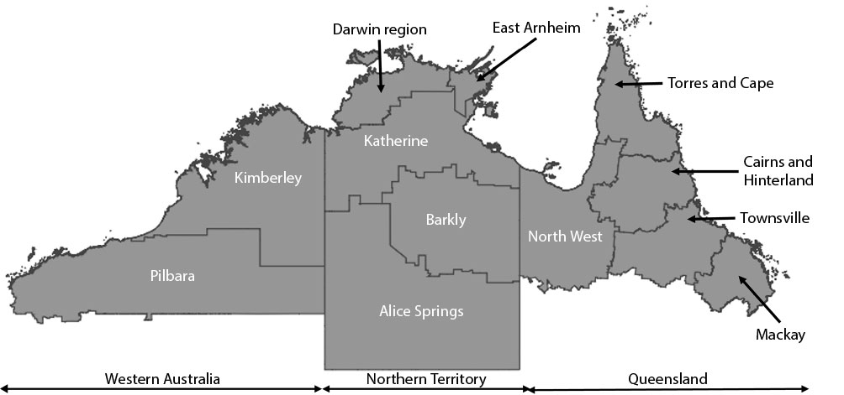

## Surveillance data

From 2022 1 January to 31 December 2022, data were collected from 164 community healthcare clinics and 50 hospitals across three jurisdictions of northern Australia (northern Western Australia, the Northern Territory and northern Queensland). These data included 56,003 clinical isolates. HOTspots coverage in the Northern Territory and northern Western Australia includes the major community healthcare (private pathology) and hospital healthcare providers, as it is impractical to cover all clinical sites across northern Australia. There is currently limited data in HOTspots from community healthcare in northern Queensland.

The clinical importance of bacterial species and antimicrobial agents included in HOTspots is based on expert advice and has been previously described.2 The report focusses on eight bacterial species: *Escherichia coli* (*E. coli*); *Klebsiella pneumoniae* (*K. pneumoniae*); *Staphylococcus aureus* (*S. aureus*); *Pseudomonas aeruginosa* (*P. aeruginosa*); *Streptococcus pyogenes* (*S. pyogenes*); *Streptococcus pneumoniae* (*S. pneumoniae*); *Haemophilus influenzae* (*H. influenzae*); and *Acinetobacter baumannii* (*A. baumannii*); and on the antimicrobial agents tested against these organisms.

## Antimicrobial susceptibility data

Antimicrobial susceptibility data are contributed by four main pathology service providers: Western Diagnostic Pathology (Western Diagnostic); PathWest Laboratory Medicine Western Australia (PathWest); Territory Pathology; and Pathology Queensland, on invasive and non-invasive isolates of eight key clinically important bacterial species.

The participating laboratories employ two widely used international susceptibility method systems: the Clinical and Laboratory Standards Institute (CLSI) and the European Committee on Antimicrobial Susceptibility Testing (EUCAST). Susceptibility results are determined by VITEK2 (bioMerieux Inc., Durham, NC, USA, AST-P612 susceptibility panel and software version 7.01) and disc diffusion susceptibilities where appropriate.

The susceptibility methods used by each pathology provider are as follows:

* PathWest (covering northern Western Australia): data are provided as CLSI-interpreted values (‘susceptible’, ‘intermediate’, and ‘resistant’);
* Territory Pathology (covering the Northern Territory): data are provided as raw minimum inhibitory concentration values, and the 2021 CLSI *M100-S27 Performance Standards for Antimicrobial Susceptibility Testing, 31st edition* are applied;17
* Western Diagnostic (covering northern Western Australia and the Northern Territory): data are provided as CLSI-interpreted values (‘susceptible’, ‘intermediate’, and ‘resistant’); and
* Pathology Queensland (covering northern Queensland): data are provided as EUCAST-interpreted values (‘susceptible’, ‘susceptible to increased exposure’ and ‘resistant’).

With the exception of Territory Pathology, which supplies the minimum inhibitory concentration values, all pathology providers report antimicrobial susceptibility testing data as ‘susceptible’, ‘intermediate’, or ‘resistant’. Differences in reporting, depending on which reporting guideline is used, are based on different breakpoints used for interpretation. The EUCAST guideline converts the ‘intermediate’ category to the ‘susceptible to increased exposure’ category.

For the data included in HOTspots, the only discrepancies between EUCAST and CLSI would be for reporting of amoxicillin-clavulanic acid resistance in Enterobacterales. Pathology Queensland (northern Queensland data) uses EUCAST and only reports the ‘susceptible’ and ‘resistant’ categories. The pathology providers that use CLSI-interpretive breakpoints report ‘susceptible’, ‘intermediate’, or ‘resistant’ for this organism group. This combination of organism group and antimicrobial is not included in this data report due to the potential for differences in the breakpoints between the EUCAST and CLSI guidelines.

Inferring resistance is based on advice from each pathology provider.

Clindamycin resistance:

* In PathWest, Territory Pathology and Queensland Pathology, clindamycin resistance is inferred from erythromycin resistance and a D-test is only performed upon request (referred to as inducible clindamycin);
* In Western Diagnostic, inducible clindamycin resistance is determined off the VITEK2 card.

Methicillin resistance in *S. aureus*:

* In Territory Pathology, Western Diagnostic, Pathology Queensland and PathWest, methicillin resistance is inferred from resistance to cefoxitin.

## Demographic data

HOTspots does not collect detailed patient-level or demographic data other than sex and age. Therefore, clinical significance or onset of infection are not able to be determined. Information on the specimen type (i.e., blood, urine, respiratory, skin and soft tissue, and other source) and the location of sample source (i.e., the postcode of where the sample was taken) are included in HOTspots data. The postcode data are not publicly available and are only used for the purpose of this analysis.

## Data cleaning and validation

As per accepted and published18 AMR surveillance approaches and to minimise duplicates, only data from the first isolate, per specimen type, per patient, and per year are included in this analysis. This approach aligns with methods used by the Australian Passive Antimicrobial Resistance Surveillance (APAS) system19 and the World Health Organization Global Antimicrobial Resistance and Use Surveillance System (WHO GLASS).18 Results from isolates detected in infection prevention and control screening sampling are excluded as per accepted AMR surveillance approaches.18 All line listed data are aggregated by region. Data are harmonised across the three jurisdictions by standardising antimicrobial, organism, and specimen type nomenclature.

Data validation is conducted by checking on yearly variation in resistance for each combination of bacterium and antimicrobial. The validity of the HOTspots data and the code that is used to interpret data are further assessed by comparing resistance rates reported by pathologies from the region. The hospital antibiograms from the Top End and Central Australia health services are the only regularly analysed sources of reference data from the Northern Territory. These antibiograms, compiled by Territory Pathology Microbiology using data from Royal Darwin and Palmerston hospitals (for the Top End Health Service) and Alice Springs (for the Central Australia Health Service), are provided to the HOTspots data management team solely for this analysis and are not publicly available. An agreement statistic is calculated to determine the validity of HOTspots data against the Top End Health Service antibiograms for a select number of clinical isolates using the equation M = 100% × (1 − [sum(|R − A|)/sum(R)]), where M denotes the percent agreement; R denotes the reference susceptibility; and A denotes the HOTspots susceptibility for a given bacterium/antimicrobial combination. This data validation approach for HOTspots has been previously described.2

## Data analysis

The proportion of resistant isolates is calculated by dividing the number of isolates resistant to the antimicrobial by the total number of isolates tested. Data are not shown on the HOTspots digital surveillance platform when the number of isolates per year is less than 15.

The statistical significance of the change in resistance was calculated using a chi-squared test in R (version 4.3.0) (R Core Team, 2018) with R-studio (version 2023.09.1+949); it is important to note that a small change in resistance can be detected as significant due to the large sample size. Here, we have presented clinically significant changes and their respective statistical significance.

## Mapping

All maps were created using Plotly graphing libraries (Plotly version 3.10.9; Montréal)[1] available in the Python programming language.

## Ethics and data governance

HOTspots operates with the approval of the Human Research Ethics Committee of the Northern Territory Department of Health and Menzies School of Health Research (HREC-2018-3084), the Commonwealth Scientific and Industrial Research Organisation (CSIRO) Health and Medical Human Research Ethics Committee (CHMHREC 2020_090_RR) and Western Australia (WA) Health Central Health and Medical Human Research Ethics Committee (RGS0000007026). In addition, the HOTspots program is authorised under the powers of the *Queensland Health Public Health Act 2005* (Section 280) in Queensland.20 Jurisdictional participation is voluntary, and all data provided to the program have authorisation from the respective data custodians and owners.

All surveillance data are handled per CSIRO’s Information and Data Policy, Governance Policy, Privacy Policy and Cyber Security Principles in accordance with legislative, ethical, cultural, and contractual obligations. CSIRO aligns with the Information Security Manual and Essential Eight framework of the Australian Cyber Security Centre. All data are de-identified and transferred electronically to the HOTspots data management team, and aggregated and stored on a secure Australian-based server hosted by CSIRO.

# Results

Epidemiology of antimicrobial resistance across northern Australia

In 2022, a total of 56,003 isolates were reported to HOTspots for the eight clinically important bacteria, namely *S. aureus*, *E. coli*, *K. pneumoniae*, *S. pyogenes*, *P. aeruginosa*, *S. pneumoniae*, *H. influenzae* and *A. baumannii* (Table 1). Data are provided for these eight clinically important bacteria.

Table 1: The number of isolates recovered for the eight clinically important bacteria by healthcare settinga in northern Australia for 2022

| Species | northern Western Australia | | Northern Territoryb | | northern Queensland | | Overall | | |
| --- | --- | --- | --- | --- | --- | --- | --- | --- | --- |
| Hosp. | Com. | Hosp. | Com. | Hosp. | Com. | Hosp. | Com. | Total |
| *S. aureus* | 1,365 | 2,027 | 5,951 | 2,219 | 11,317 | 1,389 | 18,633 | 5,635 | 24,268 |
| *E. coli* | 674 | 879 | 3,131 | 1,585 | 7,997 | 401 | 11,802 | 2,865 | 14,667 |
| *S. pyogenes* | 808 | 1,110 | NA | 1,096 | 3,469 | 871 | 4,277 | 3,077 | 7,354 |
| *P. aeruginosa* | 192 | 272 | 1,189 | 309 | 2,608 | 64 | 3,989 | 645 | 4,634 |
| *K. pneumoniae* | 108 | 166 | 771 | 255 | 1,908 | 68 | 2,787 | 489 | 3,276 |
| *S. pneumoniae* | 48 | 75 | NA | 65 | 328 | 17 | 376 | 157 | 533 |
| *H. influenzae* | 40 | 84 | NA | 136 | 656 | 40 | 696 | 260 | 956 |
| *A. baumannii* | 4 | 11 | 129 | 20 | 146 | 5 | 279 | 36 | 315 |
| Total | 3,239 | 4,624 | 11,171 | 5,685 | 28,429 | 2,855 | 42,839 | 13,164 | 56,003 |

a Hosp.: hospitals; Com.: community healthcare clinics.

b NA: no data available.

The majority of the bacterial isolates recovered were from hospital settings (76.5%; n = 42,839), with the remainder from community healthcare clinics (23.5%; n = 13,164). The most frequently recovered bacterium in northern Australia was *S. aureus* (43.3%; n = 24,268), followed by *E. coli* (26.2%; n = 14,667). The most common site sampled with bacterial growth was skin and soft tissue (49.1%), followed by urine (41.0%) and blood cultures (4.2%).

For region-specific information about specimen type, bacterial species, antimicrobial, age group and sex categories not presented in this report, please refer to the open-access HOTspots digital surveillance platform.[2] This report provides a focus discussion on the two most commonly reported bacteria to HOTspots, namely *S. aureus* and *E. coli*.

### *Staphylococcus aureus* in northern Australia

In 2022, a total of 24,268 *S. aureus* isolates was reported across northern Australia (Table 1). Most of the clinical isolates (76.8%; n = 18,633) were derived from hospital patients, with the remaining 23.2% (n = 5,635) reported in community healthcare settings. More than half of the *S. aureus* isolates were from northern Queensland (n = 12,706), followed by the Northern Territory (n = 8,170) and northern Western Australia (n = 3,392; Table 1, Table 2).

Table 2: The number of *Staphylococcus aureus* isolates tested for methicillin resistance, by region, in 2022

| Jurisdiction | Region | Number of isolates |
| --- | --- | --- |
| Western Australia | Kimberley | 2,056 |
| Pilbara | 1,320 |
| Northern Territory | Alice Springs | 2,666 |
| Barkly | 489 |
| Darwin | 3,655 |
| East Arnhem | 499 |
| Katherine | 768 |
| Queensland | Cairns and Hinterland | 4,123 |
| Mackay | 1,613 |
| North West | 1,313 |
| Torres and Cape | 2,617 |
| Townsville | 3,039 |

There was geographical variation of methicillin-resistant *S. aureus* (MRSA) across northern Australia in 2022 (Figure 2). MRSA was observed to be highest in the Alice Springs region (53.1%) and Barkly region (47.9%) in the Northern Territory, followed by the Kimberley region (46.3%) in northern Western Australia. The lowest MRSA proportion was observed in the east, in the Mackay region (14.4%) of northern Queensland.

Figure 2: The percentage of methicillin-resistant *Staphylococcus aureus* (MRSA) isolates in northern Australia for 2022

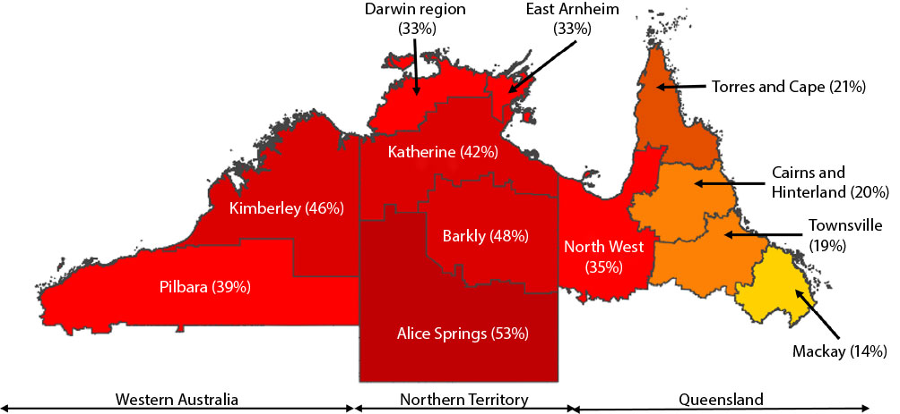

Since 2017, resistance to clindamycin in methicillin-susceptible *S. aureus* (MSSA) and MRSA isolates has been highest in the Northern Territory, followed by northern Western Australia and northern Queensland (Figure 3, Table 3).

Figure 3: Clindamycin resistance patterns in methicillin-resistant and methicillin-susceptible *Staphylococcus aureus* (respectively MRSA and MSSA) isolates in northern Australia,a for 2017, 2021 and 2022

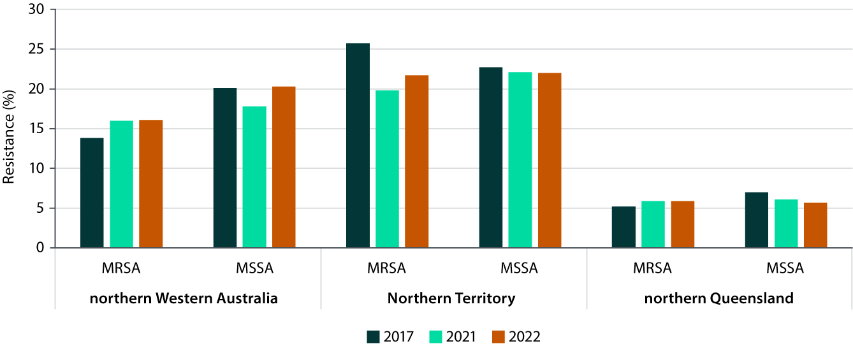

a Data presented are for all specimen types across community healthcare clinics and hospitals.

Table 3: Proportions of clindamycin resistance in Staphylococcus aureus isolates in northern Australia,a for 2017, 2021 and 2022

| Year | northern Western Australia | | | | Northern Territory | | | | northern Queensland | | | |
| --- | --- | --- | --- | --- | --- | --- | --- | --- | --- | --- | --- | --- |
| MRSAb,c | | MSSAc,d | | MRSAb,c | | MSSAc,d | | MRSAb,c | | MSSAc,d | |
| N | % | N | % | N | % | N | % | N | % | N | % |
| 2017 | 65 | 13.8% | 239 | 20.1% | 3,291 | 25.7% | 6,657 | 22.7% | 3,601 | 5.2% | 8,242 | 7.0 |
| 2021 | 1,841 | 16.0% | 2,009 | 17.8% | 2,834 | 19.8% | 5,403 | 22.1% | 2,970 | 5.9% | 10,048 | 6.1 |
| 2022 | 1,451 | 16.1% | 1,913 | 20.3% | 3,354 | 21.7% | 5,453 | 22.0% | 2,633 | 5.9% | 10,052 | 5.7 |

a Data presented are for all specimen types across community healthcare clinics and hospitals.

b MRSA: methicillin-resistant *Staphylococcus aureus*.

c N: total isolates for each jurisdiction; %: percentage resistance for each jurisdiction.

d MSSA: methicillin-susceptible *Staphylococcus aureus*.

In northern Western Australia, clindamycin resistance was more common in MSSA than in MRSA isolates in 2017, 2021 and 2022. Clindamycin-resistant MRSA has increased from 13.8% in 2017 to 16.1% in 2022 (χ2 = 0.092; *p* = 0.76), albeit non-significant, possibly attributable to the small number of MRSA isolates tested for clindamycin (N = 65) in 2017 compared with 2022 (N = 1,451).

The same trend of a higher proportion clindamycin-resistant MSSA than of clindamycin-resistant MRSA was not observed in the Northern Territory or northern Queensland (Figure 3, Table 3).

In northern Queensland, clindamycin-resistant MSSA has remained stable with a gradual decrease from 7.0% in 2017 (N = 8,242) to 5.7% in 2022 (N = 10,052) (χ2 = 14.081; *p* < 0.001).

Furthermore, there were no observed differences between community and hospital-associated clindamycin-resistant MRSA in northern Western Australia in 2022 (community: 16.6%, N = 856; hospital: 15.3%, N = 595) (data not shown; χ2 = 0.353; *p* = 0.56). In the Northern Territory and northern Queensland, clindamycin-resistant MRSA was higher in hospital isolates (Northern Territory: 24.1%, N = 2,600; northern Queensland: 7.0%, N = 2,300) than in community isolates (Northern Territory: 14.4%, N = 754; northern Queensland: 2.3%, N = 333) in 2022 (Northern Territory: χ2 = 29.752, *p* < 0.001; northern Queensland: χ2=9.500, *p* = 0.002) (data not shown).

### *Escherichia coli* in northern Australia

In 2022, a total of 14,667 *E. coli* isolates was reported across northern Australia (Table 1). Most clinical isolates reported were from hospitals (80.5%; n = 11,802), with the remaining 19.5% (n = 2,865) from community healthcare settings. More than half of the *E. coli* isolates were from northern Queensland (n = 8,398), followed by the Northern Territory (n = 4,716) and northern Western Australia (n = 1,553).

In 2022, there was observed geographical variation of ceftriaxone-resistant *E. coli* across northern Australia (Figure 4). The highest burden of ceftriaxone-resistant *E. coli* was observed in the Barkly (22.1%; N = 331) and Alice Springs (23.4%; N = 1,244) regions in the Northern Territory, followed by the North West region (14.4%; N = 757) of Queensland. The lowest ceftriaxone-resistant *E. coli* burden was observed in the Torres and Cape region (3.9%; N = 652) of Queensland (Figure 4, Table 4). Ceftriaxone resistance in *E. coli* is most commonly caused by extended spectrum beta-lactamases (ESBL), which hydrolyse many beta-lactam antibiotics; such resistance limits readily available treatment options.21

Figure 4: The percentage of ceftriaxone-resistant *Escherichia coli* isolates in northern Australia for 2022

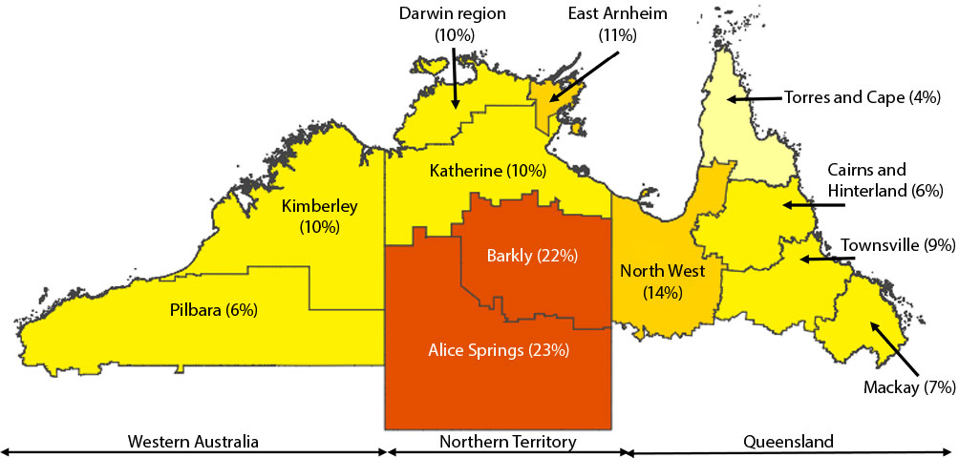

Table 4: The number of *Escherichia coli* isolates tested for ceftriaxone resistance, by region, in 2022

| Jurisdiction | Region | Number of isolates |
| --- | --- | --- |
| Western Australia | Kimberley | 883 |
| Pilbara | 665 |
| Northern Territory | Alice Springs | 1,244 |
| Barkly | 331 |
| Darwin | 2,388 |
| East Arnhem | 244 |
| Katherine | 458 |
| Queensland | Cairns and Hinterland | 2,962 |
| Mackay | 1,588 |
| North West | 757 |
| Torres and Cape | 652 |
| Townsville | 2,412 |

The next part of this data report provides a focused description of AMR in the Northern Territory.

## Epidemiology of antimicrobial resistance in the Northern Territory

In 2022, HOTspots received data on 16,856 clinical isolates from Northern Territory hospitals and community healthcare clinics (Table 1). Of the isolates described by these data, 66.3% (n = 11,171) were from all Northern Territory public hospitals; the remaining 33.7% (n = 5,685) were from 102 community healthcare clinic collection sites.

The most commonly recovered clinical bacterial isolates in the Northern Territory were *S. aureus* and *E. coli*, representing 48.5% and 28.0% of total isolates respectively. These two bacteria are the focus of a more detailed description in the following sections of this report.

### *Staphylococcus aureus* in the Northern Territory

In 2022, there were 8,170 *S. aureus* isolates recovered from both community healthcare clinics and public hospitals across the Northern Territory (Table 1).

Blood cultures had the highest resistance (to methicillin and clindamycin) observed, compared to urine and skin and soft tissue (Figure 5). The overall resistance of *S. aureus* to methicillin and clindamycin was 32.9% and 21.82% respectively in 2022 (Figure 5). Most (94%; N = 2,124) of *S. aureus* from skin and soft tissue or other sites were resistant to penicillin; analysis from blood cultures was not possible due to a limited number of samples (data not shown). There were no *S. aureus* isolates with vancomycin resistance in the Northern Territory in 2022 (Figure 5).

Figure 5: The percentage of *Staphylococcus aureus* isolates with antimicrobial resistance, by specimen type,a in the Northern Territory for 2022

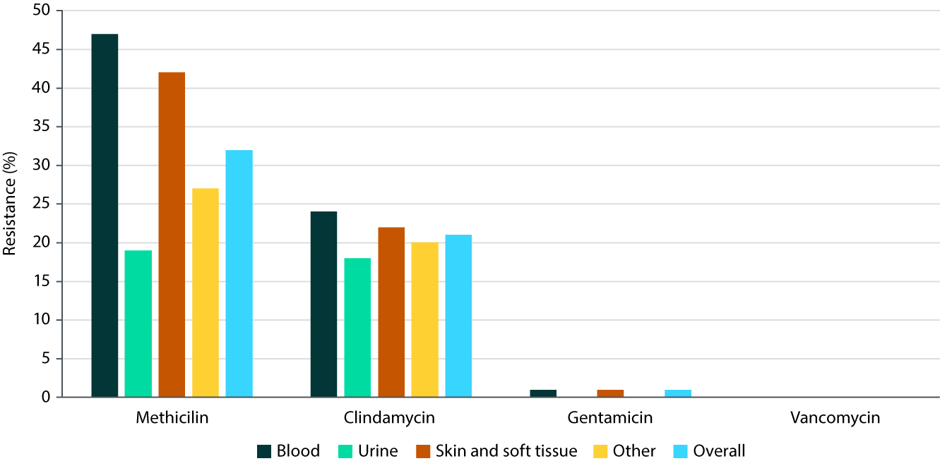

a ‘Other’ category is provided to HOTspots as an aggregated category by pathology providers; it includes any specimen source other than blood, urine, skin and soft tissue.

General trends of MRSA prevalence in the Northern Territory in 2017, 2021 and 2022 are presented for community healthcare clinics and hospitals (Figure 6). To better support antimicrobial stewardship in the Northern Territory, we have reported MRSA data according to local experts’ needs. The data are categorised by region and by healthcare setting (community and hospital) to ensure the most effective use of surveillance information.

Figure 6: The percentage of methicillin-resistant *Staphylococcus aureus* by healthcare settinga and region in the Northern Territory for 2017, 2021, and 2022

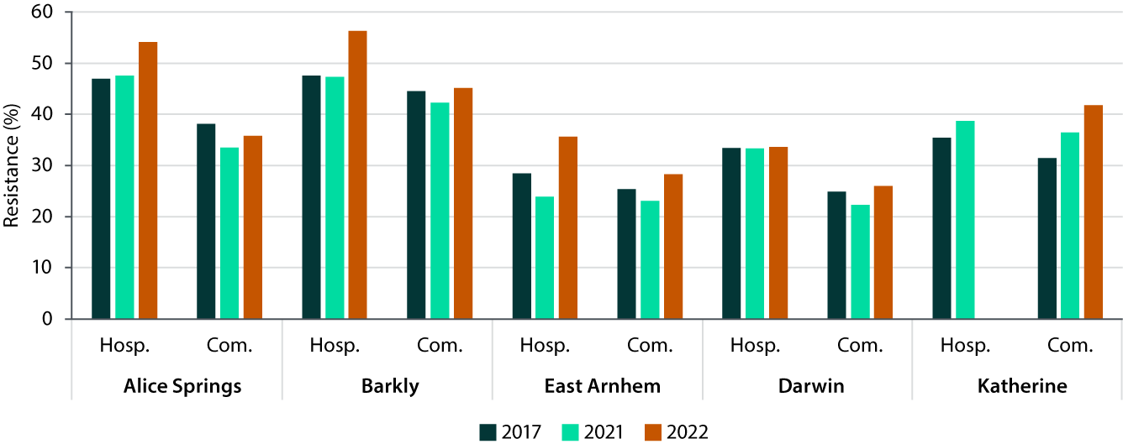

a Hosp: hospitals; Com.: community healthcare clinics.

In community healthcare clinics of the Northern Territory, there has been a gradual increase in MRSA in the Katherine region from 31.4% in 2017 to 41.8% in 2022 (χ2 = 26.32; *p* < 0.001; Figure 6). In 2022, MRSA was highest in Barkly region community healthcare clinics (45.2%; N = 354), followed by Katherine (41.8%; N = 735). The lowest observed MRSA was in the Darwin region (26.0%; N = 731). All community healthcare clinics recorded a higher rate of resistance in 2022 than in 2021.

In the hospitals of the Northern Territory, there was a notable increase in MRSA prevalence in the Alice Springs, Barkly and East Arnhem regions in 2022 compared to 2017 (Figure 6). In the Barkly region, MRSA increased from 47.5% (N = 242) in 2017 to 56.3% (N = 135) in 2022, albeit this increase was statistically non-significant (χ2 = 2.33; *p* = 0.13). In the Alice Springs region, MRSA in hospitals increased from 46.9% (N = 2,431) in 2017 to 54.1% (N = 2,476) in 2022 (χ2 = 4.33; *p* = 0.037). MRSA in isolates from hospitals in the Darwin region has remained stable across 2017, 2021 and 2022.

Across most regions of the Northern Territory, the clindamycin resistance of *S. aureus* isolates from community healthcare clinics and hospitals was lower in 2022 than in 2021 (Figure 7). Additional region-specific data, not presented in this report, can be found on the the open-access HOTspots digital surveillance platform.[3]

Figure 7: The percentage of clindamycin-resistant *Staphylococcus aureus* by healthcare settinga and region in the Northern Territory for 2017, 2021, and 2022

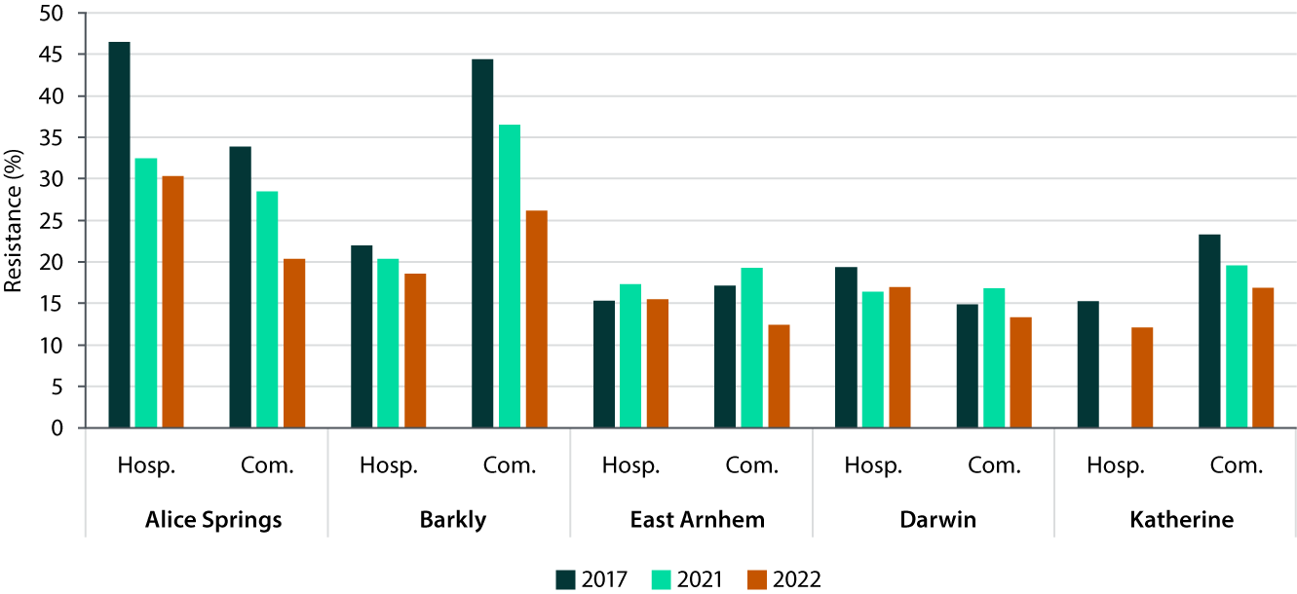

a Hosp: hospital setting; Com.: community healthcare clinic.

For all other antimicrobials, changes in percentage resistance in *S. aureus* isolates since 2017 are shown in Table 5.

Table 5: *Staphylococcus aureus* antimicrobial resistance patterns by healthcare setting in the Northern Territory for 2017, 2021, and 2022

| Antimicrobial | Community healthcare clinicsa | | | Hospitalsa,b | | |
| --- | --- | --- | --- | --- | --- | --- |
| 2017 | 2021 | 2022 | 2017 | 2021 | 2022 |
| (N = 6,609) | (N = 4,799) | (N = 2,132) | (N = 3,431) | (N = 3,526) | (N = 5,947) |
| Methicillin | 31.8% | 32.4% | 35.0% | 35.0% | 37.4% | 43.9% |
| Clindamycin | 25.6% | 23.3% | 18.3% | 21.2% | 18.0% | 23.0% |
| Gentamicin | 0.4% | 0.5% | 0.8% | 1.4% | 1.8% | 0.4% |
| Vancomycin | 0.1% | 0.1% | 0.0% | 0.1% | 0.0% | 0.0% |
| Penicillin | 97.4% | 95.4% | 95.0% | NA | NA | NA |

a N: number of isolates.

b NA: < 30 isolates recovered per year, or data are not reported.

Other notable changes observed in *S. aureus* isolates from the Northern Territory are as follows:

* There has been a decrease in the proportion of clindamycin-resistant *S. aureus* isolates from community healthcare clinics over the past five years, from 25.6% in 2017 to 18.3% in 2022 (χ2= 46.7; *p* < 0.001). This decrease was not observed in hospital-associated isolates.
* There has been a decrease in the proportion of gentamicin-resistant *S. aureus* isolates from hospitals over the past five years, from 1.4% in 2017 to 0.4% in 2022 (χ2 = 28.2; *p* < 0.001).
* There has been an increase in the proportion of MRSA in community healthcare clinic isolates over the past five years, from 31.8% in 2017 to 35.0% in 2022 (χ2 = 7.59; *p* = 0.006). Similarly there has been a proportional increase in MRSA hospital isolates over the past five years, from 35.0% in 2017 to 43.9% in 2022 (χ2 = 71.43; *p* < 0.001).
* There has been a decrease in the proportion of penicillin-resistant *S. aureus* isolates from community healthcare clinics over the past five years, from 97.4% in 2017 to 95.0% in 2022 (χ2= 27.5; *p* < 0.001).
* Gentamicin-resistant *S. aureus* isolates from community healthcare clinics were stable (< 1%) over the past five years.
* Vancomycin resistance in *S. aureus* was stable and very low (less than 0.1%) in both community healthcare clinics and hospitals from 2017 to 2022.

### *Escherichia coli* in the Northern Territory

In 2022, there were 4,716 *E. coli* isolates recovered from both community healthcare clinics and public hospitals across the Northern Territory (Table 1).

*E. coli* was most frequently isolated from urine specimens (N = 4,186) compared to blood (N = 217) and other sources (N = 313) (data not shown). Resistance in *E. coli* blood isolates (Figure 8a) was observed to be higher than in urine isolates (Figure 8b). The most notable differences in resistance profiles between blood and urine isolates were for cefazolin resistance (30% in blood specimens compared to 17.6% in urine) and ceftriaxone resistance (24.4% blood specimens compared to 13% in urine).

Figure 8: Escherichia coli antimicrobial resistance in (a) blood and (b) urine specimens in the Northern Territory in 2022a

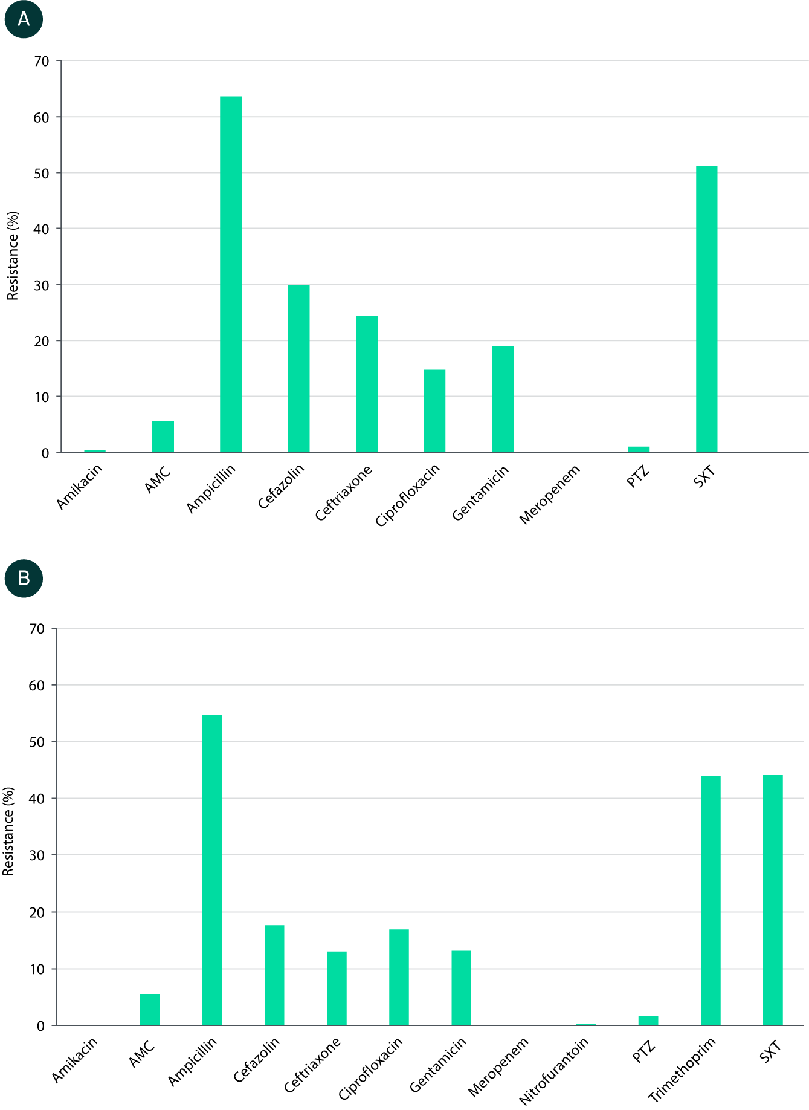

a AMC: amoxicillin-clavulanate; PTZ: piperacillin-tazobactam; SXT: trimethoprim-sulfamethoxazole.

In 2022, in the Northern Territory, ceftriaxone resistance was lower in community healthcare clinics (10.6%; N = 1,585) than in hospitals (16.3%; N = 3,131) (χ2 = 27.82; *p* < 0.001; see Table 6).

Table 6: *Escherichia coli* antimicrobial resistance patterns by healthcare setting in the Northern Territory for 2017, 2021, and 2022

| Antimicrobial | Community healthcare clinicsa,b | | | Hospitalsa | | |
| --- | --- | --- | --- | --- | --- | --- |
| 2017 | 2021 | 2022 | 2017 | 2021 | 2022 |
| (N = 4,960) | (N = 3,841) | (N = 1,585) | (N = 1,869) | (N = 2,305) | (N = 3,131) |
| Amikacin | 0.1%c | 0.1%c | 0%d | 0.4% | 0.0% | 0.1% |
| Amoxicillin-clavulanate | 5.3% | 6.4% | 5.8% | 10.1% | 5.9% | 5.6% |
| Ampicillin | 58.8% | 54.1% | 52.5% | 58.5% | 54.8% | 57.5% |
| Cefazolin | 14.0% | 14.4% | 15.9% | 15.0% | 15.1% | 20.6% |
| Ceftriaxone | 5.7% | 9.7% | 10.6% | 9.0% | 10.6% | 16.3% |
| Ciprofloxacin | 26.3% | 19.0% | 20.3% | 15.2% | 14.8% | 15.4% |
| Gentamicin | 8.7% | 9.7% | 11.1% | 10.5% | 11.0% | 14.9% |
| Meropenem | 0.4%c | 0%c | 0%d | 0.0% | 0.1% | 0% |
| Nitrofurantoin | NA | NA | NA | 0.2% | 0.4% | 0.2% |
| Piperacillin-tazobactam | NA | NA | NA | 2.9% | 2.2% | 1.7% |
| Trimethoprim | NA | NA | NA | 39.7% | 38.9% | 44.7% |
| Trimethoprim-sulfamethoxazole | NA | NA | NA | 36.3% | 36.3% | 42.7% |

a N: number of isolates.

b NA: < 30 isolates recovered per year, or data are not reported.

c For amikacin and meropenem in community healthcare clinics in this year, the sample size tested was N = 1,000.

d For amikacin and meropenem in community healthcare clinics in this year, the sample size tested was N = 363.

Other notable changes observed in *E. coli* isolates from the Northern Territory are:

* There was a decrease in the proportion of amoxicillin-clavulanate resistant *E. coli* isolates from hospitals, from 10.1% in 2017 (N = 1,869) to 5.6% in 2022 (N = 3,131) (χ2 = 34.19; *p* < 0.001). Amoxicillin-clavulanate resistance remains low in *E. coli* isolates from community healthcare clinics (5.8% in 2022).
* There was a decrease in the proportion of piperacillin-tazobactam resistant *E. coli* isolates from hospitals, from 2.9% in 2017 (N = 1,869) to 1.7% in 2022 (N = 3,131) (χ2 = 7.29; *p* = 0.007).
* There was an increase in the proportion of cefazolin-resistant *E. coli* isolates from community healthcare clinics, from 14.0% in 2017 (N = 4,960) to 15.9% in 2022 (N = 1,585) (χ2 = 3.85; *p* = 0.05). Negligible change was observed when comparing 2017 with 2021 (14.0%; N = 3,841) (χ2 = 0.47; *p* = 0.49).
* There were increases in the proportions of ceftriaxone-resistant *E. coli* isolates from both hospitals and community healthcare clinics. Isolates from community settings increased from 5.7% in 2017 (N = 4,960) to 10.6% in 2022 (N = 1,585) (χ2 = 43.03; *p* < 0.001) but only a small change was observed when 2022 was compared to 2021 (9.6%; N = 3,841) (χ2 = 1.03; *p* = 0.31). The proportion of ceftriaxone-resistant *E. coli* isolates from hospitals has increased from 9.0% in 2017 (N = 1,869) to 16.3% in 2022 (N = 3,131) (χ2 = 51.64; *p* < 0.001).
* Similarly, there were increases in the proportions of gentamicin-resistant *E. coli*, from 8.7% in 2017 (N = 4,960) to 11.1% in 2022 (N = 1,585) in community healthcare clinics (χ2 = 7.56; *p* = 0.006), and from 10.5% in 2017 (N = 1,869) to 14.9% in 2022 (N = 3,131) in hospitals (χ2 = 21.28; *p* < 0.001). Amikacin resistance in *E. coli* remains low (< 0.2%) in 2022.
* There were increases in the proportions of *E. coli* isolates from hospitals resistant to trimethoprim and trimethoprim-sulfamethoxazole by 5% since 2017, to a total of 44.7% (N = 3,131; χ2 = 11.90; *p* < 0.001) and 42.7% (N = 3,131; χ2 = 19.32; *p* < 0.001) respectively in 2022.
* There was no change, and very low (0.2%) resistance, in *E. coli* isolates from hospitals to nitrofurantoin.

### *Streptococcus pneumoniae* isolates from community in the Northern Territory

In 2022, HOTspots did not receive any data on *S. pneumoniae* isolates from hospitals, and only a limited number of isolates were recovered from community-associated infections in the Northern Territory (N = 65; Table 1). The vast majority of *S. pneumoniae* isolates from community healthcare clinics were from respiratory infections, among which 0.4% were penicillin-resistant, and there were no vancomycin-resistant *S. pneumoniae* isolates observed (data not shown).

### *Streptococcus pyogenes* isolates from community in the Northern Territory

In 2022, due to limited laboratory capacity available for data extraction, HOTspots did not receive any data on *S. pyogenes* isolates from hospitals. The *S. pyogenes* isolates collected from community settings were largely recovered from skin and soft tissue infections. Of the 1,096 *S. pyogenes* skin and soft tissue isolates, 10% were resistant to erythromycin, and no resistance was reported for vancomycin in 2022 (data not shown).

# Discussion

The 2022 surveillance data from HOTspots shows that the patterns of resistance in northern Australia are geographically diverse and remain high for the selected bacterial pathogens.

In 2022, MRSA incidence in northern Australia showed geographical variation, ranging from 14.4% in Mackay to 53.1% in Alice Springs and 46.3% in the Kimberley. These rates are much higher than in southern Australia,4 particularly in remote regions such as Alice Springs (53.1%), Barkly (47.9%), and the Kimberley (46.3%), where AMR risk is known to be higher.12 Despite this, vancomycin remains an important antimicrobial for use in patients with sepsis or empirically in serious *S. aureus* infections as resistance is low. Resistance of MRSA to the second-line antibiotic clindamycin has gradually reduced from 25.7% in 2017 to 21.7% in 2022 (χ2 = 14.27; *p* = 0.002) but remains higher in the Northern Territory than in the rest of northern Australia. High clindamycin resistance in patients with an MRSA infection is a local impediment to the empirical use of this agent for community-associated MRSA. Compared to national data, clindamycin-resistant MRSA in northern Australia (range from 5.7% to 22.7%) in 2022 was lower than the national average reported for blood isolates (range from 31.5% in 2017 to 23.0% in 2021).5 The elevated resistance to clindamycin in *S. aureus* may be driven by clindamycin usage itself, or cross-resistance from other antimicrobial including those used in mass drug administration such as azithromycin.22

In the Northern Territory, MRSA in community isolates significantly increased from 31.8% in 2017 to 35.0% in 2022 (χ2 = 7.59; *p* = 0.006), and in hospitals from 35.0% to 43.9% (χ2 = 71.43; *p* < 0.001). MRSA rates in community clinics remained stable, but high in Barkly (45.2%), and low in Darwin (26.0%), but increased in Katherine and East Arnhem. Amongst hospital patients, MRSA has increased in the Alice Springs, Barkly and East Arnhem regions since 2017. In 2022, MRSA was highest in the Barkly region hospital patients (56.3%) and Alice Springs hospital patients (54.1%) and lowest in the Darwin region hospital patients (33.7%).

In this report, we do not include *S. aureus* trimethoprim-sulfamethoxazole resistance due to the variation in testing methodology used by different laboratories. Some laboratories use the automated broth microdilution using the Vitek system, while others use disk diffusion. Discordance between these methodologies has previously been reported, potentially falsely giving the impression of large differences in resistance patterns in different regions.23

Most *E. coli* isolates reported to HOTspots were from urinary tract infections and these showed geographical variation in resistance across northern Australia in 2022. Specific to the Northern Territory, ceftriaxone-resistant *E. coli* has increased in isolates from both hospital and community healthcare clinics since 2017. The high percentage of ceftriaxone-resistant *E. coli* in isolates from community (10.6%) and hospital (16.3%) settings in 2022 remains a challenge for the treatment of severe urinary tract infections.24 Additionally, the current recommendation for the use of gentamicin (in combination with ampicillin), for severe urinary tract infection,24 is concerning given the gradual increase in gentamicin-resistant *E. coli* in Northern Territory community healthcare clinics (8.7% to 11.1% from 2017 to 2022) and in hospital settings (10.5% to 14.9% from 2017 to 2022).

Data from remote northern Australian community healthcare clinics25 suggest that trimethoprim is commonly used to treat urinary tract infections, as recommended in national guidelines.26 However, resistance to trimethoprim (44.7%) and trimethoprim-sulfamethoxazole (42.7%) in *E. coli* isolates has increased over the past five years and is high in the Northern Territory. Reassuringly, resistance to nitrofurantoin in *E. coli* isolates in the Northern Territory remains stable and low at 0.2% in 2022. For urinary tract infections, use of nitrofurantoin, cefalexin or amoxicillin-clavulanate could be considered as treatment options in settings where trimethoprim resistance is high (e.g. > 25%).25

From the limited number of *S. pneumoniae* and *S. pyogenes* clinical isolates contributed to HOTspots from the Northern Territory, it was observed that *S. pneumoniae* isolates remain susceptible to vancomycin (0.0% resistance) and penicillin (0.4% resistance) in patients with respiratory infections.

There are several limitations of this report. Firstly, whilst HOTspots aims to be representative of the population, there are some populations that may be under-represented in this report. In particular, there are some private pathology services in northern Australia, mainly in northern Queensland, that do not contribute data. Additionally, some populations, especially those living in very remote areas, may not seek healthcare, resulting in their data not being captured. This can lead to fewer samples being collected from remote regions compared to urban areas in northern Australia. Consequently, our data may underestimate the level of resistance in these remote regions. The extent of population coverage in HOTspots is currently under assessment to determine the percentage of the population under surveillance. Secondly, there may be certain geographical locations where specimens are collected only if a patient does not respond to initial antibiotic treatment, which might lead to an overestimate of resistance in these regions. Thirdly, the attribution of resistance to a particular location in Northern Territory hospital bloodstream infections indicates where the sample was processed, not necessarily where the infections were acquired. Due to limited laboratory capacity in 2022, we did not receive data on hospital-associated *S. pyogenes*. As a result, this report does not provide information on the epidemiology of this pathogen among hospital patients in Northern Territory. Lastly, while there are ongoing efforts to link HOTspots surveillance data with antibiotic usage data in northern Australia, this report does not demonstrate how changes in antibiotic usage affect resistance patterns. These efforts aim to better support and inform local stewardship activities in the future.

In conclusion, regions of northern Australia have some of the highest rates of AMR in Australia,4,10 highlighting the need for greater investment in consistent and comparable surveillance across jurisdictions, including in regional and remote settings. The increasing prevalence of community-associated MRSA and ceftriaxone-resistant *E. coli* are concerning as these infections are difficult to treat. Addressing AMR requires enhanced prevention, detection and management efforts. This epidemiological report demonstrates persistent disparities in AMR across northern Australia, emphasising the importance of ongoing surveillance with region-specific strategies and healthcare workforce capacity building. Annual monitoring is essential for identifying trends and for enabling effective, data-driven responses to the growing threat of AMR in northern Australia.

# Acknowledgments

We acknowledge the significant contribution of data on antimicrobial resistance from the jurisdictions and the private sector to the HOTspots Surveillance and Response Program. We are grateful for the continued support from the following pathology services: Pathology Queensland (Queensland Health), Territory Pathology (Northern Territory Government), PathWest Laboratory Medicine Western Australia (Department of Health, Western Australia), and Western Diagnostic Pathology (Healius Group). We would like to thank Dr Yen Pham and Dr Lorraine Bell for editorial feedback.

We acknowledge the support of members of the HOTspots Advisory Committee:

Professor Robert Baird, Director of Pathology Infectious Diseases, Territory Pathology, NT Government

Professor Bart Currie, Infectious Diseases Physician, Royal Darwin Hospital, Menzies School of Health Research

Professor Bhavini Patel, Executive Director Medicine Management, NT Department of Health

Dr Michael Leung, Clinical microbiologist & regional microbiologist, PathWest Pathology Medicine WA

Dr Shalinie Perera, Microbiologist, Western Diagnostic Pathology, WA

Ms Amy Legg (PhD Candidate), Menzies School of Health Research, Charles Darwin University, Darwin, Northern Territory, Australia

Department of Pharmacy, Royal Brisbane and Women’s Hospital, Brisbane, Queensland, Australia

Dr Sonali Coulter, Data Manager – Antimicrobial Stewardship Data, Microbiologist, Pathology Queensland, Qld Health

Dr Nadine Hillock, National Antimicrobial Utilisation Surveillance Program Manager / Senior Pharmacist, South Australia Health

Ms Kim Stewart, A/Stream Director, AURA, Infection Prevention and Control, Healthcare-Associated Infections and Emerging Issues, Australian Commission on Safety and Quality in Health Care

# Funding

The pilot of HOTspots integration into the Antimicrobial Use and Resistance in Australia surveillance program was funded by the Australian Government Department of Health and Aged Care.

# Author details

Assoc Prof Teresa M Wozniak, Principal Research Scientist1

Ms Alys R Young, Research Assistant2

Dr Aminath Shausan, Postdoctoral Fellow1

Ms Amy Legg, Clinical Pharmacist3,4

Dr Michael J Leung, Clinical Microbiologist5

Dr Sonali A Coulter, Microbiologist6

Dr Shalinie Pereira, Microbiologist7

Prof Robert W Baird, Director of Pathology8

Dr Majella G Murphy, Program Manager1

1. Australian e-Health Research Centre, Commonwealth Scientific and Industrial and Research Organisation, STARS Herston, Queensland, 4029, Australia
2. Australian e-Health Research Centre, Commonwealth Scientific and Industrial and Research Organisation, Parkville, Melbourne, Victoria 3052, Australia
3. Menzies School of Health Research, Charles Darwin University, Darwin, Northern Territory, Australia
4. Department of Pharmacy, Royal Brisbane and Women’s Hospital, Brisbane, Queensland, Australia
5. Pathwest Pathology Medicine, Department of Health (WA Health), Perth, Western Australia, 6000, Australia
6. Antimicrobial Stewardship Data, Pathology Queensland, Queensland Health, Herston, Queensland, 4029, Australia
7. Western Diagnostic Pathology, Jandakot, Western Australia, 6164, Australia
8. Departments of Infectious Diseases and Pathology and Northern Territory Medical Program, Royal Darwin Hospital, Darwin, Northern Territory, 0811, Australia

Corresponding author

Assoc Prof Teresa Wozniak

Australian e-Health Research Centre

Commonwealth Scientific and Industrial Research Organisation

Level 7, 296 Herston Road, STARS Building, Herston Qld 4029

Phone: +61 7 3253 3681, 0412 15 1438

Email: [teresa.wozniak@csiro.au](mailto:teresa.wozniak@csiro.au)

# References

1. Wozniak TM, Smith-Vaughan H, Andrews R. Convergence of surveillance blind spots with antimicrobial resistance hotspots. *Aust N Z J Public Health*. 2021;45(6):541–2. doi: <https://doi.org/10.1111/1753-6405.13165>.
2. Wozniak TM, Cuningham W, Buchanan S, Coulter S, Baird RW, Nimmo GR et al. Geospatial epidemiology of *Staphylococcus aureus* in a tropical setting: an enabling digital surveillance platform. *Sci Rep*. 2020;10(1):13169. doi: <https://doi.org/10.1038/s41598-020-69312-4>.
3. Goddard L, Wozniak TM. Antimicrobial resistance surveillance to support decision-making in a high-prevalence region: an evaluation. *Front Trop Dis*. 2021;2. doi: <https://doi.org/10.3389/fitd.2021.772491>.
4. Australian Commission on Safety and Quality in Health Care (ACSQHC). *AURA 2021: Fourth Australian report on antimicrobial use and resistance in human health*. Sydney: ACSQHC; 2021. Available from: <https://www.safetyandquality.gov.au/sites/default/files/2021-09/aura_2021_-_report_-_final_accessible_pdf_-_for_web_publication.pdf>.
5. ACSQHC. AURA 2023: *Fifth Australian report on antimicrobial use and resistance in human health*. Sydney: ACSQHC; 16 November 2023. Available from: <https://www.safetyandquality.gov.au/our-work/antimicrobial-resistance/antimicrobial-use-and-resistance-australia-aura/aura-2023-fifth-australian-report-antimicrobial-use-and-resistance-human-health>.
6. ACSQHC. *Specification for a Hospital Cumulative Antibiogram*. Sydney: ACSQHC; December 2019. Available from: <https://www.safetyandquality.gov.au/publications-and-resources/resource-library/specification-hospital-cumulative-antibiogram-2019>.
7. Central Australian Rural Practitioners Association (CARPA) Editorial Committee. *CARPA Standard Treatment Manual (8th edition)*. Alice Springs: Centre for Remote Health; 2022. [Accessed in May 2023.] Available from: <https://remotephcmanuals.com.au/home.html>.
8. Northern Territory Primary Health Network (NT PHN). Northern Territory HealthPathways. [Website.] DarwinL NT PHN; 2022. Available from: <https://www.ntphn.org.au/health-professionals-hub/nt-healthpathways/>.
9. HOT NORTH. *HOT NORTH Antimicrobial Academy 2022 Program*. Darwin: Royal Darwin Hospital/Menzies School of Health Research, HOT NORTH; 2022. Available from: <https://www.naccho.org.au/app/uploads/2022/06/HNAA_2022_Program.pdf>.
10. Wozniak TM, Dyda A, Merlo G, Hall L. Disease burden, associated mortality and economic impact of antimicrobial resistant infections in Australia. *Lancet Reg Health West Pac*. 2022;27:100521. doi: <https://doi.org/10.1016/j.lanwpc.2022.100521>.
11. Wozniak TM, Dyda A, Lee X. The increased length of hospital stay and mortality associated with community-associated infections in Australia. *Open Forum Infect Dis*. 2022;9(5):ofac133. doi: <https://doi.org/10.1093/ofid/ofac133>.
12. Wozniak TM, Cuningham W, Ledingham K, McCulloch K. Contribution of socio-economic factors in the spread of antimicrobial resistant infections in Australian primary healthcare clinics. *J Glob Antimicrob Resist*. 2022;30:294–301. doi: <https://doi.org/10.1016/j.jgar.2022.06.005>.
13. Cuningham W, Perera S, Coulter S, Nimmo GR, Yarwood T, Tong SYC et al. Antibiotic resistance in uropathogens across northern Australia 2007–20 and impact on treatment guidelines. *JAC Antimicrob Resist*. 2021;3(3):dlab127. doi: <https://doi.org/10.1093/jacamr/dlab127>.
14. (a) Antimicrobial Resistance Collaborators. Global burden of bacterial antimicrobial resistance in 2019: a systematic analysis. *Lancet*. 2022;399(10325):629–55. doi: <https://doi.org/10.1016/S0140-6736(21)02724-0>. (b) ibid. (Erratum). *Lancet*. 2022;400(10358):1102. doi: <https://doi.org/10.1016/S0140-6736(21)02653-2>.
15. Babu Rajendran N, Arieti F, Mena-Benítez CA, Galia L, Tebon M, Alvarez J et al. EPI-Net One Health reporting guideline for antimicrobial consumption and resistance surveillance data: a Delphi approach. *Lancet Reg Health Eur*. 2022:26;100563. doi: <https://doi.org/10.1016/j.lanepe.2022.100563>.
16. Australian Bureau of Statistics. Australian Statistical Geography Standard (ASGS). [Online resource.] Canberra: Australian Bureau of Statistics; 2021. [Accessed in May 2023.] Available from: <https://www.abs.gov.au/statistics/statistical-geography/australian-statistical-geography-standard-asgs>.
17. Clinical and Laboratory Standard Institute (CLSI). *M100 – Performance Standards for Antimicrobial Susceptibility Testing, 31st Edition*. Wayne, PA: CLSI; 29 March 2021. [Accessed in May 2023.] Available from: <https://clsi.org/about/press-releases/clsi-publishes-m100-performance-standards-for-antimicrobial-susceptibility-testing-31st-edition/>.
18. World Health Organization (WHO) Global Antimicrobial Resistance Surveillance System (GLASS). *GLASS report: early implementation 2016–2017*. Geneva: WHO, GLASS; 29 January 2018. Available from: <https://www.who.int/publications/i/item/9789241513449>.
19. ACSQHC. Australian Passive AMR Surveillance (APAS). [Webpage.] Sydney: ACSQHC; 2024. Available from: <https://www.safetyandquality.gov.au/our-work/antimicrobial-resistance/antimicrobial-use-and-resistance-australia-aura/hospital-and-community-antimicrobial-resistance/australian-passive-amr-surveillance-apas>.
20. Queensland Government, Office of the Queensland Parliamentary Counsel. *Public Health Act 2005*. [Legislation.] Brisbane: Queensland Government; 2023. [Accessed in May 2023.] Available from: <https://www.legislation.qld.gov.au/view/html/inforce/current/act-2005-048>.
21. Tamma PD, Komarow L, Ge L, Garcia-Diaz J, Herc ES, Doi Y et al. Clinical impact of ceftriaxone resistance in *Escherichia coli* bloodstream infections: a multicenter prospective cohort Study. *Open Forum Infect Dis*. 2022;9(11):ofac572. doi: <https://doi.org/10.1093/ofid/ofac572>.
22. Rolfe RJ, Shaikh H, Tillekeratne LG. Mass drug administration of antibacterials: weighing the evidence regarding benefits and risks. *Infect Dis Poverty*. 2022;11(1):77.   
    doi: <https://doi.org/10.1186/s40249-022-00998-6>.
23. McGuinness SL, Holt DC, Harris TM, Wright C, Baird R, Giffard PM et al. Clinical and molecular epidemiology of an emerging Panton-Valentine leukocidin-positive ST5 methicillin-resistant *Staphylococcus aureus* clone in northern Australia. *mSphere*. 2021;6(1):e00651-20. doi: <https://doi.org/10.1128/msphere.00651-20>.
24. CARPA Editorial Committee. *CARPA Standard Treatment Manual (7th edition)*. Alice Springs: Centre for Remote Health; 2017. [Accessed in May 2023.] Available from: <https://remotephcmanuals.com.au/>.
25. Cuningham W, Anderson L, Bowen AC, Buising K, Connors C, Daveson K et al. Antimicrobial stewardship in remote primary healthcare across northern Australia. *PeerJ*. 2020;8:e9409. doi: <https://doi.org/10.7717/peerj.9409>.
26. Therapeutic Guidelines (eTG). Antibiotic (version 16). [Webpage.] West Melbourne: Therapeutic Guidelines Limited; 2019. Available from: <https://app.tg.org.au/viewTopic?guidelinePage=Antibiotic&etgAccess=true>.
27. Australian Institute of Health and Welfare (AIHW). Hospitals info and downloads: Glossary. [Webpage.] Canberra: Australian Government, AIHW; 2023. Available from: <https://www.aihw.gov.au/reports-data/myhospitals/content/glossary#:~:text=Hospital%3A%20A%20health%20care%20facility,and%2For%20care%20to%20patients>.

# Glossary

Term Definition

Community-associated Clinical isolates that were identified and reported from a non-hospital (community) healthcare setting.

Community healthcare clinic A primary healthcare facility offering essential healthcare services provided by general practitioners, nursing staff and allied health professionals. It includes primary healthcare delivered in prisons and in Aboriginal Community Controlled Health Organisations.

Hospital-associated Clinical isolates that were identified and reported from a hospital healthcare setting.

Hospital A healthcare facility established under Commonwealth, state, or territory legislation as a hospital or a free-standing day procedure unit, and authorised to provide treatment and/or care to patients.27

Region-specific information The information being reported within a geographical region. There are 12 regions which we refer to in this report (Figure 1).

© Commonwealth of Australia as represented by the Department of Health and Aged Care

ISSN: 2209-6051 Online

This journal is indexed by Index Medicus and Medline.

Creative Commons Licence

This publication is licensed under a Creative Commons Attribution-NonCommercial-NoDerivatives 4.0 International Licence (CC BY-NC-ND) available from <https://creativecommons.org/licenses/by-nc-nd/4.0/legalcode> (Licence). You must read and understand the Licence before using any material from this publication.

Restrictions

The Licence does not cover, and there is no permission given for, use of any of the following material found in this publication (if any):

* the Commonwealth Coat of Arms (by way of information, the terms under which the Coat of Arms may be used can be found on the Department of Prime Minister and Cabinet website;
* any logos (including the Department of Health and Aged Care’s logo) and trademarks;
* any photographs and images;
* any signatures; and
* any material belonging to third parties.

Disclaimer

Opinions expressed in *Communicable Diseases Intelligence* are those of the authors and not necessarily those of the Department of Health and Aged Care or the Communicable Diseases Network Australia. Data may be subject to revision.

Enquiries

Enquiries regarding any other use of this publication should be addressed to the CDI Editor at: [cdi.editor@health.gov.au](mailto:cdi.editor@health.gov.au).

Communicable Diseases Network Australia

Communicable Diseases Intelligence contributes to the work of the [Communicable Diseases Network Australia](http://www.health.gov.au/cdna).

About Communicable Diseases Intelligence

*Communicable Diseases Intelligence* (CDI) is a peer-reviewed scientific journal published by the Health Security & Emergency Management Division, Department of Health and Aged Care. The journal aims to disseminate information on the epidemiology, surveillance, prevention and control of communicable diseases of relevance to Australia.

**Editor**: Christina Bareja • **Deputy Editor**: Simon Petrie • **Design and Production**: Lisa Thompson

**Editorial Advisory Board**: David Durrheim, Mark Ferson, Clare Huppatz, John Kaldor, Martyn Kirk and Meru Sheel

Submit an Article

Submit your next communicable disease related article to CDI for consideration. [Information for authors](https://www1.health.gov.au/internet/main/publishing.nsf/Content/cda-pubs-cdi-auth_inst.htm) and details on how to [submit your publication](https://www1.health.gov.au/internet/main/publishing.nsf/Content/cda-pubs-cdi-auth_inst.htm#submission_package) is available on our website, or by email at [cdi.editor@health.gov.au](mailto:cdi.editor@health.gov.au).

Contact us

Communicable Diseases Intelligence (CDI)

Health Security & Emergency Management Division

Department of Health and Aged Care

GPO Box 9848, CANBERRA ACT 2601

Website: [www.health.gov.au/cdi](http://www.health.gov.au/cdi)

Email: [cdi.editor@health.gov.au](mailto:cdi.editor@health.gov.au)

1. <https://plotly.com/>.
2. The latest version of the HOTspots platform is available here: <https://amr-hotspots.net>.
3. <https://amr-hotspots.net>.