• Volume • • Electronic publication date:

The first year of respiratory syncytial virus (RSV) surveillance in Tasmania, 1 July 2022 – 30 June 2023

Michelle McPherson, Nicola Stephens, Bhavika Yadav, Shannon Melody

# Abstract

Respiratory syncytial virus (RSV) became notifiable in Tasmania on 1 July 2022. This study describes the epidemiology and data quality of all notifications of laboratory confirmed RSV that had a specimen collection date from 1 July 2022 to 30 June 2023 in Tasmania. Descriptive analysis was undertaken by age group, sex, month of notification and residential location; data quality was assessed through completeness of reporting. There were 4,491 notifications of RSV in Tasmania, equating to a notification rate of 779 per 100,000 population per year. The highest proportion of RSV notifications were in children, there was a seasonal increase during winter and higher notification rates in the North region. Data completeness was greater than 98% for most person, place and time variables. This analysis of RSV notifications provides a baseline for the ongoing surveillance of RSV in Tasmania.

Keywords: respiratory syncytial virus; RSV; surveillance; Tasmania

# Introduction

Respiratory syncytial virus (RSV) became a nationally notifiable disease in Australia in 2021 and became notifiable in Tasmania from 1 July 2022 as per the *Public Health Act* (1997).1 Notifications for RSV were added to the existing passive surveillance system in Tasmania, with reporting of laboratory confirmed cases only.

RSV is a highly contagious and common virus that infects the airways and lungs, and re-infection is common. RSV generally affects young children and older adults, particularly those with underlying illnesses and a suppressed immune system.2 RSV usually presents with mild to moderate symptoms; however, it can cause serious complications and even death in some cases, especially for those at the extremes of age, the very young and elderly.3

The RSV immunisation landscape is rapidly evolving, with vaccines and monoclonal antibody treatments available for infant and older adult protection.4 At the time of this analysis, vaccination against RSV was not funded under the National Immunisation Program; however, in 2024, some states offered either high-risk or universal infant immunisation programs against RSV.5 In 2025, a comprehensive national maternal and infant immunisation program is underway.

Due to the scarcity of publications exploring RSV epidemiology in Tasmania,6 and to provide baseline data for the ongoing surveillance, evaluation, and monitoring of RSV and its associated preventative therapies, this study describes the epidemiology and data quality of RSV notifications in Tasmania in the first year since it became a notifiable disease.

# Methods

All notifications of laboratory confirmed RSV that met the national surveillance case definition,7 had a specimen collection date from 1 July 2022 to 30 June 2023 and resided in Tasmania, were included in the study. Notifications are received from laboratories and therefore only include data from the request form completed by the treating doctor. As such, a descriptive analysis was undertaken by age group, sex, month of notification and residential location. Rates per 100,000 population per year were calculated using the estimated resident population from the Australian Bureau of Statistics, 2023. Notification rates by Socio-Economic Indexes for Areas (SEIFA) were calculated using the Index of Relative Socio-Economic Advantage and Disadvantage (IRSAD) based on residential postcode and using the deciles for within Tasmania. Data quality was evaluated by determining the completeness of each variable in the dataset. An incomplete field was either blank or coded as ‘missing/not stated’ or ‘unknown’. The descriptive analysis was performed using Microsoft Excel.

The study was approved by the University of Tasmania Human Research Ethics Committee on 29 January 2024 (HREC approval 29396).

# Results

There were 4,491 notifications of RSV in Tasmania during 1 July 2022 – 30 June 2023, the first year RSV was notifiable, equating to a notification rate of 779 per 100,000 population per year.

The median age of RSV notifications was 8 years (interquartile range [IQR]: 1–48 years) and over half were female (53%). The median age for males was 5 years (IQR: 1–42 years) and for females was 20 years (IQR: 2–51 years). Notifications were most common in those aged 0–4 years; within this age group, notifications were higher in those aged less than two years (Table 1). Within those less than 24 months of age, the number of notifications in three-month age groups was similar, although with fewer in the 0–2 months age group (Figure 1).

Table 1: Number and rate per 100,000 population of RSV notifications by age group and sex,a Tasmania, 1 July 2022 – 30 June 2023

| Age group | Females | | Males | | Total | |
| --- | --- | --- | --- | --- | --- | --- |
| Number | Rate per 100,000 | Number | Rate per 100,000 | Number | Rate per 100,000 |
| 0–4 | 899 | 6,339.9 | 1,022 | 6,747.2 | 1,921 | 6,550.3 |
| < 1 year | 259 | 9,174.6 | 311 | 10,531.7 | 579 | 10,024.2 |
| 1 year | 276 | 9,640.2 | 280 | 9,265.4 | 563 | 9,566.7 |
| 2 years | 162 | 5,742.6 | 196 | 6,520.3 | 361 | 6,195.3 |
| 3 years | 124 | 4,381.6 | 146 | 4,738.7 | 273 | 4,618.5 |
| 4 years | 78 | 2,742.6 | 89 | 2,884.9 | 168 | 2,833.5 |
| 5–9 | 144 | 929.2 | 180 | 1,102.5 | 324 | 1,018.1 |
| 10–14 | 57 | 347.7 | 63 | 359.1 | 120 | 353.6 |
| 15–19 | 75 | 492.1 | 54 | 328.5 | 129 | 407.2 |
| 20–29 | 205 | 599.6 | 92 | 255.4 | 297 | 423.0 |
| 30–39 | 234 | 614.1 | 118 | 308.4 | 352 | 461.0 |
| 40–49 | 144 | 428.6 | 83 | 259.8 | 227 | 346.3 |
| 50–59 | 188 | 497.6 | 104 | 291.3 | 292 | 397.3 |
| 60–69 | 172 | 448.4 | 134 | 368.1 | 306 | 409.3 |
| 70–79 | 127 | 445.9 | 136 | 504.2 | 263 | 474.2 |
| 80+ | 133 | 829.3 | 89 | 719.0 | 222 | 781.3 |
| Total | 2,378 | 826.1 | 2,075 | 732.8 | 4,453 | 779.9 |

a Excludes 38 cases where sex was either not stated or inadequately described.

Figure 1: Number of RSV notifications in persons aged less than 24 months,a Tasmania, 1 July 2022 – 30 June 2023

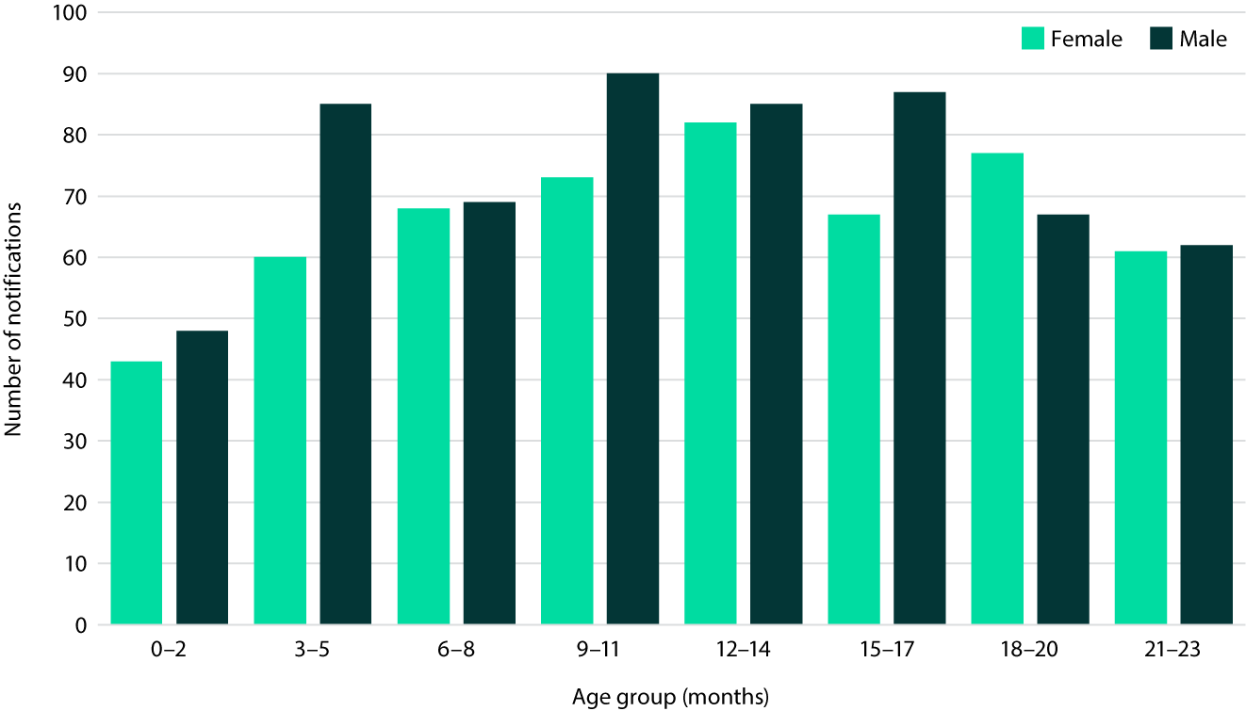

a Excludes 14 cases where age or sex was either not stated or inadequately described.

There was a seasonal distribution of notifications, with increases seen over the winter and spring months from June to September, with the peak of notifications occurring in August, at 1,479 (Figure 2).

Figure 2: Number of RSV notifications by month, Tasmania, 1 July 2022 – 30 June 2023

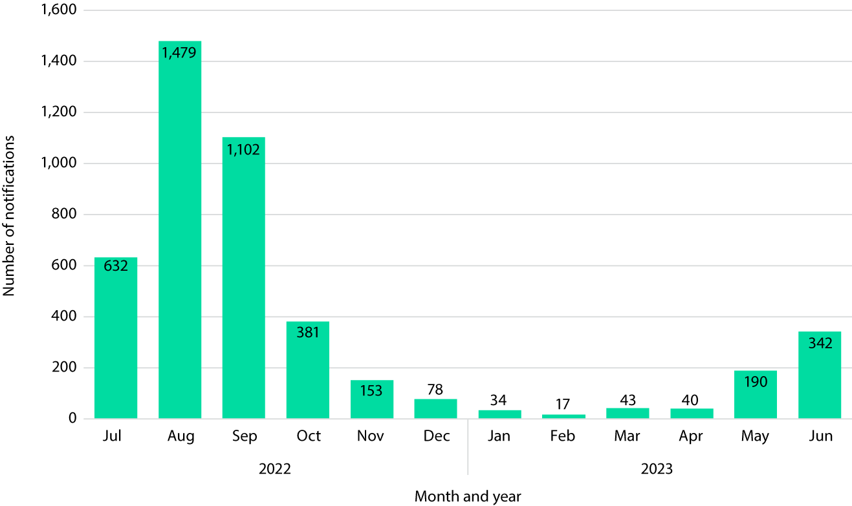

Tasmania is divided into three regions: the North (27% of the population), North-West (21%) and South (52%). The notification rate was highest in the North region, at 1,129 per 100,000 population per year, followed by the South region at 697 per 100,000 population per year then the North-West at 642 per 100,000 population per year. The SEIFA quintile with the highest notification rate was quintile 4, at 1,057 per 100,000 population per year. This was followed by the middle SEIFA quintile, at 854 per 100,000 population per year. The second most disadvantaged SEIFA quintile (quintile 2) had the lowest RSV notification rate (Figure 3).

Figure 3: Rate of RSV notifications per 100,000 population by Socio-Economic Indexes for Areas (SEIFA) for postcodes, Tasmania, 1 July 2022 – 30 June 2023

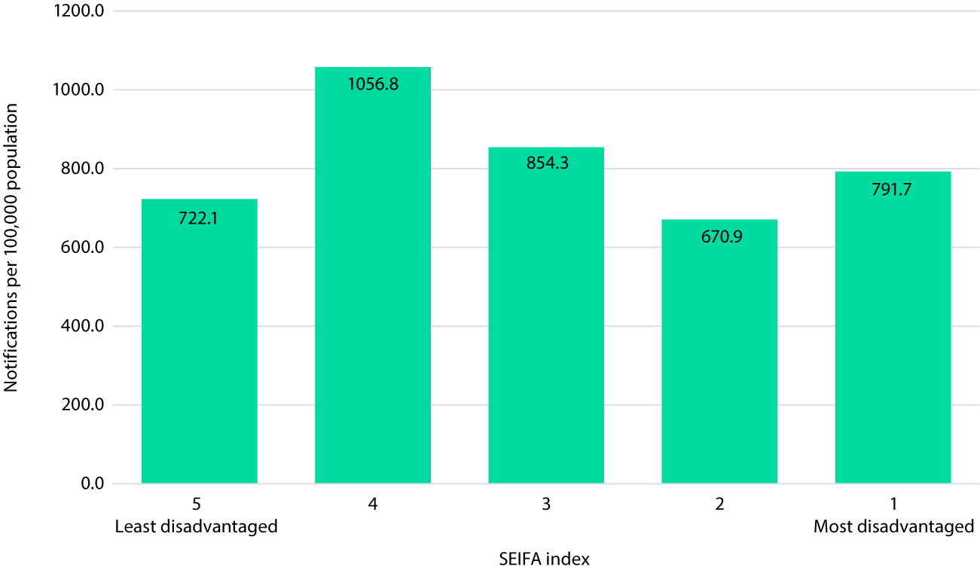

Data completeness was determined for 15 data fields that required data entry (Table 2). Of these, there was greater than 98% completeness for most person, place and time variables, but low completeness for hospitalisation (1.6%), Indigenous status (1.7%), death status (0.1%), place of acquisition (0.0%) and onset date (0.0%). Vaccination fields had no data, as vaccination had not commenced in Australia.

Table 2: Data completeness (%) of RSV notifications, Tasmania, 1 July 2022 – 30 June 2023

| Data field | Number missing | Completeness (%) |
| --- | --- | --- |
| State | 0 | 100.0 |
| Suburb/town | 0 | 100.0 |
| Postcode | 0 | 100.0 |
| Age | 0 | 100.0 |
| Specimen collection date | 0 | 100.0 |
| Case found by | 14 | 99.7 |
| Local government area (LGA) | 24 | 99.5 |
| Region | 24 | 99.5 |
| Sex | 38 | 99.2 |
| Indigenous status | 4,414 | 1.7 |
| Hospitalised | 4,419 | 1.6 |
| Death status | 4,488 | 0.1 |
| Onset date | 4,490 | 0.0 |
| Place of acquisition | 4,490 | 0.0 |
| Vaccinated? | 4,491 | 0.0 |
| Total | 4,491 | — |

# Discussion and conclusions

The first year of mandatory notifications of laboratory confirmed cases of RSV in Tasmania between 1 July 2022 and 30 June 2023 was age-specific, with children being the most affected. These results corroborate with previous findings of the significant burden of RSV in children in Australia,8–10 and are consistent with notifications reported nationally in the National Notifiable Disease Surveillance System (NNDSS) dashboard.[1] However, the notification rate of RSV in Tasmania, of 779 per 100,000 population during the study period, was higher than that reported on the NNDSS by the other mainland jurisdictions.

There were RSV notifications year-round in Tasmania; however, there was an increase during the winter and early spring months. It is difficult to assess whether this was a typical temporal distribution for RSV in Tasmania, as the study was limited to the first year of notifications only. Additionally, the seasonality of RSV is likely to be affected by the recent COVID-19 pandemic.

The highest notification rates in Tasmania were found in the North region and in middle SEIFA quintiles, as determined at the postcode level. This may reflect testing practices in these areas.

Assessing the data quality of RSV notifications, through measuring completeness of the data, emphasised that the existing passive surveillance system was ready to receive these new RSV notifications from laboratory diagnoses. Most of the pertinent data fields had completeness higher than 98%. Those with lower completeness, such as Aboriginal or Torres Strait Islander status, vaccination status and hospitalisation status, are fields not routinely included in laboratory request forms, and are therefore unable to be included in laboratory notifications. By using passive surveillance data, this study assesses disease activity; it is not able to assess disease severity. Passive surveillance is also limited to those RSV cases that seek healthcare and are tested, with this under-ascertainment resulting in an underestimation of the true burden of RSV in Tasmania.11

However, this analysis does provide a baseline of RSV in Tasmania, as it describes RSV epidemiology in the first year of surveillance. Adding RSV to the existing passive surveillance system was a straightforward process and has provided an assessment of disease activity for RSV in Tasmania. Efforts to improve completeness of Aboriginality for laboratory based notifiable diseases will be important to characterise the burden of RSV (and other notifiable diseases) in this population. Knowing that notifications were highest in the youngest Tasmanians also contributes further evidence that the target group of a selective immunisation program should be these vulnerable populations. This study also highlights the importance of having robust local and national surveillance to inform immunisation programs.

# Author details

Ms Michelle McPherson,1

Dr Nicola Stephens,1

Ms Bhavika Yadav,1

Dr Shannon Melody2

1. Tasmanian School of Medicine, University of Tasmania, Hobart, Tasmania
2. Public Health Services, Department of Health, Hobart, Tasmania

Corresponding author

Michelle McPherson

Associate Professor of Public Health, Public Health Programs, Tasmanian School of Medicine, College of Health & Medicine, University of Tasmania, Hobart TAS 7000

Phone: +61 3 6226 4229

Email: [michelle.mcpherson@utas.edu.au](mailto:michelle.mcpherson@utas.edu.au)

# References

1. Tasmanian State Government Register of Legislation. *Public Health Act 1997*. [Legislation.] Hobart: Tasmanian State Government Department of Premier and Cabinet; 24 October 2022. Available from: <https://www.legislation.tas.gov.au/view/html/inforce/current/act-1997-086>.
2. Esposito S, Abu Raya B, Baraldi E, Flanagan K, Martinon Torres F, Tsolia M et al. RSV prevention in all infants: which is the most preferable strategy? *Front Immunol*. 2022;13:880368. doi: <https://doi.org/10.3389/fimmu.2022.880368>.
3. Savic M, Penders Y, Shi T, Branche A, Pirçon JY. Respiratory syncytial virus disease burden in adults aged 60 years and older in high-income countries: a systematic literature review and meta-analysis. *Influenza Other Respir Viruses*. 2023;17(1):e13031. doi: <https://doi.org/10.1111/irv.13031>.
4. Stiboy E, Chan M, Islam MS, Saravanos GL, Lui K, Jaffe A et al. Variation in clinical practice guidelines for use of palivizumab in preventing severe respiratory syncytial viral (RSV) disease in high-risk infants. *Pediatr Pulmonol*. 2023;58(4):1210–20. doi: <https://doi.org/10.1002/ppul.26324>.
5. Australian Technical Advisory Group on Immunisation (ATAGI). Australian Immunisation Handbook. [Website.] Canberra: Australian Government Department of Health and Aged Care; 2024. [Accessed on 9 July 2024.] Available from: <https://immunisationhandbook.health.gov.au/>.
6. Farquharson KA, Anthony D, Menzies R, Homaira N. Burden of respiratory syncytial virus disease across the lifespan in Australia and New Zealand: a scoping review. *Public Health*. 2024;226:8–16. doi: <https://doi.org/10.1016/j.puhe.2023.10.031>.
7. Communicable Diseases Network of Australia (CDNA). *Respiratory syncytial virus – Surveillance case definition*. Canberra: Australian Government Department of Health and Aged Care; 1 January 2022. [Accessed on 9 July 2024.] Available from: <https://www.health.gov.au/resources/publications/respiratory-syncytial-virus-surveillance-case-definition>.
8. Brusco NK, Alafaci A, Tuckerman J, Frawley H, Pratt J, Daley AJ et al. The 2018 annual cost burden for children under five years of age hospitalised with respiratory syncytial virus in Australia. *Commun Dis Intell (2018)*. 2022;46. doi: <https://doi.org/10.33321/cdi.2022.46.5>.
9. Gebremedhin AT, Hogan AB, Blyth CC, Glass K, Moore HC. Developing a prediction model to estimate the true burden of respiratory syncytial virus (RSV) in hospitalised children in Western Australia. *Sci Rep*. 2022;12(1):332. doi: <https://doi.org/10.1038/s41598-021-04080-3>.
10. Saravanos GL, Sheel M, Homaira N, Dey A, Brown E, Wang H et al. Respiratory syncytial virus-associated hospitalisations in Australia, 2006–2015. *Med J Aust*. 2019;210(10):447–53. doi: <https://doi.org/10.5694/mja2.50159>.
11. Gibbons CL, Mangen MJJ, Plass D, Havelaar AH, Brooke RJ, Kramarz P et al. Measuring underreporting and under-ascertainment in infectious disease datasets: a comparison of methods. *BMC Public Health*. 2014;14:147. doi: <https://doi.org/10.1186/1471-2458-14-147>.

© Commonwealth of Australia as represented by the Department of Health and Aged Care

ISSN: 2209-6051 Online

This journal is indexed by Index Medicus and Medline.

Creative Commons Licence

This publication is licensed under a Creative Commons Attribution-NonCommercial-NoDerivatives 4.0 International Licence (CC BY-NC-ND) available from <https://creativecommons.org/licenses/by-nc-nd/4.0/legalcode> (Licence). You must read and understand the Licence before using any material from this publication.

Restrictions

The Licence does not cover, and there is no permission given for, use of any of the following material found in this publication (if any):

* the Commonwealth Coat of Arms (by way of information, the terms under which the Coat of Arms may be used can be found on the Department of Prime Minister and Cabinet website;
* any logos (including the Department of Health and Aged Care’s logo) and trademarks;
* any photographs and images;
* any signatures; and
* any material belonging to third parties.

Disclaimer

Opinions expressed in *Communicable Diseases Intelligence* are those of the authors and not necessarily those of the Department of Health and Aged Care or the Communicable Diseases Network Australia. Data may be subject to revision.

Enquiries

Enquiries regarding any other use of this publication should be addressed to the CDI Editor at: [cdi.editor@health.gov.au](mailto:cdi.editor@health.gov.au).

Communicable Diseases Network Australia

Communicable Diseases Intelligence contributes to the work of the [Communicable Diseases Network Australia](http://www.health.gov.au/cdna).

About Communicable Diseases Intelligence

*Communicable Diseases Intelligence* (CDI) is a peer-reviewed scientific journal published by the Health Security & Emergency Management Division, Department of Health and Aged Care. The journal aims to disseminate information on the epidemiology, surveillance, prevention and control of communicable diseases of relevance to Australia.

**Editor**: Christina Bareja • **Deputy Editor**: Simon Petrie • **Design and Production**: Lisa Thompson

**Editorial Advisory Board**: David Durrheim, Mark Ferson, Clare Huppatz, John Kaldor, Martyn Kirk and Meru Sheel

Submit an Article

Submit your next communicable disease related article to CDI for consideration. [Information for authors](https://www1.health.gov.au/internet/main/publishing.nsf/Content/cda-pubs-cdi-auth_inst.htm) and details on how to [submit your publication](https://www1.health.gov.au/internet/main/publishing.nsf/Content/cda-pubs-cdi-auth_inst.htm#submission_package) is available on our website, or by email at [cdi.editor@health.gov.au](mailto:cdi.editor@health.gov.au).

Contact us

Communicable Diseases Intelligence (CDI)

Health Security & Emergency Management Division

Department of Health and Aged Care

GPO Box 9848, CANBERRA ACT 2601

Website: [www.health.gov.au/cdi](http://www.health.gov.au/cdi)

Email: [cdi.editor@health.gov.au](mailto:cdi.editor@health.gov.au)

1. <https://nindss.health.gov.au/pbi-dashboard/>.