Hospital outcomes after a COVID-19 diagnosis from January to May 2020 in New South Wales Australia
Bette Liu, Paula Spokes, Maria Alfaro-Ramirez, Kate Ward, John M Kaldor

Abstract

Objective
To describe hospitalisation rates following COVID-19 infection in NSW.

Design, setting and participants
Analysis of all confirmed COVID-19 cases diagnosed in NSW from 1 January to 31 May 2020 extracted from the NSW Notifiable Conditions Information Management System and linked to routinely collected hospitalisation data.

Outcome measures
In-patient hospitalisations and hospital service utilisation details.

Results
There were 3,101 COVID-19 cases diagnosed between 1 January and 31 May 2020 in NSW: mean age 46.7 years, 50.5% were females. Overall, 12.5% (n = 389) had a record of inpatient hospitalisation, 4.2% (n = 130) were admitted to ICU and 1.9% (n = 58) received ventilation. Among adult cases, hospital and ICU admission rates increased with increasing age: 2.9% of those aged 20–29 years were hospitalised, increasing to 46.6% of those aged 80–89 years; 0.6% of those aged 20–29 years were admitted to ICU, increasing to 11.2% of those aged 70–79 years. The median time from symptoms to hospitalisation was seven days (IQR 4–11). The median time in hospital was nine days (IQR 4–20), and in ICU six days (IQR 2–15); the median time in hospital increased with older age. Almost half (49.4%) of those hospitalised with a diagnostic code had pneumonia/lower respiratory tract infection and another 36.6% had an upper respiratory tract infection or other known COVID-19 symptoms.

Conclusion
COVID-19 is a serious infection particularly in older adults. During January to May of 2020, 1 in 8 of those diagnosed in NSW were hospitalised. While this partly reflects the cautious approach to case management in the initial phase of the pandemic, it also demonstrates the large potential impact of COVID-19 on Australian health services and need for continuing mitigation strategies.
Keywords: COVID-19, hospitalisations, surveillance, morbidity, record linkage

Introduction
An unprecedented effort worldwide is underway to understand the transmission and pathophysiology of COVID-19, the disease caused by the novel coronavirus SARS-CoV-2, in order to guide prevention and treatment strategies. In many high-income countries, disease surveillance systems are providing robust and comprehensive data on case counts and deaths, generally broken down by age and sex, but much more limited information is available on health service use, in particular hospitalisation data.^{1,2} Systematically-collected information on COVID-19 hospitalisations provides an indication of disease severity, as well as enabling health systems to model and plan requirements for future waves of infection and to predict potential benefits from vaccines when they become available.
Recent models, utilised to inform the Australian response to COVID-19, have relied on data collected in China on hospitalisations and intensive care unit (ICU) stays.^{3,4} Whilst these data have served Australia well in informing the initial public health responses, local data would be preferable. Hospitalisation rates are strongly influenced by local factors including health system structure, accessibility, and clinical management protocols. Compared to other countries, Australia’s relatively high rates for COVID-19 testing⁵ may also influence the total pool of cases identified and therefore the estimated proportion of identified cases requiring hospital care.
New South Wales (NSW) is Australia’s most populous state with over 8 million people or a third of the Australian population.⁶ The state managed close to half of the Australian COVID-19 cases in the first five months of 2020. During this period the majority of cases in NSW had acquired their infection overseas, including on cruise ships. Subsequent to the ‘first wave’, NSW has managed to contain further outbreaks with efficient testing, contact tracing and quarantine as well as through continued observance of social distancing and restrictions on gatherings. Our aim was to conduct an enhanced surveillance study using record linkage to provide comprehensive estimates of hospitalisations following a COVID-19 diagnosis for all cases diagnosed from January to May 2020 in NSW.

Methods

Data sources and linkage
Two administrative datasets, the Notifiable Conditions Information Management System (NCIMS) and the NSW Admitted Patient Data Collection (APDC), were used for analyses. The NCIMS records details of all confirmed cases of COVID-19 reported to NSW Public Health Units under the NSW Public Health Act.⁷ Cases are required to have a laboratory confirmatory test.⁸ Data collected includes disease onset date, symptoms, and test results. Information on outcomes such as hospitalisation, recovery and death are also collected, although hospitalisation data in the NCIMS relies primarily on the case interview and therefore, depending on the interview date, can be incomplete or inaccurate.
The NSW APDC receives reports from all public and private hospitals in NSW on inpatient episodes of care, although private hospitals only submit data to the collection annually. Data include the principal and up to 50 secondary diagnoses related to the admission coded according to the International Classification of Diseases version 10, Australian Modification (ICD-10-AM), and admission and discharge dates. Information on ICU admission and procedures including invasive and non-invasive forms of ventilation is also recorded.
The administrative datasets were linked as part of a Public Health Register. Linkage was conducted by the NSW Centre for Health Record Linkage using probabilistic matching of identifiers and only de-identified data were provided to researchers. For this report, confirmed COVID-19 cases recorded up to 31 May on NCIMS were linked to APDC records of hospitalisation reported up to 14 July 2020. This enhanced follow-up of COVID-19 cases was part of routine public health surveillance of cases by NSW Health and hence no ethics approvals were required.

Analysis
For each person notified to NCIMS with COVID-19, information from the APDC and NCIMS was extracted in regard to hospitalisations. Due to timeframes for reporting, the diagnostic codes in the APDC may be incomplete for up to three months following discharge. Therefore, we defined a hospitalisation as COVID-19-related if the admission date was in the period two weeks prior to and up to six weeks following the COVID-19 onset date in the NCIMS. We only included in-patient hospitalisations and excluded day-only stays, emergency-department-only admissions, ward types not routinely used for COVID-19 hospitalisations and outpatient management (e.g. Hospital in the Home). As stated earlier, because private hospital admissions are only updated annually in the APDC and hence at the time of linkage they were not sufficiently up to date, we used the NCIMS records to ascertain admissions to private (or interstate or Northern Beaches) hospitals.
A person was determined to have an ICU admission if the APDC record had an ICU admission date, or if NCIMS had a record that the person had been admitted to ICU. Respiratory support was ascertained if there was a procedure code in the APDC record indicating ventilation (Australian Classification of Health Interventions codes 13882-xx and 92209-xx) or if the NCIMS recorded ventilation.
Using these definitions, we calculated the proportion of people notified with COVID-19 who had been hospitalised, admitted to ICU and were ventilated, overall and by age. We also calculated time from symptom onset to first hospital admission (in those reporting symptoms whose hospital admission occurred after symptom onset) and calculated the length of hospital and ICU stay in cases with discharge dates in their APDC record. For people with more than one hospitalisation that met the inclusion definition, their lengths of stay were summed. Early in the pandemic, most people with COVID-19 were admitted to hospital and ICU for isolation and monitoring; accordingly, we also restricted analyses to cases diagnosed from 1 March onwards. Where hospital diagnostic coding information was available, this was examined to determine the underlying causes of admission.

Results
Between 1 January and 31 May 2020 in NSW, there were 3101 COVID-19 cases. The mean age of cases was 46.7 years (standard deviation 20), with 30.5% aged 60 years or older; 50.5% were females and more than half (58.0%) acquired their infection overseas. Overall, 12.5% (n = 389) had an inpatient hospitalisation record, 4.2% (n = 130) an ICU admission and 1.9% (n = 58) were ventilated; 3% (n = 13) of hospitalised cases were recorded in NCIMS as admitted to private hospitals. As shown in Figure 1, the highest number of hospitalised cases was among 60–69 year olds and the lowest among those aged 0–9 years. Inpatient hospitalisation proportions varied by age, with those aged 80–89 years most likely to be hospitalised (46.6%), while those aged 70–79 years were most likely to be admitted to ICU (11.2%) and to need ventilation (5.9%). No cases aged less than 30 years required ventilation.

Figure 1: Hospitalisation, ICU admission and ventilation in COVID-19 cases by age group, NSW, January–May 2020
A) Frequencies
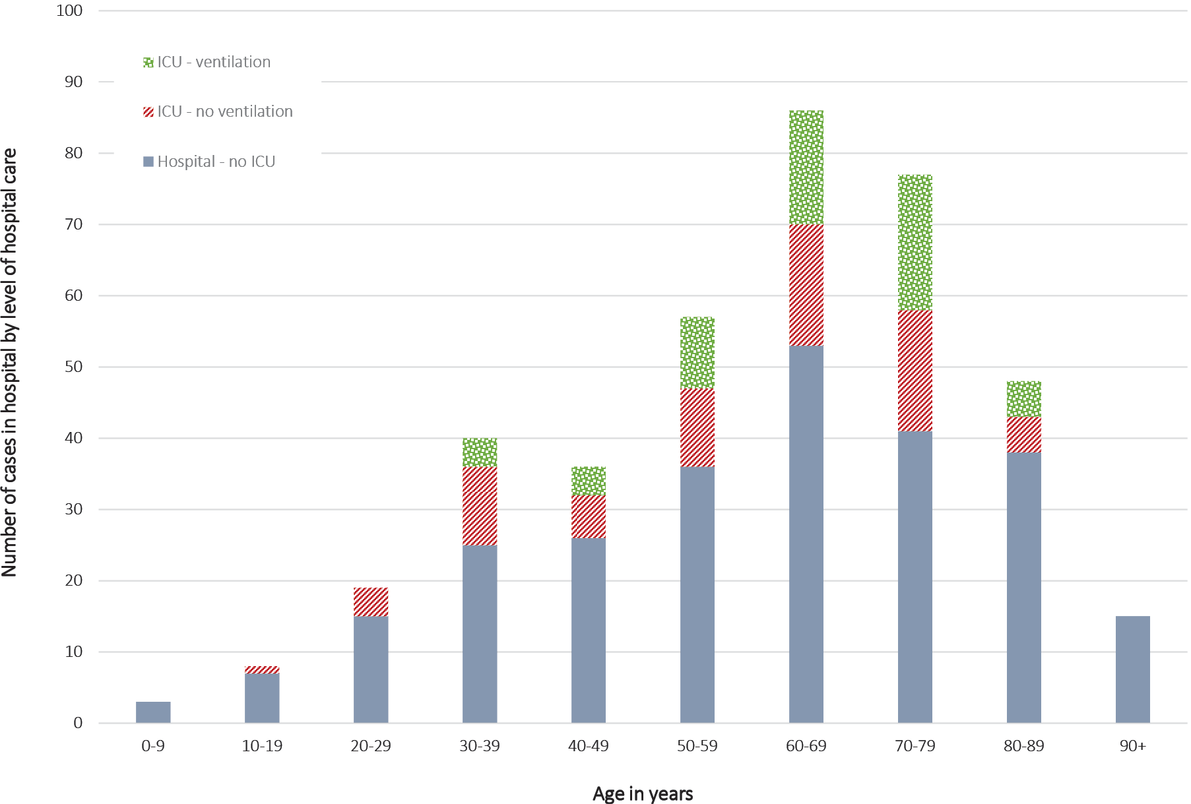
B) Proportions
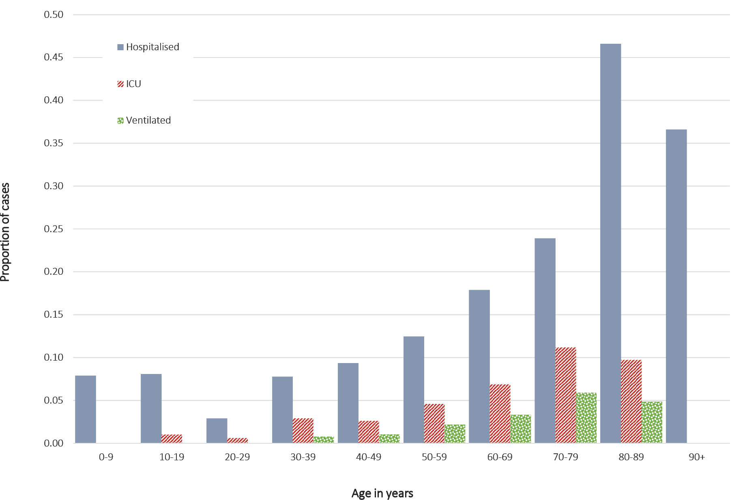
Of the 389 people hospitalised in the follow-up period, 358 (92.0%) had ICD-10-AM coded diagnostic data available and 337/358 (94.1%) of those with diagnostic data had a specific code for coronavirus or COVID-19 (ICD-10-AM: B34.2; B97.2; U07.1; U07.2). The most common principal diagnosis code recorded and coded was ‘Other viral pneumonia’ (ICD-10-AM J12.8; n = 133). Of those with diagnostic data, 177/358 (49.4%) had an ICD-10-AM diagnostic code for pneumonia or lower respiratory tract infection, LRTI (ICD-10-AM J12–J18; J20–J22). Another 131/358 (36.6%) of those without a pneumonia or LRTI code had an ICD-10-AM code for an upper respiratory tract infection or other known COVID-19 symptoms (e.g. cough, fever; ICD-10-AM J00–J06; R05–R09; R40–R43; R50–R51; R53).
Hospitalisation rates varied by month of COVID-19 onset (Figure 2). Of the four cases in January, all were admitted to hospital, and 3/4 (75%) admitted to ICU. These proportions decreased over time, so that of the 2,634 cases with an onset date in March, 11.8% were hospitalised and 4.1% admitted to ICU. Similar proportions were seen in the 354 cases in April and the 63 in May.
Figure 2: Proportion of COVID-19 cases hospitalised and admitted to ICU in NSW, by month of onset
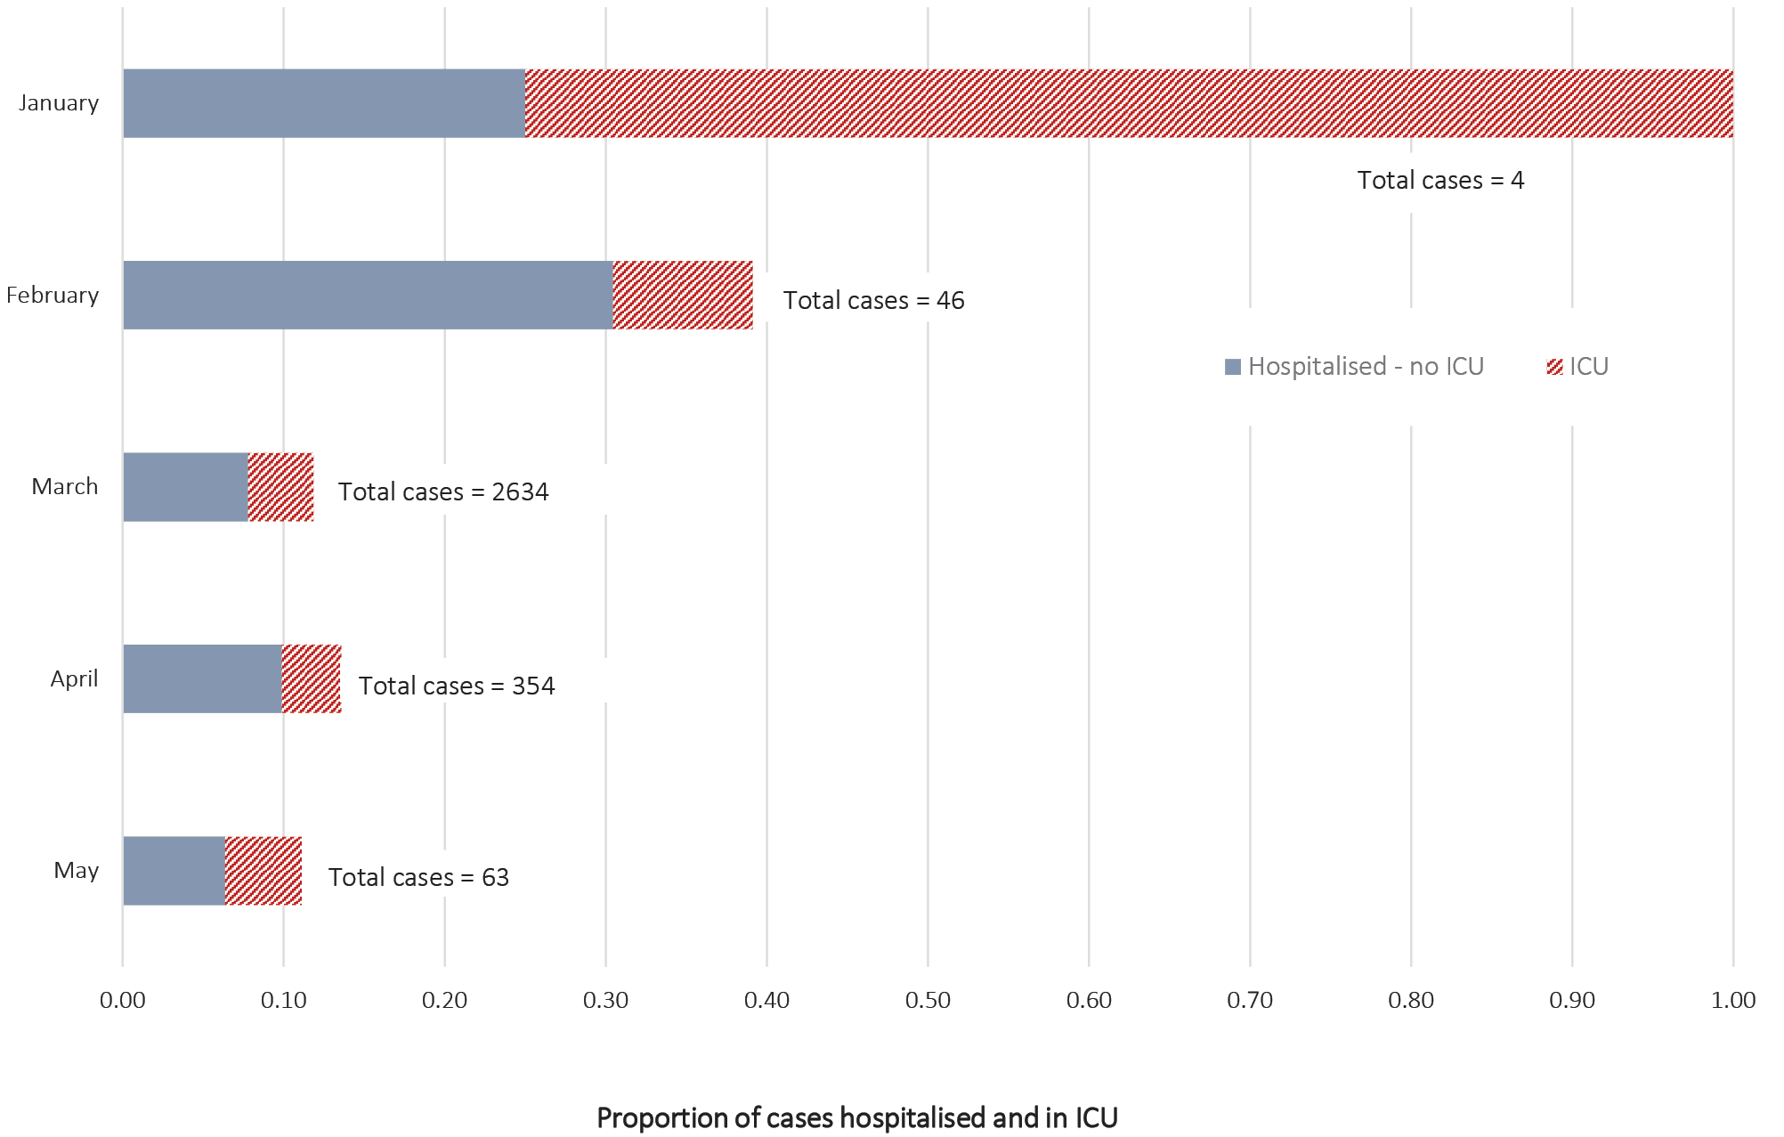
Analyses of the time to first admission and time in hospital and ICU were restricted to cases in March, April and May, the peak of the first wave of infections in NSW. Overall, the median time from onset of illness to first hospitalisation was seven days (interquartile range, IQR: 4–11), and to first ICU admission it was 8.5 days (IQR 6–12). Figure 3 shows the median number of days from symptom onset to first hospital or ICU admission by age. The median time to hospitalisation was shorter in those aged 80+ years: this interval was four and three days in those aged 80–89 and 90+ years respectively. For ICU admission, the relationship was less clear.

Figure 3: Median number of days from symptom onset to first hospital or ICU admission among COVID-19 cases in NSW, by age group, March–May 2020ª
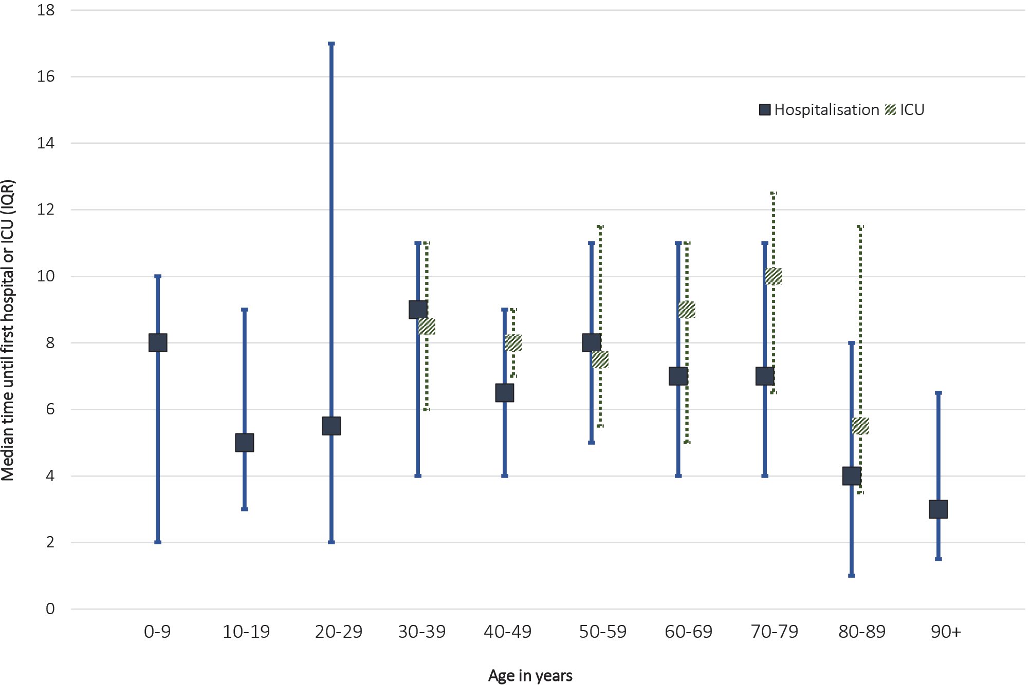
a Time until ICU admission not shown for the age ranges of 0–29 and 90+ years, due to small numbers.
There were 353 cases with sufficiently-complete data to enable calculation of total time in hospital (373 hospital admissions) and 112 cases for which to calculate total time in ICU (112 ICU admissions). Overall, the median time in hospital for cases was nine days (IQR 4–20) and the median time in ICU was six days (IQR 2–15). Time in hospital differed by age: the median time in hospital for those aged 60 years and older was more than double that in those < 60 years old (Figure 4).

Figure 4: Median number of days in hospital and ICU in COVID-19 cases in NSW, by age group, March–May 2020ª
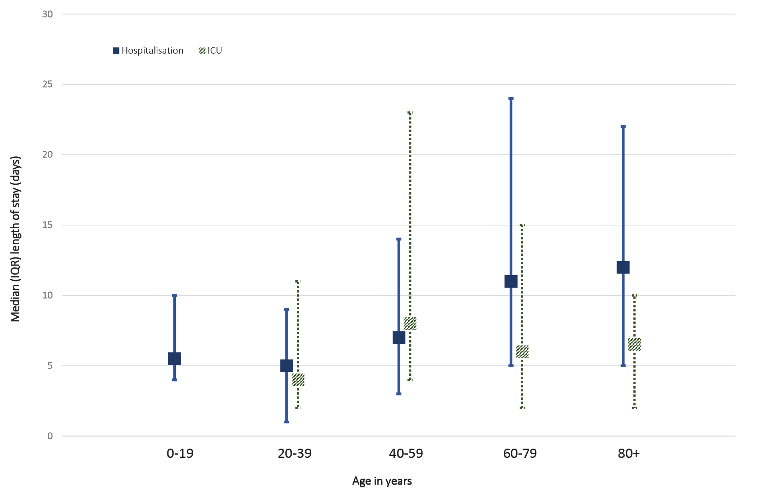
a Time in ICU not shown for 0–19 years, due to small numbers (n < 5).
In analyses restricted to cases with an onset of infection after February 2020, the proportions hospitalised and admitted to ICU were similar to those for all cases: 12.0% hospitalised; 4.0% admitted to ICU; 1.8% ventilated. This is because the majority of cases in NSW occurred after February, so exclusion of cases from earlier months did not greatly change the overall percentages estimated.

Discussion
This is the first comprehensive census of hospital, ICU and ventilation requirements related to COVID-19 in Australia. The surveillance data show that COVID-19 has had a significant impact on health services with 1 in 8 cases hospitalised, 4% admitted to ICU, and close to 2% requiring ventilation. The most common reason for hospital admission was pneumonia resulting from the infection. Our findings confirm that infection is most serious in older adults, with almost a quarter of those aged 70–79 years and close to half of those aged 80–89 years hospitalised. On a population-level overview, the findings also reinforce the seriousness of COVID-19 and demonstrate the overwhelming impact this disease will have on health systems if large numbers of people in Australia are infected.
Comparisons of COVID-19 hospital burden across countries is difficult due to differences in health systems, in hospital capacity, in case management protocols, and in characteristics of the epidemic within each setting, particularly the age groups most affected. For example: in Australia early in the pandemic, all COVID-19 cases were hospitalised irrespective of disease severity, for isolation and monitoring. In addition, differences in testing eligibility and access imply that case ascertainment differs between populations. Throughout the pandemic, NSW has had relatively high testing rates per head of population (e.g. as of 30 April 2020 in NSW, it was 27 per 1,000 population) and very low positivity,^{5,9} suggesting that the vast majority of cases have been diagnosed. Hence our findings reflect patterns of hospitalisation in a high income, well-resourced environment where most COVID-19 cases are identified.
Few countries have COVID-19 surveillance systems that comprehensively capture hospitalisation information on all cases. In one of the most frequently-cited reports from China,¹⁰ where all laboratory-confirmed cases were hospitalised as part of management,¹¹ it was shown that of over 44,000 laboratory-confirmed cases, 81% experienced ‘mild’ disease which included pneumonia; 14% experienced severe disease which included dyspnea and hypoxia (oxygen saturations ≤ 93%); and 5% had critical disease which included respiratory and/or other organ failure. Data from Canada are available for 67% of COVID-19 cases and indicate a similar proportion of the population hospitalised (15%) as is seen in our NSW data, but lower proportions requiring ICU and ventilation.¹ Surveillance systems for the European Union / European Economic Area (EU/EEA) report much higher hospitalisation rates (overall 30%) but show a more similar requirement for ICU/ventilation (overall 3%); however, there is substantial variation between European countries.¹² A study in the United States of America (USA), which followed ~3,500 people (with an average age of 54 years) testing positive to COVID-19 in a Louisiana integrated health delivery system, reported 40% hospitalised;¹³ whilst among 585 COVID-19 cases aged 55–74 years registered in a Veterans Health system, 50% were hospitalised.¹⁴ However both USA cohorts were substantially older than our whole-of-population sample, and testing rates in the USA mean that many less severe COVID-19 cases are likely to be undetected.
Compared to hospitalisations alone, there are substantially more reports on ICU admission and use of ventilation among series of patients hospitalised with COVID-19. A systematic review reported: from 44 studies and 6,513 hospitalised patients, 19% of patients required ICU admission; from 34 studies and 7,519 hospitalised patients, 17% required non-invasive ventilation; and from 45 studies of 6,933 patients, 9% required invasive mechanical ventilation; there was significant heterogeneity for each estimate.¹⁵ In a review of 2,634 patients with COVID-19 admitted to New York hospitals, 14% were treated in ICU and 12% received mechanical ventilation.¹⁶ In our report, of the 389 cases hospitalised, 130/389 (33.4%) were admitted to ICU and 58/389 (14.9%) required ventilation. Compared to the international experience, our data suggest that NSW cases may have been more likely to be admitted to ICU even though they did not require ventilation.
Our findings on time from symptom onset to hospitalisation are consistent with international studies. Early studies from China¹⁷ and surveillance data from the EU¹² suggest the median time from symptom onset to first hospitalisation was similar to our finding of seven days. Regarding the time in hospital and ICU, a systematic review of 52 studies reported substantial variations in hospital length of stay.¹⁸ The variation in sampling frames of the studies included in this review make comparisons difficult (e.g. some studies only included adults; some studies did not clarify if patients were still in hospital when estimates were made). The time in hospital we report here was somewhat consistent with that estimated from an Australian hospital sentinel surveillance system which reported a median length of stay of seven days (IQR 3–13).⁵
The local context of hospital care in NSW needs to be considered in interpretation of the hospitalisation patterns presented here. Hospital in the Home is a model of care that has been utilised for COVID-19 cases but was not included in our measure of hospitalisations. It allows treatment at home for less serious cases (e.g cases not requiring oxygen therapy) or cases where the treating physician determines that effective and appropriate care can be provided in the residential setting. In some NSW Health Districts, Hospital in the Home was offered to all cases aged 70 years and above. Therefore in our results, the lower proportion of cases aged over 90 years who were hospitalised needs to be interpreted with care: we know from our linked APDC data that at least as many cases aged over 90 years as were hospitalised as inpatients instead received care through Hospital in the Home programs.
The strengths of the data presented include the almost complete follow-up of all cases of COVID-19 diagnosed in NSW through use of both case interviews and linkage to routinely-collected hospitalisation records. Limitations include the possibility that a number of hospitalisations counted were not related to COVID-19 and may have been incidental (although this number is likely to be small, given the overwhelming proportion of hospital stays with coded diagnostic information indicating the admission was related to COVID-19). This may also be balanced somewhat by the possibility that a small number of admissions to private or cross-border hospitals were not captured in the NCIMS or linked APDC records.
The findings from this study demonstrate the seriousness of SARS-CoV-2 infection and uniquely provide whole-of-population quantification of its impact on Australian hospital services. Our methods can also be used to track changes in outcomes over time; to inform future projections of Australian health system needs, including for health system preparedness planning; and to enable modelling of the benefits of future vaccination programs.

Author details
Bette Liu^{1,2}
Paula Spokes²
Maria Alfaro-Ramirez²
Kate Ward²
John M Kaldor³
- School of Population Health, University of New South Wales
- New South Wales Ministry of Health
- Kirby Institute, University of New South Wales

Corresponding author
Bette Liu
UNSW School of Population Health, Samuels Building, Kensington Campus, UNSW SYDNEY NSW 2052 AUSTRALIA
Telephone: +61 (2) 9385 2445
Email: bette.liu@unsw.edu.au

References
- Public Health Agency of Canada (PHAC). Coronavirus disease 2019 (COVID-19). Epidemiology update. Hospitalizations, intensive care unit (ICU), mechanical ventilation and deaths. [Internet.] Ottawa: PHAC; 2020. Available at: https://health-infobase.canada.ca/covid-19/epidemiological-summary-covid-cases.html#a7.
- Centers for Disease Control and Prevention (CDC). COVID-NET: a weekly summary of US COVID-19 hospitalization data. COVID-19 laboratory-confirmed hospitalizations. [Internet.] Atlanta: United States Government Department of Health and Human Services, CDC; 2020. Available at: https://gis.cdc.gov/grasp/COVIDNet/COVID19_5.html.
- Moss R, Wood J, Brown D, Shearer FM, Black AJ, Glass K et al. Coronavirus disease model to inform transmission reducing measures and health system preparedness, Australia. Emerg Infect Dis. 2020;26(12). doi: https://doi.org/10.3201/eid2612.202530.
- Price DJ, Shearer FM, Meehan MT, McBryde E, Moss R, Golding N et al. Early analysis of the Australian COVID-19 epidemic. Elife. 2020;9. doi: https://doi.org/10.7554/eLife.58785.
- COVID-19 National Incident Room Surveillance Team. COVID-19, Australia: epidemiology report 20. (Fortnightly reporting period ending 5 July 2020). Commun Dis Intell (2018). 2020;44. doi: https://doi.org/10.33321/cdi.2020.44.63.
- Australian Bureau of Statistics. 3101.0 - Australian Demographic Statistics, Jun 2019. Media release: Australia’s population grows by 1.5 per cent. [Internet.] Canberra: Australian Government, Australian Bureau of Statistics; 19 December 2019. Available at: https://www.abs.gov.au/ausstats/abs@.nsf/lookup/3101.0Media%20Release1Jun%202019.
- New South Wales Legislation. Public Health Act 2010 No 127. [Legislation.] Sydney: Government of New South Wales; 2010. Available at: https://www.legislation.nsw.gov.au/#/view/act/2010/127.
- Australian Government Department of Health, Communicable Diseases Network Australia (CDNA). Coronavirus disease 2019 (COVID-19): CDNA national guidelines for public health units. Canberra: Australian Government Department of Health; 2020. Available from: https://www1.health.gov.au/internet/main/publishing.nsf/Content/cdna-song-novel-coronavirus.htm.
- New South Wales Government Department of Health. COVID-19 weekly surveillance in NSW - week ending 30 April 2020. Sydney: New South Wales Government Department of Health; 1 May 2020. Available at: https://www.health.nsw.gov.au/Infectious/covid-19/Documents/covid--surveillance-report-20200430.pdf.
- Wu Z, McGoogan JM. Characteristics of and important lessons from the coronavirus disease 2019 (COVID-19) outbreak in China: summary of a report of 72 314 cases from the Chinese Center for Disease Control and Prevention. JAMA. 2020;323(13). doi: https://doi.org/10.1001/jama.2020.2648.
- Li Z, Chen Q, Feng L, Rodewald L, Xia Y, Yu H et al. Active case finding with case management: the key to tackling the COVID-19 pandemic. Lancet. 2020;396(10243):63–70.
- European Centre for Disease Prevention and Control (ECDC). COVID-19 surveillance report. [Internet.] Solna: ECDC; 2020. Available from: https://covid19-surveillance-report.ecdc.europa.eu/#2_severity.
- Price-Haywood EG, Burton J, Fort D, Seoane L. Hospitalization and mortality among black patients and white patients with Covid-19. N Engl J Med. 2020;382(26):2534–43. doi: https://doi.org/10.1056/NEJMsa2011686.
- Rentsch CT, Kidwai-Khan F, Tate JP, Park LS, King JT, Skanderson M et al. Covid-19 testing, hospital admission, and intensive care among 2,026,227 United States veterans aged 54–75 years. Version 1 medRxiv. 2020. doi: https://doi.org/10.1101/2020.04.09.20059964.
- Grant MC, Geoghegan L, Arbyn M, Mohammed Z, McGuinness L, Clarke EL et al. The prevalence of symptoms in 24,410 adults infected by the novel coronavirus (SARS-CoV-2; COVID-19):a systematic review and meta-analysis of 148 studies from 9 countries. PLoS One. 2020;15(6):e0234765. doi: https://doi.org/10.1371/journal.pone.0234765.
- Richardson S, Hirsch JS, Narasimhan M, Crawford JM, McGinn T, Davidson KW et al. Presenting characteristics, comorbidities, and outcomes among 5700 patients hospitalized with COVID-19 in the New York City area. JAMA. 2020;323(20):2052–9.
- Wang D, Hu B, Hu C, Zhu F, Liu X, Zhang J et al. Clinical characteristics of 138 hospitalized patients with 2019 novel coronavirus–infected pneumonia in Wuhan, China. JAMA. 2020;323(11):1061–9.
- Rees EM, Nightingale ES, Jafari Y, Waterlow NR, Clifford S, Pearson CAB et al. COVID-19 length of hospital stay: a systematic review and data synthesis. BMC Med. 2020;18(1):270.

Communicable Diseases Intelligence
ISSN: 2209-6051 Online

Communicable Diseases Intelligence (CDI) is a peer-reviewed scientific journal published by the Office of Health Protection, Department of Health. The journal aims to disseminate information on the epidemiology, surveillance, prevention and control of communicable diseases of relevance to Australia.

Editor: Tanja Farmer
Deputy Editor: Simon Petrie
Design and Production: Kasra Yousefi
Editorial Advisory Board: David Durrheim, Mark Ferson, John Kaldor, Martyn Kirk and Linda Selvey

Website: http://www.health.gov.au/cdi

Contacts
Communicable Diseases Intelligence is produced by:
Health Protection Policy Branch, Office of Health Protection, Australian Government Department of Health
GPO Box 9848, (MDP 6) CANBERRA ACT 2601

Email: cdi.editor@health.gov.au

Submit an Article
You are invited to submit your next communicable disease related article to the Communicable Diseases Intelligence (CDI) for consideration. More information regarding CDI can be found at: http://health.gov.au/cdi.
Further enquiries should be directed to: cdi.editor@health.gov.au.

This journal is indexed by Index Medicus and Medline.

Creative Commons Licence - Attribution-NonCommercial-NoDerivatives CC BY-NC-ND
© 2020 Commonwealth of Australia as represented by the Department of Health
This publication is licensed under a Creative Commons Attribution-NonCommercial-NoDerivatives 4.0 International Licence from https://creativecommons.org/licenses/by-nc-nd/4.0/legalcode (Licence). You must read and understand the Licence before using any material from this publication.

Restrictions
The Licence does not cover, and there is no permission given for, use of any of the following material found in this publication (if any):
- the Commonwealth Coat of Arms (by way of information, the terms under which the Coat of Arms may be used can be found at www.itsanhonour.gov.au);
- any logos (including the Department of Health’s logo) and trademarks;
- any photographs and images;
- any signatures; and
- any material belonging to third parties.

Disclaimer
Opinions expressed in Communicable Diseases Intelligence are those of the authors and not necessarily those of the Australian Government Department of Health or the Communicable Diseases Network Australia. Data may be subject to revision.

Enquiries
Enquiries regarding any other use of this publication should be addressed to the Communication Branch, Department of Health, GPO Box 9848, Canberra ACT 2601, or via e-mail to: copyright@health.gov.au

Communicable Diseases Network Australia
Communicable Diseases Intelligence contributes to the work of the Communicable Diseases Network Australia.
http://www.health.gov.au/cdna

