SAEFVIC: Surveillance of adverse events following immunisation (AEFI) in Victoria, Australia, 2018
Hazel J Clothier, Jock Lawrie, Georgina Lewis, Melissa Russell, Nigel W Crawford and Jim P Buttery

Abstract

Background
SAEFVIC is the Victorian surveillance system for adverse events following immunisation (AEFI). It enhances passive surveillance by also providing clinical support and education to vaccinees and immunisation providers.
This report summarises surveillance, clinical and vaccine pharmacovigilance activities of SAEFVIC in 2018.

Methods
A retrospective observational cohort study of AEFI reports received by SAEFVIC in 2018, compared with previous years since 2008. Data were categorised by vaccinee demographics of age, sex, pregnancy and Indigenous status, vaccines administered and AEFI reactions reported. Age cohorts were defined as infant (0–12 months); young child (1–4 years); school-aged (5–17 years); adult (18–64 years); and older person (65+ years). Proportional reporting ratios were calculated for signal investigation of serious adverse neurological events with all vaccines and with influenza vaccines. Clinical support services and educational activities are described.

Results
SAEFVIC received 1730 AEFI reports (26.8 per 100,000 population), with 9.3% considered serious. Nineteen percent (n = 329) attended clinical review. Annual AEFI reporting trends increased for infants, children and older persons, but were stable for school-aged and adult cohorts. Females comprised 55% of all reports and over 80% of reports among adults. There were 17 reports of AEFI in pregnant women and 12 (0.7%) in persons identifying as Indigenous Australians. A possible signal regarding serious adverse neurological events (SANE) was detected, but was not supported by signal validation testing. A clinical investigation is ongoing. Two deaths were reported coincident to immunisation with no evidence of causal association.

Conclusion
SAEFVIC continues to provide robust AEFI surveillance supporting vaccine safety monitoring in Victoria and Australia, with new signal detection and validation methodologies strengthening capabilities.
Keywords: Vaccine safety, adverse events, immunisation, surveillance, pharmacovigilance

Introduction
Surveillance of Adverse Events Following Vaccination In the Community (SAEFVIC) is a public health partnership initiative of the Victorian Immunisation Program funded by the Victorian Government Department of Health and Human Services. AEFI surveillance is an essential component of post-licensure vaccine safety monitoring and aims to detect rare, late onset or unexpected safety signal events. SAFEVIC has been in operation since May 2007. It comprises a central reporting enhanced passive surveillance system integrated with clinical services and is focused on adverse events following immunisation (AEFI) identification for the state of Victoria.¹
Innovative aspects of SAEFVIC include integration of surveillance with jurisdictional clinical services, enabling timely comprehensive follow-up of individual cases including enriching case information with subsequent clinical reviews. This model has also been associated with an increase in reporting rates.² Responsive education on immunisation for healthcare professionals, parents and the public is provided through the Melbourne Vaccine Education Centre (MVEC) online initiative.³
This is the first report describing SAEFVIC data and service delivery since 2012, and the first report following the system evaluation conducted in 2015.^{2,4} It provides important baseline background as the SAEFVIC model expands through uptake by other jurisdictions and leading towards a harmonised national AEFI surveillance platform across Australia. The AEFI data received by SAEFVIC are reported to the Therapeutic Goods Administration (TGA) and entered into their searchable database of adverse event notifications (DAEN). National reports of AEFI using these collated data are prepared by the National Centre for Immunisation Research and Surveillance (NCIRS) and published annually.⁵
SAEFVIC undertakes quarterly reporting to the Immunisation Advisory Committee of the Victorian Government Department of Health and Human Services and is the home of the Australian Adverse Events Following Immunisation Clinical Assessment Network, AEFI-CAN. This report collates and summarises SAEFVIC surveillance activity from 1 January to 31 December 2018 and provides, with comparisons to previous years where relevant: 1) descriptive analyses of AEFI reports for vaccines administered in Victoria; 2) an analysis of serious AEFI; 3) a summary of signal detection and investigation activities; and 4) an outline of the continuing development of educational and clinical services provided by SAEFVIC.

Methods
This retrospective observational cohort study describes AEFI reported to SAEFVIC, Victoria, Australia from 1 January to 31 December 2018 and provides comparisons to AEFI reported in the preceding decade, 2008–2017. Data presented in this report may differ from other reports for the same period as records are continually updated and may be re-categorised following clinical review or for specific analyses.

AEFI data source
Reports are entered into SAEFVIC for any AEFI reported in Victoria (reporter with Victoria postcode) for vaccine administered anywhere (including overseas) regardless of causality assessment, providing the AEFI occurred after vaccination. Reports may include immunisation errors that do not result in a reaction or historical events reported for investigation due to concern for future vaccinations.
SAEFVIC is an integrated AEFI reporting system, including passive reports voluntarily received from immunisation providers (medical practitioners, nurses and pharmacists) and from consumers (vaccinees or their guardians). Since 2016, SAEFVIC has additionally recorded and integrated reports submitted from active surveillance where the event has resulted in a medical attendance. Active surveillance means reports have been solicited through either a search of records or a prompted response, and in Victoria are obtained through two systems: 1) the Paediatric Active Enhanced Disease Surveillance (PAEDS) hospital sentinel system,⁶ which seeks admission information for selected serious childhood conditions, particularly vaccine preventable diseases and potential AEFI; and 2) the AusVaxSafety network, which uses SMS prompts to elicit information on AEFI from vaccinees within 7 days of immunisation.⁷ All reports encountered through PAEDS with a relevant vaccination history are entered into the SAEFVIC database. However, of those reports encountered through AusVaxSafety, only those that are identified as being AEFIs temporally associated with vaccines, resulting in a medical attendance, are entered and it requires the general practitioner (GP) or practice to consent to forwarding the events to the Victorian vaccine safety team at SAEFVIC.

Definitions
An Adverse Event Following Immunisation (AEFI) is defined as any untoward medical occurrence that follows immunisation but does not necessarily have a causal relationship with the administration of the vaccine. The adverse event may be a sign, symptom or defined illness. This represents a temporal association and does not necessarily have a causal relationship with the vaccine.
AEFI reactions are recorded as signs and symptoms described by the reporter using general medical terminology. Reactions may be further categorised according to standard case definitions, where available and as determined by the Brighton Collaboration, Australian Immunisation handbook or SAEFVIC in hierarchical order as previously described.¹ A case may report more than one AEFI reaction.
An AEFI is determined as serious (SAEFI) if the report indicates a reaction that: resulted in death; was life threatening; required in-patient hospitalization or prolongation of an existing hospitalization; resulted in persistent or significant disability/incapacity; caused a congenital anomaly/birth defect; or was deemed medically important by SAEFVIC clinicians.⁵ A life-threatening event is an event or reaction in which the vaccinee was at risk of death at the time of the event/reaction; it does not refer to an event/reaction that hypothetically might have caused death if it were more severe (e.g. anaphylaxis).
Shoulder injury related to vaccine administration (SIRVA) is a term used to describe a syndrome of pain, inflammation and restricted movement that can arise when the position of the needle is too high causing injury.⁶
Serious adverse neurological events (SANE) include transverse myelitis, optic neuritis, multiple sclerosis and Guillain-Barré syndrome (GBS).
A signal is defined as an increase in AEFI reporting above that which is expected and may be an abitrary determination through clinical perception or breaching a statistical calculation threshold (see below for proportional reporting ratio calculation and thresholds).

Data categories
Reporter type is recorded by the vaccine administering profession or consumer: the category of consumer includes reports submitted by the vaccinee or their parent or guardian.
Vaccines administered are recorded by brand name but were grouped by antigen for the purpose of analysis. A case may receive multiple vaccines in one encounter, therefore any AEFI reaction described is recorded in association with each vaccine administered at that encounter.
Age groups were determined as best fit to the National Immunisation Program (NIP) age groups of infant 0–12 months, young child 1–4 years, school-aged 5–17 years, adult 18–64 years and older person 65+ years.⁸

Analyses
Data were extracted and analysed using Microsoft Power BI (version 2.71.55523.941, July 2019).⁹ Reports were analysed as counts, proportions of reports received and proportions by age-group and vaccinee demographics.
Reports per 100,000 population were calculated using Victorian mid-year population estimates obtained from the Australian Bureau of Statistics (ABS); specifically the 2018 mid-year estimates Regional Population Growth and mid-year projections for 2018 by age and sex, Victoria.¹⁰
The long-term average for serious AEFI reporting was calculated as the proportion of serious AEFI reported using the sum data from the preceding decade (2008–2017).
Reporting rates per 100,000 doses administered were calculated using Australian Immunisation Register (AIR) recorded administered doses for each age group in 2018, collated by vaccine brand as at the date of extraction (24 July 2019).
Signal investigation methods included comparison of reporting frequency trends and calculation of proportional reporting ratio (PRR). PRR is calculated for vaccine-reaction pairs using a 2 × 2 table convention where PRR = Thresholds were defined as PRR ≥ 2 and chi-squared (χ2) ≥ 4.

Ethical approval
Approval was granted by the Royal Children’s Hospital Human Research Ethics Committee for this registered database (Number 37194).

Results

Reports received
SAEFVIC received a total of 1730 AEFI reports during 2018 (Box 1).

Box 1: Flow diagram of reports available for analysis, SAEFVIC 2018
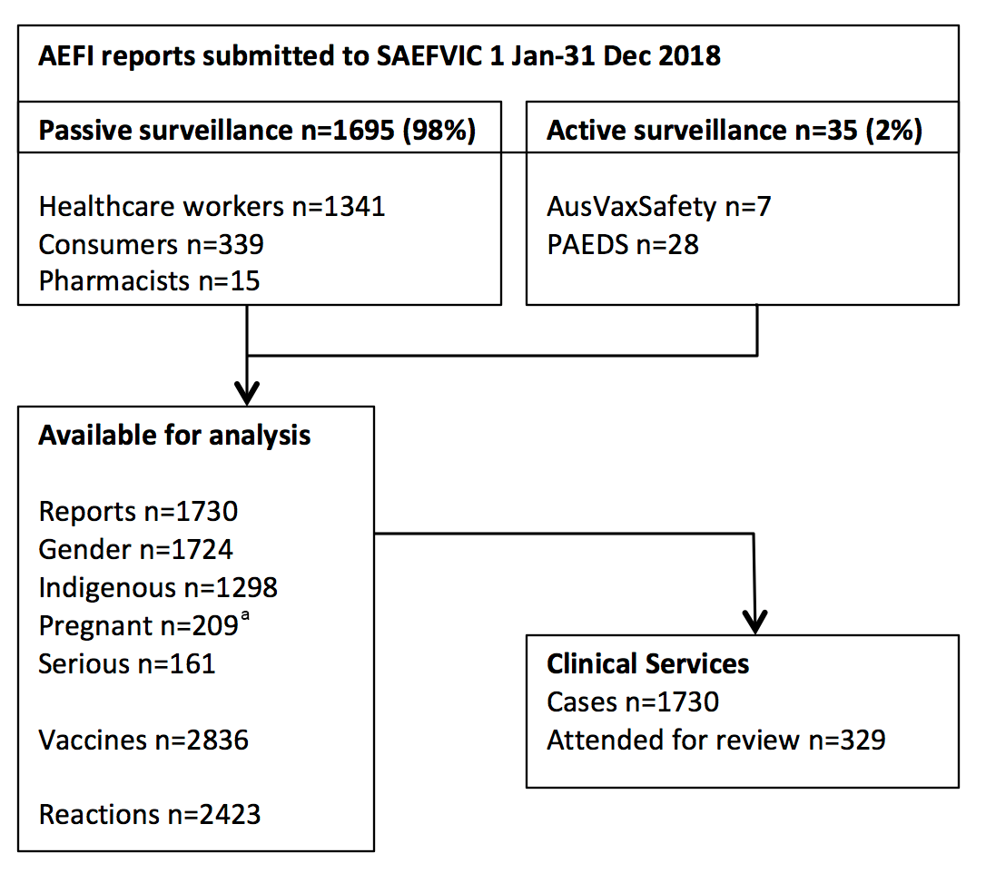
a Pregnancy is positively reported for adult females (i.e. +ve or blank)
The 1,730 AEFI reports to SAEFVIC submitted during 2018 was a slight decrease on the 1,802 received in 2017 but was still higher than any other previous year (Figure 1). This equates to a reporting rate of 26.8 per 100,000 population per annum. The proportion of reports meeting the definition of serious AEFI was 9.3%, which was less than the long-term average, across the preceding decade, of 12.4% (p = 0.008). Despite fluctuating overall reporting, the annual proportion of serious AEFI has decreased across the last three years, from a peak of 13.6% in 2015.

Serious AEFI
Of the 1730 reports, 9.3% (n = 161) met the definition of serious, of which 48 (29.8%) had been admitted to hospital and a further 100 (62.1%) attended an emergency department without admission. The majority of serious AEFI were reported in infants (31.7%; 51/161) and children (34.6%; 55/161). As a proportion of the AEFI within each age group, infants had the highest frequency of a serious AEFI being reported (14.8%; 51/344) (Table 1).

Figure 1: AEFI reports and reports per 100,000 population, by year, SAEFVIC, Victoria, 2008–2018
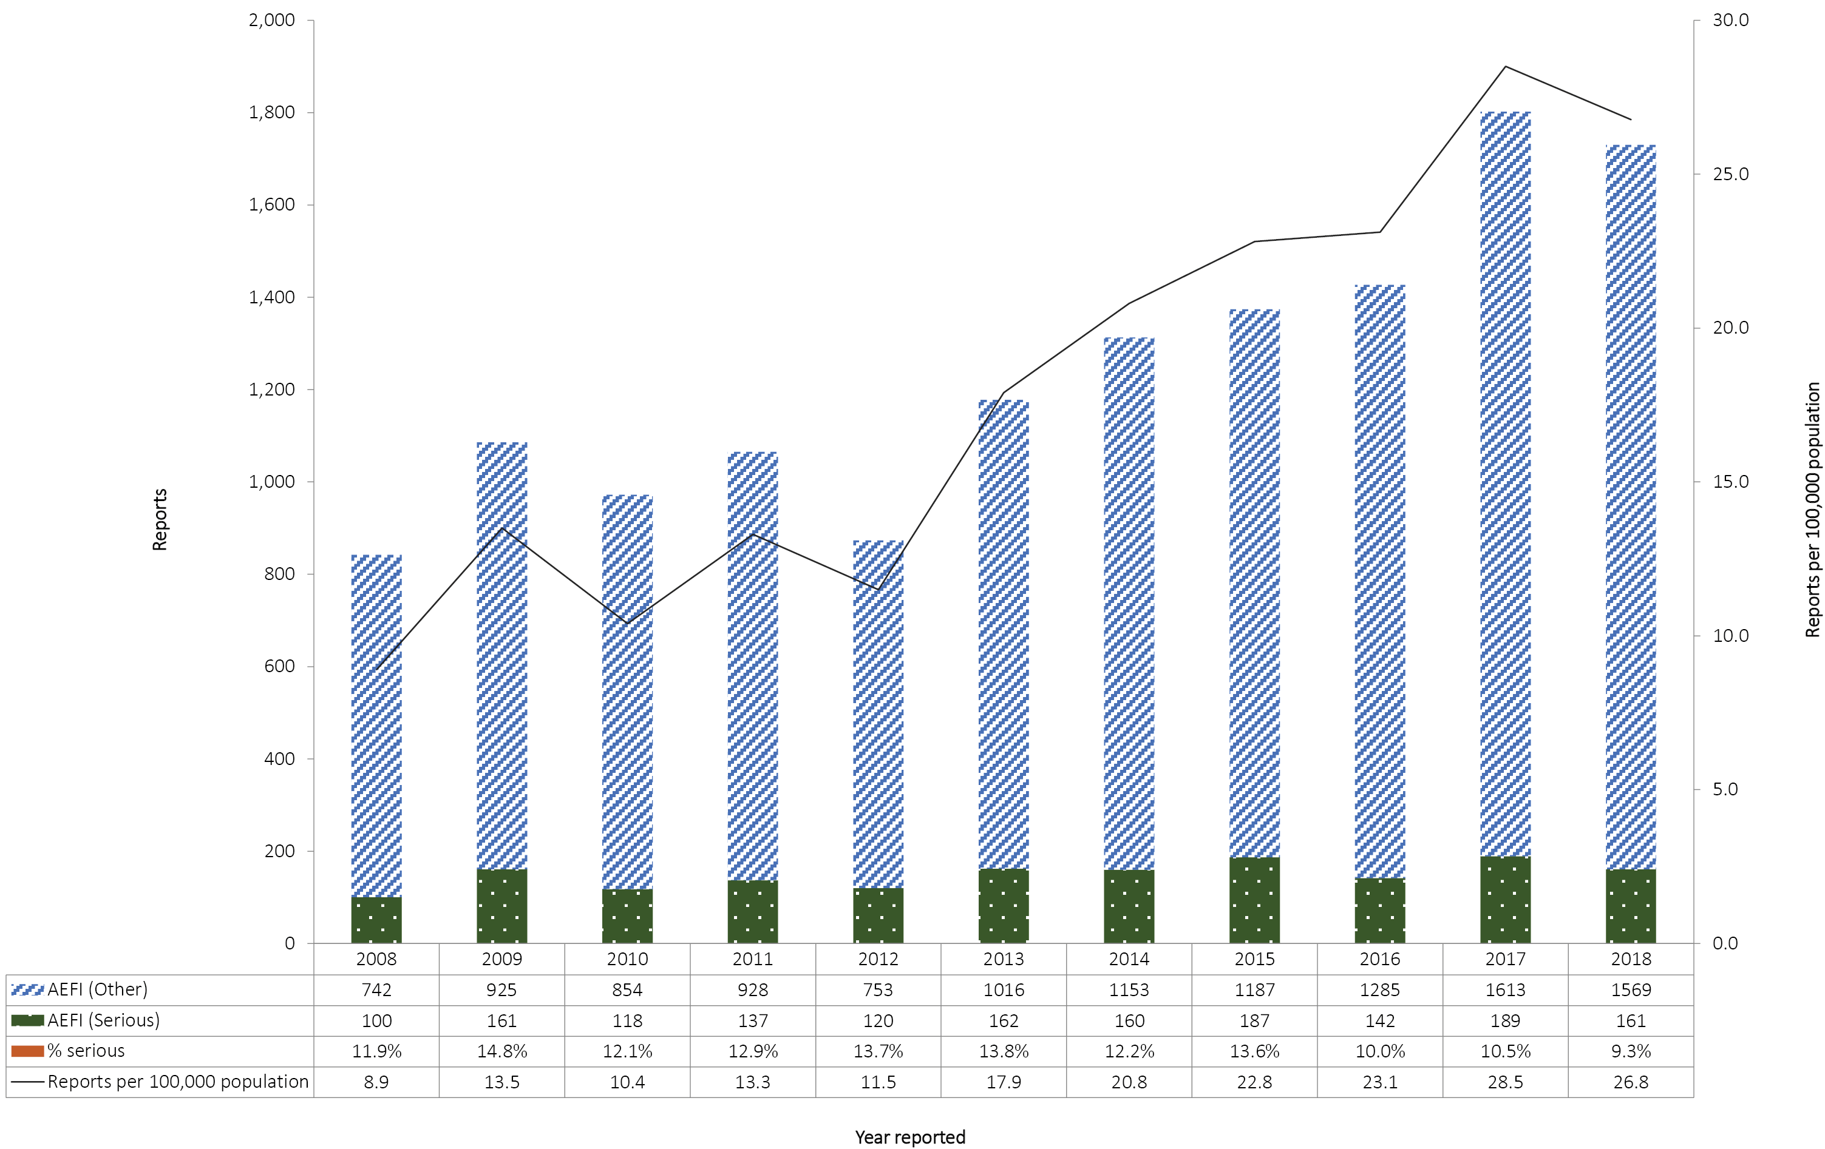

Table 1: AEFI reports by ‘serious’ category, age group, and sex,ª SAEFVIC, Victoria, 2018
 | AEFI reports
Age group (years) | Total |  |  |  | Male |  | Female |  | Male:female  population reporting ratio
 |  | Per 100,000 population | Serious  AEFI  n | Serious  AEFI  % | Cases | Per 100,000 population | Cases | Per 100,000 population
<1 | 344 | 408.8 | 51 | 14.8% | 173 | 400.4 | 169 | 412.8 | 0.97
1–4 | 669 | 203.5 | 55 | 8.2% | 360 | 213.0 | 308 | 192.9 | 1.10
5–17 | 284 | 28.4 | 19 | 6.7% | 136 | 26.5 | 146 | 30.1 | 0.88
18–64 | 259 | 6.4 | 21 | 8.1% | 49 | 2.4 | 209 | 10.2 | 0.24
65+ | 174 | 17.6 | 13 | 7.5% | 59 | 12.9 | 115 | 21.7 | 0.59
Total | 1,730 | 26.8 | 161 | 9.3% | 777 | 24.3 | 947 | 29.0 | 0.84
a Sex was not recorded for 6 cases

Two deaths temporally associated with vaccine administration were reported: an older Australian administered influenza vaccine in the general practice setting was reported deceased later the same day with cause of death attributed to a history of cardiac disease; and the death of an infant from neurological sequelae secondary to disseminated infection was noted to have received routine vaccines 2 weeks prior. These deaths showed no evidence of causal association.

Reporting modality
Online reporting continues to be the favoured modality of report submission, stabilising at just over half of reports received (53.4%), followed by telephone (22.5%) and fax reporting (23.0%) (Figure 2).

Reporter type
Reports were submitted predominantly by health/immunisation providers (doctors 23.6%, nurses 49.7%), with consumers (either the vaccinee or the parent or guardian) contributing approximately one-fifth of reports (20.0%). The proportion of consumer reporting has remained consistent across the last three years.¹¹ Fifteen reports (0.9%) related to vaccines administered by a pharmacist (which compares with 11 in 2017 and 3 in 2016, the year pharmacist administration commenced) (Figure 3).

Figure 2: Proportion of AEFI reporting modality, by year, SAEFVIC, Victoria 2008–2018
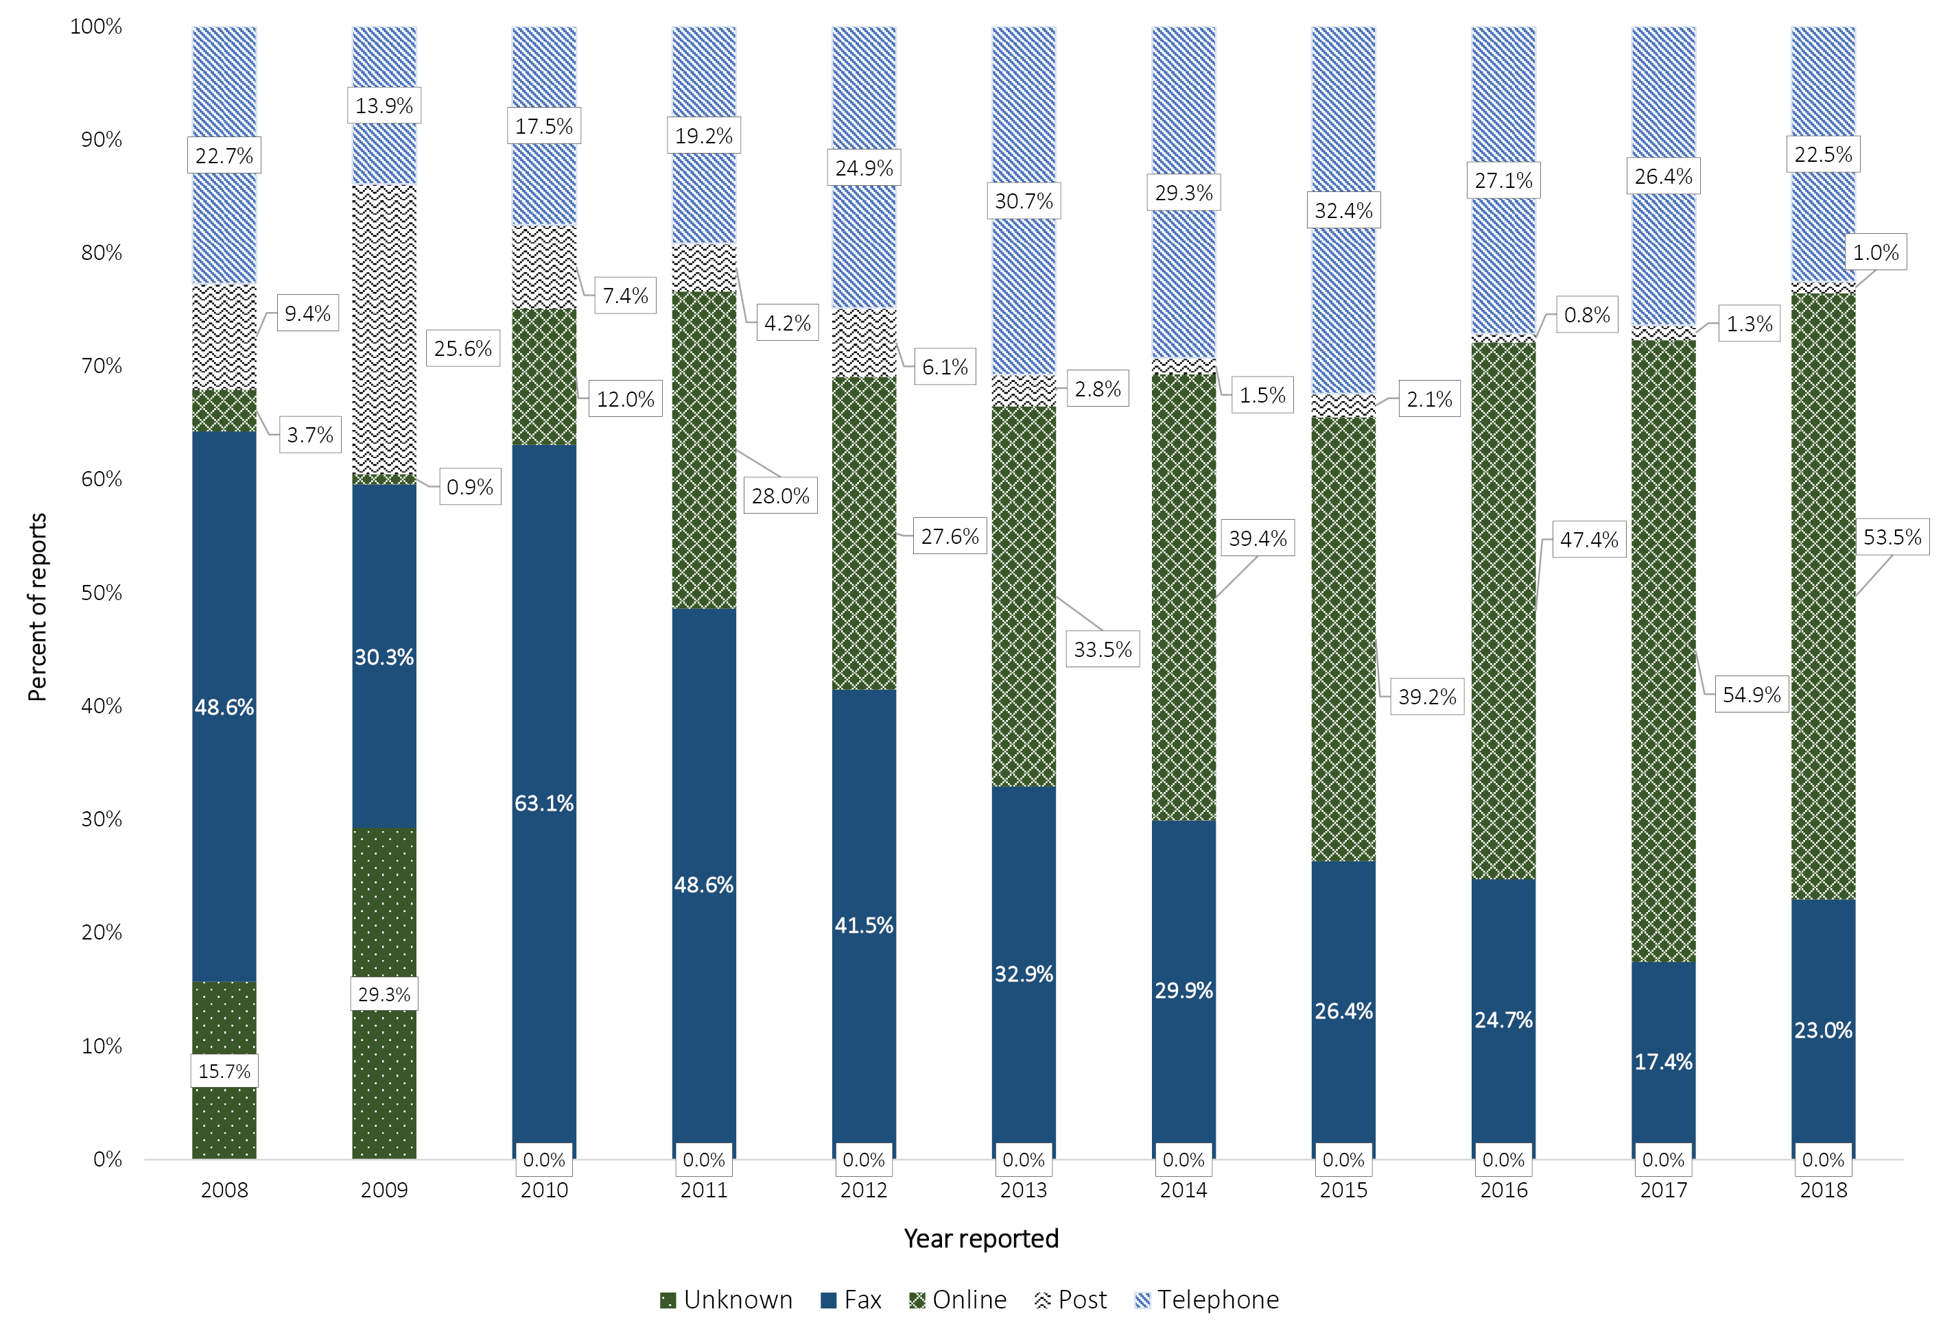
Figure 3: Proportion of AEFI reports by reporter type, by year, SAEFVIC, Victoria 2008–2018
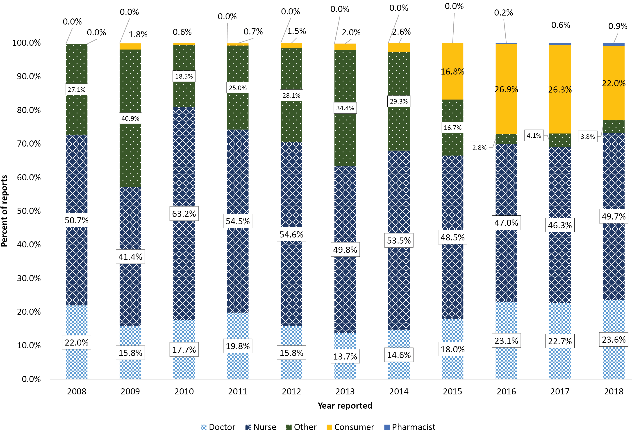

Active surveillance [PAEDS & AusVaxSafety]
The proportion of reports from active surveillance remained low at 2.0% (35/1730) and related to a broad range of vaccines administered. Just over half of active surveillance reports (18/35; 51.4%) were for serious AEFI, which is consistent with PAEDS being hospital-based surveillance and the selective entering of only those active surveillance cases requiring follow-up reported through AusVaxSafety.

Age and sex distribution
The young child age group (1–4 years) formed the largest proportion of AEFI reports (Figure 4), consistent with reporting across all previous years (Figure 4). While the trend for increased reporting was observed across all age groups, it was more pronounced in young children and older persons. The increased reporting in older persons aligns with initiation of the Zoster vaccine program commencement in November 2016. Reporting for school-aged children increased in 2013 commensurate with expansion of the HPV program from girls only to both sexes, but has since remained stable across the last three years (Figures 5).
Figure 4: Proportion of AEFI reports received, by age group, SAEFVIC, Victoria, 2018
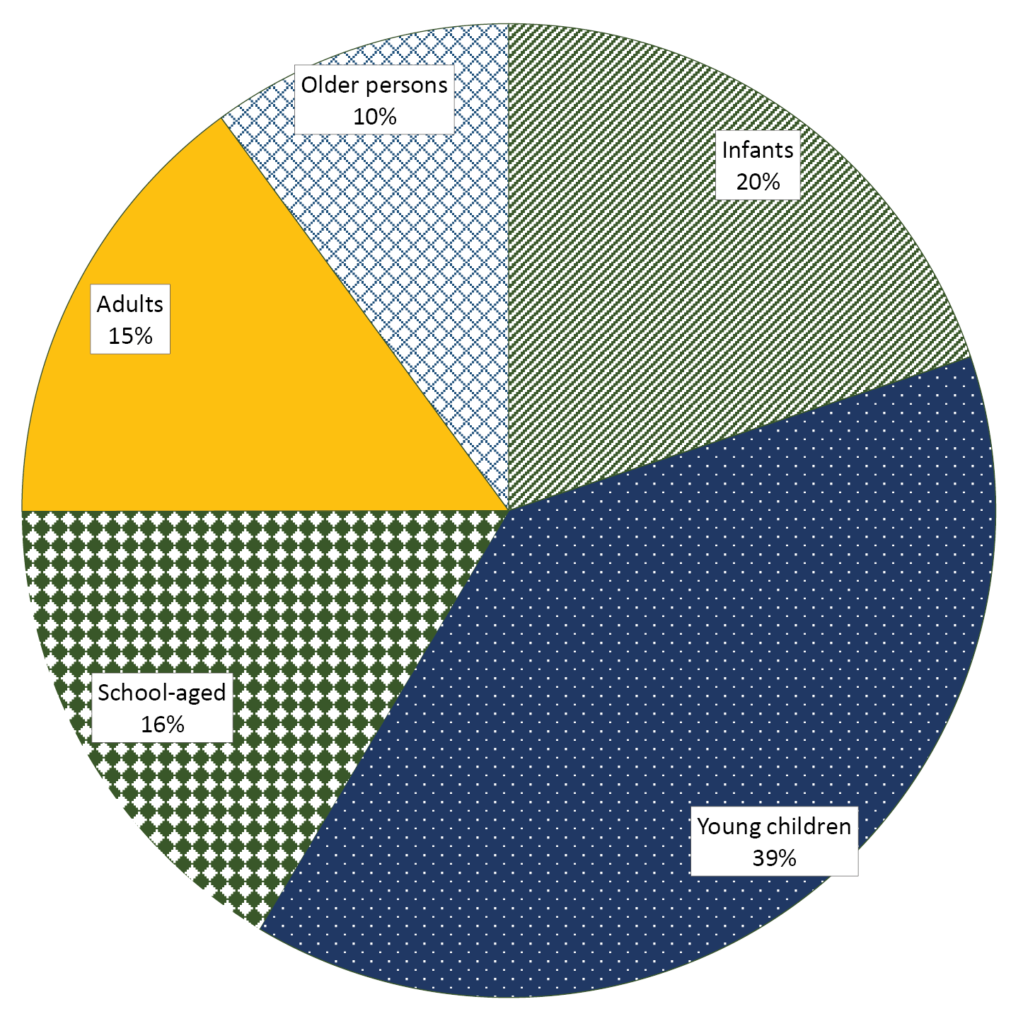

Figure 5: AEFI reports received by age group and year reported, SAEFVIC, Victoria 2008–2018
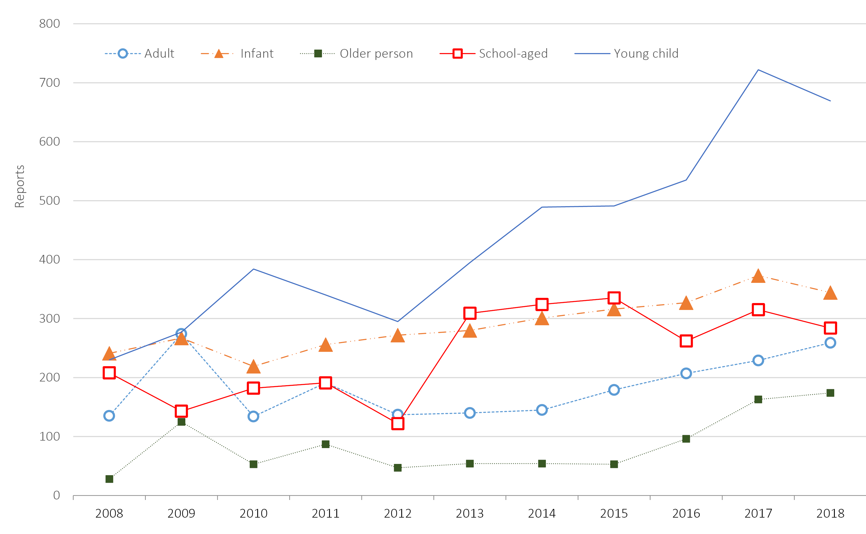

Overall just over half of all reports were for females (55.0%), however this varied by age group. In the infant and young child age groups, reporting was mostly even between the sexes (Table 1). However, females accounted for 81.0% of AEFI reports in adults (18–64 years) and for 66.1% of reports for older persons (65+ years).

At-risk populations
Routine capture of subgroup demographics e.g pregnancy and Aboriginal and/or Torres Strait Islander (Indigenous Australians) status commenced in 2016. In 2018, Indigenous status was reported for 75% of reports, with 0.7% being from persons identifying as Indigenous Australians. This proportion is similar to the Victorian Aboriginal and/or Torres Strait Islander population estimate of 0.8% (2016 census data).¹⁰
Seventeen reports were for AEFI during pregnancy, which was 8.1% (17/209) of reports received for adult females (aged 18–64).

Vaccines
A total of 2,836 vaccines were administered to the 1,730 persons reporting an AEFI, a median of two per vaccination encounter. The young child vaccines, DTP and MMR/MMRV, were the most frequently reported (Figure 6, Table 2).

Figure 6: Frequency of reports by vaccine group and age group, 2018
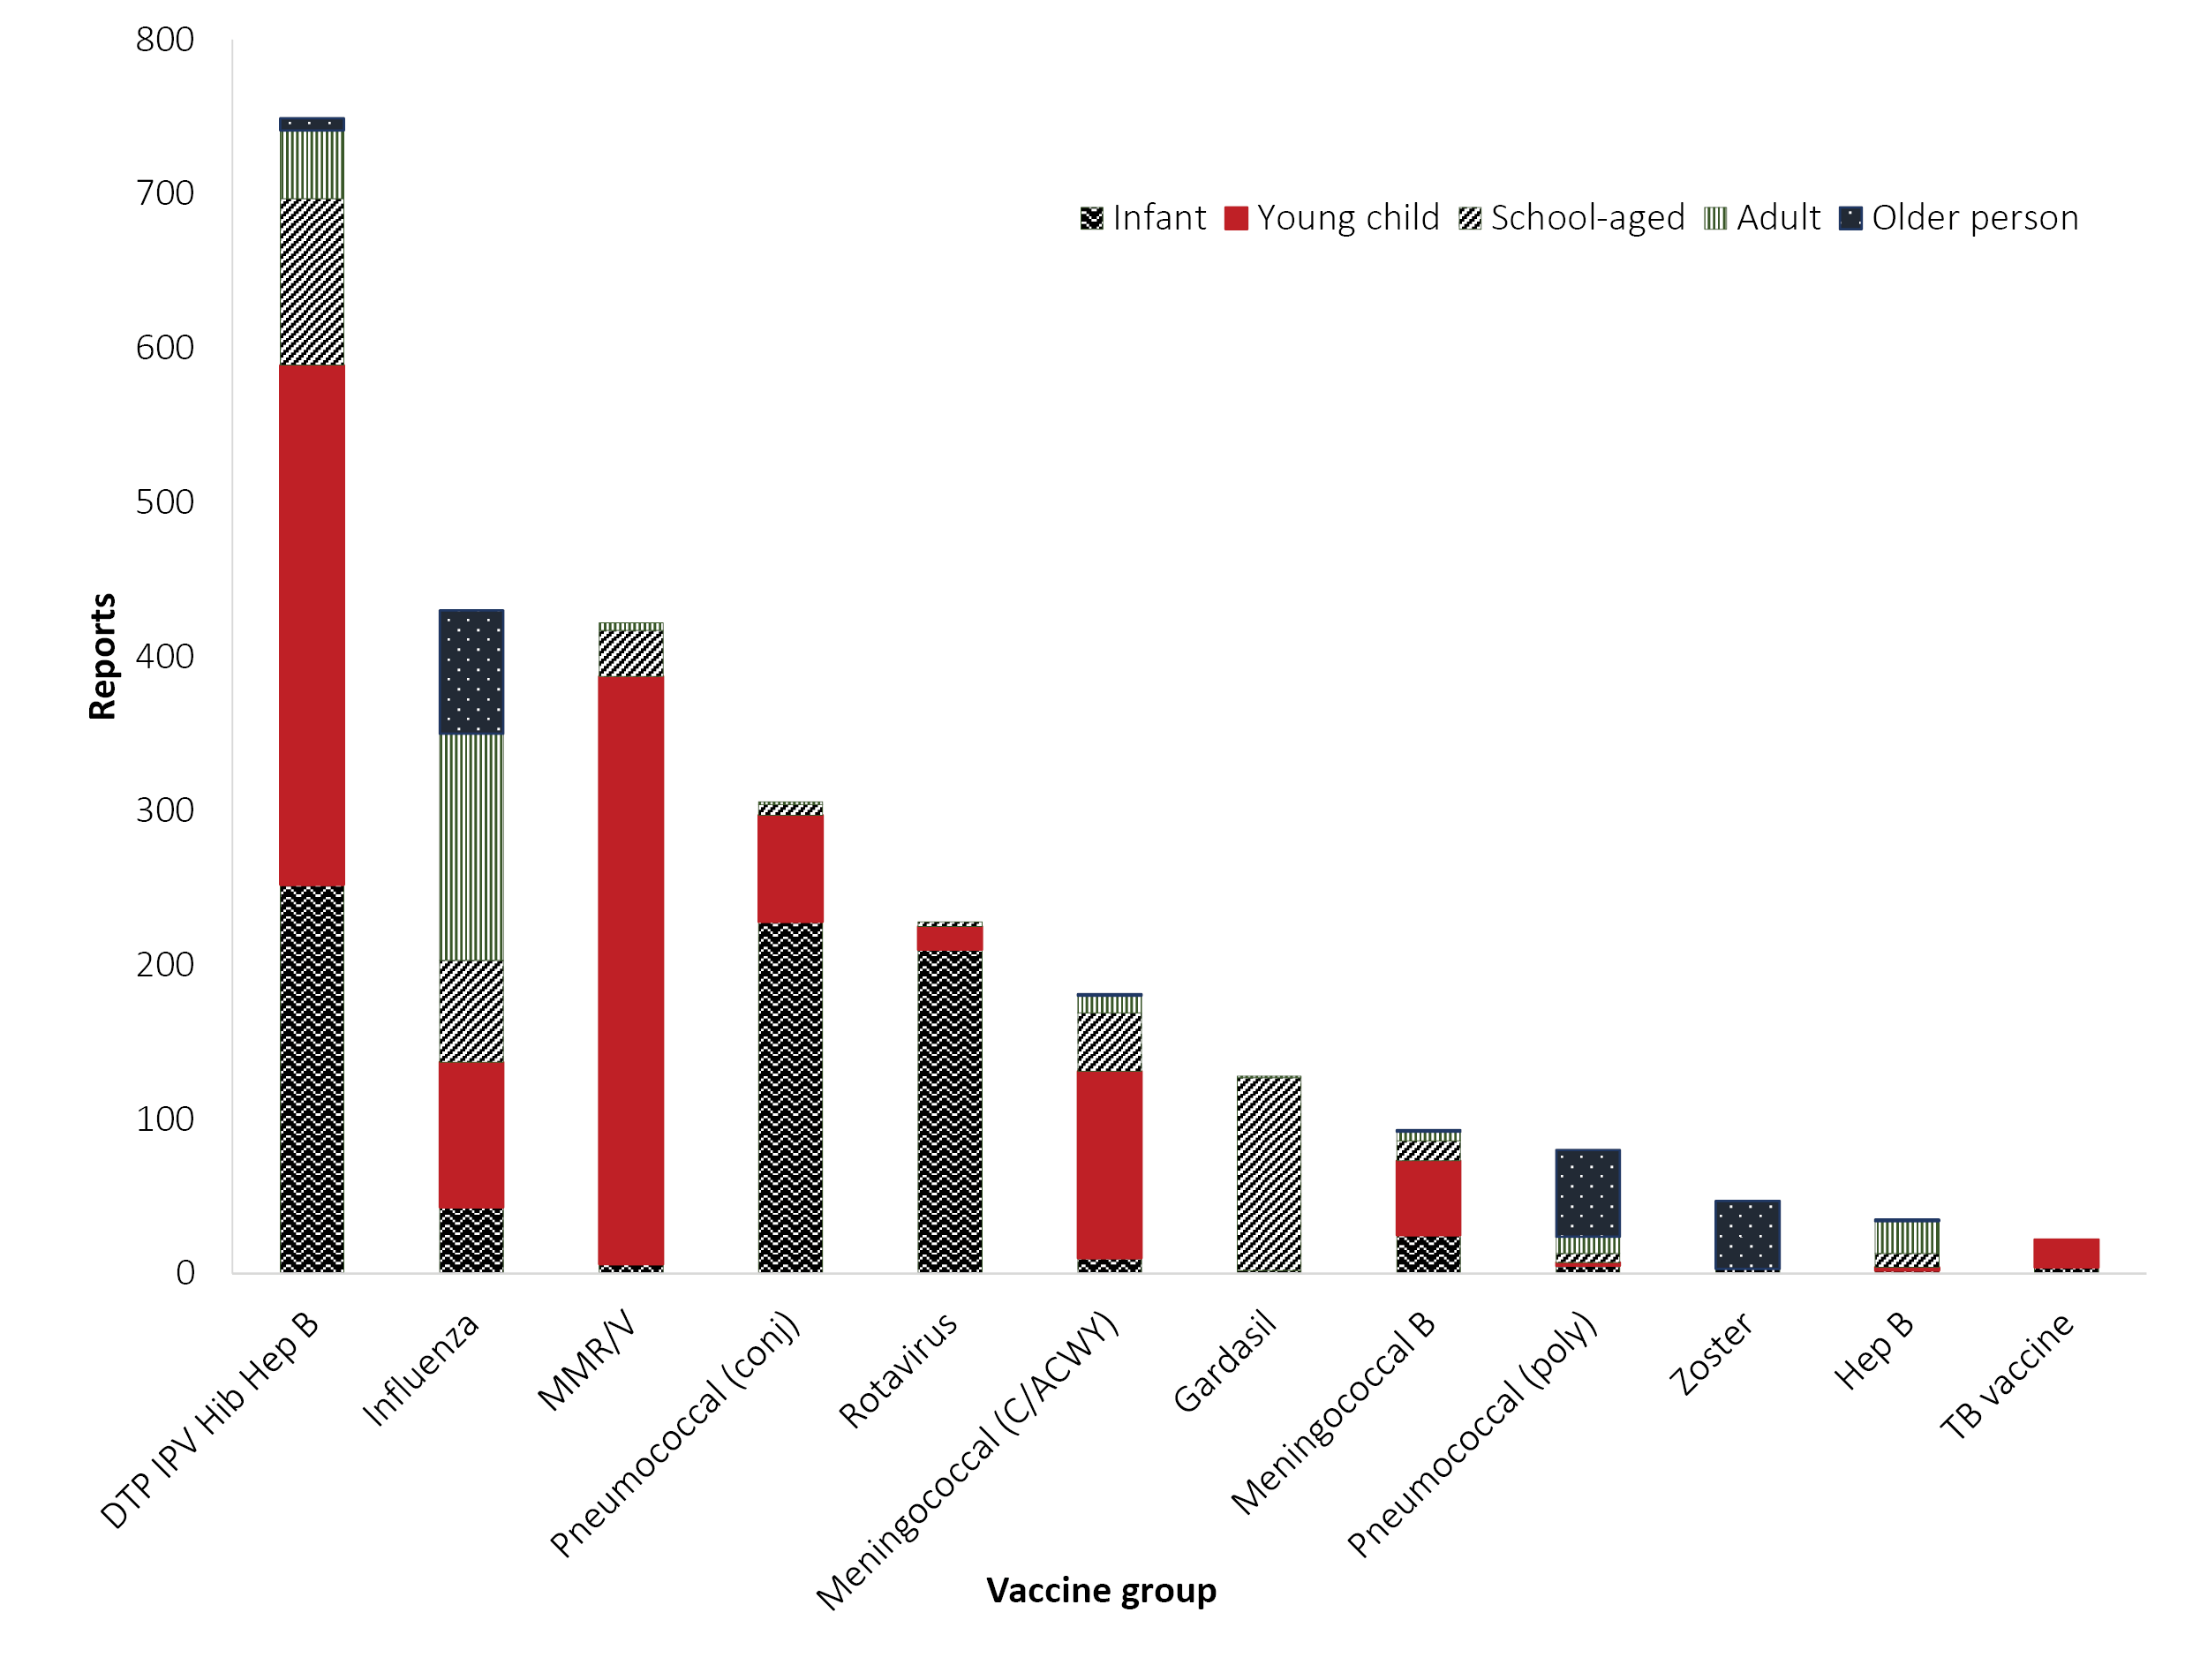

Table 2: AEFI reports by NIP schedule and vaccine, Victoria, 2018
National Immunisation Schedule (NIP) vaccines
Age group | Vaccine antigen | Reports (n) | Reports per 100,000 doses administered
Infant  <12 months  (n = 344) | Hepatitis B (birth) | 3 | 80.0
 | DTP IPV Hib Hep B | 245 | 123.5
 | Pneumococcal | 228 | 141.2
 | Rotavirusª | 210 | 176.7
 | Influenza | 38 | 120.2
 | Meningococcal B | 25 | 176.3
Young child  1–4 years  (n = 669) | Measles Mumps Rubella +/- Varicella (MMR or MMRV) | 305 | 188.6
 | Pneumococcal^{b} | 68 | 218.7
 | Meningococcal | 110 | 131.4
 | DTP | 370 | –
 | Influenza | 94 | –
 | Meningococcal B | 48 | –
 | TB | 18 | –
School-aged  5–17 years  (n = 284) | HPV | 125 | –
 | Influenza | 65 | –
 | DTP | 84 | –
 | Meningococcal | 34 | –
Adult  18–64 years  (n = 259) | DTP^{c} | 38 | –
 | Pneumococcal^{d} | 11 | –
 | Influenza^{e} | 154 | –
Older person  65+ yrs  (n = 174) | Pneumococcal | 55 | –
 | Shingles | 44 | –
 | Influenza | 80 | –
a Rotavirus vaccine used is Rotarix, with a 2-dose schedule (2 and 4 months), with last dose recommended by 24 weeks of age
b 12-month routine dose commenced 1 July 2018
c Pregnant women
d Indigenous Australian or medically at risk
e Not in NIP but recommended for at risk/healthcare workers.

AEFI reactions
The 1,730 AEFI reports described 2,423 reactions (a vaccine recipient may describe multiple AEFI reactions) of which 255 were included in the 160 reports meeting the definition of serious adverse event from immunisation (SAEFI).
The distribution and frequency of reactions listed in AEFI reports for 2018 (commonly reported and selected conditions) are shown in Table 3. Minor/common/expected injection site reaction was the most frequently reported reaction overall (13.3%; n = 322/2,423) as well as for each age group category.

Table 3: AEFI reactions reported (>20 reports & selected conditions in italics) by age group, SAEFVIC, 2018^{a,b}
Reaction reported | Infant | % of Infant reports | Child | % of Child reports | School-aged | % of School-aged reports | Adult | % of Adult reports | Older person | % of Older person reports | Total reactions | % of Total reactions
Injection site reaction (minor) | 21 | 4% | 168 | 20% | 45 | 11% | 43 | 10% | 45 | 17% | 322 | 13.3%
Rash | 68 | 14% | 112 | 13% | 41 | 10% | 16 | 4% | 10 | 4% | 247 | 10.2%
Drug errors | 44 | 9% | 83 | 10% | 34 | 9% | 27 | 6% | 27 | 10% | 215 | 8.9%
Injection site reaction (severe) | 7 | 1% | 128 | 15% | 23 | 6% | 18 | 4% | 18 | 7% | 194 | 8.0%
vomiting | 34 | 7% | 39 | 5% | 13 | 3% | 16 | 4% | 6 | 2% | 108 | 4.5%
Fever (unspecified) | 18 | 4% | 34 | 4% | 11 | 3% | 13 | 3% | 18 | 7% | 94 | 3.9%
Fever (> 38; < 40) | 25 | 5% | 49 | 6% | 9 | 2% | 3 | 1% | 1 | 0% | 87 | 3.6%
Urticaria/hives | 22 | 5% | 31 | 4% | 13 | 3% | 14 | 3% | 4 | 1% | 84 | 3.5%
Pain in limb | 5 | 1% | 2 | 0% | 22 | 6% | 23 | 5% | 18 | 7% | 70 | 2.9%
Lethargy | 4 | 1% | 13 | 2% | 15 | 4% | 19 | 4% | 17 | 6% | 68 | 2.8%
Diarrhoea | 34 | 7% | 16 | 2% | 5 | 1% | 4 | 1% | 5 | 2% | 64 | 2.6%
Vasovagal episode | 0 | 0% | 14 | 2% | 43 | 11% | 6 | 1% | 0 | 0% | 62 | 2.6%
Irritable | 41 | 9% | 18 | 2% | 1 | 0% | 1 | 0% | 0 | 0% | 61 | 2.5%
Nausea | 1 | 0% | 3 | 0% | 17 | 4% | 19 | 4% | 14 | 5% | 54 | 2.2%
Headache | 2 | 0% | 1 | 0% | 14 | 4% | 12 | 3% | 9 | 3% | 38 | 1.6%
Angioedema | 6 | 1% | 6 | 1% | 4 | 1% | 14 | 3% | 5 | 2% | 35 | 1.4%
Respiratory symptoms | 5 | 1% | 8 | 1% | 1 | 0% | 14 | 3% | 7 | 3% | 35 | 1.4%
HHE^{c} | 31 | 7% | 3 | 0% | 0 | 0% | 0 | 0% | 0 | 0% | 34 | 1.4%
Dizziness | 1 | 0% | 1 | 0% | 11 | 3% | 15 | 3% | 5 | 2% | 33 | 1.4%
Paraesthesia | 0 | 0% | 2 | 0% | 4 | 1% | 17 | 4% | 6 | 2% | 29 | 1.2%
Myalgia | 3 | 1% | 0 | 0% | 5 | 1% | 9 | 2% | 7 | 3% | 24 | 1.0%
Fever (>40) | 2 | 0% | 19 | 2% | 1 | 0% | 0 | 0% | 0 | 0% | 22 | 0.9%
Influenza-like-illness | 1 | 0% | 1 | 0% | 2 | 1% | 12 | 3% | 6 | 2% | 22 | 0.9%
Pallor | 8 | 2% | 1 | 0% | 3 | 1% | 1 | 0% | 0 | 0% | 21 | 0.9%
Anaphylaxis | 2 | 0% | 4 | 0% | 2 | 1% | 7 | 2% | 1 | 0% | 16 | 0.7%
GBS | 0 | 0% | 3 | 0% | 1 | 0% | 1 | 0% | 1 | 0% | 6 | 0.2%
Optic neuritis | 0 | 0% | 0 | 0% | 3 | 1% | 0 | 0% | 0 | 0% | 3 | 0.1%
Transverse myelitis | 1 | 0% | 0 | 0% | 0 | 0% | 2 | 0% | 0 | 0% | 3 | 0.1%
Total reactions | 472 |  | 837 |  | 399 |  | 445 |  | 270 |  | 2,423
% of all reactions | 19.5% |  | 34.5% |  | 16.5% |  | 18.4% |  | 11.1%
a The above table presents counts and percentages of reactions reported: a person may report more than one reaction.
b Highlighted values indicate reactions with higher reporting in a particular age-group variation.
c Hypotonic-hyporesponsive episode; definition is restricted to children aged < 2years.

There were some notable variations in the age-group proportional reporting with higher proportions seen for injection site reaction (severe) in young children (15%); vasovagal episodes in school-aged children (11%) and fever (unspecified) in older people (7%). Two reactions were reported in much higher frequency within specific age groups; hypotonic-hyporesponsive episode (HHE) was reported exclusively in infants, which is a specification of the case definition of HHE being diagnosable in those < 2 years; 86% of fever > 40 °C occurred in young children; and vasovagal episode (syncope or faint) in school-aged children accounting for 69% of vasovagal reports.

Drug / immunisation errors
SAEFVIC received 210 reports of immunisation errors, involving administration of 241 vaccines (more than one vaccine was administered with an error at some encounters). The highest number of reports were for young children (n = 80). As a proportion of all SAEFVIC reports received for a given age group, drug errors were most commonly reported in older persons (27/174; 15.5%).
The most frequently-implicated vaccines with immunisation error reports were the seasonal influenza brands which, when grouped together, accounted for 22.8% (55/241), predominantly for administration to a person outside of the vaccine-brand-registered prescribing age range. The next most frequently-implicated vaccine was live attenuated Zoster vaccine (Zostavax®) (10.0%; 24/241), for which the immunisation errors were predominantly associated with inadvertent administration of additional doses (19/24; 79.2%). There was one drug error (1/24; 4.2%) where Zoster vaccine was inadvertently administered to an immunocompromised patient (with no AEFI outcome noted); a marked improvement on 2017, when 9 such incidents were reported (9/39; 23.1%).
Repeated administration of routine vaccines was the most commonly-reported error, often accompanied by an explanation of the recipient having given unreliable information on their vaccination history; followed by vaccines administered outside of the prescribed age range (notably seasonal influenza vaccines, as above, and rotavirus vaccines) and the wrong vaccines being administered. There were 6 reports of Infanrix-hexa® being administered as the pre-filled diluent only syringe, without being reconstituted with the Hib pellet. The ‘other’ category comprises a range of uniquely reported errors such as later discovering the recipient had been pregnant at the time of immunisation, spilling the vaccine, vomiting after administration of rotavirus vaccine and one report of immunisation in a school setting without correct consent forms. Immunisation errors are summarised in Table 4. (Note that cold chain breaches are predominantly reported to the Department of Immunisation.)

Table 4: Summary of reported immunisation errors and implicated vaccines, SAEFVIC, 2018
Immunisation error description | Reports | Commonly implicated vaccines
Vaccine administered outside of prescribed age range | 68 | Seasonal influenza vaccines (75.0%, 51/68)  Rotavirus vaccines (17.6%, 12/68)
Incorrect vaccine administered | 63 | 12 and 18 month routine vaccines
Repeat dose/s administered | 66 | Zoster vaccine (27.3%, 18/66)
Expired vaccine | 17
Minimum interval not observed | 8
Diluent only | 6 | Infanrix-hexa (100%, 6/6)
Other | 12
Total reports | 241 | Seasonal influenza vaccines 22.8% (55/241)  Zoster vaccine (10.0%, 24/241)

Targeted monitoring
SAEFVIC conducts targeted monitoring of AEFI for specific vaccines, for specific reactions, or when programmatic changes occur that may have potential for increased risk of a signal or have heightened attention within the community. These are summarised in Table 5.

Table 5: Targeted monitoring for vaccine pharmacovigilance, SAEFVIC, 2018
Vaccines / population | Monitoring period | Reason for targeted monitoring | Findings
Influenza | Annual seasonal  Mar–Oct | Seasonal changes to strain with past history of AEFI signal events | Hypothesised increase in serious adverse neurological events (SANE)—likely attributable to increased administration of influenza vaccines. Ongoing review of cases in collaboration with TGA.
Meningococcal ACWY  Menactra® | 2017–2019 | New vaccine introduced to the Victorian school-based program for funded ACWY meningococcal vaccine. | AEFI reporting has decreased to 5 or fewer reports per month from a peak of 29 reports in August 2017. This is consistent with early increased reporting patterns following introduction of a new vaccine.¹²
BCG | 2014–2018 | Vaccine strain changes and restricted provider permissions. | 2018 saw the lowest reporting for 3 years.  This is consistent with reduced BCG vaccine administration resulting from provider restrictions in situ during 2018.¹³
Zoster | 2016–2018 | New vaccine introduced for 70–79 year olds  Death following administration to an immunocompromised person.¹⁴ | AEFI reporting has decreased to fewer than 5 reports per month, from a peak of 20 in March 2017, consistent with increased reporting patterns following introduction of a new vaccine at that time.  Noted immunisation errors of administration to immunocompromised persons and inadvertent administration of second dose. Improved education to immunisation providers was instigated.  Monitoring of shingles post Zostavax® is routinely included in AEFI-CAN.
Pharmacist administered | 2016–2019 | Victorian Pharmacist-Administered Vaccination Program | Small number of reports and most common is for minor injection site reactions.

Signal investigations
SAEFVIC initiated investigation into two signal hypotheses that were raised initially by clinical immunisation staff perceiving an increase in reporting. It is important to note that these investigations do not infer causality but are included here as an indication of SAEFVIC’s role in examining issues of potential vaccine safety in our jurisdiction.
Serious adverse neurological events (SANE) are known and rare AEFI, particularly with influenza vaccines,¹⁵ but they can also occur with temporal association to vaccines without causal association.^{16,17} Cases reported in 2018 encompassed a broad spectrum of ages (paediatric and adult) and vaccines. The proportional reporting ratio of SANE in 2018 (across all vaccines) was significantly higher than in previous years (PRR = 2.51, χ² = 6.78). However, when calculating the PRR limited to influenza vaccines alone, SANE reporting in 2018 was not disproportionately increased (PRR = 1.57, χ² = 0.48). The increase in number of reports was therefore hypothesised to be a consequence of increased influenza vaccine administration in 2018. This signal hypothesis was reported to the TGA and is the subject of an ongoing national review, supported by AEFI-CAN.
SAEFVIC perceived an increase in reporting of limb pain, restricted movement and bursitis during 2018, suggestive of shoulder injury related to vaccine administration (SIRVA). Following this increase in Victorian (SAEFVIC) notifications, the TGA was alerted and a review, conducted by the Advisory Committee on Vaccines, was initiated.¹⁸ This resulted in the development of new resources by both the Melbourne Vaccine Education Centre (MVEC) and the Australian Government Department of Health, which led a national educational initiative on correct injection technique included in the Australian Immunisation Handbook (April 2019). Resources are available via the MVEC website. Reported SIRVA cases are undergoing a clinical review for diagnostic confirmation, with symptom follow-up and long term outcomes to be determined.

System innovations
During 2018, SAEFVIC transitioned analysis of data to Microsoft Power Business Intelligence (PowerBI) software.⁹ This permits simpler and more rapid processing of data accompanied by visual presentation. Enhanced semi-automated signal monitoring processes using frequentist and Bayesian methodologies are being explored.
Tabulations of vaccine-event pairs reaching signal hypothesis threshold levels using proportional reporting ratios (PRR) and Bayesian algorithms are generated weekly and reviewed to determine whether an investigation may be warranted. We are developing a ranking system to classify new signal detections, to identify increases in magnitude of known signals, and to undertake automated notification of identified signals.

SAEFVIC service delivery
SAEFVIC surveillance is integrated with clinical service delivery. All AEFI reports are reviewed by an immunisation nurse with follow-up conversation with the vaccinee (or parent or guardian) to confirm the AEFI reaction. For serious AEFI, or if the vaccinee has reduced confidence in further vaccinations, a specialist clinical review is offered.

Clinical review
One fifth (329/1,730) of all cases attended specialist clinical services for review at either of two tertiary hospitals (Royal Children’s Hospital or Monash Health), via Telehealth or at regional services by arrangement. One hundred and sixty such cases (48.6%) received onward vaccination via these services (Figure 7), with 61 being vaccinated under high-level supervision in day (n = 31) or overnight (n = 30) admission settings. Note that not all clinic attendees would require further vaccination at the clinic attendance timepoint.

Figure 7: Clinic attendance and further vaccination by age group, SAEFVIC, 2018
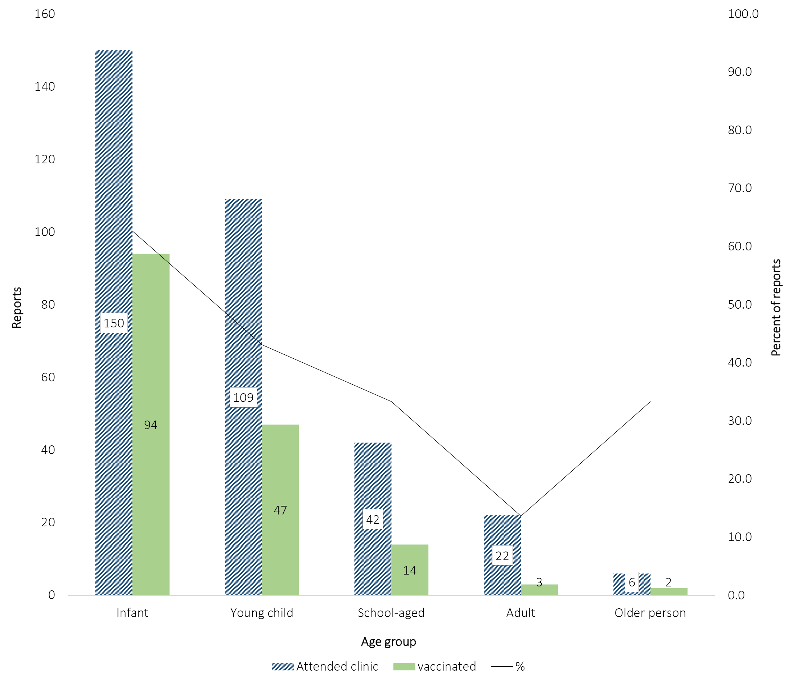

Immunisation advice
The SAEFVIC team responded to 3,140 phone calls during 2018, a 5% increase compared to 2017 (n = 2,987). Two additional short-term information services for immunisation providers and public/ consumers were provided in 2018, funded by the Victorian Government Department of Health and Human Services. The first was a 10-week telephone immunisation advice line providing expert advice on all NIP vaccines and particularly regarding: 1) recently-introduced federal and jurisdictional legislation¹⁹ restricting access to kindergarten and family payment benefits for unvaccinated children, called ‘No Jab No Play, No Jab No Pay’; 2) the Victorian Immunisation Program; and 3) the AIR. This was followed by 6-week clinical support via email providing immunisation advice on all NIP vaccines (paediatric and adult); the seasonal influenza program; immunisation catch-up requirements by age; advice around the Victorian immunisation schedule and vaccine eligibility criteria; changes to the National Immunisation Program; and other advice as relevant.

AEFI Clinical Assessment Network (AEFI-CAN)
AEFI-CAN is a national vaccine safety network coordinated by SAEFVIC, providing a collaborative approach to clinically assess and manage individual patients following serious or unexpected adverse events following immunisation. SAEFVIC leads national monthly teleconferences to discuss clinical cases of interest. A national database (with some funding support through AusVaxSafety) is being developed with capacity to harmonise AEFI data collation across jurisdictions for these serious clinical AEFI cases, seen in specialist immunisation clinics. In support of this initiative, SAEFVIC reviewed the case definitions used for AEFI surveillance and prepared a report for discussion as first steps towards uniform reporting across jurisdictions reporting. As a national network, this will improve data transfer with the Therapeutic Goods Administration and enhance assessment of serious AEFI.
During 2018, AEFI-CAN has led clinical reviews of: shingles cases temporally associated with Zostavax®; SANE with seasonal influenza vaccines; and SIRVA. AEFI-CAN has also supported the Commonwealth-led education campaign on vaccine administration techniques (see references above). The network of specialist immunisation clinics is also being utilised to discuss ‘No Jab No Pay’ special exemptions with the Commonwealth.

Education
SAEFVIC seeks to develop and strengthen communication about important vaccine safety issues among both public and healthcare professional stakeholders and to provide information to support the management of any adverse events or concerns about vaccine safety.

Melbourne Vaccine Education Centre (MVEC)
The Melbourne Vaccine Education Centre web-based initiative provides up-to-date immunisation information for healthcare professionals, parents and the public. SAEFVIC, working in collaboration with the Victorian Government Department of Health and Human Services, has successfully achieved accreditation for MVEC as a World Health Organization Vaccine Safety Net approved website. Vaccine Safety Net websites have been evaluated by the World Health Organization and meet the Global Advisory Committee on Vaccine Safety (GACVS) criteria for good information practices.²⁰

Clinical Vaccinology Updates (CVU)
The Clinical Vaccinology Updates (CVU) are a series of educational conferences providing an opportunity for immunisation providers and healthcare professionals, from Victoria and interstate, the opportunity to meet and discuss vaccines, vaccine preventable disease epidemiology and vaccine safety. Two symposiums in 2018 attracted over 400 attendees including general practitioners, nurse immunisers, pharmaceutical representatives and healthcare providers.
CVU presentations are publicly available as a resource accessible by all health professionals and interested members of the public on the Melbourne Vaccine Education Centre (MVEC) website.
AEFI reporting in Victoria was 26.8 per 100,000 population in 2018, comparable to 2017 and represents a tripling since SAEFVICs first full year of operation in 2008. SAEFVIC Victoria is now the highest AEFI reporting jurisdiction nationally, with the second highest reporting rate by population.²¹ The increased reporting, both in number and by population, is likely indicative of improved case ascertainment rather than increase in vaccine reactogenicity. This conclusion is supported by the decreasing proportion of reports deemed serious. The high number of reports received by SAEFVIC means that Victoria’s contribution to Australian national AEFI reporting is considerable, comprising 41.5% of all reports nationally in 2017—the most recently-published national report available—and triple that of New South Wales (25.3 to 8.7 AEFI reports per 100,000 population respectively), despite the similar jurisdictional population size of both states.²¹ Comparative national and jurisdictional data are accessible online from the Australian Government Department of Health, Therapeutic Goods Administration Database of Adverse Event Notifications (DAEN), however restricted by a 90 day access lag.²²
Age-group vaccine-specific AEFI reporting rates were estimated using records of administered vaccines from the AIR, which was established in 2016 as an all-of-life expansion of the previous age-restricted Australian Childhood Immunisation Register (ACIR). AEFI reporting is predictably higher in Victoria than other jurisdictions as a result of the higher case ascertainment achieved through the SAEFVIC surveillance model. However, further rate elevations were notable in reporting for non-NIP vaccines such as meningococcal B in children and non-universal vaccines administered in adult age groups. This is anticipated as a consequence of under-reporting for non-NIP administered doses into AIR, widely attributed to a lack of incentive payments for notification.²³ For this reason vaccine AEFI reporting rate estimations were not presented in this report beyond the infant age group. As AIR becomes established and systems for automated extraction of immunisation data from primary care software expand to include all encounters, regardless of funding drivers (for vaccine administration and/or data recording into AIR), AEFI reporting rate calculations will become more reliable.
SAEFVIC provides vaccine safety insight into several important areas: antenatal; Indigenous Australians; specialist provider programs; and for individual vaccine programs. Routine capture of information on pregnancy and Indigenous status commenced in 2016. AEFI reporting for persons identifying as Indigenous (0.7% of reports in 2018) is commensurate with the Indigenous population in Victoria. However, the number of reports received for immunisations administered in pregnancy was low, at only 8% of reports from adult females. Eighty per cent of adult reports were for females, reflecting the NIP in this adult age group that targets predominantly vaccination in pregnancy and seasonal influenza vaccine in healthcare workers who are also predominantly female. This is an important contribution to AEFI surveillance in pregnancy, which is acknowledged as a global priority especially as new vaccines are introduced to this cohort.^{24,25} Integration with active surveillance, whereby activities can be specifically directed to populations of interest, will further strengthen monitoring of vaccine safety for population subgroups.^{26,27}
The pharmacist administration of vaccines program commenced in 2016 with provisions for seasonal influenza vaccines. The number of AEFI reports received for pharmacist administered vaccines in 2018 was small and predominantly for minor injection site reactions, reflective of findings in the Western Australia pharmacist program that commenced earlier in 2014.²⁸ In September 2018 the program was expanded, authorising appropriately trained and registered pharmacists to administer measles-mumps-rubella (MMR) vaccine, along with influenza and pertussis-containing vaccines, to people aged 16 years and over subject to some exclusions. In 2019 we would expect to see an increase in AEFI reporting for pharmacist administered immunisations as the volume of vaccines administered through this pathway increases. The AIR does not record the immunisation provider so an alternative source of denominator data is required to accurately assess vaccine safety from this program.
Global bacillus Calmette–Guérin (BCG) vaccine supply shortages have resulted in frequent changes in BCG vaccine availability via the national authorised prescriber process, with recent transition to ‘19A regulations’ for approval to supply alternative brands within public health justifications.¹³ There is disparate jurisdictional administration of BCG and reporting on BCG AEFI, with such reporting predominantly from Victoria and Northern Territory; this is further exacerbated by low reporting in 2018, partially related to vaccine availability issues.^{29,30} SAEFVIC is currently comparing reporting by BCG vaccine product to inform future policy decision-making as BCG vaccine availability evolves.
As the largest contributor to AEFI reporting nationally,²¹ scrutiny of SAEFVIC surveillance data is likely to provide the earliest potential for signal hypothesis generation. In 2018 SAEFVIC referred suggestive signal events for SANE and SIRVA for further consideration by the national regulator (TGA). Additional innovations such as the incorporation of SAEFVIC data into business intelligence software, allowing improved visualisation, characterisation, mapping and statistical transformation, has enhanced our ability to understand and communicate our findings, as well as automating many of these processes to reduce delay.
Limitations of passive surveillance remain applicable to SAEFVIC and should be considered when drawing conclusions from these data. While reporting is presented as rates per population to provide trend estimation, they cannot be interpreted as AEFI incidence rates due to known ubiquitous under-reporting and biases associated with passive surveillance.^{31,32} Equally, AEFI are reported alongside all vaccines administered at a single encounter and cannot therefore be concluded as attributable to each individual vaccine. Vaccine program delivery scheduling is influenced by school terms, convenience and vaccine distribution constraints. These impact on AEFI reporting patterns and therefore seasonality is not analysed as part of this report.
While passive AEFI surveillance is subject to under-reporting,^{31,32} we believe SAEFVIC has established a strong balance for ascertaining serious AEFI and representative data for common or mild AEFI. Case ascertainment is further supported through inclusion of AEFI notified in Victoria through the active surveillance platforms of PAEDS and AusVaxSafety, the advent of which have improved immunisation safety surveillance in Australia.^{33,34} As an example, AusVaxSafety had almost 74,000 solicited participant-reported outcomes post-influenza vaccination recorded in 2017, with 6.6% reporting adverse events.³⁴ One third of the 300 AusVaxSafety sentinel sites were within Victoria. AEFI requiring medical attention identified from the active surveillance pathways are incorporated into the SAEFVIC comprehensive state-based vaccine safety system. However, with only 2.0% of AEFI reported to SAEFVIC acquired through the partner active surveillance systems, effective passive AEFI surveillance remains crucial, particularly to detect rare, unexpected or delayed events post-immunisation. Through integrating surveillance platforms, our aim is to provide a comprehensive vaccine safety system that captures all serious AEFI and supports clinicians and patients through specialist immunisation clinical review where indicated.
SAEFVIC’s unique platform of surveillance integrated with clinical services is further complemented by the MVEC education website, enabling responsive action to emergent vaccine safety issues. For example, enhanced monitoring of Zoster vaccine and analyses of the opportunistic reporting of drug administration errors, facilitated identification of several addressable issues such as Zoster vaccine administration in contraindication to immunocompromised persons. This led to development of new educational resources for immunisers. Vaccines continue to be administered in contravention of age and interval guidelines, particularly with influenza vaccines, raising demand for strategies to minimise age and interval violations.
The facility of the MVEC website for reactive and responsive publication and dissemination of resources meets the needs of immunisers and the increasing demand of community for directly accessible information.³⁵
SAEFVIC continues to evolve as a leader in AEFI surveillance, providing a broad spectrum of pharmacovigilance services to community, immunisation providers and regulators. The SAEFVIC platform is now adoptable by other jurisdictions as an independent data silo or with collaborative reporting and analytic services. Goals for the future are to formalise robust amalgamated processes for signal detection and to substantiate Victorian and national clinical support services through MVEC and AEFI-CAN. Ongoing optimisation of data visualisation and signal detection algorithms incorporating not just AEFI reports but also alternate health datasets will help ensure jurisdictional and national immunisation programs remain among the safest in the world.

Conclusion
SAEFVIC received 26.8 per 100,000 population reports in 2018, a tripling of the annual reporting rate since its inception, with no unexpected increases in the frequency or severity of AEFI reporting. Potential signal events were closely monitored with serious adverse neurological events (SANE) and SIRVA referred for national consideration but with no ongoing signal verified. Passive surveillance is useful for informing vaccine safety pharmacovigilance and for detecting potential safety signals. Integration with clinical services enhances the capacity for signal investigation and provides extended opportunity for collaborations to enhance pharmacovigilance nationally.

Author details
Hazel J Clothier^{1,2,3} Jock Lawrie^{1,2} Georgina Lewis¹ Melissa Russell³ Nigel W Crawford^{1,4,5} Jim P Buttery^{1,2,6}
- SAEFVIC, Murdoch Children’s Research Institute, Melbourne, Victoria, Australia
- Monash Centre for Health Research Implementation, Monash University, Clayton, Victoria, Australia
- School of Population & Global Health, University of Melbourne, Parkville, Victoria, Australia
- Immunisation Service, Royal Children’s Hospital, Parkville, Victoria, Australia
- Department Paediatrics, University of Melbourne, Parkville, Victoria, Australia
- Monash Immunisation, Monash Health, Clayton, Victoria, Australia

Corresponding author
Hazel J Clothier c/o SAEFVIC, Royal Children’s Hospital, Flemington Road, Parkvill, Victoria, Australia
Phone: 0421 900 113
Email: hazel.clothier@mcri.edu.au

References
- Clothier HJ, Crawford NW, Kempe A, Buttery JP. Surveillance of adverse events following immunisation: The model of SAEFVIC, Victoria. Commun Dis Intell Q Rep. 2011;35(4):294–8.
- Clothier HJ, Crawford NW, Russell M, Kelly H, Buttery JP. Evaluation of ‘SAEFVIC’, a pharmacovigilance surveillance scheme for the spontaneous reporting of adverse events following immunisation in Victoria, Australia. Drug Saf. 2017;40(6):483–95. doi: https://doi.org/10.1007/s40264-017-0520-7.
- Melbourne Vaccine Education Centre Melbourne(MVEC). [Internet.] Melbourne: SAEFVIC, MVEC; 2020. [Accessed on 3 March 2020.] Available from: https://mvec.mcri.edu.au/ .
- Clothier HJ, Selvaraj G, McMinn A, Lewis G, Crawford NW, Buttery JP. SAEFVIC: Surveillance of adverse events following immunisation (AEFI) in Victoria, 2012. Vic Infect Dis Bull. 2013;16(4):2–9.
- World Health Organization (WHO) Collaborating Centre for International Drug Monitoring. Uppsala monitoring centre. [Internet.] Uppsala: WHO; 2019. [Accessed on 25 July 2019.] Available from: https://www.who-umc.org/.
- Cross GB, Moghaddas J, Buttery J, Ayoub S, Korman TM. Don’t aim too high: avoiding shoulder injury related to vaccine administration. Aust Fam Physician. 2016;45(5):303–6.
- National Centre for Immunisation Research & Surveillance (NCIRS). AusVaxSafety. [Internet.] Sydney: NCIRS; 2016. [Accessed in January 2017.] Available from: http://www.ncirs.edu.au/vaccine-safety/ausvaxsafety/ .
- Australian Technical Advisory Group on Immunisation (ATAGI). Australian Immunisation Handbook. Canberra: Australian Government Department of Health; 2018. Available from: https://immunisationhandbook.health.gov.au/.
- Microsoft. Power BI. [Software.] Richmond: Microsoft Corporation; 2019. [Accessed on 27 June 2019.] Available from: https://powerbi.microsoft.com/en-us/.
- Australian Bureau of Statistics. [Internet.] Canberra: Australian Government, Australian Bureau of Statistics; 2019. [Accessed on 10 September 2019.] Available from: https://www.abs.gov.au/websitedbs/D3310114.nsf/home/Home.
- Clothier HJ, Selvaraj G, Easton ML, Lewis G, Crawford NW, Buttery JP. Consumer reporting of adverse events following immunization. Hum Vaccin Immunother. 2014;10(12):3726–30. doi: https://doi.org/10.4161/hv.34369.
- Hoffman KB, Dimbil M, Erdman CB, Tatonetti NP, Overstreet BM. The Weber effect and the United States Food and Drug Administration’s adverse event reporting system (FAERS): analysis of sixty-two drugs approved from 2006 to 2010. Drug Saf. 2014;37(4):283–94. doi: https://doi.org/10.1007/s40264-014-0150-2.
- Therapeutic Goods Administration (TGA). Section 19A: Guidance for industry. Supplying substitute medicines when registered medicines are unavailable or in short supply. Version 1.1, October 2017. Canberra: Australian Government Department of Health, TGA; 2018. [Accessed on 25 September 2019.] Available from: https://www.tga.gov.au/publication/section-19a-guidance-industry.
- Alexander KE, Tong PL, Macartney K, Beresford R, Sheppeard V, Gupta M. Live zoster vaccination in an immunocompromised patient leading to death secondary to disseminated varicella zoster virus infection. Vaccine. 2018;36(27):3890–3. doi: https://doi.org/10.1016/j.vaccine.2018.05.078.
- Crawford NW, Cheng A, Andrews N, Charles PG, Clothier HJ, Day B et al. Guillain-Barré syndrome following pandemic (H1N1) 2009 Influenza A immunisation in Victoria: a self-controlled case series. Med J Aust. 2012;197(10):574–8.
- Clothier HJ, Lee KJ, Sundararajan V, Buttery JP, Crawford NW. Human papillomavirus vaccine in boys: background rates of potential adverse events. Med J Aust. 2013;198(10):554–8.
- Williams SE, Pahud BA, Vellozzi C, Donofrio PD, Dekker CL, Halsey N et al. Causality assessment of serious neurologic adverse events following 2009 H1N1 vaccination. Vaccine. 2011;29(46):8302–8. doi: https://doi.org/10.1016/j.vaccine.2011.08.093.
- TGA. Advisory committee on vaccines meeting statement, meeting 11, 5 December 2018. [Internet.] Canberra: Australian Government Department of Health, TGA; 2018. [Accessed on 3 July 2019.] Available from: https://www.tga.gov.au/committee-meeting-info/acv-meeting-statement-meeting-11-5-december-2018.
- Victorian Government. No jab, no play. [Internet.] Melbourne: Victorian Government Department of Health and Human Services; 2019. [Accessed on 25 September 2019.] Available from: https://www2.health.vic.gov.au/public-health/immunisation/vaccination-children/no-jab-no-play.
- WHO. Vaccine safety net. [Internet.] Geneva: WHO; 2019. [Accessed on 3 July 2019.] Available from: https://www.who.int/vaccine_safety/initiative/communication/network/vaccine_safety_websites/en/.
- Dey A, Wang H, Quinn H, Hiam R, Wood N, Beard F et al. Surveillance of adverse events following immunisation in Australia annual report, 2017. Commun Dis Intell (2018). 2019;43. doi: https://doi.org/10.33321/cdi.2019.43.29.
- TGA. Database of adverse event notifications (DAEN). [Internet.] Canberra: Australian Government Department of Health, TGA; 2018. [Accessed on 20 May 2018.] Available from: https://www.tga.gov.au/database-adverse-event-notifications-daen.
- Hull B, Hendry AJ, Dey A, Brotherton BJ, Macartney K, Beard F. Annual immunisation coverage report 2017. Commun Dis Intell (2018). 2019;43. doi: https://doi.org/10.33321/cdi.2019.43.47.
- Kochhar S, Edwards KM, Ropero Alvarez AM, Moro PL, Ortiz JR. Introduction of new vaccines for immunization in pregnancy - programmatic, regulatory, safety and ethical considerations. Vaccine. 2019;37(25):3267–77. doi: https://doi.org/10.1016/j.vaccine.2019.04.075.
- Cassidy C, MacDonald NE, Steenbeek A, Ortiz JR, Zuber PL, Top KA. A global survey of adverse event following immunization surveillance systems for pregnant women and their infants. Hum Vaccin Immunother. 2016;12(8):2010–6. doi: https://doi.org/10.1080/21645515.2016.1175697.
- McHugh L, Crooks K, Creighton A, Binks M, Andrews RM. Safety, equity and monitoring: a review of the gaps in maternal vaccination strategies for Aboriginal and Torres Strait Islander women. Hum Vaccin Immunother. 2020;16(2):371–6. doi: https://doi.org/10.1080/21645515.2019.1649552.
- AusVaxSafety. Pertussis vaccine safety surveillance data: pregnant women. [Internet.] Sydney: NCIRS, AusVaxSafety; 2019. [Accessed on 25 September 2019.] Available from: http://www.ausvaxsafety.org.au/safety-data/pertussis-vaccine.
- Hattingh HL, Sim TF, Parsons R, Czarniak P, Vickery A, Ayadurai S. Evaluation of the first pharmacist-administered vaccinations in Western Australia: a mixed-methods study. BMJ Open. 2016;6(9):e011948. doi: https://doi.org/10.1136/bmjopen-2016-011948.
- Hendry AJ, Dey A, Beard FH, Khandaker G, Hill R, Macartney KK. Adverse events following immunisation with bacille Calmette-Guérin vaccination: baseline data to inform monitoring in Australia following introduction of new unregistered BCG vaccine. Commun Dis Intell Q Rep. 2016;40(4):E470–4.
- Khandaker G, Beard FH, Dey A, Coulter C, Hendry AJ, Macartney KK. Evaluation of bacille Calmette-Guérin immunisation programs in Australia. Commun Dis Intell Q Rep. 2017;41(1):E33–48.
- Gibbons CL, Mangen MJ, Plass D, Havelaar AH, Brooke RJ, Kramarz P et al. Measuring underreporting and under-ascertainment in infectious disease datasets: a comparison of methods. BMC Pub Health. 2014;14:147. doi: https://doi.org/10.1186/1471-2458-14-147.
- Hazell L, Shakir SAW. Under-reporting of adverse drug reactions : a systematic review. Drug Saf. 2006;29(5):385–96.
- Westphal DW, Williams SA, Leeb A, Effler PV. Continuous active surveillance of adverse events following immunisation using SMS technology. Vaccine. 2016;34(29):3350–5. doi: https://doi.org/10.1016/j.vaccine.2016.05.015.
- Pillsbury AJ, Glover C, Jacoby P, Quinn HE, Fathima P, Cashman P et al. Active surveillance of 2017 seasonal influenza vaccine safety: an observational cohort study of individuals aged 6 months and older in Australia. BMJ Open. 2018;8(10):e023263. doi: https://doi.org/10.1136/bmjopen-2018-023263.
- Mus M, Kreijkamp-Kaspers S, McGuire T, Deckx L, van Driel M. What do health consumers want to know about childhood vaccination? An evaluation of data from an Australian medicines call centre. Aust N Z J Public Health. 2017;41(1):74–9. doi: https://doi.org/10.1111/1753-6405.12607.

Communicable Diseases Intelligence
ISSN: 2209-6051 Online

Communicable Diseases Intelligence (CDI) is a peer-reviewed scientific journal published by the Office of Health Protection, Department of Health. The journal aims to disseminate information on the epidemiology, surveillance, prevention and control of communicable diseases of relevance to Australia.

Editor: Tanja Farmer
Deputy Editor: Simon Petrie
Design and Production: Kasra Yousefi
Editorial Advisory Board: David Durrheim, Mark Ferson, John Kaldor, Martyn Kirk and Linda Selvey

Website: http://www.health.gov.au/cdi

Contacts
Communicable Diseases Intelligence is produced by:
Health Protection Policy Branch, Office of Health Protection, Australian Government Department of Health
GPO Box 9848, (MDP 6) CANBERRA ACT 2601

Email: cdi.editor@health.gov.au

Submit an Article
You are invited to submit your next communicable disease related article to the Communicable Diseases Intelligence (CDI) for consideration. More information regarding CDI can be found at: http://health.gov.au/cdi.
Further enquiries should be directed to: cdi.editor@health.gov.au.

This journal is indexed by Index Medicus and Medline.

Creative Commons Licence - Attribution-NonCommercial-NoDerivatives CC BY-NC-ND
© 2020 Commonwealth of Australia as represented by the Department of Health
This publication is licensed under a Creative Commons Attribution-NonCommercial-NoDerivatives 4.0 International Licence from https://creativecommons.org/licenses/by-nc-nd/4.0/legalcode (Licence). You must read and understand the Licence before using any material from this publication.

Restrictions
The Licence does not cover, and there is no permission given for, use of any of the following material found in this publication (if any):
- the Commonwealth Coat of Arms (by way of information, the terms under which the Coat of Arms may be used can be found at www.itsanhonour.gov.au);
- any logos (including the Department of Health’s logo) and trademarks;
- any photographs and images;
- any signatures; and
- any material belonging to third parties.

Disclaimer
Opinions expressed in Communicable Diseases Intelligence are those of the authors and not necessarily those of the Australian Government Department of Health or the Communicable Diseases Network Australia. Data may be subject to revision.

Enquiries
Enquiries regarding any other use of this publication should be addressed to the Communication Branch, Department of Health, GPO Box 9848, Canberra ACT 2601, or via e-mail to: copyright@health.gov.au

Communicable Diseases Network Australia
Communicable Diseases Intelligence contributes to the work of the Communicable Diseases Network Australia.
http://www.health.gov.au/cdna

https://www.abs.gov.au/Population
Cold chain breach is the exposure of vaccines to temperatures outside the recommended range of 2 °C to 8 °C.
https://mvec.mcri.edu.au/immunisation-references/shoulder-injury-related-to-vaccine-administration
http://www.mvec.vic.edu.au
for example, https://mvec.mcri.edu.au/immunisation-references/nip-schedule-changes-july-1-2018-faqs
http://www.mvec.vic.edu.au/clinical-vaccinology-update-2018/
www.ausvaxsafety.org.au/our-work/active-vaccine-safety-surveillance
https://mvec.mcri.edu.au/immunisation-references/zoster/

