Aboriginal and Torres Strait Islander Epidemiology Report on COVID-19, 28 February 2021
Aboriginal and Torres Strait Islander Advisory Group on COVID-19; COVID-19 National Incident Room Surveillance Team; and Indigenous and Remote COVID-19 Policy and Implementation Branch
We acknowledge Aboriginal and Torres Strait Islander peoples and communities and pay respect to Elders past and present. We acknowledge Aboriginal and Torres Strait Islander peoples as the First Peoples of Australia and as the Traditional Custodians of the land and water on which we live, work and play. We value the principles of self determination and empowerment, working towards equal participation and equitable inclusion and voice.

Purpose
This report presents information on specific Aboriginal and Torres Strait Islander surveillance indicators in the Australian National Disease Surveillance Plan for COVID-19, as well as additional aspects of the coronavirus disease 2019 (COVID-19) response which have specific relevance for Aboriginal and Torres Strait Islander peoples (see the ‘Other elements of the response’ section).

Reporting period
This report compiles data for the duration of the COVID-19 pandemic, reported according to the following time periods:
- Cumulative: 25 January 2020 to 28 February 2021
- This reporting period: 1 February to 28 February 2021
Where reporting periods differ, this is indicated in the text.

Snapshot
As at 28 February 2021, there were 150 cases of COVID-19 notified in Aboriginal and Torres Strait Islander people, representing approximately 0.5% of all Australian confirmed cases. The last case in Aboriginal and Torres Strait Islander people was 16 January 2021 in Queensland (overseas acquired).
The majority of Aboriginal and Torres Strait Islander cases were locally acquired (77%; 115/150) and in Major Cities (79%; 91/115). Of all cases notified in Aboriginal and Torres Strait Islander persons, 20 cases were reported as requiring hospitalisation. There have been no deaths from COVID-19 reported among Aboriginal and Torres Strait Islander persons to date.
The reported testing rate for Aboriginal and Torres Strait Islander peoples during this reporting period was 18.0 per 1,000 persons. Testing rates are lower among Aboriginal and Torres Strait Islander people than non-Indigenous people.

Methods

Data sources
This report draws on data from various surveillance systems. The relevant data source(s) are shown for each section of the report in parentheses below the heading. Potential biases applicable to each source are discussed in the relevant section, with further information on the source in Appendix A. Due to the dynamic nature of these sources, data in this report are subject to retrospective revision and may vary from data reported in other reports and from reports of notification data by states and territories.

Analysis
Data are summarised under relevant indicators from the Australian National Disease Surveillance Plan for COVID-19.¹ Analyses are descriptive, using frequencies and percentages. Hospitalisation and case fatality ratios are calculated using number of cases hospitalised and deceased (respectively) divided by total number of cases. Population data from the Australian Bureau of Statistics (ABS) Estimated Resident Population were used to estimate rates of infection and testing uptake by jurisdiction, age group, sex and Aboriginal and Torres Strait Islander status. National, state and territory population data as at June 2020 were used for the total resident population and June 2016 data were used for Aboriginal and Torres Strait Islander status by sex and age group.
Where indicated, rates are standardised using direct or indirect age-standardisation, with the method chosen dependent on numbers and therefore the stability of stratum-specific rates.

Cultural review and considerations
In line with principles of data governance outlined in the Australian National Disease Surveillance Plan for COVID-19,¹ the Aboriginal and Torres Strait Islander Advisory Group on COVID-19 has reviewed this report and all data contained within.
This report aims to disseminate data to empower communities with information for decision-making and responses around coronavirus disease 2019 (COVID-19). Given the small numbers of Aboriginal and Torres Strait Islander cases to date, this report may contain counts of fewer than five people. However, in specific areas of disaggregation, numbers may be suppressed where there is a potential risk to individual privacy.
Comparisons made in this report between Aboriginal and Torres Strait Islander peoples and non-Indigenous people aim to highlight the importance of health equity between these populations. For further information about culturally appropriate interpretation and analysis of this information, please see the section on ‘Governance and Implementation’ in the Australian National Disease Surveillance Plan for COVID-19.¹

Results

Notified cases

(Source: NNDSS)
As at 28 February 2021, there were 150 COVID-19 cases notified in Aboriginal and Torres Strait Islander peoples since the beginning of the pandemic, representing approximately 0.5% (150/29,135) of all Australian cases. There have been two distinct peaks in March and July for Aboriginal and Torres Strait Islander case notifications (Figure 1). This mirrors COVID-19 case notifications in the non-Indigenous population. There were no cases of COVID-19 reported in Aboriginal or Torres Strait Islander peoples from 1 to 28 February 2021 (Table 1).

Figure 1: COVID-19 notifications among Aboriginal and Torres Strait Islander peoples by diagnosis date and jurisdiction, 9 March 2020 to 28 February 2021
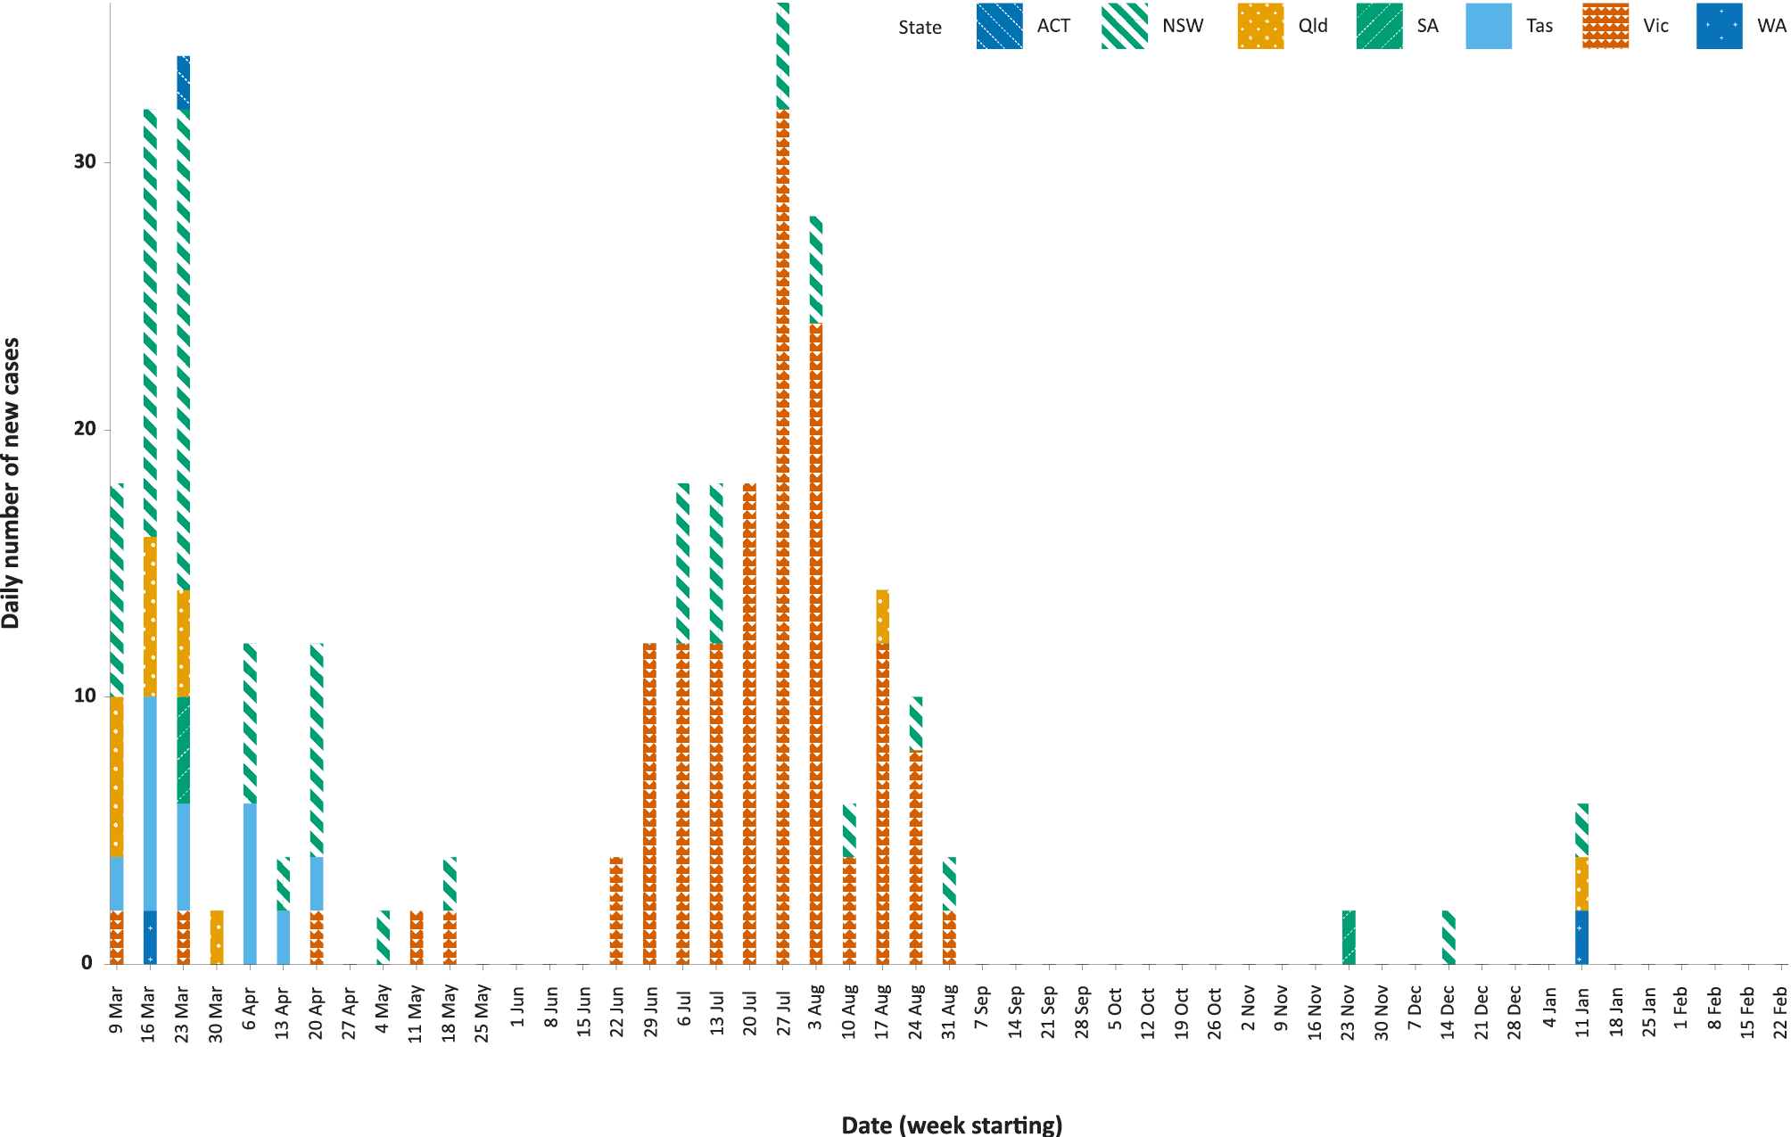
Table 1: COVID-19 notifications among Aboriginal and Torres Strait Islander peoples and non-Indigenous people
Confirmed cases in Australia | 4–31 January 2021  No. (rate per 100,000 population) | 1–28 February 2021  No. (rate per 100,000 population) | Cumulative  No. (rate per 100,000 population)
Aboriginal and Torres Strait Islander peoples | 3 (0.4) | 0 (–) | 150 (19)
Non-Indigenous people | 297 (1.2) | 150 (0.6) | 28,985 (116)

All jurisdictions except the Northern Territory have reported at least one Aboriginal and Torres Strait Islander case to date (Table 2). The last reported case among Aboriginal and Torres Strait Islander peoples was diagnosed on 16 January 2021 in Queensland (Table 3). No historic cases were notified during this reporting period.

Table 2: COVID-19 notifications of confirmed cases among Aboriginal and Torres Strait Islander peoples by place of acquisition and area of remoteness
Jurisdiction | Locally acquired, Australiaª |  |  |  |  | Overseas acquired | Unknown | Total
 | Major City | Inner Regional | Outer Regional | Remote Area | Acquired interstate
ACT | 0 | 0 | 0 | 0 | 0 | 1 | 0 | 1
NSW | 20 | 8 | 1 | 0 | 1 | 16 | 0 | 46^{b}
NT | 0 | 0 | 0 | 0 | 0 | 0 | 0 | 0
Qld | 4 | 0 | 0 | 0 | 0 | 7 | 0 | 11
SA | 2 | 0 | 0 | 0 | 1 | 0 | 0 | 3
Tas. | 0 | 0 | 5 | 1^{c} | 0 | 6 | 0 | 12
Vic. | 65 | 7 | 0 | 0 | 0 | 2 | 1 | 75
WA | 0 | 0 | 0 | 0 | 0 | 2 | 0 | 2
Australia | 91 | 15 | 6 | 1 | 2 | 34 | 1 | 150
a ‘Locally acquired’ comprises all cases without an overseas or unknown place of acquisition.
b These data are accurate as an extract from the National Notifiable Diseases Surveillance System (NNDSS) as of April 2021; however, the New South Wales Notifiable Conditions Information Management System (NCIMS) identifies a cumulative total of 47 Aboriginal and Torres Strait Islander persons with COVID-19. The reason for the discrepancy in numbers is currently being investigated.
c This case resides in a region classified as Remote Australia, but not within a remote Aboriginal and Torres Strait Islander community.
Table 3: Number of days since date of diagnosis of the last confirmed case among Aboriginal and Torres Strait Islander peoples by jurisdiction and place of acquisition, at 28 February 2021
Jurisdiction | Days since diagnosis of last confirmed case
 | Locally acquired | Overseas acquired
ACT | – | 339
NSW | 73 | 46
NT | – | –
Qld | 194 | 43
SA | 96 | –
Tas. | 314 | 340
Vic. | 181 | 280
WA | – | 45

Place of acquisition

(Source: NNDSS)
Overall, 77% (115/150) of cases notified in Aboriginal and Torres Strait Islander persons were locally acquired. Of locally-acquired cases, 79% (91/115) were reported as being acquired in Major Cities, 18% (21/115) in Inner or Outer Regional Australia, 1% (1/115) in Remote/Very Remote Australia and 2% (2/115) were reported as interstate travel (Table 2).
Approximately 23% (34/150) of cases were reported as overseas acquired (Table 2 and Figure 2). Of these cases, 41% (14/34) were associated with cruise ships.

Figure 2: COVID-19 notifications among Aboriginal and Torres Strait Islander peoples by source of acquisition and jurisdiction, at 28 February 2021
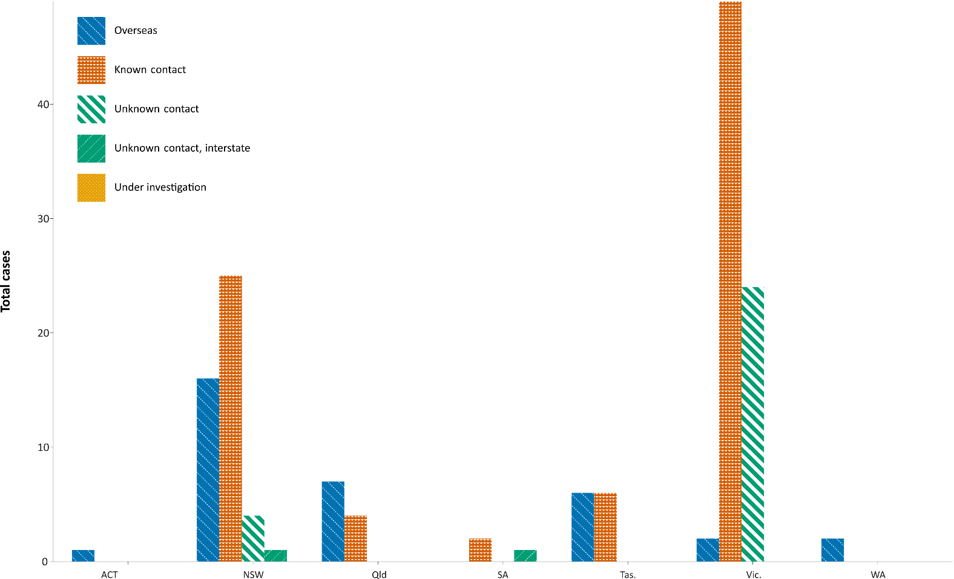

Of the 116 locally-acquired cases and cases with an unknown source of acquisition, 74% (86/116) were contacts of a confirmed case and/or part of an identified cluster. There are no cases currently under investigation.

Demographics

(Source: NNDSS)
The median age of Aboriginal and Torres Strait Islander COVID-19 cases was 31 (range 1–95; interquartile range (IQR): 21–50) years old (Table 4). For non-Indigenous people, the median age was 37 (range 0–106; IQR: 25–56) years old. A slightly higher proportion of cases in Aboriginal and Torres Strait Islander peoples were female (58%; 88/150) compared to non-Indigenous cases (51%; 14,804/29,392).

Table 4: Distribution of COVID-19 cases in Aboriginal and Torres Strait Islander peoples by age group, at 28 February 2021
Age group (years) | Number of cases
0–9 | 13
10–19 | 20
20–29 | 36
30–39 | 26
40–49 | 16
50–59 | 20
60–69 | 13
70–79 | 5
80 & over | 1
Total | 150

Rates

(Source: NNDSS)
For all notifications to date, Aboriginal and Torres Strait Islander peoples have reported lower rates of infection per 100,000 population at all age groups than has the non-Indigenous population (Figure 3). Amongst Aboriginal and Torres Strait Islander cases, the highest notification rate was in those aged 70–79 years (36.0 cases per 100,000 population), followed by the 60–69 years age group (34.4 cases per 100,000 population). Similar to non-Indigenous cases, children aged 0–9 years had the lowest notification rate among Aboriginal and Torres Strait Islander cases (6.9 cases per 100,000 population). These findings should be interpreted with caution, due to unstable rates from small numbers of cases.

Figure 3: COVID-19 notifications by age group among Aboriginal and Torres Strait Islander peoples and non-Indigenous people, at 28 February 2021
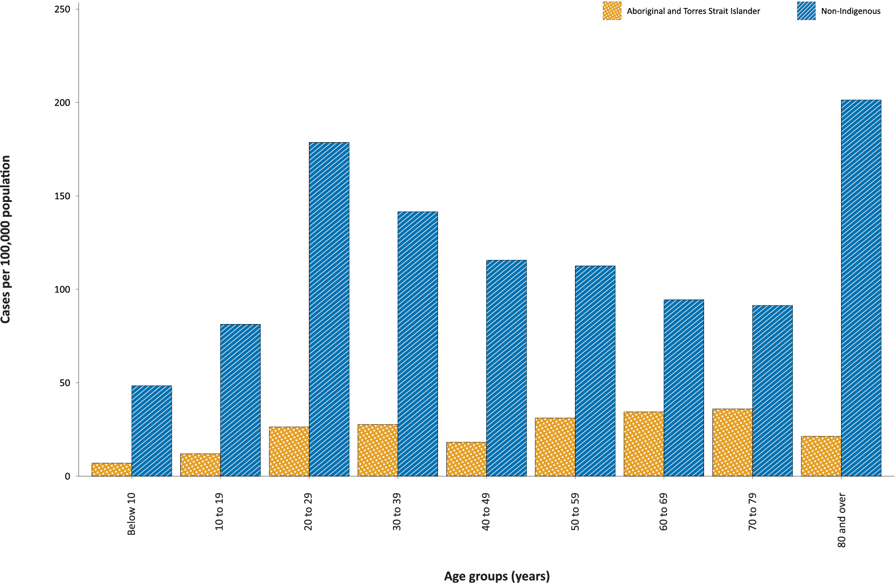

Overall, the notification rate among Aboriginal and Torres Strait Islander peoples was 19 per 100,000 population, which was lower than that of the non-Indigenous population of 116 cases per 100,000 population (Table 1). The indirect age-standardised notification rate ratio was 0.2, indicating that the Aboriginal and Torres Strait Islander population COVID-19 case rates were 80% lower than in the non-Indigenous population after accounting for differences in population age structure.
Notifiable diseases data are always prone to potential undercount; that is, only those who seek medical care and are tested are included in disease counts. It is important to acknowledge that there may be legitimate reasons why people do not seek medical care or testing, including barriers to access. This potential underreporting needs to be taken into account when comparing rates of COVID-19 between groups. While Aboriginal and Torres Strait Islander peoples may have lower rates of testing for COVID-19 compared with non-Indigenous people (see ‘Laboratory testing’), the difference in notification rates is quite large and differences in testing uptake appear unlikely to be the main factor influencing this.

Severity

Hospitalisations

(Sources: FluCAN, NNDSS)
The current hospitalisation rate in Aboriginal and Torres Strait Islander peoples, based on National Notifiable Diseases Surveillance System (NNDSS) data for confirmed COVID-19 cases to date, is 13.3% (20/150). This is similar to the rate for non-Indigenous people (at 13.5%). Of all cases notified in Aboriginal and Torres Strait Islander peoples, 20 cases were reported as requiring hospitalisation (eight males and twelve females). The last case requiring hospitalisation was reported through the NNDSS on 19 January 2021. The median age for cases who were hospitalised was 51 years old (range 1–70; IQR: 35–64). The highest rate of hospitalisation was in the 60-69 year age group (6/13; see Table 4 and Figure 4). It should also be noted that cases may be hospitalised for isolation purposes and hospitalisation may not reflect severity of illness.
Figure 4: Sex and age distribution of COVID-19 cases in Aboriginal and Torres Strait Islander persons admitted to hospital
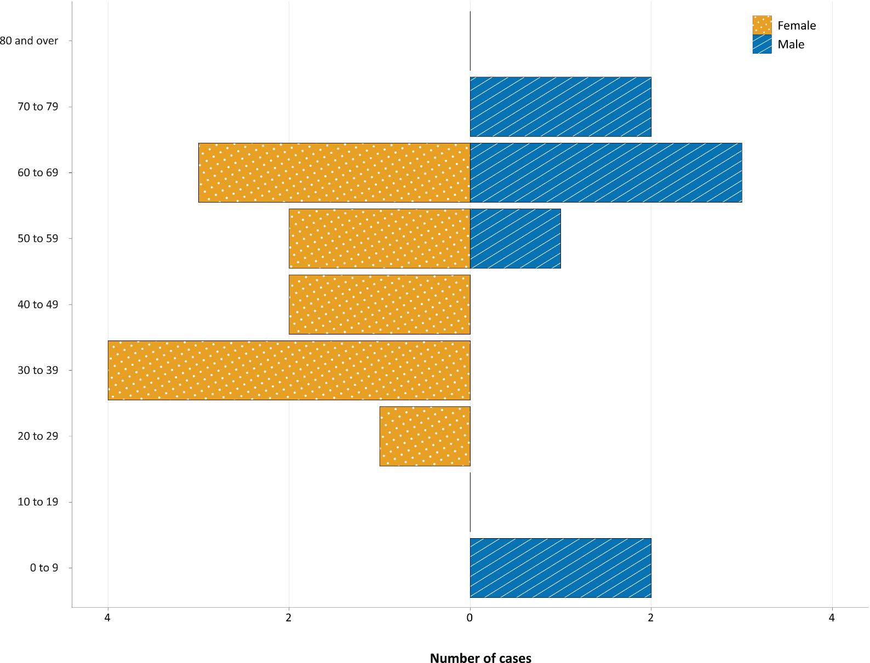

Of those hospitalised in sentinel sites (n = 481),² six (1.2%) were identified as Aboriginal and Torres Strait Islander people (1 unknown and 8 missing data; > 98% completeness of Indigenous status).

Intensive care admissions

(Sources: NNDSS, Sprint-SARI)
To date, one Aboriginal and Torres Strait Islander case (in the 60–69 years age group) has required ICU admission, representing 5% of all hospitalised Aboriginal and Torres Strait Islander cases.
It is important to note potential biases of the data reported above. NNDSS data may have less than 100% completion for recording hospitalisation. FluCAN² and SPRINT-SARI³ are sentinel surveillance systems that do not cover all hospitals in Australia and data collection was interrupted from January 2021. Their representativeness for Aboriginal and Torres Strait Islander status has not been formally assessed. For more information on these sources see Appendix A.

Deaths

(Source: State and territory reporting)
There were no COVID-19 deaths reported in Australia during 1–28 February 2021, with the crude case-fatality rate (CFR) among Aboriginal and Torres Strait Islander peoples remaining at zero and the CFR for the non-Indigenous population remaining at 3.1%.

Symptoms

(Source: NNDSS)
Of all cases notified in Aboriginal and Torres Strait Islander people, 121 included symptom data. The most commonly reported symptoms were cough (49%; 59/121), headache (47%; 57/121), malaise/lethargy/fatigue (39%; 47/121), and sore throat (33%; 40/121) (Figure 5). Information on symptoms was unknown or missing for 19% (29/150) of Aboriginal and Torres Strait Islander cases, compared to 33% (9,790/29,240) of non-Indigenous cases.

Figure 5: Common COVID-19 symptoms reported among cases in Aboriginal and Torres Strait Islander peoples and non-Indigenous people
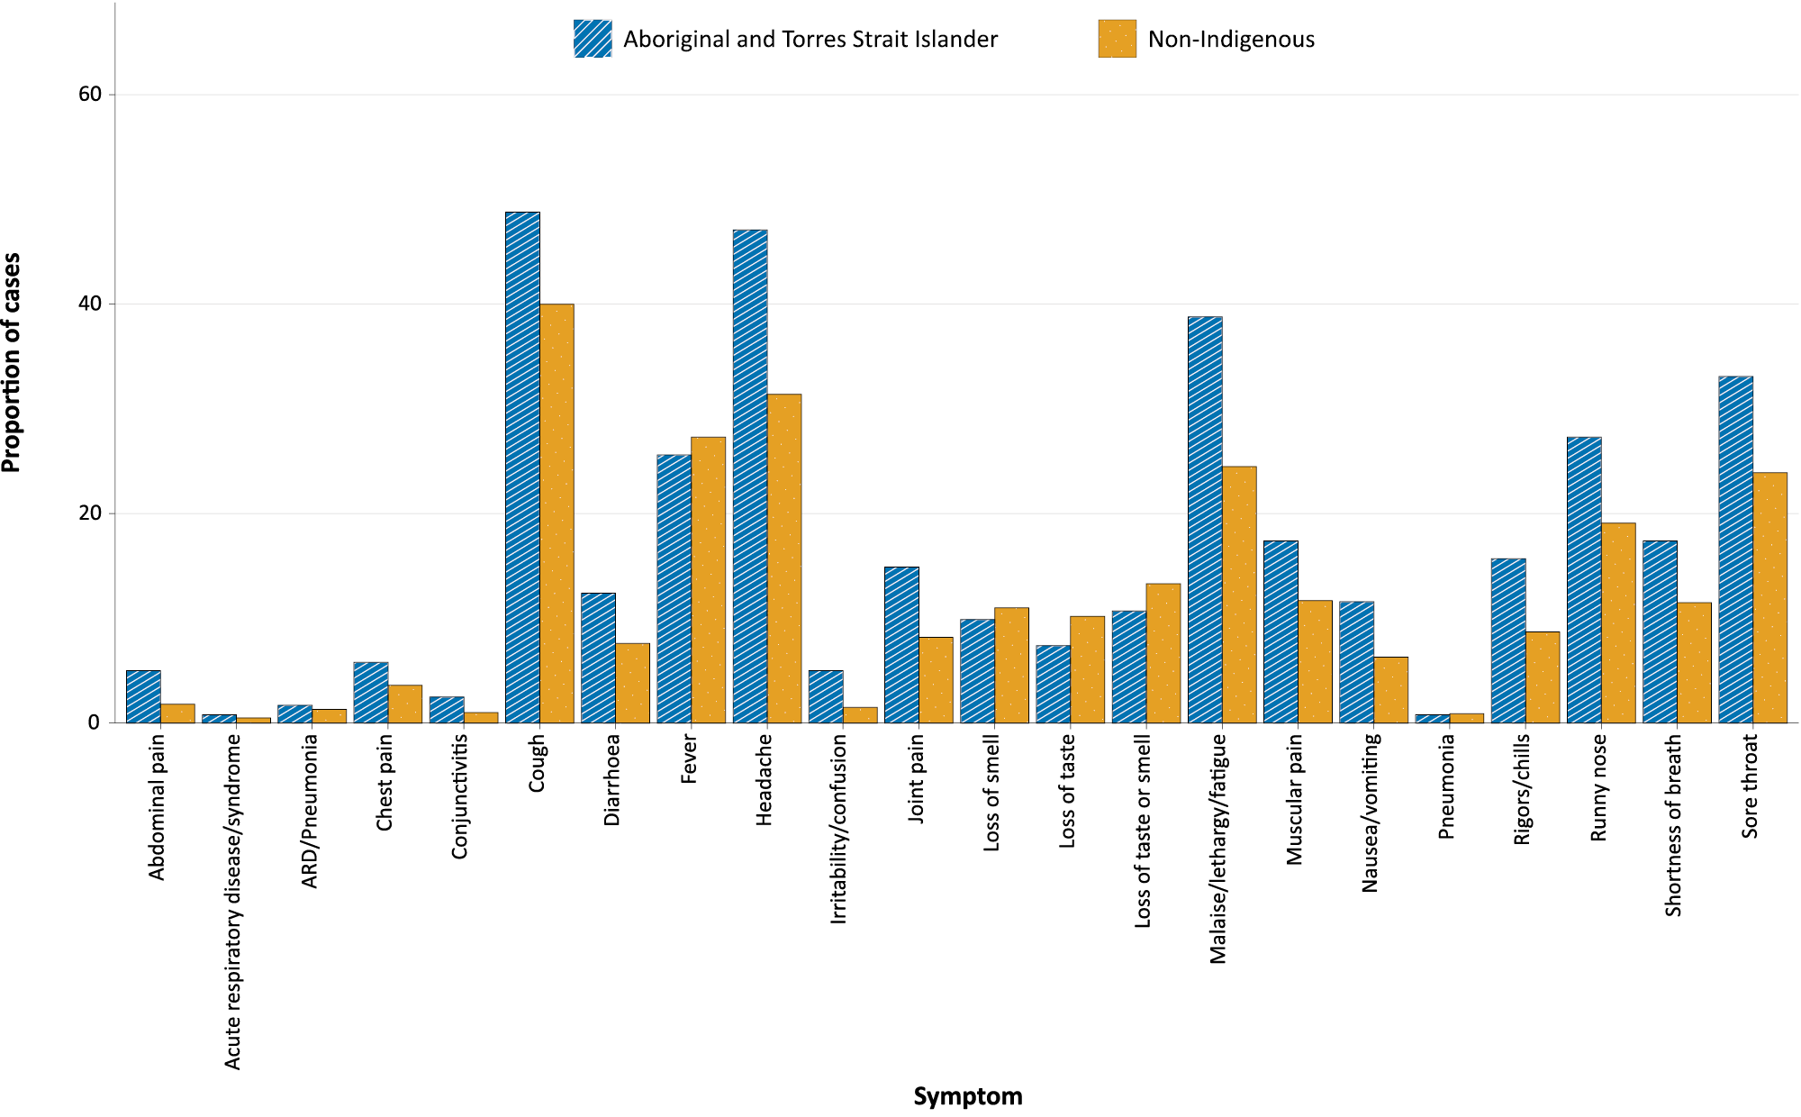

NNDSS data completeness

(Source: NNDSS)
Completeness of the ‘Indigenous Status’ field in NNDSS data has been close to 100% in all jurisdictions. Data completeness remains acceptable at over 85% for all jurisdictions (Table 5). Acceptability is based on the goal set by the Communicable Diseases Network Australia (CDNA) of >80%. Completeness of the ‘Indigenous Status’ field is defined as a person’s Indigenous status being recorded (whether Aboriginal, Torres Strait Islander, Aboriginal and Torres Strait Islander, or Non-Indigenous). Incomplete data includes ‘Not stated’ responses and blank fields.
Table 5: NNDSS completeness of the ‘Indigenous Status’ field by jurisdiction up to week ending 28 February 2021
Jurisdiction | NNDSS Indigenous Status  field completeness
ACT | 98%
NSW | 95%
NT | 100%
Qld | 99%
SA | 99%
Tas. | 96%
Vic. | 92%
WA | 99%

Laboratory testing

(Source: State and territory reporting)
As at 26 February 2021, a total of 67,927 reported tests have been conducted among Aboriginal and Torres Strait Islander peoples in four jurisdictions (the other four jurisdictions do not routinely report tests conducted by Indigenous status to the Commonwealth). Between 30 January and 26 February 2021, 6,739 tests were conducted among Aboriginal and Torres Strait Islander peoples, representing a testing rate of 18.0 per 1,000 population. The reported testing rate is lower than the rate among non-Indigenous people (34.9 per 1,000 population, Table 6).

Table 6: COVID-19 tests by Aboriginal and Torres Strait Islander statusª and jurisdiction
Jurisdiction^{b} | 30 January – 26 February 2021 |  | Cumulative  27 June 2020 – 26 February 2021 |  | Completeness of identification  30 January – 26 February 2021
 | Aboriginal and Torres Strait Islander  Number of tests (Rate per 1,000 population^{c}) | Non-Indigenous  Number of tests (Rate per 1,000 population) | Aboriginal and Torres Strait Islander  Number of tests (Rate per 1,000 population^{c}) | Non-Indigenous  Number of tests (Rate per 1,000 population)
ACT | 217 (25.8) | 16,893 (40.0) | 1,920 (228.2) | 140,608 (332.6) | 88%
NSW | – | – | – |  | –
NT | 2,355 (30.0) | 20,088 (120.0) | 17,444 (221.9) | 92,712 (553.9) | 69%
Qld | 2,883 (12.0) | 87,410 (17.7) | 33,045 (137.1) | 1,049,134 (212.7) | 50%
SA | 1,284 (28.0) | 128,708 (74.7) | 11,452 (249.4) | 958,779 (556.3) | 44%
Tas. | – | – | – |  | –
Vic. | – | – | – |  | –
WA | – | – | – |  | –
Total | 6,739 (18.0) | 253,099 (34.9) | 63,861 (170.7) | 2,241,233 (309.3) | 51%
a For the purpose of this report, it is assumed that all tests undertaken by people who are not identified as Aboriginal and Torres Strait Islander are non-Indigenous. Reporting of non-Indigenous testing rates is only presented for jurisdictions that report Indigenous status of test patients.
b The Australian Capital Territory, the Northern Territory, Queensland and South Australia have consistently reported aggregate testing numbers by Indigenous status since the week ending 3 July 2020. New South Wales, Tasmania, Victoria and Western Australia do not report testing numbers by Indigenous status to the Commonwealth but may compile this using different mechanisms (including data linkage) at different time intervals at a jurisdictional level.
c Estimated Aboriginal and Torres Strait Islander population for June 2020 used to calculate rate.

This difference may indicate that further effort is required to ensure equitable access to testing. However, it is also important to note that completeness of this field is relatively low among some of the reporting jurisdictions, and that in some jurisdictions not all laboratories submit testing numbers. Both of these factors may influence the apparently lower testing rate among Aboriginal and Torres Strait Islander peoples and highlight the importance of ongoing attention towards improving Indigenous status identification in testing data.

Time until test result received

(Source: General Practice (GP) Respiratory Clinic consultation data)
The time from when the test was taken until receipt of the test result is important to allow rapid execution of public health responses. At a national level, this information is currently only available from Commonwealth GP-led Respiratory Clinics. While this may not be a representative sample, data from these clinics indicate that the time taken to receive the test result has decreased across both metropolitan and non-metropolitan areas. Currently, the time until the result is received is less than two days for Aboriginal and Torres Strait Islander peoples and non-Indigenous people in both metropolitan and non-metropolitan areas (Figure 6). In Aboriginal and Torres Strait Islander peoples, time until result is received has dropped across all remoteness areas since April 2020, with an ongoing reduction in time taken evident largely in remote areas since September 2020 (Figure 7). This may reflect improved access to cartridge-based nucleic acid amplification tests (NAAT) in remote Aboriginal and Torres Strait Islander communities.
Figure 6: Mean length of time until SARS-CoV-2 test result received by Aboriginal and Torres Strait Islander status of patient and remoteness of clinic, April 2020 to February 2021
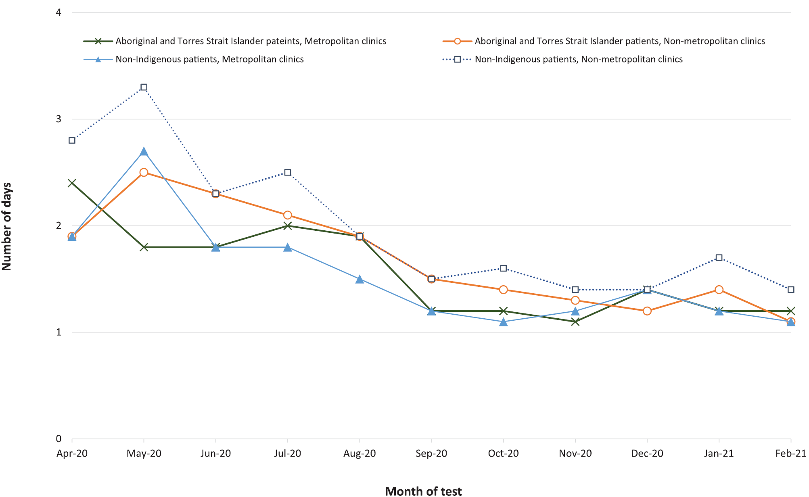
Figure 7: Mean length of time to SARS-CoV-2 test result in Aboriginal and Torres Strait Islander peoples by remoteness of clinic, April 2020 to February 2021
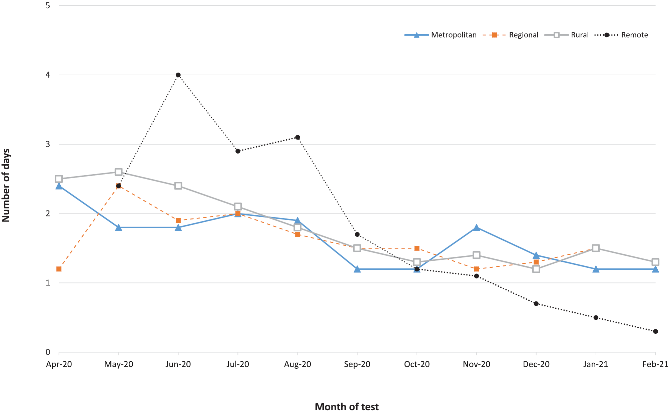

Point-of-care testing program

(Source: Remote Point of Care Testing Program for rural and remote Aboriginal and Torres Strait Islander communities)
As of 28 February 2021, there were 85 active point-of-care (POC) testing sites as part of the Aboriginal and Torres Strait Islander COVID-19 Point-of-Care Testing (POCT) program.⁴ Staff at one additional site have been trained but the site is yet to commence testing. This program delivers rapid (same day) testing results, using polymerase chain reaction (PCR) technology (GeneXpert) conducted at clinical sites by trained operators, to individuals living in areas where access to formal laboratory testing may lead to significant delays in accessing results. These sites had conducted 15,186 POC tests, with 52.4% among Aboriginal and Torres Strait Islander persons. Indigenous status was not stated in 23.2% of tests. Figure 8 shows SARS-CoV-2 patient tests by jurisdiction. Point-of-care tests are undertaken in all participating jurisdictions, with differences across jurisdictions due to varying number of sites and Aboriginal community population (note also that Queensland joined the program later than other states). Surges in testing have occurred in response to local outbreaks in the jurisdiction. The lower number of POC tests in May–June 2020 reflect a period when the program was rolling out.
Figure 8: COVID-19 remote POCT program patient tests by reporting period and jurisdiction
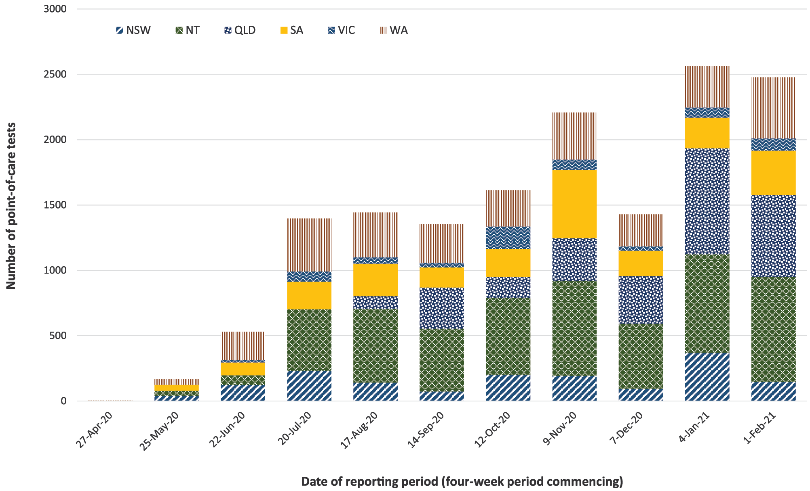

Clusters

(Source: COVID-Net)
Following the development of the Australian National Disease Surveillance Plan for COVID-19, COVID-Net has commenced the collection of Aboriginal and Torres Strait Islander cases in clusters on 21 September 2020. Since this time, no clusters that pose a higher risk to Aboriginal and Torres Strait Islander people have been recorded.

Community and primary care surveillance

(Sources: FluTracking, GP Respiratory Clinics)

FluTracking
Among FluTracking surveys⁵ received from 1 to 28 February 2021 where participants identified as Aboriginal and Torres Strait Islander people, 0.61% (16/2,616) experienced fever and cough. This compares to 0.65% (14/2,163) in the previous four-week period. Children aged 17 years and younger had the highest proportion with fever and cough (Figure 9). Figure 10 shows the percentage of Aboriginal and Torres Strait Islander people reporting runny nose and sore throat via FluTracking.
Figure 9: Percentage of Aboriginal and Torres Strait Islander FluTracking participants reporting fever and cough, by age group, for four-weekly reporting periods, 2 March 2020 – 28 February 2021
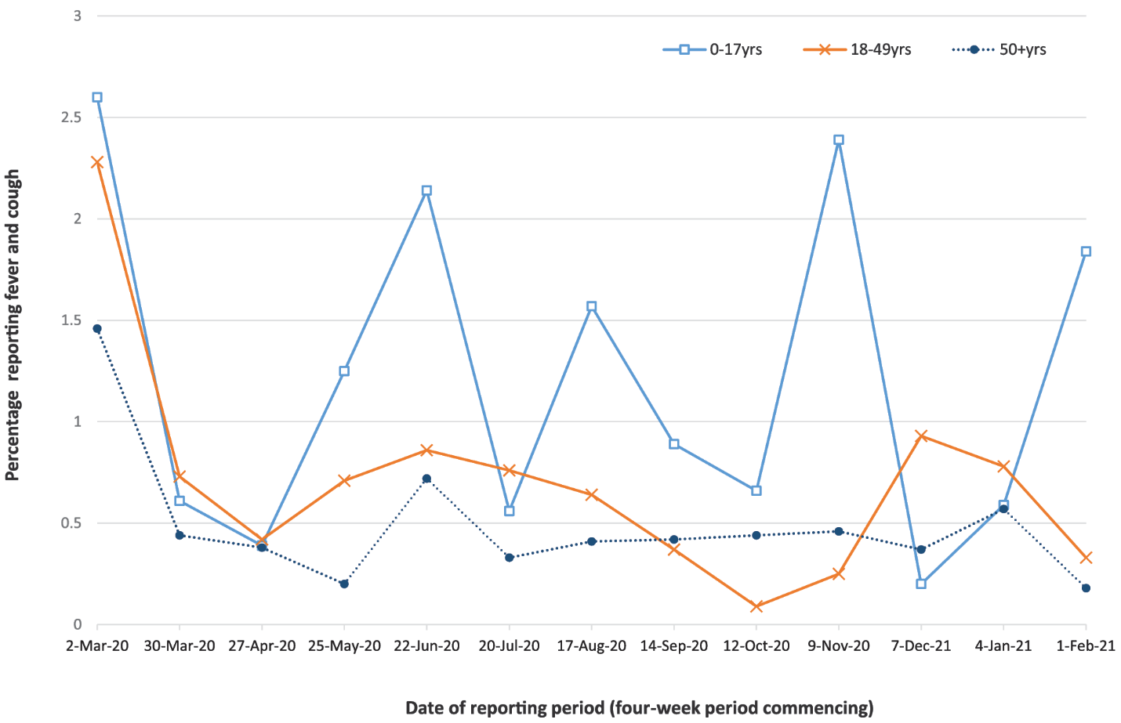

Figure 10: Percentage of Aboriginal and Torres Strait Islander FluTracking participants reporting sore throat and runny nose, by age group, for four-weekly reporting periods, 30 March 2020 – 28 February 2021
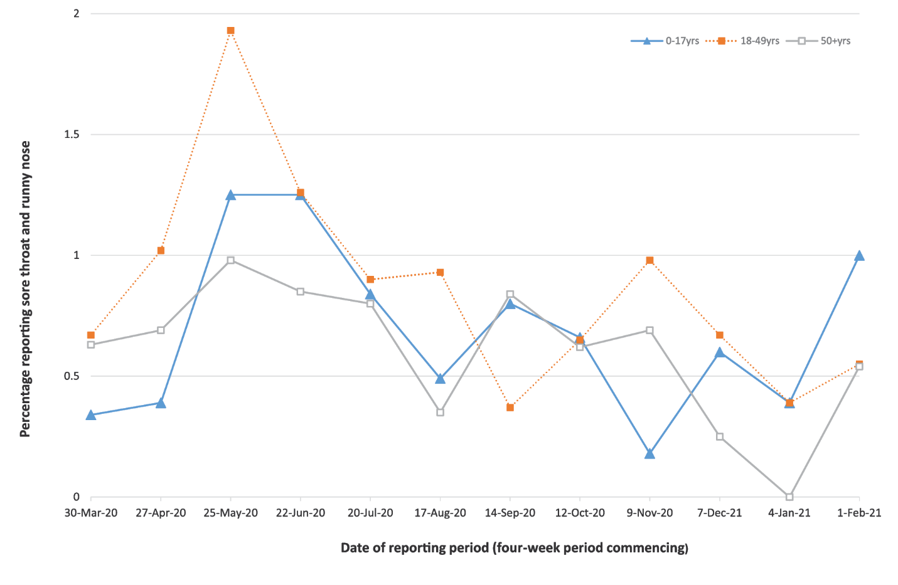
The percentage of Aboriginal and Torres Strait Islander individuals who experienced symptoms of Acute Respiratory Illness (ARI), and then presented for and received testing for COVID-19, is difficult to estimate at a community level. While FluTracking collects these data, the number of participants is very small, leading to high levels of variability.

GP-led Respiratory Clinics
While not representative of community testing rates, data are available on the proportion of those who present to GP-led Respiratory Clinics with ARI symptoms and are tested for SARS-CoV-2. To 28 February 2021, there were 1,043,123 assessments at the clinics, with 960,811 (92.1%) who consented to share information. Of these assessments, 35,837 (3.7%) were for Aboriginal and Torres Strait Islander peoples: 17,632 (49.2%) metropolitan; 5,001 (14.0%) regional; 11,823 (33.0%) rural; and 1,381 (3.9%) remote areas.
Amongst those individuals who consented to share information, 1,028,078 had symptoms recorded that met the case definition for ARI (749,629 non-Indigenous; 33,877 Aboriginal and Torres Strait Islander peoples; and 93,684 not stated).

Other elements of the response

Early aeromedical evacuations

(Source: Aeromedical retrievals data)
A case of COVID-19 in a remote Aboriginal and Torres Strait Islander community has the potential to rapidly cause an outbreak which may have high levels of mortality and morbidity. For this reason, consideration of early evacuation of suspect and confirmed cases, with or without their contacts, is a component of the response.⁶
As of 28 February 2021, the Royal Flying Doctor Service has conducted 15 early evacuations (that is retrievals of suspect or confirmed cases and/or their contacts, where the main indication for evacuation was to prevent onwards transmission rather than for clinical reasons)⁷ from remote Aboriginal and Torres Strait Islander communities. All of these occurred between April and June 2020, and all were for suspect cases and their contacts. None of the suspect cases were ultimately confirmed. These data are shown in Figure 11, which also shows that evacuations from these communities ceased when POCT sites were established. This may indicate that exclusion of COVID-19 in suspect cases via early testing reduces the need for early evacuations. However, any relationship between early evacuations and POCT sites must be interpreted cautiously, as the completeness of this source has not been formally assessed. This caution must also be applied to interpreting early evacuations data more generally. Evacuations will also be influenced by community risk perception, disease activity in the broader Australian community, restrictions on movement, and community and jurisdictional recommendations on early evacuation.
Figure 11: Number of early aeromedical evacuations by month, with timing of relevant POCT sites
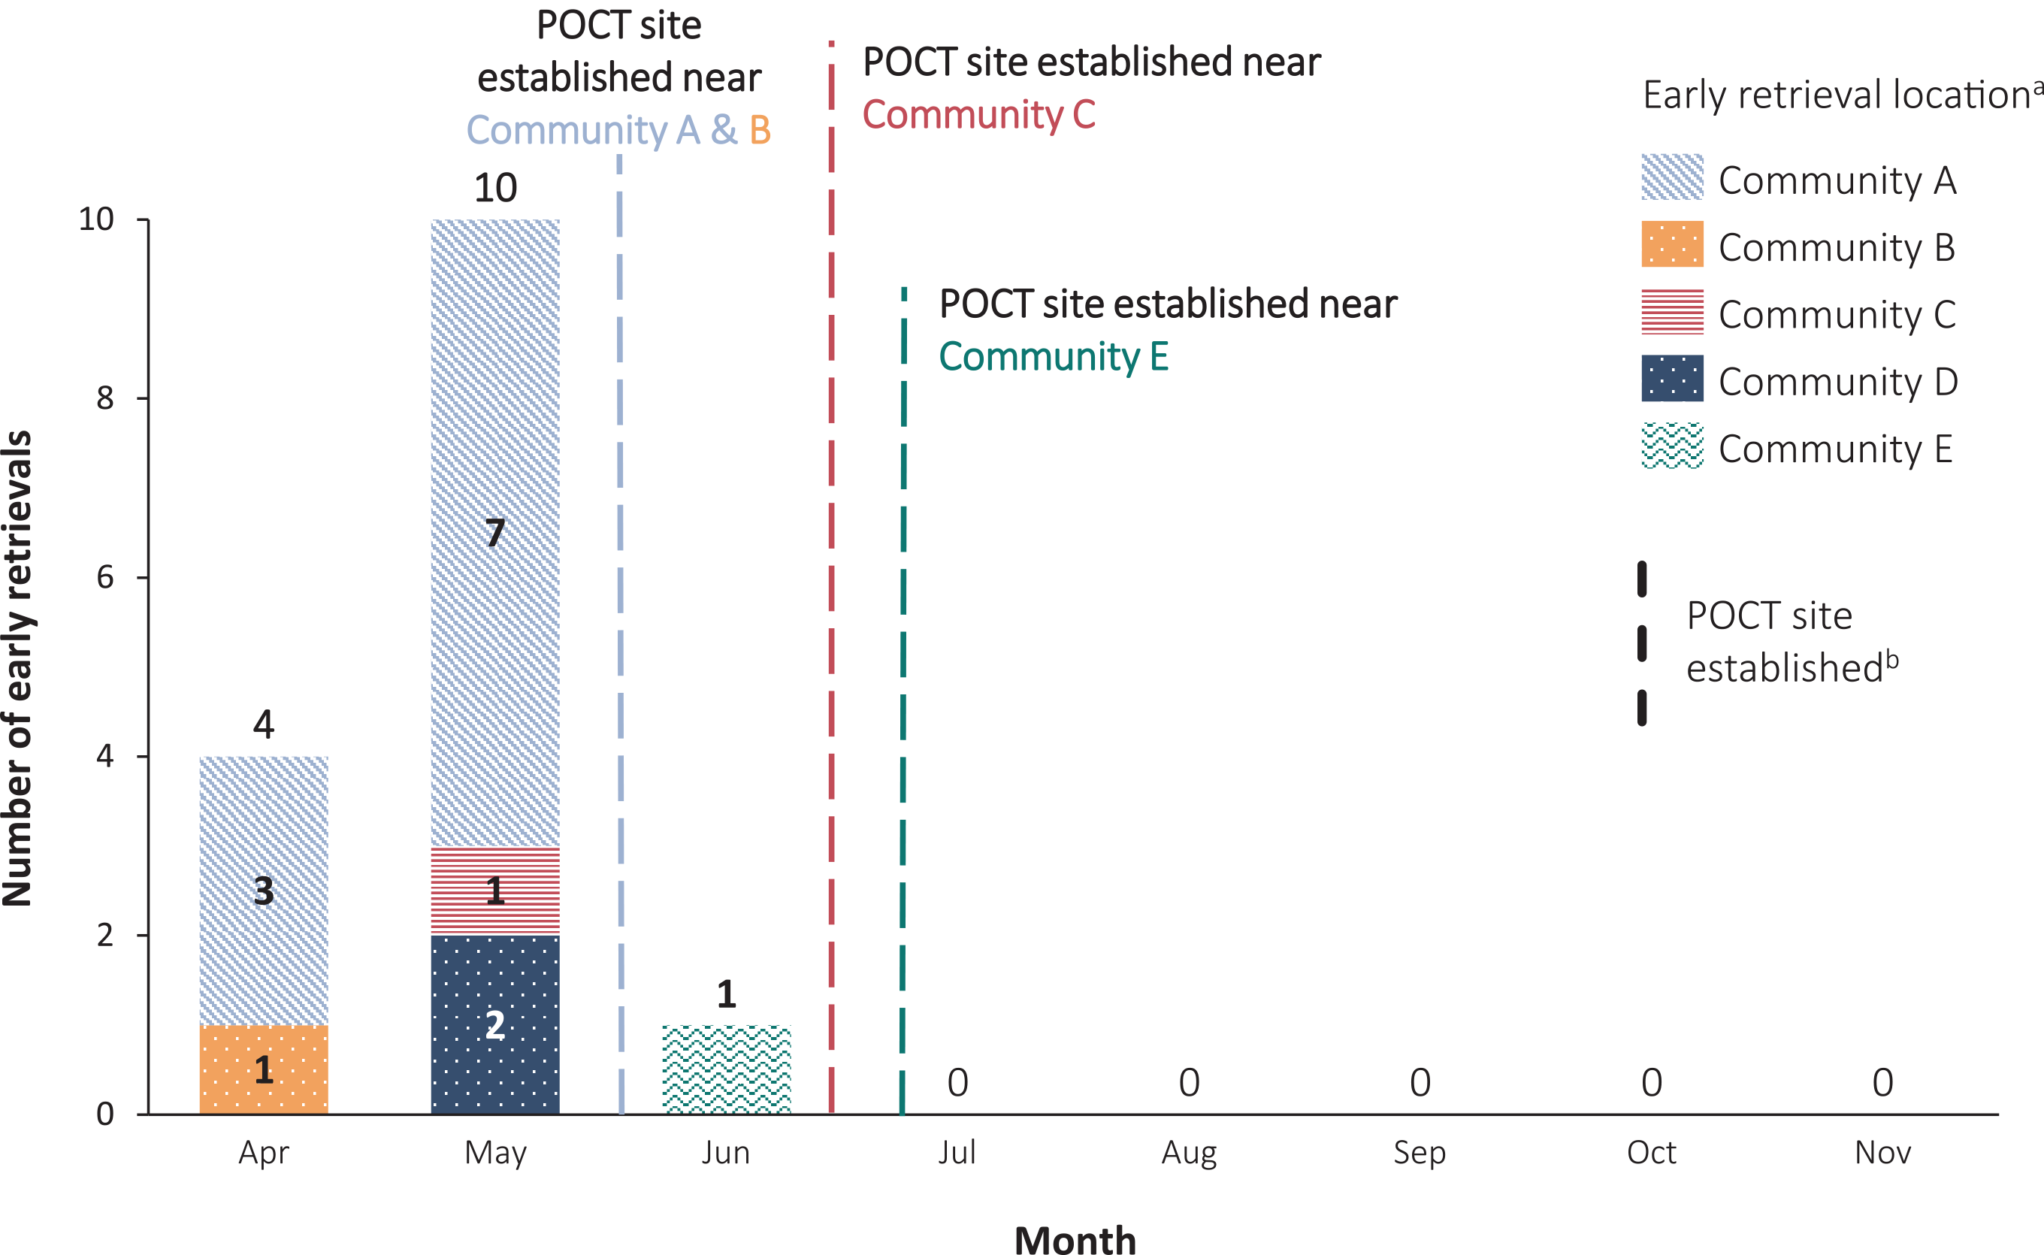
a Source: RFDS monthly invoicing data, up to Nov 2020.
b Source: POC2DOC POCT data.

Acknowledgements
We thank public health staff from incident emergency operations centres and public health units in state and territory health departments, and the Australian Government Department of Health, along with state and territory public health laboratories. We thank those who have provided data from surveillance systems, such as Commonwealth GP-led respiratory clinics, Flutracking, FluCAN, Sprint-SARI, COVID-Net, the Kirby Institute, and Aeromedical retrievals services.

Author details

Corresponding author
National Aboriginal and Torres Strait Islander Advisory Group on COVID-19, Australian Government Department of Health, GPO Box 9484, MDP 125, Canberra, ACT 2601.
Email: indigenous.ops@health.gov.au

References
- Australian Government Department of Health. Australian National Disease Surveillance Plan for COVID-19. [Internet.] Canberra: Australian Government Department of Health; 29 May 2020. Available from: https://www.health.gov.au/resources/publications/australian-national-disease-surveillance-plan-for-covid-19.
- Monash Health. FluCAN (Influenza surveillance): FluCAN (The Influenza Complications Alert Network) [Internet.] Melbourne: Monash Health; 2020. Available from: https://monashhealth.org/services/monash-infectious-diseases/research/influenza-research/flucan-influenza-surveillance-2/.
- Australian and New Zealand Intensive Care Society (ANZICS). SPRINT-SARI: Short period incidence study of severe acute respiratory infection. [Internet.] Camberwell: ANZICS; 2020. Available from: https://www.anzics.com.au/current-active-endorsed-research/sprint-sari/.
- COVID-19 POC Testing. COVID-19POCT: Aboriginal and Torres Strait Islander COVID-19 Point-of-Care Testing Program. [Website.] Canberra: Australian Government Department of Health, COVID-19 POC Testing; 2020. Available from: https://www.covid19poct.com.au/.
- Dalton C, Durrheim D, Fejsa J, Francis L, Carlson S, d’Espaignet ET et al. Flutracking: a weekly Australian community online survey of influenza-like illness in 2006, 2007 and 2008. Commun Dis Intell Q Rep. 2009;33(3):316–22.
- Australian Government Department of Health. CDNA National Guidance for remote Aboriginal and Torres Strait Islander communities for COVID-19. [Internet.] Canberra: Australian Government Department of Health; 11 January 2021. Available from: https://www.health.gov.au/resources/publications/cdna-national-guidance-for-remote-aboriginal-and-torres-strait-islander-communities-for-covid-19.
- Australian Government Department of Health. Coronavirus (COVID-19) early aero-medical evacuation of COVID-19 cases and contacts from remote communities. [Internet.] Canberra: Australian Government Department of Health; 20 August 2020. Available from: https://www.health.gov.au/resources/publications/coronavirus-covid-19-early-aero-medical-evacuation-of-covid-19-cases-and-contacts-from-remote-communities.
- Australian Government Federal Register of Legislation. National Health Security Act 2007. No. 174, 2007. Compilation No. 15. [Legislation.] Canberra: Australian Government, Federal Register of Legislation; 19 July 2016. Available from: https://www.legislation.gov.au/Details/C2016C00847.
- Australian Government Department of Health. Coronavirus Disease 2019 (COVID-19): CDNA national guidelines for public health units. Canberra: Australian Government Department of Health; 11 January 2021. Available from: https://www1.health.gov.au/internet/main/publishing.nsf/Content/7A8654A8CB144F5FCA2584F8001F91E2/$File/COVID-19-SoNG-v4.1.pdf.

Appendix A: Data sources
Information on data sources used in this report is below. For further detail including key limitations and representativeness, please refer to Appendix 7: Australian National Disease Surveillance Plan for COVID-19 principal data sources in the Australian National Disease Surveillance Plan for COVID-19.¹

Cases of COVID-19 from National Notifiable Diseases Surveillance System and other notifications to health departments
The majority of data presented in this report were derived from the National Notifiable Diseases Surveillance System (NNDSS). COVID-19 is a notifiable disease under public health legislation in all states and territories and is listed on the National Notifiable Diseases List under the National Health Security Act 2007.⁸ Accordingly, all jurisdictions report confirmed and probable cases of COVID-19 through the NNDSS. The national case definition for surveillance is available in the COVID-19 Series of National Guidelines.⁹ Due to the dynamic nature of the NNDSS, numbers presented in this report may be subject to revision and may vary from numbers previously reported and from case notifications released by states and territories. Case numbers for the most recent dates of illness onset may be subject to revision, due to reporting delays. Data for the current report were extracted from the NNDSS on 24 March 2021 for notifications with date of diagnosis up to 28 February 2021. Data for COVID-19 deaths were extracted from daily notifications from state and territory health departments to the National Incident Room (NIR), received up to 24 March 2021.

COVID-19 severity data from hospitalisations
To report on COVID-19 disease severity, we draw on hospitalisations (as recorded in NNDSS) and intensive care unit (ICU) admissions data provided from two sentinel surveillance systems:
FluCAN - FluCAN is a real-time hospital sentinel surveillance system for acute respiratory disease requiring hospitalisation.² Established to monitor for seasonal influenza, FluCAN has been modified to include surveillance for COVID-19. Participating sites collect detailed clinical and laboratory information from all hospitalised patients with a confirmed diagnosis of COVID-19. Indigenous status reported by FluCAN is based on hospital administrative data generally collected at admission.
SPRINT-SARI - SPRINT-SARI is a sentinel system that collects detailed data on the characteristics and outcomes of, and interventions for, patients admitted to ICUs or High Dependency Units with COVID-19 at participating sites across Australia.³
Both FluCAN and SPRINT-SARI collect data on the Aboriginal and Torres Strait Islander status of patients. However, as they are sentinel systems, their representativeness for Aboriginal and Torres Strait Islander status has not been formally assessed.

Laboratory testing data
COVID testing data from jurisdictions - Aggregated testing data are reported weekly to the NIR by jurisdictions. Testing data by demographic breakdown, including Indigenous status, are also reported on a weekly basis by four jurisdictions.
Point of Care Testing - The (COVID-19) Remote Point of Care Testing Program, funded by the Australian Government and managed by the Kirby Institute, is a program that delivers rapid testing (with test results in 45 minutes).⁴ The program is funded to provide POC testing at 86 sites around Australia where health workers are able to use the Xpert SARS-CoV-2 test, to rapidly test those presenting with symptoms clinically compatible with potential COVID-19 infection. These sites act as hubs (operate the POC machines), but also conduct POC testing on specimens collected and transferred from an additional 62 spoke clinics, providing access to rapid test results at 140 clinics. Most clinics are in remote locations and are at least two hours’ drive from a laboratory, with 50% of sites at greater than ten hours’ drive or a flight (if an island).

Surveillance systems for acute respiratory illness (ARI)
We report data from surveillance systems that monitor trends in the number of people reporting symptoms of mild respiratory illnesses in the community and in primary care settings. These systems gather information from across Australia and include the online FluTracking syndromic surveillance system and the Commonwealth General Practice (GP)-led Respiratory Clinics sentinel surveillance system.
FluTracking - FluTracking is an online syndromic surveillance system that monitors influenza-like illness (ILI) in the community.⁵ During the influenza season, participants receive a weekly email survey which collects data on the rate of ILI-related symptoms and healthcare seeking behaviour in communities. The survey usually commences at the beginning of May each year but commenced at the end of February in 2020 to support the COVID-19 response. Approximately 70,000 to 85,000 people participate in FluTracking across Australia each week, of whom approximately 1,000 are Aboriginal and Torres Strait Islander peoples.
GP-led Respiratory Clinics - In response to COVID-19, the Australian Government rapidly established GP-led Respiratory Clinics throughout Australia for clinical assessment of people with mild to moderate respiratory symptoms and/or fever. Of the 150 clinics stood up as part of this program, 23 were set up by Aboriginal Controlled Community Health Services (ACCHS). Up to 25 October 2020, there had been approximately 650,000 assessments conducted at the GP-led Respiratory Clinics, with Aboriginal and Torres Strait Islander peoples comprising around 3.9% of these.
COVID-Net
We report on data from COVID-Net, a nationally coordinated network established to facilitate local data collection about time-critical surveillance data, focusing on cluster and outbreak investigations, and other data as required. Aggregated outbreak summary data are reported weekly by COVID-Net epidemiologists. Clusters defined as higher risk to Aboriginal and Torres Strait Islander peoples are those involving people identifying as Aboriginal and Torres Strait Islander or those that occur in settings where there is a risk of transmission to Aboriginal and Torres Strait Islander peoples.

Other elements of the response
We report further information on some contextual indicators to the COVID-19 response, specific to Aboriginal and Torres Strait Islander peoples. In future reports this will include collecting and sharing strengths-based, qualitative information about planning and response as part of applying a cultural lens to understanding the impact of the COVID-19 response for Aboriginal and Torres Strait Islander peoples.

Aeromedical retrievals data
Aeromedical retrieval data are reported monthly via invoice records for Commonwealth-funded aeromedical services in rural and remote Australia. We report on early evacuations; these are defined as evacuations of suspect and confirmed COVID-19 cases or contacts where the rationale for evacuation is for public health rather than clinical reasons.⁷
Communicable Diseases Intelligence
ISSN: 2209-6051 Online

Communicable Diseases Intelligence (CDI) is a peer-reviewed scientific journal published by the Office of Health Protection and Response, Department of Health. The journal aims to disseminate information on the epidemiology, surveillance, prevention and control of communicable diseases of relevance to Australia.

Editor: Jennie Hood
Deputy Editor: Simon Petrie
Design and Production: Kasra Yousefi
Editorial Advisory Board: David Durrheim, Mark Ferson, John Kaldor, Martyn Kirk and Linda Selvey

Website: http://www.health.gov.au/cdi

Contacts
CDI is produced by Environmental Health and Health Protection Policy Branch, Office of Health Protection and Response, Australian Government Department of Health, GPO Box 9848, (MDP 6) CANBERRA ACT 2601

Email: cdi.editor@health.gov.au

Submit an Article
You are invited to submit your next communicable disease related article to the Communicable Diseases Intelligence (CDI) for consideration. More information regarding CDI can be found at: http://health.gov.au/cdi.
Further enquiries should be directed to: cdi.editor@health.gov.au.

This journal is indexed by Index Medicus and Medline.

Creative Commons Licence - Attribution-NonCommercial-NoDerivatives CC BY-NC-ND
© 2021 Commonwealth of Australia as represented by the Department of Health
This publication is licensed under a Creative Commons Attribution-NonCommercial-NoDerivatives 4.0 International Licence from https://creativecommons.org/licenses/by-nc-nd/4.0/legalcode (Licence). You must read and understand the Licence before using any material from this publication.

Restrictions
The Licence does not cover, and there is no permission given for, use of any of the following material found in this publication (if any):
- the Commonwealth Coat of Arms (by way of information, the terms under which the Coat of Arms may be used can be found at www.itsanhonour.gov.au);
- any logos (including the Department of Health’s logo) and trademarks;
- any photographs and images;
- any signatures; and
- any material belonging to third parties.

Disclaimer
Opinions expressed in Communicable Diseases Intelligence are those of the authors and not necessarily those of the Australian Government Department of Health or the Communicable Diseases Network Australia. Data may be subject to revision.

Enquiries
Enquiries regarding any other use of this publication should be addressed to the Communication Branch, Department of Health, GPO Box 9848, Canberra ACT 2601, or via e-mail to: copyright@health.gov.au

Communicable Diseases Network Australia
Communicable Diseases Intelligence contributes to the work of the Communicable Diseases Network Australia.
http://www.health.gov.au/cdna

Further explanation is provided in the ‘Governance and Implementation’ section in the Australian National Disease Surveillance Plan for COVID-19.

