COVID-19 Australia: Epidemiology Report 28
Fortnightly reporting period ending 25 October 2020
COVID-19 National Incident Room Surveillance Team

Summary
Nationally, there was a continuing downward trend in notifications of COVID-19. The daily average number of cases for this reporting period was 13 compared to an average of 18 cases per day in the previous fortnight. There were 176 cases of COVID-19 and 7 deaths this fortnight, bringing the cumulative case count to 27,582 and 905 deaths. New South Wales reported the highest proportion of cases this fortnight (42%; 74/176), the majority of which were overseas acquired (52). Locally-acquired cases accounted for 31% (54/176) of all cases reported this fortnight. While the majority of these were reported from Victoria (33/54), there continues to be a decrease in new cases in this state resulting from public health interventions. Testing rates increased during the reporting period and remain high overall at 10.3 tests per week per 1,000 persons. There was variability in the testing rate by jurisdiction, with testing rates depending on the epidemic context. The overall positivity rate for the reporting period was 0.05%, with Western Australia reporting a positivity rate of 0.21% for this reporting period. In all other jurisdictions the positivity rate was ≤ 0.06%.
Keywords: SARS-CoV-2; novel coronavirus; 2019-nCoV; coronavirus disease 2019; COVID-19; acute respiratory disease; epidemiology; Australia

Introduction
Coronavirus disease 19 (COVID-19), caused by the novel severe acute respiratory syndrome coronavirus 2 (SARS-CoV-2), was first identified in humans in Wuhan, China, in December 2019. The disease subsequently spread rapidly, leading to a global pandemic.¹ The predominant modes of transmission for COVID-19 are through direct or close contact with an infected person via respiratory droplets, or indirectly via contact with contaminated fomites.² The median incubation period of COVID-19 is 5–6 days, ranging from 1 to 14 days.^{3,4} The infectious period remains uncertain; however, it has recently been estimated to be from 48 hours before symptoms develop until two weeks from symptom onset.^{3,5} The predominant symptoms reported in COVID-19 cases are cough, sore throat, fatigue, runny nose and fever.⁶ The majority of cases recover from the disease without clinical intervention; however, approximately 20% of global cases result in more severe outcomes, such as shortness of breath and pneumonia, necessitating hospitalisation and the requirement of additional oxygen or ventilation.^{7,8} Severe or fatal outcomes are generally more common among elderly cases or those with comorbid conditions.⁸ A visual depiction of the severity spectrum of COVID-19, and of the data sources that we use in this report to measure aspects of severity, is provided in Figure 1.

Figure 1: Severity spectrum of COVID-19 cases and data sources used to measure severity in Australia
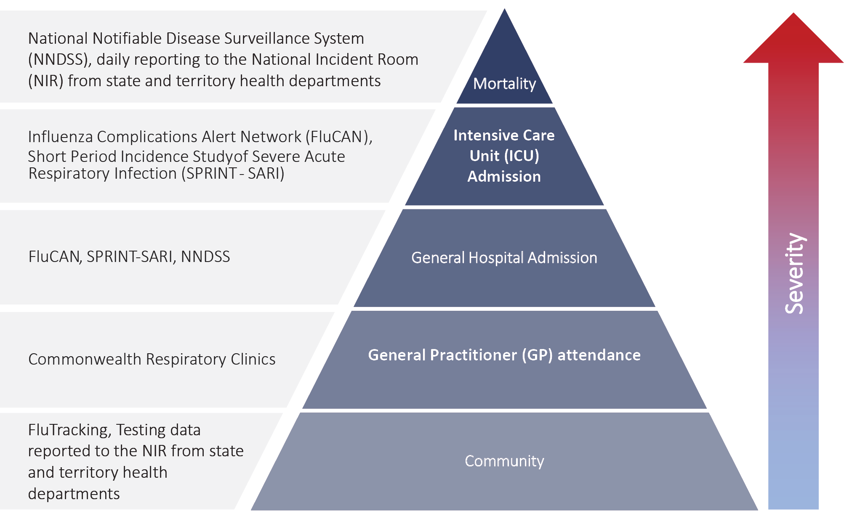
The epidemiology of COVID-19 in Australia has continued to evolve since cases were first detected in the country in late January 2020. This report provides an overview of the Australian COVID-19 epidemic, and compiles data from a variety of sources to describe cases and clusters, testing patterns, disease severity, public health response measures and the international situation. The report addresses indicators listed in the Australian National Disease Surveillance Plan for COVID-19,⁴ which describes a national approach for disease surveillance for COVID-19 and its causative agent, SARS-CoV-2. The sources of surveillance data used in this report relate to different parts of the severity spectrum of COVID-19 (Figure 1).

Data sources

Notifications to health departments
The majority of data presented in this report were derived from the National Notifiable Diseases Surveillance System (NNDSS). COVID-19 is a notifiable disease under public health legislation in all states and territories and is listed on the National Notifiable Diseases List under the National Health Security Act (2007). Accordingly, all jurisdictions report confirmed and probable cases of COVID-19 through the NNDSS. The national case definition for surveillance is available in the COVID-19 Series of National Guidelines.⁹ Due to the dynamic nature of the NNDSS, numbers presented in this report may be subject to revision and may vary from numbers previously reported and from case notifications released by states and territories. Case numbers for the most recent dates of illness onset may be subject to revision, due to reporting delays. Data for the current report were extracted from the NNDSS on 27 October 2020 for notifications received up to 25 October 2020. Data for COVID-19 deaths were extracted from daily notifications from state and territory health departments to the National Incident Room (NIR), received up to 25 October 2020.

Acute respiratory illness
We report data from surveillance systems that monitor trends in the number of people reporting symptoms of mild respiratory illnesses in the community and in primary care settings. These systems gathered information from across Australia and include the online FluTracking syndromic surveillance system,¹⁰ the Commonwealth General Practice (GP) Respiratory Clinics, and the Australian Sentinel Practice Research Network (ASPREN) and Victorian Sentinel Practice Influenza Network (VicSPIN) GP sentinel surveillance systems. These systems capture data on any respiratory illness experienced by participants, including pathogens such as SARS-CoV-2.

Hospitalisations
To report on COVID-19 disease severity, we draw on hospitalisations and intensive care unit (ICU) admissions data provided from two sentinel surveillance systems: Influenza Complications Alert Network (FluCAN)¹¹ and the Short Period Incidence Study of Severe Acute Respiratory Infection Study (SPRINT-SARI).¹² FluCAN is a real-time hospital sentinel surveillance system for acute respiratory disease requiring hospitalisation. Established to monitor for seasonal influenza, FluCAN has been modified to include surveillance for COVID-19. Participating sites collect detailed clinical and laboratory information from all hospitalised patients with a confirmed diagnosis of COVID-19. SPRINT-SARI is a sentinel system that collects detailed data on the characteristics and outcomes of and interventions for patients admitted to ICUs or High Dependency Units with COVID-19 at participating sites across Australia. Data on severity is presented in the report each month, rather than on a fortnightly basis.

Viral genomics
The Global Initiative on Sharing All Influenza Data (GISAID) is an international virus sequence database that provides open access to SARS-CoV-2 genomic data.¹³ Phylogenetic analyses are publicly available through the Nextstrain platform, which uses virus sequence data from GISAID to track the global evolution and spread of SARS-CoV-2.¹⁴

Testing data
Aggregated testing data are reported daily to the NIR by jurisdictions. Testing data by demographic breakdown are also reported on a weekly basis by jurisdictions.

Denominators
We use population data from the Australian Bureau of Statistics (ABS) Estimated Resident Population (as at 30 December 2019) to estimate rates of infection by jurisdiction, age group, sex and Indigenous status.

International
All data reported in the international section have been extracted from the World Health Organization (WHO) Dashboard on 25 October 2020 unless otherwise specified.¹⁵

Activity

Acute respiratory illness

(FluTracking and Commonwealth Respiratory Clinics)
Based on self-reported FluTracking data, fever and cough in the community continues to be low nationally, fourfold lower than the historical average from April to October (Figure 2). Runny nose and sore throat symptoms in the community remained stable across this reporting period.

Figure 2: Weekly trends in respiratory illness amongst FluTracking survey participants (age-standardised) compared to the average of the previous five years, Australia, 1 March to 25 October 2020ª
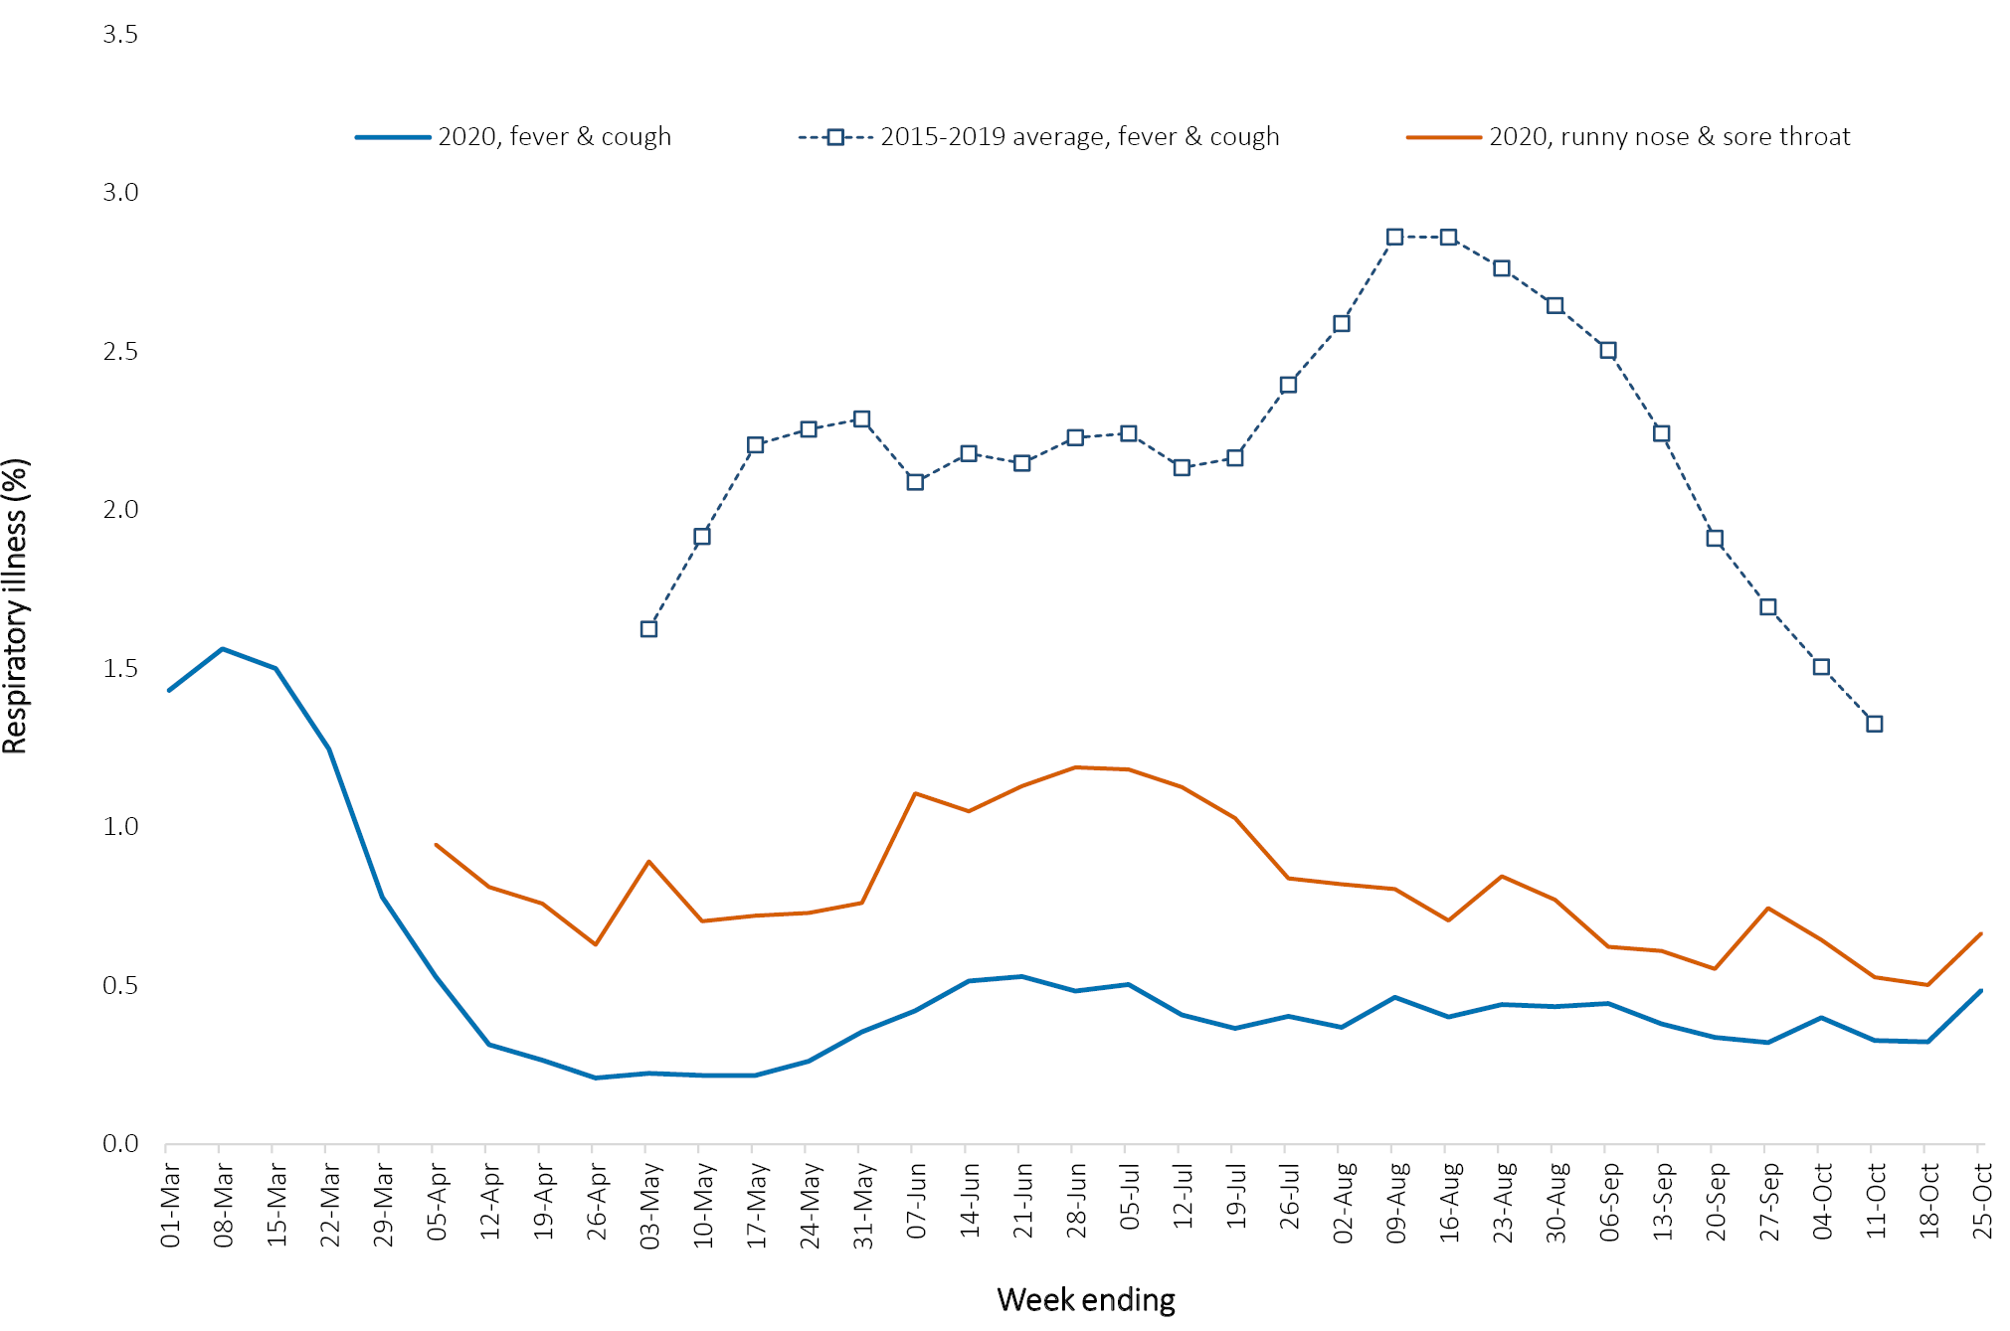
a In previous years, FluTracking was activated during the main Influenza season from May to October. A historical average beyond the week ending 11 October is therefore not available. In 2020, FluTracking commenced 10 weeks early to capture data for COVID-19. Data on runny nose and sore throat were only collected systematically after 29 March 2020, therefore a historical average for this symptom profile is unavailable.
In this reporting period, acute respiratory illness was highest in those aged 0–9 and 30–39 years old, based on both self-reported FluTracking data and presentations to Commonwealth Respiratory Clinics. Females reported respiratory illness more frequently than males. Rates of fever and cough by jurisdiction were generally similar to the rates reported in the previous fortnight, ranging from 1.8/1,000 FluTracking participants in Queensland to 5.9/1,000 participants in the Northern Territory.
FluTracking data indicate that 48% of those in the community with ‘fever and cough’ and 23% of those with ‘runny nose and sore throat’ were tested for SARS-CoV-2. Testing rates varied by jurisdiction, being lowest in Western Australia and Queensland and highest in Victoria and New South Wales. It is important to acknowledge that there may be legitimate reasons why people did not get tested, including barriers to accessing testing. Symptoms reported to Flutracking are not specific to COVID-19 and may also be due to chronic diseases.
During this reporting period, there were 32,574 assessments at Commonwealth Respiratory Clinics with > 95% tested for SARS-CoV-2. There were no positive SARS-CoV-2 test results in these Clinics for this reporting period.
In patients experiencing influenza-like illness in this reporting period and tested through the ASPREN and VicSPIN GP sentinel surveillance systems, the most frequent respiratory viruses detected were rhinoviruses.
The rate of self-reported fever and cough among Aboriginal and Torres Strait Islander peoples over this reporting period was similar to that observed in all other participants based on FluTracking data.
Rates of respiratory illness in health care worker populations were similar to those observed in the wider community, based on FluTracking data.
Based on all presentations to Commonwealth Respiratory Clinics to date, the principal symptoms reported in COVID-19 cases were cough, sore throat, tiredness, runny nose, and fever.

Transmission trends of confirmed COVID-19

(NNDSS and jurisdictional reporting to NIR)
As at 25 October 2020, there were 27,582 COVID-19 cases including 905 deaths reported nationally, with two distinct peaks in March and July (Figure 3). In this reporting period, there were 176 cases and 7 deaths reported. On average, 13 cases were notified each day over this reporting period, a decrease from the average of 18 cases reported per day over the previous reporting period. The largest number of cases diagnosed this fortnight was from New South Wales (42%; 74/176), followed by Western Australia (26%; 45/176) and Victoria (22%; 39/176).
Figure 3: COVID-19 notified cases by source of acquisition and diagnosis date, Australia, week ending 25 October 2020 (Source: NNDSS)
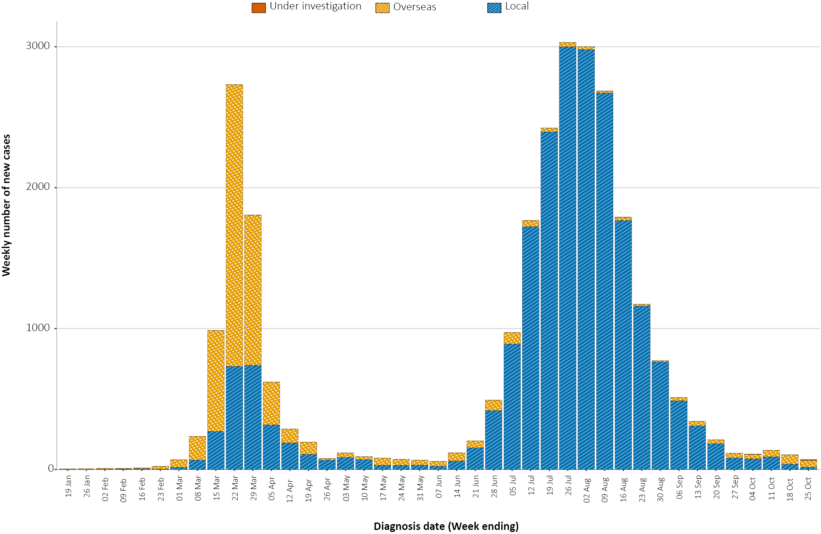
Small numbers of cases were reported in South Australia (11), Queensland (6), and the Australian Capital Territory (1). No new cases were reported in Tasmania and the Northern Territory.

Source of acquisition

(NNDSS)
In this reporting period, the majority of cases were reported as overseas acquired (64%; 113/176). Locally-acquired cases accounted for 31% (54/176) of cases, and the contact was not identified for 6% (3/54) of these cases, which is lower than the previous reporting period (11%; 18/166). In total, 5% (9/176) of cases reported this fortnight were under investigation at the time of reporting (Table 1).
Table 1: COVID-19 notifications by jurisdiction and source of acquisition, Australia, 12–25 October 2020
Source | NSW | Vic. | Qld | WA | SA | Tas. | NT | ACT | Australia
Overseas | 52 | 0 | 6 | 45 | 10 | 0 | 0 | 0 | 113
Local — source known | 21 | 30 | 0 | 0 | 0 | 0 | 0 | 0 | 51
Local — source unknown | 0 | 3 | 0 | 0 | 0 | 0 | 0 | 0 | 3
Under investigation | 1 | 6 | 0 | 0 | 1 | 0 | 0 | 1 | 9
Total | 74 | 39 | 6 | 45 | 11 | 0 | 0 | 1 | 176

In this reporting period, the largest number of overseas-acquired cases was reported in New South Wales (46%; 52/113), followed by Western Australia (40%; 45/113). The higher number of overseas-acquired cases reported in New South Wales reflects the number of returned travellers managed there. The majority of overseas-acquired cases in Western Australia were acquired at sea among cargo ship workers. All locally-acquired cases with unknown source (3) were from Victoria, where the highest proportion of locally-acquired cases with known source was also reported (59%; 30/51).
Nationally, there were 0.2 locally-acquired cases per 100,000 population in this reporting period, compared to 0.7 per 100,000 population in the previous reporting period (Table 2). The rate of locally-acquired cases in Victoria decreased to 0.6 per 100,000 population, from 2.0 per 100,000 population in the previous reporting period.
Table 2: Locally-acquired COVID-19 case numbers and rates per 100,000 population by jurisdiction and reporting period, Australia, 25 October 2020
Jurisdiction | Reporting period  12–25 October |  | Cumulative cases
 | Number of cases | Rate per 100,000 population | Number of cases | Rate per 100,000 population
NSW | 22 | 0.3 | 1,959 | 24.2
Vic. | 39 | 0.6 | 19,356 | 293.5
Qld | 0 | 0 | 301 | 5.9
WA | 0 | 0 | 100 | 3.8
SA | 1 | 0.1 | 152 | 8.7
Tas. | 0 | 0 | 152 | 28.4
NT | 0 | 0 | 6 | 2.4
ACT | 1 | 0.2 | 30 | 7
Australia | 63 | 0.2 | 22,056 | 87.0
Cumulatively, the infection rate to date for all locally-acquired cases was highest in Victoria with 293.5 infections per 100,000 population. The rate of infection in Tasmania was 28.4 infections per 100,000 population, largely as a result of an outbreak in North West Tasmanian hospitals in April 2020. Tasmania reported its most recent case in the fortnight ending 16 August 2020. That case was associated with interstate travel.

Demographic features

(NNDSS)
In this reporting period, the largest number of cases occurred in those aged 20–29 years (34 cases). For all notifications to date, the highest rate of infection was in those aged ≥ 90 years old with a rate of 386.8 per 100,000 population (Appendix A, Table A.1). Children aged 0–9 years old had the lowest rate of infection (43.8 cases per 100,000 population), despite comparable testing rates to other age groups.
Cumulatively, the male-to-female rate ratio was approximately 1:1 in most age groups, except in the 20–29 years age group and those aged ≥ 80 years old where rates were higher among females, and in the 70–79 years age group where rates were higher in males. (Figure 4). The largest difference in cumulative rates was in the ≥ 90 years age group, where the cumulative rate among males was 333.7 cases per 100,000 population and among females 413.3 cases per 100,000 population (Appendix A, Table A.1).
Figure 4: Cumulative COVID-19 cases, by age group and sex, Australia, 23 January 2020 to 25 October 2020
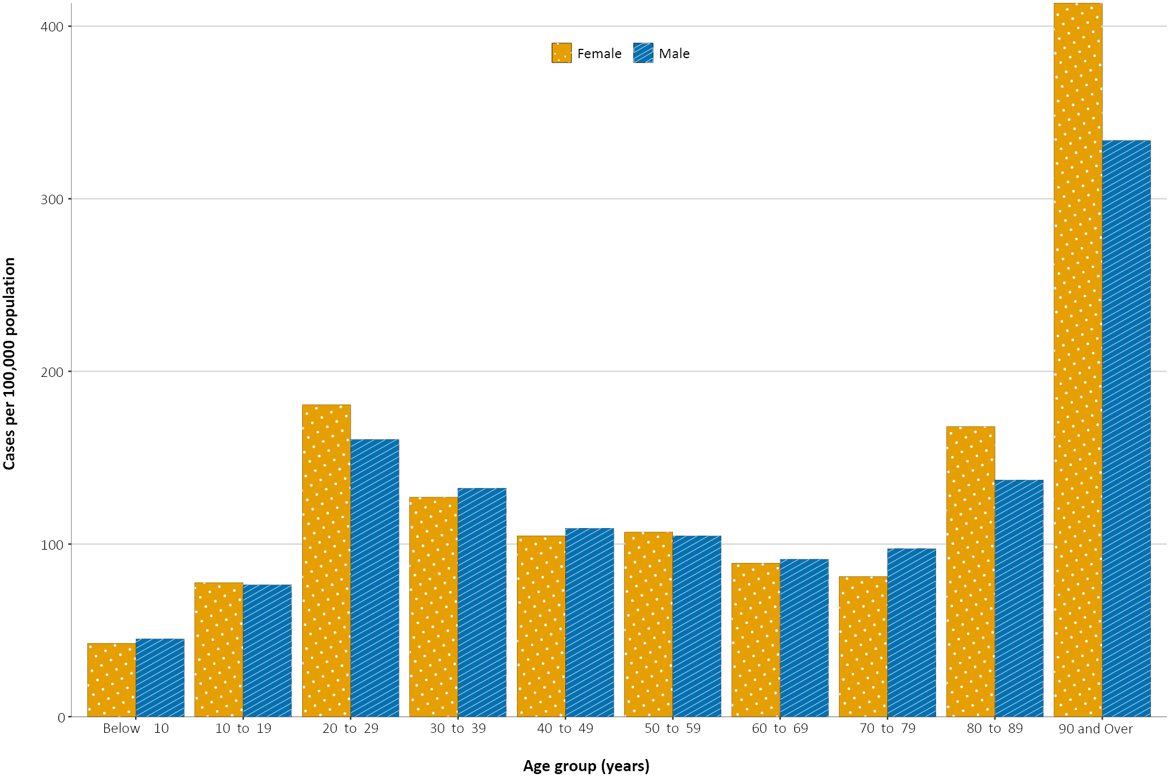
Since the beginning of the epidemic in Australia, the median age of all cases was 37 years old (interquartile range, IQR: 25–57) which has not changed since the beginning of August. Prior to 1 June 2020, COVID-19 cases were slightly older with a median age of 46 years old (IQR: 29–62), associated with a high proportion of cases having a recent travel history or acquisition on a cruise ship. In cases reported after 1 June 2020, the median age was 34 years old (IQR: 23–53) reflecting transmission in the community and across a range of settings, especially in Victoria. The median age of cases in this reporting fortnight was 35 years old (IQR: 25–49).

Aboriginal and Torres Strait Islander persons

(NNDSS)
There have been 147 cases of COVID-19 notified in Aboriginal and Torres Strait Islander persons since the beginning of the epidemic. This represents approximately 0.5% of all confirmed cases. There were no cases among Aboriginal and Torres Strait Islander persons in the past six weeks. Table 3 compares the remoteness of cases in Aboriginal and Torres Strait Islander persons with those in the Non-Indigenous population. No new overseas-acquired cases have been reported among Aboriginal and Torres Strait Islander persons since the end of August.
Table 3: COVID-19 notifications by Aboriginal and Torres Strait Islander status by jurisdiction, source of acquisition and remoteness classification, Australia, 25 October 2020
 | Locally-acquired |  |  |  | Interstate acquired | Overseas acquired | Unknownª | Total
 | Major Cities of Australia | Inner Regional Australia | Outer Regional Australia | Remote / Very Remote Australia
Aboriginal and  Torres Strait Islander^{b} | 89 | 15 | 6 | 1 | 4 | 31 | 1 | 147
Non-Indigenous | 20,392 | 908 | 224 | 22 | 152 | 5,495 | 215 | 27,435
a Includes 29 Non-Indigenous cases classified as overseas residents who were diagnosed in Australia; and 186 Non-Indigenous cases and one Aboriginal and Torres Strait Islander case with an unknown remoteness classification.
b Excludes 1 probable Aboriginal and Torres Strait Islander case.
The median age of COVID-19 cases in Aboriginal and Torres Strait Islander persons was 31 years old (IQR: 21–48), which was younger than for Non-Indigenous cases where the median age was 37 years old (IQR: 25–57).
The notification rate across all age groups was higher in Non-Indigenous persons than in Aboriginal and Torres Strait Islander persons (Figure 5). The age-standardised Aboriginal and Torres Strait Islander:Non-Indigenous notification rate ratio was 0.2, indicating that the Aboriginal and Torres Strait Islander population generally had a lower COVID-19 case rate than the Non-Indigenous population after accounting for differences in age structure. Amongst Aboriginal and Torres Strait Islander cases, the highest notification rate was in those aged 70–79 years (36.0 cases per 100,000 population), followed by the 60–69 years age group (34.4 cases per 100,000 population). Similar to Non-Indigenous cases, children aged 0–9 years had the lowest notification rate among Aboriginal and Torres Strait Islander cases (7.0 cases per 100,000 population).

Figure 5: National COVID-19 notification rate per 100,000 population by age group, Aboriginal and Torres Strait Islander persons and Non-Indigenous persons, Australia, 23 January 2020 to 25 October 2020
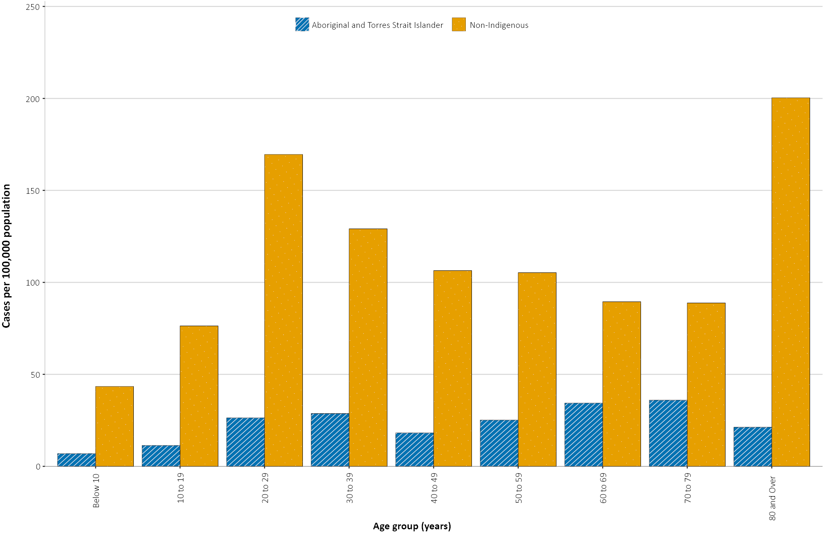

Severity

(NNDSS, FluCAN, SPRINT-SARI)
The current estimated hospitalisation rate based on NNDSS data for confirmed COVID-19 cases to date in Australia remains at 13%. While this estimate comes with caveats around data completeness and definitional uniformity across jurisdictions, an earlier hospital-notification data linkage study for New South Wales cases found a similar proportion (12.4% of cases notified to 19 April hospitalised).¹⁶
Since 16 March 2020, FluCAN has recorded 442 COVID-19 cases hospitalised in sentinel sites,¹¹ of which 89 (20%) were subsequently admitted to an intensive care unit (ICU). There have been only 20 hospital admissions for confirmed COVID-19 cases in participating sites since the last severity report (COVID-19 epidemiology report 26: data to 27 September).¹⁷
Since 17 February 2020, SPRINT-SARI has recorded 466 COVID-19 cases admitted to ICU in participating sites,¹² 55% of whom have been subject to mechanical ventilation for at least an hour on at least one day of their admission. There have been no ICU admissions at these sites since the last severity report (data to 27 September 2020).¹⁷

Length of hospital stay
Length of hospital stay for patients with confirmed COVID-19 increases with advancing age category: those ≥ 80 years old stay slightly longer in hospital than those aged 60–79 years (Table 4). Cumulative length-of-stay has changed little compared to the previous severity report (data to 27 September)¹⁷ as only a small number of patients have had their discharge status updated in the intervening four weeks (n=13, Table 5). Length of stay in ICU for survivors (n = 396) ranged from 0 to 106 days (median 6 days; IQR: 3–15); non-survivors stayed longer (median 9 days; IQR: 5–21).
Table 4: Hospital length-of-stay for confirmed COVID-19 cases discharged alive from sentinel sites by ICU/high dependency unit (HDU) admission status, Australia, as at 25 October 2020
 | Hospital length of stayª |  |  | ICU length of stay^{b}
Age group (years) | n | Median (IQR) | Mean (SD) | n | Median (IQR) | Mean (SD)
< 18 | 32 | 2.5 (1.0–6.5) | 4.9 (6.7) | 7 | 12.0 (4.0–25.0) | 17.3 (17.8)
18–39 | 64 | 4.0 (2.0–8.0) | 6.4 (6.7) | 51 | 4.0 (2.0-7.0) | 6.6 (10.0)
40–59 | 89 | 8.0 (4.0–13.0) | 11.2 (17.1) | 147 | 5.0 (3.0–12.0) | 9.2 (11.2)
60–79 | 79 | 10.0 (5.0–17.0) | 11.9 (11.3) | 182 | 8.0 (3.0–17.0) | 12.7 (13.2)
≥ 80 | 36 | 11.0 (7.5–15.5) | 11.9 (7.0) | 10 | 3.5 (3.0–8.0) | 6.5 (7.2)
a Source: FluCAN (n = 300).
b Source: SPRINT-SARI – includes 77 sentinel ICU/HDUs and only those with discharge outcome (n = 396).
Table 5: Hospital and ICU length-of-stay over time based on those discharged during the reporting periods specified, Australia, as at 25 October 2020ª
Length of Stay | Two previous reporting periods  31 August – 27 September |  |  | Current two reporting periods  28 September – 25 October |  |  | Cumulative data to date  27 February – 25 October
 | n | Median (IQR) | Mean (SD) | n | Median (IQR) | Mean (SD) | n | Median (IQR) | Mean (SD)
Hospital^{b} | 33 | 12.0  (7.0–17.0) | 12.2  (7.3) | <5 |  |  | 300 | 7.0  (3.0–13.0) | 9.7  (12.1)
ICU^{c} | 30 | 9.5  (6.0–24.0) | 16.0  (13.8) | <5 |  |  | 396 | 6.0  (3.0–14.0) | 10.5  (12.3)
a Data over two reporting periods has been used to reduce the impact of small numbers on metric volatility.
b Source: FluCAN.
c Source: SPRINT-SARI.
a Source: FluCAN (n = 442).
b Source: SPRINT-SARI (n = 461).
There were too few cases discharged from hospital and ICU at sentinel sites since the previous severity report to make meaningful comparisons in length-of-stay with those discharged during the previous two reporting periods (31 August-27 September, Table 5).

Characteristics of those with severe COVID-19 disease
The median age of cases who were hospitalised in sentinel sites (58 years; IQR: 39–74) and admitted to ICU (61 years; IQR: 50–70) was higher than for cases overall (37 years; IQR: 25–56). The ratio of males to females was similar in hospitalised cases (1.2:1) while substantially more males were admitted to ICU (ratio: 1.7:1); sex-ratios remain unchanged from the previous severity report. For ICU-admitted COVID-19 patients, the male:female ratio increased with advancing age (Figure 6), while in hospitalised patients, the pattern was reversed for those aged over 80 years. This likely reflects the fact that more COVID-19 infections occurred in general (i.e., with non-hospitalised cases included) in females than in males in this age category.
Of those hospitalised in sentinel sites (n = 422),¹¹ fewer than five (< 1%) identified as Aboriginal and/or Torres Strait Islander persons.
Figure 6: Age and sex distribution for all COVID-19 cases (to 25 October), admitted to hospital (16 March – 25 October 2020)ª or admitted to ICU (27 February – 25 October2020),^{b} Australia
a) Admitted to hospital
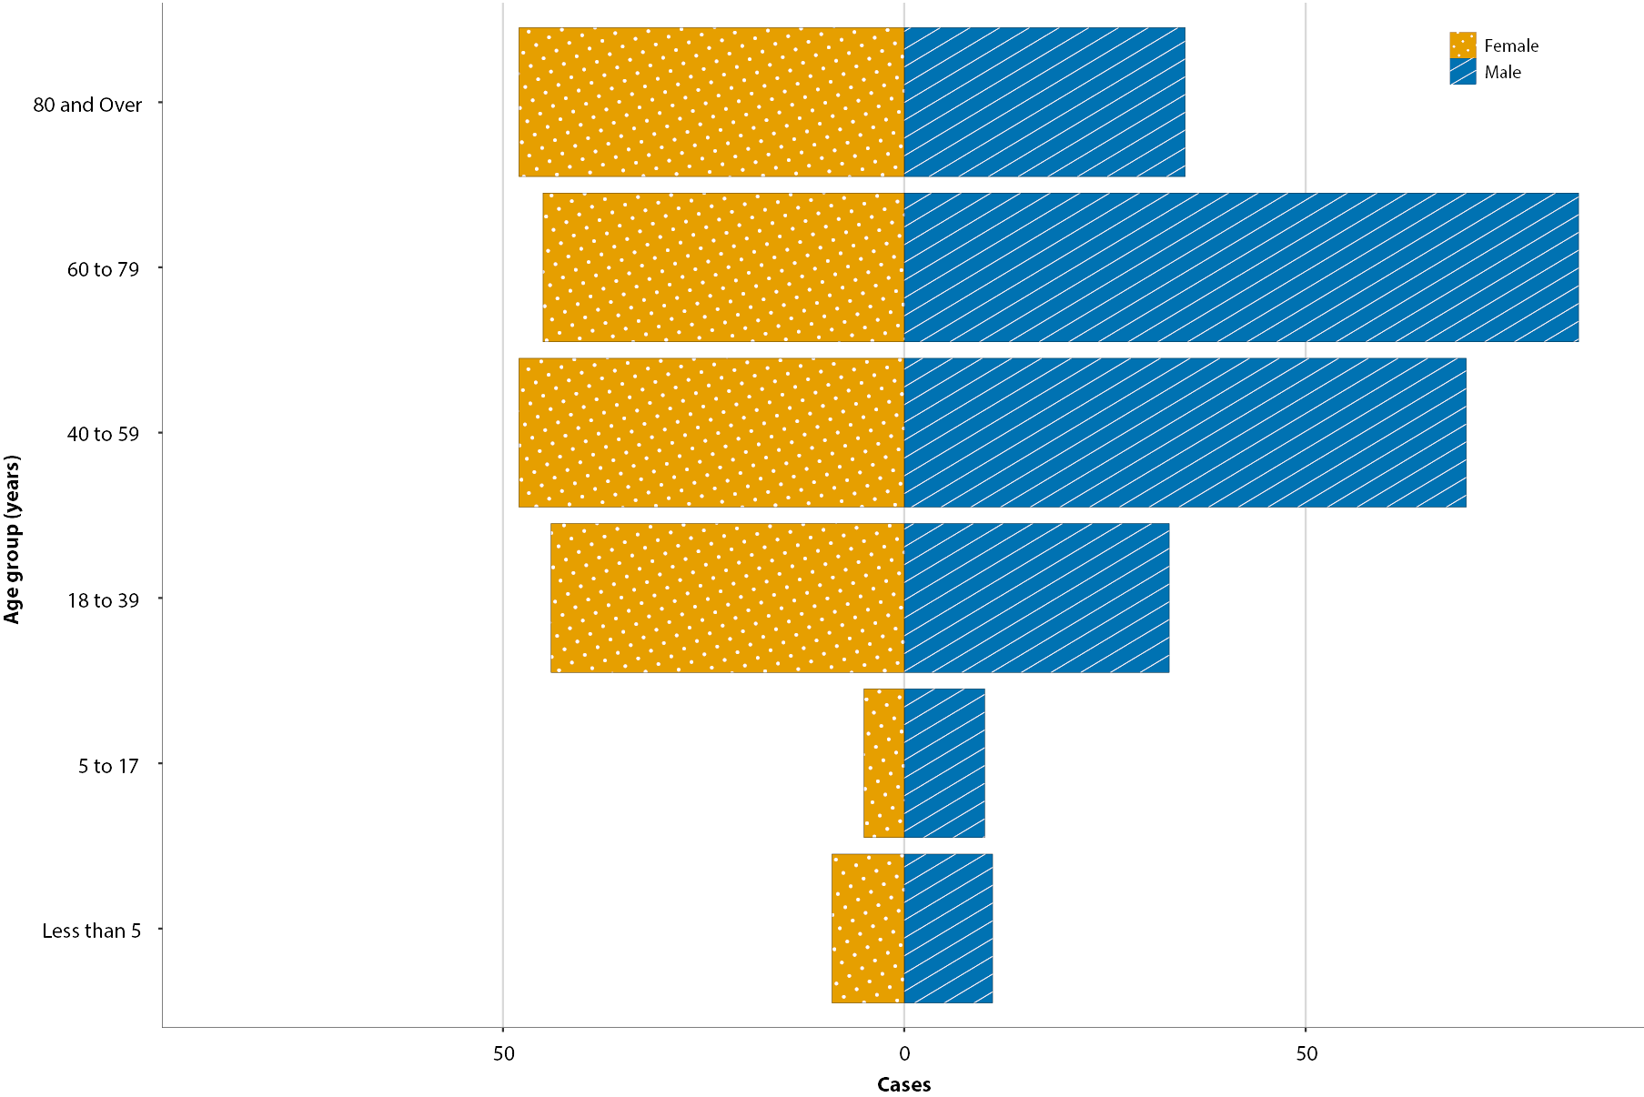
b) Admitted to ICU
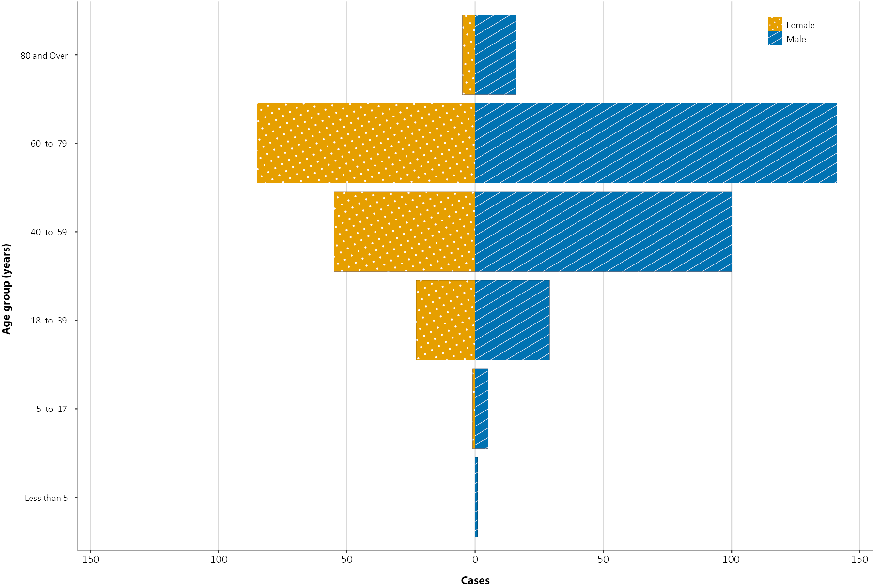
a Source: FluCAN.11 Excludes those with missing data (123–124 cases; 30%) or where comorbidity is unknown (2–22 cases; 0.5–5.4%)
b Source: SPRINT-SARI.12 Excludes those with missing data (38–48 cases; 8.3–10.5%) on comorbidities or where comorbidity is unknown (0–15 cases; 0–3.3%)
c Includes asthma.
d Includes chronic respiratory conditions, cardiac disease (excluding hypertension), immunosuppressive condition/therapy, diabetes, obesity, liver disease, renal disease and neurological disorder.

Underlying medical conditions and other risk factors
Comorbidity data were extracted from both sentinel hospital surveillance systems, FluCAN and SPRINT-SARI; the data reflects information on hospitalised COVID-19 cases which is not generalisable to all cases. Risk factor information was not always available: 123 cases (30%) over the age of 18 captured in FluCAN had no known comorbidity information. In Australian hospitalised patients, the most prevalent comorbidity was cardiac disease (36%; Table 6); diabetes was common across both levels of hospitalisation and particularly amongst those who died while in hospital (43%). Over a quarter of ICU-admitted COVID-19 patients were classified as obese (a body mass index of > 30 or over 120 kg). Mortality rates by comorbidity, amongst those admitted to ICU, increased with rising numbers of comorbidities. The highest case fatality rate (CFR) of all comorbidities was for those with a malignancy (46%) followed by those with chronic renal disease (40%). A history of smoking, either as a current or past smoker, was identified where data were available in 34% (111/329) of those hospitalised and 13% (52/404) of those admitted to an ICU. Only five of the hospitalised cohort were pregnant at the time of their hospitalisation (1.2%).

Table 6: Comorbidities for adult COVID-19 cases (> 18 years) amongst those hospitalised, those admitted to ICU and those who died in ICU from COVID-19, and case fatality rate by comorbidity, Australia, as at 25 October 2020
Comorbidity | Hospitalised casesª  (n = 407)  (%) | ICU cases^{b}  (n = 428)  (%) | In-ICU deaths^{c}  (n = 56)  (%) | Case fatality amongst those admitted to ICU^{b}  (n = 56)  (%)
Cardiac disease | 101 (36) | 61 (15) | 19 (35) | 19 (32)
Chronic respiratory condition^{c} | 85 (31) | 85 (21) | 15 (27) | 15 (18)
Diabetes | 97 (35) | 121 (30) | 23 (43) | 23 (19)
Obesity | 58 (22) | 109 (27) | 16 (29) | 16 (15)
Chronic renal disease | 22 (8) | 26 (6) | 10 (18) | 10 (40)
Chronic neurological condition | 79 (29) | 6 (1) | 2 (4) | 2 (33)
Malignancy | 28 (10) | 24 (6) | 11 (21) | 11 (46)
Chronic liver disease | 12 (4) | 20 (4) | 6 (11) | 6 (30)
Immunosuppression | 37 (14) | 29 (7) | 10 (19) | 10 (36)
Number of specified comorbidities^{d}
One or more | 243 (86) | 308 (72) | 51 (91) | 51 (17)
Two or more | 132 (47) | 173 (40) | 38 (68) | 38 (23)
Three or more | 51 (18) | 89 (21) | 23 (41) | 23 (27)
No comorbidities | 41 (14) | 151 (35) | 9 (16) | 9 (6)
a Source: NNDSS. (Total cases = 27,486).
b Source: FluCAN. Includes 21 sentinel hospitals (total cases = 339).
c Source: SPRINT-SARI. Includes 77 sentinel ICU/HDUs and only those with discharge outcome (total cases = 456).

COVID-19 deaths
Overall, the crude CFR (3.3%, Table 7) increased slightly since the last severity report (to 27 September 2020)¹⁷ when it was 3.1%, with 64 cases in the NNDSS updated during the past four weeks as having died. Of all cases (to 25 October), the highest CFR remains in males over the age of 80; males in this age group and admitted to ICU were subject to a CFR of 71%.

Table 7: Number of fatalities and CFR for all cases, hospitalised cases and cases admitted to ICU, by age group and sex, Australia, at 25 October 2020
 | All casesª  n (CFR) |  |  | Hospitalisation^{b}  n (CFR) |  |  | ICU^{c}  n (CFR)
 | Male | Female | Persons | Male | Female | Persons | Male | Female | Persons
Total | 434 (3.3) | 465 (3.3) | 899 (3.3) | 23(13.0) | 17 (10.5) | 40 (11.8) | 44 (15.5) | 15 (9.0) | 60 (13.2)
< 50 | 5 (0.1) | 0 (0.0) | 5 (0.03) | 0 (0.0) | 0 (0.0) | 0 (0.0) | 2 (2.9) | 0 (0.0) | 2 (1.8)
50–64 | 19 (0.8) | 10 (0.4) | 29 (0.6) | 1 (2.4) | 1 (3.1) | 2 (2.7) | 9 (9.2) | 3 (5.4) | 12 (7.8)
65–79 | 116 (8.8) | 61 (5.0) | 177 (7.0) | 7 (17.7) | 2 (7.4) | 9 (13.2) | 23 (22) | 9 (14.5) | 32 (19.3)
80 + | 294 (40.9) | 394 (29.7) | 688 (33.6) | 15 (50.0) | 14 (40.0) | 29 (44.62) | 10 (71.4) | 3 (60.0) | 14 (58.3)

Clusters and outbreaks

(State and territory reporting)
Nationally, for the fortnight ending 25 October 2020, there was a total of 18 open outbreaks associated with 319 cases. Of these, 11 (61%; 11/18) were reported in Victoria, four (22%; 4/18) in New South Wales, two (11%; 2/18) in Western Australia, and one (6%; 1/18) in Queensland. Outbreaks were reported most frequently from residential aged care settings (4), workplaces (3), cargo ships (3), and family and social gatherings (3).
Nationally, since the beginning of the epidemic, there have been 826 outbreaks associated with 13,199 cases. Figure 7 shows that the first peak in outbreaks occurred in mid-March. This was followed by a rapid increase in outbreaks which began in early July, corresponding with community transmission in Victoria.

Figure 7: Number of outbreaks throughout the course of the pandemic, Australia, 25 October 2020
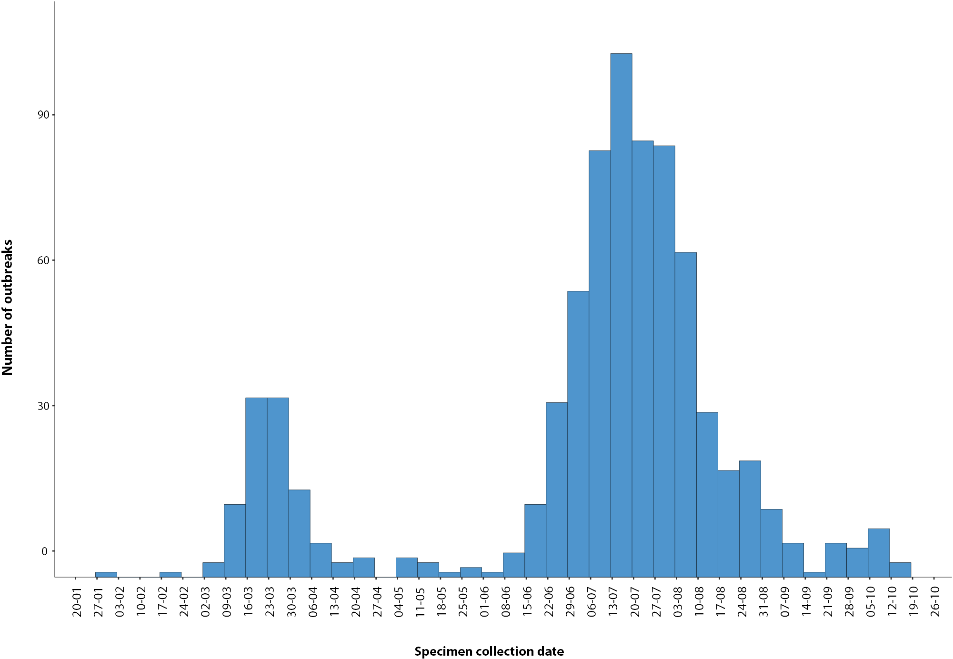
The median number of cases associated with the outbreaks was 6 (range 2–260). The largest proportion (39%, 335/826) of outbreaks have had 6 to 24 cases and many (33%, 269/826) had only 3 to 5 cases (Figure 8). The largest single jurisdictional outbreak occurred in a residential aged care facility and was associated with 260 cases.

Figure 8: Number of outbreaks by size, Australia, 25 October 2020
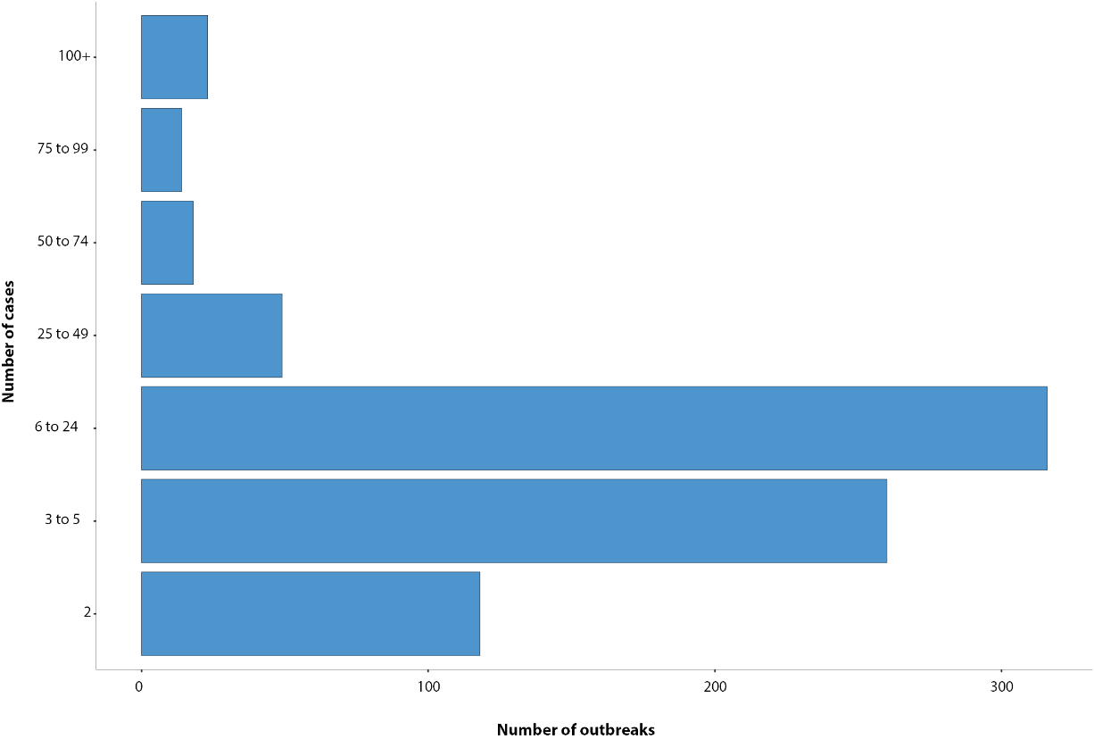
Residents of aged care facilities are at increased risk of COVID-19 infection due to the environment of communal living facilities and are more vulnerable to serious complications if they do become infected. As at 25 October 2020, there have been 4,293 cases of COVID-19 associated with 218 residential aged care facilities, with 3,606 recoveries and 683 deaths. 2,049 of these cases occurred in aged care residents, with the remaining 2,244 cases occurring in care staff. The Commonwealth is actively supporting services with reported incidents and outbreaks of COVID-19, providing access to personal protective equipment and additional staffing resources where required. Advice and guidelines have been provided to aged care services, including the release of an outbreak management guide.^{18,19}

Virology

(GISAID)
At the time of this report, there were 11,887 SARS-CoV-2 genome sequences available from Australian cases on the global sequence repository, GISAID.¹³ These sequences were dispersed throughout the global lineages, reflecting multiple concurrent introductions into Australia.^{1,20,21} Recent Australian SARS-CoV-2 sequences from the last month include 22 collected from Victoria and 28 from New South Wales. Most of these sequences from the last month belong to the B.1.1.25 lineage, reflecting ongoing local transmission of this lineage.

Public health response measures
Since COVID-19 first emerged internationally, Australia has implemented public health measures informed by the disease’s epidemiology (Figure 9). On 8 May, the Australian Government announced a three-step framework for easing COVID-19 restrictions. Building on this framework, on 23 October, National Cabinet announced in-principle agreement to a ‘National Framework for Reopening’ to a COVID Normal Australia by Christmas 2020.²² This Framework will be finalised at the next National Cabinet meeting on 13 November.²³ States and territories continue to ease restrictions at their own pace depending on the local public health and epidemiological situation, and in line with the framework (Table 8).

Figure 9: COVID-19 notifications in Australia by week of diagnosis and jurisdiction to 25 October 2020, with timing of key public health measures
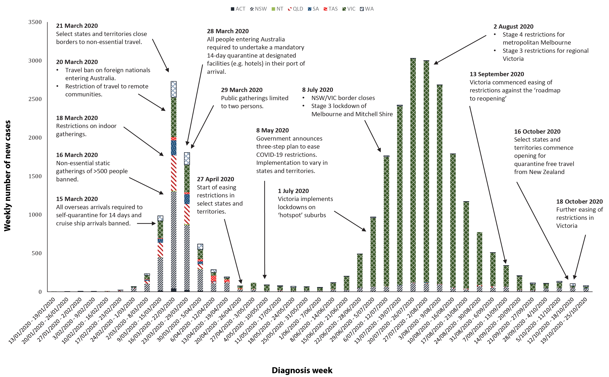

Table 8: State and territory changes to COVID-19 restrictions, Australia, 12 to 25 October 2020
Jurisdiction | Summary of changes to COVID-19 restrictions
New South Wales | From 23 October the following restrictions were eased:²⁴  - Up to 30 permitted to gather outdoors  - Protests and demonstrations up to 500 people permitted outdoors  - Groups of up to 30 permitted in hospitality venues  - Up to 300 permitted in places of worship  From 16 October, travellers from New Zealand entering NSW were not required to quarantine.
Victoria | From 18 October the following restrictions were eased:²⁵  In regional Victoria:  - Up to 10 permitted to gather outdoors  - Up to 2 visitors permitted to private households each day  - Up to 20 permitted in community centres (e.g. libraries, places of worship)  - In hospitality: up to 40 permitted indoors and up to 70 permitted outdoors  In metropolitan Melbourne:  - Individuals can travel up to 25km from their homes  - The two hour limit on visitation and exercise is removed  - Up to 10 people from two households permitted to gather outdoors or exercise  - Some outdoor sports and recreation open with restrictions  - Up to 5 permitted to work outdoors for certain professions  - Hairdressers and barbers permitted to recommence work
Queensland | From 16 October the following restrictions were eased:²⁶  - Up to 40 permitted in private homes and public spaces  - Aged care residents may attend excursions  - Up to 40 permitted to dance at weddings  - Dancing permitted at Year 12 formals.
Western Australia | From 24 October, up to 60% capacity permitted in seated entertainment spaces. Eligible venues include: theatres, concert halls, music auditoriums, cinemas, comedy lounges and performing arts centres.²⁷
South Australia | From 20 October, travellers from New Zealand entering SA were not required to quarantine.²⁸  From 24 October, additional exemptions permitted for travel from Victoria to South Australia.
Tasmania | No further easing of restrictions during this reporting period.²⁹
Australian Capital Territory | No further easing of restrictions during this reporting period.³⁰
Northern Territory | From 16 October, travellers from New Zealand entering NT were not required to quarantine.³¹
a Population data based on Australian Bureau of Statistics (ABS) Estimated Resident Population (ERP) as at 30 December 2019.

Testing

(State and territory reporting)
As at 25 October 2020, a total of 8,535,842 tests have been conducted in Australia. The cumulative nationwide proportion of positive tests remains low at < 0.4% (Table 9). With the exception of Victoria, the cumulative testing positivity in individual jurisdictions was < 0.2%.
Table 9: Diagnostic tests performed, by jurisdiction, Australia, 25 October 2020
Jurisdiction | Tests performed 28 September – 11 October |  |  | Tests performed 12 October – 25 October |  |  | Cumulative tests performed to 25 October
 | n | Positivity (%) | Per 100,000 populationª | n | Positivity (%) | Per 100,000 populationª | n | Positivity (%) | Per 100,000 populationª
NSW | 139,135 | 0.04 | 1,720.80 | 175,229 | 0.06 | 2,167.21 | 2,986,756 | 0.15 | 36,939.79
Vic | 178,697 | 0.08 | 2,710.04 | 211,791 | 0.03 | 3,211.93 | 3,052,477 | 0.67 | 46,292.55
Qld | 59,609 | 0.01 | 1,170.52 | 56,548 | 0.01 | 1,110.41 | 1,214,121 | 0.1 | 23,841.23
WA | 32,128 | 0.06 | 1,225.40 | 30,821 | 0.21 | 1,175.55 | 473,120 | 0.16 | 18,045.37
SA | 35,681 | 0.02 | 2,036.21 | 36,673 | 0.04 | 2,092.82 | 534,150 | 0.09 | 30,482.34
Tas | 6,466 | 0 | 1,209.50 | 5,872 | 0 | 1,098.39 | 114,617 | 0.2 | 21,439.81
NT | 4,868 | 0 | 1,978.03 | 4,970 | 0 | 2,019.48 | 56,316 | 0.06 | 22,883.10
ACT | 5,304 | 0 | 1,244.64 | 5,827 | 0.02 | 1,367.36 | 104,285 | 0.11 | 24,471.49
Australia | 461,888 | 0.05 | 1,821.5 | 527,731 | 0.05 | 2,081.16 | 8,535,842 | 0.32 | 33,661.93

During this reporting period, 527,731 tests were conducted nationally, with a positivity rate of 0.05%. This represented a 12% increase in testing numbers compared to the last reporting period. Testing rates increased to 10.3 tests per 1,000 population per week during this reporting period, a rate nonetheless lower than the peak of 19.4 tests per 1,000 population per week in early August. Jurisdictional testing rates are driven by both current case numbers and numbers of people experiencing symptoms. All states except Western Australia reported a positivity rate of < 0.06%. Western Australia reported a positivity rate of 0.21%, which is an increase from the previous reporting period (0.06%), reflecting an increased number of overseas-acquired cases and stable testing rates during the reporting period. Victoria reported a positivity rate of 0.03%, which is a decrease from the previous reporting period (0.08%). The low national positivity rate, along with high rates of testing, indicates a low prevalence of COVID-19 nationally.
For the fortnight ending 23 October 2020, testing rates were stable for those aged 60 years old and above and rose among children aged 0–19 years old (Figure 10). Testing rates were lowest in those aged 0–19 years old.

Figure 10: SARS-CoV-2 polymerase chain reaction (PCR) testing rates per 1,000 population per week by age group, Australia, 1 May to 23 October 2020^{a,b}
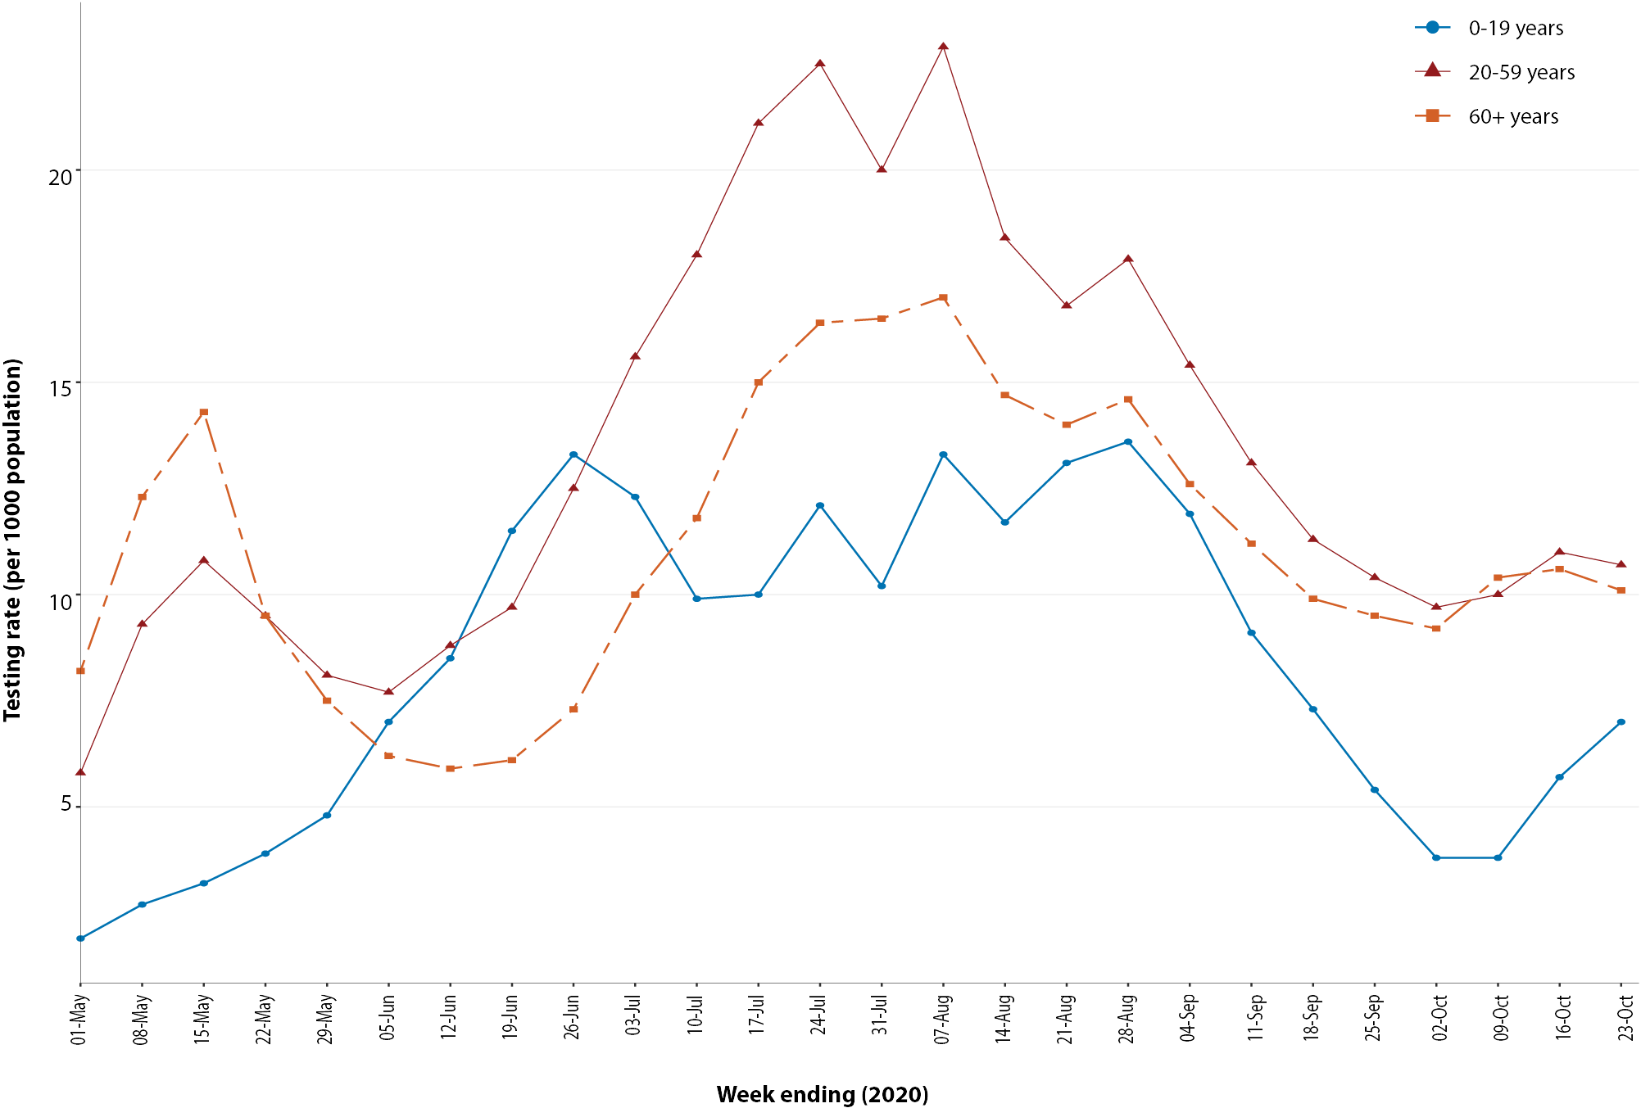
a Data provided by jurisdictions to the National Incident Room (NIR) weekly.
b The jurisdictions reporting each week (i.e. the denominator population) may vary.

Countries and territories in Australia’s near region
According to WHO, as of 25 October, 19 countries and territories in Australia’s near region reported 61,355 newly confirmed cases and 1,462 deaths in this reporting period.¹⁵ These cases were largely concentrated in Indonesia, French Polynesia and Guam, where community transmission continues to remain a challenge (Table 10).

Table 10: Transmission patterns for countries in Australia’s near region, 25 October 2020
Category | Country
No cases  Countries/territories/areas with no cases | Cook Islands, Kiribati, Marshall Islands, Federated States of Micronesia, Nauru, Niue, Palau, Samoa, Tokelau, Tonga, Tuvalu, and Vanuatu.
Sporadic cases  Countries/territories/areas with one or more cases, imported or locally detected | Fiji, French Polynesia, Wallis and Futuna, New Caledonia, New Zealand, Solomon Islands, Timor-Leste.
Clusters of cases  Countries/territories/areas experiencing cases, clustered in time, geographic location and/or by common exposures | Guam
Community transmission  Countries /territories/areas experiencing larger outbreaks of local transmission defined through an assessment of factors including, but not limited to:  - large numbers of cases not linkable to transmission chains  - large numbers of cases from sentinel lab surveillance or increasing positive tests through sentinel samples (routine systematic testing of respiratory samples from established laboratories)  - multiple unrelated clusters in several areas of the country/territory/area. | Indonesia, Papua New Guinea
Indonesia reported 57,028 new cases and 1,440 deaths in this reporting period, an increase in total cases of 17.3% from the previous reporting period, to reach 385,980 cumulative cases. Cumulative deaths increased by 12.2% from the reporting period to reach 13,205 deaths.
French Polynesia continued to see the number of cases rising, with 5,859 cumulative cases and 20 deaths. A total of 3,105 new infections were reported to WHO in this reporting period, more than doubling the cumulative cases reported as of the previous fortnight. French Polynesia re-opened to tourists on 15 July. At that time, there had been no new infections since the end of June, and just 62 for the whole pandemic. Cases were largely concentrated on the island of Tahiti. The territory of Wallis and Futuna reported its first case on 16 October 2020, which was identified in hotel quarantine and asymptomatic.
Guam has reported 1,099 newly-confirmed cases and 12 deaths in this reporting period, bringing the cumulative total to 4,155 cases and 71 deaths. Cases were reported in circulation in the community and in the US military based there.
New Zealand, Fiji, Solomon Islands and Timor-Leste have reported sporadic cases or cases primarily detected in quarantine and reported under public health management. Timor-Leste currently has one active case contributing to a cumulative total of 29 confirmed cases and no deaths. The Solomon Islands reported 3 new cases in returnees in quarantine in the last reporting period, bringing the cumulative total of cases to 4, and no deaths. New Zealand reported 64 confirmed cases in the previous fortnight. All but five were linked with overseas travel and were contained in managed isolation and quarantine. The last locally-acquired case was reported on 23 October 2020. There is currently no community transmission.
Papua New Guinea reported 33 new cases and no deaths in the previous fortnight but there is evidence that limited capacity for testing may mean community transmission is going undetected. Papua New Guineans have been urged to adopt the ‘Niupela Pasin’—the new normal—of living with COVID-19: practising social distancing, wearing face masks, and washing hands.³²
Vanuatu, Tuvalu, Tonga, Samoa, Palau, Marshall Islands, Kiribati, and the Federated States of Micronesia have reported no cases since the start of the pandemic.
New Caledonia has reported no active cases. The 27 cumulative cases were all reported related to travellers, with the last reported case on 26 September 2020.
A single reported case was reported in Fiji on 21 October 2020 and was identified in a returned traveller in hotel quarantine. This brings Fiji’s reported cumulative cases to 33 and cumulative deaths to 2.
Over 5.3 million new cases and 76,195 deaths of COVID-19 have been reported across the six WHO regions in the past reporting fortnight. This is the highest number of reported cases so far in a reporting period. To date, over 42.5 million COVID-19 cases and 1.14 million deaths have been reported globally. Almost a third of the cases (31.5%) and almost half of the deaths (43.6%) continue to be reported in the Region of the Americas. The European Region continued to report a rapid increase in cases and deaths, with over 2.3 million new cases reported in the past reporting fortnight—a 32.8% fortnightly increase in cases compared to the previous week—contributing to 42.7% of all new cases reported worldwide. Similarly, the number of deaths continued to climb, with a 26.4% increase from the previous reporting fortnight. Increases, although more gradual, were also observed in the African, Eastern Mediterranean and Western Pacific Regions. The countries reporting the highest number of cases in the past week remain the same as last fortnight: the United States of America, India, France, Brazil and the United Kingdom.
An international summary by WHO Region can be found in the WHO Epidemiology Update dated 28 October 2020.^{33,34}

Interpretation
Since the first cases of COVID-19 were identified in Australia, all states and territories have reported cases of COVID-19, with some jurisdictions experiencing higher numbers and more substantial community-associated transmission. These differences arise from factors including state demographics, population size, and patterns of overseas arrivals. Australia continues to experience low levels of community transmission of COVID-19 in some jurisdictions.
Nationally, there has been an overall downward trend in cases following a secondary peak in late July 2020. The majority of locally-acquired cases in the last fortnight occurred in Victoria, most of which were associated with localised outbreaks or clusters. Victoria has continued to report declines in case numbers due to interventions and intensive investigations of all cases and outbreaks; for the first time since late April, Victoria did not have the highest proportion of cases overall this fortnight.
Accompanying the decline in overall case numbers has been a reduction in hospital admissions to sentinel surveillance sites; in the past two fortnights there have been just 20 cases admitted to FluCAN participating hospitals and there have been no admissions to ICU in SPRINT-SARI sites during the same period. Early data from the outbreak indicated approximately 20% of infections are severe resulting in severe outcomes.³⁵ Between-country comparisons for COVID-19 disease severity are difficult due to vast differences in sample sizes. However, reported hospitalisation rates for COVID-19 positive cases in Australia were similar to Canada (12%; 12,754/108,288)³⁶ and to the United States of America (USA) (12% hospitalised cases between 12 February and 16 March 2020).³⁷ The ICU admission rate (20%) amongst hospitalised patients in Australia to date was comparable to Canada (23%; 2,948/12,745)³⁶ and to previous data from the United Kingdom (17%; 3,001/18,183).³⁸
Australia has seen an increase in hospital length-of-stay for COVID-19 patients with advancing age similar to other countries.³⁸ Australia reports a shorter median length-of-stay of 7.0 days for surviving hospitalised patients than does a recent systematic review of five countries/regions (median 14; IQR, 11–17).³⁹ Similarly, ICU length of stay for survivors was longer in international data⁴⁰ than observed in Australian sentinel data. The overall mortality rate among hospitalised cases in Australia (Table 7) is substantially lower than that observed in European hospitalised cases (CFR: 29%; data from 21 countries).⁴¹ Mortality rates among adults admitted to ICU with confirmed COVID-19 was also lower than those reported internationally.⁴⁰
There was a shift in the source of acquisition of cases this fortnight, with a greater proportion of overseas-acquired cases reported than locally-acquired cases; this has not occurred since early June, prior to the secondary peak. This fortnight, New South Wales continued to report the highest proportion of overseas-acquired cases, all of which were in quarantine. There was also a large proportion of overseas-acquired cases in Western Australia, the majority of which were crew members on offshore cargo ships. The Australian Capital Territory also reported one overseas-acquired case during the reporting period, which was the first case reported in this jurisdiction since early July.
This fortnight, those aged 20–29 years had the highest rate of notification, which is consistent with the previous fortnight; however, people aged ≥ 90 years old continue to have the highest rate overall. This trend is likely to reflect the large number of outbreaks that occurred in aged care settings, which has declined in recent weeks. Other demographic trends remained consistent, with children aged 0–9 years old having the lowest rate of infection, and cases in Aboriginal and Torres Strait Islander persons accounting for fewer than 1% of all confirmed cases. The local and national epidemiology of COVID-19 continues to inform the public health measure implemented, with a number of jurisdictions easing restrictions this fortnight as COVID-19 case numbers declined or were sustained at low levels.
As Australian states and territories are at different stages in managing the epidemic of COVID-19, there is significant variation in the public health measures implemented. It is important to note that changes in notifications over time are strongly influenced by a range of factors other than disease incidence. These factors include changes in testing policies; screening programs, including the preferential testing of high-risk populations; and periodic awareness campaigns.

Definitions
“Cluster” in relation to COVID-19 refers to two or more cases (who do not reside in the same household) that are epidemiologically related in time, place or person where a common source (such as an event or within a community) of infection is suspected but not yet established.
“COVID-19” is the disease caused by a novel coronavirus—SARS-CoV-2—that emerged in China in late 2019. ‘CO’ stands for corona-, ‘V’ stands for virus, ‘ID’ stands for infectious disease, and ‘-19’ refers to the year that this disease was first reported.
“COVID-19 associated death” is defined for surveillance purposes as a death in a probable or confirmed COVID-19 case, unless there is a clear alternative cause of death that cannot be related to COVID-19 (e.g. trauma).³⁷ There should be no period of complete recovery from COVID-19 between illness and death. Where a Coroner’s report is available, these findings are to be observed.
“Date of illness onset” is derived from data collected by the NNDSS and represents the diagnosis date, or reported true onset of disease date. If unknown, the earliest of specimen collection date, notification date or notification receive date is used.
“Notification received date” is reported in the NNDSS and represents the date the case is first notified on the NNDSS. As notification can only occur after testing is completed and information processed, counts for a defined period will vary according to the date type used.
“Outbreak” in relation to COVID-19 refers to two or more cases (who do not reside in the same household) among a specific group of people and/or over a specific period of time where illness is associated with a common source (such as an event or within a community). Some states and territories may report a single case associated with a residential aged care facility as an outbreak.
“SARS-CoV-2” is the virus that causes the disease COVID-19. It is a betacoronavirus genetically related to the 2003 Severe acute respiratory syndrome coronavirus (SARS-CoV).
“This reporting period” refers to the period covered by this report, i.e. 12–25 October 2020.

Acknowledgements
This report represents surveillance data reported through Communicable Diseases Network Australia (CDNA) as part of the nationally-coordinated response to COVID-19. We thank public health staff from incident emergency operations centres and public health units in state and territory health departments, and the Australian Government Department of Health, along with state and territory public health laboratories. We thank those who provided data from surveillance systems, such as Commonwealth respiratory clinics, SPRINT-SARI, Flutracking, and FluCan.

Author details

Corresponding author
COVID-19 National Incident Room Surveillance Team, Australian Government Department of Health, GPO Box 9484, MDP 14, Canberra, ACT 2601. Email: epi.coronavirus@health.gov.au

References
- Rockett RJ, Arnott A, Lam C, Sadsad R, Timms V, Gray KA et al. Revealing COVID-19 transmission in Australia by SARS-CoV-2 genome sequencing and agent-based modeling. Nat Med. 2020. doi: https://doi.org/10.1038/s41591-020-1000-7.
- World Health Organization (WHO). Transmission of SARS-CoV-2: implications for infection prevention precautions. Scientific brief. [Internet.] Geneva: WHO; 9 July 2020. [Accessed on 14 October 2020.] Available from: https://www.who.int/news-room/commentaries/detail/transmission-of-sars-cov-2-implications-for-infection-prevention-precautions.
- McAloon C, Collins Á, Hunt K, Barber A, Byrne AW, Butler F et al. Incubation period of COVID-19: a rapid systematic review and meta-analysis of observational research. BMJ Open. 2020;10(8). doi: https://doi.org/10.1136/bmjopen-2020-039652.
- Australian Government Department of Health. Australian National Disease Surveillance Plan for COVID-19. [Internet.] Canberra: Australian Government Department of Health; 30 May 2020. Available from: https://www.health.gov.au/resources/publications/australian-national-disease-surveillance-plan-for-covid-19.
- Yuan Z, Xiao Y, Dai Z, Huang J, Zhang Z, Chen Y. Modelling the effects of Wuhan’s lockdown during COVID-19, China. Bull World Health Organ. 2020;98(7):484–94.
- Rothan HA, Byrareddy SN. The epidemiology and pathogenesis of coronavirus disease (COVID-19) outbreak. J Autoimmun. 2020;109. doi: https://doi.org/10.1016/j.jaut.2020.102433.
- Hu Y, Sun J, Dai Z, Deng H, Li X, Huang Q et al. Prevalence and severity of corona virus disease 2019 (COVID-19): A systematic review and meta-analysis. J Clin Virol. 2020; 127. doi: https://doi.org/10.1016/j.jcv.2020.104371.
- WHO. Report of the WHO-China Joint Mission on Coronavirus Disease 2019 (COVID-19). Geneva: WHO; 2020. [Accessed on 14 October 2020.] Available from: https://www.who.int/docs/default-source/coronaviruse/who-china-joint-mission-on-covid-19-final-report.pdf.
- Australian Government Department of Health. Coronavirus Disease 2019 (COVID-19): CDNA National guidelines for public health units. Canberra: Australian Government Department of Health; 9 October 2020. [Accessed on 13 October 2020.] Available from: https://www1.health.gov.au/internet/main/publishing.nsf/Content/7A8654A8CB144F5FCA2584F8001F91E2/$File/COVID-19-SoNG-v3.9.pdf.
- Dalton C, Durrheim D, Fejsa J, Francis L, Carlson S, d’Espaignet ET et al.Flutracking: a weekly Australian community online survey of influenza-like illness in 2006, 2007 and 2008. Commun Dis Intell Q Rep. 2009;33(3):316–22.
- Monash Health. FluCAN (Influenza surveillance): FluCAN (The Influenza Complications Alert Network) [Internet.] Melbourne: Monash Health; 2020. Available from: https://monashhealth.org/services/monash-infectious-diseases/research/influenza-research/flucan-influenza-surveillance-2/.
- Australian and New Zealand Intensive Care Society (ANZICS). SPRINT-SARI: Short period incidence study of severe acute respiratory infection. [Internet.] Camberwell: ANZICS; 2020. Available from: https://www.anzics.com.au/current-active-endorsed-research/sprint-sari/.
- Global Initiative on Sharing All Influenza Data (GISAID). [Website.] Berlin: Federal Republic of Germany, Freunde von GISAID e.V.; 2020. [Accessed on 15 October 2020.] Available from: https://www.gisaid.org/.
- Bedford T, Neher R, Hadfield J, Hodcroft E, Sibley T, Huddleston J et al. Nextstrain: Genomic epidemiology of novel coronavirus - Oceania-focused subsampling. [Internet.] Nextstrain; 2020. [Accessed on 15 October 2020.] Available from: https://nextstrain.org/ncov/oceania.
- WHO. WHO Coronavirus Disease (COVID-19) dashboard. [Internet.] Geneva: WHO; 25 October 2020. [Accessed on 26 October 2020.] Available from: https://covid19.who.int/.
- Government of New South Wales. COVID-19 weekly surveillance in NSW: epidemiological week 23, ending 6 June 2020. Sydney: Government of New South Wales; 10 June 2020. [Accessed on 31 August 2020.] Available from: https://www.health.nsw.gov.au/Infectious/covid-19/Documents/covid-19-surveillance-report-20200606.pdf.
- COVID-19 National Incident Room Surveillance Team. COVID-19, Australia: epidemiology report 26: fortnightly reporting period ending 27 September 2020. Commun Dis Intell (2018). 2020; 44. doi: https://doi.org/10.33321/cdi.2020.44.78.
- Australian Government Department of Health. Coronavirus (COVID-19) advice for the health and aged care sector. [Internet.] Canberra: Australian Government Department of Health; 2020. [Accessed 13 August 2020.] Available from: https://www.health.gov.au/news/health-alerts/novel-coronavirus-2019-ncov-health-alert/coronavirus-covid-19-advice-for-the-health-and-aged-care-sector.
- Communicable Diseases Network Australia (CDNA). Coronavirus disease 2019 (COVID-19) outbreaks in residential care facilities: CDNA national guidelines for the prevention, control and public health management of COVID-19 outbreaks in residential care facilities in Australia. Canberra: Australian Government Department of Health, CDNA; 13 March 2020. [Accessed on 13 August 2020.] Available from: https://www.health.gov.au/sites/default/files/documents/2020/03/coronavirus-covid-19-guidelines-for-outbreaks-in-residential-care-facilities.pdf.
- Seemann T, Lane CR, Sherry NL, Duchene S, Goncalves da Silva A, Caly L et al. Tracking the COVID-19 pandemic in Australia using genomics. Nat Commun. 2020;11(1):4376. doi: https://doi.org/10.1038/s41467-020-18314-x.
- Eden JS, Rockett R, Carter I, Rahman H, de Ligt J, Hadfield J et al. An emergent clade of SARS-CoV-2 linked to returned travellers from Iran. Virus Evol. 2020;6(1):veaa027. doi: https://doi.org/10.1093/ve/veaa027.
- Australian Government Department of Health. Framework for national reopening – October 2020. [Internet.] Canberra: Australian Government Department of Health; 23 October 2020. [Accessed on 26 October 2020.] Available from: https://www.health.gov.au/resources/publications/framework-for-national-reopening-october-2020.
- Prime Minister of Australia. Media statement: 23 October 2020. [Internet.] Canberra: Australian Government Department of Prime Minister and Cabinet; 23 October 2020. [Accessed on 26 October 2020.] Available from: https://www.pm.gov.au/media/national-cabinet-1.
- Government of New South Wales. What you can and can’t do under the rules: recent and upcoming changes. [Internet.] Sydney: Government of New South Wales; 2020. [Accessed on 26 October 2020.] Available from: https://www.nsw.gov.au/covid-19/what-you-can-and-cant-do-under-rules#recent-and-upcoming-changes.
- Victoria State Government Health and Human Services (DHHS). Summary of changes to restrictions for metropolitan Melbourne and regional Victoria. [Internet.] Melbourne: Victoria State Government, DHHS; 18 October 2020. [Accessed on 26 October 2020.] Available from: https://www.dhhs.vic.gov.au/summary-of-the-changes-to-restrictions-for-metropolitan-melbourne-and-regional-victoria.
- Queensland Government. Roadmap to easing restrictions. [Internet.] Brisbane: Queensland Government; 2020. [Accessed on 26 October 2020.] Available from: https://www.covid19.qld.gov.au/government-actions/roadmap-to-easing-queenslands-restrictions.
- Government of Western Australia. COVID-19 coronavirus: WA Roadmap. [Internet.] Perth: Government of Western Australia; 2020. [Accessed on 26 October 2020.] Available from: https://www.wa.gov.au/organisation/department-of-the-premier-and-cabinet/covid-19-coronavirus-wa-roadmap.
- Government of South Australia. COVID-19 response: COVID response updates. [Internet.] Adelaide: Government of South Australia; 2020. [Accessed on 26 October 2020.] Available from: https://www.covid-19.sa.gov.au/recovery.
- Tasmanian Government. Coronavirus disease (COVID-19): important community updates. [Internet.] Hobart: Tasmanian Government; 2020. [Accessed on 26 October 2020.] Available from: https://coronavirus.tas.gov.au/facts/important-community-updates.
- Australian Capital Territory Government. Canberra’s recovery plan: easing of restrictions. [Internet.] Canberra: Australian Capital Territory Government; 2020. [Accessed on 26 October 2020.] Available from: https://www.covid19.act.gov.au/community/canberra-recovery.
- Northern Territory Government. International travel: New Zealand travel bubble. [Internet.] Darwin: Northern Territory Government; 2020. [Accessed on 26 October 2020.] Available from: https://coronavirus.nt.gov.au/travel/international-travel#section5.
- WHO. Niupela Pasin - Papua New Guinea’s “New Normal” in the time of COVID-19 Pandemic. [Internet.] Geneva: WHO; 25 August 2020. (Accessed on 27 October 2020.] Available from: https://www.who.int/papuanewguinea/internal-publications-detail/niupela-pasin.
- WHO. Weekly operational update - 23 October 2020. [Internet.] Geneva: WHO; 24 October 2020. [Accessed on 27 October 2020.] Available from: https://www.who.int/publications/m/item/weekly-update-on-covid-19---23-october.
- WHO. Weekly epidemiological update - 27 October 2020. [Internet.] Geneva: WHO; 27 October 2020. [Accessed on 27 October 2020.] Available from: https://www.who.int/publications/m/item/weekly-epidemiological-update---27-october-2020
- Wu Z, McGoogan JM. Characteristics of and important lessons from the coronavirus disease 2019 (COVID-19) outbreak in China: summary of a report of 72 314 sases from the Chinese Center for Disease Control and Prevention. JAMA. 2020;323(13):1239–42. doi: https://doi.org/10.1001/jama.2020.2648.
- Statistics Canada. Table 13-10-0775-01. Detailed preliminary information on cases of COVID-19: 4 Dimensions (Aggregated data), Public Health Agency of Canada. [Internet.] Ottawa: Statistics Canada; 2020. [Accessed on 28 October 2020.] Available from: https://www150.statcan.gc.ca/t1/tbl1/en/tv.action?pid=1310077501.
- CDC COVID-19 Response Team. Severe outcomes among patients with Coronavirus Disease 2019 (COVID-19) - United States, February 12-March 16, 2020. MMWR Morb Mortal Wkly Rep. 2020;69(12):343-6.
- Docherty AB, Harrison EM, Green CA, Hardwick HE, Pius R, Norman L et al. Features of 20 133 UK patients in hospital with covid-19 using the ISARIC WHO Clinical Characterisation Protocol: prospective observational cohort study. BMJ. 2020;369:m1985. doi: http://dx.doi.org/10.1136/bmj.m1985.
- Rees EM, Nightingale ES, Jafari Y, Waterlow NR, Clifford S, Pearson CAB et al. COVID-19 length of hospital stay: a systematic review and data synthesis. BMC Med. 2020;18(1):270. doi: https://doi.org/10.1186/s12916-020-01726-3.
- Intensive Care National Audit and Research Centre (ICNARC). ICNARC report on COVID-19 in critical care, England, Wales and Northern Ireland, 25 September 2020. London: ICNARC; 2020. [Accessed on 27 October 2020.] Available from: https://www.icnarc.org/Our-Audit/Audits/Cmp/Reports.
- European Centre for Disease Prevention and Control (ECDC). COVID-19 surveillance report: Week 38, 2020. [Internet.] Solna: ECDC; 24 September 2020. [Accessed on 1 October 2020.] Available from: https://covid19-surveillance-report.ecdc.europa.eu/.

Appendix A: Supplementary figures and tables
Table A.1: COVID-19 case notifications and rates per 100,000 population, by age group and sex, 25 October 2020, Australia
Age Group | This reporting period |  |  |  |  |  | Cumulative
 | Cases |  |  | Rate per 100,000 population |  |  | Cases |  |  | Rate per 100,000 population
 | Male | Female | People | Male | Female | People | Male | Female | People | Male | Female | People
0 to 9 | 7 | 12 | 19 | 0.4 | 0.8 | 0.6 | 736 | 659 | 1,395 | 45.0 | 42.5 | 43.8
10 to 19 | 8 | 6 | 14 | 0.5 | 0.4 | 0.5 | 1,198 | 1,153 | 2,351 | 76.3 | 77.6 | 76.9
20 to 29 | 21 | 13 | 34 | 1.1 | 0.7 | 0.9 | 2,983 | 3,254 | 6,261 | 160.5 | 180.7 | 171.1
30 to 39 | 19 | 14 | 33 | 1.0 | 0.8 | 0.9 | 2,407 | 2,359 | 4,781 | 132.3 | 127.1 | 130.1
40 to 49 | 25 | 8 | 33 | 1.5 | 0.5 | 1.0 | 1,766 | 1,734 | 3,528 | 109.1 | 104.7 | 107.7
50 to 59 | 18 | 4 | 22 | 1.2 | 0.3 | 0.7 | 1,579 | 1,682 | 3,269 | 104.7 | 106.9 | 106.1
60 to 69 | 8 | 5 | 13 | 0.6 | 0.4 | 0.5 | 1,158 | 1,194 | 2,354 | 91.1 | 88.9 | 90.0
70 to 79 | 5 | 3 | 8 | 0.6 | 0.3 | 0.4 | 847 | 749 | 1,596 | 97.4 | 81.2 | 89.1
80 to 89 | 0 | 0 | 0 | 0.0 | 0.0 | 0.0 | 490 | 775 | 1,265 | 137.1 | 168.0 | 154.5
90 and over | 0 | 0 | 0 | 0.0 | 0.0 | 0.0 | 229 | 552 | 782 | 333.7 | 413.3 | 386.8

Appendix B: Frequently asked questions
Q: Can I request access to the COVID-19 data behind your CDI fortnightly reports?
A: National notification data on COVID-19 confirmed cases is collated in the National Notifiable Disease Surveillance System (NNDSS) based on notifications made to state and territory health authorities under the provisions of their relevant public health legislation.
Normally, requests for the release of data from the NNDSS requires agreement from states and territories via the Communicable Diseases Network Australia, and, depending on the sensitivity of the data sought and proposed, ethics approval may also be required.
Due to the COVID-19 response, unfortunately, specific requests for NNDSS data have been put on hold. We are currently looking into options to be able to respond to data requests in the near future.
We will continue to publish regular summaries and analyses of the NNDSS dataset and recommend the following resources be referred to in the meantime:
- NNDSS summary tables: http://www9.health.gov.au/cda/source/cda-index.cfm
- Daily case summary of cases: https://www.health.gov.au/news/health-alerts/novel-coronavirus-2019-ncov-health-alert/coronavirus-covid-19-current-situation-and-case-numbers
- Communicable Diseases Intelligence COVID-19 epidemiology report: https://www1.health.gov.au/internet/main/publishing.nsf/Content/novel_coronavirus_2019_ncov_weekly_epidemiology_reports_australia_2020.htm
- State and territory public health websites.
Q: Can I request access to data at postcode level of confirmed cases?
A: Data at this level cannot be released without ethics approval and permission would need to be sought from all states and territories via the Communicable Diseases Network Australia. As noted above, specific requests for NNDSS data are currently on hold.
Where current or recent reported case numbers are high enough to justify it, a GIS/mapping analysis of cases will be included in the Communicable Diseases Intelligence COVID-19 epidemiology report. In order to protect privacy of confirmed cases, data in this map will be presented at SA3 level.
Q: Where can I find more detailed data on COVID-19 cases?
A: We are currently looking into ways to provide more in-depth epidemiological analyses of COVID-19 cases, with regard to transmission and severity, including hospitalisation. These analyses will continue to be built upon in future iterations of the Communicable Diseases Intelligence report.
Q: Where do I find the COVID-19 background information which was included as Appendix A in previous fortnightly epidemiology reports?
A: This information was most recently published in Epidemiology Report 24 (https://doi.org/10.33321/cdi.2020.44.75). Additional information can be found in the CDNA Series of National Guidelines (SoNG) for COVID-19. (https://www1.health.gov.au/internet/main/publishing.nsf/Content/cdna-song-novel-coronavirus.htm).
Communicable Diseases Intelligence
ISSN: 2209-6051 Online

Communicable Diseases Intelligence (CDI) is a peer-reviewed scientific journal published by the Office of Health Protection, Department of Health. The journal aims to disseminate information on the epidemiology, surveillance, prevention and control of communicable diseases of relevance to Australia.

Editor: Tanja Farmer
Deputy Editor: Simon Petrie
Design and Production: Kasra Yousefi
Editorial Advisory Board: David Durrheim, Mark Ferson, John Kaldor, Martyn Kirk and Linda Selvey

Website: http://www.health.gov.au/cdi

Contacts
Communicable Diseases Intelligence is produced by:
Health Protection Policy Branch, Office of Health Protection, Australian Government Department of Health
GPO Box 9848, (MDP 6) CANBERRA ACT 2601

Email: cdi.editor@health.gov.au

Submit an Article
You are invited to submit your next communicable disease related article to the Communicable Diseases Intelligence (CDI) for consideration. More information regarding CDI can be found at: http://health.gov.au/cdi.
Further enquiries should be directed to: cdi.editor@health.gov.au.

This journal is indexed by Index Medicus and Medline.

Creative Commons Licence - Attribution-NonCommercial-NoDerivatives CC BY-NC-ND
© 2020 Commonwealth of Australia as represented by the Department of Health
This publication is licensed under a Creative Commons Attribution-NonCommercial-NoDerivatives 4.0 International Licence from https://creativecommons.org/licenses/by-nc-nd/4.0/legalcode (Licence). You must read and understand the Licence before using any material from this publication.

Restrictions
The Licence does not cover, and there is no permission given for, use of any of the following material found in this publication (if any):
- the Commonwealth Coat of Arms (by way of information, the terms under which the Coat of Arms may be used can be found at www.itsanhonour.gov.au);
- any logos (including the Department of Health’s logo) and trademarks;
- any photographs and images;
- any signatures; and
- any material belonging to third parties.

Disclaimer
Opinions expressed in Communicable Diseases Intelligence are those of the authors and not necessarily those of the Australian Government Department of Health or the Communicable Diseases Network Australia. Data may be subject to revision.

Enquiries
Enquiries regarding any other use of this publication should be addressed to the Communication Branch, Department of Health, GPO Box 9848, Canberra ACT 2601, or via e-mail to: copyright@health.gov.au

Communicable Diseases Network Australia
Communicable Diseases Intelligence contributes to the work of the Communicable Diseases Network Australia.
http://www.health.gov.au/cdna

