COVID-19 Australia: Epidemiology Report 61
Reporting period ending 8 May 2022
COVID-19 National Incident Room Surveillance Team

Summary

Four-week reporting period (11 April – 8 May 2022)
The case data provided in this report includes confirmed cases reported to the National Interoperable Disease Surveillance System (NINDSS). With the exception of Table 1, which is sourced from data reported by jurisdictions to the National Incident Centre, the case data in this publication does not include cases that are positive on rapid antigen tests (RAT) only. Therefore, case numbers, particularly since January 2022, will under-represent the incidence of disease in the community. Due to NINDSS transmission issues, data are not available since 6 April 2022 for the Northern Territory, and since 4 May 2022 for Western Australia.
Trends – In the last four weeks from 11 April to 8 May 2022, there were 466,855 polymerase chain reaction (PCR) confirmed cases of coronavirus disease 2019 (COVID-19) reported in Australia. In the most recent fortnight, a total of 201,196 confirmed cases were notified (an average of 14,371 cases per day), compared to 245,659 in the previous fortnight (an average of 17,547 cases per day).
Age group – In the four weeks ending 8 May 2022, the highest PCR-confirmed notification rate was observed among adults aged 18 to 29 years and the lowest rate was among children aged 5 to 11 years. Across all age groups, weekly case notification rates converged over the four-week reporting period. For the entire Omicron wave to date (15 December 2021 – 8 May 2022), the highest PCR-confirmed notification rate was in adults aged 18 to 29 years.
Aboriginal and Torres Strait Islander persons –Between 11 April and 8 May 2022, there were 11,180 new PCR confirmed cases notified in Aboriginal and Torres Strait Islander people. In the current Omicron wave to date (15 December 2021 – 8 May 2022), there have been 95,097 confirmed cases of COVID-19 notified in Aboriginal and Torres Strait Islander people, representing 3.2% (95,097/3,009,795) of all confirmed cases; 18% of confirmed cases notified in that same period had an unknown or missing Indigenous status. Therefore, the number of cases classified as Aboriginal and Torres Strait Islander people is likely an underestimate.
Severity – The notification rate of confirmed cases with severe illness has remained relatively stable since late March 2022, at approximately 1.0 cases per 100,000 population. In the current wave, severe cases peaked in the week ending 16 January 2022, at approximately 3.7 per 100,000 population. This is more than three times the peak rate of severe cases observed during the Delta wave, of 1.2 per 100,000 population in the week ending 5 September 2021. Twelve cases of paediatric inflammatory multisystem syndrome temporally associated with SARS-Cov-2 (PIMS-TS) have been notified in the current reporting period.
Virology – Nationally, SARS-CoV-2 strains from 2.8% of COVID-19 cases have been sequenced since the start of the pandemic. For samples collected in the 21-day period from 18 April to 9 May 2022, the BA.2 sub-lineage constituted 94.6% (2,342/2,475) of all lineages identified in AusTrakka. This indicates a genuine dominance of the BA.2 lineage among the sequenced samples. Of the sequences in AusTrakka to date, 44,233 have been identified as the Omicron VOC: 58.8% are BA.1; 41.1% are BA.2; <0.001% are BA.3; 0.027% are BA.4 and 0.011% are BA.5.
Acute respiratory illness – Based on self-reported FluTracking data, over the four-week reporting period, there was an increase in the prevalence of both fever and cough, and runny nose and sore throat symptoms in the community; in the week ending 8 May 2022, 2.09% of survey participants reported fever and cough symptoms and 1.66% of participants reported runny nose and sore throat. The current rate of both sets of symptoms is higher than that observed during the peak of the Omicron wave in January 2022.
International situation – According to the World Health Organization (WHO), cumulative global COVID-19 cases stood at more than 515 million, with over 6.2 million deaths reported globally, as of 8 May 2022. In Australia’s near region, the South East Asia and Western Pacific Regions reported 6,493,096 cases and 15,222 deaths in the four-week period to 8 May 2022.
Keywords:SARS-CoV-2; novel coronavirus; 2019-nCoV; coronavirus disease 2019; COVID-19; acute respiratory disease; epidemiology; Australia
This reporting period covers the four-week period of 11 April – 8 May 2022. Within this period, data for each week is compared. The previous reporting period was the preceding four weeks (14 March – 10 April 2022).¹
The focus of this report is on the epidemiological situation in Australia since the beginning of the current Omicron wave. For the purposes of this report, 15 December 2021 is used as a proxy for the beginning of this wave. This date was chosen as, from this date onwards, the majority of sequenced cases were Omicron. Readers are encouraged to consult prior reports in this series for information on the epidemiology of COVID-19 in Australia.
From report 46 onward, and unless otherwise specified, tabulated data and data within the text are extracted from the National Interoperable Notifiable Diseases Surveillance System (NINDSS) based on ‘notification received date’ rather than ‘diagnosis date’ (see the Technical Supplement for definitions).²As a case’s diagnosis date can be several days prior to the date of its notification, there is potential for newly-notified cases to be excluded from the case count in the current reporting period when reporting by ‘diagnosis date’. Using ‘notification received date’ ensures that the case count for the reporting period better reflects the number of newly-notified cases. As the graphs presented in this report, based on NINDSS data, reflect a longer time period (i.e. year to date and entire pandemic), these will continue to be based on diagnosis date to enable a more accurate understanding of infection risk and local transmission.
Further—as a result of community transmission levels, of the increase in international arrivals, and of reduced quarantine and testing requirements—the ability of jurisdictions to accurately report place of acquisition has been greatly reduced. This directly impacts the value of data around international arrivals. Therefore, from report 59 onwards, cases are no longer separated into ‘locally acquired’ or ‘overseas acquired’. All case numbers should be interpreted as the aggregate of all places of acquisition.
Due to NINDSS transmission issues, data are not available for WA since 4 May 2022, and for NT since 6 May 2022.

Background and data sources
See the Technical Supplement for general information on COVID-19 including modes of transmission, common symptoms and severity.²

Activity

COVID-19 trends

(NINDSS and jurisdictional reporting to the National Incident Centre)
Cumulatively, from the beginning of the pandemic to 8 May 2022, jurisdictions within Australia have reported 6,282,370 COVID-19 cases (PCR-confirmed and RAT probable cases) to the National Incident Centre (Table 1). In the same time period, there have been 3,244,698 PCR confirmed cases of COVID-19 reported to NINDSS nationally. The difference in these case numbers arises because cases positive by RAT are not reported by all jurisdictions to NINDSS. The analyses in this report are limited to PCR-confirmed cases only.
Table 1: PCR-confirmed and RAT positive COVID-19 cases by jurisdiction, 1 January 2020 – 8 May 2022^{a,b}
 | Australia (total) | ACT | NSW | NT | Qld | SA | Tas. | Vic. | WA
Cases – PCR confirmed cases | 3,401,168 | 69,736 | 1,380,668 | 15,948 | 506,848 | 293,041 | 37,768 | 874,265 | 222,894
Cases – RAT positive cases | 2,881,202 | 42,671 | 992,567 | 50,135 | 534,602 | 143,277 | 106,583 | 772,708 | 238,659
Cases – total | 6,282,370 | 112,407 | 2,373,235 | 66,083 | 1,041,450 | 436,318 | 144,351 | 1,646,973 | 461,553
a Source: Jurisdictional reporting to the National Incident Centre.
b ACT: Australian Capital Territory; NSW: New South Wales; NT: Northern Territory; Qld: Queensland; SA: South Australia; Tas.: Tasmania; Vic.: Victoria; WA: Western Australia.
In the last four weeks from 11 April to 8 May 2022, there were 446,855 polymerase chain reaction (PCR) confirmed cases of coronavirus disease 2019 (COVID-19) reported in Australia to NINDSS. In the most recent fortnight, a total of 201,196 confirmed cases were notified (an average of 14,371 cases per day), compared to 245,659 in the previous fortnight (17,547 cases per day). In the week ending 8 May 2022, PCR case rates were highest in the Australian Capital Territory at 819 per 100,000 population per week, followed by South Australia (688 per 100,000 population per week) (Table 2).
Prior to December 2021, the number of cases diagnosed each week had peaked in October 2021, at approximately 15,000 cases diagnosed per week. From December 2021, confirmed case numbers increased steeply to a peak of over 450,000 cases diagnosed in the week ending 9 January 2022, then declined until the week ending 27 February 2022. From 28 February to 3 April 2022, PCR-confirmed case numbers increased gradually and have since decreased (Figure 1). As trends are presented using diagnosis date rather than notification date, case numbers for the most recent week are likely an underestimate; additional cases may be identified in the coming week that have a diagnosis date in this period. In addition, case numbers since January 2022 are an underestimate, as RAT probable cases are excluded from these counts.

Demographic features

(NINDSS)
In the reporting period between 11 April and 8 May 2022, the highest PCR-confirmed notification rate was observed among adults aged 18 to 29 years and the lowest rate was among children aged 5 to 11 years (Appendix A, Table A.1). Across all age groups, weekly case notification rates converged over the four-week reporting period (Figure 2). For the entire Omicron wave to date (15 December 2021 – 8 May 2022), the highest PCR-confirmed notification rate was in adults aged 18 to 29 years. For this age group, the weekly notification rate peaked in the week ending 9 January 2022 at 4,464 cases per 100,000 population.
Among paediatric age groups, the highest notification rate during the reporting period was in children aged 0 to 4 years (Figure 2). Case rates decreased across all paediatric age groups over the reporting period.
Table 2: PCR-confirmed COVID-19 cases by jurisdiction and date of notification, 15 December 2021 – 8 May 2022^{a,b}
Jurisdiction | Reporting period |  |  |  |  |  |  |  | Current ‘Omicron’ wave
 | 11–17 April 2022 |  | 18–24 April 2022 |  | 25 April – 1 May 2022 |  | 2–8 May 2022 |  | 15 December 2021 – 8 May 2022
 | No. of cases | Rate^{c} | No. of cases | Rate^{c} | No. of cases | Rate^{c} | No. of cases | Rate^{c} | No. of cases | Rate^{c}
ACT | 3,405 | 787.7 | 3,545 | 820.1 | 3,357 | 776.6 | 3,542 | 819.4 | 68,015 | 15,734.5
NSW | 45,021 | 549.8 | 39,682 | 484.6 | 35,201 | 429.8 | 32,848 | 401.1 | 1,163,186 | 14,203.8
NT^{d} | 524 | 212.7 | 575 | 233.4 | 464 | 188.4 | 204 | 82.8 | 14,297 | 5,803.8
Qld | 14,008 | 268.3 | 13,397 | 256.6 | 10,557 | 202.2 | 10,524 | 201.6 | 499,835 | 9,573.2
SA | 19,467 | 1,097.8 | 17,807 | 1,004.2 | 15,626 | 881.2 | 12,197 | 687.8 | 296,644 | 16,728.9
Tas. | 2,227 | 411.3 | 1,796 | 331.7 | 1,519 | 280.5 | 1,297 | 239.5 | 38,148 | 7,045.1
Vic. | 22,794 | 342.8 | 20,732 | 311.8 | 20,468 | 307.8 | 20,982 | 315.6 | 728,250 | 10,952.5
WA^{d} | 19,325 | 720.6 | 21,354 | 796.3 | 21,475 | 800.8 | 10,935 | 407.8 | 201,420 | 7,511.1
Australia | 126,771 | 492.5 | 118,888 | 461.9 | 108,667 | 422.2 | 92,529 | 359.5 | 3,009,795 | 11,693.4
a Source: NINDSS, extract from 9 May 2022 for notifications from 15 December 2021 to 8 May 2022.
b ACT: Australian Capital Territory; NSW: New South Wales; NT: Northern Territory; Qld: Queensland; SA: South Australia; Tas.: Tasmania; Vic.: Victoria; WA: Western Australia.
c Rates are per 100,000 population for the given time period. Population data based on Australian Bureau of Statistics (ABS) Estimated Resident Population (ERP) as at June 2021. The ABS June 2021 ERP was ACT: 432,266; NSW: 8,189,266; NT: 246,338; Qld: 5,221,170; SA: 1,773,243; Tas.: 541,479; Vic.: 6,649,159; WA: 2,681,633; Australia: 25,739,256.
d Due to NINDSS transmission issues, data are not available (NA) since 6 May 2022 for the Northern Territory and since 4 May 2022 for Western Australia.

Figure 1: Confirmed weekly COVID-19 notified cases by diagnosis date, 13 December 2021 – 8 May 2022^{a,b}
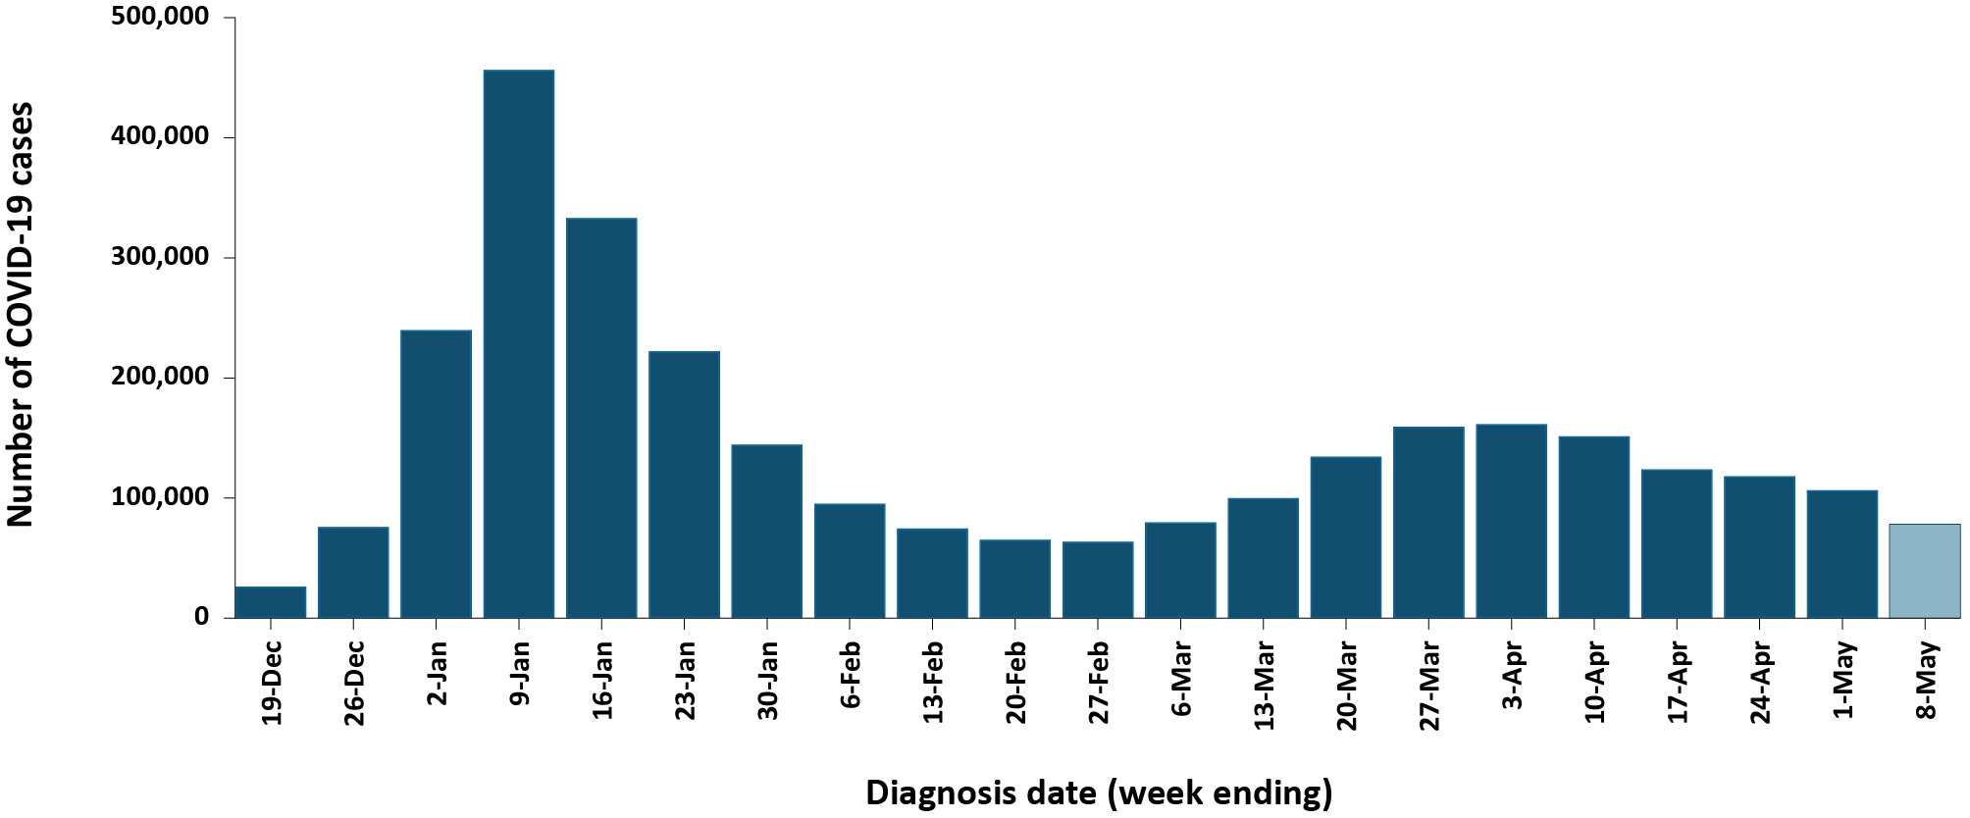
a Source: NINDSS, extract from 9 May 2022 for notifications from 15 December 2021 to 8 May 2022.
b The shaded bar at the right represents the most recent reporting week and should be interpreted with caution as additional cases may be identified in the coming week that have a diagnosis date during this period.

Figure 2: PCR-confirmed COVID-19 case rates for (a) all ages and (b) children, by age group by week, Australia, 29 November 2021 – 8 May 2022ª
a
b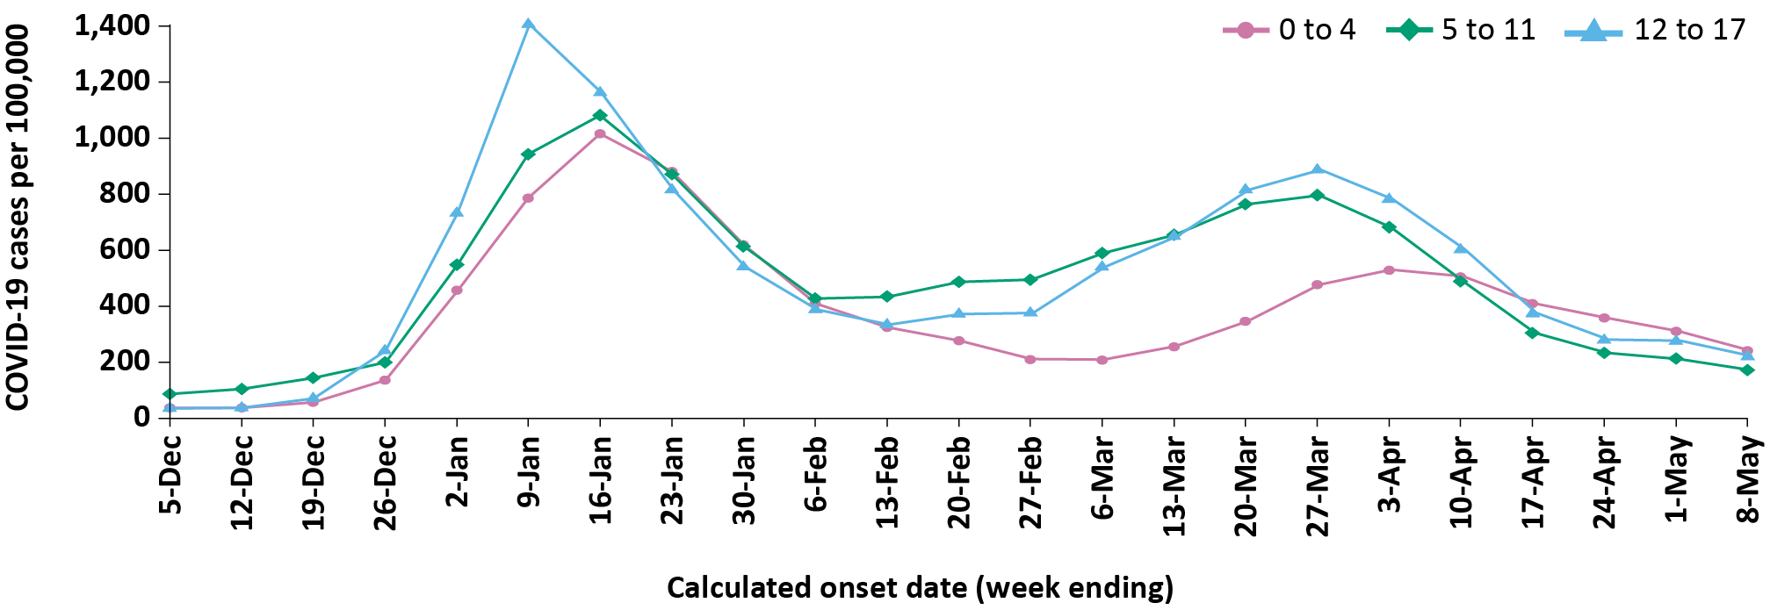
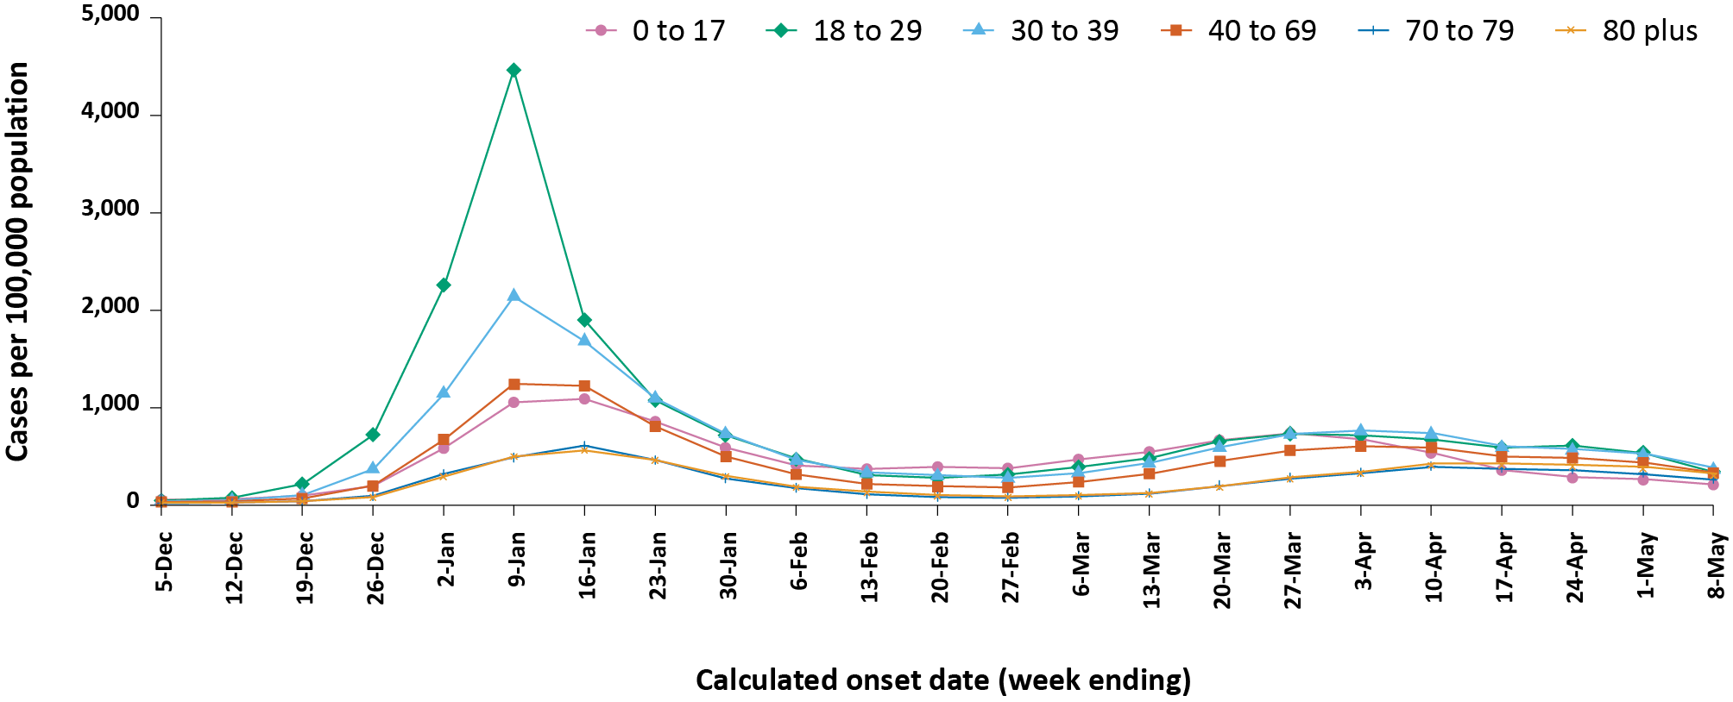
a Source: NINDSS, extract from 9 May 2022 for notifications from 15 December 2021 to 8 May 2022.

Aboriginal and Torres Strait Islander persons

(NINDSS)
Overall, since the start of the pandemic, Indigenous status is unknown for approximately 18% of confirmed cases. Therefore, the number of cases classified as Aboriginal and Torres Strait Islander people is likely an underrepresentation.
During the reporting period, there were 11,180 new confirmed cases notified in Aboriginal and Torres Strait Islander people (Table 3). In the current Omicron wave (15 December 2021 –8 May2022) there have been 95,097 confirmed cases of COVID-19 notified in Aboriginal and Torres Strait Islander people, representing 3.2% (95,097/3,009,795) of all confirmed cases.
Table 3: PCR-confirmed cases of COVID-19 among Aboriginal and Torres Strait Islander peoples by jurisdiction and date of notification, 31 December 2021 – 8 May 2022ª
Jurisdiction | 11–17 April 2022 | 18–24 April 2022 | 25 April – 1 May 2022 | 2–8 May 2022 | 15 December 2021 – 8 May 2022 (Omicron wave)
Australian Capital Territory | 62 | 78 | 71 | 64 | 1,316
New South Wales | 1,293 | 1,069 | 898 | 885 | 41,078
Northern Territory^{b} | 68 | 57 | 54 | 30 | 2,866
Queensland | 469 | 434 | 359 | 327 | 20,827
South Australia | 404 | 354 | 316 | 261 | 9,290
Tasmania | 84 | 66 | 40 | 17 | 1,302
Victoria | 199 | 184 | 158 | 170 | 6,506
Western Australia^{b} | 923 | 795 | 692 | 299 | 11,912
Total | 3,502 | 3,037 | 2,588 | 2,053 | 95,097
a Source: NINDSS, extract from 11 April 2022 for notifications to 8 May 2022.
b Due to NINDSS transmission issues, data are not available (NA) since 6 May 2022 for the Northern Territory and since 4 May 2022 for Western Australia.
Of the PCR-confirmed cases notified in Aboriginal and Torres Strait Islander people from 15 December 2021 to date, 48% (45,445/95,097) lived in a regional or remote area (Table 4). It should be noted that the reliance on RATs for diagnosing COVID-19 is greater in regional and remote areas than in major cities, resulting in a larger underrepresentation of cases in regional and remote areas than in major cities when counting PCR-confirmed cases only.
Nationally, there have been 120 deaths among PCR-confirmed cases reported in Aboriginal and Torres Strait Islander people from the start of the pandemic to 8 May 2022. This includes 47 from New South Wales, 27 from Queensland, 21 from the Northern Territory, 11 from WA, nine from South Australia and five from Victoria. An additional 309 Aboriginal and Torres Strait Islander cases have been admitted to intensive care units (ICU) nationally. During the Omicron wave, the overall notification rate, to NINDSS, of severe cases (measured as those who were admitted to ICU or died) in Aboriginal and Torres Strait Islander people was 32.6 per 100,000 population, compared to 16.2 per 100,000 population during the Delta wave (Table 5). The higher rates of severe illness during the Omicron wave are due to the significantly higher levels of disease transmission in the community during the Omicron wave, rather than the Omicron variant inherently causing more severe illness compared to the Delta variant. Note that ICU status in NINDSS is likely incomplete.
Table 4: PCR-confirmed cases of COVID-19 among Aboriginal and Torres Strait Islander people by area of remoteness, 15 December 2021 – 8 May 2022ª
Jurisdiction^{b} | Major city | Inner regional | Outer regional | Remote^{c} | Overseas resident | Unknown | Missing source | Total
Australian Capital Territory | 1,272 | 15 | 4 | 0 | 0 | 25 | 0 | 1,316
New South Wales | 24,410 | 12,095 | 3,610 | 633 | 13 | 303 | 14 | 41,078
Northern Territory^{d} | 0 | 0 | 828 | 1,855 | 0 | 180 | 3 | 2,866
Queensland | 7,644 | 4,363 | 7,492 | 1,299 | 1 | 27 | 1 | 20,827
South Australia | 4,716 | 798 | 1,908 | 1,735 | 61 | 64 | 8 | 9,290
Tasmania | 12 | 882 | 397 | 7 | 0 | 2 | 2 | 1,302
Victoria | 4,347 | 1,682 | 449 | 0 | 0 | 27 | 1 | 6,506
Western Australia^{d} | 6,256 | 640 | 874 | 3,879 | 7 | 253 | 3 | 11,912
Australia | 48,657 | 20,475 | 15,562 | 9,408 | 82 | 881 | 32 | 95,097
a Source: NINDSS, extract from 9 May 2022 for notifications from 15 December 2021 to 8 May 2022.
b Cases are classified based on jurisdiction of notification not jurisdiction of residence. Some cases are notified to a different jurisdiction to their location of residence.
c ‘Remote’ here also includes areas classified as ‘very remote’.
d Due to NINDSS transmission issues, data are not available (NA) since 6 May 2022 for the Northern Territory and since 4 May 2022 for Western Australia.
Table 5: PCR-confirmed COVID-19 cases in Aboriginal and Torres Strait Islander people by age and highest level of illness severity, Australia, 1 January 2020 to 8 May 2022
Age group (years) | 15 December 2021 – 8 May 2022  (Omicron wave) |  |  |  | 16 June 2021 – 14 December 2021  (Delta wave) |  |  |  | 1 January 2020 – 8 May 2022  (Pandemic to date)
 | ICUª | Diedª | ICU or diedª | Rate ICU or died^{b} | ICUª | Diedª | ICU or diedª | Rate ICU or died^{b} | ICUª | Diedª | ICU or diedª | Rate ICU or died^{b}
0–17 | 19 | 1 | 19 | 5.9 | 8 | 0 | 8 | 2.5 | 27 | 1 | 27 | 8.3
18–59 | 104 | 31 | 130 | 31.2 | 84 | 11 | 88 | 21.1 | 189 | 42 | 219 | 52.5
60+ | 65 | 63 | 111 | 196.7 | 26 | 14 | 33 | 58.5 | 93 | 77 | 146 | 258.7
All | 188 | 95 | 260 | 32.6 | 118 | 25 | 129 | 16.2 | 309 | 120 | 392 | 49.1
a ‘ICU’ and ‘died’ are not mutually exclusive categories; ‘died’ can include cases who died with or without prior admission to ICU. Therefore, the number of cases admitted to ICU or having died will not equal the sum of cases in ICU or died.
b Rate per 100,000 population for the given time period.

Vaccinations

(Department of Health)
As of 8 May 2022, a total of 58,134,062 doses of COVID-19 vaccine had been administered (Table 6), of which 37,006,174 doses were administered by the Commonwealth in primary care or aged care and disability facilities. Nationally, 19,701,938 people aged over 16 years (> 95%) were fully vaccinated. Among children aged 5–11 years, 1,202,090 (52.8%) had received at least one dose, including 856,355 (37.6%) who were fully vaccinated. Among children aged 12-15 years, 1,054,341 (84.8%) had received at least one dose, including 999,598 (80.4%) who were fully vaccinated.

Table 6: Total number of vaccinations administered, by jurisdiction, Australia, 8 May 2022ª
Jurisdiction^{b} | Total number of doses administered | Percentage of people aged 16 and over who have had two or more doses^{d}
Australian Capital Territory | 1,518,116 | > 99%
New South Wales | 18,034,497 | 94.8%
Northern Territory | 579,908 | 88.7%
Queensland | 10,996,928 | 92.2%
South Australia | 4,014,511 | 93.3%
Tasmania | 1,311,189 | 98.9%
Victoria | 15,283,780 | 93.9%
Western Australia | 6,395,133 | 97.5%
Total | 58,134,062 | 95.6%
a Source: Australian Government Department of Health website.³
b ‘Jurisdiction’ refers to state/territory of residence.

Severity

(NINDSS, FluCAN, SPRINT-SARI)
Given the delay between illness onset and severe illness, and so as to provide a more accurate assessment of severity, cases with an onset in the last two weeks were excluded from analyses on the weekly rate of cases with severe illness (defined as cases admitted to ICU or died) and on the proportion of cases admitted to ICU or died.
In the current wave, the notification rate of confirmed cases with severe illness peaked in the week ending 16 January 2022, at approximately 3.7 per 100,000 (Figure 3). This is more than three times the peak rate of severe cases observed during the Delta wave, of 1.2 per 100,000 population in the week ending 5 September 2021. Since late March 2022, severe cases have remained relatively stable at approximately 1.0 cases per 100,000 population. Rates of severe cases continue to be greater in older age groups (Figure 4).
Figure 3: COVID-19 cases, deaths and ICU admissions, Australia, by date of onset, Australia, 31 May 2021 to 8 May 2022^{a,b}
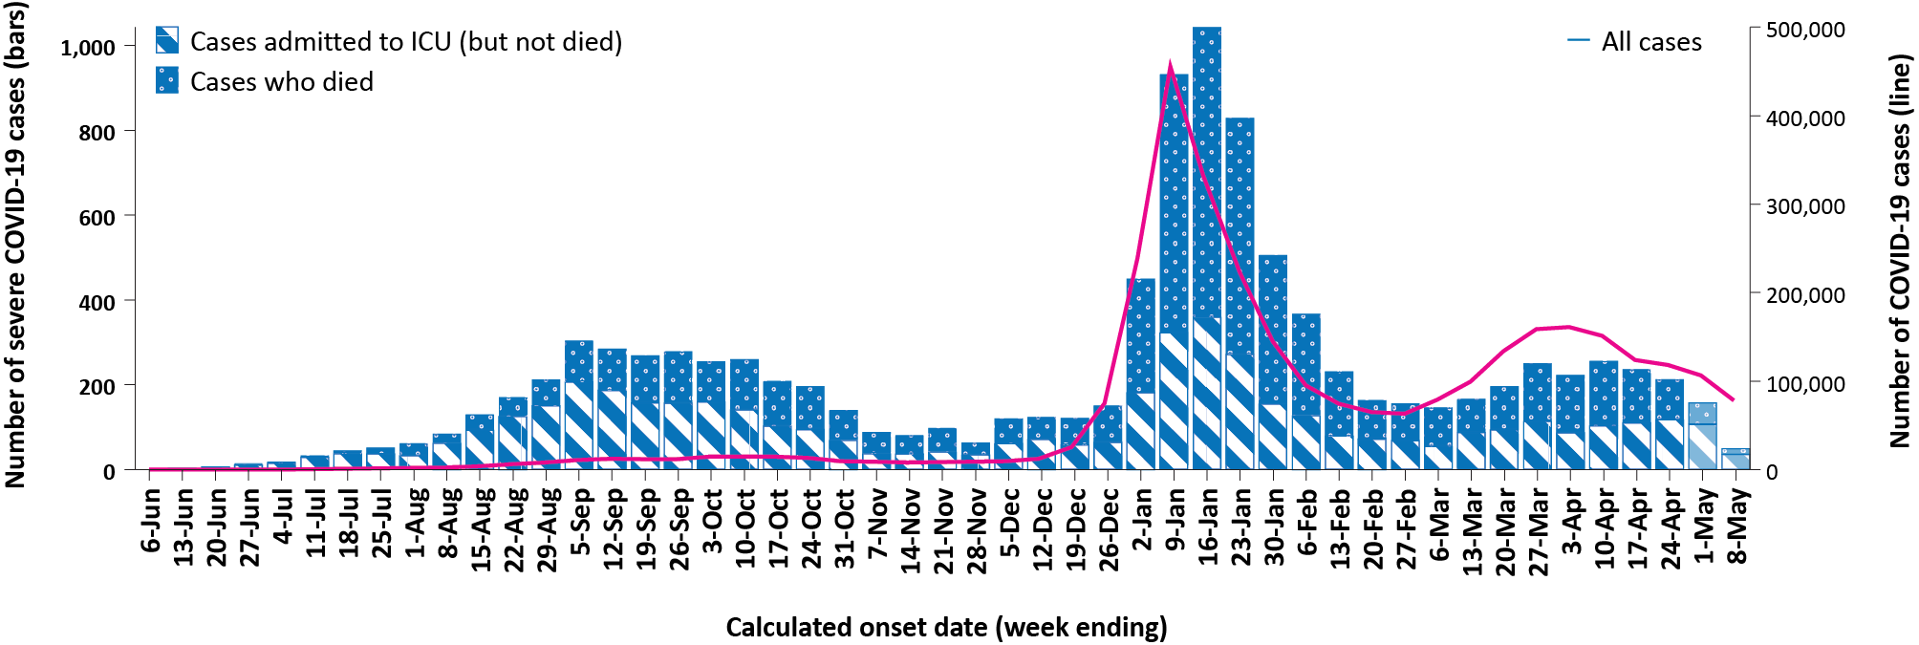
a NINDSS, extract from 9 May 2022, for cases notified to 8 May 2022.
b The shaded bars at the right represent the most recent two reporting weeks and should be interpreted with caution as cases with an illness onset in these weeks may not have yet developed severe disease.
Figure 4: Age-specific rates of COVID-19 cases admitted to ICU or died, by date of diagnosis, Australia, 31 May 2021 to 24 April 2022ª
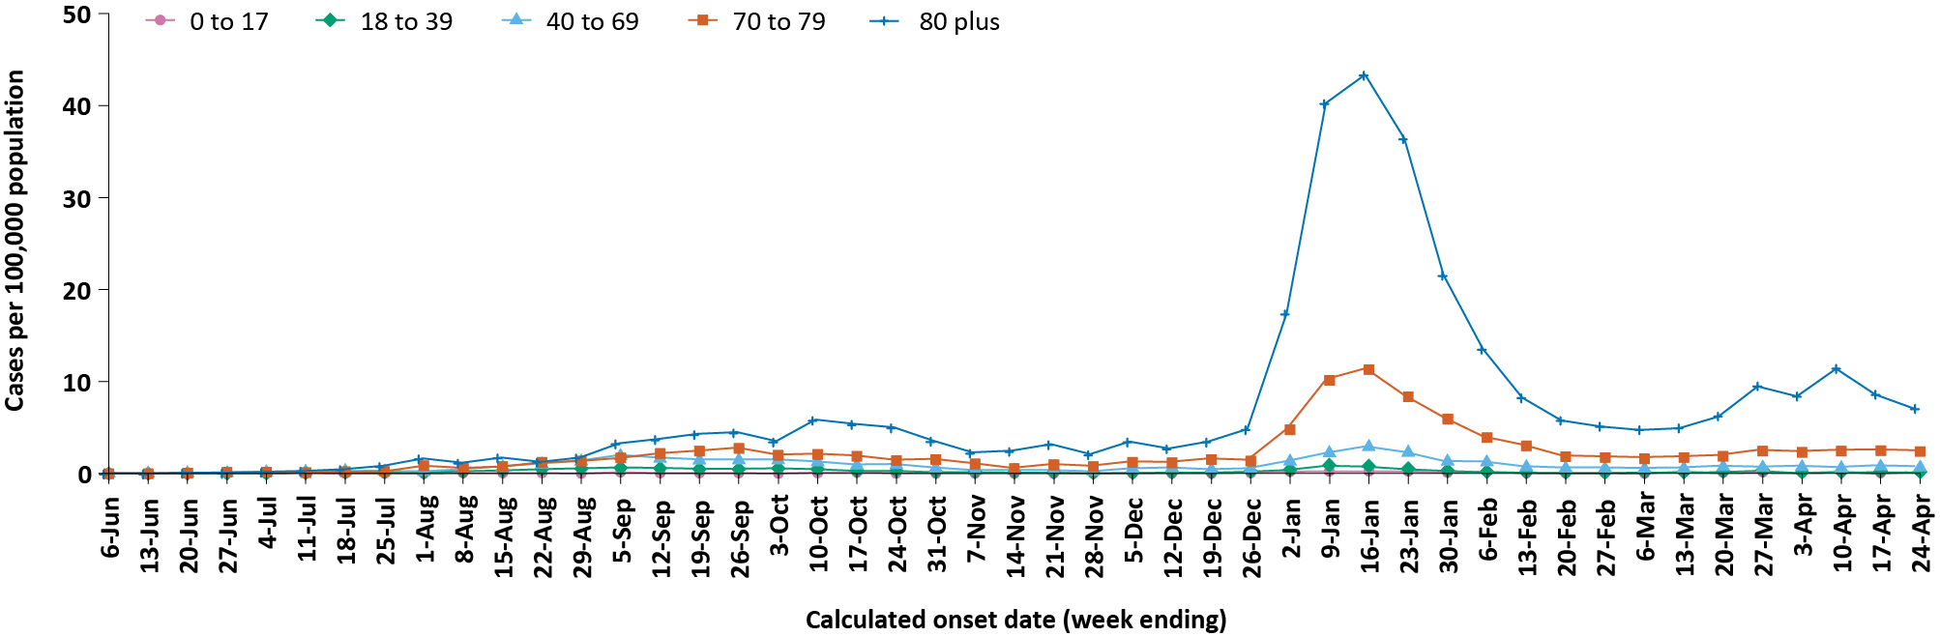
a NINDSS, extract from 9 May 2022. Includes cases with an illness onset up to 24 April 2022; cases with an illness onset in the last two weeks (25 April – 8 May 2022) were excluded to account for the delay between onset and development of severe illness.

Hospitalisation and ICU admissions
Between 15 December 2021 and 8 May 2022, there were 2,922 hospital admissions with confirmed COVID-19 reported at Influenza Complications Alert Network (FluCAN) sentinel sites, including 9% (257/2,922) admitted directly to ICU. In the current reporting period to 8 May 2022, there were 312 admissions with COVID-19 reported, including 6% (19/312) who were admitted directly to ICU. From the start of the Omicron wave to 8 May 2022, there were 2,041 COVID-19 cases admitted to ICUs participating in the sentinel surveillance system, Short Period Incidence Study of Severe Acute Respiratory Infection (SPRINT-SARI),⁴with 246 of these admitted during this reporting period (11 April – 8 May 2022).
Since 15 December 2021, for patients admitted to FluCAN sentinel sites with confirmed COVID-19, the median length of stay was 5 days (interquartile range, IQR: 2–9); mean (standard deviation, SD) = 6.8 days (7.2). This is lower than the median length of stay observed during the Delta wave, which was 6 days (IQR: 3–10); mean (SD) = 8.8 days (21.3).

Risk factors for severe disease
Comorbidity data extracted from SPRINT-SARI reflect the sickest patients with COVID-19 who are managed in ICU; data are therefore not generalisable to all cases (Table 7). In patients admitted to ICU with COVID-19 since 15 December 2021, the most prevalent comorbidity was diabetes, followed by obesity (a body mass index of > 30 or weight over 120 kg). Of those adult patients admitted to ICU since 15 December 2021 for whom comorbidity data was known, 75% (1,318/1,761) had at least one comorbidity; 25% of patients (443/1,761) had none of the listed comorbidities recorded.

Table 7: Comorbidities for adult COVID-19 cases (aged greater than or equal to 18 years) amongst those admitted to ICU, Australia, 15 December 2021 – 8 May 2022ª
Comorbidity | ICU casesª (n = 1,761) (%)
Cardiac disease (n = 1,746) | 422 (24%)
Chronic respiratory condition (n = 1,746)^{b} | 409 (23%)
Diabetes (n = 1,744) | 607 (35%)
Obesity (n = 1,710) | 461 (27%)
Chronic renal disease (n = 1,732) | 263 (15%)
Chronic neurological condition (n = 1,734) | 99 (6%)
Malignancy (n = 1,742) | 200 (12%)
Chronic liver disease (n = 1,741) | 90 (5%)
Immunosuppression (n = 1,738) | 295 (17%)
Number of specified comorbidities (n = 1,761)^{c}
No comorbidities | 443 (25%)
One or more | 1,318 (75%)
Two or more | 838 (48%)
Three or more | 429 (24%)
a Source: SPRINT-SARI. Only includes adult cases (≥ 18 years old) and excludes those with missing data on comorbidities or where comorbidity is unknown.
b Includes asthma.
c Includes chronic respiratory conditions, cardiac disease (excluding hypertension), immunosuppressive condition/therapy, diabetes, obesity, liver disease, renal disease and neurological disorder.

PIMS-TS

Paediatric Active Enhanced Disease Surveillance (PAEDS)
Since the start of the pandemic to 8 May 2022, there have been 107 cases of paediatric inflammatory multisystem syndrome temporally associated with SARS-CoV-2 (PIMS-TS) reported to PAEDS, including 72 cases reported in 2022 and 12 in the current reporting period. The majority of PIMS-TS cases to date have occurred in those aged 5 to < 12 years (56%; 60/107), followed by those aged 6 months to < 5 years (23%; 25/107).

COVID-19 deaths
There were 512 COVID-19 associated deaths among PCR-confirmed cases notified during the reporting period. After rising throughout March and early April 2022, there was a decreasing trend over the current reporting period, with 56 deaths reported among confirmed cases in the most recent week, compared with 157 in the week ending 17 April 2022. This brings the total number of COVID-19-associated deaths among confirmed cases reported in NINDSS to 6,524 (Table 8).
Across all age groups, the population mortality rate for the current Omicron wave to date has exceeded that of the Delta wave. For those aged 70 years and over, the population mortality rate during the Omicron wave is more than double that observed during the Delta wave (Table 9). The higher mortality rates during the Omicron wave are due to the significantly higher levels of disease transmission in the community during the Omicron wave, rather than the Omicron variant inherently causing more severe illness compared to the Delta variant.

Table 8: Deaths associated with COVID-19 by reporting period, Australia, 1 January 2020 – 8 May 2022^{a,b}
Jurisdiction^{c} | 11–17 April 2022 | 18–24 April 2022 | 25 April – 1 May 2022 | 2–8 May 2022 | 15 December 2021 – 8 May 2022  (Omicron wave) | 1 January 2020 – 8 May 2022  (Pandemic to date)
ACT | 3 (1.9%) | 1 (0.6%) | 3 (2.4%) | 2 (3.6%) | 36 (0.8%) | 48 (0.7%)
NSW | 77 (49.0%) | 79 (45.4%) | 50 (40.0%) | 25 (44.6%) | 1,775 (41.6%) | 2,470 (37.9%)
NT | 2 (1.3%) | 4 (2.3%) | 2 (1.6%) | 0 (0.0%) | 34 (0.8%) | 35 (0.5%)
Qld | 19 (12.1%) | 24 (13.8%) | 17 (13.6%) | 8 (14.3%) | 710 (16.6%) | 717 (11.0%)
SA | 16 (10.2%) | 15 (8.6%) | 10 (8.0%) | 0 (0.0%) | 354 (8.3%) | 358 (5.5%)
Tas. | 1 (0.6%) | 0 (0.0%) | 0 (0.0%) | 0 (0.0%) | 11 (0.3%) | 25 (0.4%)
Vic. | 38 (24.2%) | 50 (28.7%) | 42 (33.6%) | 21 (37.5%) | 1,281 (30.0%) | 2,796 (42.9%)
WA | 1 (0.6%) | 1 (0.6%) | 1 (0.8%) | 0 (0.0%) | 66 (1.5%) | 75 (1.1%)
Total | 157 (100.0%) | 174 (100.0%) | 125 (100.0%) | 56 (100.0%) | 4,267 (100.0%) | 6,524 (100.0%)
a Source: NINDSS, extract from 9 May 2022 for deaths to 8 May 2022.
b Deaths are categorised into time periods using date of death. Deaths with a missing date of death are classified using date of illness onset.
c ACT: Australian Capital Territory; NSW: New South Wales; NT: Northern Territory; Qld: Queensland; SA: South Australia; Tas.: Tasmania; Vic.: Victoria; WA: Western Australia.
Table 9: COVID-19 associated deaths notified to NINDSS, by age group and date of onset, 1 January 2020 to 8 May 2022ª
Age group (years) | 15 December 2021 – 8 May 2022 (Omicron wave) |  | 16 June 2021 – 14 December 2021  (Delta wave) |  | 1 January 2020 – 8 May 2022  (Pandemic to date)
 | Deaths | Population mortality rate^{b} | Deaths | Population mortality rate^{b} | Deaths | Population mortality rate^{b}
0–4 | 5 | 0.3 | — | 0.0 | 5 | 0.3
5–11 | 2 | 0.1 | 1 | < 0.05 | 3 | 0.1
12–15 | 2 | 0.2 | 1 | 0.1 | 3 | 0.2
16–17 | 1 | 0.2 | — | 0.0 | 1 | 0.2
18–29 | 13 | 0.3 | 8 | 0.2 | 22 | 0.5
30–39 | 36 | 1.0 | 22 | 0.6 | 60 | 1.6
40–49 | 69 | 2.1 | 48 | 1.5 | 119 | 3.6
50–59 | 148 | 4.7 | 122 | 3.9 | 285 | 9.1
60–69 | 403 | 14.7 | 212 | 7.7 | 652 | 23.8
70–79 | 870 | 44.6 | 364 | 18.6 | 1,394 | 71.4
80–89 | 1,545 | 176.3 | 439 | 50.1 | 2,362 | 269.5
90+ | 1,066 | 480.3 | 228 | 102.7 | 1,618 | 729.0
Unknown | — | — | — | — | — | —
Total | 4,160 | 16.2 | 1,445 | 5.6 | 6,524 | 25.3
a Source: NINDSS, extract from 9 April 2022.
b Population mortality rates are presented per 100,000 population for the given time period.

Genomic surveillance and virology

Communicable Disease Genomics Network, AusTrakka and jurisdictional sequencing laboratories)
Nationally, 2.8% of COVID-19 cases have been sequenced since the start of the pandemic in January 2020, based on jurisdictional reporting of cases (Table 10). Case numbers and sequencing proportion are based on PCR results only, as rapid antigen tests do not allow for sequencing. The significant rise in case numbers nationally during recent reporting periods has required jurisdictional laboratories to move towards sequencing for surveillance purposes, resulting in a drop in the overall sequencing proportion. However, overall output of number of cases sequenced remains similar to, or higher than, previous periods (Figure 5).
Table 10: Australian SARS-CoV-2 genome sequences and proportion of positive cases sequenced, 11 April – 8 May 2022 and cumulative to date
Measure | Reporting period  11 April – 8 May 2022 | Cumulative  23 January 2020 – 8 May 2022
SARS-CoV-2 cases sequencedª | 7,168 | 96,797
Percentage of positive cases sequenced^{b} | 1.55% | 2.82%
a Based on individual jurisdictional reports of sequences and case numbers. Calculations of the percentage of cases sequenced based on the number of sequences available in AusTrakka may not always be up-to-date, since this may include duplicate samples from cases and may not represent all available sequence data.
b Total SARS-CoV-2 case numbers as reported by jurisdictional laboratories based on PCR results only. Cases identified via rapid antigen testing are reported differently by each jurisdiction and cannot be followed up for sequencing. They are therefore not included in the sequencing proportions reported here. Sequencing of samples from cases identified in the reporting period may be in process at the time of reporting. Remaining unsequenced samples may be due to jurisdictional sequencing strategy, or where samples have been deemed unsuitable for sequencing (typically because viral loads were too low for sequencing to be successful).

Variants of concern (VOC)
AusTrakka⁵ is actively monitoring and reporting on the two lineages currently designated Variants of Concern (VOC) by international organisations, including the World Health Organisation: Delta (B.1.617.2) and Omicron (B.1.1.529). Both variants display characteristic sets of mutation, including a number of variations in the genomic region encoding the spike protein thought to have the potential to increase transmissibility and/or immune evasion. The CDGN VOC working group demoted three previously designated VOCs (Alpha (B.1.1.7); Beta (B.1.351) and Gamma (P.1)) due to the sustained absence of any cases in Australia, and very limited prevalence globally. Further information on variants is available in the Technical Supplement.²
For samples collected in the 21-day period from 18 April to 9 May 2022, the BA.2 sub-lineage constituted 94.6% (2,342/2,475) of all lineages identified in AusTrakka. This indicates a genuine dominance of the BA.2 lineage among the sequenced samples. Of the sequences in AusTrakka to date, 31,510 have been identified as the Delta VOC (including AY sub-lineages) and 44,233 have been identified as the Omicron VOC (including Omicron-like sub-lineages). Of identified Omicron sub-lineages, 58.8% are BA.1; 41.1% are BA.2; < 0.001% are BA.3; 0.027% are BA.4 and 0.011% are BA.5. All sub-sub-lineages have been collapsed into respective major sub-lineages.

Figure 5: Samples in AusTrakka from 10 November 2021 to 8 May 2022, by lineage and date of collectionª
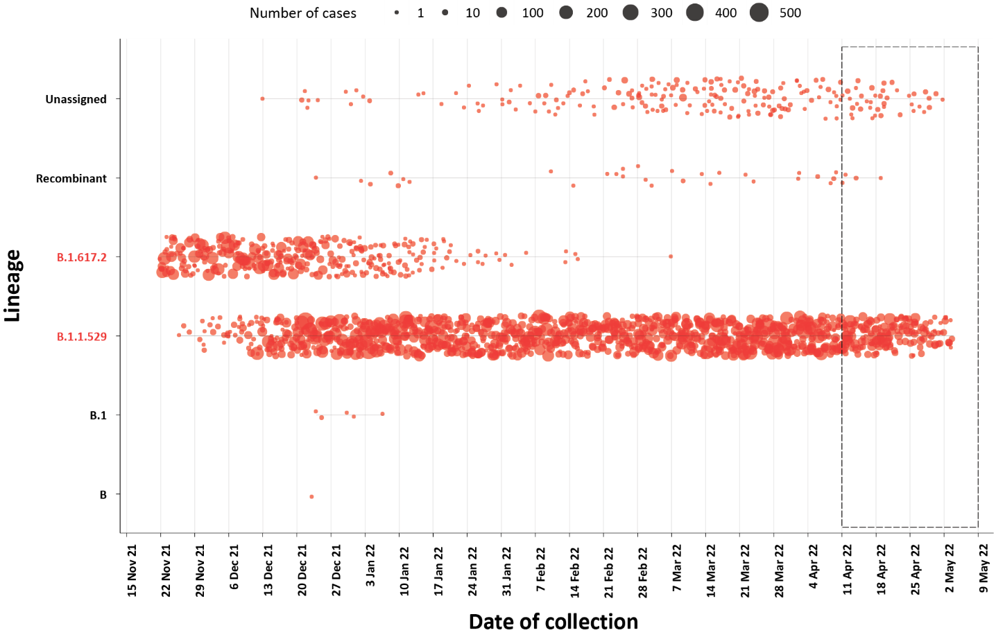
a The current reporting period (11 April to 8 May 2022) is marked by the dashed lines, and variant of concern samples are coloured red. The size of the circle is proportional to the number of samples in the lineage at each time point.
Figure 6: Sequences in Austrakka by Omicron sub-lineage and collection date, 14 March to 8 May 2022ª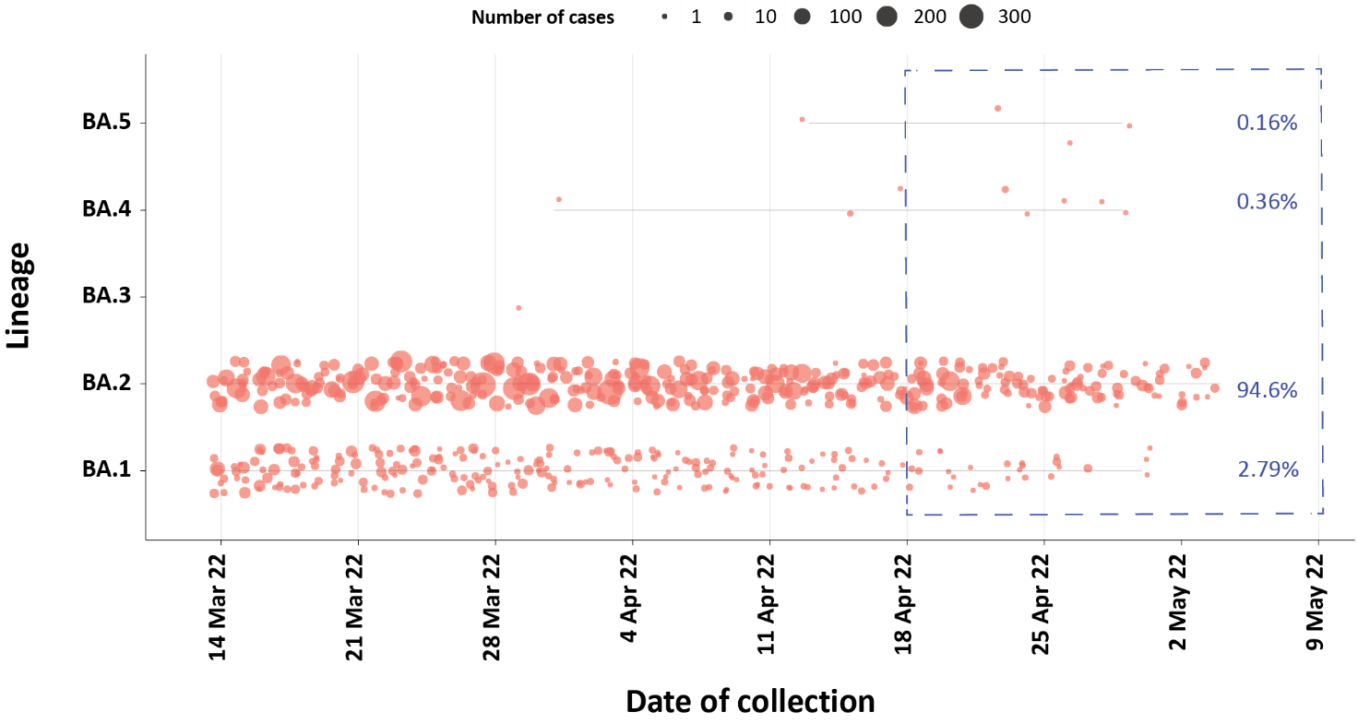
a The most recent three-week period (18 April to 8 May 2022) is marked by the dashed lines. The size of the circle is proportional to the number of samples in the lineage at each time point.

Testing

(State and territory reporting)
From the commencement of the pandemic to 8 May 2022, over 70 million COVID-19 PCR tests have been conducted nationally. Jurisdictional PCR testing rates are driven by current case numbers, testing policies and numbers of people experiencing symptoms. The number, rates and percent positivity of RATs cannot be calculated, as there is currently no reporting of negative RATs.
During the four-week reporting period from 11 April to 8 May 2022, over 2 million PCR tests were conducted. During the reporting period, weekly PCR testing rates decreased across all jurisdictions, except for Victoria (Figure 7). In the week ending 8 May 2022, PCR percent positivity by jurisdiction ranged from 6.1% in the Northern Territory to 30.0% in the Australian Capital Territory.

Figure 7: SARS-CoV-2 polymerase chain reaction (PCR) testing rates per 1,000 population and percent positivity by jurisdiction and date of notification, 31 May 2021 – 8 May 2022ª
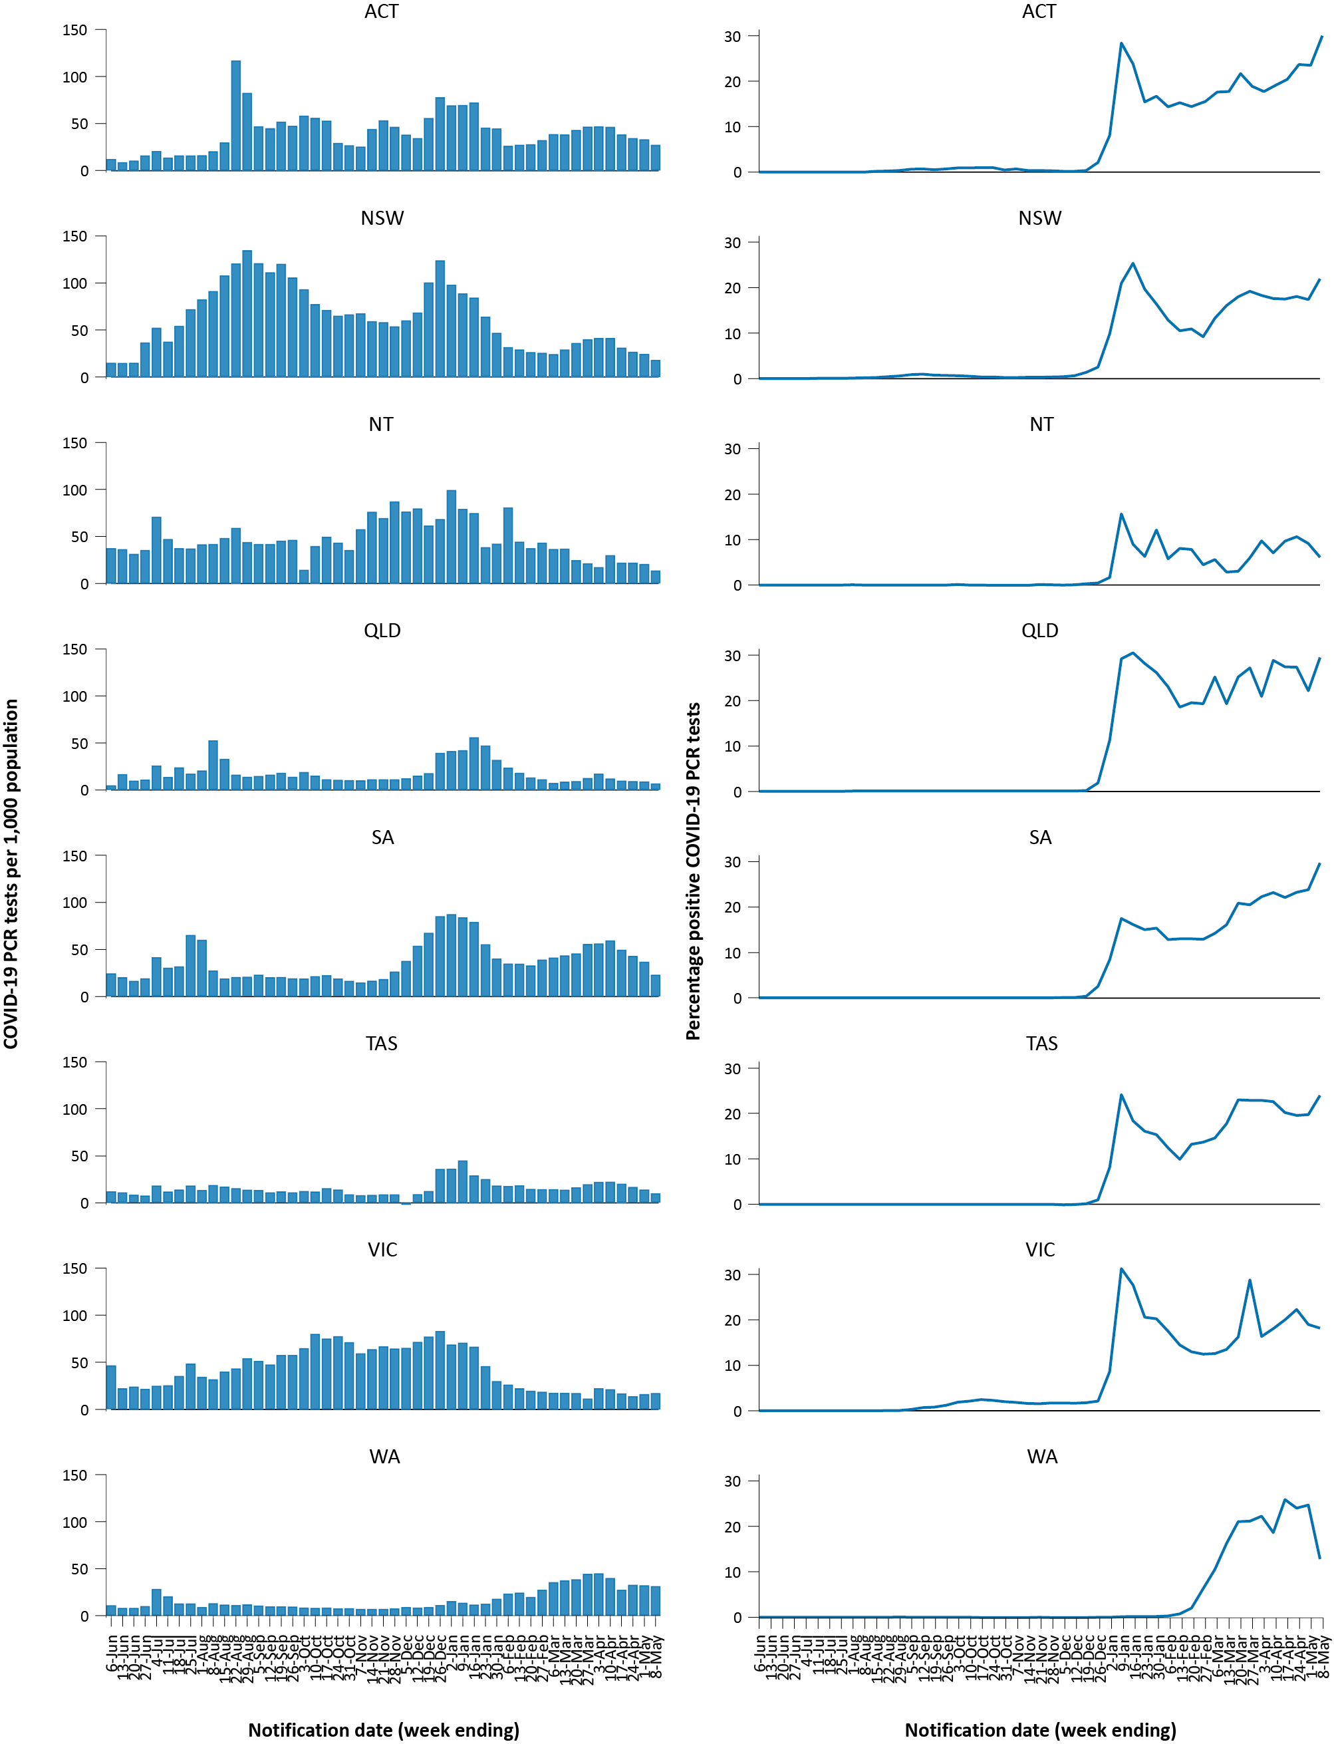
a Source: testing data provided by jurisdictions to the NIR daily, current to 8 May 2022; case data extracted from NINDSS on 10 May 2022 for cases with a notification date up to 8 May 2022; population data based on Australian Bureau of Statistics (ABS) Estimated Resident Population (ERP) as at June 2021.

Acute respiratory illness

(FluTracking, ASPREN, and Commonwealth Respiratory Clinics)
Based on self-reported FluTracking data,⁶ prevalence of fever and cough in the community over this reporting period increased from 1.7% to 2.1% (Figure 8). This is higher than the rate observed during the peak of cases in the Omicron wave in January 2022, which was 1.5%. The prevalence of runny nose and sore throat symptoms also increased throughout the reporting period from 1.4% to 1.7%, which is notably higher than the prevalence of 0.9% that was observed for runny nose and sore throat symptoms during the apparent peak of the Omicron wave in January 2022.
Figure 8: Weekly trends in respiratory illness amongst FluTracking survey participants (age-standardised) compared to the average of the previous five years, Australia, by epidemiological week,ª 1 January 2020 – 8 May 2022^{b}
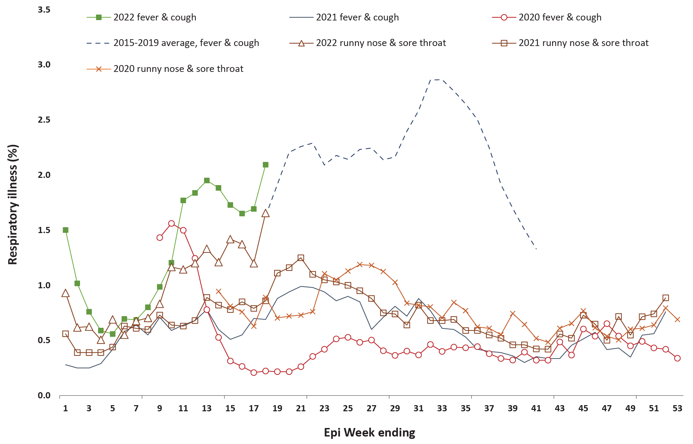
a Epidemiological weeks are a standardised method for numbering weeks across years, with the first epidemiological week of any year ending on the first Saturday in January.
b In years prior to 2020, FluTracking was activated during the main Influenza season from May to October. A historical average beyond the week ending 11 October (epidemiological week 41) is therefore not available. In 2020, FluTracking commenced ten weeks early to capture data for COVID-19. Data on runny nose and sore throat were only collected systematically after 29 March 2020, therefore a historical average for this symptom profile is unavailable.
In this reporting period, acute respiratory illness was highest in those aged 0 to 9 years, based on both self-reported FluTracking data and presentations to Commonwealth Respiratory Clinics. Throughout the reporting period, fever and cough symptoms were observed more commonly in younger age groups and generally decreased with age, whilst the rate of runny nose and sore throat symptoms were highest in those aged 30 to 39 years.
Rates of fever and cough by jurisdiction ranged from 12.1 per 1,000 FluTracking participants in Tasmania to 15.6 per 1,000 participants in Queensland. Rates of runny nose and sore throat ranged from 9.5 per 1,000 FluTracking participants in Western Australia to 16.2 per 1,000 FluTracking participants in the Australian Capital Territory. Overall, rates for both sets of symptoms increased from the previous reporting period.
Over the reporting period, FluTracking data indicated that 34% of participants with ‘fever and cough’ were tested for SARS-CoV-2 with a PCR test and 88% were tested using a RAT (noting that in some instances RATs will be followed up by a PCR test for the same case). Of those with runny nose and sore throat, 17% were tested for SARS-CoV-2 using a PCR test and 76% were tested using a RAT. Of those with fever and cough who tested for SARS-CoV-2, 60% who were tested with a PCR test, and 55% who were tested with a RAT, were positive. In comparison, of participants with runny nose and sore throat who tested for SARS-CoV-2, 20% of those tested by PCR, and 12% of those tested by RAT, tested positive. Note that participants with one set of symptoms are not excluded from having the other.
Based on FluTracking data, in the most recent four-week period, testing rates for fever and cough were highest in South Australia for PCR (55.0%) and in Western Australia for RATs (92.1%), while rates were lowest in Queensland for PCR (17.1%) and in the Australian Capital Territory for RATs (81.9%). Testing rates for runny nose and sore throat were highest in South Australia for PCR (26.8%) and in Western Australia for RATs (85.5%), whilst rates were lowest in Queensland for PCR (8.6%) and in the Northern Territory for RATs (63.2%). It is important to acknowledge that there may be legitimate reasons why people did not get tested, including barriers to accessing testing. Symptoms reported to FluTracking are not specific to COVID-19 and may also be due to infections with other respiratory pathogens and chronic diseases, such as asthma.
From 11 April to 8 May 2022, there were 66,442 assessments at Commonwealth Respiratory Clinics. Of these, there were 60,471 assessments with consent to share information, with 90% (54,132/ 60,471) tested for SARS-CoV-2. Of those who tested, 16% (8,665/ 54,132) were found to be positive. The most commonly reported symptom amongst presentations that tested positive for COVID-19 was sore throat (55%), followed by cough (52%) and tiredness (44%).

Countries and territories in Australia’s near region
According to the World Health Organization (WHO), countries and territories in the South East Asian and Western Pacific regions reported 6,493,096 newly-confirmed cases and 15,222 deaths in the four-week period to 8 May 2022, bringing the cumulative cases in the two regions to over 113.7 million, and cumulative deaths in these regions to over 1 million.⁷New case numbers in the South East Asian region over this four-week reporting period have almost halved in comparison to the previous four week reporting period, and new cases in the Western Pacific region have decreased by more than a third.⁸The number of new deaths in the four-week reporting period have followed the same pattern as cases, with decreases in the South East Asian region compared to the previous four weeks and decreases in the Western Pacific region.
Table 11 outlines the new cases and deaths in the four-week period to 8 May 2022 and cumulative cases and deaths for the pandemic in selected countries with the highest number of new cases in the South East Asian region and the Western Pacific region.

Table 11: Cumulative cases and deaths, and new cases and deaths reported in the four-week period to 8 May 2022 for selected countries in Australia’s near region according to WHOª
Country | Cumulative cases | New cases reported in the last 4 weeks | Change in new cases in the last 4 weeks^{b} | Cumulative deaths | New deaths reported in the last 4 weeks | Change in new deaths in the last 4 weeks^{b}
South East Asian region
Indonesia | 5,890,495 | 1,082,717 | 102% | 152,166 | 6,990 | 595%
Thailand | 3,184,825 | 591,498 | 120% | 23,709 | 1,273 | 149%
India | 42,990,991 | 359,570 | -93% | 515,850 | 7,185 | -68%
Bangladesh | 1,949,486 | 39,822 | -86% | 29,111 | 292 | -57%
Nepal | 977,937 | 4,878 | -96% | 11,950 | 58 | -79%
Western Pacific region
Republic of Korea | 6,556,432 | 5,205,805 | 691% | 10,395 | 3,314 | 330%
Vietnam | 5,903,147 | 3,418,666 | 617% | 41,290 | 2,428 | -28%
Japan | 5,720,394 | 1,888,430 | -5% | 26,029 | 5,827 | 229%
Australia | 3,163,767 | 660,694 | -44% | 5,571 | 1,025 | -46%
Philippines | 3,670,175 | 35,945 | -92% | 57,441 | 2,511 | 21%
a Source: World Health Organization Coronavirus (COVID-19) Dashboard, accessed 11 May 2022.
b Percent change in the number of newly confirmed cases/deaths in the most recent four-week period compared to the four weeks prior.
As of 8 May 2022, almost 515 million COVID-19 cases and over 6.2 million deaths have been reported globally since the start of the pandemic, with a global case fatality rate (CFR) of 1.2%. The two regions reporting the largest burden of disease over the past four weeks were the European region (42% of total cases) and the Americas region (30% of total cases).

Acknowledgements
We thank public health staff from incident emergency operations centres and public health units in state and territory health departments, and the Australian Government Department of Health, along with state and territory public health laboratories. We thank those who have provided data from surveillance systems, such as Commonwealth respiratory clinics, ASPREN, FluTracking, FluCAN, SPRINT-SARI, Communicable Disease Genomics Network, AusTrakka and jurisdictional sequencing laboratories.

Author details

Corresponding author
COVID-19 National Incident Room Surveillance Team
Australian Government Department of Health, GPO Box 9484, MDP 14, Canberra, ACT 2601.
Email: epi.coronavirus@health.gov.au

References
- COVID-19 National Incident Room Surveillance Team. COVID-19 Australia: Epidemiology Report 60: Reporting period ending 10 April 2022.Commun Dis Intell (2018). 2022;46. doi: https://doi.org/10.33321/cdi.2022.46.33.
- COVID-19 National Incident Room Surveillance Team. Technical supplement. COVID-19 Australia: Epidemiology reporting.Commun Dis Intell (2018). 2021;45. doi: https://doi.org/10.33321/cdi.2021.45.2.
- Australian Government Department of Health. Vaccination numbers and statistics. [Internet.] Canberra: Australian Government Department of Health; 2022. [Accessed on 9 May 2022.] Available from: https://www.health.gov.au/initiatives-and-programs/covid-19-vaccines/numbers-statistics.
- Australian and New Zealand Intensive Care Research Centre (ANZIC-RC). SPRINT-SARI: Short period incidence study of severe acute respiratory infection. [Internet.] Melbourne: Monash University, ANZIC-RC; 2020. Available from: https://www.monash.edu/medicine/sphpm/anzicrc/research/sprint-sari.
- Communicable Diseases Genomics Network (CDGN). AusTrakka. [Website.] Melbourne: CDGN; 2020. Available from: https://www.cdgn.org.au/austrakka.
- Dalton C, Durrheim D, Fejsa J, Francis L, Carlson S, d’Espaignet ET et al. Flutracking: a weekly Australian community online survey of influenza-like illness in 2006, 2007 and 2008.Commun Dis Intell Q Rep. 2009;33(3):316–22.
- World Health Organization (WHO). WHO Coronavirus Disease (COVID-19) dashboard. [Internet.] Geneva: WHO; 2021. Available from: https://covid19.who.int/.
- WHO. Weekly epidemiological update on COVID-19 – 11 May 2022. [Internet.] Geneva: WHO; 11 May 2022. [Accessed on 12 May 2022.] Available from: https://www.who.int/publications/m/item/weekly-epidemiological-update-on-covid-19---11-may-2022.

Appendix A: Supplementary figures and tables
Table A.1: COVID-19 cases and rates per 100,000 population, by age group, sex, and notification received date, Australia, 15 December 2021 – 8 May 2022^{a,b}
Age group | Four-week reporting period |  |  |  |  |  | Current ‘Omicron’ wave
 | 14 March – 8 May 2022 |  |  |  |  |  | 15 December 2021 – 8 May 2022
 | Cases |  |  | Rate per 100,000 population |  |  | Cases |  |  | Rate per 100,000 population
 | Male | Female | People | Male | Female | People | Male | Female | People | Male | Female | People
0–4 | 10,683 | 10,092 | 21,125 | 1,365.1 | 1,366.8 | 1,389.0 | 68,746 | 63,677 | 134,085 | 8,784.8 | 8,624.0 | 8,816.0
5–11 | 11,232 | 10,622 | 22,612 | 956.4 | 953.8 | 988.3 | 128,661 | 122,346 | 255,036 | 10,955.3 | 10,986.2 | 11,146.4
12–15 | 6,730 | 7,634 | 14,834 | 1,030.6 | 1,234.2 | 1,166.6 | 69,061 | 72,917 | 144,245 | 10,575.8 | 11,788.2 | 11,343.9
16–17 | 3,457 | 4,435 | 8,177 | 1,139.2 | 1,548.8 | 1,386.4 | 34,981 | 40,576 | 76,690 | 11,527.0 | 14,170.5 | 13,002.5
18–29 | 38,805 | 46,090 | 87,865 | 1,873.4 | 2,316.7 | 2,163.7 | 350,736 | 387,311 | 748,844 | 16,932.4 | 19,468.1 | 18,440.6
30–39 | 36,245 | 41,986 | 80,091 | 1,944.1 | 2,191.1 | 2,118.5 | 250,362 | 280,533 | 537,707 | 13,428.9 | 14,639.8 | 14,222.8
40–49 | 28,974 | 33,838 | 64,109 | 1,774.6 | 2,035.6 | 1,945.6 | 189,348 | 218,435 | 412,374 | 11,597.1 | 13,140.5 | 12,515.1
50–59 | 26,995 | 31,237 | 59,163 | 1,758.9 | 1,941.5 | 1,882.0 | 148,338 | 162,545 | 313,964 | 9,665.0 | 10,103.0 | 9,987.2
60–69 | 21,519 | 22,322 | 44,295 | 1,622.5 | 1,581.3 | 1,617.9 | 100,157 | 101,251 | 202,982 | 7,551.8 | 7,172.7 | 7,413.8
70–79 | 14,075 | 12,964 | 27,236 | 1,488.0 | 1,287.8 | 1,394.8 | 56,360 | 50,746 | 107,904 | 5,958.2 | 5,040.8 | 5,526.1
80–89 | 6,230 | 6,224 | 12,576 | 1,607.6 | 1,273.4 | 1,435.1 | 23,095 | 22,923 | 46,495 | 5,959.3 | 4,689.8 | 5,305.7
90 + | 1,462 | 2,659 | 4,198 | 1,879.5 | 1,844.5 | 1,891.5 | 5,275 | 9,076 | 14,600 | 6,781.3 | 6,296.0 | 6,578.2
a Source: NINDSS, extract from 9 May 2022 for notifications to 8 May 2022. Excludes cases where age or sex data is missing.
b Population data based on Australian Bureau of Statistics (ABS) Estimated Resident Population (ERP) as at June 2021.

Communicable Diseases Intelligence
ISSN: 2209-6051 Online

Communicable Diseases Intelligence (CDI) is a peer-reviewed scientific journal published by the Office of Health Protection and Response, Department of Health. The journal aims to disseminate information on the epidemiology, surveillance, prevention and control of communicable diseases of relevance to Australia.

Editor: Noel Lally
Deputy Editor: Simon Petrie
Design and Production: Kasra Yousefi
Editorial Advisory Board: David Durrheim, Mark Ferson, John Kaldor, Martyn Kirk and Linda Selvey

Website: http://www.health.gov.au/cdi

Contacts
CDI is produced by the Office of Health Protection and Response, Australian Government Department of Health, GPO Box 9848, (MDP 6) CANBERRA ACT 2601

Email: cdi.editor@health.gov.au

Submit an Article
You are invited to submit your next communicable disease related article to the Communicable Diseases Intelligence (CDI) for consideration. More information regarding CDI can be found at: http://health.gov.au/cdi.
Further enquiries should be directed to: cdi.editor@health.gov.au.

This journal is indexed by Index Medicus and Medline.

Creative Commons Licence - Attribution-NonCommercial-NoDerivatives CC BY-NC-ND
© 2022 Commonwealth of Australia as represented by the Department of Health
This publication is licensed under a Creative Commons Attribution-NonCommercial-NoDerivatives 4.0 International Licence from https://creativecommons.org/licenses/by-nc-nd/4.0/legalcode (Licence). You must read and understand the Licence before using any material from this publication.

Restrictions
The Licence does not cover, and there is no permission given for, use of any of the following material found in this publication (if any):
- the Commonwealth Coat of Arms (by way of information, the terms under which the Coat of Arms may be used can be found at www.itsanhonour.gov.au);
- any logos (including the Department of Health’s logo) and trademarks;
- any photographs and images;
- any signatures; and
- any material belonging to third parties.

Disclaimer
Opinions expressed in Communicable Diseases Intelligence are those of the authors and not necessarily those of the Australian Government Department of Health or the Communicable Diseases Network Australia. Data may be subject to revision.

Enquiries
Enquiries regarding any other use of this publication should be addressed to the Communication Branch, Department of Health, GPO Box 9848, Canberra ACT 2601, or via e-mail to: copyright@health.gov.au

Communicable Diseases Network Australia
Communicable Diseases Intelligence contributes to the work of the Communicable Diseases Network Australia.
http://www.health.gov.au/cdna

Previously known as the National Notifiable Diseases Surveillance System (NNDSS).

