COVID-19 Australia: Epidemiology Report 51
Reporting period ending 26 September 2021
COVID-19 National Incident Room Surveillance Team

Summary
Trends – The weekly number of new COVID-19 cases has remained stable in the last two weeks. The daily average of 1,704 cases for this reporting period was similar to the previous fortnight’s daily average of 1,629 cases. There were 23,855 cases of COVID-19 reported this fortnight, bringing the 2021 cumulative case count to 70,616.
Local cases – More than 99% (23,825/23,855) of COVID-19 cases reported this fortnight are known to be locally acquired. The majority of these cases were reported in New South Wales (63%; 15,003/23,825), followed by Victoria (36%; 8,550/23,825).
Clusters and high-risk settings – For the first time since the start of the Sydney metropolitan outbreak, the number of new locally-acquired cases reported in New South Wales in a fortnight decreased, with 14,868 locally-acquired cases reported this reporting period, compared to 18,639 locally-acquired cases reported in the previous reporting period. As at 26 September 2021, there were 53,865 locally-acquired cases in New South Wales, including 309 deaths, since the first case on 16 June 2021. Genomic testing showed that the outbreak's primary case was infected with the ‘Delta’ SARS-CoV-2 variant of concern (B.1.617.2). Several cases in other states had also been linked to this cluster. At the end of this reporting period, new case numbers were reducing in south-western and western Sydney and increasing case numbers were being seen in South Eastern Sydney, Northern Sydney and Sydney local health districts, as well as in a number of regional areas.
Locally-acquired cases reported in Victoria were linked to cases first reported on 5 August 2021. As at 26 September 2021, there were 12,515 cases associated with the Victorian outbreaks, which involved the Delta variant and were closely associated with the current New South Wales and recent July 2021 Victorian outbreaks. The number of cases reported this reporting period was more than twice that of the previous reporting period. Most cases in the Victorian outbreaks were in Greater Melbourne; however, cases had also been reported in regional Victoria.
The number of new cases associated with the Australian Capital Territory outbreak remained similar in this reporting period compared to the previous reporting period. The primary case in the outbreak was reported on 12 August 2021 and was infected with the Delta variant. As at 26 September 2021, a total of 769 cases had been reported as part of this outbreak.
In Queensland, most locally-acquired cases notified during the reporting period were part of an outbreak linked to travellers from New South Wales, with the first cases reported on 5 September 2021. As at 26 September 2021, a total of 14 cases were linked to this outbreak.
Aboriginal and Torres Strait Islander persons – During the reporting period, 1,222 new Aboriginal and Torres Strait Islander cases were notified, of which 1,157 were from New South Wales, 33 from Victoria and 32 from the Australian Capital Territory. To date in 2021, there were 2,960 cases and seven deaths reported among Aboriginal and Torres Strait Islander people. Of locally-acquired cases notified in 2021, 32% (916/2,916) lived in a regional or remote area.
Overseas cases – There were 30 overseas-acquired cases this reporting period, with the largest number of cases reported in New South Wales (50%; 15/30).
Severity – In 2021, based on the highest level of severity reported for cases with an illness onset up to 12 September 2021, 1% of cases were reported to have died, 2% of cases required intensive care and a further 13% required admission to hospital, noting that cases may be hospitalised for reasons other than clinical COVID-19 related care. Given the delay between illness onset and severe illness, cases with an onset in the last two weeks were excluded from the analysis on severity. During the reporting period, 147 new COVID-19-associated deaths were notified.
Vaccinations – As at 26 September 2021, there had been 26,806,343 doses of COVID-19 vaccine administered in Australia. Nationally, 15,695,827 people (76.1% of people aged 16 or over) have had at least one dose and 10,684,489 people (51.8% of people aged 16 or over) are fully vaccinated.
Keywords: SARS-CoV-2; novel coronavirus; 2019-nCoV; coronavirus disease 2019; COVID-19; acute respiratory disease; epidemiology; Australia
This reporting period covers the two-week period 13–26 September 2021, with data for this period compared to that from the previous two-week reporting period (30 August–12 September 2021).¹ The focus of this report is on the epidemiological situation in Australia since the beginning of 2021. Readers are encouraged to consult prior reports in this series for information on the epidemiology of cases in Australia in 2020.
Acute respiratory illness, testing, public health response measures, virology and the international situation are reported in detail on a four-weekly basis and are not included in this report. The latest information on these topics can be found in Epidemiology Report 50,¹ state and territory health websites, the World Health Organization’s weekly situation reports, and the Department of Health’s current situation and case numbers webpage.
From report 46 onward, and unless otherwise specified, tabulated data and data within the text are extracted from the National Interoperable Notifiable Diseases Surveillance System (NINDSS) based on ‘notification received date’ rather than ‘diagnosis date’ (see the Technical Supplement for definitions).² As a case’s diagnosis date can be several days prior to the date of its notification, there is potential for newly-notified cases to be excluded from the case count in the current reporting period when reporting by ‘diagnosis date’. Using ‘notification received date’ ensures that the case count for the reporting period better reflects the number of newly-notified cases. As the graphs presented in this report, based on NINDSS data, reflect a larger time period (i.e. year to date and entire pandemic), these will continue to be based on diagnosis date to enable a more accurate understanding of infection risk and local transmission.

Background and data sources
See the Technical Supplement for general information on COVID-19 including modes of transmission, common symptoms and severity.²

Activity

COVID-19 trends

(NINDSS and jurisdictional reporting to NIR)
The number of cases reported this fortnight was similar to the number reported in the previous fortnight. A total of 23,855 cases were notified in this two-week reporting period (an average of 1,704 cases per day), compared to 22,806 cases (an average of 1,629 cases per day) in the previous reporting period. The majority of cases occurred in New South Wales (63%; 15,018/23,855), followed by Victoria (36%; 8,551/23,855). Tasmania did not report any cases during the reporting period (Table 1).
Table 1: COVID-19 notifications by jurisdiction and source of acquisition, with a notification received date of 13–26 September 2021ª
Source^{b} | ACT | NSW | NT | Qld | SA | Tas. | Vic. | WA | Australia
Overseas | 0 | 15 | 4 | 2 | 4 | 0 | 1 | 4 | 30
Local, source known | 208 | 3,765 | 0 | 6 | 0 | 0 | 2,562 | 0 | 6,541
Local, source unknown | 47 | 158 | 0 | 0 | 0 | 0 | 10 | 0 | 215
Local, investigation ongoing | 0 | 10,944 | 0 | 0 | 0 | 0 | 0 | 0 | 10,944
Interstate, source known | 3 | 1 | 1 | 0 | 0 | 0 | 0 | 0 | 5
Interstate, source unknown | 1 | 0 | 0 | 1 | 0 | 0 | 0 | 1 | 3
Under initial investigation | 0 | 135 | 0 | 0 | 0 | 0 | 5,978 | 0 | 6,113
Missing source of acquisition | 0 | 0 | 1 | 1 | 0 | 0 | 0 | 2 | 4
Total | 259 | 15,018 | 6 | 10 | 4 | 0 | 8,551 | 7 | 23,855
a Source: NINDSS extract from 28 September 2021 for notifications to 26 September 2021.
b ACT: Australian Capital Territory; NSW: New South Wales; NT: Northern Territory; Qld: Queensland; SA: South Australia; Tas.: Tasmania; Vic.: Victoria; WA: Western Australia.
In the year to date, from 1 January 2021 to 26 September 2021, there have been 70,616 COVID-19 cases reported nationally. Until the week ending 20 June 2021, the number of weekly cases diagnosed this year had been below 180 cases per week. Since then, cases have increased and there have been over 1,000 cases diagnosed each week since the week ending 25 July 2021 and over 8,000 cases diagnosed each week since the week ending 29 August 2021. In the latest fortnight, case numbers decreased but still exceeded 8,000 each week, noting that this most recent week is likely an underestimate as additional cases may be identified in the coming week that have a diagnosis date in this period (Figure 1). The current peak in 2021 was 12,700 cases per week, which occurred in the week ending 12 September 2021. This peak considerably surpasses the two distinct peaks experienced in March and July of 2020, when new cases diagnosed per week reached approximately 2,700 and 3,000, respectively (Figure 2). Cumulatively, since the beginning of the epidemic in Australia, there have been 99,027 COVID-19 cases reported in Australia.
Figure 1: COVID-19 notified cases by source of acquisition and diagnosis date, 28 December 2020 – 26 September 2021^{a,b}
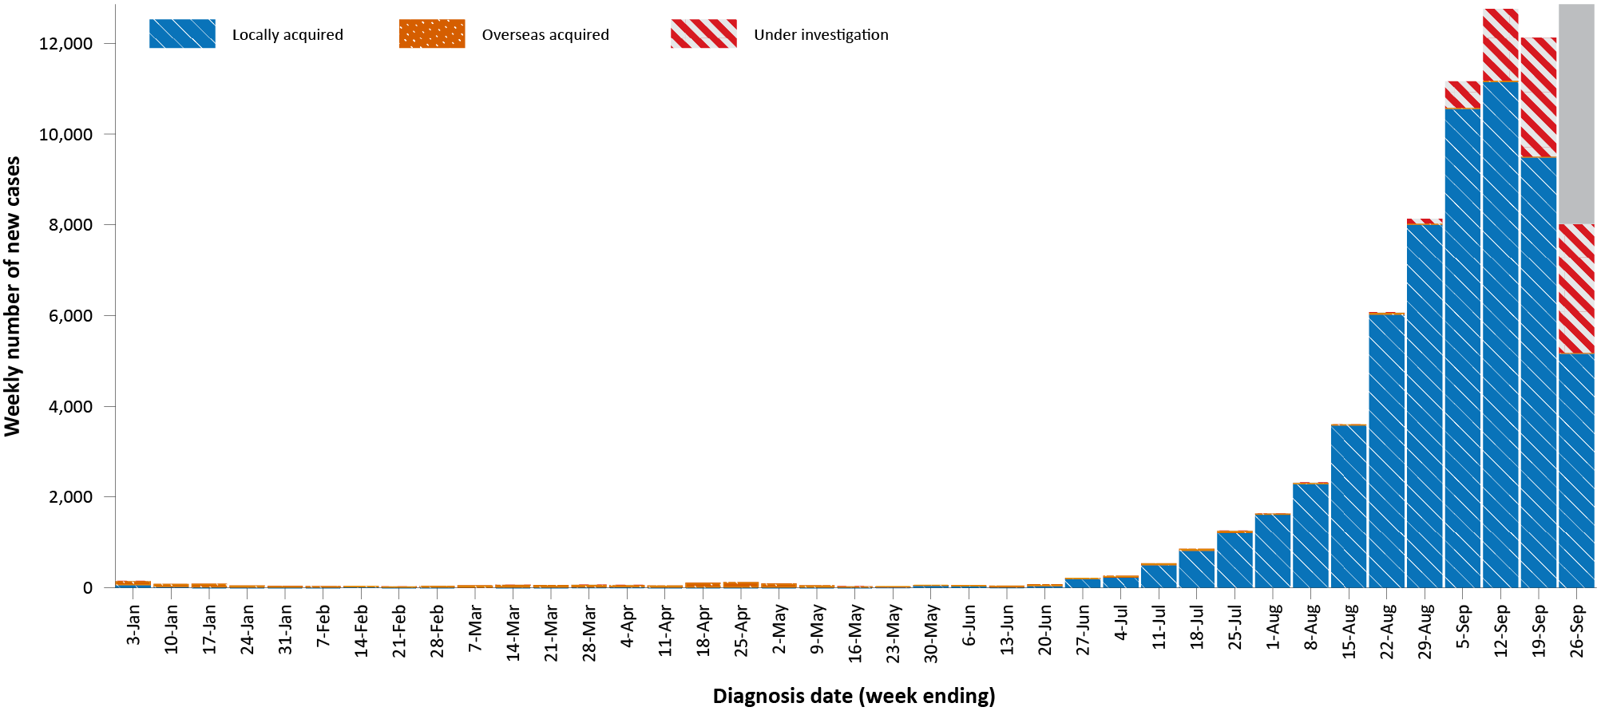
a Source: NINDSS, extract from 28 September 2021 for notifications to 26 September 2021.
b The shading shown on the bar chart, for the most recent reporting week, represents the scope for an as-yet-indefinite number of additional cases, not yet identified, but with a diagnosis date during this period.
Figure 2: COVID-19 notified cases by source of acquisition and diagnosis date, 2 March 2020 – 26 September 2021^{a,b}
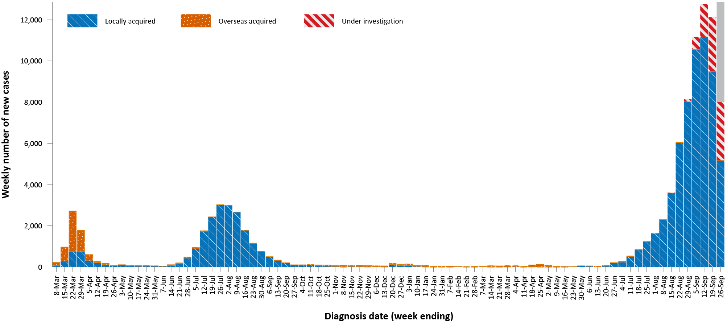
a Source: NINDSS, extract from 28 September 2021 for notifications to 26 September 2021.
b The shading shown on the bar chart, for the most recent reporting week, represents the scope for an as-yet-indefinite number of additional cases, not yet identified, but with a diagnosis date during this period.

Source of acquisition

(NINDSS)
In this reporting period, > 99% of cases notified (23,825/23,855) were considered to be locally acquired, comprising 27% (6,541/23,855) locally acquired with known source, 1% (215/23,855) locally acquired with unknown source, 46% (10,944/23,855) under ongoing investigation, 26% (6,113/23,855) under initial investigation, eight interstate acquired cases, and four cases missing a source of acquisition; < 1% of cases (30/23,855) were overseas acquired (Table 1).
New South Wales reported the majority of locally-acquired cases (63%; 15,003/23,825) in this fortnight, followed by Victoria (36%; 8,550/23,825). In the reporting period, 27% of locally-acquired cases (6,541/23,825) had a known contact or link to a cluster, and 218 cases (158 in New South Wales, 47 in the Australian Capital Territory and ten in Victoria) had an unknown source. At the end of the reporting period, the source of infection initial or ongoing investigation for 17,057 cases.
For 2021 to date, New South Wales had the highest infection rate for locally-acquired cases with 657.8 infections per 100,000 population, followed by Victoria with a rate of 206.4 per 100,000 population and the Australian Capital Territory with a rate of 178.8 infections per 100,000 population (Table 2). Excluding interstate-acquired cases, Tasmania reported that it had been more than a year since the last locally-acquired case (Table 3).
In the reporting period, New South Wales reported the largest number of cases (50%; 15/30) that were overseas acquired, followed by the Northern Territory, South Australia and Western Australia (each 13%; 4/30, respectively). In the past 28 days (30 August to 26 September), 41% (33/81) of confirmed overseas-acquired cases had an unknown country of acquisition. Cases acquired at sea (35%; 17/48) were the most frequent of those with an identified country of acquisition in the past 28 days, followed by cases acquired in Afghanistan (13%; 6/48) and Pakistan (8%; 4/48). The number of cases acquired in different countries is influenced by travel patterns of returning Australians, travel restrictions, and the prevalence of COVID-19 in the country of travel.

Demographic features

(NINDSS)
In this reporting period, the largest proportion of cases occurred in those aged 20 to 29 years (20%; 4,764/23,855). For this year, the highest rate of infection has been in those aged 20 to 29 years with a rate of 418.1 infections per 100,000 population (Figure 3; Appendix A, Table A.1). Adults aged 70 to 79 years have had the lowest rate of infection this year.
In 2021, notification rates were similar among males and females in those aged 0 to 19 and over 90 years old. In all other age groups, notification rates were higher among males than females (Figure 3; Appendix A, Table A.1). The median age of cases in this reporting period was 29 years (range: 0 to 100 years; interquartile range, IQR: 16 to 44 years).
Table 2: Locally-acquired COVID-19 case numbers and rates per 100,000 population by jurisdiction and reporting period, Australia, with a notification received date from 1 January to 26 September 2021
Jurisdiction | Reporting period | Reporting period | Cases this year
 | 13–26 September 2021 | 30 August 2021 – 12 September 2021 | 1 January 2021 – 26 September 2021
 | Number of cases^{b} | Number of cases^{b} | Number of cases^{b} | Rate per 100,000 population^{b,c}
ACT | 259 | 251 | 771 | 178.8
NSW | 15,003 | 18,674 | 53,923 | 660.2
NT | 2 | 0 | 13 | 5.3
Qld | 8 | 12 | 242 | 4.7
SA | 0 | 3 | 31 | 1.8
Tas. | 0 | 0 | 1 | 0.2
Vic. | 8,550 | 3,814 | 13,819 | 206.4
WA | 3 | 1 | 20 | 0.8
Australia | 23,825 | 22,755 | 68,820 | 267.8
a Source: NINDSS, data extract from 28 September 2021 for notifications to 26 September 2021.
b This total excludes overseas acquired cases and includes cases under initial investigation and with a missing source of acquisition. In previous reports, cases under initial investigation and those with a missing source of acquisition were excluded from this total.
c Population data based on Australian Bureau of Statistics (ABS) Estimated Resident Population (ERP) as at June 2020.
Table 3: Days since last locally-acquired COVID-19 case (source unknown and source known), by jurisdiction and diagnosis date, 26 September 2021ª
Jurisdiction | Locally acquired — source unknown^{b} |  | Locally acquired — source known^{b}
 | Date of last case | Days since last case | Date of last case | Days since last case
ACT | 25 September 2021 | 1 | 26 September 2021 | 0
NSW | 26 September 2021 | 0 | 26 September 2021 | 0
NT | NA^{c} | NA^{c} | 6 July 2021 | 82
Qld | 6 August 2021 | 51 | 24 September 2021 | 2
SA | 24 March 2020 | 551 | 3 August 2021 | 54
Tas. | 9 August 2020 | 413 | 24 April 2020 | 520
Vic. | 20 September 2021 | 6 | 26 September 2021 | 0
WA | 3 April 2020 | 541 | 2 August 2021 | 55
a Source: NINDSS, extract from 28 September 2021 for notifications to 26 September 2021.
b This does not include locally-acquired cases that were interstate acquired.
c NA: not applicable. The Northern Territory has not reported any locally-acquired cases with an unknown source of infection.
Figure 3: Cumulative COVID-19 cases for the calendar year to date, by age group and sex, Australia, with a diagnosis date of 1 January 2021 – 26 September 2021ª
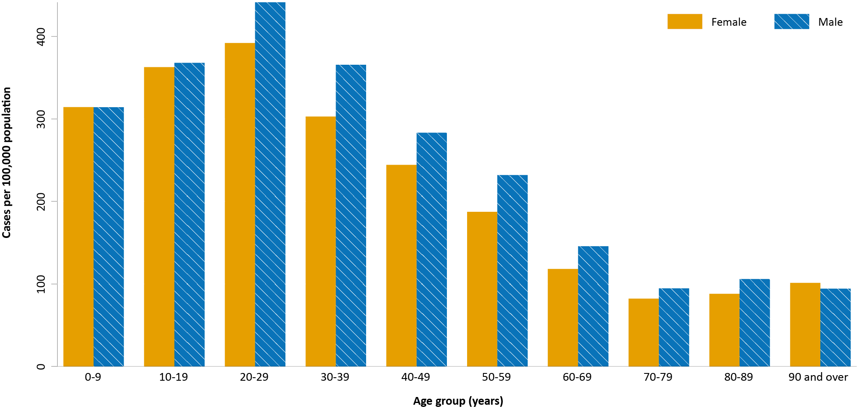
a Source: NINDSS, extract from 28 September 2021 for notifications to 26 September 2021.

Aboriginal and Torres Strait Islander persons

(NINDSS)
During the reporting period, there were 1,222 new cases notified in Aboriginal and Torres Strait Islander people, with 1,157 from New South Wales, 33 from Victoria and 32 from the Australian Capital Territory. Since the beginning of 2021, there have been 2,960 confirmed cases of COVID-19 notified in Aboriginal and Torres Strait Islander people, representing 4% (2,960/70,616) of all confirmed cases this year. Of the locally acquired cases notified in 2021, 32% (916/2,916) resided in a regional or remote area (Table 4).

Table 4: Confirmed cases of COVID-19 among Aboriginal and Torres Strait Islander peoples by place of acquisition and area of remoteness, 1 January – 26 September 2021ª
Jurisdiction | Locally acquired, Australiaª |  |  |  |  |  | Overseas acquired | Under initial investigation | Total
 | Major city | Inner regional | Outer regional | Remote | Overseas resident | Unknown
ACT | 42 | 0 | 0 | 0 | 0 | 0 | 0 | 0 | 42
NSW | 1,911 | 521 | 135 | 260 | 2 | 34 | 2 | 8 | 2,873
NT | 0 | 0 | 0 | 0 | 0 | 0 | 0 | 0 | 0
Qld | 3 | 0 | 0 | 0 | 0 | 0 | 3 | 0 | 6
SA | 0 | 0 | 0 | 0 | 0 | 0 | 0 | 0 | 0
Tas. | 0 | 0 | 0 | 0 | 0 | 0 | 0 | 0 | 0
Vic. | 8 | 0 | 0 | 0 | 0 | 0 | 0 | 30 | 38
WA | 0 | 0 | 0 | 0 | 0 | 0 | 1 | 0 | 1
Australia | 1,964 | 521 | 135 | 260 | 2 | 34 | 6 | 38 | 2,960
a Source: NINDSS, extract from 28 September 2021 for notifications to 26 September 2021.
The majority of cases reported in Aboriginal and Torres Strait Islander people in 2021 have been associated with the Sydney metropolitan and western regional outbreaks in New South Wales. There have been 2,862 locally acquired cases reported in Aboriginal and Torres Strait Islander people in New South Wales since 16 June 2021 when the Sydney metropolitan outbreak began. Since the start of the pandemic, there have been seven COVID-19 associated deaths in Aboriginal and Torres Strait Islander people, which were associated with the current outbreaks in New South Wales.
In total, up to 26 September 2021, there have been 3,108 cases in Aboriginal and Torres Strait Islander people, representing approximately 3% (3,108/99,027) of all confirmed cases in Australia, since January 2020. Indigenous status was unknown for approximately 23% of confirmed cases (22,400/99,027), with the majority of these associated with more recently reported cases, especially in New South Wales.
As at 26 September 2021, it has been 0 days since the last locally-acquired Aboriginal and Torres Strait Islander case was diagnosed and two days since the last overseas-acquired Aboriginal and Torres Strait Islander case was diagnosed. To date, the majority of Aboriginal and Torres Strait Islander cases were reported as locally acquired (98%; 3,032/3,108), with 38 cases each that were overseas acquired and under investigation. The median age of locally-acquired Aboriginal and Torres Strait Islander cases is 23 years old (range 0 to 99 years), while the median age of overseas-acquired cases is 39 years old (range 7 to 75 years). Overall, there has been a slightly higher proportion of cases among females (51%; 1,581/3,101) than among males (49%; 1,520/3,101), where the denominator is cases for which sex was known.

Vaccinations

(Department of Health)
As of 26 September 2021, a total of 26,806,343 doses of COVID-19 vaccine had been administered (Table 5), including 968,805 doses provided to aged care and disability residents. Nationally, 15,695,827 people (76.1% of people aged 16 or over) have had at least one dose and 10,684,489 people (51.8% of people aged 16 or over) are fully vaccinated.
Table 5: Total number of vaccinations administered, by jurisdiction, Australia, 26 September 2021ª
Jurisdiction | Total number of doses administered | Percentage of people aged 16 and over who have had at least one dose^{b} | Percentage of people aged 16 and over who are fully vaccinated
ACT | 651,381 | 87.6% | 61.5%
NSW | 9,705,842 | 85.7% | 60.4%
NT | 265,069 | 65.2% | 51.1%
Qld | 4,632,371 | 64.1% | 45.1%
SA | 1,652,188 | 66.1% | 47.8%
Tas. | 581,818 | 74.9% | 56.6%
Vic. | 6,982,207 | 77.9% | 47.7%
WA | 2,335,467 | 63.6% | 45.1%
Aged care and disability facilities^{c} | 968,805 | NA | NA
Primary cared | 14,416,986 | NA | NA
Total | 26,806,343 | 76.1% | 51.8%
a Source: Australian Government Department of Health website.³
b Includes people who are fully vaccinated.
c Commonwealth vaccine doses administered in aged care and disability facilities.
d Commonwealth vaccine doses administered in primary care settings.

Clusters and outbreaks

Sydney Metropolitan Outbreak and New South Wales Regional Outbreak – New South Wales
In total, as at 26 September 2021, there had been 53,865 locally-acquired cases in New South Wales, including 309 deaths, reported following notification of outbreak's first case in this outbreak on 16 June 2021. Genomic testing results showed that the first case was infected with the Delta SARS-CoV-2 variant of concern (B.1.617.2); however, the sequence did not match cases from the Victorian Delta variant outbreak that occurred from May to June 2021. This sequence had not been seen in Australia previously, but matched one from the United States of America.
For the first time since the start of the outbreak, the number of new locally-acquired cases in a fortnight decreased, with 15,003 locally-acquired cases (including cases under initial investigation) reported this reporting period, compared to 18,674 such cases reported in the previous reporting period. Following the initial start of the outbreak in south-east Sydney, the largest number of new cases were subsequently reported among residents of south-western and western Sydney, with cases also reported in residents of regional and remote areas in New South Wales, particularly in western New South Wales. At the end of the most recent reporting period, case numbers were reducing in south-western and western Sydney, while increasing case numbers were being seen in South Eastern Sydney, Northern Sydney and Sydney LHDs, as well as the regional areas of Illawarra and Cowra.

Metropolitan Melbourne and Victorian Regional Outbreak – Victoria
As at 26 September 2021, there had been 12,515 locally-acquired cases, including 27 deaths, reported in Victoria since two unlinked cases were reported on 5 August 2021. The size of the Victorian outbreak continued to increase during the reporting period, with the number of locally-acquired cases (including those under investigation) in Victoria this fortnight (8,550 cases) more than twice that of the previous fortnight (3,814 cases). Investigations into the source of infection were ongoing, but genomic testing had determined these outbreaks involved the Delta variant and are genomically closely associated with recent clusters in New South Wales and the previous two seeding events in Victoria from July 2021.
Most cases in the outbreak were in the northern and western suburbs of Greater Melbourne. However, since 20 August 2021, cases had also been reported in regional Victoria. Initially, regional cases were mainly reported in Shepparton. However, in the last two weeks, cases were also reported in other regional areas, including Ballarat, Geelong, Mitchell Shire and Surf Coast.

Canberra – Australian Capital Territory
As at 26 September 2021, a total of 769 cases had been reported as part of this outbreak. The first case in this outbreak, which was the first locally-acquired case in the Australian Capital Territory in over a year, was reported on 12 August 2021 and was confirmed to have the Delta variant. The source of infection remained under investigation at the end of this reporting period, though it was genomically related to the Sydney Metropolitan Outbreak. The number of new cases in the Australian Capital Territory during this reporting period (259) was similar to the previous reporting period (251).

Queensland
As at 26 September 2021, a total of 14 cases had been reported as part of an outbreak in Sunnybank, Brisbane, Queensland. The outbreak commenced on 5 September 2021, with the first cases reported among a small group of people who travelled from New South Wales to Queensland for essential work. As at 26 September 2021, the latest date that a case was infectious in the community was 10 September 2021.

Severity

(NINDSS, SPRINT-SARI)

Hospitalisation and intensive care unit admission
Given the delay between illness onset and severe illness, to provide a more accurate assessment of the highest level of severity, cases with an onset in the last two weeks were excluded from the analysis. In 2021, based on the highest level of severity reported for cases with an illness onset up to 12 September 2021, 1% of cases were reported to have died, 2% of cases required intensive care and a further 13% required admission to hospital (Table 6). The majority of hospitalisations in 2021 were associated with the current outbreak in New South Wales. Note that hospitalisation data in NINDSS should be interpreted with caution: hospitalisation is not always reflective of severe illness, as cases may be hospitalised for reasons other than clinical COVID-19 related care; additionally, hospitalisation and intensive care unit (ICU) status in NINDSS is likely incomplete.
Table 6: COVID-19 cases by age group and highest level of illness severity, selected jurisdictions, 1 January 2021 – 12 September 2021ª
Age group | Count |  |  |  |  | % of cases
 | Not severe^{b} | Hospitalised only  (not ICU or died) | ICU  (but not died) | Died | Total cases | Hospitalised only  (not ICU or died) | ICU  (but not died) | Died
0–4 | 3,241 | 232 | 2 | 0 | 3,475 | 7% | < 1% | 0%
5–11 | 4,635 | 190 | 2 | 0 | 4,827 | 4% | < 1% | 0%
12–15 | 2,888 | 159 | 3 | 1 | 3,051 | 5% | < 1% | < 1%
16–17 | 1,544 | 84 | 6 | 0 | 1,634 | 5% | < 1% | 0%
18–29 | 11,737 | 1,257 | 87 | 5 | 13,086 | 10% | 1% | < 1%
30–39 | 7,694 | 1,228 | 122 | 7 | 9,051 | 14% | 1% | < 1%
40–49 | 5,074 | 1,097 | 165 | 13 | 6,349 | 17% | 3% | 0%
50–59 | 3,480 | 914 | 217 | 28 | 4,639 | 20% | 5% | 1%
60–69 | 1,671 | 625 | 189 | 45 | 2,530 | 25% | 7% | 2%
70–79 | 566 | 401 | 82 | 74 | 1,123 | 36% | 7% | 7%
80–89 | 183 | 258 | 21 | 91 | 553 | 47% | 4% | 16%
90+ | 44 | 70 | 0 | 32 | 146 | 48% | 0% | 22%
Age unknown | 1 | 0 | 0 | 0 | 1 | 0% | 0% | 0%
Total | 42,758 | 6,515 | 896 | 296 | 50,465 | 13% | 2% | 1%
a Source: NINDSS, extract from 28 September 2021 for notifications to 29 August 2021.
b ‘Not severe’ includes all cases that were not hospitalised, admitted to ICU or died.
In the year to date to 26 September 2021, there were 981 COVID-19 cases admitted to ICUs participating in the sentinel surveillance system, Short Period Incidence Study of Severe Acute Respiratory Infection (SPRINT-SARI),⁴ with 190 of these admitted during this reporting period (13 – 26 September 2021).

Risk factors for severe disease
The proportion of cases who were admitted to hospital increased as a person’s age increased (Table 6).
Comorbidity data extracted from SPRINT-SARI reflect the sickest patients with COVID-19 managed in ICU; data are therefore not generalisable to all cases (Table 7). In patients admitted to ICU with COVID-19 since 1 February 2021, the most prevalent comorbidity was diabetes, closely following by obesity (a body mass index of > 30 or weight over 120 kg). Of those adult patients admitted to ICU this year for whom comorbidity data was known, 61% (477/776) had at least one comorbidity; 39% (299/776) of patients had none of the listed comorbidities recorded.
Table 7: Comorbidities for adult COVID-19 cases (aged greater than or equal to 18 years) amongst those admitted to ICU, Australia, 1 February 2021 – 26 September 2021ª
Comorbidity | ICU casesª (n = 956) (%)
Cardiac disease (n = 767) | 81 (11)
Chronic respiratory condition (n = 768) ^{b} | 108 (14)
Diabetes (n = 769) | 237 (31)
Obesity (n = 744) | 229 (31)
Chronic renal disease (n = 765) | 38 (5)
Chronic neurological condition (n = 764) | 19 (2)
Malignancy (n = 765) | 28 (4)
Chronic liver disease (n = 766) | 16 (2)
Immunosuppression (n = 764) | 28 (4)
Number of specified comorbidities (n = 776) ^{c,d}
One or more | 477 (61)
Two or more | 204 (26)
Three or more | 72 (9)
No comorbidities | 299 (39)
a Source: SPRINT-SARI. Only includes adult cases (≥ 18 years old) and excludes those with missing data on comorbidities or where comorbidity is unknown.
b Includes asthma.
c Includes chronic respiratory conditions, cardiac disease (excluding hypertension), immunosuppressive condition/therapy, diabetes, obesity, liver disease, renal disease and neurological disorder.
d Excludes cases where comorbidity data is missing or unknown for all comorbidities.

COVID-19 deaths
In the past two weeks, there were 147 deaths associated with COVID-19, 126 in New South Wales, 20 in Victoria and one in the Australian Capital Territory. This brings the total number of COVID-19 associated deaths in 2021 to 339 (Table 8).
Table 8: Deaths associated with COVID-19 by reporting period, Australia, 1 January 2020 – 26 September 2021a
Reporting period | Number of deaths^{b}
Reporting period 13–26 September 2021 | 147
Year to date (2021) 1 January – 26 September 2021 | 339
Epidemic to date 1 January 2020 – 26 September 2021 | 1,248
a Source: NINDSS, extract from 28 September 2021, based on notification received date.

Acknowledgements
We thank public health staff from incident emergency operations centres and public health units in state and territory health departments, and the Australian Government Department of Health, along with state and territory public health laboratories.

Author details

Corresponding author
COVID-19 National Incident Room Surveillance Team
Australian Government Department of Health, GPO Box 9484, MDP 14, Canberra, ACT 2601.
Email: epi.coronavirus@health.gov.au

References
- COVID-19 National Incident Room Surveillance Team. COVID-19 Australia: Epidemiology Report 50: Reporting period ending 12 September 2021. Commun Dis Intell (2018). 2021;45. doi: https://doi.org/10.33321/cdi.2021.45.50.
- COVID-19 National Incident Room Surveillance Team. Technical supplement. COVID-19 Australia: Epidemiology reporting. Commun Dis Intell (2018). 2021;45. doi: https://doi.org/10.33321/cdi.2021.45.2.
- Australian Government Department of Health. Vaccination numbers and statistics. [Internet.] Canberra: Australian Government Department of Health; 2021. [Accessed on 28 September 2021.] Available from: https://www.health.gov.au/initiatives-and-programs/covid-19-vaccines/numbers-statistics.
- Australian and New Zealand Intensive Care Research Centre (ANZIC-RC). SPRINT-SARI: Short period incidence study of severe acute respiratory infection. [Internet.] Melbourne: Monash University; 2020. Available from: https://www.monash.edu/medicine/sphpm/anzicrc/research/sprint-sari. a Source: NINDSS, extract from 28 September 2021 for notifications up to 26 September 2021. Excludes cases where age or sex data is missing. b Population data based on Australian Bureau of Statistics (ABS) Estimated Resident Population (ERP) as at June 2020. c Note the change to focus on rates in this year only. For cumulative rates since the beginning of the epidemic in Australia, readers are encouraged to consult previous reports.

Appendix A: Supplementary figures and tables
Table A.1: COVID-19 cases and rates per 100,000 population, by age group, sex and diagnosis date Australia, 26 September 2021^{a,b}
Age group | This reporting period |  |  |  |  |  | This year^{c}
 | 13–26 September 2021 |  |  |  |  |  | 1 January 2021 – 26 September 2021
 | Cases |  |  | Rate per 100,000 population |  |  | Cases |  |  | Rate per 100,000 population
 | Male | Female | People | Male | Female | People | Male | Female | People | Male | Female | People
0–9 | 1,904 | 1,744 | 3,663 | 116 | 113 | 115 | 5,143 | 4,866 | 10,076 | 314.2 | 314.3 | 316.4
10–19 | 2,014 | 1,785 | 3,807 | 127 | 119 | 123 | 5,836 | 5,443 | 11,315 | 368.0 | 362.7 | 366.6
20–29 | 2,472 | 2,285 | 4,764 | 134 | 129 | 132 | 8,122 | 6,969 | 15,129 | 441.3 | 392.0 | 418.1
30–39 | 2,260 | 1,980 | 4,250 | 122 | 104 | 113 | 6,790 | 5,756 | 12,576 | 365.6 | 302.8 | 334.6
40–49 | 1,480 | 1,364 | 2,850 | 91 | 82 | 87 | 4,618 | 4,070 | 8,715 | 283.2 | 244.3 | 264.4
50–59 | 1,206 | 1,067 | 2,279 | 79 | 67 | 73 | 3,532 | 2,994 | 6,554 | 231.9 | 187.4 | 210.0
60–69 | 622 | 604 | 1,228 | 48 | 43 | 46 | 1,904 | 1,643 | 3,559 | 145.7 | 118.2 | 132.0
70–79 | 317 | 319 | 639 | 35 | 33 | 34 | 863 | 796 | 1,667 | 94.7 | 82.2 | 88.7
80–89 | 163 | 148 | 311 | 44 | 31 | 37 | 393 | 417 | 812 | 106.0 | 88.0 | 96.1
90 and over | 18 | 46 | 64 | 25 | 33 | 30 | 69 | 140 | 209 | 94.3 | 101.3 | 98.9
a Source: NINDSS, extract from 28 September 2021 for notifications up to 26 September 2021. Excludes cases where age or sex data is missing.
b Population data based on Australian Bureau of Statistics (ABS) Estimated Resident Population (ERP) as at June 2020.
c Note the change to focus on rates in this year only. For cumulative rates since the beginning of the epidemic in Australia, readers are encouraged to consult previous reports.

Communicable Diseases Intelligence
ISSN: 2209-6051 Online

Communicable Diseases Intelligence (CDI) is a peer-reviewed scientific journal published by the Office of Health Protection and Response, Department of Health. The journal aims to disseminate information on the epidemiology, surveillance, prevention and control of communicable diseases of relevance to Australia.

Editor: Jennie Hood
Deputy Editor: Simon Petrie
Design and Production: Kasra Yousefi
Editorial Advisory Board: David Durrheim, Mark Ferson, John Kaldor, Martyn Kirk and Linda Selvey

Website: http://www.health.gov.au/cdi

Contacts
CDI is produced by the Office of Health Protection and Response, Australian Government Department of Health, GPO Box 9848, (MDP 6) CANBERRA ACT 2601

Email: cdi.editor@health.gov.au

Submit an Article
You are invited to submit your next communicable disease related article to the Communicable Diseases Intelligence (CDI) for consideration. More information regarding CDI can be found at: http://health.gov.au/cdi.
Further enquiries should be directed to: cdi.editor@health.gov.au.

This journal is indexed by Index Medicus and Medline.

Creative Commons Licence - Attribution-NonCommercial-NoDerivatives CC BY-NC-ND
© 2021 Commonwealth of Australia as represented by the Department of Health
This publication is licensed under a Creative Commons Attribution-NonCommercial-NoDerivatives 4.0 International Licence from https://creativecommons.org/licenses/by-nc-nd/4.0/legalcode (Licence). You must read and understand the Licence before using any material from this publication.

Restrictions
The Licence does not cover, and there is no permission given for, use of any of the following material found in this publication (if any):
- the Commonwealth Coat of Arms (by way of information, the terms under which the Coat of Arms may be used can be found at www.itsanhonour.gov.au);
- any logos (including the Department of Health’s logo) and trademarks;
- any photographs and images;
- any signatures; and
- any material belonging to third parties.

Disclaimer
Opinions expressed in Communicable Diseases Intelligence are those of the authors and not necessarily those of the Australian Government Department of Health or the Communicable Diseases Network Australia. Data may be subject to revision.

Enquiries
Enquiries regarding any other use of this publication should be addressed to the Communication Branch, Department of Health, GPO Box 9848, Canberra ACT 2601, or via e-mail to: copyright@health.gov.au

Communicable Diseases Network Australia
Communicable Diseases Intelligence contributes to the work of the Communicable Diseases Network Australia.
http://www.health.gov.au/cdna

https://www.health.gov.au/news/health-alerts/novel-coronavirus-2019-ncov-health-alert#local-outbreak-information.
https://www.who.int/emergencies/diseases/novel-coronavirus-2019/situation-reports/.
https://www.health.gov.au/news/health-alerts/novel-coronavirus-2019-ncov-health-alert/coronavirus-covid-19-current-situation-and-case-numbers.
Previously known as the National Notifiable Diseases Surveillance System (NNDSS).
Almost all cases under initial investigation and with a missing source of acquisition are known to be locally acquired. Therefore, case numbers and rates of locally-acquired cases reported in this section include cases under initial investigation and missing a source of acquisition. The inclusion of cases under initial investigation, and those missing source of acquisition, among jurisdictional locally-acquired case totals differs from the data analysis in previous reports in this series; accordingly, comparison of locally-acquired case numbers and case rates from this report with values tabulated in previous reports should be undertaken with care.

