2024 • Volume 48 • https://doi.org/10.33321/cdi.2024.48.27 • Electronic publication date: 24/06/2024

Australian Rotavirus Surveillance Program Annual Report, 2022
Celeste M Donato, Susie Roczo-Farkas, Sarah Thomas, Nada Bogdanovic-Sakran, Eleanor A Lyons, Julie E Bines and the Australian Rotavirus Surveillance Group

Abstract
This report from the Australian Rotavirus Surveillance Program describes the circulating rotavirus genotypes identified in children and adults during the period 1 January to 31 December 2022. After two years of a lower number of stool samples received as a result of the coronavirus disease 2019 (COVID-19) pandemic, this reporting period saw the highest number of samples received since the 2017 surveillance period, with samples received from all states and territories. During this period, 1,379 faecal specimens had been referred for rotavirus G- and P- genotype analysis, of which 1,276 were confirmed as rotavirus positive. In total, 1,119/1,276 were identified as wildtype rotavirus, 155/1,276 identified as the Rotarix vaccine strain and 2/1,276 that could not be confirmed as vaccine or wildtype due to sequencing failure. Whilst G12P[8] was the dominant genotype nationally among wildtype samples (28.2%; 315/1,119), multiple genotypes were identified at similar frequencies including G9P[4] (22.3%; 249/1,119) and G2P[4] (20.3%; 227/1,119). Geographical differences in genotype distribution were observed, largely driven by outbreaks reported in some jurisdictions. Outbreaks and increased reports of rotavirus disease were reported in the Northern Territory, Queensland, and New South Wales. A small number of unusual genotypes, potentially zoonotic in nature, were identified, including: G8P[14]; G10[14]; canine-like G3P[3]; G6P[9]; and G11P[25]. Ongoing rotavirus surveillance is crucial to identify changes in genotypic patterns and to provide diagnostic laboratories with quality assurance by reporting incidences of wildtype, vaccine-like, or false positive rotavirus results.
Keywords: rotavirus; gastroenteritis; genotype; surveillance; Australia; vaccine; G12P[8]; G9P[4]

Introduction
Group A rotaviruses were identified as the cause of 128,500 deaths and 258 million episodes of diarrhoea among children < 5 years of age in 2016.¹ To address this burden, two rotavirus vaccines, Rotarix™ [GlaxoSmithKline] and RotaTeq™ [Merck], have been successfully introduced in the National Immunisation Programs (NIP) of 123 countries, drastically reducing the rotavirus burden of disease.² In Australia, the Australian NIP implemented both vaccines on 1 July 2007, significantly reducing rotavirus-coded and non-rotavirus-coded acute gastroenteritis hospitalisations of children ≤ 5 years of age.^{3–5} Within the first six years of vaccine introduction, an estimated 77,000 hospitalisations were prevented, 90% of which were in children ≤ 5 years, with indications of herd protection occurring in older age groups.⁵ RotaTeq was administered in Queensland, South Australia, and Victoria, whereas Rotarix was administered in the Australian Capital Territory, New South Wales, the Northern Territory, and Tasmania. Western Australia initially administered Rotarix and changed to RotaTeq in May 2009. On 1 July 2017, all states and territories in Australia changed to Rotarix.^{6,7}
Rotavirus surveillance programs utilise a binary classification system based on the two outer capsid proteins, VP7 (G, glycoprotein) and VP4 (P, protease-sensitive), to describe rotavirus genotypes.⁸ Globally, there are five common genotype combinations identified in humans: G1P[8], G2P[4], G3P[8], G4P[8], and G9P[8], although G8P[8] and G12P[8] have also been described as globally important genotypes in recent years.^{9–11} Additionally, whole genome classification assigns genotypes to each of the 11 genes: Gx-P[x]-Ix-Rx-Cx-Mx-Ax-Nx-Tx-Ex-Hx, denoting the VP7-VP4-VP6-VP1-VP2-VP3-NSP1-NSP2-NSP3-NSP4-NSP5/6 genes.¹² The majority of human rotavirus genomes fall under two genotype constellations: Wa-like (genogroup 1: G1/3/4/9/12-P[8]-I1-R1-C1-M1-A1-N1-T1-E1-H1), and DS-1-like (genogroup 2: G2-P[4]-I2-R2-C2-M2-A2-N2-T2-E2-H2).¹² A third genogroup, AU-1-like, is also detected in humans, however less frequently (genogroup 3: G3-P[9]-I3-R3-C3-M3-A3-N3-T3-E3-H3).¹² Numerous mechanisms contribute to rotavirus diversity including genetic drift, reassortment and zoonotic transmission. The segmented genome allows for reassortment both within and between human and animal strains, leading to the emergence of novel strains and unusual genotype combinations.
Since 1999, the Australian Rotavirus Surveillance Program (ARSP) has characterised rotavirus genotypes causing severe disease in Australian children ≤ 5 years of age. From 2010 onwards, surveillance was extended to children ≥ 5 years of age and adults. Genotype surveillance data has revealed changes in diversity, as well as temporal and geographic fluctuations over time.^{6,13} Furthermore, differences in genotype diversity and dominance were observed when comparing vaccines by jurisdictions, suggesting that RotaTeq and Rotarix exert different immunological pressures.^{6,13} The continued surveillance and characterisation of rotavirus genotypes circulating in Australia will provide important insights into whether changes in vaccine immunisation programs could impact virus epidemiology and alter strain diversity, which could have ongoing consequences for the success of current and future vaccination programs.
This report describes the G- and P- genotype distribution of rotavirus strains causing severe gastroenteritis in Australia for the period 1 January to 31 December 2022.

Methods
Faecal samples were tested for the presence of rotavirus by quantitative reverse transcription polymerase chain reaction (RT-qPCR), enzyme immunoassay (EIA), or latex agglutination by collaborating laboratories Australia-wide. Positive samples were frozen and sent to the National Rotavirus Reference Centre (NRRC) Melbourne, together with available metadata including date of collection (DOC), date of birth (DOB), gender, postcode, and the RT-qPCR cycle threshold (Ct) values generated by the collaborating laboratory. Specimens were received from the following 14 collaborating centres located in the Australian Capital Territory (ACT), New South Wales (NSW), Northern Territory (NT), Queensland (Qld), South Australia (SA), Tasmania (Tas.), Victoria (Vic.), and Western Australia (WA) (n = number of specimens received):
- Microbiology Department, Canberra Hospital, ACT (n = 15);
- Microbiology Department, SEALS-Randwick, Prince of Wales Hospital, NSW (n = 85);
- Department of Microbiology and Infectious Diseases, Liverpool Hospital, Liverpool, NSW (n = 99);
- Virology Department, The Children’s Hospital, Westmead, NSW (n = 62);
- Douglass Hanly Moir Pathology, NSW (n = 17);
- The Microbiology Department, Alice Springs Hospital, Alice Springs, NT (n = 61);
- Pathology Queensland, Royal Brisbane and Women’s Hospital, Herston, Qld (n = 687);
- Microbiology and Infectious diseases laboratory, SA Pathology, Adelaide, SA (n = 52);
- Molecular Medicine, Pathology Services, Royal Hobart Hospital; Hobart, Tas. (n = 20);
- Department of Microbiology, Monash Medical Centre, Clayton, Vic. (n = 94);
- Laboratory Services, Royal Children’s Hospital, Parkville, Vic. (n = 67);
- Enteric Virus Reference Laboratory, Victorian Infectious Diseases Reference Laboratory, Peter Doherty Institute for Infection and Immunity, Melbourne, Vic. (n=20); and
- QEII Microbiology Department, PathWest Laboratory Medicine, Nedlands, WA (n = 100).
Samples were allocated a unique laboratory code and entered into the NRRC database (Excel and REDCap). Samples were stored at -30 ⁰C until analysed.
Viral RNA was extracted from 10–20% faecal extracts using the QIAamp Viral RNA mini extraction kit (QIAGEN), according to the manufacturer’s instructions with the exception of eluting in 50 µl of nuclease-free water. Rotavirus G- and P- genotypes were determined using an in-house hemi-nested multiplex RT-PCR assay. The first-round RT-PCR reactions were performed using the One Step RT-PCR kit (QIAGEN), in conjunction with VP7 (VP7F/VP7R) or VP4 (VP4F/VP4R) conserved primers.^{14,15} The second-round genotyping PCR reactions were conducted using specific oligonucleotide primers for G types G1, G2, G3, G4, G8, and G9, or P types P[4], P[6], P[8], P[9], P[10], and P[11].^{15–17} The G- and P- genotype was determined using agarose gel electrophoresis of second-round PCR products. Samples failing to generate a second-round PCR amplicon or with inconclusive results were further tested by VP6-specific RT-PCR using the Superscript III One-Step RT-PCR System with Platinum Taq DNA Polymerase (Invitrogen) and primers Rot3 and Rot5 as described previously.^{18,19}
Sanger sequencing was used to determine the VP7 and/or VP4 nucleotide sequence for PCR non-typeable or VP6 positive samples. The current set of primers in the second-round G-typing protocol is not able to assign genotypes to equine-like G3, G12, and unusual rotavirus strains. The VP7 gene of each G1P[8] sample was sequenced to determine if wildtype or Rotarix vaccine strain was detected. Samples which had no first-round PCR amplicon were re-amplified using the Superscript III One-Step RT-PCR System with Platinum Taq DNA Polymerase (Invitrogen), in conjunction with VP7 (Beg9/End9) or VP4 (Con2/Con3) primers, as described previously.^{16,17,20} First-round VP7, VP4 and VP6 amplicons were purified using the Wizard SV Gel for PCR Clean-Up System (Promega) or the QIAquick Gel Extraction Kit (QIAGEN), according to the manufacturer’s protocol, with the exception of eluting in 30 µl of nuclease-free water. Purified DNA and oligonucleotide primers (Rot3/Rot5, VP7F/VP7R, VP4F/VP4R, Beg9/End9, or Con2/Con3) were sent to the Australian Genome Research Facility (AGRF), Melbourne, and sequenced using an ABI PRISM BigDye Terminator Cycle Sequencing Reaction Kit (Applied Biosystems) in an Applied Biosystems 3730xl DNA Analyzer (Applied Biosystems). Electropherograms were visually analysed and edited using Sequencher v.5.4.6. Genotype assignment was determined using BLAST.
Rotavirus has been a notifiable disease in Australia since 2010, with all states and territories reporting through the National Notifiable Diseases Surveillance System (NNDSS) in 2022.²¹ Ethics approval was not required as all samples are provided as de-identified with no clinical data.

Results

Number of specimens
A total of 1,379 specimens determined to be rotavirus positive by collaborating laboratories were referred to the NRRC during the period 1 January to 31 December 2022 (Figure 1). A subset of samples were not analysed further due to sample being duplicate (n = 8), insufficient (n = 17), missing (not received; n = 6), or not confirmed as rotavirus positive by VP6 PCR analysis at the Murdoch Children’s Research Institute (MCRI) (n = 71). A single sample was not processed as it arrived after the cut-off date for sample processing for this report.
Figure 1: Consort diagram of rotavirus positive stool samples included in the 2022 ARSP; 1 January to 31 December 2022
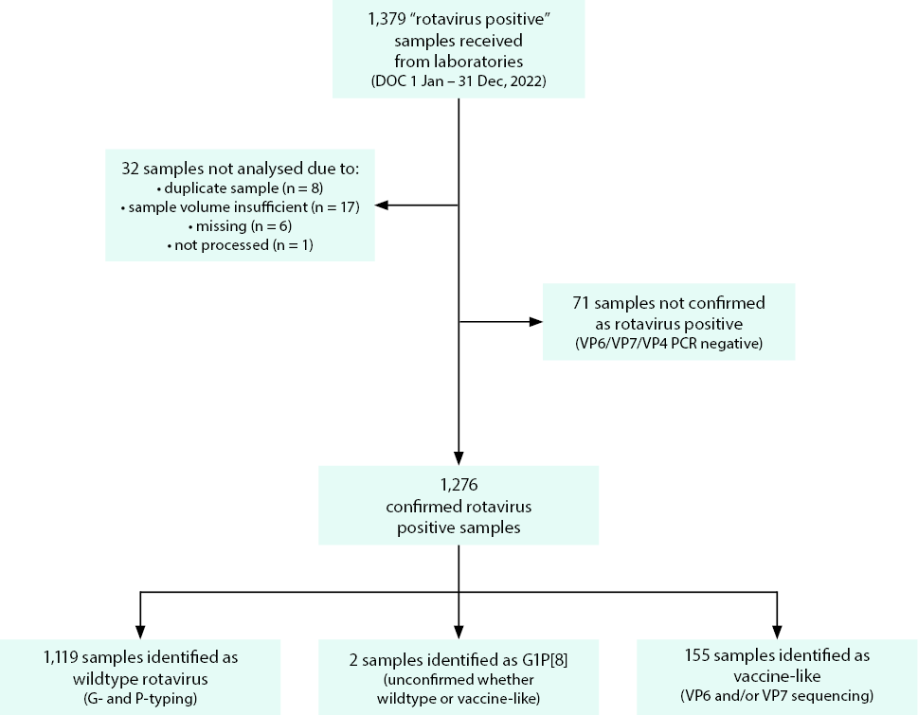
A total of 1,276 samples were genotyped. Samples were then classified as wildtype (no vaccine component identified) or vaccine-like (Rotarix vaccine component identified), based on genotype and the analysis of the top BLAST hits of any G1 VP7 or VP6 sequence. Of the 1,119 samples confirmed as wildtype, 490 (43.8%) were collected from children < 5 years of age, and 629 (56.2%) were obtained from children ≥ 5 years of age and from adults (Table 1). An additional 155 samples were identified as vaccine-like by VP7 or VP6 sequencing, with the majority (151/155; 97.4%) obtained from infants ≤ 6 months of age. Two samples genotyped as G1P[8] could not be determined as either wildtype or vaccine-like, due to repeated failed attempts to generate adequate sequencing results.
Table 1: Age distribution of wildtype rotavirus gastroenteritis cases, Australia, 1 January to 31 December 2022
Age (months) | Age (years) | n | % of total | % < 5 years of age
0–6 |  | 70 | 6.3 | 14.3
7–12 | ≤ 1 | 72 | 6.4 | 14.7
13–24 | 1 –≤ 2 | 135 | 12.1 | 27.6
25–36 | 2 –≤ 3 | 100 | 8.9 | 20.4
37–48 | 3 –≤ 4 | 69 | 6.2 | 14.1
49–59 | 4 –< 5 | 44 | 3.9 | 9.0
Subtotal |  | 490 | 43.8 | 100.0
60–120 | 5 –≤ 10 | 133 | 11.9
121–240 | 10 –≤ 20 | 68 | 6.1
241–960 | 20 –≤ 80 | 383 | 34.2
961+ | > 80 | 45 | 4.0
Subtotal |  | 629 | 56.2
Total |  | 1,119 | 100.0

Rotavirus positive samples identified by month, 2022
Wildtype and vaccine-like rotavirus positive samples were analysed by date of collection (DOC: month) and compared to the notifications received by the NNDSS, to examine the temporal distribution (Figure 2).²¹ Jurisdiction-based notification rates per 100,000 population revealed that notifications in South Australia were steady across the year, after a decrease observed early in the year (Figure 3). In the Australian Capital Territory, Tasmania, Western Australia, Victoria and New South Wales, the notification rates were relatively steady across the year until increases were observed from September onwards, peaking in November or December. Notifications in the Northern Territory had minor fluctuations until a marked increase was observed in August and September. Similarly in Queensland, notifications were high from August to December, with a peak of cases between September and October (Figure 3). Community outbreaks were reported by jurisdictional Department of Health units in the Northern Territory, New South Wales and Queensland, accounting for the high number of cases from these three jurisdictions. The peak of notifications reported by the NNDSS correlated with the number of samples received by the NRRC in 2022. There was no temporal association for the identification of vaccine-like cases (Figure 2).
In 2022, collaborating laboratories were less impacted by SARS-CoV-2 testing compared to the 2020 and 2021 surveillance periods, and many laboratories returned to prior capacity to collect, store, and send rotavirus samples to the NRRC. The number of samples submitted to NRRC was the highest since 2017 due to the outbreaks in New South Wales and Queensland.
Figure 2: Number of analysed wildtype and vaccine-like specimens compared to NNDSS notifications received for rotavirus, Australia, 1 January to 31 December 2022
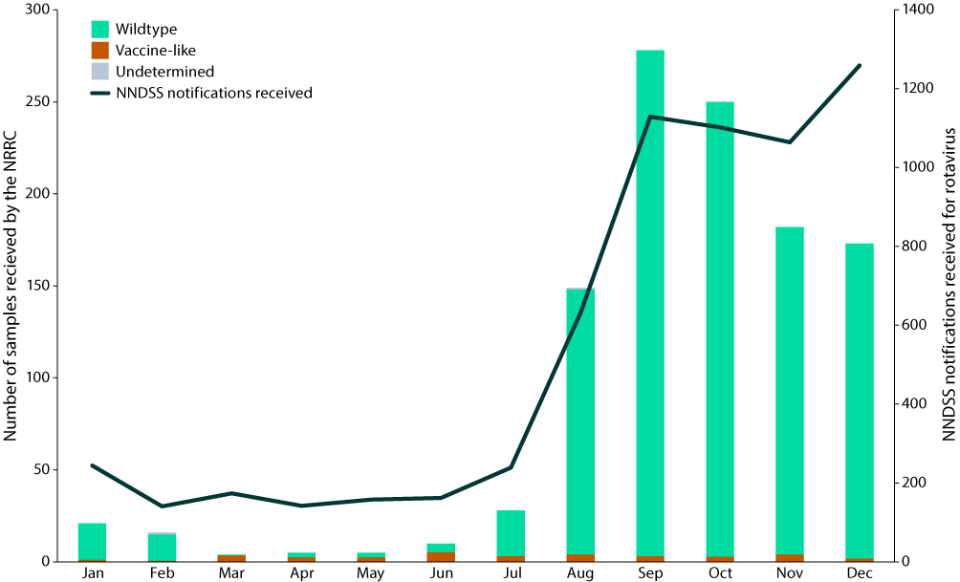
Figure 3: State-based number of NNDSS notifications received for rotavirus, 1 January to 31 December 2022
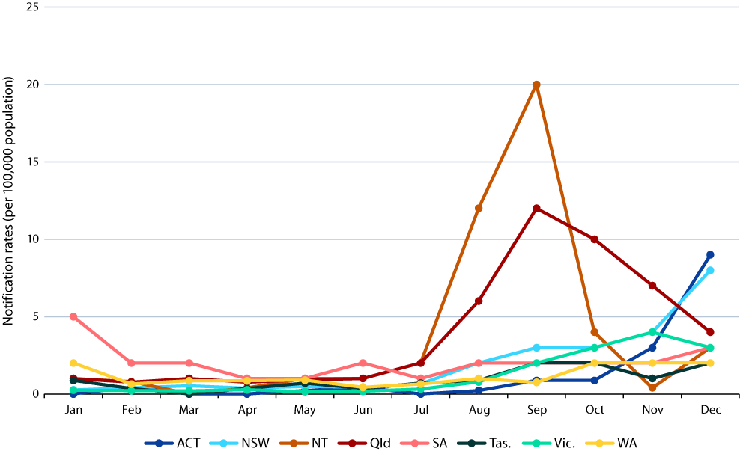

Wildtype rotavirus specimens

Age distribution for wildtype rotavirus infections
From 1 January to 31 December 2021, just under half of wildtype rotavirus positive samples (n = 490/1,119; 43.8%) were obtained from children < 5 years of age (Table 1). The highest proportions of positive samples from children < 5 years of age were obtained from the 13–24 and 25–36 month age groups, accounting for 27.6% (n = 135/490) and 20.4% (n = 100/490) of samples respectively (Table 1). The majority of samples from individuals ≥ 5 years of age were from the 241–960 (n = 383/629) and 60–120 (n = 133/629) months of age groups (Table 1).

Geographic distribution for wildtype rotavirus infections
Rotavirus positive specimens were received from all states and territories for the 2022 surveillance period. Over half of all wildtype samples for this surveillance period were from Queensland (54.8%, 613/1,119), followed by New South Wales (18.9%, 211/1,119); reflecting the sustained outbreaks reported in these states. Compared to recent surveillance periods, this reveals a more comprehensive national representation, as no samples were received from South Australia in 2021 and Tasmania in 2020 and 2021.

Wildtype rotavirus genotype distribution
Genotype analysis was performed on all 1,119 confirmed wildtype rotavirus positive samples from children and adults (Table 2).
G12P[8] was the most common genotype identified nationally, representing 28.2% of all wildtype specimens analysed (n = 315/1,119) and identified in 6/8 jurisdictions. The incidence of G12P[8] was similar between the < 5 and ≥ 5 years of age groups, representing 28.6% (n = 140/490) and 27.8% (n = 175/629) of samples respectively. G12P[8] were almost exclusively detected in Queensland (n = 281/315, 89.2%).
G9P[4] was the next most common genotype identified, representing 22.3% of all wildtype specimens analysed (n = 249/1,119) and identified in 7/8 jurisdictions. The incidence of G9P[4] was similar between the < 5 and ≥ 5 years of age groups, representing 23.9% (n = 117/490) and 21.0% (n = 132/629) of samples respectively. The majority of G9P[4] samples were from Queensland (82.7%, n = 206/249) with a further 10.4% (n = 26/249) detected in New South Wales.
G2P[4] accounted for 20.3% of all wildtype specimens analysed (n = 227/1,119) and was identified in all jurisdictions, with a similar incidence reported between the < 5 and ≥ 5 years of age groups, representing 22.2% (n = 109/490) and 18.8% (n = 118/629) of samples respectively. G2P[4] was the dominant genotype identified in the Northern Territory, accounting for 86.4% of samples (n = 37/43). G2P[4] was also dominant in New South Wales, accounting for 39.3% of samples (n = 83/211), closely followed by human G3P[8] accounting for 32.2% of samples (n = 68/211). Human G3P[8], the most common genotype identified in the 2020, 2019 and 2018 surveillance periods, accounted for 15.7% of all wildtype specimens analysed in 2022 (n = 176/1,119) and was identified in 7/8 jurisdictions. G2P[4] and G3P[8] were co-dominant in Victoria, accounting for 39.9% (n = 59/148) and 40.5% (n = 60/148) of samples respectively.

Table 2: Rotavirus G and P genotype distribution in infants, children and adults, 1 January to 31 December 2022
Jurisdictionª | Age (years) | Total (n) | G1P[8] |  | G2P[4] |  | G3P[8] |  | Eq G3P[8]^{b} |  | G8P[8] |  | G9P[4] |  | G12P[8] |  | Mixed |  | Other^{c} |  | Non-type^{d}
 |  |  | n | % | n | % | n | % | n | % | n | % | n | % | n | % | n | % | n | % | n | %
ACT | < 5 | 6 | 0 | 0.0 | 2 | 33.3 | 3 | 50.0 | 0 | 0.0 | 0 | 0.0 | 1 | 16.7 | 0 | 0.0 | 0 | 0.0 | 0 | 0.0 | 0 | 0.0
 | ≥ 5 | 3 | 0 | 0.0 | 2 | 66.7 | 1 | 33.3 | 0 | 0.0 | 0 | 0.0 | 0 | 0.0 | 0 | 0.0 | 0 | 0.0 | 0 | 0.0 | 0 | 0.0
NSW | < 5 | 94 | 1 | 1.1 | 37 | 39.4 | 26 | 27.7 | 1 | 1.1 | 1 | 1.1 | 16 | 17.0 | 10 | 10.6 | 0 | 0.0 | 1 | 1.1 | 1 | 1.1
 | ≥ 5 | 117 | 1 | 0.9 | 46 | 39.3 | 42 | 35.9 | 2 | 1.7 | 1 | 0.9 | 10 | 8.5 | 8 | 6.8 | 1 | 0.9 | 5 | 4.3 | 1 | 0.9
NT | < 5 | 30 | 1 | 3.3 | 26 | 86.7 | 0 | 0.0 | 0 | 0.0 | 1 | 3.3 | 0 | 0.0 | 1 | 3.3 | 0 | 0.0 | 1 | 3.3 | 0 | 0.0
 | ≥ 5 | 13 | 0 | 0.0 | 11 | 84.6 | 0 | 0.0 | 0 | 0.0 | 1 | 7.7 | 1 | 7.7 | 0 | 0.0 | 0 | 0.0 | 0 | 0.0 | 0 | 0.0
Qld | < 5 | 265 | 0 | 0.0 | 6 | 2.3 | 8 | 3.0 | 1 | 0.4 | 22 | 8.3 | 95 | 35.8 | 122 | 46.0 | 1 | 0.4 | 8 | 3.0 | 2 | 0.8
 | ≥ 5 | 348 | 3 | 0.9 | 9 | 2.6 | 9 | 2.6 | 3 | 0.9 | 44 | 12.6 | 111 | 31.9 | 159 | 45.7 | 0 | 0.0 | 7 | 2.0 | 3 | 0.9
SA | < 5 | 9 | 0 | 0.0 | 2 | 22.2 | 4 | 44.4 | 0 | 0.0 | 1 | 11.1 | 0 | 0.0 | 2 | 22.2 | 0 | 0.0 | 0 | 0.0 | 0 | 0.0
 | ≥ 5 | 28 | 1 | 3.6 | 6 | 21.4 | 12 | 42.9 | 2 | 7.1 | 1 | 3.6 | 3 | 10.7 | 2 | 7.1 | 0 | 0.0 | 1 | 3.6 | 0 | 0.0
Tas. | < 5 | 2 | 1 | 50.0 | 0 | 0.0 | 1 | 50.0 | 0 | 0.0 | 0 | 0.0 | 0 | 0.0 | 0 | 0.0 | 0 | 0.0 | 0 | 0.0 | 0 | 0.0
 | ≥ 5 | 8 | 0 | 0.0 | 2 | 25.0 | 5 | 62.5 | 0 | 0.0 | 1 | 12.5 | 0 | 0.0 | 0 | 0.0 | 0 | 0.0 | 0 | 0.0 | 0 | 0.0
Vic. | < 5 | 62 | 2 | 3.2 | 26 | 41.9 | 21 | 33.9 | 2 | 3.2 | 0 | 0.0 | 4 | 6.5 | 4 | 6.5 | 0 | 0.0 | 3 | 4.8 | 0 | 0.0
 | ≥ 5 | 87 | 1 | 1.1 | 33 | 37.9 | 39 | 44.8 | 2 | 2.3 | 0 | 0.0 | 6 | 6.9 | 4 | 4.6 | 1 | 1.1 | 1 | 1.1 | 0 | 0.0
WA | < 5 | 22 | 0 | 0.0 | 10 | 45.5 | 4 | 18.2 | 0 | 0.0 | 1 | 4.5 | 1 | 4.5 | 1 | 4.5 | 1 | 4.5 | 2 | 9.1 | 2 | 9.1
 | ≥ 5 | 25 | 2 | 8.0 | 9 | 36.0 | 1 | 4.0 | 1 | 4.0 | 7 | 28.0 | 1 | 4.0 | 2 | 8.0 | 0 | 0.0 | 2 | 8.0 | 0 | 0.0
Subtotal | < 5 | 490 | 5 | 1.0 | 109 | 22.2 | 67 | 13.7 | 4 | 0.8 | 26 | 5.3 | 117 | 23.9 | 140 | 28.6 | 2 | 0.4 | 15 | 3.1 | 5 | 1.0
 | ≥ 5 | 629 | 8 | 1.3 | 118 | 18.8 | 109 | 17.3 | 10 | 1.6 | 55 | 8.7 | 132 | 21.0 | 175 | 27.8 | 2 | 0.3 | 16 | 2.5 | 4 | 0.6
Total |  | 1,119 | 13 | 1.2 | 227 | 20.3 | 176 | 15.7 | 14 | 1.3 | 81 | 7.2 | 249 | 22.3 | 315 | 28.2 | 4 | 0.4 | 31 | 2.8 | 9 | 0.8
a ACT: Australian Capital Territory; NSW: New South Wales; NT: Northern Territory; Qld: Queensland; SA: South Australia; Tas.: Tasmania; Vic.: Victoria; WA: Western Australia.
b Equine-like G3P[8].
c Other: unusual and rarely detected genotypes as detailed in Table 3.
d Specimen where G or P genotype was not determined.

The most frequently detected genotype in the 2021 surveillance period was G8P[8], which accounted for 7.2% (n = 81/1119) of samples in 2022; the majority were detected in Queensland throughout the year. Other unusual, potentially zoonotic genotypes were identified this year, including canine-like G3P[3] (n = 2); G6P[9] (n = 2); G6P[11] (n = 1); G6P[14] (n = 1); G8P[14] (n = 2); G10P[14] (n = 1); and G11P[25] (n = 1) (Table 2, Table 3).
Table 3: Unusual and rarely detected genotype combinations identified in infants, children and adults, 1 January to 31 December 2022
Genotype | Total
G1P[6] | 1
G2P[8] | 5
(Canine-like) G3P[3] | 2
(Canine-like) G3P[4] | 1
G3P[6] | 1
G4P[6] | 1
G4P[8] | 1
G6P[9] | 2
G6P[11] | 1
G6P[14] | 1
G9P[6] | 1
G9P[8] | 10
G8P[14] | 2
G10P[14] | 1
G11P[25] | 1
Total | 31

Vaccine-like rotavirus specimens

Age distribution for rotavirus vaccine-like samples
All G1P[8] samples (n = 170) were analysed by VP7 sequencing to identify vaccine-like strains. Overall, 168 samples were successfully sequenced, of which 155 were Rotarix vaccine-like and 13 were wildtype. Of the vaccine-like samples, 97.4% (n = 151/155) were from the 0–6 months of age group. The remaining samples were single identifications in patients aged 7 months, 4 years, 23 years, and 41 years old.

Discussion
In this Australian Rotavirus Surveillance Program Report for 2022, we describe the distribution of rotavirus genotypes identified in Australia for the period 1 January to 31 December 2022, marking the fifth year of exclusive use of Rotarix in the National Immunisation Program.^{6,7} A total of 1,379 specimens, determined to be rotavirus positive by collaborating laboratories, were referred to the NRRC. During the 2020 and 2021 reporting periods, the coronavirus disease 2019 (COVID-19) pandemic had a major impact on the collection and storage of stool samples at collaborating centres and on the transportation of samples to the NRRC. The 2022 surveillance period saw most collaborating centres return to capacity, resulting in improved rates of sample collection and referral of rotavirus-positive samples to the ARSP nationwide. The number of specimens collected in 2022 represented the largest number of samples received since the 2017 surveillance period.²² Similarly, the national rotavirus notification rates reported by the NNDSS in 2022 were also the highest since 2017.²¹ The ARSP captured stool samples for 21.4% of all notifications in 2022.
In 2021, outbreaks were reported in Western Australia and the Northern Territory in September and continued through to December, as many parts of Australia emerged from a prolonged period of social distancing due to COVID-19 restrictions.²³ The increased rates of rotavirus notifications in the latter months of 2021 persisted into 2022 and outbreaks continued to shape the temporal and geographic distribution of rotavirus disease in 2022. High rotavirus notification rates were observed in Queensland, New South Wales, and the Northern Territory. In Queensland between October and December, there were 1,119 NNDSS notifications for rotavirus, with the overall 2022 notification and rates of rotavirus 4.2 times higher than for 2021. Notifications were primarily in children under 1 year of age, but all age groups were impacted, and the notification rates were the highest reported since 2019 when widespread outbreaks also occurred.^{24,25} The Centre for Disease Control in the Northern Territory reported an increase in the number of rotavirus notifications between August and September.²⁶ The majority of reported cases occurred in the Alice Springs region; based on samples received by the NRRC, the dominant genotype circulating during the outbreak was G2P[4].
For the first time since 2015, G12P[8] was identified as the dominant genotype (28.2%); however, this genotype was primarily detected in association with an outbreak in Queensland.²⁷ This represents a re-emergence of G12P[8] in Australia. Reflecting the global emergence of this genotype at the time, G12P[8] was one of the most common genotypes detected in Australia between 2012 and 2015, primarily detected in jurisdictions implementing the RotaTeq vaccine. The prevalence declined from 2016 onwards, with only three samples detected from 2018 to 2021.^{6,23,24,28,29}
G9P[4] was the next most common genotype identified, representing 22.3% of all wildtype specimens analysed. Overall, 82.7% of G9P[4] samples were from Queensland, where they were detected in co-circulation with G12P[8] during the months of increased rotavirus activity. A further 10.4% of G9P[4] were detected in New South Wales. The first Australian G9P[4] was identified in 2009 and detection of this genotype remained at low levels (< 5 samples detected per year) until 2014, where a year-on-year minor increase in detection was observed and by 2019 the genotype accounted for 3.6% of samples.²⁴ The 2022 surveillance period represents the first time G9P[4] has been detected as one of the dominant genotypes in Australia. Globally, G9P[4] strains exhibiting a DS-1-like genome constellation have emerged in the last decade, detected at increasing frequency in national surveillance programs. In 2017, G9P[4] accounted for 14.9% of samples genotyped in Argentina.³⁰ Between 2006 and 2014, G9P[4] was infrequently detected by the European Rotavirus Network. However, from 2015 onwards, detection increased, with the genotype accounting for 5–7% of samples genotyped annually between 2015 and 2020, and the genotype was detected in numerous countries including the United Kingdom, Greece, Italy, Spain, Finland and Belgium.³¹ G9P[4] has also been consistently reported in India between 2013 and 2019.³²
G2P[4] accounted for 20.3% of all wildtype specimens analysed (n = 227/1,119) and was identified in all jurisdictions. G2P[4] was the dominant genotype identified in the Northern Territory, accounting for 86.4% of samples and was the dominant genotype detected during a reported outbreak in Alice Springs. G2P[4] was also dominant in New South Wales, accounting for 39.3% of samples, closely followed by human G3P[8] accounting for 32.2% of samples. G2P[4] and G3P[8] were co-dominant in Victoria.
Over the last few years, wildtype G1P[8] has been rarely detected (2016, n = 4; 2017, n = 1; 2018, n = 1; 2019, n = 2; 2020, n = 1; and 2021, n = 2). ^{22-24,28,29,33} In 2022, there was a moderate increase in the detection of G1P[8] samples compared to prior years, with 13 identified nationwide, from Victoria (n = 2), New South Wales (n = 2), Northern Territory (n = 1), Queensland (n = 3), South Australia (n = 1), Tasmania (n = 1) and Western Australia (n = 3). These wildtype G1P[8] were identified in children < 5 years of age (n = 4) and from older children and adults (n = 9). Sequence analysis identified three wildtype variants were circulating with no geographical association and were closely related to globally circulating variants identified over recent years.
In the 2021 surveillance period, G8P[8] was identified as the predominant genotype, accounting for 87.5% of all wildtype samples genotyped, and was identified in association with outbreaks in Western Australia and the Northern Territory.²³ Surprisingly in 2022, the prevalence of G8P[8] dramatically decreased to 7.2% of samples genotyped and cases were primarily detected in Queensland. The prevalence of G8P[8] was also noted to dramatically decline in Europe; after detection peaked in 2018–2019, G8P[8] had all but disappeared by 2021 and was only detected in three specimens from the combined surveillance of twelve European countries.³¹
In prior years when widespread community outbreaks have impacted multiple jurisdictions, the same genotype has been implicated, for example, the G8P[8] outbreaks in Western Australia and the Northern Territory in 2021,²³ and the human G3P[8] outbreaks in Queensland and New South Wales in 2019.²⁴ Uniquely in 2022, the widespread community outbreaks were not attributed to a single genotype. In New South Wales, G2P[4] and human G3P[8] co-circulated at similar frequencies during periods of increased rotavirus disease. Similarly in Queensland, G12P[8] and G9P[4] co-circulated at similar frequencies during periods of increased rotavirus disease. The 2022 season is notable as the number of specimens collected represents the largest number of samples received since the 2017 surveillance period.²² Interestingly, in 2017 there were also multiple community outbreaks caused by varied genotypes; including G2P[4] (Northern Territory, Western Australia and South Australia), equine-like G3P[8] (New South Wales), and G8P[8] (New South Wales and Victoria). It has been proposed that the increase in rotavirus disease observed in some parts of Australia in 2021 and 2022 is a result of the extensive social distancing measures enforced during the peak of the COVID-19 pandemic. These measures decreased the transmission of rotavirus in the community, reducing exposure and preventing natural boosts to immunity for the wider population, leading to outbreaks.
There continues to be a substantial detection of rotavirus vaccine-like virus in samples from infants. This is most likely due to the shift in diagnostic techniques in recent years to multiplex PCR panels that do not distinguish between wildtype and vaccine rotavirus strains.^{34,35} Consequently, it is important to interpret a rotavirus positive result in children aged less than 8 months of age with caution, as this result could be due to the receipt of a recent dose of a rotavirus vaccine.
In conclusion, in this 2022 Annual Rotavirus Surveillance Report, we describe the incidence of both wildtype and vaccine-like rotavirus strains detected in Australia for the period of 1 January – 31 December 2022. During this period, G12P[8] re-emerged as the dominant genotype, largely due to a widespread outbreak in Queensland, where G9P[4] also co-circulated. In New South Wales, G2P[4] and human G3P[8] co-circulated during widespread community outbreaks. A localised outbreak in Alice Springs was due to G2P[4]. The extensive lockdowns and social changes during the first two years of the COVID-19 pandemic in 2020–2021 appear to have impacted the transmission dynamics of rotavirus disease in Australia. Decreased herd immunity in children and the wider community, due to reduced exposure, may be driving the increase in community rotavirus disease reported in many jurisdictions in 2022. It remains important to describe the genotypes circulating in the community to understand how genotype dominance and distribution change over time in response to vaccination and societal factors.

Acknowledgments
The Australian Rotavirus Surveillance Program is supported by grants from the Australian Government Department of Health and Aged Care and from GlaxoSmithKline Biologicals SA [Study#209328]. The Murdoch Children’s Research Institute (MCRI) is supported by the Victorian Government’s Operational Infrastructure Support program. GlaxoSmithKline Biologicals SA was provided the opportunity to review a preliminary version of this manuscript for factual accuracy, but the authors are solely responsible for final content and interpretation. The authors received no financial support or other form of compensation related to the development of the manuscript.
We thank H Tran for providing technical assistance.
Rotavirus positive specimens were collected from numerous centres throughout Australia. We acknowledge and appreciate the significant time and effort involved in the collection, storage, packaging, compiling data and forwarding of specimens.

Author details
Dr Celeste M Donato, Senior Research Officer^{1,2,3}
Mrs Susie Roczo-Farkas, Research Assistant¹
Mrs Sarah Thomas, Research Assistant¹
Mrs Nada Bogdanovic-Sakran, Research Assistant¹
Dr Eleanor A Lyons, Research Officer¹
Prof. Julie E Bines, Group Leader^{1,2,4}
and the Australian Rotavirus Surveillance Group
- Enteric Diseases, Murdoch Children’s Research Institute, Parkville, Victoria
- Department of Paediatrics, University of Melbourne, Parkville, Victoria
- Department of Microbiology, Biomedicine Discovery Institute, Monash University, Clayton, Victoria
- Department of Gastroenterology and Clinical Nutrition, Royal Children’s Hospital, Parkville, Victoria
Corresponding author
Professor Julie E Bines
Murdoch Children’s Research Institute, The Royal Children’s Hospital, 50 Flemington Road, Parkville, Victoria 3052 Australia
Telephone: +61 3 8341 6383
Email: jebines@unimelb.edu.au

The National Rotavirus Surveillance Group includes:

Australian Rotavirus Surveillance Program Central Laboratory
Dr Celeste M Donato, Senior Research Officer, Enteric Diseases, MCRI; Department of Paediatrics, University of Melbourne; Department of Microbiology, Biomedicine Discovery Institute, Monash University
Mrs Susie Roczo-Farkas; Coordinator Australian Rotavirus Surveillance Program, Research Assistant, Enteric Diseases, MCRI
Mrs Sarah Thomas, Research Assistant, Enteric Diseases, MCRI
Mrs Nada Bogdanovic-Sakran, Research Assistant, Enteric Diseases, MCRI
Dr Eleanor A Lyons, Research Officer, Enteric Diseases, MCRI
Prof. Julie E Bines, Director, Australian Rotavirus Surveillance Program; Leader, Enteric Diseases, MCRI; Department of Paediatrics, University of Melbourne; Department of Gastroenterology and Clinical Nutrition, Royal Children’s Hospital

Australian Capital Territory
Assoc Prof K Kennedy, Ms. S Bradbury and members of the Microbiology Department, Canberra Hospital

New South Wales
Mr P Huntington, Prof. M Lahra and members of the Microbiology Department, SEALS, Prince of Wales Hospital
Prof A Kesson, Ms I Tam, and members of the Virology Department, The Children’s Hospital, Westmead
M Brown, T Olma, and members of the Centre for Infectious Disease and Microbiology, Westmead
Dr M Wehrhahn, and members of Douglass Hanly Moir Pathology, New South Wales
F Jozwiak, J Merif and members of the Department of Microbiology and Infectious Diseases, Liverpool Hospital, Liverpool
Dr R Givney, S Pearce, K Delves, K Ross, and members of the Microbiology Department, John Hunter Hospital, Newcastle

Northern Territory
Dr R Baird, Mr K Freeman, Mr D. Menouhos, Ms T Eapen, and members of Territory Pathology, Royal Darwin Hospital, Tiwi, NT

Queensland
Dr C Bletchly, Dr. R Gupta and department members, Pathology Queensland Central

South Australia
Mr M Turra, Dr J Arthur, and members of the Microbiology and Infectious diseases laboratory SA Pathology, Adelaide

Tasmania
Dr J Williamson and members of Molecular Medicine, Pathology Services, Royal Hobart Hospital, Hobart, Tasmania

Victoria
Dr T Korman, Mrs D Kotsanas, and members of the Department of Microbiology, Monash Medical Centre, Clayton
Ms K Rautenbacher, Ms P Adamopoulos, Laboratory Services, Royal Children’s Hospital, Parkville
Dr L Bruggink, and members of the Enteric Virus Reference Laboratory, Victorian Infectious Diseases Reference Laboratory (VIDRL), Peter Doherty Institute for Infection and Immunity, Melbourne

Western Australia
Dr D Speers, Mr D Bradford, Mrs D Tennant, and members of QEII Microbiology Department, PathWest Laboratory Medicine WA, Perth

References
- Troeger C, Khalil IA, Rao PC, Cao S, Blacker BF, Ahmed T et al. Rotavirus vaccination and the global burden of rotavirus diarrhea among children younger than 5 years. JAMA Pediatr. 2018;172(10):958–65. doi: https://doi.org/10.1001/jamapediatrics.2018.1960.
- International Vaccine Access Center (IVAC). VIEW-hub by IVAC. [Website.] Baltimore: Johns Hopkins Bloomberg School of Public Health, IVAC; 2023. Available from: https://view-hub.org.
- Buttery JP, Lambert SB, Grimwood K, Nissen MD, Field EJ, Macartney KK et al. Reduction in rotavirus-associated acute gastroenteritis following introduction of rotavirus vaccine into Australia’s National Childhood vaccine schedule. Pediatr Infect Dis J. 2011;30(1 Suppl):S25–9. doi: https://doi.org/10.1097/INF.0b013e3181fefdee.
- Macartney KK, Porwal M, Dalton D, Cripps T, Maldigri T, Isaacs D et al. Decline in rotavirus hospitalisations following introduction of Australia’s national rotavirus immunisation programme. J Paediatr Child Health. 2011;47(5):266–70. doi: https://doi.org/10.1111/j.1440-1754.2010.01953.x.
- Reyes JF, Wood JG, Beutels P, Macartney K, McIntyre P, Menzies R et al. Beyond expectations: post-implementation data shows rotavirus vaccination is likely cost-saving in Australia. Vaccine. 2017;35(2):345–52. doi: https://doi.org/10.1016/j.vaccine.2016.11.056.
- Roczo-Farkas S, Kirkwood CD, Cowley D, Barnes GL, Bishop RF, Bogdanovic-Sakran N et al. The impact of rotavirus vaccines on genotype diversity: a comprehensive analysis of 2 decades of Australian surveillance data. J Infect Dis. 2018;218(4):546–54. doi: https://doi.org/10.1093/infdis/jiy197.
- Australian Government Department of Health and Aged Care. Clinical update: ATAGI advice on Rotarix® to replace RotaTeq®. [Internet.] Canberra: Australian Government Department of Health and Aged Care; 20 December 2017. Available from: https://beta.health.gov.au/news-and-events/news/clinical-update-atagi-advice-on-rotarixr-to-replace-rotateqr.
- Desselberger U. Rotaviruses. Virus Res. 2014;190:75–96. doi: https://doi.org/10.1016/j.virusres.2014.06.016.
- Bányai K, László B, Duque J, Steele AD, Nelson EA, Gentsch JR et al. Systematic review of regional and temporal trends in global rotavirus strain diversity in the pre rotavirus vaccine era: insights for understanding the impact of rotavirus vaccination programs. Vaccine. 2012;30(Suppl 1):A122–30. doi: https://doi.org/10.1016/j.vaccine.2011.09.111.
- Dóró R, László B, Martella V, Leshem E, Gentsch J, Parashar U et al. Review of global rotavirus strain prevalence data from six years post vaccine licensure surveillance: is there evidence of strain selection from vaccine pressure? Infect Genet Evol. 2014;28:446–61. doi: https://doi.org/10.1016/j.meegid.2014.08.017.
- Kondo K, Tsugawa T, Ono M, Ohara T, Fujibayashi S, Tahara Y et al. Clinical and molecular characteristics of human rotavirus G8P[8] outbreak strain, Japan, 2014. Emerg Infect Dis. 2017;23(6):968–72. doi: https://doi.org/10.3201/eid2306.160038.
- Matthijnssens J, Ciarlet M, McDonald SM, Attoui H, Bányai K, Brister JR et al. Uniformity of rotavirus strain nomenclature proposed by the Rotavirus Classification Working Group (RCWG). Arch Virol. 2011;156(8):1397–413. doi: https://doi.org/10.1007/s00705-011-1006-z.
- Donato CM, Roczo-Farkas S, Kirkwood CD, Barnes GL, Bines JE. Rotavirus disease and genotype diversity in older children and adults in Australia. J Infect Dis. 2022;225(12):2116–26. doi: https://doi.org/10.1093/infdis/jiaa430.
- Gómara MI, Cubitt D, Desselberger U, Gray J. Amino acid substitution within the VP7 protein of G2 rotavirus strains associated with failure to serotype. J Clin Microbiol. 2001;39(10):3796–8. doi: https://doi.org/10.1128/JCM.39.10.3796-3798.2001.
- Simmonds MK, Armah G, Asmah R, Banerjee I, Damanka S, Esona M et al. New oligonucleotide primers for P-typing of rotavirus strains: strategies for typing previously untypeable strains. J Clin Virol. 2008;42(4):368–73. doi: https://doi.org/10.1016/j.jcv.2008.02.011.
- Gentsch JR, Glass RI, Woods P, Gouvea V, Gorziglia M, Flores J et al. Identification of group A rotavirus gene 4 types by polymerase chain reaction. J Clin Microbiol. 1992;30(6):1365–73. doi: https://doi.org/10.1128/jcm.30.6.1365-1373.1992.
- Gouvea V, Glass RI, Woods P, Taniguchi K, Clark HF, Forrester B et al. Polymerase chain reaction amplification and typing of rotavirus nucleic acid from stool specimens. J Clin Microbiol. 1990;28(2):276–82. doi: https://doi.org/10.1128/jcm.28.2.276-282.1990.
- Donato CM, Ch’ng LS, Boniface KF, Crawford NW, Buttery JP, Lyon M et al. Identification of strains of RotaTeq rotavirus vaccine in infants with gastroenteritis following routine vaccination. J Infect Dis. 2012;206(3):377–83. doi: https://doi.org/10.1093/infdis/jis361.
- Elschner M, Prudlo J, Hotzel H, Otto P, Sachse K. Nested reverse transcriptase-polymerase chain reaction for the detection of group A rotaviruses. J Vet Med B Infect Dis Vet Public Health. 2002;49(2):77–81. doi: https://doi.org/10.1046/j.1439-0450.2002.00510.x.
- Cowley D, Donato CM, Roczo-Farkas S, Kirkwood CD. Emergence of a novel equine-like G3P[8] inter-genogroup reassortant rotavirus strain associated with gastroenteritis in Australian children. J Gen Virol. 2016;97(2):403–10. doi: https://doi.org/10.1099/jgv.0.000352.
- Australian Government Department of Health and Aged Care. National Communicable Disease Surveillance Dashboard. [Website.] Canberra: Australian Government Department of Health and Aged Care; 2023. [Accessed on 27 April 2023.] Available from: https://nindss.health.gov.au/pbi-dashboard/.
- Roczo-Farkas S, Cowley D, Bines JE, the Australian Rotavirus Surveillance Group. Australian Rotavirus Surveillance Program: Annual Report, 2017. Commun Dis Intell (2018). 2019;43. doi: https://doi.org/10.33321/cdi.2019.43.28.
- Roczo-Farkas S, Thomas S, Bogdanovic-Sakran N, Donato CM, Lyons EA, Bines J et al. Australian Rotavirus Surveillance Program: Annual Report, 2021. Commun Dis Intell (2018). 2022;46. doi: https://doi.org/10.33321/cdi.2022.46.75.
- Thomas S, Donato CM, Roczo-Farkas S, Hua J, Bines JE. Australian Rotavirus Surveillance Program: Annual Report, 2019. Commun Dis Intell (2018). 2021;45. doi: https://doi.org/10.33321/cdi.2021.45.4.
- Queensland State Government Department of Health (Queensland Health). Vaccine preventable and invasive diseases in Queensland: 1 January 2022–December 2022. Brisbane: Queensland Health; 2023. Available from: https://www.health.qld.gov.au/__data/assets/pdf_file/0020/1173710/vpd-quarterly-surveillance-2022.pdf.
- Northern Territory Government Department of Health (NT Health). Health Alert: Rotavirus. Darwin: NT Health, Centre for Disease Control. Available from: https://health.nt.gov.au/__data/assets/pdf_file/0013/1216102/health-alert-rotavirus.pdf.
- Roczo-Farkas S, Kirkwood CD, Bines JE, Australian Rotavirus Surveillance Group. Australian Rotavirus Surveillance Program annual report, 2015. Commun Dis Intell Q Rep. 2016;40(4):E527–38.
- Roczo-Farkas S, Bines JE, Australian Rotavirus Surveillance G. Australian Rotavirus Surveillance Program: Annual Report, 2018. Commun Dis Intell (2018). 2021;45. doi: https://doi.org/10.33321/cdi.2021.45.6.
- Roczo-Farkas S, Thomas S, Donato CM, Bogdanovic-Sakran N, Bines JE. Australian Rotavirus Surveillance Program: Annual Report, 2020. Commun Dis Intell (2018). 2021;45. doi: https://doi.org/10.33321/cdi.2021.45.64.
- Degiuseppe JI, Stupka JA, Argentinean Rotavirus Surveillance Network. Emergence of unusual rotavirus G9P[4] and G8P[8] strains during post vaccination surveillance in Argentina, 2017–2018. Infect Genet Evol. 2021;93:104940. doi: https://doi.org/10.1016/j.meegid.2021.104940.
- Hungerford D. EUROROTANET Annual Report 2021. Liverpool: University of Liverpool Centre for Global Vaccine Research; March 2023. Available from: https://www.eurorotanet.com/wp-content/uploads/2023/03/EuroRotaNet_report-2021_20220303_Final-v1.0.pdf.
- Varghese T, Alokit Khakha S, Giri S, Nair NP, Badur M, Gathwala G et al. Rotavirus strain distribution before and after introducing rotavirus vaccine in India. Pathogens. 2021;10(4):416. doi: https://doi.org/10.3390/pathogens10040416.
- Roczo-Farkas S, Kirkwood CD, Bines JE, Enteric Virus Group. Australian Rotavirus Surveillance Program: Annual Report, 2016. Commun Dis Intell Q Rep. 2017;41(4):E455–71.
- Whiley DM, Ye S, Tozer S, Clark JE, Bletchly C, Lambert SB et al. Over-diagnosis of rotavirus infection in infants due to detection of vaccine virus. Clin Infect Dis. 2020;71(5):1324–6. doi: https://doi.org/10.1093/cid/ciz1196.
- Ye S, Whiley DM, Ware RS, Kirkwood CD, Lambert SB, Grimwood K. Multivalent rotavirus vaccine and wild-type rotavirus strain shedding in Australian infants: a birth cohort study. Clin Infect Dis. 2018;66(9):1411–8. doi: https://doi.org/10.1093/cid/cix1022.

About Communicable Diseases Intelligence
Communicable Diseases Intelligence (CDI) is a peer-reviewed scientific journal published by the Health Protection Policy & Surveillance Division, Department of Health and Aged Care. The journal aims to disseminate information on the epidemiology, surveillance, prevention and control of communicable diseases of relevance to Australia.
© 2024 Commonwealth of Australia as represented by the Department of Health and Aged Care
ISSN: 2209-6051 Online
This journal is indexed by Index Medicus and Medline.
This publication is licensed under a Creative Commons Attribution-NonCommercial-NoDerivatives 4.0 International Licence (CC BY-NC-ND) available from https://creativecommons.org/licenses/by-nc-nd/4.0/legalcode (Licence). You must read and understand the Licence before using any material from this publication.
Restrictions
The Licence does not cover, and there is no permission given for, use of any of the following material found in this publication (if any):
- the Commonwealth Coat of Arms (by way of information, the terms under which the Coat of Arms may be used can be found at www.pmc.gov.au/resources/commonwealth-coat-arms-information-and-guidelines);
- any logos (including the Department of Health and Aged Care’s logo) and trademarks;
- any photographs and images;
- any signatures; and
- any material belonging to third parties.
Disclaimer
Opinions expressed in Communicable Diseases Intelligence are those of the authors and not necessarily those of the Australian Government Department of Health and Aged Care or the Communicable Diseases Network Australia. Data may be subject to revision.
Enquiries
Enquiries regarding any other use of this publication should be addressed to the CDI Editor at: cdi.editor@health.gov.au
Communicable Diseases Network Australia
Communicable Diseases Intelligence contributes to the work of the Communicable Diseases Network Australia. www.health.gov.au/cdna
Editor: Christina Bareja • Deputy Editor: Simon Petrie • Design and Production: Lisa Thompson/Kasra Yousefi
Editorial Advisory Board: David Durrheim, Mark Ferson, Clare Huppatz, John Kaldor, Martyn Kirk, Meru Sheel and Stephanie Williams
Contacts
CDI is produced by:
Health Protection Policy & Surveillance Division, Australian Government Department of Health and Aged Care,
GPO Box 9848, (MDP 6) CANBERRA ACT 2601
Website: www.health.gov.au/cdi
Email: cdi.editor@health.gov.au
Submit an Article
You are invited to submit your next communicable disease related article to the Communicable Diseases Intelligence (CDI) for consideration. More information regarding CDI can be found at: www.health.gov.au/cdi.
Further enquiries should be directed to: cdi.editor@health.gov.au

http://blast.ncbi.nlm.nih.gov/Blast.cgi.

