2024 • Volume 48 • https://doi.org/10.33321/cdi.2024.48.29 • Electronic publication date: 17/07/2024

Changes in norovirus incidence in Victoria, Australia, 2022: are we back to normal yet after COVID?

Leesa D Bruggink, Bruce Thorley

# Abstract

There were 108 norovirus-positive outbreaks in 2022, with 45 (41.7%) occurring during the first quarter (Q1), January–March. Aged care facilities accounted for 44.4% of norovirus-positive outbreaks; 43.5% were in childcare settings. Overall, the GII.P31/GII.4 genotype was the most common, involved in 39.4% of outbreaks; however, there were shifts in the most common genotype across the year. In Q1, the GII.P31/GII.4 genotype accounted for 73.3% of typed outbreaks, but by Q3 (July–September) the GII.P7/GII.6 was the most prominent genotype at 45.0%. In Q4 (October–December), the dominant genotype had changed again to GII.P16/GII.4 (52.6%). While the incidence of norovirus outbreaks in 2022 was average regarding overall prevalence and genotype diversity, there are still ongoing effects from the coronavirus disease 2019 (COVID-19) pandemic in relation to seasonality, outbreak demographics and specimen referral.

Keywords: norovirus; viral gastroenteritis; childcare; outbreak; genotypes; COVID-19 restrictions

Noroviruses are non-enveloped single stranded ribonucleic acid (RNA) viruses that can cause gastroenteritis in individuals of all ages, primarily transmitted person-to-person with a faecal-oral pathway.1 Norovirus infection is recognised as a major cause of morbidity and mortality globally and is estimated to annually cause 212,000 deaths.1 Viral particles are particularly resilient, able to withstand temperatures from freezing to 60 °C as well as exposure to alcohol disinfectants.1 This has implications for the ease of transmissibility and difficulty in ensuring effective disinfection of surfaces when contamination has occurred.

Ten norovirus genogroups have been described, with genogroups one (GI), two (GII) and four (GIV) most often associated with human disease.1 However, GII noroviruses are by far the most common, globally accounting for approximately 93% of infections.1

Norovirus incidence has been shown to occur all year round, with a baseline in Victoria, Australia, of up to nine norovirus positive outbreaks per calendar month.2 Most locations, including Europe and the United States of America, present with a yearly autumn/winter peak,3–6 although in Australia and New Zealand there is a tendency to have a spring/early summer peak.2,7,8 Additionally, the years when a new pandemic strain has emerged are associated with a larger number of outbreaks than non-pandemic years.3

Gastroenteritis outbreaks are reported to the Victorian Department of Health and faecal specimens are sent to the Victorian Infectious Diseases Reference Laboratory (VIDRL) for norovirus testing. A gastroenteritis outbreak in a care facility is defined as ‘two or more residents/staff having onset of symptoms within 72 hours of each other (that cannot be explained by medication or other medical conditions) in a setting that makes epidemiological sense’.9 In 2022, there were 814 gastroenteritis outbreaks notified in Victoria, and VIDRL received 398 faecal specimens from 155 outbreaks. The percentage of outbreaks with specimens referred in 2022 (19.0%) was down from the 2017–2019 average (29.9%) by about a third, even though notifications were increased above the 2017–2019 yearly average of 674 notifications (Table 1). A higher proportion of outbreaks were notified from childcare settings in 2022; however, a similar level of reduced referral was seen for all setting types, including childcare.

Table 1: Gastroenteritis outbreak notifications in Victoria, Australia, 2017–2019 and 2022

| Year | Number of gastroenteritis outbreak notifications | Number of gastroenteritis outbreaks with specimens received (%) |
| --- | --- | --- |
| 2017 | 825 | 260 (31.5%) |
| 2018 | 570 | 159 (27.9%) |
| 2019 | 628 | 186 (29.6%) |
| 3-year average 2017–2019 | 674.3 | 201.7 (29.9%) |
| 2022 | 814 | 155 (19.0%) |

Norovirus is detected using a commercial real-time reverse transcription polymerase chain reaction assay (RT-qPCR), RIDAGENE Norovirus I & II, R-Biopharm, PG1415.10 At least one specimen received from each norovirus-positive outbreak undergoes genotyping for epidemiological purposes. From a given outbreak, specimens chosen for genotyping have the lowest cycle threshold and therefore potentially the highest viral load and test sensitivity. Genotyping is performed on both the polymerase and capsid regions of the viral genome to identify recombinant viruses. All specimens included in this study were referred from outbreaks occurring in Victoria, Australia. Data are collected as part of routine clinical microbiology testing for public health surveillance purposes and specimens are deidentified, representing a low risk that is exempt from needing human ethics approval.

In 2022, of the 155 outbreaks with specimens received at VIDRL, norovirus was detected in 108 (69.7%). Norovirus genogroup II (GII) was detected in 87 outbreaks (80.6%), norovirus genogroup I (GI) in 16 outbreaks (14.8%) and both GI and GII norovirus in five outbreaks (4.6%). The monthly distribution of norovirus positive outbreaks, along with a breakdown of their settings, is shown in Figure 1. In 2022, 41.7% of norovirus positive outbreaks occurred in January–March (Q1).

Figure 1: Monthly norovirus positive outbreaks in Victoria, Australia, in 2022a

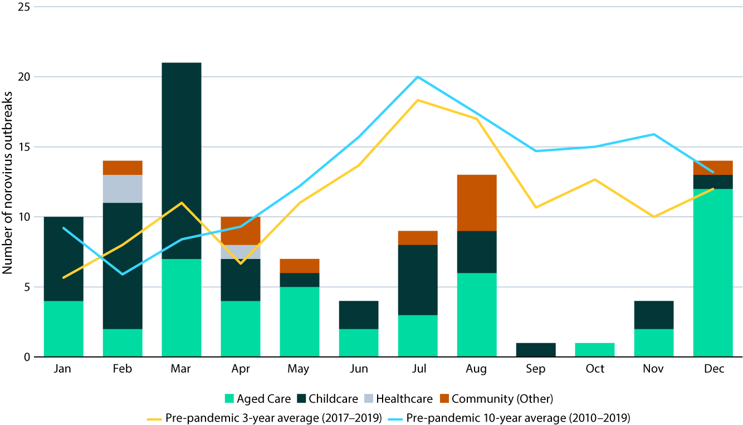

a The category ‘Healthcare’ includes disability care facilities and hospital wards. The category ‘Community (other)’ includes gatherings, restaurants, camps and military barracks.

The predominant setting for norovirus-positive outbreaks in 2022 was aged care (44.4%; n = 48), closely followed by childcare centres (43.5%; n = 47) and then community settings (9.3%; n = 10). Norovirus outbreaks at healthcare settings (other than aged care) were still infrequent (2.8%; n = 3), most probably due to continued COVID-19 precautions such as visitor restrictions/requirements and enhanced cleaning processes. In the years immediately preceding the start of the COVID-19 pandemic (i.e. 2017–2019), approximately two thirds of norovirus outbreaks detected at VIDRL were from aged care settings (67.3%), followed by childcare (13.4%) then community settings (11.2%) and healthcare other than aged care (8.0%).

In 2022, at least one specimen was typed from 100 of the 108 outbreaks with norovirus detected by RT-qPCR. Norovirus from eight outbreaks could not be typed due to a low viral load as evidenced by a high cycle threshold value in the RT-qPCR assay. Monthly genotyping results are displayed in Figure 2. The predominant genotype for the year was GII.P31/GII.4 (39.4%); however, the dominant genotype varied across the year. In Q1 (January–March), the GII.P31/GII.4 genotype accounted for 73.3% of typed outbreaks, but by Q3 (July–September) the GII.P7/GII.6 was the most prominent genotype at 45.0%. In Q4 (October–December), the major genotype was GII.P16/GII.4 (52.6%), which was the dominant genotype pre-pandemic in 2019 and early 2020.

Figure 2: Monthly norovirus genotyping results in Victoria, Australia, in 2022a

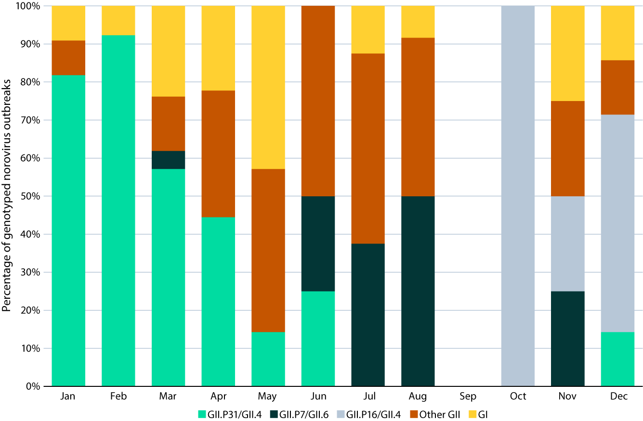

a The first half of the genotype designates the typing of the polymerase region and the second half the capsid region (i.e. polymerase/capsid). The ‘Other GII’ combined category includes eight separate genotypes. The ‘GI’ combined category includes four separate genotypes.

As noted previously, the number of norovirus outbreak notifications in 2022 was higher than the three-year average for the years just prior to the COVID-19 pandemic; however, the percentage of outbreaks with specimens referred to VIDRL was down. This study is limited, in that there is no way to know if sample referral was reduced due to a continued shift in focus to COVID-19 during this period, or because of ‘testing fatigue’ of institutes and individuals. As this reduction was observed across all setting types, including both the two main settings, aged care and childcare, it is not a result of demographics.

With the lifting of non-pharmaceutical interventions (such as lockdowns, mask wearing and social distancing) used in the response to COVID-19, there was considered to be a risk of resurgence of other infectious diseases.11 Such an increase was forecast in England, where modelling predicted that the annual norovirus incidence may be double that of a typical season, due to low levels of norovirus incidence during 2020–2021 resulting in a largely susceptible population, and that out of season and/or particularly intense outbreaks of disease could occur.12 To an extent, this has been reported in Victoria with a large increase of norovirus outbreaks in childcare at the start of 2021 when general restrictions were eased.13 However, further public health restrictions were re-imposed throughout 2021 before there was a transition to the lifting of almost all restrictions by the end of that year, including the resumption of international travel. The implication was that a larger than average norovirus season could be experienced in 2022.13 While norovirus incidence in 2022 was not exceptionally high, the peak in incidence falling in Q1 was unseasonal. For the 18-year period prior to the pandemic (2002–2019), 83% of those years had a peak in norovirus incidence in the second half of the year (Q3 33%; Q4 50%), with only one year (2013) having a peak in norovirus incidence in Q1 with continued outbreaks from a late peak the previous year. There was also a renewal of norovirus genotype diversity in 2022, with 15 different polymerase/capsid genotype combinations detected, comparable to the pre-pandemic (2017-2019) average of 14.7. The 2020–2021 average was only five combinations.

In summary, the proportion of norovirus outbreaks confirmed in 2022 was evenly divided between aged care and childcare settings, whereas prior to the COVID-19 pandemic, most norovirus outbreaks were reported from aged care facilities. While the number of gastroenteritis outbreak notifications increased in 2022 compared to pre-pandemic levels, the referral of specimens for screening and typing decreased. The referral of more specimens from gastroenteritis outbreaks is needed to determine the extent of norovirus transmission in different settings.

# Author details

Dr Leesa D Bruggink, Senior Medical Scientist1

Dr Bruce Thorley, Head of the Enteric Virus Laboratory1

1. Enteric Virus Laboratory, Victorian Infectious Diseases Reference Laboratory (VIDRL), Royal Melbourne Hospital, at the Peter Doherty Institute for Infection and Immunity.

Corresponding author

Leesa D Bruggink

Victorian Infectious Diseases Reference Laboratory, Royal Melbourne Hospital, at the Peter Doherty Institute for Infection and Immunity, 792 Elizabeth St, Melbourne, Victoria, Australia

Phone: +61 3 9342 9607

Email: leesa.bruggink@vidrl.org.au

# References

1. Lucero Y, Matson DO, Ashkenazi S, George S, O’Ryan M. Norovirus: facts and reflections from past, present, and future. Viruses. 2021;13(12):2399. doi: https://doi.org/10.3390/v13122399.

Bruggink LD, Sturge K, Gaston J, Gregory J, Catton MG, Marshall JA. Patterns of norovirus-associated gastroenteritis outbreaks in Victoria 2001–2010. Victorian Infect Dis Bull. 2011;14:78–81.

Hall AJ, Lopman BA, Payne DC, Patel MM, Gastanaduy PA, Vinjé J et al. Norovirus disease in the United States. Emerg Infect Dis. 2013;19(8):1198–205. doi: https://doi.org/10.3201/eid1908.130465.

Lopman B, Vennema H, Kohli E, Pothier P, Sanchez A, Negredo A et al. Increase in viral gastroenteritis outbreaks in Europe and epidemic spread of new norovirus variant. Lancet. 2004;363(9410):682–8. doi: https://doi.org/10.1016/S0140-6736(04)15641-9.

Mounts AW, Ando T, Koopmans M, Bresee JS, Noel J, Glass RI. Cold weather seasonality of gastroenteritis associated with Norwalk-like virus. J Infect Dis. 2000;181(Suppl 2):S284–7. doi: https://doi.org/10.1086/315586.

Phillips G, Tam CC, Rodrigues LC, Lopman B. Prevalence and characteristics of asymptomatic norovirus infection in the community in England. Epidemiol Infect. 2010;138(10):1454–8. doi: https://doi.org/10.1017/S0950268810000439.

Bruggink LD, Marshall JA. The incidence of norovirus-associated gastroenteritis outbreaks in Victoria, Australia (2002–2007) and their relationship with rainfall. Int J Environ Res Public Health. 2010;7(7):2822–7. doi: https://doi.org/10.3390/ijerph7072822.

Greening GE, Hewitt J, Rivera-Aban M, Croucher D. Molecular epidemiology of norovirus gastroenteritis outbreaks in New Zealand from 2002–2009. J Med Virol. 2012;84(9):1449–58. doi: https://doi.org/10.1002/jmv.23349.

Victoria State Government Department of Health. Guidelines for the investigation of gastroenteritis for Environmental Health Officers. [Internet.] Melbourne: Victoria State Government Department of Health; 4 December 2020. [Accessed on 20 February 2023.] Available from: https://www.health.vic.gov.au/publications/guidelines-for-the-investigation-of-gastroenteritis-for-environmental-health-officers.

Dunbar NL, Bruggink LD, Marshal JA. Evaluation of the RIDAGENE real-time PCR assay for the detection of GI and GII norovirus. Diagn Microbiol Infect Dis. 2014;79(3):317–21. doi: https://doi.org/10.1016/j.diagmicrobio.2014.03.017.

Oh KB, Doherty TM, Vetter V, Bonanni P. Lifting non-pharmaceutical interventions following the COVID-19 pandemic – the quiet before the storm? Expert Rev Vaccines. 2022;21(11):1541–53. doi: https://doi.org/10.1080/14760584.2022.2117693.

O’Reilly KM, Sandman F, Allen D, Jarvis CI, Gimma A, Douglas A et al. Predicted norovirus resurgence in 2021–2022 due to the relaxation of nonpharmaceutical interventions associated with COVID-19 restrictions in England: a mathematical modeling study. BMC Med. 2021;19(1):299. doi: https://doi.org/10.1186/s12916-021-02153-8.

Bruggink LD. Changes in norovirus incidence in Victoria, Australia, during the COVID-19 pandemic, 2020–2021. Commun Dis Intell (2018). 2022;46. doi: https://doi.org/10.33321/cdi.2022.46.61.

About Communicable Diseases Intelligence

Communicable Diseases Intelligence (CDI) is a peer-reviewed scientific journal published by the Health Protection Policy & Surveillance Division, Department of Health and Aged Care. The journal aims to disseminate information on the epidemiology, surveillance, prevention and control of communicable diseases of relevance to Australia.

© 2024 Commonwealth of Australia as represented by the Department of Health and Aged Care

ISSN: 2209-6051 Online

This journal is indexed by Index Medicus and Medline.

This publication is licensed under a Creative Commons Attribution-NonCommercial-NoDerivatives 4.0 International Licence (CC BY-NC-ND) available from https://creativecommons.org/licenses/by-nc-nd/4.0/legalcode (Licence). You must read and understand the Licence before using any material from this publication.

Restrictions

The Licence does not cover, and there is no permission given for, use of any of the following material found in this publication (if any):

* the Commonwealth Coat of Arms (by way of information, the terms under which the Coat of Arms may be used can be found at www.pmc.gov.au/resources/commonwealth-coat-arms-information-and-guidelines);
* any logos (including the Department of Health and Aged Care’s logo) and trademarks;
* any photographs and images;
* any signatures; and
* any material belonging to third parties.

Disclaimer

Opinions expressed in *Communicable Diseases Intelligence* are those of the authors and not necessarily those of the Australian Government Department of Health and Aged Care or the Communicable Diseases Network Australia. Data may be subject to revision.

Enquiries

Enquiries regarding any other use of this publication should be addressed to the CDI Editor at: [cdi.editor@health.gov.au](mailto:cdi.editor@health.gov.au)

Communicable Diseases Network Australia

Communicable Diseases Intelligence contributes to the work of the Communicable Diseases Network Australia. www.health.gov.au/cdna

**Editor**: Christina Bareja • **Deputy Editor**: Simon Petrie • **Design and Production**: Lisa Thompson

**Editorial Advisory Board**: David Durrheim, Mark Ferson, Clare Huppatz, John Kaldor, Martyn Kirk, Meru Sheel and Stephanie Williams

Contacts

CDI is produced by:

Health Protection Policy & Surveillance Division, Australian Government Department of Health and Aged Care,  
GPO Box 9848, (MDP 6) CANBERRA ACT 2601

Website: [www.health.gov.au/cdi](http://www.health.gov.au/cdi)

Email: [cdi.editor@health.gov.au](mailto:cdi.editor@health.gov.au)

Submit an Article

You are invited to submit your next communicable disease related article to the *Communicable Diseases Intelligence* (CDI) for consideration. More information regarding CDI can be found at: www.health.gov.au/cdi.

Further enquiries should be directed to: [cdi.editor@health.gov.au](mailto:cdi.editor@health.gov.au)