FluTracking: Weekly online community-based surveillance of influenza-like illness in Australia, 2019 Annual Report
Sandra J Carlson, Reilly J Innes, Zachary L Howard, Zoe Baldwin, Michelle Butler, Craig B Dalton
We acknowledge the First Nations Peoples of Australia, who are the Custodians of the land and waters on which we live and work. We acknowledge the contributions, wisdoms, knowledges and experiences of the First Nations participants involved in FluTracking.
We respectfully refer to Aboriginal and Torres Strait Islander people as First Nations peoples, recognising Aboriginal and Torres Strait Islander people as the sovereign people of this land, and acknowledging the many cultures and nations across the country.

Abstract
FluTracking provided evidence for an early, long, but moderate influenza season in the Australian community compared to prior years. Influenza-like illness (ILI) activity in 2019 peaked earlier (week ending 16 June) than any season on record in FluTracking data. ILI attack rates were above average early in the 2019 season (peak of 2.2%), and the duration of peak activity was longer than most prior years. However, ILI attack rates were lower than the five-year average in the latter half of the season.
FluTracking participants reported higher vaccination coverage in 2019 (73.3%) compared with 2018 (65.7%), with the most notable increase in children aged less than five years (69.3% in 2019, compared to 55.6% in 2018).
The total 2019 count of laboratory notifications (312,945) was higher than prior years (2007 onwards), and the peak weekly count of 18,429 notifications in 2019 was also higher than all prior years, except 2017. FluTracking makes a comparison to another surveillance system each year. The peak weekly percentage of calls to HealthDirect that were influenza-related was higher in 2019 (12.8%) than for 2014–2018 (range of 8.2–11.4% for peak week of activity each year).
FluTracking participants reported a 2.5 times increase in influenza testing from 2018 to 2019 and a 1.5 times increase from 2017.
Although 2019 was of higher activity and severity than 2018, Flutracking data indicates that 2019 was a lower activity and severity season than 2017, and notifications and influenza-related calls were heightened by increased community concern and testing.
Keywords: FluTracking; influenza; influenza-like illness; surveillance; epidemiology; testing; vaccination

Introduction
FluTracking provides weekly community level influenza-like illness (ILI) surveillance that is not biased by health-seeking behaviour, clinician testing practices or differences in jurisdictional surveillance methods. ^{1–5} FluTracking provides an indication of the differential ILI attack rates by age and geography, and seriousness of disease at a community level. ⁶ The FluTracking surveillance system has been incorporated into Australia’s National Influenza Surveillance Scheme and the weekly Australian Influenza Surveillance Report since 2009. ⁷
The main aims of FluTracking are:
- to contribute to community-level influenza surveillance in Australia;
- to provide consistent surveillance of influenza attack rates across all jurisdictions and over time; and
- to provide year-to-year comparison of the timing; attack rates; health-seeking behaviour of participants; laboratory testing; and severity of influenza in the community.
In this report, we:
- describe the epidemiology of ILI in the community for 2019;
- describe self-reported influenza vaccine coverage and laboratory influenza testing among participants;
- describe the performance characteristics of the FluTracking system;
- compare FluTracking ILI estimates with notifications of laboratory-confirmed influenza; and
- compare FluTracking ILI estimates with the percentage of influenza-related calls from HealthDirect Australia data. ⁸

Methods
The FluTracking surveillance system operated for 29 weeks in 2019, from the week ending Sunday 7 April to the week ending Sunday 20 October 2019. FluTracking commenced one month earlier than usual in 2019 in response to higher than usual influenza activity reported in other Australian surveillance systems for the summer and autumn months.⁹
Enhanced recruitment occurred from 1 April to 8 May, although participants were able to join at any time during the year. Recruitment methods were similar to those used in 2007–2018.^{2,5}
The weekly survey questions evolved during 2007–2012. ^{1,2,4} The survey questions have remained unchanged from 2013 onwards. ^{5,10,11} Weekly surveys were available to respond to for up to five weeks from the date and time of being sent.
Descriptive statistics were tabulated and summarised for each state and territory, by age group, sex, education level, First Nations status, and influenza vaccination status.
Across all years, a participant was defined as anyone who had a survey submitted by themselves or on their behalf. A respondent was anyone who submitted a survey either for themself or on behalf of a household member.
The participation rate for state and territory, age group, and sex was calculated using the Australian Bureau of Statistics June 2019 Estimated Resident Population. ¹² The participation rate for education level was calculated using the 2011 Australian Census data, and the 2016 Australian Census data for First Nations status.^{13,14}
Peak week participation was defined as the week with the highest national survey count.
Unless otherwise stated, a participant with ILI was defined as having both self-reported fever and cough. For all ILI analyses, any responses of ‘don’t know’ for the ‘fever’ or ‘cough’, ‘time off work or normal duties’ or ‘influenza vaccination status’ variables were removed from analysis.
For ILI percentage (attack rate) calculations, the numerator included all participants who completed a survey for the current week and reported new ILI symptoms, and the denominator included all participants who completed a survey for that week. Where there were consecutive weeks of reporting ILI symptoms, only the first week was used to determine attack rates. If a person reported ILI symptoms in one week, and then reported at least one week of no symptoms, followed by another report of symptoms, then this second symptom report was considered a new case of ILI.
Participants were defined as vaccinated two weeks after they reported being vaccinated, to allow for a protective immunity to develop. This delay was not applied to participants who were already vaccinated at the time of their first FluTracking survey of the season.
We calculated the percentage of vaccinated participants who were aged less than 5 years; who were aged greater than 65 years; who identified as First Nations; or who were categorised as a healthcare worker with patient contact.
Weekly ILI percentages were compared by self-reported influenza vaccination status for participants. The un-stratified (by vaccination status) ILI percentages were also compared with national laboratory-confirmed influenza notifications for 2009 to 2019.
We compared the weekly percentage of participants who had fever and cough from 2011 to 2019 and who:
- had two or more days off work or normal duties; and
- visited a general practitioner or emergency department, or were admitted to hospital due to fever and cough.
The average weekly percentage of FluTracking participants with ILI who were tested for influenza was compared across states and territories from 2013 to 2019.
We compared the cumulative incidence of ILI across age groups for 2019, and for First Nations participants for 2017 to 2019. We compared the percentage of influenza-related calls from HealthDirect data with FluTracking weekly ILI percentages (excluding Victoria and Queensland data, as these data were not available from HealthDirect).⁸

Results

Recruitment
An additional 15,012 FluTracking participants were recruited in 2019, compared with 16,190 and 7,833 new participants recruited during 2018 and 2017 respectively.
For 2019, the most successful recruitment strategy continued to be an email asking existing respondents from prior years to invite two friends (6,313 participants signing up between 1 April and 8 April). The first survey was emailed to respondents on 8 April, with 2,263 new participants joining in the following week as a result. Another recruitment email was sent on 30 April, asking respondents who had signed up to FluTracking in 2019 to invite two friends to join. Subsequently, 1,189 participants joined between 30 April and May (Figure 1).
Facebook is one of the key mediums for recruitment. Facebook posts were boosted (paid promotion of posts to a total of $380) on the FluTracking Facebook page in April, which resulted in a combined 893 post likes, 57 post comments, 603 post shares and a reach of 66,636. The number of ‘likes’ on the FluTracking Facebook page increased from 6,835 to 7,325 and there were 7,283 followers at the end of 2019.

Figure 1: Significant FluTracking recruitment events and impact, 2019
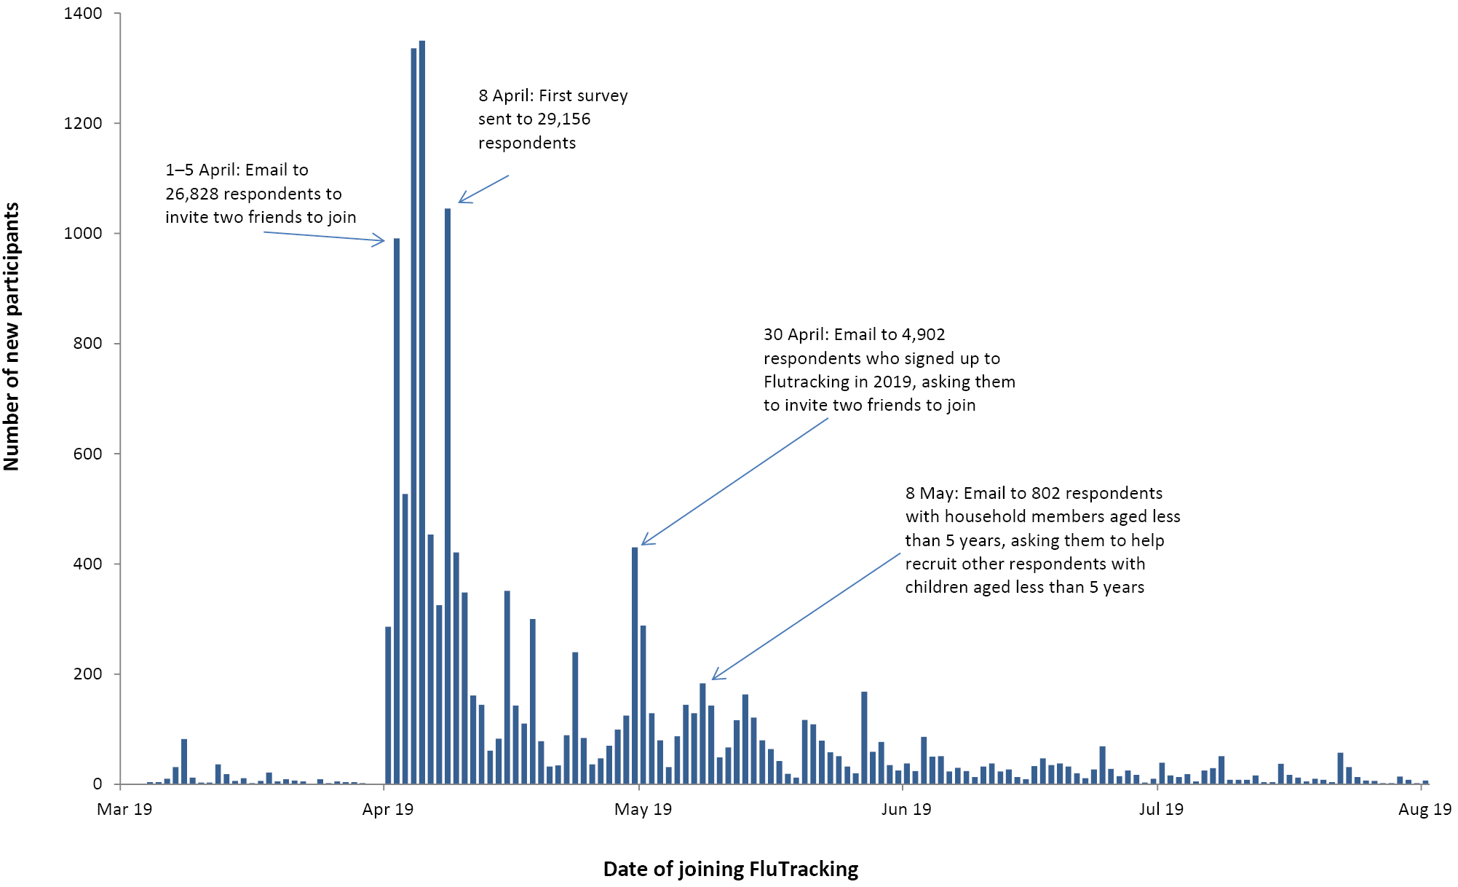

Participation
At least one survey for the 2019 season was completed by 30,063 respondents and on behalf of 22,738 household members for a total of 52,801 participants. This represented a 16.0% increase in the number of participants compared with 45,532 in 2018 (Figure 2). Of the 48,273 participants who completed a survey during the first four survey weeks, 32,728 (67.8%) completed all available surveys, and 38,547 (79.9%) completed more than 90% of available surveys. Of the 2018 participants, a total of 38,347 (84.2%) completed at least one survey during 2019 and comprised 72.6% of the 2019 participants.
During 2019, increases in peak week participation were most marked in Victoria, the Australian Capital Territory, and Tasmania (19.8%, 19.1%, and 18.3% increase in participation respectively from 2018). Queensland was the only jurisdiction with fewer than 100 participants (98.0) per 100,000 population (Figure 3 and Appendix A, Table A.1). Tasmania continued to have the highest rate of FluTracking participation, with 724.3 FluTracking participants per 100,000 population (Figure 3 and Appendix A, Table A.1).

Figure 2: Number of participants who completed at least one survey, Australia, 2006 to 2019, by year
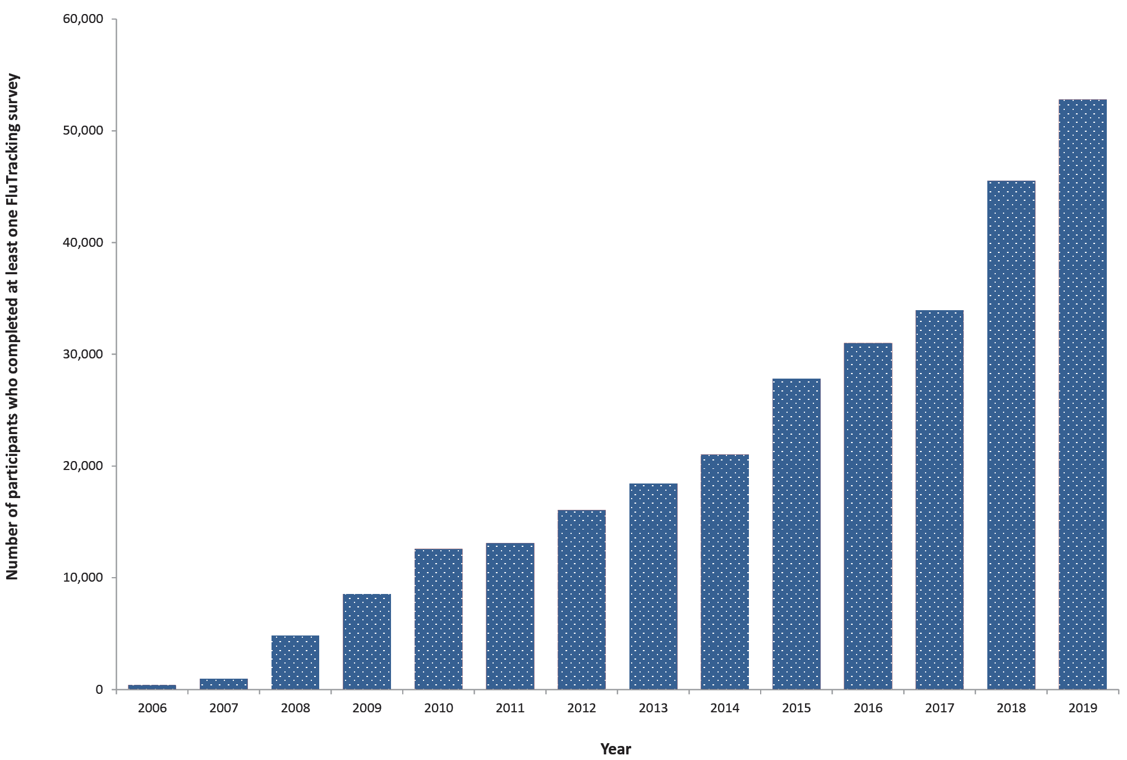

Figure 3: FluTracking participation per 100,000 population, by jurisdiction, peak week 2019

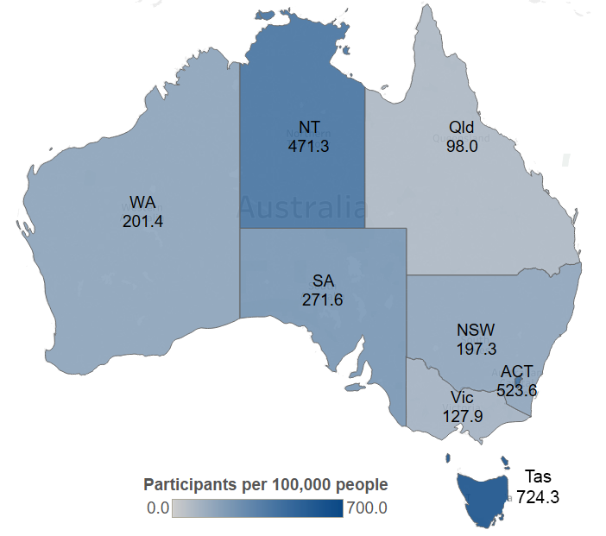Socio-demographic characteristics
Of the participants who completed at least one survey in 2019, complete demographic details were available for 49,962 (94.6%). The largest percentage of participants were aged 50 to 64 years (30.0%), followed by participants aged 35 to 49 years (22.1%) (Appendix A, Table A.2). The percentage of participants who identified as female was 59.7% (compared to 50.4% of the Australian population; Table A.3), and the percentage of participants who had completed a postgraduate degree was 22.6%, compared to 3.6% of the Australian population (Table A.4). The percentage of participants who identified as First Nations was 1.7%, compared to 3.3% of the Australian population (Table A.5). ¹⁴

Time to respond to survey each week
Of all participants who responded within the five weeks from the survey being sent, most responded within 24 hours, with a mean 24 hour response of 75.1% over the 29 weeks. The 65 years or over age group had a mean 24 hour response of 83.5% over the 29 weeks, which was the highest of all age groups.

Percentage of participants vaccinated
By the final survey for 2019, a total of 73.3% of participants had received the annual influenza vaccine, compared with 65.7% of participants vaccinated by the end of 2018 (Figure 4). Participants aged less than five years had the largest increase in vaccine coverage, with 69.3% coverage compared to 55.6% in 2018.
Figure 4: Percentage of participants vaccinated with the seasonal influenza vaccine at the final survey of each participant, by participant characteristics, Australia, 2007 to 2019, by year
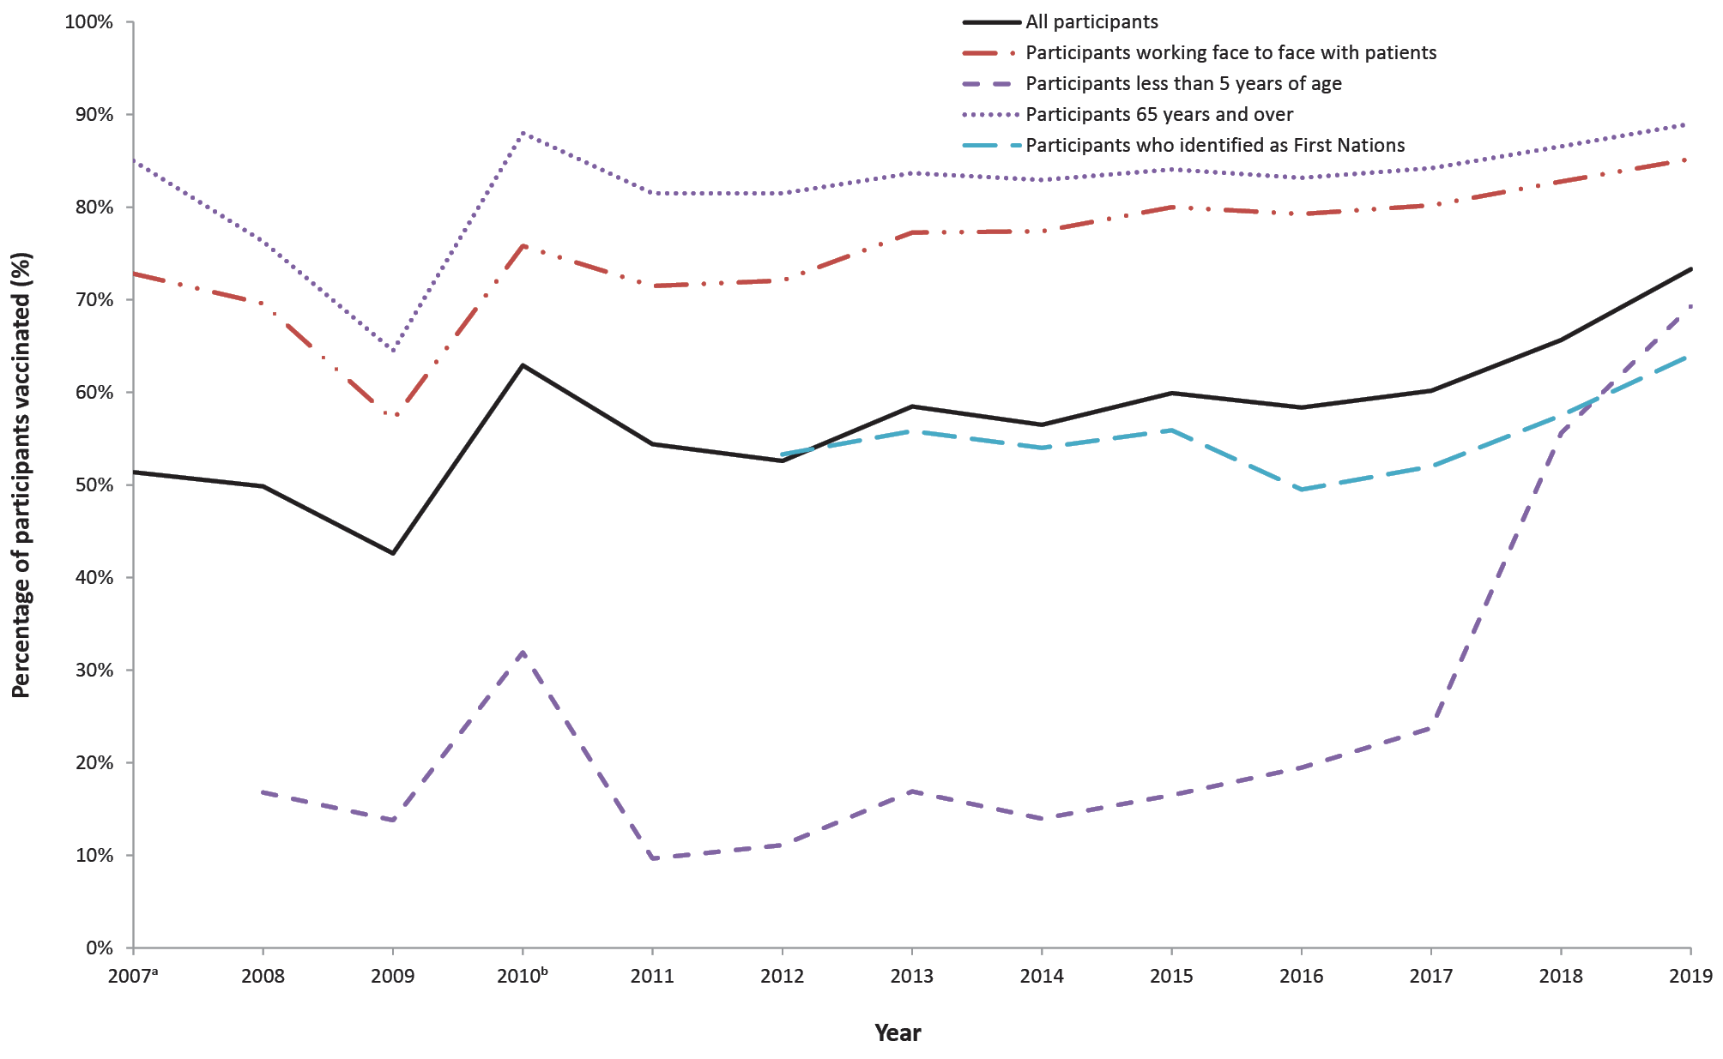
a No data are available for participants aged less than 5 years of age in 2007, as surveys were only available for completion by, or on behalf of, participants aged 18 years or older.
b This percentage calculation included participants who received either the monovalent H1N109 influenza vaccine in 2009 or 2010, or who received the 2010 seasonal influenza vaccine.

Percentage of participants with influenza-like illness symptoms
Of participants who completed at least one survey during 2019, fever and cough was reported by 29.1% (compared with 26.9% in 2018), and 24.6% reported fever, cough and sore throat (compared with 22.7% in 2018) (Appendix A, Table A.6).

Detection of influenza-like illness
The peak in ILI activity for 2019 occurred during the week ending 16 June, with 2.7% unvaccinated and 2.0% vaccinated participants reporting fever and cough during this week. Divergence between the vaccinated and unvaccinated participants’ ILI percentages was highest during the week ending 23 June (0.7% difference; 1.9% in the vaccinated group and 2.6% in the unvaccinated group) (Figure 5).
Figure 5: Percentage of participants with fever and cough stratified by influenza vaccination status, Australia, 2009 to 2019, by week
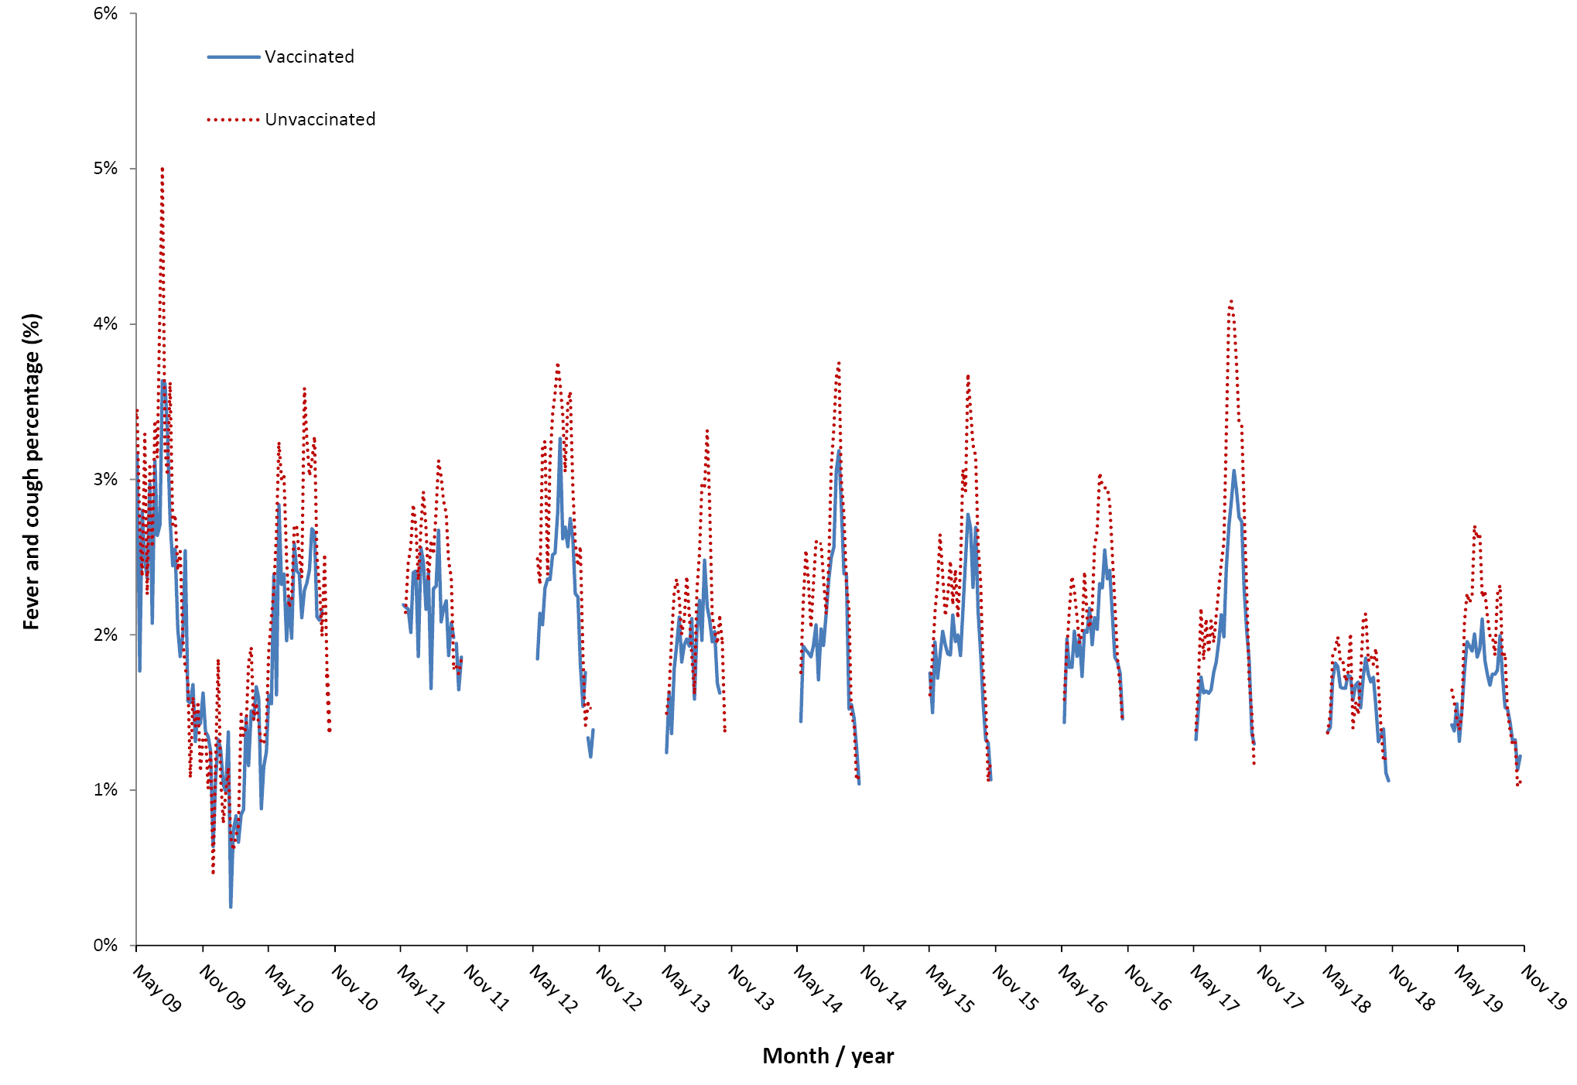

Comparison with national laboratory influenza notifications
Nationally there was a large increase in the number of laboratory-confirmed cases of influenza in 2019 compared to 2018 and 2017 (312,945, 58,649, and 251,235 laboratory notifications respectively). In 2019, the peak FluTracking ILI level was 2.2% (week ending 16 June), which was three weeks earlier than the peak week of laboratory notifications of influenza (18,429 laboratory notifications) (Figure 6).

Figure 6: Fever and cough percentage, 1 April to 31 Octoberª compared with national influenza laboratory notifications, Australia, 2009 to 2019, by week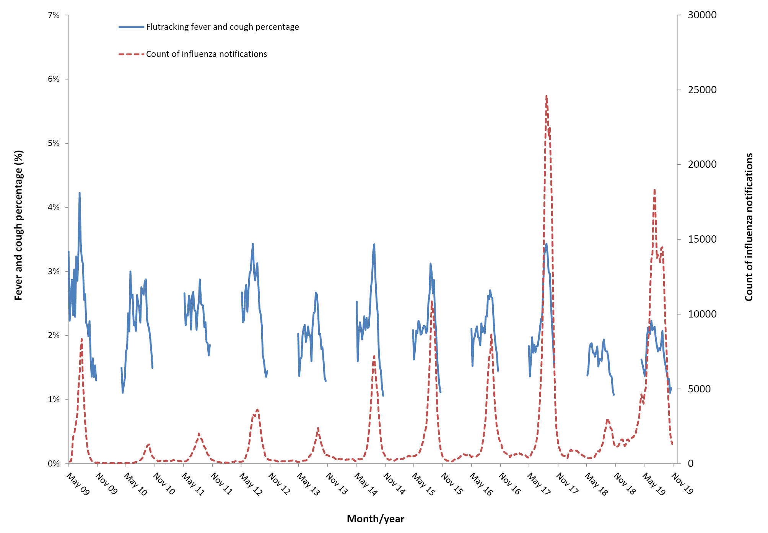
a Not stratified by vaccination status.

Percentage of self-reported laboratory influenza tests
There was an increase in the average percentage of FluTracking participants with fever and cough in 2019 who were tested for influenza, compared to previous years (7.6%, compared to 3.1% in 2018 and 5.0% in 2017). This increase was consistent across all jurisdictions. Within jurisdictions, the percentage of participants who reported being tested for influenza ranged from 4.5% of participants in the Northern Territory to 8.7% in Victoria; Figure 7). Based on a 1.5-fold increase in testing from 2017 to 2019, we estimated that total laboratory notifications would have decreased by 17.0% from 2017 to 2019 if testing rates had not increased (compared to an unadjusted 24.6% increase from 2017 to 2019). This assumes all other factors are equal, and the increase in notifications in 2019 was purely due to increased testing.

Figure 7: Average weekly percentage of FluTracking participants with fever and cough who reported being tested for influenza, 2013–2019, by jurisdiction, epidemiological weeks 18-41
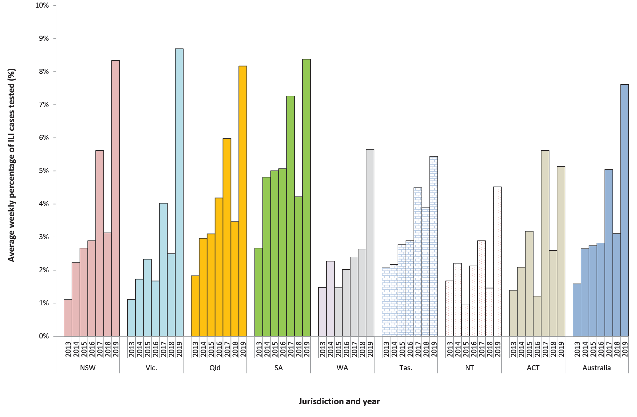

Time off work or normal duties and health-seeking behaviour
The peak weekly percentage of participants taking time off work or normal duties was 1.3% in 2019 and 1.1% in 2018, while the peak weekly percentage of participants seeking health care was 0.8% in 2019 and 0.7% in 2018 (Figure 8).

Figure 8: Weekly influenza-like illness severity,ª Australia, 2011 to 2019, by week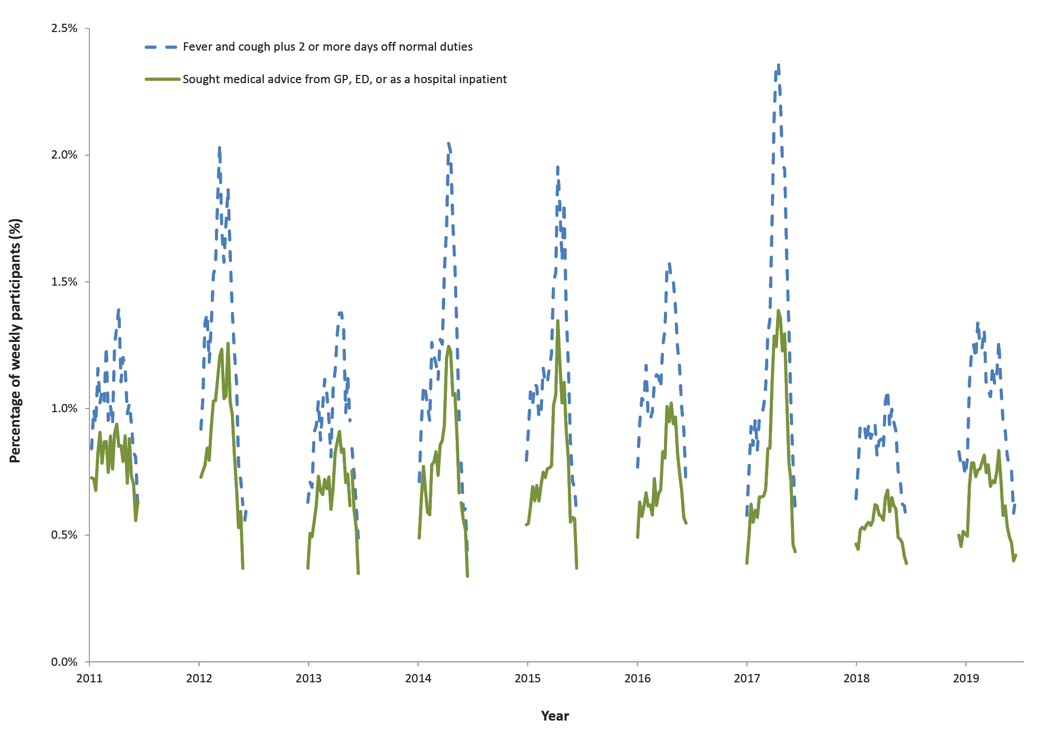
a The denominator is the number of weekly participants.

Burden of illness of influenza activity
The percentage of FluTracking participants seeking care for ILI was higher for the 2019 influenza season (45.0%), compared to the 2018 influenza season (40.8%), but similar to the 2017 season (45.3%). Likewise, the percentage of FluTracking participants with ILI that tested positive for influenza in 2019 was also higher than 2018, at 4.9%, but similar to 2017 (Table 1).
Table 1: FluTracking burden of Illness of influenza activity in 2017, 2018 and 2019, Australia (epidemiological weeks 17–42 of each survey year)
Self-reported symptom and testing behaviour | 2017  n (%) | 2018  n (%) | 2019  n (%)
Tested positive for influenza | 483 (4.1%) | 135 (1.1%) | 754 (4.9%)
Tested for influenza | 768 (6.5%) | 436 (3.5%) | 1332 (8.7%)
Sought medical care | 5381 (45.3%) | 5,060 (40.8%) | 6,902 (45.0%)
Fever and cough | 11880 (100.0%) | 12,414 (100.0%) | 15,336 (100.0%)

Cumulative incidence
For participants completing all 29 surveys for 2019, the cumulative incidence of ILI was highest in participants aged under 5 years, reaching 69.9%, and lowest in those aged 65 years or older (20.9%). There was a gradual increase in cumulative incidence for all age groups, with a sharper rise in ILI during May/June for participants aged 0 to 17 years (Figure 9).
Figure 9: Cumulative incidence of influenza-like illness, by age group, April to October 2019, by weekª
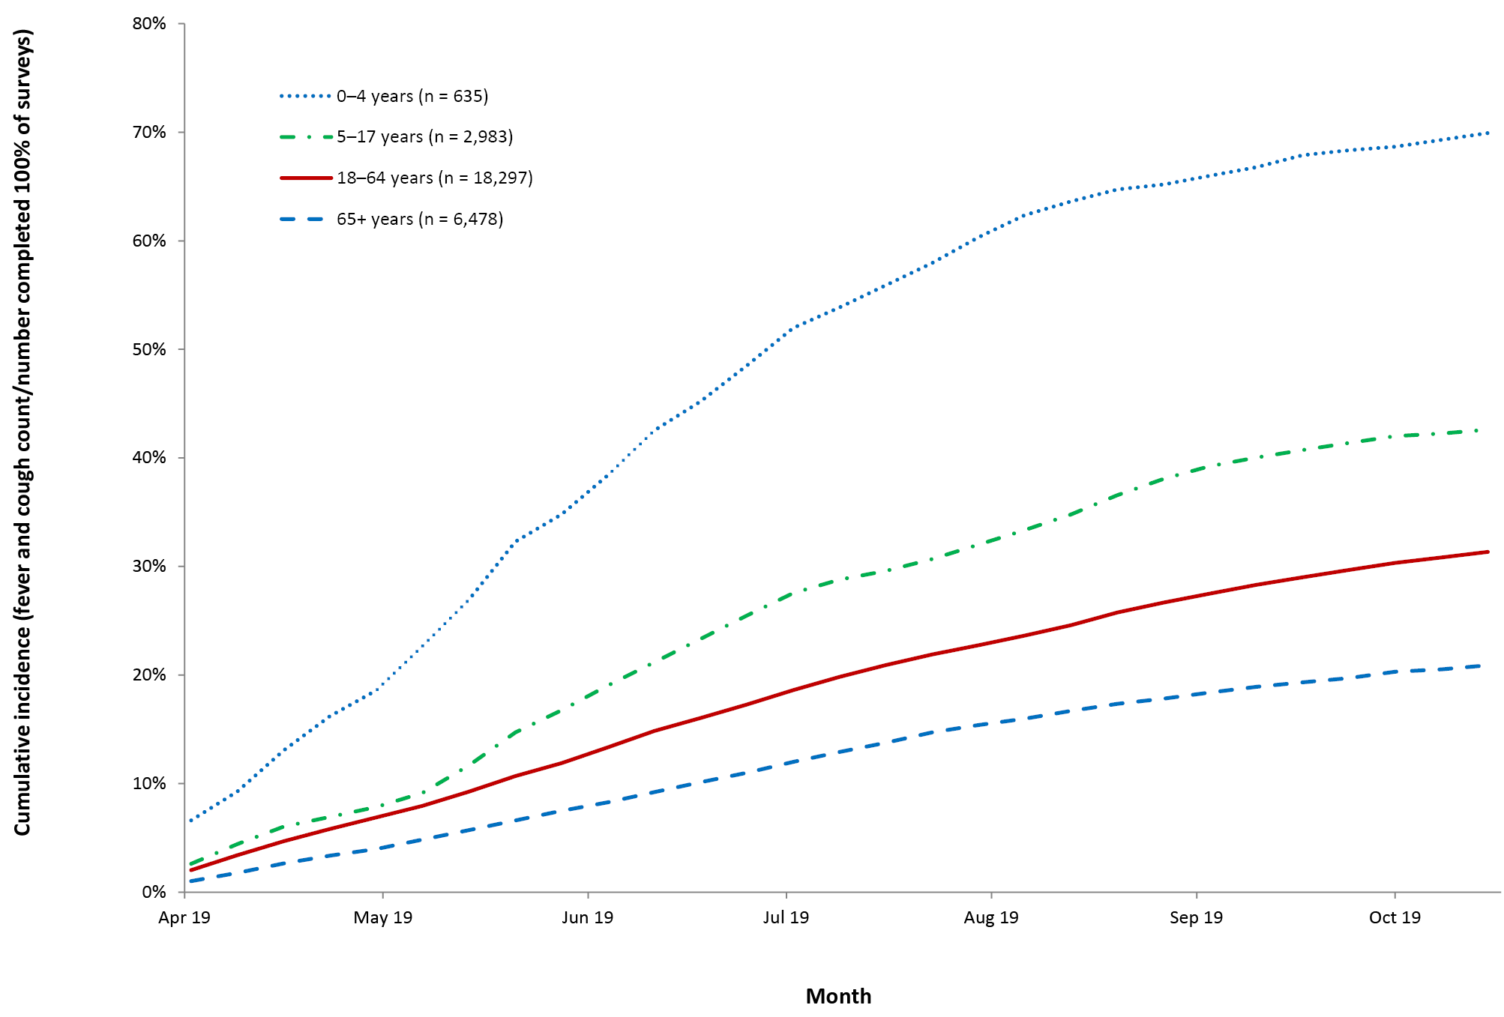
a Only the first ILI episode of each participant was included.

First Nations ILI incidence comparison, 2017–2019
Comparing the cumulative incidence of ILI for First Nations participants during the 2017, 2018, and 2019 influenza seasons, the highest rate (38.9%) occurred in 2018. The 2019 season reflected a similar cumulative incidence of ILI for First Nations participants as did the 2017 season (37.1% for both 2017 and 2019; Figure 10).
Figure 10: Cumulative incidence of ILI by First Nations status,ª Australia, April to October 2017–2019, by week (age-standardised) 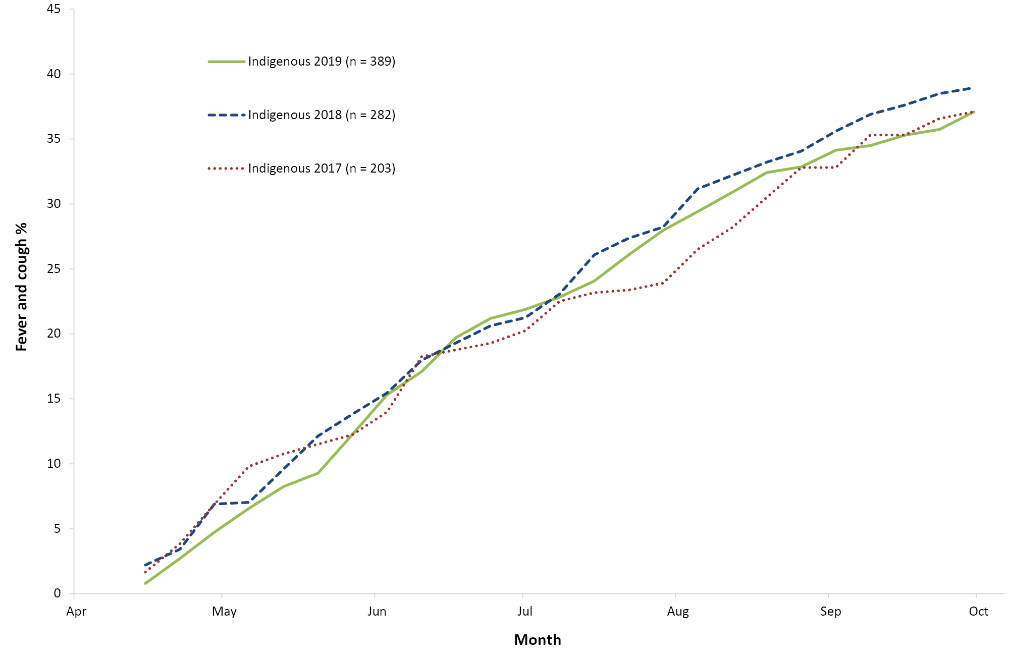
a Only the first ILI episode of each participant was included.

Comparison with HealthDirect Australia influenza-related calls
Nationally (excluding Victoria and Queensland), the weekly percentage of influenza-related calls followed a very similar trend to the weekly percentage of FluTracking participants with fever and cough for the period 2015 to 2018, with similar relative size and timing of the peak of ILI and influenza related calls (timing of the peak in activity varied by 1–2 weeks between FluTracking and HealthDirect, except for 2018: 7 weeks). However, the 2019 peak percentage of influenza-related calls received by HealthDirect was higher than the peak percentage for the years 2015–2018, whereas the peak FluTracking fever and cough percentage in 2019 was similar to 2018, and much lower than the fever and cough percentage peaks of 2015, 2016 and 2017 (Figure 11). In addition, the timing of the 2019 peak for HealthDirect influenza-related calls was four weeks later than the peak FluTracking fever and cough percentage (week ending 14 July 2019).

Figure 11: Fever and cough percentage, 1 April to 31 October,ª compared with percentage of calls to HealthDirect related to ILI,^{b} Australia (excluding Victoria and Queensland), 2015 to 2019, by week
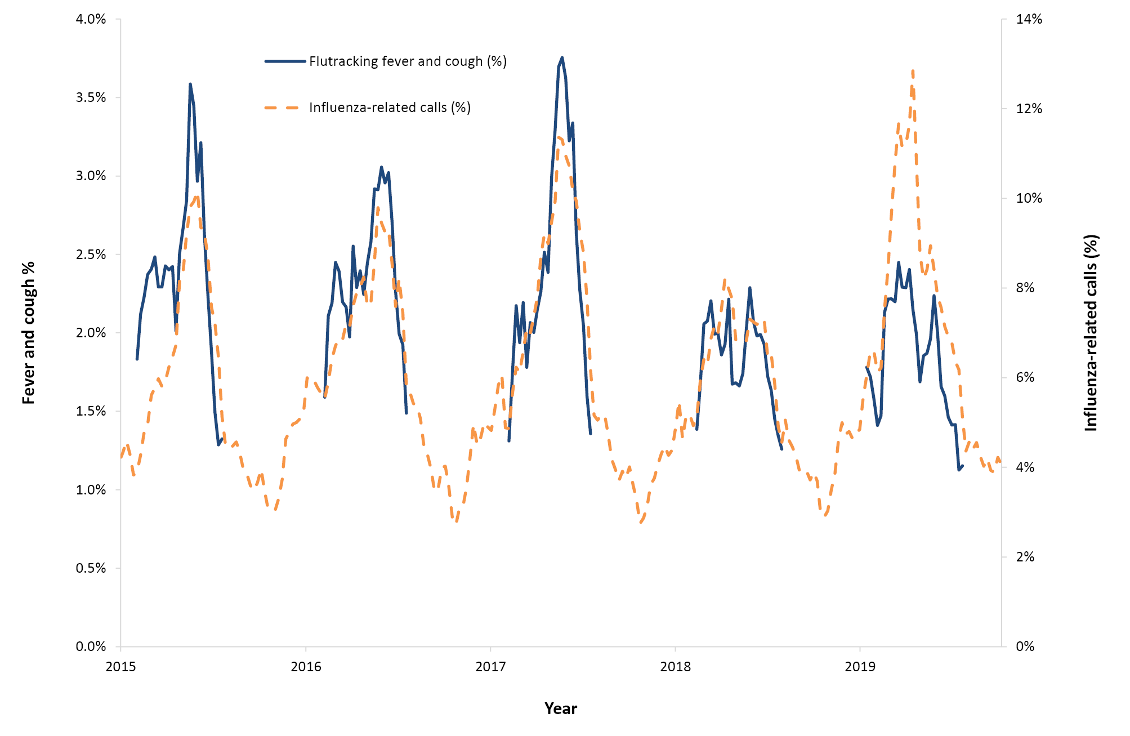
a Not stratified by vaccination status.
b HealthDirect data available for all weeks from 2015–2019.Discussion
The key highlights of FluTracking in 2019 were:
- identification of a much earlier, moderate peak in ILI activity compared to prior years;
- assisting in the interpretation of influenza surveillance in a year in which there was a massive increase in testing for influenza; and
- noting a large increase in self-reported influenza vaccination rates in children.
There was a continued steady increase in the number of community members signing up to participate in FluTracking in 2019. In comparison to the Australian population, there were fewer children and First Nations Australian participants in FluTracking, and more females and participants with higher levels of education.
The commitment of FluTracking participants continued to be demonstrated by the large percentage of participants completing their surveys within 24 hours (average 75.1%) and the high completion rate, with 67.8% and 79.9% of participants completing all and greater than 90% of surveys, respectively.
FluTracking participants reported higher vaccination coverage for each age group in 2019 than in previous years, with the most notable increase in children aged less the five years. In 2019, funding of the influenza vaccine commenced in the Northern Territory for all children aged six months to five years. ¹⁵ This followed on from an introduction of funding for the influenza vaccine in children six months to five years for all other states and territories in 2018 (funding of the influenza vaccine for children was introduced in 2008 for Western Australia). ¹⁶ The increases in vaccination rates in children aged less than five years may also have had ‘flow-on’ effects to older age groups that are not funded (5–17 years age group). ¹⁷ Heightened awareness of influenza driven by media reports of the ‘summer flu’ and a deadly influenza season may have also contributed to increases in vaccination rates for children, as well as older age groups. ^{18,19}
ILI activity in the 2019 influenza season peaked earlier than in any prior season on record in FluTracking data (two months earlier than the 2018 peak). The levels of ILI in 2019 were above average early in the season, and the duration of peak activity was longer than most prior years. However, ILI levels were much lower than the five-year average for ILI in the latter half of the season. Of participants who completed at least one survey during 2019, the percent of participants who reported fever and cough (29.1%) was lower than the five-year average (32.8%, unpublished data).
Nationally, the total number of laboratory-confirmed influenza notifications in 2019 was higher than all prior years from 2007 onwards. FluTracking data suggests this increase in notifications may be partially explained by an increase in testing, with a large increase in the percentage of participants with ILI having a test for influenza (a 2.5-fold increase in 2019 compared to 2018, and a 1.5-fold increase compared to 2017). Intense media reporting on an earlier flu season in 2019 (‘summer flu’) contributed to this disproportionate increase in testing in 2019. ¹⁸ Additionally, although FluTracking data indicated a 1.8-fold increase in the percent positivity for influenza from 2018 to 2019 (percentage of participants positive for influenza of those tested), there was a decrease in percent positivity from 2017 to 2019 (62.9% and 56.6% respectively).
The peak percentage of influenza-related calls to HealthDirect in 2019 was much higher than in prior years, whereas FluTracking 2019 fever and cough rates were lower than most years. The increase in influenza-related calls may be driven by an increase in influenza activity. However, media reports of the ‘summer flu’ may have also contributed to increased community concern and an increase in influenza-related calls at the start of the 2019 season, with flow-on effects later in the season. HealthDirect data has a much larger percentage of children than FluTracking data (just under 30 percent of HealthDirect patients were aged 0–4 years), and these data were not age-standardised for this analysis, as HealthDirect age data could not be obtained. ²⁰ HealthDirect data is therefore much more impacted by changes in influenza activity among children, and changes in concern about infection in children, than other surveillance systems.
The 2019 season was documented as ‘the worst flu season ever’ by media. Although 2019 was of higher activity and severity than the ‘mild’ 2018 season, Flutracking data indicates that at the community level, 2019 was a lower activity and severity season than 2017, and that notifications and influenza-related calls were heightened by increased community concern and testing. ²¹
Despite an earlier moderate activity season in 2019 compared to prior years, severity of ILI in the Australian community was lower in 2019 than in most prior years. The peak percentage of participants with fever and cough who had two or more days off work due to their illness was higher in 2019 than in 2018, but lower than in most prior years of FluTracking data. The peak percentage of participants with fever and cough who sought medical advice for ILI symptoms in 2019 was also lower than in most prior years of FluTracking data (but higher than in 2018).
Moa et al. observed using laboratory confirmed influenza notifications data that the 2017 and 2019 seasons were of similar activity levels, but acknowledged the role of increased testing in the 2019 season alongside a ‘true’ increase in summer activity. Shepherd et al also highlighted the impact of increased testing on a so-called ‘mutant flu season’ in 2019. ^{21,22}
Our comparison of 2017–2019 ILI attack rates demonstrates that severity of influenza seasons do not always align for First Nations and non-First Nations people: a severe influenza season for First Nations people may be masked by a relatively mild influenza season in the broader population.
FluTracking allows the identification of sometimes complex and important differences between influenza seasons and potential surveillance biases that enhances the interpretation of multiple other surveillance streams.
During 2020, we aim to report on the community-level experience of illness relating to COVID-19. We also aim to continue expanding FluTracking participation in Australia and New Zealand. We are planning to introduce FluTracking to Hong Kong in 2020.

Acknowledgements
We acknowledge the University of Newcastle for their continued support, and the Australian Government Department of Health and Aged Care and the Hunter Medical Research Institute for their funding and support. We also acknowledge Stephen Clarke for software and database development, the First Nations Health Protection staff for their guidance and support, John Fejsa for his contribution to the design of the project, and the many thousands of FluTracking participants who freely give their time each week to contribute to influenza surveillance.

Author details
Sandra J Carlson ¹
Reilly J Innes ^{1,2}
Zachary L Howard ¹
Zoe Baldwin ¹
Michelle Butler ¹
Craig B Dalton ^{1,2}
- Hunter New England Population Health, New South Wales, Australia
- University of Newcastle, Callaghan, Australia

References
- Carlson SJ, Dalton CB, Tuyl FA, Durrheim DN, Fejsa J, Muscatello DJ et al. Flutracking surveillance: comparing 2007 New South Wales results with laboratory confirmed influenza notifications. Commun Dis Intell Q Rep . 2009;33(3);323–7.
- Dalton CB, Durrheim DN, Fejsa J, Francis L, Carlson SJ, d’Espaignet ET et al. Flutracking: a weekly Australian community online survey of influenza-like illness in 2006, 2007 and 2008. Commun Dis Intell Q Rep . 2009;33(3);316–22.
- Parrella A, Dalton CB, Pearce R, Litt JCB, Stocks N. ASPREN surveillance system for influenza-like illness: a comparison with FluTracking and the National Notifiable Diseases Surveillance System. Aust Fam Physician . 2009;38(11);932–6.
- Carlson SJ, Dalton CB, Durrheim DN, Fejsa J. Online Flutracking survey of influenza-like illness during pandemic (H1N1) 2009, Australia. Emerg Infect Dis. 2010;16(12):1960–2. doi: https://doi.org/10.3201/eid1612.100935.
- Dalton CB, Carlson SJ, Durrheim DN, Butler MT, Cheng AC, Kelly HA. Flutracking weekly online community survey of influenza-like illness annual report, 2015. Commun Dis Intell Q Rep . 2016;40(4);E512–20.
- World Health Organization (WHO). Pandemic Influenza Severity Assessment (PISA): a WHO guide to assess the severity of influenza epidemics and pandemic . Geneva: WHO; May 2017. Available from: https://apps.who.int/iris/bitstream/handle/10665/259392/WHO-WHE-IHM-GIP-2017.2-eng.pdf.
- Australian Government Department of Health. Australian influenza report 2009. Canberra: Australian Government Department of Health; 2009.
- HealthDirect Australia. Flu trends in Australia. [Internet.] Canberra: HealthDirect Australia; 2020. [Accessed on 9 March 2020.] Available from: https://www.HealthDirect.gov.au/flu-trends-in-australia.
- Australian Government Department of Health and Aged Care. Australian Influenza Surveillance Reports – 2019. [Webpage.] Canberra: Australian Government Department of Health and Aged Care; 2020. [Accessed on 12 March 2020.] Available from: https://www.health.gov.au/resources/collections/australian-influenza-surveillance-reports-2019?language=en.
- Moberley S, Carlson SJ, Durrheim DN, Dalton CB. Flutracking: Weekly online community-based surveillance of influenza-like illness in Australia, 2017 Annual Report. Commun Dis Intell (2018) . 2019;43. doi: https://doi.org/10.33321/cdi.2019.43.31.
- Howard ZL, Carlson SJ, Moberley S, Butler M, Dalton CB. FluTracking: Weekly online community-based surveillance of influenza-like illness in Australia, 2018 annual report. Commun Dis Intell (2018) . 2022;46. doi: https://doi.org/10.33321/cdi.2022.46.41.
- Australian Bureau of Statistics (ABS). 3101.0 - Australian Demographic Statistics, Jun 2019. [Webpage.] Canberra: ABS; 19 December 2019. [Accessed on 9 March 2020.] Available from: https://www.abs.gov.au/AUSSTATS/abs@.nsf/Lookup/3101.0Main+Features1Jun%202019.
- ABS. 2011 Census Fact Sheet. Topic – Highest Level of Education . Canberra: ABS; 25 November 2016. [Accessed on 9 March 2020.] Available from: https://www.abs.gov.au/websitedbs/censushome.nsf/4a256353001af3ed4b2562bb00121564/mediafactsheets2nd/$file/Topic%20-%20Highest%20Level%20of%20Education.pdf.
- ABS. Estimates of Aboriginal and Torres Strait Islander Australians, June 2016. [Webpage.] Canberra: ABS; 31 August 2018. [Accessed on 5 March 2020.] Available from: https://www.abs.gov.au/statistics/people/aboriginal-and-torres-strait-islander-peoples/estimates-aboriginal-and-torres-strait-islander-australians/jun-2016.
- Northern Territory Government. Flu vaccination. [Internet.] Darwin: Northern Territory Government; 2020. [Accessed on 9 March 2020.] Available from: https://nt.gov.au/wellbeing/healthy-living/immunisation/flu-vaccination.
- National Centre for Immunisation Research and Surveillance (NCIRS). Significant events in influenza vaccination practice in Australia . Sydney: NCIRS; July 2018. [Accessed on 9 March 2020.] Available from: http://www.ncirs.org.au/sites/default/files/2018-11/Influenza-history-July-2018.pdf.
- Howard ZL, Dalton CB, Carlson SJ, Baldwin Z, Durheim DN. Impact of funding on influenza vaccine uptake in Australian children. Public Health Res Pract . 2021;31(1);e3112104. doi: https://doi.org/10.17061/phrp3112104.
- Dalton CB. Media hype and increased testing: this year’s flu numbers are high, but there’s more to the story. [Internet.] Melbourne: The Conversation Media Group Ltd; 22 July 2019. [Accessed on 11 March 2020.] Available from: https://theconversation.com/media-hype-and-increased-testing-this-years-flu-numbers-are-high-but-theres-more-to-the-story-120004.
- Australian Associated Press. Flu experts predict 4,000 Australians will die from influenza this year. [Webpage.] Sydney: Guardian Australia; 7 May 2019. [Accessed on 12 December 2022.] Available from: https://www.theguardian.com/australia-news/2019/may/07/flu-experts-predict-4000-australians-will-die-from-influenza-this-year.
- HealthDirect Australia. Annual Report Financial Year 2018 – 2019 . Canberra: HealthDirect Australia; 2019. [Accessed on 29 November 2022.] Available from: https://media.healthdirect.org.au/publications/HDA_Annual_Report_18-19_FA_Screen_Spreads.pdf.
- Moa A, Trent M, Menzies R. Severity of the 2019 influenza season in Australia - a comparison between 2017 and 2019 H3N2 influenza seasons. Global Biosecurity . 2019;1. doi: https://doi.org/10.31646/gbio.47.
- Sheppeard V, Gilmour R, Tobin S. Record number of influenza tests in 2019, not a “mutant flu crisis”. Med J Aust . 2019;211(7):333. doi: https://doi.org/10.5694/mja2.50321.

Appendix A: Supplementary material
Table A.1: Recruitment and participation in FluTracking, 2018 and 2019, by jurisdiction
State or territory | Percent distribution of Australian population | 2018 |  |  | 2019 |  |  | Percent change (participation), 2018 to 2019
 |  | Number of participants (peak week) | FluTracking participation per 100,000 population | Percent of participants (peak week) | Number of participants (peak week) | FluTracking participation per 100,000 population | Percent of participants (peak week)
NSW | 31.9 | 13,933 | 172.2 | 34.2 | 15,959 | 197.3 | 34.2 | 14.5
Vic. | 26.0 | 7,044 | 106.8 | 17.3 | 8,436 | 127.9 | 18.1 | 19.8
Qld | 20.1 | 4,496 | 88.2 | 11.0 | 4,993 | 98.0 | 10.7 | 11.1
SA | 6.9 | 4,259 | 243.1 | 10.5 | 4,757 | 271.6 | 10.2 | 11.7
WA | 10.3 | 4,702 | 179.3 | 11.6 | 5,279 | 201.4 | 11.3 | 12.3
Tas. | 2.1 | 3,272 | 612.4 | 8.0 | 3,870 | 724.3 | 8.3 | 18.3
NT | 1.0 | 1,113 | 452.6 | 2.7 | 1,159 | 471.3 | 2.5 | 4.1
ACT | 1.7 | 1,875 | 439.4 | 4.6 | 2,234 | 523.6 | 4.8 | 19.1
Total | 100.0 | 40,689 | 160.4 | 100 | 46,715 | 184.2 | 100.0 | 14.8

Table A.2: Age distribution of FluTracking participants who completed at least one survey, Australia, 2018 and 2019
Age (years) | 2018 |  |  | 2019 |  |  | % Australian population
 | Frequency | % | Rate /100,000 | Frequency | % | Rate /100,000
0–15 | 6,048 | 13.3 | 129.9 | 6,967 | 13.2 | 138.4 | 19.8
16–34 | 7,090 | 15.6 | 101.1 | 8,156 | 15.4 | 120.5 | 26.7
35–49 | 10,330 | 22.7 | 209.8 | 11,660 | 22.1 | 230.7 | 19.9
50–64 | 14,173 | 31.1 | 322.7 | 15,824 | 30.0 | 354.2 | 17.6
65 and over | 7,890 | 17.3 | 218.0 | 10,198 | 19.3 | 252.5 | 15.9
Total participants | 45,531  (1 missing) | 100.0 | 184.0 | 52,805 | 100.0 | 208.2 | 100.0

Table A.3: Gender distribution of FluTracking participants who completed at least one survey, Australia, 2018 and 2019
Gender | 2018 |  |  | 2019 |  |  | % Australian population
 | Frequency | % | Rate /100,000 | Frequency | % | Rate /100,000
Male | 17,986 | 40.2 | 143.0 | 20,983 | 40.3 | 166.8 | 49.6
Female | 26,749 | 59.8 | 209.3 | 31,096 | 59.7 | 243.3 | 50.4
Other | 24 | 0.1 |  | 44 | 0.1
Total reported | 44,759 | 100.0 |  | 52,123  (682 missing) | 100 |  | 100.0
Table A.4: Education levels of FluTracking participants who completed at least one survey, Australia, 2018 and 2019
Highest level of education completed by participant | 2018 |  |  | 2019 |  |  | % Australian population
 | Frequency | % | Rate /100,000 | Frequency | % | Rate /100,000
Year 11 or below (or equiv) or Certificate I/II/III/IV | 8,201 | 21.3 | 107.2 | 9,518 | 21.3 | 124.4 | 44.1
Year 12 (or equivalent) | 3,165 | 8.2 | 109.8 | 3,583 | 8.0 | 124.3 | 16.6
Advanced Diploma/Diploma | 3,623 | 9.4 | 260.1 | 4,316 | 9.7 | 309.8 | 8.0
Completed Bachelor Degree | 8,796 | 22.8 | 375.8 | 10,325 | 23.1 | 441.1 | 13.5
Grad Diploma/Grad Certificate | 4,611 | 12.0 | 1551.1 | 5,307 | 11.9 | 1785.2 | 1.7
Postgraduate Degree | 8,708 | 22.6 | 1379.8 | 10,083 | 22.6 | 1597.6 | 3.6
Total who nominated an ABS equivalent education level  (15 years and over only) | 38,509 | 100.0 | 221.8 | 44,709 | 100.0 | 257.5 | 100.0

Table A.5: Aboriginal and/or Torres Strait Islander status of FluTracking participants who completed at least one survey, Australia, 2018 and 2019
Aboriginal and/or Torres Strait Islander status | 2018 |  |  | 2019 |  |  | % Australian population
 | Frequency | % | Rate /100,000 | Frequency | % | Rate /100,000
Yes | 713 | 1.6 | 89.3 | 856 | 1.7 | 107.2 | 3.3
No | 42,377 | 97.9 | 181.2 | 49753 | 97.9 | 212.7 | 96.7
Prefer not to say | 204 | 0.5 |  | 220 | 0.4
Total reported | 43,294 | 100.0 | 179.0 | 50829  (1,976 missing) | 100 | 210.1 | 100.0
Table A.6: Incidence of influenza-like illness for participants who completed at least one survey, Australia, 2017 to 2019 (epidemiological weeks 17–41)
ILI symptoms | Participants who completed at least one survey (epidemiological weeks 17–41)
 | 2017 (N = 33,800) |  | 2018 (N = 45,345) |  | 2019 (N = 51,734)
 | n | % | n | % | n | %
Fever | 14,011 | 41.5% | 15,155 | 33.4% | 18,040 | 34.9%
Cough | 23,104 | 68.4% | 29,311 | 64.6% | 33,177 | 64.1%
Fever & cough | 11,894 | 35.2% | 12,199 | 26.9% | 15,068 | 29.1%
Fever, cough & sore throat | 9,935 | 29.4% | 10,294 | 22.7% | 12,701 | 24.6%

Communicable Diseases Intelligence
ISSN: 2209-6051 Online

Communicable Diseases Intelligence (CDI) is a peer-reviewed scientific journal published by the Office of Health Protection, Department of Health and Aged Care. The journal aims to disseminate information on the epidemiology, surveillance, prevention and control of communicable diseases of relevance to Australia.

Editor: Noel Lally
Deputy Editor: Simon Petrie
Design and Production: Kasra Yousefi
Editorial Advisory Board: David Durrheim, Mark Ferson, Clare Huppatz, John Kaldor, Martyn Kirk, Meru Sheel and Steph Williams

Website: http://www.health.gov.au/cdi

Contacts
CDI is produced by the Office of Health Protection, Australian Government Department of Health and Aged Care, GPO Box 9848, (MDP 6) CANBERRA ACT 2601

Email: cdi.editor@health.gov.au

Submit an Article
You are invited to submit your next communicable disease related article to the Communicable Diseases Intelligence (CDI) for consideration. More information regarding CDI can be found at: http://health.gov.au/cdi.
Further enquiries should be directed to: cdi.editor@health.gov.au.

This journal is indexed by Index Medicus and Medline.

Creative Commons Licence - Attribution-NonCommercial-NoDerivatives CC BY-NC-ND
© 2023 Commonwealth of Australia as represented by the Department of Health and Aged Care
This publication is licensed under a Creative Commons Attribution-NonCommercial-NoDerivatives 4.0 International Licence from https://creativecommons.org/licenses/by-nc-nd/4.0/legalcode (Licence). You must read and understand the Licence before using any material from this publication.

Restrictions
The Licence does not cover, and there is no permission given for, use of any of the following material found in this publication (if any):
- the Commonwealth Coat of Arms (by way of information, the terms under which the Coat of Arms may be used can be found at www.itsanhonour.gov.au);
- any logos (including the Department of Health and Aged Care’s logo) and trademarks;
- any photographs and images;
- any signatures; and
- any material belonging to third parties.

Disclaimer
Opinions expressed in Communicable Diseases Intelligence are those of the authors and not necessarily those of the Australian Government Department of Health and Aged Care or the Communicable Diseases Network Australia. Data may be subject to revision.

Enquiries
Enquiries regarding any other use of this publication should be addressed to the Communication Branch, Department of Health and Aged Care, GPO Box 9848, Canberra ACT 2601, or via e-mail to: copyright@health.gov.au

Communicable Diseases Network Australia
Communicable Diseases Intelligence contributes to the work of the Communicable Diseases Network Australia.
http://www.health.gov.au/cdna

682 participants were missing sex status; 1,976 were missing First Nations status who would have signed up prior to sex and First Nations status being collected; and 1,560 participants aged 15 years and over were missing highest level of education completed.

